Original Research Article

MORPHOLOGICAL AND MOLECULAR CHARACTERISATION OF THREE FUNGI, ANTAGONISTIC TO PLANT PATHOGENS

.
ABSTRACT

Aims: This study characterized three antagonistic fungi viz Trichoderma sp, Penicillium sp and a Putative Metarhizium sp. Morphological and Molecular characterization were conducted on the three antagonistic fungi for proper identification to the species level.
Study design: The study employed an experimental laboratory design combining morphological and molecular techniques to isolate, characterize, and identify potential antagonistic fungi (Trichoderma, Penicillium, and a putative Metarhizium) obtained from soil and culture collections.
Place and Duration of Study: Department of Crop and Soil Sciences, KNUST, Kumasi and Cocoa Research Institute of Ghana (CRIG) Akyem New Tafo, Ghana, between February 2022 and May 2023.
Methodology: For morphological characterization of the three antagonistic fungi, a single spore of the antagonistic fungi was centrally placed on PDA plate (three replicate plates per fungi) and grown on a laboratory bench in a room with approx. 8 h photo period at approx. 28 ºC. Colony diameters were measured from the underside of the plates with a meter rule from day 1 to day 7 (for the penicillium sp. and the putative Metarhizium sp.) and for day 1 to day 4 for Trichoderma sp.
Fungal reproductive structures were studied using a modified slide culture technique. Measurement of the various structures of each organism were measured using an Amscope microscope. Colony coloration was described using the pantone colour chart. Genomic DNA was extracted using the CTAB method. PCR, Gel electrophoresis and DNA sequencing were done at the functional Biosciences, WI Madison, USA.
Results: Molecular determinations conducted on the three antagonistic fungi conclusively, identified the Trichoderma sp. as T. asperellum, the Penicillium sp. as P. citrinum and the putative Metarhizium as Myxotrichum stiputatum.
Conclusion: With proper identification using molecular approaches, the three antagonistic fungi were found to be Trichoderma asperellum, Penicillium citrinum, and Myxotrichum stipitatum. When then three antagonistic fungi were tested against all the seven plant pathogens for biocontrol potential using the dual culture technique, T. asperellum exhibited the strongest antagonistic activity against all seven plant pathogens

Keywords: [Trichoderma, Penicillium, Myxotrichum sequencing, DNA extraction}

1. INTRODUCTION

Biocontrol agents (BCAs) are increasingly being utilized as an alternative or complementary approach to synthetic chemicals in plant disease management because of the negative impacts of synthetic chemicals on the environment and human health as well as the build-up of pesticide resistance by plant pathogens (Vinale et al., 2008; Raymaekers et al., 2020). Moreover, BCAs are target-specific, have a rapid rate of reproduction, and have short generation times (Thambugala et al., 2020).
The diverse microbial community known as the rhizosphere microbiome is found in the rhizosphere. This microbial community, which includes a variety of helpful microorganisms like bacteria, algae, and fungi, resides around the roots of plants (Mohanram et al., 2019).
The BCAs can demonstrate a variety of direct and indirect modes of action that achieve disease prevention. Some of these mechanisms include antibiosis (i.e., where the antagonist produces an inhibitory metabolite or antibiotic against the pathogen); mycoparasitism (i.e., the antagonist obtains part or all of its nutrients from the pathogen); induced resistance (i.e., a host plant's defensive response against a plant pathogen is induced in the host plant); and growth enhancement (i.e., promotion of plant growth while the effects of the disease are being reduced) (Chandrashekara et al., 2012).
Trichoderma species are the most widely utilized fungal species in the biological management of plant diseases (Singh et al., 2014). These fungi are prevalent in the rhizospheres of plants (Vinale et al., 2008). Trichoderma species are non-sexual organisms that co-exist with other soil-dwelling fungi with teleomorphs of the Hypocrea genus, Ascomycota (Druzhinina et al., 2006).
Penicillium species are much more common in the aerial environment. Compared to other species of fungi, they also exist as endophytes in the tissues of plants (Rashmi et al., 2019). A variety of Penicillium species have been identified as antagonists to causative agents of plant diseases with methods of action such as induced resistance (Hossain et al., 2007), the synthesis of antimicrobial compounds, as well as the development of mycoparasitic contacts (Nicoletti et al., 2004; Yang et al., 2008). Studies have shown that the culture filtrate of P. janczewskii showed some inhibitory activity towards Rhizoctonia solani (Niciletti et al., 2007).
Myxotrichum stipitatum is a type of fungus that belongs to the Myxotrichaceae family.
M. stipitatum is associated with mycorrhizal interactions. Mycorrhizae are symbiotic associations between fungi and plant roots. An extensive search of the literature on the antifungal properties indicates that the fungus M. stipitatum has not been extensively studied. In Ghana, little progress has been made in the discipline of biocontrol technology against major plant pathogens. The few studies available include those by Odamtten (1985); Akrasi and Awuah (2009); Gyempeh et al. (2015); Akrofi et al. (2017); Larbi-Koranteng et al. (2020); and Agbetiameh et al. (2020). It is thus important to periodically screen microorganisms for activity towards plant pathogens with a view to developing promising microorganisms into biocontrol agents. The research sought to confirm the identities of three isolates of potential biocontrol agents tentatively identified as Trichoderma, Penicillium, and a putative Metarhizium species to the species level using morphological and molecular means.
2. material and methods
2.1 Sources of antagonistic fungi
Isolate of the Trichoderma sp. was obtained through a soil analysis conducted at the Plant Pathology Section of CSIR-Crops Research Institute, Ghana, whiles cultures of both Penicillium and putative Metarhizium spp. were obtained from the Plant Pathology Laboratory, Faculty of Agriculture, KNUST, Ghana.

2.2 Single-spore isolation of fungi
Fungi were established on artificial Potato Dextrose Agar (PDA) plates by single sporing. For each fungus, a piece of spore-bearing mycelium from the plated tissue, was manually shaken in 10 ml of sterile distilled water contained in a 20 ml test tube. The initial spore suspension was further diluted by transferring a 1 ml aliquot to 9 ml sterile water in another test tube. One millilitre of this suspension was pipetted and spread on 2 % water agar (WA) plates by swirling the plates. The inoculated plate was incubated for 24 hours and scanned with a dissecting microscope for germinating spores. Single germinating spore was removed together with a bit of their surrounding medium using a sterilized transfer needle with a fine tip and subsequently grown on PDA plates to establish a single spore isolate of each fungus.

2.3 Morphological studies
A single spore of each of the three potential antagonistic fungi was centrally placed on a PDA plate (three replicate plates per fungus) and grown on a laboratory bench in a room with approximately 8 h photoperiod (cool white fluorescent light) at approximately 28℃. Colony diameters were measured from the underside of the plates with a meter rule (average of two diagonal measurements per plate) every 24 h for seven days (i.e., for the Penicillium and putative Metarhizium spp.) and four days (i.e., for the Trichoderma sp.).
Fungal reproductive structures were studied using a modified slide culture technique (Ridell, 1950). Briefly for each fungus, mycelial bits from a seven-day-old culture were placed at the four sides of a 1 cm³ agar block of Water agar and resting on a sterilized microscope slide placed on a bent glass rod. The set up was placed in a sterilized Petri dish lined with moistened filter paper and the entire set up incubated on a lab bench with 8 h photoperiod (cool white fluorescent light) at 28 °C as described above. Between 24-48 h, fungal growth from the WA block were examined with a compound microscope (Amscope microscope, USA). Measurements of Conidia, phialides, metulae and conidiophores sizes and shapes were measured using a compound microscope. Fifty measurements of conidia for each of the three potential antagonists were made and averaged. Ten measurements of conidiophores, phialides and metulae were made for the three potential antagonists. Colony colouration was described using the Pantone color chat (2017).

2.4 Molecular studies
From each single-spored seven-day-old fungal colony grown on PDA, genomic DNA was extracted from the three potential antagonistic fungi using the Cetyltrimethyl ammonium bromide (CTAB) method. A sterilized pestle was used to grind about 50 mg of the mycelial colony in a sterilized mortar in liquid nitrogen. To the ground mycelial mat, 900 µl of pre-warmed extraction buffer (65℃) added and the sample was incubated at 65 ℃ for 1 hour. Following incubation, equal volume of phenol: chloroform (1:1) mixture (900 µl each) was then added, vortexed and centrifuged at 14,000 rpm for 10 min. The upper aqueous phase was transferred into a new 2 ml Eppendorf tubes. At 37 °C for 30 min, 2 µl RNAse (10 mg/ul) was added. After incubation, 750 µl of chloroform was added to the mixture, vortexed and centrifuged for 10 min at 14,000 rpm. 400 µl of the upper aqueous phase was transferred into sterile 2 ml Eppendorf tubes. To the transferred aqueous phase, 1 ml of 99 % ethanol and 250 ul of 7.5 M NH4OAc was added and the mixture was placed in the freezer (-20) for 30 min and centrifuged at 14,000 rpm for 10 min. The upper aqueous phase was discarded while the pellet was washed with 1000 µl of 70 % ethanol and centrifuged at 14,000 rpm for 5 min. The remaining ethanol was removed by blotting the open end of the Eppendorf tube (containing the DNA pellet) on a sterilized tissue paper by aeration in the laminar flow chamber for 20 min. The DNA pellet was dissolved in 40 µl Tris EDTA (TE) buffer and sent to the Functional Biosciences Inc, Madison WI, USA for further activities.
In the polymerase chain reaction, each fungal DNA sample was resuspended in 20 µl of Nanopure water in a 0.2 ml PCR tube before being prepared for PCR using a Hotstart Taq polymerase. The nuclear rDNA ITS section of each of the three potential antagonistic fungi was amplified using a set of universal primers, ITS1 (5'-TCCGTAGGTGAACCTGCGGC-3') and ITS4 (5'-TCCTCCGCTTATTGATATGC-3'). The potential antagonistic fungus was subsequently identified by sequencing the amplified areas in order to get genetic information. The PCR amplification products were subjected to gel electrophoresis alongside a 1.0 kb DNA marker on 1.5% agarose gel stained with SYBR.
To permit the migration of amplified PCR products, the gel was subjected to an electric voltage of 100 volts for 45 minutes. The generated DNA bands were observed under UV light and images of the bands were captured with a camera attached to a computer. PCR products were cleaned up using Qiagen MinElute 96 UF PCR Purification Plate and sequencing procedures were carried out using the Sanger dideoxy chain termination method (Du et al., 2005). The purified PCR products were then run and analysed on an AB13730XL DNA analyzer device.
Sequence alignment was conducted by comparing the ITS1/ITS4 sequences with those in the National Center for Biotechnology Information (NCBI) sequence database using the Basic Local Alignment Search Tool (BLAST) algorithm and corresponding searches were carried out in order to guarantee proper identification. The DNA sequences for the three antagonistic fungi were deposited at the GenBank (NCBI) and accession numbers obtained.

3. results and discussion

3.1 Morphology of potential antagonistic fungi
Penicillium sp.: Colonies were slow growing at 28 ºC on PDA, attaining an average colony diameter of 1.9 cm in seven days with a range of 1.8-2.0 cm with green-cyan colour and dense conidiophore production. Margins were entire and whitish (Plate.1, A2). The texture was velvety to powdery; mycelium initially whitish at the obverse side of plate, later becoming green-cyan after seven days. The reverse side of colony was yellowish to brown (Plate.1, B2). Conidia were catenulate (in chain) and produced in basipetal succession (youngest at the bottom) on phialides borne on metulae; conidiophore branching pattern was biverticillate (Plate 2 A). Conidia were round, smooth-walled, with average size of 2.7 × 2.5 µm.
Putative Metarhizium sp.: Colonies of the putative Metarhizium were slow growing on PDA, attaining an average colony diameter of 3.8 cm in seven days (range 3.6-4.0 cm) at 28 ºC and dark green colour (obverse side of plate) with a whitish and serrated margin (Plate 1, A1). Colony texture was powdery with orange to yellow coloration at the reverse side (plate 1, B1). Conidia were ellipsoidal (Plate 1, C1) with average size of 4.8 × 3.4 µm. Conidia were catenulate and borne on phialides on a biverticillate conidiophore (Plate 2 B).
Trichoderma sp.: Colonies were fast growing at 28 ℃ on PDA attaining an average colony diameter of 8.8 cm in four days with a range of 8.5-9.0 cm. Colony was initially white and later becoming green and powdery, interspersed with three greenish concentrical mycelia pattern (Plate 1, A3). The reverse of the colony was cream to white, interspersed with dull greenish concentric pattern (Plate 1, B3). Conidia were globose (Plate 1, C3) with an average size of 3.2 × 2.8 µm, smooth-walled, and bearing clusters of flask-shaped phialides. (Plate 2, C).

Table .1. Some macro and micro characteristics of the potential antagonistic fungi used in the study

Antagonistic fungi | Colony diameter  (cm) | Conidiophor² (L×W) µm | Phialide³  (L×W) µm |  | Metulae⁴  (L×W) µm | Conidia size¹  (L×W) µm
Putative Metarhizium sp. | 3.6-4.0 | 90- 200 × 2-3 |  | 9-13 × 2-3 11-16 × 2-3 4.8 × 3.4
Penicillium sp. | 1.8-2.0 | 60-200 ×2-3 |  | 8-12 × 2-3.5 10-15 × 2-3 2.7 × 2.5
Trichoderma sp. | 8.5-9.0 | 100-230 × 2-4 |  | 11-18 × 2-3 - 3.2 × 2.8

¹ Conidia size: Each is an average of 50 measurements.
² Conidiophores: 10 measurements were made.
³ Phialides: 10 measurements were made.
⁴ Metulae: 10 measurements were made.

Table 2. Colony characteristics (macro and micro) of antagonistic fungi used for the study
Antagonistic fungi | Obverse colour | Reverse colour | Growth pattern | Colony texture | Conidia shape
Putative Metarhizium sp.  (PP716765) | Dark green and whitish margin | Creamish to pale yellow brown | Non-concentric | Powdery | Ellipsoidal
Penicillium sp.  (OR677882) | Green cyan with whitish margin | Yellowish to brown | Non-concentric | Velvety to powdery | Globose
Trichoderma sp.  (OR677884) | White and green center with ring- like zones | Cream to white and light green | Concentric | Cottony | Globose

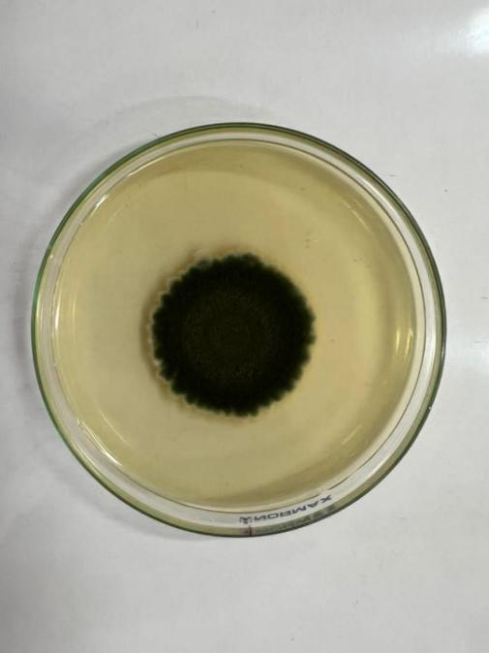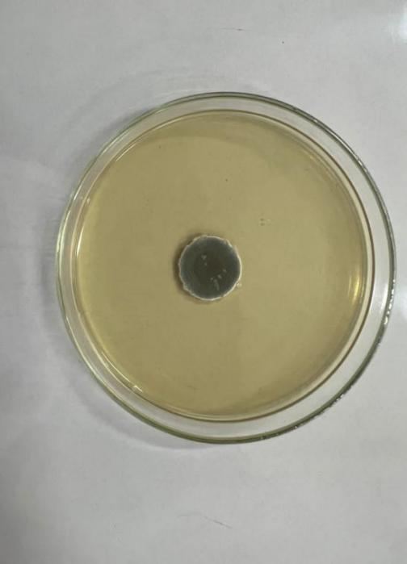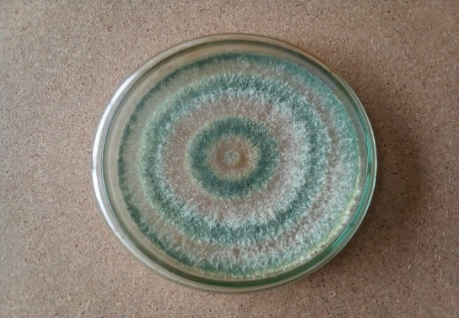
2
3
1
A

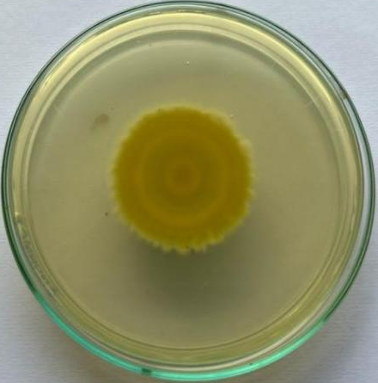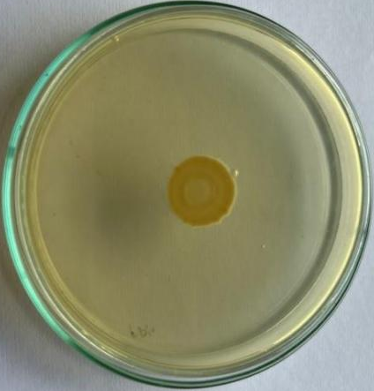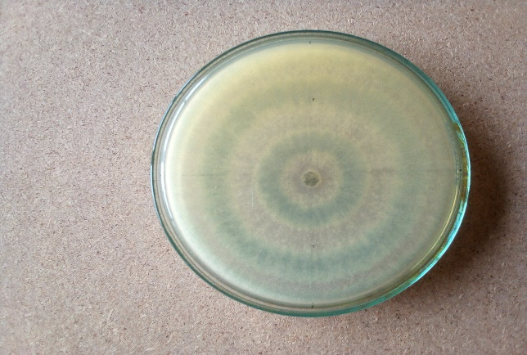
B
1
2
3

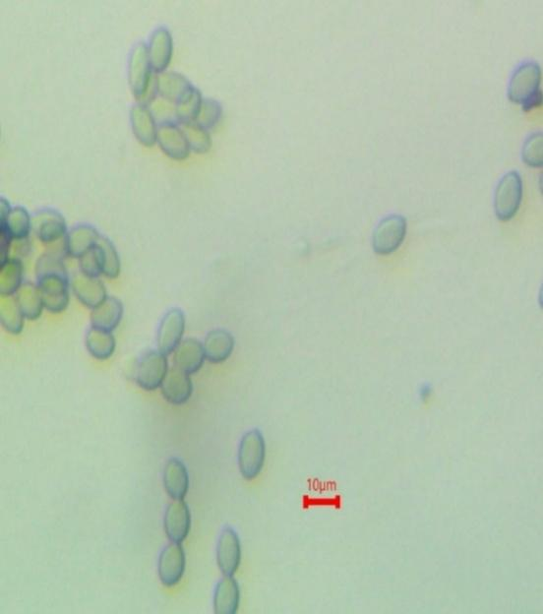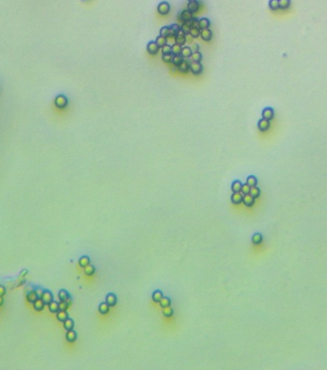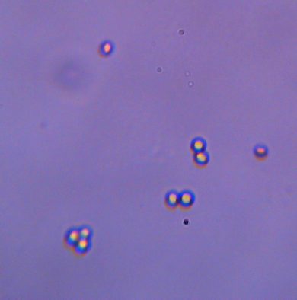
1
C
3
2

Plate 1 Colonies (7-day-old) of three antagonistic fungi. L-R: Putative Metarhizium sp.; Penicillium sp., and Trichoderma sp. Row A = Top of culture plates of potential antagonistic fungi. Row B= Underside of culture plates. Row C= Conidia of antagonistic fungi from a seven-day-old culture. Bars = 10 µm.

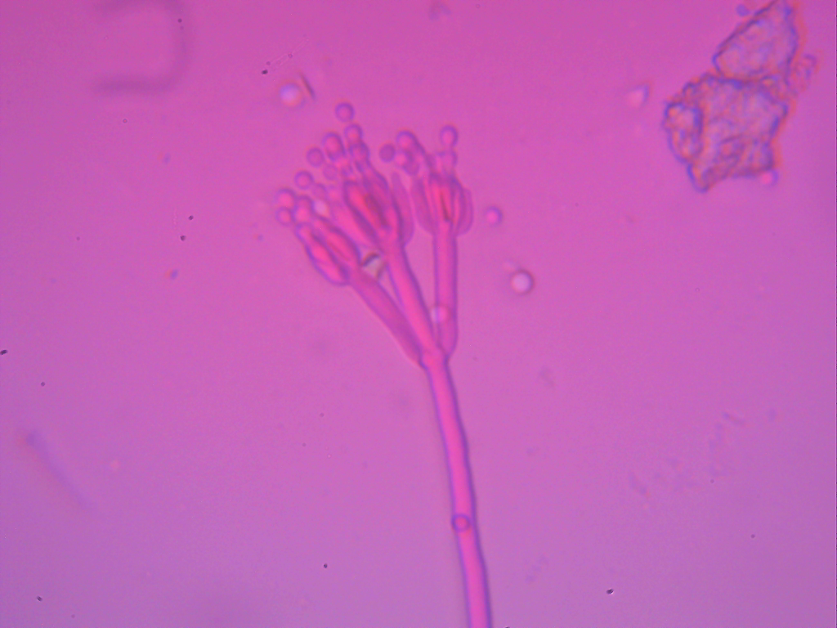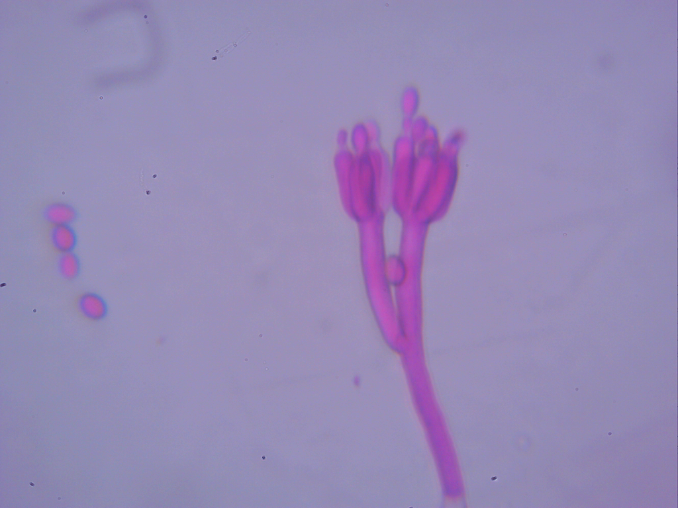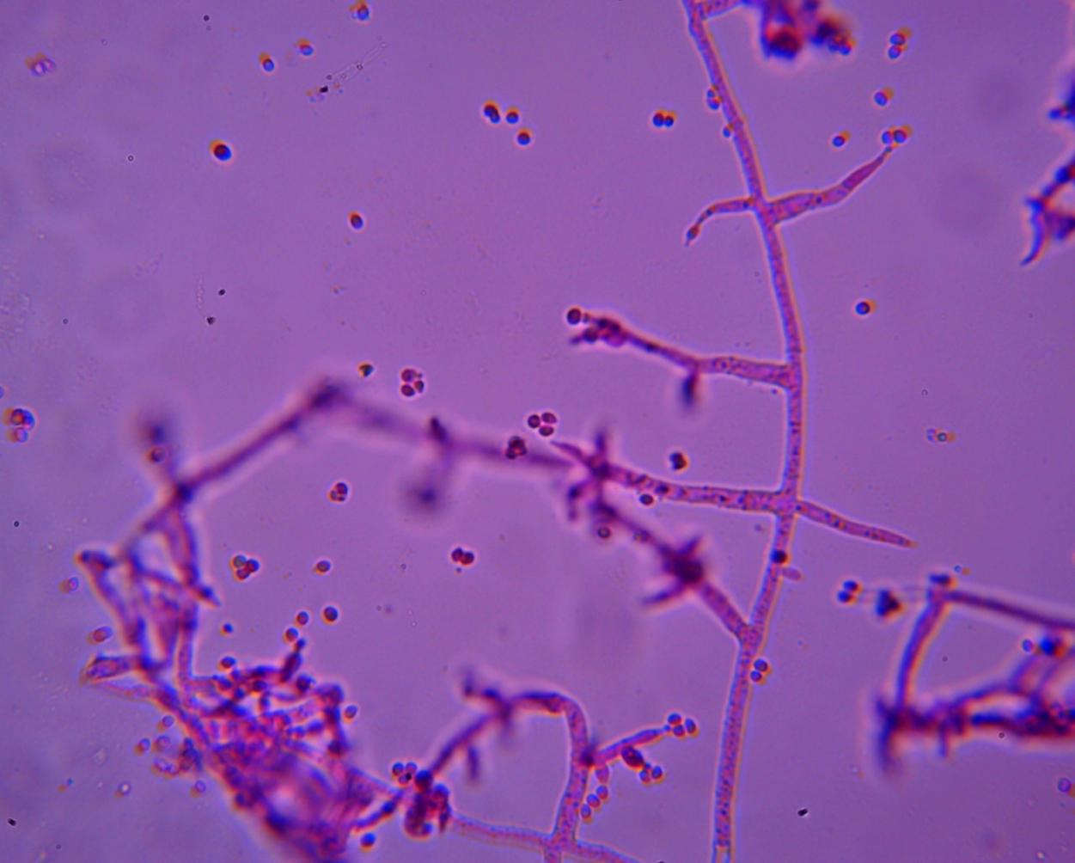
B
A
C
Conidiophore
Conidia
Conidiophore
Metulae
Phialide
Conidia
Conidiophore
Metulae
Phialide
Conidia
Phialide

Plate 2 Microscopic structures of antagonistic fungi. A: Penicillium sp. B: Putative Metarhizium sp. and C: Trichoderma sp.

Molecular characterisation of three potential antagonistic fungi

The universal primers ITS-1 and ITS-4 PCR products of Penicillium, Putative Metarhizium and Trichoderma spp. amplified at a size of 410, 500 and 400 base pairs, respectively (Plate 3). Sequences of the three potential antagonistic fungi when matched to known sequences in the GenBank showed that, the Trichoderma sp. was T. asperellum, the Penicillium sp. was P. citrinum and the putative Metarhizium sp. was Myxotrichum stipitatum.

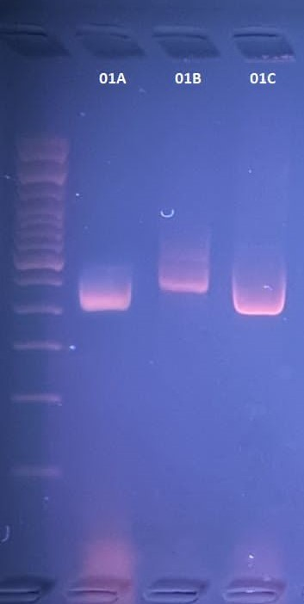

Plate 3. Gel electrophoresis of polymerase chain reaction amplification products for the three potential antagonistic fungi.
Lane 01A: Penicillium citrinum, Lane 01B: Myxotrichum stipitatum and Lane 01C: Trichoderma asperellum.

DISCUSSION
The morphological and cultural characteristics of the three potential antagonistic fungi revealed clear variations in growth rate, colony morphology, and microscopic features. Penicillium sp. showed slow growth with green-cyan colonies, velvety to powdery texture, and smooth, globose conidia of 2.7 × 2.5 µm. These measurements agree with Houbraken et al. (2010), who reported similar conidial dimensions for P. citrinum. Trichoderma sp. exhibited fast growth, attaining nearly 9 cm colony diameter in four days, with distinct concentric rings, cottony texture, and globose conidia measuring 3.2 × 2.8 µm. These observations corroborate Barnett and Hunter (1972), who described Trichoderma asperellum as producing cottony colonies with green concentric rings and rapid coverage of culture medium. The conidial dimensions were also in line with Pandian et al. (2016), who reported conidia lengths of 2.56–3.09 µm and widths of 2.15–2.62 µm. The putative Metarhizium isolate, although morphologically similar to Metarhizium species, was identified molecularly as Myxotrichum stipitatum. Its colony features slow growth, dark green obverse with serrated margins, and ellipsoidal conidia (4.8 × 3.4 µm) overlapped with some Metarhizium traits, which initially led to misidentification. This highlights the limitations of relying solely on morphological criteria for fungal identification, as environmental and culture conditions can significantly alter phenotypic traits (Hawksworth & Lücking, 2017). Therefore, integrating molecular techniques, such as ITS sequencing, provides more reliable identification. Lücking et al. (2020) emphasized that combining cultural, molecular, and ecological approaches is essential to achieve accurate fungal taxonomy. The ITS sequence analysis confirmed the identities as Trichoderma asperellum, Penicillium citrinum, and Myxotrichum stipitatum. Similar integrative approaches have been reported in other studies to accurately identify antagonistic fungi. For instance, Chaibub et al. (2020) employed both molecular and morphological tools to characterize rice phylloplane fungi and determine their antagonistic activities against rice pathogens. Likewise, Mazrou et al. (2020) used molecular markers to characterize Trichoderma harzianum isolates from Saudi Arabia and link their identity with antagonistic potential. Azuddin et al. (2021) also demonstrated the value of molecular phylogeny for identifying endophytic fungi from rattan spines and assessing their antagonistic activity against plant pathogens.
4. Conclusion
The integration of morphological and molecular approaches in the present study ensured reliable identification of the three antagonistic fungi. This methodology avoided the potential pitfalls of misidentification based solely on morphology, as occurred with the misclassified Metarhizium isolate. The consistency of conidial measurements and cultural features with published descriptions further validated the identifications of P. citrinum and T. asperellum, while molecular analysis clarified the identity of M. stipitatum marking its first isolation and identification in Ghana.

DISCLAIMER (ARTIFICIAL INTELLIGENCE)

Author(s) hereby declare that NO generative AI technologies such as Large Language Models (ChatGPT, COPILOT, etc.) and text-to-image generators have been used during the writing or editing of this manuscript.

Disclaimer (Artificial intelligence)
Option 1:
Author(s) hereby declare that NO generative AI technologies such as Large Language Models (ChatGPT, COPILOT, etc.) and text-to-image generators have been used during the writing or editing of this manuscript.
Option 2:
Author(s) hereby declare that generative AI technologies such as Large Language Models, etc. have been used during the writing or editing of manuscripts. This explanation will include the name, version, model, and source of the generative AI technology and as well as all input prompts provided to the generative AI technology
Details of the AI usage are given below:
1.
2.
3.

References

- Agbetiameh, D., Ortega-Beltran, A., Awuah, R. T., Atehnkeng, J., Cotty, P. J. & Bandyopadhyay, R. (2018). Prevalence of aflatoxin contamination in maize and groundnut in Ghana: population structure, distribution, and toxigenicity of the causal agents. Plant disease, 102(4): 764-772.
- Akrasi, K. O. & Awuah, R. T. (2009). Evaluation of some yam rhizobacteria for fungitoxic activity. In 9th African Crop Science, Conference Proceedings, Cape Town, South Africa, 28 September-2 October 2009 (pp. 617-620). African Crop Science Society.
- Akrofi, A. Y., Terlabie, J. L., Amoako-Attah, I. & Asare, E. K. (2017). Isolation and characterization of bacteria from different cacao progenies and their antagonistic activity against the black pod disease pathogen, Phytophthora palmivora. Journal of Plant Diseases and Protection, 124: 143-152.
- Azuddin, N. F., Mohd, M. H., Rosely, N. F. N., Mansor, A., & Zakaria, L. (2021). Molecular phylogeny of endophytic fungi from rattan (Calamus castaneus Griff.) spines and their antagonistic activities against plant pathogenic fungi. Journal of Fungi, 7(4), 301.
- Barnett, H. L., & Hunter, B. B. (1972). Illustrated genera of imperfect fungi.Chandrashekara, K. N., Manivannan, S., Chandrashekara, C. and Chakravarthi, M. (2012). Biological control of plant diseases. Eco-friendly innovative approaches in plant disease management, 147-166.
- Chaibub, A. A., de Sousa, T. P., de Araújo, L. G., & de Filippi, M. C. C. (2020). Molecular and morphological characterization of rice phylloplane fungi and determination of the antagonistic activity against rice pathogens. Microbiological Research, 231, 126353.
- Druzhinina, I. S., Kopchinskiy, A. G. & Kubicek, C. P. (2006). The first 100 Trichoderma species characterized by molecular data. Mycoscience, 47(2): 55-64.
- Gyempeh, N., Offei, S. K., Cornelius, E. W. & Honger, J. O. (2015). Importance of the onion leaf twister disease in Ghana and the effect of Trichoderma asperellium on the mycelial growth and sporulation of the causal agent. Ghana Journal of Science, 55, 51-65.
- Hawksworth, D. L., & Lücking, R. (2017). Fungal diversity revisited: 2.2 to 3.8 million species. Microbiology spectrum, 5(4), 10-1128.
- Hossain, M. M., Sultana, F., Kubota, M., Koyama, H. & Hyakumachi, M. (2007). The plant growth-promoting fungus Penicillium simplicissimum GP17-2 induces resistance in Arabidopsis thaliana by activation of multiple defense signals. Plant and cell physiology, 48(12): 1724-1736.
- Kabaluk, J. T. & Ericsson, J. D. (2007). Metarhizium anisopliae seed treatment increases yield of field corn when applied for wireworm control. Agronomy Journal, 99(5): 1377-1381.
- Larbi-Koranteng, S., Awuah, R. T. & Kankam, F. (2020). Biological control of black pod disease of cocoa (Theobroma cacao L.) with Bacillus amyloliquefaciens, Aspergillus sp. and Penicillium sp. in vitro and in the field. Journal of Microbiology and Antimicrobials, 12(2): 52-63.
- Lücking, R., Aime, M. C., Robbertse, B., Miller, A. N., Ariyawansa, H. A., Aoki, T., ... & Schoch, C. L. (2020). Unambiguous identification of fungi: where do we stand and how accurate and precise is fungal DNA barcoding?. IMA fungus, 11(1): 1-32.
- Mazrou, Y. S., Makhlouf, A. H., Elseehy, M. M., Awad, M. F., & Hassan, M. M. (2020). Antagonistic activity and molecular characterization of biological control agent Trichoderma harzianum from Saudi Arabia. Egyptian journal of biological pest control, 30(1), 4.
- Mohanram, S., & Kumar, P. (2019). Rhizosphere microbiome: revisiting the synergy of plant-microbe interactions. Annals of Microbiology, 69, 307-320.
- Nicoletti, R., Lopez-Gresa, M. P., Manzo, E., Carella, A., & Ciavatta, M. L. (2007). Production and fungitoxic activity of Sch 642305, a secondary metabolite of Penicillium canescens. Mycopathologia, 163(5): 295-301.
- Nicoletti, R., Lopez-Gresa, M. P., Manzo, E., Carella, A., & Ciavatta, M. L. (2007). Production and fungitoxic activity of Sch 642305, a secondary metabolite of Penicillium canescens. Mycopathologia, 163(5): 295-301.
- Odamtten, G. T. and Clerk, G. C. (1985). Proceedings 9th International Cocoa Res. Conf. Cocoa Producers’ Alliance, Lagos 293-301.
- Picardal, J. (2019). Antagonistic activity of Metarhizium anisopliae (Metschnikoff) Against Phytopathogenic Fusarium oxysporum f. sp. cubense (Schlecht.) as a biological control. CNU-Journal of Higher Education, 13, 25-33.
- Rashmi, M., Kushveer, J. S. & Sarma, V. V. (2019). A worldwide list of endophytic fungi with notes on ecology and diversity. Mycosphere, 10(1): 798-1079
- Ravindran, K., Chitra, S., Wilson, A., and Sivaramakrishnan, S. (2014). Evaluation of antifungal activity of Metarhizium anisopliae against plant phytopathogenic fungi. In Microbial diversity and biotechnology in food security (pp. 251-255). Springer, New Delhi.
- Raymaekers, K., Ponet, L., Holtappels, D., Berckmans, B. and Cammue, B. P. (2020). Screening for novel biocontrol agents applicable in plant disease management–a review. Biological Control, 144, 104240.
- Singh, A., Sarma, B. K., Singh, H. B. & Upadhyay, R. S. (2014). Trichoderma: a silent worker of plant rhizosphere. In Biotechnology and biology of Trichoderma (pp. 533-542). Elsevier.
- Thambugala, K. M., Daranagama, D. A., Phillips, A. J., Kannangara, S. D., & Promputtha, I. (2020). Fungi vs. fungi in biocontrol: An overview of fungal antagonists applied against fungal plant pathogens. Frontiers in cellular and infection microbiology, 10, 604923.
- Vinale, F., Sivasithamparam, K., Ghisalberti, E. L., Marra, R., Woo, S. L., & Lorito, M. (2008). Trichoderma–plant–pathogen interactions. Soil Biology and Biochemistry, 40(1): 1-10.
- Wilson, C. L., Wisniewski, M. E., Biles, C. L., McLaughlin, R., Chalutz, E., and Droby, S. (1991). Biological control of post-harvest diseases of fruits and vegetables: alternatives to synthetic fungicides. Crop protection, 10(3): 172-177.
- Yang, L., Xie, J., Jiang, D., Fu, Y., Li, G. & Lin, F. (2008). Antifungal substances produced by Penicillium oxalicum strain PY-1—potential antibiotics against plant pathogenic fungi. World Journal of Microbiology and Biotechnology, 24(7): 909-915.
- Zimmermann, G. (2007). Review on safety of the entomopathogenic fungus Metarhizium anisopliae. Biocontrol Science and technology, 17(9): 879-920.

