Evaluation and quantification of zooplankton diversity of Ottu reservoir in Haryana, India

Abstract
The study was carried from March 2021 to June 2021. The evaluation of the zooplanktonic population revealed that there were 17 genera of zooplankton belongs to class Copepoda (9 genera), Rotifera (2 genera), Cladocera (4 genera), and Protozoa (2 genera). The highest abundance of zooplankton was observed at Site 4 (77,520 no/L), while the lowest was at Site 1 (33,150 no/L). Among all groups, Cladocera was found to be dominant. The Shannon–Weaver diversity index ranged from a maximum of 3.10 at Site 1 to a minimum of 2.82 at Site 4. Significant variation was observed in zooplankton abundance across sites and months. The findings emphasize the role of zooplankton as bioindicators and provide baseline data for ecological assessment and management of the Ottu reservoir.
Keywords: Ottu reservoir, Evaluation, Zooplankton, Shannon ,Weaver diversity index
1. Introduction:
Water is a vital component of the natural environmental and is fundamental role in sustaining life on Earth (Shyam et al., 2020). With its abundant water resources, the state of Haryana, located in north-eastern India, holds significant potential for enhancing fish production (Bhatnagar and Singh, 2010). Freshwater reservoirs are particularly important because they are not only provide water for irrigation and domestic use but also support aquatic biodiversity. A reservoir is an artificial or man-made body of water formed by building a dam over a river or stream (Mehta et al., 2024). The Ottu reservoir is located in Ottu village near Rania, in the south-central region of Sirsa district, Haryana (Sunder and Khatri, 2018). The Ottu head, positioned close to Ottu village in Sirsa, functions as a feeder structure for the Northern and Southern Ghaggar canals, which supply irrigation water to parts of northern Rajasthan (Sunder and Khatri, 2018; Mehta et al., 2024). The Ottu reservoir in Haryana was selected for this study because it serves as a key source of irrigation, sustains local fisheries, and represents an important aquatic ecosystem that has not been well documented for zooplankton diversity.
The term “plankton” is derived from the Greek word planktos, meaning “drifter”, reflecting their passive movement dependent on water currents. Plankton are broadly categorized into two primary groups: phytoplankton and zooplankton. These microscopic organisms play a crucial role in aquatic ecocsystem by serving as the primary source of nourishment for many aquatic species, Occupying the base of the aquatic food pyramid, plankton-both phytoplankton and zooplankton are essential links in the aquatic food web. Phytoplanktons in particular, are key contributors to the production of organic matter through photosynthesis, thereby supporting the productivity and energy dynamics of aquatic ecosystem (Yadav 2015; Mehta et al., 2024).
Zooplanktons are tiny microscopic organism that plays a vital role in aquatic ecosystem. They are highly sensitive to environmental disturbances, making them useful indicator of ecological changes such as global warming and rising atmospheric carbon dioxide levels (Dai et al., 2016). Zooplanktons are commonly used to assess water quality, trophic conditions, and pollution levels. The zooplankton additionally plays a crucial role in indicating the presence or absence of certain species of fish and in determining the population densities (Krishnakumar et al., 2023; Mohan & Prabha, 2024). Acing as crucial link in the aquatic food web, zooplankton contribute significantly to secondary production by transferring energy from lower to higher trophic levels. As a major group of aquatic animals, they form an essential part of the diet for many fish and other aquatic organism (Ansari and Khan, 2014). The main categories of zooplankton include Rotifers, Cladocereans, Copepods, and Ostracods (Kanagasabapathi and Rajan, 2010). The present study is designed to evaluate and quantify the zooplankton diversity of Ottu Reservoir in Haryana, India. By analyzing species composition, abundance, and diversity indices, the research aims to understand the ecological status of the reservoir. The findings will provide baseline information for biodiversity conservation and sustainable management of the water body.
2. Material and method
  - Study Area
The Ottu Resevoir is located approximately 14 kilometers from the Sirsa district in Haryana. It lies at coordinates 29°29'21" N latitude and 74°53'38" E longitude (Sunder and Khatri, 2018).It has an average depth of 2.2 meters and covers a surface area of around 67,400 square meters. It is a man- made water body constructed for irrigation purposes. It supports fisheries and provides water to surrounding agricultural lands. Its ecological significance makes it an ideal site for evaluating zooplankton diversity.
2.2 Sampling stations
For the current study, four designated sampling sites were established at different directional points- East, West, North and South around the Ottu Reservoir. These were label as sampling Site 1, Site 2, Site 3, and Site 4 for the collection of zooplankton. Description of the sites given below.
Site 1: Located close to the outlet where water is discharged in to canals. This site is influenced by continuous water movement and turbulence.
Site 2: Situated near the inflow area of the reservoir. It receives surface runoff and nutrient input from the catchment, which can promote plankton growth.
Site 3: Positioned near the embankment and human activity zone. This site is moderately disturbed and reflects mixed ecological conditions.
Site 4: Located in a relatively undisturbed and deeper portion of the reservoir. The reduced water flow and higher organic matter deposition make it nutrient-rich.

Fig 1: Map of Ottu reservoir with different sampling sites
2.3 Collection of sample and analysis
Zooplankton samples were collected by filtering 50L of water through a 50 µm mesh plankton net with a demarcating collecting tube. These samples were collected in 100ml plastic bottles and then concentrated to a standard volume of 50ml with distilled water. 4% buffered formalin were used to preserve the sample and brought to laboratory for qualitative and quantitative analysis. The collected sample was observed under a high-quality compound microscope (Magnus MX21iLED) at 4X, 10X, 40X, and 100X for the identification of zooplankton. The identification of zooplankton were done up to the genus level by using the methods from (Ward and Whipple, 1959; Needham and Needham, 1962; APHA, 1998; Bhatnagar and Singh 2010). For quantitative analysis, zooplankton, sample were placed in a Sedgwick rafter cells (1 ml capacity). After allowing organism to settle, 10 randomly selected microscopic fields were counted. The number of organism per liter (L-1) was then calculated using the as following formula:
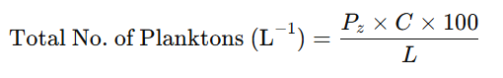
Where,
Pz = Number of zooplanktons counted in ten fields
C = Volume of final concentrate of sample (ml)
L = Volume of water sample filtered
2.4 Species Diversity Index (d)
Shannon and Weaver (1963) diversity index was used to determine the species diversity of zooplankton.
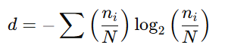
Where
d = Species diversity
n_{i} = Number of individuals of i^{th} species.
N = Total number of individuals in the sample
2.5 Statistical analysis:
The data obtained in the present investigation were subjected to analysis to a 2-factor analysis completely randomized design (CRD). The critical difference value at P =.05 level was used for making a comparison among different zooplankton Groups and Months. All the values are the mean of 3 replications.
3. Result and Discussions
The qualitative analysis of these 4 different samples exposed that among the zooplankton total 17 genera belonging to class Copepoda, Cladocera, Rotifera, and Protozoa. Copepoda included 9 genera and represented by Cyclops, Mesocyclops, Naupilus larvae, Diaptomus, Eucyclops, Macrocyclops, Diacyclops, Harpacticus and Phyllodiaptomus. Cladocera included 4 genera and represented by Daphnia, Moina, Ceriodaphnia and Diaphnosoma. Rotifers were involved 2 genera namely Branchinous and Asplancha and Protozoa represented by 2 genera Paramisium and Arcella. Representative zooplankton species were recorded from Ottu reservoir shown in (Fig 3). In all sampling sites, the Cladocera group was found to be the most dominant while the least dominant group recorded was Protozoa. The percentage distribution of sampling sites is given in Fig 2. The monthly distribution of different zooplankton species and group at sampling sites was shown in Table 1.
3.1 Quantitative analysis
Quantitative analysis for total zooplankton was different at sampling sites. The total zooplankton count estimated in the Ottu reservoir was 1,77,160 no/L. The maximum zooplankton count was recorded in sampling site 4, and the minimum at site 1. (Fig. 4 a) shows the quantity of zooplankton in different sampling sites. The species and site wise distribution is provided in table no 2.
3.2 Species diversity index
The maximum value of the Shannon and Weaver diversity index was recorded in June (3.10) and the minimum in April (2.35). Site 1 showed the highest diversity among different sampling sites, and minimum diversity also recorded in Site 1. The Species diversity index of zooplankton in different sampling sites and months is shown in fig. 4.
3.3 Zooplankton
The total zooplankton genera found during the study on Ottu reservoir was 17 and belonged to 4 major groups Copepoda (9 genera), Cladocera (4 genera), Rotifera (2 genera), and Protozoa (2 genera). Similar group observed by (Singh et al., 2024; Verma et al., 2024: Nogueira, 2001). Shyam et al. (2020) and Kamble et al. (2013) also observed similar groups from three different sites S1, S2, and S3, and also observed by Sitre (2012) with Ostracoda group. During the present investigation, the zooplankton group dominant in Ottu reservoir was Cladocera (56.13%), Copepoda (32.50%), Rotifera (8.80%), and Protozoa (2.47%). Dutta and Patra (2013) also found Cladocera (45.2%) as a dominant group during the studied period. Ansari and Khan (2014) found zooplankton abundance respectively Cladocera, Rotifera, Copepoda, and Ostracoda. Manjare, (2015) identified zooplanktons from four major groups as Rotifera, Cladocera, Copepoda, and Ostracoda (Paliwal and Bhandarkar, 2017; Dede and Deshmukh, 2015) reported to contradict the results.
3.4 Quantity of zooplankton
In the present study, zooplankton abundance was highest in April and lowest in March. Site 4 consistently showed higher zooplankton abundance compared to the others sites. This was attributed to its relatively nutrient rich condition due to greater organic matter deposition from the surrounding catchment, reduced water flow, and lower distribution, all of which favour phytoplankton growth and thereby support higher zooplankton density. Our findings agree with earlier reports where zooplankton population peaked in the summer season (Dhanasekaran et al., 2017; Dede and Deshmukh, 2015;Goswami and Mankodi, 2012). Seasonal increases are generally explained by higher decomposition rate of decomposition due to which water becomes nutrient-rich and availability of food (phytoplankton) is also obtainable in sthe environment as agreed by (Mohan et al., 2023; Site, 2012).
3.5 Shannon and Weaver diversity index for Zooplankton
During the present investigation, the value of Shannon and Weaver diversity index for zooplankton of different sampling sites showed the difference in their value. The descending order of species diversity index value (H) was respectively site 1 (3.10) > site 2 (2.88) > site 3 (2.86) > site 4 (2.82) and a bit similar species diversity index value recorded by (Dutta and Patra, 2013) during December, January, and February being 2.96, 2.99, and 2.92 respectively. (Sharma and Kumari, 2018) also found Shannon- wiener diversity index of zooplankton ranged from 2.80-3.16 at s1, 2.84-3.17 at s2, and 2.87-3.05 at s3 of the Prashar lake during the study period.
Fig: 2 Percentage variation of different zooplankton group at A. site 1 B. site 2 C. site D. site 4

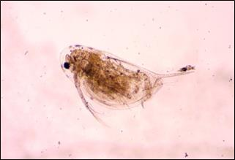 | 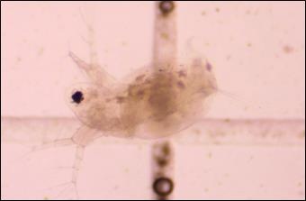 | 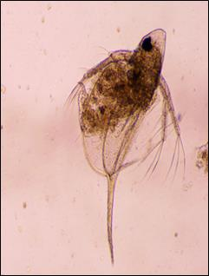
(1). Daphnia Catawba | (2). Daphnia manga | (3). Daphnia mendotae
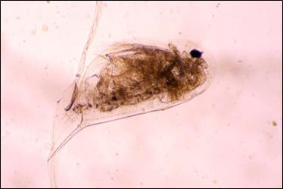 | 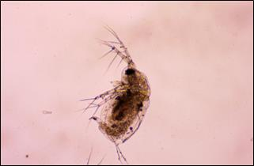 | 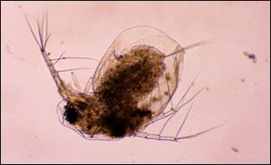
(4). Daphnia longispina | (5). Moina macrocopa | (6). Moina micrura
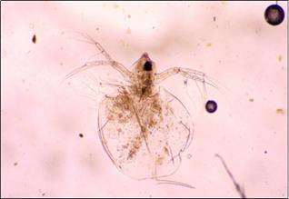 | 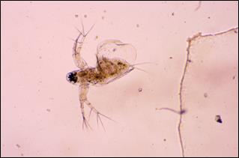 | 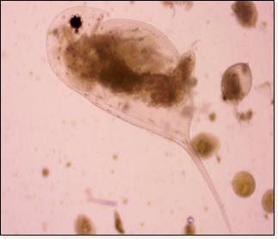
(7). Ceriodaphnia cornuta | (8). Diaphanosoma branchhyrum | (9). Daphnia similis
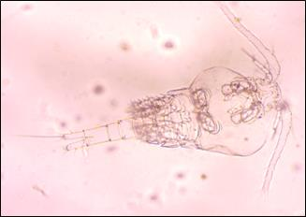 | 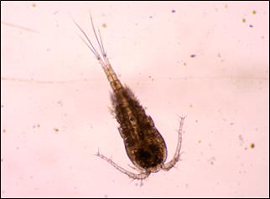 | 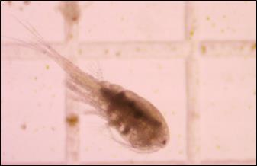
(10). Cyclops stretnum | (11).Cyclops scutifer | (12). Eucyclops sp
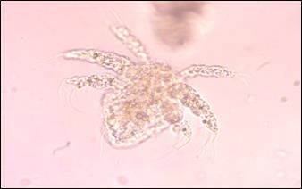 | 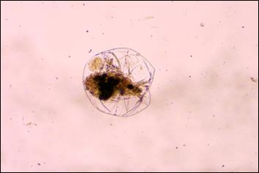 | 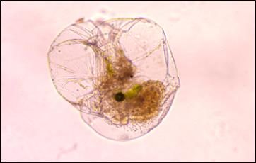
(13).Naupilus larva | (14). Asplanchus herriki | (15). Asplanchus pariodonta
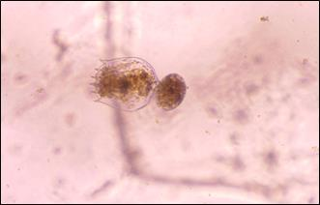 | 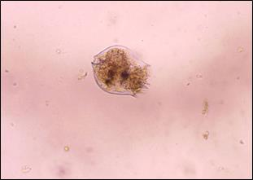 | 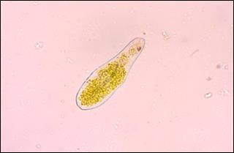
(16). Branchinous roundiformis | (17). Branchinous calciflorus | (18). Paramecium sp
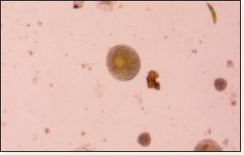
(19). Arcella sp.

Fig 3: Different zooplankton species found in Ottu reservoir

Fig. 4. a. Quantity of zooplankton in different sampling sites b. Species diversity index of zooplankton in different sampling sites and months
3.6 Statistical analysis for zooplankton groups
Statistical analysis for zooplankton groups showed that in all the sampling a significant difference (P=.05) was observed for the zooplankton groups present every month from March to June (Table.1).

Table 1: Statistical analysis for Zooplankton groups in different sites
Statistical Analysis | Site 1 |  | Site 2 |  |  | Site 3 |  | Site 4
CD at 5% | zooplankton group | Total Months |  | zooplankton groups | Total Months | zooplankton groups | Total Months | zooplankton groups | Total Months
 | 1.38 | 1.38 |  | 1.31 | 1.31 | 1.22 | 1.22 | 5.00 | 5.00
 | P*M=2.77 |  |  | P*M= 2.63 |  | P*M= 2.44 |  | P*M= 10
Here Z= Zooplankton groups and M= Month, TWO WAY ANOVA (Mean of three replication)
Conclusion
This study highlights zooplankton's function as bioindicators of ecological health by documenting their diversity and distribution in the Ottu reservoir. The results offer crucial baseline information for assessing trophic status and identifying alterations in water quality. The impact of seasonal changes, nutritional dynamics, and environmental factors is reflected in variations in community composition, highlighting the zooplankton's susceptibility to ecological disruptions. For the purpose of directing sustainable management and detecting pollution or eutrophication early, these communities must be regularly monitored. All things considered, the study advances knowledge of freshwater biodiversity and backs conservation measures for the integrity of aquatic ecosystems.
Conflict of interest
Authors have declared that no competing interests exist.

Disclaimer (Artificial intelligence)
Option 1:
Author(s) hereby declare that NO generative AI technologies such as Large Language Models (ChatGPT, COPILOT, etc.) and text-to-image generators have been used during the writing or editing of this manuscript.
Option 2:
Author(s) hereby declare that generative AI technologies such as Large Language Models, etc. have been used during the writing or editing of manuscripts. This explanation will include the name, version, model, and source of the generative AI technology and as well as all input prompts provided to the generative AI technology
Details of the AI usage are given below:
1. Author(s) hereby declare that NO generative AI technologies such as Large Language Models (ChatGPT, COPILOT, etc.) and text-to-image generators have been used during the writing or editing of this manuscript.
2.
3.

References
Ansari, S. and Khan, A. A. (2014). Diversity and distribution of zooplankton in a freshwater body of Aligarh region. Indian Journal of Scientific Research and Technology, 2(1): 73-82.
APHA, AWWA, WPCF. (1998). Standard methods for the examination of water and waste water. 20th edition. New York: American Public Health Association.
Bhatnagar, A. and Singh, G. (2010). Culture fisheries in village ponds: a multi-location study in Haryana, India. Agriculture and Biology Journal of North America, 1(5): 961-968.
Dai, J., Wang, R., Zheng, H., Ji, G. and Qiao, X. (2016). ZooplanktoNet: Deep convolutional network for zooplankton classification. Oceans, 1-6.
Dede, A. N. and Deshmukh, A. L. (2015). Study on zooplankton composition and seasonal variation in Bhima River near Ramwadi Village, Solapur District (Maharashtra), India. International Journal of Current Microbiology and Applied Sciences, 4(3): 297-306.
Dhanasekaran, M., Bhavan, P. S., Manickam, N. and Kalpana, R. (2017). Physico-chemical characteristics and zooplankton diversity in a perennial lake at Dharmapuri (Tamil Nadu, India). Journal of Entomology and Zoology Studies, 5(1): 285-292.
Dutta, T. K. and Patra, B. C. (2013). Biodiversity and seasonal abundance of Zooplankton and its relation to physico – chemical parameters of Jamunabundh, Bishnupur, India. International Journal of Scientific and Research Publications, 3(8): 1-7.
Goswami, A. P. and Mankodi, P. C. (2012). Study on Zooplankton of Fresh Water Reservoir Nyari–II Rajkot district, Gujarat, India. ISCA Journal of Biological Sciences, 1(1): 30-34.
Kamble, S. P., Patil, S. R. and Babare, M. R. (2013). Seasonal diversity of protozoans, rotiferans, cladocerans, and copepodans, from Krishna River Ghat near Miraj, Dist. Sangli, MS, India. Galaxy: International Multidisciplinary Research Journal, 1-7.
Kanagasabapathi, V. and Rajan, M. K. (2010). A preliminary survey of Plankton in Irrukkangudi Reservoir, Virudhunagar District, TN, India. Journal of Phytology, 2(3): 63-72.
Krishnakumar B. Vaghela, Devangee P. Shukla and Nayan K. Jain. (2023). A Study of Phytoplankton and Zooplankton Diversity in the River Sabarmati, Gujarat, India. Asian Journal of Environment & Ecology, 22(4), 28–38.
Manickam N, Saravana Bhavan P, Santhanam P, Muralisankar T, Srinivasan V, et al. (2014). Seasonal Variations of Zooplankton Diversity in a Perennial Reservoir at Thoppaiyar, Dharmapuri District, South India. Austin Journal of Aquaculture and Marine Biology, 1(1): 1-7.
Manickam, N., Bhavan, P. S. and Santhanam, P. (2017). Seasonal variations in species composition and community structure of zooplankton in a two perennial lakes of Coimbatore, Tamil Nadu, Southern India. Journal of Aquatic Research and Marine Sciences, 1-12.
Manjare, S. A. (2015). Qualitative and Quantitative study of zooplankton from freshwater tanks of Kolhapur district,(Maharashtra). Research Journal of Life Sciences, Bio informatics, Pharmaceutical and Chemical Sciences, 1(1): 54-61
Mehta, P., Singh, G., Ravikant, A. S., Ansari, M. N., Shahi, S., Yadav, S. R., & Kumar, S. (2024). Evaluation and quantification of phytoplankton diversity of Ottu reservoir in Haryana, India. International Journal of Advanced Biochemistry Research, 8(2): 289-295
Mohan, B., and Prabha, D. (2024). Evaluation of trophic state conditions in the three urban perennial lakes of the Coimbatore district, Tamil Nadu: Based on water quality parameters and rotifer composition. HydroResearch, 7, 360-371.
Mohan, B., Priyadarshinee, S., Kalpana, R., Bhavan, P. S., Manickam, N., Santhanam, P. and Prabha, D. (2023). Impact of seasonal changes in freshwater phytoplankton and zooplankton biodiversity at Valankulam lake, Coimbatore district, Tamil Nadu, India. Journal of Applied Life Sciences and Environment, 3 (191), 271-292
Needham, J. G. and Needham, P. R. (1962). A guide to the study of freshwater biology. 5th ed. Liolden-day. Inc.
Nogueira, M. G. (2001). Zooplankton composition, dominance and abundance as indicators of environmental compartmentalization in Jurumirim Reservoir (Paranapanema River), Sao Paulo, Brazil. Hydrobiologia, 455(1): 1-18.
Paliwal, G. T. and Bhandarker, S. V. (2017). Zooplankton Composition in Navegaonbandh Reservoir of Navegaon National Park Dist Gondia MS India. International Journal of Researches In Biosciences, Agriculture and Technology, 5(2): 182-188.
Shannon, E. E. and Weaver, W. (1963). The mathematical theory of communication. University of Illinois. Press Urhana, pp. 1-117.
Sharma, R. C. and Kumari, R. (2018). Seasonal variation in zooplankton community and environmental variables of sacred Lake Prashar Himachal Pradesh, India. International Journal of Fisheries and Aquatic Studies, 6(2): 207-213.
Shyam, R., Kumar, P. and Badola, S. (2020). Seasonal variation in the planktonic diversity of Tumaria reservoir of Kashipur Uttarakhand India. Environment Conservation Journal, 21(3): 119-125.
Singh, A., Verma, S., Mehta, P., Jatav, S. K. and Yadav, S. (2024). Study of hydrobiological parameters and their effect on plankton diversity in yamuna river at okhla barrage. Journal of Experimental Zoology India, 27(1).
Sitre, S. R. (2012). Studies on the Seasonal Variation of Freshwater Zooplankton in a perennial urban lake of Nagpur City (MS) India. Lokavishkar International E-Journal, 1(3): 10.
Sunder, S. and Khatri, A. K. (2018). Seasonal variations of benthic fauna of Ottu reservoir, Sirsa (Haryana), India. International Journal of Creative Research Thoughts, 6(1): 1464-1468.
Verma, S., Singh, G., Singh, A., Ravikant, Mehta, P., Maurya, M. and Pandey, S. (2024). Assessment of plankton diversity of Blue Bird Lake at Hisar, Haryana, India. International Journal of Advanced Biochemistry Research, SP-8(1), 77–86. https://doi.org/10.33545/26174693.2024.v8.i1Sb.288
Ward HB, Whipple GC.(1959). Assessment of environmental changes in the Iraqi Marshes by index of biological integrity. Freshwater biology, 3(7):1248.
Yadav. P. (2015). Studies on biodiversity of zooplankton in Kass lake during rainy and winter seasons. International Journal of Researches in Biosciences, Agriculture and Technology, 3(2): 399-402.
Table 2: Monthly distribution of different zooplankton species and groups at sampling sites

Group | Species | Site 1 |  |  |  | Site 2 |  |  |  | Site 3 |  |  |  | Site 4
Group | Species | M | A | May | J | M | A | May | J | M | A | May | J | M | A | May | J
Protozoa | Paramecium sp. | _ | + | + | _ | _ | + | + | _ | _ | + | _ | _ | + | + | _ | _
Protozoa | Arcella sp. | _ | _ | _ | + | _ | _ | _ | + | _ | _ | _ | + | _ | _ | _ | +
Copepoda | Cyclops stretnum | + | + | + | + | + | + | + | + | + | + | + | + | + | + | + | _
Copepoda | Eucyclops sp. | _ | _ | + | + | _ | _ | + | + | _ | _ | + | + | _ | _ | + | +
Copepoda | Macrocyclops albidis | _ | _ | + | + | _ | _ | + | + | _ | _ | _ | _ | _ | _ | _ | +
Copepoda | Phyllodiaptomus sp. | _ | _ | + | _ | _ | _ | + | _ | - | - | - | - | - | _ | _ | +
Copepoda | Mesocyclops sp. | _ | _ | + | + | _ | + | + | + | + | + | + | + | _ | + | _ | _
Copepoda | Hapacticoid copepods | _ | _ | _ | + | _ | _ | _ | _ | _ | _ | + | + | + | _ | + | +
Copepoda | Diaptomus sp. | _ | _ | _ | + | _ | _ | _ | + | _ | _ | _ | + | _ | _ | + | +
Copepoda | Naupilus larvae | + | + | _ | _ | + | + | _ | _ | + | + | _ | _ | + | + | _ | _
Copepoda | Diacyclops themsi | _ | + | _ | _ | _ | + | _ | _ | + | + | _ | _ | + | + | _ | _
Copepoda | Cyclops sutifer | + | _ | _ | _ | + | _ | _ | _ | + | _ | _ | _ | _ | _ | _ | _
Cladocera | Daphnia Pulex | _ | _ | _ | + | _ | _ | + | + | _ | _ | + | + | _ | _ | + | +
Cladocera | Daphnia pulicaria | + | _ | _ | + | + | _ | + | + | _ | _ | + | + | _ | _ | + | +
Cladocera | Daphnia catwaba | + | + | + | + | + | + | + | + | + | + | + | + | + | + | + | +
Cladocera | Daphnia carinata | _ | _ | _ | + | + | + | _ | _ | _ | _ | _ | _ | _ | _ | _ | _
Cladocera | Daphnia longispina | _ | _ | _ | _ | + | _ | _ | _ | _ | _ | _ | _ | + | _ | _ | _
Cladocera | Daphnia manga | _ | + | + | + | + | _ | + | + | + | + | + | + | + | + | + | +
Cladocera | Daphnia laevis | _ | + | + | _ | _ | + | _ | _ | _ | + | _ | + | _ | + | + | _
Cladocera | Daphnia similis | _ | + | _ | + | _ | _ | + | + | _ | _ | _ | _ | _ | _ | + | _
Cladocera | Moina micrura | + | + | + | + | + | + | + | + | + | + | + | + | + | + | + | +
Cladocera | Moina macrocopa | + | + | + | + | + | + | + | + | + | + | + | + | + | + | + | +
Cladocera | Daphnia mendotae | _ | + | + | + | _ | + | + | + | _ | + | + | + | _ | + | + | _
Cladocera | Diaphnosoma sarsi | _ | _ | + | + | _ | _ | + | + | _ | _ | + | + | _ | _ | + | +
Cladocera | Diaphnosoma branchyrus | _ | + | + | + | + | + | + | + | _ | + | + | + | + | + | + | _
Cladocera | Ceriodaphnia corunta | _ | + | + | + | _ | + | + | + | _ | + | _ | _ | _ | + | + | +
Rotifera | Branchinous calciflorus | _ | + | _ | _ | + | + | _ | _ | _ | + | _ | _ | + | + | _ | _
Rotifera | Branchinous urceoleris | _ | + | _ | _ | _ | + | _ | _ | _ | + | _ | _ | _ | + | _ | _
Rotifera | Branchinous roundiformis | + | _ | + | + | _ | _ | _ | + | _ | _ | + | + | + | _ | + | +
Rotifera | Branchinous pictilis | _ | _ | + | + | _ | _ | _ | _ | _ | _ | _ | _ | _ | _ | _ | _
Rotifera | Branchinous variabilis | _ | _ | _ | _ | + | _ | _ | _ | _ | _ | _ | _ | _ | _ | _ | _
Rotifera | Asplencha herrikki | + | _ | _ | _ | + | _ | + | _ | + | _ | _ | _ | + | _ | _ | _
Rotifera | Asplencha pariodonta | _ | _ | _ | _ | + | _ | _ | _ | + | _ | _ | _ | _ | _ | - | -
Mar- March, A- April, M- May, J- June

