Original Research Article
DNA barcode development of two catfishes Heteropneustes fossilis and Mystus bleekeri from Upper Lake Bhopal, Madhya Pradesh,India

Abstract

Aims: To develop cox1 based DNA barcodes for Heteropneustes fossilis and Mystus bleekeri, from Upper Lake, Bhopal, to support accurate species identification and molecular taxonomy.
Study design: The study involved the collection and morphological identification of samples followed by DNA isolation, PCR amplification, Sanger sequencing, and barcode generation.
Place and Duration of Study: Laboratory of molecular Biology and Genomics, Department of Bioscience, Barkatullah University, Bhopal (M.P.), India, between March 2024 to July 2025.
Methodology: The genomic DNA was extracted using Phenol:Chloroform:Isoamyl (25:24:1) method. The quality of extracted DNA was determined on a 1% agarose gel. The cox1 gene fragments were amplified using universal primer (FishF1 and FishR1). Sequenced through Sanger sequencing and analysed using BLAST, MEGA11, and BOLD systems for species identification, phylogenetic assessment and barcode development.
Result: In this study, two samples were analysed to generate DNA barcodes. A 615 bases long fragment of the cox1 gene was sequenced, resulting sequences (658 bp for H. fossilis and 609 bp for M. bleekeri) were submitted to GenBank (accession number PP754237 and PX116877). Sequence composition analysis revealed a moderate AT-bias (A+T = 56.35%) with the highest GC content at the first codon position. BLAST analysis confirmed 99-100% similarity with reference sequences, validating species level identification. Phylogenetic analyses using Neighbor-Joining (NJ) trees highlighted contrasting patterns: H. fossilis sequences clustered into a single cohesive clade with low divergence across South Asia, while M. bleekeri grouped within a diverse genus level dataset showing clear interspecific separation but some overlap with congeners.
Conclusion: These findings confirm the reliability of cox1 as a DNA barcode for both species. Overall, this study contributes validates barcodes for two freshwater catfishes of Upper Lake and emphasizes the value of DNA barcoding in fish taxonomy, biodiversity.

Keywords: Upper Lake; cox1 gene; DNA barcoding; Bold system; molecular taxonomy; biodiversity conservation.

- Introduction

Catfishes (Order Siluriformes) constitute a highly diverse group of freshwater fishes, comprising over 3,000 species distributed across 478 genera and 36 families (Ferraris and DePinna, 1999). Fishes, owing to their vast diversity and distribution, are not only a rich source of nutrition but also play a vital role in ecological balance. India harbors about 2,500 fish species, including 930 freshwater and 1,570 marine forms, making it one of the word’s megadiverse countries and ranking ninth globally in freshwater fish diversity (Kar et al., 2003).

Modern taxonomy integrates multiple disciplines, including internal anatomy, physiology, behavior, genetic markers, isozymes, geographic distribution, and morphological characteristics, which collectively remain essential to taxonomic frameworks (Ward et al., 2009). Upper Lake is a major body located on the western side of Bhopal, the capital of Madhya Pradesh, India. Positioned in the west-central region of the city, it is bordered by Van Vihar National Park to the south, residential areas to the south, residential areas to the east and north, and agricultural land to the west. The lake covers an area of 31 km² and is supported by a catchment area of 361 km².

DNA barcoding was introduced as a fast, reliable, automated, and globally applicable approach for species identification and delimitation (Hebert et al., 2003). By employing a standardized and validated DNA based approach, DNA barcoding enhances the accuracy of species level identification on a global scale (Bhattacharya et al., 2016). It can be applied both for distinguishing species boundaries and in tagging certain species (Quilang and Yu, 2015). Standardized DNA barcodes based on the mitochondrial COX1 gene, providing validated entries in GenBank and BOLD to support accurate species identification and ecological monitoring Raghuwanshi et al., (2024). Mitochondrial genome genes are free of introns, pseudogenes, and repetitive elements, which simplifies the alignment of amplified sequences (Lin et al., 2005).

Advances in genetic and DNA based tools are increasingly enabling more precise assessments of biodiversity, both within and among species, and are proving valuable in resolving cryptic species complexes. Such information is also crucial for delineating conservation units within species (Bickford et al., 2007; Valentini et al., 2009). It provides significant value to fisheries managers by offering tools that allow for precise specimen identification and effective assessment of stock structure (Ward, 2000). This approach has led to the discovery of numerous new species (Mohapatra et al., 2023). DNA barcoding has wide-ranging applications across various sectors, including species identification, conservation, pest management, and product authentication (Uikey et al., 2024). Using DNA barcoding for fish species identification offers novel insights into ecological studies and advances the systematics of fish taxonomy (Sachithanandam and Mohan, 2020). Molecular markers-including allozymes, mtDNA, microsatellites, RAPD, and SNPs have been widely utilized for assessing genetic diversity, managing stock, and conservation strategies (Mahoviya et al., 2025). Environment DNA (eDNA) metabarcoding is a non-invasive approach that enables the detection and identification of rare and endangered species across diverse ecosystems, particularly aquatic habitats, by analysing genetic material shed into the environment by organisms (Sahu et al., 2023).

Community driven initiatives to build comprehensive DNA barcode libraries particularly the Barcode of Life Data Systems (BOLD) has led to the adaptation DNA barcoding as the gold standard for species identification and significantly enhanced its effectiveness (Wong et al., 2011). The BOLD database offers comprehensive information on COI sequenced species, including details on the origin and present location of voucher specimens (Ratnasingham and Hebert, 2007). Other algorithms also rely heavily on parameter settings, such as gap width, for accurate performance. While the BIN system offers a useful preliminary estimate of the number of distinct units, it still requires confirmation through additional lines of evidence (Sale et al., 2017).

- Material and Methods

2.1 Study Site and Sample collection
The Upper Lake of Bhopal, considered one of the oldest man-made lakes in India, was created in the 11th century by Raja Bhoj through the construction of an earthen dam across the Kolans River. The watershed of the Upper Lake is predominantly rural, with limited urban development near its eastern margin. Originally a tributary of the Halali River, the Kolans River was redirected following the construction of an earthen dam and diversion channel, causing its upper reach along with the Bada Talaab to discharge into the Kaliasote River. The Upper Lake (Fig. 1) is designated as Ramsar site in 2002. Therefore, this study was conducted in Upper Lake, District Bhopal, Madhya Pradesh (23.2531º N, 77.3382º E).

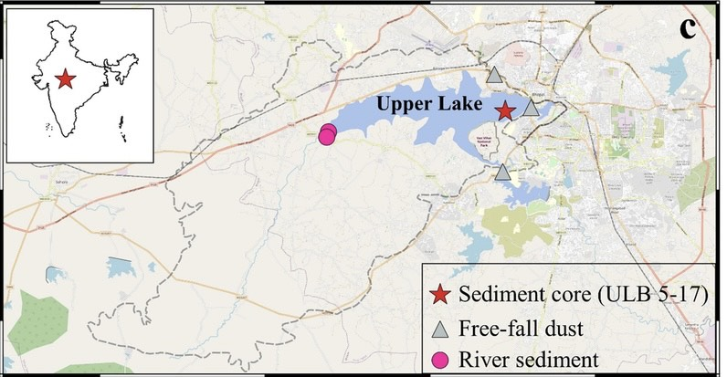

Fig. 1. Showing sampling site Upper Lake, Bhopal (Madhya Pradesh), India

Samples required for molecular analysis, including DNA barcoding and sequencing, were obtained with the assistance of local fishermen. Muscle and liver tissue were simultaneously extracted from freshly collected fish specimens, with approximately 500 mg of tissue and 100 mg of liver tissue taken from each. The samples were preserved in 70% ethanol and archived at the Laboratory of molecular Biology and Genomics, Department of Bioscience, Barkatullah University, Bhopal (M.P.), India, for genetic analysis. Standard molecular protocol were followed, including genomic DNA extraction, quantification, PCR amplification, agarose gel electrophoresis, and subsequent Sanger sequencing of the cox1 gene.

2.2 Genomics DNA Isolation and Quantification

Genomics DNA was extracted from tissue samples using the phenol:chloroform:isoamyl alcohol (25:24:1) method with slight modification. The quality and integrity of the isolated DNA were evaluated through 1% agarose gel electrophoresis. To ensure purity, samples were treated with ribonuclease and proteinase-K, maintaining an absorbance ratio (A260/A280) close to 1.8 and DNA concentration in the range of 40-60 ng/µL for PCR amplification of the cox1 gene.

2.3 PCR amplification

Primer design is the most important component of selective amplification. The purpose of the cox1 (cytochrome c oxidase subunit 1) primer is to selectively target and amplify the cox1 gene, and it was amplified using universal sets of primer Table 1, namely Forward (FishF1: 5- TCAACCAACCACAAAGACATTGGCAC-3) and Reverse (FishR1: TAGACTTCTGGGTGGCCAA AGAATCA-3) primers. The cox 1gene was amplified in a 25 µL reaction volume with 12.50 µL of 2X PCR master mix (HiMedia, India), 1.0 µL of each forward and reverse primer (10 µm concentration), 1.0 µL of DNA template, and 9.50 µL of molecular grade distilled water (Table 2). The cox1 gene was amplified using PCR cycling parameters that included on cycle of initial denaturation at 95ºC for 5 min, 35 cycles of 95 ºC for 30 sec, 53 ºC for 1.0 min, and 72 º for 1.0 min for annealing, followed by a final extension step of 72 ºC for 10 min and 4ºC for 10 min as holding temperature.

Table 1. Universal primer set used for amplification of cox1 gene
Primer Name | Sequences | GC% | Tm value | Molecular weight (g/mol)
FishF1 | 5’-TCAACCAACCACAAAGACATTGGCAC-3’ | 46.2 | 60.2ºC | 7886.20
FishR1 | 5’-TAGACTTCTGGGTGGGTGGCCAAAGAATCA-3’ | 46.2 | 59.8ºC | 8019.30

Table 2. Composition of PCR Master Mix
S. No. | Chemicals | Configuration | Amount
1. | PCR Master Mix | 2X | 12.5 µl
2. | Primer (F) | 10 µM | 1.00 µl
3 | Primer (R) | 10 µM | 1.00 µl
4 | Distilled water | Molecular Grade | 9.50 µl
5. | Template DNA | 40-60 ng/µl | 1.00 µl
Total 25.00 µl

  - Agarose gel electrophoresis

After amplification, the PCR products were subjected on 1% agarose gel in 1X TAE buffer and then visualized using UV-Transilluminator (Hi-UV^{tm} Duo). A 1 kb DNA ladder (MBT051, Himedia, India) was used as a standard during agarose gel electrophoresis to determine the molecular weight of the targeted cox1 gene (Fig. 2).

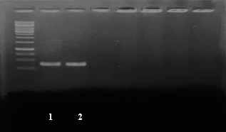
Fig. 2. Showing PCR amplicons of the studied fish using cox1 gene. The DNA fragments were 600 bp long and were confirmed by running them on a 1% agarose gel alongside a 1Kb Ladder.

  - Tools for Bioinformatics and DNA Sequencing

Sanger DNA sequencing of the cox1 gene was outsourced to Biokart Pvt. Lvt., India. For sequencing, the forward primer (FishF1: 5’- TCAACCAACCACAAAGACATTGGCAC-3’) was used to amplified the forward strand. The resulting sequences were analysed using ORF Finder (https://www.ncbi.nlm.nih.gov), nucleotide BLAST (https://blast.ncbi.nlm.nih.gov), and Sequencing Analysis Software v5.2 (Applied Biosystems Inc., CA, USA) to eliminate low- quality reads and sequencing dropouts. All newly generated sequences, along with relevant database sequences, were aligned using Clustal-X to assemble the final dataset. To ensure consistency, the dataset was trimmed to match the sequence length of the cox1 gene from both samples, thereby minimizing discrepancies in phylogenetic and genetic variation analyses.

The DNA barcode sequence of the cox1 gene for Heteropneustes fossilis and Mystus bleekeri was generated through the BOLD Systems (www.boldsystems.org) and is available for reference and species identification. Additional cox1 gene sequences, along with their accession numbers, are archived in GenBank (NCBI, USA). Sequence alignment and divergence analyses were performed using MEGA11. Based on Kimura-2-Parameter (K2P) distances, Neighbor-Joining (NJ), Nearest-Neighbor (NN) analysis was conducted using nucleotide composition data, while cluster sequence analysis was performed through BOLD. The BOLD dataset was compiled from seven primary specimen records, while included Name of species, voucher information, collection details (date and collector), specimen identification number, COI sequences of more than 600 bp, PCR primer details used for amplification of the cox1 gene and trace files of the sequenced gene. For Heteropneustes fossilis and Mystus bleekeri, the BOLD entry comprises a biphasic record, consisting of both a specimen page and a sequence page, which can be directly accessed through the project portal ULBNU (https://boldsystems.org/).

- Result and Discussion

In this study, two catfish species were collected from Upper Lake, Bhopal and initially identified based on external morphological features. The cox1 gene was amplified using the universal primer pair FishF1 (5’- TCAACCAACCACAAAGACATTGGCAC-3’) and FishR1 (5’- TAGACTTCTGGGTGGGTGGCCAAAGAATCA-3’), resulting in two successful sequences exceeding 600 bp. These fish species were classified as species of least concern by the IUCN conservation status. The BLAST analysis confirmed that both sequences corresponded to Heteropneustes fossilis and Mystus bleekeri, with 99-100% similarity to existing NCBI reference sequences (voucher specimens ULBR06A, ULVSP22). The trimmed and annotated sequences were submitted to GenBank and obtained accession numbers as PP754237 and PX116877 Table 3, and corresponding DNA barcodes were generated through the Barcode of Life Data Systems (BOLD Systems), USA.
Table 3. cox1 gene sequence submitted at GenBank, NCBI, USA.

S No. | Species Name | Voucher no. | Targeted gene | Accession no. | No. of samples | Sequence length
 | Heteropneustes fossilis | ULBR06A | mtcox1 | PP754237 | 1 | 658 bp
 | Mystus bleekeri | ULVSP22 | mtcox1 | PX116877 | 1 | 609bp

Sequence composition analysis Table 4 of the cox1 fragments from the two records (representing Heteropneustes fossilis and Mystus bleekeri) revealed a moderate AT-bias mean nucleotide frequencies were A = 25.96%, T = 30.39% (A+T = 56.35%), C = 26.79% and G = 16.87%, giving an overall mean GC of 43.65%. Examination by codon position showed a clear gradient in GC content: GC at codon 1 position 1 was highest (mean = 56.96%), intermediate at position 2 (mean = 42.63%), and lowest at position at 3 (mean = 31.32%). Standard errors for single nucleotide percentage and overall GC were small (Ses < 0.57), indicating strong compositional similarity between the two sequences, whereas the larger SE at third codon position (SE = 0.84) reflects relatively greater variability at synonymous site. Biologically, the elevated GC at first codon positions and the conserved nature of second positions likely reflects functional constraints on amino-acid coding, while the AT-rich third positions indicate relaxed selection and higher substitution rates a pattern that enhances the discriminatory power of the cox1 barcode for closely related fish species. Taken together, these composition characteristics support the suitability of the amplified cox1 fragment for DNA barcoding and phylogenetic analyses in these catfishes.
Table 4. Statistics for nucleotide frequency distribution are provided in this table
Sl. No. | GC (%), AT (%) | Min | Mean | Max | SE
1 | G% | 16.26 | 16.87 | 17.48 | 0.4317
2 | C% | 25.99 | 26.79 | 27.59 | 0.5651
3 | A% | 25.78 | 25.96 | 26.14 | 0.1272
4 | T% | 30.38 | 30.39 | 30.40 | 0.0062
5 | GC% | 43.47 | 43.65 | 43.84 | 0.1334
6 | GC% Codon Pos 1 | 56.82 | 56.98 | 57.14 | 0.1148
7 | GC% Codon Pos 2 | 41.87 | 42.63 | 43.38 | 0.5328
8 | GC% Codon Pos 3 | 30.14 | 31.32 | 32.51 | 0.8398

The COI-5P neighbor-joining (NJ) trees generated from BOLD datasets provided insights into the phylogenetic placement and barcode resolution of the two catfish species (Heteropneustes fossilis and Mystus bleekeri). For Heteropneustes fossilis, the NJ tree contained 100 records (>200bp) that predominantly clustered within a single cohesive clade, with three sequences lacking species level assignment. The samples spanned a wide geographic distribution across South Asia (India, Bangladesh, Nepal, Pakistan, Sri Lanka, and records from Iran and Iraq). Branch length within the cluster were short, indicating low COI divergence among specimens. In contrast, the Mystus dataset comprised 100 records representing 15 nominal species from two genera of the family Bagridae, including M. bleekeri. Multiple M. bleekeri sequences from India and Bangladesh were observed, clustering together but interspersed with other Mystus congeners (e.g., M. armatus, M tengara, M. malabaricus). This broader genus level dataset displayed clear interspecific divergence, with several well-defined clusters corresponding to different Mystus species (Fig. 6).

The contrasting NJ topologies of the two datasets reflect different level of barcode resolution. In H. fossilis, compact clustering and low branch divergence across multiple countries suggest strong utility of COI barcodes for species level identification but limited power for detecting population level structure. Conversely, the Mystus dataset demonstrates substantial COI variation within the genus, enabling discrimination among many congeneric taxa. However, close clustering of some congeners and the presence of an unidentified entry point to possible issues of incomplete lineage sorting. While COI is effective for genus and species level assignments in Mystus, additional markers may be required to fully resolve taxonomic ambiguities among closely related species. Both datasets confirm the suitability of the cox1 gene fragment as a DNA barcode for freshwater catfishes. For H. fossilis, barcoding is most effective for confirming species identity across wide geographic ranges, while for M. bleekeri, COI enables species differentiation within a diverse genus but requires careful interpretation in case of overlapping divergence.

The nucleotide sequence length of Heteropneustes fossilis was 658 base pair (bp), while Mystus bleekeri exhibited a slightly shorter sequence of 609 bp. This differences in sequence length may be attributed to natural variability in mitochondrial genome regions or sequencing coverage, though both lengths fall within the optimal range for COI-based barcoding. The GC content was moderately higher in M. bleekeri (G: 99, C:168) compared to H. fossilis (G: 115, C:171), with both sequences displaying the characteristic AT-rich composition of vertebrate mitochondrial DNA. At the amino acid level, the COI sequence of H. fossilis translated into 234 residues, while M. bleekeri yielded 218 residues. The illustrative barcode representations for both species showed uniform and district banding patterns, reflecting clean sequence reads across the entire length (Fig. 3). No sequencing errors, insertions, or deletions were observed in these barcodes, and both trace files were classified as high quality, affirming the reliability of the obtained data. Comparatively, H. fossilis provided a slightly longer and more compositionally balanced sequence, which could offer enhanced species resolution. However, both sequences are robust and meet the standard requirements for inclusion in global barcoding databases like BOLD and GenBank.

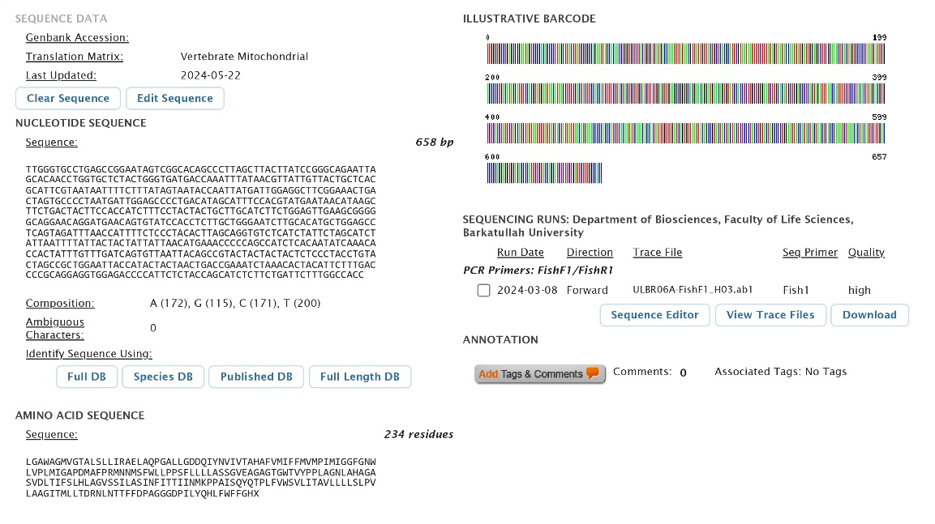
- Heteropneustes fossilis

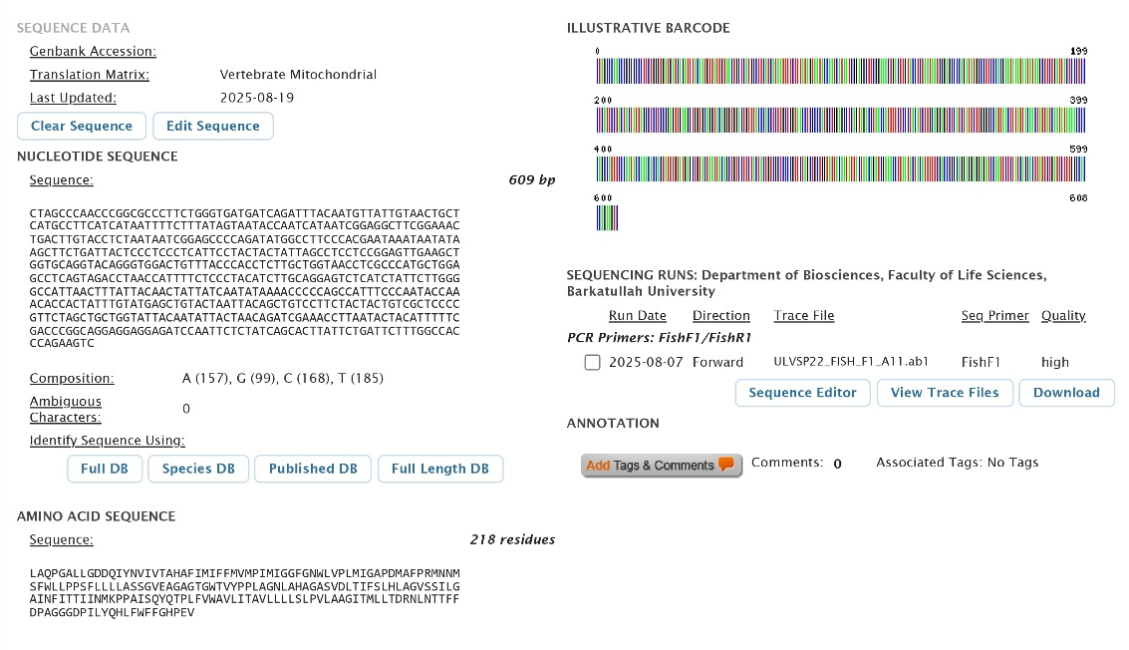

- Mystus bleekeri

Fig. 3. Developed DNA barcode database of (A) Heteropneustes fossilis and (B) Mystus bleekeri on BOLD system

Barcode gap analysis was conducted for Heteropneustes fossilis and Mystus bleekeri, to evaluated the discriminatory power of DNA barcoding using inter and intra-specific genetic distances. The analysis is visualized through three scatter plots and provides insight into the genetic distinctiveness between and within the species. The first scatter plot compares the maximum intra-specific genetic distance with the nearest neighbour (NN) distance, representing the smallest inter-specific divergence (Fig. 4). The single data point lies well above the 1:1 diagonal line, where values of intra- and inter-specific distances would be equal. This indicates that, Maximum intra-specific divergence is significantly lower than the nearest inter-specific distance and the nearest neighbour distance is approximately 30%, whereas the maximum intra-specific distance is negligible (approaching zero). This wide separation signifies a clear and substantial barcode gap between H. fossilis and M. bleekeri, validating their genetic distinctiveness based on the barcoding region used. The second scatter plot assesses potential sampling bias by plotting the number of individuals per species against their maximum intra-specific distance. Only one individual per species, and zero intra-specific genetic variation detected.

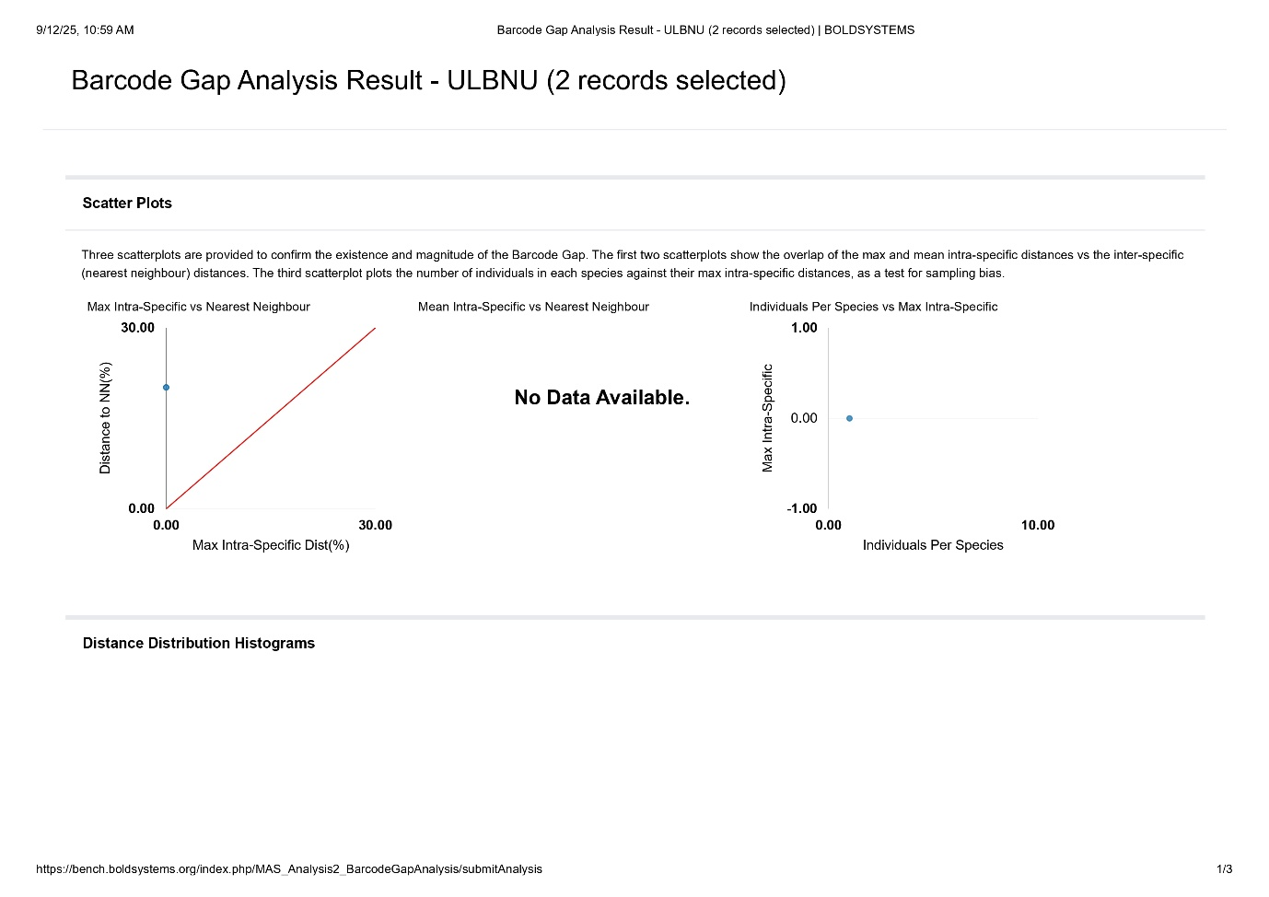
Fig. 4. Shows two scatterplots are provided to confirm the existence and magnitude of the Barcode Gap
For each species, the mean and maximum intra-specific values are compared to the nearest neighbour distance in the below Table 5. Both species exhibited zero intra-specific divergence, as only one individual per species was analysed. Consequently, the mean and maximum intra-specific distances were recorded as 0.00%, and intra-specific variation could not be assessed. Despite this limitation, the inter-specific (nearest neighbour) genetic distance between the two species was calculated at 20.14%, indicating a substantial barcode gap. This is further supported by the scatter plot, where the data point lies well above the line 1:1 line, highlighting that the nearest neighbour distance is much greater than any observed intra-specific variation. The absence of intra-specific variation is a result of singleton sampling. However, the large inter-specific divergence confirms the effectiveness of DNA barcoding in distinguishing H. fossilis and M. bleekeri. These findings provide preliminary evidence of the reliability of the COI marker for species identification in Indian catfishes.

Table 5. Comparison of intra- and inter-specific divergence in fish species
Order | Family | Species | Mean Intra-Sp | Max Intra Sp | Nearest Neighbour | Nearest species | Distance to NN
Siluriformes | Bagridae | Mystus bleekeri | N/A | 0 | ULBNU003-24 | Heteropneustes fossilis | 20.14
Siluriformes | Heteropneustidae | Heteropneustes fossilis | N/A | 0 | ULBNU017-25 | Mystus bleekeri | 20.14

The top-hit similarity score revealed a 99.0% identity with sequences available in the Barcode of Life Data System (Fig. 5), confirming that the present study successfully generated DNA barcodes for the Heteropneustes fossilis and Mystus bleekeri and reliably identified the species using the developed dataset.

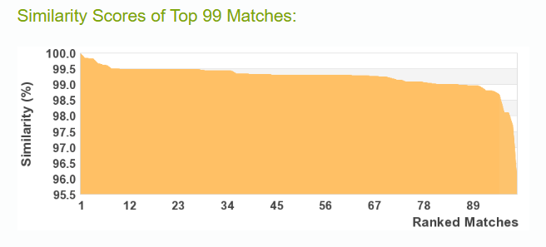
Fig. 5. Similarity scores of the top 99% matches with database available on https:boldsystems.org

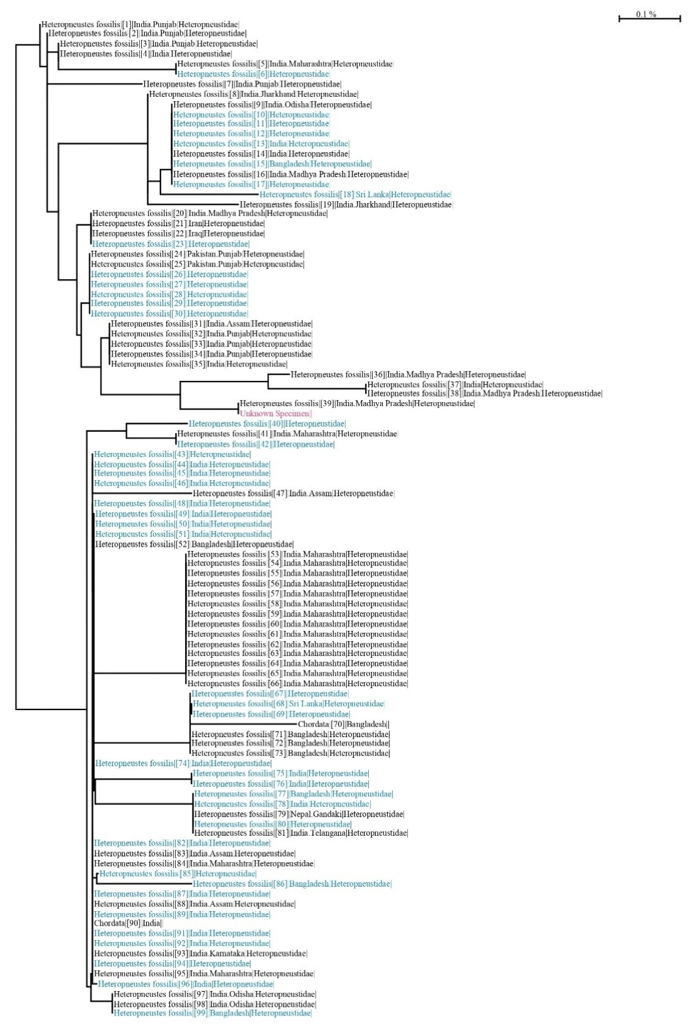
- Heteropneustes fossilis

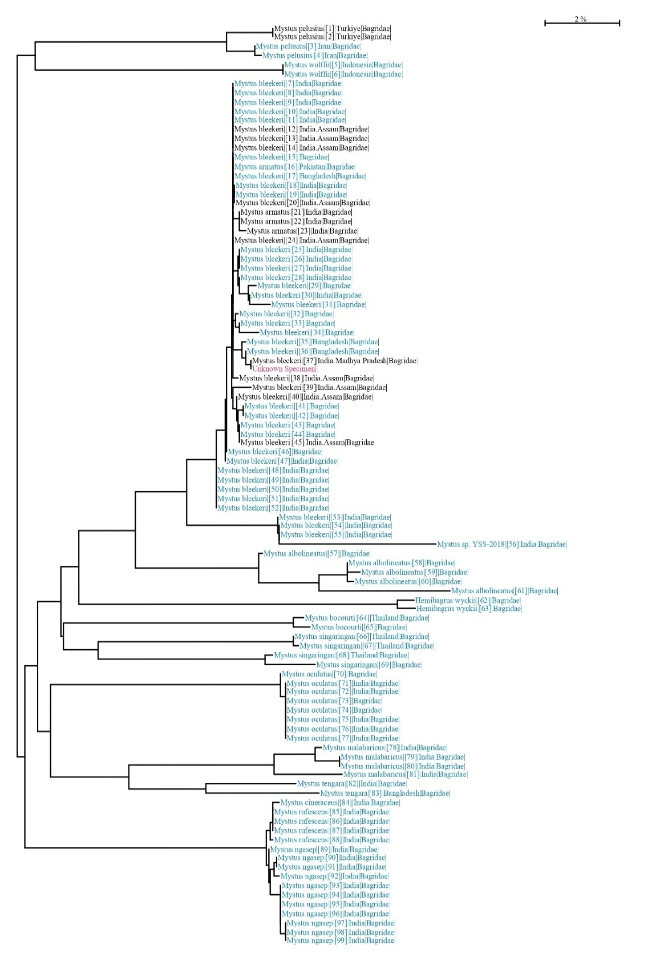
- Mystus bleekeri

Fig. 6. Showing neighbour-joining tree (K2P tree) of studied fish species

- Conclusion

This study demonstrates the successful application of DNA barcoding for the identification and molecular characterization of catfishes. The generated cox1 sequences, validated through BLAST and deposited in GenBank and BOLD, provide reliable barcodes that strengthen global reference libraries. These results reinforce the effectiveness of COI based DNA barcoding as a tool for accurate species identification and biodiversity assessment. The data contributes to the molecular inventory of freshwater fish from the Upper Lake and supports broader applications in ecological monitoring, conservation planning, and detecting cryptic or invasive species.

Disclaimer (Artificial intelligence)
Author(s) hereby declare that NO generative AI technologies such as Large Language Models (ChatGPT, COPILOT, etc.) and text-to-image generators have been used during the writing or editing of this manuscript.
References

Bhattacharya, M., Sharma, A.R., Patra, B.C., Sharma, G., Seo, E.M., Nam, J.S., & Lee, S.S. (2016). DNA Barcoding to fishes: current status and future directions. Mitochondrial DNA Part A, 27(4), 2744-2752.
Bickford, D., Lohman, D.J., Sodhi, N.S., Ng, P.K.L. and Meier, R., Winker, K., and Das, I. (2007). Cryptic species as a window on diversity and conservation. Trends in ecology & evolution, 22(3), 148-155.
Ferraris, C.J., Jr., DePinna, M.C.C. (1999). Higher level names for catfishes (Actinopterygii: Ostariophysi: Siluriformes). Proceedings of the California Academy of Sciences, 51,1-17.
Hebert, P.D., Cywinska, A., Ball, S.L., and DeWaard, J.R. (2003). Biological identifications through DNA barcodes. Proceedings of the Royal Society of London. Series B: Biological Science, 270 (1512), 313-321.
Kar, D., Kumar, C.B., Bohra, C., Singh, L.K. (2003). Fishes of Barak drainage, mizaram and Tripura. Environment, pollution and management, APH publishing corporation, New Delhi, 604, 203-211.
Lin, W.F., Shiau, C.Y., & Hwang, D.F. (2005). Identification of four Thunnus tuna species using mitochondrial cytochrome b gene sequence and PCRRFLP analysis. Journal of Food Drug Analysis, 13, 382-387.
Mahoviya, N., Manohar, S., Garg, R.K. (2025). A review on molecular markers development for Chitala chitala: Applications in genetic studies and conservation. Asian J Microbiol Biotechnol Environ Sci. 2025,27(3–4), 201-8.
Mohapatra, A., Ray, D., & Kumar, V. (2013). A new fish species of the Genus Hapalogenys (Perciformes: Hapalogenyidae) from the Bay of Bengal, India. Zootaxa, 3718, 367-377.
Quilang, J.P., & Yu, S.C.S. (2015). DNA barcoding of commercially important catfishes in the Philippines. Mitochondrial DNA, 26(3), 435-444.
Raghuwanshi, D., Garg, R., Khandait, R., Jagdish, P., & Vyas, V. (2024). Identifying Single DNA Barcode Regions of Oreochromis niloticus of Shahpura Lake, Bhopal and their Contribution to a Reference Library. Asian Journal of Biological and Life Sciences, 13(1), 221–228.
Ratnasingham, S., & Hebert, P.D. (2007). BOLD: The Barcode of Life Data System. Molecular ecology notes, 7(3),355-364.
Sachithanandam, V., & Mohan, P.M. (2020). A review on DNA barcoding on fish taxonomy in India. DNA barcoding and molecular phylogeny, 153-175.
Sahu, A., Kumar, N., Singh, C.P., and Singh, M. (2023). Environment DNA (eDNA): Powerful technique for biodiversity conservation. Journal for Nature Conservation, 71,126325.
Sales, N.G., Mariani, S., Salvador, G.N., Pessali, T.C. and Carvalho, D.C. (2018). Hidden diversity hampers conservation efforts in a highly impacted Neotropical river system. Frontiers in Genetics, 9 ,271.
Uikey N, Yadav S, Garg R. (2024). Unlocking Nature’s Genetic Secret: The Power of DNA Barcoding to Identify Mislabeled Fish Species of Upper Lake of Bhopal, India. Asian Journal of Biotechnology and Genetic Engineering 7(2), 332-344.
Valentini, A., Pompanon, F., & Taberlet, P. (2009). DNA barcoding for ecologists. Trends in ecology & evolution, 24(2), 110-117.
Ward, B.R. (2000). Declivity in steelhead (Oncorhynchus mykiss) recruitment at the Keogh River over the past decade. Canadian Journal of Fisheries and Aquatic Sciences, 57(2),298-306.
Ward, R.D., Hanner, R., Hebert P.D.N. (2009). The campaign to DNA barcode all fishes, FISH-BOL. Journal of Fish Biology, 74(2), 329-356.
Wong, L.L., Peatman, E., Lu, J., Kucuktas, H., He, S., Zhou, C., Nakorn, U.N. & Liu, Z. (2011). DNA barcoding of catfish: species authentication and phylogenetic assessment. PlosS one, 6(3), e17812.

