Original Research Article
STANDARDISATION OF 16S rRNA GENE BASED NESTED PCR AS A SENSITIVE TOOL FOR CANINE LEPTOSPIROSIS DIAGNOSIS

.
ABSTRACT

Aim: The present study aimed to standardize a 16S rRNA gene-based nested PCR assay for the sensitive detection of leptospirosis in dogs and to compare its diagnostic performance with PCR targeting lipL32 and microscopic agglutination test (MAT). To achieve this, a cross-sectional diagnostic study was conducted on clinically suspected canine cases of leptospirosis.
Place and Duration of Study: The study was carried out at the Department of Veterinary Epidemiology and Preventive Medicine, College of Veterinary and Animal Sciences, Pookode, during November 2024 to August 2025.
Methodology: A total of 53 dogs with clinical signs suggestive of leptospirosis were screened. Serum samples were tested by MAT using 13 serovars of Leptospira interrogans. Whole blood was subjected to conventional PCR targeting the lipL32 gene, and nested PCR targeting the conserved region of the 16S rRNA gene. The sensitivity of different diagnostic tests was compared using kappa statistics.
Results: Of the 53 suspected dogs, 21 (39.6%) were positive by nested PCR, 14 (26.4%) by lipL32 PCR, and 6 (11.3%) by MAT. The predominant serovar detected was Leptospira interrogans Pomona (50%). Nested PCR showed the highest sensitivity (100%), compared to PCR (66.7%) and MAT (28.6%).
Conclusion: The study demonstrates that 16S rRNA gene-based nested PCR is a highly sensitive diagnostic tool for canine leptospirosis, capable of detecting infection even in early stages when antibody response is absent, a finding that is consistent with and supported by existing knowledge. Integration of molecular techniques with serological assays can provide a more reliable diagnostic strategy and enhance surveillance and control of leptospirosis in endemic regions.
.

Keywords: Leptospirosis, Canine, Nested PCR, 16S rRNA, Diagnosis

1. INTRODUCTION

Leptospirosis is an important re-emerging zoonotic disease that affects humans, along with a wide range of domestic and wild animals, and continues to pose a serious global public health concern. Leptospirosis is caused by spirochete bacteria of the genus Leptospira, which includes 69 recognized species categorized into over 250 serovars across more than 25 serogroups (Antoniolli et al. 2025). The primary mode of leptospirosis transmission is contact with water or soil contaminated by the urine of infected animals. The bacteria enter the body through skin abrasions, cuts, or intact mucous membranes (like the eyes and mouth). It can also be acquired by drinking contaminated water or handling infected animal tissues. Due to diagnostic challenges, leptospirosis is frequently underdiagnosed. Clinical signs in companion animals are highly nonspecific, spanning from subclinical infection to acute multi-organ failure, with the liver and kidneys most severely affected. Infection can be identified through various laboratory techniques, including culture-based methods, serological methods such as microscopic agglutination test (MAT), and molecular techniques like conventional PCR. However, culture is time-consuming and has a low sensitivity, while MAT demands a large panel of live antigens that are not always readily available and is unable to detect infection in the acute phase. Conventional PCR, though useful, may lack the sensitivity needed to detect low bacterial loads present in early infection. In contrast, nested PCR targeting the 16S rRNA gene offers improved sensitivity by amplifying low concentrations of leptospiral DNA and enables rapid detection and differentiation of both pathogenic and non-pathogenic strains. Considering these limitations, the present study was primarily aimed at standardizing a nested PCR assay to enhance diagnostic sensitivity for canine leptospirosis.

2. material and methods
The study was conducted at the Department of Veterinary Epidemiology and Preventive Medicine, College of Veterinary and Animal Sciences, Pookode during the period from November 2024 to August 2025. A total of 53 dogs presented to veterinary hospitals under Kerala Veterinary and Animal Sciences University with clinical signs suggestive of leptospirosis viz. pyrexia, anaemia, icterus, vomiting, diarrhoea, loss of appetite, lethargy, depression, dehydration and polyuria/ oliguria/ anuria/ haematuria/ haemoglobinuria formed the materials for study.

2.1 Sample collection
About 3-5 ml of blood was collected aseptically from dogs in sterile heparinized and serum vials for obtaining blood and serum respectively. As per the Committee for Control and Supervision of Experiments in Animals (CCSEA) guidelines, studies involving clinical samples do not require prior approval from the Institutional Animal Ethics Committee, and sampling was carried out with the informed consent of the animal owners.

2.2 MICROSCOPIC AGGLUTINATION TEST
The serum samples were tested using the MAT. The test employed a panel of 13 serovars of Leptospira interrogans, following the standard method established by Faine (1982). The specific serovars used were: L.interrogans serovar Australis, L.interrogans serovar Autumnalis, L.interrogans serovar Bataviae, L.interrogans serovar Canicola, L.interrogans serovar Grippotyphosa, L.interrogans serovar Hebdomadis, L.interrogans serovar Icterohaemorrhagiae, L.interrogans serovar Javanica, L.interrogans serovar Hardjo, L.interrogans serovar Djasiman, L.interrogans serovar Pomona, L.interrogans serovar Patoc and L.interrogans serovar Pyrogenes. Serum samples with a titer of 1:200 and above were considered positive (Vijayachari et al., 2001).

2.3 PCR TARGETING lipL32 GENE
The DNA was extracted from whole blood using a commercially available Genomic DNA extraction kit (Origin™) following the manufacturer’s instructions and samples were stored at -20°C. The conventional PCR assay was carried with primers targeting lipL32 gene as described by Krishna et al. (2013). Details of the primers used for detection are given in Table1.

Table 1. Details of primers for PCR targeting lipL32 gene
Sl No. | Target gene | Primer sequence 5’-3’ | Product size
1. | lipL32 | F- 5’-CGC GCT GCA GTT ACT TAG TCG CGT CAG AAG-3’  R- 5’-CGC GGT CGA CGC TTT CGG TGG TCT CTG CCA AGC-3’ | 790 bp

2.4 NESTED PCR TARGETING 16S rRNA GENE
Nested PCR was carried out using two pairs of 16S rRNA based primers as described earlier (Natarajaseenivasan et al., 2012). Details of the primers used for amplification are given in Table 2. The nested PCR was standardized using positive DNA isolated from reference cultures.

Table 2. Details of primers used for Nested PCR
Sl no. | Target gene | Primer sequence 5’-3’ | Product size
1 | 16S rRNA | First round primers  F – 5’-GGC GGC GCG TCT TAA ACA TG-3’  R – 5’- GTC CGC CTA CGC ACC CTT TAC G-3’ | 525bp
1 | 16S rRNA | Second round primers  F -5’-CAA GTC AAG CGG AGT AGC AA-3’  R - 5’-TAA CCT GCT GCC TCC CGT A-3’ | 289bp

The initial amplification round was conducted in a 25 μL reaction mixture. This mixture consisted of 12.50 μL of Emerald Amp® GT PCR Master Mix, a pair of primers (1 μL each), 5.50 μL of nuclease-free water, and 5 μL of template DNA. The thermal cycling parameters for initial amplification round are given in Table 3.

Table 3. Thermal cycling parameters for Step 1 - PCR
Initial denaturation | 95 °C | 5 min | 30 cycles
Denaturation | 95 °C | 1 min | 30 cycles
Annealing | 60 °C | 45 sec | 30 cycles
Extension | 72 °C | 1 min | 30 cycles
Final extension | 72 °C | 7 min | 30 cycles

For the second round of amplification, 1μL of the product from the first PCR was used as the template. The reaction mixture contained 12.50 μL of Emerald Amp® GT PCR Master Mix, a pair of primers (1 μL each), and 9.50 μL of nuclease-free water. The same thermal conditions and program were used as in the first round, with the exception that the annealing temperature was adjusted to 62 °C for 45 seconds.
The PCR products were identified using a submerged agarose gel electrophoresis system. A one percent agarose gel stained with ethidium bromide was used, with Tris Borate EDTA (TBE) buffer serving as the matrix, and the gel was run at 90V. The gel was then visualized, and the results were documented using a Gel Doc system (Bio-Rad, USA). All procedures involving ethidium bromide were performed with appropriate safety measures, including the use of gloves, lab coats, and protective eyewear, and waste was disposed of following institutional biosafety guidelines to minimize environmental and health hazards. All experimental procedures adhered to standard veterinary biosafety and ethical guidelines.

3. results

Out of 53 suspected dogs, 21 showed positive for leptospirosis in any one of the tests. Most of the positive dogs were within the age of one to four years. Eight cases belong to the five to nine years of age. One case each belongs to less than one year and above ten years of age (Table 4). Out of 21 positive animals, fourteen (66.67%) were males and seven (33.33%) were females. Most of the positive dogs in the present study were labrador retriever, followed by non-descriptive, dachshund, german shepherd, spitz, rottweiler, golden retriever, doberman, lhasa apso and cane Corso (Table 5). The dog cases were presented mostly in june and april: seven cases each (33.34%), followed by five cases (23.80%) in march, and two cases (9.52%) during may. Most predominant clinical sign manifested by dogs positive for leptospirosis was anorexia, followed by lymphadenopathy, pyrexia, vomiting, dark yellow urine, jaundice, weakness, melena, haematuria, splenomegaly, anuria, halitosis and hepatomegaly.

Table 4. Age wise distribution of canine leptospirosis
Age group (years) | No. of animals | Per cent
Less than 1 | 1 | 4.80
1–4 | 11 | 52.40
5–9 | 8 | 38.10
Greater than 10 | 1 | 4.80

Table 5. Breed wise distribution of canine leptospirosis
Breed | No. of animals | Per cent
Labrador retriever | 5 | 23.8
Non-Descriptive | 4 | 19
Dachshund | 3 | 14.3
German Shepherd | 2 | 9.5
Spitz | 2 | 9.5
Golden Retriever | 1 | 4.8
Cane Corso | 1 | 4.8
Rottweiler | 1 | 4.8
Lhasa Apso | 1 | 4.8
Doberman | 1 | 4.8

3.1 MICROSCOPIC AGGLUTINATION TEST

Of the 53 suspected samples examined, six (11.32%) yielded positive results for antibodies against different serovars of Leptospira. Serum samples with a titer of 1:200 and above were considered positive (Fig.1,2,3). The predominant serovar showing agglutination was Leptospira interrogans serovar Pomona (3 cases, 50%), followed by Leptospira interrogans serovar Icterohaemorrhagiae (2 cases, 33.34%) and Leptospira interrogans serovar Pyrogens (1 case, 16.67%).

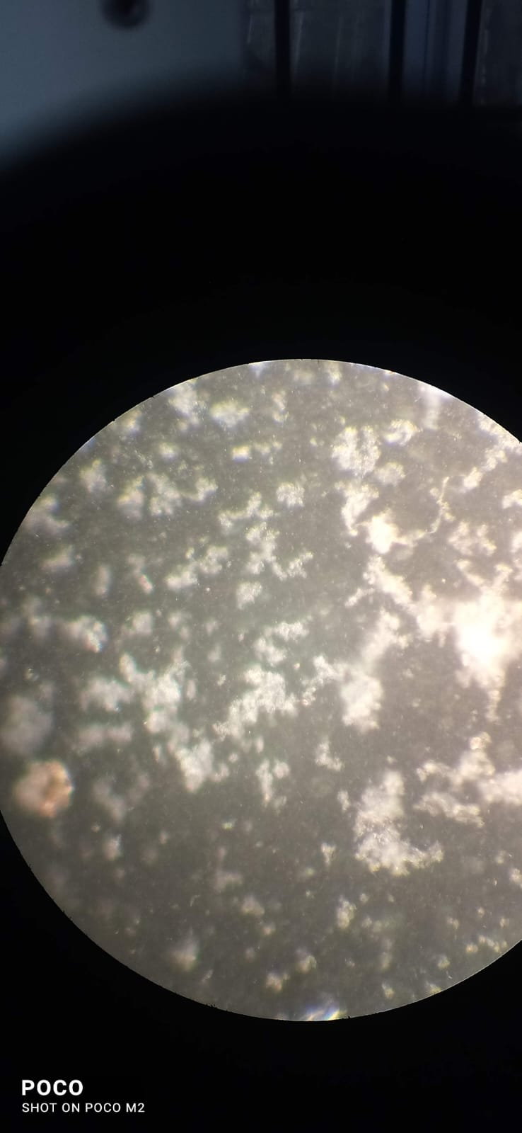 | 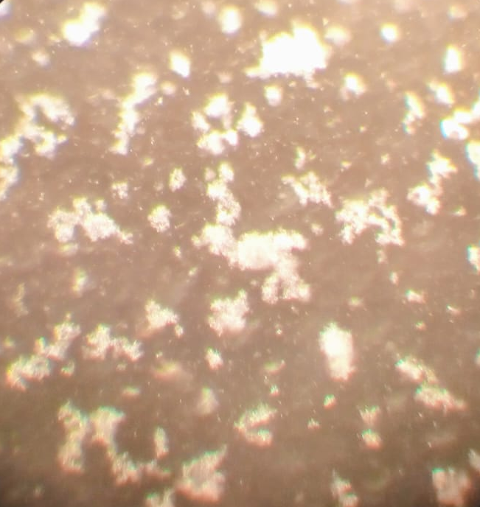 | 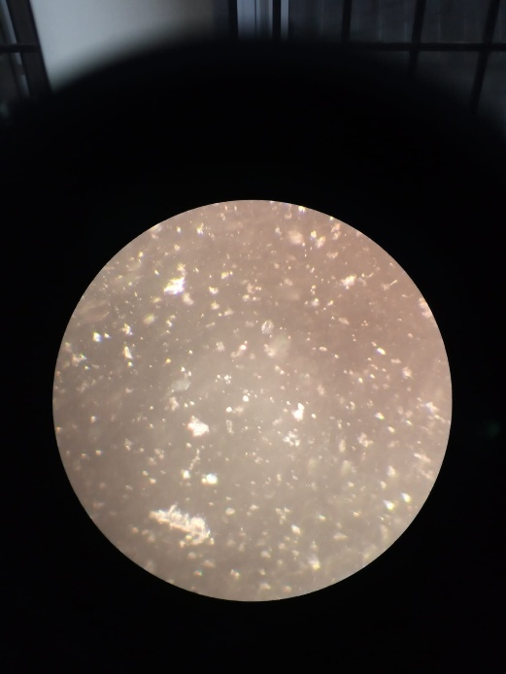

Fig.1.MAT showing a representative positive reaction at 1:200 dilution against Leptospira interrogans serovar Pomona observed under 20× magnification. Clear agglutination indicates the presence of specific antibodies in the canine serum sample.
Fig.2.MAT showing a representative positive reaction at 1:400 dilution against Leptospira interrogans serovar Pomona observed under 20× magnification.
Fig.3.MAT showing a representative positive reaction at 1:600 dilution against Leptospira interrogans serovar Pomona observed under 20× magnification.

3.2 PCR TARGETING lipL32 GENE

Fifty-three blood samples collected from suspected leptospirosis cases were tested using polymerase chain reaction (PCR) targeting the lipL32 gene. Out of these 14 cases (26.41%) showed positive results producing a 790 bp amplicon specific to pathogenic leptospires (Fig.4). This is in agreement with the observations of Joseph et al. (2018), who reported a 27.29 per cent prevalence in Southern India. Di Azevedo et al. (2021) documented a 45 per cent prevalence in canine clinical samples using conventional PCR targeting lipL32.

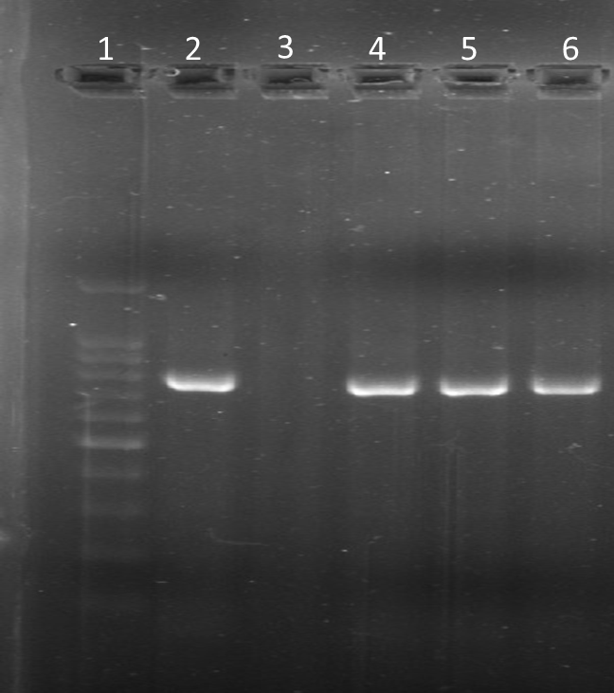
790bp

Fig.4. PCR results: Lane 1: Ladder, Lane 2: Positive control, Lane 3: Negative control, Lane 4,5,6: Clinical samples (C 1500, C 2182, C 583 respectively) showing positive result with amplicon size-790bp

3.3 NESTED PCR TARGETING 16S rRNA GENE

A nested PCR assay targeting the conserved region of the 16S rRNA gene of pathogenic Leptospira spp. was successfully standardized (Fig.5). Optimization was performed using DNA extracted from the reference culture of Leptospira interrogans serovar Pomona, maintained in our laboratory. Primary amplification consistently yielded the expected 525 bp fragment in positive control reactions, although amplification from several field samples appeared weak. Subsequent nested amplification with internal primers generated distinct 289 bp products in all positive controls, while a subset of test samples also produced strong intensity 289 bp bands, confirming the presence of leptospiral DNA.
A total of 53 dogs clinically suspected of leptospirosis were screened using nested PCR targeting the 16S rRNA gene. Among them, 21 dogs (39.6%) tested positive, with a characteristic amplicon size of 289 base pairs (Fig.6). Similar findings were reported by Miotto et al. (2018), who found a 42.4 per cent positivity rate in suspected dogs.

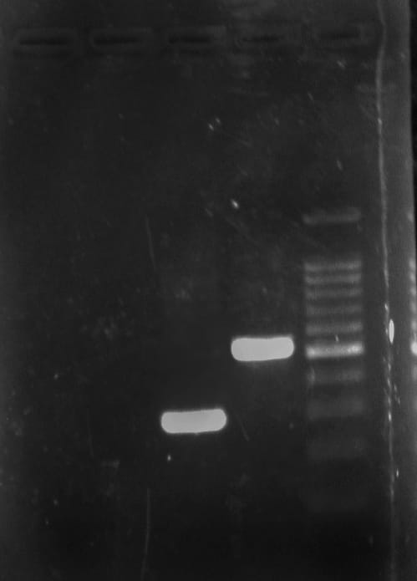  289bp  525bp | 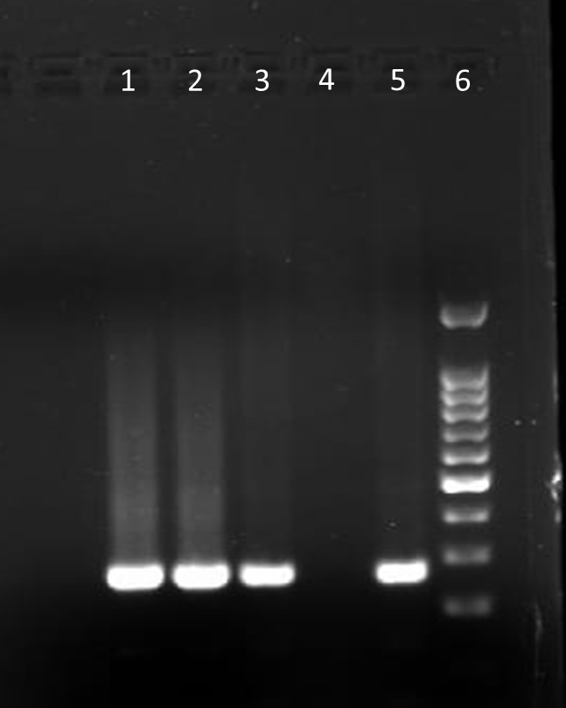  289bp

Fig.5. Validation of primers for 16S rRNA showing amplicons with 525bp in step 1 PCR and 289bp in nested PCR

Fig.6. Nested PCR results of clinical samples- Lane1,2,3: Clinical samples showing positive result (Amplicon size-289bp), Lane 4: Negative control, Lane 5: Positive control, Lane 6: Ladder

3.4 COMPARISON OF DIAGNOSTIC TESTS

Comparison between different diagnostic tests were done using kappa statistics. Nested PCR showed the highest sensitivity, achieving 100 per cent compared to 66.7 per cent for PCR targeting lipL32 and 28.6 per cent of MAT(Table 6). In the present study, MAT showed comparatively poor performance in detecting acute cases of leptospirosis. This limitation can be attributed to the fact that MAT detects antibodies, which typically appear only after the first week of infection. In acute infections, animals may present before a detectable antibody response has developed, leading to false-negative results. Moreover, MAT requires paired sera to confirm rising titres, which is often impractical in clinical settings where early diagnosis is critical. These factors explain the lower sensitivity of MAT in comparison to molecular techniques such as nested PCR, which can detect leptospiral DNA even in the early stages of infection. Combining molecular methods like nested PCR with MAT may provide the most robust diagnostic strategy for leptospirosis.

Table 6: Details of diagnostic test results
Tests | Positive | Negative | Sensitivity (%)
MAT | 6 | 52 | 28.6
PCR | 14 | 38 | 66.7
Nested PCR | 21 | 31 | 100
4.DISCUSSION

In the present study, Leptospira interrogans serovar Pomona emerged as the predominant serovar, representing 50 per cent of the seropositive cases. This observation aligns with the findings of Soman et al. (2014), who identified Pomona as the most common serovar (38.63%), followed by Australis (36.36%), in central and northern Kerala. The repeated detection of Pomona across studies indicates its epidemiological significance in the region and reinforces its established role in canine leptospirosis. Although Leptospira interrogans serovar Icterohaemorrhagiae and Leptospira interrogans serovar Pyrogenes were detected less frequently, their presence reflects the diversity of leptospiral serovars infecting dogs and emphasizes the need for a broad reference panel of antigens for MAT in endemic regions. The relatively low seropositivity rate (11.32%) observed in this study may be attributed to the limited sensitivity of MAT in acute infections, where antibody titres often remain below the diagnostic threshold. This shortcoming highlights the value of complementing serological tests with molecular assays to achieve greater diagnostic accuracy.

The 26.41per cent positivity observed with PCR targeting lipL32 gene in this study is comparable to the 27.29 per cent prevalence reported by Joseph et al. (2018) in Southern India. Higher prevalence rates, such as the 45 per cent reported by Di Azevedo et al. (2021) in canine clinical samples, may be influenced by regional differences, the characteristics of the sampled population, or the stage of infection at the time of sampling. These findings highlight the variable sensitivity of conventional PCR targeting lipL32 and emphasize the advantage of more sensitive molecular assays, such as nested PCR, for the accurate detection of leptospirosis in dogs.

The 39.6 per cent positivity observed with nested PCR in this study closely aligns with the 42.4 per cent prevalence reported by Miotto et al. (2018) in suspected dogs, underlining the high sensitivity of 16S rRNA-based nested PCR for detecting leptospiral infection. Compared to conventional PCR and serological methods, nested PCR demonstrates superior diagnostic performance by amplifying low levels of bacterial DNA present during the early stages of infection, when antibody responses may still be absent. The consistent amplification of the 289 bp product in both positive controls and clinical samples further confirm the reliability and reproducibility of this assay. These results reinforce the value of nested PCR as a rapid and highly sensitive molecular tool for the diagnosis of canine leptospirosis.

5. Conclusion

The present study successfully standardized a 16S rRNA gene-based nested PCR assay for the diagnosis of leptospirosis in dogs. Among the diagnostic tests employed, nested PCR demonstrated the highest sensitivity (100%), outperforming both lipL32 PCR (66.7%) and MAT (28.6%). This highlights its superior ability to detect leptospiral DNA, particularly in early stages of infection when serological responses may be absent. The predominance of Leptospira interrogans serovar Pomona was evident among MAT-positive cases, reaffirming earlier reports of its prevalence in Kerala. These findings emphasize the need for molecular assays, particularly nested PCR, as a routine diagnostic tool to improve early detection and management of leptospirosis in dogs. Integrating molecular methods with serological assays may provide the most reliable diagnostic strategy, thereby supporting better surveillance and control of this important zoonosis. The present study is constrained by a relatively small sample size and cross-sectional design, which may limit the broader applicability of the findings. Further research involving larger populations, multi-center validation in field conditions, and assessments of cost-effectiveness is recommended to better establish the utility of nested PCR in routine diagnostic and epidemiological practice.

Disclaimer (Artificial intelligence)
Option 1:
Author(s) hereby declare that NO generative AI technologies such as Large Language Models (ChatGPT, COPILOT, etc.) and text-to-image generators have been used during the writing or editing of this manuscript.

References

Antoniolli A, Guis H, Picardeau M, Goarant C, Flamand C. One Health field approach applied to Leptospirosis: A Systematic review and meta-analysis across humans, animals and the environment. In Open Forum Infectious Diseases. 2025 Jan 12(1):757. https://doi.org/10.1093/ofid/ofae757.

Faine S. Guidelines for the Control of Leptospirosis.1982. 171pp.

Vijayachari P, Sugunan AP, Sehgal SC. Evaluation Of Microscopic Agglutination Test as a Diagnostic Tool during Acute Stage of Leptospirosis in High and Low Endemic Areas. Indian Journal of Medical Research. 2001. 114, 99.

Krishna V, Joseph S, Ambily R, Mini M, Anto I, Mohan SG. Cloning and sequencing of the virulent gene lipL32 of Leptospira interrogans serovar Autumnalis. Vet world. 2013; 6(4):193-195. Doi:10.5455/vetworld.2013.193-195.

Natarajaseenivasan K, Raja V, Narayanan R. Rapid diagnosis of leptospirosis in patients with different clinical manifestations by 16S rRNA gene based nested PCR. Saudi J Biol Sci. 2012; 19(2):151-155. Doi: 10.1016/J.Sjbs.2011.11.005.

Soman M, Jayaprakasan V, Mini M. Epidemiological study on human and canine leptospirosis in central and north kerala. Vet world. 2014; 7(10):759-764. Doi:10.14202/vetworld.2014.759-764.

Joseph S, Mini M, Sriram VK, Ambily R, Aravindakshan T, Ajithkumar S. Evaluation of real-time PCR, MAT, and recombinant LipL32-based ELISA for the diagnosis of canine leptospirosis in a disease-endemic South Indian state, Kerala. Turk J Vet Anim Sci. 2018; 42(3):191-197. doi:10.3906/vet-1711-29.

Di Azevedo MIN, Lilenbaum W. An overview on the molecular diagnosis of animal leptospirosis. Lett Appl Microbiol. 2021; 72(5):496-508. doi:10.1111/lam.13442.

Miotto BA, Tozzi BF, Penteado MDS, Guilloux AGA, Moreno LZ, Heinemann MB, et al. Diagnosis of acute canine leptospirosis using multiple laboratory tests and characterization of the isolated strains. BMC Vet Res. 2018; 14(1):222. doi:10.1186/s12917-018-1547-4.

Weis S, Rettinger A, Bergmann M, Llewellyn JR, Pantchev N, Straubinger RK, Hartmann K. Detection of Leptospira DNA in urine and presence of specific antibodies in outdoor cats in Germany. J Feline Med Surg. 2017; 19(4):470-476. doi:10.1177/1098612X16634389.

Umesha S, Chandan S, Gopinath SM, Shareef MI. Detection of Leptospira in canine samples using polymerase chain reaction based on LipL32 gene and biochemical profiles in canine leptospirosis. 2014. Available from: http://13.232.72.61:8080/jspui/handle/123456789/2077.

Sykes JE, Francey T, Schuller S, Stoddard RA, Cowgill LD, Moore GE. Updated ACVIM consensus statement on leptospirosis in dogs. J Vet Intern Med. 2023; 37(6):1966-1982. doi:10.1111/jvim.16903.

Sarangi S, Vijaya Bharathi M, Madhanmohan M, Meenambigai TV, Soundararajan C, Manimaran K, Senthilkumar TM. Occurrence of leptospirosis in dogs with renal and/or hepatic disease in Chennai, India. Indian J Anim Health. 2024; 63:256-262. doi:10.36062/ijah.2024.05924.

Rohilla P, Khurana R, Kumar A, Batra K, Gupta R. Detection of Leptospira in urine of apparently healthy dogs by quantitative polymerase chain reaction in Haryana, India. Vet World. 2020; 13(11):2411-2415. doi:10.14202/vetworld.2020.2411-2415.

Reshma T, Ambily R, Mani BK, Priya PM, Menon KV, Ajith Y, Reshma PS. Isolation and molecular detection of Leptospira from pigs. J Vet Anim Sci. 2024; 55(4):845-847. Available from: www.thepharmajournal.com.

Rahayu A, Prakoso YA, Desiandura K, Kristianingrum YP. Sensitivity and specificity of serology, histopathology, and molecular tests in the detection of leptospirosis from slaughtered cattle in Indonesia. World Vet J. 2021; 11(4):556-561. doi:10.54203/scil. 2021.wvj71.

Raghavan R, Brenner K, Higgins J, Van der Merwe D, Harkin KR. Evaluations of land cover risk factors for canine leptospirosis: 94 cases (2002–2009). Prev Vet Med. 2011; 101(3-4):241-249. doi: 10.1016/j.prevetmed.2011.05.010.

Na YS, Kim HL, Kim CM, Yun NR, Kim DM. Usefulness of nested polymerase chain reaction with clinical specimens for diagnosis of leptospirosis: a case series and a review of literature. J Korean Med Sci. 2020; 35(36): e301. doi:10.3346/jkms.2020.35. e301.

Martin EA, Heseltine JC, Creevy KE. The evaluation of the diagnostic value of a PCR assay when compared to a serologic micro-agglutination test for canine leptospirosis. Front Vet Sci. 2022; 9:815103. doi:10.3389/fvets.2022.815103.

Lakshmipriya C, Anandhagiri S, Natarajaseenivasan K. Prevalence of canine leptospirosis in Tiruchirappalli, Tamil Nadu. Indian J Anim Sci. 2012; 82(7):702-705.

Karpagam KB, Ganesh B. Leptospirosis: a neglected tropical zoonotic infection of public health importance—an updated review. Eur J Clin Microbiol Infect Dis. 2020; 39(5):835-846. doi:10.1007/s10096-019-03797-4.

Green MR, Sambrook J. Nested polymerase chain reaction (PCR). Cold Spring Harb Protoc. 2019; 2019(2):pdb-prot095182. doi:10.1101/pdb. prot095182.

Greene CE. Infectious diseases of the dog and the cat. 4th ed. Missouri: Elsevier; 2012. p.227-270.

Desai D, Makwana P, Solanki J, Kalyani I, Patel D, Mehta S, Parmar S. Detection and prevalence of canine leptospirosis from Navsari district of South Gujarat, India. Microbiol Res J Int. 2020; 30(9):103-110. doi:10.9734/MRJI/2020/v30i930269.

Divya D, Joseph S, Mini M, Nair RS, Davis KJ. Seroprevalence of leptospirosis in animals in Thrissur District of Kerala. Int J Curr Microbiol Appl Sci. 2021; 10:1616-1620. doi:10.20546/ijcmas.2021.1003.203.

Ciurariu E, Prodan-Barbulescu C, Mateescu DM, Tutac P, Sorop VB, Susan M, Varga NI. Diagnostic advances in leptospirosis: a comparative analysis of paraclinical tests with a focus on PCR. Microorganisms. 2025; 13(3):667. doi:10.3390/microorganisms13030667.

Gayathri R, Archana V, Ramya M. Molecular diagnostic methods for the detection of leptospirosis. J Pure Appl Microbiol. 2022; 16(2). doi:10.22207/JPAM.16.2.24.

Ambily R, Mini M, Joseph S, Krishna SV, Abhinay G. Canine leptospirosis—a seroprevalence study from Kerala, India. Vet World. 2013; 6(1):42-44. doi:10.5455/vetworld.2013.42-44.

Altheimer K, Jongwattanapisan P, Luengyosluechakul S, Pusoonthornthum R, Prapasarakul N, Kurilung A, Hartmann K. Leptospira infection and shedding in dogs in Thailand. BMC Vet Res. 2020; 16(1):89. doi:10.1186/s12917-020-2230-0.

Backstedt BT, Buyuktanir O, Lindow J, Wunder EA Jr, Reis MG, Usmani-Brown S, Pal U. Efficient detection of pathogenic leptospires using 16S ribosomal RNA. PLoS One. 2015; 10(6): e0128913. doi: 10.1371/journal.pone.0128913.

Blanco RM, Romero EC. Evaluation of nested polymerase chain reaction for the early detection of Leptospira spp. DNA in serum samples from patients with leptospirosis. Diagn Microbiol Infect Dis. 2014; 78(4):343-346. doi: 10.1016/j.diagmicrobio.2013.12.009.

