Comparative Evaluation of MAT, PCR, and LAMP Assays for the Diagnosis of Canine Leptospirosis

ABSTRACT
Leptospirosis is a globally significant zoonosis in dogs, yet its clinical diagnosis remains challenging due to the heterogeneous performance of available assays. This study evaluated the diagnostic accuracy of the microscopic agglutination test (MAT), polymerase chain reaction (PCR), and loop-mediated isothermal amplification (LAMP) in dogs presenting with clinical signs suggestive of leptospirosis at the Teaching Veterinary Clinical Complex, Pookode. Among the total 52 dogs screened, 50.0% (26/50) were confirmed positive by at least one diagnostic assay. Of these, 23.1% were detected by MAT, 53.9% by PCR, and 88.5% by LAMP. MAT demonstrated 100% specificity but low sensitivity (23.1%), identifying Pomona, Icterohaemorrhagiae, and Pyrogenes as predominant serovars. PCR targeting the lipL32 gene achieved moderate sensitivity (53.9%), reflecting its value during the leptospiraemic phase but diminished reliability in later infection. The LAMP assay showed superior diagnostic performance, with 88.5% sensitivity, substantial agreement with PCR (κ = 0.63), and a highest accuracy by ROC analysis (AUC = 0.94) compared with PCR (AUC = 0.77) and MAT (AUC = 0.62). These findings underscore the limitations of MAT in acute diagnosis, while highlighting LAMP as a rapid, robust, and highly sensitive alternative suitable for clinical and field application. Integration of molecular assays, particularly LAMP, with serology offers a comprehensive diagnostic strategy across different stages of canine leptospirosis, with implications for both veterinary care and zoonotic surveillance.
KEYWORDS: Canine Leptospirosis, Pomona, Icterohaemorrhagiae, Pyrogenes
INTRODUCTION
Leptospirosis is a worldwide zoonosis caused by infection with pathogenic spirochetes that belong to the genus Leptospira. Leptospira spp. colonize the proximal renal tubules of various mammals and are excreted in the urine of carrier animals. Transmission of leptospirosis in humans and animals occurs by exposure to water or soil contaminated by the urine of infected animals or by direct contact with infected animals, as reported by Faine et al., (1999). Leptospirosis was first described as an acute infectious syndrome with spleen tumour, jaundice, and nephritis (Weil, 1886).
The genus Leptospira belongs to the family Leptospiraceae, order Spirochaetales (Adler and De la Peña Moctezuma., 2010). Within the pathogenic genospecies L.interrogans, Leptospira are grouped into 24 antigenically related serogroups and classified into more than 250 serovars (Llanes et al., 2016).
According to the meta-analysis by Esteves et al. (2023) a pooled global seropositivity rate of 19.7% in dog populations exists, with significant regional variability in serogroup distribution and risk factors such as lifestyle, climate, and vaccination status. The current guidelines for diagnosis of canine leptospirosis recommend a combination of clinical suspicion, paired serologic testing with the Microscopic Agglutination Test (MAT), and nucleic acid amplification tests (PCR) on blood and urine samples collected before antibiotic treatment to optimize detection and confirm infection (Sykes et al., 2023). Direct detection approaches for diagnosis of leptospirosis, like dark-field microscopy (DFM) and histochemical staining, are seldom recommended in animals due to their inherently poor sensitivity and low specificity. Since DFM identifies only samples with organism loads exceeding 10⁴ cells/mL and culture may require months for organism recovery owing to slow growth rates and fastidious culture requirements, rendering it impractical for timely veterinary intervention (Ciurariu et al., 2025).
Serological tests such as the microscopic agglutination test (MAT) and Enzyme Linked Immuno-Sorbent Assay (ELISA) remain the most broadly utilized laboratory methods in dogs, though their accuracy is compromised by antibodies due to previous vaccination and repeated environmental exposure to Leptospira. Additionally, MAT is labor-intensive which relies on the continuous maintenance of a panel of live Leptospira cultures (Warnasekara et al., 2022).
Molecular diagnostic techniques, especially conventional and quantitative PCR targeting lipL32, lipL21, and lipL41 genes, offer substantially higher specificity and sensitivity for Leptospira detection in blood and urine. Nevertheless, these assays require sophisticated laboratory infrastructure and trained personnel and the sensitivity may be low as leptospiremia may rapidly wane after the acute phase due to immune clearance (Wang et al., 2025).
In this context, loop-mediated isothermal amplification (LAMP) has emerged as a promising alternative nucleic acid amplification method. The technique can be performed in a simple water bath at a constant temperature, producing results within approximately 60 minutes without the need for thermal cycling. The amplification can be visualised directly by eye, making it highly suitable to resource-limited and field settings (Williams, 2024).
MATERIALS AND METHODS
Patient selection criteria and sample collection
The study was conducted in the Department of Veterinary Epidemiology and Preventive Medicine from November 2024 to August 2025 and clinical samples were collected from dogs reported at the Teaching Veterinary Clinical Complex, College of Veterinary and Animal Sciences, Pookode. Blood samples for PCR and serum samples for microscopic agglutination test, were collected from animals exhibiting clinical manifestations suggestive of leptospirosis, including pyrexia, anorexia, vomiting, lethargy, jaundice, oliguria/anuria/haematuria/haemoglobinuria.
Microscopic agglutination test
Microscopic agglutination test was carried out using live Leptospira serovars, as described by Faine (1982). The serovars employed in MAT were Icterohaemorrhagiae, Canicola, Grippotyphosa, Pomona, Pyrogenes, Patoc, Australis, Autumnalis, Hardjo, Hebdomadis, Bataviae, Javanica and Djasiman.
Serum dilutions of 1:100 were prepared in PBS; 50 μL of each was taken and mixed with 50 μL of each of the four-day old live leptospiral serovars separately. Antigen controls were prepared with 50 μL of PBS and 50 μL of different live leptospiral serovars, and the plates were incubated at 37°C for 2 hours. After incubation, the results were read by examining a drop of the serum-antigen mixture from each well under a 10x objective of the DFM for the agglutination of leptospires. Samples positive at a 1:100 dilution were again serially diluted up to 1:1200. The dilution at which 50 per cent or more leptospiral organisms were seen agglutinated was taken as positive. In cases where samples showed agglutination against more than one serovar, paired sera samples were taken to confirm the infecting serovar.
Polymerase Chain Reaction
The DNA was isolated from whole blood using a commercially available Genomic DNA extraction kit (Origin™), according to the procedure described by the manufacturer. The DNA was amplified using PCR for the detection of LipL32 gene, specific to pathogenic leptospira. The details of primers used are depicted in table 1. Components of PCR mixture were 5.00 µL of Template DNA, 12.50 µL Emerald Amp GT PCR Master Mix (Takara), 1.00 µL of forward and reverse primers each were added, and the final volume was adjusted to 25 µL using nuclease free water. A T100 thermal cycler (Biorad, USA), was used for amplification.
Table 1. PCR primers used for the detection of Leptospira spp.
Serial no: | Target gene | Primer sequence 5’-3’ | Product size | Reference
1. | lipL 32 | Forward- 5’-CGC GCT GCA GTT ACT TAG TCG CGT CAG AAG-3’  Reverse – 5’-CGC GGT CGA CGC TTT CGG TGG TCT CTG CCA AGC-3’ | 790 bp | Krishna et al. (2013)

Gel loading dye (6X) (Thermo-scientific Cat. No. R0611) was used for gel electrophoresis and the results were visualized using electrophoresis system and gel documentation system (Biorad, USA).
Loop-mediated isothermal amplification
Details of the primers for the Loop-Mediated Isothermal Amplification (LAMP) Assay, purchased from Vision Scientific Solutions, Angamali, Kerala, were presented in Table 2. A set of two inner (FIP, BIP), two outer primers (F3, B3), and two loop (LF, LB) primers targeting the conserved sequence of the lipl32 gene of Leptospira spp. as reported by Suwanchareon et al. (2016). A working solution at a concentration of 40 µM for the inner primer, 10 µM for the outer primer, and 10 µM for the loop primer was prepared using sterile, nuclease-free water.
Table 2. LAMP primers used for the detection of Leptospira spp.
Primers | Primer sequence 5’ – 3’
Forward Inner Primer (FIP) | 5’CGCTTACTAAGTCTCCGTCGCGTAATCGCTGAA ATGGGAGT-3’
Backward Inner Primer (BIP) | 5’GCGGCTACCCCAGAAGAAAAGCATAATCGCCG ACATTCT-3’
Forward Outer primer (F3) | 5’-TCTATGTTTGGATTCCTGCC-3’
Backward Outer Primer (B3) | 5’-TGCCACATTGGTTTGATACTTG-3’
Forward loop primer (LF) | 5’-CTCACCGATTTCGCCTGT-3’
Reverse loop primer (LB) | 5’- TGCCACATTGGTTTGATACTTG-3’

For LAMP assay 5.00 µL of Template DNA, 8.50 µL Bst Mix (OriginTM, cat. No. OBD01), 1.00 µL of each primer were added, and the final volume was adjusted to 25 µL using nuclease free water were combined and incubated at 95 °C for five minutes to achieve denaturation. Following this, 8.5 µL Bst Mix was introduced to the reaction mixture, and incubation was performed at 60°C for 60 minutes. The reaction was subsequently inactivated by cooling to room temperature. All incubation steps were conducted using a programmable heat block (Equitron Medica Private Limited, Mumbai, India). The results of the reaction were visualised based on a colour change in the reaction mix from deep pink to salmon pink and yellow. Further confirmation of amplification was achieved through visualisation of DNA by agarose gel electrophoresis, as described above.
Figure 1. Schematics of diagnosis for leptospirosis
Patient selection
Suspected cases of canine leptospirosis.
Whole blood sample for molecular testing.
Serum sample for serological testing.
MAT
Using the panel of 13 leptospiral reference cultures
Polymerase Chain Reaction (PCR) and Loop-mediated isothermal amplification
Isolation of pathogenic DNA, followed by amplification and visualisation

Statistical analysis
Statistical analysis was performed to evaluate and compare the diagnostic performance of MAT, PCR, and LAMP assays. Inter-test agreement was assessed using Cohen’s Kappa statistics, with values interpreted according to standard benchmarks. Additionally, Receiver Operating Characteristic (ROC) curve analysis was carried out to determine the overall diagnostic accuracy of each assay, expressed as the area under the curve (AUC).
RESULT AND DISCUSSION
Out of 52, 11.5% (6 cases) tested positive by MAT, 26.9% (14 cases) by PCR, and 44.2% (23 cases) by LAMP. Overall, 50.0% (26 cases) were confirmed positive for leptospirosis by at least one of the diagnostic assays.
Microscopic agglutination test
Among the 26 confirmed leptospirosis cases, six (23.1%) tested positive by the microscopic agglutination test (MAT). Canine serum samples suspected of leptospirosis were screened against 13 Leptospira serovars, with titres of ≥1:200 considered positive. The sensitivity of MAT was 23.07 per cent, whereas the specificity was 100 per cent.
Antibodies were detected in six samples, with Pomona identified as the predominant serovar (2/6; 33.3%), followed by Icterohaemorrhagiae (1/6; 16.7%) and Pyrogenes (1/6; 16.7%).
Two samples exhibited agglutination with more than one serovar. In such cases, the serovar showing agglutination at the highest dilution was considered the infecting serovar. Mixed infections were detected in two samples: Canicola with Pomona (1/6; 16.7%) and Icterohaemorrhagiae with Pyrogenes (1/6; 16.7%).
The microscopic agglutination test (MAT) identified only 23.1 per cent of confirmed cases in this study, despite demonstrating 100 per cent specificity. This result highlights a recognised limitation of MAT: its poor sensitivity in acute infections, when detectable antibody levels have not yet developed (Levett, 2001; Samrot et al., 2021). Although MAT remains the reference standard for serological confirmation, its primary value lies in epidemiological surveillance and serovar distribution studies rather than in acute clinical diagnosis. In the present investigation, the predominant serovars detected were Pomona (33.3%), Icterohaemorrhagiae (16.7%), and Pyrogenes (16.7%), consistent with reports from canine leptospirosis in India and globally (Ambily et al., 2013; Raj et al., 2021). These findings reaffirm the epidemiological importance of these serovars and support their inclusion in surveillance and vaccine strategies.
Two samples exhibited agglutination with more than one serovar. In such cases, the serovar showing an increase in agglutination titre following a paired sera sample was considered the infecting serovar. The two samples showed agglutination for Canicola with Pomona (1/6; 16.7%) and Icterohaemorrhagiae with Pyrogenes (1/6; 16.7%), where Canicola and Icterohaemorrhagiae showed an increase in tire, respectively.
According to Jayasundara et al. (2021) MAT results revealing reactivity against multiple serovars are particularly valuable for estimating true disease burden and predicting the diversity of circulating serogroups, which in turn shapes local surveillance efforts and intervention strategies.
Plate 1 : The results for MAT: a. 1:600 dilution; b. 1:400 dilution; c. 1:200 dilution.
a.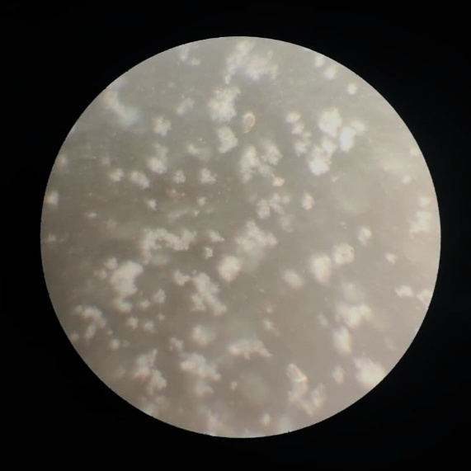 b.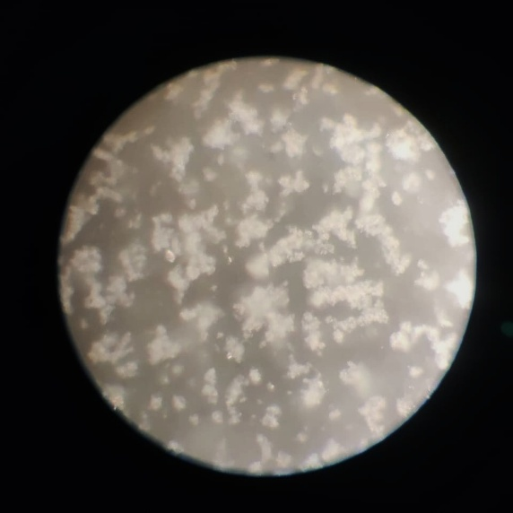
c.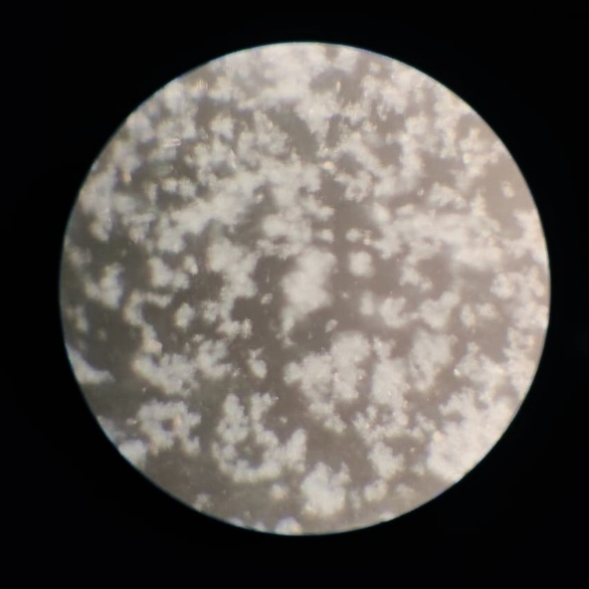
Polymerase Chain Reaction
Fourteen of the 26 confirmed cases (53.9%) yielded a 790 bp amplicon specific to pathogenic Leptospira. The assay targeted the lipL32 gene, a well-established pathogenic marker of Leptospira spp. (Sykes et al., 2011). Despite its recognised diagnostic value, the sensitivity of PCR is influenced by several factors, including bacterial load, the stage of infection at the time of sampling, and the presence of inhibitors in clinical specimens. These limitations may account for the moderate performance observed. Our findings corroborated with earlier reports indicating that PCR was particularly valuable during the early leptospiraemic phase, but its diagnostic reliability diminishes in later stages due to bacterial clearance (Levett, 2001; Sykes et al., 2011).
Plate 2 : The results for PCR: Lane 1 depicts 100 bp ladder. Lane 2 and 3: Positive and negative control. Lane 4,5 and 6: Positive samples
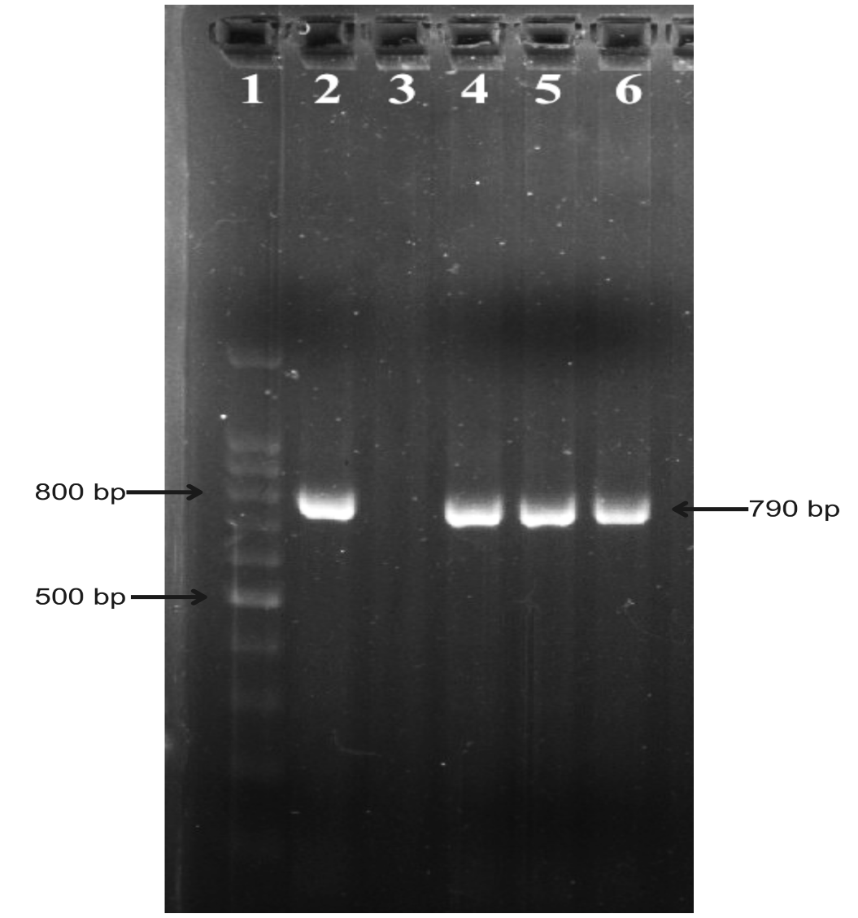

Loop-mediated isothermal amplification
Twenty-three of the 26 confirmed samples (88.5%) tested positive by the LAMP assay. Positive reactions were characterised by a distinct colour change from deep pink to salmon pink or yellow, and the amplification products displayed the typical ladder-like pattern on agarose gel electrophoresis.
The loop-mediated isothermal amplification (LAMP) assay demonstrated superior diagnostic performance compared with both MAT and PCR. The rapid amplification process, straightforward visualisation of results, and methodological robustness highlight its potential as a practical tool for field-level diagnosis of leptospirosis. Comparable findings have been reported by Chen et al. (2015) and Suwanchareon et al. (2016), who similarly observed enhanced sensitivity of LAMP relative to conventional diagnostic assays, thereby reaffirming its diagnostic value.
Plate 3 : The results for LAMP assay were : Lane 1-5: positive results. Lane 6 and 7: positive and negative controls.
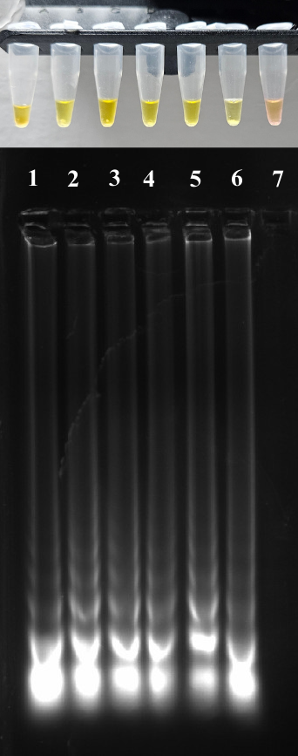
Cohen’s kappa statistics
A summary of the performance of various diagnostic tests was depicted in table 3. On comparison of PCR with MAT kappa statistics revealed a score of 0.52, indicative of moderate agreement between the tests, while the comparison of LAMP with MAT revealed a score of 0.28, indicative of fair agreement between the tests. The comparison of LAMP with PCR revealed a score of 0.63, indicative of substantial agreement between the tests.
PCR and MAT exhibited moderate agreement (κ = 0.52), while LAMP and MAT showed only fair agreement (κ = 0.28), underscoring the limitations of MAT in acute infections. In contrast, the substantial agreement observed between LAMP and PCR (κ = 0.63) highlights the consistency of molecular methods and confirms that LAMP can reliably complement PCR.
Table 3. Performance of MAT, PCR, and LAMP in the diagnosis of Leptospirosis
MAT (+)  PCR (+)  LAMP (+) | MAT (+)  PCR (-)  LAMP (-) | MAT (-)  PCR (+)  LAMP (+) | MAT (-)  PCR (-)  LAMP (+) | MAT (-)  PCR (-)  LAMP (-) | TOTAL
3 | 3 | 11 | 9 | 26 | 52

ROC analysis
ROC analysis showed the highest accuracy for LAMP (AUC = 0.94), followed by PCR (AUC = 0.77), while MAT had lower accuracy (AUC = 0.62). The results are depicted in Figure 1.
Receiver operating characteristic (ROC) analysis reinforced the observations of kappa statistics. LAMP achieved the highest diagnostic accuracy (AUC = 0.94), followed by PCR (AUC = 0.77), whereas MAT exhibited lower accuracy (AUC = 0.62). Collectively, these findings demonstrate that molecular assays, particularly LAMP, provide superior diagnostic performance over serology and are more dependable for early detection of leptospirosis in dogs.

Figure 2. ROC curve for different diagnostic tests for leptospirosis
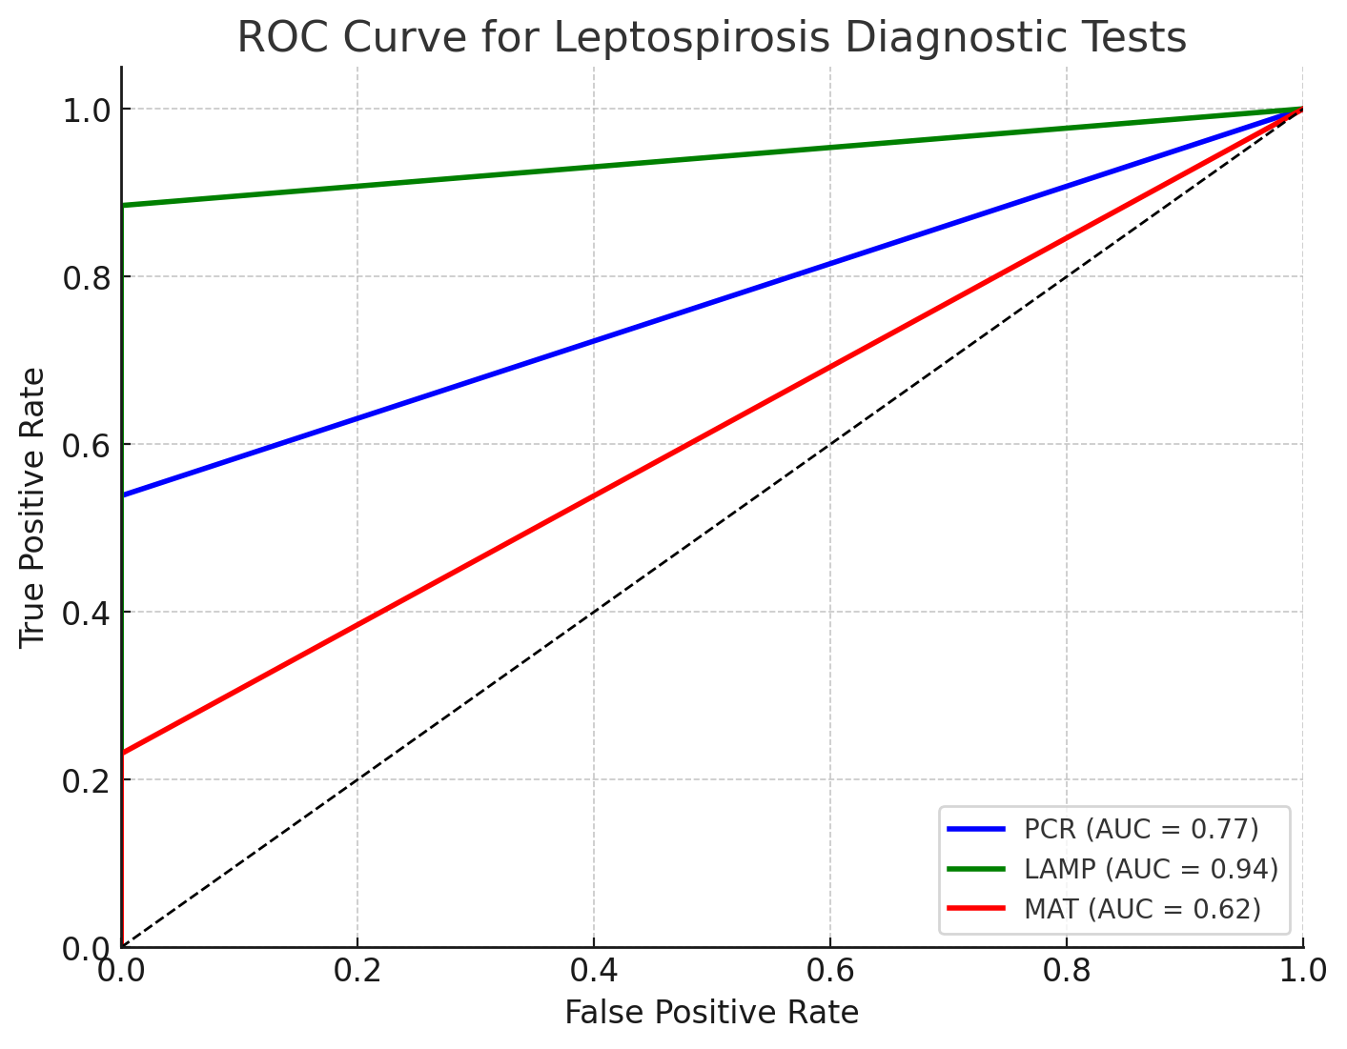

Interpretation of Diagnostic Discordance
The observed discordance underscores the strengths and limitations of each assay type. Molecular assays (PCR and LAMP) target leptospiral DNA, identifying infection at early or acute stages, whereas MAT detects antibodies produced in later stages of infection. LAMP had higher sensitivity than PCR, likely due to its amplification efficiency and tolerance to inhibitors and it agreed with previous reports. The presence of MAT-positive but molecular-negative cases indicated the natural decline of leptospiral DNA as immune clearance progressed, with antibodies persisting longer.
Implications for Clinical Diagnostics
The findings advocate combined use of molecular and serological tests to improve case detection throughout the infection timeline. While LAMP was useful for rapid molecular screening with superior sensitivity, MAT would be useful sero-epidemiological surveillance and confirmation of cases in convalescent phases. Efforts should focus on integrating test platforms in diagnostic algorithms tailored to clinical presentation and infection stage.
CONCLUSION
This study demonstrated that among dogs suspected of leptospirosis, LAMP assay provided higher detection rates compared to PCR and MAT, but concordant results across all modalities remain limited. The diagnostic discordance highlighted distinct infection phases and assay capabilities. Combined molecular and serological testing could be recommended for diagnostic accuracy, guiding timely and appropriate management in veterinary settings.

Disclaimer (Artificial intelligence)
Option 1:
Author(s) hereby declare that NO generative AI technologies such as Large Language Models (ChatGPT, COPILOT, etc.) and text-to-image generators have been used during the writing or editing of this manuscript.
Option 2:
Author(s) hereby declare that generative AI technologies such as Large Language Models, etc. have been used during the writing or editing of manuscripts. This explanation will include the name, version, model, and source of the generative AI technology and as well as all input prompts provided to the generative AI technology

REFERENCES
Faine, S., Adler, B., Bolin, C. and Perolat, P. 1999. Leptospira and Leptospirosis, 2nd ed., MediSci, Melbourne.
Weil, A. (1886). Ueber eine eigentümliche, mit Milztumor, Icterus und Nephritis einhergehende acute Infektionskrankheit. Deutsches Archiv für klinische Medizin, 39, 209–232.
Llanes, A, Carlos M. R. and Sreekumari R. 2016. "Whole genome sequencing allows better understanding of the evolutionary history of Leptospira interrogans serovar Hardjo." PloS one 11: 0159387.
Esteves, S. B., Santos, C. M., Silva, B. C. S., Salgado, F. F., Guilloux, A. G. A., Cortez, A., Lucco, R. C., & Miotto, B. A. (2023). Time for change? A systematic review with meta-analysis of leptospires infecting dogs to assess vaccine compatibility in Brazil. Preventive veterinary medicine, 213, 105869. https://doi.org/10.1016/j.prevetmed.2023.105869
Sykes, J. E., Francey, T., Schuller, S., Stoddard, R. A., Cowgill, L. D., & Moore, G. E. (2023). Updated ACVIM consensus statement on leptospirosis in dogs. Journal of veterinary internal medicine, 37(6), 1966–1982. https://doi.org/10.1111/jvim.16903
Ciurariu, E., Prodan-Barbulescu, C., Mateescu, D. M., Tutac, P., Sorop, V. B., Susan, M., & Varga, N. I. (2025). Diagnostic Advances in Leptospirosis: A Comparative Analysis of Paraclinical Tests with a Focus on PCR. Microorganisms, 13(3), 667. https://doi.org/10.3390/microorganisms13030667
Warnasekara, J., Srimantha, S., Kappagoda, C., Jayasundara, D., Senevirathna, I., Matthias, M., Agampodi, S., & Vinetz, J. M. (2022). Diagnostic method-based underestimation of leptospirosis in clinical and research settings; an experience from a large prospective study in a high endemic setting. PLoS neglected tropical diseases, 16(4), e0010331. https://doi.org/10.1371/journal.pntd.0010331
Wang, W., Gao, Y., Ji, J., Huang, Z., Xiong, B., & Xiang, S. (2025). Trends and advances in Leptospira, a bibliometric analysis. Frontiers in microbiology, 15, 1514738. https://doi.org/10.3389/fmicb.2024.1514738
Williams C (2025). A Novel Loop-Mediated Isothermal Amplification (LAMP) Assay for the Detection of Leptospira in Febrile Patients. J Infect Dis Diagn. 10:332.
Krishna, S.V., Siju Joseph, S.J., Ambily, R., Mini, M., Liya Anto, L.A. and Mohan, S.G., 2013. Cloning and sequencing of the virulent gene LipL32 of Leptospira interrogans serovar Autumnalis. Vet. World 6: 193-195
Suwancharoen, D., Sittiwicheanwong, B., and Wiratsudakul, A. (2016). Evaluation of loop-mediated isothermal amplification method (LAMP) for pathogenic Leptospira spp. detection with leptospires isolation and real-time PCR. The Journal of veterinary medical science, 78(8), 1299–1302. https://doi.org/10.1292/jvms.15-0702
Levett P. N. (2001). Leptospirosis. Clinical microbiology reviews, 14(2), 296–326. https://doi.org/10.1128/CMR.14.2.296-326.2001
Samrot, A. V., Sean, T. C., Bhavya, K. S., Sahithya, C. S., Chan-Drasekaran, S., Palanisamy, R., Robinson, E. R., Subbiah, S. K., and Mok, P. L. (2021). Leptospiral Infection, Pathogenesis and Its Diagnosis-A Review. Pathogens (Basel, Switzerland), 10(2), 145. https://doi.org/10.3390/pathogens10020145
Ambily, R., Mini, M., Joseph, S., Abhinay, G., and Saseendranath, M. R. (2013). Seroprevalence of leptospirosis among dogs in Kerala. Journal of Veterinary and Animal Sciences, 44(1), 47–49.
Raj, J., Campbell, R., and Tappin, S. (2021). Clinical findings in dogs diagnosed with leptospirosis in England. The Veterinary record, 189(7), e452. https://doi.org/10.1002/vetr.452
Jayasundara, D., Gamage, C., Senavirathna, I., Warnasekara, J., Matthias, M. A., Vinetz, J. M., & Agampodi, S. (2021). Optimizing the microscopic agglutination test (MAT) panel for the diagnosis of Leptospirosis in a low resource, hyper-endemic setting with varied microgeographic variation in reactivity. PLoS neglected tropical diseases, 15(7), e0009565. https://doi.org/10.1371/journal.pntd.0009565
Sykes, J. E., Hartmann, K., Lunn, K. F., Moore, G. E., Stoddard, R. A., and Goldstein, R. E. (2011). 2010 ACVIM small animal consensus statement on leptospirosis: diagnosis, epidemiology, treatment, and prevention. Journal of veterinary internal medicine, 25(1), 1–13. https://doi.org/10.1111/j.1939-1676.2010.0654.x
Chen, H.-W., Weissenberger, G., and Ching, W.-M. (2015). Development of lyophilized loop-mediated isothermal amplification reagents for the detection of Leptospira. Military Medicine, 181(5 Suppl), 227–231. https://doi.org/10.7205/MILMED-D-15-00149

