Original Research Article
ADVANCEMENT OF IN VITRO REGENERATION AND BIOLISTC GENETIC TRANSFORAMTION TECHNIQUES IN TOMATO CV. ANAND ROMA (Solanum lycopersicum L.)

ABSTRACT

Tomato (Solanum lycopersicum L.) an important Solanaceae crop which was genetically transformed via particle bombardment using cotyledon explants of cv. Anand Roma. An efficient regeneration protocol was optimized through sequential media combinations and resulting in enhanced callus, shoot, and root induction. The MS9 (0.5 mg/L IAA and 1.5 mg/L Zeatin), MSE6 (0.5 mg/L IAA and 1.0 mg/L BAP), RM8 (2 mg/L IBA with half-strength MS media) media combination was found most effective and supporting for early callus induction, maximum shoot regeneration (4.90 shoots/plants), and highest rooting efficiency (84.51%). Among 248 bombarded explants, 127 survived selection on 10 mg/mL hygromycin, of which 107 (84.20%) formed callus, 65 (60.74%) regenerated shoots and 37 (56.92%) developed roots. Ultimately, 27 plantlets survived acclimatization and were confirmed as putative transgenic through PCR amplification of the hptII gene representing a total transformation efficiency of 10.88%. These results highlight the robustness of particle bombardment for stable gene transfer in tomato providing a reliable platform for functional genomics, trait improvement and crop biotechnology particularly in cultivars with limited Agrobacterium susceptibility.
Key words: Growth regulators, Anand Roma, Regeneration, Genetic Transformation, Particle Bombardment

1. INTRODUCTION
The solanaceae family comprising nearly 3000-4000 species across about 90 genera includes tomato as one of its most economically important members. Initially placed in Solanum by Linnaeus (1753) and later in Lycopersicon by Miller (1754) based on anther morphology and its taxonomic position remained debated for centuries. However, integrative evidence from both morphology and molecular phylogenetics has firmly reinstated tomato within the genus Solanum (Peralta et al., 2008). Tomato (Solanum lycopersicum L.) is the second most popular dicot and important vegetable plant after potato. Tomato belongs to the family Solanaceae (also known as the nightshade family) having chromosome number of 2n = 2x = 24 and have medium size genome of approximately 782 Mb (Hosmani et al., 2019).
In world, India is the second largest producer (20.7 million metric tonnes) of tomato next to China. In India, tomato ranks third in priority after potato and onion. Top five major tomato growing states are Madhya Pradesh, Andhra Pradesh, Karnataka, Gujarat and Odisha (Anonymous, 2024). Tomato has become a model plant in a wide range of research disciplines including genetics (Chetelat et al., 2000), evolution (Peralta and Spooner, 2005; Moyle, 2008) and reproductive biology. Tomato is a key ingredient in both vegetarian and non-vegetarian dishes. It is rich in Vitamin C, Vitamin B, and β-carotene, and contains lycopene, a powerful antioxidant linked to reduced cancer risk. The fruit also supports health, vitality, and wound healing due to its antibiotic properties (Senapati, 2016). Tomato exhibits significant heterosis for traits such as earliness, yield potential, resistance, and fruit uniformity, making hybrids the preferred choice in high-input cultivation systems. However, the reliance on labour-intensive hand emasculation and pollination poses challenges to large-scale hybrid seed production.
Conversely, plant tissue culture serves as a powerful tool in crop improvement, with micropropagation enabling the rapid multiplication of large numbers of plants within a relatively short time frame (Kumar et al., 2017). Successful in vitro regeneration is influenced by several factors, including the type of explant, genotype, composition of the basal MS medium, choice of gelling agent, concentrations of growth regulators, photoperiod, light quality and intensity, temperature, and the nature of culture vessels and their closures (Reed, 1999). Tomato regeneration is predominantly achieved through the organogenic differentiation of cotyledon, leaf and hypocotyl explants (Compton and Veilleux, 1991). Plant tissue culture serves as a vital tool in biotechnology and provides a platform for genetic transformation (Jamous and Abu-Qaoud, 2015).
Plant genetic transformation is a fundamental approach in modern biotechnology that enables the stable integration of foreign DNA into the host genome (Samal et al., 2018). This technology has revolutionized agricultural biotechnology by facilitating the development of crops with desirable traits including tolerance to biotic and abiotic stresses, enhanced yield potential and improved nutritional quality (Sanagala et al., 2017 and Baltes et al., 2017). Since the first successful demonstration of Agrobacterium-mediated transformation in tobacco cells over three decades ago (De Block et al., 1984) significant progress has been made in developing diverse gene delivery systems. Limitations of Agrobacterium-mediated transformation, particularly host specificity and variable infectivity (Sivamami et al., 2009) have prompted the emergence of several direct gene transfer methods such as electroporation, microinjection, silicon carbide fiber-mediated transformation, chemical methods (PEG), microinjection and particle bombardment (Ozyigit et al., 2020 and Ozyigit, 2020). Among these, Agrobacterium-mediated transformation and particle bombardment remain the most widely adopted and effective strategies for plant genetic engineering (Que et al., 2019).
In the early 1980s, Sanford and colleagues pioneered the biolistic method or biological ballistics to facilitate DNA delivery into plant cells, leading to the first successful demonstration of transient gene expression in onion epidermis using DNA-coated tungsten particles (Sanford et al., 1987). This innovation soon enabled stable transformation in several plant species including soybean, tobacco, maize and was later extended to organelle transformation in chloroplasts and mitochondria. Particle bombardment has since become a versatile alternative to Agrobacterium-mediated transformation particularly for recalcitrant species by enabling direct DNA transfer into a wide range of plant tissue. The development of this method represented a major advancement in plant biotechnology, significantly broadening the scope of genetic transformation (Ozyigit and Kurtoglu, 2020).
The objective of this study was to develop an efficient regeneration protocol through optimized through sequential media combinations and resulting in enhanced callus, shoot, and root induction and to establish a reliable genetic transformation system of the pAAU vector in tomato (cv. Anand Roma) via particle bombardment using callus induction from cotyledon explants. This work aims to enhance transformation efficiency and provide a robust platform for functional genomics and crop improvement studies in tomato.
2. MATERIALS AND METHODS
2.1 Plant Materials
The present research work was conducted at Central of Excellence in Biotechnology, Anand Agricultural University, Anand, Gujarat, India. The seeds of Anand Roma variety from the Main Vegetable Research Station, Anand Agricultural University, Anand, Gujarat, India. The procured seeds were sterilized using 5% (V/V) Tween-20 solution for 10 min, followed by Bavistin (150 mg in 100 mL sterile distilled water) for 15 min, immersion in 70% ethanol for 1 min and then 0.4% sodium hypochlorite solution (in 100 mL) for 5 min. After each treatment step, seeds were immediately rinsed 3-4 times with sterile Milli-Q water to remove residual chemicals.
2.2 Media Composition for Regeneration in Anand Roma
Sterile tomato seeds were cultured on half-strength Murashige and Skoog (MS) medium (Cat No. PT114, HiMedia) with vitamins, sucrose and CleriGel™, adjusted to pH 5.8 before autoclaving. Seeds were incubated in the dark at 28°C until radicle emergence (3-4 days) and later maintained under a 16/8 h light/dark cycle at 25°C using cool white LED light. For shoot induction, cotyledonary explants from 12 days old seedlings were excised under aseptic conditions, dissected to remove cotyledonary nodes and distal portions, and placed adaxially on MS medium with B5 (Cat No. M0231, Duchefa) supplemented with vitamins, CleriGel™, and various plant growth regulators [IAA and Zeatin (Cat No. Z0917, Duchefa)] (Table 1). Regeneration parameters such as days to callus induction and callusing percentage were recorded. Regenerated shoots were multiplied on MS medium with B5 vitamins, sucrose, CleriGel™, and different plant growth regulator (IAA and BAP) concentrations (Table 1), and data on number of shoots per explant and shoot length were collected. For rooting, elongated shoots were transferred to full or half-strength MS medium with B5 vitamins, sucrose, CleriGel™, and varying concentrations of IBA (Table 1) The root regeneration efficiency along with per cent mortality were assessed. Stock solutions of various growth hormones and antibiotics were filter sterilized using 0.22 µm nylon syringe filters and added to the media after autoclaving.
2.3 Particle Bombardment
2.3.1 Preparation of target explants
Cotyledon leaves from 12-16 days old seedlings were used as explants. Prior to bombardment, explants were pre-cultured on osmotic medium (MS medium supplemented with 0.2 M sorbitol and 0.2 M mannitol with 7% agarose) for 2 h and retained for an additional 2 days post-bombardment to enhance transformation efficiency (Vain et al., 1993).
2.3.2 Preparation of tungsten microcarriers
Tungsten particles (30 mg) were washed sequentially with ethanol and sterile water, followed by suspension in 50% glycerol. The prepared stock was stored at -20°C for up to 6 weeks without loss of efficiency.
2.3.3 DNA coating of tungsten particles
Plasmid DNA (pAAU) was adsorbed onto tungsten particles using 2.5 M CaCl₂ and freshly prepared 100 mM spermidine. The suspension was vortexed, precipitated on ice and stored until bombardment. Each preparation was sufficient for 5-6 bombardments.

Table 1. Composition of different culture media used for callus and shoot induction, shoot multiplication and, root induction
Callus and Shoot Induction |  |  |  | Shoot Multiplication and Elongation |  |  | Root Induction
Sr. No. | Medium Code | Combination of plant growth regulators (mg/L) |  | Medium Code | Combination of plant growth regulators (mg/L) |  | Medium Code | Combination of plant growth regulators (mg/L)
Sr. No. | Medium Code | IAA | Zeatin | Medium Code | IAA | BAP | Medium Code | Combination of plant growth regulators (mg/L)
1 | MS1 | 0.2 | 1.0 | MSE1 | 0.2 | 0.5 | RM1 | Full strength MS media + 0.5 mg/L IBA
2 | MS2 | 0.3 | 1.0 | MSE2 | 0.3 | 0.5 | RM2 | Full strength MS media + 1.0 mg/L IBA
3 | MS3 | 0.5 | 1.0 | MSE3 | 0.5 | 0.5 | RM3 | Full strength MS media + 1.5 mg/L IBA
4 | MS4 | 0.2 | 1.5 | MSE4 | 0.2 | 1.0 | RM4 | Full strength MS media + 2.0 mg/L IBA
5 | MS5 | 0.3 | 1.5 | MSE5 | 0.3 | 1.0 | RM5 | Half strength MS media + 0.5 mg/L IBA
6 | MS6 | 0.5 | 1.5 | MSE6 | 0.5 | 1.0 | RM6 | Half strength MS media + 1.0 mg/L IBA
7 | MS7 | 0.2 | 2.0 | MSE7 | 0.2 | 1.5 | RM7 | Half strength MS media + 1.5 mg/L IBA
8 | MS8 | 0.3 | 2.0 | MSE8 | 0.3 | 1.5 | RM8 | Half strength MS media + 2.0 mg/L IBA
9 | MS9 | 0.5 | 2.0 | MSE9 | 0.5 | 1.5 | RM8 | Half strength MS media + 2.0 mg/L IBA
10 | MS10 | 0.2 | 2.5
11 | MS11 | 0.3 | 2.5
12 | MS12 | 0.5 | 2.5
IAA = Indole-3-acetic acid (Cat No. I0901, Duchefa), BAP = 6-benzylaminopurine (Cat No., B0904, Duchefa), IBA = Indole-3-butaric acid (Cat No. I0902, Duchefa)
2.3.4 Particle bombardment procedure
Bombardment was performed in a vacuum chamber sterilized with 80% ethanol. DNA-coated tungsten particles were accelerated using helium gas at 12 kg/cm², with explants positioned 15 cm below the filter holder (Gene Pro 2000 He, Bio-Rad). The particles penetrated cotyledon tissue and bombarded explants were maintained on osmotic medium for 2 days in dark place before transfer to selective regeneration medium (SRM) containing antibiotic (10 mg/L Hygromycin) as selection marker for selection of transformed plants.
2.3.5 Plant regeneration and acclimatization
Explants were sequentially cultured on callus induction, shoot induction, elongation, and rooting media containing selective (hygromycin) agent. Putative transgenic shoots with established roots were transferred to cocopeat moistened with half-strength MS medium and maintained under polythene covers for primary hardening. The transformation efficiency was recorded and calculated. Subsequently, plantlets were transferred to greenhouse conditions for secondary hardening and growth.
2.4 Confirmation of Putative Transgenic Plants
Regenerated tomato plantlets were initially hardened in plastic pots containing cocopeat and later transferred to soil after the development of sufficient secondary roots. Well-established T₀ plants were subsequently maintained under containment conditions in a transgenic greenhouse. Genomic DNA was extracted from young leaves of putative transgenic plants using the CTAB method with minor modifications (Doyle, 1990). PCR amplification was performed using hptII (Hygromycin Phosphotransferase II) gene-specific primers to confirm the integration of the transgene. Each 25 µl PCR reaction consisted of 1µL template DNA (100 ng/µL), 12.5 µL CloneAmp HiFi PCR master mix (2×; Cat No. 639298, Takara), 1.25 µl of each primer (10 pmol: forward; 5’ TTCTTTGCCCTCGGACGAGTG 3’ and reverse; 5’ ACAGCGTCTCCGACCTGATG 3’ primers), and 9 µL nuclease free water. Amplification was carried out with the following thermal cycling profile: initial denaturation at 98°C for 5 min; 35 cycles of denaturation at 95°C for 45 sec, annealing at 58°C for 50 sec, and extension at 72°C for 1 min and 30 sec; followed by a final extension at 72°C for 10 min. The PCR products were electrophoresed on a 1.5% agarose gel (stained with 1 mg/10 mL ethidium bromide solution) alongside a 1 Kb DNA ladder.
2.5 Statistical Analysis
Statistical data analysis was carried for various parameters namely, Days to callus induction, callusing percentage, number of shoots, shoots length, percent rooting and per cent mortality using CRD design with four replications of experiment (Fisher, 1935) for in vitro grown plants. The transformation efficiency was carried out for in vitro grown transformed tomato plants.
3. RESULTS AND DISCUSSION
3.1 Callus Induction
Significant variation was observed in the response of cotyledon explants to different media combinations (Table 2). The number of days required for callus initiation ranged from 11.00 (MS9) to 17.00 days (MS1), indicating that medium composition strongly influenced morphogenic response (Fig 1). The highest percentage of callus induction (90.43%) was recorded on MS9 medium, followed by MS6 (84.51%), while the lowest (55.35%) was observed on MS10. (Fig 2A). These findings suggest that optimized growth regulator combinations enhance explant competence, in agreement with earlier reports in tomato and other solanaceous crops (Sun et al., 2015; Sharma et al., 2017 and Sandhya et al., 2022).
3.2 Shoot Induction and Multiplication
The efficiency of shoot induction also varied with media formulations. The maximum number of shoots per explant (4.90) with an average shoot length of 4.26 cm was obtained on MSE6 medium, followed by MSE5 (3.33 shoots, 3.76 cm) (Table 2). In contrast, MSE1 supported only 0.24 shoots with an average length of 0.60 cm (Fig 2B). This indicates that specific cytokinin-auxin ratios are critical for shoot morphogenesis (Fig 1). Comparable results were reported by Van Eck et al. (2006), who emphasized that explant age and hormonal balance strongly influence regeneration frequency in tomato. The other studies also reported (Pawar et al., 2012; Gerszberg et al., 2016 and Sharma et al., 2021) that the BAP is very crucial for the shoot induction and multiplication of the tomato regeneration.
3.3 Rooting Response
Root induction studies revealed that the highest rooting percentage (84.51%) was achieved on RM8 medium, followed closely by RM7 (80.20%) (Fig 2C). In contrast, RM6 exhibited the medium rooting efficiency (75.16%) and with moderate mortality (73.30%) (Table 2). This suggests that auxin type and concentration play a decisive role in root induction and plant survival, corroborating earlier observations in tomato regeneration studies (Gubis et al., 2004; Bhutia et al., 2018).

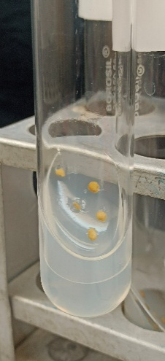  (A) | 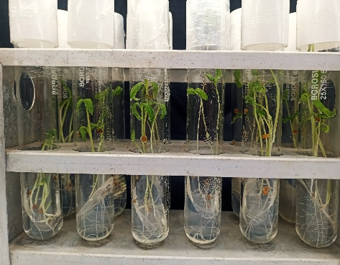  (B) | 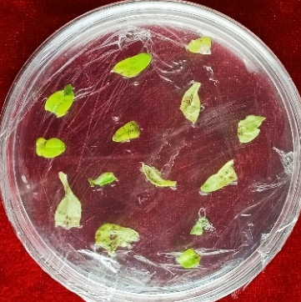  (C)
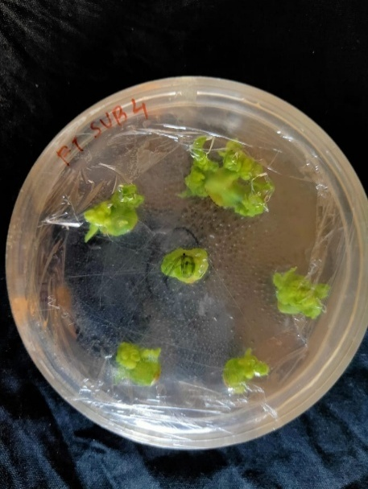(D) | 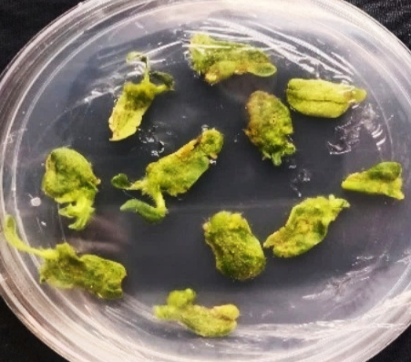  (E) | 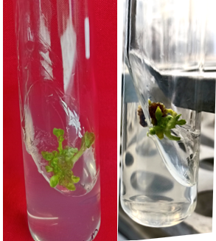  (F)
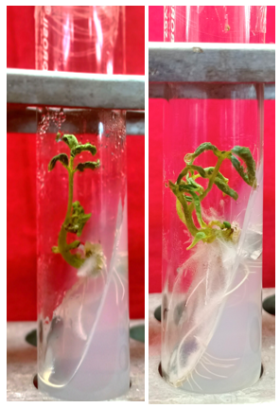  (G) | 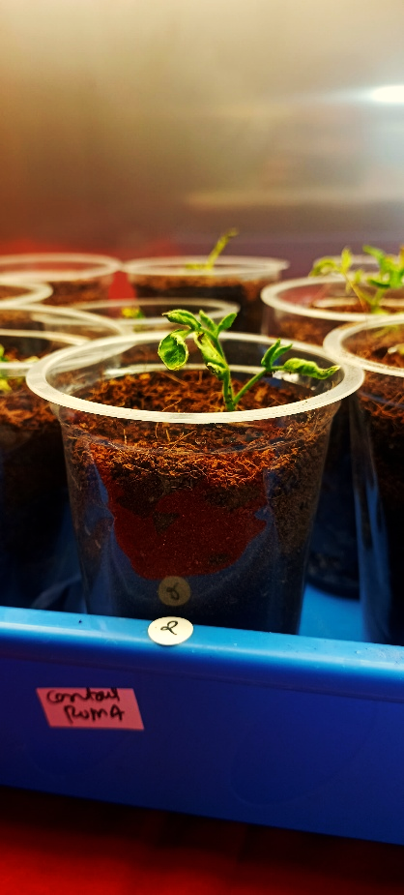  (H) | 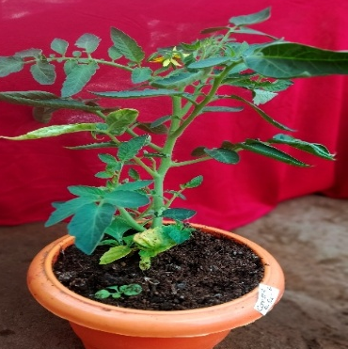  (I)
Fig 1. In vitro regeneration of cotyledonary explants in different MS media (A) & (B) In vitro seed inoculation and germination of tomato cv. Anand Roma (C) Cotyledonary explants in callus induction medium supplemented with IAA and Zeatin (D) Callus formation after 25-30 days of explants inoculation (E) Shoot bud formation (F) Shoot multiplication and elongation (G) Rooting of well-developed shoots (H) Primary hardening of tomato plants (I) Secondary hardening of tomato plants in green house
3.4 Overall Regeneration Efficiency
Among the tested treatments, the MS9 (0.5 mg/L IAA and 1.5 mg/L Zeatin), MSE6 (0.5 mg/L IAA and 1.0 mg/L BAP), RM8 (2 mg/L IBA with half-strength MS media) combination proved most effective, supporting early callus induction (11.00 days), the highest shoot regeneration (4.90 shoots/explant), longest shoot length (4.26 cm), and superior rooting efficiency (84.51%). This indicates that optimized sequential media formulations enhance overall regeneration efficiency, thereby providing a reliable platform for particle bombardment-mediated genetic transformation in tomato.

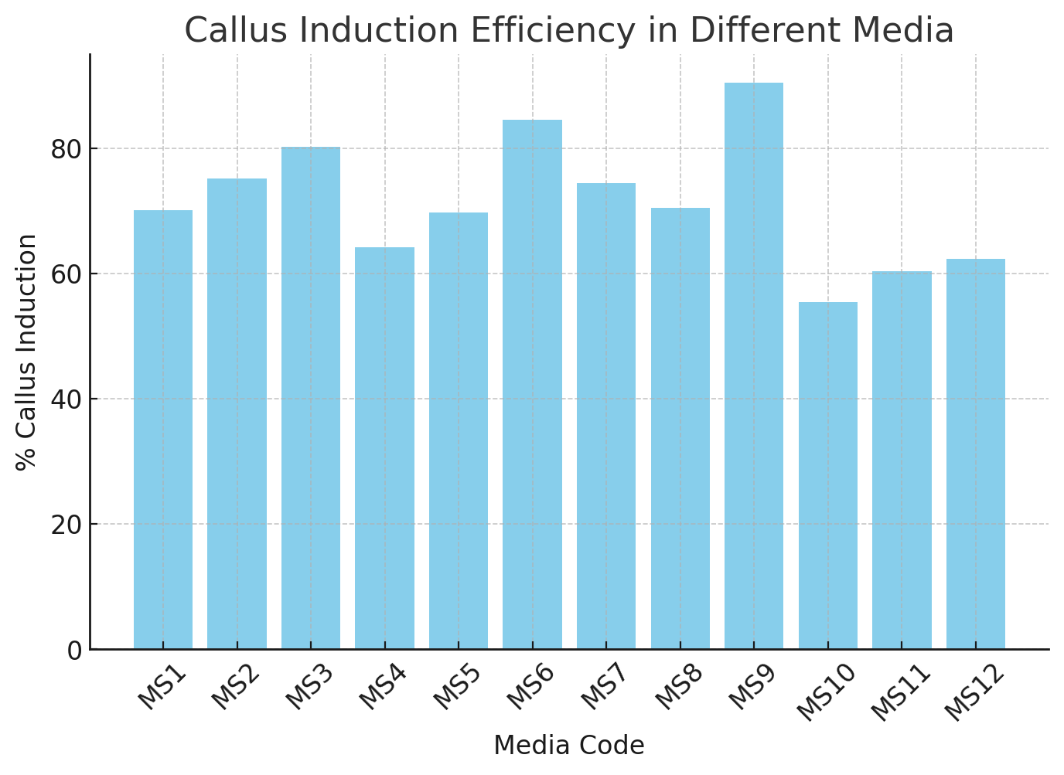 | 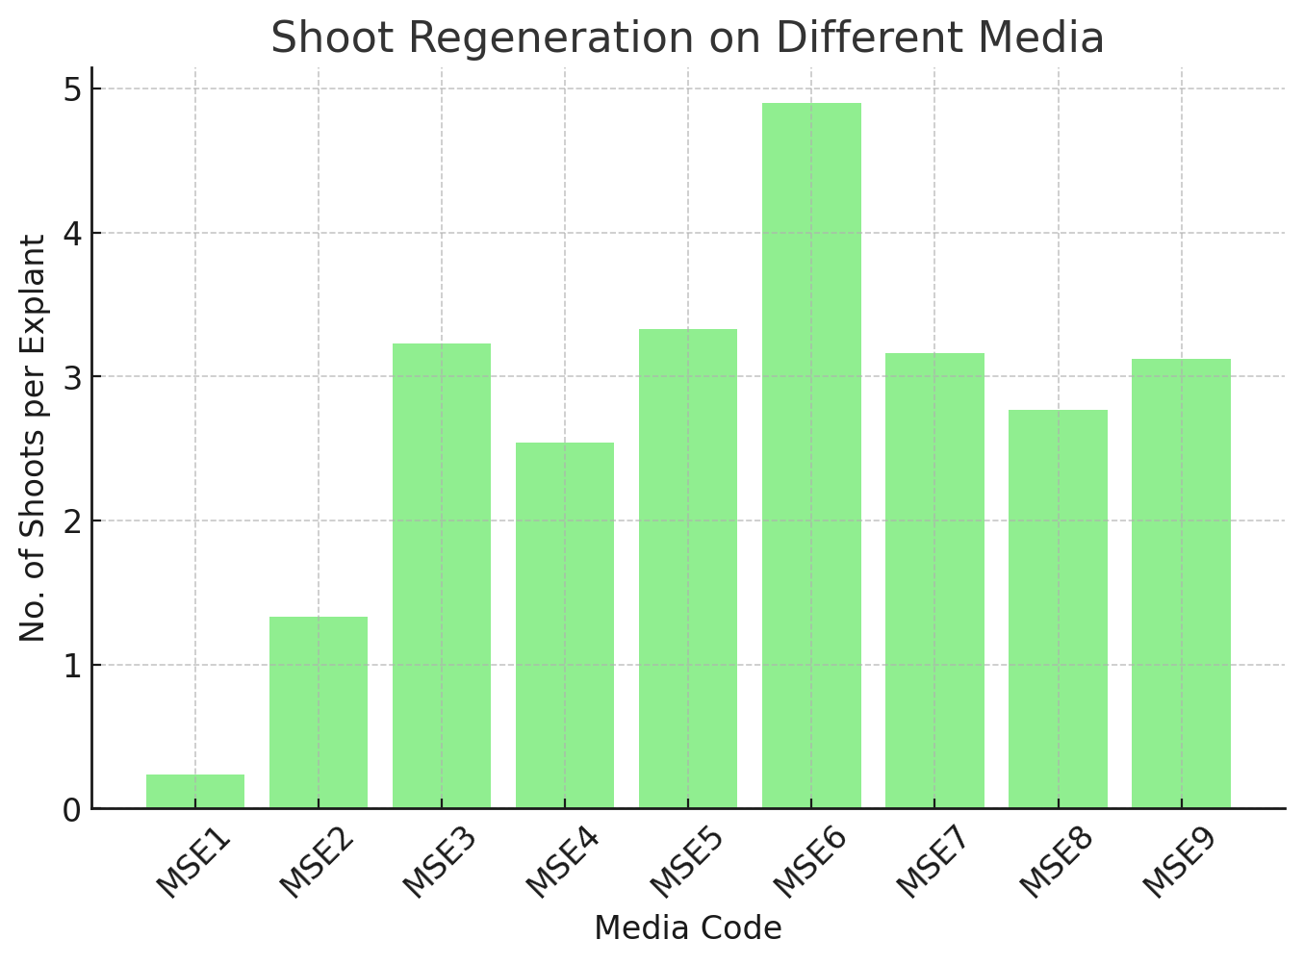
(A) | (B)
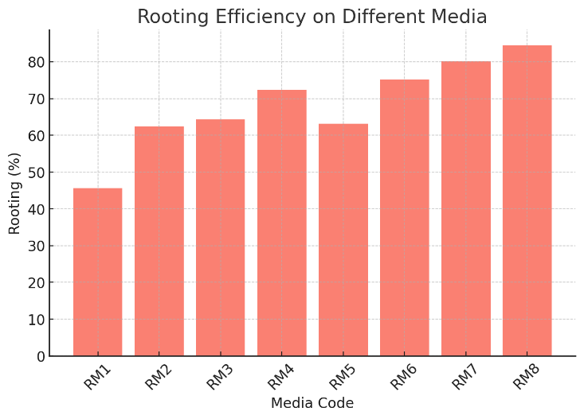
(C)
Fig 2. In vitro regeneration response of tomato cotyledon explants under different media combinations (A) Callus induction efficiency (B) Shoot regeneration and (C) Rooting efficiency
3.5 Regeneration Efficiency of Tomato (cv. Ananad Roma) Under Particle Bombardment-Mediated Genetic Transformation
The efficiency of particle bombardment-mediated genetic transformation in tomato cotyledon explants is summarized in Table 3. A total of 248 explants were subjected to bombardment, of which 127 explants (51.20%) survived the initial selection on hygromycin (10 mg/L), indicating successful resistance marker expression. Among these, 107 explants (84.20%) formed callus, 65 (60.74%) regenerated shoots, and 37 (56.92%) successfully developed roots (Fig 3). Ultimately, 27 plantlets survived acclimatization and were confirmed as putative transgenics, representing a transformation efficiency (TE) of 72.97% at the final stage and an overall total transformation efficiency (ToE) of 10.88% Table 3).
The progressive decline in explant numbers from selection to survival reflects the multiple bottlenecks inherent in biolistic transformation, including tissue damage during bombardment, variable DNA uptake, and stress from hygromycin selection. Similar observations have been reported in tomato, where particle bombardment typically yields transformation frequencies ranging between 3-12% depending on cultivar, explant type, and culture conditions (McCormick, 1991; Van Eck et al., 2006; Ramesh et al., 2004). The ToE value obtained in this study (10.88%) falls within the upper range of previously published reports, highlighting the robustness of the protocol developed for cv. Anand Roma.
Notably, the high callus induction frequency (84.20%) and shoot regeneration rate (60.74%) demonstrate that cotyledon explants are highly responsive to in vitro regeneration following osmotic pretreatment and selective pressure. This suggests that optimization of factors such as particle size, helium pressure, and selective agent concentration could further improve the recovery of stable transformants. These findings confirm that particle bombardment, while less commonly applied than Agrobacterium-mediated transformation due to relatively high costs and tissue damage, remains a valuable method for stable gene transfer in tomato, particularly in cultivars or experimental contexts where Agrobacterium susceptibility is low.
3.5 Molecular Analysis of Transformed Tomato Plants
Genomic DNA was extracted from leaves of both putative T₀ tomato transformants and non-transformed wiled type control plants. DNA concentrations ranged from 550-650 ng/µL in transformants and 520-700 ng/µL in controls, confirming sufficient quality and quantity for used in molecular analysis. Samples were standardized to 100 ng/µL for uniform PCR input. PCR using hptII gene specific primers confirmed the presence of the transgene in hygromycin-resistant plants. In the particle bombardment-mediated transformation experiment, a total of 37 putative transgenic tomato plants were successfully rooted. All regenerated plants, along with non-transformed control plants, were screened by PCR for the presence of the hptII gene, which served as a selectable marker (hygromycin resistance). Among the 37 plants derived from cotyledon explants, 27 were confirmed positive for the hptII gene, indicating successful transgene integration. No amplification was observed in the non-transformed control plants. The results of the PCR analysis for the hptII gene are shown in Fig 4.

(A) | 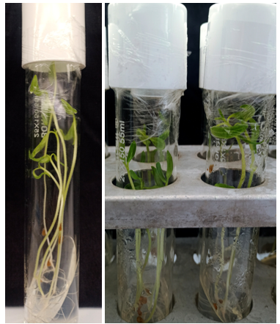  (B) | 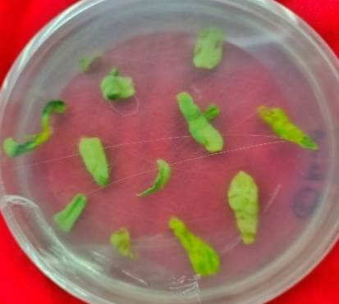  (C) | 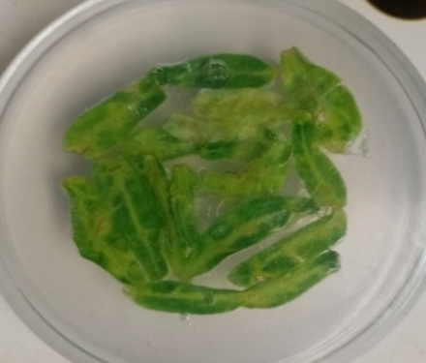  (D) | 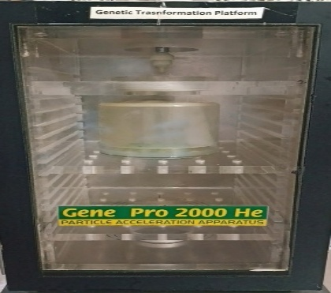  (E)
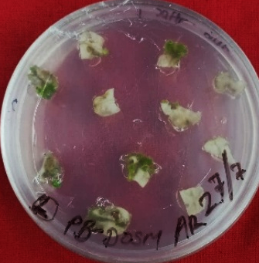  (F) | 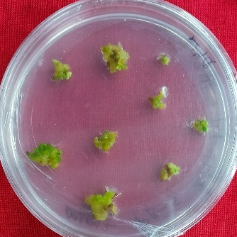  (G) | 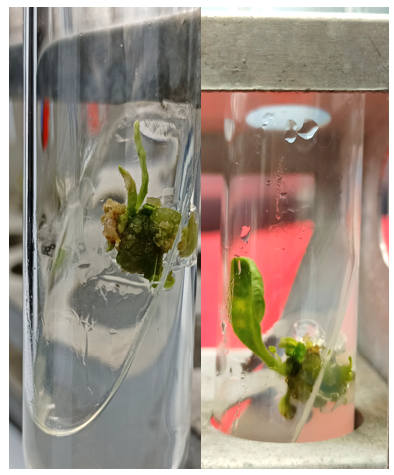  (H) | 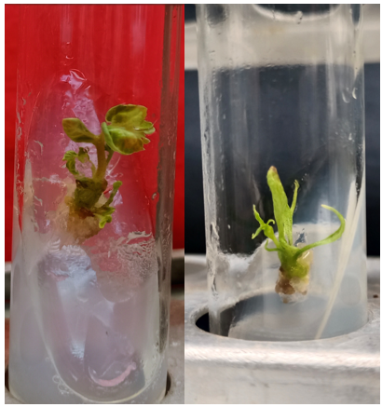  (I) | 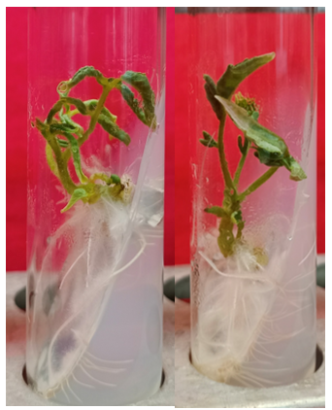 (J)
 | 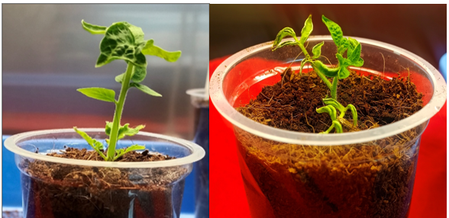  (K) |  | 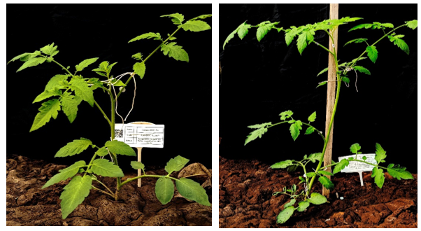  (L)
Fig 3. Particle bombardment-mediated genetic transformation in tomato (A) & (B) In vitro seed inoculation and germination of tomato (C) MS media supplemented with sucrose (D) MS media with osmotic medium (E) Particle Bombardment equipment (F) Response of explant on selection media (G) Survival of transformed explant (H) Shoot formation and multiplication (I) Well-developed shoot (J) Rooting of well-developed shoot (K) Primary hardening of transformed tomato plants (I) Secondary hardening of transformed tomato plants in green hou
Table 2. In vitro response of tomato cotyledon on different media combinations
Sr. No. | Media Code for Callus | Days to Callus induction | % Callus induction | Media Code for shoot induction | No. of shoots | Shoot length (cm) | Media Code for Rooting | Rooting (%) | Mortality (%)
1 | MS1 | 17.00 | 70.13 | MSE1 | 0.24 | 0.60 | RM1 | 45.59 | 50.35
2 | MS2 | 16.75 | 75.18 | MSE2 | 1.33 | 1.55 | RM2 | 62.48 | 55.75
3 | MS3 | 13.00 | 80.20 | MSE3 | 3.23 | 3.08 | RM3 | 64.25 | 64.25
4 | MS4 | 15.00 | 64.18 | MSE4 | 2.54 | 2.40 | RM4 | 72.36 | 72.36
5 | MS5 | 16.00 | 69.75 | MSE5 | 3.33 | 3.76 | RM5 | 63.13 | 62.88
6 | MS6 | 12.00 | 84.51 | MSE6 | 4.90 | 4.26 | RM6 | 75.16 | 73.30
7 | MS7 | 15.00 | 74.45 | MSE7 | 3.16 | 2.26 | RM7 | 80.20 | 80.25
8 | MS8 | 16.25 | 70.43 | MSE8 | 2.77 | 3.20 | RM8 | 84.51 | 83.05
9 | MS9 | 11.00 | 90.43 | MSE9 | 3.12 | 3.58 | RM8 | 84.51 | 83.05
10 | MS10 | 14.00 | 55.35
11 | MS11 | 16.00 | 60.30
12 | MS12 | 15.00 | 62.33
S.Em. |  | 0.11 | 0.20 |  | 0.05 | 0.04 | RM8 | 0.23 | 0.24
CD @ 1% |  | 0.45 | 0.79 |  | 0.20 | 0.19 | RM8 | 0.93 | 0.96
CV% |  | 5.31 | 4.22 |  | 5.37 | 5.20 | RM8 | 4.94 | 5.12

Table 3. Transformation efficiency of tomato cotyledons via particle bombardment
Sr. No. | No. of cotyledon explant used | Selection by Hygromycin | Callus Formation | Shoot formation | Root formation | Plant survived/ positive plant
1 | 87 | 45 | 39 | 25 | 15 | 13
2 | 78 | 42 | 33 | 18 | 12 | 08
3 | 83 | 40 | 35 | 22 | 10 | 06
Total | 248 | 127 | 107 | 65 | 37 | 27
TE | - | 51.20 | 84.20 | 60.74 | 56.92 | 72.97
ToE | - | 51.20 | 43.14 | 26.20 | 14.91 | 10.88
TE= Transformation efficiency, ToE= Total Transformation efficiency
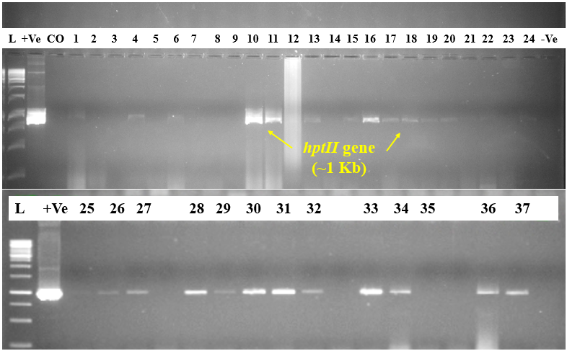
Fig 4. Confirmation of tomato transformants through PCR amplification using hptII gene primer (L = 1Kb DNA ladder, +Ve = Positive control of pAAU plasmid, CO = Anand Roma non-transformed (Control), -Ve = Negative control)
4. CONCLUSION
The study successfully established an efficient regeneration and transformation protocol for tomato cv. Anand Roma using particle bombardment. Optimized hormone combinations markedly improved callus, shoot and root induction with cotyledon explants showing high regeneration potential. The MS9, MSE6 and RM8 media combination was most effective, achieving a transformation efficiency of 10.88%. PCR analysis confirmed stable transgene integration in 27 of 37 plants. These findings highlight particle bombardment as a reliable alternative to Agrobacterium-mediated transformation in tomato.
Declarations
Ethics approval and consent to participate:
Not applicable
Consent for publication:
By submitting this research paper for publication, all authors consent to its dissemination and acknowledge that it has not been previously published nor is it under consideration elsewhere.
Availability of data and material:
The data that has been used is confidential and raw data available as supplementary file.
Declaration of competing interest:
The authors declare that they have no known competing financial interests or personal relationships that could have appeared to influence the work reported in this paper.
Disclaimer (Artificial intelligence)
The authors declare that they have used generative AI technologies for the writing or editing of manuscripts.
Details of the AI usage are given below:
1. Chat GPT – (GPT-5), version 5.1
Details of the AI used in the manuscript are given below:
1. Some writing or grammar was used in introduction part (5-6 sentences).
2. The graph (fig 2) was edited in AI (Chat GPT).

References
Anonymous (2024). National Horticulture Board 2024. www.nhb.gov.in.
Baltes, N. J., Gil-Humanes, J., & Voytas, D. F. (2017) Chapter one - Genome engineering and agriculture: opportunities and challenges. In: Weeks DP, Yang B (eds) Progress in Molecular Biology and Translational Science, vol-149. Academic Press, Cambridge, pp 1–26.
Bhutia, K. L., Pattanayak, A., Mohanty, C. S., & Dash, S. K. (2018). In vitro regeneration of tomato (Solanum lycopersicum L.) using different explants. Journal of Applied and Natural Science, 10(2), 605-609.
Chetelat, R. T., Meglic, V., & Cisneros, P. (2000). A genetic map of tomato based on BC (1) Lycopersicon esculentum, Solanum lycopersicoides reveals overall synteny but suppressed recombination between these homeologous genomes. Genetics, 154, 857-867.
Compton, M. E., & Veillux, R. E. (1991). Shoot, root and flower morphogenesis on tomato inflorescence explants. Plant Cell, Tissue and Organ Culture, 24:223-31.
De Block, M., Herrera-Estrella, L., Van Montagu, M., Schell, J., & Zambryski, P. (1984). Expression of foreign genes in regenerated plants and in their progeny. European Molecular Biology Organization Journal, 3(8):1681.
Doyle, J. J. (1990). Isolation of plant DNA from fresh tissue. Focus, 12, 13-15.
Fisher, R. A. (1935). The Design of Experiments. Oliver & Boyd, Edinburgh.
Gerszberg, A., Hnatuszko Konka, K., Kowalczyk, T., & Kononowicz, A. K. (2016). Efficient in vitro callus induction and plant regeneration protocol for different Polish tomato cultivars. Notulae Botanicae Horti Agrobotanici, 44 (2), 452-458.
Gubis, J., Lajchova, Z., Klcova, L., & Mihalik, D. (2004). Effect of growth regulators on shoot induction and plant regeneration in tomato (Lycopersicon esculentum Mill.). Biology of Plants, 48(2), 209–211.
Hosmani, P. S., Flores-Gonzalez, M., van de Geest, H., Maumus, F., Bakker, L. V., Schijlen, E., & Saha, S. (2019). An improved de novo assembly and annotation of the tomato reference genome using single-molecule sequencing, Hi-C proximity ligation and optical maps. Biorxiv, 767764.
Jamous, F. E. D. A. A., & Abu-Qaoud, H. A. S. S. A. N. (2015). In vitro regeneration of tomato (Lycopersicon esculentum Mill). Plant Cell Biotechnology and Molecular Biology, 16(3-4), 181-190.
Kumar, S., Jindal, S. K., Sarao, N. K., & Dhaliwal, M. S. (2017). Development of an efficient in vitro regeneration protocol in tomato (Solanum lycopersicum L.). Journal of Agricultural Research, 54, 475-479.
Linnaeus, C. (1753). Species plantarum (Vol. 1): Impensis G. C. Nauk (1st ed.), Stockholm.
McCormick, S. (1991). Transformation of tomato with Agrobacterium tumefaciens. In D. G. Lindsey, & B. G. Glick (Eds.), Plant Tissue Culture Manual, (pp. 1–9). Dordrecht: Springer. https://doi.org/10.1007/978-94-009-2075-0_1.
Miller, P. (1754). The Gardener’s dictionary, Abridged 4th Ed. John and James. Rivington, London, UK.
Moyle, L. C., & Nakazato, T. (2008). Comparative genetics of hybrid incompatibility: sterility in two Solanum species crosses. Genetics, 179, 1437-1453.
Ozyigit, I. I., Can, H., & Dogan, I. (2020). Phytoremediation using genetically engineered plants to remove metals: a review. Environmental Chemistry Letters, https://doi.org/10.1007/s10311-020-01095-6.
Ozyigit, I. I., & Yucebilgili Kurtoglu, K. (2020). Particle bombardment technology and its applications in plants. Molecular Biology Reports, 47(12), 9831-9847.
Ozyigit, I. I. (2020). Gene transfer to plants by electroporation: methods and applications. Molecular Biology Reports, 47(4):3195–3210. https://doi.org/10.1007/s1103 3-020-05343 -4.
Pawar, B. D., Jadhav, A. S., Kale, A. A, Chimote, V. P., & Pawar, S. V. (2012). Zeatin induced direct in vitro shoot regeneration in tomato (Solanum lycopersicum L.). The Bioscan, 7 (2), 247-250.
Peralta, I. E., Spooner, D. M., & Knapp, S. (2008). Taxonomy of wild tomatoes and their relatives (Solanum sect. Lycopersicoides, sect. Juglandifolia, sect. Lycopersicon; Solanaceae). Systematic Botany Monographs, 84, 1-186.
Que, Q., Chilton, M. M., Elumalai, S., Zhong, H., & Dong, S. S. (2019). Repurposing macromolecule delivery tools for plant genetic modification in the era of precision genome engineering. Methods in Molecular Biology, 1864:3–18. https://doi.org/10.1007/978-1-4939-8778-8_1.
Ramesh, S. A., Rajasekaran, K., Srinivasan, T., Sundar, A. R., & Veluthambi, K. (2004). Efficient transformation of tomato using particle bombardment. Plant Cell Reports, 22(6), 417–424. https://doi.org/10.1007/s00299-003-0707-0.
Reed, B. M. (1999). Design a micropropagation system, Workshop presentation from the 1998 SIVB Congress on in vitro biology. In Vitro Cellular & Developmental Biology – Plant, 35: 275-84.
Samal, K. C., & Rout, G. R. (2018). Chapter 10 - Genetic improvement of vegetables using transgenic technology. In: Rout GR, Peter KV (eds) Genetic Engineering of Horticultural Crops, Academic Press, Cambridge, pp 193–224.
Sanagala, R., Moola, A. K., & Diana, R. K. B. (2017). A review on advanced methods in plant gene targeting. Journal of Genetic Engineering and Biotechnology, 15(2):317–321. https://doi.org/10.1016/j.jgeb.2017.07.004.
Sandhya, D., Jogam, P., Venkatapuram, A. K., Savitikadi, P., Peddaboina, V., Allini, V. R., & Abbagani, S. (2022). Highly efficient Agrobacterium-mediated transformation and plant regeneration system for genome engineering in tomato. Saudi Journal of Biological Sciences, 29 (6), 103292.
Sanford, J. C., Klein, T. M., Wolf, E. D., & Allen, N. (1987). Delivery of substances into cells and tissues using a particle bombardment process. Particulate Science and Technology, 5(1):27–37.
Senapati, S. K. (2016). A review on research progress on in vitro regeneration and transformation of tomato. Annual Research & Review in Biology, 9(6).
Sharma, M., Pandey, S., & Singh, R. (2017). Standardization of tissue culture protocols in tomato (Solanum lycopersicum L.). International Journal of Pure & Applied Bioscience, 5(6), 140–146.
Sharma, S. K., Rajyaguru, R., Gajera, H. P., Tomar, R. S., Kheni, J., Bhalani, H., & Golakiya, B. A. (2021). Optimization of in vitro regeneration protocol for tomato (Solanum lycopersicon Mill.) cv. Junagadh tomato-3. Journal of Cell and Tissue Research, 21(2), 7081-7090.
Sivamani, E., DeLong, R. K., & Qu, R. (2009). Protamine-mediated DNA coating remarkably improves bombardment transformation efficiency in plant cells. Plant Cell Reports, 28(2):213–221.
Sun, H. J., Uchii, S., Watanabe, S., & Ezura, H. (2015). A highly efficient transformation protocol for micro-tom, a model cultivar for tomato functional genomics. Plant and Cell Physiology, 47(3), 426–431.
Vain, P., McMullen, M. D., & Finer, J. J. (1993). Osmotic treatment enhances particle bombardment-mediated transient and stable transformation of maize. Plant Cell Reports, 12(2), 84–88. https://doi.org/10.1007/BF00241944.
Van Eck, J., Kirk, D. D., & Walmsley, A. M. (2006). Tomato (Lycopersicum esculentum). In K. Wang (Ed.), Methods in Molecular Biology: Agrobacterium Protocols (Vol. 343, pp. 459–473). Totowa, N. J.: Humana Press. https://doi.org/10.1385/1-59745-130-4:459.

