Original Research Article
Incidence and Control Measures of Gumboro Disease in a Native Chicken farm : A Field Study

ABSTRACT
The present investigation was undertaken to characterize and confirm an outbreak of Infectious Bursal Disease (IBD, Gumboro disease) in a native chicken farm housing 800 Aseel birds and to assess the clinical outcome following therapeutic and biosecurity interventions. The outbreak occurred on a native chicken farm in Periyakangangkuppam village, Cuddalore district, Tamil Nadu, India. Affected birds were subjected to detailed clinical observation, and necropsy examinations were performed to record gross pathological lesions. Laboratory confirmation of IBD was achieved using counter-immunoelectrophoresis (CIEP). Supportive treatment consisted of broad-spectrum antibiotics (cephalexin), liver tonics, and strict farm-level biosecurity practices, including disinfection with phenolic compounds. Daily monitoring of clinical progress and mortality patterns revealed that the outbreak was characterized by acute onset of anorexia, depression, ruffled feathers, watery diarrhoea, and high mortality rates. Post-mortem examination revealed pathognomonic lesions, including petechial and ecchymotic haemorrhages in the breast and thigh muscles and swollen, haemorrhagic bursae of Fabricius. Laboratory results confirmed the diagnosis of IBD. Following therapeutic and managemental interventions, a progressive decline in mortality was observed, with marked clinical recovery by the fifth day of treatment. The investigation confirmed IBD as the cause of mortality in the affected flock and demonstrated that prompt therapeutic management combined with stringent biosecurity measures effectively mitigated economic losses. These findings underscore the importance of timely vaccination, strict hygiene protocols, and rapid disease confirmation as critical components in the prevention and control of IBD outbreaks in native poultry production systems.
Keywords: Native Chicken, Infectious Bursal Disease, Biosecurity measures, Vaccination
1. INTRODUCTION
Poultry farming plays a vital role in the livelihood of rural communities in India, particularly through the rearing of native or desi chickens such as Aseel, which are valued for their adaptability, disease resistance and meat quality (Murali and Vimalarani, 2025). However, the intensification of rearing practices in backyard and smallholder poultry systems without parallel implementation of scientific management and disease control practices has increased the vulnerability of these flocks to infectious diseases, particularly viral infections.
One of the most economically important diseases affecting young chickens is Infectious Bursal Disease (IBD), also known as Gumboro disease. IBD is an acute, highly contagious, immunosuppressive disease that affects chickens primarily between the ages of 3 to 6 weeks, although outbreaks have also been recorded in slightly older birds under field conditions (Chitradevi, 2022). The causative agent, Infectious Bursal Disease Virus (IBDV), belongs to the genus Avibirnavirus within the family Birnaviridae. The virus is non-enveloped, double-stranded RNA and its primary target is the bursa of Fabricius, a central organ in the development of the chicken’s humoral immune system (Van den Berg, 2000 and Muller et al., 2003).
The infection leads to severe lymphoid depletion, edema and hemorrhage in the bursa, resulting in profound immunosuppression that predisposes affected birds to secondary bacterial, viral and parasitic infections (Chettle et al., 1989). This immunosuppressive effect also compromises the efficacy of vaccination against other pathogens such as Newcastle disease, infectious bronchitis and Marek’s disease, resulting in compounded losses (Sharma et al., 2000; Eterradossi and Saif, 2019).
IBD is primarily transmitted by the faecal-oral route, and the virus is extremely resistant to environmental conditions, surviving for long periods in contaminated litter, feed, water and fomites. This environmental persistence, along with its short incubation period and rapid spread, contributes to explosive outbreaks in susceptible populations (Girish et al., 2025). Mortality rates can range from 10% to over 80%, depending on factors such as the virulence of the strain, the age and breed of the birds, and the presence or absence of maternal or vaccine-derived antibodies (Skeeles and Lukert, 1997).
Although commercial poultry operations have established vaccination protocols and biosecurity measures to control IBD, these are often lacking in backyard systems, especially among small-scale native poultry farmers. Native chicken breeds are often perceived as being more resistant to disease; however, recent reports indicate that without proper vaccination and hygiene, even these hardy breeds are susceptible to IBD outbreaks, resulting in significant economic losses and food insecurity at the household level (Sharma et al., 2017).
The Aseel breed, in particular, while prized for its hardiness and performance under extensive systems, is not immune to IBD, especially when kept in larger numbers and under semi-intensive or intensive conditions without proper health interventions. In this context, it becomes crucial to document disease outbreaks, diagnostic methods and effective treatment and control strategies in native breeds under field conditions.
The present study reports a field outbreak of IBD in a Aseel chicken farm located in Periyakangangkuppam village, Cuddalore district, Tamil Nadu. The study provides insights into the epidemiological characteristics, clinical signs, gross lesions, diagnostic confirmation and treatment and disinfection strategies undertaken. This case study aims to underscore the need for improved disease surveillance, vaccination coverage and biosecurity practices in backyard poultry systems involving native breeds.
2.1 Farm Description and Data Collection
A field investigation was conducted at a poultry farm located in Periyakangangkuppam, Cuddalore district, Tamil Nadu. The flock consisted of 800 Aseel chickens, eight weeks of age, managed under a system involving daytime scavenging and nighttime housing in shelters. Farm level data were collected through structured interviews with the owner and direct on-site observations. Parameters recorded included flock composition, source and age of chicks, feeding and watering practices, housing infrastructure, recent management changes, disease occurrence and vaccination history. The farm had no prior vaccination records, including against Infectious Bursal Disease and lacked implementation of standard biosecurity measures.
2.2 Clinical Examination and Mortality Assessment
Affected birds were clinically evaluated to document the pattern and progression of disease manifestation. Assessments were carried out twice daily, with emphasis on behavioural changes, feed and water intake, droppings consistency, posture and locomotor activity. Prominent clinical signs included severe depression, anorexia, ruffled feathers, profuse watery diarrhoea and shivering. In most cases, clinical onset was acute, with birds deteriorating rapidly and dying within 24 to 72 hours of symptom onset. No external injuries or localized lesions were observed and supportive management had minimal effect on clinical outcomes.
Mortality data were recorded daily to assess the outbreak dynamics. A sudden spike in mortality was observed, with 42 deaths reported on the first day of clinical detection and a cumulative total of 169 deaths by the third day. The rapid progression, high case fatality and uniformity of clinical signs were suggestive of an acute, highly contagious disease. Continuous monitoring of clinical signs and mortality patterns was undertaken to facilitate presumptive diagnosis and determine the need for confirmatory laboratory testing.
2.3 Postmortem Examination and Tissue Collection
Carcasses of representative birds were subjected to systematic gross pathological examination to assess disease-associated lesions. Particular attention was given to lymphoid and visceral organs, including the bursa of Fabricius, spleen, kidneys and intestines, which were examined for gross abnormalities such as enlargement, congestion, haemorrhage or necrosis. Tissue specimens from these organs were maintained under refrigerated conditions and transported to the Central University Laboratory, Tamil Nadu Veterinary and Animal Sciences University for subsequent virological analyses.

2.4 Laboratory Diagnosis
Laboratory diagnosis was carried out at the Central University Laboratory, TANUVAS. Counter-immunoelectrophoresis (CIEP), as described by Truscot, (1976), was employed as the serological technique to detect the presence of Infectious Bursal Disease Virus (IBDV) antigen in bursal tissue homogenates.
3. RESULTS AND DISCUSSION
3.1 Clinical Signs and Mortality Pattern
The outbreak was characterized by an acute onset of clinical disease affecting a large proportion of the flock within a short period. Initial clinical signs recorded in the affected Aseel chickens included dullness, inappetence, ruffled feathers, watery whitish diarrhoea, vent pecking, reluctance to move and progressive weakness. Many birds exhibited huddling behaviour and appeared depressed, with some showing shivering or trembling movements, which are typical neurological manifestations occasionally associated with severe IBD infections. As the disease progressed, affected birds became recumbent and eventually succumbed within 24 - 72 hours of the onset of symptoms.
The mortality pattern revealed the acute and highly contagious nature of the outbreak. On the first day of clinical observation, 42 birds (5.25%) died. Mortality rose sharply and by the third day, the cumulative deaths reached 169 birds (21.12%). Overall, approximately 640 birds (80%) showed clinical illness during the course of the outbreak, reflecting the high morbidity characteristic of Gumboro disease. Such mortality dynamics are consistent with previous field reports in native chickens, where IBD outbreaks have been associated with mortality rates ranging from 25–40% in unvaccinated and fully susceptible flocks. Seger et al., (2019) similarly documented mortality rates of 30% in Aseel and 25% in Brahma breeds in Iraq, attributing these losses to very virulent IBD virus (vvIBDV) strains. Studies from Coimbatore and Tirupur districts of Tamil Nadu, although reporting relatively low overall prevalence of IBD (1.82–0.77%), confirmed that outbreaks are often acute and result in substantial mortality in 0–8-week-old desi chickens (Chitradevi, 2022; Vadivoo et al., 2020). Reports from Ethiopia further corroborate these findings, with mortality reaching 45–68% in commercial flocks and approximately 32% in backyard chickens (Hailegebreal et al., 2022). The high attack rate (80% morbidity) recorded in the present outbreak parallels these findings and reflects the exceptional transmissibility of vvIBDV under field conditions, especially in the presence of biosecurity lapses that facilitate horizontal transmission.
The epidemiological profile observed in this outbreak is in close agreement with previous reports. Durairajan et al., (2019) documented comparably high morbidity and mortality in naive or unvaccinated flocks, emphasizing the severe economic consequences of uncontrolled IBD outbreaks. Furthermore, the age of the affected flock (8 weeks) corresponded to the window of susceptibility (4 - 6 weeks, extending up to 12 weeks) reported by Rajendran et al., 2006 and Van den Berg, 2000. The absence of vaccination in the present flock and poor biosecurity practices likely compounded the severity of the outbreak, predisposing the birds to rapid viral spread and increased mortality.
These findings clearly demonstrate that IBD can cause devastating losses in unvaccinated native flocks, similar to those reported in commercial broilers, highlighting the urgent need for adopting preventive vaccination and biosecurity measures in native poultry farming systems.
3.2 Gross Lesions
Postmortem examinations of the affected Aseel chickens revealed a consistent set of gross pathological changes (Fig 1) that are considered pathognomonic for Infectious Bursal Disease. Prominent haemorrhages were observed in the pectoral and thigh muscles, particularly under the shoulder region, a feature earlier documented as characteristic of acute IBD outbreaks. The bursa of Fabricius was markedly swollen, oedematous and often haemorrhagic, which has been well recognized as the key diagnostic lesion of the disease. In addition, linear petechial haemorrhages at the junction of the proventriculus and gizzard and enlarged, pale kidneys with urate deposition were observed, indicating systemic involvement.
These lesions are in close agreement with previous descriptions by Orakpoghenor et al. (2020) and Miles & Butcher (2004), who emphasized the diagnostic significance of bursal swelling and muscular haemorrhages. Similar patterns have also been reported in field outbreaks: Mazengia et al. (2009) described gross and microscopic bursal lesions suggestive of IBD in village chickens in Ethiopia, while Badau et al. (2023) reported acute inflammatory swelling of the bursa with hemorrhage in 90.9% of cases and hemorrhages in thigh and breast muscles in 72.2% of cases, highlighting these as specific diagnostic criteria for IBD. Likewise, Setta et al., (2024) documented multiple hemorrhages in the bursa and thigh muscles, as well as lesions at the proventriculus–gizzard junction, reinforcing the classical pathology of IBD. Furthermore, Teshager, (2015) demonstrated that the bursa was swollen and hyperemic in the acute stage, later progressing to severe atrophy, confirming its role as the central lesion in IBD pathogenesis.
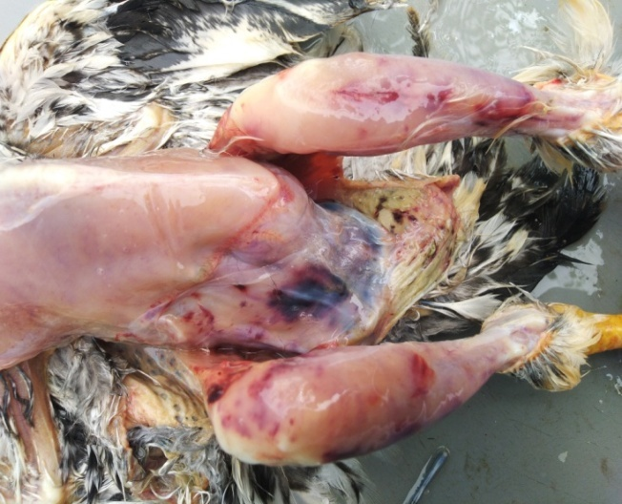
Hemorrhages under abdomen and thigh regions
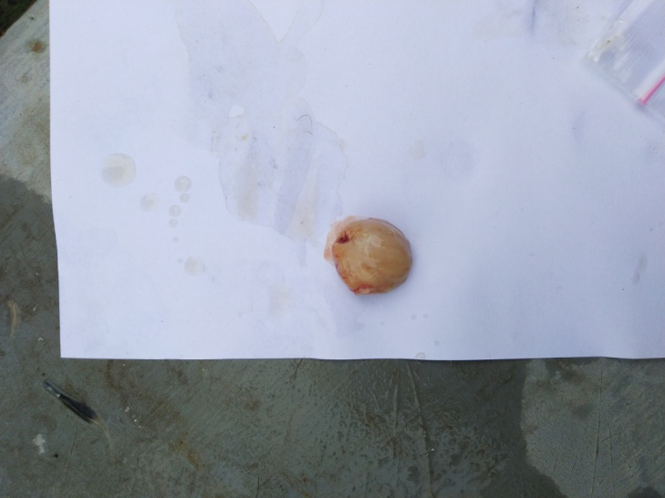 | 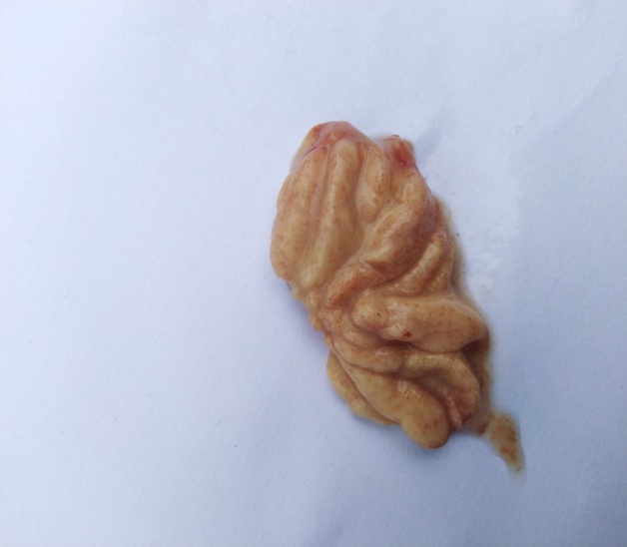
Swelling of bursa | Petechial hemorrhages in bursa
Fig 1. Gross lesions noticed in Aseel Chicken
Taken together, these findings indicate that the combination of muscle hemorrhages, swollen and hemorrhagic bursa of Fabricius, kidney enlargement with urate deposition and proventriculus–gizzard hemorrhages represent the pathognomonic lesion complex of IBD, consistently described across different geographical regions and production systems.
3.3 Laboratory Diagnosis
The laboratory findings in this outbreak confirmed the presence of Infectious Bursal Disease Virus (IBDV). Counter-immunoelectrophoresis carried out at the Central University Laboratory, TANUVAS detected viral antigen in bursal tissue homogenates. This result provided conclusive confirmation of IBD in the affected flock.
The present findings align with earlier reports where serological assays have been successfully employed for IBD diagnosis. For instance, Mazengia et al. (2009) confirmed IBD in Ethiopian village chickens through agar gel immunodiffusion, which detected IBDV-specific antibodies in recovered birds in addition to gross and microscopic bursal lesions
Similarly, Teshager, (2015) reported that bursal tissue examination, both histologically and serologically, provided reliable confirmation of IBDV infection in backyard chickens. In acute outbreaks, Badau et al. (2023) also highlighted the utility of immunological assays such as AGID and ELISA in confirming IBD alongside characteristic lesions.
The agreement between our CIEP results and these earlier reports reinforces the reliability of immunological assays in diagnosing IBD under both commercial and backyard production conditions. Combined with the gross pathological features observed in the present study, the positive laboratory confirmation provides unequivocal evidence that the outbreak was due to Gumboro disease.
3.4 Treatment and Control
As no specific antiviral therapy is available for Infectious Bursal Disease (IBD), treatment during the outbreak was directed towards supportive care and prevention of secondary bacterial infections. Affected birds were administered cephalexin, a broad-spectrum antibiotic at the rate of 20 gm per 250 birds, to reduce the risk of opportunistic bacterial complications, which often exacerbate morbidity in immunocompromised flocks. In addition, a liver tonic at the rate of 10 ml per 100 birds was provided to improve hepatic function and aid in metabolic recovery, while multivitamin supplements, particularly vitamins A, D₃ and E were included at the rate of 2 ml per litre of drinking water to enhance immune function and overall resilience of the birds.
Parallel to therapeutic measures, strict biosecurity and disinfection protocols were enforced across the farm. Disinfection of poultry houses and surrounding areas was carried out using 5% carbolic acid (phenol) solution, sprayed over three consecutive days to reduce environmental contamination and viral load. Severely affected birds (n=105) were promptly segregated and managed in an isolation shed located approximately 100 feet away from the main housing unit to prevent cross-infection. Bedding materials, litter and faecal waste were carefully collected and burned to eliminate possible reservoirs of infection. Furthermore, movement of personnel within and around the poultry unit was restricted and the sharing of utensils and feeding equipment between healthy and affected birds was strictly avoided to minimize the risk of further viral spread.
Following the implementation of therapeutic and biosecurity interventions, a marked improvement in flock health was observed. Clinical signs, including diarrhoea, depression, and anorexia, showed noticeable regression by the third day of treatment, accompanied by a substantial decline in daily mortality. The mortality rates recorded during the first three days of intervention were 4%, 2%, and 0.5%, respectively. By the fifth day, the outbreak was effectively brought under control and the surviving birds had resumed normal activity levels, with restoration of appetite and feeding behaviour.
These observations are consistent with earlier reports where supportive management and strict hygiene reduced the severity of IBD outbreaks. Mazengia et al. (2009) also emphasized the importance of isolating affected birds, applying disinfectants and enforcing biosecurity to contain village chicken outbreaks. Similarly, Badau et al. (2023) highlighted that while therapeutic interventions cannot eliminate the virus, supportive care combined with sanitation and environmental disinfection significantly reduces mortality in acute IBD outbreaks. The present findings reaffirm that in the absence of curative treatment, early supportive therapy coupled with rigorous biosecurity and disinfection remains the most practical strategy to mitigate losses during IBD outbreaks in native chicken flocks. Furthermore, they underscore the importance of integrating preventive vaccination programs into backyard and semi-intensive poultry systems to avoid such costly outbreaks in the future.
4. CONCLUSION
The present field investigation highlights the susceptibility of native chickens, particularly Aseel to Infectious Bursal Disease in the absence of vaccination and biosecurity measures. Although indigenous breeds are considered more resilient, this outbreak demonstrated that they are not immune to highly contagious viral infections. The high morbidity and mortality observed underline the urgent need for systematic vaccination programs, particularly at 14 - 18 days of age, along with strict farm hygiene, biosecurity and routine health monitoring. Supportive therapy and disinfection helped reduce losses in this case, but long-term prevention through vaccination and improved management remains the most effective strategy. Raising farmer awareness on the importance of preventive health care for diseases such as IBD, Newcastle Disease and Fowl Pox will be essential to safeguard productivity and ensure the sustainability and profitability of native poultry farming.

Disclaimer (Artificial intelligence)

Author(s) hereby declare that generative AI technology has been used during the editing of manuscripts.
Details of the AI usage are given below:
1.Chatgpt

REFERENCES
- Badau, S. J., Igbokwe, I. O., Hassan, S. U., & El-Yuguda, A.D. (2023). Outbreaks of acute infectious bursal disease of chickens in Maiduguri, Nigeria (2008–2018): Retrospective survey. Research Square, 1 – 23. https://doi.org/10.21203/rs.3.rs-2305788/v1.
- Chettle, N., Stuart, J. C., & Wyeth, P. J. (1989). Outbreak of virulent infectious bursal disease in East Anglia. The Veterinary Record, 125(10), 271–272. https://doi.org/10.1136/vr.125.10.271
- Chitradevi, S. (2022). Disease occurrences in desi chicken in Coimbatore district of Tamil Nadu. The Pharma Innovation Journal, 11(12): 2149–2152. https://www.researchgate.net/profile/Chitradevi-Somasundaram/publication/366399847_Disease_occurrences_in_desi_chicken_in_Coimbatore_district_of_Tamil_Nadu/links/63a03cac024dc52c8a320be2/Disease-occurrences-in-desi-chicken-in-Coimbatore-district-of-Tamil-Nadu.pdf
- Durairajan, R., Murugan, M., & Bharathi, R. (2019). Incidence of infectious bursal disease (IBD) virus infection and its control in the desi chicken farm of Kanchipuram district. Indian Veterinary Journal, 96(01), 36 – 37. http://krishikosh.egranth.ac.in/handle/1/5810097700
- Eterradossi, N., & Saif, Y. M. (2019). Infectious bursal disease. In D. E. Swayne, M. Boulianne, C. M. Logue, L. R. McDougald, V. Nair, D. L. Suarez, S. de Wit, T. Grimes, D. Johnson, M. Kromm, T. Y. Prajitno, I. Rubinoff, & G. Zavala (Eds.), Diseases of poultry (14th ed., pp. 257–283). Wiley-Blackwell. https://doi.org/10.1002/9781119371199.ch7
- Girish, S., Reddy, M. R., and Praveen, T. (2025). Pathological investigation of field outbreaks of infectious bursal disease in native chickens in India. Indian Veterinary Journal, 102(4), 45–49. https://www.researchgate.net/publication/390132002_Studies_on_the_pathomorphology_of_epidemics_of_Infectious_Bursal_Disease_IBD_in_chicken#fullTextFileContent
- Hailegebreal G., Tanga B.M., Woldegiorgis W., Sulayeman M., Sori T. (2022). Epidemiological investigation of morbidity and mortality of improved breeds of chickens in smallholder poultry farms in selected districts of Sidama Region, Ethiopia. Heliyon, 8(7): e10074. https://doi.org/10.1016/j.heliyon.2022.e10074
- Mazengia, H., Tilahun, S. B., and Negash, T. (2009). Incidence of infectious bursal disease in village chickens in two districts of Amhara Region, Northwest Ethiopia. Livestock Research for Rural Development, 21(12). Retrieved from http://www.lrrd.org/lrrd21/12/maze21212.htm.
- Miles, R. D., and Butcher, G. D. (2004). Infectious bursal disease in poultry. Veterinary Medicine Extension, University of Florida. Fact Sheet VM-102. https://edis.ifas.ufl.edu/publication/VM024
- Muller, H., Islam, M. R., and Raue, R. (2003). Research on infectious bursal disease - the past, the present and the future. Veterinary Microbiology, 97(1–2), 153–165. https://doi.org/10.1016/j.vetmic.2003.08.005
- Murali, P., and M. Vimalarani. (2025). Performance of Genetically Improved Janapriya Chickens As an Alternative to Backyard Poultry in Kallakurichi District, Tamil Nadu, India: A Field Study. Journal of Biology and Nature, 17 (2): 215 - 222. https://doi.org/10.56557/joban/2025/v17i29537.
- Orakpoghenor, O., Oladele, S. B., & Abdu, P. A. (2020). Infectious bursal disease: Transmission, pathogenesis, pathology and control – An overview. World’s Poultry Science Journal, 76(2), 268–281. https://doi.org/10.1080/00439339.2020.1716652
- Rajendran, K., Manoharan, K., and Balasubramaniam, G. A. (2006). Mortality pattern in broiler chicken flocks affected with infectious bursal disease in Tamil Nadu. Indian Veterinary Journal, 83(8), 860–862.
- Seger, W. M., Kraidi, Q. A., Hussien, T. J., & Ramadhan, M. A. K. (2019). Natural outbreaks of infectious bursal disease in Brahma and Aseel chicken in Iraq. Journal of Global Pharma Technology, 11(10), 504–512. https://un.uobasrah.edu.iq/papers/14636.pdf
- Setta, A., Yehia, N., Shaheen, M., Shami, A., Al-Saeed, F. A., Alsamghan, A., Amin, R., El-Saadony, M. T., El-Tarabily, K. A., & Salem, H. M. (2024). Continuous clinicopathological and molecular recognition of very virulent infectious bursal disease virus in commercial broiler chickens. Poultry Science, 103(2), 103306. https://doi.org/10.1016/j.psj.2023.103306
- Sharma, J. M., Kim, I. J., Rautenschlein, S., and Yeh, H. Y. (2000). Infectious bursal disease virus of chickens: Pathogenesis and immunosuppression. Developmental and Comparative Immunology, 24(2–3), 223–235. https://doi.org/10.1016/S0145-305X(99)00078-4
- Sharma, R. N., Kataria, J. M., and Dhama, K. (2017). Infectious bursal disease (Gumboro disease) in poultry: A review of recent developments with special reference to India. Journal of Poultry Science and Technology, 5(1), 01–10.
- Skeeles, J. K., and Lukert, P. D. (1997). Infectious bursal disease. In B. W. Calnek (Ed.), Diseases of Poultry (10th ed., pp. 721–738). Iowa State University Press. https://www.jstor.org/stable/1589676
- Teshager, N. (2015). Pathological and seroprevalence studies on infectious bursal disease in chickens in and around Bahir Dar, North West, Ethiopia (Master’s thesis, Addis Ababa University, College of Veterinary Medicine and Agriculture, Department of Pathology and Parasitology). Addis Ababa University.
- Truscott, R. B. (1976). Isolation and identification of avian pathogens. Poultry Science, 55(5), 2112 – 2113. https://doi.org/10.3382/ps.0552112
- Vadivoo V.S., Arthanarieswaran M., Lakshmikantan U., Hariharan T., Mathivananan R. (2020). A retrospective study on the prevalence of infectious diseases in desi fowls of Tirupur district, India. International Journal of Current Microbiology and Applied Sciences, 9(6): 721–731. https://doi.org/10.20546/ijcmas.2020.906.092
- Van den Berg, T. P. (2000). Acute infectious bursal disease in poultry: A review. Avian Pathology, 29(3), 175–194. https://doi.org/10.1080/03079450050045431.

