Antioxidant Potential of Heteropneustes fossilis: Ethno-Medicinal Perspectives from Manipur, India

Abstract
Heteropneustes fossilis, commonly known as stinging catfish is a freshwater fish of high nutritional and ethno-medicinal value, traditionally consumed in Manipur and across Northeast India for its health-promoting properties. Despite its importance, little is known about the antioxidant potential of H. fossilis. The present study, conducted in September 2024, aimed to evaluate the antioxidant activity of H. fossilis collected from four locations in Manipur, India. Antioxidant activity was assessed using the 2,2-diphenyl-1-picrylhydrazyl (DPPH) radical scavenging assay, with ascorbic acid as the standard. This study showed a concentration-dependent scavenging activity, with ascorbic acid achieving 66.73% inhibition and an IC₅₀ of 0.70 mg/mL. The radical scavenging activity of H. fossilis increased with concentration similarly to the ascorbic acid ranging from 22.50% at 400 µg/mL to a maximum of 35.40% at 2000 µg/mL. The IC50 value of the ethanolic extract was 1.90 mg/mL, which, although higher than that of ascorbic acid, indicates moderate antioxidant activity. H. fossilis samples showed moderate antioxidant activity, 35.40% inhibition at 2000 µg/mL with an IC₅₀ of 1.90 mg/mL. This study provide preliminary evidence that H. fossilis contains bioactive compounds with antioxidant potential, supporting its traditional ethno-medicinal applications and highlighting its promise as a source of functional ingredients for nutraceutical and medicinal development.
Keywords: Stinging catfish, Antioxidant activity, Radical scavenging, Ethno-medicine, Fish-derived peptides

Introduction
Heteropneustes fossilis, commonly known as the stinging catfish, is one of the most economically and therapeutically important freshwater fish species found across Asian countries including India, Thailand, Bangladesh, Myanmar, Indonesia, and Cambodia (Burgess, 1989; Akand et al., 1991). In India, it occurs widely in Manipur, Assam, Arunachal Pradesh, Meghalaya, Tripura, Nagaland, West Bengal, and several other states (Talwar and Jhingran, 1991). This elongated, scaleless fish species is characterized by the presence of a poison gland on its pectoral fin, which, despite being capable of inflicting painful stings, contributes to its high market value (Bhimachar, 1944). It is commonly found in ponds, ditches, swamps, and marshes, and is occasionally found in muddy rivers. H. fossilis is considered as an ideal candidate for aquaculture due to its rapid growth rate, tolerance to high stocking densities, and ability to survive in oxygen-depleted and harsh environmental conditions.
The demand and popularity of H. fossilis extends beyond its palatability to its high nutritional and medicinal properties (Chakraborty and Nur, 2012). Its flesh tissue has been found to contain significantly higher levels of iron (226 mg/100 g) and calcium than many other freshwater fish species (Saha and Guha, 1939). Moreover, being a lean fish with a low fat content of around 2.57 ± 0.24% on a fresh weight basis, it is especially suitable for individuals who need to restrict animal fat intake (Rahman et al., 2013). H. fossilis is valued as a good nutritional supplement for convalescing patients, owing to its unique taste, low fat, high iron, and medicinal properties (Araf et al., 2021). Ethno-medicinal practices also highlight its role in treating anaemia, for example, the Karbi tribe of Assam consume boiled stinging catfish as a tonic against anaemia (Gupta and Dey, 2017). Similarly, in Manipur, the fish is consumed in diverse forms such as sun-dried, smoked, or freshly cooked, particularly by children and pregnant women, as it is believed to prevent anaemia (Personal Communication).
Antioxidants are biologically important compounds that protect cells against oxidative stress induced by free radicals unstable molecules that can damage cellular structures and contribute to aging as well as several chronic diseases (Erhirhie and Paul, 2019). Since ancient times, fish have been regarded not only as a highly nutritious food source but also as a reservoir of bioactive components such as vitamins, proteins, fatty acids, omega-3s, antioxidant enzymes, peptides, and amino acids, all of which plays an essential roles in maintaining health (Alp-Erbay and Yeşilu, 2021; Allam et al., 2020; Panda, 2016). In recent years, research attention has been directed towards the identification and characterization of bioactive peptides of medicinal importance, whose structural and functional properties make them promising candidates for use as nutraceuticals, functional food ingredients, and pharmaceutical agents to improve human health and prevent several diseases (Najafian and Babji, 2012).
Despite its rich ethno-medicinal and nutritional profile, relatively very few studies has been conducted on the antioxidant properties of H. fossilis. To address this gap, the present study was aimed at evaluating the antioxidant potential of stinging catfish collected from Manipur, India.
Materials and Methods
The present study was undertaken to evaluate the antioxidant properties of H.fossilis collected during September 2024 from different locations in Manipur, namely Keibul Lamjao Village (24°20′ N, 93°50′ E), Thangal Bazar (24°48′ N, 93°56′ E), Bishnupur Bazar (24°37′ N, 93°45′ E), and Nambol Bazar (24°43′ N, 93°50′ E). Immediately after collection, the fish samples were thoroughly washed with sterile distilled water and dried in a hot air oven at 100 °C for approximately for 190 minutes. The dried samples were then ground into fine powder using a high-speed blender and stored in airtight plastic containers until further analysis.
The antioxidant activity of H. fossilis samples was evaluated using the 2,2-diphenyl-1-picrylhydrazyl (DPPH) radical scavenging assay, following the standard protocols. Ascorbic acid dissolved in methanol was used as the reference standard, prepared at concentrations of 200, 400, 600, 800, and 1000 µL. A DPPH working solution was obtained by dissolving 6 mg of DPPH in 100 mL of methanol. The standard solutions were mixed with the DPPH solution, incubated in the dark at room temperature for 30 minutes, and absorbance was recorded at 517 nm using a UV-Vis spectrophotometer.
For the test samples, stock solutions were prepared at a concentration of 2 mg/ml. Aliquots of 200, 500, and 1000 µL of each fish extract were combined with 3 mL of the DPPH solution, incubated at room temperature for 30 minutes, and the absorbance was measured at 517 nm. The radical scavenging activity (%) was calculated using the equation:
Radical Scavenging Activity (%) = ((AB-AA)/AB) x 100
Where, AB is the absorbance of the blank; AA is the absorbance of the sample. A calibration curve was plotted to determine the antioxidant activity based on the percentage of DPPH radicals scavenged.

Results and Discussion
This study investigate the antioxidant potential of H. fossilis using the DPPH radical scavenging assay. The DPPH assay is a widely used method to assess antioxidant capacity (Erhirhie and Paul, 2019; Diment et al., 2025; Yamauchi et al., 2024). Oxidative stress, caused by excess free radical generation, plays a central role in the development of several chronic diseases such as cardiovascular disorders, and rheumatoid arthritis, however, dietary antioxidants can alleviate these harmful effects. Fish including H. fossilis are increasingly recognized not only for their nutritional value but also as a source of natural antioxidants (Chakraborty and Nur, 2012; Linda et al., 2025; Najafian and Babji, 2012).
The antioxidant activity of H. fossilis flesh tissues was quantified by evaluating the percentage of radical scavenging activity (% RSA) and the half-maximal inhibitory concentration (IC₅₀) values, which represent the concentration of the sample required to inhibit 50% of the DPPH radicals. Table 1 shows the DPPH radical scavenging activity of ascorbic acid, which served as the standard antioxidant. The RSA% increased in a dose-dependent manner, with maximum inhibition of 66.73% observed at 1000 µg/ml and an IC50 value of 0.70 mg/ml.
Table 1: DPPH radical scavenging activity of standard (Ascorbic Acid)
Volume (µl) | Concentration (µg/ml) | Absorbance (517nm) | RSA% | IC₅₀ (mg/ml)
Solvent | DPPH Blank | 0.493 |  | 0.70 mg/ml
100 | 200 | 0.367 | 25.64 ± 0.41 | 0.70 mg/ml
200 | 400 | 0.347 | 29.76 ± 0.42 | 0.70 mg/ml
300 | 600 | 0.268 | 45.75 ± 0.20 | 0.70 mg/ml
400 | 800 | 0.227 | 54.12 ± 0.17 | 0.70 mg/ml
500 | 1000 | 0.164 | 66.73 ± 0.17 | 0.70 mg/ml
Table 2 presents the antioxidant activity of the ethanolic extract of H. fossilis. The radical scavenging activity increased with concentration similarly to the standard,ranging from 22.50% at 400 µg/mL to a maximum of 35.40% at 2000 µg/mL. The IC50 value of the ethanolic extract was 1.90 mg/mL, which, although higher than that of ascorbic acid, indicates moderate antioxidant activity.
Table 2: DPPH radical scavenging activity of H. fossilis extracts in ethanol solvent
Sample | Volume of sample in µl | Concentration  (2000µg/ml) | Absorbance  (517nm) | %Inhibition | IC₅₀
H. fossilis extracts |  | DPPH Blank | 0 | 0 | 1.90mg/ml
H. fossilis extracts | 200 | 400 | 0.382 | 22.50 ± 0.88 | 1.90mg/ml
H. fossilis extracts | 500 | 1000 | 0.354 | 28.17 ± 0.77 | 1.90mg/ml
H. fossilis extracts | 1000 | 2000 | 0.319 | 35.40 ± 0.62 | 1.90mg/ml

The standard curve, scavenging activity patterns, and comparative inhibition effects are shown in Figure 1-4.
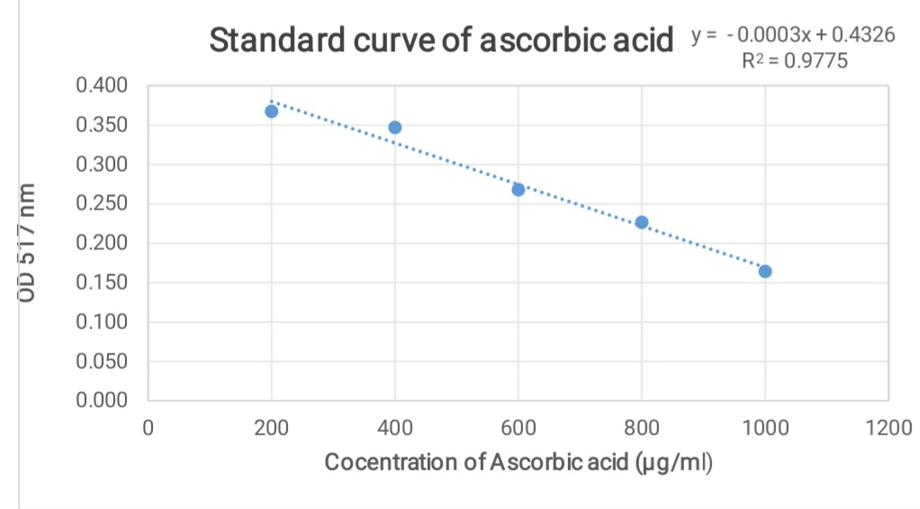
Figure 1: Standard linearity curve of ascorbic acid in the DPPH assay
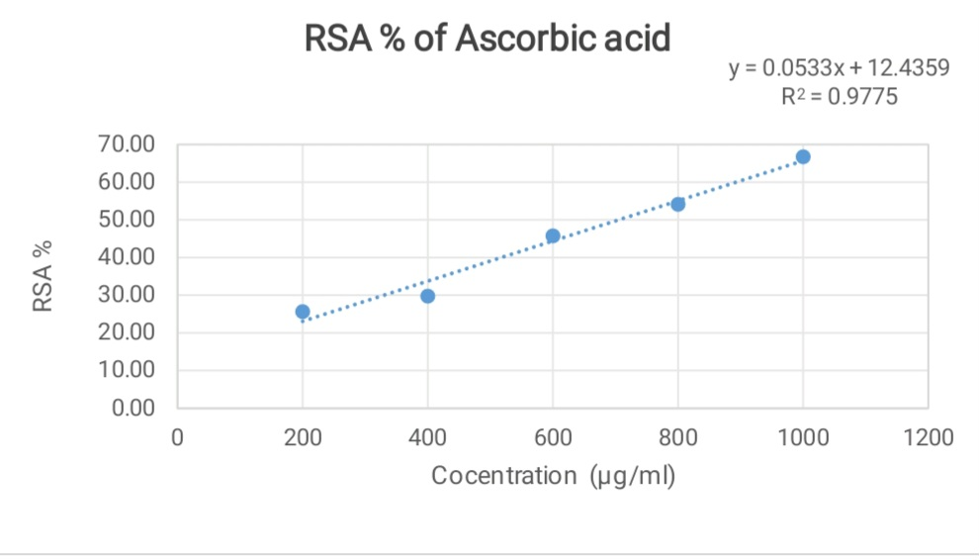
Figure 2: Radical scavenging activity (%) of the standard control (ascorbic acid)

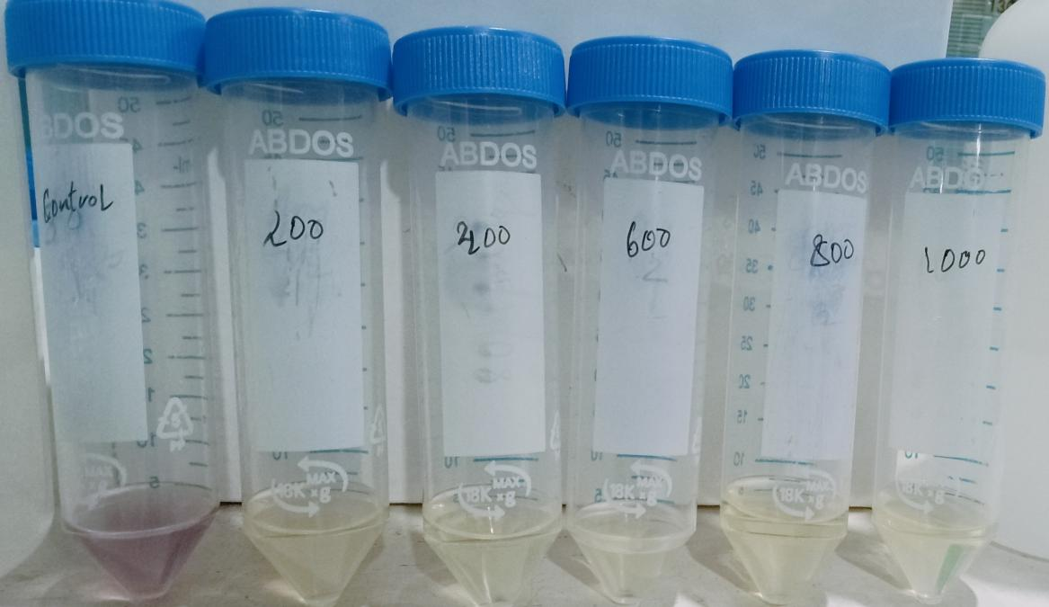
Figure 3: a) Ascorbic acid (standard) response in the DPPH assay

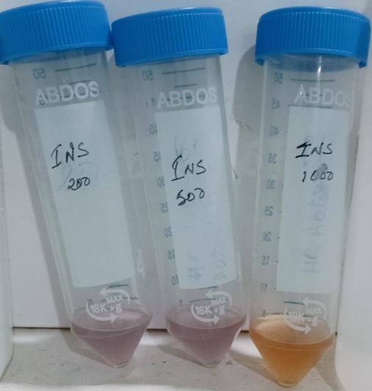

Figure 3 b: DPPH radical scavenging activity of H. fossilis ethanolic extracts

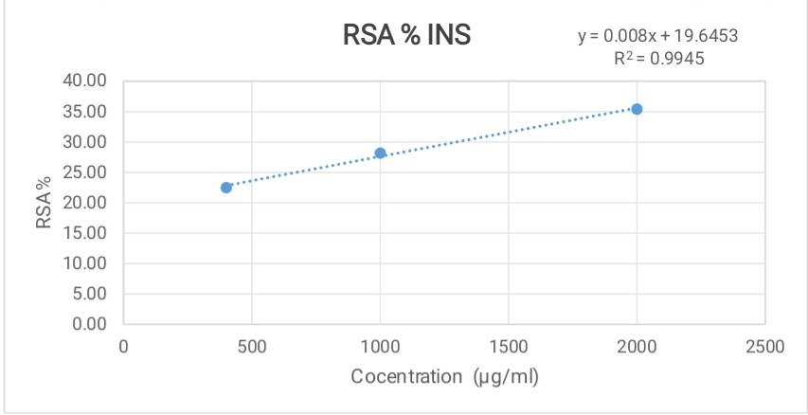

Figures 4: Radical scavenging activity (%) of H. fossilis ethanol extracts
The results shows that H. fossilis possesses concentration-dependent radical scavenging activity, supporting earlier studies that freshwater fish species could be an important source of antioxidant peptides and bioactive compounds (Culbert et al., 2022; Garcí-Moreno et al., 2014). García-Moreno et al. (2014) identified antioxidant peptides derived from actin and myosin proteins in sardines and small-spotted catshark. It is also important to highlight that the extraction solvents used in the assay can influence the antioxidant activity of samples. In this study, ethanolic extracts of H. fossilis showed moderate antioxidant activity, consistent with previous studies by Zhou and Yu (2004), who reported that antioxidant properties of wheat and wheat-based food products varied significantly depending on the solvent used for extraction. Similar results have also been reported in other marine and freshwater fish species, where polar solvents such as ethanol and methanol were found to extract peptides and phenolic compounds with moderate to high antioxidant activity (Najafian, and Babji, 2012).
The moderate antioxidant potential of H. fossilis, as shown in this study, complements its ethno-medicinal applications where the fish is traditionally consumed by pregnant women, children, and anaemic patients to enhance immunity and overall health (Araf et al., 2021; Gupta and Dey, 2017). Although its antioxidant activity was lower compared to the ascorbic acid standard, the findings suggest that H. fossilis contains bioactive compounds capable of scavenging free radicals. These results, together with previous research on antioxidant peptides in fish, highlight the potential of stinging catfish as a sustainable functional food with medicinal value.
Conclusion
This study provides preliminary evidence of the antioxidant potential of H. fossilis extracts. These findings support the traditional ethno-medicinal use of this fish species and highlight its potential as a promising source of natural antioxidants. Based on this preliminary assessment, future work could focus onisolation and characterizing the specific antioxidant peptides and bioactive compounds, followed by in vivo and clinical studies to validate their therapeutic efficacy.

Disclaimer (Artificial intelligence)
Option 1:
Author(s) hereby declare that NO generative AI technologies such as Large Language Models (ChatGPT, COPILOT, etc.) and text-to-image generators have been used during the writing or editing of this manuscript.

References
- Akand, A. M., Hasan, M. R. and Habib, M. A. B. (1991). Utilization of carbohydrate and lipids as dietary energy source by stinging catfish, Heteropneustes fossilis (Bloch). In S.S. De Silva (Ed), Fish Nutrition Research in Asia. Asian fisheries Society. 93-100.
- Allam, B.W., Khali, H.S., Mansour, A.T., Srour, T.M., Omar, E.A. and Nour, A.A.M. (2020). Impact of substitution of fish meal by high protein distillers dried grains on growth performance, plasma protein and economic benefit of striped catfish (Pangasianodon hypophthalamus). Aquaculture 517, 734792.
- Alp –Erbay, E. and Yeşilsu, A.F., (2021). Fish Protein and Its Derivatives: Functionality, Biotechnology and Health Effects. Aquatic Food Studies, 1(1). https://doi.org/10.4194/AFS13
- Araf, T., Hossain, M.A., Chowdhury, G., Hossain, M.A., Rahman, M.A. and Iqbal, M.M. (2021). Artificial propagation and embryonic growth of stinging catfish, Heteropneustes fossilis (Bloch, 1794) using S-GnRHa (Salmon gonadotropin releasing hormone analogue). Journal of Tropical Life Science. 11(2), 141-149. https//doi.org/10.11594/jtls.11.02.03
- Bhimachar, B. S. (1944). Poison glands in the pectoral spines of two catfishes—Heteropnuestes fossilis (Bloch) and Plotosus arab (Forsk), with remarks on the nature of their venom. In Proceedings/Indian Academy of Sciences. 19 (3). 65-70.
- Burgess, W.E. (1989). An atlas of freshwater and marine catfish-A preliminary survey of the Siluriformes. Neptune City, NJ: T.F.H Publications. 784.
- Chakraborty, B. K. and Nur, N. N. (2012). Growth and yield performance of shingi, Heteropneustes fossilis and koi, Anabas testudineus in Bangladesh under semi-intensive culture system. International Journal of agricultural Research, Innovation and Technology, 2 (2), 15-24
- Culbert, B.M., Dijkstra, P.D., Gilmour, K.M. and Balshine, S. (2022). Antioxidant capacity differs across social ranks and with ascension in males of a group- living fish. Comparative Biochemistry and Physiology Part A: Molecular & Integrative Physiology, 265, 111126.
- Diment, D., Musl, O., Balakshin, M. and Rigo, D. (2025). Guidelines for Evaluating the Antioxidant Activity of Lignin via the 2, 2‐diphenyl‐1‐picrylhydrazyl (DPPH) Assay. Chem Sus Chem, 18(10), e202402383.
- Erhirhie, E. and Paul, C. (2019). Edible Insects bio-actives as anti-oxidants: Current status and perspectives. Journal of Complementary Medicine Research, 10(2), 89-102 https://doi.org/10.5455/jcmr.20190130100319
- Garcí-Moreno, P.J., Bastista, I., Pires, C., Bandara, N.M., Espejo-carpio, F.J., and Guadix, E.M. (2014). Antioxidant activity of protein hydrolysates obtained from discarded Mediterranean fish species. Food Research International. 65. 469-476.
- Gupta, T. and Dey, M., (2017). Ichthyotherapy among karbi people. European Journal of Pharmaceutical Research, 4, 341-343.
- Linda, S. S., Islam, M. J., Mou, S. A., Islam, M. H., Shahjahan, M. and Islam, M. S. (2025). Synbiotic Supplementation Boosts Growth, Gut Health, and Immunity in Asian Fossil Catfish (Heteropneustes fossilis). Aquaculture Research, 2025(1), 4542077.
- Najafian, L. and Babji, A. S. (2012). A review of fish-derived antioxidant and antimicrobial peptides: Their production, assessment, and applications. Peptides, 33(1), 178-185.
- Panda, S. (2016). A review on induced breeding in fishes. International Journal of Bioassays, 5(05). 4579.
- Rahman, M. M., Hossain, M. Y., Hossain, M. I., Provhat, S. J., Islam, M. S. and Hossain, M . B. (2013). Induced breeding of the stinging catfish, Heteropneustes fossilis: comparision among different inducing agents. Turkish Journal of Fisheries and Aquatic Science, 13(3): 532-537. https://doi.org/10.4194/1303-2712-v13_3_17
- Saha, K. C. and Guha, B. C. (1939). Nutritional investigation of Bengal fish. Indian Journal of Medical Research, 26, 921-927.
- Talwar, P. K. and Jhingran, A. G. (1991). Inland Fishes of India and Adjacent Countries. New Delhi: Oxford & IBH publishing Co. 1(2), 1158.
- Yamauchi, M., Kitamura, Y., Nagano, H., Kawatsu, J. and Gotoh, H. (2024). DPPH measurements and structure—Activity relationship studies on the antioxidant capacity of phenols. Antioxidants, 13(3), 309.
- Zhou, K. and Yu, L. (2004). Effects of extraction solvent on wheat bran antioxidant activity estimation. LWT - Food Science and Technology, 37(7), 717–721. https://doi.org/10.1016/j.lwt.2004.02.008

