Original Research Article
Evaluation of antiphytopathogenic potential of Schizophyllum commune (Fries)
Abstract
This study investigates the antimicrobial potential of Schizophyllum commune methanolic extracts against several plant pathogenic fungi and bacteria. The extracts exhibited significant dose-dependent antifungal and antibacterial activity across concentrations ranging from 2000 to 5000 ppm. In antifungal assays, Cercospora sp. and Fusarium sp. were the most responsive, showing inhibition zones of 14.00 mm at 5000 ppm. Moderate responses were observed for Colletotrichum sp. and Curvularia sp., with inhibition zones ranging from 3.35 mm to 7.00 mm and 4.50 mm to 7.50 mm, respectively. The least responsive fungi were Alternaria sp. and Bipolaris sp., with maximum inhibition zones of 8.15 mm and 8.65 mm, respectively at 5000 ppm. For antibacterial activity, the methanolic extracts showed strong effects against Pseudomonas sp. and Bacillus sp., with inhibition zones reaching 12.50 mm and 11.50 mm, respectively, at 5000 ppm. Xanthomonas sp. and Rhizobium sp. also demonstrated significant inhibition, albeit at lower levels (10.50 mm and 9.33 mm, respectively). These results confirm the broad-spectrum antimicrobial potential of S. commune extracts, highlighting their possible use as natural agents for plant disease management, particularly for combating Fusarium and Pseudomonas infections. Future research should focus on identifying the specific bioactive compounds responsible for these effects and assessing their efficacy under field conditions.
Keywords: Schizophyllum commune, methanolic extract, antimicrobial activity, plant pathogens, biocontrol, zone of inhibition.
Introduction
Schizophyllum commune Fr. (Family: Schizophyllaceae), commonly known as the split gill mushroom, is a globally distributed edible fungus that thrives on decaying wood, particularly during the rainy season. The name Schizophyllum, meaning "split gill," reflects its distinctive morphological feature, which sets it apart from other gilled fungi (Imtiaj et al., 2008). This white-rot fungus is found on every continent except Antarctica, owing to the absence of suitable woody substrates (Klaus et al., 2011). In various South and Southeast Asian regions—including Thailand, Taiwan, Malaysia, Vietnam, Southern China, and Northeast India—S. commune is consumed both as a food and a traditional medicine. In Northeast India, it holds cultural and culinary importance: in Manipur, it is known as “Kanglayen” and is a key ingredient in the Manipuri dish "Paaknam," while in Mizoram, it is called “Pasi” (with pa meaning mushroom and si meaning tiny), and is regarded as one of the most highly prized edible mushrooms. Beyond its culinary value, S. commune has been recognized for its medicinal potential (Han et al., 2005).
Mushrooms, including S. commune, have garnered attention for their eco-friendly, non-toxic, and health-promoting properties. They have been shown to enhance immune responses, reduce disease susceptibility, and even decrease mortality rates (Milovanović et al., 2014). Extracts from mushrooms, particularly in concentrated forms, are often used for their bioactive effects. Ethanol and water are commonly used solvents for extracting these compounds. Notably, the crude extract of S. commune has demonstrated strong antioxidant properties, acting as a free radical scavenger and oxidative stabilizer to prolong the shelf life of lipid-rich foods. Methanolic extracts have also shown significant antimicrobial activity against clinically relevant bacteria, including Bacillus cereus, Staphylococcus aureus, Pseudomonas aeruginosa, Escherichia coli, Shigella spp., Salmonella typhi, and others (Mirfat et al., 2014).
Food-borne pathogens such as E. coli, B. cereus, P. aeruginosa, S. aureus, Listeria monocytogenes, Salmonella spp., and Vibrio parahaemolyticus are major contributors to food poisoning and antibiotic resistance worldwide (Jose et al., 2013) Previous studies have demonstrated that various mushroom species, including Pleurotus ostreatus and P. sajor-caju, exhibit significant antimicrobial effects against these pathogens. For example, high concentrations of ethanol, chloroform, and acetone extracts of P. ostreatus significantly inhibited the growth of S. aureus and E. coli (Pandey et al., 2021; Thillaimaharani et al., 2013). Additionally, P. sajor-caju and P. ostreatus have shown superior antimicrobial and antifungal activity compared to other oyster mushrooms (Murati et al., 2023; Akyüz et al., 2023). With the rise of antibiotic resistance and concerns surrounding synthetic chemical agents, the search for effective, sustainable, and natural antimicrobial compounds has intensified (Neha et al., 2025). Fungi, especially basidiomycetes, are valuable sources of structurally diverse and biologically potent metabolites (Berikashvili et al., 2023). S. commune is emerging as a promising yet underexplored candidate in this domain. Its potential in combating phytopathogens and human pathogens alike highlights the need for deeper investigation (Rijia et al., 2024).
The present study investigates the antimicrobial potential of methanol extracts from Schizophyllum commune against various phytopathogens. By testing its efficacy, the research aims to determine whether this mushroom species can be a natural alternative to chemical pesticides. The results could highlight its potential as a biocontrol agent in agriculture. Overall, the study seeks to evaluate the effectiveness of S. commune in combating plant diseases.
Materials and Methods
Study location
The study was conducted during the 2023–2024 season at the Advanced Centre of Mushroom Research, Dr. Rajendra Prasad Central Agricultural University (RPCAU), Pusa, Samastipur, Bihar, India.
Collection and preparation of mushroom samples
Fruiting bodies of Schizophyllum commune were collected from the Advanced Centre of Mushroom Research, RPCAU, Pusa. The collected specimens were sun-dried, ground into a fine powder using a mechanical grinder, and stored in airtight containers at ambient temperature for further analysis. The fungal strain used in the study, identified as "Pusa Schizo-II," was maintained on Potato Dextrose Agar (PDA) slants under standard laboratory conditions.
Microbial strains used for antimicrobial evaluation
A variety of Gram-positive, Gram-negative bacterial strains, and fungal pathogens were selected for antimicrobial screening. These microbial strains were obtained from the Department of Plant Pathology & Nematology, PGCA, and the Department of Microbiology, CBS&H, RPCAU, Pusa, Bihar. The bacterial strains tested included Pseudomonas syringae, Xanthomonas campestris, Rhizobium leguminosarum and Bacillus subtilis. and fungal pathogens strains tested includes Cercospora melongenae, Fusarium oxysporum, Colletotrichum musae. Curvularia lunata. Alternaria brassicae. Bipolaris sorokiniana. and Cochliobolus miyabeanus.
Preparation of Methanol Extracts
Dried fruiting bodies of S. commune were oven-dried at 40°C and ground into a fine powder. Ten grams of the powder was soaked in 100 mL of absolute methanol for 48 hours with intermittent shaking. The extract was filtered through Whatman No. 1 filter paper and concentrated using a rotary evaporator under reduced pressure. The semi-solid residue was further dried at 30–35°C to yield 160 mg of solid extract, which was re-dissolved in methanol to obtain a 160 mg/mL stock solution and stored at –20°C. From the stock solution (1,60,000 ppm), a 20,000 ppm working solution was prepared. Eight concentrations (250, 500, 750, 1000, 2000, 3000, 4000, and 5000 ppm) were then obtained by serial dilution with sterile distilled water.
Antimicrobial Activity Assay (Agar Well Diffusion)
The methanol extracts were tested against bacterial and fungal strains using the agar well diffusion method. Bacteria were cultured on Nutrient Agar (NA) and fungi on Potato Dextrose Agar (PDA). Wells were made with a sterile cork borer, and 60 µL of each extract concentration was added. NA plates were incubated at 37 ± 1°C for 24 hours, while PDA plates were incubated at 27 ± 2°C for 4–5 days. Zones of inhibition were measured to assess antimicrobial activity.
Results and Discussion
The methanol extracts of Schizophyllum commune exhibited notable antifungal and antibacterial activity across a range of concentrations (2000 – 5000 ppm), confirming their potential as natural agents for plant disease management. A clear dose-dependent response was observed, with increasing inhibition zones corresponding to higher concentrations of the extract.
Antifungal Activity
The antifungal efficacy was evaluated against six important phytopathogenic fungi, and the results showed varying degrees of susceptibility (Table 1). Among the tested pathogens, Cercospora melongenae. and Fusarium oxysporum. were the most responsive, each exhibiting a maximum inhibition zone of 14.00 mm at 5000 ppm. Cercospora melongenae showed the most significant increase in inhibition, rising from 3.50 mm at 2000 ppm to 13.50 mm increase indicating high sensitivity to the bioactive compounds. Similarly, Fusarium oxysporum showed a consistent increase from 5.50 mm to 14.00 mm, confirming its susceptibility. Colletotrichum musae. and Curvularia lunata. demonstrated moderate inhibition, with inhibition zones increasing from 3.35 mm to 7.00 mm and 4.50 mm to 9.50 mm, respectively. Notably, Colletotrichum musae exhibited a sharp increase between 3000 and 4000 ppm, nearly doubling its inhibition zone. The least responsive fungi were Alternaria brassicae. and Bipolaris sorokiniana. which exhibited lower inhibition even at the highest concentration (3.95 mm and 8.65 mm, respectively). Both pathogens showed minimal increases in inhibition between 2000 and 3000 ppm, indicating a delayed or weaker response, possibly due to higher resistance or reduced membrane permeability.
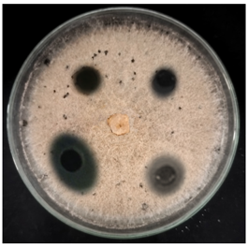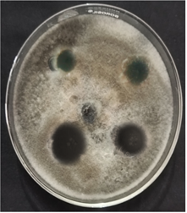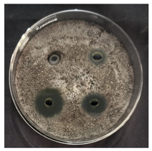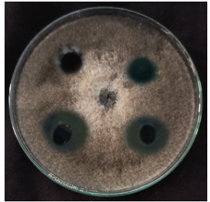
(a) (b) (c) (d)
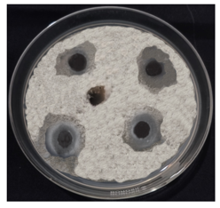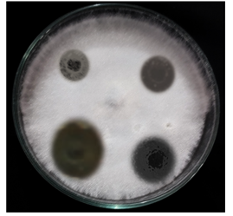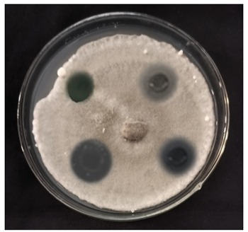
(e) (f) (g)
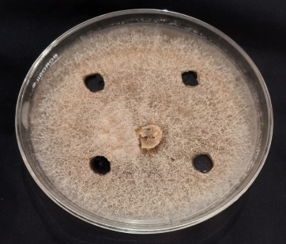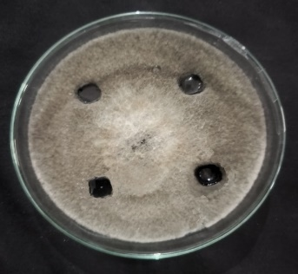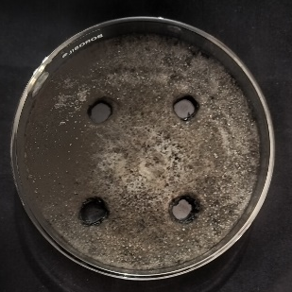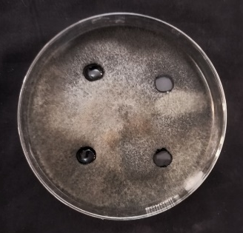
(Control) a (Control) b (Control) c (Control) d

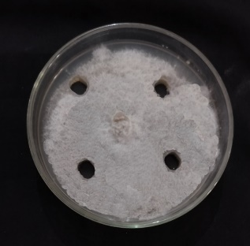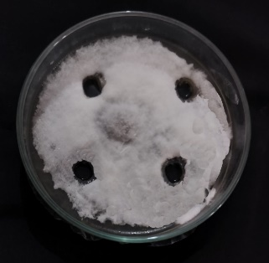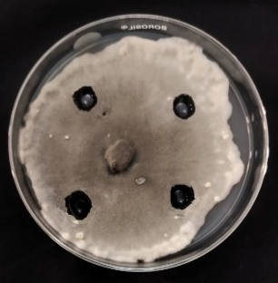
(Control) e (Control) f (Control) g
Fig.1: Antifungal activity of of S. commune against: (a) Colletotrichum musae; (b) Curvularia lunata; (c) Alternaria brassicae; (d) Cochliobolus miyabeanus; (e) Cercospora melongenae; (f) Fusarium oxysporum ; (g) Bipolaris sorokiniana.; (Control a-g) – Control for all the respective treatments.

Overall, all pathogens exhibited at least a two-fold increase in inhibition from the lowest to the highest concentration, confirming the dose-dependent nature of the extract. The most significant increases in activity occurred in the 4000–5000 ppm range for nearly all fungi, suggesting that higher concentrations are necessary for effective control. The broad-spectrum antifungal activity of S. commune highlights its potential as a biocontrol agent, especially against Fusarium oxysporum and Cercospora melongenae.
Antibacterial Activity
The antibacterial potential of S. commune methanol extract was assessed against four common plant pathogenic bacteria, with all concentrations showing measurable activity (Table 2). Among the tested strains, Pseudomonas syringae. showed the highest sensitivity, with the inhibition zone expanding from 4.00 mm at 2000 ppm to 12.50 mm at 5000 ppm increase. This was followed closely by Bacillus subtilis., which exhibited increase (3.67 mm to 11.50 mm). Xanthomonas compestris. also showed a substantial response, increasing from 3.50 mm to 10.50 mm, while Rhizobium leguminosarum. demonstrated the lowest inhibition (3.16 mm to 9.33 mm), though still indicative of significant antibacterial activity (Al-Azad and Ping, 2022). These findings underscore the potential of S. commune methanol extracts as a natural antimicrobial agent against both fungal and bacterial plant pathogens. The extract demonstrated broad-spectrum activity, with efficacy varying by organism and concentration (Wongaem et al., 2021).

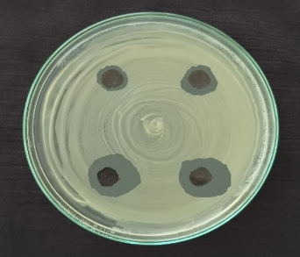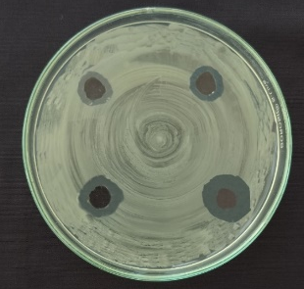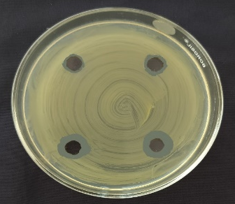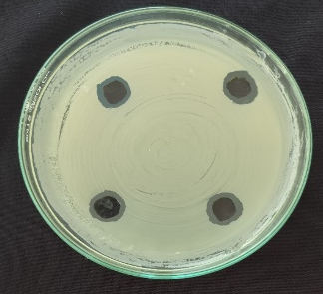
- (b) (c) (d)
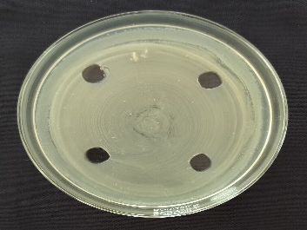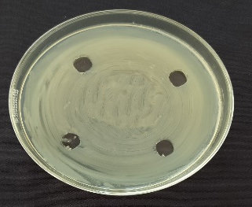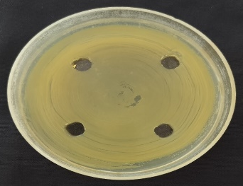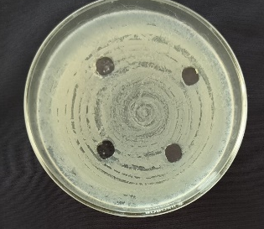
(Control) a (Control) b (Control) c (Control) d
Fig.2: Antibacterial activity of S. commune against: (a) Bacillus subtilis; (b) Pseudomonas syringae; (c) Xanthomonas compestris; (d) Rhizobium leguminosarum. (Control a-d) – Control for all the respective treatments.
These results are consistent with Khardziani et al. (2020), who also identified Schizophyllum commune BCC64 as the most active strain among 30 Basidiomycetes, showing strong inhibition against E. coli (17 ± 1 mm) and S. aureus (19 ± 1 mm), along with notable activity against other pathogens. Submerged cultivation with xylose and glucose further enhanced inhibition, reaching 70% and 60% against S. aureus and E. coli, respectively. These results are further supported by the study of Berikashvili et al. (2023), who demonstrated that Schizophyllum commune exhibited the highest antifungal activity among 23 mushroom species tested against major plant pathogens, including Aspergillus niger, Botrytis cinerea, Fusarium oxysporum, and Glomerella bidwellii, with inhibition rates of 35.7%, 6.5%, 50.4%, and 66.0%, respectively. Sharma et al. (2024) also reported strong antibacterial activity of Schizophyllum commune ethyl acetate extracts against multiple pathogens, including S. aureus, E. coli, K. pneumoniae, and P. aeruginosa, with MIC and MBC values ranging from 1.25 to 10 mg/ml. The extract showed a bactericidal mode of action, supporting the broad-spectrum antimicrobial potential observed in the present study.
Table 1: Anti-fungal activity of S. commune towards fungal phytopathogens
Pathogen | Zone Inhibition (mm) at different concentrations of S. commune extract (ppm)
Pathogen | 2000 | 3000 | 4000 | 5000
Cercospora melongenae | 3.50 | 6.35 | 9.35 | 13.50
Fusarium oxysporum | 5.50 | 7.35 | 9.85 | 14.00
Colletrotrichum musae | 3.35 | 4.35 | 8.35 | 7.00
Curvularia lunata. | 4.50 | 5.15 | 9.00 | 9.50
Alternaria brassicae | 4.00 | 4.85 | 6.35 | 8.15
Bipolaris sorokiniana | 4.00 | 4.35 | 6.55 | 8.65
Cochliobolus miyabeanus | 3.95 | 4.45 | 6.55 | 8.40

Graph:1: Inhibitory effect of S. commune against fungal phytopathogens

Table 2: Anti-bacterial activity of S. commune towards bacterial phytopathogens
Pathogen | Zone Inhibition(mm) at different concentrations S. commune extract (ppm)
Pathogen | 2000 | 3000 | 4000 | 5000
Bacillus subtilis | 3.67 | 6.50 | 9.83 | 11.50
Pseudomonas syringae | 4.00 | 6.83 | 10.00 | 12.50
Xanthomonas compestris | 3.50 | 6.00 | 9.50 | 10.50
Rhizobium leguminosarum | 3.16 | 5.66 | 8.33 | 9.33

Graph:2: Inhibitory effect of S. commune against bacterial phytopathogens

Conclusion
The results of this study demonstrate the significant antimicrobial potential of Schizophyllum commune methanol extracts against a wide range of fungal and bacterial plant pathogens, including Fusarium oxysporum and Pseudomonas syringae. The observed dose-dependent inhibition supports the feasibility of utilizing S. commune extracts as effective, eco-friendly alternatives for plant disease management. Given the broad-spectrum activity observed, further research is warranted to identify and characterize the specific bioactive compounds responsible for these effects. Future studies should also focus on optimizing extraction protocols, assessing the stability and bioavailability of active compounds, and evaluating the practical efficacy of these extracts under field conditions. With continued investigation, S. commune could emerge as a valuable natural product in sustainable agriculture for the control of plant diseases.

COMPETING INTERESTS DISCLAIMER:
Authors have declared that they have no known competing financial interests OR non-financial interests OR personal relationships that could have appeared to influence the work reported in this paper.

Disclaimer (Artificial intelligence)
Author(s) hereby declare that NO generative AI technologies such as Large Language Models (ChatGPT, COPILOT, etc.) and text-to-image generators have been used during the writing or editing of this manuscript.
References
Akyüz, M., İnci, Ş. and Kırbağ, S. (2023). Evaluation of antimicrobial, antioxidant, cytotoxic and DNA protective effects of oyster mushroom: Pleurotus pulmonarius (Fr.) Quel. Arabian Journal for Science and Engineering, 48(6), 7273-7283.
Al-Azad, S. and Ping, V. C. A. (2022). Antioxidant properties and antimicrobial activity in the extracts of two edible mushroom, Pleurotus sajor caju and Schizophyllum commune. Advances in Bioscience and Biotechnology, 13(9), 352-361.
Berikashvili, V., Khardziani, T., Kobakhidze, A., Kulp, M., Kuhtinskaja, M., Lukk, T., Gargano, M. L., Venturella, G., Kachlishvili, E., Metreveli, E., Elisashvili, V. I.and Asatiani, M. (2023). Antifungal activity of medicinal mushrooms and optimization of submerged culture conditions for Schizophyllum commune (Agaricomycetes). International Journal of Medicinal Mushrooms, 25(10), 1–21. https://doi.org/10.1615/IntJMedMushrooms.2023049836
Han, C.H., Liu, Q.H., Ng, T.B., Wang and H.X., 2005. A novel homodimeric lactose-binding lectin from the edible split gill medicinal mushroom Schizophyllum commune. Biochem. Biophys. Res. Commun. 336, 252–257.
Imtiaj, A., Lee, G. W., Lee, T. S. and Lee, S. S. (2008). Screening of antibacterial and antifungal activities from Korean wild mushrooms. World Journal of Agricultural Sciences, 4(S), 862–865.
Jose Alves, M., CFR Ferreira, I., Dias, J., Teixeira, V., Martins, A. And Pintado, M. (2013). A review on antifungal activity of mushroom (basidiomycetes) extracts and isolated compounds. Current Topics in Medicinal Chemistry, 13(21), 2648-2659.
Khardziani, T., Metreveli, E., Didebulidze, K. And Elisashvili, V. I. (2020). Screening of Georgian medicinal mushrooms for their antibacterial activity and optimization of cultivation conditions for the split gill medicinal mushroom, Schizophyllum commune BCC64 (Agaricomycetes). International Journal of Medicinal Mushrooms, 22(7), 659–669. https://doi.org/10.1615/IntJMedMushrooms.2020035051
Klaus, A., Kozarski, M., Niksic, M., Jakovljevic, D., Todorovic, N. and Van Griensven, L. J. L. D. (2011). Antioxidative activities and chemical characterization of polysaccharides extracted from the basidiomycete Schizophyllum commune. LWT - Food Science and Technology, 44(10), 2005–2011.
Milovanović, I., Stajić, M., Ćilerdžić, J., Stanojković, T., Knežević, A. and Vukojević, J. (2014). Antioxidant, antifungal and anticancer activities of Se-enriched Pleurotus spp. mycelium extracts. Archives of Biological Sciences, 66(4), 1379-1388.
Mirfat, A. H. S., Noorlidah, A. and Vikineswary, S. (2014). Antimicrobial activities of split gill mushroom Schizophyllum commune Fr. American Journal of Research Communication, 2(7), 113-124.
Murati, E., Murati, A. and KARADELEV, M. (2023). Exploring the potency of wild mushrooms: A compressive review of antifungal activity in the republic of north macedonia. Journal of Agriculture and Sustainable Rural Development, 1(1-2), 80-85.
Neha, Y. D. and Girish, K. (2025). Evaluation of the Antimicrobial Potential of Pleurotus ostreatus Extracts. Journal of Scientific Research, 17(1), 305-315.
Pandey, A. T., Pandey, I., Kerkar, P. and Singh, M. P. (2021). Antimicrobial activity and mycochemical profile of methanol extract from Pleurotus flabellatus. Vegetos, 34, 619-629.
Rijia, A., Krishnamoorthi, R., Rasmi, M., Mahalingam, P. U. and Kim, K. S. (2024). Comprehensive analysis of bioactive compounds in wild Ganoderma applanatum mushroom from Kerala, South India: Insights into dietary nutritional, mineral, antimicrobial, and antioxidant activities. Pharmaceuticals, 17(4), 509.
Sharma, A., Rashid, M., Chauhan, P., Kaur, S. and Kaur, A. (2024). In vitro antibacterial and anti-biofilm potential of an endophytic Schizophyllum commune. AMB Express, 14(1), 10. https://doi.org/10.1186/s13568-024-01663-x
Thillaimaharani, K. A., Sharmila, K., Thangaraju, P., Karthick, M. and Kalaiselvam, M. (2013). Studies on antimicrobial and antioxidant properties of oyster mushroom Pleurotus florida. International Journal of Pharmaceutical Sciences and Research, 4(4), 1540.
Wongaem, A., Reamtong, O., Srimongkol, P., Sangtanoo, P., Saisavoey, T., & Karnchanatat, A. (2021). Antioxidant properties of peptides obtained from the split gill mushroom (Schizophyllum commune). Journal of Food Science and Technology, 58(2), 680-691.

