Unravelling trait interrelationship and effects in mapping population derived from Jaya × Goa Dhan 2 of rice (Oryza sativa L.)

ABSTRACT
The study aimed to analyse the relationship between grain yield and its component traits in rice for identifying key contributors to yield improvement. An Augmented Randomized Complete Block Design (RCBD) was employed to evaluate 244 recombinant inbred lines (RILs) derived from the cross Jaya × Goa Dhan 2 along with ten check varieties. The experiment was conducted during the Rabi, 2022–23 at field conditions at ICAR-Central Coastal Agricultural Research Institute, Goa. Thirteen agronomic traits were recorded and subjected to correlation and path coefficient analysis to determine their direct and indirect effects on grain yield. Correlation analysis revealed significant positive associations of grain yield with straw yield (0.40), harvest index (0.56), total productive tillers (0.46), days to 50% flowering (0.34), total number of grains per panicle (0.20), number of fertile grains per panicle (0.25) and flag leaf width (0.14), whereas plant height (–0.23) and flag leaf length (–0.19) were negatively correlated. Path coefficient analysis indicated that harvest index (0.944) and straw yield (0.842) recorded the strongest positive direct effects, supported by moderate contributions from total productive tillers and number of fertile grains per panicle. The residual effect of 0.092 indicated that a portion of yield variation remained unexplained by the studied traits, suggesting the role of additional physiological and morphological factors in determining rice productivity. Overall, harvest index, straw yield and total productive tillers were identified as the most important determinants of grain yield, highlighting their potential as selection targets in rice breeding programs aimed at enhancing productivity.
Key words: Correlation, path analysis, RILs, rice.
- INTRODUCTION
Rice (Oryza sativa L., 2n = 24) is a major cereal crop that sustains over half of the global population (Khush, 2005; Darko et al., 2025), belonging to the family Poaceae and subfamily Oryzoideae, originated in south-east Asia. As a short-day, self-pollinating C₃ plant adapted to hydrophilic conditions, rice is the principal source of dietary calories and protein for billions of people, with over 90% of its production and consumption concentrated in Asia (Glauber and Mamun, 2025). Globally, rice is cultivated on about 167.6 million ha, producing 527.6 million tons with an average yield of 4170 kg ha⁻¹ (Durand and Mulimbi, 2024). India possesses the largest rice-growing area (47.83 million ha) and ranks second in global production (137.82 million tons) with a yield of 2882 kg ha⁻¹. Domestically, rice is second to wheat in contribution to national food supply, and exports of ~10 million tons annually provide substantial foreign exchange earnings (Indiastat, 2024) and future demand is projected to reach 650 million tons by 2050 (Mishra et al., 2018), and the global food demand is expected to increase by upto 56% (Van et al., 2021) while crop yields could decline by as much as 23% as a result of climate change (Rezaei et al., 2023).
Selection based solely on grain yield may not always be reliable, as yield in rice is a polygenically controlled trait and is strongly influenced by multiple yield-contributing characters. Therefore, improvement programs must consider both yield and its component traits. Understanding the correlations between yield and associated attributes, as well as the interrelationships among these attributes, is crucial for effective selection. Correlation coefficients often reveal complex interactions among yield-related traits, making it difficult to identify their precise contributions. Path coefficient analysis serves as a powerful tool in this context, as it partitions correlations into direct and indirect effects, thereby offering clearer insights into the causal relationships among traits. This method estimates the direct influence of one variable (cause) on another (effect) while accounting for the confounding influence of additional variables, under the assumptions of linearity and additivity. Consequently, path analysis provides a more meaningful understanding of the actual contribution of individual characters to grain yield.
The present investigation was thus conducted to identify trait associations and the contribution of individual characters to yield through path coefficient analysis. Correlation studies help determine the extent of mutual relationships among characters and clarify which components should be prioritized in breeding for genetic improvement. Since rice yield is a quantitative character governed by numerous traits, selection for desirable plant types should emphasize key component traits rather than yield alone.
- MATERIAL AND METHODS
The experimental material consisted of 244 recombinant inbred lines (RILs) in the F₇ generation, developed at ICAR–CCARI, Goa, from a cross between two contrasting rice cultivars, namely, Jaya (salinity susceptible) and Goa Dhan 2 (salinity tolerant) (Manohara et al. 2025). These lines were sequentially designated JGD RIL 1 to JGD RIL 244. In addition, five salinity-tolerant checks (FL 478, Goa Dhan 1, Goa Dhan 2, Goa Dhan 3 and Goa Dhan 4) and five susceptible checks (Jaya, Jyothi, Karjat 3, IR 29 and Pusa 44) were included. The set of 244 RILs, along with ten check varieties, were evaluated for correlation and path coefficient analysis using an Augmented Randomized Complete Block Design, where RILs were grouped into four blocks with replicated checks in each block. The trial was conducted at the experimental farm of ICAR–CCARI, Goa, during Rabi 2022–23.
The observations were recorded for thirteen traits viz., plant height (PH), days to 50% flowering (DFF), total productive tillers (TPT), panicle length (PL), number of fertile grains per panicle (FG), total number of grains per panicle (GP), fertility percentage (FP), flag leaf length (FLL), flag leaf width (FLW), grain yield (GY), straw yield (SY), test weight (TW) and harvest index (HI). Correlation coefficients were calculated at the genotypic and phenotypic levels using the formulae suggested by Falconer (1981) as following:
Phenotypic coefficient of correlation (r_{p}) = r (x_{i}. x_{j})_{p} = $\frac{Cov.(xi.xj)p}{\sqrt{V (xi) g. V (xj)p}}$
Where; r (x_{i}. x_{j})_{p} is phenotypic correlation between i^{th} and j^{th} characters, Cov. (x_{i}.x_{j}) _{p} is phenotypic covariance between i^{th} and j^{th} characters, V (x_{i}) _{p} is phenotypic variance of i^{th} character and V (x_{j}) _{p} is phenotypic variance of j^{th} character. Along with correlation estimations, path analysis was also carried out using the phenotypic correlation coefficients to know the direct and indirect effects of the components on yield as suggested by Wright (1921) and illustrated by Dewey and Lu (1959) and further classified as very high (>1.0), high (0.3-0.9), moderate (0.2-0.29), low (0.1-0.19) and negligible (<0.1) as suggested by Lenka and Misra (1973).
- RESULTS AND DISCUSSION
The heat map illustrating the correlation coefficients among the thirteen quantitative traits is presented in Fig. 1, where deeper shades of blue indicate stronger positive correlations, while red shades represent the magnitude of negative correlations. Plant height exhibited significant positive correlations with flag leaf length (0.43), straw yield (0.10), number of grains per panicle (0.33), fertile grains per panicle (0.34) and panicle length (0.71). In contrast, it was negatively associated with grain yield (-0.23), harvest index (-0.35) and productive tillers (-0.47). Days to 50% flowering showed significant positive correlations with flag leaf width (0.52), panicle length (0.21), number of grains per panicle (0.42), fertile grains per panicle (0.39), grain yield (0.34), harvest index (0.29) and productive tillers (0.15). Productive tillers were positively associated with harvest index (0.29), grain yield (0.46), days to 50% flowering (0.15) and straw yield (0.13), but negatively correlated with fertile grains per panicle (-0.19), total grains per panicle (-0.23), flag leaf length (-0.28), plant height (-0.47) and panicle length (-0.28). Panicle length was significantly and positively correlated with plant height (0.71), flag leaf length (0.29), straw yield (0.15), flag leaf width (0.17), days to 50% flowering (0.21), total grains per panicle (0.57) and fertile grains per panicle (0.56), while showing a negative association with productive tillers (-0.28). Fertile grains per panicle displayed strong positive correlations with panicle length (0.58), plant height (0.34), flag leaf length (0.16), straw yield (0.16), flag leaf width (0.42), days to 50% flowering (0.39), total grains per panicle (0.91) and grain yield (0.25). Negative correlations were recorded with test weight (-0.25) and productive tillers (-0.19). Total grains per panicle had significant positive correlations with panicle length (0.57), plant height (0.33), flag leaf length (0.20), straw yield (0.14), flag leaf width (0.49), days to 50% flowering (0.42), fertile grains per panicle (0.91) and grain yield (0.20). Negative correlations were observed with test weight (-0.30), fertility percentage (-0.33) and productive tillers (-0.23). Fertility percentage was positively associated with test weight (0.18) but negatively correlated with total grains per panicle (-0.33), days to 50% flowering (-0.15), flag leaf width (-0.23) and flag leaf length (-0.12). Flag leaf length showed positive correlations with panicle length (0.29), plant height (0.43), flag leaf width (0.14), total grains per panicle (0.20) and fertile grains per panicle (0.16). Negative correlations were detected with days to 50% flowering (-0.13), fertility percentage (-0.12), grain yield (-0.19), harvest index (-0.28) and productive tillers (-0.28). Flag leaf width was positively correlated with panicle length (0.17), flag leaf length (0.14), days to 50% flowering (0.52), number of grains per panicle (0.49), fertile grains per panicle (0.42) and grain yield (0.14), but showed a negative correlation with fertility percentage (-0.23). Grain yield was positively associated with straw yield (0.40), flag leaf width (0.14), days to 50% flowering (0.34), total grains per panicle (0.20), fertile grains per panicle (0.25), harvest index (0.56) and productive tillers (0.46), but negatively correlated with plant height (-0.23) and flag leaf length (-0.19). Straw yield showed significant positive correlations with panicle length (0.15), plant height (0.12), total grains per panicle (0.14), fertile grains per panicle (0.16), grain yield (0.40) and productive tillers (0.13), while exhibiting a negative relationship with harvest index (-0.49). Test weight was positively associated with fertility percentage (0.18), but negatively correlated with fertile grains per panicle (-0.25), total grains per panicle (-0.30) and days to 50% flowering (-0.15). Harvest index exhibited strong positive correlations with productive tillers (0.29), grain yield (0.56) and days to 50% flowering (0.29). On the other hand, negative correlations were observed with panicle length (-0.13), plant height (-0.35), flag leaf length (-0.28) and straw yield (-0.49).
Understanding the direction and strength of associations among different traits facilitates indirect selection for grain yield in breeding programs, since direct selection for such a complex trait is often less effective due to its polygenic nature and strong environmental influence (Grafius, 1956). Grain yield per hectare showed significant positive correlations with straw yield (0.40), flag leaf width (0.14), days to 50% flowering (0.34), total grains per panicle (0.20), fertile grains per panicle (0.25), harvest index (0.56) and productive tillers (0.46). Similar correlation was reported for number of fertile grains per panicle, total number of grains per panicle and total productive tillers by Panika et al. (2022) and Kiran et al. (2023). These associations indicate that selecting for these traits can lead to an indirect improvement in grain yield. Conversely, a negative correlation between but negatively correlated with plant height (-0.23) and flag leaf length (-0.19). suggests that genotypes with more height tend to have lower yields, which could be an important selection criterion for breeding programs aimed at improving yield.
Similar reports of positive correlation of plant height with panicle length by Fentie et al. (2021) and Heera et al. (2023), with number of filled grains per panicle by Lakshmi et al. (2020). Negative correlation of plant height with total productive tillers by Lakshmi et al. (2020). And similarly, positive correlation of panicle length with number of filled grains per panicle was reported by Fentie et al. (2021) and Heera et al. (2023), with total grains per panicle by Bhargava et al. (2021), while total productive tillers have shown negative association with number of filled grains per panicle as reported by Lakshmi et al. (2017) and positive correlation with total grains per panicle by Sahithi et al. (2023). Kondi et al. (2022) also reported similar results of positive correlation with total productive tillers and negative correlation with plant height. Similarly, Kiran et al. (2023) also reported positive association of grain yield with total productive tillers, number of filled grains per panicle and total number of grains per panicle. Parte et al. (2022) also reported similar findings of positive correlation of grain yield with harvest index.
The results of path effects are shown in Table 1 and Figure 2. Plant height exerted a low positive direct effect (0.063) on grain yield, complemented by indirect influences through straw yield (0.105) and number of fertile grains per panicle (0.028). However, strong negative indirect effects via harvest index (–0.335), total productive tillers (–0.043) and panicle length (–0.022) resulted in an overall negative correlation (–0.228) with yield. Days to 50% flowering had a small positive direct effect (0.041), which was notably strengthened by its indirect contributions through harvest index (0.276) and fertile grains per panicle (0.033). Negative effects operated through total grains per panicle (–0.027), panicle length (–0.007) and straw yield (–0.005). Total productive tillers exhibited a moderate direct effect (0.093) on yield, reinforced by substantial indirect effects via harvest index (0.271), straw yield (0.110) and grains per panicle (0.015). Small negative indirect pathways through plant height (–0.029), fertile grains per panicle (–0.016) and fertility percentage (–0.006) minimized the overall impact, yet the total association remained strongly positive (0.456). Panicle length recorded a small negative direct influence (–0.032), although positive indirect effects were channelled through straw yield (0.124), fertile grains per panicle (0.048) and plant height (0.044). These were offset by negative effects from harvest index (–0.123), grains per panicle (–0.036) and productive tillers (–0.026). The number of fertile grains per panicle showed a moderate positive direct effect (0.084) on yield, supported by indirect contributions through straw yield (0.131), harvest index (0.100), plant height (0.021) and flowering time (0.016). Negative indirect effects were mediated by grains per panicle (–0.057), productive tillers (–0.018) and panicle length (–0.018). Total grains per panicle had a small negative direct effect (–0.063), though it contributed positively via straw yield (0.114), fertile grains per panicle (0.076) and harvest index (0.059). Negative but minor pathways were linked to productive tillers (–0.021) and panicle length (–0.018). Fertility percentage exerted a low negative direct effect (–0.050), but this was partly compensated by indirect effects through harvest index (0.073), straw yield (0.036) and productive tillers (0.011). Flag leaf length had a very low negative direct effect (–0.015), but indirect positive contributions from straw yield (0.094), plant height (0.027) and fertile grains per panicle (0.014) failed to outweigh the strong negative effects of harvest index (–0.260), productive tillers (–0.026) and grains per panicle (–0.013). Flag leaf width showed a negligible positive direct effect (0.007), enhanced by days to 50% flowering (0.021), straw yield (0.031), fertile grains per panicle (0.035) and harvest index (0.086). Negative indirect contributions from grains per panicle (–0.031) and productive tillers (–0.011) reduced its overall impact. Straw yield contributed the largest positive direct effect (0.842) on grain yield. However, this was tempered by a substantial negative indirect influence from harvest index (–0.462). Test weight exhibited a minimal direct effect (0.005), but was slightly favourable overall through indirect positive contributions of straw yield (0.046) and grains per panicle (0.019), despite negative effects from fertile grains (–0.021). Harvest index recorded the second-highest positive direct effect (0.944) on grain yield, only weakly reduced by the negative indirect influence of straw yield (–0.412). Its overall association remained strongly positive (0.558) via multiple indirect pathways. The phenotypic residual effects for grain yield were estimated as 0.092 values suggest that a substantial proportion of variation in yield is attributed to factors beyond the traits analysed, as well as to environmental variation.
Path coefficient analysis partitions correlation coefficients into direct and indirect effects of different traits on grain yield. This enables the identification of both primary and mediated causes of associations, providing deeper insights into the underlying mechanisms of trait interrelationships and allowing the relative importance of each contributing factor to be evaluated. Thus, partitioning correlations into direct and indirect effects is essential for identifying the actual contribution of individual traits to grain yield. The integration of correlation analysis with path coefficient analysis provides a clearer understanding of the cause–effect relationships among traits, thereby supporting rice breeding programs aimed at simultaneously improving multiple attributes along with yield. In the present study, the phenotypic correlations between grain yield per plant and its related yield components were decomposed into direct and indirect effects through path analysis and the outcomes were critically analysed and interpreted. Similar positive direct effect on grain yield was reported by Ali et al. (2013), Manohara and Singh (2015), Aarthi et al. (2019), Saha et al. (2019), Sumithra et al. (2019), Muthuvijayaragavan and Murugan (2020), Manohara et al. (2020) and Kumar et al. (2023), Nandini et al. (2025) and Praveena et al. (2025). Conversely, the negative direct effect on yield was also registered in the current study which was in accordance with previous studies of Karim et al. (2014), Singh et al. (2016), Tripathi et al. (2018), Saha et al. (2019), Shrivatsav et al. (2020). The residual effect reflects the extent to which the considered traits account for variation in grain yield. In the present study, the residual effect was positive (0.092), suggesting that the traits included in the analysis did not fully explain the observed variability in yield. This indicates the need to explore additional morpho-physiological attributes that may contribute to enhancing grain productivity in rice.
- CONCLUSION
Overall, the study revealed significant correlations among most of the evaluated traits, with positive associations of straw yield, flag leaf width, days to 50% flowering, total grains per panicle, fertile grains per panicle, harvest index and productive tillers with grain yield. These traits emerge as key yield-contributing characters, suggesting that their improvement through selection could enhance grain yield in rice. In contrast, plant height and flag leaf length exhibited significant negative correlations with yield, indicating that applying simultaneous selection pressure in the opposite direction may also be beneficial. Path coefficient analysis further emphasized the strong direct effects of straw yield and harvest index, along with moderate direct contributions from productive tillers and fertile grains per panicle, underscoring their utility as selection criteria for yield improvement. The residual effect (0.092) indicated that a considerable proportion of yield variation remained unexplained by the traits studied, highlighting the importance of examining additional morpho-physiological attributes that may contribute to enhancing rice productivity.
ACKNOWLEDGEMENT
The authors acknowledge the support of Indian Council of Agricultural Research (ICAR), ICAR – Central Coastal Agricultural Research Institute, Goa for providing all the planting material and logistic support in conduct of the experiment.
Disclaimer (Artificial intelligence)
Author(s) hereby declares that NO generative AI technologies such as Large Language Models (ChatGPT) have been used during the writing or editing of manuscripts.

REFERENCES
Aarthi, M., Vennila, S., & Palaniraja, K. (2019). Studies on genetic diversity of rice (Oryza sativa L.) under natural saline condition. The Pharma Innovation Journal, 8(7), 524-527.
Ali, S., Gautam, R. K., Mahajan, R., Krishnamurthy, S. L., & Sarangi, S. K. (2013). Genetic variability and association analysis for grain yield components among SALTOL QTL introgressed rice genotypes under normal and environments. J. Indian Soc. Coastal agric. Res, 31(1), 34-40.
Bhargava, K., Shivani, D., Pushpavalli, S.N.C.V.L., Sundaram, R.M., Beulah, P & Senguttuvel, P. (2021). Genetic variability, correlation and path coefficient analysis in segregating population of rice. Electronic Journal of Plant Breeding. 12 (2): 549-555.
Darko, A.M., Danquah, E.O., Dormatey, R., Keteku, A.K., Frimpong, F., Adjah, K.L., Osei-Wusu, M.O., Ayamba, B.E., Ofosu, K.A., Dankwa, K.O., & Danquah, F.O. (2025). Global rice production: Current status, challenges, and future scenarios. In Rice Cultivation Under Abiotic Stress, 3-21. Academic Press.
Dewey, D. R., & Lu, K. (1959). A correlation and path‐coefficient analysis of components of crested wheatgrass seed production 1. Agronomy journal, 51(9), 515-518.
Durand-Morat, A., & Mulimbi, W. (2024). International Rice Outlook: International Rice Baseline Projections 2023-2033.
Falconer, D. S. (1996). Introduction to quantitative genetics. Pearson Education India.
Fentie, D.B., Abera, B.B. & Ali, H.M. (2021). Association of agronomic traits with grain yield of lowland rice (Oryza sativa L.) genotypes. International Journal of Agricultural Science. 8(3): 2348-3997.
Glauber, J. W., & Mamun, A. (2024). Global rice market: Current outlook and future prospects.
Grafius, J. E. (1956). Components of yield in oats: a geometrical interpretation 1. Agronomy Journal, 48(9), 419-423.
Heera, P.K., Ram, M., Kumar, R., Murali, S. & Kumar, A. (2023). Analysis of Genetic Variability, Heritability and Genetic Advance for Yield and Yield Associated traits in Rice (Oryza sativa L.). Ecology Environment and Conservation. 29: 160-163.
Indiastat. (2024). Agricultural Production Statistics of India: 2023-24. https://www.indiastat.com/data/agriculture.
Karim, D., Siddique, M. N. A., Sarkar, U., Hasnat, Z., & Sultana, J. (2014). Phenotypic and genotypic correlation co-efficient of quantitative characters and character association of aromatic rice. Journal of Bioscience and Agriculture Research, 1(1), 34-46.
Khush, G. S. (2005). What it will take to feed 5.0 billion rice consumers in 2030. Plant molecular biology, 59(1), 1-6.
Kiran, A. K., Sharma, D. J., Subbarao, L. V., Gireesh, C., & Agrawal, A. P. (2023). Correlation coefficient and path coefficient analysis for yield, yield attributing traits and nutritional traits in rice genotypes. The Pharma Innovation Journal, 12(2), 1978-1983.
Kondi, R. K. R., Kar, S & Mandawi, N. (2022). Study of genetic parameters, correlation and path analysis for yield and quality characters in fine scented rice genotypes. Oryza-An International Journal on Rice. 59(1): 20–30.
Kumar, P. A. S., Delvadiya, I. R., Murali, S., & Ginoya, A. V. (2023). Unraveling the genetic architecture of rice (Oryza sativa L.) using variability, correlation, path analysis and diversity analysis: Insights for crop improvement strategies. International Journal of Plant & Soil Science, 35(15), 32-39.
Lakshmi, L., Rao, B.M.N., Raju, S & S. Reddy, N.S. (2017). Variability, correlation and path analysis in advanced generation of aromatic rice. International Journal of Current Microbiology and Applied Sciences. 6(7): 1798-1806.
Lakshmi, V.G.I., Sreedhar, M., Gireesh, C & Vanisri, S. (2020) Genetic variability, correlation and path analysis studies for yield and yield attributes in African rice 126 (Oryza glaberrima) germplasm. Electronic Journal of Plant Breeding. 11 (2): 399-404.
Lenka, D., and P. K. Misra. "Response of groundnut (Arachis hypogaea L.) to irrigation." (1973): 492-497.
Manohara, K. K., & Singh, N. P. (2015). Genetic variability, correlation and path analysis in rice (Oryza sativa L.) under coastal salinity conditions of Goa. Journal of the Indian Society of Coastal Agricultural Research, 33(1), 34-39.
Manohara, K. K., Morajkar, S., & Shanbagh, Y. (2020). Genetic analysis of grain yield and its associated traits in diverse salt-tolerant rice genotypes under coastal salinity condition. Journal of Cereal Research, 12(3), 290-296.
Manohara, K. K., Shanbhag, Y., Paramesha, V., Kumar, P., Rathod, S., & Singh, N. K. (2025). Genetic Analysis of a Recombinant Inbred Line Population Derived from Salt-Tolerant Rice Landrace Korgut under Coastal Ecology. Agricultural Research, 14(1), 89-96.
Mishra, R., Joshi, R. K., & Zhao, K. (2018). Genome editing in rice: recent advances, challenges, and future implications. Frontiers in Plant Science, 9, 1361.
Muthuvijayaragavan, R., & Murugan, E. (2020). Association analysis of F2 generation in rice (Oryza sativa L.) under salinity condition. Electronic Journal of Plant Breeding, 11(1), 283-289.
Nandini, A., Venkatesan, M., Sathyaraj, D., & Rani, M. A. (2025). Genetic correlation, path and multivariate analysis in rice under coastal saline ecosystem of Tamil Nadu. Journal of Environmental Biology, 46(4), 546-554.
Panika, N., Singh, Y., Singh, S. K., Rahangdale, S., & Shukla, R. S. (2022). Genetic variability, correlation and path coefficient study of indigenous rice (Oryza sativa L.) accessions for different yield and quality contributing traits.
Parte, D., Sathish, K., Sahu, P., Sharma, D., Bhainsa, K., Das, B. K., & Shrivastava, R. (2022). Correlation and path analysis studies for yield and quality traits of rice landraces and mutants of Chhattisgarh, India. International Journal of Environment and Climate Change, 12(12), 1771-1779.
Praveena, M. V., Rao, P. V. R., Badri, J., & Ch, S. (2025). Association and Genetic Variability Studies for Reproductive Stage Salinity Tolerance Traits in Rice (Oryza sativa L.). International Journal of Plant & Soil Science, 37(6), 477-485.
Rezaei, E. E., Webber, H., Asseng, S., Boote, K., Durand, J. L., Ewert, F., ... & MacCarthy, D. S. (2023). Climate change impacts on crop yields. nature reviews earth & environment, 4(12), 831-846.
Saha, S. R., Hassan, L., Haque, M. A., Islam, M. M., & Rasel, M. (2019). Genetic variability, heritability, correlation and path analyses of yield components in traditional rice (Oryza sativa L.) landraces: Variability and traits association in rice. Journal of the Bangladesh Agricultural University, 17(1), 26-32.
Sahithi, M., Abdul Fiyaz, R., Sameer Kumar, CV & GS Laha. (2023). Genetic variability and character association studies for yield and yield related traits in rice (Oryza sativa L.). The Pharma Innovation Journal. 12(9): 598-602.
Shrivastav, S. P., Verma, O. P., Singh, V., & Lal, K. (2020). Interrelationships among yield and its contributing traits in rice (Oryza sativa L.) under sodic soil. Electronic Journal of Plant Breeding, 11(4), 1044-1052.
Singh, A., Dwivedi, D. K., Devi, A., Kumari, P., Verma, O. P., & Singh, K. N. (2016). Correlations and path coefficient analysis in rice recombinant inbred lines. Journal of Biotechnology and Crop Science, 5(6), 76-81.
Sumithra, V., Palaniraja, K., & Vennila, S. (2019). Assessment of trait association and path effects of rice (Oryza sativa L.) under saline condition. Journal of Pharmacognosy and Phytochemistry, 2, 410-412.
Tripathi, N., Verma, O. P., Singh, P. K., & Rajpoot, P. (2018). Studies on correlation and path coefficient analysis for yield and its components in rice (Oryza sativa L.) under salt affected soil. Journal of Pharmacognosy and Phytochemistry, 7(3), 1626-1629.
Van Dijk, M., Morley, T., Rau, M. L., & Saghai, Y. (2021). A meta-analysis of projected global food demand and population at risk of hunger for the period 2010–2050. Nature food, 2(7), 494-501.
Wright, S. (1921). Correlation and causation. Journal of agricultural research, 20(7), 557.

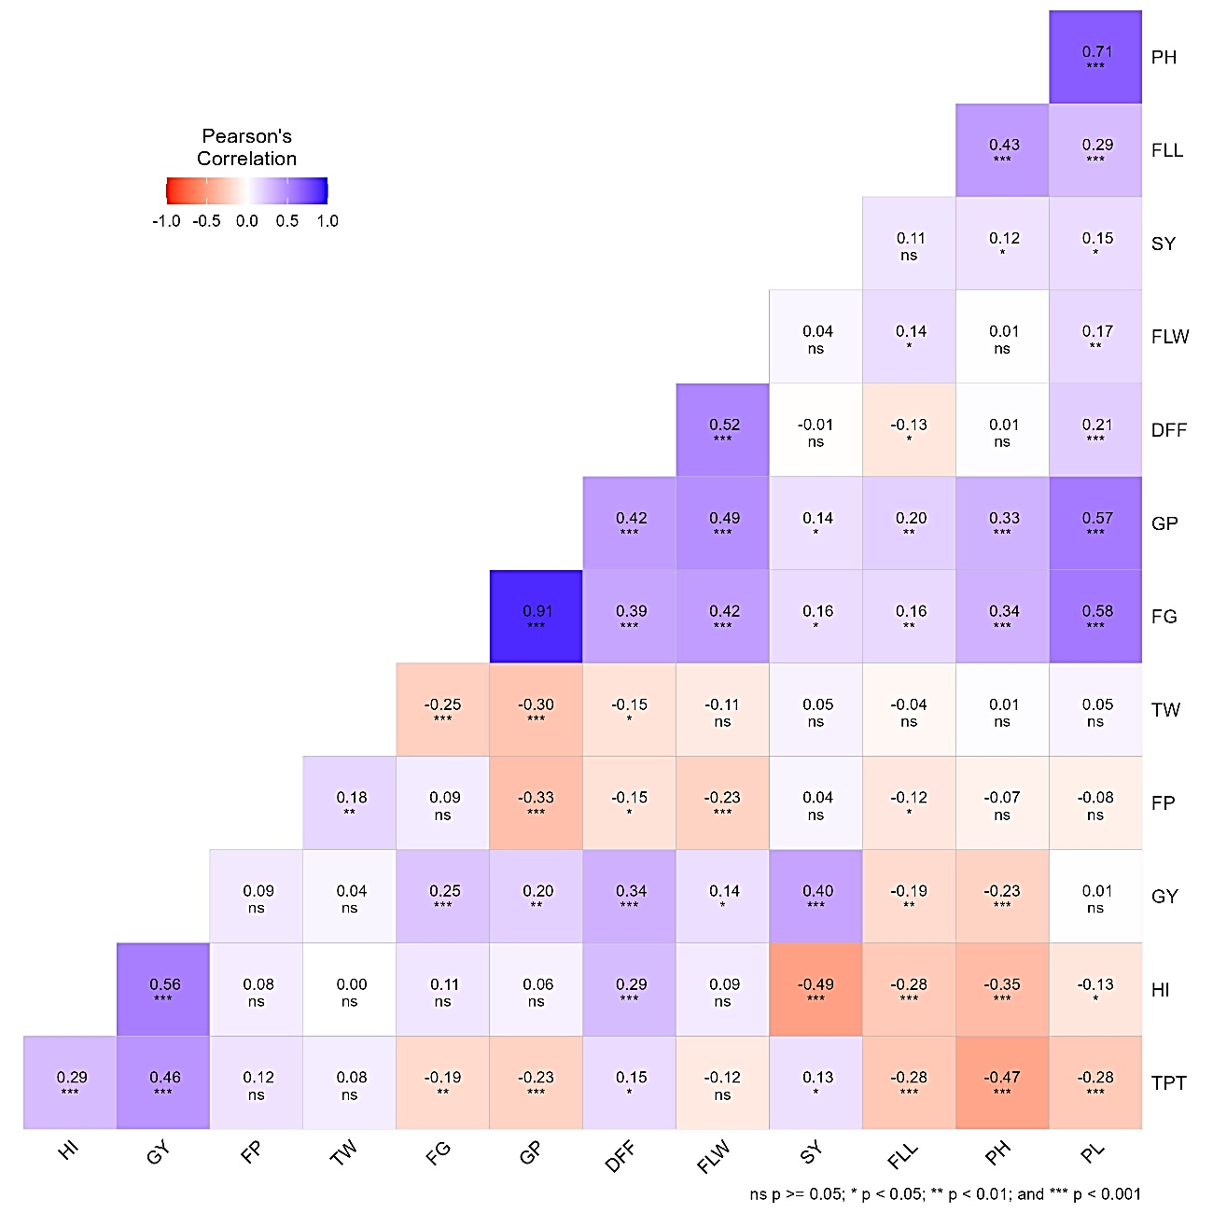
Fig. 1 Correlation heatmap for grain yield and its attributes during Rabi 2022-23
PH – Plant height (cm), DFF – Days to 50% flowering, TPT – Total productive tillers, PL – Panicle length (cm), FG – Number of fertile grains per panicle, GP – Total number of grains per panicle, FP – Fertility percentage (%), FLL – Flag leaf length (cm), FLW – Flag leaf width (cm), GY - Grain yield (kg ha⁻¹), SY – Straw yield (kg ha⁻¹), TW – Test weight (g), HI – Harvest index

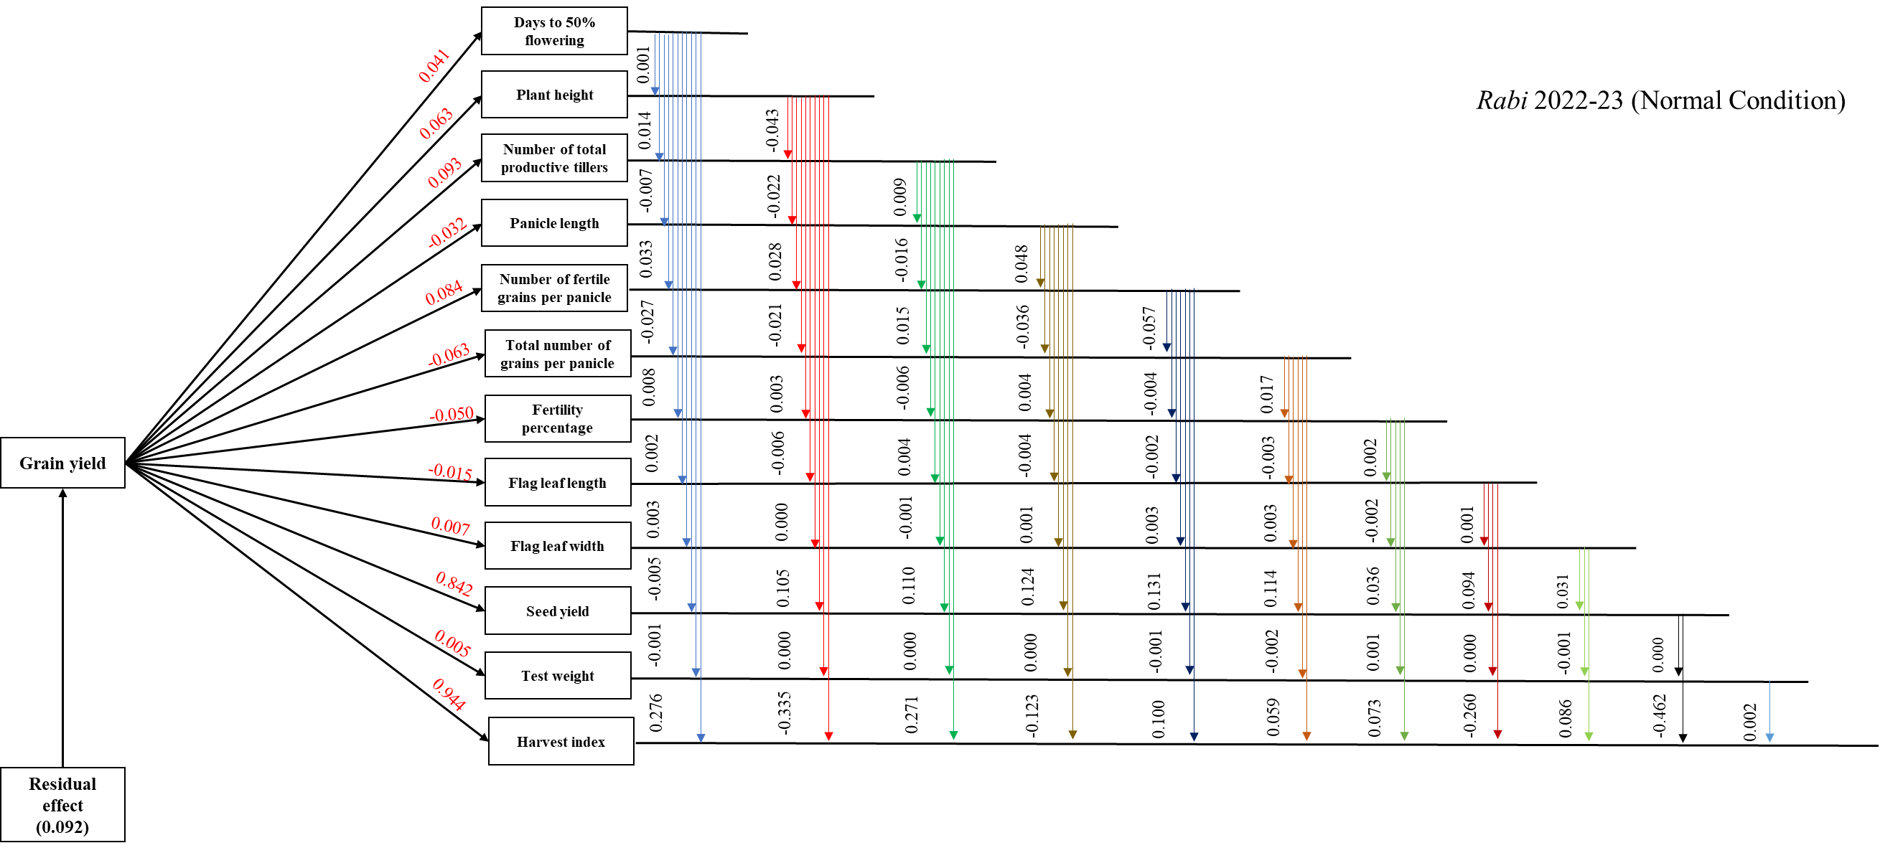

Fig. 2 Path diagram for direct and indirect effects of yield attributes on grain yield during Rabi 2022-23

Table 1. Direct and indirect effects of yield attributes on grain yield during Rabi 2022-23
Trait | DFF | PH | TPT | PL | FG | GP | FP | FLL | FLW | SY | TW | HI | GY
DFF | 0.041 | 0.001 | 0.014 | -0.007 | 0.033 | -0.027 | 0.008 | 0.002 | 0.003 | -0.005 | -0.001 | 0.276 | 0.338***
PH | 0.001 | 0.063 | -0.043 | -0.022 | 0.028 | -0.021 | 0.003 | -0.006 | 0.000 | 0.105 | 0.000 | -0.335 | -0.228***
TPT | 0.006 | -0.029 | 0.093 | 0.009 | -0.016 | 0.015 | -0.006 | 0.004 | -0.001 | 0.110 | 0.000 | 0.271 | 0.456***
PL | 0.009 | 0.044 | -0.026 | -0.032 | 0.048 | -0.036 | 0.004 | -0.004 | 0.001 | 0.124 | 0.000 | -0.123 | 0.010
FG | 0.016 | 0.021 | -0.018 | -0.018 | 0.084 | -0.057 | -0.004 | -0.002 | 0.003 | 0.131 | -0.001 | 0.100 | 0.252***
GP | 0.017 | 0.021 | -0.021 | -0.018 | 0.076 | -0.063 | 0.017 | -0.003 | 0.003 | 0.114 | -0.002 | 0.059 | 0.199**
FP | -0.006 | -0.004 | 0.011 | 0.003 | 0.007 | 0.021 | -0.050 | 0.002 | -0.002 | 0.036 | 0.001 | 0.073 | 0.092
FLL | -0.005 | 0.027 | -0.026 | -0.009 | 0.014 | -0.013 | 0.006 | -0.015 | 0.001 | 0.094 | 0.000 | -0.260 | -0.186**
FLW | 0.021 | 0.000 | -0.011 | -0.005 | 0.035 | -0.031 | 0.011 | -0.002 | 0.007 | 0.031 | -0.001 | 0.086 | 0.142*
SY | 0.000 | 0.008 | 0.012 | -0.005 | 0.013 | -0.009 | -0.002 | -0.002 | 0.000 | 0.842 | 0.000 | -0.462 | 0.396***
TW | -0.006 | 0.001 | 0.007 | -0.002 | -0.021 | 0.019 | -0.009 | 0.001 | -0.001 | 0.046 | 0.005 | 0.002 | 0.043
HI | 0.012 | -0.022 | 0.027 | 0.004 | 0.009 | -0.004 | -0.004 | 0.004 | 0.001 | -0.412 | 0.000 | 0.944 | 0.558***
Residual effect = 0.092

PH – Plant height (cm), DFF – Days to 50% flowering, TPT – Total productive tillers, PL – Panicle length (cm), FG – Number of fertile grains per panicle, GP – Total number of grains per panicle, FP – Fertility percentage (%), FLL – Flag leaf length (cm), FLW – Flag leaf width (cm), GY - Grain yield (kg ha-1), SY – Straw yield (kg ha-1), TW – Test weight (g), HI – Harvest index

