**Hairy root induction for production of bioactive metabolites from *Picrorhiza kurroa* Royle ex Benth**

**Abstract**

*Picrorhiza kurroa* Royle ex Benth (kutki) is a community herb of local tribes of Uttarakhand. This plant is habitant of Himalaya found at the ranges between (3000-5300m) from mean sea level (msl). Significance is undoubtedly proven for various ailments and their care management. An excessive damage from natural habitat threatened the existence of this particular herb by virtue of unsustainable harvesting practices, habitat behavior due to changing climate effect. As a result its natural population is being diminishing upto an extent of its extinction. Our laboratory research data based on various experiments conducted during *in vitro* growth and development with special reference to hairy roots. Leaf explants were used for initial callus induction on media containing Thidiazuron (TDZ) (2.27 μM). Induced callus(s) on basal Murashige and Skoog (MS) media with desired phytoregulators selected on the basis of required responses include Naphthalene-1-acetic acid (NAA) (2.15µM) and Indole-3-acetic acid (IAA) (2.28µM). Hairy root induction and subsequent proliferation from callus(s) was observed. Indirectly regenerated shoot tips from callus(s) upon sub culturing with NAA (10.74µM) and IAA (11.42µM) showed hairy roots in addition to normal regenerated roots. Indirectly regenerated leaves while inoculated as further explants(s) from indirectly regenerated plantlet with NAA (2.15µM) and IBA (2.95µM) showed hairy root development upto a greater extent compared to various phytoregulator and their combination.NAA (2.15µM) alone showed hairy root induction while nodal regions of regenerated plantlets were used as explants. Picroside-II, the principal iridoid glycoside of Picrorhiza kurroa, was quantitatively analyzed using High-Performance Liquid Chromatography (HPLC), enabling precise determination of this key bioactive compound. This attempt provides an opportunity to generate the desired plant material for further extraction of bioactive metabolites alongwith sustainable conservation strategy for *Picrorhiza kurroa*.

**Keywords**

*Agrobacterium rhizogenes*; Kutki; Metabolites; Phytoregulators; Sustainable; Threatened

**Introduction**

The Plantaginaceae family represents a significant source plants consisting of bioactive principles (Vendruscolo et al. 2022). Medicinal plant species (90-120) out of 800-900 total species across about 90 genera have been well recognized by virtue of established potential of care management (Malik et al. 2015). Plantaginaceae family found to account for 12-15% diversity. The Himalaya carries particularly significant medicinal genera including Plantago (plantains) with 275 species (Vendruscolo et al. 2022), Digitalis (foxgloves) with 5-7 species (Nazir et al. 2008),Veronica (speedwells) with 200 species (Salehi et al. 2019) and Picrorhiza/Neopicrorhiza with 2-3 species (Sharma 2021)

The medicinal properties of Plantaginaceae plant species known from their diverse phytochemical profiles. Digitalis species are renowned for their cardiac glycosides, with *D. purpurea* producing digoxin, digitoxin, and gitoxin alongside flavonoids like luteolin and apigenin. *D. lanata* synthesizes lanatosides A, B, and C in addition to cardiac glycosides (Verma et al. 2016). Veronica species characteristically produce iridoid glycosides such as aucubin and catalpol, combined with phenolic compounds including chlorogenic and caffeic acids (Salehi et al. 2019). Plantago species display remarkable consistency in their iridoid glycoside content, with aucubin and catalpol being predominant, while also producing phenylethanoid glycosides like plantamajoside and acteoside (Ronsted et al. 2000). Picrorhiza and Neopicrorhiza genera are distinguished by their unique picroside compounds (picroside I and II) and kutkoside, alongside phenolic compounds such as apocynin and vanillic acid (Prakash et al. 2020).

The conservation landscape for these medicinal plants reveals significant disparities in protection needs and cultivation success. Plantago species demonstrate remarkable adaptability to human-modified landscapes, thriving in disturbed areas without specific conservation measures (Chesney et al. 2025). In contrast, *Picrorhiza kurroa* faces multiple severe threats including overharvesting at natural and habitat further degradation, climate change, and slow regeneration rates, leading to its CITES Appendix I listing and implementation of harvest bans in several regions (Pandey and Gaur 2025). *Neopicrorhiza scrophulariiflora* similarly faces overharvesting pressures and alpine habitat loss (Kafle et al. 2018). However, harvest regulations have been established to protect this plant in nature.

Plant tissue culture techniques offer promising alternatives to decline wild harvesting for such plant species. Digitalis species have achieved the most successful tissue culture protocols, with *D. purpurea* demonstrating cardenolide production of 2 fold increase in digitoxin *in vitro* through multiple approaches including shoot multiplication, somatic embryogenesis, and hairy root culture (Rady and Rady 2019). *D. lanata* has shown even greater success with optimized digoxin production enhanced by elicitors in bioreactor systems (Verma et al. 2016). Veronica species show limited progress, with only basic callus induction and shoot multiplication protocols established with an observation of lower iridoid production potential than wild plants (Shahzad et al. 2011). Plantago species have achieved moderate success with aucubin production, though levels remain suboptimal compared to wild-type plants (Rahamouz 2023). The most challenging species remain *Picrorhiza kurroa* and *Neopicrorhiza scrophulariiflora*, where picroside production reaches only 1-3% compared to wild plant despite various culture practices for higher levels of production of picroside *in vitro* developed callus and other differentiated organs (Mondal et al. 2013).

Transformative potential using genetic modifications for enhancing bioactive compound production in Plantaginaceae species are now promising to achieve the potential of deserved metabolites. Digitalis species have been successfully transformed using Agrobacterium-mediated methods through CRISPR-Cas9 editing, achieving 2-4 fold increases in cardiac glycoside content (Kairuz et al. 2020). Thus metabolic engineering has modified glycoside profiles and created stress-resistant cultivars as well. Plantago species have also shown promising results with transformed lines demonstrating 30-50% increased mucilage production and enhanced aucubin content (Rocha et al. 2024). *Picrorhizakurroa* and *Neopicrorhizascrophulariiflora* are still ongoing challenges, with preliminary transformation efforts via RNA interference approaches, and precursor feeding experiments but still much progress to be made to achieve substantial amount of bioactive principles (Rao et al. 2025).

Semi-synthetic modifications of natural chemical skeleton from Plantaginaceae species have generated numerous derivatives with improved pharmacological properties. Digitalis glycosides have undergone extensive modifications including sugar moiety alterations and steroid nucleus changes, producing compounds like acetyldigitoxin, metildigoxin, and deslanoside with reduced toxicity and improved bioavailability (Elbaz et al. 2012; Comelius et al. 2013; Mijatovic et al. 2007). Veronica iridoid glycosides have been modified through catalposide derivatization and esterification to enhance anti-inflammatory activity (Saracoglu and Harput 2012). Plantago compounds have seen polysaccharide modifications yielding sulfated derivatives with improved immunomodulatory properties, while phenylethanoid conjugates show enhanced wound healing capabilities (Huan et al. 2024). Picrosides have also been extensively modified with diverse derivatives with improved hepatoprotective activity, various nano-formulations including phospholipids complexes for targeted delivery of bioactive protective compounds, however some quite effective and making high market demand (Han et al. 2019).

Plantaginaceae species demonstrate remarkable hepatoprotective capabilities through diverse mechanisms. Digitalis species contain self-protective compounds that prevent autotoxicity from their cardiac glycosides (Shereen et al. 2024). Veronica species employ antioxidant mechanisms through their iridoid glycosides and phenolic compounds, inhibiting liver inflammation and reducing oxidative stress (Tan et al. 2017; Beera et al. 2015). Plantago species utilize aucubin and catalpol to reduce liver enzyme elevations and protect against toxin-induced damage (Rahamouz 2023). Most notably, *Picrorhiza kurroa* exhibits exceptional hepatoprotective effects through picrosides I and II, providing strong protection against various hepatotoxins. *Neopicrorhiza scrophulariiflora* demonstrates similar protective mechanisms against oxidative stress and inflammation in liver tissue (Almeleebia et al. 2022).Our observation on hairy roots induced and their production potential were aimed for comparative effectiveness of picroside production in callus(s) and other differentiated organs.

*Picrorhiza kurroa* is found from sub alpine to alpine regions ranging from North Western to North Eastern Himalaya (Chandra et al. 2021; Debnath et al. 2020; Bisht and Chauhan 2018) Plant grows preferably in porous soil (Patial et al. 2012). Hairy roots when elicited *in vitro* rapid and profused growth was observed. This is found for enabling an efficient production of bioactive lead compounds (Sharan et al. 2019; Verma et al. 2015). *In situ* hairy roots might primarily observe due to Agrobacterium rhizogenes (Chilton et al. 1982; Gelvin 2009; Bisht and Chauhan 2018; Bagal et al. 2023). Such hairy roots had been established for enhanced genesis and metabolism of bioactive principles (Tremouillaux 2013; Gai et al. 2015). In addition, *in vitro* hairy root cultures offer regulated and reproducible approach toward molecular understanding of genetic transformation (Gutierrez-Valdes et al. 2020; Shi et al. 2021; Jariani and Naghavi 2024; Clemow et al 2011). *Agrobacterium* species are widely known for their ability of forming a wide variety of disorders, including crown gall ( *Agrobacterium tumefaciens*) (Van Montagu et al. 2022; Brown et al. 2023; Lee et al. 2009; Meyer et al. 2019) and (*Agrobacterium vitis*) (Flores-Flex et al. 2020; Herlache and Triplett 2002; Faist et al. 2016) hairy roots are induced by  *Agrobacterium rhizogenes* (Cheng et al. 2021; Sathasivam et al. 2022; Mishra et al. 2011; Thiruvengadam et al. 2016; Verma et al. 2007) while cane gall is observed by a virulent *Agrobacterium rubi* (Gelvin 2003; Kuzumanovic et al. 2018). *Agrobacterium rhizogenes* mediated hairy root cultures are found satisfactory for efficient production of desired metabolites (Biswas et al. 2023; Mondal et al. 2013). As a matter of fact, climate change globally affect including Himalaya which is already a fragile and vulnerable ecosystem (Tewari et al. 2017). In view of this, it becomes extremely important to make our attempts to sustain this important plant resource. Thus, in this plan of our experiments, we could optimized *in vitro* hairy root induction for the efficient propagation and evaluated hairy roots via Agrobacterium rhizogenes strains (A4, LBA9402, K599, and 15834) which were maintained in our laboratory during COVID-19 pandemic, however, no response for hairy root induction could be observed even after repeated efforts. Alongwith MS basal media supplemented with different combinations of plant growth regulators were also checked for responding hairy roots *in vitro*. In later experiments hairy roots *in vitro* were found to induce and proliferate. These observations were recorded and these were found repeatedly observed in our lab. The present study aimed to develop and validate a high-performance liquid chromatography (HPLC) method in accordance with International Council for Harmonisation (ICH) guidelines for the quantification of picroside-II in *Picrorhiza kurroa* samples. The validated method can be effectively utilized in pharmaceutical industries for the standardization of *P. kurroa* based formulations and for further phytochemical investigations of the species.

As such our studies are beneficial in order to maintain the germplasm *in vitro* as well as harvesting the optimum potential of bioactive compounds for testing efficacy for combinatorial behavior for generating a chemical nucleus under strict regulatory observation of growth and development of hairy roots.

**Materials and methods**

**Collection of plant material**

*Picrorhiza kurroa* was collected from Jhuni, Bageshwar, North West Himalayan Region of Uttarakhand (India) in November 2023. The collection site stands at an altitude of 520 meters (1706.04 ft), and coordinates 29.94°N 79.90°E, propagating through rhizome. During collection, the temperature ranged from a maximum of 18.5°C (65.3°F) to a minimum of 3.4°C (38.1°F), with a humidity level of 48%.

**Experimental site**

Sample collected, plantations were reared at College of Basic Science and Humanities (CBSH), Govind Ballabh Pant University of Agriculture and Technology (GBPUAT), Pantnagar-263145 (Uttarakhand) greenhouse and laboratories for *ex situ*. In November 2023, collected materials were maintained for sustenance of conservation strategies development of collected germplasm growth in suitable pots containing soil: sand: compost in the ratio of 1:1:1(w/w/w) at the height of 243.8m (799.8ft) and coordinates 290N 790E as well as under greenhouse/ laboratory for optimum *in vitro* culture practices. The germplasm evaluation and bio-product development facilities were maintained at 250C- 280C and 70-80% relative humidity for the survival of these plants. The plant *Picrorhiza kurroa* germplasm, thus could be under conditions of relatively controlled parameters of growth upto the level of certain extent for our research and to develop potential agropractices at cultivation sites *in situ* and or *ex situ*.

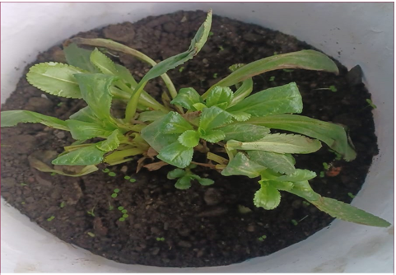

Fig 1(a): *Picrorhiza kurroa* under growth in suitable size (height- 16cm, width- 14cm ) plastic pots containing soil (collected from Dr NE Borlaug Crop Research Centre) sand: compost (obtained from cow dung collected from Dairy Research Farm) in the ratio of 1:1:1 w/w/w with required moisture contents filled upto 3/4th of height

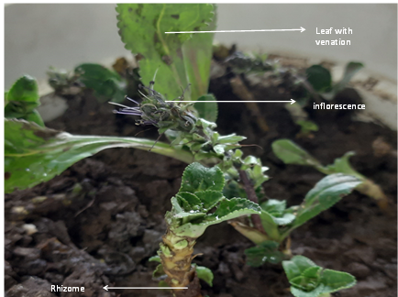

Fig 1(b): Morphology of *Picrorhiza kurroa* under growth

**Explants**

The intact leaves of *Picrorhiza kurroa* were picked up for explants. Leaf explants surface sterilized and as such thoroughly sterilized explants of suitable sizes in different orientation observed for callus induction in suitable glass vessels consisting of sterilized MS basal medium with required growth regulators. Approximately leaves length of 5-6cm were washed under tap water, and then treated with 0.1 % (w/v) Bavistin for 30 minutes at an ambient temperature (280C) and normal pressure. After rinsing with deionized water, these leaves were sterilized with 0.1% (w/v) HgCl₂ for 35 seconds, followed by 70% ethanol for 30 seconds. Final rinsing with autoclaved deionized water was carried out in a laminar air flow cabinet to avoid contamination.

**Dedifferentiation**

As such few cytokinen (BAP, TDZ and KIN) and only auxin (IBA) were used for finding out the optimum levels of growth regulators effect *in vitro* growth regimes of controlled environment. Unorganised mass (callus) was obtained in TDZ (2.27µM) only.

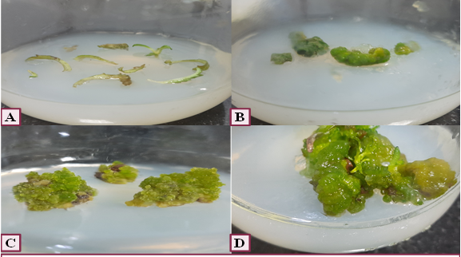

**Fig 2: (A),(B),(C) Callus induction from leaves on MS medium containing TDZ(2.27 µM)**

**(D) Induced callus(s) after 4 week**

**Redifferentiation**

Since, hairy root production was aimed, thus further these callus(s) were subjected to more defined conditions of growth and development toward hairy or other kinds of roots. Further sub culturing of induced callus on Murashige and Skoog (MS) basal media with supplementation of Naphthalene-1-acetic acid(2.15µM) and Indole-3-acetic acid(2.28µM) showed hairy root induction and proliferation while NAA(2.15 μM) and IBA(1.97 μM) showed hairy root induction alongwith shoot formation.

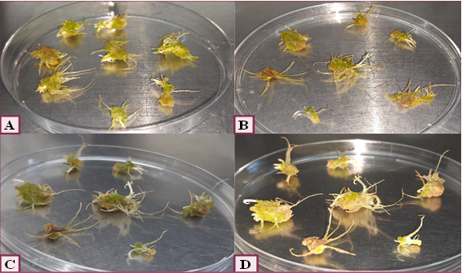

**Fig 3 (A-D): Hairy root proliferation in an induced callus after 2 week of subculture in a medium supplemented with NAA (2.15µM) and IAA (2.28µM)**

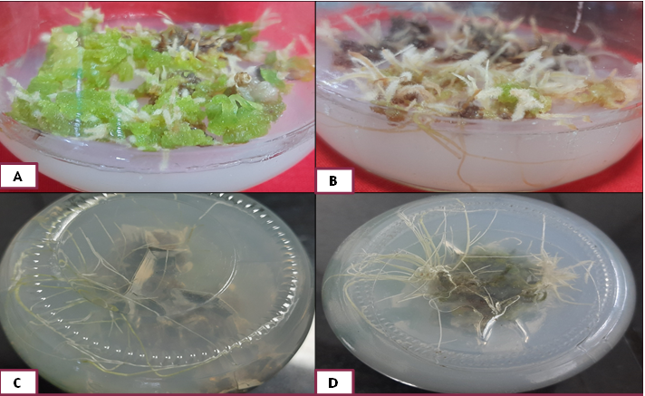

**Fig 4:A) Hairy root proliferation after 1 week subculture in NAA(2.15μM) and IAA( 2.28μM) (B)after 3 week (C) after 5 week (D) after 6 week of culture**

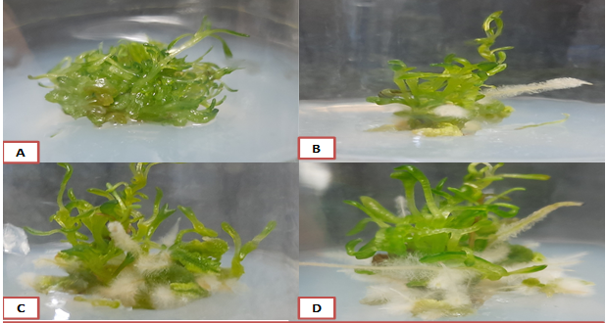

**Fig 5: (A-D) hairy root proliferation after few weeks of sub culturing**

Explants from *in vitro* developed leaves were also subjected for inoculation in basal MS media supplemented with Naphthalene-1-acetic acid (2.15µM) and Indole-3-butyric acid (2.95µM) which showed highest hairy root development. *In vitro* shoots when placed upon suitable basal medium from indirectly regenerated plantlets also showed hairy roots in addition to normal roots. Such developed shoot nodes when placed upon suitable basal medium consisting of NAA (2.15µM) alone showed hairy root induction.

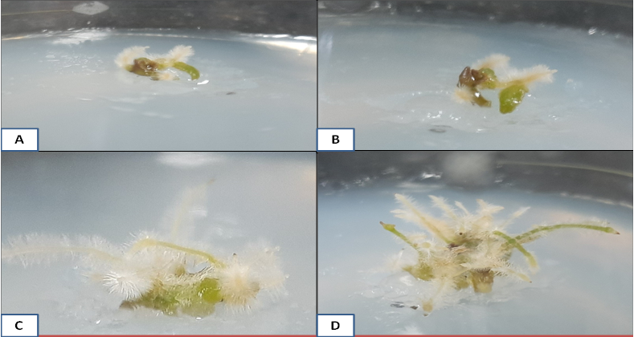

**Fig 6: (A) Hairy root proliferation in leave explant after 1 week of subculture in NAA (2.15μM) and IBA (2.95μM) (B) hairy root proliferation after 2 week (C) after 3 week (D) after 5 week of culture**

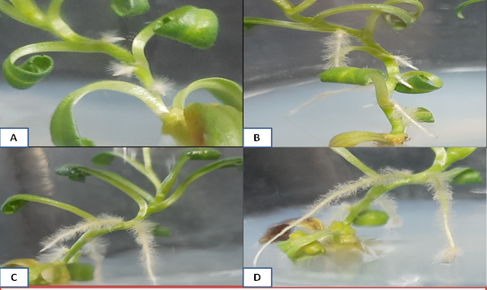

**Fig 7: (A) Hairy root initiation in shoot after 2 week of subculture in NAA (2.15μM) (B) hairy root proliferation after 3 week (C) after 4week (D) after 5 week of culture**

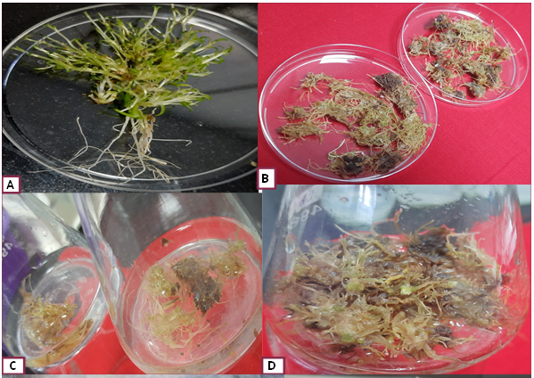

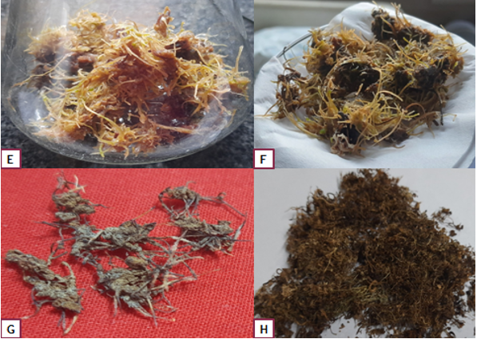

**Fig 8: A) Uprooted tissue culture raised plant; B) Hairy root isolates; C) & D) Hairy roots segments maintained in suspension culture; E) &F) Extensive proliferation showing dense branching pattern; G) & H) Dry hairy roots for further experimentation**

FIG 8: A) Uprooted tissue culture raised plant; B) Hairy root isolates; C) & D) Hairy roots segments maintained in suspension culture; E) &F) Extensive proliferation showing dense branching pattern; G) & H) Dry hairy roots for further experimentation.

**Results**

The experimental results were statistically analyzed to assess the variation among treatments. A one-way Analysis of Variance (ANOVA) was employed among the treatment groups to determine whether the observed differences in mean values were statistically significant. When the ANOVA indicated significant variation, Tukey’s Honestly Significant Difference (HSD) test was applied as a post-hoc analysis between treatment means. A probability value of **p < 0.05** was considered the threshold for statistical significance.

|  |  |  |  |
| --- | --- | --- | --- |
| **Treatment (μM)** | **Callus induction**  **Frequency (%)** | **Relative efficiency (%)** | **Callus type** |
| control | 0±0ᶜ | - | - |
| IBA 2.46 | 6.25±3.60ᶜ | 7.69 | Mucilaginous |
| IBA 3.69 | 0±0ᶜ | - | - |
| TDZ 2.27 | 81.25±8.06ᵃ | 100 | Green compact |
| TDZ 3.41 | 40.62±5.98ᵇ | 50.03 | Green friable |
| BAP 2.25 | 0±0ᶜ | - | - |
| BAP 3.33 | 0±0ᶜ | - | - |
| KIN 2.32 | 0±0ᶜ | - | - |
| KIN 3.49 | 0±0ᶜ | - | - |
| IBA 2.46/ TDZ 3.41 | 46.87±5.98ᵇ | 57.69 | green friable |
| IBA 2.46/ TDZ 2.27 | 40.62±5.98ᵇ | 49.99 | Yellow friable |
| IBA 3.69/ TDZ 2.27 | 31.25±3.60ᵇ | 38.46 | Yellow friable |
| IBA 3.69/ TDZ 3.41 | 31.25±8.06ᵇ | 38.46 | Brown friable |
| BAP 2.25/ KIN 2.32 | 0±0ᶜ | - | - |
| BAP 2.25/ KIN 3.49 | 0±0ᶜ | - | - |
| BAP 3.33/ KIN 2.32 | 0±0ᶜ | - | - |
| BAP 3.33/ KIN 3.49 | 0±0ᶜ | - | - |
| IBA 2.46/ KIN 2.32 | 0±0ᶜ | - | - |
| IBA 2.46/ KIN 3.49 | 0±0ᶜ | - | - |
| IBA 3.69/ KIN 2.32 | 0±0ᶜ | - | - |
| IBA 3.69/ KIN 3.49 | 0±0ᶜ | - | - |

**Table 1: The effect of few cytokinen (TDZ, BAP, KIN) and auxin (IBA) on *in vitro* callus induction. Callus Induction frequency (%) is expressed as mean ± SE, with statistical significance (p < 0.05). Relative Efficiency (%) calculated using TDZ 2.27 μM (81.25%) as 100%. Treatments with 0% induction showed no response.**

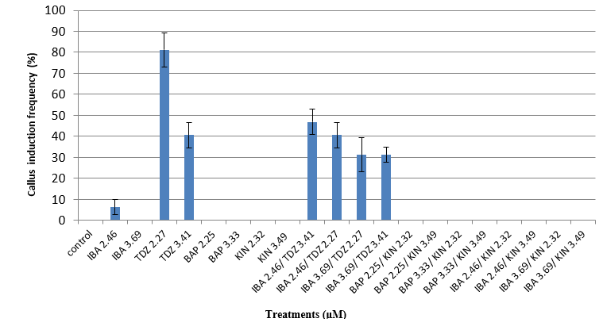

**Fig 9: The bar graph shows the effects of different plant growth regulators (IBA, TDZ, BAP and KIN). TDZ (2.27μM) exhibits the highest response. No response was observed in BAP and KIN.**

**Treatments (μM)**

The effect of different plant growth regulators (PGRs), alone and in combination, on callus induction from explants was evaluated. Among the individual treatments, **TDZ at 2.27 μM exhibited the highest callus induction frequency (81.25%) with green compact callus,** followed by TDZ at 3.41 μM (40.62%) producing green friable callus. In contrast IBA, BAP, and KIN alone showed less or no response. In combination, **IBA (2.46 μM) with TDZ (3.41 μM)** yielded 46.87% callus induction with green friable callus, while other IBA–TDZ combinations comparatively produced yellow or brown friable calli at lower frequencies. BAP and KIN combinations did not support callus induction. Overall, the results indicate that **TDZ, either alone or in combination with IBA, is the most effective regulator for inducing callus,** whereas BAP and KIN are ineffective under the tested conditions.

|  |  |  |
| --- | --- | --- |
| **Treatment (μM)** | **Hairy root induction frequency (%)** | **Relative Efficiency (%)** |
| control | 0±0ᵈ | - |
| IAA 1.14 | 0±0ᵈ | - |
| IAA 2.28 | 0±0ᵈ | - |
| IBA 0.98 | 0±0ᵈ | - |
| IBA 1.97 | 0±0ᵈ | - |
| NAA 2.15 | 0±0ᵈ | - |
| NAA 1.07 | 0±0ᵈ | - |
| NAA 1.07/ IAA 1.14 | 25±5ᶜ | 27.78 |
| NAA 1.07/ IAA 2.28 | 45±5ᵇ | 50.00 |
| NAA 2.15/ IAA 1.14 | 55±5ᵇ | 61.11 |
| NAA 2.15/ IAA 2.28 | 90±5.77ᵃ | 100 |
| NAA 1.07/ IBA 0.98 | 0±0ᵈ | - |
| NAA 1.07/ IBA 1.97 | 0±0ᵈ | - |
| NAA 2.15/ IBA 0.98 | 0±0ᵈ | - |
| NAA 2.15/ IBA 1.97 | 0±0ᵈ | - |

**Table 2: The effect ofauxins (IAA, IBA, NAA) on hairy root induction from callus**. **Hairy Root Induction frequency (%) is expressed as mean ± SE, with statistical significance (p < 0.05)**. **Relative Efficiency (%) calculated using NAA 2.15 / IAA 2.28 (90%) as 100%**. **Treatments with 0% induction showed no response.**

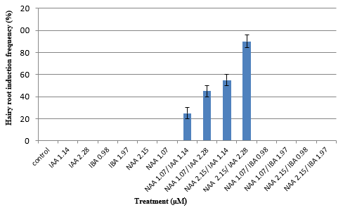

**Treatment (μM)**

**Fig 10: The bar graph shows the effects of different plant growth regulators (NAA, IAA and IBA). NAA 2.15/ (IAA 2.28μM) exhibit the highest response. No response was observed in NAA and IBA.**

The auxin combinations exert a profound effect on hairy root induction in the tested sample, while individual auxin treatments (IAA, IBA, or NAA) somewhat failed to induce any response. Among the combinations tested, the synergistic effect of NAA and IAA with induction frequency increasing proportionally with auxin concentration. The highest induction (99%) and relative efficiency was achieved with **NAA 2.15 μM + IAA 2.28 μM**, followed by moderate responses at lower concentrations of the same combination (55% and 45%). A comparatively low induction (25%) was observed with **NAA 1.07 μM + IAA 1.14 μM**, while all combinations of NAA with IBA were ineffective. These findings suggest that **IAA acts synergistically with NAA to trigger hairy root induction, whereas IBA does not contribute positively**.

|  |  |  |
| --- | --- | --- |
| **Treatment (μM)** | **Hairy root**  **Induction frequency (%)** | **Relative Efficiency**  **(%)** |
| control | 0±0ᵈ | - |
| IAA 2.85 | 0±0ᵈ | - |
| IAA 5.71 | 0±0ᵈ | - |
| IBA 4.92 | 0±0ᵈ | - |
| IBA 9.84 | 0±0ᵈ | - |
| NAA 2.69 | 0±0ᵈ | - |
| NAA 5.37 | 0±0ᵈ | - |
| NAA 5.37/ IAA 5.71 | 62.5±7.21ᵇ | 66.67 |
| NAA 5.37/ IAA 11.42 | 31.25±11.96ᶜ | 33.33 |
| NAA 10.74/ IAA 5.71 | 75±10.20ᵃᵇ | 80.00 |
| NAA 10.74/ IAA 11.42 | 93.75±6.25ᵃ | 100 |
| NAA 5.37/ IBA 4.92 | 0±0ᵈ | - |
| NAA 5.37/ IBA 9.84 | 0±0ᵈ | - |
| NAA 10.74/ IBA 4.92 | 0±0ᵈ | - |
| NAA 10.74/ IBA 9.84 | 0±0ᵈ | - |

**Table 3: The effect of auxins (IAA, IBA, NAA) on hairy root induction in indirectly regenerated shoot. Hairy root induction frequency (%) is expressed as mean ± SE**, **with statistical significance (p < 0.05)**. **Relative Efficiency (%) calculated using NAA 10.74 / IAA 11.42 (93.75%) as 100%. Treatments with 0% induction showed no response.**

**Hairy root induction frequency (%)**

**Treatment(μM)**

**Fig 11: The bar graph shows the effects of different plant growth regulators (NAA, IAA and IBA). NAA 10.74/ IAA 11.42μM exhibit the highest response. No response was observed in NAA and IBA**.

Treatment of auxins such as IAA, IBA and NAA when treated alone at different concentrations does not induce hairy roots, as indicated by 0% induction frequency. However, combinations of NAA with IAA significantly enhanced hairy root induction. Among the different combinations, NAA (10.74 μM) with IAA (11.42 μM) exhibited the maximum response, achieving a hairy root induction frequency of 93.75% with 100% relative efficiency, followed by NAA (10.74 μM) and IAA (5.71 μM), which yielded 75% induction and 80% relative efficiency. Moderate induction was observed with NAA (5.37 μM) and IAA (5.71 μM) (62.5%), NAA (5.37 μM) and IAA (11.42 μM) (31.25%). By contrast, combinations of NAA with IBA were completely ineffective, showing 0% induction across all tested concentrations. These findings suggest that combinations of NAA and IAA are crucial for hairy root induction, whereas IBA in combination with NAA does not support this response.

|  |  |  |
| --- | --- | --- |
| **Treatment (μM)** | **Hairy root**  **Induction frequency (%)** | **Relative Efficiency**  **(%)** |
| control | 0±0ᵈ | - |
| IAA 2.28 | 0±0ᵈ | - |
| IAA 3.42 | 0±0ᵈ | - |
| IBA 1.97 | 0±0ᵈ | - |
| IBA 2.95 | 31.25±3.60ᵇᶜ | 33.33 |
| NAA 2.15 | 37.5±5.10ᵇ | 40 |
| NAA 3.22 | 0±0ᵈ | - |
| NAA 2.15/ IAA2.28 | 0±0ᵈ | - |
| NAA 2.15/ IAA 3.42 | 0±0ᵈ | - |
| NAA 3.22/ IAA 2.28 | 0±0ᵈ | - |
| NAA 3.22/ IAA3.42 | 0±0ᵈ | - |
| NAA 2.15/ IBA 1.97 | 21.87±3.12ᶜ | 23.33 |
| NAA 2.15/ IBA 2.95 | 93.75±3.60ᵃ | 100 |
| NAA 3.22/ IBA 1.97 | 0±0ᵈ | - |
| NAA 3.22/ IBA 2.95 | 0±0ᵈ | - |

**Table 4: The effect ofauxins (IAA, IBA, NAA) on hairy root induction from leaves**. **Hairy Root Induction frequency (%)is expressed as mean ± SE with statistical significance (p < 0.05)**. **Relative Efficiency (%) calculated usingNAA 2.15 / IBA 2.95 (93.75%) as 100%.**

**Hairy root induction frequency (%)**

**Treatment(μM)**

**Fig 12: The bar graph shows the effects of different auxins (NAA, IAA and IBA). NAA 2.15/ IBA 2.95μM exhibit the highest response, while certain combinations also show moderate effects. No response was observed in NAA and IAA.**

Individual treatments of IAA at both concentrations tested did not induce hairy roots, whereas IBA (2.95 μM) and NAA (2.15 μM) alone produced moderate responses with 31.25% and 37.5% induction frequency, corresponding to relative efficiencies of 33.33% and 40%, respectively. The combination of NAA (2.15 μM) and IBA (2.95 μM) resulted in a significantly higher induction frequency of 93.75% with 100% relative efficiency, indicating a strong synergistic effect of these auxins. In contrast, higher NAA concentration (3.22 μM) alone or in combination with either IAA or IBA failed to induce hairy roots. The combination of NAA (2.15 μM) with a lower concentration of IBA (1.97 μM) showed limited induction (21.87%), while all NAA and IAA combinations remained ineffective. These findings suggest that optimum concentrations of NAA and IBA act synergistically to promote hairy root induction, whereas IAA alone or in combination with NAA does not contribute effectively.

|  |  |  |
| --- | --- | --- |
| **Treatment (μM)** | **Hairy root induction frequency (%)** | **Relative Efficiency (%)** |
| Control | 0±0ᶜ | - |
| IAA 2.28 | 0±0ᶜ | - |
| IAA 3.42 | 0±0ᶜ | - |
| IBA 1.97 | 0±0ᶜ | - |
| IBA 2.95 | 0±0ᶜ | - |
| NAA 2.15 | 93.75±6.25ᵃ | 100 |
| NAA 3.22 | 0±0ᶜ | - |
| NAA 2.15/ IAA 2.28 | 18.75±6.25ᵇ | 20 |
| NAA 2.15/ IAA 3.42 | 0±0ᶜ | - |
| NAA 3.22/ IAA 2.28 | 0±0ᶜ | - |
| NAA 3.22/ IAA 3.42 | 0±0ᶜ | - |
| NAA 2.15/ IBA 1.97 | 0±0ᶜ | - |
| NAA 2.15/ IBA 2.95 | 0±0ᶜ | - |
| NAA 3.22/ IBA 1.97 | 0±0ᶜ | - |
| NAA 3.22/ IBA 2.95 | 0±0ᶜ | - |

**Table 5: The effect ofauxins (NAA, IAA and IBA)onhairy root induction from nodal explants**. **Hairy Root Induction frequency (%)is expressed asmean ± SE**, **with statistical significance (p < 0.05)**. **Relative Efficiency (%) calculated usingNAA (2.15 μM) (93.75%) as 100%**.

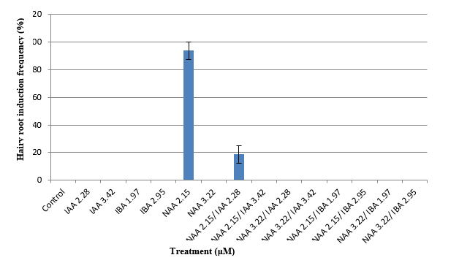

**Fig 13: The bar graph shows the effects of different auxins (NAA, IAA and IBA). NAA (2.15μM) exhibit the highest response. No response was observed in NAA and IBA.**

An individual treatment of IAA or IBA at the tested concentrations does not induce hairy roots, and similar ineffectiveness was also recorded for their combinations with NAA, except in one case. A prominent response was observed with NAA (2.15 μM) alone, which exhibited the highest hairy root induction frequency of 93.75% and a relative efficiency of 100%, indicating that this concentration was highly effective in triggering root induction. A minor induction (18.75%) was noted with the combination of NAA (2.15 μM) and IAA (2.28 μM), but this was substantially lower compared to NAA alone. Increasing the NAA concentration to 3.22 μM, either singly or in combination with IAA or IBA, completely suppressed root induction. These results highlight that low-dose NAA is the most potent auxin for hairy root induction under the tested conditions, whereas IAA and IBA, either individually or in combination, do not significantly contribute to the response.

**Suspension culture**

Hairy roots were suspended *in vitro* growth media in suitable vessels in shaking environment. Such suspension cultures were analysed to possess high biosynthetic capacity and biochemical stability. Hairy roots were observed to synthesize more than one bioactive metabolite and therefore such suspension cultures might be better economically during commercial efforts toward bioactive principles (Meyer et al. 2019). High level of lateral branching resulted into faster growth rate, enhancing biomass accumulation leading to production efficiency in terms of bioactive metabolites.

**High Performance Liquid Chromatography (HPLC) analysis**

Qualitative and Quantitative determination of picroside-II: A principal iridoid glycoside in *Picrorhiza kurroa* was analyzed upon High-Performance Liquid Chromatography (HPLC) system. This analytical technique enabled precise quantification of this bioactive compound through standardization. Quality assessment of the plant material thus could be made after comparative analytics. The HPLC profile of picroside-II is characterized by a distinct retention time under optimized chromatographic conditions, typically using a C18 column with mobile phase comprising water and acetonitrile (75:25) v/v. Detection was performed at UV wavelengths at 270 nm.

A

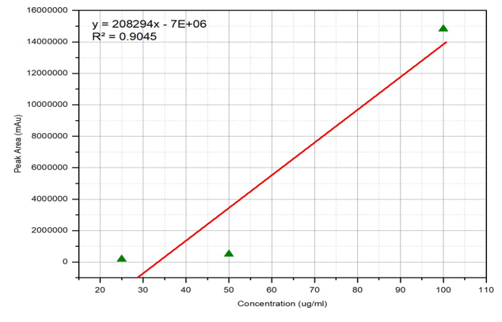

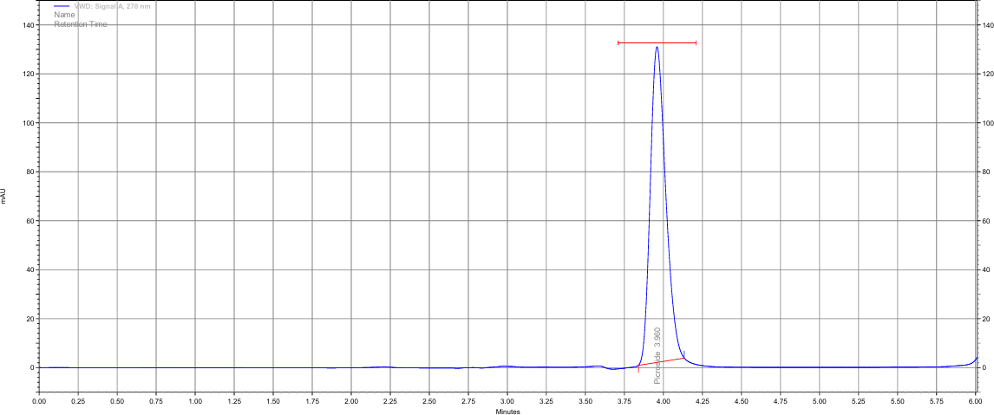

B

C

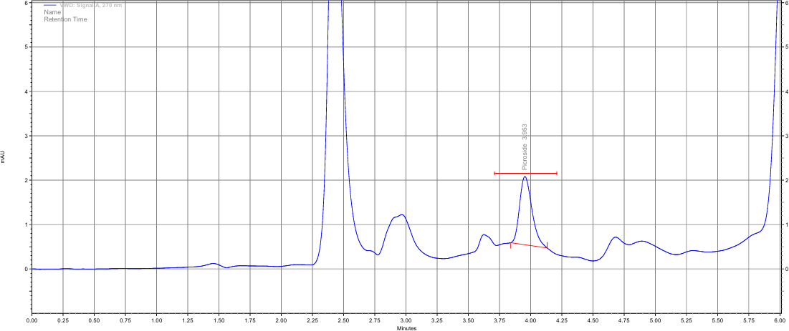

Fig 14: A) Calibration curve of Picroside II B) HPLC analysis of picroside II (Standard) C) HPLC analysis of picroside II (sample) in the roots of *Picrorhizakurroa*

## Discussion

The present study demonstrates successful induction and proliferation of hairy roots in *Picrorhiza kurroa* through an indirect organogenesis approach utilizing various explants types and auxin combinations. The efficacy of TDZ (2.27 μM) and IBA 2.46/ TDZ 3.41 μM for callus induction from leaf explants aligns with previous findings on TDZ's potent cytokinin-like activity in medicinally important plant tissue culture (Giri and Narasu 2000). While other combinations of IBA/Kn and BAP/Kn showed no response. In micropropagation, multiple shoot induction, somatic embryogenesis, callus induction, and shoot organogenesis TDZ was found to be more effective as compared to other cytokinins (Deepa et al. 2018).TDZ proved to be the most effective cytokinin for callus induction, particularly at lower concentrations, while IBA in combination with TDZ further enhanced callus formation, suggesting a synergistic interaction between auxin and cytokinin in promoting morphogenic callus. In contrast, BAP and KIN were largely ineffective, indicating their limited role under the tested conditions. Our results reveal that hairy root induction requires specific auxin concentrations and combinations as well, with NAA (2.15 μM) emerging as a crucial component across multiple experimental conditions. The differential response observed across explant types suggests tissue-specific sensitivity to auxin treatments. Previous research have shown that incubation of agro-infected explants produced hairy roots on Murashige and Skoog (MS) medium without plant growth regulators (Wang et al. 2012) (Gupta et al. 2011). Hairy root are characterized by their rapid growth on basal media, genetic and biosynthetic stability and ability to produce bioactive metabolites (Abraham and Thomas 2017). Hairy root induction responses showed strong variability depending on auxin type and concentration. While some experiments highlighted the synergistic role of NAA and IAA, others demonstrated that NAA in combination with IBA, or even NAA alone at optimal levels, could achieve maximum induction. This variability indicates that auxin balance plays a decisive role, and the effectiveness of a particular auxin or combination may be species and explants specific. Overall, the results emphasize the importance of optimizing both the type and concentration of PGRs for successful *in vitro* morphogenesis. This variation in auxin requirements indicates distinct physiological and biochemical states across different tissue types, potentially related to endogenous hormone levels or receptor expression. The simultaneous induction of shoots and hairy roots on media demonstrates the potential for developing complete regeneration protocols alongside hairy root production systems. Such morphogenesis pathway particularly becomes valuable when rapid propagation is also required while maintaining hairy root production capacity. High Performance Liquid Chromatography (HPLC) analysis confirming picroside-II content in the induced hairy roots validates their biosynthetic capacity for this medicinally important iridoid glycoside. Production of metabolites with such practices sustained production of valuable metabolites without disturbing wild diminishing population.

**Conclusion**

Study could be able to decipher growth behavior *in vitro* with response to phytohormone concentrations at each stage while further optimizing this process for production of biomass and yield of compound. TDZ (2.27 μM) was effective for initial callus induction under specific auxin combinations, particularly NAA (2.15 μM) with either IAA (2.28 μM) or IBA (2.95 μM) with promoting hairy root development from *in vitro* developed leave explants and nodal explants. Findings revealed explant specific responses to auxin treatments, when indirectly regenerated leaves used as explants, superior hairy roots could be developed upon NAA (2.15 μM) and IBA (2.95μM) supplementations. Nodal segments required only NAA (2.15μM) for effective induction of hairy roots. Findings contribute valuable insights into tissue-specific sensitivity and response of specific plant growth regulators in *P. kurroa*, providing basis for modifying culture conditions according to specific morphogenic outcomes with respect to desired metabolites. In this study, HPLC analysis confirmed the presence of picroside-II in the induced hairy roots, which further validating biosynthetic capacity of this medicinally important compound. Bioactive metabolite production also demonstrated the potential of the established culture system for sustainable production of medicinally valuable compounds relatively assured availability without relying on wild harvesting and cultivation practice. The established methods of our study could be further modified for optimization for further scale up of process from hairy root biomass. Subsequently extraction of fair amount of picroside-II and other valuable bioactive metabolites can be achieved.

COMPETING INTERESTS DISCLAIMER:

Authors have declared that they have no known competing financial interests OR non-financial interests OR personal relationships that could have appeared to influence the work reported in this paper.

Disclaimer (Artificial intelligence)

This is the original research paper and we hereby declare that NO generative AI technologies such as Large Language Models (ChatGPT, COPILOT, etc.) and text-to-image generators have been used during the writing or editing of this manuscript.

**References:**

1. Abraham, J., & Thomas, T. D. (2017). Hairy root culture for the production of useful secondary metabolites. *Biotechnology and production of anti-cancer compounds*, 201-230.
2. Almeleebia, T. M., Alsayari, A., & Wahab, S. (2022). Pharmacological and clinical efficacy of Picrorhizakurroa and its secondary metabolites: A comprehensive review. *Molecules*, *27*(23), 8316.
3. Bagal D, Chowdhary AA, Mehrotra S, Mishra S, Rathore S, Srivastava V (2023) Metabolic engineering in hairy roots: An outlook on production of plant secondary metabolites. *Plant Physiology and Biochemistry* 201, 107847.
4. Beara, I., Živković, J., Lesjak, M., Ristić, J., Šavikin, K., Maksimović, Z., & Janković, T. (2015). Phenolic profile and anti-inflammatory activity of three Veronica species. *Industrial Crops and Products*, *63*, 276-280.
5. Bisht AS, Chauhan RS (2018) Phenological Studies of High Value Endangered Medicinal Herbs: Picrorhizakurroa and Saussureacostus in Sub-alpine Regions of Garhwal Hiamalya. Uttarakhand India.
6. Biswas D, Chakraborty A, Mukherjee S, Ghosh B (2023) Hairy root culture: a potent method for improved secondary metabolite production of Solanaceous plants. *Frontiers in Plant Science* 14, 1197555.
7. Brown PJ, Chang JH, Fuqua C (2023) Agrobacterium tumefaciens: a transformative agent for fundamental insights into host-microbe interactions, genome biology, chemical signaling, and cell biology. *Journal of Bacteriology* 205(4), e00005-23.
8. Chandra N, Singh G, Lingwal S, Bisht MP, Tiwari LM (2021) Population assessment and habitat distribution modelling of the threatened medicinal plant PicrorhizakurroaRoyle ex Benth. in the Kumaun Himalaya, India. *Journal of Threatened Taxa* 13(7):18868-77.
9. Chesney, L. E., Carnovale, F., Huson, K. M., Rutherford, N., & Patterson, D. (2025). Plantain (Plantago lanceolata L.) as an Alternative Forage to Build Resilience and Reduce the Environmental Footprint of Grazing Dairy Systems in Temperate Northern Climates: A Review. *Sustainability (2071-1050)*, *17*(7).
10. Cheng Y, Wang X, Cao L, Ji J, Liu T, Duan K (2021) Highly efficient Agrobacterium rhizogenes-mediated hairy root transformation for gene functional and gene editing analysis in soybean. *Plant Methods* 17, 1-12.
11. Chilton MD, Tepfer DA, Petit A, David C, CasseDelbart F, Tempé J (1982) Agrobacterium rhizogenes inserts T-DNA into the genomes of the host plant root cells. *Nature*295, 432–434. doi: 10.1038/295432a0
12. Clemow SR, Clairmont L, Madsen LH, Guinel FC (2011) Reproducible hairy root transformation and spot-inoculation methods to study root symbioses of pea. *Plant methods* 7, 1-15.
13. Cornelius, F., Kanai, R., & Toyoshima, C. (2013). A structural view on the functional importance of the sugar moiety and steroid hydroxyls of cardiotonic steroids in binding to Na, K-ATPase. *Journal of Biological Chemistry*, *288*(9), 6602-6616.
14. Debnath P, Rathore S, Walia S, Kumar M, Devi R, Kumar R (2020) Picrorhizakurroa: a promising traditional therapeutic herb from higher altitude of western Himalayas. *Journal of Herbal Medicine*23, 100358.
15. Deepa, A. V., Anju, M., & Dennis Thomas, T. (2018). The applications of TDZ in medicinal plant tissue culture. *Thidiazuron: from urea derivative to plant growth regulator*, 297-316.
16. Elbaz, H. A., Stueckle, T. A., Tse, W., Rojanasakul, Y., & Dinu, C. Z. (2012). Digitoxin and its analogs as novel cancer therapeutics. *Experimental hematology & oncology*, *1*, 1-10.
17. Faist H, Keller A, Hentschel U, Deeken R (2016) Grapevine (Vitis vinifera) crown galls host distinct microbiota. *Applied and Environmental Microbiology* 82(18), 5542-5552.
18. Flores-Félix JD, Menéndez E, Peix A, García-Fraile P, Velázquez E (2020) History and current taxonomic status of genus Agrobacterium. *Systematic and applied Microbiology* 43(1), 126046.
19. Gai QY, Jiao J, Luo M, Wei ZF, Zu YG, Ma W, Fu YJ (2015) Establishment of hairy root cultures by Agrobacterium rhizogenes mediated transformation of Isatistinctoria L. for the efficient production of flavonoids and evaluation of antioxidant activities. *PLoS One* 10(3), e0119022.
20. Gardiner, P., Phillips, R., & Shaughnessy, A. F. (2008). Herbal and dietary supplement–drug interactions in patients with chronic illnesses. *American family physician*, *77*(1), 73-78.
21. Gelvin SB (2003) Agrobacterium-mediated plant transformation: the biology behind the “gene-jockeying” tool. *Microbiology and molecular biology reviews* 67(1), 16-37.
22. Gelvin SB (2009) Agrobacterium in the genomics age. *Plant Physiol* 150, 1665–1676. doi: 10.1104/pp.109.139873
23. Giri A, Narasu ML (2000) Transgenic hairy roots: recent trends and applications. *Biotechnol. Advan* 18:1-22; http://dx.doi.org/10.1016/S0734-9750(99) 00016-6
24. Gupta, S. K., Liu, R. B., Liaw, S. Y., Chan, H. S., & Tsay, H. S. (2011). Enhanced tanshinone production in hairy roots of ‘Salvia miltiorrhiza Bunge’under the influence of plant growth regulators in liquid culture. *Bot Stud*, *52*(4), 435-443.
25. Gutierrez-Valdes N, Häkkinen ST, Lemasson C, Guillet M, Oksman-Caldentey KM, Ritala A, Cardon F (2020) Hairy root cultures—a versatile tool with multiple applications. *Frontiers in plant science* 11, 33.
26. Han, H., Li, Z., Gao, Z., Yin, X., Dong, P., Yang, B., & Kuang, H. (2019). Synthesis and biological evaluation of picroside derivatives as hepatoprotective agents. *Natural Product Research*, *33*(19), 2845-2850.
27. Herlache TC, Triplett EW (2002) Expression of a crown gall biological control phenotype in an avirulent strain of Agrobacterium vitis by addition of the trifolitoxin production and resistance genes. *BMC biotechnology* 2, 1-7.
28. Huan, C., Zhang, R., Xie, L., Wang, X., Wang, X., Wang, X., ... & Gao, S. (2024). Plantago asiatica L. polysaccharides: Physiochemical properties, structural characteristics, biological activity and application prospects: A review. *International Journal of Biological Macromolecules*, *258*, 128990.
29. Jariani P, Naghavi MR (2024) Hairy roots as a platform for recombinant protein expression and secondary metabolite production: current status and future prospects. *In Vitro Cellular & Developmental Biology-Plant* 1-17.
30. Kafle, G., Bhattarai, I., Siwakoti, M., & Shrestha, A. K. (2018). Demand, End‐Uses, and Conservation of Alpine Medicinal Plant Neopicrorhizascrophulariiflora (Pennell) DY Hong in Central Himalaya. *Evidence‐Based Complementary and Alternative Medicine*, *2018*(1), 6024263.
31. Kairuz, E., Pérez-Alonso, N., Capote-Pérez, A., Pérez-Pérez, A., Espinosa-Antón, A. A., Angenon, G., ... & Chong-Pérez, B. (2020). Enhancement of cardenolide production in transgenic Digitalis purpurea L. by expressing a progesterone-5β-reductase from Arabidopsis thaliana L. *Industrial Crops and Products*, *146*, 112166.
32. Kuzmanović N, Smalla K, Gronow S, Puławska J (2018) Rhizobium tumorigenes sp. nov., a novel plant tumorigenic bacterium isolated from cane gall tumors on thornless blackberry. *Scientific reports* 8(1), 1-8.
33. Lee CW, Efetova M, Engelmann JC, Kramell R, Wasternack C, Ludwig-Muller J, Deeken R (2009) Agrobacterium tumefaciens promotes tumor induction by modulating pathogen defense in Arabidopsis thaliana. *The Plant Cell* 21(9), 2948-2962.
34. Malik, Z. A., Bhat, J. A., Ballabha, R., Bussmann, R. W., & Bhatt, A. B. (2015). Ethnomedicinal plants traditionally used in health care practices by inhabitants of Western Himalaya. *Journal of Ethnopharmacology*, *172*, 133-144.
35. Meyer T, Thiour-Mauprivez C, Wisniewski-Dyé F, Kerzaon I, Comte G, Vial L, Lavire C (2019) Ecological conditions and molecular determinants involved in Agrobacterium lifestyle in tumors. *Frontiers in Plant Science* 10, 978.
36. Mijatovic, T., Van Quaquebeke, E., Delest, B., Debeir, O., Darro, F., & Kiss, R. (2007). Cardiotonic steroids on the road to anti-cancer therapy. *Biochimica et Biophysica Acta (BBA)-Reviews on Cancer*, *1776*(1), 32-57.
37. Mishra J, Bhandari H, Singh M, Rawat S, Agnihotri RK, Mishra S, Purohit S (2011) Hairy root culture of PicrorhizakurroaRoyle ex Benth.: a promising approach for the production of picrotin and picrotoxinin. *Acta physiologiae plantarum* 33, 1841-1846.
38. Mondal TK, Bantawa P, Sarkar B, Ghosh P, Chand PK (2013) Cellular differentiation, regeneration, and secondary metabolite production in medicinal Picrorhiza spp. *Plant Cell, Tissue and Organ Culture* (PCTOC) 112, 143-158.
39. Nazir, R., Reshi, Z., &Wafai, B. A. (2008). Reproductive ecology of medicinally important Kashmir Himalayan species of Digitalis L. *Plant Species Biology*, *23*(2), 59-70.
40. Pandey, B., & Gaur, A. K. (2025). PicrorhizakurroaRoyle ex Benth: potential of hairy root cultures for bioactive metabolic principles. *Proceedings of the Indian National Science Academy*, 1-8.
41. Patial V, Devi K, Sharma M, Bhattacharya A, Ahuja PS (2012) Propagation of PicrorhizakurroaRoyle ex Benth: An important medicinal plant of Western Himalaya. *J Med Plant Res* 6(34), 4848-4860.
42. Prakash, V., Kumari, A., Kaur, H., Kumar, M., Gupta, S., & Bala, R. (2020). Chemical constituents and biological activities of genus picrorhiza: an update. *Indian J Pharm Sci*, *82*(4), 562-577.
43. Rady, M. R., & Rady, M. R. (2019). Plant biotechnology and foxglove. *Plant Biotechnology and Medicinal Plants: Periwinkle, Milk Thistle and Foxglove*, 149-197.
44. Rahamouz-Haghighi, S. (2023). Biological activities and analytical methods for detecting aucubin and catalpol iridoid glycosides in plantago species: A review study. *Pharmaceutical and Biomedical Research*, *9*(2), 85-114.
45. Rao, K., Liu, S., Tang, X., Jia, G., Yang, S., Ren, C., & Pei, J. (2025). Integrative analysis of metabolite and transcriptome reveals the biosynthetic pathway and candidate genes for iridoid glycoside biosynthesis in Neopicrorhizascrophulariiflora (Pennell) DY Hong. *Frontiers in Plant Science*, *16*, 1527477.
46. Rocha, M. E. B., Kakuda, L., Souto, E. B., & Oliveira, W. P. (2024). Extraction and characterization of Plantago major L. mucilage as a potential natural alternative over synthetic polymers for pharmaceutical formulations. *Sustainable Chemistry and Pharmacy*, *42*, 101764.
47. Rønsted, N., Göbel, E., Franzyk, H., Jensen, S. R., & Olsen, C. E. (2000). Chemotaxonomy of Plantago. Iridoid glucosides and caffeoyl phenylethanoid glycosides. *Phytochemistry*, *55*(4), 337-348.
48. Salehi, B., Shivaprasad Shetty, M., V. Anil Kumar, N., Živković, J., Calina, D., OanaDocea, A., ... & Sharifi-Rad, J. (2019). Veronica plants—Drifting from farm to traditional healing, food application, and phytopharmacology. *Molecules*, *24*(13), 2454.
49. Saracoglu, I., &Harput, U. S. (2012). In vitro cytotoxic activity and structure activity relationships of iridoid glucosides derived from Veronica species. *Phytotherapy Research*, *26*(1), 148-152.
50. Sathasivam R, Choi M, Radhakrishnan R, Kwon H, Yoon J, Yang SH, ... Park SU (2022) Effects of various Agrobacterium rhizogenes strains on hairy root induction and analyses of primary and secondary metabolites in Ocimumbasilicum. *Frontiers in Plant Science* 13, 983776.
51. Shahzad, A., Parveen, S., & Fatema, M. (2011). Development of a regeneration system via nodal segment culture in Veronica anagallis-aquatica L.–an amphibious medicinal plant. *Journal of Plant Interactions*, *6*(1), 61-68.
52. Sharan S, Sarin NB, Mukhopadhyay K (2019) Elicitor-mediated enhanced accumulation of ursolic acid and eugenol in hairy root cultures of Ocimumtenuiflorum L. is age, dose, and duration dependent. *South African Journal of Botany* 124, 199-210.
53. Sharma, N. (2021). Picrorhizakurroa. In *Himalayan Medicinal Plants* (pp. 67-83). Academic Press.
54. Shereen, S., Fareedullah, M., & Jabeen, R. (2024). A case report on digoxin toxicity. *International Journal of Basic & Clinical Pharmacology*, *13*(3), 389.
55. Shi M, Liao P, Nile SH, Georgiev MI, Kai G (2021) Biotechnological exploration of transformed root culture for value-added products. *Trends in Biotechnology* 39(2), 137-149.
56. Tan, S., Lu, Q., Shu, Y., Sun, Y., Chen, F., & Tang, L. (2017). Iridoid Glycosides Fraction Isolated from Veronica ciliata Fisch. Protects against Acetaminophen‐Induced Liver Injury in Mice. *Evidence‐Based Complementary and Alternative Medicine*, *2017*(1), 6106572.
57. Tewari VP, Verma RK,VonGadow K (2017) Climate change effects in the Western Himalayan ecosystems of India: evidence and strategies. *Forest Ecosystems* 4(1), 1-9.
58. Thiruvengadam M, Rekha K, Chung IM (2016) Induction of hairy roots by Agrobacterium rhizogenes-mediated transformation of spine gourd (Momordica dioicaRoxb. ex. willd) for the assessment of phenolic compounds and biological activities. *Scientia horticulturae* 198, 132-141.
59. Trémouillaux-Guiller J (2013) Hairy root culture: an alternative terpenoid expression platform. Natural Products; Ramawat, K., Mérillon, JM, Eds.; Springer: Berlin/Heidelberg, Germany 2941-2970.
60. Van Montagu M, Pauwels L, De Coninck B (2022) Agrobacterium and Ti Plasmids.
61. Vendruscolo, M. H., Von Poser, G. L., Henriques, A. T., & Nemitz, M. C. (2022). Herbal products of Plantago species: International patents survey. *Journal of Herbal Medicine*, *36*, 100603.
62. Verma PC, ur Rahman L, Negi AS, Jain DC, Khanuja SPS, Banerjee S (2007) Agrobacterium rhizogenes-mediated transformation of PicrorhizakurroaRoyle ex Benth.: establishment and selection of superior hairy root clone. *Plant Biotechnology Reports*, 1, 169-174.
63. Verma PC, Singh H, Negi AS, Saxena G, Rahman LU, Banerjee S (2015) Yield enhancement strategies for the production of picroliv from hairy root culture of PicrorhizakurroaRoyle ex Benth. *Plant signaling & behavior*10(5), e1023976.
64. Verma, S. K., Das, A. K., Cingoz, G. S., & Gurel, E. (2016). In vitro culture of Digitalis L.(Foxglove) and the production of cardenolides: An up-to-date review. *Industrial Crops and Products*, *94*, 20-51.
65. Wu, J., Wang, Y., Zhang, L. X., Zhang, X. Z., Kong, J., Lu, J., & Han, Z. H. (2012). High-efficiency regeneration of Agrobacterium rhizogenes-induced hairy root in apple rootstock Malus baccata (L.) Borkh. *Plant Cell, Tissue and Organ Culture (PCTOC)*, *111*(2), 183-189.