Ameliorative Effect of Alfa-Lipoic Acid on Cadmium-Intoxicated Developing Chicken Embryo

ABSTRACT
Background: Exposure to heavy metals has increased due to recent industrial activities. The bioaccumulation of heavy metals, such as cadmium, has numerous negative effects on various organs. Cadmium interferes with biological functions like growth, proliferation, and differentiation of cells. Alfa-lipoic acid acts as a metal-chelating supplement that can help with vascular disease, hypertension, inflammation and fatty liver disease.
Aim: The study aimed to assess the protective effect of alfa-lipoic acid in cadmium-intoxicated chicken embryos.
Methodology: A total of 48 fertilised chicken eggs were divided into four groups, having 12 eggs. On day 1 of incubation, group I eggs were kept as controls, group II eggs were intoxicated with cadmium (3μg/egg), group III eggs were treated with cadmium (3μg/egg) and alfa-lipoic acid (5μg/egg), and group IV eggs were treated with cadmium (3μg/egg) and alfa-lipoic acid (10μg/egg) in-ovo inoculation. Six eggs from each group were carefully opened in a Petri dish on the seventh day to assess the degree of vascularisation and embryonic deformity. Six eggs from each treatment group were opened on the fourteen day to gather liver and heart tissue samples, which were stained with Hematoxylin & Eosin and Masson's trichrome stain to document histopathological changes.
Results: Cadmium inhibited vascularisation in chicken embryos at the 7th day. Amplified vascularisation and arbourization of chief and small blood vessels were clearly apparent because of alfa-lipoic acid’s ameliorative effect. At the 14th day, cadmium-intoxicated chicken embryos showed significant necrosis, congestion, fibrosis, haemorrhage and hypertrophy of cells in hepatic and cardiac tissues. These pathological changes were reversed significantly by alfa-lipoic acid as seen in histology.
Conclusion: As Alpha-lipoic acid protects cadmium-intoxicated developing chicken embryos by ameliorating decreased neovascularisation in the CAM and restoring normal cellular architecture of liver and heart, it can reduce the severity of cadmium intoxication.
Keywords: Chicken embryo, Cadmium, Alfa-lipoic acid, Histopathology, Heavy metal
- INTRODUCTION
Industrial and anthropogenic activities, as well as modern industrialisation, have increased exposure to heavy metals, resulting in negative health consequences [1]. Cadmium and other heavy metals have a variety of immediate and long-term negative effects on different body organs, which can lead to consequences like neurological issues, gastrointestinal and renal dysfunction, lesions of the skin, damage to blood vessels, immune system collapse, and birth defects [2]. It is a highly poisonous and non-essential heavy metal, is a severe danger because of its persistence and bioaccumulation (Jayasval et al., 2025).
In addition to the electroplating industry, cadmium exposure can also happen in the alloy, battery, and glass manufacturing industries. They may frequently react with biological systems, releasing one or more electrons and producing metal cations that are attracted to significant macromolecules' nucleophilic sites [3]. Cadmium has been linked to hepatotoxicity. Acute toxicity can manifest as necrosis or apoptosis, depending on the circumstances of exposure [4]. Cadmium poisoning has been linked to an increase in mortality due to cardiovascular damage [5]. Cadmium's involvement in cardiovascular disease and myocardial infarction is demonstrated by endothelial dysfunction at the beginning of the condition, loss of endothelial cell structure leading to cell death, and thrombogenic events [6]. Due to the increased risk of nephrotoxicity, BAL (British Anti-Lewisite) treatment is not administered in cadmium poisoning. There are a jillion ways by which cadmium may be prevalent in the environment as the pollutant or may be through contaminated water, food or by smoking. Cadmium poisoning may be seen in the form of itai itai disease. It expresses its effect by the formation of stress proteins that depend on the amount of exposure and time of exposure (Deshwal et al., 2021).
Cadmium reduces antioxidant enzymes, produces reactive oxygen species, and oxidises lipids. Cadmium causes oxidative stress through the formation of reactive oxygen species (ROS), causing organ toxicity, carcinogenicity, and apoptotic cell death [7]. Antioxidants like vitamin C and E have been shown to protect experimental mice from cadmium poisoning. By reducing lipid peroxidation and increasing glutathione levels in rats, a blend of alpha-tocopherol, ascorbic acid, and selenium is helpful against cadmium poisoning [8].
Alpha-lipoic acid (thioctic acid) is a natural chemical present in plant and animal cell membranes and cytoplasm [9]. Because it is inadequate in the human diet, the body spontaneously synthesises it in the liver, heart, and testis to produce the needed alfa-lipoic acid. It also preserves cellular membranes by interacting with vitamin C and glutathione, recycling vitamin E in the process [10]. In addition to playing a crucial role in mitochondrial energy metabolism, which is easily absorbed from the gut and crosses the blood–brain barrier, it is known for its potent antioxidative effects. Due to these important properties, it is used as a dietary supplement and therapeutic for the treatment of chronic diseases linked to high levels of oxidative stress (Superti & Russo, 2024). It is also present in Solanum tuberosum (potato), Spinacia oleracea(spinach), Solanum lycopersicum (tomato), Beta vulgaris (beet), Daucus carrota (carrot), Brassica oleracea (broccoli), Pisum sativum (Peas) [11] (Markiewicz-Górkaet al. 2019), and organ meats of liver, kidney, spleen, brain, testis, etc (Fig. 1). Determination of the toxicity of drugs needs a preclinical model to be employed. The chick embryo and its extra-embryonic membranes provide appropriate models for this purpose due to good reproducibility of results, cost-benefit, and reduced ethical and legal aspects. The growing repository of genetic, anatomical, and physiological data continues to expand the tractability of the chick embryo for toxicology studies (Salari et al., 2021).

Figure 1: Sources of Alpha-lipoic acid
The therapeutic role of alfa-lipoic acid against lead is due to chelation, antioxidative, anti-inflammatory, and antiapoptotic activities [12]. Considering the potential of alfa-lipoic acid as a protectant, we aimed to assess the protective effect of alfa-lipoic acid in cadmium-intoxicated chicken embryos.
- MATERIALS AND METHODS
Chemicals
Cadmium was employed @ 3μg/egg, which is the lethal dose (LD)₅₀ [13]. Cadmium and alfa-lipoic acid, were obtained from MP Biomedicals, France and kept at 2–8°C. Both cadmium and alfa-lipoic acid stock solutions were prepared in Millipore water and serially diluted up to the required dosage before inoculation in liquid form.
Fertilised chicken eggs
48 fertilised chicken eggs weighing around 55.0 ± 2.0 g and 0-day-old were bought from the Central Poultry Development Organisation, Bhubaneswar, Odisha. Candling was performed to determine whether the eggs had been fertilised. The research was carried out at CVSc & AH, OUAT, Bhubaneswar. As per the CPCSEA, experiments involving avian embryos and chicken CAM models do not necessitate ethical approval [14] (Fauzia et al., 2018). This is because chick embryos lack nociception and do not experience pain until day 14 [15, 16, 17, 18]. Nevertheless, all necessary precautions were taken to ensure the experiment was conducted ethically.
Experimental protocol
The total numbers of eggs were divided into four groups, each with 12 eggs. On day 1 of incubation, group I eggs were kept as controls, while group II eggs were cadmium (3μg/egg) intoxicated, group III eggs were cadmium (3μg/egg) and alfa-lipoic acid (5μg/egg) treated, and group IV eggs were cadmium (3μg/egg) and alfa-lipoic acid (10μg/egg) treated through in-ovo inoculation. Using a dental drill, a tiny hole was bored into each egg on the side opposite the air sac, i.e., into egg albumin [19]. After administration of cadmium and alfa-lipoic acid with an insulin syringe, the pores in the eggs were closed with parafilm, and incubation was done at 37°C and 65–75 % relative humidity.
Gross examination
On the seventh day, six eggs from each group were gently cracked open in a Petri plate (after angiogenesis was complete) to assess the level of vascularisation, angiogenesis, and macroscopically the embryonic malformation in the chorioallantoic membrane of treated eggs [13].
Histological Evaluation
Six eggs from each treatment group were opened on the fourteenth day (after organogenesis was complete) to collect liver and heart tissue samples in 10% BNF. After 72 hours of fixation, routine processing of the samples was done to obtain 6 µm-thick serial paraffin slices. Hematoxylin and Eosin staining was performed for histoarchitecture, and Masson's trichrome stain was employed to demonstrate collagen fibres [20]. The histopathological alterations were documented using a trinocular research microscope (Leica, DM 2500, Digital camera system DFC 290).
- RESULTS AND DISCUSSION
The chick's chorioallantoic membrane (CAM) is an extra-embryonic membrane that is packed with capillaries, lymphatic channels, and blood vessels. The avian embryo's chorioallantoic membrane (CAM) is an inherently fascinating organ for gas exchange and osmoregulation that has an impact on the development of the heart and central arteries [21]. It is frequently utilised to investigate in vivo angiogenesis and anti-angiogenesis of biomolecules and medications. The CAM tests use in ovo techniques with restricted access to the CAM and better viability of the embryo [22]. The chicken egg CAM assay can record the response of blood vessels to a variety of agonists [23], evaluate the efficacy of anticancer drug delivery [24], study CAM tumour model of adenoviral vectors [25], and perform cardiovascular research [21]. It is an upcoming model for fields of bioengineering, developmental biology, morphology, vascular biology, biochemistry, and transplant biology [23].
Figure 2: Alfa-lipoic acid recovers cadmium-intoxicated developing chicken embryo

Following treatment, the four groups of resealed fertilised chicken eggs were examined and loosened on the seventh and fourteenth day of incubation. It was observed that the cadmium at a concentration of 3µg/egg reduced vascularisation in 7-day fertilised chicken eggs (Figure 3a). Our findings proved that cadmium has an angiostatic effect on endothelial cells (Table 1). Cadmium may prevent angiogenesis by interfering with cadherin-mediated cell-cell adhesion and changing the location and functionality of VE-cadherin, a molecule necessary for angiogenesis [28]. In the course of the regular angiogenic process, it inhibits endothelial cell migration, proliferation, and tube creation. Additionally, VE-cadherin inhibits tube formation by being sequestered from the endothelial cell surface [29]. It can target molecules such as metal ion transporters, protein kinase signalling pathways, and cell adhesion molecules that are present in vascular endothelial cells [30, 31].
Table 1: Gross pathological changes of fertilised chicken egg at 7th day of incubation period

Group/  parameters | Vascularisation (Number of primary blood vessels, their organisation and network formation) | Angiogenesis (Number of secondary and tertiary blood vessels) | Embryonic malformation (Disorganisation of the embryo)
I | ++++ | ++++ | -
II | ± | ± | +++
III | ++ | + + | +
IV | +++ | ++++ | ±

Note:(++++) = Strong, (+++) = Moderate, (++) = Fair, (+) = Mild, (±) = Feeble, (-) = Negative

The effects of cadmium toxicity on the embryo could not be reversed by alfa-lipoic acid at 5 µg/egg; however, at 10 µg/egg, cadmium-induced altered vascularisation, angiogenesis, and embryonic malformation—all indicators of the growth and development of fertilised chicken eggs—could almost completely be reversed. Significant development of major and minor blood vessels in the cardiac and hepatic tissues was indicative of the reduced neo-vascularisation brought on by cadmium and its reversal by alfa-lipoic acid (Figure 3b and 3c). Alfa-lipoic acid’s ability to restore vascular architecture in cadmium-intoxicated chicken embryos may be due to its antioxidant effect. Alfa-lipoic acid shows noticeable enhancement in antioxidant enzymes in rat erythrocytes and biomarkers of oxidative stress, proving its cytoprotective and antioxidant effect in combating free radical-induced tissue injury and oxidative stress in cadmium toxicity [32].
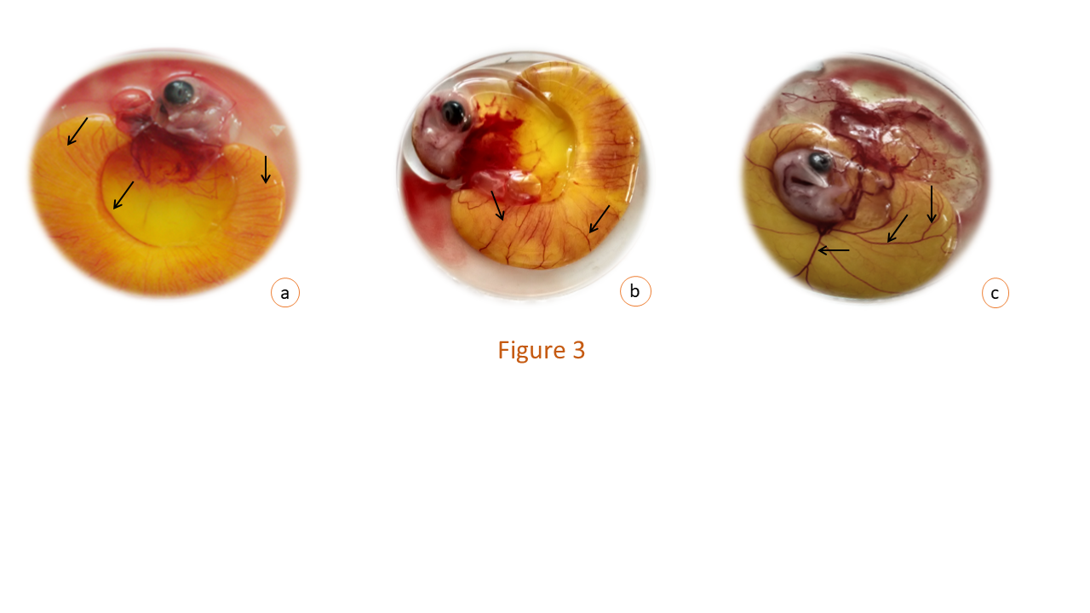
Figure 3: Gross examination of a 7-day-old developing chicken embryo
Figure 3a: Group II: Cadmium(3µg) treated embryonated egg opened at 7th day showing faintly appearing blood vessels (arrow).
Figure 3b: Group III: Cadmium (3µg) + dl-α-lipoic acid (5µg) treated embryonated egg opened at 7th day showing appreciable blood vessels (arrow) but not in the appropriate pattern.
Figure 3c: Group IV: Cadmium (3µg) + dl-α-lipoic acid (10µg) treated embryonated egg opened at 7th day showing very prominent blood vessels (arrow) arborised (primary, secondary and tertiary blood vessels) in a definite pattern.

The cadmium-intoxicated liver and heart tissue from 14-day fertilised chicken eggs displayed pathological changes of hepatic and cardiac parenchyma, respectively. The liver tissue showed hypertrophied hepatocytes with pyknotic nuclei and vacuolated cytoplasm, dilated sinusoids (Fig 4a), moderate fibrosis, focal necrosis, degeneration, and haemorrhage. Moderate hyperplasia and hypertrophy of Kupffer cells and inflammatory cells as a perivascular cuff were also observed. At some locations, the hepatic capsule was also found to be discontinuous and disrupted. The cadmium-intoxicated heart tissue revealed severe interstitial inflammation of the myocardial fibres with loss of the characteristic cross-striation pattern. There was moderate cytoplasmic vacuolation arranged irregularly as a syncytium (Fig. 4b). Aggregation of mononuclear cells in between the myofibers, desquamation of the endothelial lining of the endocardium, and moderate haemorrhage were noted. Both the ventricular walls of the heart were thickened. Pawlak et al. (2013) observed Alike histopathological changes due to cadmium toxicity, but in the case of the heart, only thickening of the right ventricle wall was recorded [33]. Acute and/or high cadmium exposures could negatively affect organ morphology and physiology in a non-compensated, irreversible and detrimental manner [34].
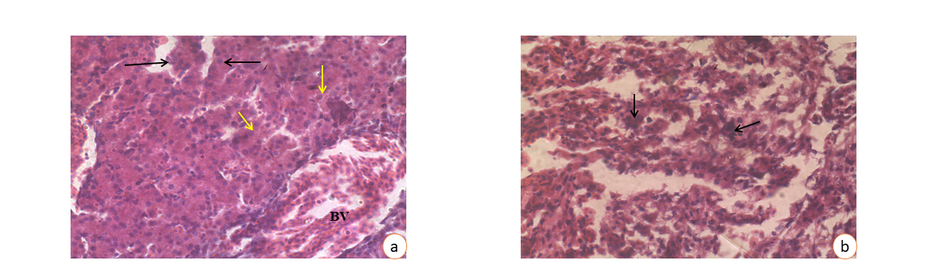
Figure 4: Photomicrograph of liver (a) and heart (b) of chick embryo at 14th day of incubation period treated with Cadmium (3µg/egg)
a: Hypertrophied hepatic sinusoids (black arrow). The nuclear condensation (yellow arrow) of the hypertrophied Kupffer cells and highly enlarged blood vessels (BV) are noted.
H & E- staining × 400
b: Condensation of chromatin material within nuclei of myocardiocytes (arrow). The atrophied and pycnotic nuclei, as well as fragmented nuclei, are noted.
H & E - staining × 400
The hepatic parenchyma of cadmium-intoxicated chicken embryo treated with alfa-lipoic acid @ 5µg/egg exhibited near normal histoarchitecture with minor pathological alterations (Fig. 5a, b). Some of the hepatocytes had a moderate vacuolization in the cytoplasm. Necrosis and haemorrhage were apparently absent. There was mild sinusoidal dilatation and mononuclear cell infiltration. The histomorphology of the cadmium-intoxicated liver tissue treated with alfa-lipoic acid (@ 10µg/egg was very close to normal. The hepatocytes had vesicular central nuclei, normal sinusoids, Kupffer cells, and negligible infiltration of inflammatory cells (Fig. 5c, d). The ameliorative effect of alfa-lipoic acid against cadmium toxicity-related histopathology reveals that alfa-lipoic acid treatment triggered the repair of damaged histoarchitecture in the liver, which was more apparent at the dose rate of alfa-lipoic acid @10µg/egg. A reduced level of damage in chicken liver exposed to cadmium treated with alfa-lipoic acid, suggesting that its protective effect is exerted by stabilising the cell membrane of hepatocytes [35].
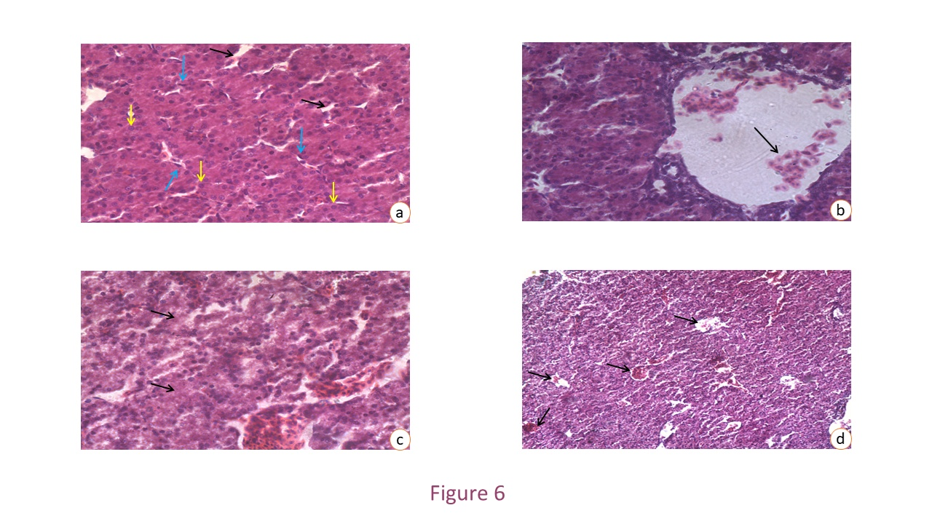
Figure 5: Photomicrograph of the liver of a chick embryo at the 14th day of the incubation period
Figure 5a: Group III: Cadmium (3µg) + dl-α-lipoic acid (5µg) showing the euchromatic circular nucleus (yellow arrow) in most of the hepatocytes and moderately enlarged sinusoids (black arrow). The normal morphology and frequency of Kupffer cells (blue arrow) on the sinusoidal walls are noted.
H & E - staining × 400
Figure 5 b: Group III: Cadmium (3µg) + dl-α-lipoic acid (5µg) showing loose scatters of RBC (arrow) in the lumen of blood vessels of the hepatic parenchyma. Strongly eosinophilic and granular cytoplasm of the hepatocytes is noted.
H & E - staining × 400
Figure 5c: Group IV: Cadmium (3µg) + dl-α-lipoic acid (10µg) showing the highly eosinophilic and granular cytoplasm of the hepatocytes (arrow). The slight degree of vacuolation in the cytoplasm of hepatocytes are noted.
H & E- staining × 400
Figure 5d: Group IV: Cadmium (3µg) + dl-α-lipoic acid (10µg) showing the extensive proliferation of blood vessels (arrow) in the hepatic parenchyma.
H & E- staining × 100
The heart of cadmium-intoxicated chicken embryo treated with alfa-lipoic acid @ 5µg manifested a diffuse cross-striation pattern of myocardial fibres, moderate myocardial inflammation and necrosis, rare mononuclear cell infiltration, along with a continuous endocardium. The tissue section of cadmium-intoxicated heart treated with alfa-lipoic acid @ 10µg exhibited almost normal histomorphology. Myocardial fibres had distinct cross-striations, no myocarditis, fibrosis, or congestion with an intact endocardium (Fig. 6a,b,c). Myocardiocytes contained an euchromatic nucleus and uniformly eosinophilic cytoplasm. Alpha-lipoic acid supplement amplified antioxidative potential and partly normalised the liver and kidney function by decreasing oxidative stress and inflammatory marker levels [11]. Alpha lipoic acid significantly prevented cardiac damage, marker enzymes leakage, reduced cardiac free radicals’ generation, antioxidant status, structural changes [36], and increased metallothionein induction when co-administered with melatonin, showing efficacy in protection against oxidative cardiac damage induced by cadmium [37]. Following cadmium exposure, alfa-lipoic acid upregulated Nrf2 and GPx1 gene expression and downregulated Keap1 in the rabbits' brain, showing its effectiveness in protection against cadmium-induced oxidative stress and the depletion of cellular antioxidants due to its free radical scavenging antioxidant, and chelating effects [38]. Alfa-lipoic acid acts as an enzymatic cofactor for metabolism regulation, energy production, and has epigenetic genes of inflammatory mediators, like PGE2, IL-1β, TNF-α, iNOS, COX-2, and IL-6 [39]. Also, its antioxidant capacity prevents excess free radical formation, improves mitochondrial performance [40].
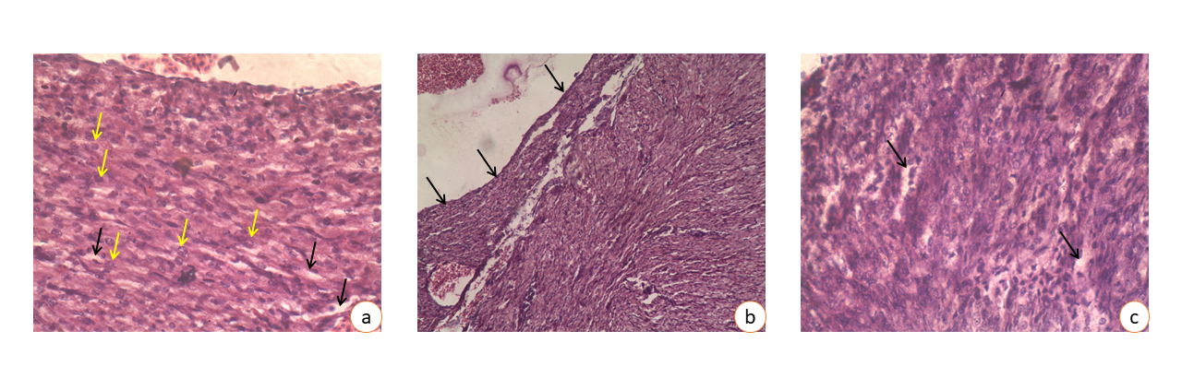
Figure 6: Photomicrograph of the heart of a chick embryo at the 14th day of the incubation period
Figure 6a: Group III: Cadmium (3µg) + dl-α-lipoic acid (5µg) showing the vacuolation (black arrow) between myocardial fibres. The euchromatic nuclei (yellow arrow) are more frequent than the heterochromatic nuclei of myocardiocytes are noted.
H & E- staining × 400
Figure 6 b: Group III: Cadmium (3µg) + dl-α-lipoic acid (5µg) showing the normal endocardium (arrow) of the heart with a slight degree of desquamation.
H & E- staining × 100
Figure 6c: Group IV: Cadmium (3µg) + dl-α-lipoic acid (10µg) showing a mild degree of vacuolation (arrow) between the myocardial fibres.
H & E - staining × 400
- LIMITATIONS
α-lipoic acid significantly showed its protective action against cadmium-induced toxicity. However, optimum recovery of different organs is yet to be achieved.
- FUTURE LINE OF WORK
Administration of supplements like phytochemicals, vitamins, or minerals along with α-lipoic acid can work together to protect organs from cadmium damage. Further research can be done to assess the synergistic effects of supplements along with alpha-lipoic acid.
- CONCLUSION
Cadmium inhibited neovascularisation in the CAM of the chick embryo and altered the cell construction of the liver and heart. Alpha-lipoic acid protects cadmium-intoxicated developing chicken embryos by ameliorating decreased neovascularisation in the CAM and restoring normal cellular architecture of liver and heart. Thus, alfa-lipoic acid can be proposed as a possible remedy for cadmium toxicity.

Disclaimer (Artificial intelligence)
The author (s) hereby declare that NO generative AI technologies, such as Large Language Models (ChatGPT), have been used during the writing or editing of the manuscript.

REFERENCES
- Luo L, Wang B, Jiang J, Fitzgerald M, Huang Q, Yu Z, Li H, Zhang J, Wei J, Yang C, Zhang H. Heavy metal contaminations in herbal medicines: Determination, comprehensive risk assessments, and solutions. Frontiers in pharmacology. 2021; 11: 595335.. https://doi.org/10.3389/fphar.2020.595335

- Gazwi HS, Yassie EE, Hassan HM. Mitigation of lead neurotoxicity by the ethanolic extract of Laurus leaf in rats. Ecotoxicology and environmental safety. 2020; 192:110297.

- Balali-Mood M, Naseri K, Tahergorabi Z, Khazdair MR, Sadeghi M. Toxic mechanisms of five heavy metals: Mercury, Lead, Chromium, Cadmium, and Arsenic. Frontiers in pharmacology. 2021; 12. https://doi.org/10.3389/fphar.2021.643972

- Pi H, Xu S, Reiter RJ, Guo P, Zhang L, Li Y, Li M, Cao Z, Tian L, Xie J, Zhang R. SIRT3-SOD2-mROS-dependent autophagy in cadmium-induced hepatotoxicity and salvage by melatonin. Autophagy. 2015 ;11(7):1037-51. http://dx.doi.org/10.1080/15548627.2015.1052208

- Pradhan S, Palai S, Dash J R, Patra R, Sahoo P R, Behera P C, Parija S C. Characterisation of selenium nanoparticles and Phyllanthus niruri Hook. f. selenium nanoparticles with histopathological investigation of their effects on cadmium-induced gastric toxicity in Wistar rats. Annals of Phytomedicine. 2023;12(1):367-375. http://dx.doi.org/10.54085/ap.2023.12.1.41

- Rafati-Rahimzadeh M., Rafati-Rahimzadeh M, Kazemi S, Moghadamnia, AA. Cadmium toxicity and treatment: An update. Caspian journal of internal medicine. 2017; 8(3):135–145. https://doi.org/10.22088/cjim.8.3.135

- Branca JJ, Fiorillo C, Carrino D, Paternostro F, Taddei N, Gulisano M, Pacini A, Becatti M. Cadmium-induced oxidative stress: focus on the central nervous system. Antioxidants. 2020; 9(6):492. https://doi.org/10.3390/antiox9060492

- Koyuturk M, Yanardag R, Bolkent S, Tunali S. Influence of combined antioxidants against cadmium induced testicular damage. Environmental toxicology and pharmacology. 2006;21(3):235-40. https://doi.org/10.1016/j.etap.2005.08.006

- Tripathi AK, Ray AK, Mishra SK, Bishen SM, Mishra H, Khurana A. Molecular and therapeutic insights of alpha-lipoic acid as a potential molecule for disease prevention. Revista Brasileira de Farmacognosia. 2023;33(2):272-87. https://doi.org/10.1007/s43450-023-00370-1

- Jan AT, Azam M, Siddiqui K, Ali A, Choi I, Haq QM. Heavy metals and human health: mechanistic insight into toxicity and counter-defense system of antioxidants. International journal of molecular sciences. 2015;16(12):29592-630. https://doi.org/10.3390/ijms161226183

- Markiewicz-Górka I, Pawlas K, Jaremków A, Januszewska L, Pawłowski P, Pawlas N. Alleviating effect of α-lipoic acid and magnesium on cadmium-induced inflammatory processes, oxidative stress and bone metabolism disorders in Wistar rats. International journal of environmental research and public health. 2019;16(22):4483. https://doi.org/10.3390/ijerph16224483

- Deore MS, S K, Naqvi S, Kumar A, Flora SJ. Alpha-lipoic acid protects co-exposure to lead and zinc oxide nanoparticles induced neuro, immuno and male reproductive toxicity in rats. Frontiers in pharmacology. 2021;12:626238. https://doi.org/10.3389/fphar.2021.626238

- Khandia RA, Dwivedi A, Sahu P, Vishwakarma A, Kumar K, Dhama Munjal A, et al,. 2017. Anti-angiogenic Effects of Cadmium Chloride on the Process of Neovascularization. Journal of Biological Sciences. 17(1):42-46. https://doi.org/10.3923/jbs.2017.42.46

- Fauzia E, Barbhuyan TK, Shrivastava AK, Kumar M, Garg P, Khan MA, Robertson AA, Raza SS. Chick embryo: a preclinical model for understanding ischemia-reperfusion mechanism. Frontiers in Pharmacology. 2018;9:1034. https://doi.org/10.3389/fphar.2018.01034

- Ribatti D. The chick embryo chorioallantoic membrane (CAM). A multifaceted experimental model. Mechanisms of development. 2016;141:70-7. https://doi.org/10.1016/j.mod.2016.05.003

- Buhr CR, Wiesmann N, Tanner RC, Brieger J, Eckrich J. The chorioallantoic membrane assay in nanotoxicological research—An alternative for in vivo experimentation. Nanomaterials. 2020;10(12):2328. https://doi.org/10.3390/nano10122328

- Kundeková B, Máčajová M, Meta M, Čavarga I, Bilčík B. Chorioallantoic membrane models of various avian species: Differences and applications. Biology. 2021;10(4):301. https://doi.org/10.3390/biology10040301

- Mishra CB, Dash JR, Patra R, Mishra UK, Parija SC, Palai S. Protective effect of morin against cadmium induced toxicity in the developing chicken embryo. Annals of Phytomedicine. 2021;10(2):376-83. http://dx.doi.org/10.21276/ap.2021.10.2.50

- Dżugan M, Lis M, Droba M, Niedziółka J. Effect of cadmium injected in ovo on hatching results and the activity of plasma hydrolytic enzymes in newly hatched chicks. Acta Veterinaria Hungarica. 2011;59(3):337-47. https://doi.org/10.1556/AVet.2011.020

- Bancroft JD, Stevens A. Wiley-liss. Theory and Practice of Histological Techniques, 4th ed. Churchill Livingstone, New York/London/San Francisco/Tokyo. 1996.

- Burggren W, Rojas Antich M. Angiogenesis in the avian embryo chorioallantoic membrane: a perspective on research trends and a case study on toxicant vascular effects. Journal of cardiovascular development and disease. 2020;7(4):56. https://doi.org/10.3390/jcdd7040056.

- Naik M, Brahma P, Dixit M. A cost-effective and efficient chick ex-ovo CAM assay protocol to assess angiogenesis. Methods and protocols. 2018;1(2):19. https://doi.org/10.3390/mps1020019.

- Nowak-Sliwinska P, Segura T, Iruela-Arispe ML. The chicken chorioallantoic membrane model in biology, medicine and bioengineering. Angiogenesis. 2014;17(4):779-804. https://doi.org/10.1007/s10456-014-9440-7

- Vu BT, Shahin SA, Croissant J, Fatieiev Y, Matsumoto K, Doan TL, Yik T, Simargi S, Conteras A, Ratliff L, Jimenez CM. Chick chorioallantoic membrane assay as an in vivo model to study the effect of nanoparticle-based anticancer drugs in ovarian cancer, Sci. Rep. 8 (2018) 8524. https://doi.org/10.1038/s41598-018-25573-8.

- Durupt F, Koppers-Lalic D, Balme B, Budel L, Terrier O, Lina B, Thomas L, Hoeben RC, Rosa-Calatrava M. The chicken chorioallantoic membrane tumor assay as model for qualitative testing of oncolytic adenoviruses. Cancer gene therapy. 2012;19(1):58-68. https://doi.org/10.1038/cgt.2011.68

- Burggren W, Rojas Antich M. Angiogenesis in the avian embryo chorioallantoic membrane: a perspective on research trends and a case study on toxicant vascular effects. Journal of cardiovascular development and disease. 2020;7(4):56. https://doi.org/10.3390/jcdd7040056

- Wang Y, Xue W, Pustovalova M, Kuzmin DV, Leonov S. Chick Embryo Chorioallantoic Membrane (CAM) Model for Cancer Studies and Drug Evaluation. Frontiers in Bioscience-Landmark. 2025;30(5):37456. https://doi.org/10.1002/ame2.12380

- Woods JM, Leone M, Klosowska K, Lamar PC, Shaknovsky TJ, Prozialeck WC. Direct antiangiogenic actions of cadmium on human vascular endothelial cells. Toxicology in vitro. 2008;22(3):643-51. https://doi.org/10.1016/j.tiv.2007.12.009.

- Prozialeck WC, Edwards JR, Nebert DW, Woods JM, Barchowsky A, Atchison WD. The vascular system as a target of metal toxicity. Toxicological Sciences. 2008;102(2):207-18. https://doi.org/10.1093/toxsci/kfm263

- Prozialeck WC, Edwards JR, Woods JM. The vascular endothelium as a target of cadmium toxicity. Life sciences. 2006;79(16):1493-506. https://doi.org/10.1016/j.lfs.2006.05.007.

- Oliveira-Paula GH, Martins AC, Ferrer B, Tinkov AA, Skalny AV, Aschner M. The impact of manganese on vascular endothelium. Toxicological Research. 2024;40(4):501-17. https://doi.org/10.1007/s43188-024-00260-1

- Hussein SA, Omnia M, Fayed AM. Protective effects of alpha-lipoic acid and melatonin against cadmium-induced oxidative stress in erythrocytes of rats. Benha Veterinary Medical Journal, 2014;26(1):19‐33.

- Pawlak K, Dugan M, Wojtysiak D, Lis M, Niedzioka J. Effect of in ovo injection of cadmium on chicken embryo heart. African Journal of Agricultural Research. 2013;8(16):1534-9. https://doi.org/10.5897/AJAR12.2116

- Lee WK, Thévenod F. Cell organelles as targets of mammalian cadmium toxicity. Archives of Toxicology. 2020;94(4):1017-49. https://doi.org/10.1007/s00204-020-02692-8

- Shi XT, Zhu HL, Xu XF, Xiong YW, Dai LM, Zhou GX, Liu WB, Zhang YF, Xu DX, Wang H. Gestational cadmium exposure impairs placental angiogenesis via activating GC/GR signaling. Ecotoxicology and Environmental Safety. 2021; 224:112632. https://doi.org/10.1016/j.ecoenv.2021.112632

- Mukherjee R, Banerjee S, Joshi N, Singh PK, Baxi D, Ramachandran AV. A combination of melatonin and alpha lipoic acid has greater cardioprotective effect than either of them singly against cadmium-induced oxidative damage. Cardiovascular toxicology. 2011;11(1):78-88. https://doi.org/10.1007/s12012-010-9092-9

- Dosoky WM, Farag SA, Almuraee AA, Youssef IM, Awlya OF, Abusudah WF, Qadhi A, Arbaeen AF, Moustafa M, Hassan H, Tellez-Isaias G. Vitamin C and/or garlic can antagonize the toxic effects of cadmium on growth performance, hematological, and immunological parameters of growing Japanese quail. Poultry Science. 2024;103(3):103457. https://doi.org/10.1016/j.psj.2024.103457 .

- Saleh HM, El-Sayed YS, Naser SM, Eltahawy AS, Onoda A, Umezawa M. Efficacy of α-lipoic acid against cadmium toxicity on metal ion and oxidative imbalance, and expression of metallothionein and antioxidant genes in rabbit brain. Environmental Science and Pollution Research. 2017;24(31):24593-601. https://doi.org/10.1007/s11356-017-0158-0

- Famurewa AC, Hamdi H, Sedky A. Lipoic acid abates testis lead accumulation, sperm-endocrine deficits, testicular oxidative inflammation and apoptosis and modulates gene expression of Bax and Bcl-2 in rats. Scientific African. 2023; 21:e01842. https://doi.org/10.1016/j.sciaf.2023.e01842

- Correia Y, Scheel J, Gupta S, Wang K. Placental mitochondrial function as a driver of angiogenesis and placental dysfunction. Biological Chemistry. 2021;402(8):887-909. https://doi.org/10.1515/hsz-2021-0121

- Salari, Z., Tavakkoli, H., Khosravi, A., Karamad, E., Salarkia, E., Ansari, M., ... & Sharifi, F. (2021). Embryo-toxicity of docosahexaenoic and eicosapentaenoic acids: In vivo and in silico investigations using the chick embryo model. Biomedicine & Pharmacotherapy, 136, 111218.

- Jayasval, A., Pandey, T., & Kumar, A. (2025). A comprehensive review on cadmium toxicity in freshwater fish: Physiological, ecological and health implications. Asian Journal of Research in Zoology, 8(3), 97–121.

- Superti, F., & Russo, R. (2024). Alpha-Lipoic Acid: Biological Mechanisms and Health Benefits. Antioxidants, 13(10), 1228.

- Deshwal, A., Kaur, N., Mehta, P., & Thakur, N. (2021). A review on the effects of cadmium toxicity on living beings. Journal of Pharmaceutical Research International, 33(57A), 300–305.

