Isolation and morphological identification of endophytic fungi associated with chilli (Capsicum annum L.)

ABSTRACT

Endophytes are microbes that live in plant tissues without causing any damage to the host plants. The present study aimed to isolate and identify fungal endophytes associated with healthy chilli (Capsicum annuum L.) plants. Healthy plants were collected from the experimental field of the Department of Plant Pathology, College of Agriculture, Latur. Plant tissues (roots, stems, and leaves) were surface sterilized to eliminate surface microorganisms and plated on Potato Dextrose Agar (PDA) for fungal growth. A total of ten fungal endophytes were successfully isolated five from roots two from stems and three from leaves. Morphological and cultural characteristics such as colony color, texture, growth pattern, and microscopic features including conidial structure, shape, and septation were used for identification with reference to standard mycological keys. The identified fungal endophytes included Trichoderma harzianum, Rhizoctonia solani, Fusarium oxysporum, Fusarium solani, Macrophomina phaseolina, Aspergillus flavus, Aspergillus niger, Alternaria solani, Rhizopus sp. and Colletotrichum capsici. The diversity of these endophytes tests a complex microbial community within chilli tissues that may contribute to plant health and resilience. Fungi isolated as endophytes from chilli (Cv. Pusa Jawala) were tested in order to ascertain whether they are capable of causing disease symptoms in healthy chilli stem, root and leaves. The pathogenicity test of fungal endophytes was carried out by pin prick method (for stem endophytes), spore suspension method (for leaf endophytes), root or soil drenching method (for root endophytes). No fungal species of endophytic fungi were able to cause any diseased symptoms on chilli plant and were observed to remain healthy.

Keywords: [Endophytes, isolation, identification, chilli, morphology]

1. INTRODUCTION
Endophytes are microbes that live in plant tissues without causing any damage to the host plants. They are ubiquitous in most plant species, especially field plants and are present in most vascular plant species, have been studied and include bacteria, actinomycetes and fungi (Hasegawa et al. 2006). Endophytes have been shown to confer fitness on host plants, including tolerance to herbivory, salt, heat, disease and drought and to increase above and below ground biomass. Endophytic colonization can also improve host ecological adaptation by increasing tolerance to biotic and abiotic stresses (Khan. 2008). Endophytes have the ability to deliver antibiotics that act as antifungal, antibacterial, antiviral, and insecticidal properties that strongly inhibit the growth of other microorganisms, including plant pathogens (Guntalika, 2006). Endophytes as an impending source of drugs against various forms of diseases and other possible medicinal use. (Gouda. et al.,(2016) Endophytic microorganisms have received considerable attention due to their biotechnological utility in several fields of agriculture, industry and medicine (Azevedo et al., 2000). Microbial endophytes can develop different forms of interactions with their host plants, ranging from beneficial commensals to latent and dormant pathogens passing through mutualistic microbes/ even saprobes (Schulz and Boyle, 2005). Many endophytes have the potential to synthesize various bioactive metabolites that may directly or indirectly be used as therapeutic agents against numerous diseases. (Kusari et al.,2012)
Asymptomatic colonization of endophytes in plant tissues can be temporary or more extensive during the life cycle of the plant. The persistence of interaction status from one interaction type to another depends on factors such as the genetic predisposition of the two partners, nutritional status, developmental stages and environmental factors (Schulz and Boyle,2006). The phenotypic plasticity of endophytes allowed them to establish asymptomatically in the plant tissue, intercellular or intracellular, using more options such as local or also systemic colonization, mutualism, latent pathogens or saprophyte. Latent infectious fungi and endophytes can infect Chilli plant tissue and become established after invansion, but the infection does not indirectly cause visible disease symptoms. Fungal endophytes possess significant role in agriculture as it results in increase in the yield of crop, shoot and root biomass, (Singh et al., (2021)
(Capsicum annuum L.) is one of the most important spice and vegetable crops cultivated in tropical and sub-tropical regions worldwide, with India being a leading producer. Beyond its culinary and economic importance, chilli harbors a variety of microorganisms within its tissues, including fungal endophytes. Endophytes are microorganisms that reside asymptomatically inside plant tissues during part or all of their life cycle. They are increasingly recognized for their ecological roles, which may include promoting host growth, enhancing tolerance to abiotic stress, and providing protection against pathogens through various mechanisms. (Harsonowati et al., 2024). Root endophytic fungus improved development of chilli seedlings by applied beneficial rhizobacteria may improve the growth of vegetable transplants and reduce diseases. (Vyshakhi et al., 2021) The isolation and identification of fungal endophytes from chilli plants form the foundation for understanding their diversity, biology, and potential applications in sustainable agriculture. Proper identification is essential, as fungal endophytes differ greatly in their morphology, physiology, and interactions with the host plant. In the present study, fungal endophytes were isolated from different plant parts of healthy chilli plants and identified based on morphological and cultural characteristics.

2. material and methods
1. Isolation of fungal endophytes
Apparently symptomless, healthy, disease free and mature chilli plants were selected from the field of chilli during reproductive stage of crop during, kharif 24-25 and brought to the laboratory for isolation of the fungal endophytes. The samples were collected from three parts of the chilli plants, leaves, stem and roots. All plant samples were first rinsed thoroughly under running tap water. Leaves were cut into 5 to 6 mm diamand1cm in length, while stem and root were cut into 1 to 2cm in length. All the plant parts were then separately subjected to surface sterilization / disinfection. The leaves, stem and parts of roots were first washed under running tap water, immersed in 75% ethanol (1 min.) followed by sodium hypochlorite (NaOCl )1to13% depending upon type oftissuefor3to5min.andthenwith75% ethanol (30 sec.). All the plant parts were then washed thrice with sterilized distilled water and allowed to surface-dry on filter paper. 2 All the sterilized /disinfected plant part (leaves, stem and roots) were aseptically placed on Potato Dextrose Agar (PDA) medium supplemented with Streptocycline (50µg/ml) to inhibit the bacterial growth. These Figures were incubated at 27±1 C. After7-8 days the growth of the fungus was observed. As soon as, growth was observed, the hyphal tips were transferred to fresh PDA medium to enhance typical sporulation for better identification of fungus. The maintained pure culture was sub-cultured on Potato Dextrose Agar slants and allowed to grow for one week at 27±1 C. Such slants were stored in a refrigerator at 8 C and again sub-cultured once in a month during the study under aseptic conditions to maintain the viability of the endophytes.
2. Pathogenicity test of fungal endophytes
Representative isolates of fungal endophytes were tested during this study. Pathogenicity test of isolated fungal endophytes was carried out by three methods for stem endophytic fungi (pin prick method), for leaf endophytic fungi (spore suspension method) and for root endophytic fungi (root drenching method) were used for their ability to cause disease symptoms in stem, root and Agar (PDA) media for at least one week.
To test the pathogenicity of the fungal isolates by pin prick method, the endophytic fungi were isolated from stem portion. Surface sterilized (2-3 % sodium hypochloride solution, for 5 min.) seeds of Cv. Pusa Jawala were sown @ 10 seeds/ plot in pots (20×30 cm), filled with autoclaved potting mixture of soil: sand: FYM (2:1:1), watered regularly and kept in screen house for the further growth. The stem was prickled or wounded by picking them with disinfected needle in multiple (5-10 numbers) points. Fungal inoculum (2 or 3 ml) was placed on the prickled area by placing a drop of cell suspension and through cotton swab, which was pre-soaked in inoculum. Larger injuries at the injection site were avoided and plants incubated in at humid conditions. The potted soybean seedlings injected with sterile distilled water were maintained as untreated control. These method of the current investigation were consonent with those previously reported by a number of researchers Pravi et al., (2014) and Mahadevkumar et al., (2016)
Endophytic fungi isolated from leaves were undertaken for pathogenicity test by fungal spore suspension (2 to 3 ml) in sterilized distilled water. Spore- cum-mycelial suspension of fungal isolates were prepared by flooding 5 – 10 ml distilled water on 10- 12 days old culture of test fungal endophytes isolated form leaves, on PDA A spore suspension was sprayed on to leaves of healthy chilli plants. To increase the chance of infection, a subset of leaves were wounded by puncturing. The potted chilli seedlings sprayed with sterile distilled water were maintained as untreated control. These method of the current investigation were consonent with those previously reported by a number of researchers (Vega et al., 2018), (Kadam et al.,2024)
To test the pathogenicity of the fungal endophytes isolates by root drenching method, the endophytic fungi were isolate from root portion. Fungal isolates from roots were grown on potato dextrose broth for 1 to 2 days. Then full grown fungal isolates on potato dextrose broth were poured around the root zone in the soil by disturbing the root zone. The potted chilli seedlings poured with distilled water were maintained as untreated control. These method of the current investigation were consonent with those previously reported by a number of researchers (Catambacan and Cumagun 2021), (Prasa et al., 2013)
After 2-3 weeks, observations on symptoms induced or not were recorded
3. Identification of fungal endophytes
After incubation, the isolated fungus was identified on the basis of morpho-cultural and microscopic characteristics such as
mycelium colour, colony appearance and structure, shape of conidiophore and conidia (shape, color, etc.) and characters
of conidiogenous cells (Barnett and Hunter, 1998 and Sutton,1980) with authoritative monographs and other taxonomic
papers analogous to certain genera and species of endophytes were referred for identification of isolated endophytic fungi.
3. results and discussion
3.1 Isolation of endophytic fungi
A total of ten fungal endophytes were isolated from healthy chilli plant tissues (table 1). Root tissues yielded the highest number of isolates (five), followed by leaves (three) and stems (two). The higher diversity in roots may be attributed to their continuous interaction with the soil microbiome, providing a broader range of potential endophytic colonizers.

Table 1: Endophytic fungi isolated from chilli plants
Plant part | Fungal endophytes identified
Roots | Trichoderma harzianum, Rhizoctonia solani, Fusarium oxysporum, Fusarium solani, Macrophomina phaseolina
Stems | Aspergillus flavus, Aspergillus niger
Leaves | Alternaria solani, Rhizopus sp., Colletotrichum capsica

Fig 1: Diversity of fungal endophytes in chilli
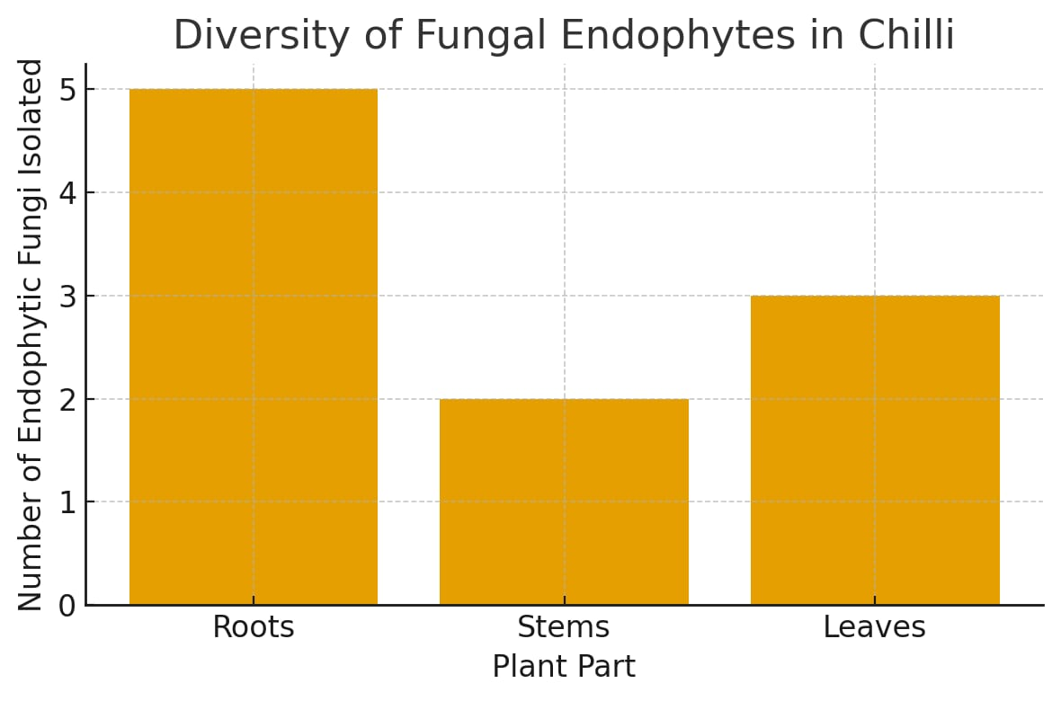
Here’s a graphical representation of the diversity of fungal endophytes across chilli plant parts. Roots hosted the highest number of endophytes (5 species), followed by leaves (3 species) and stems (2 species).
The isolation of ten distinct fungal endophytes across different chilli tissues highlights the rich microbial diversity associated with this crop. Root tissues exhibited the highest diversity, which is expected given their continuous interaction with soil microorganisms. This suggests that roots act as a major gateway for endophyte colonization, potentially influencing nutrient acquisition, stress tolerance, and below-ground pathogen defense.
Interestingly, several isolates such as Fusarium spp. and Macrophomina phaseolina, typically recognized as pathogenic, persisted as symptomless endophytes. This supports the concept of context-dependent lifestyles where fungi can behave as latent pathogens or mutualists depending on host condition and environmental cues. Such plasticity indicates that endophytes represent a dynamic microbial community contributing to chilli plant resilience.
From an application perspective, the presence of taxa like Trichoderma harzianum and Aspergillus spp. is particularly significant. Trichoderma is well documented for its antagonistic action against soil-borne pathogens through competition, mycoparasitism, and secondary metabolite production, while certain Aspergillus species are known to enhance nutrient cycling. Harnessing these endophytes could reduce chemical pesticide use, improve soil health, and promote sustainable chilli cultivation.
During this study, we stated about pathogenicity test of fungal endophytes of chilli. The pathogenicity test of 10 fungal endophytes was carried out by pin prick method (stem endophytic fungi), spore suspension method (leaf endophytic fungi) and root drenching method (root endophytic fungi). The fungi were inoculated into the stem by pin prick method. After 2 to 3 weeks, the two stem endophytic fungi Aspergillus flavus, Aspergillus niger and control were not produced any disease symptoms. Fungi were incubated into the leaves by sprayed of spore suspension. After 2-3 weeks, the three leaf endophytic fungi Alternaria solani, Rhizopus sp. Colletotrichum capsici and control were not produced any disease symptoms
The fungi were inoculated into root by, root drenching method. After 2-3 weeks, the five root endophytic fungi Trichoderma harzianum, Rhizoctonia solani, Fusarium oxysporum. Fusarium solani, Macrophomina phaseolina and control were not produced any diseased symptoms.
All the 10 fungal endophytic species were nonpathogenic nature of fungal endophytes were reported by many scientists. Fungal endophytes were capable of living in host plants without causing any diseased symptoms (Petrini et al., 1992) Similar results were also found by (Mmbaga et al., 2018) studied the pathogenicity of the fungal isolates on bell pepper seedlings in in vivo and described that F. solani, F. oxysporum and M. Phaseolina did not cause any symptoms on inoculated bell pepper seedlings.

3.2 Morpho-cultural characteristics

Each isolate exhibited distinct growth patterns and pigmentation on PDA

1.Aspergillus niger

On PDA plates, this strain developed quickly and the colonies were carbon black in colour. Plate 1.A shows that, the strain generated a large number of sub-merged mycelia in the media. Near the vesicle, conidiophores were colourless and aseptate with thick walls. The globose, fuscous black conidial heads were seen (Plate 1 B). The globose, colourless vesicles have thick walls (Plate 1 C). The vesicles' whole surface was covered with conidial chains. The conidia were globose dark in colour (Plate 1 D).
These findings of the current investigation were consonent with those previously reported by a number of researchers (Piemental et al., 2006; Lakshman and Kurundwad, 2013; Pieterase et al.,2018 and Kukarni and Dalal, 2012). Endophytic fungi such as Aspergillus, Fusarium, Rhizoctonia and Alternaria sp. associated with soybean were identified based on their morphological and cultural characteristics.

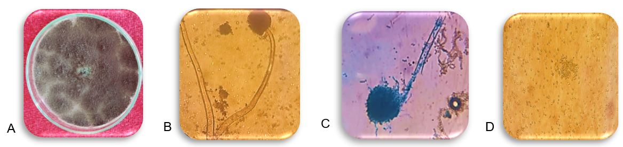
Plate 1: Isolated endophytic fungus Aspergillus niger, A) pure culture on PDA plate,
Microphotograph of, B) Conidiophore with conidial head, C) Vesicle and D) conidia
at 45X magnification

2.Aspergillus flavus
On PDA, colonies quickly formed powdery masses of yellowish-green conidia on the upper surface, with reddish-gold pigmentation below (Plate 2 A). Hyphae are septate and hyaline; conidiophores are colourless with uniseriate or biseriate phialides (Plate 2 B). The conidia are mentioned in (Plate 2 D).
The current study’s findings were consonant with those previously reported by a number of researchers (Sandhu et al., 2014; Gaikwad et al., 2017 and Soumya et al.,2018) who identified endophytic fungi such as Aspergillus, Fusarium, Rhizoctonia and Alternaria sp. associated with soybean based on their morphological characteristics.
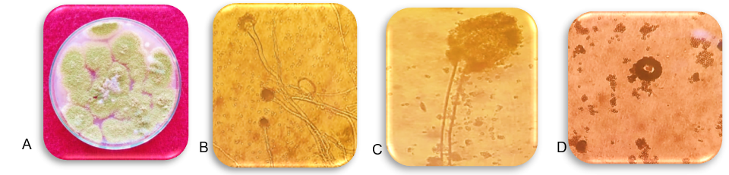

Plate 2: Isolated endophytic fungus Aspergillus flavus. A) pure culture on PDA plate,
Microphotograph of B) Conidiophore and conidial head C) Vesicles with phialides &
D) conidia at 45 X magnification.

3. Alternaria solani
Colonies on PDA typically appeared olive to grey-brown with and dark reverse pigmentation (Plate 3 A). Conidia are brown, muriform (with 3–9 transverse septa), multicelled with beaked apexes (Plate 3 B) This morphological characters are consonant with Alternaria species affecting solanaceous hosts. The current study’s findings were consonant with earlier researcher (Gulzar et al., 2021) who identified that, endophytic fungi Alternaria solani associated with tomato plant based on its morphological characteristics.
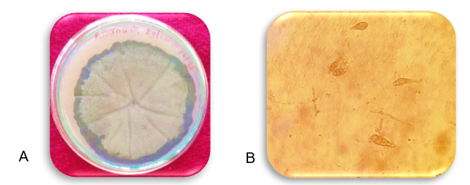
Plate 3: Isolated endophytic fungus Alternaria solani, A) pure culture on PDA plate,
microphotographs of, B) conidia have prominent beak & both transverse
longitudinal sepata creating a muriform (Brick like appearance.) at 45X
magnification
4.Fusarium oxysporum
Colonies on PDA at 25–28 °C have cottony mycelium that appears white to cream at first, with pinkish–brown colouration appearing underneath (Plate 4 A). Numerous spores found on aerial mycelium, micro-conidia are usually oval to reniform, primarily non-septate with sporadic 1‑septate forms. The hyaline, thin-walled, straight to slightly curved (falcate) (Plate 4 B). Macro-conidia have three to five septa (Plate 4 C). Chlamydospores are globose, have thick walls and can form alone or in pairs. These traits are very similar to the typical descriptions of F. oxysporum which effects on solanaceous plants.
The current study’s findings were consonant with the findings and earlier researchers (Anitha et al., 2013 and Fernandes et al., 2015) who identified endophytic fungi such as Fusarium oxysporum and F. solani associated with soybean roots based on their morphological characteristics.
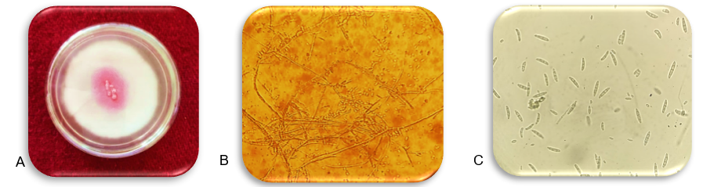
Plate 4: Isolated endophytic fungus Fusarium oxysporum A) pure culture on PDA plate,
microphotogrphs of, B) septate hyphae that branched at acute right angles, produce
microconidia C) Macroconidia (elongated, curved 3 to 5 septate, at 45 X magnification

5. Fusarium solani
On PDA, colonies grew rapidly (in 7 days), appearing as white and cottony with potential brown pigmentation at the center (Plate 5 A). Macroconidia are hyaline, slightly curved, broad, aggregating in fascicles (Plate 5 B). Micro-conidia are smooth, oval/cylindrical, mostly non-septate. Chlamydospores are brown, globose, produced singly or in pairs (Plate 5 C) under sub-optimal conditions.
The current study’s findings were consonant with the findings of earlier researchers (Pragathi et al., 2013) who identified endophytic fungi associated with chickpea and groundnut plant based on their morphological characteristics.
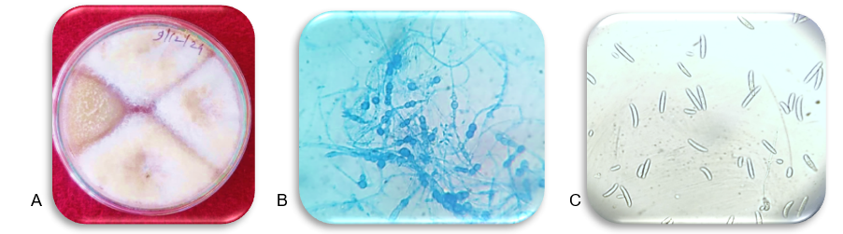
Plate 5: Isolated endophytic fungus Fusarium solani, A) Pure culture on PDA plate,
Microphotographs of B) Chlamydospores at 45X magnification C)
Macroconidia without septation at 45X magnification.

6.Colletotrichum capsici
On PDA at 25–30 °C, colonies exhibited colour variation from white or ash to grey, dark brown depending on the isolate (Plate 6 A). Growth is rapid, reaching in 7 days. Conidia are hyaline, single-celled and falcate to sickle-shaped (Plate 6 B).
The current study’s findings were consonent with those researchers (Prajapati et al., 2020 and Joiy et al.,2024) who identified endophytic fungi, Colletotrichum capsici associated with chilli plant based on its morphological characteristics.
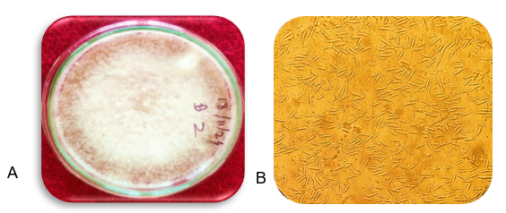
Plate 6: Isolated endophytic fungus Colletotrichum capsici, A) pre culture on PDA
plate, Microphotograph of. B) Conidia, falcate (Sickle-shaped) at 45 X magnification
7. Rhizophus sp.
Colonies grew rapidly on potato dextrose agar (PDA), initially as white and cottony in texture later, turned grey to black due to profuse sporulation (Plate 7 A). The mycelium was coarse, coenocytic (non-septate) and formed dense aerial growth. Sporangiophores were long, unbranched, arising from stolons and bearing terminal, globose sporangia. Sporangia were black, containing numerous non-motile, ovoid sporangiospores. No sclerotia formation was observed.
These results were in conformity with earlier reports of Kumar and Singh (2015) who, isolated Rhizopus sp. as endophytic fungi from chilli and other solanaceous crops and identified them based on its cultural and morphological features.
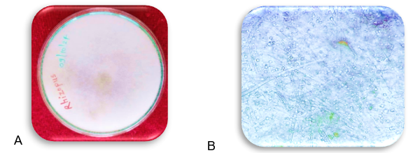
Plate 7: Isolated endophytic fungus Rhizopus sp., A) pure culture on PDA plate, and
Microphotograph of, B) network of hyphae include stolons, rhizoids,

sporangiophores sporangia. at 45 X magnification
8. Macrophomina phaseolina
On PDA, Rhizoctonia solani produced cottony or feathery mycelium with variable coloration (white to tan) (Plate 8 A). No conidia are produced. Microscopically, it consisted of multinucleate, inflated hyphae with binucleate segments. Hyphae are right angled to each other (Plate 8 B).
The current study’s findings were consonant with earlier researcher (Kulkarni and Dalal, 2012) who identified endophytic fungi such as Rhizoctonia, Aspergillus, Fusarium and Alternaria sp. associated with chilli plant based on its morphological characteristics.
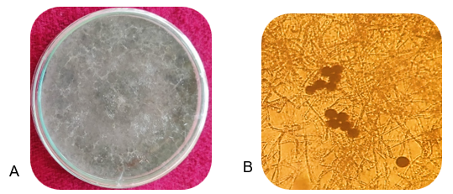

Plate 8: Isolated endophytic fungus M. phaseolina, A) pure culture on PDA
plate, Microphotograph of, B) microsclerotia with mycelium at 45X
magnification.

9. Rhizoctonia solani
On PDA, Rhizoctonia solani produced cottony or feathery mycelium with variable coloration (white to tan) (Plate 9 A). No conidia are produced. Microscopically, it consisted of multinucleate, inflated hyphae with binucleate segments. Hyphae are right angled to each other (Plate 9 B).

The current study’s findings were consonant with earlier researcher (Kulkarni and Dalal, 2012) who identified endophytic fungi such as Rhizoctonia, Aspergillus, Fusarium and Alternaria sp. associated with soybean plant based on its morphological characteristics.

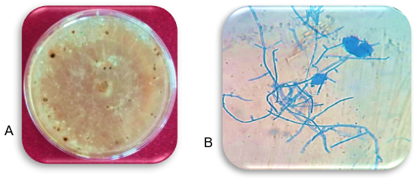
Plate 9: Isolated endophytic fungus Rhizoctonia solani A) pure culture on PDA
plate, Microphotograph of, B) mycelium at 100 X magnification
10. Trichoderma harzianum
On PDA, colonies were white before developing concentric rings of dense yellow-green to dark-green spores and the reverse side appeared as pale or beige (Plate 10 A). Microscopically, highly branched conidiophores with flask-shaped phialides produce smooth, ellipsoidal conidia (Plate 10 B and C). This morphology is typical of T. harzianum and correlates with its reported antagonistic action against chilli pathogens.
The current study’s findings were consonant with earlier researchers (Mohiddin, et al., 2018) who identified endophytic fungi associated with chilli plant based on its morphological characteristics.

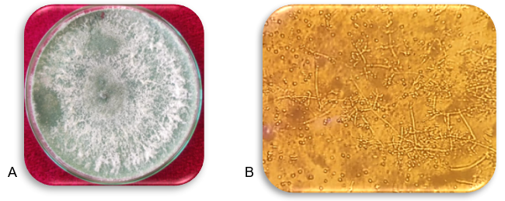
Plate 10: Isolated endophytic fungus Trichoderma harzianum A) pure culture on
PDA plate, microphotograph of B) branched conidiophore, flask-
shaped shaped phialides with conidia at 45 X magnification
The isolation of multiple fungal taxa from chilli indicates that endophyte diversity spans several genera, including both well-known saprophytes and potential biocontrol agents. Many of these genera, such as Trichoderma, Fusarium, and Colletotrichum, have been reported as common endophytes in solanaceous crops.
The predominance of root-associated endophytes reflects the role of soil as a reservoir for fungal colonizers.
Morphological identification remains a valuable first step in cataloguing endophyte diversity.
Conclusion
The present investigation successfully isolated and identified ten fungal endophytes from different tissues of chilli (Capsicum annuum L.), with root tissues showing the highest diversity. The isolates represented a wide spectrum of fungal genera, including Trichoderma, Fusarium, Aspergillus, Alternaria, Colletotrichum, Macrophomina, Rhizoctonia, and Rhizopus. Such diversity reflects the complex microbial consortia that inhabit chilli tissues and underscores the ecological significance of endophytes as integral components of the plant holobiont.
Importantly, none of the isolated fungi produced disease symptoms in pathogenicity assays, confirming their non-pathogenic, endophytic nature. This finding is crucial, as it demonstrates that even taxa typically known as pathogens can persist asymptomatically within host tissues, suggesting context-dependent lifestyles influenced by host–microbe and environmental interactions.
The documentation of this fungal diversity has far-reaching implications. Endophytic fungi are increasingly recognized for their roles in enhancing plant growth, nutrient acquisition, and tolerance to abiotic stresses such as drought, salinity, and heat. Moreover, genera such as Trichoderma and certain non-pathogenic strains of Fusarium are well known for their antagonistic potential against plant pathogens, either through mycoparasitism, competition, or the production of secondary metabolites. Thus, the endophytes associated with chilli not only represent a hidden reservoir of biodiversity but also hold promise for sustainable disease management and biofertilization strategies
Overall, the study provides baseline knowledge of chilli-associated endophytic fungi and highlights their potential contribution to host fitness and resilience. Future work should focus on functional characterization of these isolates, including their bioactive metabolite profiles, stress-mitigation properties, and biocontrol potential. Harnessing such beneficial microbial communities could contribute significantly to eco-friendly and sustainable chilli cultivation.

Disclaimer (Artificial intelligence)
Option 1:
Author(s) hereby declare that NO generative AI technologies such as Large Language Models (ChatGPT, manuscript.

References

1. Anitha, D., Vijaya, T., Pragathi, D., Reddy, N. V., Mouli, K. C., Venkateswarulu, N. & Bhargav, D. S. (2013). Isolation and characterization of endophytic fungi from endemic medicinal plants of Tirumala hills. International Journal of Life Science Biotechnology and Pharm Research, 2(3): 110-115.
2. Azevedo, J. L., Jr. W. Maccheroni, J.O. Pereira and W.L. Araujo, (2000) Endophytic microorganisms, a review on insect control and recent advances on tropical plants. Electric.Journal Biotechnology., 3(1):40-65.
3. Barnett, H.L. and B.B. Hunter, 1998: Illustrated Genera of Imperfect Fungi. APS Press: st. Paul Minnesota.
4.Catambacan G. & Cumagun R. (2021). Weed-Associated fungal endophytes as Biocontrol agents of Fusarium oxysporum f.Sp. cubense TR4 in cavendish banana. Multidisciplinary digital publishing institute.7(3),224;
5. Fernandes, E. G., Pereira, O. L. Silva, C. C., Bento, C. B. & Queiroz, M. V. (2015). Diversity of endophytic fungi in Glycine max. Microbiological Research. 181: 84-92.
6.Guntalika, A.L., (2006) Natural products from plant associated microorganisms: distribution, structural diversity, bioactivity and implications of their occurrence. Journal of Natural Protection. 69(3):509-526
7. Gouda, S. et al., (2016). Endophytes: a treasure house of bioactive compounds of medicinal importance. Front. Microbiol.
7: 1538.
8 Gaikwad, Milind N., Mulani, Ramjan M. & Bodke, Shrirang S. (2017). Isolation and diversity of fungal endopyhte from tuberous rhizome Curculigo orchioides Gaertn. International Journal of Applied Research, 3(4): 612-616.
9. Gulzar, N., Azara, N., Kamili & Shah, M. (2021). Tomato early blight (Alternaria solani), pathogen, disease development and defense response phytoharmone signaling. International Research Journal of Plant Sciences. 12(4), 1-10.
10. Hasegawa, S., A. Meguro, M. Shimizu, T. Nishimura and H. Kunoh, (2006) Endophytic actinomycetes and their interactions with host plants. Actinomycetol. 20(2):72-81.
11.Harsonowati, W., Latifah, E., Nurrahma, A. H. I., Purwani, J., Iqbal, R., Parray, J. A., & Patel, A. D. (2024). Emerging diseases: trend research and omics-based analysis reveals mechanisms of endophytes modulate Chilli plant resilience. Symbiosis, 93(3), 241-254.
12. Joiy, E. T., Amrutha, P., Johnson, J. M., et al., (2024). Cultural, morphological and pathogenic variability in C. capsici isolates causing anthracnose and fruit rot of chilli in Kerala. International Journal of Plant & Soil Science, 36(6): 304–316.
13.Kadam S.S, Magar S.J. & Banne S.N. (2024). Isolation, pathogenicity test, characterization and identification of endophytic fungi of soybean (Glycine max L. merril). Journal of plant disease sciences. 19: 13-21
14.Kusari, S., Hertweck, C. & Spiteller, M. (2012). Chemical ecology of endophytic fungi: origins of secondary metabolites. Chem. Biol. 19: 792–798.
15. Khan, S.A, M. Hamayun, H. Yoon, H. Y. Kim and S. J. Suh, Hwang, (2008) Plant growth promotion and . Penicillium citrinum BMC Microbiology., 8(1):231.
16. Kulkarni, N. S & Dalal, J. M. (2012). Isolation and identification of endophytic microorganisms of soybean (Glycine max (L.) Biology and Phyatomocrobiology, Journal 52: 183-385.
17. Kumar, A. and Singh, R. (2015). Morphological and cultural characterization of Rhizopus species isolated from solanaceous vegetable crops. Journal of Mycology and Plant Pathology, 45(2): 179–183.
18. Lakshman, H. C. & Kurandawad, J. M. (2013). Diversity of the endophytic fungi isolated from Spilanthes acmella Linn. - a promising medicinal plant. International Journal Pharm. Biological Science, 4(2): 1259-1266.
19. Mahadevakumar, S. Yadav, V. Tejaswini, G. S. & Janardhana G. S. (2016). Morphological and molecular characterization of Sclerotium rolfsii associated with fruit rot of Cucurbita maxima. European Journal of Plant Pathology. 145, 215-219.
20. Mohiddin, F. A., Bhat, F.A., Bhat, K.A., Bhat, Z.A., Bhat, M.A., Hamid, B. & Bashir, I. (2018). Development of Trichoderma harzianum based bio‑formulations for the management of chilli wilt. Journal of Pharmacognosy and Phytochemistry, 7(1): 2118–2122.
21. Pragathi, D., Vijaya, T., Mouli, K. C. and Anitha, D. (2013). Diversity of fungal endophytes and their bioactive metabolites from endemic plants of Tirumala hills, Seshachalam biosphere reserve. African Journal of Biotechnology, 12 (27): 4317-4323.
22. Prajapati, M.K., Rawat, S., Singh, P. & Shankar, K. (2020). Cultural and morphological characterization of Colletotrichum capsici causing anthracnose of chilli (Capsicum annuum L.). Journal of Pharmacognosy and Phytochemistry, 9(3): 1985–1989.
23. Prasa S., Ortiz V. & Vega. E. (2013). Establishing fungal entomopathogens as endophytes: towards endophytic biological control. Journal of visualized experiments. 11;(74):50360.
24. Pravi, V, Jeeva, M. L. & Archana P. V. (2014). Rapid and Sensitive Detection of Sclerotium rolfsii associated with collar rot disease of Amorphophallus paconiifolius by species-specific polymerase chain reaction assay. Molecular Biotechnology. 56, 787-794.
25. Piemental, I. C., Glienke-Blanco, C., Gabardo, J., Makowiecky, S. & Azevedo, L. (2006). Identification and colonization of endophytic fungi from soybean (Glycine max L.) under different environmental conditions. Brazil Archives Biology and Technology, 49(5): 705-711.
26. Pieterse, Z., Aveling, T. A., Jacobs, A. & Cowan, D. A. (2018). Seasonal variability in fungal endophytes from Aizoaceae plants in the Succulent Karoo biodiversity hotspot, South African Journal Arid Environment,156, 19-26
27. Sandhu, S. S. Komar, S & Altarwal, R. P. (2014). Isolation and identification of endophytic fungi from Richess commasis linn, and their antibacterial activity. International Journal of Research in Pharm and Chemisty, 43:611-618.
28. Schulz, B. and C. Boyle, (2005) The endophytic continuum. Mycological Research. 109:661–686.
29. Schulz, B. and C. Boyle, (2006) What are endophytes In: Schulz, B., Boyle, C, Sieber, T.N. (Eds.) Microbial root endophytes. Soil Biology. 9:1–13.
30. Singh, R. et al., (2021). Endophytic fungi in chilli: diversity and potential applications. Physiol. Mol. Plant Pathol. 115: 101692.
31. Soumya P. R. Rukodiana Begum S. & Tamil Selvi K. S. (2018). Endophytic fungi latent pathogens in Eichhorna Crestpes (Man) Solms, Journal of Adam Sr Research. and Mangement., 3:10.
32. Sutton, B.C., (1980) The Coelomycetes. Fungi imperfecti with pycnidia, acervuli and stromata. 1st ed Kew: CMI.
33. Vega E. (2018). The use of fungal entomopathogens as endophytes in biological control. Mycologia.110: 4-30
34.Vyshakhi, A. S., & Anith, K. N. (2021). Co-inoculation with the root endophytic fungus Piriformospora indica and endophytic bacteria improves growth of solanaceous vegetable seedlings. International Journal of Vegetable Science, 27(6), 536-551.

