Diversity and Molecular Characterization of endophytic actinomycetes associated with Banana (Musa spp.) Cultivars in Tamil Nadu ,India
Abstract
Banana (Musa spp.) is one of the most important fruit crops in Tamil Nadu; however, its productivity is critically threatened by Fusarium wilt incited by Fusarium oxysporum f.sp. cubense (Foc). Endophytic actinomycetes, particularly members of the genus Streptomyces, have emerged as promising eco-friendly alternatives to chemical fungicides due to their dual roles in biocontrol and plant growth promotion. To investigate their diversity and functional potential, systematic surveys were conducted between July 2023 and January 2024 across nine major banana-growing districts representing different genome groups (AB and AAB) and diverse soil types. Endophytic actinomycetes were isolated from surface-sterilized pseudo stem and root tissues and subjected to phenotypic and biochemical characterization, including colony morphology, Gram reaction, cell morphology, spore formation, and assays for catalase, oxidase, gelatin hydrolysis, starch hydrolysis, casein hydrolysis, and H₂S production. Molecular identification was performed by amplifying the 16S rRNA gene using universal primers (27F/1492R), followed by sequencing, BLAST analysis, and phylogenetic reconstruction with MEGA X. Nine unique isolates were resolved, identified as Streptomyces mutabilis, S. tendae, S. calvus, S. griseoviridis, S. colonosanans, S. rochei, S. turius, and S. levis, with amplicon sizes ranging from 1,365 to 1,490 bp. Concordance of biochemical traits with molecular data confirmed their species-level identities. These findings highlight the substantial diversity of banana-associated actinomycetes in Tamil Nadu and underscore their potential applications in sustainable management of Fusarium wilt through biocontrol and growth-promoting mechanisms.
Keywords: Banana (Musa spp.); endophytic actinomycetes; Streptomyces; biochemical traits; 16S rRNA sequencing
1. Introduction
Banana (Musa spp.) is among the most important fruit crops globally, cultivated in more than 130 countries with an annual production exceeding 125 million tonnes (Thompson, 2011). India is the largest producer, contributing approximately 26% of global output, with Tamil Nadu ranking among the leading banana growing states owing to its favourable agro-ecological diversity, fertile soils, and advanced irrigation facilities (Vinayagamoorthi et al., 2019). The state cultivates several genome groups, including AAA (Grand Nine), AAB (Red Banana), ABB (Monthan, Karpooravalli), and AB (Ney Poovan), each adapted to specific soil and climatic conditions (Meghwa and Jayachandran, 2023).
Despite its economic and nutritional importance, banana cultivation faces severe challenges from Fusarium wilt, caused by Fusarium oxysporum f.sp. cubense (Foc), which can result in yield losses of up to 70–100% in susceptible cultivars (Siamak and Zheng, 2018). The long-term persistence of Foc in soil and the lack of durable host resistance complicate its management. Conventional methods such as chemical control, crop rotation, and clean planting material often provide only partial or short-term success (Sumner, 2018), creating an urgent need for sustainable and ecologically sound disease management approaches. Endophytic actinomycetes, particularly Streptomyces sp., are increasingly recognized as promising allies in sustainable agriculture. These filamentous bacteria colonize internal plant tissues without causing apparent harm and contributing significantly to plant health and productivity (Oyedoh et al., 2023). They exhibit multiple plant growth-promoting traits, including the production of phytohormones such as indole-3-acetic acid (IAA), phosphate solubilization, and biological nitrogen fixation, while also enhancing nutrient availability (Swarnalakshmi et al., 2016). More importantly, Streptomyces sp. is renowned for producing diverse bioactive secondary metabolites with strong antifungal, antibacterial, and nematicidal properties (Ayswaria et al., 2020). Their ability to secrete siderophores, hydrolytic enzymes (e.g., chitinases, cellulases, glucanases), and antibiotics enables effective suppression of soilborne pathogens. In addition, many actinomycetes can trigger induced systemic resistance (ISR) or systemic acquired resistance (SAR), priming plants for enhanced defense responses (Ansari et al., 2020).
In banana, studies on endophytic Streptomyces remain relatively limited compared to bacterial genera such as Bacillus and Pseudomonas. However, available reports suggest their significant potential in Fusarium wilt management. For instance, certain Streptomyces isolates have been shown to inhibit Foc through the production of antifungal metabolites and lytic enzymes, while also promoting banana growth under greenhouse conditions (Zhang et al., 2021). Given their extraordinary metabolic diversity and adaptability, endophytic Streptomyces are considered a largely untapped resource for developing novel biocontrol and growth-promoting formulations (Vurukonda et al., 2021).
Although Tamil Nadu represents a major hub for banana cultivation with diverse cultivars, soil types, and climates, systematic studies on the diversity and functional attributes of endophytic actinomycetes across banana genome groups are scarce. Previous research has often been restricted to localized surveys, single cultivars, or relied solely on culture-dependent methods without comprehensive morphological, biochemical, and molecular characterization (Khan et al., 2023; Cao et al., 2020). A broader understanding of endophytic actinomycete diversity across major banana-growing districts is critical for harnessing their potential in integrated disease management and sustainable crop production.
The present study was therefore undertaken to (i) conduct a state-wide survey of banana cultivars across diverse agro-ecological regions of Tamil Nadu, (ii) isolate endophytic actinomycetes, particularly Streptomyces spp., from pseudostem and root tissues, (iii) characterize them morphologically, biochemically, and by 16S rRNA gene sequencing, and (iv) document their taxonomic diversity as a foundation for exploring their roles in plant growth promotion and Fusarium wilt suppression.
2. Materials and Methods
2.1 Survey and Sample Collection
Field surveys were conducted across major banana-growing districts of Tamil Nadu to isolate endophytic actinomycetes. Sampling locations were selected to represent diverse agro-ecological conditions, soil types, cultivars, genome groups, and crop stages. Each site was georeferenced using a handheld GPS device (Garmin eTrex® 32x), and soil types were confirmed based on field characteristics and cross-referenced with the Soil Survey and Land Use Organisation classification system. Cultivar identity, genome group, and crop age (in months) were recorded through field observation. From each site, three symptom-free banana plants were randomly selected from the inner rows of the plantation. Pseudostem and root segments (10–15 cm) were excised with sterile tools, packed in labelled polyethylene bags, and transported to the Department of plant pathology, Faculty of Agriculture, Annamalai university, Chidambaram, Tamil Nadu for further downstream analysis.
2.2 Isolation of Endophytic Actinomycetes
Isolation was carried out within 24 h of collection following a modified protocol of Coombs et al., 2003. Plant tissues were washed under running tap water for 5–10 min and surface sterilized by sequential immersion in 70% ethanol (1 min), 3% sodium hypochlorite (5 min), and 70% ethanol (30 s), followed by three rinses with sterile distilled water. Sterility of the samples was confirmed by plating 100 µL of the final rinse water onto starch casein agar (SCA) and incubating at 28 ± 2 °C for 7 days. Sterilized tissues were macerated in sterile phosphate-buffered saline (PBS, pH 7.2), serially diluted up to 10⁻⁵, and plated (100 µL aliquots) onto selective media including SCA, actinomycete isolation agar (AIA), and humic acid-vitamin agar (HV) supplemented with cycloheximide (50 µg/mL) and nalidixic acid (20 µg/mL) to suppress contaminants. Plates were incubated at 28 ± 2 °C for 7–14 days, and colonies exhibiting typical actinomycete morphology (powdery, leathery, pigmented aerial mycelium with earthy odour) were purified through repeated sub-culturing. Pure cultures were coded as BBE isolates, maintained on agar slants at 4 °C, and preserved in 20% glycerol at −80 °C for long-term storage.
2.3 Morphological Characterization
Cultural and morphological characteristics of the isolates were assessed on agar slants after incubation at 28 ± 2 °C for 7–10 days, following the guidelines of the International Streptomyces Project (Shirling & Gottlieb, 1970). Colony traits including aerial and substrate mycelium colour, spore pigmentation and diffusible pigment production were recorded. Spore chain morphology was examined under a light microscope (100×) using slide cultures. Gram staining confirmed the filamentous, Gram-positive nature of the isolates, consistent with Streptomyces.
2.4 Biochemical Characterization
Biochemical traits were evaluated to support taxonomic identification (Zheng et al. 2019). Starch hydrolysis was determined on starch agar using Gram’s iodine, while casein and gelatin hydrolysis were assessed on casein agar and gelatin agar, respectively, based on the appearance of clear zones around colonies. Cellulase activity was tested on carboxymethyl cellulose agar stained with Congo red, and chitinase activity on colloidal chitin agar. Catalase activity was determined by observing bubble production after the addition of 3% hydrogen peroxide. Nitrate reduction and H₂S production were tested using standard bacteriological protocols
2.5 Molecular Characterization
Genomic DNA was extracted from 7-day-old cultures grown in starch casein broth using a modified cetyl trimethyl ammonium bromide (CTAB) method (Mehling et al., 1995). DNA quality and concentration were determined using a NanoDrop™ 2000 spectrophotometer (Thermo Scientific). The 16S rRNA gene was amplified using universal primers 27F (5′-AGAGTTTGATCCTGGCTCAG-3′) and 1492R (5′-GGTTACCTTGTTACGACTT-3′) in a 25 µL PCR reaction mix containing 12.5 µL of 2× PCR Master Mix (Promega), 0.5 µL of each primer (10 µM), 2 µL of DNA template, and nuclease-free water. PCR conditions were: initial denaturation at 95 °C for 3 min; 35 cycles of denaturation at 95 °C for 30 s, annealing at 55 °C for 30 s, extension at 72 °C for 90 s; and a final extension at 72 °C for 10 min. PCR products (~1.3–1.5 kb) were resolved on 1% agarose gels, purified using a QIAquick PCR Purification Kit (Qiagen), and sequenced bi-directionally (Eurofins Genomics, Bengaluru, India). Consensus sequences were assembled in BioEdit v7.2 and compared against GenBank entries using BLASTn. Multiple sequence alignments were generated in ClustalW, and phylogenetic trees were constructed using the Neighbour-Joining method in MEGA 11 with 1000 bootstrap replicates to assess clade support.
3. Results and Discussion
3.1 Survey and Isolation of Endophytic Actinomycetes
A systematic survey across five major banana-growing districts of Tamil Nadu yielded nine morphologically distinct endophytic actinomycete isolates from diverse cultivars, genome groups, and soil types (Table 1). The sampling sites represented a broad range of agro-ecological conditions, with soil textures varying from sandy loam and alluvial to red loamy and clay soils. Cultivars sampled included Ney Poovan (AB genome) and Red Banana (AAB genome), with crop stages ranging from 7 to 9 months. Geographic coordinates confirmed the wide distribution of endophytic actinomycetes across the state. Comparable patterns of endophyte diversity influenced by cultivar and soil environment have been reported in banana and other crops, where microbial associations vary with genotype and agro-ecological conditions (Rossmann et al., 2015). The predominance of Streptomyces as banana endophytes is well documented, particularly for their ability to antagonize Fusarium oxysporum f. sp. cubense (Cao et al., 2020).
Table 1. Survey and isolation of endophytic actinomycetes from different Banana Cultivars Across Tamil Nadu
S.No | District | Isolate code | Village | Latitude & Longitude | Soil type | Cultivar | Genome group | Crop Stage  (Months)
1 | Trichy | BBE102 | Thottiyum | 10.9833°N, 78.3333°E | Red loamy soil | Ney Poovan | AB | 9
2 | Trichy | BBE73 | Musiri | 10.9333° N, 78.4500° E | Alluvial | Ney Poovan | AB | 8
3 | Trichy | BBE21 | Thuraiyur | 11.1415°N, 78.5945°E | Sandy loam | Ney Poovan | AB | 9
4 | Cuddalore | BBE80 | Sivapuri | 11.3728° N, 79.7134° E | Clay | Red Banana | AAB | 7
5 | Cuddalore | BBE99 | C. Mutlur | 11.4476°N, 79.7102°E | Sandy clay | Red Banana | AAB | 7
6 | Theni | BBE101 | Kamaya  goundan Patti | 9.7261°N, 77.3186°E | Red sandy loam | Red Banana | AAB | 9
7 | Theni | BBE65 | Cumbum | 9.7344°N, 77.2844°E | Red sandy loam | Red Banana | AAB | 7
8 | Coimbatore | BBE50 | Avinashi | 11.1929° N, 77.2686° E | Red loamy | Ney Poovan | AB | 9
9 | Erode | BBE1 | T. N. Palayam | 11.5048°N, 77.2384°E | Sandy loam | Red banana | AB | 8
3.2 Morphological and Biochemical Characterization
All isolates displayed characteristic actinomycete traits including filamentous growth, leathery or powdery texture, and earthy odour, with aerial mycelia ranging from white to gray and diffusible pigmentation observed in some strains (Table 2). Spore morphology varied across isolates, reflecting diversity within the genus Streptomyces.

Table 2. Morphology and bio-chemical characteristics of banana endophytic actinomycetes
S. No | Isolates | Colony morphology | Bio chemical characteristics
S. No | Isolates | Colony morphology | Catalase | Oxidase | Gelatin Hydrolysis | Starch Hydrolysis | Casein Hydrolysis | H2S production
1 | BBE102 | Aerial mycelium white to gray; produces diffusible pigments. | - | Rod | - | - | - | +
2 | BBE73 | Aerial mycelium gray to grayish-white | - | Rod | - | Variable | - | +
3 | BBE21 | White aerial mycelium; non-pigmented | + | Rod | + | - | - | +
4 | BBE80 | Gray aerial mycelium; produces gray soluble pigment. | - | Rod | - | Variable | - | +
5 | BBE99 | Aerial mycelium white; no pigment production. | - | Rod | - | Variable | Variable | +
6 | BBE101 | White to gray aerial mycelium; reddish-brown diffusible pigment. | - | Rod | - | Variable | - | +
7 | BBE65 | Aerial mycelium light gray; pigment absent | + | Rod | + | - | - | +
8 | BBE50 | White to gray aerial mycelium; pigment absent | - | Rod | - | - | + | +
9 | BBE1 | Aerial mycelium white; no diffusible pigments. | + | Rod | + | - | - | +

+ Postive reaction ; - Negative reaction
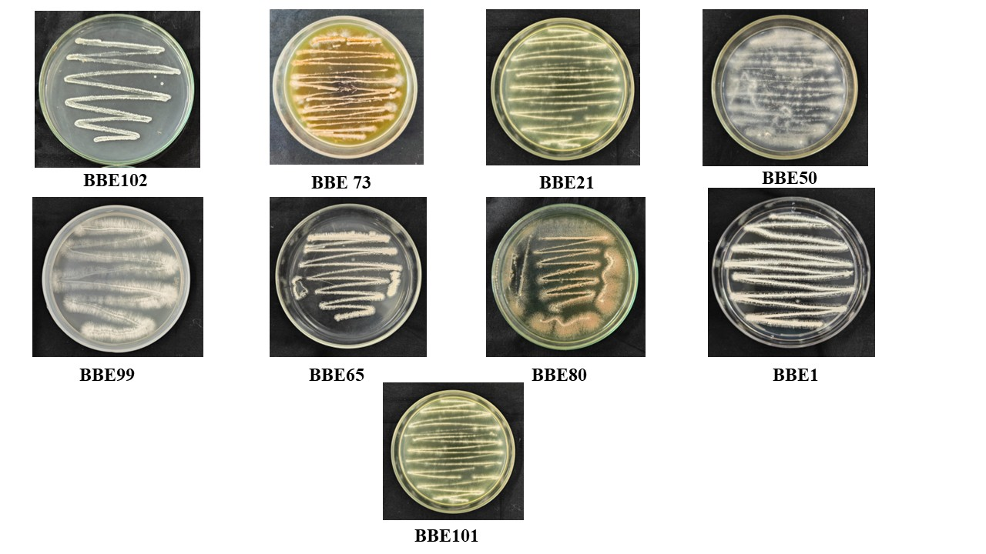
Biochemical assays revealed functional variability among isolates. Catalase activity was detected in most isolates, while starch and casein hydrolysis were widespread. Variable responses were observed for gelatin liquefaction and H₂S production. Such metabolic versatility highlights the ecological adaptability of endophytic Streptomyces, contributing to their capacity for nutrient cycling, antifungal activity, and plant growth promotion (Jog et al., 2014; Barka et al., 2016). The observed diversity in enzymatic activities suggests that these isolates may play important roles in enhancing banana resilience against soilborne pathogens (Chen et al., 2018).
Figure 1: Axenic cultures of endophytic actinomycetes isolated from different banana cultivars
3.3 Molecular Identification
Partial 16S rRNA sequencing confirmed that all isolates belonged to the genus Streptomyces (Table 3). The identified taxa included S. mutabilis, S. tendae, S. calvus, S. griseoviridis, S. colonosanans, S. rochei, S. turius, and S. levis, with amplicon sizes ranging from 1,365 to 1,490 bp. Phylogenetic analysis using the Neighbour-Joining method clustered the isolates with their respective reference sequences with strong bootstrap support (>95%), validating their taxonomic affiliations.
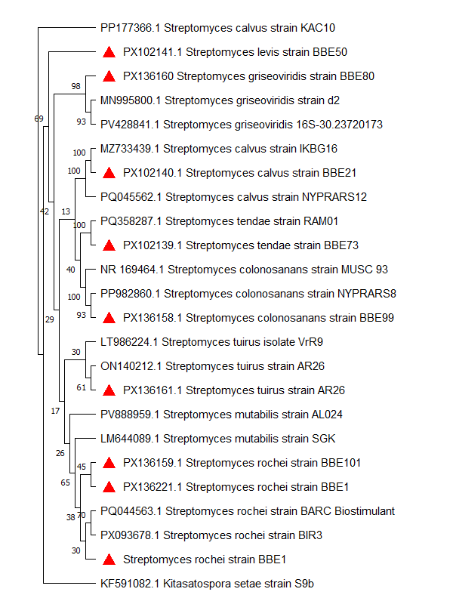
The dominance of Streptomyces spp. is consistent with earlier reports in banana and other crops, where these actinomycetes are recognized as prolific producers of secondary metabolites and hydrolytic enzymes (Yun et al., 2023). Notably, isolates of S. rochei and S. griseoviridis have been associated with the suppression of F. oxysporum through the production of antifungal compounds and cell wall-degrading enzymes (Duan et al., 2020). The recovery of multiple Streptomyces species from different banana cultivars underscores their ecological significance and highlights their potential as biocontrol agents and plant growth promoters in sustainable banana production systems (Nguyen et al. 2025).

Figure 2. Phylogenetic tree of banana endophytic actinomycetes based on 16S rRNA sequences. The tree was generated using the Neighbor-Joining method with 1,000 bootstrap replications.

Table 3. Molecular characterization of banana endophytic actinomycetes
Isolate code | Organisms | Accession numbers | Amplicon size (bp)
BBE102 | Streptomyces mutabilis | PX136200 | 1372
BBE73 | Streptomyces tendae | PX102139 | 1433
BBE21 | Streptomyces calvus | PX102140 | 1490
BBE80 | Streptomyces griseoviridis | PX136160 | 1421
BBE99 | Streptomyces colonosanans | PX136158 | 1490
BBE101 | Streptomyces rochei | PX136159 | 1398
BBE65 | Streptomyces tuirus | PX136161 | 1365
BBE50 | Streptomyces levis | PX102141 | 1397
BBE1 | Streptomyces rochei | PX136221 | 1486
4. Conclusion
This study documented nine endophytic Streptomyces isolates from banana cultivars across Tamil Nadu through combined morphological, biochemical, and molecular approaches. The characterized diversity highlights their ecological significance and potential application as biocontrol agents and plant growth promoters, providing a sustainable avenue for integrated banana disease management.

Disclaimer (Artificial intelligence)
Option 1:
Author(s) hereby declare that NO generative AI technologies such as Large Language Models (ChatGPT, COPILOT, etc.) and text-to-image generators have been used during the writing or editing of this manuscript.
Option 2:
Author(s) hereby declare that generative AI technologies such as Large Language Models, etc. have been used during the writing or editing of manuscripts. This explanation will include the name, version, model, and source of the generative AI technology and as well as all input prompts provided to the generative AI technology
Details of the AI usage are given below:
1.
2.
3.

References
Thompson, A. K. (2011). Banana (Musa spp.). In Postharvest biology and technology of tropical and subtropical fruits (pp. 216-244e). Woodhead Publishing.
Vinayagamoorthi, N., Sekhar, C., & Palanisamy, N. (2019). Area, Production and Productivity and Economic Appraisal of Banana in India. Epitome: International Journal of Multidisciplinary Research, 5(3), 1-10.
Meghwal, M., & Jayachandran, A. (2023). Advances in production technology of banana. Fischer. Verlag. Jena, 79-89
Siamak, S. B., & Zheng, S. (2018). Banana Fusarium wilt (Fusarium oxysporum f. sp. cubense) control and resistance, in the context of developing wilt-resistant bananas within sustainable production systems. Horticultural Plant Journal, 4(5), 208-218.
Sumner, D. R. (2018). Crop rotation and plant productivity. In Handbook of agricultural productivity (pp. 273-314). CRC Press.
Oyedoh, O. P., Yang, W., Dhanasekaran, D., Santoyo, G., Glick, B. R., & Babalola, O. O. (2023). Sustainable agriculture: rare-actinomycetes to the rescue. Agronomy, 13(3), 666.
Swarnalakshmi, K., Senthilkumar, M., & Ramakrishnan, B. (2016). Endophytic actinobacteria: nitrogen fixation, phytohormone production, and antibiosis. In Plant growth promoting Actinobacteria: a new avenue for enhancing the productivity and soil fertility of grain legumes (pp. 123-145). Singapore: Springer Singapore.
Ayswaria, R., Vasu, V., & Krishna, R. (2020). Diverse endophytic Streptomyces species with dynamic metabolites and their meritorious applications: a critical review. Critical Reviews in Microbiology, 46(6), 750-758.
Ansari, W. A., Krishna, R., Zeyad, M. T., Singh, S., & Yadav, A. (2020). Endophytic actinomycetes-mediated modulation of defense and systemic resistance confers host plant fitness under biotic stress conditions. In Microbial versatility in varied environments: microbes in sensitive environments (pp. 167-180). Singapore: Springer Singapore.
Zhang, L., Zhang, H., Huang, Y., Peng, J., Xie, J., & Wang, W. (2021). Isolation and evaluation of rhizosphere actinomycetes with potential application for biocontrolling Fusarium wilt of banana caused by Fusarium oxysporum f. sp. cubense tropical race 4. Frontiers in Microbiology, 12, 763038.
Vurukonda, S. S. K. P., Giovanadri, D., & Stefani, E. (2021). Growth Promotion and Biocontrol Activity of Endophytic Streptomyces spp. Prime Archives in Molecular Sciences, 2nd Edition, 1, 1-55.
Khan, S., Srivastava, S., Karnwal, A., & Malik, T. (2023). Streptomyces as a promising biological control agents for plant pathogens. Frontiers in Microbiology, 14, 1285543.
Cao, P., Li, C., Wang, H., Yu, Z., Xu, X., Wang, X., Xiang, W. (2020). Community structures and antifungal activity of root-associated endophytic actinobacteria in healthy and diseased cucumber plants and Streptomyces sp. HAAG3-15 as a promising biocontrol agent. Microorganisms, 8(2), 236.
Coombs, J. T., Franco, C. M., & Loria, R. (2003). Complete sequencing and analysis of pEN2701, a novel 13-kb plasmid from an endophytic Streptomyces sp. Plasmid, 49(1), 86-92.
Shirling, E. B., & Gottlieb, D. (1970). Report of the International Streptomyces Project-five years of collaborative research. The Actinomycetales. Gustav, Fischer. Verlag. Jena, 79-89.
Zheng, X., Wang, J., Chen, Z., Zhang, H., Wang, Z., Zhu, Y., & Liu, B. (2019). A Streptomyces sp. strain: Isolation, identification, and potential as a biocontrol agent against soilborne diseases of tomato plants. Biological control, 136, 104004.
Mehling, A., Wehmeier, U. F., & Piepersberg, W. (1995). Nucleotide sequences of streptomycete 16S ribosomal DNA: towards a specific identification system for streptomycetes using PCR. Microbiology, 141(9), 2139-2147.
Rossmann, M., Schlaeppi, K., Mäder, P., Borsetto, C., Yousaf, S., & Weyens, N., et al. (2015). Agroforestry leads to shifts within the gammaproteobacterial microbiome of banana plants cultivated in Central America. Frontiers in Microbiology, 6, 91.
Cao, L., Qiu, Z., You, J., Tan, H., & Zhou, S. (2005). Isolation and characterization of endophytic Streptomycete antagonists of Fusarium wilt pathogen from surface-sterilized banana roots. FEMS Microbiology Letters, 247(2), 147–152.
Barka, E. A., Vatsa, P., Sanchez, L., Gaveau-Vaille, N., Jacquard, C., Klenk, H.-P., Clément, C., Oudot-Le Secq, M.-P., & van Wezel, G. P. (2016). Taxonomy, physiology, and natural products of Streptomyces spp. isolated as endophytes. Applied Microbiology and Biotechnology, 100(14), 6381–6392.
Jog, R., Pandya, M., Nareshkumar, G., & Rajkumar, S. (2014). Mechanism of phosphate solubilization and antifungal activity of Streptomyces spp. isolated from wheat roots and rhizosphere and their application in improving plant growth. Microbiology, 160(4), 778-788.
Chen, Y., Zhou, D., Qi, D., Gao, Z., Xie, J., & Luo, Y. (2018). Growth promotion and disease suppression ability of a Streptomyces spp. CB-75 from banana rhizosphere soil. Frontiers in microbiology, 8, 2704.
Yun, T., Zang, X., Zhou, D., Jing, T., Li, K., Zhao, Y., … Xie, J. (2023). Antimicrobial mechanisms and secondary metabolite profiles of Streptomyces hygroscopicus subsp. hygroscopicus 5–4 against banana fusarium wilt disease using metabolomics. Frontiers in Microbiology, 14, 1159534.
Duan, Y., Chen, J., He, W., Pang, Z., Xie, J., & Hu, H. (2020). Fermentation optimization and disease suppression ability of a Streptomyces sp. FS-4 from banana rhizosphere soil. BMC Microbiology, 20, Article 24.
Nguyen, T. T., Nguyen, T. T., Nguyen, T. H., Nguyen, L. T., Tran, D. T., Dinh, S. T., ... & Nguyen, C. X. (2025). In silico and in vitro analyses reveal the potential use of Streptomyces parvulus VNUA74 as bioagent for sustainable banana production. Scientific Reports, 15(1), 7049.

