MOLECULAR DETECTION OF HAEMOPROTOZOAN PATHOGENS IN TICK POPULATION OF
MIZORAM, INDIA

Abstract

Aim: To assess the occurrence of bovine haemoprotozoa in ticks from Mizoram, India. This study seeks to evaluate the potential role of ticks as vectors for transboundary livestock diseases in a region with high biodiversity and porous international borders.
Study design: This cross-sectional study involved the collection and morphological identification of ticks from livestock in Mizoram, followed by PCR-based screening of selected tick DNA samples to assess the presence of parasites like Theileria orientalis, Anaplasma spp., and Babesia bigemina.
Place and Duration of the study: Department of Veterinary Parasitology, C.V.Sc & A.H, Central Agricultural University, Aizawl, Mizoram during a period of April 2021 to January 2022.
Methodology: The study employed a cross-sectional design to assess the presence of haemoprotozoa parasites in ticks collected from livestock across three districts of Mizoram—Aizawl, Kolasib, and Champhai—selected based on their high cattle and mithun populations. A representative tick samples of various life stages and species, were randomly collected from cattle and mithun. Sixty DNA samples, 20 from each district and representing key tick species (Rhipicephalus microplus, Haemaphysalis bispinosa, and Amblyomma spp.), were randomly selected and screened using PCR for T. orientalis, Anaplasma spp., and B. bigemina.
Results: Out of 60 randomly selected tick DNA samples screened, 5% (n=3) each were tested positive for T. orientalis and Anaplasma spp. in ticks from Aizawl district and Champhai district, respectively, while none of the samples showed the presence of B. bigemina.
Conclusion: This study describe the first demonstration of tick as a vector for bovine haemoprotozoan pathogens in Mizoram. These finding highlights the risk of haemoprotozoan infections for the need of ongoing surveillance, expanded sampling, and targeted tick control strategies to protect livestock health in the region.

Keywords: Tick-borne-haemoprotozoa, Theileria orientalis, Anaplasma spp., Babesia spp., Mizoram
- INTRODUCTION
Ticks are a diverse group of blood-feeding ectoparasites known to transmit a wide range of infectious diseases affecting both humans and animals (de la Fuente et al., 2008; Madison-Antenucci et al., 2020; Rochlin and Toledo, 2020). Ticks are known to harvest several haemoprotozoan parasites like Babesia, Anaplasma and Theileria spp. which cause great economic loss in the livestock industry all around the world (Ghosh and Nagar, 2014). Beyond their role as vectors of haemoparasitic diseases, tick infestations themselves can lead to significant production losses. This occurs due to "tick worry" and the onset of anaemia, which negatively impacts animal health and productivity (Johansson et al., 2020; Singh et al., 2022).
The increasing global interconnectedness also raises the risk of introducing infectious diseases into new regions, posing serious threats to the livestock industry (Beltran-Alcrudo et al., 2019). Mizoram, located in northeastern India (between 21°56'N to 24°31'N and 92°16'E to 93°26'E), shares international borders with Myanmar to the east and south, and Bangladesh to the west. The region, characterized by tropical wet evergreen forests, falls within one of India’s four recognized biodiversity hotspots.
Until October 2022, cattle were officially imported from Myanmar into Mizoram and Bangladesh. However, due to the porous nature of the approximately 830 km Indo-Myanmar and Indo-Bangladesh borders, the possibility of ongoing illegal livestock movement remains high (Purie, 2022). This raises concerns that Mizoram could serve as a gateway for the introduction and potential spread of transboundary and zoonotic livestock diseases to other parts of India. Supporting this concern, molecular phylogenetic studies have shown that PRRS virus strains found in pigs in Mizoram are genetically closer to isolates from China and Vietnam than to those found in mainland India (Rajkhowa et al., 2016). Several researchers have employed PCR techniques to detect haemoprotozoan parasites from tick DNA samples, demonstrating its effectiveness as a diagnostic tool (Adham et al., 2009; Kakati et al., 2015). In light of these risks, the present study aims to assess the occurrence of haemoparasites in ticks collected from livestock in Mizoram, India.
- MATERIAL AND METHODS
2.1 Sampling:
A total of 949 ticks were collected from livestock in three districts of Mizoram—Aizawl (humid mild sub-tropical hill zone), Kolasib (humid mild tropical hill zone), and Champhai (humid temperate sub-alpine zone) (Fig. 1), which were selected based on having the highest population of cattle and mithun, according to the 20th Livestock Census of Mizoram (2019).
Ticks were randomly collected from Zebu cattle (Bos indicus), Taurine cattle (Bos taurus), and mithun (Bos frontalis) of varying age, sex, and breed. Ticks were carefully removed from the animals' body surfaces and preserved immediately in 70% alcohol. Collected specimens included all life stages: larvae, nymphs, adults (both males and engorged females) (Fig. 2). The samples were transported to the Department of Veterinary Parasitology, College of Veterinary Sciences and Animal Husbandry, Central Agricultural University, Selesih, Mizoram, for identification and further analysis. Morphological identification and sorting of ticks were carried out using standard keys (Kettle, 1995; Mullen and Durden, 2019); R. microplus were sampled from all the three districts, H. bispinosa (n=1) from Kolasib district and Amblyomma spp. (n=1) from Champhai district were sampled for this study.
2.2 Screening for the role of tick in the transmission of livestock haemoparasites:
Sixty randomly selected tick DNA samples—20 each from Aizawl, Kolasib, and Champhai—were subjected to PCR screening for three major haemoparasitic pathogens: Theileria orientalis, Anaplasma spp., and Babesia spp. using specific primers given on Table no. 1. DNA isolation from ticks was done using the Genomic DNA Extraction kit (Thermo Fisher Scientific, USA) following the manufacturer’s protocol. To minimize the contamination of host DNA during its extraction, DNA was extracted from an un-engorged tick sample. The detail PCR conditions for the target gene amplifications are listed in table 1. The PCR products were visualized on 1% (w/v) agarose gel with the addition of ethidium bromide.
- RESULTS AND DISCUSSION
A total of 60 numbers of randomly selected tick from Aizawl, Kolasib and Champhai districts of Mizoram (20 samples from each) were screened for an infection with T. orientalis, Anaplasma spp. and B. bigemina by PCR. It was observed that 5% (n=3) each of the total sample examined showed positive amplification for T. orientalis and Anaplasma spp., approx. 744 bp and 1433 bp, respectively (Fig. 3 & 4). Tick harvesting/carrying T. orientalis were found from Champhai district while Anaplasma spp. were found from Aizawl district, respectively.
In the context of Mizoram, a few studies have reported the occurrence of haemoprotozoan infections in domestic animals such as dogs and cattle. Specifically, Ghosh et al. (2020) and Gonmei et al. (2020) have documented the presence of haemoparasites in the region, highlighting the potential risk posed by tick-borne diseases to animal health in Mizoram. These findings underscore the importance of continued surveillance and molecular detection methods in understanding the epidemiology of haemoprotozoan infections (Sarma et al., 2019).
Detection of T. orientalis with all positive samples originating from Champhai district, is noteworthy. Champhai, located in the eastern part of Mizoram, shares international borders with Myanmar and has been reported to have active livestock movement, which might contribute to the circulation and potential transmission of T. orientalis. The findings indicate a localized distribution of infection, suggesting possible environmental, ecological, or management-related factors unique to Champhai that may favor the maintenance or emergence of this parasite. Similarly, Anaplasma spp. was found exclusively in Aizawl district which is central part of Mizoram. Earlier studies have documented its presence in cattle from Aizawl district (Behera et al., 2024; Das et al., 2022). This study affirmed the transmitting vector is R. microplus in Mizoram. The region is found with humid subtropical climate, that might influence tick distribution and pathogen dynamics.
Out of the 60 numbers of sampled ticks which comprises of R. microplus, H. bispinosa and Amblyomma spp., B. bigemina was not found. This may indicate the absence of this parasite in Mizoram or the prevalence may be too low to be detected in the current sample size. Environmental factors, host availability, and vector competence may all influence the local absence or low circulation of Babesia parasite. Out of all the sample collected, one sample each of H. bispinosa and Amblyomma spp. were collected from Kolasib and Champhai district, respectively. The low level of these tick density may be due to the invasive nature of R. microplus tick, yet, their role in the transmission haemoprotozoa requires investigation. Lalawmpuii (2022) found Coxiella-like endosymbiont in these tick including R. microplus from Mizoram, the DNA sequences from all the three ticks are homology with 100% identity. This finding unveiled that as a similar type of endosymbiont is found in these tick and also different genera of ticks can transmit these parasites, their role in the transmission of haemoprotozoa need further study as demonstrated by other researchers (Hammer et al., 2015; Lu et al., 2023; Dos Santos et al., 2024; Cárdenas-Amaya et al., 2025).
Overall, the low prevalence both the parasite indicates a limited but detectable presence of these pathogens in the tick population of Mizoram. These findings highlight the need for larger-scale surveillance both in the host as well as in tick for vector identification and transmission dynamics of tick-borne pathogens in this region. Such efforts are essential for informing effective control strategies and preventing potential outbreaks in livestock.
- Conclusion
This study successfully demonstrates the use of PCR-based molecular techniques for the detection of important tick-borne haemoprotozoan pathogens in livestock ticks from Mizoram. Among the 60 tick DNA samples screened, T. orientalis and Anaplasma spp. were each detected in 5% of the samples, while no evidence of Babesia spp. infection was found. The findings highlight a limited but present risk of tick-borne haemoprotozoan infections in the region’s livestock, emphasizing the importance of continuous monitoring and further research on tick ecology and environmental factors affecting pathogen transmission. Overall, this study provides baseline data for the epidemiological mapping of haemoprotozoan infections in Mizoram and supports the need for integrated tick management and disease control strategies to safeguard animal health and livestock productivity in the region.

Ethical Statement
The study was conducted after being approved by the Institutional Animal Ethics Committee (IAEC), 2020 (CVSC/CAU/IAEC/19-20/p-6).

COMPETING INTERESTS DISCLAIMER:
Authors have declared that they have no known competing financial interests OR non-financial interests OR personal relationships that could have appeared to influence the work reported in this paper.

Disclaimer (Artificial intelligence)
Author(s) hereby declare that NO generative AI technologies such as Large Language Models (ChatGPT, COPILOT, etc.) and text-to-image generators have been used during the writing or editing of this manuscript.
REFERENCES

- Adham, F.K., Abd-el-Samie, E. M., Gabre, R. M., el-Hussein, H. (2009). Detection of tick blood parasites in Egypt using PCR assay I-- Babesia bovis and Babesia bigemina. Parasit Res, 105, 721-730.
- Barlough JE, Madigan JE, DeRock E, Bigornia L (1996). Nested polymerase chain reaction for detection of Ehrlichia equi genomic DNA in horses and ticks (Ixodes pacificus). Vet Parasitol. 63(3-4):319-29.
- Behera, B., Ravindran, R., Arya, R.S., Behera, P., Patra, G., Islam, S.J., Sharma, R., Sahoo, B.., Mohanta (2024). Molecular characterisation of Anaplasma marginale and Theileria orientalis in slaughtered bovines of Aizawl District, Mizoram. Indian J Anim Res. DOI: 10.18805/IJAR.B-5255.
- Beltran-Alcrudo, D., Falco, J.R., Raizman, E., Dietze, K. (2019). Transboundary spread of pig diseases: the role of international trade and travel. BMC Vet Res, 15, 64.
- Cárdenas-Amaya, C., Romero-Salas, D., Rafael, M., Chaparro-Gutiérrez, J. J., López-Osorio, S., Aguilar-Domínguez, M., Alonso-Díaz, M. Á., Pérez de León, A. Á., & de la Fuente, J. (2025). Molecular detection of Anaplasma marginale in Amblyomma mixtum infesting cattle in the major livestock-producing states of Mexico. Pathogens (Basel, Switzerland), 14(3), 214.
- Das, D., Sarma, K., Eregowda, C. G., Roychoudhury, P., Rajesh, J. B., Behera, P., Prasad, H., Lalrinkima, H., Aktar, F., Bora, N., Deka, C., Thakur, N., & Tolenkhomba, T. C. (2022). Naturally occurring Anaplasma marginale infection in cattle: Molecular prevalence and associated risk factors, haemato-biochemical alterations, oxidant/antioxidant status and serum trace mineral levels. Microb Pathog. 167, 105575.
- de la Fuente, Jose & Estrada-Peña, Agustín & Venzal, José & Kocan, Katherine & Sonenshine, Daniel. (2008). Overview: Ticks as vectors of pathogens that cause disease in humans and animals. Frontiers in Bioscience: a journal and virtual library, 13, 6938-6946.
- Dos Santos, J. C., Garcia, M. V., Duarte, P. O., Oshiro, L. M., Martins, F. I., de Oliveira Souza Higa, L., de Lima, Á. A., & Andreotti, R. (2024). Babesia bigemina (smith and Kilbourne, 1893) detection in Amblyomma sculptum (Berlese, 1888) ticks in the Mato Grosso do Sul state, Brazil. Parasitol Int. 102, 102912.
- Ghosh, S., Nagar, G. (2014). Problem of ticks and tick-borne diseases in India with special emphasis on progress in tick control research: A review. J Vector Borne Dis, 51, 259.
- Ghosh, S., Patra, S., Borthakur, S. K., Behera, P., Tolenkhomba, T.C., Deka, A., Khare, R. K., Biswas, P., 2020. Prevalence of haemoprotozoa in cattle of Mizoram, India. Biol Rhythm Res, 51, 76-87.
- Gonmei, C., Sarma, K., Roychoudhury, P., Ali, M. A., Singh, D., Prasad, H., Ahmed, F. A., Lalmuanpuii, R., Shah, N., Singh, N., Singh, N. S., Choudhury, J. K. (2020). Molecular diagnosis and clinic-hemato-biochemical alterations and oxidant-antioxidant biomarkers in Babesia-infected dogs of Mizoram, India. J Vector Borne Dis, 5, 226-233.
- Hammer, J. F., Emery, D., Bogema, D. R., Jenkins, C. (2015). Detection of Theileria orientalis genotypes in Haemaphysalis longicornis ticks from southern Australia. Parasites Vectors, 8, 229.
- Johansson, M., Mysterud, A., Flykt, A., 2020. Livestock owners' worry and fear of tick-borne diseases. Parasites Vectors, 13(1):331.
- Kakati, P., Sarmah, P. C., Ray, D., Bhattacharjee, K., Sharma, R. K., Barkalita, L. M., Sarma, D. K., Baishya, B. C., Borah, P., Stanley, B. (2015). Emergence of oriental theileriosis in cattle and its transmission through Rhipicephalus (Boophilus) microplus in Assam, India. Vet World, 8, 1099.
- Kettle, D. S. (1995). Medical and Veterinary Entomology. Wallingford, Oxon, UK: CAB International. 2nd Edition.
- Lalawmpuii, K. (2022). MVSc thesis submitted to College of Veterinary Sciences & Anima Husbandry, Central Agricultural University (I), Aizawl, Mizoram, India.
- Lu, M., Meng, C., Li, Y., Zhou, G., Wang, L., Xu, X., Li, N., Ji, Y., Tian, J., Wang, W., Li, K. (2023). Rickettsia sp. and Anaplasma spp. in Haemaphysalis longicornis from Shandong province of China, with evidence of a novel species "Candidatus Anaplasma Shandongensis". Ticks Tick-Borne Dis, 14(1), 102082.
- Madison-Antenucci, S., Kramer, L. D, Gebhardt, L.L., Kauffman, E. (2020). Emerging tick-borne diseases. Clin Microbiol Rev, 33(2): e00083-18.
- Mullen, G. R., Durden, L. A. (2019). Medical and Veterinary Entomology. Elsevier Publication. 3rd Edition.
- Ota N, Mizuno D, Kuboki N, Igarashi I, Nakamura Y, Yamashina H, Hanzaike T, Fujii K, Onoe S, Hata H, Kondo S, Matsui S, Koga M, Matsumoto K, Inokuma H, Yokoyama N. (2009). Epidemiological survey of Theileria orientalis infection in grazing cattle in the eastern part of Hokkaido, Japan. J Vet Med Sci, 71(7):937-944.
- Purie, A. (2022). Mizoram government bans import of cattle from Myanmar. India Today NE, Oct 22, 2022.
- Rajkhowa, T. K., Mohanarao, J., Gogoi, A., Hauhnar, L. (2016). Indian porcine reproductive and respiratory syndrome virus bears discontinuous deletion of 30 amino acids in nonstructural protein 2. VirusDisease, 27, 287–293.
- Rochlin, I., Toledo, A. (2020). Emerging tick-borne pathogens of public health importance: a mini-review. J Med Microbiol 69, 781-79.
- Sarma, K., Nachum-Biala, Y., Kumar, M., Baneth, G. (2019). Molecular investigation of vector-borne parasitic infections in dogs in Northeast India. Parasites Vectors, 12(1), 122.
- Singh, K., Sharma, A. K., Kumar, S., Sankar M., Ghosh, S. (2022). Synergistic properties of essential oils of eucalyptus (Eucalyptus globulus) and lemon grass (Cymbopogon flexuosus) against cattle tick, Rhipicephalus microplus. Int J Acarol, 48, 338-343.
- Sivakumar T, Kothalawala H, Abeyratne SA, Vimalakumar SC, Meewewa AS, Hadirampela DT, Puvirajan T, Sukumar S, Kuleswarakumar K, Chandrasiri AD, Igarashi I, Yokoyama N (2012). A PCR-based survey of selected Babesia and Theileria parasites in cattle in Sri Lanka. Vet Parasitol, 190(1-2): 263-267.
Target Gene | Oligonucleotide Primer | PCR Amplification Condition |  | Expected Amplicon Size | Reference
Target organism | Primer Sequence | PCR Conditions |  | Target size (bp) | References
Theileria orientalis  MPSP gene | Forward:  5’-CTTTGCCTAGGATACTTCCT-3’  Reverse:  5’-ACGGCAAGTGGTGAGAACT-3’ | Initial denaturation | 94° C for 5 mins | 744 | Ota et al., 2009
Theileria orientalis  MPSP gene |  | Cyclical denaturation (35 cycles) | 94° C for 1 min | 744 | Ota et al., 2009
Theileria orientalis  MPSP gene |  | Annealing temperature | 61°C for 30 secs | 744 | Ota et al., 2009
Theileria orientalis  MPSP gene |  | Extension | 72° C for 90 secs | 744 | Ota et al., 2009
Theileria orientalis  MPSP gene |  | Final extension | 72° C for 10 mins | 744 | Ota et al., 2009
Theileria orientalis  MPSP gene |  | Initial denaturation | 4°C | 744 | Ota et al., 2009
Anaplasma spp.  16S rRNA | Forward:  5’-TCCTGGCTCAGAACGAACGCT GGCGGC-3’  Reverse:  5’-AGTCACTGACCCAACCTTAAA TGGCTG-3’ | Initial denaturation | 94° C for 5 mins | 1433 | Barlough et al., 1996
Anaplasma spp.  16S rRNA |  | Cyclical denaturation  (35 Cycles) | 94° C for 1 min | 1433 | Barlough et al., 1996
Anaplasma spp.  16S rRNA |  | Annealing temperature | 55°C for 30 secs | 1433 | Barlough et al., 1996
Anaplasma spp.  16S rRNA |  | Extension | 72° C for 90 secs | 1433 | Barlough et al., 1996
Anaplasma spp.  16S rRNA |  | Final extension | 72° C for 10 mins | 1433 | Barlough et al., 1996
Anaplasma spp.  16S rRNA |  | Initial denaturation | 4°C | 1433 | Barlough et al., 1996
B. bigemina  (Apical Membrane Antigen-1) | Forward:  5’-TACTGTGACGAGGACGGATC-3’  Reverse:  5’-CCTCAAAAGCAGATTCGAGT-3’ | Initial denaturation | 94° C for 5 mins | 211 | Sivakumar et al., 2012
B. bigemina  (Apical Membrane Antigen-1) |  | Cyclical denaturation  (35 Cycles) | 94° C for 1 min | 211 | Sivakumar et al., 2012
B. bigemina  (Apical Membrane Antigen-1) |  | Annealing temperature | 60°C for 30 secs | 211 | Sivakumar et al., 2012
B. bigemina  (Apical Membrane Antigen-1) |  | Extension | 72° C for 1 min | 211 | Sivakumar et al., 2012
B. bigemina  (Apical Membrane Antigen-1) |  | Final extension | 72° C for 10 mins | 211 | Sivakumar et al., 2012
B. bigemina  (Apical Membrane Antigen-1) |  | Initial denaturation | 4° C | 211 | Sivakumar et al., 2012

Table 1. The detailed PCR conditions for the target gene amplifications

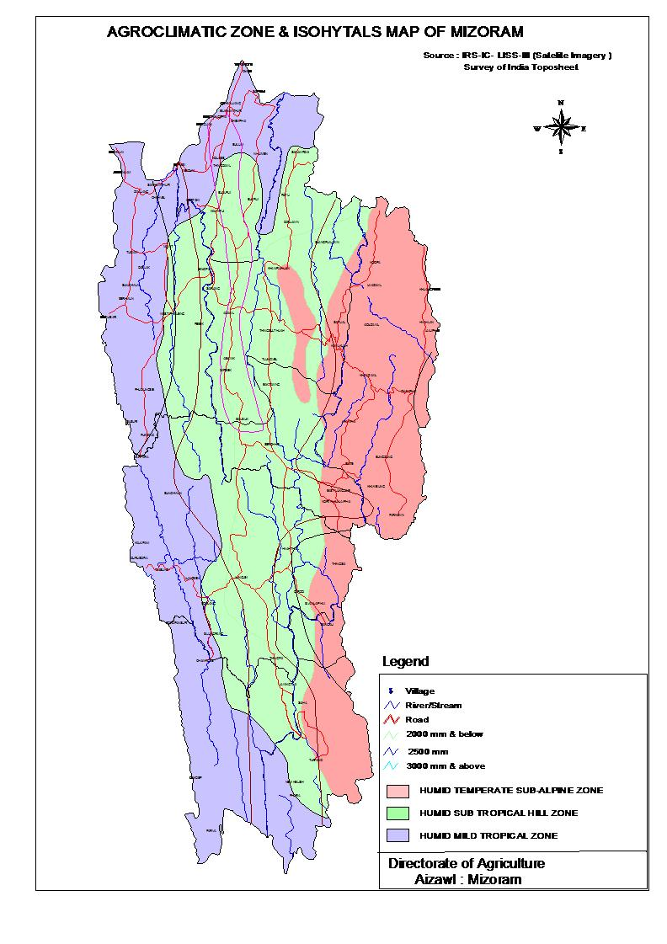

Figure 1 showing the various climatic regions of Mizoram

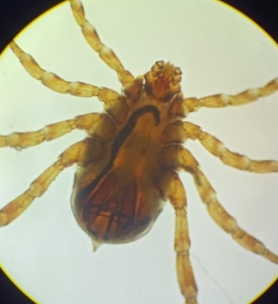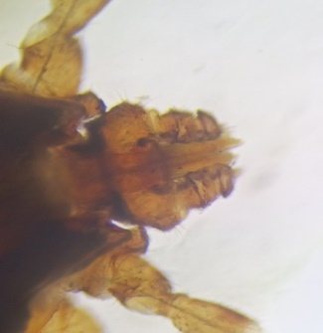
(a)
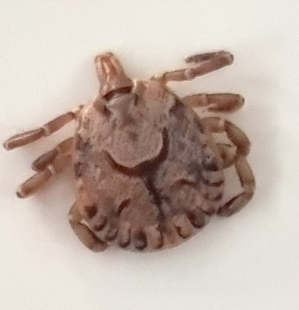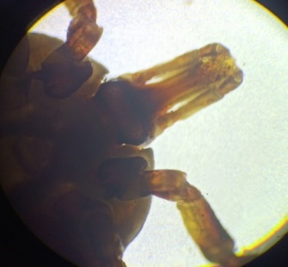
(b)

Figure 2 showing collected ticks comprising of larvae, nymphs and adults of R. microplus (a) and Amblyomma spp (b).

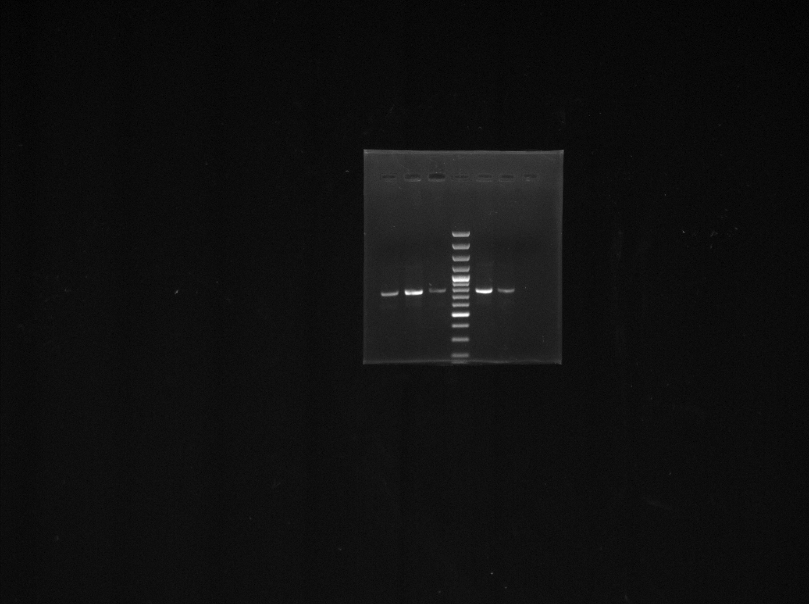

1 M 2 3 N

744 bp

Fig. 3 showing PCR amplification of T. orientalis.
Lane 1, 2 & 3 : PCR amplicon at 744 bp
Lane M : 100 bp DNA marker
Lane N : Negative Control

N M 1

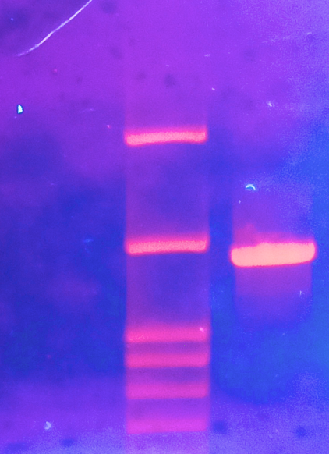

1433 bp

Fig. 4 showing PCR amplification of Anaplasma spp.
Lane N : Negative Control
Lane M : 1 kb DNA marker
Lane 1 : PCR amplicon at 1433 bp

