Original Research Article
Diversity and conservation value of the woody flora of the Peleforo Gon Coulibaly University Campus, Côte d’Ivoire
ABSTRACT

In the urban environment, green spaces play a major role in conserving tree diversity and improve the quality of life and attractiveness of cities. However, there is limited data on the woody floristic composition and the biodiversity conservation value of these areas in northern Côte d’Ivoire. This study aims to establish the woody plant species list and assess the biodiversity conservation value of the green space at the Peleforo Gon Coulibaly University campus in Korhogo. Surface surveys were carried out on the campus site. A purposive sampling approach was used for data collection. Species richness, floristic composition, and biocenotic diversity indices were used for the floristic analysis. For the calculation of diversity indices, the MVSP 3.1 software was used. Five compartments within the university campus were selected and served as plots for vegetation surveys. The conservation value of the site’s phytodiversity was assessed through the presence of species with a status. The study identified 57 woody species belonging to 44 genera and 19 families. Fabaceae and Moraceae are the most represented families in terms of species number. Analysis of both the unweighted and weighted spectra of the biological types of the flora highlights the dominance of microphanerophytes, accounting for 71.93% of the species and 52.33% of the individuals. They are followed by mesophanerophytes, which represent 21.05% of the unweighted spectrum and 38.60% of the weighted spectrum. The biocenotic index values highlight the contribution of native species to the aesthetic of the campus green space. Seven families and ten species are found to have significant ecological importance. The most important species are predominantly native (e.g., Isoberlinia doka Craib & Stapf, Daniellia oliveri (Rolfe) Hutch. & Dalziel, Khaya senegalensis (Desr.) A.Juss). Among the recorded species, 44 are listed as threatened by the IUCN. The green space of the Peleforo Gon Coulibaly University campus thus represents a significant site for phytodiversity conservation, underlining the importance of preserving and enhancing the density and diversity of its threatened species to promote a more sustainable urban ecological balance.

Keywords: Côte d’Ivoire, floristic diversity, green space, Korhogo, shade trees.

1. INTRODUCTION

In the urban environment, trees are important factor in maintaining diversity and constitute green spaces that enhance the quality of life and the attractiveness of cities (Clergeau, 1996; Laïlle et al., 2013). They function as bioindicators of urban conditions thanks to their morphological characteristics, dendrochronology, and dendrobiochemistry (Lüttge & Buckeridge, 2023). These green spaces, which range from isolated plants to much larger formations, include parks, public and private gardens, roadside and shade trees, fallows, etc. (Mehdi et al., 2012). They help to reduce the effects of suffocating tropical heat, improve microclimate, provide protection against wind, noise, and dust, and serve as spaces for relaxation, leisure, recreation, and ornamentation, all essential to human life (N’Zala & Miankodila, 2002).
In Africa, the incorporation of trees into urban areas has been part of colonial policies that promoted social, economic, and spatial separation from local populations (Samsahatou et al., 2020). Since then, many countries have implemented greening policies to better cope with heatwaves. This vegetation has materialized by species that have regenerated naturally and have been able to grow freely. On the other hand, in many cases, other species are planted. They can be found along streets, in the courtyards of houses, in frontages, in the woodland etc., forming a kind of urban forest (Samsahatou et al., 2020).
Unfortunately, green spaces in general, and street trees in particular, are under intense anthropogenic pressure. These trees are very often eliminated as soon as their presence is a nuisance, without even considering their ecological role for humans (Kouadio et al., 2016). In such a context, the question arises regarding the long-term sustainability of street and shade trees in urban areas. To support the case for preserving street trees and other types of green spaces, studies have been carried out in major cities, including Porto-Novo (Osseni et al., 2014), Marrakech (El Faiz et al., 2016), Grand Nokoué (Amontcha et al., 2017), Ziguinchor (Charahabil et al., 2018), and Bobo-Dioulasso (Gomgnimbou et al., 2019). These studies have shown that urban areas still support considerable vegetation, which can help mitigate the impacts of climate change.
In Côte d'Ivoire, most of the studies on vegetation in urban areas have been carried out in cities located below the eighth parallel, particularly in the district of Abidjan in the communes of Plateau (Vroh et al., 2014; Kouadio et al., 2016) and Bingerville (Moussou et al., 2016), and in a few inland cities such as Daloa (Kouassi et al., 2018) and Yamoussoukro (Nomel et al., 2019). However, no study has focused on urban plant diversity in the northern part of the country, particularly in the city of Korhogo. Yet, this city contains significant floristic diversity that contributes to the well-being of its inhabitants, such as the woody landscape of the Peleforo Gon Coulibaly University campus (Coulibaly et al., 2018). The objective of this study is to assess the diversity and importance of the woody flora within this public green space in Korhogo. it aims to determine species richness and floristic composition, followed by to characterisation this flora through the analysis of ecological parameters.
2. material and methods
2.1. Study Area

The study area, covering 35.68 hectares, is located within Peleforo Gon Coulibaly University, which is situated in the municipality of Korhogo, the capital of the Poro region. It lies between longitudes 5°38’6’’ and 5°37’30’’ West and latitudes 5°25’30’’ and 5°25’48’’ North (Figure 1 and 2). According to the work of Guillaumet and Adjanohoun (1971), the university is situated within the sub-Sudanian ecological zone. This sector is characterised by natural vegetation composed of dense dry forests, open forests, wooded savannas, and shrub savannas (Kouamé et al., 2010). The study area is located between the 800 mm and 1200 mm isohyets and experiences two alternating seasons: a dry season from November to March, and a rainy season from May to October. The average annual rainfall is about 1200 mm, with considerable interannual variability. Average annual temperatures range from 24°C to 29°C. The soils are mainly ferruginous and ferralitic (Koné, 2004).

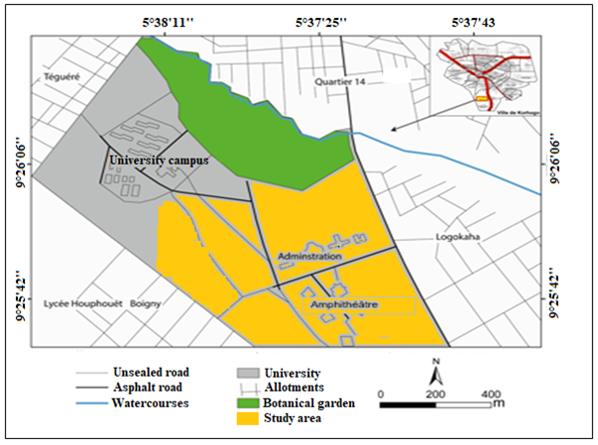
Fig. 1. Geographic location of the study area
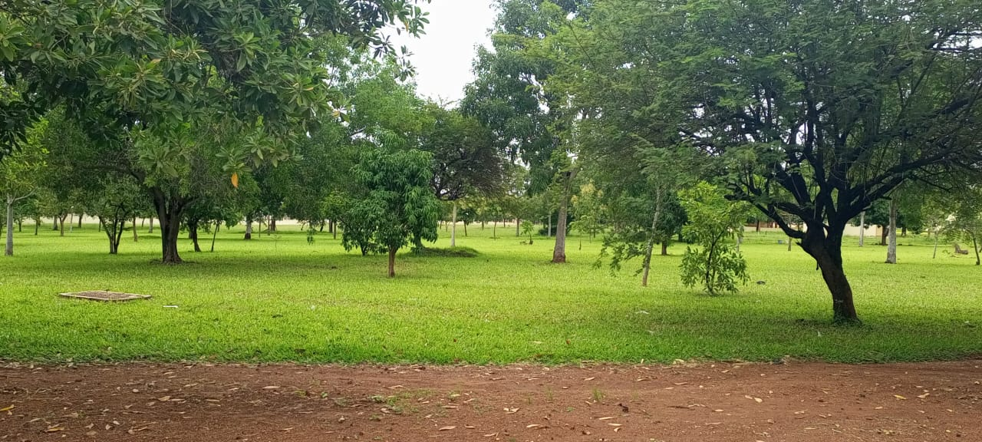

Fig. 2. Overview of the university campus green space

2.2. Data Collection

A purposive sampling approach was used for data collection. Five areas of the university campus were selected, ranging in size from 0.53 ha to 11.7 ha, and were used as plots for vegetation surveys. Within each plot, all woody species (trees, shrubs, and small trees) encountered were identified, and the number of individuals per species was recorded on a data sheet labelled with the plot number. The inventory focused on species with a diameter at breast height (dbh) greater than or equal to 5 cm and a total height of at least 2 meters. This minimum dbh threshold was chosen to include a greater number of individuals and thereby maximise species diversity (Gueulou et al., 2019). Several species were identified in situ. For those that could not be identified in situ, plant samples were collected for later identification by comparing them with samples from the National Floristic Center at Félix Houphouët-Boigny University (Côte d'Ivoire). The nomenclature adopted is that of the APG IV system (APG, 2016).
2.3. Data Analysis
2.3.1. Determination of richness and floristic composition
Floristic richness was assessed by counting the total number of woody species recorded on the campus, along with the genera and families to which they belong. Floristic composition was analysed by determining the biological types (Raunkiaer, 1934) and chorological types (White, 1986) of the recorded species. The main biological types considered were megaphanerophytes (MP), mesophanerophytes (mP), microphanerophytes (mp), and nanophanerophytes (np). The principal chorological types were Sudanian-Zambezian (SZ), Guineo-Congolian (GC), and Guineo-Congolian–Sudanian-Zambezian (GC-SZ). Introduced species have been associated with these major chorological types.
2.3.2. Assessment of quantitative floristic diversity

Quantitative floristic diversity was assessed using three ecological indices : Margalef’s index (RMG), Shannon’s index (H’), and Pielou’s evenness index (E). Margalef’s index (RMG) is used to evaluate habitat diversity based on the relationship between species richness and the total number of individuals. It does not consider the distribution of individuals across species.
Margalef’s Index is defined by the formula:
$${\text{R}}_{\text{MG}}\text{=}\frac{\text{S-1}}{\text{ln(N)}}$$
Where S is the number of species, and N is the total number of individuals.
The diversity of a given environment is considered :
- low when RMG is less than 2 ;
- high when RMG is greater than 6 ;
- moderate when RMG is between 2 and 6.
Shannon's Diversity Index (H’) is used to assess the diversity of a plant community, considering species richness and the relative abundance of species. It is calculated as follows:
$$H'=\sum{(\frac{ni}{N}}×ln\frac{ni}{N})$$
Where nᵢ is the number of individuals of species i, and N is the total number of individuals across all species.
According to Djego et al. (2012), the diversity is:
- low if H' is less than 3;
- high if H' is greater than 4;
- moderate if H' ranges between 3 and 4.
Pielou’s Evenness Index (E) measures how evenly individuals are distributed among the species present. It is calculated using:

$$\text{E=}\frac{\text{H}\text{'}}{\text{ln} \text{S}}$$
Where H' is Shannon’s diversity index, and S is the total number of species. This index reflects the degree of uniformity in species distribution.

2.3.3. Assessment of the relative importance of flora

The relative importance of the flora was assessed using the Species Importance Value Indices (SIVI) and Family Importance Value Indices (FIVI). The Species Importance Value Index (SIVI) and the Family Importance Value Index (FIVI) are used to identify dominant ecological entities within a community or ecological compartment. These indices help determine which species or families have the highest ecological value in each habitat. According to Reitsma (1988), cited in Nsangua et al. (2018), a species or family is considered ecologically significant when SIVI or FIVI ≥ 10.
According to Sabongo (2015), the SIVI and FIVI are calculated using the following formulas:
$$\text{SIVI = }\text{DoR}\text{ + }\text{DeR}\text{ + }\text{F}\text{e}\text{R}\text{ =}\left[\left(\frac{\text{ni}}{\text{∑ni}}\right)\text{+}\left(\frac{\text{gi}}{\text{∑gi}}\right)\text{+}\left(\frac{\text{fi}}{\text{∑fi}}\right)\right]\text{×100}$$
$$\text{FIV}\text{I}\text{ = }\text{DoR}\text{ + }\text{DeR}\text{ + }\text{DiR}\text{ =}\left[\left(\frac{\text{ni}}{\text{∑ni}}\right)\text{+}\left(\frac{\text{gi}}{\text{∑gi}}\right)\text{+}\left(\frac{\text{fi}}{\text{∑fi}}\right)\right]\text{×100}$$
Where:
- DoR is Relative Dominance;
- DeR is Relative Density;
- FeR = Relative Frequency (for species);
- DiR is Relative Diversity (for families);
- nᵢ is the number of individuals of species i or family I;
- gᵢ is the basal area of species i or family I;
- fᵢ is the number of plots containing species i or family i.
2.3.4. Assessment of the conservation value of phytodiversity

The conservation value of phytodiversity in the study area was evaluated based on the presence of species with special conservation status. Specifically, we identified Ivorian endemic species (GCi), species endemic to the Upper Guinean forests (HG), or to the West African forest block (GCW), using the pre-established species lists by Aké-Assi (2001, 2002) and Pooter et al. (2004). In addition to these endemic species, we included the list of rare or threatened plant species in Côte d'Ivoire according to the IUCN (2024).

2.4. Statistical Analysis

The collected data were entered into Microsoft Excel for descriptive statistical analysis (sums, means, percentages, and cross-tabulated lists), along with illustrative graphs. For the calculation of diversity indices, the MVSP 3.1 software was used.

3. results
3.1. Floristic richness and composition

The inventory of woody species on the Peleforo Gon Coulibaly University campus recorded a total of 1,199 individuals. These individuals belong to 57 species, 44 genera, and 19 botanical families (Table 1). The most species-rich families are, Fabaceae (17 species; 30.36%), Moraceae (8 species; 14.29%), and the Combretaceae, Meliaceae, and Verbenaceae, each represented by 4 species (7.14%) (Fig. 3).

Table 1. Taxonomic and floristic data of the woody plant population
Floristic parameters | Value
Number of individuals | 1199
Number of species | 57
Number of genera | 44
Number of families | 19

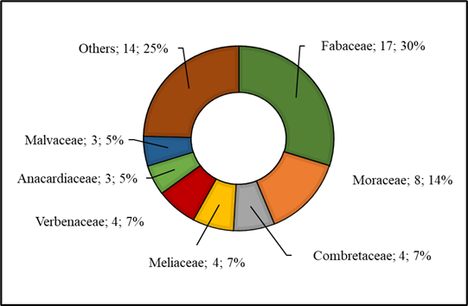
Fig. 3. Distribution spectrum of plant species inventoried in the families
Analysis of both the unweighted and weighted spectra of the biological types of the flora (Fig. 4) highlights the dominance of microphanerophytes, accounting for 71.93% of the species and 52.33% of the individuals. They are followed by mesophanerophytes, which represent 21.05% of the unweighted spectrum and 38.60% of the weighted spectrum. Megaphanerophytes and nanophanerophytes show the lowest proportions in the unweighted spectrum (3.51%), while nanophanerophytes are the least represented in terms of individuals (2.49%).
Regarding the chorological types (Fig. 5), the Sudanian-Zambezian (SZ) species are the most abundant, comprising 35.09% of the species and 43.76% of the recorded individuals. They are followed by Guineo-Congolian–Sudanian-Zambezian (GC-SZ) species in the unweighted spectrum (31.58%) and introduced species in the weighted spectrum (31.2%). Guineo-Congolian (GC) species are the least represented, with 3.51% of the species and 0.83% of the individuals recorded.

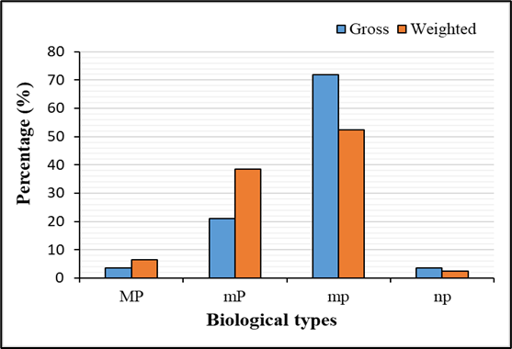
Fig. 4. Unweighted and Weighted spectra of the biological types of the flora
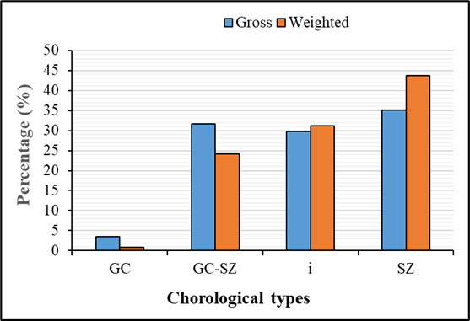
Fig. 5. Unweighted and Weighted spectra of the chorological types of the flora
3.2. Diversity Indices and importance value of taxa
The biocenotic diversity of the flora, according to the Shannon index (H’), Piélou's Evenness index (EH’), and Margalef index, is summarised in Table 2. The value of the Shannon index (2.66 ± 0.39), being below 3, indicates a low diversity of the woody flora. Regarding Piélou's Evenness index, the value (0.81 ± 0.03) is close to 1, suggesting an almost equitable distribution of individuals among the different species inventoried. As for the Margalef index, the value (5.05 ± 1.63), which falls between 2 and 6, shows that the diversity of the studied flora is moderate.

Table 2. Indices of biocenotic diversity of flora

Diversity Indices | Value
Shannon Index | 2.66 ± 0.39
Piélou Index | 0.81 ± 0.03
Margalef Index | 5.05 ± 1.63

The evaluation of the relative importance of the inventoried flora reveals ten (10) ecologically dominant species, each having an Importance Value Index (IVI) greater than or equal to 10 (Table 3). The most representative species of this flora is Isoberlinia doka, with an IVI of 29.50. It is followed by Azadirachta indica A. Juss. (28.62), Daniellia olivera (Rolfe) Hutch. & Dalziel (21.62), and Khaya senegalensis (Desr.) A.Juss) (21.18) (Fig. 6). The least important species in this category are Pinus caribaea (10.91) and Cola cordifolia (10.01).
As for the ecologically predominant families, there are seven (Table 4). These are the families with an Importance Value Index (IVI) greater than or equal to 10. The Fabaceae family is the most important, with an IVI of 106.52. It is followed by Meliaceae (37.23) and Verbenaceae (34.40).

Table 3. List of species with Importance Value Indices ≥ 10

N° | Species | DeR (%) | DoR (%) | FeR (%) | SIVI (%)
1 | Isoberlinia doka Craib & Stapf | 9.90 | 16.81 | 2.80 | 29.50
2 | Azadirachta indica A. Juss. | 6.66 | 18.46 | 3.50 | 28.62
3 | Daniellia olivera (Rolfe) Hutch. & Dalziel | 10.23 | 7.89 | 3.50 | 21.62
4 | Khaya senegalensis (Desr.) A.Juss) | 7.57 | 11.51 | 2.10 | 21.18
5 | Tectona grandis L.f. | 8.32 | 8.11 | 2.10 | 18.53
6 | Parkia biglobosa (Jacq.) R.Br. ex G. Don | 4.16 | 5.99 | 2.80 | 12.95
7 | Pericopsis laxiflora (Benth.) Harms | 6.24 | 2.70 | 3.50 | 12.43
8 | Diospyros mespiIiformis Hochst. ex DC. | 4.33 | 4.07 | 3.50 | 11.89
9 | Pinus caribaea Morelet | 6.57 | 2.24 | 2.10 | 10.91
10 | Cola cordifolia (Cav.) R. Br. | 1.83 | 6.08 | 2.10 | 10.01
Table 4. List of families with importance value indices ≥ 10

N° | Families | DeR (%) | DoR (%) | DiR (%) | FIVI (%)
1 | Fabaceae | 44,84 | 31,32 | 30,36 | 106,52
2 | Meliaceae | 14,56 | 15,53 | 7,14 | 37,23
3 | Verbenaceae | 11,31 | 15,95 | 7,14 | 34,40
4 | Malvaceae | 2,58 | 17,51 | 5,36 | 25,44
5 | Moraceae | 2,33 | 3,72 | 14,29 | 20,34
6 | Combretaceae | 2,50 | 3,07 | 7,14 | 12,71
7 | Anacardiaceae | 2,41 | 4,56 | 5,36 | 12,33

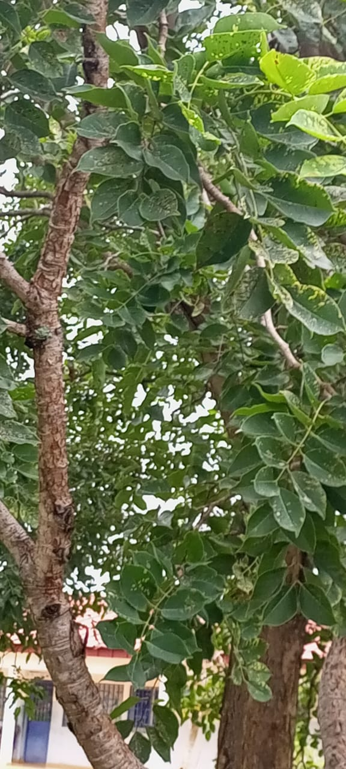
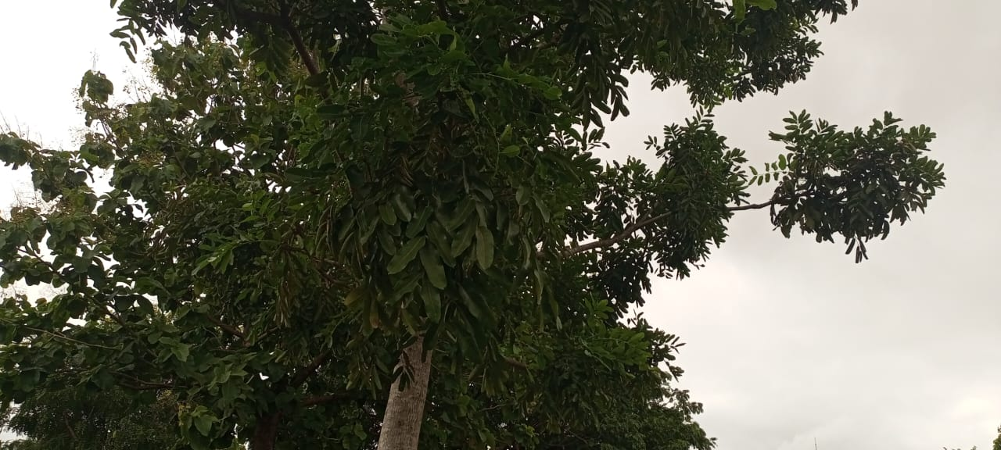
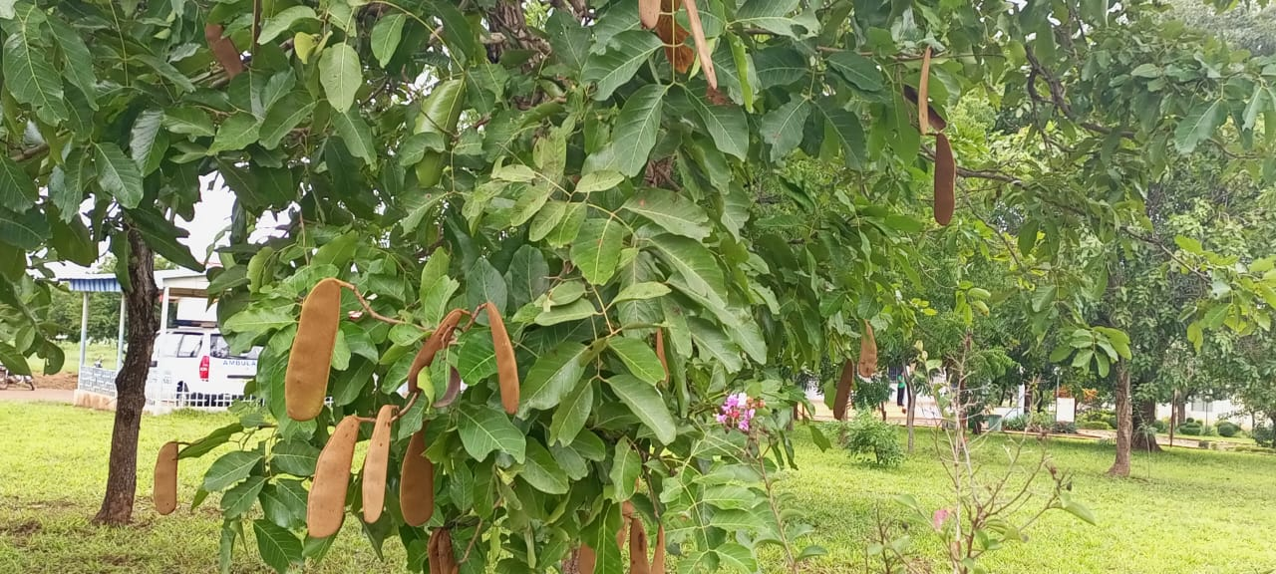
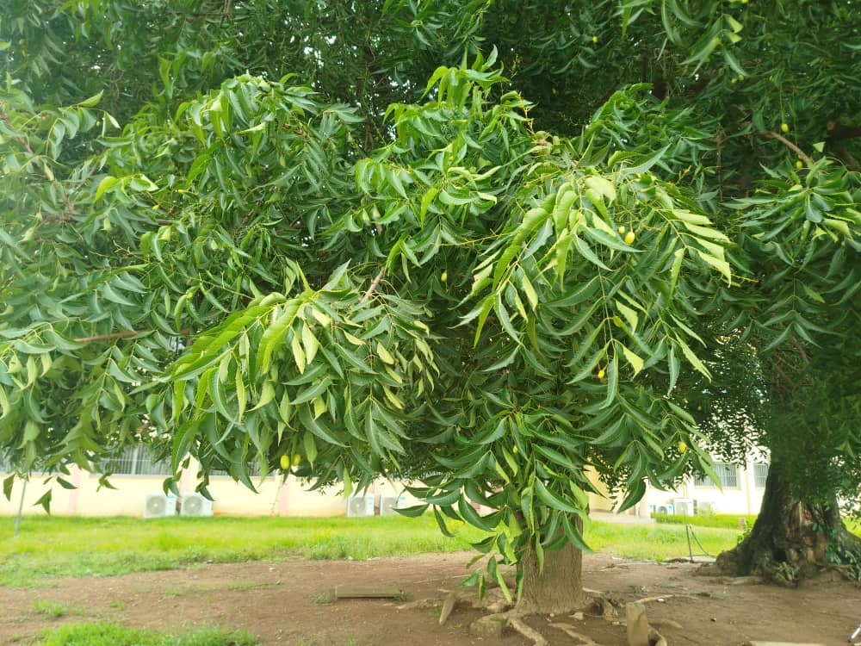
Fig. 6. Espèces d’importance écologique: (A) Isoberlinia doka; (B) Azadirachta indica; (C) Daniellia olivera; (D) Khaya senegalensis.

3.3. Conservation value of phytodiversity

The analysis of the general list of recorded species reveals 50 species with a particular status or value for the conservation of phytodiversity (Table 5). These species mainly belong to different categories of the IUCN Red List. 46 species are considered of least concern (LC), including Cassia javanica, Delonix regia, and Stereospermum kunthianum, which are introduced species, and Carapa procera, Detarium microcarpum, and Parkia biglobosa, which are local species. Two species are considered vulnerable (VU), namely Khaya senegalensis and Vitellaria paradoxa, and two species are listed as endangered (EN), namely Pterocarpus erinaceus and Tectona grandis.

Table 5. Categories of species with special status recorded in the project plots

Species status types | Number of species
Least Concern (LC) | 46
Vulnerable (VU) | 2
Endangered (EN) | 2
Total | 50

4. Discussion

The inventory of the tree flora on the Peleforo Gon Coulibaly University campus identified a total of 57 species. Based on a mixture of exotic and local species, this diversity of species was mentioned by El Faiz et al. (2016) in the municipality of Marrakech in Morocco. This flora, which reflects the richness of the area, is representative of the urban flora of the city of Korhogo. The species richness observed is significantly higher than that those recorded in the cities and municipalities of Abidjan and Daloa (Kouadio et al., 2016; Kouassi et al., 2018). However, it remains lower than the species richness reported by Nomel et al. (2020) in the private gardens of Yamoussoukro. This variability in floristic richness is likely due, on one hand, to the deliberate actions of city dwellers to plant species based on preferences, preservation, the introduction, and adoption of mostly exotic species (Depaule & Topalov, 1996), and on the other hand, to the size and types of compartments considered by the studies. Similar studies conducted by Fousséni et al. (2019) and Samsahatou et al. (2020) confirm this hypothesis. The most represented plant families in the flora are Fabaceae and Moraceae. The high representation of these families in green space flora is attributed to their adaptability to local climatic and edaphic conditions of the environment, but also to their distinctive ornamental and shady character in all seasons (El Faiz et al., 2016; Kouadio et al., 2016; Leblanc & Malaisse, 1978). The relative importance of the Moraceae family is explained by the high representativeness of the local species Ficus genus preserved on the site during the development of the university campus. The biological spectrum reveals a dominance of microphanerophytes, accounting for more than 50% of the species. Similar results were obtained by Kouassi et al. (2018) and Nomel et al. (2020) in the cities of Daloa and Yamoussoukro. The abundance of microphanerophytes on the university campus site can be explained by the fact that these species are adapted to the urban environment and do not pose a threat to the infrastructure in place. These species easily provide shade for populations. This finding is further linked to the strong presence of local species in the university campus landscape. Indeed, the analysis of the chorological type spectrum highlights a high proportion of species from local phytogeographic zones (GC, GC-SZ, SZ), with the dominance of Sudanian-Zambezian species (35.09%) suggesting the conservation of a portion of the original vegetation on the site (Samsahatou et al., 2020).
The relatively high proportion of introduced species (29.82%) can be explained by the policy of planting species that make a decorative contribution, as noted by Aké-Assi (2015), cited by Nomel et al. (2020). These species, most of which are evergreen trees, provide shade throughout the year (Monssou et al., 2016). This is the case for Cassia javanica, Acacia mangium, Ficus benjamina and Terminalia catappa.
The value of the Shannon index of ≥ 2.5 bits obtained in an urban environment indicates a moderate level of the floral diversity in the study area. This diversity reflects a clear intent by local authorities to preserve native species for the beautification of the campus landscape. The high number of local species of ecological importance throughout the IVI confirms this thesis. Sehoun et al (2021) rightly assert that the enhancement of endogenous plant species in urban green spaces would greatly help to conserve local plant diversity within urban ecosystems. The relatively high equitability index (0.81) remains within the range of values 0.6 to 0.8 considered as optimal by Odum (1976). It reflects a good distribution of individuals within the species on the site.
The presence of special-status species confirms the role that green spaces on the university campus can play in conserving plant diversity. The deliberate choice to preserve local or endogenous species as green space trees is at the root of the presence of special-status species. These are vulnerable and endangered species such as Khaya senegalensis, Pterocarpus erinaceus and Vitellaria paradoxa, for which conservation efforts should be prioritised (Myers et al., 2000).
5. Conclusion

This ecological investigation focused on the floristic diversity and conservation value of the woody species within the Peleforo Gon Coulibaly University campus. The floristic inventory recorded 57 woody species belonging to 44 genera and 19 families. The Fabaceae and Moraceae families form the core of this floristic composition. This rich and diverse flora also stands out in terms of biological and chorological types. Species such as Isoberlinia doka, Daniellia olivera, and Khaya senegalensis, emblematic of the site’s original vegetation, are omnipresent. The assessment of species diversity using biocenotic indices reveals a moderately high diversity of woody vegetation, mainly due to the presence of native species. Within this vegetation, several species with special status were identified, including vulnerable, endangered, and rare species listed on the IUCN Red List, highlighting the site’s biodiversity conservation value. The results of this study therefore constitute a reference situation for the sustainable management and development of the green space on the Peleforo Gon Coulibaly University campus.

DISCLAIMER (ARTIFICIAL INTELLIGENCE)
Author(s) hereby declare that NO generative AI technologies such as Large Language Models (ChatGPT, manuscript.

COMPETING INTERESTS
Authors have declared that they have no known competing financial interests or non-financial interests or personal relationships that could have appeared to influence the work reported in this paper.

References

Aké-Assi, E. (2015). Plants with Ornamental Potential in the Flora of Southern Côte d'Ivoire: Taxonomic, Ethnobotanical Studies, and Domestication Trial of Thunbergia atacorensis Akoegninou & Lisowski (Acanthaceae), a Newly Introduced Species. Doctoral Thesis. Abidjan: Félix Houphouët-Boigny University.
Aké-Assi, L. (2001). Flora of Côte d'Ivoire: Catalog, Systematics, Biogeography, and Ecology 1. Geneva: Conservatory and Botanical Garden.
Aké-Assi, L. (2002). Flora of Côte d'Ivoire: Catalog, Systematics, Biogeography, and Ecology 2. Geneva: Conservatory and Botanical Garden.
Amontcha, A. M., Djego, J. G., Toko, I. I., & Sinsin, B. A. (2017). Phytodiversity and Uses of Private Green Spaces in the Cities of Greater Nokoué (Southern Benin). Journal of Scientific Research of the University of Lomé, 17(2), 117-140.
Charahabil, M. M., Cesar, B., Hamadou, B., Ndiaye, S., & Diatta, M. (2018). Diversity and Structure of Urban Green Spaces in the City of Ziguinchor, Senegal. International Journal of Biological and Chemical Sciences, 12(4), 1650-1666.
Clergeau, P. (1996). Urban Biodiversity? Le Courrier du CNRS, 82, 102-104.
Coulibaly, T., CST, B., & Dosso, K. (2018). Diversity and damage of termites in urban zones: the case of the campus of University Péléforo Gon Coulibaly of Korhogo (Côte d’Ivoire). International Journal of Entomology Research, 3(4), 44-50.
Depaule, J. C. & Topalov, C. (1996). The City Through Its Words. Enquête, (4), 247-266. DOI: 10.4000/enquete.963.
Djego, J., Gibigaye, M., Tente, B., & Sinsin, B. (2012). Ecological and structural analyses of the Kaodji community forest in Benin. International Journal of Biological and Chemical Sciences, 6 (2), 705-713.
El Faiz, A., Dounas, H., Meddich, A., Hafidi, M., & Ouhammou, A. (2016). Biodiversity of public green spaces in the Urban Municipality of Marrakech (CUM) (Morocco). Acta Botanica Malacitana, 41, 83-100.
Fousseni, F., Wouyo, A., Madjouma, K., Djibril, K., Kissao, G., Kperkouma, W., & Koffi, A. (2019). Flora of urban green spaces in the city of Atakpamé, Togo. Journal of Science and Technology, Synthesis, 25(2), 25-39.
Gomgnimbou, A. P. K., Ouedraogo, W. O., Sanon, A., Koné, M., Ilboudo, D., & Nacro, H. B. (2019). Carbon sequestration potential of urban landscaped green spaces in the city of Bobo-Dioulasso, Burkina Faso. Journal of Applied Biosciences, 144, 14739-14746.
Gueulou, N., Coulibaly, B., Ouattara, N. D., N’guessan, A. K., Ahoba, A., & Bakayoko, A. (2019). Management Methods and Conservation Effectiveness of Natural Forest Relics in the Dry Tropics: The Case of the Korhogo Department (North, Ivory Coast). International Journal of Biological and Chemical Sciences, 13 (7), 3332-3346.
Guillaumet, J. L., & Adjanohoun, E. (1971). The Vegetation of Ivory Coast. In J.-M. Avenard, M. Eldin, G. Girard, J. Sircoulon, P. Touchebeuf de Lussigny, J. L. Guillaumet, E. Adjanohoun & A. Perraud (Eds.), The Natural Environment of Ivory Coast (pp. 161-263). Paris: ORSTOM.
Kone, M. (2004). Study of the variability of woody cover in savannah environments using high-resolution satellite imagery: the case of northern Côte d’Ivoire (Korhogo region). Doctoral thesis. Abidjan: University of Cocody.
Kouadio, Y. J. C., Vroh, B. T. A., Goné Bi, Z. B., Adou, Y. C. Y., & N’guessan, K. E. (2016). Diversity assessment and biomass estimation of street trees in the Plateau and Cocody municipalities (Abidjan-Côte d’Ivoire). Journal of Applied Biosciences, 97, 9141-9151.
Kouame, N. F., Kouassi, K. E., Kouadio, K. & Ahimin, A. O. (2010). The Protected Areas Network. In S. Konaté & D. Kampmann (Eds.), Atlas of West African Biodiversity, Volume III, Côte d’Ivoire (pp. 276-526). Abidjan & Frankfurt: Main.
Kouassi, J. K., Kouassi, H. K., & Kouassi, H. R. (2018). Evaluation of floristic diversity and estimation of the carbon sequestration rate of trees along roads in the municipality of Daloa (Côte d’Ivoire). International Journal of Biological and Chemical Sciences, 12(4), 1876-1886.
Laïlle, P., Damien, P. & Colson, F. (2013). The Benefits of Plants in the City – Synthesis of Scientific Research and Method of Analysis, Angers: Plante et Cité.
Leblanc, M. & Malaisse, F. (1978). Lubumbashi, a tropical urban ecosystem. Lubumbashi: International Center for Semiology, National University of Zaire.
Lüttge, U., & buckeridge, M. (2023). Trees: structure and function and the challenges of urbanisation. Trees, 37(1), 9-16.
Mehdi, L., Weber, C., Di Pietro, F., & Selmi, W. (2012). Evolution of the role of plants in the city, from green spaces to green networks. VertigO - the electronic journal in environmental sciences, [Online]. DOI: https://doi.org/10.4000/vertigo.12670
Monssou, E. O., Vroh, B. T. A., Goné, B. Z. B., Adou, Y. C. Y., & N’Guessan, K. E. (2016). Evaluation of diversity and estimation of aboveground biomass of trees in the Bingerville Botanical Garden (District of Abidjan, Ivory Coast). European Scientific Journal, 12 (6), 168-184.
Myers, N., Mittermeier, R. A., Mittermeier, C. G., Da Fonseca, G. A. B. & Kent, J. (2000). Biodiversity hotspots for conservation priorities. Nature, 403, 853-858.
N’Zala, D., & Miankodila, P. (2002). Trees and green spaces in Brazzaville (C

