Surgical Management of Maxillofacial Abscess in a Malabar Giant Squirrel (Ratufa indica) Under Tiletamine - Zolazepam Anaesthesia
ABSTRACT
The Malabar giant squirrel (Ratufa indica), an ecologically significant arboreal rodent endemic to peninsular India, has limited clinical literature regarding its veterinary management. This report documents the successful diagnosis and surgical treatment of a facial abscess associated with dental malocclusion in a captive female Malabar giant squirrel. The animal, weighing 800 grams, was presented with swelling over the right side of the face, anorexia, and impaired vision. Radiographic examination revealed overgrown, maloccluded incisors piercing the facial tissues, predisposing to abscess formation. Anaesthesia was induced using intramuscular tiletamine–zolazepam at the dose rate of 4 mg/kg, ensuring safe immobilisation and rapid recovery. The abscess was surgically incised, drained, and lavaged, followed by topical mupirocin application and systemic antibiotic therapy with enrofloxacin based on culture sensitivity. Supportive care included fluid therapy and analgesia. Concurrently, dental trimming was performed to restore occlusion. Complete healing with hair regrowth and restoration of facial contour was observed within 14 days, without recurrence. This report highlights the importance of species-specific anaesthetic protocols, routine dental evaluation, and timely surgical management for successful treatment of facial abscesses in exotic squirrels. To the authors’ knowledge, this is the first documented case of surgical management of a facial abscess in Ratufa indica under tiletamine–zolazepam anaesthesia.
Keywords: Malabar giant squirrel, Ratufa indica, facial abscess, dental malocclusion, tiletamine–zolazepam, zoo medicine
INTRODUCTION
Tree squirrels (Order: Rodentia) are distributed across most continents, excluding Australia and Antarctica (Bertolino & Lurz, 2013; Thorington et al., 2012). They contribute significantly to forest ecology by dispersing seeds and facilitating pollination (Hale & Koprowski, 2018). Among them, the giant squirrels of the genus Ratufa are the largest and ecologically significant arboreal rodents, endemic to Southeast Asia. These species serve as biological indicators of habitat health due to their sensitivity to forest degradation (Bertolino & Lurz, 2013).
In India, three species of tree squirrels are recorded: the Malabar Giant Squirrel (Ratufa indica), endemic to peninsular India, the Grizzled Giant Squirrel (Ratufa macroura), found in Southern India and Sri Lanka and the Malayan Giant Squirrel (Ratufa bicolor), located in the Northeastern hill regions (Menon, 2014). Despite their conservation value and ecological importance, clinical and veterinary literature on their medical management remains sparse. A rare scientific case report describes the successful diagnosis and treatment of a facial abscess in an Indian giant squirrel also known as Malabar giant squirrel, with associated dental malocclusion, emphasizing the role of species-specific anaesthetic, surgical and dental care. On scanning available literature, no references were found on the management of facial abscess in Malabar Giant Squirrel (Ratufa indica) under tiletamine and zolazepam anaesthesia and hence the current report in placed on record.
CASE HISTORY AND CLINICAL OBSERVATION
A female Indian giant squirrel weighing 800 grams belonging to the zoo was presented to the TVCC, Mannuthy with the history of swelling on the right side of the face (Fig.1). The squirrel was anorectic for past several days. On clinical examination, swelling was covering the entire right side of its face and the squirrel was unable to open the right eye. Anaesthesia was given using tiletamine – zolazepam combination at the dose rate of 4 mg/kg body weight intramuscularly. After administration, animal was placed in lateral recumbency on a preheated pillow. Oxygen was delivered using flow-by technique. On close examination, swelling on the right side of the face was large, firm and extending from the infraorbital region caudally. The area of swelling was devoid of hair, raised and with scab and dried exudates, indicating a mature, encapsulated abscess. The surface showed crust with possible necrotic tissue, suggestive of potential internal infection or rupture. Overgrown incisor was seen piercing the soft tissue of the face. On radiographic examination of the skull in lateral and dorso-ventral view, elongated, asymmetrically curved incisors were visible, indicative of maloccluded overgrown teeth (Fig. 5) which could have predisposed to marked soft tissue swelling and abscess formation (Fig. 6).
ANAESTHESIA
Zoletil (tiletamine-zolazepam) was administered intramuscularly at the dose rate of 4 mg/kg for chemical restraint during dental trimming and abscess management in the Indian giant squirrel (Ratufa indica), as extrapolated from protocols used in similar sciuromorph rodents (Smith et al., 2013) and laboratory animals (Flecknell, 2015). One minute after administration, the animal became recumbent (Fig.2) and withdrawal reflex abolished in five minutes. During the entire procedure, respiration rate was monitored by abdominal movements. Procedure was completed within 20 minutes. The animal had complete recovery from anaesthesia within 35 minutes without any complications (Fig. 7).
TREATMENT
The abscess was incised and pus drained by gently applying pressure, and the cavity was lavaged with potassium permanganate solution followed by a saturated magnesium sulphate solution (Fig. 4). The area was then cleaned using sterile cotton. A 2% mupirocin ointment was applied topically. On culture, Gram-negative rods were observed and antibiotic coverage was given with enrofloxacin at the dose rate of 10 mg/kg body weight based on the antibiotic sensitivity test. Supportive therapy included subcutaneous administration of Ringer’s lactate (10 ml) and meloxicam at the dose rate of 0.2 mg/kg body weight. The overgrown incisors were clipped to restore normal length.
By seventh day, the squirrel resumed feeding and gnawing seeds. The wound bed appeared granulating, with clear evidence of active tissue remodelling (Fig. 8). Surrounding tissue showed oedema and erythema, but with reduced tension and restoration of vision indicated decompression and healing. The wound was left open for healing by second intention, with regular flushing and application of mupirocin ointment.
By 14th day, the wound appeared reduced in size significantly, with visible scab formation and epithelialisation (Fig. 9). No active discharge or swelling was observed, and the facial contour had gradually returned to normal. There was regrowth of the hair at the periphery, and inflammation was markedly reduced. Overall, healing was progressing and without complications, indicating successful abscess resolution. The animal had an uneventful recovery, within two weeks.
DISCUSSION
Rodent dentition is characterized by continuously growing (elodont), rootless (aradicular) incisors, which, in the absence of adequate wear through gnawing activity, are prone to overgrowth leading to malocclusion, soft tissue trauma, and secondary infections (Crossley, 1991). In squirrel like rodents, including the Indian giant squirrel, the incisors are covered with enamel only on the labial surface, which promotes a chisel-shaped occlusal edge, adapted for gnawing (Capello et al., 2005). Overgrowth may alter this natural shape, impairing feeding and oral function. These rodents lack canine teeth and have a distinct diastema separating incisors from cheek teeth, a space where abnormal growth or abscesses can also go unnoticed until significant tissue distortion occurs. Cheek teeth in squirrels are anelodont and brachyodont, meaning they have limited growth and fixed roots, unlike their incisors. Thus, improper wear of incisors could lead to occlusal misalignment without direct compensation from cheek teeth. The presence of unossified cartilaginous mandibular symphysis in squirrels allows a certain degree of independent movement between the two halves of the mandible. While adaptive for gnawing, this mobility may contribute to asymmetrical incisor overgrowth if chewing mechanics are disturbed. The masseter muscle architecture in squirrels, especially the enlarged deep masseter extending onto the rostrum, is adapted for powerful incisor gnawing. Disruption in this function, such as from pain or infection, may reduce gnawing activity and exacerbate dental overgrowth. Facial abscess formation may occur secondary to penetrating trauma from overgrown teeth, particularly when the elongated incisors pierce soft tissues or redirect food particles into gingival or facial planes (Legendre, 2003). An abscess is a localised accumulation of pus beneath the skin, typically encapsulated by a fibrous tissue wall formed in response to infection. These lesions often develop secondary to puncture wounds, bite injuries, or other penetrating traumas. In squirrels, abscesses may appear anywhere on the body and, if not promptly treated, can progress to involve deeper tissues or become systemic. Effective management of such conditions requires routine dental evaluation and trimming of overgrown incisors, along with imaging (such as radiography) to assess the extent of misalignment, root impaction, or associated abscess formation (Quesenberry and Carpenter, 2003). In small mammals particularly rabbits and rodents, intubation is generally considered challenging due to the narrow oral cavity, with the large tongue, cheek teeth and long soft palate obscuring visualisation of the epiglottis and laryngeal opening. Oxygen could be delivered through a face mask or flow-by technique using source of oxygen held in front of the nose and mouth, ideally at not more than 2cm away from the nostrils (Fig.3). In addition to tooth trimming, surgical drainage and antibiotic therapy are essential for managing facial abscesses, especially in regions with extensive paraoral structures like cheek pouches that may harbour infection. (Capello, 2008). In cases where the abscess is already draining, it is essential to maintain the opening using warm compresses to facilitate continued drainage and prevent premature closure. Closed abscesses often require veterinary intervention for surgical lancing and flushing, usually under anaesthesia. Topical and systemic antibiotic therapies are crucial in resolving infection and promoting healing. Wound care should include daily cleaning and monitoring, ensuring the cavity heals from the inside out. Supportive care, including hydration, nutrition, and pain relief, greatly contributes to recovery. Abscesses must never be left untreated, as they are not only painful but can lead to severe outcomes such as tissue necrosis, osteomyelitis, or septicaemia, potentially resulting in death. Head and facial abscesses are particularly critical, as they can impair breathing if they extend into the nasal cavity or surrounding tissues. Unlike many mammals, squirrels are obligate nasal breathers and cannot effectively compensate by breathing through the mouth. Thus, oral breathing is an emergency sign requiring immediate veterinary attention to prevent respiratory distress and potential fatality (Mancinelli and Capello, 2016). In zoo practice, routine monitoring, supportive care, and species-specific anesthetic and surgical considerations are essential for successful outcomes.
CONCLUSION
This case highlights the importance of early recognition and targeted treatment of facial abscesses in rodent species such as the Indian giant squirrel. Prompt intervention including appropriate anaesthesia, surgical drainage, dental correction, and antibiotic therapy can lead to complete recovery without complications. Early recognition and prompt management of abscesses in exotic species like the Indian giant squirrel are critical to preventing complications.
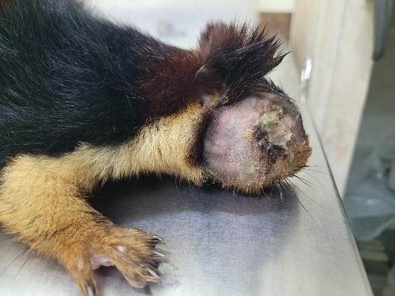  Fig 1. Swollen right side of the face | 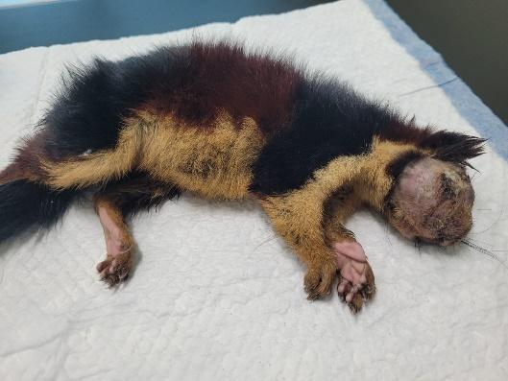  Fig 2. After administration of anaesthesia
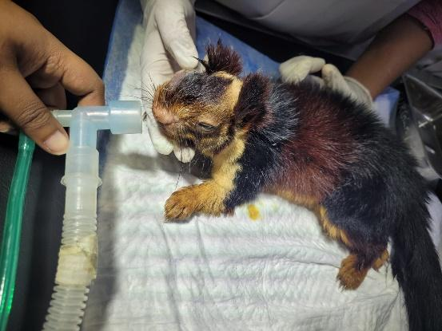  Fig 3. Oxygen therapy | 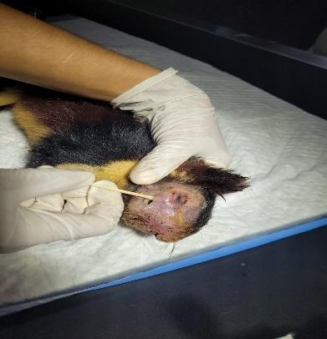  Fig 4. Taking swab for culture and sensitivity
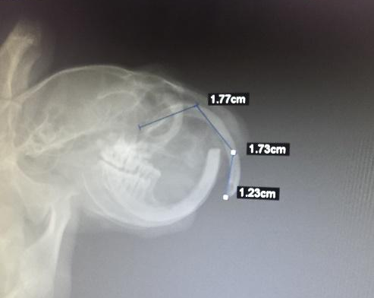  Fig 5. Skull- Lateral view | 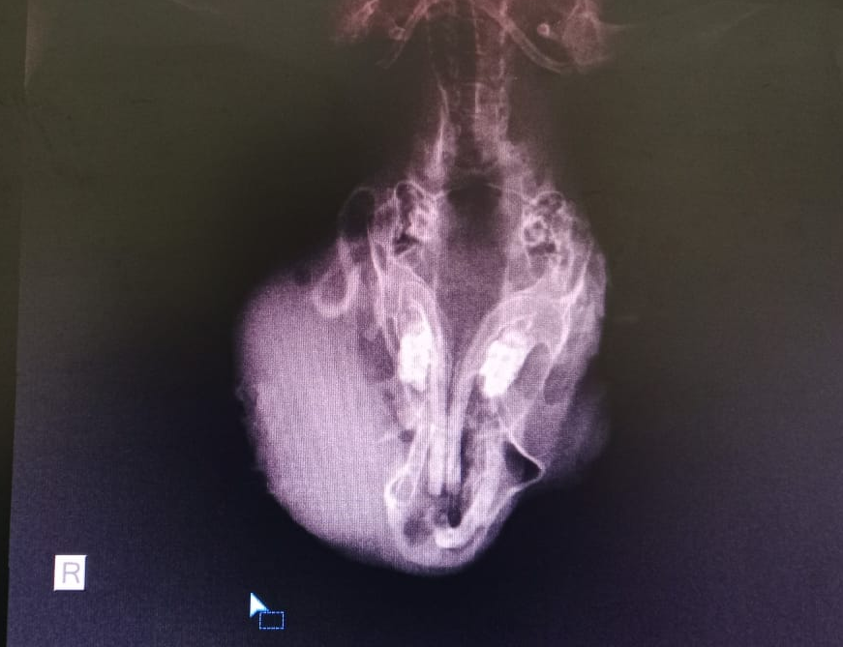  Fig 6. Skull – Dorso-ventral view
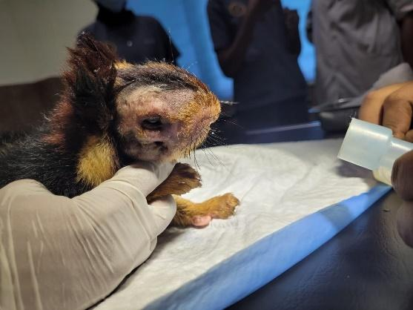  Fig 7. During recovery | 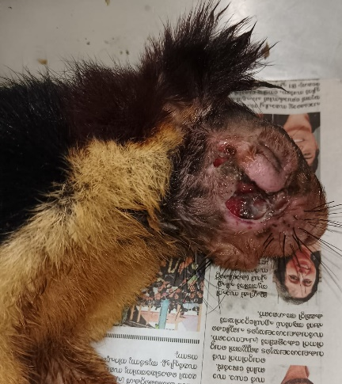  Fig 8. After seven days
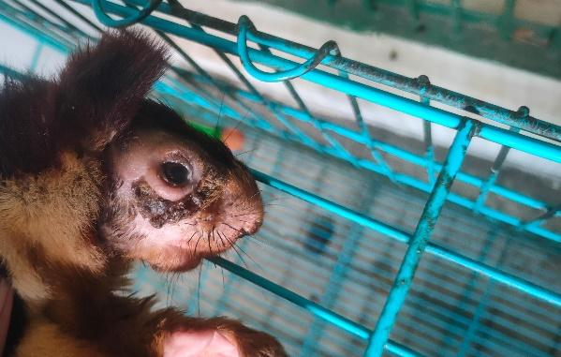
Fig 9. After 14 days

ACKNOWLEDEMENT
The authors are thankful to the Dean, College of veterinary and animal sciences, Mannuthy for providing the required facilities for the fulfilment of the work and the permission to publish the report.
Disclaimer (Artificial intelligence)
Author(s) hereby declare that NO generative AI technologies such as ChatGPT.
REFERENCES
- Capello V. 2008. Diagnosis and treatment of dental disease in pet rodents. J. Exotic Pet Med. 17(2): 114–123.
- Capello V, Gracis M, Lennox AM. 2005. Rabbits and Rodents Dentistry Handbook. Zoological Education Network, Lake Worth, FL. pp. 1–274.
- Crossley DA. 1995. Clinical aspects of rodent dental anatomy. J. Vet. Dent. 8: 131–134.
- Flecknell P. 2015. Laboratory Animal Anaesthesia. 4th ed. Academic Press, London.
- Hale AM, Koprowski JL. 2018. Squirrels as ecosystem service providers. In: Thorington RW, Koprowski JL, Steele MA, Whatton JF (eds.), Squirrels of the World. 2nd ed. JHU Press, Baltimore.
- Quesenberry K. E. And Carpenter J.W. 2003. Ferrets, Rabbits, and Rodents: Clinical Medicine and Surgery. Elsevier Health Sciences, St. Louis.
- Bertolino, S., & Lurz, P. W. (2013). C allosciurus squirrels: worldwide introductions, ecological impacts and recommendations to prevent the establishment of new invasive populations. Mammal Review, 43(1), 22-33.
- Legendre LFJ. 2005. Oral disorders of exotic rodents. Vet. Clin. N. Am. Exotic Anim. Pract. 6: 601–628.
- Mancinelli E, Capello V. 2016. Anatomy and disorders of the oral cavity of rat-like and squirrel-like rodents. Vet. Clin. Exotic Anim. Pract. 19: 871–900.
- Menon V. 2014. Indian Mammals: A Field Guide. Hachette India, Gurgaon.
- Smith M, Dodd JR, Hobson P, et al. 2013. Clinical techniques: surgical removal of elodontomas in the black-tailed prairie dog (Cynomys ludovicianus) and eastern fox squirrel. J. Exotic Pet Med. 22: 258–264.
- Thorington RW, Koprowski JL, Steele MA, Whatton JF. 2012. Squirrels of the World. JHU Press, Baltimore.

Tiletamine–zolazepam: Zoletil® 50, Virbac Animal Health, Carros, France.
Mupirocin ointment: Staphban®, GlaxoSmithKline Pharmaceuticals Ltd., Mumbai, India.
Enrofloxacin: Baytril®, Virbac Animal Health, Carros, France.
Meloxicam: Melonex®, Intas Pharmaceuticals Ltd., Ahmedabad, India.

