Comparative In vitro Assessment of Fungicides against Alternariaster helianthi in Sunflower

ABSTRACT

The present study aimed to evaluate the efficacy of systemic and contact fungicides against Alternariaster helianthi under In vitro Conditions”. Alternariaster leaf spot (Alternariaster helianthi Hansord, Simmons) is one of the major disease of sunflower during kharif 2024 season in Maharashtra. Present lab study was conducted at Department of Plant Pathology and field experiment at Oilseed Research Station, College of Agriculture, Latur, VNMKV, Parbhani, Maharashtra, India. Here, six systemic fungicides and six contact and combi products evaluated at 500 and 1000 ppm by poisoned food technique, against A. helianthi an incitant of Alternariaster leaf spot; in sunflower among the systemic fungicides, there was 100 % growth inhibition with the fungicide tested viz., Propiconazole 25 % EC and Carbendazim 50 % WP at 500 ppm and 1000 ppm and maximum inhibition was observed in Difenoconazole 25 % EC with growth inhibition (68.89 % and 71.10 %) followed by Azoxystrobin 23 % SC (63.33 % and 68.89 %), Thiophanate methyl 70 % WP with (60.74 % and 65.56 %) and Benomyl 50 % WP (54.82 % and 56.67 %) at 500 ppm and 1000 ppm respectively. Among non-systemic fungicides there was 100.00 % inhibition in fungicides viz., Mancozeb 75 % WP and Azoxystrobin 18.2 % + Difenoconazole 11.4 % SC followed by Carbendazim 12 % + Mancozeb 63 % resulted with mycelial growth inhibition (92.88 % and 100 %), Fluopyram 17.7 % + Tebuconazole 17.7 % 400 SC (64.45 % and 84.45 %), Dimethomorph 12 % + Pyraclostrobin 6.7 % WG (58.89 % and 83.34 %) and Boscalid 25.2 % + Pyraclostrobin 12.8 % WG (54.45 % and 82.23 %) at 500 ppm and 1000 ppm respectively.

Keywords: [Sunflower, Alternariaster leaf spot, Alternariaster helianthi, Helianthus annus, Fungicides, in vitro]
INTRODUCTION
Sunflower (Helianthus annuus L.) is a crucial edible oilseed crop and the genus Helianthus, which includes over 70 species worldwide. belonging to the family Compositae. Globally, sunflower ranks fourth in cultivation area after soybean, rapeseed and groundnut and second in vegetable oil production following soybean. It is extensively cultivated in the USA, Argentina, France, Spain, China, Ukraine and India and It is cultivated on an area of 26.42 million hectares, and production of 54.45 million tonnes with an average productivity of 2.06 tonns/ha in the world. (Anonymous, 2023). In India, major sunflower growing states include Punjab, Haryana, Karnataka, Gujarat, Maharashtra, Uttar Pradesh, West Bengal, Odisha, Rajasthan, Tamil Nadu and Andhra Pradesh. The crop currently spans 364,000 hectares, producing 3.63 million tonnes at a productivity rate of 996 kg/ha. Karnataka, Maharashtra and Andhra Pradesh collectively account for 70 per cent of the sunflower cultivation area in India (Indiastat, 2023). In Maharashtra, sunflower is cultivated in Akola, Ahilyanagar, Beed, Jalgaon, Latur, Solapur, Dharashiv and Chhatrapati Sambhajinagar. The area, production and productivity of sunflower is a 0.0061 million hectares, 0.0023 million tonnes and 387 kg/ha recpectively (Anonymous, 2023-24). In Marathwada region, sunflower is cultivated in Latur, Dharashiv and Chhatrapati Sambhajinagar. It is cultivated on an area of 0.13 million hectares, and production of 0.08 million tonnes with an average productivity of 633 kg/ha. (Anonymous, 2011). Sunflower is major oilseed crop in India next to soyabean and groundnut at the global level. (Shilpa, 2015) Sunflower oil is rich in PUFA (poly unsaturated fatty acids) and contains high concentration of linoleic acid. Now a days, sunflowers have many benefits, including medicine, cosmetics, textile dyes, and food (Adeleke and Babalola 2020). Sunflower is prone to various fungal and diseases. Among various diseases, Alternariaster leaf spot is most widely occurred disease caused by the fungus Alternariaster helianthi (Hansord) Simmons It affects the stem, leaves, branches and capitulum, leading to significant yield and quality losses. Hence experiment to find out effective fungicides against Alternariaster leaf spot were conducted under in vitro condition.
material and methods
The efficacy of fungicides earlier reported effective against A. helianthi were evaluated in vitro by applying Poisoned food technique (Nene and Thapliyal, 1993) and using PDA as basal medium. PDA medium was used as a basal medium for the fungicidal study. It was prepared in 250 ml conical flask. 100ml medium was taken in each flask. The medium then sterilized at 15 lbs vapour pressure for 15 minutes. Required quantity of test fungicides were calculated and added in the sterilized medium separately. Flasks containing Poisoned medium were shaken well to have even and uniform distribution of the fungicides. About 20 ml of Poisoned PDA was poured in each of the sterilized petri plates and allowed to solidify. The plates were inoculated by pure culture of Alternariaster helianthi. For this purpose, 5 mm disc of one week old culture was cut with a sterilized cork borer. The disc was lifted and transferred aseptically in the center of petriplates containing the medium with test fungicides. Three plates were maintained for each treatment. The control plates without fungicides were also inoculated and incubated. Treated plates were incubated at 26±20 C temperature. The observations on colony diameter were recorded after 8 days.

Table 1: List of systemic fungicides
Tr.No. | Treatments | Tr.No. | Treatments
T₁ | Propiconazole 25 % EC | T₄ | Carbendazim 50 % WP
T₂ | Difenoconazole 25 % EC | T₅ | Benomyl 50 % WP
T₃ | Azoxystrobin 23 % SC | T₆ | Thiophanate methyl 70 % WP
Table 2: List of contact and combi fungicides
Tr.No. | Treatments | Tr.No. | Treatments
T₁ | Mancozeb 75 % WP | T₄ | Fluopyram 17.7 % +  Tebuconazole 17.7 % 400 SC
T₂ | Azoxystrobin 18.2 % +  Difenoconazole 11.4 % SC | T₅ | Boscalid 25.2 % +  Pyraclostrobin 12.8 % WG
T₃ | Carbendazim 12 % + Mancozeb 63 % WP | T₆ | Dimethomorph 12 % + Pyraclostrobin 6.7 % WG
Observations on radial mycelial growth was recorded after seven days of incubation in all the replicated treatments. Per cent inhibition of the test pathogen was calculated by applying the formula given by Arora and Upadhay (1978) as follows,
C - T

Per cent growth inhibition =------------× 100
C
Where,
C = Growth (mm) of test fungus in untreated control plate.
T = Growth (mm) of test fungus in treated plates.
results and discussion
Effect of systemic fungicides on mycelial growth inhibition
A total of six systemic fungicides viz., Propiconazole 25 % EC, Difenoconazole 25 % EC, Azoxystrobin 23 % SC, Carbendazim 50 % WP, Benomyl 50 % WP, and Thiophanate methyl 70 % WP were evaluated (each @ 500 and 1000 ppm) against A. helianthi by applying poisoned food technique and using PDA as basic culture media in vitro condition. All the treatments were replicated thrice and a suitable untreated control was maintained.

Effect on radial mycelial growth
At 500 ppm concentration, the radial mycelial growth of test pathogen was recorded in the range of 00.00 - 40.67 mm as compared with control (90.00 mm). There was no mycelial growth with the fungicide tested viz., T₁: Propiconazole 25 % EC and T₄: Carbendazim 50 % WP. Among rest of the test fungicide, T₂: Difenoconazole 25 % EC with mycelial growth (28.00 mm) followed by T₃: Azoxystrobin 23 % SC (33.00 mm), T₆: Thiophanate methyl 70 % WP with (35.34 mm) and T₅: Benomyl 50 % WP (40.67 mm).
At 1000 ppm concentration, the radial mycelial growth of test pathogen was recorded in the range of 00.00 – 39.00 mm as compared with control (90.00 mm). There was no mycelial growth with the fungicide tested viz., T₁: Propiconazole 25 % EC and T₄: Carbendazim 50 % WP. Among rest of the test fungicide T₂: Difenoconazole 25 % EC with mycelial growth (23.67 mm). This was followed by T₃: Azoxystrobin 23 % SC (28.00 mm), T₆: Thiophanate methyl 70 % WP with (31.00 mm), T₅: Benomyl 50 % WP (39.00 mm).
Average radial mycelial growth of test pathogen was recorded in the range of (00.00 - 39.83 mm) as compared with control (90.00 mm). There was no mycelial growth with the fungicide tested viz., T₁: Propiconazole 25 % EC and T₄: Carbendazim 50 % WP. Among rest of the test fungicide, T₂: Difenoconazole 25 % EC with mycelial growth (25.83 mm). This was followed by T₃: Azoxystrobin 23 % SC (30.50 mm), T₆: Thiophanate methyl 70 % WP with (33.17 mm) and T₅: Benomyl 50 % WP (39.83 mm).
Effect on inhibition of mycelial growth
Result on inhibition of mycelial growth revealed that, all systemic fungicides viz., Propiconazole 25 % EC, Difenoconazole 25 % EC, Azoxystrobin 23 % SC, Carbendazim 50 % WP, Benomyl 50 % WP, and Thiophanate methyl 70 % WP tested at 500 ppm and 1000 ppm concentration significantly inhibited mycelial growth of pathogen over control (00.00%).
The per cent mycelial growth inhibition increased with increase in concentration of fungicides. At 500 ppm concentration the mycelial growth inhibition of test pathogen was recorded in the range of (54.82 - 100.00 %) as compared with control (00.00 %). There was 100.00 % inhibition in fungicides viz., T₁: Propiconazole 25 % EC and T₄: Carbendazim 50 % WP this was followed by T₂: Difenoconazole 25 % EC (68.89 %), T₃: Azoxystrobin 23 % SC (63.33 %), T₆: Thiophanate methyl 70 % WP (60.74%) and T₅: Benomyl 50 % WP (54.82 %).
At 1000 ppm, the mycelial growth inhibition of test pathogen was recorded in the range of (56.67 - 100.00 %) as compared with control (00.00 %). There was 100.00 % inhibition in fungicides viz., T₁: Propiconazole 25 % EC and T₄: Carbendazim 50 % WP this was followed by T₂: Difenoconazole 25 % EC (73.71 %), T₃: Azoxystrobin 23 % SC (68.89 %), T₆: Thiophanate methyl 70 % WP (65.56%) and T₅: Benomyl 50 % WP (56.67 %).
Average mycelial growth inhibition of test pathogen was recorded in all systemic fungicide ranged from (55.74 - 100.00 %) as compared with control (00.00 %). There was 100.00 % inhibition in fungicides viz., T₁: Propiconazole 25 % EC and T₄: Carbendazim 50 % WP this was followed by T₂: Difenoconazole 25 % EC (71.10 %), T₃: Azoxystrobin 23 % SC (66.11 %), T₆: Thiophanate methyl 70 % WP (63.15%) and T₅: Benomyl 50 %WP (55.74 %).
These results of the present studies are in consonance with earlier findings of several workers who reported that, systemic fungicides Propiconazole 25 % EC and Carbendazim 50 % WP were found to be effective fungicides against A. helianthi. such as Mahadevaswamy et al., (2019), Usha et al., (2019) and Athira (2017).
Table 3: In vitro evaluation of systemic fungicides against Alternariaster helianthi
Tr. No. | Treatments | Colony Dia. (mm)*  at ppm |  | Avg.  (mm) | % Inhibition*  at ppm |  | Avg. % Inhibition
Tr. No. | Treatments | 500 | 1000 | Avg.  (mm) | 500 | 1000 | Avg. % Inhibition
T₁ | Propiconazole  25 % EC | 00.00 | 00.00 | 00.00 | 100.00  (90.00) | 100.00  (90.00) | 100.00  (90.00)
T₂ | Difenoconazole 25 % EC | 28.00 | 23.67 | 25.83 | 68.89  (56.09) | 73.71  (59.15) | 71.10  (57.48)
T₃ | Azoxystrobin 23 % SC | 33.00 | 28.00 | 30.50 | 63.33  (52.73) | 68.89  (56.09) | 66.11  (54.39)
T₄ | Carbendazim  50 % | 00.00 | 00.00 | 00.00 | 100.00  (90.00) | 100.00  (90.00) | 100.00  (90.00)
T₅ | Benomyl  50 % WP | 40.67 | 39.00 | 39.83 | 54.82  (47.76) | 56.67  (48.83) | 55.74  (48.29)
T₆ | Thiophanate  methyl 70 % WP | 35.34 | 31.00 | 33.17 | 60.74 (51.20) | 65.56  (54.06) | 63.15  (52.62)
T₇ | Control  (untreated) | 90.00 | 90.00 | 90.00 | 00.00  (00.00) | 00.00  (00.00) | 00.00  (00.00)
 | S.E ± | 0.38 | 0.43 |  | 0.42 | 0.47
 | C.D. at 1% | 1.66 | 1.85 |  | 1.85 | 2.06

*: Mean of three replications, **: Values in parenthesis are arcsin transformed values, Dia.: Diameter, Avg.: Average

Plate 1: In vitro evaluation of systemic fungicides against Alternariaster helianthi
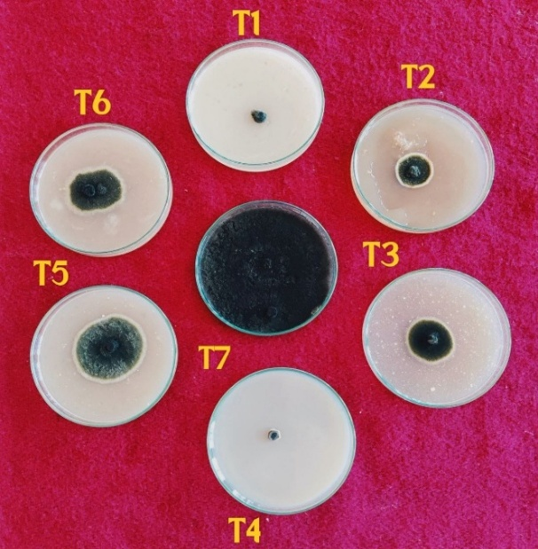 |  | 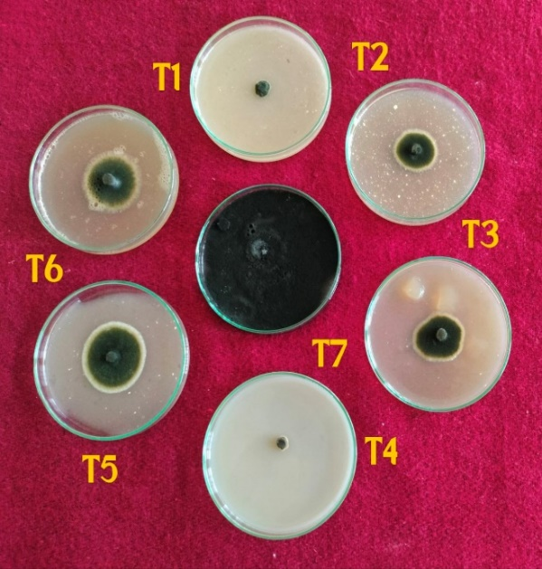
@ 500PPM |  | @ 1000 PPM

Fig 1: In vitro evaluation of systemic fungicides against Alternariaster helianthi

In vitro evaluation of contact and combi-product fungicides against Alternariaster helianthi
Effect on radial mycelial growth
At 500 ppm concentration, the radial mycelial growth of test pathogen was recorded in the range of 00.00 - 41.00 mm as compared with control (90.00mm). There was no mycelial growth with the fungicide tested viz., T₁: Mancozeb 75 % WP and T₂: Azoxystrobin 18.2 % + Difenoconazole 11.4 % SC. While T₃: Carbendazim 12 % + Mancozeb 63 % resulted with mycelial growth 6.4 mm, this was followed by T₄: Fluopyram 17.7 % + Tebuconazole 17.7 % 400 SC (32.00 mm), T₆: Dimethomorph 12 % + Pyraclostrobin 6.7 % WG (37.00 mm), T₅: Boscalid 25.2 % 50% + Pyraclostrobin 12.8 % WG (41.00 mm).
At 1000 ppm concentration, the radial mycelial growth of test pathogen was recorded in the range of 00.00 - 16.00 mm as compared with control (90.00 mm). There was no mycelial growth with the fungicide tested viz., T₁: Mancozeb 75 % WP, T₂: Azoxystrobin 18.2 % + Difenoconazole 11.4 % SC and T₃: Carbendazim 12 % + Mancozeb 63 % while T₄: Fluopyram 17.7 % + Tebuconazole 17.7 % 400 SC resulted with mycelial growth (14.00 mm), this was followed by T₆: Dimethomorph 12 % + Pyraclostrobin 6.7 % WG (15.00 mm), T₅: Boscalid 25.2 % + Pyraclostrobin 12.8 % WG (16.00 mm).
Average radial mycelial growth of test pathogen was recorded in the range of 00.00 - 28.50 mm as compared with control (90.00 mm). There was no mycelial growth with the fungicide tested viz., T₁: Mancozeb 75 % WP and T₂: Azoxystrobin 18.2 % + Difenoconazole 11.4 % SC. While T₃: Carbendazim 12 % + Mancozeb 63 % resulted with mycelial growth (3.20 mm), this was followed by T₄: Fluopyram 17.7 % + Tebuconazole 17.7 % 400 SC (23.00 mm), T₆: Dimethomorph 12 % + Pyraclostrobin 6.7 % WG (26.00 mm), T₅: Boscalid 25.2 % + Pyraclostrobin 12.8 % WG (28.50 mm)
Effect on inhibition of mycelial growth
Result on inhibition of mycelial growth revealed that all contact and combi fungicides viz., Mancozeb 75 % WP, Azoxystrobin 18.2 % + Difenoconazole 11.4 % SC, Carbendazim 12 % + Mancozeb 63 %, Fluopyram 17.7 % + Tebuconazole 17.7 % 400 SC, Boscalid 25.2 % 5 + Pyraclostrobin 12.8 % WG and Dimethomorph 12 % + Pyraclostrobin 6.7 % WG tested at 500 ppm and 1000 ppm concentration significantly inhibited mycelial growth of pathogen over control (00.00 %).
The per cent mycelial growth inhibition increased with increase in concentration of fungicides. At 500 ppm concentration the mycelial growth inhibition of test pathogen was recorded in the range of (54.45 - 100.00 %) as compared with control (00.00 %). There was 100.00 % inhibition in fungicides viz., T₁: Mancozeb 75 % WP and T₂: Azoxystrobin 18.2 % + Difenoconazole 11.4 % SC. While T₃: Carbendazim 12 % + Mancozeb 63 % resulted with mycelial growth inhibition (92.88 %), this was followed by T₄: Fluopyram 17.7 % + Tebuconazole 17.7 % 400 SC (64.45 %), T₆: Dimethomorph 12 % + Pyraclostrobin 6.7 % WG (58.89 %), T₅: Boscalid 25.2 % + Pyraclostrobin 12.8 % WG (54.45 %).
At 1000 ppm concentration the mycelial growth inhibition of test pathogen was recorded in the range of (82.23 - 100.00 %) as compared with control (00.00 %). There was 100.00 % inhibition in fungicides viz., T₁: Mancozeb 75 % WP and T₂: Azoxystrobin 18.2 % + Difenoconazole 11.4 % SC and T₃: Carbendazim 12 % + Mancozeb 63 % While T₄: Fluopyram 17.7 % + Tebuconazole 17.7 % 400 SC resulted with mycelial growth inhibition (84.45 %), this was followed by T₆: Dimethomorph 12 % + Pyraclostrobin 6.7 % WG (83.34 %), T₅: Boscalid 25.2 % + Pyraclostrobin 12.8 % WG (82.23 %).
Average mycelial growth inhibition of test pathogen was recorded in the range of ranged from (68.34 - 100.00 %) as compared with control (00.00 %). There was 100.00 % inhibition fungicide tested viz., T₁: Mancozeb 75 % WP and T₂: Azoxystrobin 18.2 % + Difenoconazole 11.4 % SC. While T₃: Carbendazim 12 % + Mancozeb 63 % resulted with mycelial growth inhibition (96.64 %), this was followed by T₄: Fluopyram 17.7 % + Tebuconazole 17.7 % 400 SC (74.45 %), T₆: Dimethomorph 12 % + Pyraclostrobin 6.7 % WG (71.11%), T₅: Boscalid 25.2 % + Pyraclostrobin 12.8 % WG (68.34 %).
These findings of the present study are in accordance with the reports of several earlier workers such as Muljowati and Hikam (2023), Karthikeyan (2021).

Table 4: In vitro evaluation of contact and combi-product fungicides against Alternariaster helianthi
Tr.  No. | Treatments | Colony Diam  (mm) at ppm |  | Av. | % Inhibition At ppm |  | Av. Inhibition  (%)*
Tr.  No. | Treatments | 500 | 1000 | Av. | 500 | 1000 | Av. Inhibition  (%)*
T₁ | Mancozeb 75 % WP | 00.00 | 00.00 | 00.00 | 100.00  (90.00) | 100.00  (90.00) | 100.00  (90.00)
T₂ | Azoxystrobin 18.2% +  Difenoconazole  11.4% SC | 00.00 | 00.00 | 00.00 | 100.00  (90.00) | 100.00  (90.00) | 100.00  (90.00)
T₃ | Carbendazim 12 % +  Mancozeb 63 % WP | 6.40 | 00.00 | 3.20 | 92.88  (74.52) | 100.00  (90.00) | 96.64  (79.43)
T₄ | Fluopyram 17.7 % +  Tebuconazole 17.7 % 400 SC | 32.00 | 14.00 | 23.00 | 64.45  (53.39) | 84.45  (66.77) | 74.45  (59.63)
T₅ | Boscalid 25.2 % +  Pyraclostrobin 12.8 % WG | 41.00 | 16.00 | 28.50 | 54.45  (47.55) | 82.23  (65.06) | 68.34  (55.75)
T₆ | Dimethomorph12 % + Pyraclostrobin 6.7 % WG | 37.00 | 15.00 | 26.00 | 58.89  (50.12) | 83.34  (65.91) | 71.11  (57.48)
T₇ | Control  (untreated) | 90.00 | 90.00 | 90.00 | 00.00  (00.00) | 00.00  (00.00) | 00.00  (00.00)
 | S. E ± | 0.4 | 0.4 |  | 0.45 | 0.45
 | C.D. at 1 % | 1.76 | 1.76 |  | 1.96 | 1.95

*: Mean of three replications.**: Values in parenthesis are arcsin transformed values. Dia.: Diameter, Avg.: Average

Plate 2: In vitro evaluation of contact and combi-product fungicides against Alternariaster helianthi
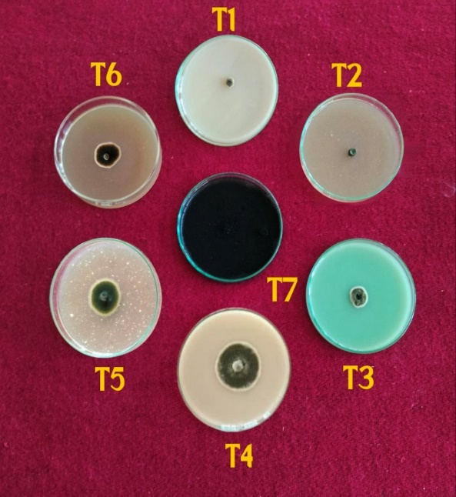 |  | 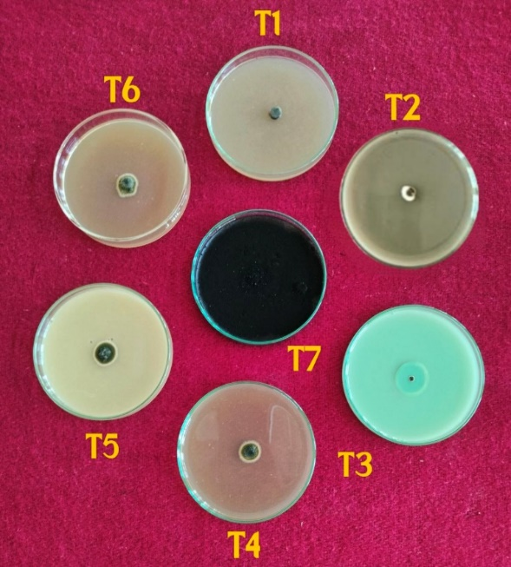
@ 500PPM |  | @ 1000PPM

*: Mean of three replications. **: Values in parenthesis are arcsin transformed values. Dia.: Diameter, Avg.: Average
Fig 2: In vitro evaluation of contact and combi-product fungicides against Alternariaster helianthi

Conclusion
The results of the conducted experiment documented that, all tested systemic, contact and combi-product fungicide significantly inhibited the growth of the test pathogen compared to the untreated control in in vitro. However, among different systemic fungicides evaluated Propiconazole 25 % EC, Difenoconazole 25 % EC and Azoxystrobin 23 % SC were found most effective in inhibiting mycelial growth of test fungus. Among different contact combi fungicides evaluated Mancozeb 75 % WP, Azoxystrobin 18.2 % + Difenoconazole 11.4 % SC, Carbendazim 12 % + Mancozeb 63 % WP, were found most effective in inhibiting mycelial growth of test fungus found most effective in inhibiting growth of pathogen.

Disclaimer (Artificial intelligence)
Option 1:
Author(s) hereby declare that NO generative AI technologies such as Large Language Models (ChatGPT, COPILOT, etc.) and text-to-image generators have been used during the writing or editing of this manuscript.
Option 2:
Author(s) hereby declare that generative AI technologies such as Large Language Models, etc. have been used during the writing or editing of manuscripts. This explanation will include the name, version, model, and source of the generative AI technology and as well as all input prompts provided to the generative AI technology
Details of the AI usage are given below:
1.
2.
3.

References
- Nene, Y.L. & Thapliyal, P.N. (1993). Evaluation of fungicides. In, Fungicides in Plant Disease Control (34 Edn.). Oxford, IBH Publishing Co, New Delhi, 531- 532.
- Arora, D.K. & Upadhyay, R.K. (1978). Effect of fungal staling growth substances on colony interaction. Plant Soil. 49, 685-690.
- Vasava, D. & Gohel, M. (2024). Eco-friendly management of Alternaria leaf blight of sunflower caused by Alternariaster helianthi (Hansford) E.G. Simmon. International Journal of Advanced Biochemistry Research. SP-8(8), 1095-1102
- Anonymous, (2023). Annual report; All India Co-ordinated Research Project on sunflower. page No.201-203.
- Indiastat (2023). Area, Production and yield of sunflower in India. Available from, https,//www.indiastat.com/table/agriculture/season-wise - area, production yield-sunflower-India-/17394.
- Mahadevaswamy, G., Vijayalakshmi, G., & Gangadharanaik, G. (2019). In vitro Evaluation of Fungicides Plant Extracts and Bio-agents against Alternaria helianthi causing Leaf Blight of Sunflower. International Journal of Current Microbiology and Applied Sciences.ISSN, 2319-7706 Volume 8 Number (2019).
- Usha, D., Santha, M., Prasada, L. & Sarada, C. (2019). Sensitivity of different fungicides against isolates of Alternariaster helianthi (Hansf) Tubaki and Nishihara, leaf blight in sunflower. Indian Phytopathology.
- Athira, K. (2017). In vitro evaluation of fungicide and biocontrol agents against Alternaria helianthin causing leaf blight of sunflower (Helianthus annuus L.) International Journal of Plant Protection.
- Muljowati, J & Hikam, A. R. (2023). Evaluation of several fungicides on mycelial growth and conidial germination of Alternaria species causing leaf spots in sunflowers under in vitro conditions. Asian Journal of Agriculture Volume 7, Number 1, June; E-ISSN, 2580-4537.
- Karthikeyan, R., Kumar, S., Prasad, R. & Singh, M. (2021) In vitro evaluation of fungicides and botanicals against Alternaria brassicae causing leaf blight of mustard. International Journal of Plant Pathology and Microbiology. 1(1), 16-19.
- Anonymous, (20). Annual report; All India Co-ordinated Research Project on sunflower. page No.201-203
- Shilpa, M., Vikas, H., Sowmya, P., Srikantaiah, M. & Dorajeerao, D. (2015). In vitro and in vivo evaluation of antagonistic microorganisms on the incidence of leaf blight of sunflower caused by Alternaria helianthi. Plant Archives Vol. 15 No. 1, 2015 pp. 411-416.
- Adeleke, B. & Babalola, S. (2020). Oilseed crop sunflower (Helianthus annuus) as a source of food, Nutritional and health benefits. Food Science Nutrition. 8,4666 - 4684.

