Effect of Blanching and Drying Methods on the Quality of Jawala Shrimp during ambient storage

Abstract
Acetes is a little shrimp from the family Sergestidae, genus Acetes. In India, a large number of this group, known locally as 'Jawala' or 'Kolim,' catch is landed along the northwest coast of Gujarat and Maharashtra. Currently, it is consumed locally in either fresh or dried form. Acetes fresh use is highly limited due to their small size, high perishability, and fragile body, making it difficult to peel the shrimp manually or mechanically. The current study investigated the influence of blanching and drying temperatures on the quality of Jawala Shrimp. The study aimed to develop a high-quality dried shrimp product with an extended shelf life by using different combinations of salt concentrations (0%, 1%, and 2%), blanching temperatures (70°C and 80°C), and steaming at 100°C without salt, and further drying temperatures of 50°C and 60°C were evaluated for moisture, protein, fat, ash, TVB-N, TMA-N, TPC, upon treatments. The study found that shrimp with 2% salt blanched at 80°C and dried at 60°C to a moisture level of 14.33% had the best organoleptic and microbiological. Moisture content gradually increased during storage, while protein, fat, and ash decreased slightly but were better preserved in this combination, indicating the effect of storage on product stability.
Key words: Acetes, blanching, drying, shelf life, moisture, colour, quality.
- Introduction
The shrimps (Acetes indicus) are in the family Sergestidae. They are a small community of planktonic crustaceans with a few members, but they are extremely valuable to the economy of waters in Asia and East Africa. At times during the year, Acetes comes together in large swarms from near the shore marine waters and is intensively fished using dol nets. The reason that they are easy to catch compensates for the reason that they are small (Omori, 1975).
Numerous members of Acetes group, also called "Jawala" or "Kolim," occur in Gujarat and Maharashtra on the northwest coast of India (Mahakal et al., 2016). Acetes is an epipelagic creature which lives on extensive surface water shoals. Four members of this genus A. indicus, A. johni, A. sibogea, and A. japonicus have been reported in commercial catches. Currently, the globe's fastest-growing food production sector is aquaculture. With a global production estimate of 7.5 million tons of shrimp from culture and capture, shrimp aquaculture is among the aquaculture sectors with the highest growth rate (Naik et al., 2020). Shrimp live in aquatic environments both in freshwater and saltwater organisms. Because of their alleged health attributes, gastronomic characteristics, and most importantly, protein value, they are now considered to be among the fastest-growing food commodity in international trade (Ajifolokun et al., 2018).
Depending on size and processing procedure, dried shrimp can be classified broadly under the categories of salted-dried shrimp, sun-dried whole shrimp, shelled dried shrimp, salting, and smoking. Locally, these products are referred to as Royya pottu (Andra Pradesh), Chingri Shutki (West Bengal), Kunchi meen or Chennakkuni (Tamil Nadu), Jawala (Maharashtra), and Sukat (Goa/Konkan). (MPEDA, 2023; CMFRI, 1985). Drying methods influence the preservation of valuable bioactive compounds, such as astaxanthin, a reddish-orange carotenoid pigment occurring naturally that is responsible for the characteristic colour of shrimp, as well as the preservation of nutritional quality of the shrimp. Besides being important for consumer acceptability, astaxanthin possesses significant antioxidant properties that enhance human health through reduced oxidative stress. Nonetheless, the temperature conditions applied during post-harvest treatment play an important role in its preservation. Unsuitable drying temperatures may severely degrade astaxanthin, which reduces the nutritional and aesthetic quality of the dried marine shrimp. Compared to conventional sun drying, the research indicated that retention of astaxanthin was significantly improved through blanching prior to drying and controlled temperatures during drying. The findings underscore the importance of the optimization of pre-treatment and drying conditions to preserve Acetes indicus functional quality and enhance its market value. (Chakrabortty et al., 2017).
Locals use Jawala on a regular basis fresh or dried up in the preparation of everyday food because there is not much use of Acetes fresh now. Being available throughout the year in the market, Acetes are taken predominantly in dry form; however, during the off-fishing season, when fresh fish is not accessible, dry Acetes consumption increases (Zynudheen et al., 2004). Acetes are hard to keep on board since they are small and fragile. Additionally, the hepatopancreatic enzymes inducing autolysis and proteolysis make it extremely perishable and easily degrade. The shrimp cannot be peeled manually or mechanically, (Zynudheen et al., 2004).
The conventional means of drying and preserving Jawala shrimp, though of economic and nutritional importance, are often not standardized by science. Uncontrolled sun drying, variable salt content, and absence of blanching are prevalent practices adopted by indigenous processors, which have the potential to lead to inconsistent quality, microbial spoilage, discoloration, and loss of nutrients. Product safety, shelf life, and acceptability of the product are all directly affected by these issues, especially when targeting high-end domestic or export markets. Moreover, most studies have only evaluated how blanching and controlled drying as individual factors influence the physicochemical, microbiological, and sensory characteristics of dried shrimp. It is, therefore, clear that improved and beneficial post-harvest processes need to be developed in an effort to enhance the quality, safety, and marketability of the dried Jawala shrimp. As a way of bridging these gaps, this research evaluates various permutations of salt concentrations, drying temperatures, and blanching times in an attempt to determine the best process for producing dried shrimp of high quality. Given this, the present study was done to identify the most effective treatment to reduce moisture content, extend shelf life, improve nutritional retention, and decrease the microbial load.

Objectives:
- To study the effect of cabinet drying on quality of Jawala shrimp during storage.

2. Material and Methods
2.1 Sample preparation
Fresh Jawala shrimp were procured from the local market, and then weighed and washed with water. Then rinsing and blanching operations followed as per treatments. After blanching samples are dried in a cabinet dryer, and then the dried samples are packed in LDPE bags and stored at ambient temperature.
LIST 1 :Treatments
Treatments | Details
T1 | NaCl 0%, B-70°C Blanching temperature and D-50°C Drying temperature
T2 | NaCl 1%, B-70°C Blanching temperature and D-50°C Drying temperature
T3 | NaCl 2%, B-70°C Blanching temperature and D-50°C Drying temperature
T4 | NaCl 0%, B-80°C Blanching temperature and D-50°C Drying temperature
T5 | NaCl 1%, B-80°C Blanching temperature and D-50°C Drying temperature
T6 | NaCl 2%, B-80°C Blanching temperature and D-50°C Drying temperature
T7 | Steaming at 100°C and D-50°C Drying temperature
T8 | NaCl 0%, B-70°C Blanching temperature and D-60°C Drying temperature
T9 | NaCl 1%, B-70°C Blanching temperature and D-60°C Drying temperature
T10 | NaCl 2%, B-70°C Blanching temperature and D-60°C Drying temperature
T11 | NaCl 0%, B-80°C Blanching temperature and D-60°C Drying temperature
T12 | NaCl 1%, B-80°C Blanching temperature and D-60°C Drying temperature
T13 | NaCl 2%, B-80°C Blanching temperature and D-60°C Drying temperature
T14 | Steaming at 100°C and D-60°C Drying temperature

Flow chart
Raw material (Fresh Jawala shrimp)
↓
Weighing and washing, rinsing
↓
Blanching (with 0%,1%,2% NaCl at 70°C and 80°C (1:2 Blanching solution)) and steaming at 100°C) for 2 min
↓
Drying (Cabinet drying at 50°C or 60°C)
↓
Packaging (LDPE) and storage
2.2 Methods of Analysis
The stored samples of Jawala shrimp were analysed according to different Proximate parameters at 0 days (the day of storage) and at 15-day intervals subsequent up to 90 days.
2.2 Proximate, Biochemical and Microbial parameters of Jawala Shrimp
The proximate parameters of the Jawala shrimp samples were monitored till the end of the 90 days of storage periods. The proximate parameters of jawala shrimp viz., moisture, ash, protein and fat content were estimated according to the methods described in AOAC (2005). Protein and fat were analyzed using Kjeldahl block digestion and steam distillation and Soxhlet extraction, respectively. The biochemical and microbial parameters of jawala shrimp viz., trimethylamine nitrogen (TMA-N), (TVB-N) Total Volatile Base Nitrogen and (TPC) Total Plate Count content were estimated according to the methods described in AOAC (2005).
2.5 Statistical analysis
Statistical analysis was performed using completely randomized design (CRD) for stored sample properties like moisture, protein, fat, ash, salt estimation, protein solubility, total volatile base nitrogen (TVB-N) Total Volatile Base Nitrogen, trimethylamine nitrogen (TMA-N) Trimethylamine Nitrogen content, physical parameters and sensory attributes i.e., appearance, colour, flavour, odour, texture and microbial analysis packed in LDPE bags for 0, 15, 30, 45,60,75 and 90days was carried out by Microsoft Excel 2013. The critical difference (CD) was used in ANOVA for comparing means.
3. Result and Discussion
3. Changes in proximate parameters, Biochemical parameters and Microbial parameters of Jawala shrimp during storage
A. Before Drying Analysis of Jawala Shrimp (Fresh Jawala Shrimp)
3.1 Proximate parameters of fresh Jawala shrimp
In a fresh shrimp contains moisture content 87.41%, protein content 10.11%, fat content 0.90% and Ash content is 1.95% respectively. The initial composition was given by table 1. Seasonal changes, diet, and environmental conditions are the main reasons for variations of proximate composition among shrimp and fish. In the present study fresh Jawala shrimp consisted of 87.41% moisture, 10.11% crude protein, 0.90% fat, and 1.95% ash. Also, the result with Sonavane (2014) showed moisture, crude protein, fat, and ash in fresh Jawala as 84.23%, 12.08%, 1.0%, and 2.72%.
Table 1. Proximate parameters of Jawala shrimp
Sr. No | Particulars | Mean*
 | Proximate parameters
1. | Moisture (%) | 87.41
2. | Protein (%) | 10.11
3. | Fat (%) | 0.90
4. | Ash (%) | 1.95
*Values are the means of the three observations
B. After Drying Analysis of Jawala Shrimp (Dried Jawala Shrimp)
The fresh Jawala shrimp was dried according to treatments under a Cabinet drying temperature of 50°C and 60°C. The best sample was detected according to microbial analysis.
3.2 Effect of different treatments on proximate composition of dried Jawala shrimp
The proximate composition values of Jawala shrimp are shown in Table 2. Maximum moisture content was observed in T7 sample (18.20±0.04%) at the end of drying and minimum in T13 sample (14.33±0.03%). The moisture content went down with increase in drying temperature. This is advantageous for water evaporation from the product. The minimum protein content was found in T1 sample (61.21±0.02%), followed by T13 sample (66.60±0.02%). The apparent decline in protein content along with loss of moisture could be because of dilution effect on wet weight basis; however, on dry weight basis, protein concentration is usually constant or increases due to loss of water. The maximum fat content was found in T13 sample (2.57±0.04%) and minimum in T1 sample (1.80±0.03%). The minimum ash content was found in T1 sample (12.11±0.11%), whereas the maximum was found in T13 sample (2.57±0.04%). The higher ash content in T13 sample is due to its reduced moisture content and addition of 2% salt in blanching or drying, contributing to mineral content.
The Jawala shrimp dried samples indicated the treatment sample blanched at (70°C and 80°C) dried at 50°C (T1-T6) contained more moisture than samples blanched at (70°C and 80°C) dried at 60°C (T8-T13). Similar results to those found by Balachandran, 2001 noticed that moisture content of dried Jawala was 16.72%, Protein content was 61.88%, Fat content was 1.88% and Ash content was 11.88%.

Table 2 Effect of different treatments on proximate composition of dried Jawala shrimp
Treatments | Moisture (%) | Protein (%) | Fat (%) | Ash (%)
T1 | 18.12±0.04 | 61.21±0.02 | 1.80±0.03 | 12.11±0.11
T2 | 17.24±0.03 | 62.44±0.03 | 1.87±0.08 | 12.30±0.04
T3 | 16.12±0.02 | 63.63±0.03 | 1.90±0.07 | 12.57±0.04
T4 | 17.81±0.04 | 61.56±0.05 | 1.96±0.03 | 12.14±0.09
T5 | 17.09±0.03 | 62.33±0.03 | 2.01±0.07 | 12.33±0.04
T6 | 16.04±0.02 | 63.34±0.04 | 2.10±0.07 | 12.77±0.06
T7 | 18.20±0.04 | 62.14±0.04 | 2.22±0.04 | 12.12±0.06
T8 | 16.22±0.02 | 62.28±0.03 | 2.26±0.05 | 12.32±0.04
T9 | 15.04±0.04 | 62.34±0.03 | 2.30±0.06 | 12.42±0.02
T10 | 14.40±0.03 | 64.10±0.08 | 2.35±0.04 | 12.94±0.04
T11 | 15.10±0.04 | 63.13±0.03 | 2.43±0.04 | 12.45±0.04
T12 | 14.72±0.02 | 62.85±0.04 | 2.47±0.05 | 13.03±0.07
T13 | 14.33±0.03 | 66.60±0.02 | 2.57±0.04 | 13.58±0.05
T14 | 17.14±0.02 | 64.26±0.02 | 2.00±0.07 | 12.28±0.04
C.D. | 0.09 | 0.08 | 0.12 | 0.10
SE(m)± | 0.03 | 0.03 | 0.04 | 0.03

3.3 Effect of different treatments on (TVB-N) Total Volatile Base Nitrogen content and (TMA-N) Trimethylamine Nitrogen content of dried Jawala shrimp
The values of data shown in Table 3. Indicate T13 sample possessed minimum Total Volatile Base Nitrogen (TVB-N) value 8.70±0.06 mg/100 g, while T1 sample possessed maximum of 14.51±0.05 mg/100 g. Likewise, T13 sample lower trimethylamine nitrogen content (TMA-N) 2.02±0.09 mg/100 g in comparison to T1 sample 4.79±0.03 mg/100 g. T13 sample lower TVB-N and trimethylamine nitrogen content (TMA-N )values are presumably due to higher blanching and drying temperatures and 2% salt, which inhibit biochemical as well as microbial and enzymatic activity, reducing spoilage and nitrogenous compound formation.
The (TVB-N) Total Volatile Base Nitrogen content and trimethylamine nitrogen content (TMA-N) analysis in dried Jawala shrimp samples of different treatments showed considerable variability. The samples blanched at 70°C and 80°C and dried at 50°C (T1-T6) had higher retained moisture contents, which most likely led to more enzymatic activity and bacterial degradation, hence higher values of (TVB-N) Total Volatile Base Nitrogen content and trimethylamine nitrogen content (TMA-N).In contrast, the treatments blanched at 70°C and 80°C, with higher drying temperatures of 60°C, including the samples T8-T13, had significantly lower values of these spoilage markers. In particular, the sample T13, blanched at 80°C, dried at 60°C, and treated with a 2% salt, had the lowest values of (TVB-N) Total Volatile Base Nitrogen content and TMA-N, reflecting the best quality of preservation and least biochemical spoilage. This impact is due to the synergetic combined effect of thermal inactivation of enzymes during blanching, increased moisture removal during drying, and the antibacterial action of salt. The results clearly demonstrate that increased blanching and drying temperatures, accompanied by salt treatment, minimally decrease spoilage and maximize the shelf life of dried Jawala shrimp. A similar result was found that Verma et al. (2024) studied the impacts of microwave drying intensities (600 W,1000 W at 60°C-70°C) on quality of brown shrimp. The initial (TVB-N) Total Volatile Base Nitrogen content values were between 35.65±0.00 to 18.30±0.96 mg/100g. A similar result was found that Verma et al. (2024) researched microwave drying levels (600 W at 60°C to 1000 W at 70°C) influencing brown shrimp. trimethylamine nitrogen content (TMA-N) initial values ranging from 3.50±0.99 to 2.03±0.96 mg/100g.

Table 3 Effect of different treatments on (TVB-N) Total Volatile Base Nitrogen content and (TMA-N) Trimethylamine Nitrogen content of dried Jawala shrimp
Treatments | TVB-N (mg/100g) | TMA-N (mg/100g)
T1 | 14.51±0.04 | 4.79±0.02
T2 | 13.80±0.03 | 4.40±0.03
T3 | 12.20±0.03 | 4.09±0.04
T4 | 12.81±0.04 | 3.90±0.04
T5 | 12.49±0.03 | 3.69±0.03
T6 | 11.88±0.05 | 3.50±0.04
T7 | 11.70±0.03 | 3.31±0.04
T8 | 11.28±0.04 | 3.10±0.04
T9 | 10.55±0.05 | 2.88±0.03
T10 | 10.19±0.03 | 2.69±0.04
T11 | 9.89±0.03 | 2.52±0.03
T12 | 9.21±0.04 | 2.31±0.04
T13 | 8.70±0.04 | 2.02±0.06
T14 | 9.39±0.03 | 2.20±0.04
C.D. at 5% | 0.10 | 0.11
SE(m) ± | 0.03 | 0.04

3.4 Effect of different treatments on the total plate count values of dried Jawala shrimp
The results presented in Table 4 indicate that the highest total plate count was observed in T1 sample 1.17×103 cfu/g, and the lowest one observed in T13 sample 0.38×103 cfu/g. The (TPC) total plate count indicates the rising trend with the rising moisture percentage in Jawala shrimp. A similar result was found that Bambale (2019) noticed sun-dried small shrimp had TPC values ranging from 0.55×10³ cfu/g to 1.15 ×10³ cfu/g.

Table 4 Effect of different treatments on the total plate count values of dried Jawala shrimp
Treatments | Total Plate Count (TPC)
T1 | 1.17×10³ (3.07)
T2 | 0.89×10³ (2.95)
T3 | 0.76×10³ (2.88)
T4 | 0.72×10³ (2.86)
T5 | 0.58×10³ (2.76)
T6 | 0.55×10³ (2.74)
T7 | 0.42×10³ (2.62)
T8 | 1.00×10³ (3.00)
T9 | 0.83×10³ (2.92)
T10 | 0.74×10³ (2.87)
T11 | 0.49×10³ (2.69)
T12 | 0.42×10³ (2.62)
T13 | 0.38×10³ (2.58)
T14 | 0.35×10³ (2.55)
C.D. at 5% | 0.13
SE(m) ± | 0.05
(Bracket value indicates log₁₀ value)
The best treatment was found that T13 (NaCl 2%, B-80°C Blanching temperature and D-60°C Drying temperature) because lower Moisture Content, TVB-N, trimethylamine nitrogen content (TMA-N) and TPC count. This treatment was stored at ambient conditions in LDPE packaging material. The storage study was conducted. The result of the Storage study was given below
C. After Drying Analysis of Ambient stored Jawala Shrimp (Dried Jawala Shrimp)
3.5 Effect of storage on proximate composition of dried Jawala shrimp stored at ambient temperature
The information given in Table 5. indicates that the best treatment out of all was sample T13. dried Jawala shrimp samples of T13 were packed in LDPE pouches and stored at room temperature for 90 days. The water content of the dried Jawala shrimp increased over a period of time, as determined by studies done at 15-day intervals for 90 days starting on the date of sample procurement and packing (day 0 analysis). The moisture content of the dried Jawala shrimp was maximum 23.93±0.05% on day 90 of storage. Protein is a polymer of amino acids composed of carbon, hydrogen, oxygen, nitrogen, and sulphur. They are highly complex nitrogenous organic molecules of very large molecular size and are normally colorless, amorphous, and colloidal in nature (Balachandran, 2001). As per the findings, the protein in dried Jawala shrimp significantly reduced over storage, as observed in the study at 15-day intervals from day 0 to day 90. The highest protein content 66.60±0.03% was recorded at day 0 (pre-storage), whereas the minimum 57.58±0.05% was observed at day 90. Moisture content after processing influences the fat content in dried Jawala shrimp. Generally, moisture and fat content are negatively correlated; the higher the moisture, the higher the percentage of fat. This is not due to a rise in the levels of total fat in shrimp, but to the loss of water in drying, which is responsible for concentrating the rest of the elements, such as fat. Akonor et al. (2016). Dried Jawala shrimp contained the maximum fat content 2.57±0.04% on day 0 of storage and the minimum 2.11±0.04% on day 90. Ash is the residue left after the complete oxidation of the sample (Balachandran, 2001). The ash content of dried Jawala shrimp was found to decrease during the analysis period, based on the data. The highest ash content of dried Jawala shrimp was at 0 day 13.58±0.07% prior to storage and the lowest was 6.50±0.07% on day 90.

Table 5. Effect on proximate composition of dried Jawala shrimp stored at ambient temperature
Storage period (Days) | Moisture (%) | Protein (%) | Fat (%) | Ash (%)
0 | 14.33±0.03 | 66.60±0.03 | 2.57±0.04 | 13.58±0.07
15 | 15.61±0.04 | 66.49±0.07 | 2.49±0.06 | 12.39±0.05
30 | 17.34±0.05 | 64.52±0.03 | 2.41±0.07 | 11.22±0.08
45 | 18.59±0.04 | 63.33±0.08 | 2.34±0.05 | 10.05±0.10
60 | 19.54±0.03 | 61.75±0.06 | 2.22±0.03 | 9.85±0.05
75 | 21.65±0.04 | 60.31±0.06 | 2.16±0.01 | 8.64±0.04
90 | 23.93±0.05 | 57.58±0.05 | 2.11±0.04 | 6.50±0.07
C.D. at 5% | 0.09 | 0.13 | 0.1 | 0.15
SE(m) ± | 0.03 | 0.04 | 0.03 | 0.05
Each value is represented as the mean ± SD n=3
3.6 Effect on (TVB-N) Total Volatile Base Nitrogen content (mg/100g) and (TMA-N) Trimethylamine Nitrogen content (mg/100g) of dried Jawala shrimp stored at ambient temperature
The data represented in Table 6. shows the best treatment among all was T13 sample. the dried Jawala shrimp from T13 sample were packaged in LDPE pouches and stored at room temperature for 90 days. Total volatile base nitrogen is known as a product of bacterial spoilage and the action of endogenous enzymes. Its content is often used as index to assess the keeping quality and shelf life of seafood products (EEC, 1995). In present study the TVB-N of the dried Jawala shrimp 8.70±0.05 mg/100g at day 0 to19.48±0.05 mg/100g at day 90 of storage. Hwang et al. (2012) noted that the salt level increased. Precisely, in all drying treatments (sun, hot air, and cold air with 0-15% salt), brined samples with greater NaCl contained less TVB-N, meaning less degradation of proteins and volatile nitrogen due to spoilage. Due to hot air drying, TVB-N decreased from 54.31 mg/100g (0% salt) to 36.42 mg/100g (15% salt). Verma et al. (2024) studied the impacts of microwave drying intensities (600 W,1000 W at 60°C-70°C) on quality of brown shrimp. The initial TVB-N values were between 35.65±0.00 to 18.30±0.96 mg/100g.
The experiment proved to show that rising salt levels caused the TVB-N values to fall from the first day and throughout storage duration. These results were observed to be in the same range as reported in previous studies. this trend is in accordance with previous research that showed the preservation action of salt on seafood products.
The data represented in Table 6. shows the best treatment among all was T13 sample. the dried Jawala shrimp from T13 sample were packaged in LDPE pouches and stored at room temperature for 90 days. Trimethylamine nitrogen trimethylamine nitrogen content (TMA-N) is an important indication of enzymatic and microbiological deterioration in seafood items. Boran and Kose (2007). The trimethylamine nitrogen content (TMA-N) content of dried Jawala shrimp was 2.00±0.01 mg/100g on day 0, increasing to 6.70±0.05 mg/100g by day 90 of storage. Based on Zhang et al. (2011), TMA concentrations in seafood increase significantly when in storage owing to microbial breakdown of trimethylamine oxide (TMAO). Such transformation, primarily caused by spoilage bacteria, is a common source of the characteristic fishy smell and frequently employed as an indicator of freshness for marine products. The analysis indicated a rising trend in trimethylamine nitrogen levels at 0 and 28 days of storage, from 7.93 to 20.09 mg/100g. In current research, a rise in salt level led to significant decreasing TMA-N values from the initial storage period and across the entire period. The obtained values were similar and were in the same range as those measured in earlier research, highlighting the significance of salt in reducing the development of trimethylamine in seafood products. Similarly, Salami et al. (2024) reported that the TMA-N content in oven-dried African catfish ranged from 2.22±0.62 mg/100g on day 0 to 3.96±0.98 mg/100g on day 42 during storage. In a similar vein, Verma et al. (2024) researched microwave drying levels (600 W at 60°C to 1000 W at 70°C) influencing brown shrimp. trimethylamine nitrogen content (TMA-N).initial values ranging from 3.50±0.99 to 2.03±0.96 mg/100g.

Table 6. Effect on (TVB-N) Total Volatile Base Nitrogen content (mg/100g) and (TMA-N) Trimethylamine Nitrogen content (mg/100g) of dried Jawala shrimp stored at ambient temperature

Storage period (Days) | TVB-N (mg/100g) | TMA-N (mg/100g)
0 | 8.70±0.05 | 2.02±0.01
15 | 10.21±0.05 | 2.60±0.03
30 | 11.89±0.04 | 3.30±0.04
45 | 13.80±0.07 | 4.09±0.05
60 | 15.61±0.06 | 5.01±004
75 | 17.80±0.03 | 5.89±0.05
90 | 19.48±0.05 | 6.70±0.05
C.D. at 5% | 0.11 | 0.091
SE(m) ± | 0.04 | 0.030
Each value is represented as the mean ± SD n=3
3.4 Effect on total plate count (cfu/g) of dried Jawala shrimp stored at ambient temperature
The data represented in Table 7. shows the best treatment among all was T13 sample. the dried Jawala shrimp from T13 sample were packaged in LDPE pouches and stored at room temperature for 90 days. according to study showing the 0.38×10³ cfu/g on day 0 and 1.08×10³ cfu/g on day 90. Gh et al. (2018) established that total plate count rose by 2×10³ cfu/g, 6.3×10¹ cfu/g, and 11.5×10² cfu/g following 1, 3, and 6 months of storage in dried small shrimp (Macrobrachium nipponense) meat. Balange et al. (2017) indicated that sun dried shrimp (Acetes spp.) contained 4.1 × 10³ cfu/g TPC content. Surendran et al. (2006) set a safe level of bacterial count at 1×10⁵ for dried fish at 37°C. Bambale (2019) noticed sun-dried small shrimp had TPC values ranging from 2.00×10⁷ cfu/g on day 0 to 1.715×10¹⁰ cfu/g on day 90. In the current study, TPC values were found to be at a comparable range to those reported in earlier research, suggesting acceptable microbial quality of the dried shrimp.

Table 7 Effect on total plate count (cfu/g) of dried Jawala shrimp stored at ambient temperature
Storage period (Days) | TPC log10(cfu/g)
0 | 0.38×10³ (2.58±0.06)
15 | 0.43×10³ (2.63±0.06)
30 | 0.56×10³ (2.74±0.04)
45 | 0.68×10³ (2.83±0.04)
60 | 0.82×10³ (2.92±0.07)
75 | 0.93×10³ (2.96±0.06)
90 | 1.08×10³ (3.03±0.06)
C.D. at 5% | 0.12
SE(m) ± | 0.04
Each value is represented as the mean ± SD n=3

4. Conclusion
It was seen from the data that Jawala shrimp processed 2% NaCl with blanching at 80 °C for 2 min and then dried at 60 °C. concentration T13 sample had the best overall quality of all treatments throughout the 90 days storage at ambient storage temperature. The T13 treatment had lowest moisture 14.33 % and highest protein content 66.60 %, which was much higher than the among all treatment and held better fat, and ash content while keeping lower level of TVB-N and TMA-N. (T13). Therefore, this method efficiently enhances nutritional quality and shelf life.

Photographs:
Plate No. 1 Different treatments of dried Jawala shrimp (Acetes indicus)
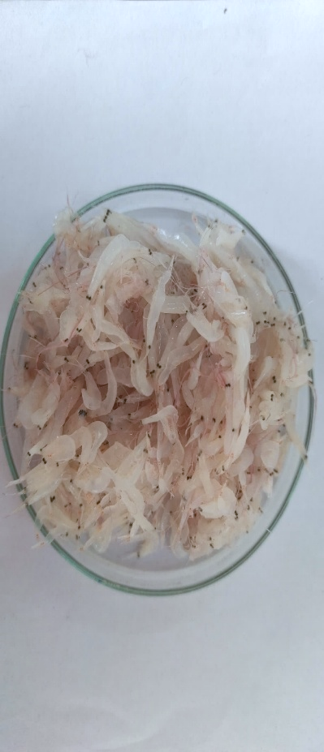 | 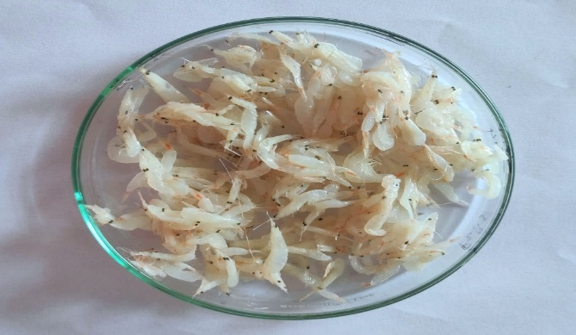
Fresh Jawala Shrimp | After blanching fresh Jawala shrimp
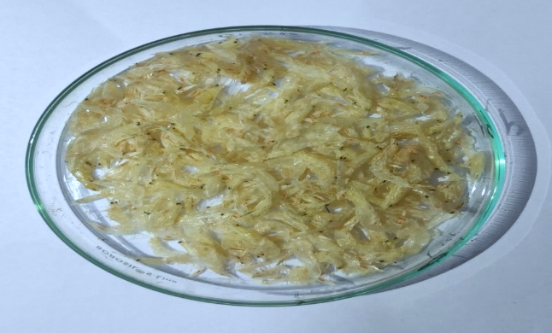 | 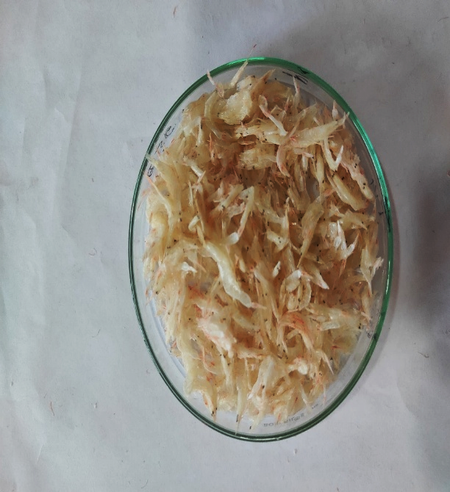
T1: 0% salt, B-70 °C, D-50 °C | T2: 1% salt, B-70 °C, D-50 °C
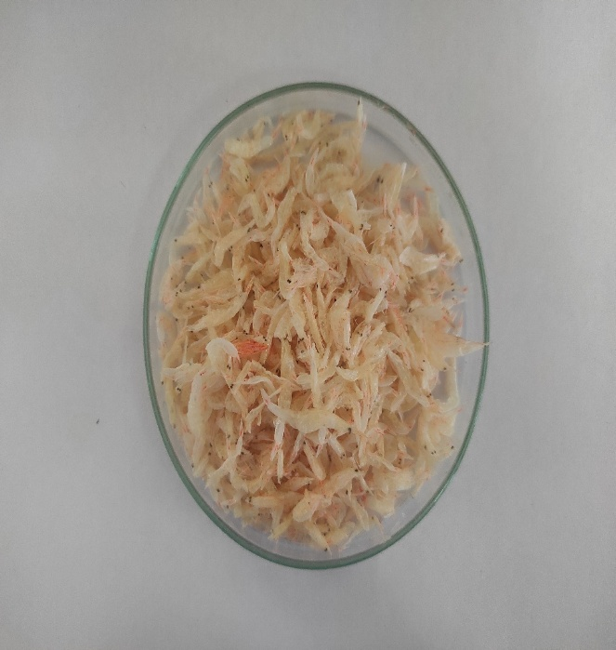 | 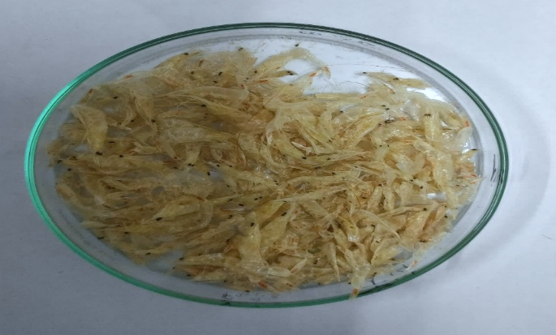
T3: 2% salt, B-70 °C, D-50 °C | T4: 0% salt, B-80 °C, D-50 °C
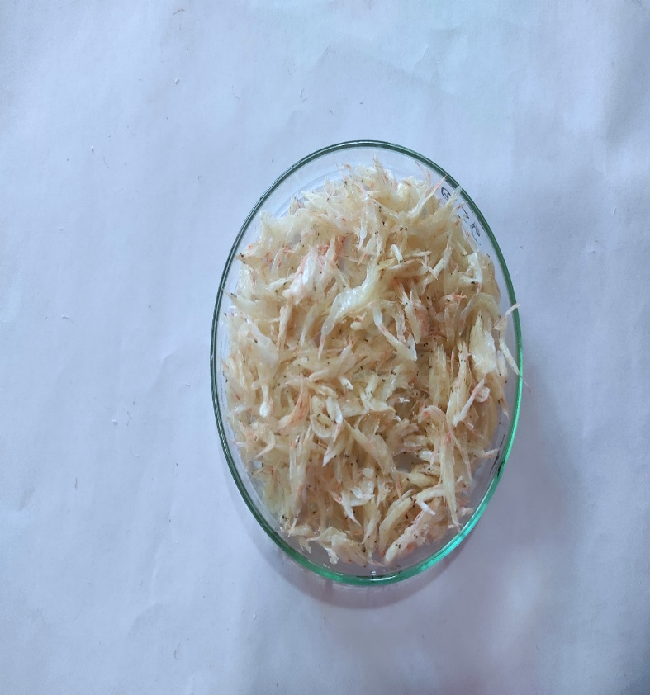 | 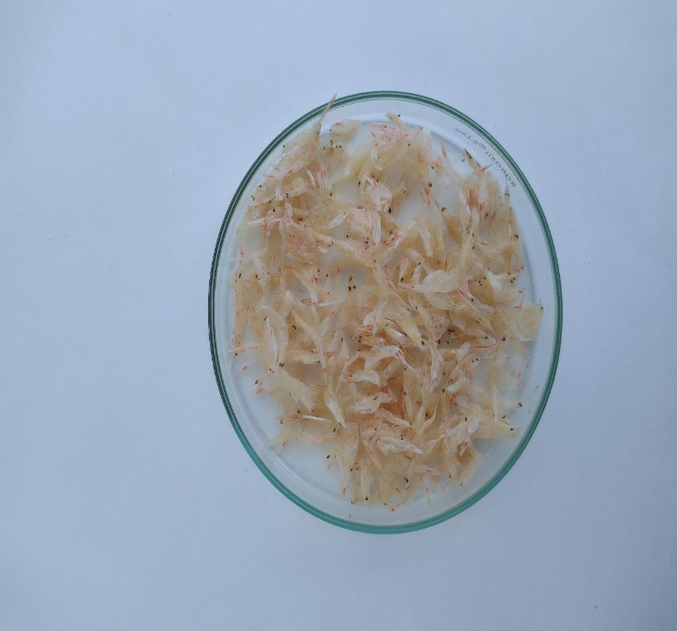
T5: 1% salt, B-80 °C, D-50°C | T6: 2% salt, B-80 °C, D-50 °C
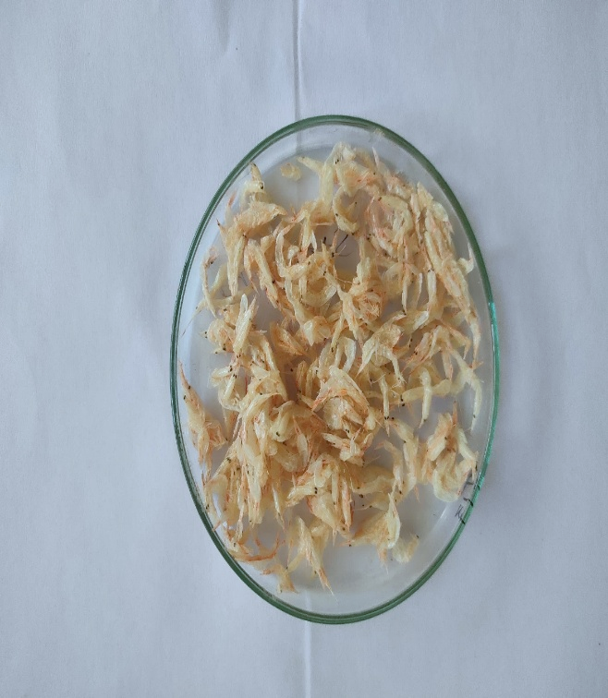 | 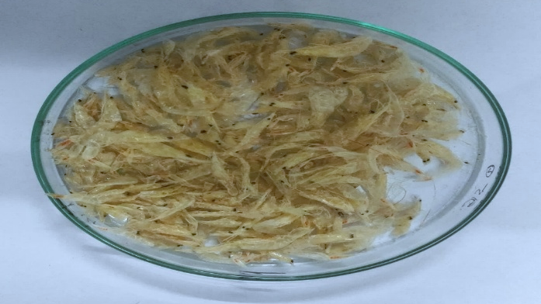
T7: Steaming 100 °C, D-50 °C | T8: 0% salt, B-70 °C, D-60 °C
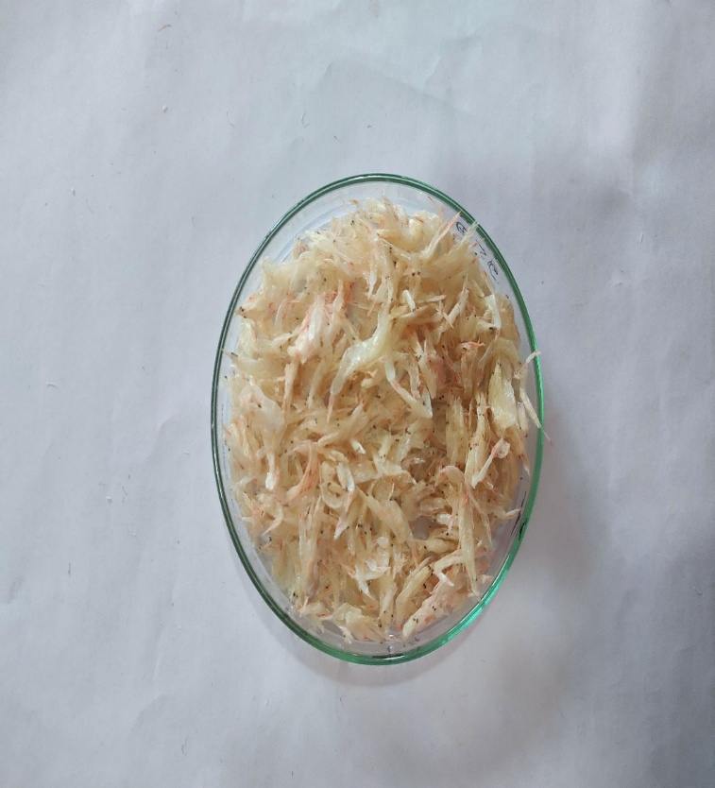 | 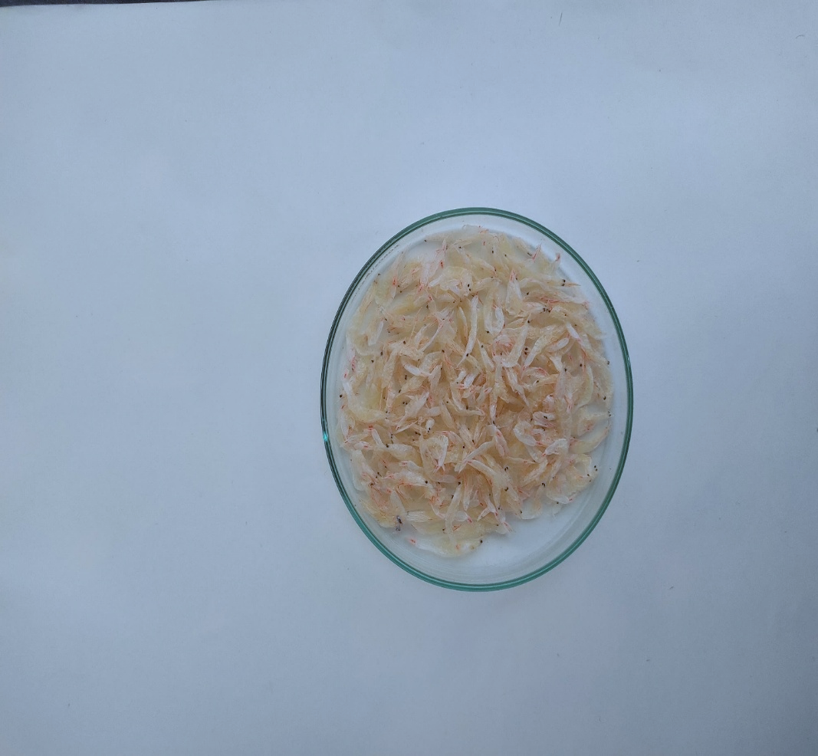
T9: 1% salt, B-70 °C, D-60 °C | T10: 2% salt, B-70 °C, D-60 °C
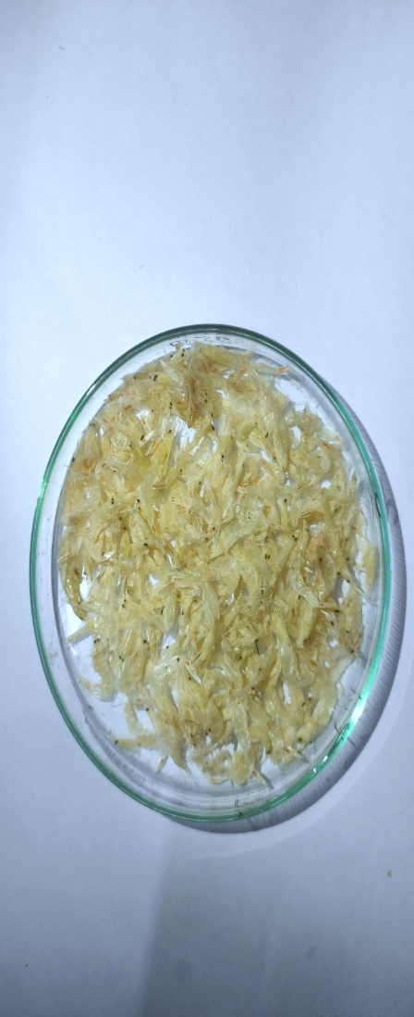 | 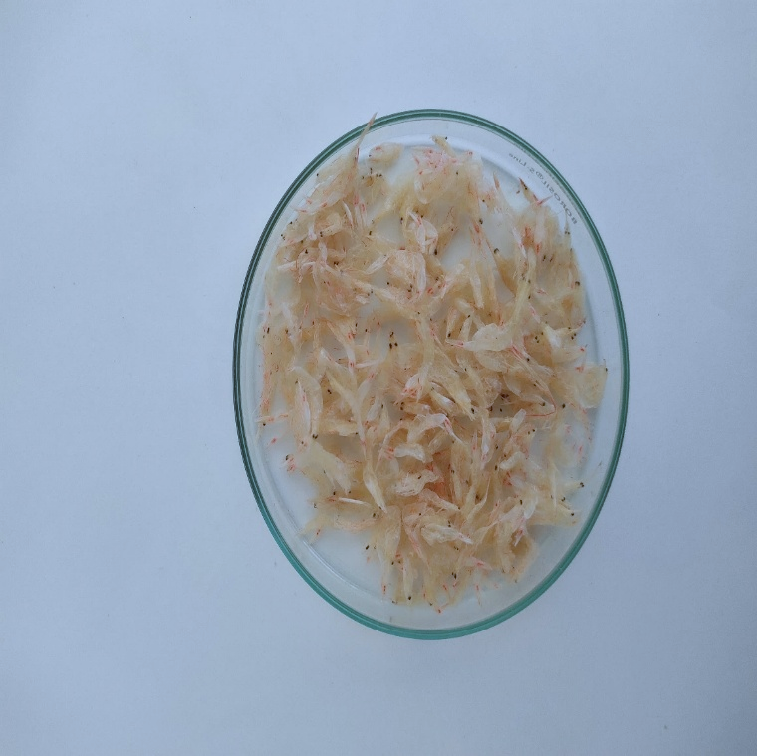
T11: 0% salt, B-80°C, D-60°C | T12: 1% salt, B-80 °C, D-60 °C
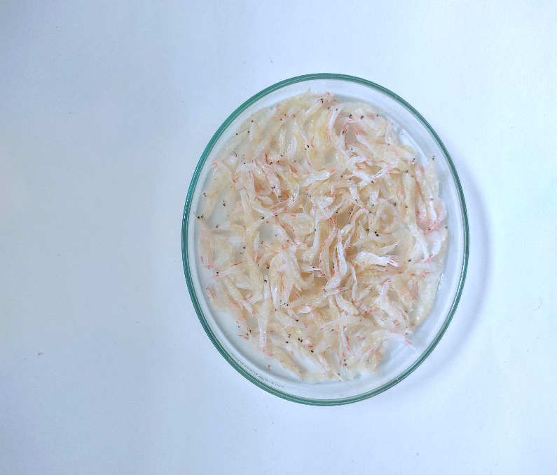 | 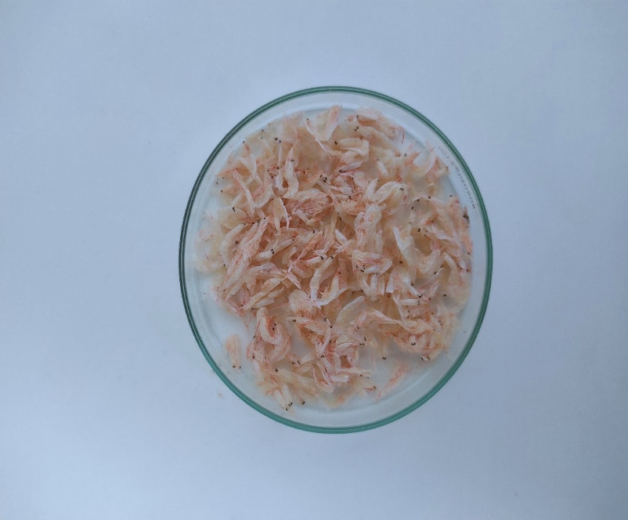
T13: 2% salt, B-80 °C, D-60 °C | T14: Steaming 100°C, D-60°C

Disclaimer (Artificial intelligence)
Option 1:
Author(s) hereby declare that NO generative AI technologies such as Large Language Models (ChatGPT, COPILOT, etc.) and text-to-image generators have been used during the writing or editing of this manuscript.
Option 2:
Author(s) hereby declare that generative AI technologies such as Large Language Models, etc. have been used during the writing or editing of manuscripts. This explanation will include the name, version, model, and source of the generative AI technology and as well as all input prompts provided to the generative AI technology
Details of the AI usage are given below:
1.
2.
3.
References
Ajifolokun, O M, Basson, A K, Osunsanmi, F. O. and Zharare, G. E, (2018) Effects of drying methods on quality attributes of shrimps. Journal of Food Processing and Technology, 10(772), :2.
Akonor, P T, Ofori, H, Dziedzoave, N. T. and Kortei, N K, (2016) Drying characteristics and physical and nutritional properties o.f shrimp meat as affected by different traditional drying techniques. International journal of food science, 2016(1), :7879097.
AOAC. (2005) Official methods of analysis of the Association of Official Analytical Chemists International, 18th edition, In: Horwitz, W. (Ed.), AOAC, Washington D. C.

Balachandran, K. K. (2001) Post-harvest technology of fish and fish products. Daya Books.
Balange, A K, Xavier, K M, Kumar, S, Nayak, B B, Venkateshwarlu, G and Shitole, S S, (2017) Nutrient profiling of traditionally sun-dried Acetes. Indian Journal of Fisheries, :64.
Bambale, S.G. (2019) storage stability of dried tiny shrimp (Nematopalaemon tenuipes) at refrigerated and ambient temperature (doctoral dissertation, Dr. Balasaheb Sawant Konkan Krishi Vidyapeeth, Dapoli Dist. Ratnagiri).
Boran, M. and Kose, M. (2007) Storage properties of three types of fried whiting balls at refrigerated temperatures. Turkish Journal of Fisheries and Aquatic Sciences, 7:65-70.
Chakrabortty, A, Aziz M A, and Rashad, M A (2017) Study on protein losses and total volatile base nitrogen (tvbn) of fresh water prawn (galda) in the shrimp value chain of bagerhat region, Bangladesh for the development of sea food quality. Journal of engineering science, 8(1), :79-82.
CMFRI, (1985) Annual Report 2016-2017, Central Marine Fisheries Statistics of India. Central Marine Fisheries Research Institute, Cochin, India.
EEC. (1995) Decision 95/149/EC. Total volatile basic nitrogen TVBN limit values for certain categories of fishery products and specifying the analysis method to be used. Official Journal, 97 :84-87.
Gh, Z, Etemadian, Y, Khanipour, A A and Fahim, A, (2018) The quality changes of frozen and dried tiny shrimp (Macrobrachium nipponense) meat during six months storage. Journal of Nutrition and Health Sciences, 5(2), :209.
Hwang, C C, Lin, C M, Kung, H F, Huang, Y L, Hwang, D F, Su, Y C and Tsai, Y H, (2012) Effect of salt concentrations and drying methods on the quality and formation of histamine in dried milkfish (Chanos chanos). Food Chemistry, 135(2), :839-844.
Mahakal, B. V, Pagarkar, A U, Baug, T E, Chaudhari, K J and Kulkarni, G N. (2016) Organoleptic and biochemical quality characteristics of Acetes chutney packed in polypropylene packs at ambient stored temperature. J. of Experimental Zoology. India, 19(2) :943-946.
MPEDA. (2023) Annual Report Marine Products Export Development Authority, Kochi, Kerala, India.
Naik, B V, Patil, S.V, Shirdhankar, M M Yadav, B M, Tibile, R M, Chaudhari, K J, Wasave, S M. and Yewale, V G, (2020) Shrimp farming Sector in South Konkan region, Maharashtra: A constraint analysis. J Ento and Zool Stud, 8(5), :356-359.
Omori, M, (1975) The systematics, biogeography, and fishery of epipelagic shrimps of the genus Acetes (Crustacea, Decapoda, Sergestidae). Ocean Research Institute, University of Tokyo.
Salami, S R, Awoniyi, and Oladipupo, T M, (2024) Comparative study of quality deterioration and microbiological safety of oven-dried and smoked products from African catfish (Clarias gariepinus) at various storage condition. International Journal of Fisheries and Aquatic Studies, 12(1), :110-116.
Sonavane. A. E. (2014) Development of Acetes sandwich. M.F.Sc. thesis submitted to Dr. Balasaheb Sawant Konkan Krishi Vidyapeeth, Dapoli, Maharashtra, India, :127.
Surendran, P, Nirmala Thampuran, Narayanannambiar, and Lalitha, K. V, (2006) Laboratory manual on microbiological examination of seafood, CIFT, Cochin, (2nd edn).
Verma, S. K, Sasikala, R Kishore, P Mohan, C O, Ganesan, P Padmavathy, P Muralidharan, N Jaganath, B, and Benjakul, S. (2024) Effects of different microwave power on the drying kinetics and physicochemical quality of brown shrimp (Metapenaeus dobsoni). Sustainable Food Technology, 2(1), :141-151.
Zhang, J Y, Liu, S L, Wang, Y, & Ding, Y T (2011) Chemical, microbiological and sensory changes of dried Acetes chinensis during accelerate storage. Food Chemistry, 127(1), :159-168.
Zynudheen, A. A, George, N, Sen, A. and Badonia, R. (2004) Processing and utilization of Acetes indicus (Jawala Prawn) In: Technology Advisory Series No.15, CIFT, Cochin, :6.

