Docking and Dynamics of Nannochloropsis oculata Compounds Targeting Colletotrichum musae
Abstract
Banana (Musa spp.) is a widely cultivated fruit crop prone to significant postharvest losses due to anthracnose, primarily caused by Colletotrichum musae. In pursuit of sustainable disease control strategies, this study evaluated the antifungal potential of extracts and biogenically synthesized nanoparticles derived from five microalgal species: Nannochloropsis oculata, Isochrysis galbana, Thalassiosira pseudonana, Dunaliella salina, and Haematococcus pluvialis. Solvent extracts were tested in vitro using the poison food technique, with the acetone extract of N. oculata exhibiting the highest inhibition (66.12%). Zinc and copper nanoparticles synthesized from N. oculata showed enhanced antifungal activity, with zinc nanoparticles producing an inhibition zone of up to 17.54 mm. GC-MS analysis revealed several bioactive compounds including neophytadiene, phytol, and isotridecanol, suggesting their role in antifungal efficacy.Results of molecular docking with these phytochemical compound shoes stronger binding affinity towards the negative regulation of apoptotic protein. Nannochloropsis ocuulata shows highest binding affinity ranges. The results indicate that microalgae-based bioformulations and green-synthesized nanoparticles hold promise as eco-friendly alternatives for managing banana anthracnose.
Keywords: Antifungal activity, banana anthracnose, GC-MS, Colletotrichum musae, microalgae, Nannochloropsis oculata, nanoparticles, molecular docking.

1.Introduction
Banana (Musa spp.) stands among the most widely cultivated fruit crops across tropical and subtropical regions, contributing significantly to food security, rural livelihoods, and national economies. However, postharvest diseases such as anthracnose, primarily caused by Colletotrichum musae, lead to considerable quality degradation and economic loss during storage and transportation (Buzdar et al., 2025). Management of such phytopathogens traditionally relies on chemical fungicides, but the growing concern over their environmental impact, pathogen resistance, and residue toxicity necessitates eco-friendly alternatives (Fatima et al., 2021).
Phytoplankton, consisting of various photosynthetic unicellular organisms, have gained attention as valuable resources in biocontrol and pharmaceutical fields, owing to their production of numerous bioactive substances such as pigments, essential fatty acids, and antimicrobial secondary metabolites (Asimakis et al., 2023). Species such as Nannochloropsis oculata, Isochrysis galbana, Thalassiosira pseudonana, Dunaliella salina, and Haematococcus pluvialis are widely studied for their nutritional and therapeutic potential, and their antifungal properties have gained increasing attention in plant pathology and crop protection (Lage et al., 2024).
Ongoing breakthroughs in green-based nanotech approaches have further extended the potential of microalgae-derived extracts through biosynthesis of metal nanoparticles, particularly zinc (Zn) and copper (Cu), which exhibit broad-spectrum antifungal activity (Kaur et al., 2024). Biogenic nanoparticle synthesis using algal metabolites as reducing and capping agents provides an environmentally sustainable route for developing effective antifungal agents with minimal toxicity (Abbasi et al., 2020). Furthermore, such nanoparticles offer enhanced surface area and reactivity, making them ideal candidates for controlling resistant phytopathogens such as Colletotrichum species.
In vitro antifungal screening methods such as the poison food technique and agar well diffusion assay have proven effective in evaluating both crude algal extracts and synthesized nanoparticles against fungal pathogens (Khan et al., 2023). Additionally, gas chromatography-mass spectrometry (GC-MS) remains a vital tool for characterizing the chemical profile of algal extracts, facilitating the identification of key antifungal constituents that could be harnessed for integrated pest management (Alseekh et al., 2021).
This study supports eco-friendly methods by focusing on a significant banana disease after harvest, which is an important fruit worldwide. The research investigates a new, environmental friendly method by combining microalgal resources with green nanotech to create natural solutions that can reduce banana fruitrot disease. Highlighting the use of living microalgal to manage diseases after harvest, the study directly related to reducing the incidence and understanding their physiological changes. Additionally, by assessing naturally sourced antifungal substances, this research aids in creating safer,eco-friendly methods for Colletotrichum musae management.
2.Materials and Methods
2.1. Isolation and Characterization of the Pathogen
Banana fruits exhibiting signs of anthracnose were sourced through a market-based survey and subsequently analyzed under laboratory conditions for precise evaluation. The tissue segment method of (Benjamin et al., 2022) was used to inoculate the pathogen on potato dextrose agar (PDA). Morphological characteristics were studied through taxonomic keys and descriptions given to determine the fungal isolates. A single-spore culture technique was used and the isolate was subcultured on PDA slants at regular intervals and incubated at27±1°C for seven days (Shu et al., 2017). The culture were stored at 4⁰ C and subcultured under aspectic conditions at regular intervals to maintain their long-term viability (Plate 1).
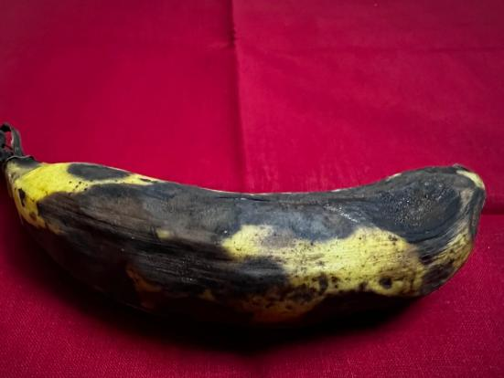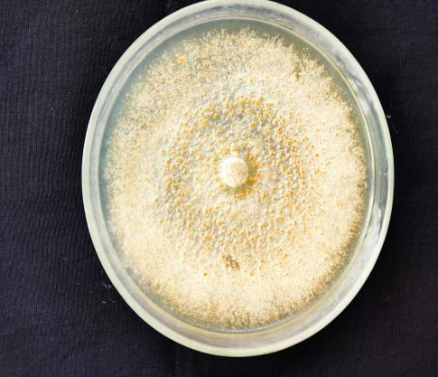
Plate 1: Isolation and Characterization of Colletotrichum musae
2.2. Collection of microalgae seaweed
The five microalgae including Nannochloropsis oculata, Isochrysis galbana, Thalassiosira pseudonana, Dunaliella salina and Haematococcus pluvialis belongs to different families were collected from CAS in marine biology Annamalai university, Parangipettai, India and used throughout the studies (Plate 2).
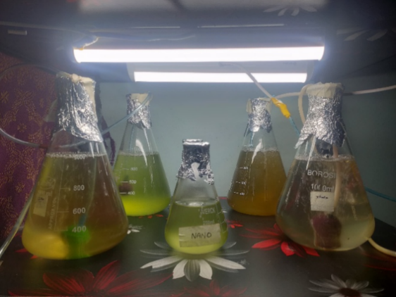
Plate 2: Production of Microalgae under controlled condition
2.3. Microalgae Biomass Production
This study explored how two distinct culture media—Conway and BG-11—affected the growth, biomass production, and biochemical characteristics of microalgae. Each medium was prepared in 5-liter flasks following its standardized formulation. To ensure quality, analytical-grade chemicals were used, including precisely measured concentrations of nitrates, phosphates, trace elements, and vitamins essential for microalgal development (Day et al., 2007). The media were made using distilled water, with sodium chloride added to adjust salinity levels: 19 ppt for Nannochloropsis and 25–27 ppt for other species. The pH was maintained within the optimal range of 7.5 to 8.0 to promote healthy algal growth (Malakootian et al., 2016). All glassware and media were sterilized via autoclaving at 121 °C and 15 psi for 15 minutes to prevent contamination (Chiu et al., 2009). The cultivation process began by inoculating each flask with 10% (v/v) of a microalgal pre-culture stock. To reduce the nutrient carryover to the inoculum, the stock culture was centrifugally cleaned by being subjected to 851 × g for 15 min before inoculation.
The experiment was conducted over a duration of eighteen days, under continuous illumination provided by cool white fluorescent lamps at an intensity of 100 μmol m²/s (Chakraborty et al., 2023). Each of the three-culture media—Conway, F/2, and BG-11—was inoculated with a 10% (v/v) volume of microalgal starter culture. The media formulations included essential nutrients along with seawater that had been filtered through a 0.22 μm membrane to ensure purity (Carvalho et al., 2019). Following sterilization, all components were introduced aseptically into the media under controlled, optimal conditions suitable for microalgal growth. The cultured microalgae after optimal growth centrifuge at 20⁰Celsius and 897 g centrifuge, the microalgae were harvested from their growth medium by centrifuging for 10 minutes (Nuno et al., 2013). The crude biomass obtained was subsequently freeze-dried and stored at -20 degrees Celsius until further analysis.
2.4. Preparation of algal extract
Soxhlet extraction is a widely utilized method for extracting crude components from microalgae, including Nannochloropsis ocuulata, Isochrysis galbana, Thalassiosira pseudonana, Dunaliella salina and Haematococcus pluvialis species. This technique involves the continuous circulation of solvent, allowing for efficient extraction of various compounds from dried biomass.
The microalgae Nannochloropsis ocuulata, Isochrysis galbana, Thalassiosira pseudonana, Dunaliella salina and Haematococcus pluvialis species after cultivation, is subjected to taken total ten gram of the dried microalgae, filled in a thimble and placed in the Soxhlet apparatus, which is connected to a distillation flask and a condenser. The extraction is carried out at 60°C using ethanol, methanol, ethyl acetate and acetone as the solvent (Hakim et al., 2021). The highest yield from the different solvent ratios is then stored for further synthesis and analysed by antifungal activity.
2.5. Invitro screening of algal extract
2.5.1. Poison food technique
To test the antifungal activity of extracts of Haematococcus pluvialis, Isochrysis galbana, Thalassiosira pseudonana, Dunaliella salina, and Nannochloropsis ocuulata species, 5 mL of 100% extract was aseptically added to each well containing 20 mL of sterilized PDA medium cooled to 45 °C in separate sterilized Petri plates. Then, in each plate, a 5 mm Colletotrichum musae mycelial disc was placed in the middle of the PDA medium. For the experiment, the five algae species were used with three replications in a completely randomized design (CRD). The inoculated plates were kept in a growth chamber at a controlled condition of 25°_{C} and 70% relative humidity (RH). The radial growth of C. musae was recorded. The mycelial growth inhibition (MGI) was determined using the formula: MGI = [(dc - dt) / dc] × 100, where dc is the mycelium diameter in untreated controls and dt is the diameter in the presence of the extract (Mishra & Dudey, 1994).
2.6. Synthesis of Nanoparticle
In the experimental protocol, a 250 mL beaker was partially filled with 50 mL of ethanol solvent. Subsequently, 1.208 g of copper salt or 1.487 g of zinc salt was introduced into the water. The salt was thoroughly mixed until it was completely dissolved, resulting in a uniform solution. A magnetic stirrer was used to ensure thorough blending and prevent undissolved particles from settling at the base of the beaker. After complete dissolution, the solution was added for further experimentation and analyses. The beaker was then placed on a thermal magnetic stirrer for 15 min to achieve the optimal salt distribution. Subsequently, 20 mL of the algal extract was added to the mixture while stirring was continued. Within half an hour, a notable color change was observed in the solution. The transition from green to yellow or dark brown indicates the formation of nanoparticles. The solution was dried, and the resulting precipitate was observed at the bottom of the container. Nanoparticles were collected in powder form and stored in centrifuge tubes for subsequent characterization and examination.
2.7. Invitro screening of algal synthesized nanoparticle against Colletotrichum musae
Antifungal effect of biosynthesized Zn and Cu nanoparticles was tested employing an agar well diffusion method. Observation of the inhibitory zone around the well was considered an important parameter in measuring the effectiveness of nanoparticles. 100 ml of sterilized potato dextrose agar was poured into three petridishes and allowed to solidify. The fungal strains grown on PDA in other plates were then placed on the agar surface in form of a 9 mm disc. Different amounts of synthesized nanoparticles were added to four wells, each measuring 5 mm in diameter, created in the agar surface. The antifungal activity of the infected plates, determined as an area of inhibition that formed around each well after 24 hours of incubation at 37°C, was measured (Rajeshkumar et al., 2014). The diameters of these zones were measured in millimeters. The experiment was done in triplicate and appropriate statistical analysis applied to ensure reliability.
2.8. GC-MS Analysis
The Agilent 5975C GC-MS system performed with an integrated triple-axis detector and auto-sampler for the GC-MS study. Compounds were separated on a 30 m fused silica capillary column with diameters of 0.25 mm and a film thickness of 0.25 mm. The carrier gas was helium, and the flow was maintained at 4.90 mL/min in the first minute of operation. The mass spectral range was from 40 to 700 m/z in EI mode at 70 eV. The injection volume of the sample was 1 µL with a split ratio of 1:10. After holding the oven at 70°C for three minutes, the injector temperature was set at 250°C, which is then gradually increased at 14°C per minute until 250°C, and finally, the total heating time for the analysis process was 41 minutes. Programmed-mode at 50⁰ C for about 2min were about to run the columns. The 1:10 ratio was set as split ratio. Comparison of retention times of crude algal extracts led to the identification of peaks. The mass spectra collected were compared with reference spectra in the NIST 11 Mass Spectral Library (2011 edition). The identification was based on the guidelines set by (Hussain et al., 2020) which state a compound may be identified if its match factor was beyond 80%.
2.9. Molecular docking
Molecular docking simulations between selected ligands and target proteins were conducted using AutoDock, with the exhaustiveness value configured to ensure a thorough exploration of potential binding conformations. Prior to initiating the docking process, both the ligands and protein structures were converted into PDBQT format. After docking, the resultant complexes were saved in PDB format and visualized using molego viewer software for 3D structural interpretation. The conformation exhibiting the highest binding energy for each ligand-protein complex was selected for detailed evaluation. Furthermore, two-dimensional interaction plots were created to identify critical hydrogen bonding and hydrophobic contacts, while additional binding interactions were analyzed through suitable molecular visualization tools.
2.9.1. Protein preparation
The three-dimensional structures of selected target proteins were obtained from the RCSB Protein Data Bank (https://www.rcsb.org/) in PDB file format. The proteins chosen for the study included 3DEA (pdb_00003dea). These protein structure was pre-processed using AutoDock Tools, which involved the elimination of water molecules, addition of polar hydrogen atoms, and assignment of Gasteiger charges. Additionally, any bound ligands or non-protein molecules were removed from the active sites. The finalized structures were then exported in PDBQT format to enable molecular docking studies.
2.9.2. Ligand preparation
The 3D molecular structures of phytoconstituents isolated and characterized from Nannochloropsis oculata by Bhuvana et al., along with a reference antifungal, antimicrobial properties, were retrieved from the PubChem database in .sdf format. These chemical structures were subsequently converted into .pdbqt format using the OpenBabel GUI software to facilitate molecular docking analysis. To assess their potential as therapeutic agents and various properties were evaluated.
2.9.3. Molecular dynamics simulations
To assess the conformational stability and dynamic properties of the protein–ligand docked complexes, computational analyses were carried out using the iMODS web servers. The docked models with the lowest binding energies were uploaded in PDB format to both platforms for further evaluation. The iMODS server was used to perform normal mode analysis (NMA) to probe the molecular mobility and dynamic behaviour of the complexes. Structural metrics such as deformability, B-factors, eigenvalues, variance, covariance matrices, and elastic network models were examined to provide a detailed insight into the flexibility and stability of the docked interactions.
3.0. Stastical Analysis
The IRRISTAT version 92 was developed by the Biometric Unit of the International Rice Research Institute, Philippines, and used to statistically analyze the data (Gomez & Gomez, 1984). However, prior to analysis of variance (ANOVA), transformation of percentage values was accomplished through the arcsine function. The ANOVA was done at two levels of significance (P < 0.05 and P < 0.01), with Duncan's Multiple Range Test (DMRT) used for mean comparisons.
4.0. Results
4.1. Invitro screening of algal extract by poison food technique
This study aimed to investigate the effectiveness of microalgal-based biostimulants for controlling the Colletotrichum musae pathogen. To obtain bioactive compounds, extracts were obtained from five microalgae, including Nannochloropsis oculata, Isochrysis galbana, Thalassiosira pseudonana, Dunaliella salina and Haematococcus pluvialis species,using ethanol, methanol, ethyl acetate and acetone. Nannochloropsis ocuulata showed the best antifungal activity and inhibited the mycelial growth of Colletotrichum musae. The acetone extract of Nannochloropsis ocuulata showed the negligible inhibition (Table 1, Graph 1, Plate 3), restricting fungal growth to (30.54 mm) and 66.12% at 20% concentration compared to the control. Thereafter, the acetone extract of Isochrysis galbana showed a mycelial growth inhibition of 64.49%. On the other hand, the antifungal activity of ethyl acetate extract of Haematococcus pluvialis was the lowest (52.68% of fungi growth inhibition), but still, the inhibition was observed with some antifungal activity.
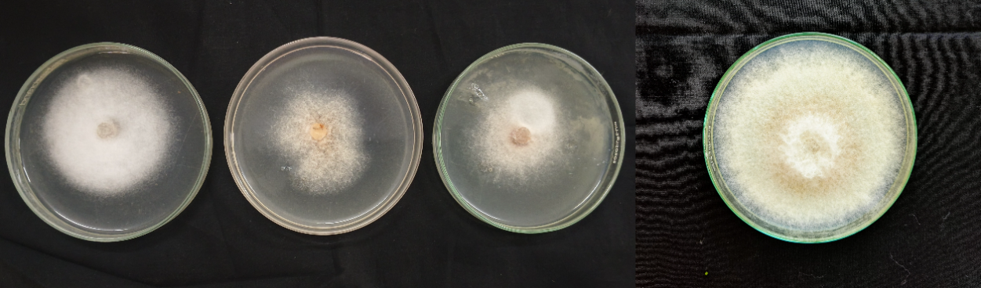
10 % 15% 20% Control

Plate 3: Screening of Nannochloropsis ocuulata at different concentration by poison food technique
4.2.Invitro Assessment of Nanoparticles Synthesized from Algae Against Colletotrichum musae
Antifungal activity was assessed through the agar well-diffusion method against Zn and Cu nanoparticles biosynthesized. Clear zones of inhibition surrounding the wells indicated the nanoparticles' effective antifungal activity. After 6-10 days of incubation at 25 ± 2 °C, the widths of the inhibition zones were determined in millimeters. The inhibition zones of Nannochloropisis oculata Cu NPs were measured at 43.65mm, 36.54mm and 25.90mm for 100, 200, and 300 ppm concentration, respectively (Table 2, Graph 2, Plate 4). The determined inhibition zones of the Nannochloropisis oculata Zn NPs are 38.53mm, 30.69mm, and 17.54mm. The zinc nanoparticles were found to be slightly more efficient than copper nanoparticles, with these results supporting a concentration-dependent increase in antifungal activity.
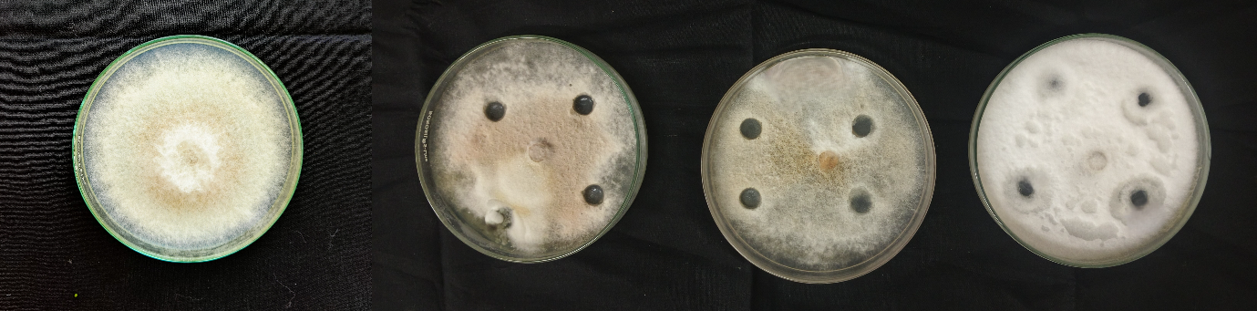
Control 100ppm 200ppm 300ppm
Plate 4: Screening of synthesized ZnNPs against Colletotrichum musae using agar well method
4.3.Bioactive Compound Profiling of Nannochloropsis oculata Using Gas Chromatography-Mass Spectrometry
A broad array of chemical compounds were detected by the GC-MS analysis of the Nannochloropsis oculata crude extract. Thirty molecules were found in all, indicating that the extract contained a variety of volatile chemicals and secondary metabolites. Due to their possible antimicrobial qualities, Neophytadiene, Phytol, and Isotridecanol- stood out among the chemicals that were found may be responsible for inhibition. At a retention duration of 12.89 minutes, Neophytadiene showed a peak area of 4.41%, whereas phytol showed a peak area of 14.15% at 15.320 minutes. Moreover, Isotridecanol-, which made up 8.69% of the entire peak area, was found at a retention duration of 12.418 minutes (Table 3, Fig1). These results advance a thorough comprehension of the chemical makeup of the extract and its possible biological relevance.
4.4. Molecular analysis for selected protein and ligand
To evaluate the binding potential of the major bioactive phytochemicals of Nannochloropsis oculata to find out the most effective compound. Docking between targeted protein (3DEA) and phytochemicals present in Nannochloropsis oculata were performed to evaluate the best binding energy. The phytochemicals shows lowest binding energy will exhibit strongest affinity and consider to be the best one among (Table 4, Fig 2a,b,c). According to the binding energy docking results, the Neophytadiene, Phytol, and Isotridecanol- shows better binding affinity towards the negative regulation of apoptotic protein from 3DEA thus promote fungal infection in banana.

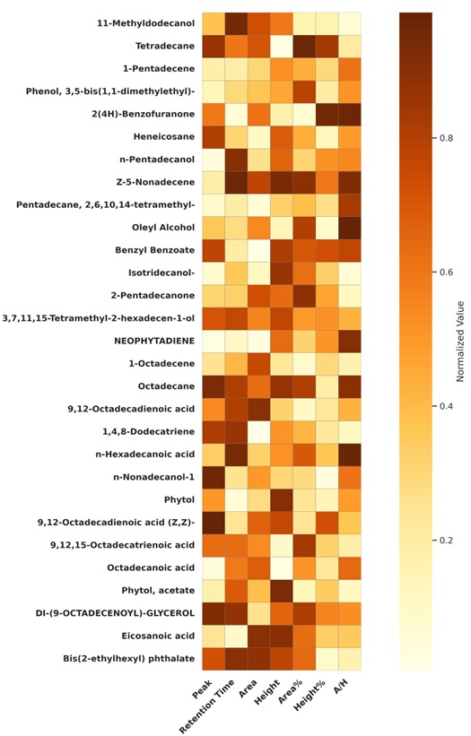
Fig 1: Heatmap of GC-MS compound of Nannochloropsis oculata
5.0. Discussion
The results of this study demonstrate the antifungal potential of microalgal-derived extracts and biosynthesized nanoparticles against Colletotrichum musae, a key postharvest pathogen in banana. Among the tested species, Nannochloropsis oculata exhibited the most consistent and significant antifungal activity. The acetone extract of N. oculata achieved 66.12% mycelial growth inhibition at 20% concentration, confirming the presence of potent antifungal metabolites. Similar findings have been reported by Abdulla et al. (2020), who demonstrated strong antimicrobial effects of N. oculata extracts against a range of phytopathogens.
Solvent-specific variability was evident, as the acetone extract of Isochrysis galbana also demonstrated considerable activity (64.49%), while the ethyl acetate extract of Haematococcus pluvialis showed comparatively lower inhibition (52.68%). This trend supports earlier research indicating that the polarity of extraction solvents greatly influences the yield and efficacy of bioactive compounds (Berthon et al., 2021).
Nanoparticles biosynthesized from N. oculata also displayed concentration-dependent antifungal effects, with copper nanoparticles exhibiting an inhibition zone of 43.65 mm at 100 ppm and zinc nanoparticles showing 38.53 mm at the same concentration. This aligns with findings by Lawal et al. (2025), who reported that metal nanoparticles synthesized from algal extracts exert enhanced antimicrobial properties due to their ability to disrupt microbial cell membranes and generate reactive oxygen species. Interestingly, the decreased efficacy observed at higher nanoparticle concentrations in our study may be attributed to nanoparticle aggregation, which reduces surface reactivity—a phenomenon previously noted by (Calatrava et al. 2024).
Gas Chromatography–Mass Spectrometry (GC-MS) profiling of the N. oculata acetone extract revealed several key secondary metabolites. Notably, squalene, phytol, and isotridecanol were present in significant proportions. Squalene has been shown to possess membrane-penetrating and oxidative stress-inducing properties that contribute to antifungal activity (Lawal et al., 2025). Phytol, a diterpene alcohol, is recognized for its antimicrobial and antioxidant effects, enhancing the bioprotective capacity of the extract (Abdel-Raouf et al., 2020). The presence of n-hexadecanoate, also identified in this study, is particularly relevant as it is known to inhibit fungal spore germination and hyphal elongation (Berthon et al., 2021).
Molecular docking of N. oculata shows several phytochemical compunds that shows higher binding affinity energy. Notably, Neophytadiene, Phytol, and Isotridecanol- are exhibited lower binding energy compared all other phytochemical exhibited in GC-MS analysis. The presence of β-lactamase inhibitors from microalgal metabolites shows lower binding affinity towards the protein which exhibits antimicrobial and cytotoxic substances exhibiting limited inhibitor factors, including fatty acids and phenolic derivatives, exhibited strong binding affinities and stable interactions with microbial proteins, reinforcing the viability of marine-sourced biocompounds as therapeutic agents (Pestana-Nobles et al.2022).
These findings reinforce the potential of N. oculata as a sustainable source of antifungal agents, both in crude and nanoparticle-embedded forms. The dual application—extract and nanoparticle—offers a strategic advantage in integrated disease management approaches. Moreover, the biogenic synthesis of nanoparticles presents an eco-friendly alternative to chemically synthesized agents, aligning with global trends in sustainable agriculture (Calatrava et al., 2024).
Future work should focus on the in vivo efficacy of these formulations under field conditions, potential phytotoxicity, and formulation development for large-scale agricultural use.
6.0. Conclusion
This study provides information about the antifungal properties of bioactive compounds and biogenically-synthesized nanoparticles derived from Nannochloropsis oculata, and their effectiveness against a significant, postharvest pathogen of banana fruit rot, Acetone extract and zinc/copper nanoparticles exhibited considerable invitro inhibition and generate promising inhibitory astrocytes. Two of the potent secondary metabolites revealed by GC-MS profiling also demonstrated in the biogenic synthesis of nanoparticles. These results support the potential application of microalgae as valuable bio-resources in the protection of fruit crops. This research underlines the importance of green nanotechnology and microbial interactions in an integrated approach to sustainable postharvest disease management, and will aid to development of alternative management strategies that are innovative approach that improve the quality and marketable approaches for farmers and sustainable management practices for agriculture sector.

Table 1: Invitro screening of algal extracts using different solvents
Microalgae |  | Acetone |  | Methanol |  | Ethanol |  | Ethyl-acetate
 | Concentration | Mycelial growth (mm) | %inhibition over control | Mycelial growth (mm) | %inhibition over control | Mycelial growth (mm) | %inhibition over control | Mycelial growth (mm) | %inhibition over control
Nannochloropsis ocuulata | 10% | 37.52 | 58.33 | 40.00 | 55.53 | 42.54 | 52.73 | 41.03 | 54.44
Nannochloropsis ocuulata | 15% | 34.25 | 62.25 | 36.56 | 59.48 | 39.00 | 56.75 | 37.56 | 58.36
Nannochloropsis ocuulata | 20% | 30.54 | 66.12 | 33.03 | 63.37 | 35.52 | 60.68 | 34.00 | 62.33
Isochrysis galbana | 10% | 39.00 | 56.67 | 41.57 | 53.80 | 44.03 | 51.15 | 42.58 | 52.84
Isochrysis galbana | 15% | 35.51 | 60.52 | 38.00 | 57.76 | 40.54 | 55.03 | 39.00 | 56.67
Isochrysis galbana | 20% | 32.00 | 64.49 | 34.52 | 61.64 | 37.05 | 58.96 | 35.54 | 60.69
Thalassiosira pseudonana | 10% | 40.04 | 55.50 | 43.36 | 51.82 | 46.47 | 48.48 | 44.77 | 50.38
Thalassiosira pseudonana | 15% | 36.59 | 59.41 | 39.41 | 56.22 | 42.20 | 53.20 | 41.44 | 54.00
Thalassiosira pseudonana | 20% | 33.02 | 63.34 | 36.88 | 59.10 | 38.66 | 57.22 | 37.98 | 57.88
Dunaliella salina | 10% | 42.41 | 52.86 | 45.29 | 49.77 | 48.97 | 45.66 | 46.53 | 48.33
Dunaliella salina | 15% | 38.65 | 57.18 | 41.54 | 53.84 | 44.02 | 52.08 | 42.86 | 52.44
Dunaliella salina | 20% | 34.64 | 61.50 | 38.73 | 57.03 | 40.61 | 54.99 | 39.11 | 56.55
Haematococcus pluvialis | 10% | 47.07 | 47.72 | 49.58 | 45.00 | 52.39 | 42.13 | 50.42 | 44.00
Haematococcus pluvialis | 15% | 43.58 | 51.64 | 46.44 | 48.52 | 48.75 | 45.97 | 47.81 | 46.89
Haematococcus pluvialis | 20% | 40.80 | 54.68 | 42.70 | 52.65 | 45.10 | 49.99 | 42.61 | 52.68
Control | -- | 90.00 | 0.00 | 90.00 | 0.00 | 90.00 | 0.00 | 90.00 | 0.00
*Mean of three replications In a column, means followed by common letters are not significantly different at the 5 % level by DMRT
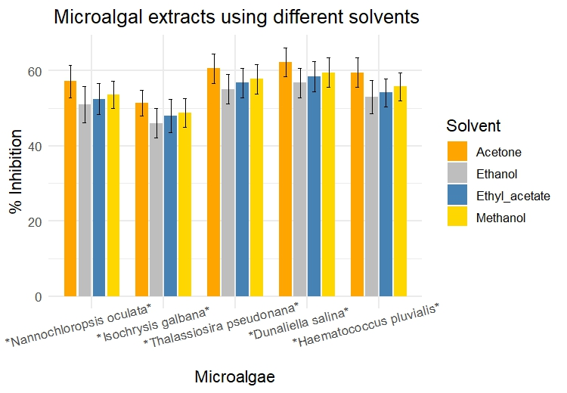
Graph 1 : Invitro screening of algal extracts using different solvents

Sl.No | Concentration (ppm) | Nannochloropisis oculata ZnNPs |  |  | Isochrysis galbana ZnNPs |  |  | Nannochloropisis oculata CuNPs |  |  | Isochrysis galbana CuNPs
Sl.No | Concentration (ppm) | Radial growth (mm) | PIOC (%) | Radial growth (mm) |  | PIOC (%) | Radial growth (mm) |  | PIOC (%) | Radial growth (mm) |  | PIOC (%)
1. | 100 | 38.53 | 57.18 | 40.68 |  | 54.80 | 43.65 |  | 51.5 | 46.75 |  | 48.05
2. | 200 | 30.69 | 65.90 | 34.76 |  | 61.37 | 36.54 |  | 59.40 | 39.02 |  | 56.64
3. | 300 | 17.54 | 80.51 | 21.09 |  | 76.56 | 25.90 |  | 71.22 | 28.76 |  | 68.04
4. | Control | 90.00 | -- | 90.00 |  | -- | 90.00 |  | -- | 90.00 |  | --
Table 2: Invitro screening of microalgal synthesised nanoparticles against Colletotrichum musae by agar well method

*Mean of three replications
In a column, means followed by common letters are not significantly different at the 5 % level by DMRT

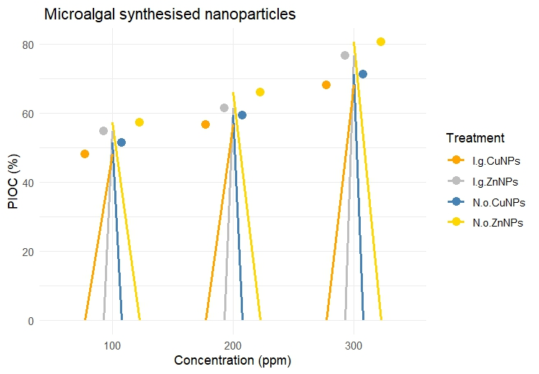

Graph 2: Invitro screening of microalgal synthesised nanoparticles against Colletotrichum musae by agar well method

Table 3: Bioactive compound profiling of Nannochloropsis oculata using GCMS analysis
S.No | Area% | R.Time | Chemical name | Molecular formula | Activity
1. | 0.65 | 6.092 | 11-Methyldodecanol | C₁₃H₂₈O | Antimicrobial activity
2. | 0.78 | 7.134 | Tetradecane (CAS) n-Tetradecane | C₁₄H₃₀ | Antimicrobial Activity
3. | 1.85 | 8.311 | 1-Pentadecene | C₁₅H₃₀ | Antimicrobial and Antioxidant activity
4. | 0.85 | 8.754 | Phenol, 3,5-bis(1,1-dimethylethyl)- | C₁₄H₂₂O | Antibacterial activity
5. | 1.70 | 9.350 | 2(4H)-Benzofuranone, 5,6,7,7a-tetrahydro-4,4,7a-trimethyl- | C₁₁H₁₆O₂ | Antimicrobial and antioxidant activity
6. | 0.61 | 9.624 | Heneicosane | C₂₁H₄₄ | Antibacterial and antifungal activity
7. | 3.54 | 10.604 | n-Pentadecanol | C₁₅H₃₂O | Antimicrobial activity
8. | 1.13 | 10.651 | Z-5-Nonadecene | C₁₉H₃₈ | Antimicrobial activity
9. | 2.17 | 10.739 | Z-5-Nonadecene | C₁₉H₃₈ | Antimicrobial activity
10. | 3.98 | 10.809 | Pentadecane, 2,6,10,14-tetramethyl- | C₁₉H₄₀ | Antimicrobial activity
11. | 0.85 | 11.743 | Oleyl Alcohol | C₁₈H₃₆O | Antibacterial & Antifungal Activity
12. | 1.53 | 12.064 | Benzyl Benzoate | C₁₄H₁₂O₂ | Antimicrobial & Antifungal Activity
13. | 8.69 | 12.418 | Isotridecanol | C₁₃H₂₈O | Antibacterial activity
14. | 2.81 | 12.521 | 2-Pentadecanone, 6,10,14-trimethy- | C₁₈H₃₆O | Antimicrobial and antioxidant activity
15. | 1.97 | 12.685 | 3,7,11,15-Tetramethyl-2-hexadecen-1-ol | C₂₀H₄₀O | Antioxidant and antimicrobial activity
16. | 4.41 | 12.892 | NEOPHYTADIENE | C₂₀H₃₈ | Antimicrobial Activity
17. | 0.65 | 12.967 | 1-Octadecene (CAS).alpha.-Octadecene | C₁₈H₃₆ | Antibacterial and antioxidant activity
18. | 1.38 | 13.027 | Octadecane | C₁₈H₃₈ | Antifungal and antibacterial activity
19. | 2.73 | 13.598 | 9,12-Octadecadienoic acid (Z,Z)- | C₁₈H₃₂O₂ | Antioxidant and antimicrobial activity
20. | 2.58 | 13.677 | 1,4,8-Dodecatriene, (E,E,E)- | C₁₂H₂₀ | --
21. | 17.45 | 13.811 | n-Hexadecanoate | C₁₆H₃₂O₂ | Antibacterial, antifungal and antioxidant activity
22. | 1.07 | 14.997 | n-Nonadecanol-1 | C₁₉H₄₀O | Antimicrobial activity
23. | 14.15 | 15.320 | Phytol | C₂₀H₄₀O | Antioxidant activity
24. | 4.53 | 15.624 | 9,12-Octadecadienoic acid (Z,Z)- | C₁₈H₃₂O₂ | Antimicrobial and antioxidant activity
25. | 6.34 | 15.696 | 9,12,15-Octadecatrienoic acid, (Z,Z,Z)- | C₁₈H₃₀O₂ | Antifungal activity
26. | 7.38 | 15.839 | Octadecanoic acid | C₁₈H₃₆O₂ | Antifungal activity
27. | 1.04 | 16.400 | Phytol, acetate | C₂₂H₄₂O₂ | Antimicrobial activity
28. | 1.10 | 17.501 | DI-(9-OCTADECENOYL)-GLYCEROL | C₃₉H₇₂O₅ | ---
29. | 1.26 | 18.476 | Eicosanoic acid | C₂₀H₄₀O₂ | Antifungal Activity
30. | 0.81 | 22.292 | 1,2-Benzenedicarboxylic acid, bis(2-ethylhexyl) ester (CAS) Bis(2-ethylhexyl) phthalate | C₂₄H₃₈O₄ | Antifungal Activity

Table 4: Molecular docking ligand structure and binding energy
S.No | Area% | Chemical name | Binding energy | Ligand structure
1. | 0.65 | 11-Methyldodecanol | -4.6 | 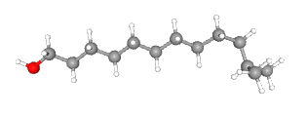
2. | 0.78 | Tetradecane (CAS) n-Tetradecane | -3.5 | 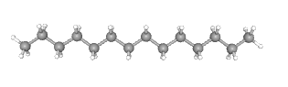
3. | 1.85 | 1-Pentadecene | -4.0 | 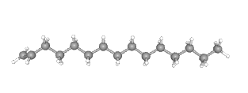
4. | 0.85 | Phenol, 3,5-bis(1,1-dimethylethyl)- | -6.0 | 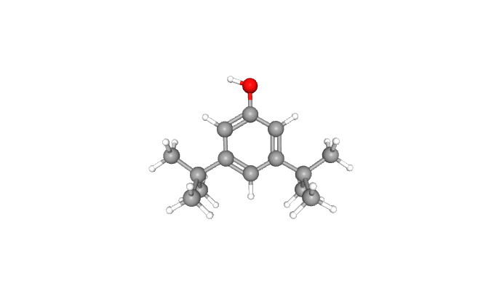
5. | 1.70 | 2(4H)-Benzofuranone, 5,6,7,7a-tetrahydro-4,4,7a-trimethyl- | -5.4 | 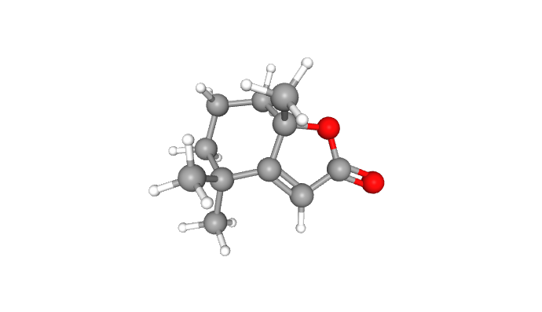
6. | 0.61 | Heneicosane | -4.4 | 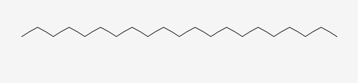
7. | 3.54 | n-Pentadecanol | -3.9 | 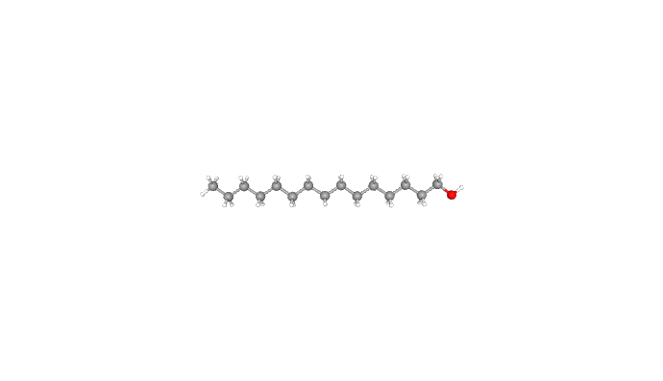
8. | 1.13 | Z-5-Nonadecene | -4.0 | 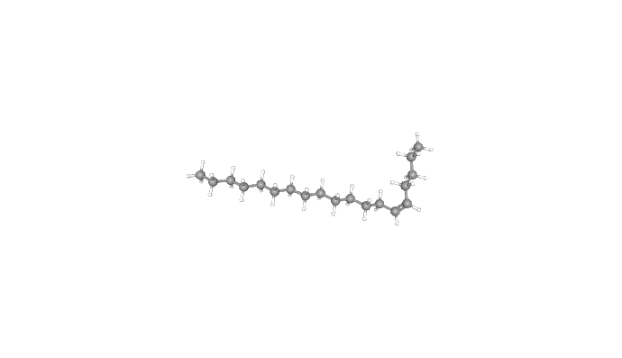
9. | 2.17 | Z-5-Nonadecene | -4.0
10. | 3.98 | Pentadecane, 2,6,10,14-tetramethyl- | -5.0 | 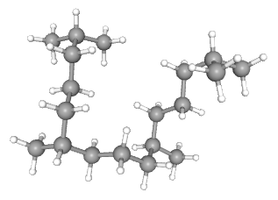
11. | 0.85 | Oleyl Alcohol | -4.6 | 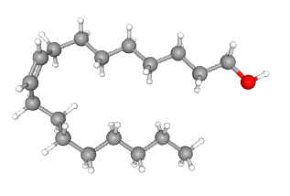
12. | 1.53 | Benzyl Benzoate | -6.0 | 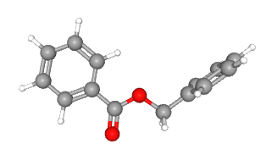
13. | 8.69 | Isotridecanol | -2.72 | 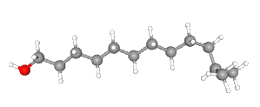
14. | 2.81 | 2-Pentadecanone, 6,10,14-trimethy- | -7.2 | 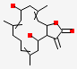
15. | 1.97 | 3,7,11,15-Tetramethyl-2-hexadecen-1-ol | -4.6 | 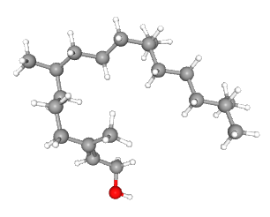
16. | 4.41 | NEOPHYTADIENE | -2.83 | 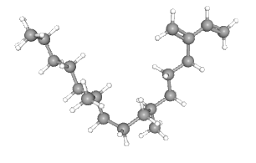
17. | 0.65 | 1-Octadecene (CAS).alpha.-Octadecene | -4.0 | 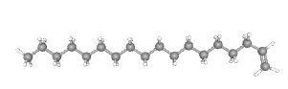
18. | 1.38 | Octadecane | -4.6 | 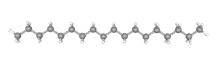
19. | 2.73 | 9,12-Octadecadienoic acid (Z,Z)- | -9.13 | 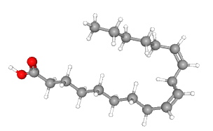
20. | 2.58 | 1,4,8-Dodecatriene, (E,E,E)- | -5.1 | 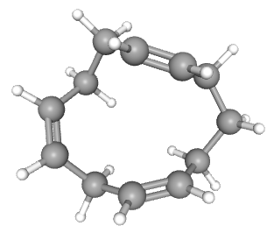
21. | 17.45 | n-Hexadecanoate | -4.7 | 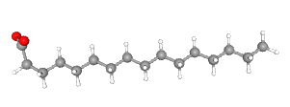
22. | 1.07 | n-Nonadecanol-1 | -3.6 | 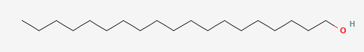
23. | 14.15 | Phytol | -2.16 | 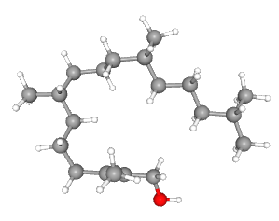
24. | 4.53 | 9,12-Octadecadienoic acid (Z,Z)- | -4.0
25. | 6.34 | 9,12,15-Octadecatrienoic acid, (Z,Z,Z)- | -4.6 | 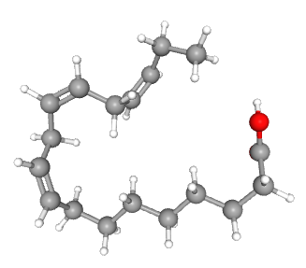
26. | 7.38 | Octadecanoic acid | -4.0 | 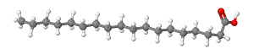
27. | 1.04 | Phytol, acetate | -3.9 | 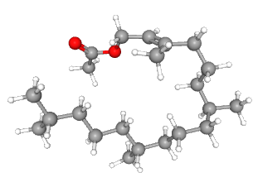
28. | 1.10 | DI-(9-OCTADECENOYL)-GLYCEROL | -4.9 | 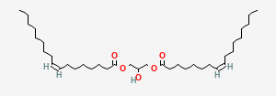
29. | 1.26 | Eicosanoic acid | -4.0 | 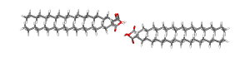
30. | 0.81 | 1,2-Benzenedicarboxylic acid, bis(2-ethylhexyl) ester (CAS) Bis(2-ethylhexyl) phthalate | -5.3 | 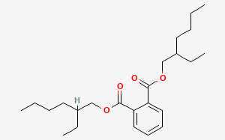

a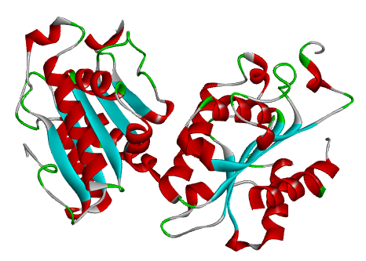 b 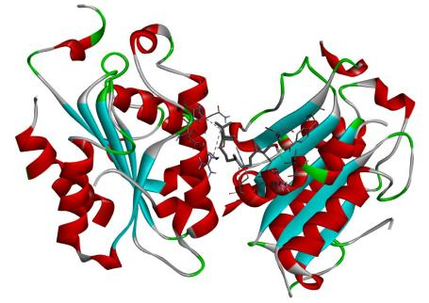
c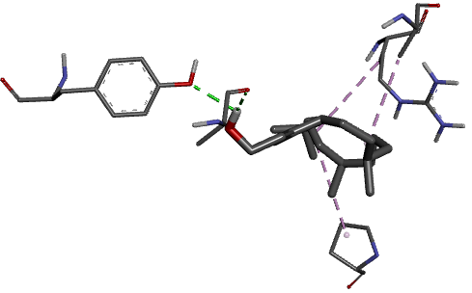d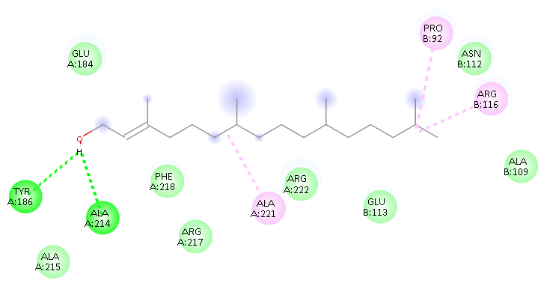
Fig 2a: Phytol ligand compound a) 3D-structure of protein molecule named 3DEA b) Protein with ligand interacted with hydrogen bond and their side chains c) Ligand interacted with side chains and hydrogen bonds d) 2D interaction structure between receptor and ligand

a b 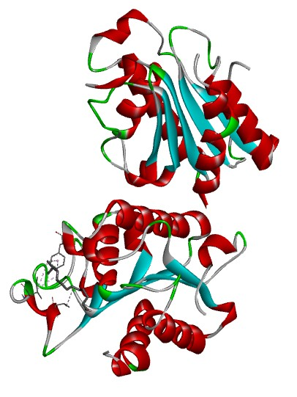
c 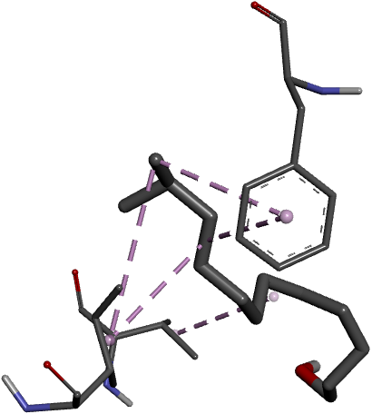 d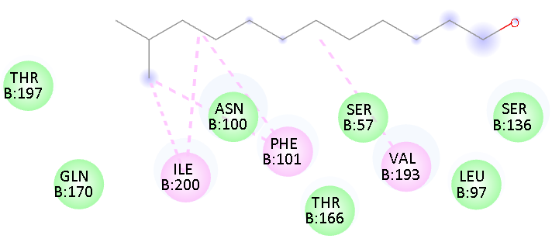

Fig 2b: Isotridecanol ligand compound a) 3D-structure of protein molecule named 3DEA b) Protein with ligand interacted with hydrogen bond and their side chains c) Ligand interacted with side chains and hydrogen bonds d) 2D interaction structure between receptor and ligand

ab 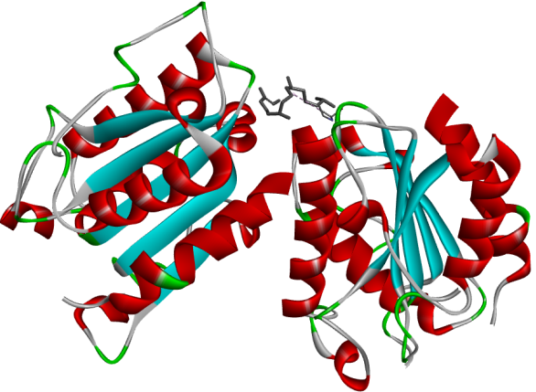
c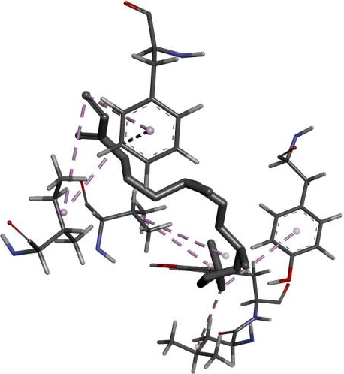d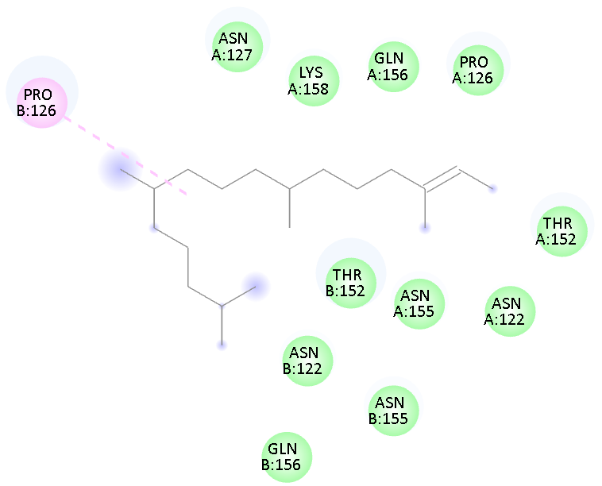
Fig 2c: Neophytadiene ligand compound a) 3D-structure of protein molecule named 3DEA b) Protein with ligand interacted with hydrogen bond and their side chains c) Ligand interacted with side chains and hydrogen bonds d) 2D interaction structure between receptor and ligand

Disclaimer (Artificial intelligence)
Author(s) hereby declare that NO generative AI technologies such as Large Language Models (ChatGPT, COPILOT, etc.) and text-to-image generators have been used during the writing or editing of this manuscript.
REFERENCE
Abbasi, B. A., Iqbal, J., Ahmad, R., Zia, L., Kanwal, S., Mahmood, T., et al. (2020). Bioactivities of Geranium wallichianum leaf extracts conjugated with zinc oxide nanoparticles. Biomolecules 10:38.
Alseekh, S., Aharoni, A., Brotman, Y. et al. (2021). Mass spectrometry-based metabolomics: a guide for annotation, quantification and best reporting practices. Nat Methods 18, 747–756.
Asimakis E, Shehata AA, Eisenreich W, Acheuk F, Lasram S, Basiouni S, Emekci M, Ntougias S, Taner G, May-Simera H, Yilmaz M, Tsiamis G. (2022). Algae and Their Metabolites as Potential Bio-Pesticides. Microorganisms.10(2):307.
Berthon J-Y, Michel T, Wauquier A, Joly P, Gerbore J, Filaire E. (2021). Seaweed and microalgae as major actors of blue biotechnology to achieve plant stimulation and pest and pathogen biocontrol – a review of the latest advances and future prospects. The Journal of Agricultural Science. 159(7-8):523-534.
Benjamin Schmid, Luísa Coelho , Peter S.C. Schulze , Hugo Pereira , Tamára Santos, Inês B. Maia and Mário Reis , João Varela. (2022). Antifungal properties of aqueous microalgal extracts. Bioresource Technology Reports, 18(101096), 2589-014X.
Buzdar, J.A., Shah, Q.A., Khan, M.Z. et al. (2025). Hepatoprotective effects of olive leaf extract against carbon tetrachloride-induced oxidative stress: in vivo and in-silico insights into the Nrf2-NFκB pathway. J Mol Histol 56, 42.
Carvalho, J. C., Sydney, E. B., Tessari, L. F. A., & Soccol, C. R. (2019). Culture media for mass production of microalgae. In A. Pandey, J.-S. Chang, C. R. Soccol, D.-J. Lee, & Y. Chisti (Eds.), Biofuels from Algae (2nd ed., pp. 33–50).
Chakraborty, B., Gayen, K., & Bhowmick, T. K. (2023). Transition from synthetic to alternative media for microalgae cultivation: A critical review. Science of The Total Environment, 897, 165412.
Chiu, S.Y., Kao, C.Y., Tsai, M.T., Ong, S.C., Chen, C.H., Lin, C.S. (2009). Lipid accumulation and CO2 utilization of Nannochloropsis oculata in response to CO2 aeration. Bioresour. Technol. 100, 833–838.
Calatrava, V., Gonzalez-Ballester, D. & Dubini, A. (2024). Microalgae for bioremediation: advances, challenges, and public perception on genetic engineering. BMC Plant Biol 24, 1261.
Lawal, H., Gaddafi, M. S., Jamiu, A. M., Edo, G. S., Fremah, O. G., El-yakub, A. U., Mahunu, G. K., Wang, K., Zhang, H., & Yang, Q. (2025). Biocontrol and Nanotechnology Strategies for Postharvest Disease Management in Fruits and Vegetables: A Comprehensive Review. Foods, 14(16), 2782.
Lage, V. M. G. B., Deegan, K. R., Sacramento, R. V., Santos, D. I. A. C. dos, Barbosa, L.V., Barbosa, C. de J., & Lima, S. T. da C. (2024). Antifungal activity of microalgaein phytopathogenic fungi: A systematic review . Ciência e Natura, 46, e84584.
Li, Z., Ali, S., Behan, A. A., Arain, M. A., Buzdar, J. A., & Yuan, H. (2025). Exploring Magnolia officinalis and their derivatives as a functional feed additive to modulate poultry health and performance: a-review. World’s Poultry Science Journal, 1–18.
Hanaa Ali Hussein, Habsah Mohamad, Maziah Mohd Ghazaly, A.A. Laith, Mohd Azmuddin Abdullah,. (2020). Anticancer and antioxidant activities of Nannochloropsis oculata and Chlorella sp. extracts in co-application with silver nanoparticles. Journal of King Saud University - Science, 32(8), 3486–3494.
- G. Day, U. Achilles‐Day, S. Brown, A. Warren. (2007). Cultivation of algae and protozoa, Manual of environmental microbiology, 79-92.
Khan A, Singh AV, Gautam SS, Agarwal A, Punetha A, Upadhayay VK, Kukreti B, Bundela V, Jugran AK, Goel R. (2023). Microbial bioformulation: a microbial assisted biostimulating fertilization technique for sustainable agriculture. Front Plant Sci. 12;14:1270039.
Malakootian, M., Hatami, B., Dowlatshahi, S., & Rajabizadeh, A. (2016). Growth and lipid accumulation in response to different cultivation temperatures in Nannochloropsis oculata for biodiesel production. Environmental Health Engineering and Management Journal, 3(1), 29-34.
Nuno, K.; Villarruel-Lopez, A.; Puebla-Perez, A.M.; RomeroVelarde, E.; Puebla-Mora, A.G. and Ascencio, F. (2013). Effects of the marine microalgae Isochrysis galbana and Nannochloropsis oculata in diabetic rats. Journal of Functional Foods, 5(1): 106 - 115.
Ostermann, A. I., Müller, M., Willenberg, I., Schebb, N. H. (2014). Determining the fatty acid composition in plasma and tissues: A comparison of methylation methods and sources of variability. Journal of Lipid Research, 55(11), 2341–2351.
Pestana-Nobles, R., Aranguren-Díaz, Y., Machado-Sierra, E., Yosa, J., Galan-Freyle, N. J., Sepulveda-Montaño, L. X., Kuroda, D. G., & Pacheco-Londoño, L. C. (2022). Docking and Molecular Dynamic of Microalgae Compounds as Potential Inhibitors of Beta-Lactamase. International Journal of Molecular Sciences, 23(3), 1630.
Rajeshkumar, S., Malarkodi, C., Paulkumar, K., Vanaja, M., Gnanajobitha, G., & Annadurai,G. (2014). Algae-mediated green fabrication of silver nanoparticles and examination of its antifungal activity against clinical pathogens. International Journal of Metals, 2014, 692643.
Rusdianasari R, Hakim L, Kalsum L (2021). The optimum yield of Nannochloropsis sp microalgae from the lipid cultivation and extraction process with Soxhlet method. Indones J Fundament Appl Chem, 6:81–89.
Shu, C., Chen, Q., Pi, L., Zhang, D., Panhwar, Q. A., & Zhou, E. (2017). Identification and antifungal activity analysis of two biocontrol antagonists to Colletotrichum musae. Journal of Phytopathology, 165(7-8), 554-561.

