Preliminary On-Station Evaluation of Five Dual-Purpose Sorghum Genotypes in Niger as a Basis for Subsequent Farmer Field Testing

Abstract
Climate change is increasingly impacting agricultural production in Niger, where sorghum, a vital cereal crop for food and fodder security, is still largely dominated by low-yielding, long-cycle, photoperiod-sensitive local varieties. This study aimed to evaluate five dual-purpose sorghum genotypes (grain and fodder) under experimental station conditions. The trial, conducted in 2024 under rainfed conditions, followed a randomized complete block design with three replications. Results showed no significant differences among genotypes for vegetative traits, including the number of leaves, leaf width, and plant height. However, significant differences were observed in key agronomic traits, including grain yield, vegetative biomass, and harvest index. The variety Soubatimi stood out with a high grain yield (2533.50 kg/ha) and a superior grain/fodder balance. DECO exhibited the highest thousand-grain weight (37.75 g) despite a moderate grain yield (676.89 kg/ha), while BKZ1 excelled in fodder production (4055.56 kg/ha). Principal component analysis revealed two main axes structuring the genotypes according to their performance profiles. These findings highlight the potential of dual-purpose sorghum, particularly Soubatimi, to enhance agricultural resilience. Further studies under farmers' field conditions and water stress scenarios are recommended to confirm these performances.
Keywords: Agro-morphological traits; Genotypic variability; Harvest Index; Yield; Niger

- Introduction
In Niger, only 12% of the country’s total land area is suitable for agriculture (Himeno et al. 2009). The agricultural sector remains largely dominated by subsistence farming systems, based on low-market-value staple crops, mainly pearl millet (75%) and sorghum (21%) of the total national cereal production (Habou et al. 2016). These cereals are often intercropped with cowpea (Vigna unguiculata (L.) Walp.) or groundnut (Arachis hypogaea) (Karim et al. 2016). However, their productivity remains low due to recurring droughts, soil degradation, and high population pressure, which is growing at an annual rate of 3.8% (INS, 2014).
In this context, sorghum stands out as a strategic crop for the country’s semi-arid regions, owing to its notable drought tolerance (Yahaya et al. 2022). It plays a dual role: as a staple food source for rural households and as an emergency fodder resource for livestock during the dry season (Abroulaye et al. 2020). This versatility makes sorghum a key lever for improving both food and fodder security. However, its potential remains underexploited due to limited access to improved seed varieties (RECA, 2024).
Sorghum is cultivated on approximately 3.7 million hectares in Niger, with an annual production of around 1.9 million tons in 2019 (Diallo et al. 2021). Local varieties, which are predominantly photoperiod-sensitive, exhibit adaptive plasticity by modulating their growth cycle in response to day length: early-sown plants remain in the vegetative stage until the photoperiod becomes inductive for flowering (Vaksman et al. 1996). Although this mechanism enables synchronization with the end of the rainy season, it is often associated with excessive vegetative growth, low grain yield, and an unbalanced grain-to-stover ratio (Trrouche et al. 1998).
In Niger, the development of dual-purpose sorghum varieties is essential to address the combined challenges of food and fodder security. However, before new genotypes can be widely promoted, it is necessary to carry out preliminary evaluations under research station conditions. Such trials provide a controlled environment to quantify baseline performance, identify promising candidates, and generate the reference data needed for the Design of subsequent on-farm participatory trials.
This study, therefore, represents the initial step in a broader selection process. Five dual-purpose sorghum genotypes, originating from the West African sub-Sahelian region, were evaluated for key agro-morphological and yield traits. The ultimate aim is to inform the choice of genotypes to be tested in multi-location and farmer-managed environments, thereby ensuring both agronomic suitability and adoption potential. Finding dual-purpose sorghum genotypes that could improve grain and fodder production in Niger's semi-arid environment is the goal of the current study, which is the first phase of a two-part evaluation procedure. This preliminary on-station assessment was conducted under controlled experimental conditions to:
- Characterize the agro-morphological and yield performance of five dual-purpose sorghum genotypes;
- Identify promising genotypes for subsequent participatory, multi-environment testing under farmers’ field conditions.
- Materials and Methods

2.1 Experimental Site
The field experiment was conducted at the experimental station of the Faculty of Science and Technology, Abdou Moumouni University of Niamey, Niger (Fig. 1).
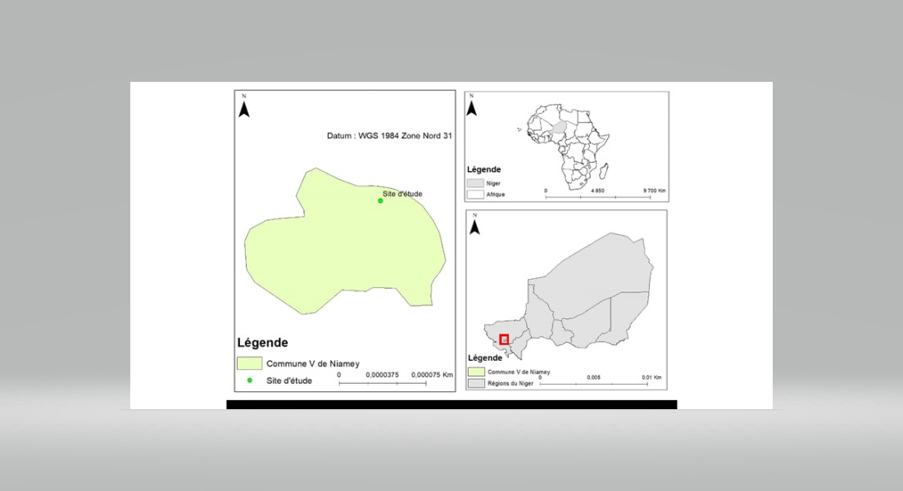
Fig. 1: Location of the experimental site.
The trial was conducted under rainfed conditions during the 2024 cropping season, which was characterized by abundant and regular rainfall across the country. The study area has a Sahelian climate, with high temperatures and a marked rainfall variability typical of semi-arid regions. Fig. 2 shows the monthly distribution of rainfall recorded in Niamey during the experimental period.

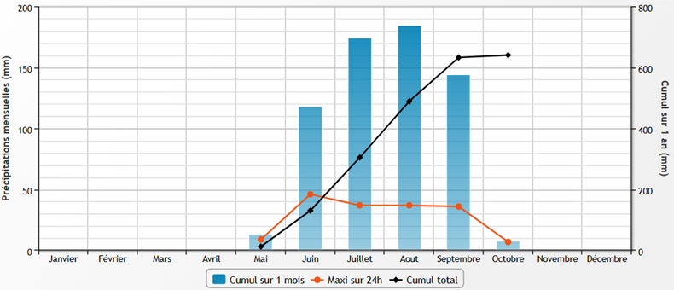
Fig. 2: Monthly rainfall distribution in Niamey during 2024.

2.2 Experimental Design and Crop Management
The field was ploughed to a depth of 15 cm with a moldboard plough before sowing. Sowing was performed manually on July 17, 2024, using a hand hoe to dig planting holes. A basal application of 60 kg.ha⁻¹ of NPK (15-15-15) was applied as a microdose (6 g per planting hole), following the method described by Aune and Bationo (2008).
The experimental layout followed a randomized complete block design (RCBD) with three replications. Each plot measured 10 m² (5 m × 2 m), with 1 m spacing between rows and between planting holes. Thinning was carried out 21 days after sowing to retain three plants per hole. A shallow hoeing was done the same day, followed by manual weeding as needed.
Five dual-purpose sorghum genotypes were tested: Soubatimi, DECO, BKZ1, SKA3, and YOHA3, all originating from the West African sub-Sahelian region. Their growth cycle ranges from 90 to 110 days. Soubatimi and DECO produce white grains, while BKZ1, SKA3, and YOHA3 produce red grains.

2.3 Measured Traits
All measurements were performed on the three central plants of each elementary plot.

2.3.1 Vegetative Traits
Vegetative traits were recorded at the early flowering stage and included: Number of leaves (NL), Leaf length (LL), Maximum leaf width (LW), Leaf area (LA), Plant height (PH), Stem dry weight (SW), Leaf dry weight (LDW)

2.3.2 Growth parameter
The Leaf Area Index (LAI) was calculated from the measured leaf area, using the following formula:
Leaf area = LL × LW × 0.75, where 0.75 is a shape correction factor for narrow leaves (Ma et al., 2013).
LAI was obtained by dividing the total leaf area by the ground area occupied by the sampled plants.

2.3.3 Yield and yield components
At harvest, following 15 days of shade drying, the following parameters were assessed: Number of panicles per hill (NP), Total panicle weight per hill (PW), Number of grains per panicle (NGP), Panicle length (PL), Thousand grain weight (TGW), Grain yield (GY), Fodder yield (FY), Harvest index (HI), calculated as the ratio of grain yield to total dry biomass (grain + fodder).
2.4 Statistical analyses
The collected data were subjected to analysis of variance (ANOVA) after checking for homogeneity of variances using Levene’s test, implemented in RStudio software (version 4.4.2). Mean comparisons were performed using Duncan’s multiple range test at a 5% significance level.
A Principal Component Analysis (PCA) was conducted to explore the relationships among measured traits and to discriminate between genotypes based on their agro-morphological profiles. In addition, Pearson’s correlation coefficient was used to assess the relationships between the different traits.

3. Results
3.1 Agro-morphological Performance of Different Sorghum Genotypes Studied
Data analysis revealed no significant differences (P > 0.05) among genotypes for the following traits: number of leaves (NL), leaf width (LW), leaf area (LA), stem height (SH), leaf area index (LAI), and number of panicles (NP) (Table 1). These traits appear to be relatively stable across the genotypes tested.
In contrast, highly significant differences (P < 0.05) were observed for several key agro-morphological traits, including leaf length (LL), stem dry weight (SW), leaf dry weight (LDW), panicle weight (PW), number of grains per panicle (NGP), grain yield (GY), and harvest index (HI). The genotype Soubatimi notably stood out, exhibiting the highest values for these traits, reflecting its strong grain productivity potential.
Regarding thousand-grain weight (TGW), the variety DECO recorded a significantly higher value (37.75 g), despite having a lower overall yield. Finally, forage yield (FY) was significantly greater in the genotype BKZ1 (4055.56 kg/ha), indicating superior biomass production for dual-purpose use (grain and forage).

Table 1: Comparison of Mean Agro-morphological Traits of Five Sorghum Genotypes
Measured traits | Genotypes
 | BKZ1 | DECO | SKA3 | SOUMBATIMI | YOHA3 | P value
NL | 4,33±1,52 | 6,00±1,00 | 4,33±2,30 | 7,00±1,00 | 7,33±0,89 | 0,1
LL (cm) | 70,43±5,88ab | 56,65±4,33b | 66,91±8,75ab | 82,85±0,51a | 68,45±11,89ab | 0,021
LW (cm) | 6,24±0,72 | 7,25±0,64 | 6,67±1,41 | 8,39±1,03 | 6,33±1,24 | 0,15
LA | 330,33±48,38 | 309,75±57,64 | 341,22±49,55 | 521,19±62,85 | 332,64±118,68 | 0,06
SH (cm) | 160,66±10,06 | 179,10±5,40 | 151,00±32,41 | 143,6±7,68 | 159,66±4,16 | 0,14
SW (g) | 50,52±18,43b | 63,67±13,91b | 109,64±21,37ab | 142,90±37,74a | 63,36±7,98b | 0,0027
LDW (g) | 7,77±2,25b | 12,81±2,61b | 10,00±4,67b | 26,39±7,73a | 12,86±2,28b | 0,0037
LAI | 4,40±0,6 | 4,13±0,76 | 4,55±1,52 | 6,94±0,83 | 4,43±1,58 | 0,06
NP | 11,33±1,21 | 10,33±4,93 | 6,00±1,00 | 10,66±3,78 | 6,33±2,30 | 0,63
PW (g) | 464,90±30,34b | 311,50±82,38b | 363,92±28,14b | 1101,13±114,68a | 427,79±74,13b | 0,0016
NGP | 3464,67±1282,63b | 1131,33±277,05c | 3475,67±662,42b | 5524,33±326,11a | 2912,33±674,56bc | 0,0005
PL (cm) | 36,00±6,55a | 23,00±1,32b | 32,33±0,28a | 29,16±1,44ab | 36,66±2,92a | 0,0033
TGW (g) | 22,96±1,37b | 37,75±2,62a | 28,04±0,51b | 25,37±1,45b | 26,61±3,41b | 0,0001
GY (kg/ha) | 1317,28±317,52bc | 676,89±111,15c | 1609,33±511,31b | 2533,50±261,88a | 1565,06±120,74b | 0,0003
FY (kg/ha) | 4055,56±400,12a | 1766,67±716,67b | 1794,44±671,10b | 2294,44±1005,86ab | 2083,33±689,81b | 0,01
HI (%) | 24,33±4,07c | 28,92±5,43bc | 47,82±4,91ab | 53,93±9,09a | 44,04±10,50ab | 0,023
Means sharing the same letter(s) within the same row are not significantly different at p < 0.05.
NL = number of leaves, LL = leaf length, LW = leaf width, LA = leaf area, SH = stem height, SW = stem dry weight, LDW = leaf dry weight, LAI = leaf area index, NP = number of panicles per plant, PW = panicle weight, NGP = number of grains per panicle, PL = panicle length, TGW = thousand grain weight, FY = forage yield, GY = grain yield, HI = harvest index.

3.2 Correlation analysis
The Pearson correlation matrix highlights significant relationships among several agro-morphological traits (Fig. 3). Strong positive correlations are observed between leaf dimensions (LL, LW, LA), biomass components (SW, LDW, FY), and yield components (PW, NGP, PL, GY). Conversely, the harvest index (HI) is negatively correlated with vegetative biomass and forage yield, reflecting a trade-off between grain and forage production.
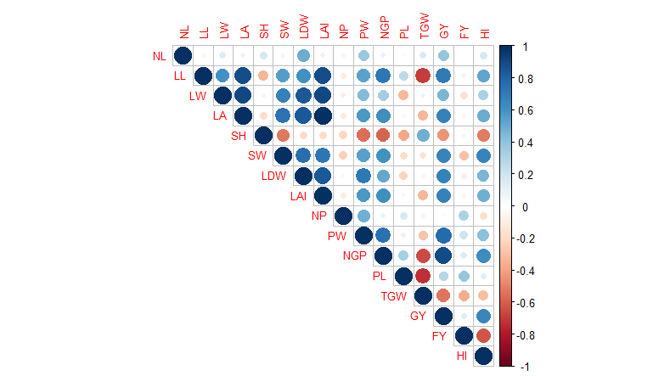
Fig. 3: Pearson Correlation Matrix of Various Agro-morphological Traits of Five Sorghum Genotypes.
NL = number of leaves, LL = leaf length, LW = leaf width, LA = leaf area, SH = stem height, SW = stem dry weight, LDW = leaf dry weight, LAI = leaf area index, NP = number of panicles per plant, PW = panicle weight, NGP = number of grains per panicle, PL = panicle length, TGW = thousand grain weight, FY = forage yield, GY = grain yield, HI = harvest index.

3.3 PCA
Fig. 4 illustrates the proportion of variance explained by each axis in the principal component analysis (PCA)
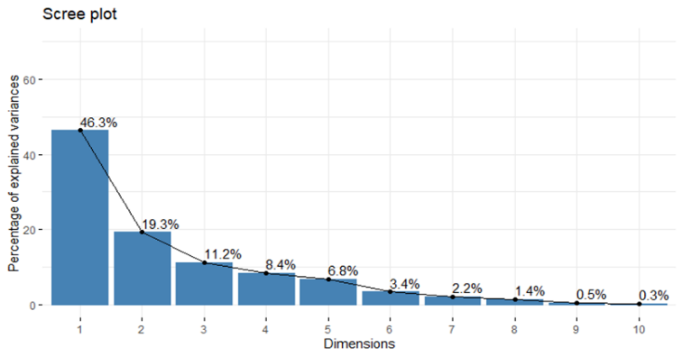
Fig. 4: Variability Explained by the Different dimensions of the PCA.
The first two dimensions (1 and 2) explain 46.3% and 19.3% of the variance, respectively, totaling 65.6% of the overall variance, which is sufficient for a reliable data analysis.
Table 2 presents the contributions and correlations of the measured traits with dimensions 1 and 2. Measured traits such as LA (leaf area), LAI (leaf area index), GY (grain yield), LL (leaf length), LDW (leaf dry weight), NGP (number of grains per panicle), SW (stem dry weight), PW (panicle weight), LW (leaf width), and HI (harvest index) are strongly and positively correlated with dimension 1 (Table 2). Therefore, this dimension can be interpreted as representing vegetative productivity and yield.
Dimension 2 contrasts thousand-grain weight (TGW) and leaf width, which are positively correlated with this dimension, with forage yield (FY) and plant length, which are negatively correlated. Thus, this dimension may reflect a trade-off between individual grain weight and forage yield along with reproductive structures.

Table 2: Contribution of measured traits to the Formation of PCA dimensions 1 and 2
LL = leaf length, LW = leaf width, LA = leaf area, SW = stem dry weight, LDW = leaf dry weight, LAI = leaf area index, PW = panicle weight, NGP = number of grains per panicle, PL = panicle length, TGW = thousand grain weight, FY = forage yield, GY = grain yield, HI = harvest index.
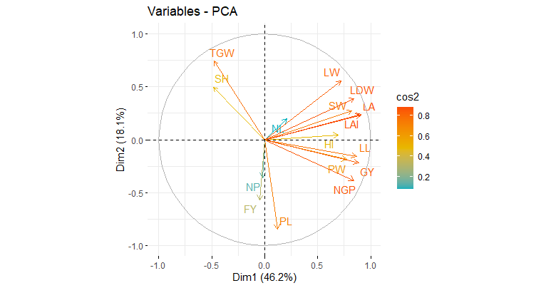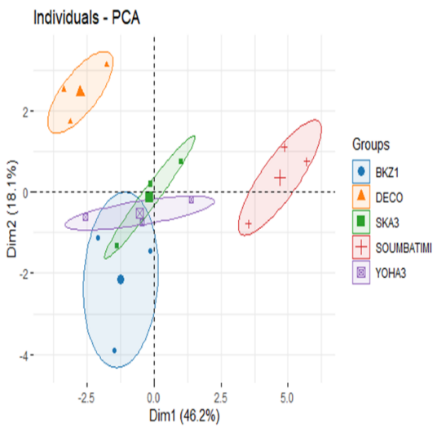
(A) (B)
Fig. 5: (A) PCA correlation circle of measured traits and (B) projection of sorghum genotypes on the first two dimensions.
The projection of sorghum genotypes on the plane defined by the first two principal components (Dim1: 46.2%, Dim2: 18.1%) reveals the formation of five distinct groups, reflecting marked phenotypic differentiation (Fig. 5(B)).
Soubatimi, strongly and positively positioned on Dim 1, is associated with traits related to vegetative productivity and grain yield (GY, LA, LAI, PW, NGP, HI), confirming its superior vigor and grain production performance.
DECO stands out with a positive projection on Dim 2, indicating a strong correlation with thousand-grain weight (TGW), which suggests better grain quality (heavier grains), although its overall productivity remains moderate.
Conversely, BKZ1 is projected negatively on Dim 2, linking it more closely to forage yield (FY) and panicle length (PL). This profile is more oriented toward biomass and forage production, with a trade-off on the grain component.
SKA3 and YOHA3 occupy intermediate positions, showing balanced profiles without marked extremes.

4 Discussion
The results show no significant differences among genotypes for vegetative traits, including the number of leaves (NL), leaf width (LW), and stem height (SH). This consistency suggests that these traits are minimally influenced by genotype under our experimental conditions. This may be due to favorable environmental factors, including ample rainfall and relatively low temperatures recorded in 2024. These findings are consistent with those of Chen et al. (2017) and Tirfi et al. (2022), who highlighted the role of climatic factors like water stress and high temperatures combined with reduced precipitation in influencing sorghum vegetative traits. Conversely, significant differences were observed for key traits such as stem dry weight (SW), grain yield (GY), and harvest index (HI). The variety Soubatimi stood out with high values for these parameters, reflecting superior grain productivity. Due to its robust biomass production and high harvest index, these results may be attributed to a more effective allocation of resources towards reproductive organs, characteristic of improved dual-purpose genotypes (Ngidi et al. 2024).
In contrast, the DECO variety, despite exhibiting a significantly higher thousand-grain weight (TGW), showed a moderate overall yield characterized by the lowest number of grains per panicle (Table 1), highlighting a trade-off between grain quality and productivity. Moreover, our results reveal a negative correlation between the number of grains per panicle (NGP) and thousand-grain weight (TGW), suggesting, as reported by Boyles et al. (2015), that an increase in grain size may be accompanied by a reduction in total grain number, thus affecting overall yield.
Furthermore, the Pearson correlation matrix showed strong positive correlations among vegetative growth traits such as leaf area (LA), stem dry weight (SW), and yield components like number of grains per panicle (NGP) and grain yield (GY). These positive correlations confirm that larger leaves and robust vegetative biomass promote grain production (Ouédraogo, 2014), likely through enhanced photosynthesis (Peng et al. 1991). Conversely, a negative correlation was observed between the harvest index (HI) and forage yield (FY). According to Camargo-Alvarez et al. (2023), the harvest index measures a crop’s ability to allocate assimilates to seeds. Previous studies have shown a trade-off between grain yield and biomass production in sorghum (McIntire et al. 1988). These authors demonstrated that increasing grain production can come at the expense of vegetative biomass, illustrating a classic physiological trade-off: preferential allocation of resources to grain production reduces biomass available for forage, and vice versa.
Principal component analysis (PCA) revealed two major axes (Fig. 5):
(i) Dim 1 (46.3% variance): "Vegetative Productivity and Yield" axis, strongly correlated with parameters such as LA, GY, and NGP. This finding underscores the importance of vegetative vigor for grain production, consistent with the work of Yahaya et al. (2022).
(ii) Dim 2 (19.3% variance): "Grain Quality vs. Forage Biomass Trade-off" axis, contrasting TGW (quality) with FY and panicle length (PL) (biomass). This opposition reflects divergent resource allocation strategies among genotypes. These results corroborate observations by Trouche et al. (1998) who documented similar functional trade-offs in traditional local varieties in the Sahel.
Soubatimi, positively positioned on Dim 1, represents a genotype oriented towards both grain and forage yield, ideal for farming systems aiming at food security. BKZ1, associated with the negative side of Dim 2, corresponds to a forage-oriented profile. DECO, characterized by its grain size predominance, it may be preferred in markets that prioritize grain quality, despite a poor yield.
5 Conclusion
This study confirms the value of dual-purpose sorghum genotypes for enhancing agricultural resilience in Niger. By targeting specific traits such as productivity, grain quality, or forage yield, breeding programs can better address the diverse socio-economic needs of farmers while helping to alleviate food and forage insecurity. The results highlight the potential of dual-purpose sorghums like Soubatimi, which combine good grain yield with acceptable biomass. This profile meets the needs of Nigerien agro-pastoralists who face climatic challenges and increasing demographic pressure. However, widespread adoption of these varieties will depend on improved access to quality seeds and the promotion of suitable agronomic practices such as micro-dosing of fertilizers. Finally, further studies incorporating multi-year data and drought stress conditions are necessary to validate the resilience of these genotypes.

Data availability: The datasets generated during and/or analyzed during the current study are available from the corresponding author on reasonable request.

Disclaimer (Artificial intelligence)
Author(s) hereby declare that generative AI technologies such as Large Language Models, etc. have been used during the writing or editing of manuscripts. This explanation will include the name, version, model, and source of the generative AI technology and as well as all input prompts provided to the generative AI technology
Details of the AI usage are given below:

The authors used OpenAI’s ChatGPT (version GPT-4, May 2025) to improve the clarity and language of the manuscript. The content was generated based on the authors’ original ideas, experimental results, and draft text. All scientific interpretations, analyses, and conclusions remain the responsibility of the authors, who reviewed and approved the final version.

References
Himeno, K., Inoue, N., Kurauchi, N., Ito, O., Nishikawa, Y., & Kobayashi, Y. (2009). Les céréales au Niger. Accent sur le mil et le sorgho. JAICAF – Association pour la collaboration internationale en matière d’agriculture et de forêts du Japon.
Habou, Z. A., Boubacar, M. K., & Adam, T. (2016). Les systèmes de productions agricoles du Niger face au changement climatique : défis et perspectives. International Journal of Biological and Chemical Sciences, 10(3), 1262–1272.
Karim, T. D., Sanoussi, A., Falalou, H., Maârouhi, I. M., Yacoubou, B., & Mahamane, S. (2016). Amélioration du rendement du mil par l’association avec le niébé en zone Sahélienne. European Scientific Journal, 12(9), 382–394.
Institut National de Statistique (INS). (2014). Enquête démographique et de santé et à indicateurs multiples : Rapport final (p. 486).
Yahaya, M. A., & Shimelis, H. (2022). Drought stress in sorghum: Mitigation strategies, breeding methods and technologies—A review. Journal of Agronomy and Crop Science, 208(2), 127–142.
Abroulaye, S., Zampaligré, N., & Abalo, K. E. (2020). Analyse des préférences des agropasteurs pour la production et la conservation du fourrage à base de variétés améliorées de cultures à double objectifs dans deux zones agro-écologiques au Burkina Faso. Journal of Animal & Plant Sciences, 46(3), 8318–8335.
Réseau National des Chambres d’Agriculture du Niger (RECA). (2024). Les variétés de semences certifiées disponibles dans l’Annuaire National 2024 : Mil-Sorgho-Niébé-Arachide (p. 9).
Diallo, M., van Mourik, T. A., Huet, E., de Boef, W., & Bonnand, J. (2021). Rapport de la collecte des données primaires pour l’évaluation du secteur des semences ISSD/SAHEL – Sorgho Niger. KIT Royal Tropical Institute & Wageningen University and Research.
Vaksmann, M., Traoré, S., & Niangado, O. (1996). Le photopériodisme des sorghos africains. Agriculture et Développement, 9, 13–18.
Trouche, G., Chantereau, J., & Zongo, J. D. (1998). Variétés traditionnelles et variétés améliorées du sorgho dans les régions sahéliennes. In Bacci, L., & Reyniers, F. (Eds.), Le futur des céréales photopériodiques pour une production durable en Afrique tropicale semi-aride (pp. 197–208). CIRAD.
Aune, J. B., & Bationo, A. (2008). Agricultural intensification in the Sahel—the ladder approach. Agricultural Systems, 98, 119–125.
Chen, J., Chopra, R., Hayes, C., Morris, G., Marla, S., Burke, J., et al. (2017). Genome-wide association study of developing leaves' heat tolerance during vegetative growth stages in a sorghum association panel. The Plant Genome, 10(2), eplantgenome2016-09.
Tirfi, A. G. (2022). Sorghum yield response to climate and other input factors in Ethiopia. Depression, 17, 18.
Ngidi, A., Shimelis, H., Abady, S., Chaplot, V., & Figlan, S. (2024). Genetic variation and association of yield, yield components, and carbon storage in sorghum (Sorghum bicolor [L.] Moench) genotypes. BMC Genomic Data, 25(1), 74.
Boyles, R. E., Cooper, E. A., & Myers, M. T. (2016). Genome‐wide association studies of grain yield components in diverse sorghum germplasm. The Plant Genome, 9(2), eplantgenome2015.09.0091.
Ouédraogo, M. (2014). Étude de la diversité agro-morphologique du sorgho et identification de cultivars tolérants au stress hydrique post-floral [Mémoire d’ingénieur, Centre Agricole Polyvalent de Matourkou]. 77 pages.
Peng, S., Krieg, D. R., & Girma, F. S. (1991). Leaf photosynthetic rate is correlated with biomass and grain production in grain sorghum lines. Photosynthesis Research, 28, 1–7.
Camargo-Alvarez, H., Elliott, R. J. R., Olin, S., Wang, X., Wang, C., Ray, D. K., & Pugh, T. A. M. (2023). Modelling crop yield and harvest index: The role of carbon assimilation and allocation parameters. Modeling Earth Systems and Environment, 9(2), 2617–2635. https://doi.org/10.1007/s40808-022-01625-x
McIntire, J., Reed, J. D., Teḍla, A., Jutzi, S., & Kebede, Y. (1988). Evaluating sorghum cultivars for grain and straw yield. In Plant Breeding and the Nutritive Value of Crop Residues: Proceedings of a Workshop Held at ILCA, Addis Ababa, Ethiopia, 7-10 December 1987 (pp. 283). ILRI.
Yahaya, M. A., Shimelis, H., Nebié, B., Ojiewo, C. O., & Danso-Abbeam, G. (2022). Sorghum production in Nigeria: Opportunities, constraints, and recommendations. Acta Agriculturae Scandinavica, Section B — Soil & Plant Science, 72(1), 660–672.

