Acute Oral Toxicity Assessment of Xlivpro premix in Wistar Rats: A Liver protective Herbal Premix
ABSTRACT
The study was aimed to evaluate the acute oral toxicity and safety profile of Xlivpro Premix in accordance with OECD-423 guidelines. Experimental study involving the assessment of toxic effects and mortality in adult Wistar rats following oral administration of Xlivpro Premix. The study was conducted at the Department of Veterinary Pharmacology and Toxicology, Post Graduate Institute of Veterinary and Animal Sciences (PGIVAS), Akola, Maharashtra, India over a period of 14 days. Six healthy adult Wistar rats (113–134 grams) were administered Xlivpro Premix orally at doses of 300 mg/kg and 2000 mg/kg body weight. Observations for toxic effects and mortality were recorded for 14 days. Blood biochemical parameters including AST, ALT, ALP, and creatinine were measured. At the end of the study, histopathological examinations of vital organs including the heart, liver, kidneys, and lungs were performed. No toxic effects or mortality were observed in Xlivpro-treated rats during the experimental period. Changes in body weight over the 14-day period remained within normal limits. Biochemical parameters and histopathological evaluations indicated no significant abnormalities. The LD50 of Xlivpro Premix exceeded 2000 mg/kg, confirming the safety of formulation.
Keywords: acute; OECD-423; poultry; Wistar rat; Xlivpro Premix

- INTRODUCTION:

Poultry industry holds significant economic importance by generating employment, providing livelihood to small scale farmers, by generating regular income from the sale of eggs and meat, enhancing food security with high-quality protein etc. The total poultry population in India is about 851.81 million according to 20th livestock census making it world's fifth-largest producer of chicken and third-largest producer of eggs (BAHS 2023, DAHD-Govt. of India). The health and productivity of poultry rely on optimal feed utilization, increased body weight, absence of disease, and low mortality rates (Singh et al., 2009). Aquaculture, on the other hand, is another rapidly growing and vital sector in the food production industry, with an average annual fish production growth rate of 7.98% recorded during 2022-2023. Currently, India ranks third among the top five fish exporting countries in the world (Handbook on Fisheries statistics 2023).
Over the years, the use of antibiotics at sub-therapeutic levels to promote growth and immunity in poultry and aquaculture has become increasingly limited. Since several countries imposes ban on the utilization of antibiotics solely for growth promotion. This move aimed to combat antimicrobial resistance (AMR) and ensure the safety of food products and public health. As an alternative, the use of phytobiotics in poultry as well as in aquaculture is emerging as a novel approach. Phytobiotics, which are plant derivatives such as herbs or plant extracts, or spices, offer a wide range of benefits, including stimulating feed intake, growth, serve as immunomodulators, resulting in reduced mortality (Abbas et al., 2010; Grashorn, 2010).
There is increasing scientific evidence supporting the use of plants and their extracts, for medicinal purpose in various animal species. In the poultry, specialized feed ingredients are added to boost growth performance and improve feed conversion ratios (FCR) (Babazadeh et al., 2011; Mirza et al., 2016). In broilers, high-energy diets, coccidiostats, and chemotherapeutic agents, place additional stress on the liver, potentially impairing its growth and function. With the phasing out of antibiotics, herbal liver tonics are being explored as natural alternatives to stimulate liver function, protection from toxins, support regeneration, and enhancing growth and production performance (Hajare et al., 2020). In layers, incorporation of liver-supportive herbs in the diet help maintain productivity, improve egg quality, and promote overall health and longevity. In fish, the liver plays a central role in nutrient metabolism, detoxification, bile production, and immune regulation and inclusion of herbal additives supports health and growth in aquaculture.
Andrographis paniculata has been found to exhibit liver protective effects by enhancing the activity of antioxidant enzymes such as superoxide dismutase, catalase, glutathione peroxidase, and decreasing lipid peroxidase activity. These actions help mitigate the generation of free radicals that can damage liver cells (Shukla et al.,1992 and Trivedi et al., 2001). It also shows antibacterial, antioxidant and immunostimulant effects in fish (Rosidah and Diana, 2021). Azadirachta indica contain triterpenoids, sterols, etc which help to manage infections, making them a viable alternative to antibiotics for promoting the health and productivity of poultry, as well as in aquaculture (Patel et al. 2021). Boerhaavia diffusa, which contains Boeravinones G and H, demonstrated significant antioxidant and hepatoprotective properties, enhancing the activity of antioxidant enzymes and reducing oxidative stress. This plant also possesses diuretic properties, helping manage fluid balance, and has shown antibacterial activity (Somvanshi et al., 2020). Therefore, Xlivpro Premix in poultry and aquaculture is recommended for mitigating the damaging effects of aflatoxins, restoring reduced feed intake, improving liver function, and optimizing feed utilization, growth, and production. Considering the high commercial value of Xlivpro Premix the present study aimed at studying its safety by determining the acute oral toxicity potential of Xlivpro Premix.

2. MATERIALS AND METHODS
The study was conducted at the Department of Veterinary Pharmacology and Toxicology, Post Graduate Institute of Veterinary and Animal Sciences (PGIVAS), Akola, Maharashtra, India. The institute is situated at a latitude of 20.70⁰ N and a longitude of 77.070⁰ E, with an elevation between 287 and 316 meters above sea level, and experiences a tropical climate. Six healthy young adults female Wistar rats, weighing 113 to 134 g, were used in this study. The study was conducted from 13th April to 26th April 2022. The animals were acquired from the Laboratory Animal Resource Section at PGIVAS, Akola. A total of four animals in one cage with corn cob as bedding material were used for ease of monitoring. Picric acid was used for animal identification. During the experiment the ambient temperature of 25±2⁰C was maintained and humidity was in the range of 50-70% during the experiment period. The animals were kept under a 12 hour light-dark cycle and had access to standard pelleted feed and water ad libitum. The animals were housed in polypropylene cages 5 days prior to experimentation as a period of acclimatization (OECD, 2001). Before the experiment began, the study protocol was approved (approval no.312/01/2000/03/22, dated 08.04.2022) by the IAEC (312/GO/ReBi/2000/CPCSEA) of PGIVAS, Akola.
Table 1. Design of acute oral toxicity study
Group No. | Type of Study Used | Number of Animals | Dose (mg/kg body weight)
I  II  III | Step 1: Sighting study  Step 2: Sighting study  Main study | 01  01  04 | 300  2000  2000

The rats were divided into three distinct experimental categories (Table 1) and were deprived of food, but not water, overnight prior to dosing. Post-fasting, the weights of all the rats were recorded. The Xlivpro Premix test substance (provided by M/s Zenex Animal Health India Private Limited) was dissolved in distilled water and administered to one rat each from Group I and Group II, at doses of 300 mg/kg and 2000 mg/kg of body weight, respectively. Observations were made to note any signs of toxicity. Since no toxic symptoms were observed in the sighting study for Group I and Group II, the main study commenced, in which all four rats in Group III were given the test substance at a dose of 2000 mg/kg of body weight. After dosing, rats in Groups I, II, and III were deprived of food for an additional 1-2 hours.
The animals were monitored for any signs of mortality, convulsions, tremors, labored breathing, piloerection, salivation, lethargy, coma, or any other abnormal behaviors. Any changes in body weight, coat condition, eyes, mucous membranes, and behavior were documented. After a 14-day observation period, the animals were euthanized using high thiopental sodium and vital organs (heart, liver, kidneys, and lungs) were collected and preserved in 10% neutral buffered formalin for histopathological examination. Sections of 4-6 µm were prepared using a rotary microtome and stained with H&E stain for histopathological analysis, as per Luna (1968). A sample of 1-2 ml of blood was drawn from the retro-orbital plexus with a capillary tube and collected in EDTA vials for biochemical estimation of alanine transaminase (ALT), aspartate aminotransferase (AST), alkaline phosphatase (ALP)and creatinine.

3. RESULT AND DISCUSSION
The body weights of each rat were recorded individually on days 0, 7, and 14 of the study. During this period, rats in the main test group (Group III) exhibited normal increase in body weights (Table 2). Biochemical analysis indicated that the levels of ALT, AST, ALP, and creatinine remained within their respective normal ranges (Table 3). Xlivpro Premix orally at a dosage of 2000 mg/kg did not result in any mortality among the rats (Table 4), establishing the LD₅₀ of the compound to be greater than 2000 mg/kg of body weight. Furthermore, no abnormal symptoms such as tremors, labored breathing, piloerection, convulsions, salivation, lethargy, or coma were observed over the experimental duration of 14 days. In gross histopathological examination no abnormal finding was observed on any of the visceral organs. Additionally, in microscopical examination there were no significant histological abnormalities detected in the heart, liver, kidney, or lungs that could be attributed to the toxicity of the test substance (Fig. 1).
Xlivpro Premix contains herbs such as Andrographis paniculata, Azadirachta indica, and Boerhaavia diffusa which are the key ingredients uesd in number of formulations in ayurvedic and Indian traditional medicine. These herbs known to possess hepatoprotective, immunomodulatory, antibacterial and free radical scavenging activities which are important for relieving stress and improving production (Trivedi et al., 2001; Somvanshi et al., 2020).
A. paniculata traditionally called as King of Bitters, Kalmegh, is used in the world as ayurvedic and homeopathic medicine, consisting mainly Andrographolide (flavone), polyphenols, terpenoids (diterpene, lactones, ent-labdane), xanthones, nocordioides. Andrographolides and their derivatives exhibit immunostimulatory, antiviral, anti-bacterial, anti-inflammatory, anti-platelet aggregation, anti-diabetic, anti-tumour, anti-microbial and hepatoprotective activity. Andrographolide is the major chemical constituent in a herb which is found mainly in leaves (Swaroop et al., 2021).
A. indica commonly known as Neem has many properties of pharmacology due to its various active constituents like azadiracthin , nimbidin, nimbolin, nimbin, gedunin, quercetin etc. Boerhavia diffusa, a perennial herb commonly called as Punarnava contains some bioactive chemical constituents mainly punarnavine, isoflavonoids, sitosterol, Eupalitin etc. show pharmacological and therapeutic properties which includes immunomodulatory, anti-inflammatory, anti-diabetic, anti-oxidant, anti-viral, anti-fungal, anti-microbial and anti-stress (Swaroop et al., 2021).
Remarkably, no adverse behavioural or physiological symptoms were observed in any of the rats. The animals maintained normal grooming habits and exhibited no signs of distress or discomfort. Specifically, there were no occurrences of tremors, which would typically indicate neurological disturbances, nor there was any evidence of convulsions or muscle spasms. Respiratory function remained stable, with no signs of labored breathing, gasping, or abnormal respiratory patterns. The fur of the rats remained smooth and well-kept, with no signs of piloerection—a common indicator of systemic stress or autonomic nervous system activation. Additionally, there were no instances of excessive salivation, which could suggest irritation or toxicity affecting the oral or gastrointestinal tract. The animals did not display lethargy or reduced activity levels; instead, they remained alert and responsive throughout the study duration. Importantly, there were no signs of coma or loss of consciousness, which would be indicative of severe central nervous system depression. The absence of these symptoms strongly suggests that Xlivpro Premix does not exert any acute toxic effects on the nervous, respiratory, or gastrointestinal systems under the tested conditions. These findings, combined with the lack of mortality and the normal progression of body weight gain, reinforce the conclusion that the compound is well tolerated and safe for oral administration at the tested dosage.
The absence of gross pathological lesions, and mortality strongly indicates a wide margin of safety of product. Based on these findings, Xlivpro Premix can be considered non-toxic under acute oral exposure conditions, supporting its safe use as an oral feed supplement in poultry, fish and shrimp production.

Table 2. Weekly body weight of rats received Xlivpro Premix @ 2000mg/kg
Dose of Xlivpro Premix | Rat No. | Body Weight (g) on Day
Dose of Xlivpro Premix | Rat No. | 0 | 7 | 14
2000mg/kg | 1 | 138 | 152 | 164
2000mg/kg | 2 | 117 | 129 | 135
2000mg/kg | 3 | 120 | 134 | 152
2000mg/kg | 4 | 126 | 141 | 155
 | Total | 125.25±4.64 | 139±4.98 | 151.5±6.06
Key: F= Female, Total values are expressed as Mean±SE (standard error)

Table 3: AST, ALT, ALP and creatinine values in experimental rats treated with Xlivpro Premix@2000mg/kg
Dose of Xlivpro Premix | Rat No. | Biochemical parameters
 |  | AST | ALT | ALP | Creatinine
2000mg/kg | 1 | 62.79 | 26.09 | 82.06 | 0.55
2000mg/kg | 2 | 40.52 | 20.11 | 79.25 | 0.51
2000mg/kg | 3 | 56.60 | 27.43 | 67.44 | 0.57
2000mg/kg | 4 | 47.92 | 22.70 | 86.32 | 0.46
 | Total | 51.95±4.88 | 24.08±1.65 | 78.76±4.04 | 0.52±0.02
Rat No. 1, 2 3 and 4 are from main test group III, Total values are expressed as Mean±SE (standard error)

Table 4: Mortality records in rats treated with Xlivpro Premix
Group No | Dose  Xlivpro premix | Number of animals used | Mortality after Dosing at |  |  |  |  |  |  | Mortality
Group No | Dose  Xlivpro premix | Number of animals used | 1-3  hr | 6  hr | 24  hr | 48  hr | 72  hr | 4-7 Days | 8-14 Days | Total mortality | Mortality %
I | 300mg/kg  Sighting study | 1 | No | No | No | - | - | - | - | Nil | Nil
II | 2000mg/kg  Sighting study | 1 | No | No | No | - | - | - | - | Nil | Nil
III | 2000mg/kg  Main study | 4 | No | No | No | No | No | No | No | Nil | Nil
Key: No= No mortality

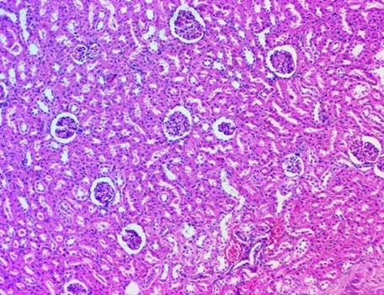
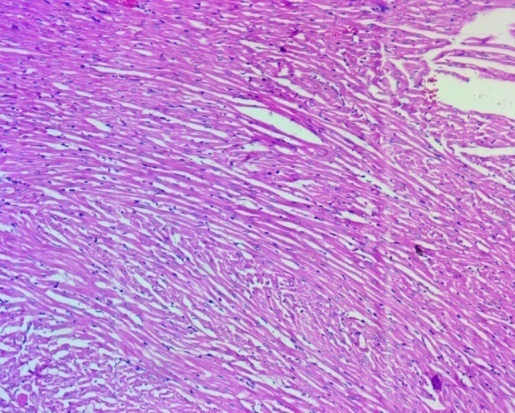
B
A

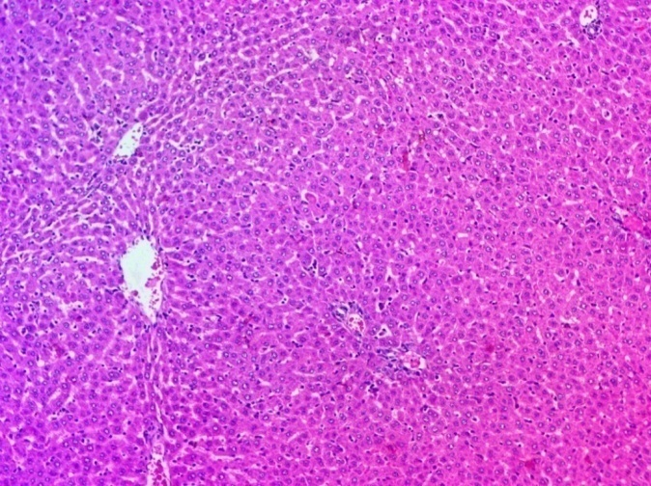..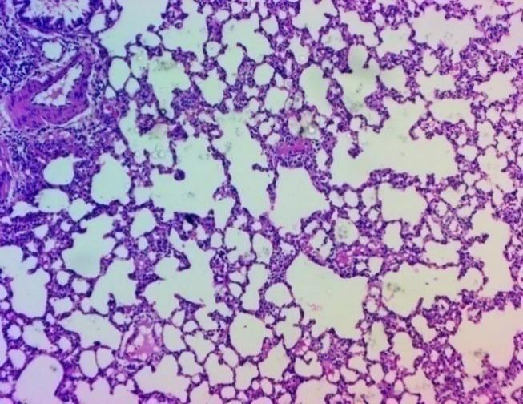
C
D
Fig 1 Histopathological observations of tissue sections showing normal histoarchitecture of Heart (A), Kidney (B), Liver (C) and Lung (D) from group III rats received Xlivpro Premix formulation @2000mg/kg BW.

- CONCLUSION:
The present study concludes that Xlivpro Premix, a liver-protective herbal formulation intended for poultry, fish and shrimp production, does not elicit any signs of acute toxicity, behavioral abnormalities, or mortality when administered orally at a limit dose of 2000 mg/kg body weight in Wistar rats. The absence of clinical signs, gross pathological lesions, and mortality strongly indicates a wide margin of safety of product. Based on these findings, Xlivpro Premix can be considered non-toxic under acute oral exposure conditions, supporting its safe use as an oral feed supplement in poultry.

AcknowledgEments
The authors are thankful to Dean, college of veterinary and animal sciences, Akola, Maharashtra, India for providing infrastructure facilities and Zenex Animal Health India Private Limited, Baddi, Himachal Pradesh for providing financial support and samples to conduct the research.
COMPETING INTERESTS
Authors have declared that no competing interests exist.
DISCLAIMER (ARTIFICIAL INTELLIGENCE)
Author(s) hereby declares that no generative AI technologies such as Large Language Models (ChatGPT, COPILOT, etc.) and text-to-image generators have been used during the writing or editing of this manuscript.
REFERENCES
Abbas, R.Z., Iqbal, Z., Khan, M.N., Zafar, M.A. and Zia, M.A. 2010. Anticoccidial activity of Curcuma longa L. in broilers. Brazilian Archives of Biology and Technology, 53: 63-67.
Babazadeh, D., Vahdatpour, T., Nikpiran, H., Jafargholipour, M. A., & Vahdatpour, S. (2011). Effects of probiotic, prebiotic and synbiotic intake on blood enzymes and performance of Japanese quails (Coturnix japonica). The Indian Journal of Animal Sciences, 81(8).
Basic Animal Husbandry Statistics for the year 2023, published by the Department of Animal Husbandry and Dairying (DAHD), Government of India.https://dahd.gov.in/sites/default/files/2024-05/BAHS2023.pdf
Grashorn, M.A. 2010. Use of phytobiotics in broiler nutrition- An alternative to infeed antibiotics? Journal of Animal and Feed Sciences, 19: 338-47.
Hajare, S., Ingole, R. S., Kotagiri, R., & Ganguly, B. (2020). Evaluation of acute oral toxicity of a polyherbal liver tonic for poultry. Biosciences Biotechnology Research Asia, 17(1), 85.
Handbook of fisheries statistics 2023 https://www.scribd.com/document/764160577/Handbook-Fisheries-Statistics-19012023
Mirza, M. W., & Mukhtar, N. (2016). Use of organic acids as potential feed additives in poultry production. Journal of World's Poultry Research, 6(3), 105-116.
Patel, S. V., Maru, H., Chavda, V. K., Shah, J. N., & Patel, S. S. (2021). Ethanolic extract of Azadirachta indica ameliorates ovarian defects through phosphoinositide-3 kinase inhibition in a rat model of polycystic ovary syndrome. Asian Pacific Journal of Reproduction, 10(1), 21-28.
Rosidah and Diana S. (2021). A Mini-review: Effect of Andrographis paniculata nees on fish health. International Journal of Fisheries and Aquatic Studies 2021, Vol. 9, Issue 5, Part b. DOI: https://doi.org/10.22271/fish.2021.v9.i5b.2571
Shukla, B., Visen, P. K. S., Patnaik, G. K., & Dhawan, B. N. (1992). Choleretic effect of andrographolide in rats and guinea pigs1. Planta medica, 58(02), 146-149.
Singh, V. K., Chauhan, S. S., Ravikanth, K., Maini, S., & Rekhe, D. S. (2009). Effect of dietary supplementation of polyherbal liver stimulant on growth performance and nutrient utilization in broiler chicken. Veterinary World, 2(9).
Somvanshi, S. P. S., Gupta, R., Kaur, N., Kumar, A., & Pandey, N. K. (2020). Effect of herbal liver stimulants on growth and performance of broiler chicks. Indian Journal of Extension Education, 56(1), 69-72.
Swaroop,A. K., Venkata N L., Meena Shanmugam, Subramanian G., Natarajan J., Jubie Selvaraj. Plant Derived Immunomodulators; A Critical Review. Advanced Pharmaceutical Bulletin. 2021 ;12(4):712–729. doi: 10.34172/apb.2022.074.
Trivedi, N. P., & Rawal, U. M. (2001). Hepatoprotective and antioxidant property of Andrographis paniculata (Neem) in BHC induced liver damage in mice.

