***Review Article***

**Climate Change Impacts on Insect Biodiversity and Distribution: A Review**

**Abstract**

Insects are vital to various ecosystems as pollinators, decomposers, and food sources for many organisms. They dominate diverse terrestrial (e.g., glassland) and aquatic (lakes, oceans, rivers, etc.) ecosystems. Climate change is an increasing global issue with extensive impacts on ecosystems, mostly on insect diversity and distribution. Insects, because of their brief life span and ecological vulnerability, are used as early warning signs of environmental change. This review encapsulates the encountered and anticipated impacts of climate change temperature change, changed precipitation patterns, and loss of habitat on insects. Key impacts are changes in phenology, expansions or contractions of ranges, population dynamics, and heightened extinction risk. Elevated atmospheric carbon dioxide levels are increasingly recognised for their profound impact on terrestrial ecosystems, particularly in the dynamics between plants and insects. Under heightened CO₂ conditions, plants exhibit significant alterations in physiology and biochemistry, including changes to nutrient composition and the production of secondary metabolites. Such modifications can reduce the efficacy of innate plant defences, rendering them more susceptible to herbivorous attack. In parallel, insects may adjust their feeding behaviour and metabolic pathways in response to these changes, potentially exacerbating pest pressures on agricultural systems. Implications for ecosystem services like pollination and biological control are also addressed in the paper, as well as pointing out the importance of enhanced monitoring, modeling, and conservation efforts.

**Keywords:** climate change, insect biodiversity, species distribution, phenology, extinction, ecosystem services

**1. Introduction**

Insects are one of the most ecologically complex and diverse groups of organisms on Earth, accounting for over 80% of all animal species known (Stork, 2018). They play a broad range of critical ecological roles, such as pollination, nutrient cycling, seed dispersal, and contributing to terrestrial ecosystems' stability and health as a primary food resource for numerous vertebrate and invertebrate species (Prather et al., 2013). Therefore, the health and stability of terrestrial ecosystems are closely linked to the health of insects. Climate change significantly impacts insect populations, distribution, and dynamics. Rising temperatures generally lead to faster development and increased survival of insects in mid to high latitudes, resulting in range expansions and shifts in species distributions. These changes can alter insect–plant interactions, pest damage to crops, and food security (Ojija et al., 2025).

Climate change is reshaping ecosystems globally, with profound impacts on insect populations. This review explores the multifaceted effects of climate change on insects, focusing on alterations in population dynamics, distribution patterns, and ecological functions. As global temperatures rise and extreme weather events become more frequent, insects are experiencing shifts in their developmental rates, survival, and distribution. Warmer temperatures generally accelerate insect development and can enhance survival rates for some species, while disrupting overwintering processes and potentially leading to increased competition and resource depletion. Changes in precipitation and humidity further affect insect habitats, physiological stress, and breeding sites, influencing population densities and disease dynamics. The review highlights significant shifts in insect distribution, including poleward and altitudinal movements in response to changing climates. These shifts are leading to non-native species' invasion of new areas and alterations in local ecosystems (Balaji et al., 2024). Yet, over the past few decades, insect diversity has faced mounting pressure from a gamut of environmental stressors, the most prominent among them being climate change (Wilson, and Fox, 2021). Anthropogenic greenhouse gas emissions are driving climate change primarily, and it is transforming temperature regimes, precipitation regimes, and the frequency of extreme climate events globally (Yadav et al., 2024). These changes are of special influence for insects because they are small, ectothermic animals with short generation times, which render them strongly responsive, frequently quickly to varied in environmental conditions.

Phenomena of climate change found to influence populations of insects include alterations in phenology (the timing of the life cycle events), alterations in geographic boundary limits, changed population dynamics, and sometimes local or global extinctions (Karuppaiah, and Sujayanad, 2012). For example, numerous insect species are increasingly becoming active earlier in the year as a result of warmer temperatures in spring, which could desynchronize host-plant or predator interactions (Stange, and Ayres, 2018). Others are shifting their ranges poleward or to higher altitudes to find appropriate climates, resulting in new species interactions and community structures. Concurrently, certain species that have poor dispersal capabilities or specialized habitat needs are experiencing increased extinction threats from habitat fragmentation and loss of climatic refugia (Holyoak, and Heath, 2016).

**Table-1. Effects of Climate Change on Insect Biodiversity and Distribution**

|  |  |  |
| --- | --- | --- |
| **Climate Change Factor** | **Effect on Insects** | **Examples** |
| **Rising Temperatures** | Accelerated development Range shifts toward poles/higher altitudes  Increased voltinism or heat stress | Butterflies shifting north in Europe Thermal stress in bumblebees |
| **Altered Precipitation** | Changes in breeding cycles Habitat desiccation  Reduced plant host quality | Drought reducing food for caterpillars Mosquito breeding in stagnant water |
| **Extreme Weather Events** | Direct mortality Habitat destruction Disruption of ecological interactions | Storms destroying insect habitats Heatwaves killing pollinators |
| **Phenological Shifts** | Mismatches between insect life cycles and host plants or prey | Pollinators emerging before or after flowering plants |
| **Habitat Loss/Fragmentation** | Reduced connectivity for migration Isolated populations more vulnerable | Forest insects unable to migrate to cooler zones |
| **Invasive Species Expansion** | New pests and disease vectors enter ecosystems Competition with native species | Aedes mosquitoes expanding into temperate regions |
| **Oceanic/Coastal Changes** | Affects coastal insect communities like salt marsh flies and mangrove pollinators | Loss of breeding grounds due to sea level rise |

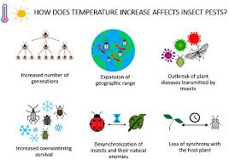These environmental changes have cascade impacts on ecosystem services. Pollination, a service essential to both reproduction in wild plants and global agriculture, is especially susceptible to interference in insect communities (Nicholls, et al., 2013). Likewise, collapse of predator and parasitic insects could undermine natural pest control processes, with implications for food security and biodiversity protection.

**Figure-1. Effect of temperature on insect**

(Source, Skendzic et al., 2021)

With the emphasis and intricacies in these challenges comes the imperative of refining our knowledge on how climate change affects insect biodiversity and distribution (Sharma et al., 2023). This review brings together existing knowledge on documented and projected insect reactions to climate change, identifies foremost ecological and conservation implications, and sets priorities for future research and policy intervention. Through this integration, we seek to inform adaptive management approaches that have the potential to protect insect diversity and the critical ecosystem services they provide.

**2. Mechanisms of Climate Change Impact on Insects**

Climate change affects insect populations through a number of direct and indirect mechanisms, most of which are related to the physical and biological properties of insects as ectothermic animals (Stange, and Ayres, 2010). Such mechanisms include temperature-related physiological responses, alterations in moisture availability, and the frequency and severity of extreme weather events. Collectively, these mechanisms modify the developmental rates, behavior, distribution, and survival of insect species in various ecosystems (Ummenhofer, and Meehl, 2017).

**2.1 Temperature Sensitivity and Metabolic Rates**

Being ectotherms, insects depend upon environmental temperatures for temperature-dependent regulation of their metabolic processes (Irlich et al., 2009). Thus, fluctuations in ambient temperatures can have significant impacts on insect development, behavior, and life cycle processes. Generally, warmer temperatures speed up metabolic activities, tending to result in accelerated development and enhanced voltinism, the number of generations per annum. For instance, warmer temperatures have allowed some pest insects, like the spruce bark beetle (*Dendroctonus rufipennis*), to produce more generations per year, resulting in extensive forest damage (Bentz, and Jönsson, 2015).

There are limitations on thermal tolerance, though. Most insects possess extremely limited thermal windows within which they can operate efficaciously. Extended exposure at temperatures outside these limits will cause thermal stress, suppress fecundity, compromise immune function, or result in death (Boni, 2009). In addition, even low-level thermal stress has the potential to impair vital physiological functions like flight ability, foraging proficiency, and reproduction. Species that are habituated to colder climates, such as alpine or polar insects, are particularly susceptible to warming temperatures and potentially experience extirpations locally as favorable thermal habitats contract (Danks, 2007).

**2.2. Secondary Consequences of Temperature Rise to Insects**

Though immediate rises in temperature directly impact insect physiology, behavior, and mortality, secondary consequences frequently have more profound and long-lasting effects (Ma, et al., 2021). A primary secondary effect is the modification of insect-plant interactions. Increased temperature may promote faster growth of plants and modify flowering dates, which can bring about mismatches in timing between insects and their food plants or pollination partners (Scaven, and Rafferty, 2013). Also, temperature-mediated host plant quality change can influence herbivore growth and reproduction. Disruption of host-parasite and predator-prey relationships is another important secondary effect. For instance, warmer temperatures have the potential to differentially impact predator and prey life cycles, causing population imbalance (Gérard, 2020). In addition, warmer temperatures can broaden the range of certain insects, particularly pests and disease vectors, introducing them to new ecosystems where native organisms might have no inherent protection. These cascading ecological impacts amplify existing stressors on insect populations, ultimately affecting biodiversity and ecosystem stability (Yadav, et al., 2024).

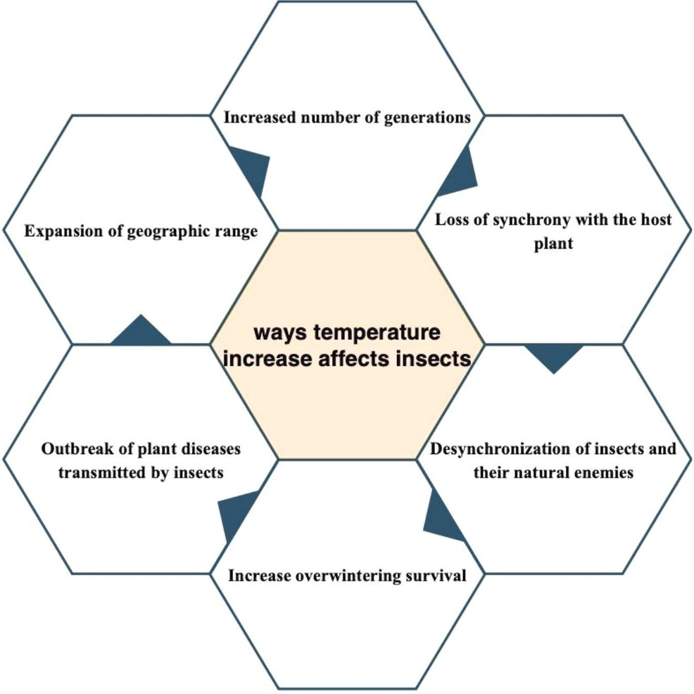

**Figure-2. Temperature increasing affected on insect**

(Source, Regina et al., 2024)

**2.3 Precipitation and Humidity Changes**

Besides temperature, water availability, modulated by precipitation and humidity patterns, is an essential environmental parameter for insect survival and reproduction (Jaworski, and Hilszczański, 2013). Global change is modifying rainfall patterns globally, which in turn is changing moisture availability both regionally and locally. These modifications affect a variety of ecological parameters, such as the frequency and quality of host plants, microhabitat structure, and site availability for breeding (Walter, 2018).

For herbivorous insects, drought can lower plant vigor, nutritional value, and defensive chemistry, thus impacting insect performance and survival. Some insects, however, can gain from plant stress if it decreases plant defense (War et all., 2012). For freshwater and semi-aquatic insects, declines in freshwater resources can cause habitat loss, lower reproductive rates, and higher risk of desiccation. On the other hand, heavy rainfall or flooding can sweep away eggs or larvae, disturb nesting sites, and heighten the presence of pathogens in flooded habitats (Bett et al., 2021).

Humidity also contributes to insect physiology through its effects on resistance to desiccation and water loss in cuticles. In this way, insects that live in arid or fluctuating habitats can possibly have to change their behavior or life cycles because of changes in humidity regimes, possibly changing their ecological niches and interactions with other species (Chown, et al., 2011).

**2.4. Insects’ Responses to CO₂**

Understanding ecological dynamics is essential to predicting and mitigating the effects of climate change on insect populations and the ecosystems they inhabit. Among the many environmental changes driven by global warming, rising atmospheric carbon dioxide (CO₂) levels play a significant role (Yadav et al., 2024). Increased CO₂ not only alters plant physiology and nutritional quality, which directly impacts herbivorous insects, but also affects insect behavior, reproduction, and survival. While multiple factors contribute to the decline in insect populations, such as habitat loss, pesticide use, and temperature extremes, this discussion will primarily focus on the specific influence of elevated CO₂ levels on insect ecology (Wagner, 2020). Recent studies have illuminated the multifaceted effects of elevated CO₂ on plant–insect interactions. For example, research published in Environmental Pollution demonstrated that higher CO₂ levels can induce substantial alterations in host plant nutrient profiles and secondary metabolite production, which in turn diminish plant defences and exacerbates damage by pests such as western flower thrips. In addition, a foundational study in Agriculture Ecosystems & Environment revealed that elevated CO₂ not only reduces plant quality but also indirectly alters the performance of omnivorous predators and their herbivorous prey, thereby reshaping trophic interactions (Bede & Blande, 2024).

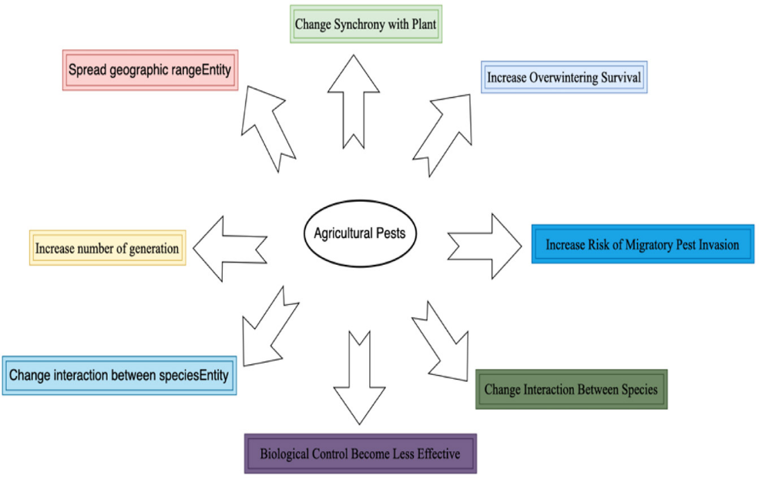

**Fig. 3.** Effect of increase CO2 on agricultural pest.

**2.5 Extreme Weather Events**

Climate change is linked to increased frequency and severity of extreme weather events such as heatwaves, storms, floods, and cold snaps (Seneviratne, et al., 2021). These events have short-term and catastrophic impacts on insects, resulting in direct mortality or sublethal stress. For instance, heatwaves can exceed lethal temperature levels for a wide range of species, particularly those that are immobile or lack good heat tolerance (Kundzewicz, 016).

Beyond their direct effects, extreme weather events can also initiate cascading ecological impacts. For example, strong storms can ruin nesting habitats for pollinators like bees or interfere with the timing of plant flowering, which creates plant-pollinator mismatches (Forrest, 2015). Hurricanes and floods homogenize habitats, lower resource levels, and enable the expansion of invasive species that outcompete local insects (Rippel, et al., 2021).

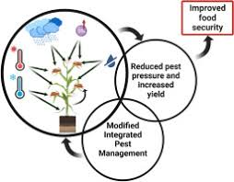

(Source, Subedi et al., 2023)

Figure-4. Impact of crop production due to climate change

In addition, sudden and unpredictable environmental changes have the potential to disrupt the timing of ecological interactions. Phenological mismatches where the emergence of insects no longer coincides with the occurrence of the most important resources or the presence of mutualistic partners are likely to decrease reproductive success and weaken population stability (Renner, and Zohner, 2018). These mismatches are especially threatening to specialist species that depend on the match between a narrow set of environmental cues and ecological partners.

**3. Changes in Insect Range and Distribution**

Climate change is transforming the geographic ranges of many insect species (Hill, et al., 2011). As the local climates become more hostile, many insects are relocating in search of more favorable environmental conditions. In doing so, the movements follow consistent patterns, e.g., northward and upward shifts, but at the same time, they lead to the establishment and intensification of invasive species. These range shifts have profound effects on ecosystem stability, interspecies interactions, public health, and agriculture (Halsch, et al., 2021).

**3.1 Latitudinal and Altitudinal Shifts**

Perhaps one of the most well-documented biological responses to climate change is the poleward and upwards shift of species' ranges (Lenoir, and Svenning, 2015). As temperatures increase on Earth, numerous insects are colonizing habitats that were too cold for them in the past (Danks2007). These latitudinal and altitudinal shifts represent attempts by species to stay within their optimal climatic envelopes and are especially pronounced among taxa with high mobility and short generation times.

A good example is from Europe, where a number of butterfly species, including *Pararge aegeria* and *Aricia agestis*, have moved their northern ranges by hundreds of kilometers in the past few decades (Mair, et al., 2014). In North America, the same patterns have occurred with dragonflies, bumblebees, and grasshoppers. These changes tend to be more extreme at the periphery of species' ranges, where the populations are more attuned to environmental limits (Olsen et al., 2022).

In mountainous areas, insects are migrating upslope to flee warming lowlands. This altitudinal migration, however, has limits. As the species move upwards, they eventually run out of habitable space, resulting in "mountaintop extinctions" for those with restricted thermal tolerance or specialized habitat conditions (La Sorte, and Jetz, 2010). This process is particularly threatening to endemic species in alpine ecosystems, which tend to have limited dispersal ability and highly specialized ecological niches.

Range shifts may also cause new species interactions, such as augmented competition, predation, or hybridization. Such processes can destabilize present ecological networks and may diminish biodiversity in both destination and origin communities (Van der Putten, 2012).

**3.2 Spread of Invasive Species**

Climate change not only urges native species to change their ranges, but it also allows invasive insect species to spread (Finch et al., 2021). Higher winter temperatures, longer growing seasons, and new corridors of favorable habitat enable non-native species to colonize and occupy areas where they could not survive. These invasions tend to cause ecological imbalance, economic loss, and public health issues (Francis, et al., 2019).

One well-known example is the expansion of the pine processionary moth (*Thaumetopea pityocampa*) northward in Europe. This forest insect, previously constrained by cool winter temperatures, has shifted its range into warmer, more temperate areas, infesting pine forests and endangering forest-associated species (Mola et al., 2021). In a similar way, agricultural pests like the fall armyworm (*Spodoptera frugiperda*) are now reaching areas far outside their traditional ranges, threatening food security in newly impacted areas (De Groote et al., 2020). Of most concern is the increase in disease-vectoring insects such as mosquitoes. Vectors such as *Aedes aegypti* and *Aedes albopictus*, which carry viruses such as dengue, Zika, and chikungunya, have been expanding into temperate regions because of warmer winters and enhanced urban heat island phenomena (Tiffin, et al., 2019). This geographic spread increases the threat of vector-borne diseases in areas that might not have public health readiness and mosquito control facilities.

Invasive insects tend to displace or outcompete indigenous insects, decrease biodiversity, and modify nutrient cycling and food web processes (Fortuna, et al., 2022). With the speeding up of global warming, the intensity and frequency of insect invasions are projected to grow, calling for proactive monitoring, early detection, and collective management approaches at local, national, and international levels (Ricciardi, et al., 2021).

**4. Impacts on Biodiversity and Extinction Hazard**

Insects are facing accelerating biodiversity loss, partly due to climate change, synergistically with habitat loss, pollution, and other human-induced stressors. With increasing climate pressures, insect populations become more susceptible to local extinctions, range shifts, and functional decline. Such changes have profound implications for insect communities themselves, as well as for ecosystems and services they underpin.

**4.1 Local Extinctions and Declines**

Perhaps the most troubling climate change trend is the growing frequency of localized insect extinctions and acute population declines. Insects with restricted geographic distributions, narrow climatic ranges, or specialized habitat needs are especially vulnerable (Halsch et al., 2021). Such species usually lack the dispersal potential or genetic diversity necessary to adapt or shift their locations in response to rapidly changing environmental conditions (Travis, et al., 2013).

For instance, montane tropical species like certain leaf beetles, moths, and ants have vanished from historical ranges as a result of increasing minimum temperatures and lower cloud cover (Janzen, and Hallwachs, 2019). In California's Sierra Nevada, research on bumblebees (*Bombus spp*.) has recorded declines and extinctions where average temperatures have increased notably, even in reserves (Graves, et al., 2020). The same trends are occurring worldwide, especially in parts of the world where climate change is being exacerbated by land-use changes.

Local extinctions can have cascading ecological impacts. As insect populations decline or disappear, the species that depend on them e.g., birds, amphibians, and other invertebrates, can likewise decline or disappear, leading to more general ecosystem decline. In addition, genetic diversity within species may decline, decreasing adaptive capacity and vulnerability to future stressors (Wagner, 2020).

**4.2 Loss of Functional Diversity**

Biodiversity is not only about species richness; it is also a measure of the variety of functional roles that species occupy in ecosystems (Coleman, and Whitman, 2005). Insects play critical roles such as pollination, decomposition, nutrient cycling, seed dispersal, and natural pest control. The loss of insects could reduce this functional diversity with far-reaching consequences for the resilience and stability of ecosystems (Kalita, and Das, 2023).

Functional characteristics like body size, feeding habits, length of life cycle, or heat tolerance dictate how insects interact with their surroundings and one another. Insect species that play unusual or unreliable functions, if lost, can contribute to diminished ecosystem function. Specialist pollinators, for instance, like long-tongued bees that are specialized for particular flowers, can reduce plant reproductive success and fragment plant-pollinator networks if they decline (Rathcke, and Jules, 1993).

Additionally, the depletion of predator or parasitoid insects can cause trophic imbalances, including pest surges, and the loss of dung beetles and detritivores can degrade soil health and nutrient cycling. Since generalist and invasive species tend to fill in vacant specialist niches, ecosystems become more homogenized and less resilient towards subsequent environmental disturbances a process referred to as "biotic simplification (Olden, and Poff, 2003)"

In the long run, the loss of functional diversity reduces the ability of the ecosystem to adjust to change, recover from disturbance, or sustain productivity. This supports the need to not only preserve species counts but also to maintain the complete range of ecological services that insects offer.

**5. Effects on Ecosystem Services**

Insects support a broad range of ecosystem services vital to natural and human well-being, agriculture, and ecosystems (Dangles, and Casas, 2019). Some of the most important of these include pollination and biological control, both of which are increasingly affected by climate change. Changes in species distributions, phenology, and community composition risk weakening or destabilising these services, potentially with severe implications for global food security, biodiversity, and ecosystem health (Muluneh, 2021).

**5.1 Pollination**

Pollination is among the most essential ecosystem services rendered by insects, particularly bees, butterflies, hoverflies, and beetles. About 75% of the globe's principal crops rely, at least partially, on animal pollination (Devi et al., 2024). Wild pollinators, specifically, play a very important role in the quality and quantity of agricultural production and in the reproduction success of wild plant populations.

Climate change impacts pollinator populations in a number of different ways. Warmer temperatures and changing precipitation patterns are pushing many pollinator species to relocate to new geographic regions or to higher altitudes. Simultaneously, flowering phenology is shifted, plants are flowering earlier or later during the year, frequently resulting in phenological mismatches between pollinators and the plants they pollinate (Petanidou et al., 2014). If insects hatch prior to or following the availability of their floral resources, they could face diminished foraging success, decreased reproductive yield, and augmented mortality (Rafferty, and Ives, 2011).

Such mismatches will have cascading effects on farm productivity. For instance, in temperate ecosystems in which wild bees are among the major pollinators of fruit and vegetable crops, asynchrony between bee activity and flowering can lower yields and fruit quality (Abrol, and Abrol, 2015). Further, wild plant communities will experience reduced reproduction and genetic diversity if pollination services deteriorate, which will ultimately impact wider biodiversity and ecosystem structure.

Climate stress also interacts with other pollinator threats, such as habitat destruction, pesticide use, and disease, multiplying risks and speeding up declines. The diminishment of pollination services due to climate change is therefore a major economic and ecological challenge.

**5.2 Biological Control**

Biological control pest suppression by their natural enemies is another important ecosystem service performed by predatory and parasitic insects like lady beetles, lacewings, and parasitoid wasps (Shanker, et al., 2011). They regulate the populations of herbivorous pests attacking crops and native vegetation and minimize the use of chemical pesticides.

Climate change impacts biocontrol services by changing the interactions among pests and their natural enemies. Warmer temperatures can move the geographic ranges and seasonal activity patterns of predators and prey, but not always in synchrony. For example, if pests extend their ranges more quickly than their predators or become active earlier during the season, pest outbursts may go unchecked (Kausrud et al., 2012). Likewise, temperature-sensitive parasitoid wasps can suffer lower reproductive success or disrupted synchrony with hosts under a changing climate.

In certain situations, climate warming can increase pest voltinism and development rates but not the natural enemy effectiveness, which can result in increased pest pressure. In addition, severe weather events like heavy rain or heatwaves have the ability to differentially impact predator and pest survival, further reducing biocontrol effectiveness.

These disruptions have the potential to lead to more frequent and intense outbreaks of agricultural pests, greater dependence on chemical control measures, and adverse downstream impacts on non-target organisms and ecosystem health (Akhter et al., 2024). Adaptive strategies will be needed to preserve effective biological control amid climate change, including the selection of climate-tolerant biocontrol agents and agroecosystem diversification to maintain healthy predator and parasitoid populations.

**6. Insect Response Monitoring and Modeling**

Monitoring and modeling insect responses to climate change are needed to understand how populations adjust. These resources are critical to identify trends, predict future changes, and guide conservation and management action. While significant advances in technology and data-sharing platforms have greatly enhanced our capacity to monitor insect biodiversity, much still needs to be accomplished especially in realising consistent, long-term, and geographically extensive monitoring (Rincon et al., 2024).

**Monitoring Advances and Gaps**

Conventional insect surveillance relying on field sampling, specimen gathering, and professional identification has yielded seminal insights into insect distributions and abundance. Despite this, such work is time-consuming, typically taxonomically constrained, and geographically skewed towards North America and Europe. Consequently, numerous regions of high biodiversity, including areas of the tropics and the Global South, are inadequately surveyed (Van Klink et al., 2022).

The development of citizen science platforms has already started to fill some of these gaps. Platforms such as iNaturalist, eButterfly, and the Global Biodiversity Information Facility (GBIF) enable amateur and professional observers to report insect sightings with geotagged photographs and associated metadata, assembling enormous repositories of occurrence data. These crowdsourced datasets have already proved extremely useful for monitoring range shifts, identifying new invasive species, and tracking phenological change at broad spatial scales.

Further, automated devices like remote sensing, acoustic sensors, and light traps with AI-based identification systems are also being invented to enhance real-time monitoring of insects. Nevertheless, such devices need to be perfected and implemented on a large scale, particularly in remote or biodiversity hotspot regions.

Even with these advances, there remain significant data gaps. Numerous insect groups (particularly small, cryptic, or nocturnal species) remain underrepresented in databases, and most monitoring programs lack standardized protocols. Furthermore, few datasets extend over the multi-decadal time scales required to determine long-term climate impacts. These gaps will be closed through continued funding, international cooperation, taxonomic training, and integration of disparate data sources.

**Modeling Insect Responses**

Ecological models are progressively employed to predict the response of insect species to different climate scenarios. Species distribution models (SDMs), for example, correlate known occurrences to climatic variables to predict future range change. They have been used for pollinators, pests, and disease vectors to predict ecological and economic consequences.

More advanced process-based models integrate physiological characteristics, life history, and species interactions to replicate population dynamics under altering situations. For instance, models with temperature-dependent development rates are capable of estimating how many generations a pest would be able to complete per year under future warming.

Yet, simulation of insect responses is still challenging because of the high variability of insect life histories, their interactions with other organisms, and sensitivity to microclimates. Additionally, uncertainties about future climate projections, particularly in precipitation and extreme events, add another layer of complication.

In order to enhance model consistency, researchers are increasingly incorporating observation data with experimentation research (e.g., warming chambers, transplant experiments) and combining ecological, behavioral, and evolutionary reactions. Coupling models with conservation and land-use planning applications also makes them more practically relevant.

**7. Conservation Strategies**

Conservation of insect diversity in the context of climate change necessitates forward-looking, multi-scale strategies that tackle ecological as well as policy issues. Although most conservation programs have historically centered on vertebrates and charismatic species, the enhanced profile of insects' ecological roles is encouraging a transition toward more general and climate-resilient conservation frameworks. Successful conservation of insects needs to involve habitat conservation, landscape connectivity, policy integration, and public outreach.

**7.1 Climate-Resilient Habitat Management**

As climate change alters habitats, static conservation approaches such as fixed reserves based on historical species ranges are becoming insufficient. Instead, there is a need for climate-resilient habitat management that anticipates ecological shifts and supports species mobility and adaptation.

One of the most important strategies is the establishment and preservation of climate corridors: linked landscapes that allow species to shift in response to changing climate envelopes. Such corridors can allow poleward or upslope movements and permit gene movement among disconnected populations, thereby increasing long-term viability. For insects, even small-scale elements like hedgerows, riparian strips, or flower-rich field margins can act as effective corridors.

Another significant strategy is recognizing and conserving *microrefugia* local habitat patches having stable microclimates that serve as shelter sites during climatically stressful times. They may be north slopes, shaded forest spots, or water-body-buffered sites. *Microrefugia* are especially beneficial for less mobile species and those with narrow ecological niches.

Restoration of degraded habitats, enhanced plant diversity (particularly native flowering plants), and pesticide reduction are other means by which habitat quality and resilience for insects can be enhanced. The integration of projections of climate into habitat planning can contribute to prioritization based on areas that will still be favorable under future conditions.

**7.2 Policy and Global Initiatives**

International environmental governance needs to take a front seat in conserving insects under climate change. Although insects are ecologically important, they remain poorly represented in global biodiversity regimes. Prominent conventions like the Convention on Biological Diversity (CBD) and the Intergovernmental Science-Policy Platform on Biodiversity and Ecosystem Services (IPBES) have heretofore focused on larger vertebrates, although steps are being taken to incorporate insect data and priorities more adequately.

National and global policies must require the incorporation of insect surveillance, conservation, and study into overall biodiversity and climate plans. For instance, National Biodiversity Strategies and Action Plans (NBSAPs) may include insect-specific indicators, and climate adaptation plans must incorporate the impact of insect-mediated ecosystem services like pollination and pest control.

In addition, strategic investments and capacity development are needed to invest in insect research and conservation in less-resourced parts of the world, especially in the tropics where insect diversity is greatest and information is least. Crucial to developing locally relevant, inclusive solutions are close collaboration between scientists, policymakers, local communities, and conservation practitioners.

Lastly, public education and participation are also key to changing attitudes toward insects and achieving support for their conservation. Citizen science projects, school-based activities, and local community-based conservation initiatives can establish a constituency for conserving insects and mediate the gap between science and policy.

**8. Conclusion**

Climate change is becoming a ubiquitous force restructuring the structure, function, and resistance of insect communities globally. As ectotherms with generally narrow ecological tolerances, insects are highly responsive to changes in temperature, precipitation, and frequency of extreme climatic events. Such climatic changes are forcing wide-ranging changes in insect phenology, geographic range, and population dynamics, frequently leading to local extinctions and the loss of functional diversity.

The effects spread far beyond single species, to the integrity of ecosystems and services that human societies depend on. Pollination, biological control, nutrient cycling, and food web stability are all being increasingly threatened, with potential consequences for agriculture, health, and climate regulation. In addition, the loss and redistribution of insects add to more general trends in ecological disturbance and loss of biodiversity.

Even with increasing awareness of these trends, huge gaps persist in our current knowledge, especially in data-poor regions and poorly studied groups. Long-term monitoring and ecological modeling are key tools to detect vulnerable species and predict future change. Likewise, incorporating insect data into international biodiversity initiatives and national climate adaptation plans is important to developing effective responses.

Coordinated and immediate action across scales and disciplines is required. Conservation efforts should give top priority to climate-resilient habitat management, landscape connectivity, and protection of ecological interactions. Policy structures should incorporate more clearly the pivotal position insects hold in ecosystem resilience and well-being. The time is also ripe for public education and outreach efforts to alter perceptions and build support for protecting insects.

In total, lessening the effects of climate change on insects is not only an ecological need but also a social one. Conserving insect diversity is crucial to maintaining the ecosystems that support life on Earth, making it a collective responsibility calling for urgent and consistent global attention.

Disclaimer (Artificial intelligence)

Option 1:

Author(s) hereby declare that NO generative AI technologies such as Large Language Models (ChatGPT, manuscript.

Option 2:

Author(s) hereby declare that generative AI technologies such as Large Language Models, etc. have been used during the writing or editing of manuscripts. This explanation will include the name, version, model, and source of the generative AI technology and as well as all input prompts provided to the generative AI technology

Details of the AI usage are given below:

1.

2.

3.

**Reference**

Abrol, D. P., & Abrol, D. P. (2015). Pollination and fruit productivity. *Pollination Biology, Vol. 1: Pests and pollinators of fruit crops*, 25-58.

Akhter, S., Naik, V. K., Naladi, B. J., Rathore, A., Yadav, P., & Lal, D. (2024). The Ecological Impact of Pesticides on Non-Target Organisms in Agricultural Ecosystems.

Bentz, B. J., & Jönsson, A. M. (2015). Modeling bark beetle responses to climate change. *Bark beetles: Biology and ecology of native and invasive species*, 533-553.

Bett, B., Tumusiime, D., Lindahl, J., Roesel, K., & Delia, G. (2021). The role of floods on pathogen dispersion. In *Nature-Based Solutions for Flood Mitigation: Environmental and Socio-Economic Aspects* (pp. 139-157). Cham: Springer International Publishing.

Boni, R. (2019). Heat stress, a serious threat to reproductive function in animals and humans. *Molecular Reproduction and Development*, *86*(10), 1307-1323.

Chown, S. L., Sørensen, J. G., & Terblanche, J. S. (2011). Water loss in insects: an environmental change perspective. *Journal of insect physiology*, *57*(8), 1070-1084.

Coleman, D. C., & Whitman, W. B. (2005). Linking species richness, biodiversity and ecosystem function in soil systems. *Pedobiologia*, *49*(6), 479-497.

Dangles, O., & Casas, J. (2019). Ecosystem services provided by insects for achieving sustainable development goals. *Ecosystem services*, *35*, 109-115.

Danks, H. V. (2007). How aquatic insects live in cold climates. *The Canadian Entomologist*, *139*(4), 443-471.

De Groote, H., Kimenju, S. C., Munyua, B., Palmas, S., Kassie, M., & Bruce, A. (2020). Spread and impact of fall armyworm (*Spodoptera frugiperda* JE Smith) in maize production areas of Kenya. *Agriculture, ecosystems & environment*, *292*, 106804.

Devi, D., Rani, P., & Bhatia, S. (2024). Insect Pollinators and their use in crop production. *Imminent Farming*, 134-154.

Finch, D. M., Butler, J. L., Runyon, J. B., Fettig, C. J., Kilkenny, F. F., Jose, S., ... & Amelon, S. K. (2021). Effects of climate change on invasive species. *Invasive species in forests and rangelands of the United States: a comprehensive science synthesis for the United States forest sector*, 57-83.

Forrest, J. R. (2015). Plant–pollinator interactions and phenological change: what can we learn about climate impacts from experiments and observations?. *Oikos*, *124*(1), 4-13.

Fortuna, T. M., Le Gall, P., Mezdour, S., & Calatayud, P. A. (2022). Impact of invasive insects on native insect communities. *Current opinion in insect science*, *51*, 100904.

Francis, R. A., Chadwick, M. A., & Turbelin, A. J. (2019). An overview of non‐native species invasions in urban river corridors. *River Research and Applications*, *35*(8), 1269-1278.

Gérard, M., Vanderplanck, M., Wood, T., & Michez, D. (2020). Global warming and plant–pollinator mismatches. *Emerging topics in life sciences*, *4*(1), 77-86.

Graves, T. A., Janousek, W. M., Gaulke, S. M., Nicholas, A. C., Keinath, D. A., Bell, C. M., ... & Sheffield, C. S. (2020). Western bumble bee: declines in the continental United States and range‐wide information gaps. *Ecosphere*, *11*(6), e03141.

Halsch, C. A., Shapiro, A. M., Fordyce, J. A., Nice, C. C., Thorne, J. H., Waetjen, D. P., & Forister, M. L. (2021). Insects and recent climate change. *Proceedings of the national academy of sciences*, *118*(2), e2002543117.

Hill, J. K., Griffiths, H. M., & Thomas, C. D. (2011). Climate change and evolutionary adaptations at species' range margins. *Annual review of entomology*, *56*(1), 143-159.

Holyoak, M., & Heath, S. K. (2016). The integration of climate change, spatial dynamics, and habitat fragmentation: A conceptual overview. *Integrative zoology*, *11*(1), 40-59.

Irlich, U. M., Terblanche, J. S., Blackburn, T. M., & Chown, S. L. (2009). Insect rate-temperature relationships: environmental variation and the metabolic theory of ecology. *The American Naturalist*, *174*(6), 819-835.

Janzen, D. H., & Hallwachs, W. (2019). Perspective: Where might be many tropical insects?. *Biological Conservation*, *233*, 102-108.

Jaworski, T., & Hilszczański, J. (2013). The effect of temperature and humidity changes on insects development their impact on forest ecosystems in the context of expected climate change.

Kalita, H., & Das, K. (2023). Exploring the Ecological Role of Insects in Biodiversity and Ecosystems.

Karuppaiah, V., & Sujayanad, G. K. (2012). Impact of climate change on population dynamics of insect pests. *World Journal of Agricultural Sciences*, *8*(3), 240-246.

Kausrud, K., Økland, B., Skarpaas, O., Grégoire, J. C., Erbilgin, N., & Stenseth, N. C. (2012). Population dynamics in changing environments: the case of an eruptive forest pest species. *Biological Reviews*, *87*(1), 34-51.

Kundzewicz, Z. W. (2016). Extreme weather events and their consequences. *Papers on Global Change*, (23), 59-69.

La Sorte, F. A., & Jetz, W. (2010). Projected range contractions of montane biodiversity under global warming. *Proceedings of the Royal Society B: Biological Sciences*, *277*(1699), 3401-3410.

Lenoir, J., & Svenning, J. C. (2015). Climate‐related range shifts–a global multidimensional synthesis and new research directions. *Ecography*, *38*(1), 15-28.

Ma, C. S., Ma, G., & Pincebourde, S. (2021). Survive a warming climate: insect responses to extreme high temperatures. *Annual Review of Entomology*, *66*(1), 163-184.

Mair, L. (2014). *The responses of British butterflies to four decades of climate change* (Doctoral dissertation, University of York).

Mola, J. M., Hemberger, J., Kochanski, J., Richardson, L. L., & Pearse, I. S. (2021). The importance of forests in bumble bee biology and conservation. *Bioscience*, *71*(12), 1234-1248.

Muluneh, M. G. (2021). Impact of climate change on biodiversity and food security: a global perspective—a review article. *Agriculture & Food Security*, *10*(1), 1-25.

Nicholls, C. I., & Altieri, M. A. (2013). Plant biodiversity enhances bees and other insect pollinators in agroecosystems. A review. *Agronomy for Sustainable development*, *33*, 257-274.

Olden, J. D., & Poff, N. L. (2003). Toward a mechanistic understanding and prediction of biotic homogenization. *The American Naturalist*, *162*(4), 442-460.

Olsen, K., Svenning, J. C., & Balslev, H. (2022). Climate change is driving shifts in dragonfly species richness across Europe via differential dynamics of taxonomic and biogeographic groups. *Diversity*, *14*(12), 1066.

Petanidou, T., Kallimanis, A. S., Sgardelis, S. P., Mazaris, A. D., Pantis, J. D., & Waser, N. M. (2014). Variable flowering phenology and pollinator use in a community suggest future phenological mismatch. *Acta Oecologica*, *59*, 104-111.

Prather, C. M., Pelini, S. L., Laws, A., Rivest, E., Woltz, M., Bloch, C. P., ... & Joern, A. (2013). Invertebrates, ecosystem services and climate change. *Biological Reviews*, *88*(2), 327-348.

Rafferty, N. E., & Ives, A. R. (2011). Effects of experimental shifts in flowering phenology on plant–pollinator interactions. *Ecology letters*, *14*(1), 69-74.

Rathcke, B. J., & Jules, E. S. (1993). Habitat fragmentation and plant–pollinator interactions. *Current Science*, 273-277.

Regina, T., Chamola, A., & Ghosh, C. (2024). The Impact of Climate Change on insects. *Environment and Ecology*, *42*(4A), 1774-1782.

Renner, S. S., & Zohner, C. M. (2018). Climate change and phenological mismatch in trophic interactions among plants, insects, and vertebrates. *Annual review of ecology, evolution, and systematics*, *49*(1), 165-182.

Ricciardi, A., Iacarella, J. C., Aldridge, D. C., Blackburn, T. M., Carlton, J. T., Catford, J. A., ... & Wardle, D. A. (2021). Four priority areas to advance invasion science in the face of rapid environmental change. *Environmental Reviews*, *29*(2), 119-141.

Rincon, D. F., Esch, E. D., Gutierrez-Illan, J., Tesche, M., & Crowder, D. W. (2024). Predicting insect population dynamics by linking phenology models and monitoring data. *Ecological Modelling*, *493*, 110763.

Rippel, T. M., Tomasula, J., Murphy, S. M., & Wimp, G. M. (2021). Global change in marine coastal habitats impacts insect populations and communities. *Current opinion in insect science*, *47*, 1-6.

Scaven, V. L., & Rafferty, N. E. (2013). Physiological effects of climate warming on flowering plants and insect pollinators and potential consequences for their interactions. *Current zoology*, *59*(3), 418-426.

Seneviratne, S. I., Zhang, X., Adnan, M., Badi, W., Dereczynski, C., Luca, A. D., ... & Allan, R. (2021). Weather and climate extreme events in a changing climate.

Shanker, C., Katti, G., Padmakumari, A. P., Padmavathi, C., & Sampathkumar, M. (2011). Biological control, functional biodiversity and ecosystem services in insect pest management. In *Crop stress and its management: Perspectives and strategies* (pp. 471-495). Dordrecht: Springer Netherlands.

Sharma, R. P., Boruah, A., Khan, A., Thilagam, P., Akanksha, S. S., Dhapola, P., & Singh, B. V. (2023). Exploring the significance of insects in ecosystems: A comprehensive examination of entomological studies. *International Journal of Environment and Climate Change*, *13*(11), 1243-52.

Skendžić, S., Zovko, M., Živković, I. P., Lešić, V., & Lemić, D. (2021). The impact of climate change on agricultural insect pests. *Insects*, *12*(5), 440.

Stange, E. E., & Ayres, M. P. (2010). Climate change impacts: Insects. *Encyclopedia of life sciences*, *1*.

Stork, N. E. (2018). How many species of insects and other terrestrial arthropods are there on Earth?. *Annual review of entomology*, *63*(2018), 31-45.

Subedi, B., Poudel, A., & Aryal, S. (2023). The impact of climate change on insect pest biology and ecology: Implications for pest management strategies, crop production, and food security. *Journal of Agriculture and Food Research*, *14*, 100733.

Tiffin, H. S., Peper, S. T., Wilson-Fallon, A. N., Haydett, K. M., Cao, G., & Presley, S. M. (2019). The influence of new surveillance data on predictive species distribution modeling of Aedes aegypti and Aedes albopictus in the United States. *Insects*, *10*(11), 400.

Travis, J. M., Delgado, M., Bocedi, G., Baguette, M., Bartoń, K., Bonte, D., ... & Bullock, J. M. (2013). Dispersal and species’ responses to climate change. *Oikos*, *122*(11), 1532-1540.

Ummenhofer, C. C., & Meehl, G. A. (2017). Extreme weather and climate events with ecological relevance: a review. *Philosophical Transactions of the Royal Society B: Biological Sciences*, *372*(1723), 20160135.

Van der Putten, W. H. (2012). Climate change, aboveground-belowground interactions, and species' range shifts. *Annual review of ecology, evolution, and systematics*, *43*(1), 365-383.

Van Klink, R., August, T., Bas, Y., Bodesheim, P., Bonn, A., Fossøy, F., ... & Bowler, D. E. (2022). Emerging technologies revolutionise insect ecology and monitoring. *Trends in ecology & evolution*, *37*(10), 872-885.

Wagner, D. L. (2020). Insect declines in the Anthropocene. *Annual review of entomology*, *65*(1), 457-480.

Walter, J. (2018). Effects of changes in soil moisture and precipitation patterns on plant-mediated biotic interactions in terrestrial ecosystems. *Plant Ecology*, *219*(12), 1449-1462.

War, A. R., Paulraj, M. G., Ahmad, T., Buhroo, A. A., Hussain, B., Ignacimuthu, S., & Sharma, H. C. (2012). Mechanisms of plant defense against insect herbivores. *Plant signaling & behavior*, *7*(10), 1306-1320.

Wilson, R. J., & Fox, R. (2021). Insect responses to global change offer signposts for biodiversity and conservation. *Ecological Entomology*, *46*(4), 699-717.

Yadav, S., Sarangi, S., Shafi, A. A. M., Pandey, K., Thodusu, M., Soni, S., & Parmar, S. (2024). Climate Change and Insect Ecology: Impacts on Pest Populations and Biodiversity. *Journal of Advances in Microbiology*, *24*(12), 103-118.

Yadav, S., Sarangi, S., Shafi, A. A. M., Pandey, K., Thodusu, M., Soni, S., & Parmar, S. (2024). Climate Change and Insect Ecology: Impacts on Pest Populations and Biodiversity. *Journal of Advances in Microbiology*, *24*(12), 103-118.

Ojija, F., Aloo, B. N., Mayengo, G., & Helikumi, M. (2025). Effect of global climate change on insect populations, distribution, and its dynamics. Journal of Asia-Pacific Entomology, 102442.

Bede, J. C., & Blande, J. D. (2024). Effects of Elevated CO2 and O3 on Aboveground Brassicaceous Plant–Insect Interactions. Annual Review of Entomology, 70.

Balaji BN, Shudeer and Chethan T. Insects in a changing climate: A review of distribution patterns, ecological roles and future challenges. Int. J. Adv. Biochem. Res. 2024;8(8S):1008-1018. DOI: 10.33545/26174693.2024.v8.i8Sn.1972