THE USE OF NOVEL BIOSYNTHESIZED Ag-Cu-Al NANOPARTICLES AS CORROSION INHIBITOR ON MILD STEEL IN 1 M HCl MEDIUM

ABSTRACT
Recently, concerns have arisen over the use of most organic and inorganic substances as corrosion inhibitors due to their expensive and toxic nature. This has necessitated the search for alternative cheap and eco-friendly inhibitors. Nanoparticles, especially trimetallic nanoparticles has of recent found unique applications in various field especially in corrosion studies owing to its superior synergistic properties compared to its monometallic and bimetallic counterparts. This study addresses the need for eco-friendly inhibitors by biosynthesizing novel Ag-Cu-Al trimetallic nanoparticles using aqueous leaves extract of Hierochloe odorata. UV-Vis analysis revealed a peak maximum of 405 nm, FTIR characterization identified the possible biomolecules responsible for biosynthesis of the nanoparticles, XRD revealed an average crystalline particle size of 36 nm while SEM-EDS analysis revealed the cylindrical nature of the nanoparticles. The effect of Ag-Cu-Al nanoparticles on corrosion of mild steel in 1 M HCl was investigated by weight loss method. The corrosion rate of the steel sample was observed to decrease with increase in concentration of the nanoparticles and increased with increasing temperature, while the inhibition efficiency increased with increasing inhibitor concentration and decreased with increasing immersion time and temperature. The highest inhibition efficiency under optimum conditions was found to be 95 %. Kinetic data revealed a first order kinetic reaction while thermodynamic investigations showed that Ag-Cu-Al NPs were spontaneously adsorbed onto the mild steel surface by mixed adsorption (physical and chemical adsorption); the Langmuir adsorption isotherm model was found to have the best linear relationship. The process was endothermic as confirmed by the positive values of ΔH. SEM analysis of mild steel samples revealed the presence of adsorbed deposits of Ag-Cu-Al NPs which indicates the adsorption of the inhibitor onto the mild steel surface confirming its effectiveness in protecting the mild steel surface used in petroleum industries.

Keywords: Ag-Cu-Al nanoparticles; biosynthesized, weight loss, corrosion inhibition, mild steel, Hierochloe odorata; HCl.

1 Introduction
“Corrosion is a widespread destructive occurrence in science and technological fields” [1]. “Carbon steels, such as mild steel and stainless steels are used in over 90 % of construction processes in the chemical and petroleum industries due to their advantageous chemical and mechanical properties” [2], “Despite its advantages, the vulnerability of steel to corrosion remains a significant challenge” [3]. “In industries, mild and stainless steels are frequently exposed to acidic environments, leading to interactions with their surroundings that can alter their properties and finally result in premature material failure due to corrosion” [4]. “Corrosion causes very important material and economical losses due to partial or total replacement of equipment and structures” [5]. “Corrosion also has social implications as it engages the safety and health of people either working in industries or living in nearby towns and villages” [6]. “Over time, several techniques have been established to combat corrosion, including coatings, innovative coatings, nanotechnology based approaches, smart materials with self-healing properties, and cathodic protection” [7]. “Recent trends in ensuring sustainability, cost reduction, and toxicity have prompted the use of green alternatives for corrosion inhibition” [8].
“Nanoparticles (NPs) have recently proven to be a promising solution to the menace of corrosion because of its increased corrosion efficiency due to their unique properties, including high surface area, multiple active sites, enhanced activity, and superior photocatalytic capacity” [9]. “These synthesized nanomaterials have distinctive capabilities that are useful for tackling gaps in sectors such as health, energy production, drug delivery systems, and wastewater treatment” [10-11]. “Nanoparticles which undergo physisorption/chemisorption to the corrosion metal surface and inhibit the corrosion efficiently also have low toxicity, low cost, and easy production” [12]. “There are various types of nanoparticles depending on their morphology and other characteristics. Metallic nanoparticles, for example gold and silver nanoparticles, have been used in numerous applications such as biosensors, efficient drug delivery systems, active food packaging, and other medicinal uses” [13]. “Metallic nanoparticles have received increasing attention among the numerous types of nanoparticles due to the usefulness of their biological features, nontoxic nature, and their distinctive properties” [14-15]. “Due to their unique optical, electrical, and magnetic properties, metal nanoparticles have been investigated for a variety of applications” [16]. “Compared to monometallic nanoparticles, multimetallic nanoparticles, composed of various metals, provide a unified system that can display unique features” [17]. “When compared to monometallic or bimetallic nanoparticles, trimetallic nanoparticles exhibit more catalytic activity, more antibacterial effect, diversified shapes” [18], “highly selective detection and sensitivity, high level of stability, and chemical transformation” [19]. “These promising features are a result of the combined or multifunctional effects of the three metals that make up trimetallic nanoparticles. These trimetallic nanoparticles have been shown to exhibit remarkable properties like, increased photocatalytic activity, increased antimicrobial activity, corrosion inhibition potential and other therapeutic activities” [20].
“Although several methods of trimetallic nanoparticles synthesis have been reported, the synthesis of trimetallic nanoparticles through biological methods is thought to be a more practical and environmentally friendly approach. In the biological method of synthesis, also known as green synthesis, of trimetallic nanoparticles, plant extracts or microorganisms are used, which serve as reducing, stabilizing, and also capping agents. Since biological agents contain various secondary metabolites, including flavonoids, terpenoids, enzymes, alkaloids, antioxidants, fungal metabolites, algal metabolites, etc. which are considered to be reducing, capping, and stabilizing agents” [21]. “One of such plants that can be used in the synthesis of trimetallic nanoparticles is Hierochloe odorata. Hierochloe odorata or Anthoxanthum nitens (commonly known as sweet grass, Manna grass or Vanilla grass) is an aromatic herb native to northern Eurasia and North America. It is used as a smudge, in herbal medicine and in the production of distilled beverages. It owes its distinctive sweet scent to the presence of coumarin and possess high antioxidant properties. The name Hierochloe odorata is from the Greek and Latin. Hierochloe means "holy grass" and odorata means "fragrant". Some North American indigenous people burn Sweet Grass in ceremonies to attract good spirits.” [22]

This study proposes Ag-Cu-Al trimetallic NPs, synthesized via green methods with aqueous leaves extracts of Hierochloe odorata, as a novel solution to corrosion inhibition of mild steel in acidic medium. Unlike existing inhibitors, Ag-Cu-Al NPs combine silver’s noble barrier, copper’s catalytic reactivity, and aluminum’s, Al₂O₃ passivation layer, potentially surpassing bimetallic benchmarks by forming a more robust protective film.
The aqueous leaves extract of Hierochloe odorata used as capping and stabilizing agent was effective (Due to the wide range of biomolecules present in the extract) in minimizing the average particle size and reduced the tendency of agglomeration of the biosynthesized Ag-Cu-Al nanoparticles. The biosynthesized trimetallic nanoparticles were characterized using UV-Vis spectroscopy, FTIR, XRD and SEM-EDS analysis. The biosynthesized trimetallic nanoparticles were verified for their corrosion inhibition potential on mild steel in 1 M hydrochloric acid solution by weight loss method. Also, the kinetics, thermodynamics, and the mechanism of the reaction involved in the corrosion inhibition will be considered.

2. Materials and Methods
2.1. Materials and Chemicals
The materials used includes ASTM A53B mild steel of known composition obtained from the Works Unit of the University of Jos, Hierochloe odorata leaves were collected and identified in the herbarium of the Federal College of Forestry Jos, Plateau State. Analytical grade copper (II) chloride (CuCl₂), silver nitrate (AgNO₃), aluminum oxide (Al₂O₃), with percentage purity of 99% and Hydrochloric acid (HCl) with percentage purity of 35% (w/w), was obtained from Thermo Fisher Scientific Pittsburgh, PA, United States of America.All the chemicals and reagents were used as received without further purification

2.2. Methods
2.2.1 Preparation of Aqueous leaves extract of Hierochloe odorata
Exactly 10 grams of fresh uninfected leaves of Hierochloe odorata was weighed and then washed several times with running tap water, rinsed with deionized water for removal of dust particles and then placed on a sieve for the water to drain off. Afterwards, the leaves were chopped into smaller pieces to obtain better yield of the extract. The chopped and weighed material was then transferred into a 500 ml beaker containing 100 ml of deionized water and then heat on a hotplate at 30ºC. The mixture was brought to stand for 15 minutes and allowed to cool after which it was filtered using Whatman filter paper No. 1. The filtrate was then kept for onward use.
2.2.2 Preparation of 0.1 M AgNO₃ and CuCl₂ and Al₂O₃ Salt Solutions
Exactly 1.70, 1.34 and 1.02 grams of silver nitrate, copper (II) chloride and aluminum oxide salts respectively were weighed and transferred into beakers containing 100 ml of deionized water. The mixtures were stirred to ensure that the salt dissolves properly after which the salt solutions were mixed together to obtain a homogenous mixture. The prepared salt solutions was then stored for onward use
2.2.3 Synthesis of Ag-Cu-Al Trimetallic Nanoparticles
The trimetallic nanoparticles was synthesized by reducing the precursor salts of silver, copper and aluminum concurrently using aqueous leaves extract of Hierochloe odorata. 30 ml of the freshly prepared leaf extract was added drop wise to 150 ml of 0.1 M AgNO₃-CuCl₂-Al₂O₃ solution (50 ml of each salt solution) with constant stirring on a magnetic stirrer. On addition of the extract and after a period of time, a colour change was observed indicating the formation of the trimetallic nanoparticles. The trimetallic nanoparticles formed was centrifuged at 3000 rpm for 15 minutes, washed with distilled water, allowed to dry at room temperature and kept for further analysis.
2.2.4 Characterization
The biosynthesized trimetallic nanoparticles was subjected to various characterization techniques to determine the size, morphology and composition of the biosynthesized nanoparticles. UV-Visible measurements of the nanoparticles were recorded using the T70 PG Instruments’ UV- Spectrophotometer at different wavelength and absorption and. FTIR (Cary 630 Agilent Technologies) was used to identify the possible biomolecules present in the plant extract responsible for capping and stabilization of the nanoparticles. SEM–EDS analysis was carried out using Quanta 250 FEG instrument to investigate the surface morphology and elemental composition of the nanoparticles. The crystalline structure and particle size of the biosynthesized nanoparticles was analyzed using X-ray diffraction (XRD Empyrean Malvern Panalytical diffractometer). XRD spectra were obtained in the 2θ angle range of 20°–100°.
2.2.5. Preparation of Mild Steel Specimen
ASTM A53B mild steel of weight % composition C: 0.21, Mn: 0.76, Cu: 0.20, P: 0.04, Si: 0.28, S: 0.04 and the remaining is Fe was used. The carbon steel was taken to the Department of Mechanical Engineering, University of Jos, Nigeria, where they were press-cut mechanically to form different coupons, each of dimensions (3.0 x 2.0 x 0.4 cm³) with a tiny hole drilled at the edge of each for the purpose of suspension in the corrodent. The surface of the coupons were thoroughly polished using emery paper of 180 to 1200 grits, rinsed with ethanol and distilled water, degreased in acetone and preserved in a desiccator. Subsequently, the initial weights of the coupons were taken using analytical weighing balance and then made ready for corrosion studies [23a, b]. The corrodent, (1 M HCl) was prepared by the dilution of analytical grade 37 % hydrochloric acid with distilled water
2.2.6. SEM Analysis.
Surface morphology of mild steel was analyzed using Scanning electron microscopy, (PHENOM PRO X SEM) Phenomworld Eindhoven, Netherlands. These were tested before and after adsorption in order to determine the effect of the inhibitor on the surface morphology of carbon steel.
2.2.7. Corrosion Studies (Weight loss)
Already weighed mild steel coupons as prepared above were individually tied through the tiny hole bored on the coupons and firmly held by a retort stand at an equal length and uniform spacing, and placed in 100 ml of 1 M HCl test solution in the absence and presence of various concentrations of Ag-Cu-Al nanoparticles (50, 100, 150, 200, 250) ppm in 100 ml of 1 M HCl test solution at a temperature of 298, 308, 318, 328, and 338 K. The coupons were retrieved, washed, dried and re-weighed. The weight difference of the coupons before and after immersion in the test solutions was calculated and expressed as weight loss. All tests were conducted in duplicates and the weight loss averages were used for calculations. The effect of time on the corrosion rate was examined for 24 hours using the same procedure as above with each coupon retrieved at 2 hours intervals. Using the weight loss information, the corrosion rate (CR), inhibition efficiency (I.E.), and the surface coverage (θ) of the extract at different concentrations were evaluated using the equations below respectively [24-26].
C_{R}= Δw/At …………………………………………………………………………………….. (1)
Where; C_{R} is the corrosion rate, Δw is the weight loss in g (gram), A is the area of the coupon measured in cm³ and t is the time hours.
IE=C_{R(blank)}−C_{R(inh})/C_{R(blank)} ×100 …………………………………………………………….. (2)
θ=C_{R(blank)}−C_{R(inh)}/C_{R(blank)} ………………………………………………………………….......(3)
3. Results and discussion
3.1. Optical Properties
One of the distinct characteristic properties of nanoparticles is their opto-electronic properties. The optical property of the trimetallic salt solution of Ag-Cu-Al, Hierochloe odorata, leaf extracts and the trimetallic noparticles of Ag-Cu-Al are shown on plate 1. After addition of 30 ml of aqueous leaf extract of Hierochloe odorata the color of the 150 ml of the 0.1 M trimetallic salt solution of Ag-Cu-Al changed from grey to olive green indicating the creation of Ag-Cu-Al trimetallic nanoparticles. The excitation of the surface plasmon resonance action in the nanoparticles is responsible for the color variations. The size and shape of metal surface plasmon oscillation, as well as their optical properties are well understood.

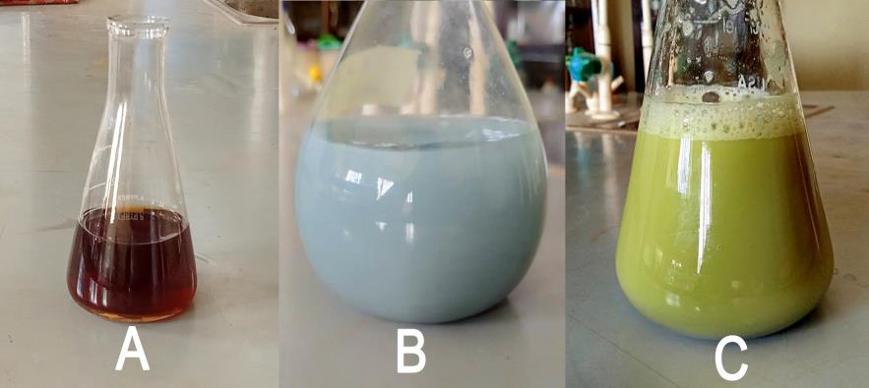
Plate 1: Hierochloe odorata leaves extract (A), Ag-Cu-Al trimetallic salt solution (B), Ag-Cu-Al nanoparticle solution (C)
3.2. UV-Visible Spectroscopy Analysis
More information about Ag-Cu-Al trimetallic nanoparticles was obtained through the use of UV-visible spectroscopy, which was used to observe the reduction of aqueous metal ions after treatment with Hierochloe odorata leaves extract (figure 1). In the UV-visible absorption spectra of Ag-Cu-Al trimetallic nanoparticle, the typical surface plasmon resonance (SPR) is observed with an absorbance of approximately 400-407 nm with peak maxima of 405 nm, which can be attributed to the presence of Ag-Cu-Al trimetallic nanoparticles. The nearly symmetrical structure of the plasmon band suggest that the nanoparticles are not uniformly distributed and homogenous. This non-uniformity of the nanoparticles is responsible for the slightly broad absorption peak. The size, shape and capping agent of nanoparticles influence the position of the SPR band.
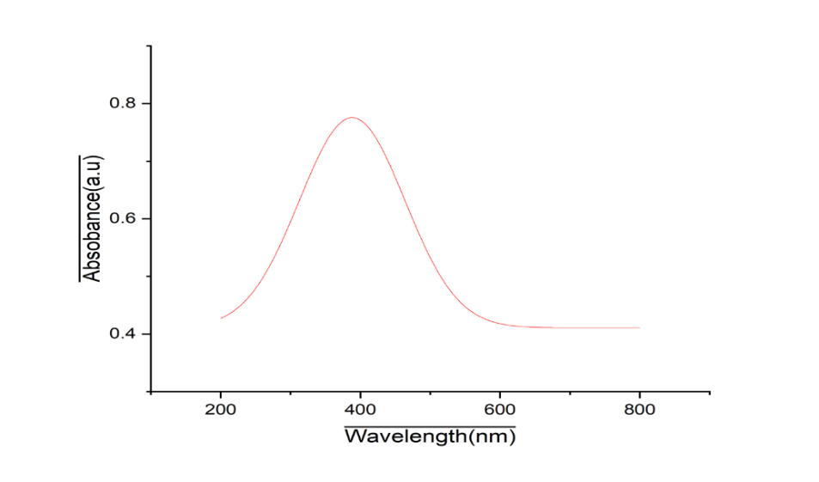
Figure 1: UV-visible spectrum of Ag-Cu-Al trimetallic nanoparticle

3.3. Fourier Transform Infra-Red Spectroscopy Analysis
“Figure 2 shows the FTIR spectra of Hierochloe odorata aqueous leaf extract mediated synthesis of Ag-Cu-Al trimetallic nanoparticles. It shows the distinct absorption bands for the functional groups involved in the reduction of the trimetallic ions. Absorbance peaks were recorded at 3317, 2938, 2080, 1735, 1367, 1217 and 1033 cm⁻¹. The band at 3317 cm⁻¹ corresponds to secondary amine (N-H), C-H medium stretching for alkane is responsible for the bonds found 2938 cm⁻¹. The 2080 cm-1 can be attributed to C=C stretch for alkenes, 1735 cm⁻¹. IR band is associated with C=O stretching for esters. 1367 cm⁻¹ is strong band for N=O stretching for nitro compounds While 1217 cm⁻¹ and 1033 cm⁻¹ are attributed for C-O stretch for esters and C-C bending stretch for alkanes respectively. Aqueous leaves extract of Hierochloe odorata is known to contain phytochemicals such as tannins, alkaloids and carbohydrates, saponins and flavonoids which are rich in antioxidant properties capable of donating atoms of hydrogen and protein moieties that can bind with metallic ions and capable of reducing metal ions of silver, copper and Aluminium and also serve as stabilizing agents to the synthesized nanoparticles” [27].
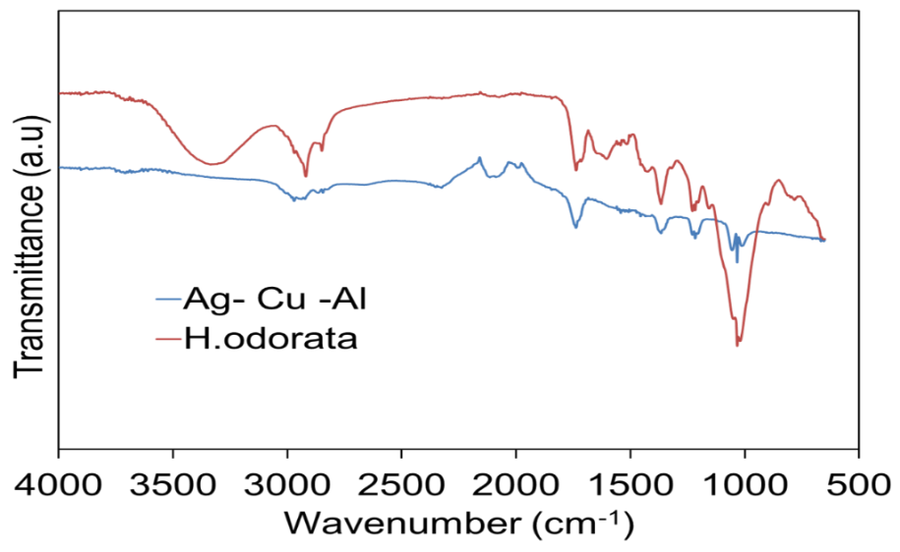
Figure 2: Comparative FTIR spectra of Ag-Cu-Al nanoparticles
3.4. XRD Analysis
Figure 3: XRD spectrum of Ag-Cu nanoparticles
“From the X-ray diffraction patterns of the biosynthesized Ag-Cu-Al nanoparticles as shown in Figure 3, it is clear that the diffraction pattern of the triimetallic nanoparticles were essentially crystalline as shown with the sharp peaks” [28]. “Estimated diffraction peaks observed at 38.47°, 44.67°, 47.12° and 65.23° corresponds to the (111), (200) and (220) standard face centered cubic structures of silver which confirms the presence of silver oxide in the sample” [28, 29]. “The XRD pattern also shows peaks of copper oxide at 28.85° and 33.26°, aluminum oxide at 57.75° and 58.60° brought about by the oxidation of copper and aluminum particles respectively” [30]. “The average size of the biosynthesized nanoparticles was determined to be 35.92 nm, which was calculated from (table 1). The values of the crystals planes of the biosynthesized Ag-Cu-Al nanoparticle observed were compared with the standard powder and diffraction card of Joint Committee on Powder Diffraction Standards (JCPDS) which showed that the biosynthesized Ag-Cu-AL nanoparticles exhibit a Face center cubic crystal. The other peaks might be as a result of some bioorganic compounds or proteins present in the plant extract” [31].
Table 1: Average size analysis of Ag-Cu-Al nanoparticles from XRD analysis
Position (nm) Height (Abs) FWHM (radians) d-Spacing (Å) Particle size (nm)
15.195 6.103 0.725 0.173 9.275
19.157 8.234 0.636 0.137 21.977
29.781 9.890 0.720 0.317 32.955
33.292 15.106 0.210 0.278 39.677
38.789 23.207 0.265 0.387 45.012
45.016 11.026 0.425 0.167 51.072
47.129 11.221 0.328 0.241 55.596
57.321 4.476 0.352 0.195 63.047
65.230 9.652 0.346 0.268 67.786

3.5. Scanning Electron Microscope - Energy-Dispersive X-ray Spectroscopy Analysis
The SEM-EDS analysis was utilized to examine the surface roughness and morphology of the Ag-Cu-Al nanoparticles as shown in plate 2. The morphology shows the intricacy of the particle size to be densely packed and revealed the cylindrical nature of the nanoparticles. The image also shows a surface roughness which might be attributed to biomolecules from the leaf extract that are bound to the Ag-Cu-Al nanoparticles. The EDS also revealed the elemental composition of the nanoparticles with silver which is easily displaced and hence more active and having the highest composition thereby forming the outer shell while aluminium forms the inner core shell.
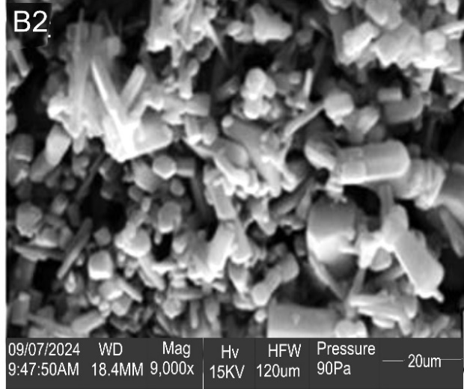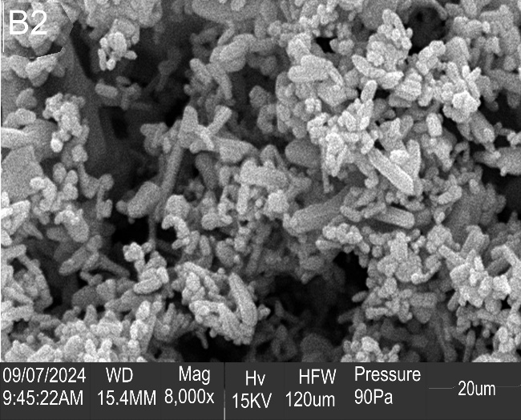
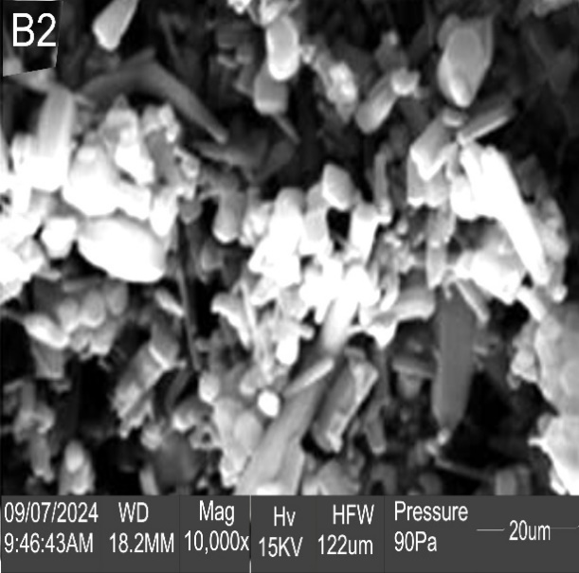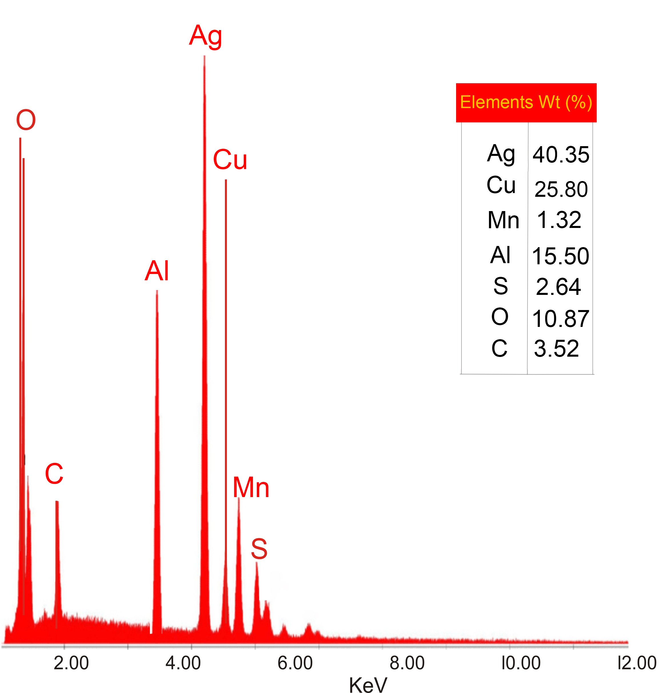
Plate 2: SEM-EDS images of Ag-Cu-Al nanopartices

3.6. Corrosion Analysis
3.6.1. Effect of Concentration on Corrosion Rate and Inhibition Efficiency
Figures 4a, 4b and table 2 presents the impact of inhibitor concentrations on the corrosion rate (CR) and inhibition efficiency (IE) for mild steel. It was observed that the inhibition efficiency increased as the inhibitor concentration increases with the highest inhibition efficiency of 93% observed at 250 ppm while corrosion rate decreased almost linearly with inhibitor concentration. This increased inhibition efficiency and reduced corrosion rate arises as a result of the effective adsorption of the nanoparticles on the surface of the mild still due to increasing concentration. The nanoparticles interact with metal surface via functional groups like hydroxyl, carbonyl, nitrogen or aromatic rings that are present in it possessing adsorptive sites leading to strong adsorption [32]. Under acidic conditions, H₃O⁺ on mild steel surface renders the surface positively charged which quickly adsorbs counter-anions, which is Cl⁻¹, resulting in a net negatively charged surface or cathodic sites. Similarly, the polar –C=O and –OH groups of the phytochemicals bonded to the nanoparticles are protonated forming positively charged particles. Hence, the nanoparticles were adsorbed physically on the surface of the mild steel through electrostatic interactions between the charged metal surface and the charged inhibitor molecule [33]. The presence of high amount of these functional groups on the nanoparticles leads to high amount being adsorbed on the surface of the mild steel which in turn leads to an increased corrosion inhibition, greater surface coverage and greater inhibition efficiency [34].
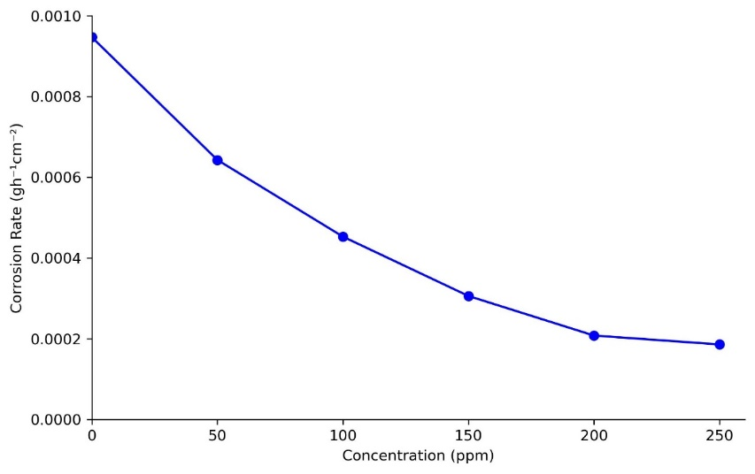
Figure 4a: Effect of Ag-Cu-Al nanoparticles concentration on the corrosion rate of mild steel in 1 M HCl at 298K
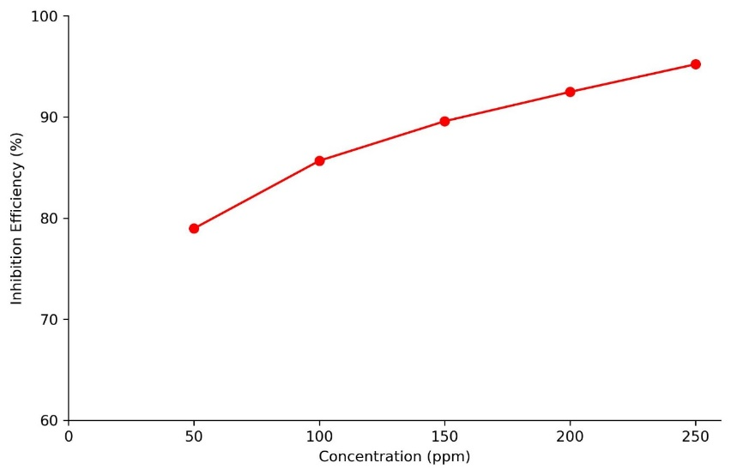
Figure 4b: Effect of Ag-Cu-Al nanoparticles concentration of on the corrosion rate of mild steel in 1 M HCl at 298K
Table 2. Effect of Nanoparticles Concentration on Corrosion Rate and Inhibition Efficiency
Conc. (ppm) | Corr. Rate (gh⁻¹cm²) | Surface Coverage (θ) | Inhibition Efficiency (%)
Blank | 0.00094 | - | -
50 | 0.00064 | 0.78971 | 78.97
100 | 0.00045 | 0.85167 | 86.67
150 | 0.00030 | 0.89582 | 89.58
200 | 0.00020 | 0.92487 | 92.49
250 | 0.00018 | 0.95817 | 95.22

3.6.2. Effect of Temperature on Corrosion Rate and Inhibition Efficiency
To assess the stability of the adsorbed inhibitor layer on the mild steel surface as well as some thermodynamic parameters of the corrosion process of mild, weight loss analysis were carried out using temperatures ranging from 298 to 338 K at 10 K intervals in the absence and presence of various concentrations of inhibitor. An increase in temperature resulted in an increase in corrosion rate as shown in figure 5a. This can be associated to an increase in the average kinetic energies of the reacting component, as temperature is directly proportional to kinetic energy. Furthermore, an increase in temperature decreases the stability of corrosion protective layers (e.g. Fe₃O₄ or FeCO₃) thereby exposing the underlying steel to corrosive agents, and can also lead to an acceleration in the diffusion of corrosive ions (e.g. Cl⁻ and H⁺) and oxygen to the steel surface, and as such intensifying corrosion process [35]. Likewise, the inhibition efficiency of Ag-Cu-Al nanoparticles decreases as temperature increases (figure 5b). This is because at high temperature, there is a high probability of desorption of the inhibitor from the surface (thermal decomposition) which might in turn lead to a change in the corrosion mechanism [36]. The reduction in inhibitory efficiency with increasing temperature is described as indicative of a physical adsorption mechanism [37]. This shows that temperature has a strong influence on the stability of the nanoparticles film adsorbed on mild steel in acid medium [38].
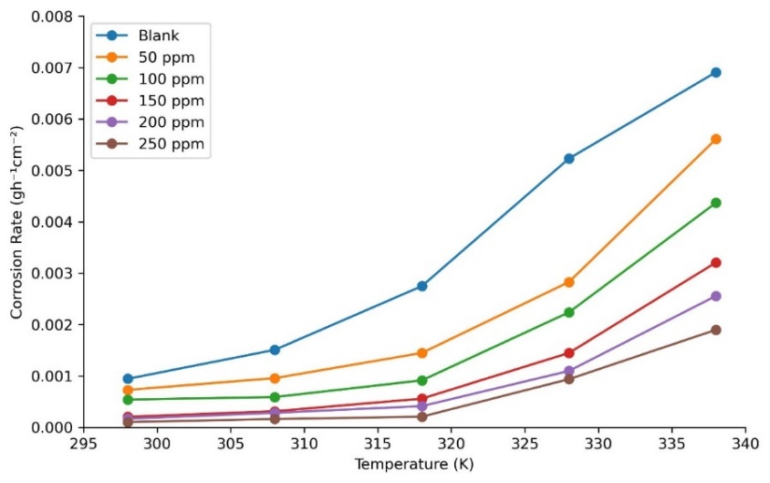
Figure 5a: Effect of Temperature on corrosion rate of mild steel in 1 M HCl
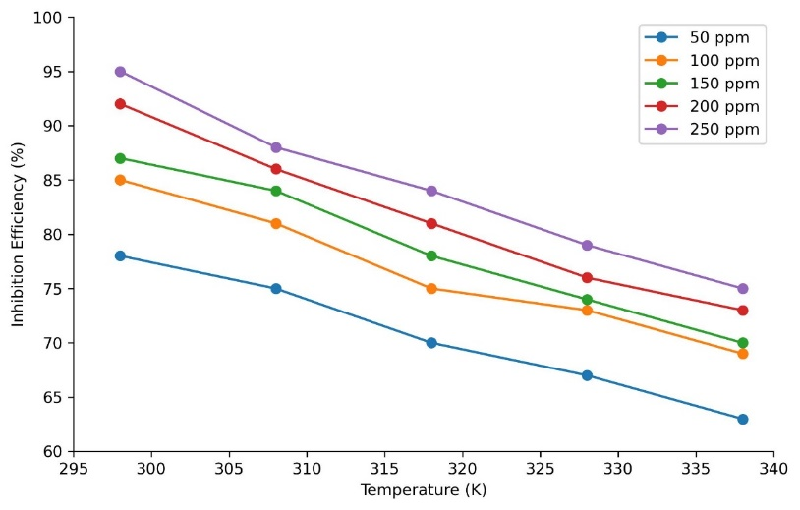
Figure 5b: Effect of Temperature on inhibition efficiency of mild steel in 1 M HCl
3.6.3. Effect of Immersion time on Corrosion Rate and Inhibition Efficiency
The effect of immersion time on corrosion parameters such as surface coverage, corrosion rate and inhibition efficiency were investigated in 1 M hydrochloric acid solution. This was done both in the presence and absence of different concentrations of Ag-Cu-Al nanoparticles at 2 hours interval for 24 hours at 298 K. The results generally show a significant reduction in corrosion rate as the nanoparticles concentration increases. The corrosion rate at the initial stage was observed to be high but, decreased with time as shown in figure 6a although a bit negligible as inhibitor concentration increases. This decrease were associated with the deposition of some corrosion products on the surface of the mild steel, forming a barrier that slows corrosion. This observation corresponds to that reported by [39]. Extended immersion time can sometimes stabilize corrosion rates as the inhibitor forms a denser layer, however, beyond optimal periods, inhibitor desorption or degradation of the protective film may increase corrosion rate [40]. Also, the result shows high inhibition efficiency (figure 6b) at initial immersion time as the nanoparticles rapidly adsorbs to the surface of the mild steel which then decreases with time, which may be associated with desorption of inhibitors [41]. This trend was also observed as the concentration of the nanoparticles increased. Ag-Cu-Al nanoparticles was observed to adsorb efficiently onto steel surface, achieving high surface coverage that correlates with reduced corrosion rates, however, at longer immersion times, the surface coverage decreased. This might be due again to desorption of adsorbed nanoparticles owing to temperature effects, agitation, or chemical interactions. This is similar to that reported by [42].
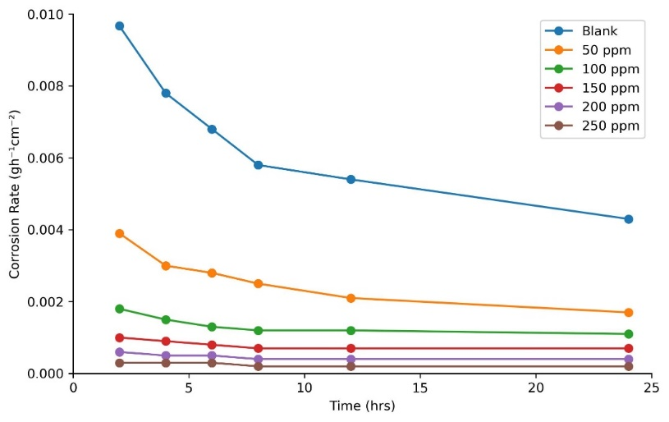
Figure 6a: Effect of Immersion time on corrosion rate of mild steel in 1 M HCl
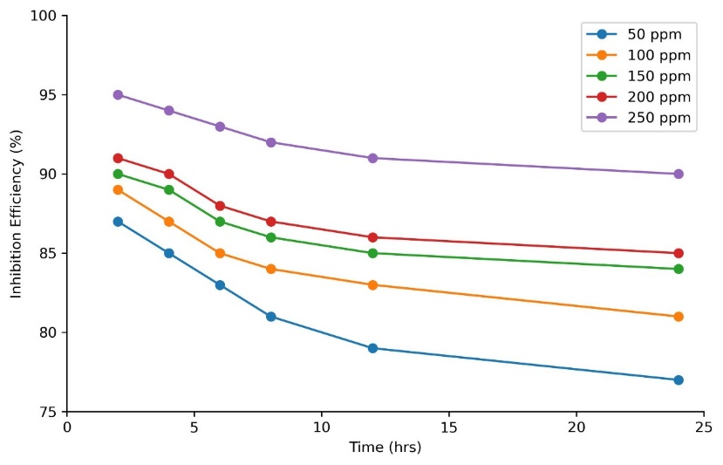
Figure 6b: Effect of Immersion time on Inhibition efficiency of mild steel in 1 M HCl
3.6.4. Kinetic Parameters for Corrosion Process.
Kinetic parameters provide insights into the rate at which the reaction occurs, adsorption mechanisms, efficiency, and stability of nanoparticle-based inhibitors. Results obtained for the relationship between change in weight loss and time and various inhibitor concentration fitted into equation 4 below. This was used in evaluating the rate of corrosion in the presence of Ag-Cu-Al nanoparticles.
ln (w_{i} - ∆w) = -Kt + In w_{i} …………………………………………………………………. ..4
w_{i} = initial weight of metal before immersion, ∆w = change in weight, t = immersion time and K = rate constant [43]. A plot of In (w_{i} - ∆w) versus time in (days) shows a linear relationship that confirms a first order reaction.
Figure 7 illustrates a linear plot of In (w_{i} - ∆w) against time and shows the adsorption of Ag-Cu-Al nanoparticles on mild steel in 1 M HCl with R² values ≥ 0.98. The plot for the various nanoparticle’s concentration is all linear but, showed a decrease trend in the values of ln (w_{i} - ∆w) as the exposure time increases. The half-life (t_{1/2}) of the corrosion were determined using equation 5.
t_{1/2} = $\frac{0.693}{K}$……………………………………………………………………………………. 5
The plot showed that the data points are well fitted into the first order kinetics reaction. The rate constants of the mild steel corrosion at different concentrations of Ag-Cu-Al nanoparticles were obtained from the slope of the graph, while the half-lives were calculated from the rate constant (Table 3). From the results, we can infer that the rate constant of corrosion on mild steel decreases as the nanoparticles concentration increases and the half-life of the reaction increases, while both remained steady at higher concentrations. These suggests that inhibition increases as the nanoparticles concentration increases causing a decrease in the dissolution rate of the mild steel in 1 M HCl. This is an indication of the further protective action of Ag-Cu-Al nanoparticles on the metal surface. This result aligns with that reported by [44]
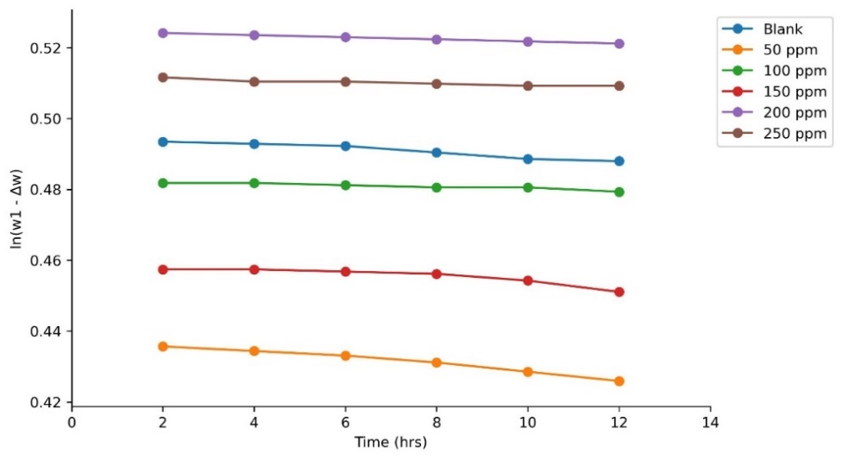
Figure 7: A plot of In(w_{i} – Δw) against Time for the adsorption of Ag-Cu-Al NPs on mild steel at room temperature

Table 3: Kinetic data for mild steel corrosion in 1 M HCl in the absence and presence of Ag-Cu-Al nanoparticles.
Conc. (ppm) | Rate Constant, K (hr⁻¹) | Half-life, t_{1/2} (days)
Blank | 0.0015 | 19.3
50 | 0.0008 | 36.1
100 | 0.0005 | 57.8
150 | 0.0004 | 72.2
200 | 0.0004 | 72.2
250 | 0.0004 | 72.2

3.6.5. Thermodynamic Parameters for Corrosion Process.
Thermodynamic parameters provide insights into the adsorption mechanisms, efficiency, and stability of nanoparticle-based inhibitors. These inhibitors exhibit both physical and chemical adsorption, often fitting one or more adsorption isotherms. The Arrhenius equation (6) was used to evaluate the activation energy of corrosion both in the presence and absence of inhibitor [45]
ln C_{R} = $\frac{Ea}{RT }$ + In A ……………………………………………………………………………...6
where; C_{R} is the corrosion rate, Ea is the activation energy, R is the molar gas constant, T is the temperature (measured in Kelvin), and A is for Arrhenius pre-exponential factor.
Figure 8a shows the plot of ln C_{R} against 1/T, while the values of the apparent energy of activation were determined from the slope Ea/R as shown in table 4. It was observed that Ea increases with an increase in concentration of nanoparticles. This indicates that the nanoparticles hinder the corrosion by heightening the energy barrier for the corrosion reaction. An increase in Ea on addition of an inhibitor arises from the blocking of active (dissolution) sites on the mild steel surface, resulting in a diffusion-controlled corrosion reaction. This trend also suggests a physiosorption mechanism [46]. Higher Ea in the presence of inhibitor indicates effective barrier formation, suggesting an effective corrosion inhibition by the nanoparticles.
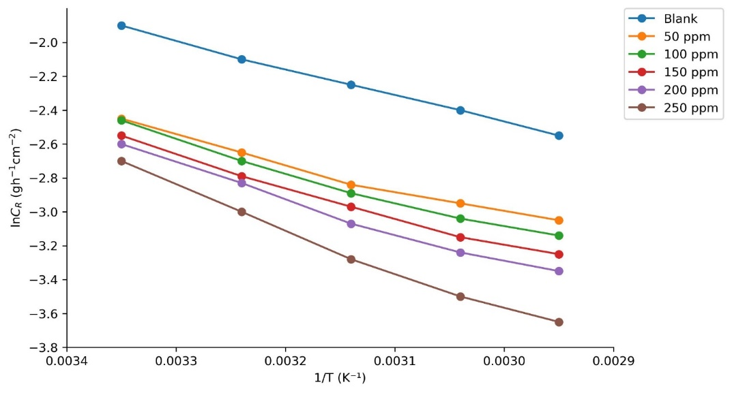
Figure 8a: Arrhenius plots of ln CR versus 1/T in the absence and presence of different concentrations of Ag-Cu-Al NPs in 1 M HCl
Equation (7) was employed to determine other relevant thermodynamic properties such as enthalpy and entropy.
ln( $\frac{CR}{T})$ = ln( $\frac{R}{Nh})$ + ln( $\frac{∆S}{R})$ + ln( $\frac{∆H}{RT})$………………………….…………………………………… 7
where; h is the Planck’s constant, N is the Avogadro’s number, T is the temperature (Kelvin), R is the molar gas constant, ∆S is the entropy of activation and ∆H is the enthalpy of reaction
A plot of the values of ln(C_{R}/T) against 1/T were used to obtain values for ΔH and ΔS as presented in figure 8b for the corrosion rate of mild steel in blank and in the presence of various concentrations of Ag-Cu-Al nanoparticles. A linear relationship with slope of ΔH/RT and an intercept equal to [ln (R/Nh + ΔS/R)] was obtained. The values of ΔH and ΔS are also presented in Table 3.
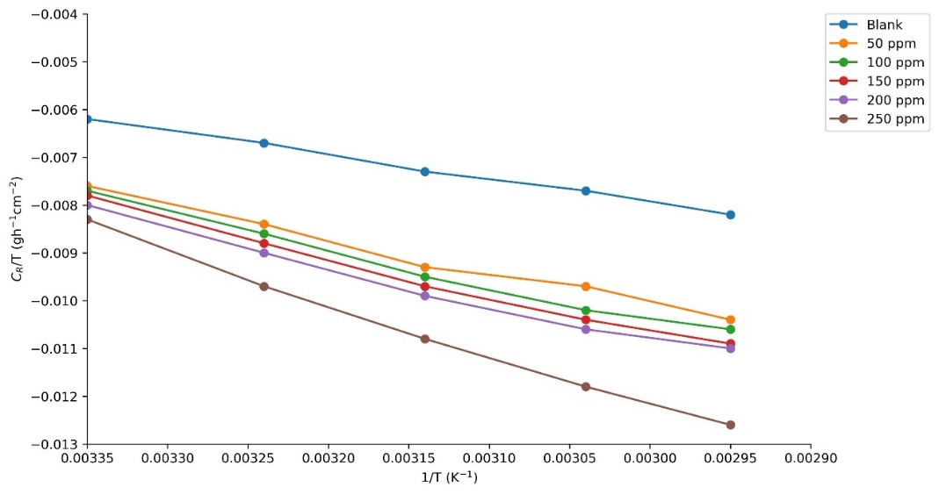
Figure 8b: Eyring transition state plot for mild steel in 1 M HCl in the absence (blank) and presence of Ag-Cu-Al NPs

The positive values of ΔH in the blank indicates an endothermic process of mild steel dissolution. It was also observed that upon adsorption of inhibitor, the values of ΔH increased with increasing inhibitor concentration which indicates that the formation of activated complex from the inhibitor is the rate-determining step of the mild steel dissolution process, and thus it is considered a hindered process of steel corrosion. Also, the positive values of ΔH is attributed to the chemisorption process of the inhibitor [47]. The entropy values were observed to be negative and became less negative as inhibitor concentration increases. These entropy values indicate a decreasing disorderliness from reactants to activated complex. This establishes the fact that the adsorption process is associated with lowering the entropy that is a high chaotic degree before adsorption and then a reduced orderliness when the inhibitor gets adsorbed onto the mild steel [48].
Also, the low value of the energy of activation of the blank compared to those with inhibitor can be attributed to the fact that the inhibitor helps to heighten the energy barrier of the corrosion process consequently increasing the energy of activation hence, the low activation energy of the blank sample [46].

Table 4: Thermodynamic Parameters (ΔH, ΔS, ΔG and Ea) for Mild Steel Dissolution Process in 1 M HCl in the absence and presence of Ag-Cu-Al Nanoparticles.
Conc. (ppm) | ΔH (Jmol⁻¹K⁻¹) | ΔS (Jmol⁻¹K⁻¹) | ΔG (KJmol⁻¹) | Ea (KJmol⁻¹)
Blank | 53.97764 | - 85.67458 | 79.50866 | 13.33303
50 | 76.64044 | - 85.61626 | 102.15409 | 18.95304
100 | 84.10417 | - 85.59598 | 109.61177 | 19.78014
150 | 84.99228 | - 85.59107 | 110.49842 | 21.47078
200 | 85.99245 | - 85.59109 | 111.49859 | 21.72057
250 | 109.00003 | - 85.62358 | 134.48580 | 29.14827

3.6.6. Scanning Electron Microscopy (SEM)
The surface morphology of mild steel before and after immersion in 1 M hydrochloric acid solution in the presence and absence of 250 ppm of Ag-Cu-Al nanoparticles after immersion for 24 hours was studied using scanning electron microscopy and the result is presented in Figure 9. The SEM image of mild steel before immersion revealed a fairly smooth surface with some polishing scratch (Figure 9a). Figure 9b shows cracks, pits, and scratches, as well as corrosion deposits on the mild steel surface which shows that the surface of mild steel without an inhibitor was attacked more by the corrosive agent. The rough surface with pits and cracks and some trace of corrosion product indicate the uniform corrosion of the mild steel sample [46].
The SEM image of the mild steel sample immersed in 1 M HCl containing 250 ppm of Ag-Cu-Al nanoparticles is shown (Figure 9c). It can be seen that the metal surface becomes smother due to deposits of Ag-Cu-Al NPs formed on the surface, and thus a protective layer/film is formed on the surface of mild steel. The presence of traces of Ag-Cu-Al particles on the surface indicates the effective adsorption of the inhibitor on the surface of mild steel, and its association with the active sites on the metal surface suggests the high inhibitory tendency of the nanoparticles at reducing corrosion and protecting the surface of the mild steel [49].

A B
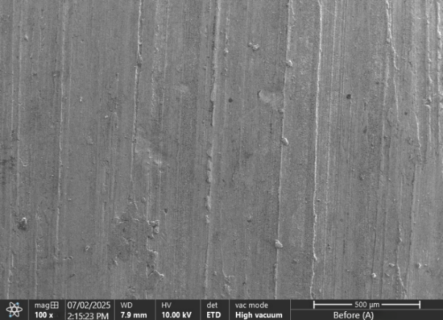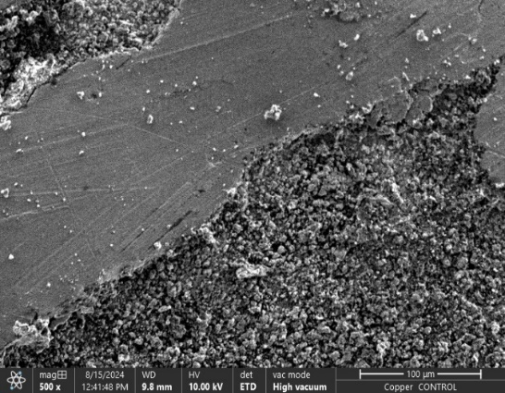
C
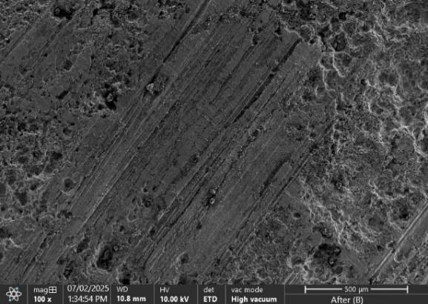
Figure 9: SEM micrographs of mild steel in (A) the clean steel surface before immersion (B) the surface after being immersed in 1 M HCl for 24 hrs. and (C) the steel surface coated with Ag-Cu-Al NPs after immersion in 1 M HCl
3.7 Corrosion Mechanism
The corrosion mechanism was investigated in order to have a better understand of the behavior of the mild steel in the acidic environment in the presence and absence of an inhibitor. The initiation phase stage was shown by the dissolution of the mild steel, and the breakdown of the passive layer of the mild steel which resulted in the evolution of hydrogen.
Iron atoms from the mild steel surface oxidize and dissolve into acidic solution as shown in equation (8) while equation (9) shows how proton from HCl gain electrons from hydrogen gas at the steel surface.
Fe = Fe²⁺ +2e⁻………………………………………………………………………………… (8)
2H⁺ + 2e⁻ = H₂ ………………………………………………………………………………… (9)
The second stage involves the dissociation of hydrochloric acid as shown in equation (10) which provides protons for the reaction and chloride ions that accelerate the corrosion.
HCl = H⁺ + Cl⁻ ………………………………………………………………………………. (10)
After this, the adsorption of the trimetallic Ag-Cu-Al NPs on the surface of the steel occurs as shown in equation (11).
Ag-Cu-Al_{(aq)} + Fe^{δ+}_{(surface)} = Ag-Cu-Al—Fe_{(adsorbed)} ………………………………………... (11)
The biosynthesized nanoparticles adsorb onto the mild steel surface via electrostatic interactions or chemisorption, forming a protective layer.
The next stage involves the formation of a protective inhibitor film as shown in equation (12).
Fe²⁺ + Ag-Cu-Al_{(adsorbed)} = [Fe—Ag-Cu-Al] _{complex} ………………………………………… (12)
A surface complex is formed between the Fe²⁺ ions and the trimetallic nanoparticles, forming a barrier layer that reduces further metal dissolution.
The final phase is the blocking of the corrosion pathway (where aggressive chloride ions are formed) as shown in equation (13), in which the adsorbed layer inhibits the electron transfer reactions needed for corrosion.
Ag-Cu-Al_{(adsorbed)} blocks Fe²⁺ + H⁺ …………………………………………………. (13)

3.8. Adsorption Isotherm
The corrosion inhibition mechanism of nanoparticles is usually based on molecular adsorption. Adsorption isotherm helps to illustrate the interaction between inhibitor molecules and the active sites of the metal surface [50]. The adsorption mechanism of various concentration of the inhibitor was studied by subjecting the result to various adsorption models such as Langmuir's, Freundlich's, Temkin's and Frumkin's adsorption isotherms. The Langmuir isotherm gave the best fit with very strong correlation coefficient (R²) for the different Ag-Cu-Al nanoparticles concentrations in 1 molar hydrochloric acid at various temperature.
The Langmuir adsorption isotherm represented in equation (8), indicates that inhibitor molecules have formed a monolayer on the metal surface without interaction between their neighbors [51].
$\frac{C}{θ}$ = $\frac{1}{Kads }$ + C …………………………………………………………………………… (8)
Where; C is the nanoparticles concentration, K_{ads} is the equilibrium constant of adsorption and θ represents the degree of surface coverage of the nanoparticles.
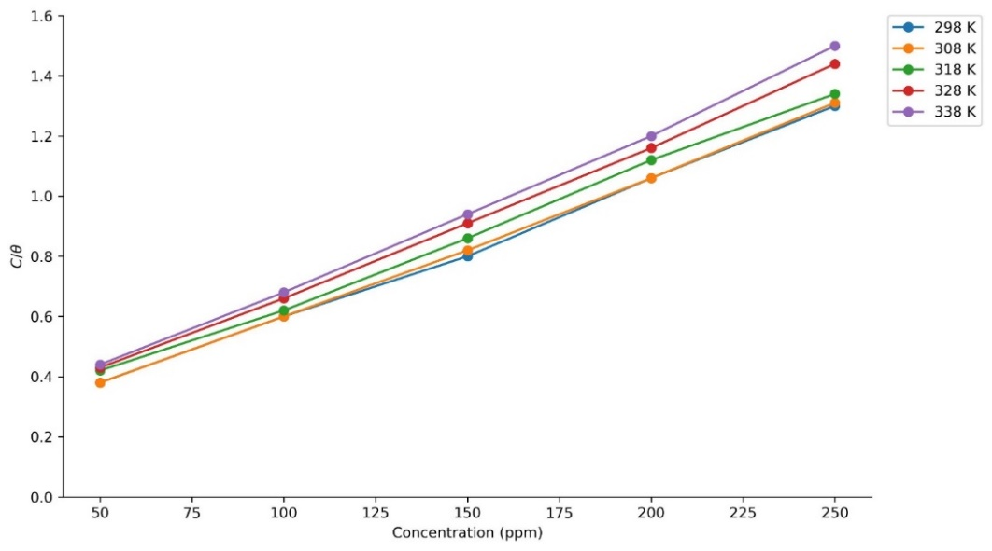
Figure 10: Langmuir adsorption isotherm plot for mild steel corrosion in 1 M HCl for Ag-Cu-Al NPs at different temperatures
As shown in figure 10, a plot of C vs C/θ results in a linear correlation wherein the values of C/θ increases as the nanoparticles concentration rises. The strong correlation (R² = 0.998) for all nanoparticles concentration at different temperature implies that inhibitor adsorption on mild steel agrees with the Langmuir isotherm. This indicates that the adsorbing Ag-Cu-Al nanoparticles occupy certain adsorption sites on the metal surface giving efficient surface coverage. Furthermore, it also indicates the adsorption of the Ag-Cu-Al nanoparticles is associated with physical adsorption [50]. The equilibrium constant of adsorption of the biosynthesized Ag-Cu-Al nanoparticles on mild steel surface relates to Gibbs free energy of adsorption ∆G, by equation (9).
∆G_{ads} = - RT ln (55.5 K_{ads}) …………………………………………………………………… (9)
where; R is the gas constant, T is the absolute temperature (K) 55.5 indicates the molar concentration of water in the solution and K_{ads} represents the adsorption constant.
The standard free energy of adsorption ΔG_{ads} provides information on how strong the molecule's adsorption is on the surface. From the results, it was observed that as temperature increases, the adsorption constant values also increase. This indicates that the interaction between molecules and the metal surface becomes strengthened where the molecules of the inhibitor possess strong interactions with a metal surface. This also indicates an increase in the protective efficiency as the temperature increases. The values of ∆G_{ads} evaluated from the intercept of the plot of Langmuir adsorption isotherm reflects high adsorption tendencies. The negative Gibbs free (∆G_{ads}) values shown in table 5 indicates that the adsorption process is spontaneous and that the adsorption layer on the mild steel is very stable.
Table 5: Calculated parameters from the Langmuir adsorption isotherm of Ag-Cu-Al NPs.
Temperature (K) | K_{ads} | ΔG_{ads} (KJmol⁻¹K⁻¹) | R²
298 | 0.05987 | - 0.1446 | 0.99
308 | 0.06048 | - 0.1497 | 0.97
318 | 0.06446 | - 0.1513 | 0.97
328 | 0.06950 | - 0.1586 | 0.99
338 | 0.07122 | - 0.1677 | 0.99

4. Conclusion
From the results above, novel Hierochloe odorata mediated biosynthesized Ag-Cu-Al nanoparticles was successfully synthesized and UV-Vis, FTIR, XRD and SEM-EDS spectroscopy were used to confirm and synthesis. The nanoparticles proved to be an effective and efficient corrosion inhibitor of mild steel in 1 M HCl solution. The corrosion rate of the steel sample decreased with increase in concentration of the nanoparticles and increased with increasing temperature, while the inhibition efficiency increased with increasing inhibitor concentration and decreased with increasing immersion time and temperature with optimum inhibition efficiency recorded at 95%. The inhibitor adsorption process on mild steel surface was observed to follow Langmuir adsorption isotherm. Thermodynamic studies revealed that the nanoparticles were spontaneously adsorbed onto the mild steel surface by mixed adsorption (physical and chemical adsorption), and that the process was endothermic. Kinetic data also revealed a first order kinetic reaction and an increase in activation energy which is attributed to a physiosorption mechanism. SEM analysis revealed the presence of adsorbed deposits of Ag-Cu-Al NPs which indicates the adsorption of the inhibitor onto the mild steel surface and its effectiveness in protecting the mild steel surface.

Disclaimer (Artificial intelligence)
Author(s) hereby declares that NO generative AI technologies such as Large Language Models (ChatGPT, COPILOT, etc.) and text-to-image generators have been used during the writing or editing of this manuscript.

References
1, H.S.S. Aljibori, A.A.H. Al-Amiery, A.A.H. Kadhum. Advances in corrosion protection coatings: A comprehensive review.Int. J. Corros. Scale Inhib., 12 (4) (2023), 10.17675/2305-6894-2023-12-4-6

2. V. Pagani de Souza, W. da Silva Labiapari, V. de Freitas Cunha Lins. Stainless steels as a
solution for corrosion and erosion problems involving grains in agribusiness sector applicationsJ. Mater. Res. Technol., 30 (2024), pp. 5605-5621, 10.1016/j.jmrt.2024.04.203

3. J.N. Hasnidawani, N.A. Hassan, H. Norita, N. Samat, N.N. Bonnia, S.N. Surip. ZnO nanoparticles for anti-corrosion nanocoating of carbon steel Mater. Sci. Forum, 894 (2017), pp. 76-80, 10.4028/www.scientific.net/MSF.894.76

4. P. Liu, Q.-H. Zhang, Y. Watanabe, T. Shoji, F.-H. Cao. A critical review of the recent advances in inclusion-triggered localized corrosion in steel. Npj Mater. Degrad., 6 (1) (2022), p. 81, 10.1038/s41529-022-00294-6

5. Zheng, Xingwen, Min Gong, Qiang Li, & Lei Guo. (2018). Corrosion inhibition of mild steel in sulfuric acid solution by Loquat (Eriobotrya Japonica Lindl) leaves extract. Scientific Reports 8. (1). 1-15
6. Esmailzadah S. M., Aliofkhazraei, & Sarlak, H. (2018). Interpretation of cyclic potentiodynamic polarization test results for study of corrosion behaviour of metals; A review. Protection of metals and physical chemistry of surfaces 54. (5). 976-989
7. H. Aljibori, A. Al-Amiery, W.N.R. Isahak Advancements in corrosion prevention techniques. J. Bio- Tribo-Corros., 10 (4) (2024), p. 78, 10.1007/s40735-024-00882-w

8. A. Al-Amiery, W.N.R. Wan Isahak, W.K. Al-Azzawi. Sustainable corrosion Inhibitors: A key step towards environmentally responsible corrosion control. Ain Shams Eng. J., 15 (5) (2024), Article 102672, 10.1016/j.asej.2024.102672

9. Q. Ali, M.A. Zia, M. Kamran, M. Shabaan, U. Zulfiqar, M. Ahmad, R. Iqbal, M.F. Maqsood. Nanoremediation for heavy metal contamination: A review, Hybrid Adv., 4 (2023), Article 100091, 10.1016/j.hybadv.2023.100091

10. Nasrollahzadeh, M.; Sajjadi, M.; Iravani, S.; Varma, R.S. Trimetallic Nanoparticles: Greener Synthesis and Their Applications. Nanomaterials 2020, 10, 1784.
11. Roy, A.; Roy, M.; Alghamdi, S.; Dablool, A.S.; Almakki, A.A.; Ali, I.H.; Yadav, K.K.; Islam, R.; Cabral-Pinto, M.M.S. Role of Microbes and Nanomaterials in the Removal of Pesticides from Wastewater. Int. J. Photoenergy 2022, 2022, 1–12.
12. Suba KE and Anda G 2016 Corrosion inhibition using nanomaterials. An overview: Int. J. Sci. Res. Modern Educ. 3(110): 2455-5630.
13. Hasan, S. A review on nanoparticles: Their synthesis and types. Res. J. Recent Sci. 2015, 2277, 2502
14. Gopinath, K.; Kumaraguru, S.; Bhakyaraj, K.; Mohan, S.; Venkatesh, K.S.; Esakkirajan, M.; Kaleeswarran, P.; Alharbi, N.S.; Kadaikunnan, S.; Govindarajan, M.; et al. Green synthesis of silver, gold and silver/gold bimetallic nanoparticles using the Gloriosa superba leaf extract and their antibacterial and antibiofilm activities. Microb. Pathog. 2016, 101, 1–11.
15. Salve, P.; Vinchurkar, A.; Raut, R.; Chondekar, R.; Lakkakula, J.; Roy, A.; Hossain, J.; Alghamdi, S.; Almehmadi, M.; Abdulaziz, O.; et al. An Evaluation of Antimicrobial, Anticancer, Anti-Inflammatory and Antioxidant Activities of Silver Nanoparticles Synthesized from Leaf Extract of Madhuca longifolia Utilizing Quantitative and Qualitative Methods. Molecules 2022, 27, 6404.
16. Park, T.; Lee, S.; Heo, N.; Seo, T. In Vivo Synthesis of Diverse Metal Nanoparticles by Recombinant Escherichia coli. Angew. Chem. 2010, 122, 7173–7178.
17. Mishra, K.; Basavegowda, N.; Lee, Y. AuFeAg hybrid nanoparticles as an efficient recyclable catalyst for the synthesis of α,β- and β,β-dichloroenones. Appl. Catal. A Gen. 2015, 506, 180–187.
18. Akbarzadeh, H.; Abbaspour, M.; Mehrjouei, E.; Kamrani, M. AgPd@Pt nanoparticles with different morphologies of cuboctahedron, icosahedron, decahedron, octahedron, and Marks-decahedron: Insights from atomistic simulations. Inorg. Chem. Front. 2018, 5, 870–878.
19. Tang, M.; Luo, S.; Wang, K.; Du, H.; Sriphathoorat, R.; Shen, P. Simultaneous formation of trimetallic Pt-Ni-Cu excavated rhombic dodecahedrons with enhanced catalytic performance for the methanol oxidation reaction. Nano Res. 2018, 11, 4786–4795.
20. Kamli, M.; Srivastava, V.; Hajrah, N.; Sabir, J.; Hakeem, K.; Ahmad, A.; Malik, M. Facile Bio-Fabrication of Ag-Cu-Co Trimetallic Nanoparticles and Its Fungicidal Activity against Candida auris. J. Fungi 2021, 7, 62
21. Nagore, P.; Ghotekar, S.; Mane, K.; Ghoti, A.; Bilal, M.; Roy, A. Structural Properties and Antimicrobial Activities of Polyalthia longifolia Leaf Extract-Mediated CuO Nanoparticles. BioNanoScience 2021, 11, 579–589.
22. “Hierochloe arctica J. presl | plants of the World Online|Kew Science” Plants of the World Online. Retrieved 14 February 2021.
23a Adejo SO, Ekwenchi MM and Banke SP 2010a Ethanol extract of leaves of Manihot esculentum as eco-friendly inhibitor for corrosion of mild steel in H2SO4 medium. Proceedings of the 33rd Annual International Conference of Chemical Society of Nigeria, Osun. 240-244.

23b Adejo SO, Ekwenchi MM, Odiniya EO, Acholo JP and Banke SP 2010b Ethanol extract of leaves of Portulaca oleracea as green inhibitor for corrosion of mild steel in H2SO4 medium. Proceedings of the International Conference on Research and Development Accra, Ghana. 113-118.

24. Bhawsar, J., Jain, P., & Jain, P. (2015). Experimental and computational studies of Nicotiana tabacum leaves extract as green corrosion inhibitor for mild steel in acidic medium. Alexandria Engineering Journal, 54, 769-775.

25. Amoko, S. J., Akinyele, O. F., Oyeneyin, O. E., Olayanju, D. S., & Aboluwoye, C. O. (2018). Synthesis, characterization and computational studies on the corrosion inhibitive potentials of (e)-3-(2-p-tolyldiazenyl)-1-nitrosonaphthalen-2-ol. Leonardo Journal of Sciences, 2018, 29-48.

26. Odewole, O. A., Ibeju, C. U., Oluwasola, H. O., Oyeneyin, O. E., Akpomie, K. G., Ugwu, C. M., Ugwu, C. G., & Bakare, T. E. (2020). Synthesis and anti-corrosive potential of Schiff bases derived 4-nitrocinnamaldehyde for mild steel in HCl medium: Experimental and DFT studies. Journal Molecular Structure, 1223, 129214.

27. Shroog Shdied Royji Albeladi, Maqsood Ahmad Malik, Shaeel Al-thabaiti, (2020). Facile biofabrication of Silver nanoparticles using Salvia officinalis leaf extract and its catalytic activity towards Congo red dye degradation, Journal of Materials Research and Technology, volume 9, Issue 5, p 10031 – 10044, ISSN 2238 – 7854, https://doi.org/10.1016/j.jmrt.2020

28. Ibrahim HMM (2015) Green synthesis and characterization of silver nanoparticles using banana peel extract and their antimicrobial activity against representative microorganisms. J Radiat Res Appl Sci 8:296–302
29. Verma AD, Pal S, Verma P, Srivastava V, Mandal RK, Sinha I (2017) Ag-Cu bimetallic nanocatalysts for p-nitrophenol reduction using a green hydrogen source. J Environ Chem Eng 5:6148–6155
30. Rosbero TMS, Camacho DH (2017) Green preparation and characterization of tentacle-like silver/copper nanoparticles for catalytic degradation of toxic chlorpyrifos in water. J Environ Chem Eng 5:2524–2532
31. Khan, F., Shariq, M., Asif, M., Siddiqui, M. A., Malan, P., & Ahmad, F. (2022). Green nanotechnology: Plant-mediated nanoparticle synthesis and application. Nanomaterials, 12(4), 673.
32. .Lin, B., Shao, J., Xu, Y., Lai, Y., & Zhao, Z. (2021). Adsorption and corrosion of renewableinhibitor of Pomelo peel extract for mild steel in phosphoric acid solution. Arabian Journal of Chemistry, 14, 103114. https://doi.org/10.1016/J.ARABJC.2021.103114.
33. Mobin, M., Ahmad, I., & Shoeb, M. (2022). Investigation into the highly efficient Artemisia absinthium-silver nanoparticles composite as a novel environmentally benign corrosion inhibitor for mild steel in 1M HCl. Journal of Adhesion Science and Technology, 36, 2562 - 2587. https://doi.org/10.1080/01694243.2022.2075523.
34. Emole, P., Obike, A., Emeruwa, C., & Ukaogo, P. (2023). PERFORMANCE of methanol extract of Kalanchoe crenata leaves on corrosion of mild steel in 5.0 M acid medium. Journal of Chemical Society of Nigeria. https://doi.org/10.46602/jcsn.v48i2.872.
35. Quan, B., Li, J., & Chen, C. (2021). Effect of Corrosion Temperature on the Corrosion of Q235 Steel and 16Mn Steel in Sodium Aluminate Solutions. ACS Omega, 6, 25904 - 25915. https://doi.org/10.1021/acsomega.1c02220
36. Emmanuel, J., & Buchweishaija, J. (2021). Temperature Effects on the Corrosion Inhibition of Mild Steel in Sulfuric Acid Solution by Acacia senegal Gum with Halide Ions. Tanzania Journal of Science. https://doi.org/10.4314/tjs.v47i5.9.
37. Ikpeseni, S., Odu, G., Owamah, H., Onochie, P., & Ukala, D. (2021). Thermodynamic Parameters and Adsorption Mechanism of Corrosion Inhibition in Mild Steel Using Jatropha Leaf Extract in Hydrochloric Acid. Arabian Journal for Science and Engineering, 46, 7789 - 7799. https://doi.org/10.1007/s13369-021-05488-9.
38. Ating, E., Umoren, S., Udousoro, V., Ebenso, E., & Udoh, A. (2010). Leaves extract of Ananas sativum as green corrosion inhibitor for aluminium in hydrochloric acid solutions. Green Chemistry Letters and Reviews, 2010(3), 61-68.
39. Baig, Muneer, Hany Rizk Ammar, Asiful Hossain Seikh, Mohammad Asif Alam, and Nabeel H. Alharthi. (2017). ―Effect of Immersion Time and Temperature on Corrosion Behaviour of Nanocrystalline Al-Fe-Cr Alloy.‖ International Journal of 130 Electrochemical Science 12(4):3336–49.
40. Rafik, A., Agustina, S., & Pramudita, M. (2022). The effect of mild steel immersion time on synergistic corrosion inhibitor ability of terminalia catappa leaves extract. Teknika: Jurnal Sains dan Teknologi. https://doi.org/10.36055/tjst.v18i1.13296.
41. Iyeni, Emmanuel and Cornelius Oghenetega Obemure (2020). ―Effect of Inhibitor Concentration and Immersion Time on the Corrosion Rate and Inhibition Efficiency of AISI 1019 Steel in Inhibited Seawater Environment.‖ American Journal of Mechanical and Materials Engineering 4(3):66–80.
42. Fayomi, O., Chahul, H., Ike, D., Ndukwe, G., & Phoebe, I. (2021). Thermodynamic and Adsorption Study of the Corrosion Inhibition of Mild Steel by Aframomum chrysanthum extract in 0.1 M Hydrochloric Acid Solution. . https://doi.org/10.9734/ajacr/2021/v8i430200.
43. Fouda, A. S., & Ellithy, A. S. (2009). Inhibition effect of 4-phenylthiazole derivatives on corrosion of 304L stainless steel in HCl solution. Corrosion Science, 51(4), 868-875.
44. James, A., & Akaranta, O. (2014). Corrosion inhibition of aluminium in 2 M sulphuric acid using acetone extract of red onion skin. International Journal of Applied Chemical Science Research, 2, 1-10.
45. Rani, P. D., & Selvaraj, S. (2010). Inhibitive and Adsorption Properties of Punica granatum Extract on Brass in Acid Media. Journal of Phytology, 2(1), 58-64.
46. Muthamma Kashmitha, Preethi Kumari, M. Lavanya, and Suma A. Rao. (2021). ―Corrosion Inhibition of Mild Steel in Acidic Media by N-[(3,4- Dimethoxyphenyl)Methyleneamino]-4-Hydroxy-Benzamide.‖ Journal of Bio- and Tribo-Corrosion 7(1):1–19.
47. Zheng, Xingwen, Min Gong, Qiang Li, & Lei Guo. (2018). Corrosion inhibition of mild steel in sulfuric acid solution by Loquat (Eriobotrya Japonica Lindl) leaves extract. Scientific Reports 8. (1). 1-15.

48. Li, L., Zhang, X., Lei, J., He, J., Zhang, S., & Pan F. (2012). Adsorption and corrosion inhibition of Osmanthus fragran leaves extract on carbon steel. Corrosion Science, 63, 82- 90.
49. Abdeen, D.H.; El Hachach, M.; Koc, M.; Atieh, M.A. A. (2019). Review on the Corrosion Behaviour of Nanocoatings on Metallic Substrates. Materials, 12, 210.
50. Alao, A.O., Popoola, A.P. & Sanni, O. The Influence of Nanoparticle Inhibitors on the Corrosion Protection of Some Industrial Metals: A Review. J Bio Tribo Corros 8, 68 (2022). https://doi.org/10.1007/s40735-022-00665-1
51. Dagdag, Omar, Ahmed El Harfi, Mustapha El Gouri, Zaki Safi, Ramzi et al. (2019a). ―Anticorrosive Properties of Hexa (3-Methoxy Propan-1,2-Diol) CyclotriPhosphazene Compound for Carbon Steel in 3% NaCl Medium: Gravimetric, Electrochemical, DFT and Monte Carlo Simulation Studies.‖ Heliyon 5(3):1–28.

