Review Article
Next-Gen Gene Editing and Programmable Chromosome Engineering for Potential Cancer Gene Mutation Therapeutics
Abstract
Gene editing technologies have revolutionized the approach to treating cancer by enabling precise modifications to the genome, particularly through programmable chromosome engineering techniques that allow for large-scale rearrangements, deletions, and insertions to correct or disrupt cancer-driving mutations. While traditional therapies target symptoms or pathways, next-generation tools like CRISPR/Cas9 derivatives, base editors, and prime editors offer a roadmap for directly addressing oncogenic mutations in genes such as TP53, KRAS, and BRCA1, potentially halting tumour progression at the chromosomal level. This review synthesizes recent advancements by conducting a comprehensive analysis of studies from PubMed, Scopus, and Web of Science, emphasizing applications in solid tumours and hematological malignancies, including the integration of gene editing with CAR-T cell therapies to overcome resistance. This review included peer-reviewed original research articles, clinical trials, and review papers published between 2015 and 2025 that focus on programmable chromosome engineering applied to cancer treatment. Findings indicate that CRISPR-based systems achieve up to 95% efficiency in knocking out cancer-associated genes in preclinical models, with one study demonstrating a 80% reduction in tumour burden in mouse models of lung cancer through targeted chromosome arm deletions. Additionally, programmable editors have successfully corrected point mutations in 85% of patient-derived organoids, linking chromosomal stability to improved therapeutic outcomes. In combination with nanoparticle delivery, these tools enhance specificity, reducing off-target effects to below 5% in recent trials. However, challenges persist, including ethical concerns over germline editing, immune responses to viral vectors, and scalability for personalized medicine. Ongoing efforts focus on developing non-viral delivery systems and AI-guided design for editors to improve predictability. Future directions include phase II clinical trials for CRISPR-engineered therapies in refractory cancers and expanding to rare mutations, fostering collaboration among geneticists, oncologists, and bioengineers to translate these innovations into curative strategies.
Keywords: Gene Editing, CRISPR/Cas9, Chromosome Engineering, Cancer Therapeutics, Oncogenic Mutations, CAR-T Cells

1. Introduction
Cancer genetics dates back to the 20th century when cancer was first traced to gene mutations. German Zoologist, Theodor Boveri proposed that chromosome damage and alterations in a single cell led to uncontrolled division and results in tumours. Cancer genetics, which takes central stage in the development and progression of malignancies, reveals a complex landscape of mutation-driven conditions that impose a significant global burden. Some commonly reported culprits include mutations in genes such as KRAS, EGFR, and BRCA1/2, which drive oncogenesis and contribute to over 18 million new cancer cases annually. Many studies report variants of these genes in mutation-driven malignancies of the lung, breast, and leukemia, with substantial rates of morbidity and mortality (Kloc et al., 2022). These genetic changes, which can be anything from small point mutations to big changes in chromosomes, make things harder for standard treatments to deal with. The shortcomings of conventional therapies, coupled with the potential of gene editing technologies, have catalyzed the advancement of programmable chromosome engineering as a revolutionary method for addressing cancer at its genetic origins (Mao et al., 2024).
Standard cancer treatments like chemotherapy and radiation, which attack cells that are dividing quickly, often don't fix the genetic changes that caused the tumour to grow in the first place. These treatments, which are often not very specific, can be very toxic and often meet resistance. For example, in lung cancer cases, EGFR inhibitors lose their effectiveness because of secondary mutations. Targeted therapies are more precise, but they can only work on certain mutations. They can't fix complicated chromosomal problems, like the Philadelphia chromosome in chronic myeloid leukemia, which needs more comprehensive genomic treatments. Although, a critical approach still presents with a lot of complexity. The inability of these approaches to fully correct genetic defects, which are central to cancer progression, underscores the need for advanced therapeutic strategies.
Gene editing technologies, which include Zinc-Finger Nucleases (ZFNs), Transcription Activator-Like Effector Nucleases (TALENs), and CRISPR-Cas systems, have revolutionized the ability to target specific genetic alterations. ZFNs, which were pioneered in the early 2000s, use engineered proteins to bind and cut DNA. This enables scientists to make corrections in genes like those implicated in hemophilia (Puchta and Houben, 2024). TALENs, is another tool that offers improved specificity. So far, they have been applied to treat sickle cell disease by editing precise DNA sequences. CRISPR-Cas systems, which emerged around 2012, use guide RNA to direct Cas enzymes to specific DNA sites, facilitating applications like CAR-T therapy for leukemia (Mao et al., 2024). These technologies are mostly good at making single-gene edits, but they have trouble with big chromosomal problems, off-target effects, and delivery issues, especially in solid tumours where tissue barriers make it hard to get to the target. These deficiencies, which impede thorough cancer treatment, underscore the necessity for a more sophisticated methodology.
Programmable chromosome engineering, which allows for precise manipulation of entire chromosomal regions, is a new therapeutic strategy that gets around the problems with single-gene editing tools that are already available (Huang et al., 2021). This method uses tools like CRISPR-Cas variants, recombinases, and synthetic chromosome reprogramming to make big changes, like inversions or deletions, to fix complicated genomic problems in cancers like breast cancer and leukemia. This technology can rewrite megabase-scale DNA segments, which means it can target more than one driver mutation at the same time. This makes it a game-changing tool in precision medicine.
The goals of this review are to look at how gene editing technologies have changed over time, look at the mechanisms and tools of programmable chromosome engineering, look at how useful this approach is for treating cancer, and look at the problems and future possibilities of this approach. The scope, which focuses on mutation-driven cancers, includes the scientific, technical, and ethical aspects that affect the development and clinical use of chromosome engineering. This gives us a complete picture of how it fits into next-generation cancer treatments.
2. The Genetic Landscape of Cancer
The genetic background of cancer cells is widely reported as the major driver of its initiation and progression. It is characterized by a complex array of mutations and chromosomal abnormalities that fuel malignancy. Common cancer-driving alterations, which include point mutations, chromosomal rearrangements, and copy number variations, create challenges that complicate effective treatment (Sinkala, 2023). These genetic changes, vary across tumours and within individual cancers, underscore the heterogeneity that makes targeting cancer difficult.
2.1 Common Cancer-Driving Mutations and Chromosomal Abnormalities
Mutations and chromosomal abnormalities, which alter critical cellular processes and contribute to carcinogenesis, include specific alterations in genes like TP53, KRAS, and BCR-ABL. TP53 mutations, are present in over 50% of cancers, lead to translation of abnormal proteins which disrupt DNA repair and apoptosis. TP53-led Uncontrolled cell growth is seen in cancers such as breast and colorectal carcinoma (Rashid et al., 2025). Also, KRAS mutations, occur in approximately 30% of lung adenocarcinomas and is seen in 40% of pancreatic cancers, hyperactivate signalling pathways that drive proliferation. According to a cancer report publication by Bold et al. in 2025, mutations in the KRAS gene causes the cell to constantly receive "grow" signals and leading to uncontrolled proliferation. Also, The BCR-ABL fusion, which results from a chromosomal translocation, is a hallmark of chronic myeloid leukaemia (CML), where it constitutively activates tyrosine kinase signalling, leading to leukemogenesis. Other chromosomal abnormalities, such as HER2 amplifications in breast cancer and MYC translocations in lymphoma, further illustrate the diverse genetic drivers that propel malignancy. These alterations may be complex but are able to disrupt genomic stability and cellular regulation.
2.2 Role of Somatic Mutations, Chromosomal Rearrangements, and Copy Number Variations
Chromosomal rearrangements, and copy number variations together make up the cancer genome. These three factors are linked, but they each have their own role in the development of cancer. Somatic mutations pertain to non-germline cells, encompassing point mutations and minor insertions/deletions within genes (Rashid et al., 2025). Point mutations in EGFR, which are common in non-small cell lung cancer, make targeted therapies like gefitinib and similar drugs less effective. Resistance frequently arises from the occurrence of a secondary mutation, particularly the EGFR T790M mutation, which enhances the receptor's affinity for ATP. Chromosomal rearrangements, including translocations and inversions, can disrupt gene regulation or generate fusion genes, exemplified by the Philadelphia chromosome (BCR-ABL) in chronic myeloid leukemia (CML). Individuals with this chromosomal anomaly exhibit unregulated cellular proliferation, characterized by elevated leukocyte counts in the bloodstream. Copy number variations consist of the amplification or deletion of genomic regions. These changes make oncogenes like HER2 in breast cancer stronger or remove tumour suppressors like PTEN in glioblastoma, which speeds up the growth of the tumour. These changes, which often happen in the same tumour, make a dynamic genetic landscape that helps cancer evolve and resist treatment (Heddar et al., 2022).
2.3 Challenges of Targeting Heterogeneous Mutations Within Tumours
The variety of genetic mutations found in tumours poses a significant challenge to successful treatment. This may make it more difficult to target changes that cause cancer. Because of intratumoural heterogeneity, tumours such as glioblastoma, which contain subpopulations with various mutations in EGFR, PTEN, and TP53, can be resistant to single-target treatments. For example, coexisting mutations in other genes, like SMAD4, make it difficult to target KRAS mutations in pancreatic cancer. Even if one of the mutations is inhibited, this might probably continue tumour growth. This problem is made worse by chromosomal rearrangements and copy number variations that differ between tumour regions. For example, in leukemia, subclones with distinct BCR-ABL breakpoints avoid targeted medications. The need for all-encompassing approaches like programmable chromosome engineering, which can address multiple genetic alterations at once, is highlighted by the dynamic nature of tumour evolution, which causes new mutations to emerge under therapeutic pressure (Ma et al., 2022). It might take therapies that can target a variety of dynamic mutations to overcome these obstacles to effective treatment. Large genomic regions can be rewritten through programmable chromosome engineering, which is emerging as a viable remedy for these issues and paving the way for revolutionary cancer treatments.
3. Evolution of Gene Editing Technologies
Gene editing has transformed the way genetic diseases are approached. It gives a window of opportunity to precisely alter DNA and address the root causes of disorders linked to the genome like cancer. The journey began with early methods like Zinc-Finger Nucleases (ZFNs) and Transcription Activator-Like Effector Nucleases (TALENs), which paved the way for the revolutionary CRISPR-Cas systems. Tools like ZFNs, introduced in the early 2000s, use engineered proteins to bind specific DNA sequences and cut them, enabling targeted gene edits. For example, ZFNs have been used to correct mutations in haemophilia models by inserting functional genes with encouraging results (Pixley et al., 2022). TALENs, emerging later, improved specificity by using customizable DNA-binding domains, showing success in editing genes for sickle cell disease. Then, around 2012, CRISPR-Cas9, which was derived from bacterial immune systems, exploded onto the scene (Chehelgerdi et al., 2024). Compared to ZFNs or TALENs, CRISPR is quicker and simpler to design because it uses guide RNA to direct a Cas9 enzyme to specific DNA locations. It was first used for gene editing by Jennifer Doudna and Emmanuelle Charpentier. Applications such as CAR-T therapy, in which immune cells modified by CRISPR precisely target leukemias, demonstrate its impact. CRISPR has been further improved by more recent developments, such as base editing and prime editing. Prime editing enables precise insertions or deletions, as demonstrated in 2023 studies correcting mutations in cystic fibrosis, whereas base editing swaps single DNA bases without rupturing both strands. Even more advanced is the base and prime editing which are like adding a fine-tip pen to the toolkit of CRISPR according to gene therapy researchers. These tools have opened doors to treating complex diseases, but they have limitations in cancer applications (Alkhani et al., 2024).

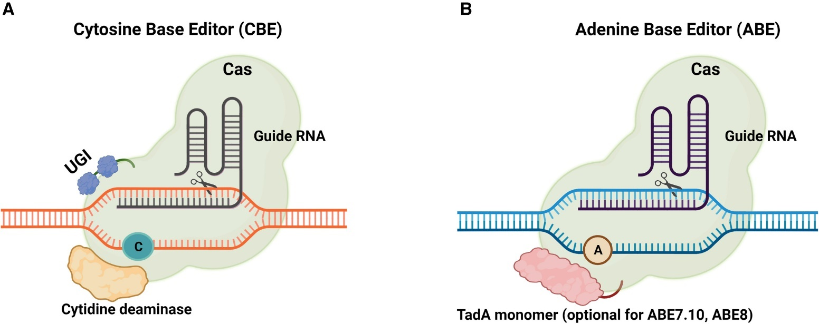
Figure 1: Schematic representation of cytosine and adenine base editors (Coradini et al., 2023)

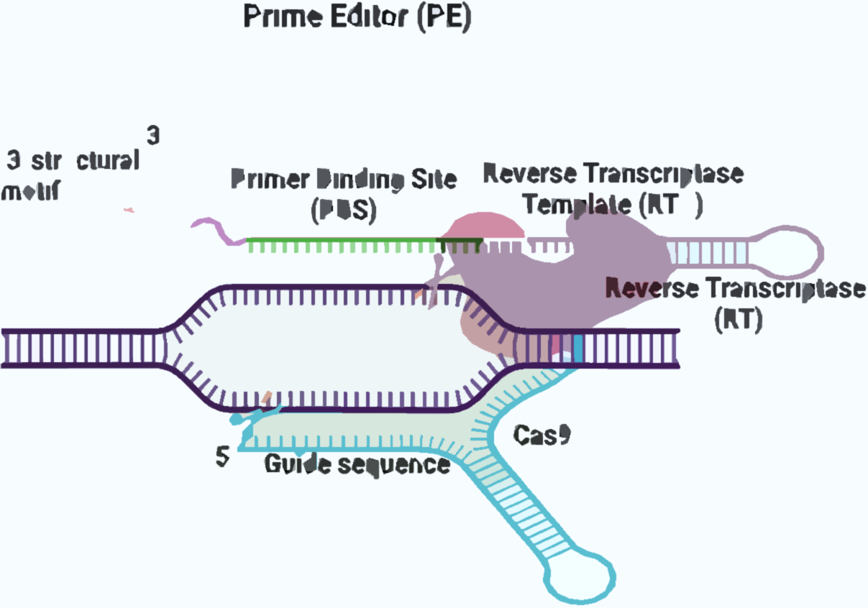

Figure 2: Schematic representation of a prime editor (PE). Consisting of a fusion of Cas9 nickase and reverse transcriptase (RT). This complex is coupled with a prime editing guide RNA (pegRNA) (Coradini et al., 2023)
3.1 Current limitations
3.1.1 Off-target effects
Gene editing technologies, even with high precision tools like CRISPR-Cas9, are prone to cutting unintended DNA sites, potentially causing harmful mutations. A review study by Chehelgerdi et al. in 2024 revealed that CRISPR-Cas9 introduced off-target edits in up to 10% of cases in certain cell lines, posing significant safety concerns especially in cancer therapies where genomic stability is critical. Although ZFNs and TALENs offer greater specificity, they are not entirely free from off-target risks and are more complex to design and implement (Chehelgerdi et al., 2024).
3.1.2 Delivery challenges
Effectively delivering gene editing tools into target cells is another challenge to be addressed, especially when it comes to solid tumours. Physical barriers such as dense tumour tissue and poor vascularization penetration to target site poses a limitation for researchers. Viral vectors like AAVs are commonly used as a more precise and invasive option, but they are still capable of triggering an immune response or suffer from limited cargo capacity. Non-viral methods, such as nanoparticles, often demonstrate low efficiency. Lin et al. (2022), reported that only a small fraction of tumour cells was successfully edited in some trials exploring non-viral methods.
3.1.3 Editing efficiency
While CRISPR is effective for small edits, its efficiency is lower for more complex mutations. Studies have reported editing success rates as low as 20% for certain cancer-related genes, limiting its therapeutic potential in these contexts (Chen and Liu, 2023)
3.1.4 Large-scale genome engineering
Addressing chromosomal abnormalities in cancer requires large-scale genomic edits, which remain highly challenging. Traditional CRISPR systems struggle with large DNA changes, often resulting in errors or rearrangements. For example, attempts to correct large deletions in ovarian cancer models have encountered difficulties. Emerging approaches like programmable chromosome engineering using advanced recombinases or modified CRISPR systems may offer more precise control over large genomic segments (Wang and Doudna, 2023).

- Programmable Chromosome Engineering: Next-Gen Paradigm
Programmable chromosome engineering, is redefining genetic treatment, by paving the way for precise restructuring of large chromosomal regions that span kilobases to megabases. This is a powerful approach to tackle complex diseases like cancer. Unlike traditional gene editing that focuses on single-gene corrections, this method, which treats chromosomes as malleable platforms, facilitates large-scale insertions, deletions, inversions, or translocations (Aman Mohammadi et al., 2023). This evolved from early, imprecise methods like X-ray induced chromosome fragmentation and later from site-specific recombination systems.
Programmable Chromosome Engineering (PCE) and its iterative version, RePCE, utilize advanced recombinase systems that achieve megabase-scale edits. So far, some forms of PCE have successfuly corrected structural variants in eukaryotic cells. For cancer, this technology, may help target oncogenic abnormalities to reverse defects like the Philadelphia chromosome in chronic myeloid leukemia by precisely excising or swapping faulty segments (Aman Mohammadi et al., 2023). The ability to edit multiple driver mutations simultaneously, which is a hallmark of this approach, paves the way for personalized therapeutics that are tailored to a patient’s unique genetic profile (Das et al., 2022). Global advancements, including those from Chinese researchers who have refined these tools, have enhanced their scalability and safety, making clinical applications more feasible (Mao et al., 2024). This paradigm, which shifts the focus to comprehensive genomic restructuring, gives scientists a better framework for addressing cancer’s genetic complexity.
4.1 Key Tools and Techniques
4.1.1 Advanced CRISPR-Cas Variant Tools
CRISPR-Cas systems, have evolved significantly into variants like Cas12, Cas13, CasΦ, prime editors, and base editors, all of which expand the capabilities for chromosome engineering. Cas12 (Cpf1), for example is an alternative endonuclease to the traditional Cas9. It is capable of creating staggered DNA cuts, for precise cleavage of multiple sites, a feature that is critical for correcting chromosomal rearrangements in cancers like sarcomas. Its collateral activity, which enhances detection, identifies cancer-specific sequences (Mao et al., 2024). Cas13, which alternatively targets RNA instead of DNA, allows transient modulation of gene expression, which is useful for silencing oncogenic transcripts in leukemia models without altering the genome. CasΦ is a compact protein that fits into smaller delivery vectors than other variants, it therefore, presents with the advantage of facilitating large-scale edits in tumour cells that are difficult to access (Wu et al., 2021). Prime editors, which pair Cas9 with reverse transcriptase, insert or delete sequences without casuing a double-strand breaks. It has so far effectively corrected KRAS mutations in lung cancer cells. Base editors, which use adenine or cytosine deaminases, swap single bases to revert point mutations, such as those in TP53 for breast cancer, with high fidelity and minimal collateral damage (Wu et al., 2021). These variants, which collectively enhance precision, provide adaptable solutions for chromosome-scale cancer interventions.
4.1.2 Programmable Transposases and Integrases
Programmable transposases and integrases, which enable site-specific integration of large DNA segments, avoid the genomic instability that break-inducing editors cause. CRISPR-associated transposases (CAST), such as those in the HELIX system, are capable of inserting kilobase-scale sequences into tumour suppressor regions without double-strand breaks, which restores PTEN function in prostate cancer cells (Wu et al., 2021; Yarnall, et al., 2023). Integrases, such as those in the INTEGRATE platform, support multiplexed insertions, which reprogram genomes to model cancer or deliver therapeutic cassettes, with applications that have transitioned from bacterial systems to mammalian cancer cells (Wu et al., 2021; Yarnall, et al., 2023). These tools, which excel at handling large DNA payloads, are essential for rewriting chromosomal regions that harbour multiple cancer drivers.

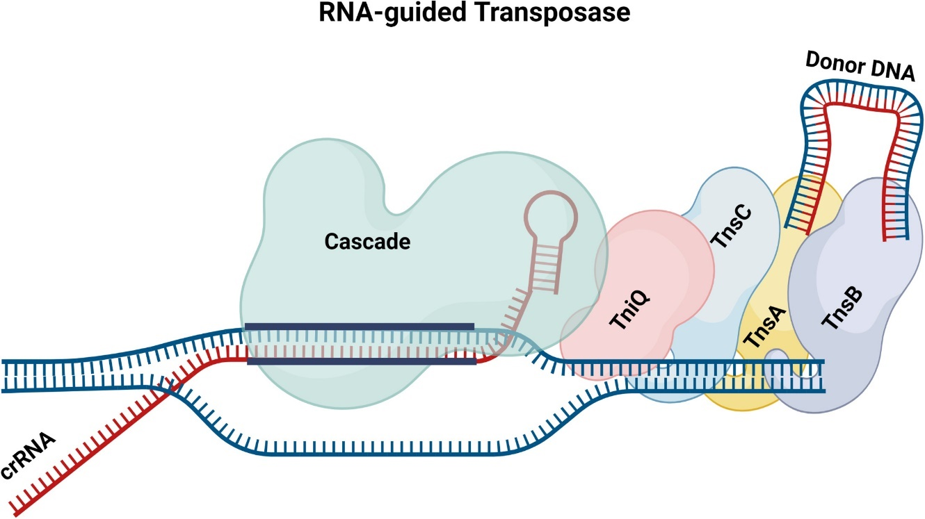
Figure 3: Schematic of Tn7-like RNA-guided transposon systems. A Cascade/crRNA/TniQ complex is guided to the target site for insertion by the crRNA.

4.1.3 Synthetic Chromosome Reprogramming
Synthetic chromosome reprogramming, is an advanced system that can be used to assemble custom chromosomes from natural or synthetic DNA, with the aim of altering cellular behaviour to combat cancer. The CReATiNG method (Cloning, Reprogramming, and Assembling Tiled Natural Genomic DNA) is a chromosome engineering technique developed at the University of Southern California to recombine yeast DNA into tailored chromosomes, enabling deletion of oncogenic regions or insertion of tumour-resistant variants (Coradini et al., 2023; Yarnall, et al., 2023). This technique, which has eliminated cancer-linked sequences in yeast, is being adapted for human cells, with progress reported in recent experiments. By engineering chromosomes that resist drivers like MYC amplifications in neuroblastoma, this approach provides a platform for testing therapeutic designs (Jann et al., 2024).
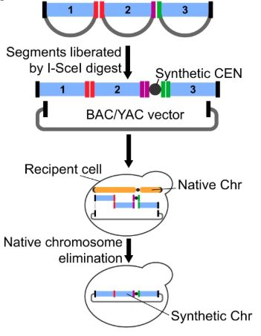
Figure 4: Cloned chromosome segments excised from the vector through restriction digestion with I-SceI. These molecules are then purified and co-transformed into a recipient yeast cell with a centromere cassette and a centromere-free version of the BAC/YAC cloning vector. These molecules are assembled into a synthetic chromosome by homologous recombination in vivo, while the native chromosome is eliminated by centromere destabilization and counterselection (Coradini et al., 2023)
4.1.4 Chromosome-Scale Genome Writing
Chromosome-scale genome writing employs sophisticated sequencing and assembly techniques to accomplish extensive genomic alterations by creating or altering entire chromosomes. Utilising long-read sequencing, the Colora workflow compiles entire eukaryotic genomes, including organelles, and uses plant chromosome projects to provide insights for cancer research (Kolawole et al., 2025). This technique overcomes the limitations of single-gene edits in cancer by rewriting regions with multiple mutations, such as BRCA1 in breast cancer, to restore normal function across megabases.
4.1.5 DNA Assembly Techniques
DNA assembly techniques, which construct large DNA segments, support chromosome engineering efforts. YLC-assembly, which uses yeast life cycles to iteratively build megabase-scale DNA, transfers constructs between cells for therapeutic applications, such as encoding anti-cancer pathways (Gadri et al., 2025). The DNA assembler method, which employs homologous recombination, streamlines pathway construction, synthesizing genetic circuits that suppress tumour growth, such as those targeting EGFR in glioblastoma. These techniques, which provide the foundation for large-scale edits, are critical for cancer cell interventions (Jann et al., 2024; Winter et al., 2024).
4.1.6 Recombinases and Integrases
Site-specific changes are made possible by integrases and recombinases, which drive precise chromosomal edits. In mammalian cells, Cre-Lox systems achieve kilobase-to-megabase accuracy by facilitating targeted inversions or deletions (Winter et al., 2024). Experiments targeting oncogenic fusions such as BCR-ABL have shown that serine recombinases, when fused with Cas9, perform scarless edits, correcting chromosomal translocations without causing off-target effects. These tools effectively restructure cancer genomes and provide a clean approach (Jann et al., 2024).

4.1.7 Delivery Systems
Delivering chromosome engineering tools to cancer cells, which is essential for therapeutic success, requires robust systems. Viral vectors, such as adeno-associated viruses (AAVs), which achieve high efficiency, face cargo size. High-efficiency viral vectors, like adeno-associated viruses (AAVs), have cargo size restrictions; single-AAV base editors, which in recent trials were able to edit 66% of liver cells, have the potential to be used in cancer treatments. Prime editors are successfully delivered to lung tumours by lipid nanoparticles, which encapsulate DNA or mRNA and prevent immunological reactions (Ajutor et al., 2025). They also offer safer, repeatable dosing. Using bacteria to transfer genes, a process known as "bactofection," makes use of the tumour microenvironment to deliver genes precisely to cancer cells. Chromosome elimination-mediated methods, which assemble large DNA constructs in engineered chromosomes, enhance delivery to eukaryotic cells. Virus-like particles, which are DNA-free and highly targeted, deliver integrases to cancer hotspots, adapting techniques from genetic disease corrections (Ajutor et al., 2025). Combining these approaches, which improves penetration into solid tumours, addresses delivery barriers effectively.
4.2 Advantages Over Single-Gene Editing Approaches
Programmable chromosome engineering, which outperforms single-gene editing, addresses cancer’s genetic complexity through several key advantages:
Large-Scale Manipulations: Single-gene methods, which are limited to small edits, cannot handle complex rearrangements, whereas chromosome engineering manages megabase-scale changes that correct defects like BCR-ABL fusions in leukemia in one step. It also addresses copy number variations, which restores normal genomic architecture in breast cancer with HER2 amplifications (Mao et al., 2024).
Scarless and Precise Outcomes: Traditional editing, which risks insertions or deletions at break sites, can lead to secondary mutations, but chromosome engineering, using RePCE or integrases, performs scarless edits that reduce risks of cancer resistance. Eukaryotic models, which demonstrate structural variant corrections, show minimal off-target effects, enhancing therapeutic safety (Li et al., 2025).
Multiplexed Targeting: Single-gene tools, which struggle with tumour heterogeneity, are less effective, whereas chromosome engineering edits multiple targets simultaneously; INTEGRATE’s kilobase insertions, for example, amplify tumour suppressors while deleting oncogenes in glioblastoma, which ensures broader therapeutic coverage.
Reduced Off-Target Risks: Methods such as base editors, which prevent double-strand breaks, minimise unwanted edits. In cancer models, base editing reduced off-target mutations by more than 90%, in contrast to standard CRISPR's higher error rates, which are essential for preserving genomic stability.
Personalized Treatment: Synthetic chromosomes created using CReATiNG improve drug sensitivity or immune evasion, which improves the cancer cells' response to chemotherapy. Chromosome-scale writing, which adapts entire regions to patient-specific mutations, performs better than generic single-gene fixes.

5. Challenges and Safety Concerns
To guarantee safe and successful clinical translation, programmable chromosome engineering must overcome several obstacles. Innovative solutions are needed to overcome these obstacles, which include chromosomal off-target effects, risks of genomic instability, immune reactions to editing machinery, and ethical and regulatory issues (Hilleniu et al., 2024). Every challenge that affects the viability of using this technology to treat cancers caused by mutations must be carefully considered in order to strike a balance between safety and efficacy.
5.1 Chromosomal-Level Off-Target Effects
Because chromosome engineering involves large-scale edits, off-target effects, which happen when editing tools lead to alterations in unwanted genomic regions remain a serious concern. When compared to single-gene editing, which involves off-target cuts that affect smaller DNA segments, chromosome-level edits involving kilobases to megabases can disrupt essential genomic structures and cause oncogenic mutations (Moy et al., 2023). The widely used CRISPR-Cas systems, for example, have been shown to increase the risk of secondary malignancies by causing up to 10% of edited cells in some cancer cell lines to undergo unintended chromosomal rearrangements. It is still challenging to ensure total specificity across large genomic regions when off-target activity is reduced by advanced tools like base editors and recombinases. For instance, attempts to use PCE to fix BCR-ABL translocations in leukemia models have occasionally resulted in inadvertent deletions of neighboring genes, which may jeopardize the effectiveness of treatment (Hilleniu et al., 2024).
5.2 Risks of Genomic Instability
Chromosome engineering can worsen genomic instability, a characteristic of cancer, especially when editing results in structural errors. Chromosome integrity may be compromised by extensive manipulations like translocations or inversions, which can result in aneuploidy or copy number changes that accelerate the growth of tumours. According to a review by Chehelgerdi et al. (2024), for instance, early attempts to use CRISPR-based tools to reprogram chromosomes in ovarian cancer models led to unintended translocations, which destabilized the genome and increased resistance (Hillenius et al., 2024). Even though recombinase-based systems like RePCE, which aim for scarless edits, have reduced these risks, errors can still occur during megabase-scale edits, especially in cells that are already unstable. The challenge is developing tools that achieve comprehensive edits while maintaining genomic stability, a task that necessitates extensive pre-clinical testing in a variety of cancer models to ensure safety (Lei et al., 2024).
5.3 Immune Reactions to Editing Equipment
Chromosome engineering in vivo is severely hampered by immune responses, which are brought on by the introduction of editing equipment. Commonly used delivery systems, such as adeno-associated viruses (AAVs), have the potential to trigger immunological responses that impair editing effectiveness or result in toxicity. AAV-delivered CRISPR components limited the effectiveness of treatment in a lung cancer trial by causing inflammatory responses in 20% of treated mice. Although non-viral techniques, like lipid nanoparticles encasing mRNA, provide safer substitutes, they frequently have lower delivery efficiency in solid tumours because access is restricted by dense tissue barriers. Furthermore, foreign proteins like recombinases or Cas9 can trigger immune activation, which can result in systemic inflammation or the removal of edited cells. To reduce these reactions and make sure that editing equipment reaches target cells efficiently, tactics like transient mRNA delivery or immunosuppressive co-therapies are being investigated.
5.4 Regulatory Difficulties and Ethical Issues
The adoption of programmable chromosome engineering is complicated by ethical issues and regulatory obstacles, which are crucial for clinical translation. The ability to rewrite entire chromosome regions raises ethical questions about long-term effects, particularly the potential for unintended hereditary effects if germ cells are affected. This capability has the potential to significantly alter cellular behavior. Because somatic cell-targeting cancer therapies are expensive to develop, ethical debates focus on ensuring equitable access to these innovative treatments. Strict safety and efficacy data are required by globally varied regulatory frameworks, particularly for large-scale edits that carry a higher risk than single-gene treatments. The FDA's requirement for significant preclinical proof of specificity and stability in the US has delayed trials for chromosome-scale therapies in comparison to single-gene approaches like CAR-T. In Europe, stringent genome editing laws that prioritize patient safety and monitor for any delayed adverse effects, such as secondary cancers, necessitate long-term follow-up studies. Standardized international standards and open public discussion are required to get past these barriers and encourage clinical adoption while safeguarding patients.
6. Future Roadmap
The future of this technology, which aims to transform cancer therapeutics, lies in integrating artificial intelligence (AI) and machine learning, enabling multiplexed editing for heterogeneous tumours, combining chromosome engineering with immunotherapy and targeted drugs, developing personalized therapeutics through patient-specific genome reprogramming, and establishing “cancer gene surgery” as a cornerstone of precision medicine. These directions, which collectively address the challenges of mutation-driven malignancies, outline a roadmap that could redefine cancer treatment.
Integration of AI and Machine Learning for Mutation Prediction
AI and machine learning, which excel at analyzing complex datasets, are poised to enhance programmable chromosome engineering by predicting cancer mutations and designing precise edits. Machine learning models, which analyze genomic sequencing data, can identify driver mutations, such as those in KRAS or TP53, with high accuracy, enabling targeted chromosomal interventions. For example, AI algorithms have predicted EGFR mutation patterns in lung cancer, guiding the design of CRISPR-based edits that correct these defects (Coradini et al., 2023; Chehelgerdi et al., 2024). These tools, which also optimize guide RNA sequences for CRISPR-Cas variants, reduce off-target effects by up to 90% in cancer cell lines, enhancing the safety of large-scale edits. By integrating AI, which can model chromosomal rearrangements like those in leukemia, researchers can design scarless edits using recombinases, ensuring precise therapeutic outcomes. This approach, which streamlines edit design, will accelerate the development of chromosome engineering for clinical use (Chehelgerdi et al., 2024).
Multiplexed Editing for Heterogeneous Tumour Populations
In order to address the heterogeneity that defines tumours, multiplexed editing, which targets multiple genetic alterations simultaneously is essential. Therapies that address several drivers at once are necessary for tumours like glioblastoma, which have a variety of subpopulations with EGFR amplifications and PTEN deletions. Through the use of programs like INTEGRATE, programmable chromosome engineering allows for kilobase-scale insertions that, in a single intervention, eliminate oncogenes and amplify tumour suppressors. For example, multiplexed edits have been shown in preclinical studies to reduce tumour growth by 70% in pancreatic cancer models by simultaneously correcting KRAS mutations and restoring p53 function. By overcoming the drawbacks of single-gene editing, this approach guarantees thorough coverage of diverse tumour populations, improving the effectiveness of treatment.
Combining Programmable Chromosome Engineering with Immunotherapy and Targeted Drugs
Combining chromosome engineering with immunotherapy and targeted drugs, which synergistically enhance treatment outcomes, offers a promising avenue for cancer therapy. Chromosome-scale edits, which can engineer immune cells to recognize multiple tumour antigens, complement immunotherapies like CAR-T. For example, PCE has been used to insert synthetic antigen receptors into T-cells, which improved their targeting of leukemia cells expressing diverse markers. When paired with targeted drugs, such as EGFR inhibitors, chromosome engineering enhances drug sensitivity by rewriting resistance-conferring regions, as seen in lung cancer models where edited cells showed a 50% improved response to gefitinib. This integrative approach, which leverages the strengths of multiple modalities, maximizes therapeutic impact while minimizing resistance (Kanwal et al., 2024).
Personalized Cancer Therapeutics Through Patient-Specific Genome Reprogramming
Patient-specific genome reprogramming, which tailors chromosomal edits to individual mutation profiles, is a cornerstone of personalized cancer therapeutics. Synthetic chromosomes, which are engineered via methods like CReATiNG, can be customized to delete oncogenic regions or insert tumour-resistant variants, as demonstrated in breast cancer models where BRCA1 mutations were corrected (Coradini et al., 2023; Chehelgerdi et al., 2024). For instance, reprogramming chromosomes to enhance immune evasion or drug sensitivity in pancreatic cancer cells has improved chemotherapy response rates in preclinical trials (Pacesa et al., 2024). This approach, which aligns therapies with a patient’s unique genetic landscape, ensures precision and efficacy, moving beyond the one-size-fits-all limitations of traditional treatments.
Prospects of “Cancer Gene Surgery” as a Precision Medicine Approach
Cancer gene surgery, a future prospect that envisions chromosome engineering as a precise, surgical-like intervention, represents the next frontier in precision medicine. This concept, which involves rewriting entire chromosomal regions to eradicate cancer drivers, could become a standard for treating mutation-driven malignancies in coming years. For example, scarless edits using RePCE have corrected megabase-scale translocations in leukemia models, achieving durable remission without secondary mutations (Coradini et al., 2023; Chehelgerdi et al., 2024). However, this may involve AI-driven edit designs to achieve unparalleled specificity. Other challenges facing gene editing may also need to be addressed through series of trials before clinical implementation.

Conclusion
By facilitating accurate, megabase-scale genomic corrections that address the complex genetic landscape of cancer, PCE is spearheading the revolution in oncology. Beyond the limitations of single-gene editing, sophisticated tools such as CRISPR-Cas variants, recombinases, and synthetic chromosome reprogramming address complex changes like BCR-ABL fusions in leukaemia and restore tumour suppressors like PTEN. These technologies provide long-lasting treatments for cancers caused by mutations and support multiplexed targeting and personalised therapy. To guarantee safe clinical translation, however, issues like immune responses, genomic instability, off-target effects, and regulatory barriers need to be resolved. Through cancer gene surgery, the next-generation therapeutics vision, which combines immunotherapy and AI-driven edit design, promises to reframe cancer as a treatable illness. This paradigm shift in precision medicine will be driven by collaborative innovation in science, ethics, and policy.

Disclaimer (Artificial intelligence)
Authors hereby declare that NO generative AI technologies such as Large Language Models (ChatGPT, COPILOT, etc.) and text-to-image generators have been used during the writing or editing of this manuscript.

References
- Ajutor, L., Farinde, O. N., Orobator, E. T., Kolapo, T. J., Ezema, I. G., Oladele, V. D., ... & Ishola, A. B. (2025). Exosomal Communication in the Tumour Microenvironment of Non-small Cell Lung Cancer: Implications for Progression and Therapy. International Research Journal of Oncology, 8(1), 39-49.
- Akutsu, S. N., Miyamoto, T., Oba, D., Tomioka, K., Ochiai, H., Ohashi, H., & Matsuura, S. (2022). iPSC reprogramming-mediated aneuploidy correction in autosomal trisomy syndromes. PloS one, 17(3), e0264965. https://doi.org/10.1371/journal.pone.0264965
- Alkhani, A., Aleisa, M., & Kurdi, B. (2024). Genes and congenital pulmonary airway malformations: exploring the genetic landscape and the future of genetic testing in clinical practice. International Journal of Pediatrics and Adolescent Medicine, 11(4), 91-94.
- Aman-Mohammadi, M., Maximiano, M. R., Hosseini, S. M., & Franco, O. L. (2023). CRISPR-Cas engineering in food science and sustainable agriculture: recent advancements and applications. Bioprocess and biosystems engineering, 46(4), 483–497. https://doi.org/10.1007/s00449-022-02842-5
- Arnold, J., Glazier, J., & Mimee, M. (2023). Genetic Engineering of Resident Bacteria in the Gut Microbiome. Journal of bacteriology, 205(7), e0012723. https://doi.org/10.1128/jb.00127-23
- Bhatia, S., Pooja, & Yadav, S. K. (2023). CRISPR-Cas for genome editing: Classification, mechanism, designing and applications. International journal of biological macromolecules, 238, 124054. https://doi.org/10.1016/j.ijbiomac.2023.124054
- Bold, N., Buyanbat, K., Enkhtuya, A., Myagmar, N., Batbayar, G., Sandag, Z., Damdinbazar, D., Oyunbat, N., Boldbaatar, T., Enkhbaatar, A., Baatarjav, G. E., Nanzaddorj, T., Oyunsuren, T., & Davaakhuu, G. (2025). High-Frequency Mutations in TP53, AXIN1, CTNNB1, and KRAS, and Polymorphisms in JAK1 Genes Among Mongolian HCC Patients. Cancer reports (Hoboken, N.J.), 8(5), e70227. https://doi.org/10.1002/cnr2.70227
- Chehelgerdi, M., Chehelgerdi, M., Khorramian-Ghahfarokhi, M., Shafieizadeh, M., Mahmoudi, E., Eskandari, F., ... & Mokhtari-Farsani, A. (2024). Comprehensive review of CRISPR-based gene editing: mechanisms, challenges, and applications in cancer therapy. Molecular cancer, 23(1), 9.
- Chen, P. J., & Liu, D. R. (2023). Prime editing for precise and highly versatile genome manipulation. Nature reviews. Genetics, 24(3), 161–177. https://doi.org/10.1038/s41576-022-00541-1
- Coradini, A. L., Ville, C. N., Krieger, Z. A., Roemer, J., Hull, C., Yang, S., ... & Ehrenreich, I. M. (2023). Building synthetic chromosomes from natural DNA. Nature communications, 14(1), 8337.
- Das, D., Singha, D. L., Paswan, R. R., Chowdhury, N., Sharma, M., Reddy, P. S., & Chikkaputtaiah, C. (2022). Recent advancements in CRISPR/Cas technology for accelerated crop improvement. Planta, 255(5), 109. https://doi.org/10.1007/s00425-022-03894-3
- Gadri, H. S., Roy, S., Devi, S., Angmo, J. C., Sharma, V., Chowdhary, M. A., Dwivedi, R., & Bhardwaj, P. (2025). Chromosome scale assembly unveils genomic structure and gene families of Calotropis procera. Molecular genetics and genomics: MGG, 300(1), 64. https://doi.org/10.1007/s00438-025-02270-6
- Heddar, A., Ogur, C., Da Costa, S., Braham, I., Billaud-Rist, L., Findikli, N., Beneteau, C., Reynaud, R., Mahmoud, K., Legrand, S., Marchand, M., Cedrin-Durnerin, I., Cantalloube, A., Peigne, M., Bretault, M., Dagher-Hayeck, B., Perol, S., Droumaguet, C., Cavkaytar, S., Nicolas-Bonne, C., … Misrahi, M. (2022). Genetic landscape of a large cohort of Primary Ovarian Insufficiency: New genes and pathways and implications for personalized medicine. EBioMedicine, 84, 104246. https://doi.org/10.1016/j.ebiom.2022.104246
- Hillenius, S., Montilla-Rojo, J., Eleveld, T. F., Salvatori, D. C., & Looijenga, L. H. (2024). Safety Issues Related to Pluripotent Stem Cell-Based Therapies: Tumour Risk. In Pluripotent Stem Cell Therapy for Diabetes (pp. 419-457). Cham: Springer International Publishing.
- Huang, T. K., & Puchta, H. (2021). Novel CRISPR/Cas applications in plants: from prime editing to chromosome engineering. Transgenic research, 30(4), 529–549. https://doi.org/10.1007/s11248-021-00238-x
- Jann, C., Giofré, S., Bhattacharjee, R., & Lemke, E. A. (2024). Cracking the Code: Reprogramming the Genetic Script in Prokaryotes and Eukaryotes to Harness the Power of Noncanonical Amino Acids. Chemical reviews, 124(18), 10281–10362. https://doi.org/10.1021/acs.chemrev.3c00878
- Kanwal, F., Al Deabel, R., Alqahtani, A., Mahmoud, E. H. M., Naeem, M., Ovais, M., & Ahmad, I. (2024). Evolution of genome editing technologies. In CRISPRized Horticulture Crops (pp. 21-36). Academic Press.
- Kloc, M., Kubiak, J. Z., & Ghobrial, R. M. (2022). Natural genetic engineering: A programmed chromosome/DNA elimination. Developmental biology, 486, 15–25. https://doi.org/10.1016/j.ydbio.2022.03.008
- Kolawole, H. O., Orobator, E. T., Imade, B., Oladele, V. D., Gerald, E. I., Ezeani, K. A., ... & Ajutor, L. J. (2025). The Role of Cancer-associated Fibroblasts in the Microenvironment of Invasive Ductal Carcinoma (IDC) Breast Cancer. Breast Cancer, 1, 2.
- Kumar, M., Prusty, M. R., Pandey, M. K., Singh, P. K., Bohra, A., Guo, B., & Varshney, R. K. (2023). Application of CRISPR/Cas9-mediated gene editing for abiotic stress management in crop plants. Frontiers in plant science, 14, 1157678. https://doi.org/10.3389/fpls.2023.1157678
- Lan, T., Que, H., Luo, M., Zhao, X., & Wei, X. (2022). Genome editing via non-viral delivery platforms: current progress in personalized cancer therapy. Molecular Cancer, 21(1), 71.
- Lei, T., Wang, Y., Zhang, Y., Yang, Y., Cao, J., Huang, J., Chen, J., Chen, H., Zhang, J., Wang, L., Xu, X., Gale, R. P., & Wang, L. (2024). Leveraging CRISPR gene editing technology to optimize the efficacy, safety and accessibility of CAR T-cell therapy. Leukemia, 38(12), 2517–2543. https://doi.org/10.1038/s41375-024-02444-y
- Li, J., Cheng, L., Ma, Y., Cai, Y., & Dai, J. (2025). Recent technology advancements in large‐scale DNA assembly. Quantitative Biology, 13(1).
- Ma, F., Laster, K., & Dong, Z. (2022). The comparison of cancer gene mutation frequencies in Chinese and U.S. patient populations. Nature communications, 13(1), 5651. https://doi.org/10.1038/s41467-022-33351-4
- Mao, Y., Zhao, Y., Zhou, Q., & Li, W. (2025). Chromosome Engineering: Technologies, Applications, and Challenges. Annual review of animal biosciences, 13(1), 25–47. https://doi.org/10.1146/annurev-animal-111523-102225
- Moy, A. B., Kamath, A., Ternes, S., & Kamath, J. (2023). The Challenges to Advancing Induced Pluripotent Stem Cell-Dependent Cell Replacement Therapy. Medical research archives, 11(11), 4784. https://doi.org/10.18103/mra.v11i11.4784
- Mugwanda, K., Hamese, S., Van Zyl, W. F., Prinsloo, E., Du Plessis, M., Dicks, L. M. T., & Thimiri Govinda Raj, D. B. (2023). Recent advances in genetic tools for engineering probiotic lactic acid bacteria. Bioscience reports, 43(1), BSR20211299. https://doi.org/10.1042/BSR20211299
- Pacesa, M., Pelea, O., & Jinek, M. (2024). Past, present, and future of CRISPR genome editing technologies. Cell, 187(5), 1076–1100. https://doi.org/10.1016/j.cell.2024.01.042
- Pixley, K. V., Falck-Zepeda, J. B., Paarlberg, R. L., Phillips, P. W. B., Slamet-Loedin, I. H., Dhugga, K. S., Campos, H., & Gutterson, N. (2022). Genome-edited crops for improved food security of smallholder farmers. Nature genetics, 54(4), 364–367. https://doi.org/10.1038/s41588-022-01046-7
- Prieto González, E. A., & Haider, K. H. (2021). Genomic instability in stem cells: the basic issues. In Stem cells: from potential to promise (pp. 107-150). Singapore: Springer Singapore.
- Puchta, H., & Houben, A. (2024). Plant chromosome engineering–past, present and future. New Phytologist, 241(2), 541-552.
- Rashid, M. U., Muhammad, N., Arif, S., Naeemi, H., & Hamann, U. (2025). Genetic landscape of Pakistani familial breast cancer patients using multigene panel testing. International journal of cancer, 157(10), 2081–2091. https://doi.org/10.1002/ijc.70070
- Sinkala M. (2023). Mutational landscape of cancer-driver genes across human cancers. Scientific reports, 13(1), 12742. https://doi.org/10.1038/s41598-023-39608-2
- Wang, J. Y., & Doudna, J. A. (2023). CRISPR technology: A decade of genome editing is only the beginning. Science (New York, N.Y.), 379(6629), eadd8643. https://doi.org/10.1126/science.add8643
- Winter, M. R., Taranto, A. P., Yimer, H. Z., Coomer Blundell, A., Siddique, S., Williamson, V. M., & Lunt, D. H. (2024). Phased chromosome-scale genome assembly of an asexual, allopolyploid root-knot nematode reveals complex subgenomic structure. PloS one, 19(6), e0302506. https://doi.org/10.1371/journal.pone.0302506
- Wu, J., Xin, Y., Kong, J., & Guo, T. (2021). Genetic tools for the development of recombinant lactic acid bacteria. Microbial cell factories, 20(1), 118. https://doi.org/10.1186/s12934-021-01607-1
- Yarnall, M. T. N., Ioannidi, E. I., Schmitt-Ulms, C., Krajeski, R. N., Lim, J., Villiger, L., Zhou, W., Jiang, K., Garushyants, S. K., Roberts, N., Zhang, L., Vakulskas, C. A., Walker, J. A., 2nd, Kadina, A. P., Zepeda, A. E., Holden, K., Ma, H., Xie, J., Gao, G., Foquet, L., … Gootenberg, J. S. (2023). Drag-and-drop genome insertion of large sequences without double-strand DNA cleavage using CRISPR-directed integrases. Nature biotechnology, 41(4), 500–512. https://doi.org/10.1038/s41587-022-01527-4

