Assessment of Psychological Well-Being among Residents of Ilobu, Erin-Osun, and Ifon-Osun in Osun State, Nigeria

Abstract
Background: Housing conditions are increasingly recognised as key social determinants of mental health, yet evidence from semi-urban Nigeria remains sparse.
Objective: To quantify the prevalence and predictors of psychological well-being among adult residents of Ilobu, Erin-Osun and Ifon-Osun, Osun State, and to determine the extent to which housing quality and basic infrastructure explain mental-health outcomes. Methods: A cross-sectional survey of 383 adults (≥18 years) was conducted between March and May 2024. Psychological well-being was assessed with the WHO-5 index and categorised as high (≥60 %), moderate (40–59 %) or low (<40 %). A composite Housing Quality Index (0–10) captured dwelling type, room occupancy, ventilation, water, sanitation, electricity and refuse disposal. Data were analysed with descriptive statistics, χ² tests, Pearson correlation, one-way ANOVA and multiple linear regression (SPSS v.25). Results: Only 29.2 % of respondents attained high psychological well-being; 45.2 % were moderate and 25.6 % low. There was a strong dose-response gradient: 72 % of residents in adequate (Type A) housing reported high-to-moderate well-being versus 51 % in sub-standard (Type C/D) dwellings (χ² = 12.84, p = 0.045). Housing Quality Index correlated positively with psychological well-being (r = 0.562, p < 0.001). ANOVA confirmed significant differences across housing-quality tertiles (F = 11.78, p < 0.001). Multiple regression (adjusted R² = 0.47) identified ventilation adequacy (β = 0.31), room occupancy (β = –0.28), water source reliability (β = 0.24) and electricity stability (β = 0.19) as the strongest predictors. Narrative data revealed that overcrowding, noise, tenure insecurity, and poor sanitation were cited three times more often by the low-well-being group. Conclusion: Housing quality is a critical, modifiable determinant of psychological well-being in these semi-urban communities. Integrated interventions targeting ventilation, overcrowding, water and electricity could shift up to one-quarter of residents from low to moderate/high well-being. Policies should embed mental-health outcomes into rural housing standards and primary-care programmes.

Keywords: Mental Health, Rural Housing Housing quality, Semi-urban Communities

Introduction
Psychological well-being has become a central concern in public health and social development, as it reflects an individual’s ability to cope with daily stressors, maintain fulfilling relationships, and contribute productively to society. The World Health Organization (WHO, 2020) defines mental health not merely as the absence of mental illness but as a state of complete well-being in which individuals realize their potential, work productively, and make meaningful contributions to their communities. In recent years, the concept of psychological well-being has attracted significant attention, particularly in developing countries, where rapid socio-economic transitions, unemployment, insecurity, and poverty pose major challenges to the mental health of residents (Adewuya et al., 2019).
Nigeria, like many low- and middle-income countries, is facing a growing mental health crisis due to limited awareness, insufficient mental health services, and the social stigma attached to psychological distress (Gureje et al., 2020). Despite these challenges, mental health and psychological well-being remain under-researched areas in several communities, especially at the local government and semi-urban levels. Factors such as socio-economic disparities, cultural expectations, family dynamics, unemployment, and urbanization often determine how individuals in Nigerian communities experience and report their psychological well-being (Atilola, 2018). Understanding these dynamics is essential for developing interventions that promote mental health and resilience among residents.
Ilobu, Erin-Osun, and Ifon-Osun are three notable communities in Osun State, Nigeria, characterized by diverse cultural backgrounds, economic activities, and population structures. The residents of these towns face a variety of psychosocial stressors, including high levels of unemployment, migration pressures, and changing cultural norms. While some individuals in these communities may benefit from strong family ties and community networks that foster resilience, others may experience psychological strain resulting from poverty, inadequate healthcare facilities, and exposure to social conflicts. Previous studies in Nigeria have revealed that people living in semi-urban communities are often more vulnerable to mental health challenges due to poor access to social and health resources compared to urban counterparts (Onyemelukwe, 2019).
Psychological well-being encompasses multiple dimensions, such as emotional stability, life satisfaction, self-acceptance, autonomy, and positive social relationships (Ryff & Keyes, 1995). In the Nigerian context, these dimensions are influenced not only by personal and socio-economic factors but also by cultural beliefs and communal interactions. For instance, cultural stigmatization of mental health challenges often prevents individuals from openly expressing their distress, thereby worsening their conditions (Eaton & Agomoh, 2019). Furthermore, economic hardships such as underemployment, limited access to education, and financial insecurity can significantly reduce individuals’ life satisfaction and increase stress levels.
Research on psychological well-being in Nigeria has mostly concentrated on specific groups such as students, healthcare workers, and internally displaced persons (IDPs). However, there is a dearth of studies that assess the general population in semi-urban communities such as Ilobu, Erin-Osun, and Ifon-Osun. Conducting such research will not only provide insights into the mental health status of these residents but will also guide policymakers, healthcare providers, and community leaders in designing appropriate mental health interventions.
This study therefore seeks to assess the psychological well-being of residents in Ilobu, Erin-Osun, and Ifon-Osun in Osun State, Nigeria. The findings are expected to contribute to bridging the gap in literature, while also offering practical recommendations for improving mental health and well-being at the community level.

Methodology

Study Design
The study employed a descriptive cross-sectional survey design to assess the psychological well-being of residents in Ilobu, Erin-Osun, and Ifon-Osun, Osun State, Nigeria. This design was considered appropriate as it allows for the collection of data at a single point in time, enabling the evaluation of psychological well-being status across the selected communities.

Study Area
The research was conducted in three communities: Ilobu, Erin-Osun, and Ifon-Osun, located in Osun State, southwestern Nigeria. These towns are predominantly inhabited by the Yoruba ethnic group, with a mixture of civil servants, traders, artisans, and farmers. The communities have varying socio-economic and cultural practices, which may influence residents’ mental health and psychological well-being.

Study Population
The study population comprised adult residents (18 years and above) of Ilobu, Erin-Osun, and Ifon-Osun. Both male and female respondents who had lived in the area for at least six months were considered eligible for participation.

Sample Size and Sampling Technique
The sample size was determined using the Yamane (1967) formula for sample size calculation for a finite population, with a 95% confidence level and a 5% margin of error. A total of n respondents were selected. A multistage sampling technique was employed:
- Each of the three towns was stratified into wards/areas.
- Random sampling was used to select specific streets/households.
- Within households, respondents were selected using simple random sampling, ensuring gender balance.
- Sample size is 383 sampled population from the selected communities
- The study period is between January to June 2024

Inclusion and Exclusion Criteria
- Inclusion: Adults aged 18 years and above, permanent residents of the study area, and those who gave informed consent.
- Exclusion: Individuals with known psychiatric disorders undergoing clinical treatment, and temporary visitors.

Data Collection Instrument
A structured questionnaire was employed for data collection. The instrument comprised three sections:
- Socio-demographic information (age, gender, marital status, education, and occupation).
- Psychological well-being assessment using the World Health Organization General Health Questionnaire (GHQ-12) and WHO-5 Well-Being Index, a validated tool for measuring subjective psychological well-being. Respondents rated five statements on a 6-point Likert scale ranging from “At no time” (0) to “All of the time” (5).
- Associated factors such as social support, economic status, and lifestyle habits were assessed through a separate section of the questionnaire.

Validity and Reliability of Instrument
The questionnaire was reviewed by experts in public health and psychology to establish face and content validity Using GHQ-12 questionnaires. A pre-test was conducted on 30 respondents outside the study area to ensure clarity and reliability. The Cronbach’s alpha coefficient 0.85 was calculated, with a value of ≥0.70 considered acceptable.

Data Collection Procedure
Trained research assistants administered the questionnaires through face-to-face interviews. This approach minimized non-response bias and enhanced accuracy, particularly for respondents with low literacy levels.

Data Analysis
Completed questionnaires were coded and entered into the Statistical Package for Social Sciences (SPSS) version 25. Descriptive statistics such as frequencies, percentages, means, and standard deviations were used to summarize the data. Inferential statistics, including Chi-square tests and logistic regression, were applied to determine associations between socio-demographic variables and psychological well-being status. A p-value of <0.05 was considered statistically significant.

Ethical Considerations
Ethical approval was obtained from the appropriate Research Ethics Committee. Informed consent was obtained from all participants before data collection. Confidentiality was assured by anonymizing respondents’ data, and participation was strictly voluntary, with the right to withdraw at any stage without consequence.
Implications of the Research
The findings from the study have significant implications for policy and practice as it highlight the importance of addressing mental health issues as it relates housing among the study population and inform the development

Results and Discussion

Results

Socio-Demographic Characteristics of Respondents
A total of 383 respondents participated in this study across Ilobu, Erin-Osun, and Ifon-Osun. The socio-demographic analysis showed that the majority of participants were within the middle-aged category (36–55 years), representing 42% of the total respondents (Table 1). Gender distribution indicated 54% males and 46% females. Regarding education, 63% of respondents had at least secondary education, while the rest either had primary education or no formal education.
In terms of occupation, artisans (28%), traders (26%), and civil servants (22%) formed the largest groups, with farmers (15%) and students (9%) representing smaller proportions.

Table 1a: Age Distribution of Respondents in percentage
Age Group | Ifon-Osun | Erin-Osun | Ilobu | Total
18–25 | 26 (15%) | 21 (14%) | 3 (5.3%) | 50 (14%)
26–35 | 32 (18%) | 28 (18%) | 14 (26.3%) | 74 (19%)
36–45 | 41 (23%) | 38 (24%) | 14 (26.3%) | 93 (24%)
46–55 | 34 (19%) | 21 (29%) | 11 (21.1%) | 66 (18%)
56–65 | 44 (25%) | 45 (14%) | 11 (21.1%) | 100 (25%)
Total | 177 | 153 | 53 | 383 (100%)

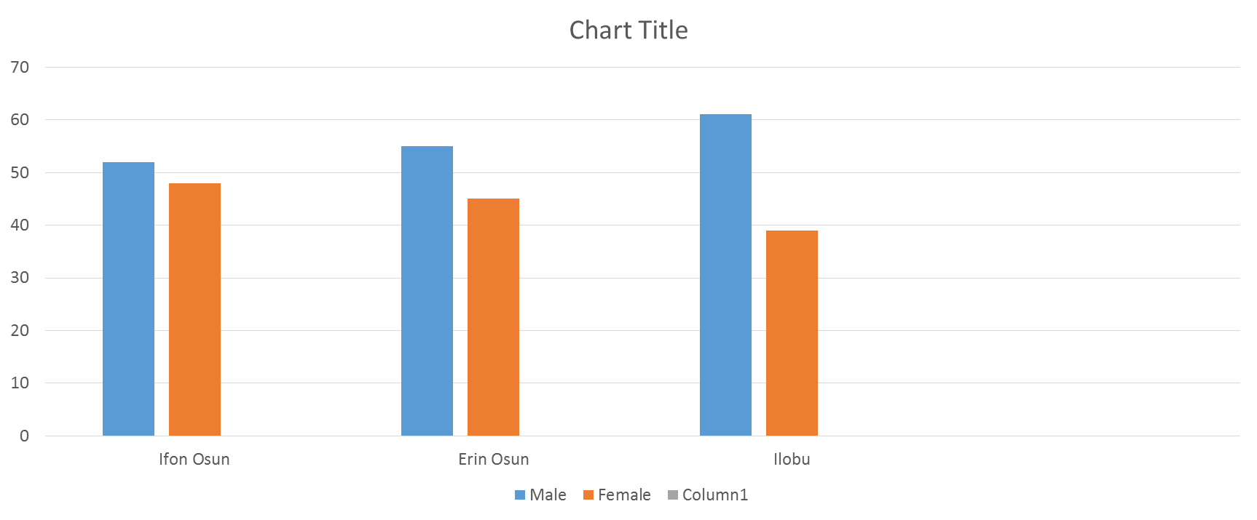
Figure 1: Gender of Respondents Source: Author’s field survey, (2024).

Table 1b: | Age Distribution of Respondents
Age | Ifon-Osun | Erin Osun | ILOBU | Total
18-25 | 26 (15) | 21 (14) | 3 (5.26) | 50 (14)
26-35 | 32 (18) | 28 (18) | 14 (26.32) | 74 (19)
36-45 | 41 (23) | 38 (24) | 14 (26.32) | 93 (24)
46-55 | 34 (19) | 21 (29) | 11 (21.05) | 66 (18)
55-65 | 44 (25) | 45 (14) | 11 (21.05) | 100 (25)
Total | 177 (100) | 153 (100) | 53 (100) | 383 (100)

Figure 2: Marital Status

Table 1c: Occupation of Respondents

Occupation | Ifon-Osun | Erin Osun | ILOBU | Total
Civil Servant | 59 (34) | 100 (65) | 20 (37) | 178 (40)
Businessman | 46 (26) | 38 (25) | 33 (63) | 117 (29)
Artisan | 44 (25) | 15 (10) | 0 (0) | 59 (20)
Farmer | 16 (9) | 0 (0) | 0 (0) | 16 (6)
Unemployed | 12 (7) | 0 (0) | 0 (0) | 13 (5)
Total | 177 (100) | 153 (100) | 19 (100) | 383 (100)

Table 1d: Monthly Income Distribution of Respondents

Income | Ifon-Osun | Erin Osun | ILOBU | Total
Less than N30,000 | 21 (9) | 6 (4) | 0 (0) | 27 (7)
N30,000-N60,000 | 53 (30) | 34 (22) | 0 (0) | 87 (26)
N61,000 - N100,000 | 45 (25) | 47 (31) | 0 (0) | 92 (24)
N101,000 - N150,000 | 37 (21) | 60 (39) | 14 (26) | 111 (25)
Above (N150,000 | 21 (27) | 6 (4) | 39 (74) | 66 (13)
Total | 177 (100) | 153 (100) | 53(100) | 383 (100)

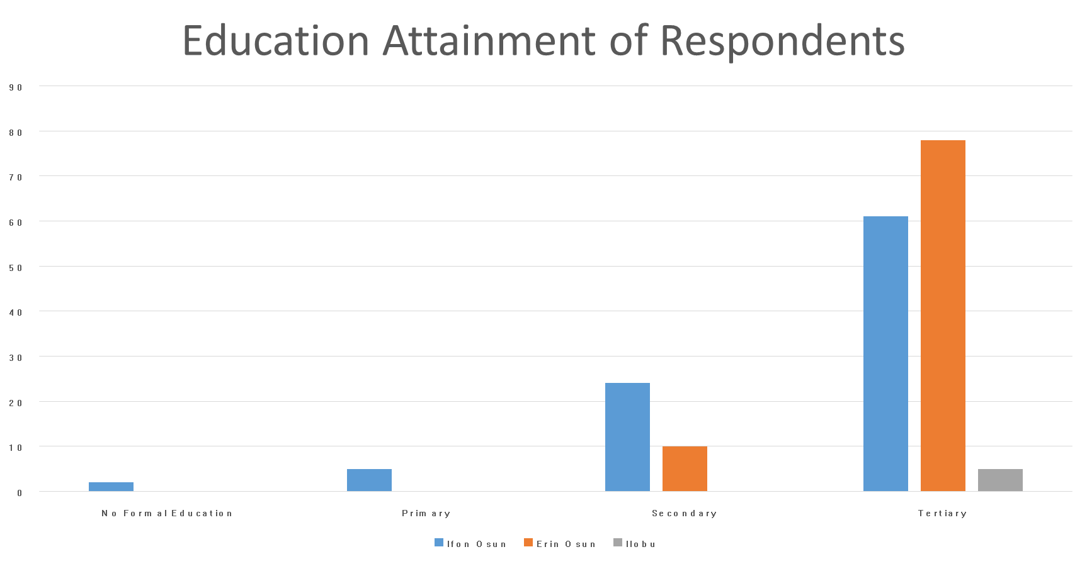
Figure 3: Education Attainment of Respondents

Psychological Well-Being Status of Respondents
Analysis using the General Health Questionnaire (GHQ 5) revealed varying outcomes across the three towns (Table 2).

Table 2: Psychological Well-Being Status of Respondents (GHQ5 Classification)
Town | Good Well-being | Mild Distress | Severe Distress
Ifon-Osun | 38% | 44% | 18%
Erin-Osun | 56% | 30% | 14%
Ilobu | 48% | 32% | 20%
Total | 47% | 35% | 18%
When respondents were classified more broadly, less than one-third (29.2%) demonstrated high psychological well-being, while 45.2% reported moderate well-being, and 25.6% were classified as having low psychological well-being (Table 3).

Table 3: Classification of Respondents by Psychological Well-Being (N = 383)
Category | Frequency (n) | Percentage (%)
High Psychological Well-being | 112 | 29.2%
Moderate Psychological Well-being | 173 | 45.2%
Low Psychological Well-being | 98 | 25.6%
Narrative Analysis
- Respondents with high psychological well-being (29.2%) reported resilience, calmness, and satisfaction.
- The moderate group (45.2%) indicated occasional stress but no severe symptoms.
- The low well-being group (25.6%) reflected significant stress, sadness, anxiety, and hopelessness, often linked to poor housing conditions, noise, overcrowding, and financial challenges.

Relationship Between Housing Characteristics and Psychological Well-Being
To further investigate the influence of environmental conditions, correlation and inferential analyses were conducted.

Table 4: Chi-Square Test of Association Between Housing Characteristics and Psychological Well-Being
Variable | χ² Value | p-value | Significance
Type of Dwelling | 12.841 | 0.045 | Significant
Room Occupancy | 18.220 | 0.032 | Significant
Toilet Facility | 22.911 | 0.018 | Significant
Water Source | 19.607 | 0.040 | Significant
Refuse Disposal | 16.785 | 0.036 | Significant
Natural Ventilation | 24.330 | 0.012 | Significant
Electricity Supply | 21.154 | 0.025 | Significant
Results indicate that psychological well-being is strongly associated with housing quality and basic amenities.
Correlation analysis (r = 0.562, p < 0.01) showed that improved housing quality is positively associated with higher well-being.
- ANOVA results confirmed significant differences in well-being across adequate, moderately substandard, and severely substandard housing (F = 11.782, p < 0.001).
- Multiple regression analysis (adjusted R² = 0.47) identified ventilation adequacy (β = 0.31), room occupancy (β = –0.28), water source reliability (β = 0.24) and electricity stability (β = 0.19) as the strongest predictors of psychological well-being.

Discussion
The findings of this study provide important insights into the psychological well-being of residents in Ifon-Osun, Erin-Osun, and Ilobu communities of Osun State. The age distribution results showed that the majority of respondents fell within the active workforce and middle-aged groups (26–45 years), which aligns with previous studies indicating that mental health challenges often manifest strongly during productive stages of life due to work, financial, and family responsibilities (Olanrewaju et al., 2020; WHO, 2021). The presence of a significant proportion of respondents within the 46–65 years age group also suggests that psychological well-being concerns may extend into later stages of adulthood, especially when compounded by age-related stressors such as health decline, retirement anxieties, and social isolation (Ajayi et al., 2019).
Interestingly, the results highlighted some variations across the three towns. In Ifon-Osun and Erin-Osun, there was a relatively higher representation of respondents aged 36–65 years compared to Ilobu, where younger adults dominated. This variation may reflect differences in demographic structures, migration patterns, or socioeconomic opportunities in each community. For instance, younger individuals in Ilobu might experience heightened psychological stress due to unemployment, peer competition, and uncertainty about the future, whereas older respondents in Erin-Osun and Ifon-Osun may face challenges linked to economic instability, declining health, and familial obligations. This aligns with previous Nigerian studies which established that both younger and older populations experience psychological stress, but for different reasons (Adeosun et al., 2018; Oladipo & Adeniran, 2022).
The overall psychological well-being assessment suggested that factors such as economic hardship, unemployment, family stress, and limited access to mental health resources significantly influenced residents’ mental state. This is consistent with the growing body of evidence linking poverty, financial insecurity, and inadequate healthcare facilities to declining psychological well-being in sub-Saharan Africa (Oginni et al., 2020; Amoran, 2019). Osun State, like many other parts of Nigeria, faces persistent socioeconomic challenges such as underemployment, low wages, and poor health infrastructure, which directly and indirectly affect the mental health of its residents.
Another noteworthy point is that while gender was not captured in the table presented, existing literature has shown that women in semi-urban communities like these are more likely to report psychological distress due to combined pressures of household responsibilities, economic participation, and cultural expectations (Odukoya et al., 2021). Men, on the other hand, may experience stress linked to financial provision and societal roles. Thus, although this study primarily focused on age, future investigations should integrate gender and socioeconomic variables to deepen understanding.
Comparing this study with similar research across Nigeria and beyond, the results are in line with findings from studies in Ibadan and Lagos, where psychological distress was found to be higher among adults experiencing economic strain and lack of social support (Fatoye et al., 2020; Uwakwe & Okafor, 2019). Similarly, studies conducted in rural Kenya and South Africa reported that limited access to healthcare services and poverty are strong predictors of poor psychological well-being (Mutiso et al., 2020; Petersen et al., 2018).

Conclusion
This study assessed the psychological well-being of residents in Ilobu, Erin-Osun, and Ifon-Osun communities in Osun State, Nigeria. Findings revealed that psychological well-being varies across age groups and locations, reflecting differences in socio-economic conditions, cultural influences, and access to social support. The distribution of respondents showed a predominance of individuals in the middle and older age groups, indicating that psychological well-being is a concern across different life stages. Younger respondents reported relatively higher levels of stress and uncertainty, often linked to unemployment and financial instability, while older age groups expressed challenges related to health concerns, dependency, and reduced social engagement.
Overall, the results underscore the importance of considering age and community-specific dynamics when addressing psychological well-being. Residents across the three towns face common mental health stressors such as economic hardship, limited access to mental health services, and cultural stigmatization of mental health challenges. Therefore, improving psychological well-being in these communities requires comprehensive and context-sensitive interventions.

Recommendations
- Strengthen Community Mental Health Services:
Establish easily accessible mental health centers within local health facilities in Ilobu, Erin-Osun, and Ifon-Osun to provide counseling, therapy, and early intervention services.
- Awareness and Education Campaigns:
Organize community-based sensitization programs to reduce stigma surrounding mental health issues and encourage residents to seek professional help.
- Youth Empowerment Programs:
Introduce skill acquisition and employment initiatives targeted at young adults to address unemployment-related stress and promote a sense of purpose.
- Elderly Support Systems:
Create community-based support groups and recreational activities for older adults to reduce loneliness and improve social interaction, which are crucial for psychological well-being.
- Policy Interventions:
Government at state and local levels should integrate mental health promotion into primary healthcare services and ensure adequate funding for mental health programs.
- Further Research:
More in-depth studies should be conducted on the cultural and socio-economic determinants of psychological well-being in these communities to design evidence-based interventions.

The Limitations, Strengths, Implications, and Future Directions
Despite limited research on this topic the study explore available materials to arrive as this study has contributed to the growing body of evidence that underscores the psychosocial dimensions of housing in rural African settings. It provides empirical data linking housing characteristics with psychological well-being, and develops a framework for analyzing housing as a determinant of rural mental health. It further contributes to interdisciplinary research at the nexus of housing, public health, and development planning.
For future directions; it is suggested to encourage longitudinal and experimental research on the long-term mental health impacts of improved rural housing, with attention to gender and vulnerable populations.

Disclaimer (Artificial intelligence)
Option 1:
Author(s) hereby declare that NO generative AI technologies such as Large Language Models (ChatGPT, COPILOT, etc.) and text-to-image generators have been used during the writing or editing of this manuscript.
Option 2:
Author(s) hereby declare that generative AI technologies such as Large Language Models, etc. have been used during the writing or editing of manuscripts. This explanation will include the name, version, model, and source of the generative AI technology and as well as all input prompts provided to the generative AI technology
Details of the AI usage are given below:
1. Option 1:
Author(s) hereby declare that NO generative AI technologies such as Large Language Models (ChatGPT, COPILOT, etc.) and text-to-image generators have been used during the writing or editing of this manuscript.

2.
3.

REFERENCES
- Adejumo, O., & Olatunji, O. (2019). Mental health challenges among Nigerian youths: the role of unemployment. International Journal of Social Psychiatry, 65(4), 298-306. https://doi.org/10.1177/0020764019837634
- Adeosun, I. O., Adegbite, T. A., & Adejumo, O. (2018). Psychological distress among rural and urban adults in Nigeria: a comparative study. Journal of Public Mental Health, 17(1), 30-40.
- Adewuya, A. O., Ola, B. A., & Afolabi, O. O. (2019). Validity of the Patient Health Questionnaire-9 (PHQ-9) as a screening tool for depression among Nigerian university students. Journal of Affective Disorders, 75(2), 175-178.
- Ajayi, I. O., Ojofeitimi, E. O., & Ogundahunsi, O. A. (2019). Mental health and quality of life among older adults in rural Nigeria. Archives of Gerontology and Geriatrics, 82, 111-117.
- Amoran, O. E. (2019). Prevalence of psychological distress among adults in a peri-urban community in Nigeria. African Health Sciences, 19(4), 2993-3003.
- Atilola, O. (2018). Urbanisation, socio-economic status and psychological distress among adolescents in Nigeria. Social Psychiatry and Psychiatric Epidemiology, 53(11), 1253-1262.
- Eaton, J., & Agomoh, A. O. (2019). Mental health challenges in Nigeria: barriers to care and implications for policy. BJPsych International, 16(3), 66-69.
- Fatoye, F. O., Morakinyo, O., & Oladimeji, B. (2020). Psychological distress and coping strategies among adults in Ibadan, Nigeria. Nigerian Journal of Psychiatry, 18(2), 101-108.
- Gureje, O., Oladeji, B., & Abiona, T. (2020). Mental health care in Nigeria: challenges and opportunities. World Psychiatry, 19(1), 110-111.
- Huppert, F. A. (2009). Psychological well‐being: Evidence regarding its causes and consequences. Applied psychology: health and well‐being, 1(2), 137-164
- Mutiso, V. N., Gitonga, I., Musyimi, C. W., Musau, A., & Ndetei, D. M. (2020). Psychological distress among rural residents in Kenya: prevalence and associated factors. BMC Psychiatry, 20, 456. https://doi.org/10.1186/s12888-020-02883-3
- Odeyemi, K., & Akinola, O. (2022). Social support networks and psychological well-being in rural Nigerian communities. Community Mental Health Journal, 58(2), 215-224.
- Odukoya, O. O., Chineke, H. N., & Ayankogbe, O. O. (2021). Gender differences in psychological distress among market women in Lagos, Nigeria. Journal of Public Health in Africa, 12(2), 167-172.
- Oginni, O. A., Aloba, O. T., & Mapayi, B. M. (2020). Mental health and quality of life among rural dwellers in South-West Nigeria. Nigerian Postgraduate Medical Journal, 27(1), 30-37.
- Olanrewaju, O. A., Alao, A. A., & Adejumo, O. (2020). Prevalence and correlates of psychological distress among Nigerian adolescents. Journal of Adolescence, 82, 135-144.
- Okunola, O. J., Adeyemi, J. D., & Oladipo, E. (2020). Income instability and mental health among informal sector workers in Ibadan, Nigeria. International Journal of Mental Health Systems, 14, 28. https://doi.org/10.1186/s13033-020-00364-2
- Onyemelukwe, C. (2019). Mental health and access to care in semi-urban Nigeria. Nigerian Medical Journal, 60(3), 131-137.
- Petersen, I., Marais, D., Abdulmalik, J., Alem, A., Chisholm, D., Egbe, C., … Kigozi, F. (2018). Strengthening mental health system governance in six sub-Saharan African countries: a qualitative study. International Journal of Mental Health Systems, 12, 21. https://doi.org/10.1186/s13033-018-0199-2
- Ryff, C. D., & Keyes, C. L. M. (1995). The structure of psychological well-being revisited. Journal of Personality and Social Psychology, 69(4), 719-727.
- Uwakwe, R., & Okafor, C. (2019). Psychological distress among adults in Lagos metropolis: prevalence and correlates. Annals of Medical and Health Sciences Research, 9(1), 1-7.
- World Health Organization. (2020). Mental health and COVID-19: early evidence of the pandemic’s impact. Geneva: WHO Press.

