Has Artificial Intelligence Improved Management Outcomes of Hand Fractures in the Tropics?

A Systematic Review and Meta Analysis

ABSTRACT
INTRODUCTION: The application of Artificial intelligence (AI) and Machine learning (ML) in hand surgery has rapidly become a powerful and emerging field with a promising patient-care reputation. This study aims to compare the diagnostic performance of AI with that of an experienced hand surgeon in terms of accuracy, specificity, and sensitivity in detecting hand injuries
METHODS: A systematic literature search of PubMed, Web of Science, Scopus, and Google Scholar databases was conducted.
RESULTS: The initial search yielded 9,317 articles. Only nine (9) articles were included in the final review with a 45,778-sample size after the application of the inclusion/exclusion criteria.
The result indicated no statistical significance of the application of AI and ML in hand surgery as compared to experienced surgeons in terms of accuracy (OR=0.947, 95% CI 0.552- 1.624; p= 0.844), sensitivity (OR=0.678, 95% CI 0.354- 1.289; p= 0.234) and specificity (OR=1.260, 95% CI 0.525- 3.022; p= 0.604).
CONCLUSION: There was no significant difference in accuracy, sensitivity, and specificity in terms of diagnosis and clinical application between an expert surgeon and AI or ML in hand surgery. Thus, Artificial intelligence can also be utilized in diagnosing hand surgery in the tropics, however since artificial intelligence is an evolving field, further calibration will be required for its improved diagnostic value. We recommend that more doctors in the tropics are better equipped with AI techniques to be used as an adjunct in clinical practice.
KEYWORDS- Artificial Intelligence, Machine Learning, Hand Fracture.

INTRODUCTION
There is a significant global burden of musculoskeletal trauma in low and middle-income countries, of which hand injuries present as the commonest owing to the rise in industrialization and machine dependency [1,2]. Hand injuries consist of about 29% of all injuries treated in an emergency, according to studies, scaphoid fractures comprise a considerable portion, with a mean annual incidence of 1.5 to 4.3 per 10,000 patients [3– 5]. These hand injuries occur mostly in younger individuals who are physically active and are characterized by non-union in about 12% to 50% of cases, pain, deformity, carpal collapse, degenerative arthritis, and loss of function [6–8]. There is also evident complication of infections and gangrene in low and middle-income countries [1].
Plain radiographs remain the primary diagnostic approach for the diagnosis of hand trauma, especially scaphoid fractures. It is usually evaluated by an experienced radiologist or orthopedist but in low and middle-income countries or busy healthcare settings where experienced medical experts may be unavailable, these hand traumas are being managed by non-specialist physicians, especially in emergency departments where prompt decision-making is needed, this only account for high chances of missing out some fractures or making inaccurate identification of fractures on radiographic film, which can negatively affect patient management, and also cause delayed detection and inappropriate immobilization may complicate other conditions which are not favorable to the patients [1–11]. These errors in the interpretation of hand fractures have been shown to account for 41 to 80% of all reported cases of diagnostic errors in emergency departments [10,12,13]. The burden of hand injuries not only includes the resultant disability but the economic burden in terms of direct health care cost, and indirect productivity cost which equates to the monetary value of productivity lost due to injury. A study by putter et. Al revealed with productivity costs (56%) outweighing direct health cost [14].
Early detection and appropriate immobilization are necessary for effective management of hand injuries [15]. Unfortunately, in many low-income countries, this does not hold owing to a lack of skilled medical experts, and few available in the healthcare settings are

being overwhelmed. Hence, developing new artificial intelligence or machine learning technologies, that are easily accessible and can assist non-specialist physicians in the early, accurate, and efficient detection of fractures on plain radiography is important [3,16]. Deep learning, a subset of artificial intelligence (AI) has evolved successfully in the analysis and interpretation of pathological images with the aid of convolutional neural networks (CNNs) [17–19]. CNN uses a convolution filter to input images and generates an array of maps useful in summarizing and ranking the output. CNN can be trained to detect a useful feature automatically, also its efficiency can be enhanced by modifying the layouts of the network or by increasing the amount and diversity of the dataset [15].
Previous studies show that the clinical performance of experienced surgeons can be compared to AI, in evaluating several fractures. According to the stud y done by Kuo et al, [20], the pooled sensitivity of AI is 92%, and the specificity is 91% in internal validation compared to Clinicians with the pooled sensitivity of 91% and 92% ,while for external validation test, the pooled sensitivity and specificity were both 91% for AI compared to pooled sensitivity and specificity of each 94% for clinicians, respectively in detecting several fractures. However, little is known on how artificial intelligence improves outcomes in hand surgery practices.
In a study done by Suen K. et al [21], the pooled sensitivity and specificity for AI in detecting scaphoid fractures were 0.85 and 0.83 respectively, while human experts exhibited 0.71 and 0.93 respectively. These findings underscore the potential of AI to enhance fracture detection and improve clinical workflow. In another study done by Brenac C. et al [22], most studies reported AI performing as or better than surgeons but with poorer specificity especially in occult scaphoid fractures.
However, in a recent retrospective study by Ramadanov N. et al on AI guided distal radial fracture detection shows accuracy, specificity and sensitivity of AI to be 95.90%, 98.45% and 92.02% respectively, and that of an experienced surgeon to be 95.1%, 97.8% and 91.5% respectively. The marginal differences in sensitivity and specificity in this

study suggesting that AI can reliably be used in clinical fracture assessment. Which highlights AI role in augmenting human expertise rather than replacing it.[23]
Thus, this systematic review and meta-analysis aims to compare with empirical evidence the diagnostic performance of AI in terms of accuracy, specificity, and sensitivity in detecting hand injuries compared with that of an experienced hand surgeon and how it relates to practice in the tropics for improved practice
An experienced hand surgeon is on that meets that meets any of the following criteria: Successful completion of a residency program, typically in orthopedic surgery, plastic surgery, or general surgery, lasting 5–7 years and completes a hand surgery fellowship, typically a 1-year accredited program focusing on hand and upper extremity surgery. Extensive hands-on experience in managing a high volume of hand and upper extremity cases, including surgical and non-surgical treatments.
Obtain board certification in a primary specialty (orthopedic surgery, plastic surgery, general surgery or subspecialty board certification in hand surgery

METHODOLOGY
A primary search yielded 9,317 articles. Our study was conducted based on The Cochrane Collaboration standard and the Preferred Reporting Items for Systematic Reviews and Meta-Analyses, (PRISMA) used for the reporting.

Search strategy
A comprehensive literature search was conducted in PubMed, Web of Science, Scopus, and Google Scholar databases independently by two researchers to identify studies comparing the accuracy, sensitivity, and specificity of AI or machine learning with an experienced surgeon in the diagnosis of hand surgery from 2019 to 2024.
The search strategy combined the following terms: ("Artificial intelligence" OR "AI" OR "machine learning" OR "Deelpearning") AND ("hand surgery" OR "hand surgeries" OR "upper limb surgery" OR "upper limb reconstruction" OR "hand operation")

OR
("Artificial intelligence" [MesH Terms]) AND ("hand surgery*" [MesH Terms])

Literature screening was done by reading the title and abstract and as well a text review for studies that were not sure they met the inclusion/exclusion criteria.

Study selection and screening
Studies satisfying the following criteria were included (1) comparing AI or Machine learning with an expert surgeon in terms of accuracy, sensitivity, and specificity (2) All studies within 2019 to 2024, (3) studies in the English language, (4) published in peer- reviewed journals, (5) Human studies
Exclusion criteria included: (1) Non-Peer-reviewed journal articles such as Editorials, commentaries, case reports, and perspectives (2) All studies conducted before 2018 (3) studies in other languages aside from English languages, (3) Duplicate studies or studies reporting similar data from the same research group (4) Non-Human studies (5) Studies that do not compare accuracy, sensitivity, and specificity of AI with that of an expert surgeon in hand surgery.
For the articles that met the eligibility criteria, full text was reviewed. A third author resolves any disagreement between the two authors.

Data extraction
Data was extracted manually by two (2) independent review authors, and the required information was summarized using an extraction table in Microsoft Excel software. The data extraction table for each outcome contained: the authors of the study, year of publication, sample size, confidence interval, and P-value.
The primary outcome measures include diagnostic accuracy, sensitivity, and specificity for each AI and Expert surgeon.

Quality assessment
Two review authors independently assessed the risk of bias using the Cochrane risk of bias tool (RoB- 2 tool), bias that may arise from the randomization process, intended intervention, missing outcome, measurement of the outcome, and selection of the reported result are visualized using Robvis. The Grading of Recommendations, Assessment, Development, and Evaluation (GRADE) tools and the Assessing the Methodological Quality of Systematic Review (AMSTAR) tools were used to assess the overall quality of the review.

Statistical analysis
The confidence interval values were extracted for each outcome measure where available. The Comprehensive Meta-analysis (CMA) software was used to analyze the outcomes for Diagnostic accuracy, Diagnostic sensitivity, and Diagnostic specificity. Statistical tools used were the random-effects model and results were presented in mean effect size, odds ratio, and confidence intervals (95%). Heterogeneity results (assessed by I²) were calculated to present variations among the included studies. Individual studies and the respective pooled estimate of the effect size were represented graphically using a forest plot. Egger's regression asymmetry test assesses small study bias or publication bias.
p-value < 0.05 was categorized as Statistically significant for all tests.

Protocol registration
The research was registered under the international prospective register of systematic reviews (PROSPERO) with registration number- CRD42024559165.

RESULTS
The selection process was done using Preferred Reporting Items for Systematic Reviews and Meta-analyses (PRISMA) flow diagram Figure 1 –shows a primary search yielded 9,317 articles. After the duplicates were excluded a total of 9259 articles were initially screened by title and abstract, out of which only 33 articles were retrieved for full-text evaluation. At a full-text stage, 24 studies were excluded using exclusion criteria. Finally,

9 studies were selected of which 2 articles were for qualitative synthesis and the final 7 articles were for quantitative synthesis.
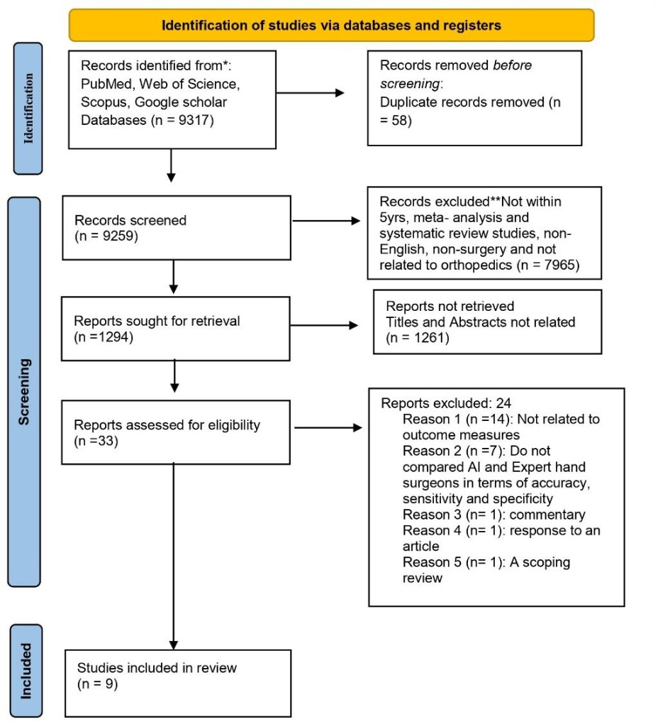

Figure 1: Prisma Flow Diagram

Table 1- Diagnostic Accuracy
 | Diagnostic |  | Diagnostic  Accuracy
Sample  Study Year Size | Accuracy  Of AI | CL | Of Expert  Surgeon | CL | P-Value
davif 2019 2340 | 93% | 90-96% | 94% | 91-96% | <0.001

David W G  Langerhuizen |  |  |  |  |  | 81-
et al | 2020 | 300 | 72% | 60-84% | 84% | 88%
ShanlinChen |  |  |  | 82- |  | 79 -
et al, | 2022 | 600 | 88% | 95% | 86% | 93% | 0.804
Takeshi |  |  |  | 90 - |  | 92.4 -
Suzuki, et al | 2022 | 961 | 99.30% | 96% | 96.7 | 98.6 | 0.046
CI= Confidence interval, AI= Artificial intelligence

Table 2- Diagnostic Specificity

 |  |  |  |  | Diagnostic
 |  |  |  |  | Specificity
 |  |  | Diagnostic |  | Of An
 |  | Sample | Specificity |  | Expert
Study | Year | Size | Of AI | CI | Surgeon | CI | P-Value
Robert |  |  |  | 92.9- |  | 85.3-
Lindsey et al | 2018 | 34,900 | 94% | 94.9 | 88% | 89.5
Kaifeng Gan  et al | 2019 | 2340 | 96% | 93-99 | 95% | 91-98 | 0.009
David W G  Langerhuizen |  |  |  | 0.46- |  | 0.93-
et al | 2020 | 300 | 60% | 0.74 | 93% | 0.99 | <0.01
ShanlinChen  et al, | 2022 | 600 | 94% | 87-100 | 96% | 90-100 | 1
Takeshi |  |  |  | 95.1- |  | 90.8-
Suzuki, et al | 2022 | 961 | 100.00% | 100 | 97.30% | 99.3 | 0.157
Emre Ozkaya | 2022 | 390 | 92% | 0.808- | 98% | 0.894- | <0.001

et al 0.978 0.999
Yoon, Alfred.
P et al 2023 15
76%
0.72-
0.80
78%
0.74-
0.81
CI= Confidence interval, AI= Artificial intelligence

Table 3- Diagnostic Sensitivity

Sample

Diagnostic Sensitivity

Diagnostic Sensitivity Of An Expert

Study Year
Size
Of AI CI
Surgeon CI P-Value

Robert |  |  |  | 89.3- |  | 76.7-
Lindsey et al | 2018 | 34,900 | 92% | 92.9 | 81% | 84.1
Kaifeng Gan  et al | 2019 | 2340 | 90% | 85-95 | 93% | 89-97 0.007
David W G  Langerhuizen |  |  |  | 0.74- |  | 0.70-
et al | 2020 | 300 | 84% | 0.94 | 76% | 0.82 0.29
ShanlinChen  et al, | 2022 | 600 | 82% | 71-93 | 76% | 64-88 0.549
Takeshi |  |  |  | 92.8- |  | 88.9-
Suzuki, et al | 2022 | 961 | 98.70% | 99.8 | 96.00% | 98.6 0.083
Emre Ozkaya |  |  |  | 0.618- |  | 0.733-
et al | 2022 | 390 | 76% | 0.869 | 86% | 0.942 <0.001
Yoon, Alfred. |  |  |  | 0.85- |  | 0.69-
P et al | 2023 | 15 | 87% | 0.89 | 72% | 0.74
CI= Confidence interval, AI= Artificial intelligence

Table 4- SUMMARY OF TABLE FINDINGS

Author Outcomes

Yoon, Alfred. P et al A survey-based experiment concluded that CNN
assistance improves physician diagnostic sensitivity and specificity as well as an inter-observer agreement for the diagnosis of occult scaphoid fractures (between February 2022 to March 2022)

Kaifeng Gan et al observational study concluded that the CNN model
shows diagnostic ability like that of orthopedic surgeons and a performance superior to that of radiologists in distinguishing AP wrist radiographs with DRFs from normal images under limited conditions between January 2010 and September 2017

David W G Langerhuizen et al
in retrospective study shows Deep learning algorithm suggests that it has trouble identifying scaphoid fractures that are obvious to human observers

Shanlin Chen et al, an observational study Indicated that the
convolutional neural network’s performance was similar to the majority vote of surgeons in scaphoid fractures between 2010 to 2020 in China
Robert Lindsey et al a retrospective study showed that a deep learning
model can be trained to detect wrist fractures in radiographs with diagnostic accuracy similar to that of senior subspecialized orthopedic surgeons from

2000 to 2016

Emre Ozkaya et al in a retrospective study concluded that Missed
Scaphoid fracture rates were higher in physicians without sufficient experience in hand surgery than CNN.

Takeshi Suzuki, et al a retrospective study showed the feasibility of a CNN
for accurate detection of DRF on wrist radiographs and showed comparable or better diagnostic capabilities than hand orthopedic surgeons under the same conditions from 2012 to 2019
Table 5. Study characteristics

Four studies in the review reported data for Diagnostic accuracy. All four studies showed AI (intervention) can be compared with Expert surgeons (control) in hand surgery. The pooled results showed Odd ratio of 0.947 with a 95% confidence interval of 0.552- 1.624 (p= 0.844).

Meta Analysis
Study name Statistics for each study Odds ratio and 95% CI Odds Lower Upper
ratio limit limit Z-Value p-Value
Kaifeng Gan et al 1.183 0.937 1.494 1.411 0.158
David W G Langerhuizen et al 2.042 1.371 3.041 3.511 0.000
Shanlin Chen et al, 0.838 0.598 1.174 -1.029 0.303
Takeshi Suzuki, et al 0.293 0.142 0.606 -3.309 0.001
Pooled 0.947 0.552 1.624 -0.197 0.844
Prediction Interval 0.947 0.080 11.197
0.01 0.1 1 10 100

Favours A Favours B

Meta Analysis

Figure 2: Forest Plot (Random Effects Model) for Diagnostic accuracy (Egger’s test, p- value = 0.513)
Log odds ratio
2.0
1.5
1.0
0.5
0.0
-0.5
-1.0
-1.5
-2.0
0.4
0.3
0.2
0.1
0.0
Funnel Plot of Standard Error by Log odds ratio
Standard Error

Seven studies review reported data for Diagnostic specificity. All seven studies Showed AI (intervention) can be compared with an Expert surgeon (control) in hand surgery.

Table 6: The pooled results showed odd ratio of 1.260 with a 95% confidence interval of 0.525- 3.022 (p= 0.604).

Meta Analysis
Study name
Statistics for each study
Odds Lower Upper
ratio limit limit Z-Value p-Value
Odds ratio and 95% CI
Robert Lindsey et al Kaifeng Gan et al
David W G Langerhuizen et al Shanlin Chen et al,
Takeshi Suzuki, et al Emre Ozkaya et al Yoon, Alfred. P et al Pooled
Prediction Interval
0.468 0.443 0.494 -27.191
0.792 0.599 1.045 -1.647
8.857 5.372 14.604 8.549
1.532 0.902 2.601 1.579
0.016 0.001 0.269 -2.879
4.152 1.884 9.149 3.532
1.120 0.204 6.140 0.130
1.260 0.525 3.022 0.518
1.260 0.065 24.553
0.000
0.100
0.000
0.114
0.004
0.000
0.896
0.604
0.01 0.1 1 10 100
Favours A Favours B
Meta Analysis

Log odds ratio
5
4
3
2
1
-1 0
-2
-3
-4
-5
2.0
1.5
1.0
0.5
0.0
Funnel Plot of Standard Error by Log odds ratio
Standard Error

Figure 3: Forest Plot (Random Effects Model) for Diagnostic specificity (Egger’s test, p- value = 0.513)

Seven studies in the review reported data for Diagnostic sensitivity. All seven studies

Showed AI (intervention) can be compared with an Expert surgeon (control) in hand surgery. Table 7: The pooled results showed odd ratio of 0.678 with a 95% confidence interval of 0.354- 1.289 (p= 0.234).
Meta Analysis
Study name

Robert Lindsey et al
Statistics for each study
Odds Lower Upper
ratio limit limit Z-Value p-Value
0.371 0.354 0.389 -41.366 0.000
Odds ratio and 95% CI
Kaifeng Gan et al 1.476 1.198 1.818 3.662 0.000
David W G Langerhuizen et al 0.603 0.402 0.906 -2.436 0.015
Shanlin Chen et al, 0.695 0.525 0.920 -2.544 0.011
Takeshi Suzuki, et al 0.242 0.119 0.494 -3.897 0.000
Emre Ozkaya et al 1.940 1.342 2.804 3.524 0.000
Yoon, Alfred. P et al 0.384 0.059 2.518 -0.997 0.319
Pooled 0.676 0.354 1.289 -1.189 0.234
Prediction Interval 0.676 0.071 6.453
0.01 0.1 1 10 100

Favours A Favours B
Meta Analysis
Figure 4: Forest Plot (Random Effects Model) for Diagnostic sensitivity (Egger’s test, p- value = 0.155)
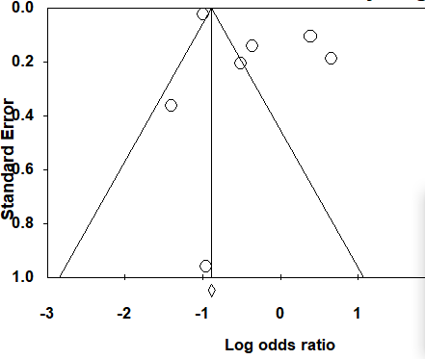

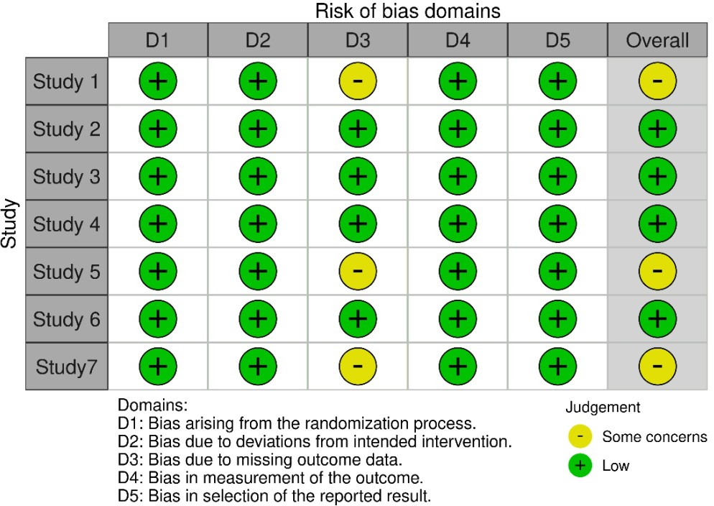

Figure 5: Risk of Bias

According to McGuinness and Higgins, 2021

DISCUSSION
Hand injuries are on the rise due to the high rate of road traffic accidents, dependency on machines, terrorism, conflicts and men in their 20s were mostly involved [1,24]. The global incidence of hand trauma is estimated to be 178.9 (95% UI 145.8 to 216.8) age- standardized hand and wrist fractures per 100 000 individuals, 24.1 per 100 000 individuals for thumb amputations and 56.0 per 100 000 individuals for non-thumb digit amputations [24]
Conventional radiographs remain the first-line method in detecting hand injuries especially those of scaphoid fractures. However, plain radiography presents a diagnostic challenge due to the high chances of misinterpretation of fractures by clinicians, influenced by several factors like fatigue, and lack of well-experienced medical personnel which is a major problem in low and middle-income countries. Misinterpretation of hand injuries in radiographs delays the identification of these injuries which might get complicated with several pathological conditions which can be avoided if artificial intelligence or machine learning is utilized in their diagnosis. Therefore, this study aimed to compare the accuracy, specificity, and sensitivity of AI or ML with an expert Surgeon in the management of hand injuries.
For accuracy of AI compared with an experienced surgeon, four studies in the review reported the data. From the forest plot for accuracy, it is shown that each of the study made use of a higher sample size with good precision. The intervals from studies done by Kaifeng Gan et al and shanlin Chen et al crossed the line of no effect as well as the pooled result signifying there is no statistically significant difference (p -value=0.513) in AI diagnostic accuracy compared with that of an expert surgeon. The mean effect size is 0.947 with a 95% confidence interval of 0.552 to 1.624. This agrees with the work of Olczak et al, [25] the accuracy of the AI model in evaluating several fractures of the wrist, hand, and ankle radiographic projections corresponds to that of two senior
orthopedic surgeons. According to the work of Suen et al [20], AI and human have comparable diagnostic accuracy, especially for distal radius fractures.
In specificity of AI compared with an experienced surgeon, seven studies in the review reported the data.
From the forest plot for specificity, it is shown that the pooled interval crossed the line of no effect signifying that there is no statistically significant difference (p -value=0.513) in AI diagnostic specificity compared with that of an expert surgeon. The mean effect size is
1.260 with a 95% confidence interval of 0.525 to 3.022. In addition, most of the studies identified that an experienced surgeon is slightly more specific when compared with AI. This is in keeping with study done by Brenac C. et al where of most studies reported AI performing as or better than surgeons but with poorer specificity especially in occult scaphoid fractures.[22]
For sensitivity of AI compared with an experienced surgeon, seven studies in the review reported the data. The forest plot for sensitivity shows that the pooled interval crossed the line of no effect signifying that there is no statistically significant difference (p - value=0.155) in AI diagnostic specificity compared with that of an expert surgeon.
However, the mean effect size is 0.676 with a 95% confidence interval of 0.354 to 1.289. Most of the studies identified that AI is more sensitive when compared with an experienced surgeon.
Publication bias analyzed with funnel plots and Egger test (figure2-4) indicates that there is no statistically significant evidence of publication bias and observed effect sizes is because of the variable being studied rather than publication bias.
In addition, the heterogeneity of the seven (7) included studies showed variance in true effects rather than sampling error, indicating a high degree of heterogeneity among the effect sizes of the included studies, with I-squared statistics of 88%, 97% and 98% respectively for accuracy, specificity and sensitivity.
From our studies in figure 2-4, the pool summary of Diagnostic accuracy, sensitivity and specificity of AI or ML compared with an expert surgeon suggests that AI or ML showed the same capabilities of an experienced surgeon and can as well serve as an alternative

diagnostic tool in some regions of the world burdened with the dearth of trained hand surgeons such as in low and middle-income countries. A study in 2017 revealed that although high income countries had the highest reported standardized age incidence of hand injuries, however, there has been a substantial decline in the incidence of hand injuries in these countries over the last 27 years; 9%, 12% and 9% decrease in hand and wrist fractures, thumb amputations and non-thumb amputations respectively [24]. During the same period, low- and middle-income countries have experienced an increase in the incidence of hand injuries; 26%, 20% and 23% increase in hand and wrist fractures, thumb and non-thumb amputation respectively [24].
This underscores the importance of accurate and timely diagnosis of hand injuries especially in countries with paucity of trained hand surgeons. This is buttressed by a study conducted in Nigeria that sighted lack of fellowship training opportunities in hand subspecialty and unavailability of hand surgeons as a major challenge to hand surgery practice [26]. Another similar study surveying 39 Sub Sharan African countries sighted lack of adequate and timely diagnosis (74%), late referral (77%) and inadequate physical and occupational rehabilitation therapy (77%) as common reasons for poor outcome with hand injuries [27].
Our study reveals Convolutional neural networks (CNN) have almost similar performance in terms of accuracy, specificity and sensitivity in diagnosis of hand trauma when compared to experienced surgeons. This can be capitalized on to obliviate the problem of inaccurate and timely diagnosis in low- and middle-income countries by training less experienced doctors to use this model.
Previous studies also show there is improved diagnostic performance and timely detection of several hand fractures when physicians are assisted with CNN in making the diagnosis according to Yoon et al and Lindsey et al, [28,29]. Our studies also agree with the work of Olczak et al, [30] the accuracy of the AI model in evaluating several fractures of the wrist, hand, and ankle radiographic projections corresponds to that of two senior orthopedic surgeons and according to the work of Suen et al [21], AI and human have comparable diagnostic accuracy, especially for distal radius fractures, and In the

detection of scaphoid fractures, the experienced surgeon was similarly sensitive but more specific. Convolutional neural networks (CNN), which is one of the deep learning technologies, also show superiority in diagnosing hand traumas compared to plain radiography especially when trained and modified with large datasets.
This finding is important because aside from timely diagnosis of these traumas, there are also advantages of minimizing any further complications, associated with hand injuries, however, there is a need for more attention and testing to improve the ability of AI to localize the fractures [25].

Limitations of our study
Despite the advantages of AI or ML in diagnosing hand injuries as proposed by our studies, its clinical usefulness in this study was limited by certain factors which include first, all the selected patient samples in this study were readily available and searchable, hence there is a possibility that some radiographs were selected in favor and or against the other.
Secondly, specialists in hand surgery might have experienced such patterns of fractures along his/her course of training and practices in the past which gives them an edge in this study, so there are possibilities that the diagnostic value of CNN, a deep learning technology in detecting these fractures, might be likely higher. More training would be required for doctors in the tropics to improve the utilization of AI in their clinical practice.
Thirdly, most of the data sets are relatively small, especially from studies published in the tropics, to de the diagnostic accuracy, sensitivity, and specificity of AI in diagnosing hand injuries, hence a larger dataset and worldwide coverage are necessary to conclude the usefulness of AI or ML in the detection of fractures in the hand.
Finally, the difference in exposure and training of hand surgeons varies from one country to another other especially in the tropics, hence may influence how the radiographs are interpreted, as against artificial intelligence such as CNNs.

CONCLUSION
The findings in this study is significant because it shows that the utilization of artificial intelligence and its subset in healthcare practices will improve patient care and as well as benefit healthcare professionals from low and middle-income countries in the management of complex cases of hand injuries, especially in emergency cases when a specialist physician is not within the reach of the hospital. However, since artificial intelligence is an evolving field, further calibration will be required for its improved diagnostic value, and future large-scale studies must be carried out before it is approved for routine clinical management of patients.

Disclaimer (Artificial intelligence)
Option 1:
Author(s) hereby declare that NO generative AI technologies such as Large Language Models (ChatGPT, COPILOT, etc.) and text-to-image generators have been used during the writing or editing of this manuscript.
Option 2:
Author(s) hereby declare that generative AI technologies such as Large Language Models, etc. have been used during the writing or editing of manuscripts. This explanation will include the name, version, model, and source of the generative AI technology and as well as all input prompts provided to the generative AI technology
Details of the AI usage are given below:
1.
2.
3.
REFERENCES
- Makobore P, Galukande M, Kalanzi E, Kijjambu SC. The Burden of Hand Injuries at a Tertiary Hospital in Sub-Saharan Africa. Emerg Med Int *Internet+. 2015; 2015:1–5. Available from: http://www.hindawi.com/journals/emi/2015/838572/
- Bernstein DN, Agarwal-Harding KJ, Dyer GSM, Rozental TD. Outcomes Measurement in Global Hand Surgery. J Hand Surg Am *Internet+. 2020 Sep;45(9):865–8. Available from: https://linkinghub.elsevier.com/retrieve/pii/S0363502320302823
- Ozkaya E, Topal FE, Bulut T, Gursoy M, Ozuysal M, Karakaya Z. Evaluation of an artificial intelligence system for diagnosing scaphoid fracture on direct radiography. Eur J Trauma Emerg Surg *Internet+. 2022 Feb;48(1):585–92. Available from: https://link.springer.com/10.1007/s00068-020-01468-0

- Hove LM. EPIDEMIOLOGY OF SCAPHOID FRACTURES IN BERGEN, NORWAY. Scand J
Plast Reconstr Surg Hand Surg *Internet+. 1999 Jan 8;33(4):423–6. Available from: http://www.tandfonline.com/doi/full/10.1080/02844319950159145

- Larsen CF, Brøndum V, Skov O. Epidemiology of scaphoid fractures in Odense, Denmark. Acta Orthop Scand *Internet+. 1992 Jan 8;63(2):216–8. Available from: http://www.tandfonline.com/doi/full/10.3109/17453679209154827

- Hayat Z, Varacallo M. Scaphoid Wrist Fracture *Internet+. StatPearls. 2024. Available from: http://www.ncbi.nlm.nih.gov/pubmed/10614752

- Jørgsholm P, Ossowski D, Thomsen N, Björkman A. Epidemiology of scaphoid fractures and non-unions: A systematic review. Handchirurgie · Mikrochirurgie · Plast Chir *Internet+. 2020 Sep 29;52(05):374–81. Available from: http://www.thieme- connect.de/DOI/DOI?10.1055/a-1250-8190

- Kawamura K, Chung KC. Treatment of Scaphoid Fractures and Nonunions. J Hand Surg Am *Internet+. 2008 Jul;33(6):988–97. Available from: https://linkinghub.elsevier.com/retrieve/pii/S0363502308003997

- Wei CJ, Tsai WC, Tiu CM, Wu HT, Chiou HJ, Chang CY. Systematic analysis of missed extremity fractures in emergency radiology. Acta radiol *Internet+. 2006 Sep 30;47(7):710–7. Available from: http://journals.sagepub.com/doi/10.1080/02841850600806340

- Guly HR. Diagnostic errors in an accident and emergency department. Emerg Med J
*Internet+. 2001 Jul 1;18(4):263–9. Available from: https://emj.bmj.com/lookup/doi/10.1136/emj.18.4.263

- Whang JS, Baker SR, Patel R, Luk L, Castro A. The Causes of Medical Malpractice Suits against Radiologists in the United States. Radiology *Internet+. 2013 Feb;266(2):548–
54. Available from: http://pubs.rsna.org/doi/10.1148/radiol.12111119

- Leeper WR, Leeper TJ, Vogt KN, Charyk-Stewart T, Gray DK, Parry NG. The role of trauma team leaders in missed injuries. J Trauma Acute Care Surg *Internet+. 2013 Sep;75(3):387–90. Available from: https://journals.lww.com/01586154-201309000- 00005

- Williams Sm, Connelly Dj, Wadsworth S, Wilson Dj. Radiological Review of Accident and Emergency Radiographs: A 1-Year Audit. Clin Radiol *Internet+. 2000 Nov;55(11):861–5. Available from: https://linkinghub.elsevier.com/retrieve/pii/S0009926000905488

- de Putter, C. E., Selles, R. W., Polinder, S., Panneman, M. J. M., Hovius, S. E. R., & van Beeck, E. F. (2012). Economic impact of hand and wrist injuries: Health-care costs and productivity costs in a population-based study. The Journal of Bone & Joint Surgery, 94(9), e56. https://doi.org/10.2106/JBJS.K.00561

- Li T, Yin Y, Yi Z, Guo Z, Guo Z, Chen S. Evaluation of a convolutional neural network to identify scaphoid fractures on radiographs. J Hand Surg (European Vol *Internet+. 2023 May 7;48(5):445–50. Available from: http://journals.sagepub.com/doi/10.1177/17531934221127092

- Gan K, Xu D, Lin Y, Shen Y, Zhang T, Hu K, et al. Artificial intelligence detection of distal radius fractures: a comparison between the convolutional neural network and professional assessments. Acta Orthop *Internet+. 2019 Jul 4;90(4):394–400. Available from: https://actaorthop.org/actao/article/view/591

- Lakhani P, Sundaram B. Deep Learning at Chest Radiography: Automated Classification of Pulmonary Tuberculosis by Using Convolutional Neural Networks. Radiology *Internet+. 2017 Aug;284(2):574–82. Available from: http://pubs.rsna.org/doi/10.1148/radiol.2017162326

- Russakovsky O, Deng J, Su H, Krause J, Satheesh S, Ma S, et al. ImageNet Large Scale Visual Recognition Challenge. Int J Comput Vis *Internet+. 2015 Dec 11;115(3):211–
52. Available from: http://link.springer.com/10.1007/s11263-015-0816-y

- He K, Zhang X, Ren S, Sun J. Delving Deep into Rectifiers: Surpassing Human-Level Performance on ImageNet Classification. In: 2015 IEEE International Conference on Computer Vision (ICCV) *Internet+. IEEE; 2015. p. 1026–34. Available from: http://ieeexplore.ieee.org/document/7410480/

- Kuo RYL, Harrison C, Curran TA, Jones B, Freethy A, Cussons D, et al. Artificial Intelligence in Fracture Detection: A Systematic Review and Meta-Analysis. Radiology
*Internet+. 2022 Jul;304(1):50–62. Available from: http://pubs.rsna.org/doi/10.1148/radiol.211785.

- Suen K, Zhang R, Kutaiba N. Accuracy of wrist fracture detection on radiographs by artificial intelligence compared to human clinicians. A systematic review and meta- analysis. Eur J Radiol *Internet+. 2024 Sep;178:111593. Available from: https://linkinghub.elsevier.com/retrieve/pii/S0720048X24003097

- Brenac C, Fazilat AZ, Fallah M, Kawamoto-Duran D, Sunwoo PS, Longaker MT, Wan DC, Guo JL. AI in plastic surgery: customizing care for each patient. Art Int Surg. 2024;4:296-315. http://dx.doi.org/10.20517/ais.2024.49

- Ramadanov, N., John, P., Hable, R. et al. Artificial intelligence-guided distal radius fracture detection on plain radiographs in comparison with human raters. J Orthop Surg Res 20, 468 (2025). https://doi.org/10.1186/s13018-025-05888-9

- Crowe, C. S., Massenburg, B. B., Morrison, S. D., Chang, J., Friedrich, J. B., Abady, G. G., Alahdab, F., Alipour, V., Arabloo, J., Asaad, M., Banach, M., Bijani, A., Borzì, A. M.,
Briko, N. I., Castle, C. D., Cho, D. Y., Chung, M. T., Daryani, A., Demoz, G. T., ... James,
S. L. (2020). Global trends of hand and wrist trauma: A systematic analysis of fracture

and digit amputation using the Global Burden of Disease 2017 Study. Injury Prevention, 26(Suppl 1), i115–i124. https://doi.org/10.1136/injuryprev-2019-043495

- Yang S, Yin B, Cao W, Feng C, Fan G, He S. Diagnostic accuracy of deep learning in orthopaedic fractures: a systematic review and meta-analysis. Clin Radiol *Internet+. 2020 Sep;75(9):713.e17-713.e28. Available from: https://linkinghub.elsevier.com/retrieve/pii/S0009926020302075

- Imediegwu, K. U., Ibe, J. C., Onyebuchukwu, C. Q., Abor, J. C., Umeji, E. I., Asuquo, B.
B., Anya, J. P., Okeke, K. C., Solagbade, R. S., Ugwuanyi, U. D., & Onah, I. I. (2025). The burden, challenges, and prospects of hand surgery practice in South Eastern Nigeria. Journal of the West African College of Surgeons, 15(1), 31–36. https://doi.org/10.4103/jwas.jwas_135_23

- Luchini, C., & Chung, K. C. (2024). Understanding the need for hand and upper extremity surgery in sub-Saharan Africa: A survey of providers. East and Central African Journal of Surgery, 29(2), 1–12. https://doi.org/10.4314/ecajs.v29i2.3*+(https://www.ajol.info/index.php/ecajs/articl e/download/268972/262628)

- Yoon AP, Chung WT, Wang CW, Kuo CF, Lin C, Chung KC. Can a Deep Learning Algorithm Improve the Detection of Occult Scaphoid Fractures in Plain Radiographs? A Clinical Validation Study. Clin Orthop Relat Res *Internet+. 2023 Sep;481(9):1828–
35. Available from: https://journals.lww.com/10.1097/CORR.0000000000002612

- Lindsey R, Daluiski A, Chopra S, Lachapelle A, Mozer M, Sicular S, et al. Deep neural network improves fracture detection by clinicians. Proc Natl Acad Sci *Internet+. 2018 Nov 6;115(45):11591–6. Available from: https://pnas.org/doi/full/10.1073/pnas.1806905115

- Olczak J, Fahlberg N, Maki A, Razavian AS, Jilert A, Stark A, et al. Artificial intelligence for analyzing orthopedic trauma radiographs: Deep learning algorithms—are they on par with humans for diagnosing fractures? Acta Orthop. 2017;88(6):581–6.

