The clinical approach for the endodontic management of mandibular first molar with radix entomolaris: A Case Report

.
ABSTRACT

The mandibular first molar typically exhibits two roots and three canals, but anatomical variations, such as the presence of an additional distolingual root known as Radix Entomolaris (RE) which can complicate endodontic treatment. This case report describes the diagnosis and endodontic management of a mandibular first molar with RE in a 24-year-old female patient who presented with symptomatic apical periodontitis. Careful clinical and radiographic examination, including angled radiographs, facilitated the identification of the additional root. A modified access cavity was prepared, and all canals were located, shaped using rotary file system, and obturated successfully. The presence of RE demands precise diagnosis, modification of access design, and meticulous instrumentation to ensure complete debridement and avoid iatrogenic damage

Keywords: Anatomical variations, Endodontic treatment, Mandibular first molars, Radix entomolaris

1. INTRODUCTION
The root canal system exhibits a highly intricate and variable anatomy that poses considerable challenges to successful endodontic treatment. Far from being a simple, single canal in each root, the pulp space can contain multiple canals, accessory canals, lateral canals, isthmuses, fins, loops, and apical deltas, all of which complicate debridement, disinfection, and obturation. These anatomic complexities are influenced by a variety of factors including tooth type, age, ethnicity, and developmental anomalies.
Due to their complex morphology, permanent mandibular first molars present a significant challenge in terms of effective cleaning and shaping. They usually have 2 roots (mesial and distal) and 3 root canals, but variations in the number of roots and canal morphology are not uncommon. Most common variations is the presence of an additional distolingual canal. Another morphological variant is the radix entomolaris , a third root located distolingually, which is typically shorter and more curved than the distobuccal root. Overall worldwide prevalence of radix endomolaris and distolingual canal in mandibular first molar was 3% and 22%, respectively.(1)
“Carabelli was the first one to mention the presence of an additional root in mandibular first molar and called it as radix entomolaris (RE)”(2).This supernumerary root is located distolingually mainly in first molars. When the extra root is present on the mesiobuccal side, it is called as radix paramolaris. This article highlights the clinical approach for the endodontic management of mandibular first molar with radix entomolaris.

2. PRESENTATION OF CASE

A 24-year-old female patient reported to the Department of Conservative Dentistry and Endodontics, Government Dental College, Kottayam, with chief complaint of pain in the left lower back tooth region. She gave a history of intermittent pain for the past one month, which had increased in intensity over the last four days. Clinical examination revealed deep occlusal caries in relation to left mandibular first molar and the tooth was tender on percussion. Thermal and electrical pulp testing elicited a negative response. The diagnostic radiograph showed caries extending to the pulp with widening of the periodontal ligament space, and an angled radiograph taken from the mesial aspect revealed an additional root located distolingual to the mesial root. A diagnosis of Pulpal necrosis with apical periodontitis in relation to left mandibular first molar was made.

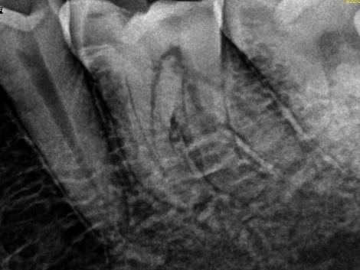
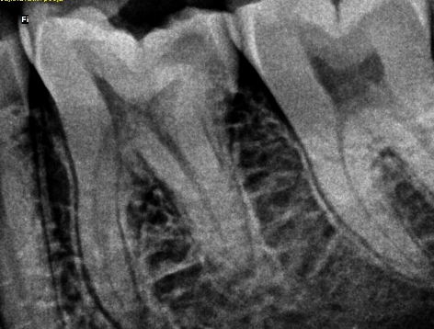
Mesial shift x ray
Straight x ray

Fig 1. Diagnostic Radiograph

TREATMENT PLAN

Non-surgical endodontic treatment of 36

TREATMENT PROCEDURE

The tooth was anesthetized and isolated using rubber dam. The access cavity was prepared using an endo access bur. Two mesial and two distal canal orifices were located using a DG-16 explorer and 10 # K-file was used to establish patency of the canals. The fourth distolingual canal orifice was negotiated more lingually, away from the rest of the three orifices. The working length was determined using an apex locator and was reconfirmed radiographically. Cleaning and shaping was carried out using the GenEndo rotary file system (Coltene). Apical enlargement were done upto 25/.04 . During instrumentation, 5.25% sodium hypochlorite was used as an irrigant and 17% EDTA followed by sodium hypochlorite was used as final rinse. Single cone Obturation was done using corresponding gutta-percha points and bioceramic sealer. Restoration of access cavity was done with composite resin and a post-obturation radiograph was taken.

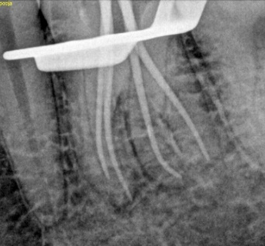
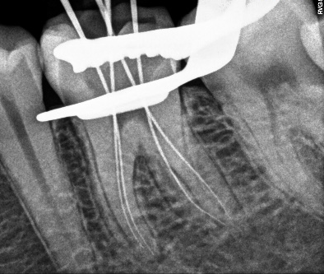

Fig 3. Master Cone X- Ray
Fig 2. Working Length Determination

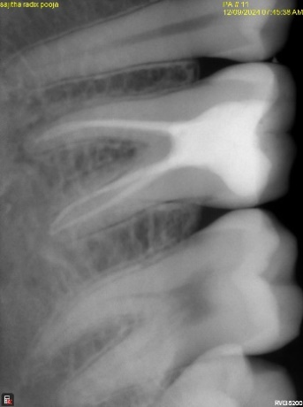
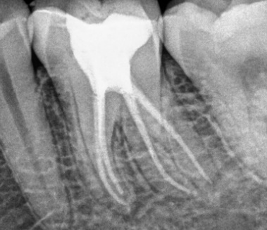

Mesial shift x ray
Straight x ray

Fig 4. Post Operative Radiograph

3. discussion

“The presence of Radix Entomolaris (RE), an additional distolongual root, in the mandibular first molar is known to be associated with specific ethnic groups. In the Indian population, the prevalence of RE is reported to be less than 5%”, (3) whereas in Mongoloid population, its occurrence ranges from 5% to more than 30%.(4) RE can be found in the first, second and third mandibular molars, though it is least commonly observed in the second molar. Several studies have also documented a bilateral occurrence of the RE in approximately 50 to 67% of cases.(5)
“The prevalence of radix entomolaris was higher in mandibular first molars than in second molars , in males than in females and in right side than in left side”.(6)
“The prevalence of supernumerary root in mandibular first molar is low in caucasian, african (egyptian), european and indian populations, while it is the high with mongoloid traits, such as korean, chinese, eskimo, and native american populations that may reach 33-40%”.(7)
Studies done in the Indian population show varied figures. Prevalence of RE to be 1.58% in the north Indian population, 13.3% in the south Indian population & 9.2% in the western Indian population. however, only mandibular molars were studied in these studies. Study done in the eastern Indian population reports a prevalence of 5.4% in first molars and 0.32% in second molars.(8)

“The etiology behind the formation of radix has not been determined yet. Recent studies link its formation to racial genetic variables, environmental factors during odontogenesis, and the dispersion of an atavistic gene or polygenetic system” .(9)

RE is typically located distolingually and may be completely or partially fused with the distal root in its coronal third. The morphology of the RE can vary significantly, ranging from a short, conical extension to a fully developed root with normal length and a distinct root canal system. In most cases, the pulpal extension of the RE is visible on radiographic examination. Generally, the RE is smaller in dimension compared to the distobuccal and mesial roots and may exist as a separate structure or exhibit partial fusion with the adjacent roots(2).
“Classification given by Carlsen and Alexanderson describe four types according to the location of the cervical part of the RE”.(10)
Type A – Distally located cervical part with two normal distal root components.
Type B – Same as type A but only one normal distal component.
Type C – Mesially located cervical part.
Type AC – Central location between mesial and distal root components
“De Moor et al classified RE-based on the curvature in buccolingual orientation into three types”.(11)
Type I – Refers to a straight root/root canal.
Type II – Refers to an initially curved entrance which continues as a straight root/root canal.
Type III – Refers to an initial curve in the coronal third of the root canal and a second
buccally oriented curve starting from middle to apical third

The presence of a Radix Entomolaris holds significant clinical relevance in endodontic treatment. Proper identification of these supernumerary roots is crucial to avoid missed canals, which can lead to treatment failure. Since the RE commonly lies in the same buccolingual plane as the distobuccal root, it may be radiographically superimposed, making detection challenging. Therefore, thorough evaluation of preoperative radiographs is essential. To enhance detection, a second radiograph taken at a mesial or distal angulation of approximately 30 degrees is recommended, as it can greatly improve diagnostic accuracy. In the present case diagnostic radiograph showed the contour of an extra root, and a mesial shift radiograph confirmed the presence of an additional root. Beyond radiographic assessment, clinical examination, including evaluation of the crown morphology and probing of the cervical area can also assist in identifying extra roots. Clues such as an accessory cusp, a prominent distal or distolingual lobe, or a cervical convexity may indicate the presence of an additional root. Early recognition of RE prior to initiating endodontic therapy allows the clinician to locate and manage the extra canal effectively.(2)
“Concerning the access cavity preparation in the presence of a RE, it is mandatory for the clinician to extend the typical trapezoidal access cavity disto-lingually to more rectangular outline form. The orifice of the RE is located disto- to mesio-lingually from the main root canal/canals in the distal root”.(12) In the present case, the fourth distolingual canal orifice was negotiated more lingually, away from the rest of the three orifices.
The Radix Entomolaris presents a significant challenge from a shaping perspective due to its thin and curved morphology. This anatomical complexity necessitates a careful and precise shaping procedures to avoid iatrogenic complications, such as canal stripping, internal or external transportation, ledge formation, and apical foramen distortion

4. Conclusion

The presence of a radix entomolaris (RE), an additional distolingual root in mandibular molars, presents a significant anatomical variation that poses challenges in endodontic diagnosis and treatment. Successful treatment requires a thorough understanding of root canal anatomy, careful interpretation of radiographs, and appropriate modification of access cavity design. Early identification and proper management of this additional root are critical to avoid missed canals and ensure long-term endodontic success

Consent

Written informed consent was obtained from the patient for publication of this case report and accompanying images.

Ethical approval

All authors hereby declare that all experiments have been performed in accordance with the ethical standards laid down in the 1964 Declaration of Helsinki.

Disclaimer (Artificial intelligence)
Option 1:
Author(s) hereby declare that NO generative AI technologies such as Large Language Models (ChatGPT, COPILOT, etc.) and text-to-image generators have been used during the writing or editing of this manuscript.
Option 2:
Author(s) hereby declare that generative AI technologies such as Large Language Models, etc. have been used during the writing or editing of manuscripts. This explanation will include the name, version, model, and source of the generative AI technology and as well as all input prompts provided to the generative AI technology
Details of the AI usage are given below:
1.
2.
3.

References

1. Hatipoğlu FP, Mağat G, Hatipoğlu Ö, Al-Khatib H, Elatrash AS, Abidin IZ, et al. Assessment of the Prevalence of Radix Entomolaris and Distolingual Canal in Mandibular First Molars in 15 Countries: A Multinational Cross-sectional Study with Meta-analysis. J Endod. 2023 Oct;49(10):1308–18.
2. Calberson FL, Moor RJD, Deroose CA. The Radix Entomolaris and Paramolaris: Clinical Approach in Endodontics. Journal of Endodontics. 2007 Jan 1;33(1):58–63.
3. Tratman E. Three rooted lower molars in man and their racial distribution. British Dental Journal [Internet]. 1938 [cited 2025 Sept 17]; Available from: https://www.semanticscholar.org/paper/Three-rooted-lower-molars-in-man-and-their-racial-Tratman/380c307d0e7edf1615cecdb7399ea468ee7c48ef
4. Walker RT, Quackenbush LE. Three-rooted lower first permanent molars in Hong Kong Chinese. Br Dent J. 1985 Nov 9;159(9):298–9.
5. Steelman R. Incidence of an accessory distal root on mandibular first permanent molars in Hispanic children. ASDC J Dent Child. 1986;53(2):122–3.
6. Duman SB, Duman S, Bayrakdar IS, Yasa Y, Gumussoy I. Evaluation of radix entomolaris in mandibular first and second molars using cone-beam computed tomography and review of the literature. Oral Radiol. 2020 Oct 1;36(4):320–6.
7. AL-Alawi H, Al-Nazhan S, Al-Maflehi N, Aldosimani MA, Zahid MN, Shihabi GN. The prevalence of radix molaris in the mandibular first molars of a Saudi subpopulation based on cone-beam computed tomography. Restor Dent Endod. 2019 Nov 14;45(1):e1.
8. Biswas M, Mazumdar D, Agarwala S, Saha KK, Dutta K. Cone-Beam Computed Tomographic Evaluation of Prevalence and Internal Dental Morphology of Radix Entomolaris and Paramolaris in Mandibular First and Second Molars—A Retrospective Study. Journal of Indian Academy of Oral Medicine and Radiology. 2024 Dec;36(4):392.
9. Cerutti F. Radix entomolaris and paramolaris [Internet]. Style Italiano Endodontics. 2024 [cited 2025 Sept 17]. Available from: https://endodontics.styleitaliano.org/radix-entomolaris-and-paramolaris/
10. Carlsen O, Alexandersen V. Radix paramolaris in permanent mandibular molars: identification and morphology. Scand J Dent Res. 1991 June;99(3):189–95.
11. De Moor RJG, Deroose C a. JG, Calberson FLG. The radix entomolaris in mandibular first molars: an endodontic challenge. Int Endod J. 2004 Nov;37(11):789–99.
12. Agarwal M, Trivedi H, Mathur M, Goel D, Mittal S. The Radix Entomolaris and Radix Paramolaris: An Endodontic Challenge. The Journal of Contemporary Dental Practice. 2014 Aug;15(4):496–9.

