Ectodermal Dysplasia Through the Lens of Clinical Cases: A Case Series
Abstract
Ectodermal dysplasias (EDs) are a heterogeneous group of hereditary conditions marked by abnormalities in ectodermal derivatives such as teeth, hair, nails, and sweat glands. These disorders show vast phenotypic diversity and are often classified by genetic mutation or by the structures involved. The hypohidrotic form, commonly associated with mutations in the ectodysplasin A (EDA) gene, often presents with a classical triad of hypodontia, hypotrichosis, and hypohidrosis. Diagnosing ED requires comprehensive clinical, radiographic, and often genetic assessments. This case series presents three patients from different age groups with clinical signs indicative of hypohidrotic ectodermal dysplasia, emphasizing phenotypic variability, inheritance patterns, and challenges in long-term multidisciplinary management.
Keywords: Ectodermal dysplasias, Phenotypic diversity, Hypodontia, Hypotrichosis, Inheritance patterns,
Introduction
Ectodermal dysplasias (EDs) are a large group of congenital disorders involving abnormalities in tissues derived from the embryonic ectoderm[1,2]. The ectoderm gives rise to multiple structures including the skin, hair, nails, teeth, and sweat glands. EDs result from disturbances during embryogenesis, particularly in the complex molecular signaling pathways such as EDA/NF-κB, WNT, and TP63[3]. The resulting malformations manifest as a spectrum of clinical signs, often involving two or more ectodermal structures.
The classification system originally proposed by Freire-Maia and Pinheiro in 1982 divided EDs into two major types: hypohidrotic/anhidrotic ED (Christ-Siemens-Touraine syndrome), characterized by reduced or absent sweating, and hidrotic ED (Clouston syndrome), where sweat glands remain functional [22]. With advances in molecular genetics, ED classification has shifted towards a genotype-based approach. Wright et al. (2019) organized EDs based on molecular signaling defects, categorizing them into defects of the EDA pathway, WNT signaling, TP63 gene mutations, and structural abnormalities [3].
Among these, hypohidrotic ectodermal dysplasia (HED) is the most prevalent variant, often inherited in an X-linked recessive manner due to mutations in the EDA gene[4]. Autosomal dominant and autosomal recessive patterns also exist, associated with mutations in EDAR and EDARADD genes [7]. EDA gene mutations result in dysfunctional ectodysplasin-A protein, which plays a key role in the morphogenesis of ectodermal derivatives[6].
EDs are considered rare disorders, with an estimated prevalence of 1 in 100,000 live births [5]. Males tend to be more severely affected in X-linked forms due to the hemizygous expression of the defective gene. Female carriers may exhibit variable expression due to lyonization (random X-chromosome inactivation) [10]. In 90% of HED cases, mutations in four genes—EDA1, EDAR, EDARADD, and WNT10A—are responsible [7].
Patients with hypohidrotic ED commonly present with the triad of hypodontia or anodontia, hypotrichosis, and hypohidrosis. Other manifestations include frontal bossing, depressed nasal bridge, sparse or absent eyebrows and eyelashes, periorbital hyperpigmentation, thin and dry skin, dystrophic nails, and everted lips[4;12]. Dental anomalies such as conical or peg-shaped teeth are characteristic[12]. These features can lead to functional issues such as difficulty in mastication, speech development delay, increased risk of dental caries, thermoregulation problems, and psychosocial distress[13].
Diagnosis of ED relies on clinical features supported by radiographic and genetic analysis. Dental panoramic radiographs can reveal hypodontia or complete anodontia[11]. Cone-beam computed tomography (CBCT) provides precise imaging for dental and maxillofacial structures. Genetic testing confirms mutations in EDA-related genes[6,7]. Skin biopsy may show a reduced number of sweat glands. Family history plays a pivotal role in identifying inheritance patterns. Here is a case series of patients showing clinical findings.
Case Series
Case 1: Pediatric Presentation
A 6-year-old male presented with parental concerns of missing teeth, dry skin, and intolerance to heat since infancy. Informed consent was taken from the parents. The child exhibited classical facial features including frontal bossing, saddle nose, thin eyebrows, sparse scalp hair, and perioral pigmentation. Lips were everted with dry, fissured skin. The skin was xerotic with reduced sweating. Intraorally, there was hypodontia in the maxillary arch and complete anodontia in the mandible. A panoramic radiograph revealed only the presence of primary anterior teeth (51, 52, 61, 62). No evidence of developing permanent tooth buds was noted in the mandible. The patient’s elder brother, aged 12, presented similar features, supporting a familial pattern (Figure:1). A diagnosis of hypohidrotic ectodermal dysplasia (likely X-linked) was made. Management included removable prosthesis, dermatologic care, and counselling.
Case 2: Adolescent Presentation
A 17-year-old male visited the dental clinic for missing teeth and difficulty in chewing. He exhibited frontal bossing, malar hypoplasia, prominent lips, hypopigmented dry skin, low-set ears, and sparse hair. Intraoral findings included oligodontia, conical teeth, peg laterals, and malformed molars. Informed consent was taken. Panoramic imaging revealed multiple congenitally missing teeth, generalized horizontal bone loss, and root resorption. His 15-year-old brother exhibited similar signs (Figure:2). The diagnosis was familial hypohidrotic ED. Management included prosthetic rehabilitation, oral hygiene maintenance, dietary guidance, and genetic counselling[16].
Case 3: Adult Presentation
A 30-year-old male presented with aesthetic concerns, difficulty eating, and brittle nails. Examination revealed sparse hair, dystrophic nails, dry papular skin changes, and everted lips. He reported reduced sweating and episodes of heat exhaustion. Dental findings included oligodontia, conical teeth, and severe alveolar ridge resorption. Radiographs confirmed multiple missing teeth, horizontal bone loss, and a root fracture in tooth 42. His 27-year-old brother showed similar features (Figure:3).Management included full-mouth prosthetic rehabilitation, dermatologic and psychological support, and long-term follow-up[18].
Discussion
EDs, particularly the hypohidrotic variant, exhibit wide phenotypic variation, even within families, due to variable gene expression and environmental interactions. Dental manifestations—ranging from conical teeth to complete anodontia—impact mastication, phonation, and aesthetics [12,13]. Dermatologic manifestations include dry, wrinkled skin and sparse scalp or body hair. Anhidrosis may lead to life-threatening hyperthermia in infants and children[4]. Early identification of symptoms, especially dental anomalies or heat intolerance in childhood, facilitates timely diagnosis and management. Our cases are in concordance with Bagdey SP et al where also similar type of presentations is discussed.
Radiologic evaluation using panoramic radiographs and CBCT allows for detection of dental agenesis and bone status for prosthetic planning[11]. Genetic testing confirms the diagnosis and enables cascade screening of family members[6,7]. Dermatologic care involves regular moisturizing .Psychosocial support is essential for addressing self-esteem and social integration, particularly in adolescents and adults with facial deformities or dental issues[13].
The management of ectodermal dysplasias, particularly the hypohidrotic form, requires an individualized, multidisciplinary strategy to address the functional, aesthetic, psychological, and genetic aspects of the condition. Dental care is central to improving the patient's ability to chew, speak, and socialize confidently. Early fabrication of removable prostheses helps restore oral function and aesthetics during childhood[15]. As the patient matures, implant-supported prostheses may be considered, depending on bone availability and medical suitability[18]. Orthodontic and restorative interventions should be personalized according to dental anatomy and functional requirements.
Dermatologic care is another important aspect of management. The use of emollients and skin barrier-repairing agents alleviates xerosis and reduces the risk of skin damage. Patients are advised to avoid extreme temperatures and should be provided with cooling strategies during hot weather to manage their inability to sweat efficiently[4].
Genetic counselling is vital for affected individuals and their families. Through genetic screening, carriers can be identified, and families can receive information regarding inheritance patterns, reproductive options, and the availability of prenatal testing in cases where the mutation is known [20].
Psychological support is essential in helping patients cope with the chronic nature of ED. Counselling plays a key role in addressing body image issues, anxiety, social withdrawal, and the stress associated with frequent medical interventions. Adolescents and adults in particular benefit from structured psychosocial support to enhance self-esteem and improve their quality of life [13].
Conclusion
Ectodermal dysplasias, especially the hypohidrotic subtype, are complex multisystemic disorders with lifelong implications. A high index of clinical suspicion, early radiographic and genetic diagnosis, and prompt multidisciplinary intervention are essential to manage these patients effectively. Prosthetic rehabilitation, dermatologic therapy, and psychological and genetic support significantly improve the quality of life for affected individuals and their families. Genetic counseling plays a vital role in guiding reproductive choices and detecting carriers in at-risk families[21].

Consent
As per international standards, parental written consent has been collected and preserved by the author(s).

Disclaimer (Artificial intelligence)
Option 1:
Author(s) hereby declare that NO generative AI technologies such as Large Language Models (ChatGPT, manuscript.
Option 2:
Author(s) hereby declare that generative AI technologies such as Large Language Models, etc. have been used during the writing or editing of manuscripts. This explanation will include the name, version, model, and source of the generative AI technology and as well as all input prompts provided to the generative AI technology
Details of the AI usage are given below:
1.
2.
3.

References
[1] Dev A, Malhi K, Mahajan R. Ectodermal dysplasia – An overview and update. Indian Dermatol Online J. 2024;15:405-14.
[2] Visinoni ÁF, Lisboa-Costa T, Pagnan NAB, Chautard-Freire-Maia EA. Ectodermal dysplasias: Clinical and molecular review. Am J Med Genet A. 2009;149A:1980–2002.
[3] Wright JT, Fete M, Schneider H, Zinser M, Koster MI, Clarke AJ, et al. Ectodermal dysplasias: Classification and organization by phenotype, genotype and molecular pathway. Am J Med Genet A. 2019;179:442‑7.
[4] Anbouba GM, Carmany EP, Natoli JL. The characterization of hypodontia, hypohidrosis, and hypotrichosis associated with X-linked hypohidrotic ectodermal dysplasia: A systematic review. Am J Med Genet A. 2020;182:831–41.
[5] Itin PH, Fistarol SK. Ectodermal dysplasias. Am J Med Genet C Semin Med Genet. 2004;131C(1):45-51.
[6] Kere J, Srivastava AK, Montonen O, et al. X-linked anhidrotic (hypohidrotic) ectodermal dysplasia is caused by mutation in a novel transmembrane protein. Nat Genet. 1996;13(4):409-16.
[7] Cluzeau C, Hadj-Rabia S, Jambou M, et al. Only four genes (EDA1, EDAR, EDARADD, and WNT10A) account for 90% of hypohidrotic ectodermal dysplasia cases. Hum Mutat. 2011;32(1):70-2.
[8] Lamartine J. Towards a new classification of ectodermal dysplasias. Clin Exp Dermatol. 2003;28(4):351-5.
[9] Priolo M, Laganà C. Ectodermal dysplasias: a new clinical-genetic classification. J Med Genet. 2001;38(9):579-85.
[10] Sweeney E, Fryer A, Mountford R, Green A, McKeown C. X-linked hypohidrotic ectodermal dysplasia (EDA) presenting in females: skewed X-inactivation and a female carrier with sweat gland agenesis. Eur J Pediatr. 2003;162(6):361-6.
[11] Jahanbin A, Mokhber N, Saberi E, Khalesi M. Craniofacial characteristics in patients with ectodermal dysplasia: a cephalometric study. J Clin Pediatr Dent. 2010;35(2):215-9.
[12] Lexner MO, Bardow A, Hertz JM, Almer L, Kreiborg S. Anomalies of tooth formation in hypohidrotic ectodermal dysplasia. Int J Paediatr Dent. 2007;17(1):10-8.
[13] Bittencourt FV, Albuquerque RC, Souza ML. Dental treatment of patients with ectodermal dysplasia: a case report with 5-year follow-up. Braz Dent J. 2001;12(2):135-8. [14] Kupietzky A, Houpt M. Hypohidrotic ectodermal dysplasia: characteristics and treatment. Quintessence Int. 1995;26(4):285-91.
[15] de Araujo T, de Oliveira M, Gomes L, da Silva Dalben G. Oral rehabilitation of a child with hypohidrotic ectodermal dysplasia: a case report. J Dent Child. 2012;79(1):29-32.
[16] Vieira KA, Teixeira MS, Guirado CG, Gaviao MB. Prosthodontic treatment of hypohidrotic ectodermal dysplasia: a case report. Quintessence Int. 2007;38(1):75-80.
[17] Lexner MO, Bardow A, Juncker I, Jensen LG, Almer L, Kreiborg S. X-linked hypohidrotic ectodermal dysplasia. Genetic and dental findings in 67 Danish patients from 19 families. Clin Genet. 2008;74(3):252-9.
[18] Guckes AD, Brahim JS, McCarthy GR. Use of endosseous implants in a 3-year-old child with ectodermal dysplasia: case report and 5-year follow-up. Pediatr Dent. 1997;19(4):282-5.
[19] Vieira KA, de Carvalho Carrara CF, de Castro LC, et al. Prosthetic treatment of hypohidrotic ectodermal dysplasia with complete anodontia: a clinical report. Quintessence Int. 2006;37(5):379-85.
[20] Salinas CF, Opitz JM. The ectodermal dysplasias: a clinical and genetic overview. Birth Defects Orig Artic Ser. 1979;15(5B):3-18.
[21] Clarke A. Hypohidrotic ectodermal dysplasia. J Med Genet. 1987;24(12):659-63.
[22] Freire-Maia N, Pinheiro M. Ectodermal dysplasias: a clinical classification and a causal review. Am J Med Genet. 1984;17(3):357-74.

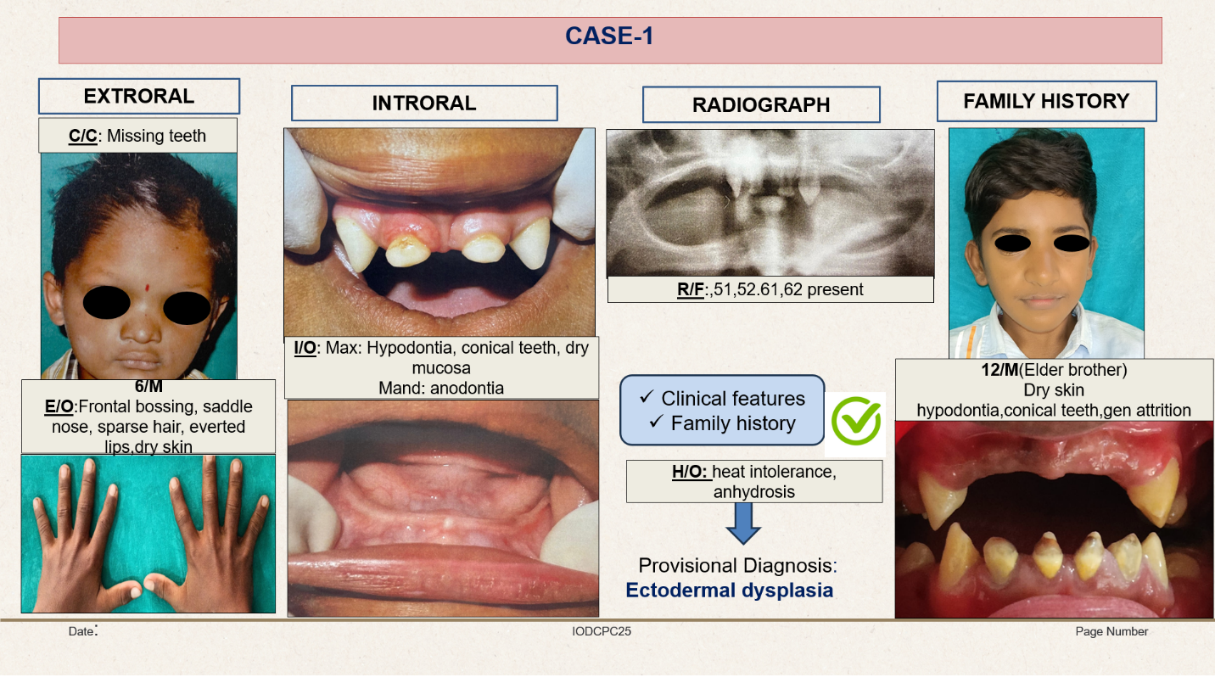

Figure: 1

Clinical case of Ectodermal Dysplasia in a 6-year-old male

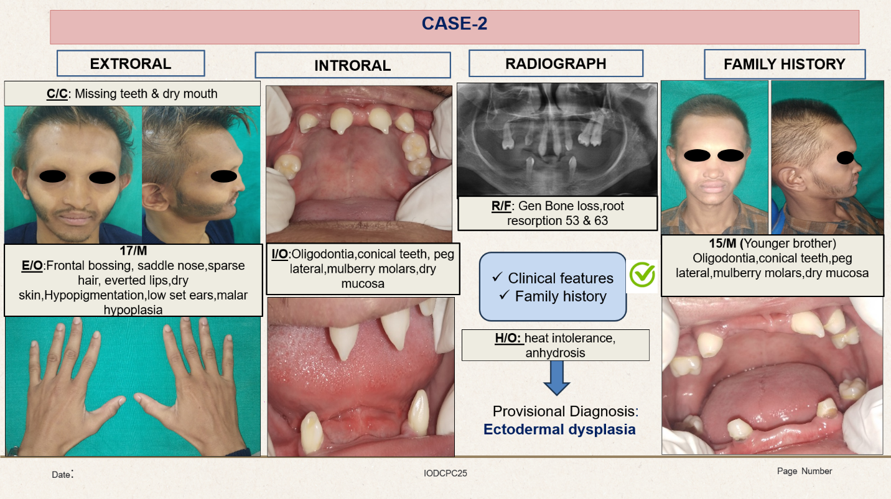

Figure: 2

Clinical case of Ectodermal Dysplasia in a 15-year-old male

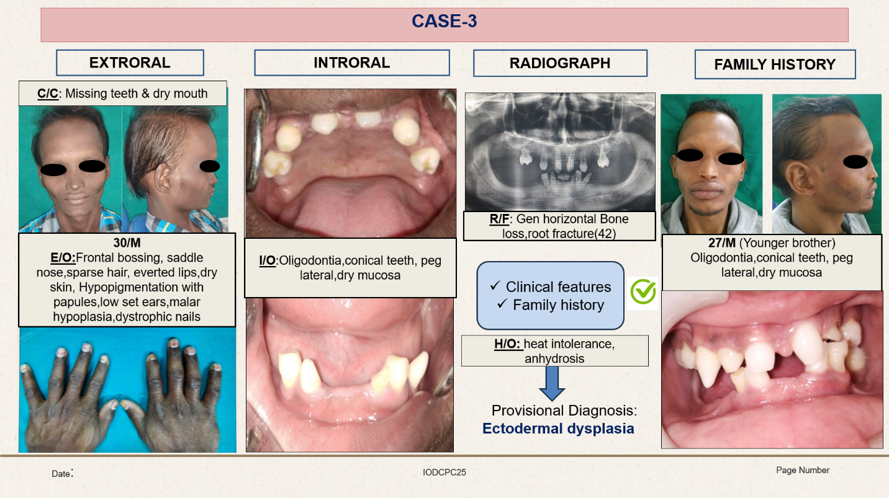
Figure: 3

Clinical case of Ectodermal Dysplasia in a 27-year-old male

