Case report

Ischemic Stroke in a Patient with Essential Thrombocythemia (ET) at St. Francis Regional Referral Hospital, Ifakara,Tanzania: A Case Report

ABSTRACT

Introduction: Essential Thrombocythemia (ET) is a slow-progressing myeloproliferative neoplasm characterized by persistent thrombocytosis and an increased risk of thrombotic and hemorrhagic events, including ischemic stroke, myocardial infarction, and venous thromboembolism. Thrombotic complications remain the leading cause of morbidity, particularly in elderly patients.

Case Presentation: An 85-year-old male presented with sudden left-sided weakness, facial deviation, lower extremity numbness, and severe headache of one-day duration. He had a three-year history of ET, confirmed by bone marrow biopsy and JAK2 V617F mutation, and was on hydroxyurea 500 mg and low-dose aspirin. His medical history included well-controlled hypertension. On examination, he was conscious (GCS 11/15) with stable vitals, left-sided weakness (0/5), mouth deviation, and splenomegaly (18 cm below the costal margin).
A non-contrast CT scan revealed a right parietal lobe ischemic infarct and senile atrophy. Laboratory tests showed platelets 988x10^3 per microliter , normal white blood cell count, and hemoglobin 10 g/dL Hydroxyurea and aspirin doses were adjusted, physiotherapy initiated, and the patient stabilized for discharge with follow-up plans.

Conclusion: Despite cytoreductive and antiplatelet therapy, patients with ET remain at risk of thrombotic events. This case highlights the need for individualized management, close follow-up, and multidisciplinary care in elderly patients with ET to mitigate morbidity, and mortality from ischemic stroke.,

Keywords: Essential thrombocythemia, Myeloproliferative Neoplasm, Ischemic stroke, JAK2 617F, Cytoreductive therapy

INTRODUCTION
Essential Thrombocythemia is one of the chronic myeloproliferative neoplasms (MPNs) characterized by a persistent elevation of platelet counts, resulting from the abnormal proliferation of megakaryocytes in the bone marrow and excessive platelet production, It commonly presents with thrombosis and hemorrhage¹.
It is a relatively rare condition, with an annual incidence of 0.2 to 2.5 new cases per 100,000 population^{1,2}. The incidence increases with age, with a median age at diagnosis ranging from 60 to 70 years; however, approximately 20% of patients are younger than 41 years, with a higher ratio in females compared to males². The pathogenesis is commonly associated with driver mutations: approximately 60% of patients harbor the JAK2 V617F mutation, while CALR mutations are present in about 75% of JAK2-negative patients, accounting for roughly one-third of all cases^{3,4}. Mutations in the MPL gene are detected in approximately 4% of patients with myeloproliferative neoplasms^{3–5}.In the early stages, patients with Essential Thrombocythemia (ET) are often asymptomatic. As the disease progresses, they may develop symptoms such as headache, dizziness, visual disturbances, splenomegaly, easy bruising, bleeding, and thrombotic complications^{2,6,7}. Thrombosis may present as ischemic stroke, myocardial infarction, superficial thrombophlebitis, deep vein thrombosis, or pulmonary embolism, while hemorrhagic events can also occur^{1,6,8}. Risk factors for thrombotic complications in ET include advanced age (>60 years), prior history of thrombosis, hypertension, diabetes mellitus, and tobacco use^{8,9}.
The disease is stratified into four categories: very low-risk, low-risk, intermediate-risk, and high-risk
¹⁰. Patients with intermediate- and high-risk disease are treated with cytoreductive therapy using hydroxyurea, along with antiplatelet agents, to reduce the risk of vascular complications^{6,10–13}.
Despite appropriate treatment, some patients with Essential Thrombocythemia (ET) may still experience serious thrombotic complication¹¹. We report the case of an 85-year-old man with ET, maintained on long-term hydroxyurea and aspirin therapy, who presented with clinical features of ischemic stroke. This case highlights the persistent risk of thrombotic events in ET, emphasizing the importance of close monitoring and individualized management by underscoring the role of interdisciplinary collaboration in optimizing patient outcomes.

CASE PRESENTATION

An 85-year-old male presents at our facility with a history of sudden onset of left-sided extremity weakness, mouth deviation, numbness in the lower extremities, and severe headache for one day. There was no history of loss of consciousness, convulsions, vomiting, difficulty in breathing, fever, or head trauma. The patient was diagnosed with essential thrombocythemia three years ago at another center. The diagnosis of essential thrombocythemia had been confirmed by a bone marrow biopsy and the presence of the JAK2 V617F mutation. The patient was attending the hematology clinic and had been on treatment with hydroxyurea 500mg and low-dose aspirin. Also, he reported a history of hypertension, which was well controlled with antihypertensives and regular follow-up in the cardiology clinic. On arrival, the patient was conscious with a Glasgow Coma Score (GCS) of 11/15 and stable vital signs. Neurological examination revealed left-sided extremity weakness, graded 0/5, and mouth deviation, with no other neurological pathological findings observed. Abdominal examination demonstrated splenomegaly measuring 18 cm below the costal margin.
Among other findings, a non-contrasted CT scan of the brain showed a right parietal lobe ischemic infarct and senile atrophy. The echocardiogram (ECHO) and electrocardiogram (ECG) were unremarkable. Laboratory investigations, including the coagulation profile, were within normal limits, except for the complete blood count, which showed an abnormal platelet count of 988x10^3 per microliter, indicating marked thrombocytosis. The total white blood cell count was within the normal range, and the hemoglobin level was 10g/dL.
The hematology team was consulted, and adjustments were made to the patient’s hydroxyurea dose, up to 1500mg once per day, and a low dose of aspirin 75mg once per day. Literature recommends increasing the dosage of low-dose aspirin to twice a day in high-risk patients. He was also commenced on physiotherapy, with significant neurological improvement observed after five days. The patient was discharged home in a stable condition with instructions to continue regular follow-up at the hematology clinic.
Fig.1a. | 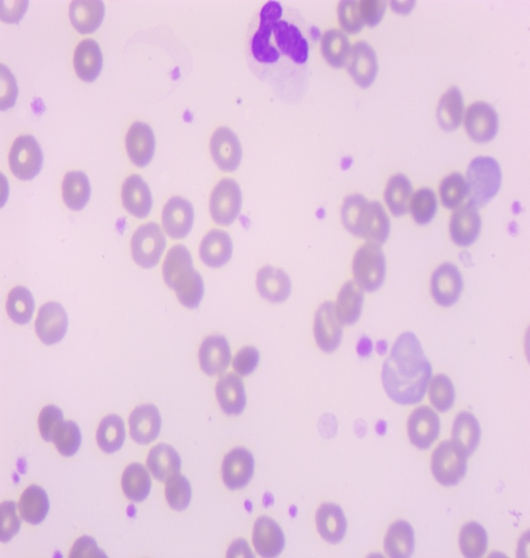  Fig. 1b.
Fig. 1a and 1b. Blood film microscopy findings under 100x magnification were notable for an increased platelet count and the presence of mature segmented neutrophils during admission, and 1b, which showed improvement one month after discharge.

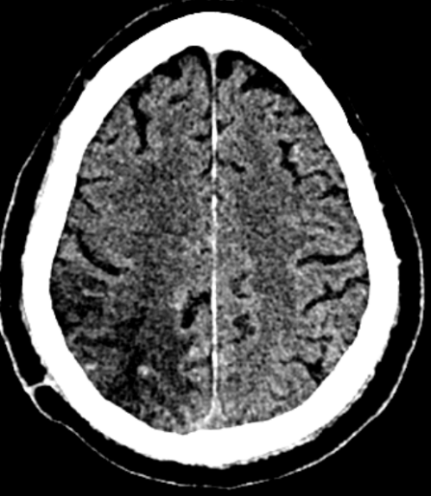  Fig. 2a. | 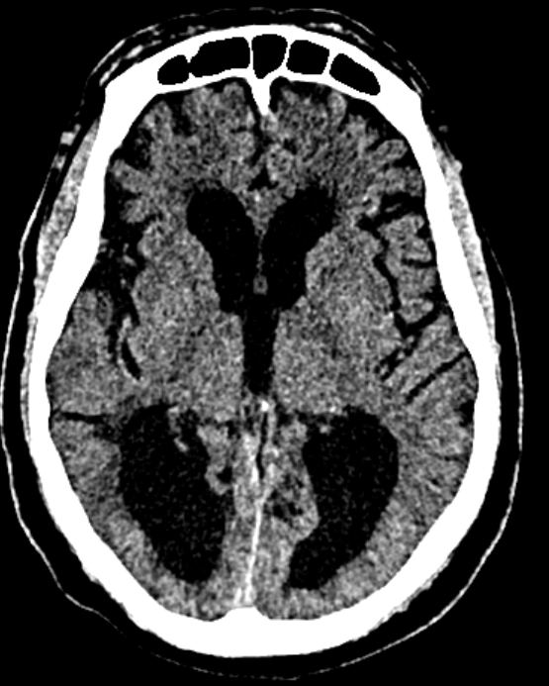  Fig.2b.
Fig. 2a and 2b. A non-contrast CT scan of the brain reveals hypodensity in the right parietal lobe, consistent with an ischemic infarct, and senile atrophy in the posterior lobe.

DISCUSSION
Essential thrombocythemia (ET) is a myeloproliferative neoplasm characterized by persistent elevation of platelets and increased risk of thrombotic complications, such as ischemic and hemorrhagic events, which remain the leading cause of morbidity and mortality ^{10,14}. Advanced age and cardiovascular comorbidities, such as hypertension, significantly increase the risk of thrombotic events, particularly ischemic stroke^{8,9,11,15}. In our case, the patient developed a thrombotic event despite receiving cytoreductive therapy with hydroxyurea and low-dose aspirin, highlighting the importance of close monitoring in high-risk patients due to the complex pathophysiology of essential thrombocythemia¹⁶.
The diagnosis of essential thrombocythemia requires the following criteria according to the WHO classification: persistent thromboctosis (platelets ≥450 × 109/L),presence of clonal markers such as JAK2, CALR, or MPL mutations, absence of other chronic myeloproliferative neoplasms such as chronic myeloid leukemia, primary myelofibrosis, polycythemia vera, myelodysplastic syndrome, and other causes of thrombocytosis⁴. These criteria signify accurate diagnosis and correct risk stratification, which is important in preventing thrombotic complications^{4,10,17}. These criteria signify an accurate diagnosis and correct risk stratification, which is important in preventing thrombotic events^{10,17}. The pathogenesis of ischemic stroke in ET involves multiple mechanisms, including endothelial dysfunction, platelet overactivation, and prothrombotic states associated with the JAK2 V617F mutation^{17,18}. Our patient had additional risk factors, including advanced age, elevated platelet counts, splenomegaly, and long-standing hypertension. Studies have shown that ischemic stroke is one of the most common thrombotic presentations in ET^{7,14,19}.
Ischemic stroke can result in long-term neurological deficits, including hemiparesis, speech impairment, cognitive dysfunction, and reduced quality of life²⁰. Survivors of ET-associated stroke may also face increased dependency, psychological sequelae, and a higher risk of recurrent vascular events, emphasizing the need for vigilant secondary prevention strategies²⁰. Stroke recurrence in ET is influenced by several factors, including older age, cardiovascular comorbidities (e.g., hypertension, diabetes), high platelet counts, JAK2 mutation positivity, prior thrombotic events, and suboptimal control of hematologic parameters^{8,9}. Treatment adherence, choice of cytoreductive therapy, and adequate antiplatelet prophylaxis are also critical^{21–23}. Understanding these risk factors can help clinicians tailor management strategies, balance the risks of thrombosis and hemorrhage, and optimize long-term outcomes^{4,8,12}.
Cytoreductive therapy with hydroxyurea aims to lower platelet counts and reduce the risk of thrombosis, while aspirin provides antiplatelet effects. In cases where patients remain at risk despite these therapies, alternative cytoreductive agents, such as anagrelide or interferon-α, may beconsidered^{12,14,24}. On the other hand, treatment failure may still occur due to disease-related factors (persistent prothrombotic state despite platelet control), therapy-related factors (hydroxyurea resistance or aspirin non-responsiveness), or patient-related factors (advanced age, comorbidities, poor adherence)¹³. These challenges lead to important management dilemmas, particularly in balancing the risk of thrombosis with the potential for hemorrhage, especially when platelet counts are extremely elevated^{4,24}. The choice of cytoreductive therapy is also complicated in settings where access to second-line agents is limited²⁴.
This case highlights the importance of considering neurological complications in patients with essential thrombocythemia (ET), even in those receiving appropriate treatment. Timely recognition of stroke presentations, prompt diagnosis, and multidisciplinary management are crucial for optimizing patient outcomes. Furthermore, close collaboration between hematologists, neurologists, and other clinicians is crucial for optimizing patient outcomes. Regular follow-up enables reassessment of thrombotic risk, adjustment of therapy, and early detection of complications, ultimately improving patient prognosis.

CONCLUSION
This case highlights the persistent thrombotic risk in patients with Essential Thrombocythemia (ET), even under appropriate cytoreductive and antiplatelet therapy. Advanced age, cardiovascular comorbidities, elevated platelet counts, and JAK2 mutation positivity increase both the risk of initial thrombotic events and stroke recurrence. Timely recognition of ischemic stroke, adherence to WHO diagnostic criteria, and individualized management strategies are essential for optimizing outcomes. Multidisciplinary care, vigilant monitoring, and consideration of alternative therapies are crucial for high-risk patients to prevent complications and improve long-term prognosis. This report also emphasizes the importance of documenting such cases from low- and middle-income countries (LMICs) to strengthen the global understanding of ET complications.

ABBREVIATIONS
CARL - Calreticulin
CBC -Complete Blood Count
CT -Computer Tomography
ECG -Echocardiogram
ECHO -Electrocardiogram
ET -Essential Thrombocythemia
GCS - Glasgow Coma Scale
IRB -Institutional Review Board
JAK2 -Janus Kinase 2
LMICs -low and middle-income countries
MPL -Myeloproliferative Leukemia
SFUCHAS -St. Francis University of Health and Allied Sciences
WHO - World Health Organization

ETHICAL APPROVAL.

Ethical approval for this case report was obtained from St. Francis University College of Health and Allied Sciences Institutional Review Board (SFUCHAS IRB). Informed consent and assent were obtained from the patient and the next of kin, respectively, for publication of this case report.

Consent
As per international standards or university standards, patient(s) written consent has been collected and preserved by the author(s).

Disclaimer (Artificial intelligence)
Author(s) hereby declare that NO generative AI technologies such as Large Language Models (ChatGPT, COPILOT, etc.) and text-to-image generators have been used during the writing or editing of this manuscript.

REFERENCES
1. Moniruzzaman M, Chandra S, Jakaria Been Sayeed SK. Ischemic Stroke in a patient with Essential Thrombocythemia: Case Report. Journal of Medicine (Bangladesh). 2022;23(2):169-172.
2. Godfrey AL, Green AC, Harrison CN. Essential Thrombocythemia ;Challenges in Clinical Practice and Future Prospects.; 2022. http://ashpublications.org/blood/article-pdf/141/16/1943/2087877/blood_bld-2022-017625-c-main.pdf
3. Beer PA, Green AR. Pathogenesis and Management of Essential Thrombocythemia.; 2009.
4. Tefferi A, Vannucchi AM, Barbui T. Essential thrombocythemia: Am J Hematol. 2024;99(4):697-718.
5. Briére JB. Essential thrombocythemia. Orphanet J Rare Dis. 2007;2(1).
6. Yu Y, Zhang X, Shi Q, Wang M, Jing J, Liu Y. Essential thrombocytosis with recurrent spontaneous abortion in the mid trimester: A case report. Medicine (United States). 2019;98(26).
7. Yan R, Mi D, Qiu X, Li Z. A case of ischemic stroke with hemorrhagic transformation associated with essential thrombocythemia and JAK-2 V617F mutation. BMC Neurol. 2022;22(1).
8. Adria Arboix CRABMFO and JSS. arboix-et-al-ischemic-stroke-as-first-manifestation-of-essential-thrombocythemia. American heart Association. 1995;26(8):1463-1466.
9. Richard S, Perrin J, Baillot PA, Lacour JC, Ducrocq X. Ischaemic stroke and essential thrombocythemia: A series of 14 cases. Eur J Neurol. 2011;18(7):995-998.
10. Accurso V, Santoro M, Contrino A, Casimiro P, Raso S. Essential thrombocythemia: Biology, clinical features, thrombotic risk, therapeutic options and outcome. Journal of Hematology and Clinical Research. 2019;3(1):053-059.
11. Ergio S, Ortelazzo C, Uido G, et al. Hydroxyurea for Patients with Essential Thrombocythemia and a High Risk of Thrombosis.; 1995.
12. Griesshammer M, Bangerter M, Grünewald M. Current Treatment Practice for Essential Thrombocythaemia in Adults.; 2001. http://www.ashley-pub.com
13. Barbui T, Vannucchi AM, Buxhofer-Ausch V, et al. Practice-relevant revision of IPSET-thrombosis based on 1019 patients with WHO-defined essential thrombocythemia. Blood Cancer J.Nature Publishing Group. 2015;5(11).
14. Chen X, Cao L, Feng H, Huang X. Successive development of ischemic stroke and hemorrhagic stroke in a patient with essential thrombocythemia: a case report. Journal of International Medical Research. 2021;49(1).
15. Kim BK, Eah KY, Park JM. Essential Thrombocythemia and Ischemic Stroke: A Case Series of Five JAK2-Positive Patients. Preprint posted online June 26, 2023. https://www.preprints.org/manuscript/202306.1743/v1
16. Patel R, DeRon N. Newly diagnosed essential thrombocythemia leading to cardiogenic shock: a case report. BMC Cardiovasc Disord. 2024;24(1).
17. Arber DA, Orazi A, Hasserjian R, et al. The 2016 revision to the World Health Organization classification of myeloid neoplasms and acute leukemia. Blood.American Society of Hematology. 2016;127(20):2391-2405.
18. Kristiansen MH, Larsen MK, Massarenti L, et al. Thromboinflammation in ischemic cerebrovascular patients with the JAK2V617F mutation. Thromb Res. 2025;245.
19. Accurso V, Santoro M, Mancuso S, et al. The Essential Thrombocythemia in 2020: What We Know and Where We Still Have to Dig Deep. Clin Med Insights Blood Disord.SAGE Publications Ltd. 2020;13.
20. Rost NS, Brodtmann A, Pase MP, et al. Post-stroke cognitive impairment and dementia. Circ Res. 2022;130(8):1252-1271.
21. Le Calloch R, Lacut K, Le Gall-Ianotto C, et al. Non-adherence to treatment with cytoreductive and/or antithrombotic drugs is frequent and associated with an increased risk of complications in patients with polycythemia vera or essential thrombocythemia. Haematologica. 2018;103(4):607-613.
22. De Stefano V, Carobbio A, Di Lazzaro V, et al. Benefit-risk profile of cytoreductive drugs along with antiplatelet and antithrombotic therapy after transient ischemic attack or ischemic stroke in myeloproliferative neoplasms. Blood Cancer J. 2018;8(3).
23. Jones E, Dillon B, Swan D, Thachil J. Practical management of the haemorrhagic complications of myeloproliferative neoplasms. Br J Haematol.John Wiley and Sons Inc. 2022;199(3):313-321.
24. Birgegård G, Besses C, Griesshammer M, et al. Treatment of essential thrombocythemia in Europe: A prospective long-term observational study of 3649 high-risk patients in the evaluation of anagrelide efficacy and long-term safety study. Haematologica. 2018;103(1):51-60.

