The role of 18-FDG PET/CT in managing unclassifiable mediastinal B-cell lymphoma -Gray Zone Lymphoma

ABSTRACT:
Introduction: Gray zone lymphoma (GZL) is a recently described disease entity. The clinical features and treatment of GZL remain to be defined because of its recent identification and rarity. Positron Emission Tomography (PET) has become the gold standard for response assessment in most FDG-avid lymphomas. Clinicians currently consider PET the gold standard in managing LZG, exhibiting excellent sensitivity and specificity.
Objectives: The study aimed to highlight the contribution of 18FDG PET in the management of gray zone lymphoma.
Materials and methods: A retrospective descriptive and analytical study of 4 patients with GZL was conducted, followed up in the Hematology Department at Farhat Hached University Hospital of Sousse, who underwent 18 FDG PET scans in the Nuclear Medicine Department at Sahloul University Hospital in Sousse. Four patients were included in the study. All patients were adults, ranging from 19 to 33 years. The study was conducted between December 2018 and October 2023. The FDG-PET scans were scored according to the 5-point Deauville scoring (DS) system.
Results: The discovery circumstances were variable, mainly a tumor syndrome. Two patients had B symptoms at diagnosis. The 9 PET scans were performed for the 4 patients: 2 baseline scans, 1 interim scan, 4 for end-of-treatment assessment, and 2 for post-treatment salvage assessment. SUV max values for lymphomatous lesions on PET scans ranged from 5.1 to 21.2. One patient was down-staged by baseline PET-CT. At the end of the treatment, all patients with PET-CT scans were evaluated. This resulted in four scans, two showing complete metabolic response and two showing progressive disease.
Conclusion: Positron Emission Tomography – Computed Tomography (PET-CT) plays a crucial role in the intermediate evaluation of lymphomas, enabling better detection of residual or recurrent lesions, even where the distinction between active disease and post-therapy fibrosis is difficult. This contributes to a more accurate assessment of response to treatment, i.e., chemosensitivity. Furthermore, using PET-CT frequently provides better sensitivity than standard CT, leading to the detection of small or occult lesions. The study also highlights the importance of baseline PET scans in interpreting interim and post-therapy PET scans. Furthermore, continued characterization of the pathology, biology, and clinic of GZL is required, and new therapeutic regimens need to be investigated, including the integration of novel and rational therapeutic agents.
Keywords: gray zone lymphoma, positron emission tomography, tumor, lymphomas

INTRODUCTION:
Nodular sclerosis Hodgkin’s lymphoma (NSHL) and primary mediastinal B-cell lymphoma (PMBL) mainly represent Mediastinal B-cell lymphomas. Clinically, they are characterized by rapidly increasing anterior mediastinal masses, which can cause compression of the surrounding tissues (18). The recent 5th edition of the World Health Organization (WHO) 2022 classification of lymphoid neoplasms(1) classifies malignant lymphoma cases that are not distinctly classifiable as either Hodgkin lymphoma or non-Hodgkin lymphoma as an intermediate group between PMBL and CHL. Because of its borderline features, the term “gray zone lymphoma “has been used to describe this group of lymphomas(2). It is a very rare liquid malignancy that possesses intersecting features between primary mediastinal B-cell lymphoma and classic Hodgkin Lymphoma (19). The clinical features and treatment of mediastinal gray zone lymphoma (MGZL) have yet to be defined because of its recent identification and rarity. An inconsistency between morphological and immunohistochemical findings is the hallmark of the disease (20). Therapeutically, MGZL’s Hodgkin-like pathology suggests treating it like Hodgkin’s lymphomas (CHL), while most MGZL’s firm expression of the CD20 B-cell protein, characteristic of PMBL, suggests using rituximab-based regimens as with PMBL (3,4).
However, dose-adjusted etoposide, prednisone, vincristine, cyclophosphamide, doxorubicin, and Rituximab (DA-EPOCH-R) alone produced durable remissions in most patients, suggesting that it is an effective treatment for these relatively resistant lymphomas (5).
Positron Emission Tomography (PET) is the preferred imaging method for initial staging and treatment response assessment (during and after therapy). Several studies have also highlighted its value in detecting relapse and assessing therapeutic response to salvage therapy.
The aim of this study was to :
-Describe the epidemiological profile, diagnostic, and therapeutic aspects of unclassifiable B lymphoma.
-Emphasize the importance of metabolic imaging in managing unclassifiable B lymphoma.
MATERIALS AND METHODS:
1. STUDY DESIGN AND TREATMENT
It is a retrospective descriptive and analytical study that occurred from December 2018 to October 2023, involving four patients with mediastinal lymphoma of the gray zone, followed at the department of hematology at the University Hospital Center Farhat Hached in Sousse, who had a PET examination at the department of nuclear medicine at University Hospital Sahloul in Sousse.
2. PATIENTS
The following data were included in our study: Patients with gray zone lymphoma, treated and followed at the Clinical Hematology Department at Farhat Hached Hospital Sousse between December 2018 and October 2023, aged over 18 years at diagnosis and underwent an 18FDG PET-CT evaluation during follow-up.
3. DATA COLLECTION
Data were collected retrospectively from patient files in the 2 departments, Haematology and Nuclear Medicine at Sousse, using pre-established and completed forms.
4. 18 FDG PET EXAMINATION AND INTERPRETATION CRITERIA
18FDG PET/CT plays a crucial role in the assessment of lymphoma activity, offering increased accuracy in localizing affected sites(6).
An invaded focus is defined as a region with significantly elevated metabolism, which correlates with lymphomatous involvement while considering the distribution of lesions on CT.
The acquisition process is done via the Siemens® Biograph mCT64 hybrid PET-CT platform, installed in 2019. After intravenous injection of a standard activity of 3 Bbq/kg of 18FDG, followed by a rest period of approximately 60 minutes, the hybrid PET scan, covering vertex to mid-thigh, invariably includes a pogrom, a CT scan without the use of contrast medium for attenuation correction and low-dose diagnosis, and a static standard PET scan with successive intervals of 2 minutes each. To avoid any confusion between a CT scan performed in a medical imaging department and a CT scan performed in nuclear medicine for PET imaging purposes, the hybrid PET-CT scan will be identified as a PET scan.
The FDG-PET scans were scored according to the 5-point Deauville scoring (DS) system, with scores of 1 to 3 considered negative and scores of 4 to 5 considered positive for disease(7).
Initial staging of unclassifiable (grey zone) large-cell B lymphoma is based on the Ann Arbor classification of both CT and PET/CT.
5. TREATMENT
All our patients received chemotherapy as first-line treatment: 2 patients = R-CHOP, and 2 patients = R-DA-EPOCH +/- autograft based on response.
RESULTS:
1. EPIDEMIOLOGICAL AND CLINICAL CHARACTERISTICS OF PATIENTS
Four patients, 1 male (M) and 3 females (F) aged between 19 and 33 years old.
The clinical circumstances for consultation were cervical adenopathy (n=2), cough with hemoptysis (n=1), and chest pain associated with exertional dyspnea (n=1).
The diagnosis was based on histopathological testing with immunohistochemistry using several modalities of biopsies: two were CT-guided biopsies, and one was during mediastinoscopy. 1 patient had a cervical adenectomy.
Nine PET scans were performed: two before treatment, 1 in the interim, 4 for end-of-treatment assessment, and 2 at post-treatment follow-up assessment.
2. CASE STUDY:
PATIENT N°1:
A 22-year-old female patient, followed since June 2023 for mediastinal stage IIE gray zone lymphoma (Ann Arbor), was treated with 4 courses of RCHOP21 + autologous stem cell transplant. The diagnosis was suspected according to the onset of a cough with hemoptysis associated with impaired general condition: recent weight loss without fever and night sweats. Clinically, no palpable lymphadenopathy was detected. A thoracic CT scan revealed a right mediastinal-pulmonary mass. A biopsy done through mediastinoscopy revealed an unclassifiable large B-cell lymphoma with features intermediate between Hodgkin’s lymphoma and diffuse large-cell mediastinal lymphoma. cells expressed CD15, CD30, and CD20 in IHC.
CBC showed inflammatory anemia and leukocytosis, and normal values of LDH were found as well.
Initial CTAP scan: Mediastinal-pulmonary lymph node complex excavated and fistulated to the pleura, with vascular and mediastinal invasion associated with mediastinal adenomegaly and carcinomatous lymphangitis. Hepatosplenomegaly was detected as well.
Initial PET-CT: Anterior mediastinal lymphoproliferative process with contiguous extension into the right lung field and the vessels.

Figure I: Initial PET scan: A: Maximal Intensity Projection (MIP) image showing Mediastinal involvement with contiguous right lung involvement, B: PET-CT merged slices, SUV max=21.2
PET end of treatment after 4 courses of RCHOP showed a complete metabolic response (DS=3).

Figure II: MIP image (A) and merged PET-CT axial section (B) show the disappearance of mediastinal and pulmonary lymphomatous involvement, confirming CR on end-of-treatment PET.
The patient was referred for peripheral stem cell autograft (PSC).
PATIENT N°2:
A female patient aged 33, followed since February 2021, for an unclassifiable B lymphoma of the mediastinal gray zone with cervical and mediastinal BulKy stage II sus subdiaphragmatic.
The patient consulted for cervical lymph node enlargement associated with B symptoms. A cervical biopsy of the adenomegaly showed an unclassifiable B lymphoma with an intermediate appearance between large-cell B lymphoma and Hodgkin’s lymphoma.
Cells were positive for CD30; CD15; CD79a; and CD23 in IHC and no bone marrow infiltration was detected.
Initial CTAP: showed a magma of pre-vascular necrotic anterior mediastinal lymph node enlargement measuring approximately 140*83 mm and enveloping the vessels, which remained permeable. Unfortunately, the initial PET scan was not performed.
4 courses of RCHOP21 were given to the patient, intermediate evaluation CT scan (after 3 courses), 45% regression, but a complement by PET-CT showed tumor progression. She received at that point 4 R-DHAP courses as salvage treatment with no response.
She underwent treatment with 3rd-line chemotherapy: 4 courses of R-IGEV (rituximab, ifosfamide, gemcitabine, vinorelbine) with no response at the end of the PET-CT exam, which showed progressive disease.

Figure III: MIP image (A) and merged axial section PET-CT (B) show tumor progression in lymph nodes, pleura, liver, and bone. Right breast hypermetabolism with secondary lymphomatous site.
The decision was to rescue with Bendamustine-Brentuximab. PET-CT after 3 courses: complete metabolic response. The patient benefited from a PSC autograft, and she is currently in CR.
PATIENT N° 3:
A 33-year-old female patient has been followed since March 2022 for stage II mediastinal gray zone lymphoma. Treated with 8 courses of R-DA-EPOCH. A right supra-clavicular mass was discovered during pregnancy. CT-guided biopsy of the mediastinal mass revealed a gray-zone lymphoma.
Initial CTAP scan: voluminous right cervico-thoracic mass, enveloping the subclavicular artery and right vertebral artery and invading the pleural and extra-pleural space of the 1st right rib, and right hilar adenomegaly. The right breast increased in size compared with the contralateral side, with no visible mass or subcutaneous tissue making it thicker.
Initial PET scan: right servico-thoracic tumor mass extending from the right cervical areas IV and V to the low lateral-tracheal region with heterogeneous hypermetabolism (SUV max= 16.4) enveloping and infiltrating the right 1st rib with associated osteolysis and extending anteriorly to BERG stage 3, by-passing the trachea and esophagus.

Figure IV: MIP image (A) and merged axial PET-CT section (B) show right cervicothoracic lympho-ganglionic tumor involvement (SUV max= 16.4) with osteolysis of the 1st right rib on initial PET scan.
Interim evaluation with CT scan and PET after 6 courses of R-DA-EPOCH showed a partial metabolic response (DS=5). However, the patient progressed by the end of treatment.

Figure V: MIP image (A) and merged axial section PET-CT (B) show a partial metabolic response (SD=5) to interim PET.

Figure VI: MIP image (A) and merged PET-CT axial section (B) show morpho-metabolic progression of the right laterocervical lymph node cast (SD=5) at end-of-treatment PET.
The decision was to catch up with NIVOLUMAB-BRENTUXIMAB with autograft if a complete metabolic response was achieved. She is currently undergoing catch-up treatment.

PATIENT N° 4:
A 19-year-old patient, followed since January 2020, for an unclassifiable mediastinal B lymphoma (gray zone lymphoma), stage IV pleural. Treated with R-DA-EPOCH. Chest pain with exertional dyspnea deterioration was the presenting circumstance. Ct scan-guided biopsy of the mediastinal mass detected at the initial CT revealed an unclassifiable (grey zone) LB (CD15+, CD30+, CD20+). No bone marrow infiltration was also determined.
Initial CTAP: Anterior mediastinal tissue mass 113x77 mm encompassing the ascending aorta and inferior vena cava, no longer visible distally, and compressing the right bronchus of the pulmonary artery, with pericardial and bilateral pleural effusion. An initial PET scan was not performed.
Evaluation after 4 courses by CT scan showed a regression of 80% of the tumor, with a reinforcement of the response at the final evaluation.

Figure VII: MIP image (A) and merged PET-CT axial section (B) show complete metabolic response (SD=3) at end-of-treatment PET.
3. ANALYSIS OF FDG QUANTIFICATION: SUVMAX
SUVmax values for lymphomatous lesions on PET scans were highly variable, ranging from 5.1 to 21.2 (TABLE I).
Diffuse and homogeneous reactive bone marrow hypermetabolism was marked in the 2 patients who benefited from an initial PET scan, which was consistent with the absence of bone marrow infiltration on bone marrow biopsy.
Table I: SUVmax values for the most intense lesions on initial PET scans
Patient | Localisation | SUVmax*
1 | Anterior mediastinal mass | 21.2
2 | Right cervicothoracic tumor-ganglion mass | 16,4
 | Bilateral mediastinal masses | 11,8
 | Right hilar adenopathy | 5,1
 | Satellite adenopathy of right berg stage 3 | 12,4
 | Lesions of the small intestine and transverse colon | 6,1
(SUVmax)*maximum standard uptake value in FDG PET
4. ANALYSIS OF TEP RESULTS:
4.1. AT DIAGNOSIS
Two of our 4 patients had a CT scan and an 18-FDG PET-CT scan at diagnosis. Down-staging was noted in only one patient (hepatic stage IV on CT and stage II on PET-CT). In the other patient, PET-CT revealed a greater number of target lesions, with no change in the disease stage.
4.2. INTERMEDIATE EVALUATION
Intermediate evaluation was performed by PET-CT for a single patient (after 06 cycles of chemotherapy (R-DA-EPOCH). The PET-CT scan showed partial metabolic remission (DS=5). The patient continued treatment with the same chemotherapy protocol.
4.3. AT THE END OF TREATMENT
All our patients underwent an evaluation PET-CT scan at the end of treatment (Table II).
Table II: End-of-treatment PET/CT evaluation and therapeutic decision
Patient | Stage of disease( Ann Arbor classification) | Treatment | PET-CT scan at the end of treatment | Decision
N°1 | Stage II mediastinal | 4 courses RCHOP21 autograft | Complete metabolic remission | Autograft
N°2 | Stage II mediastinal | 4 RCHOP21 | Metabolic progression | Salvage treatment: RDHAC
N°3 | Stage II sus diaphragmatic | 8 R-DA-EPOCH | Metabolic progression | Salvage treatment: Nivolumab-Brentuximab
N°4 | Stage IV pleural | R-DA-EPOCH | Complete metabolic remission | Wait and watch

DISCUSSION
1. EPIDEMIO-CLINICAL CHARACTERISTICS:
Unclassifiable B lymphoma, with features intermediate between diffuse large B-cell lymphoma (DLBCL) and classical Hodgkin lymphoma (CHL), was described by the World Health Organization (WHO) classification in 2008. These lymphomas have overlapping clinical, morphological, and immunophenotypic features between DLBCL and CHL, including primary large-cell B lymphoma of the mediastinum (PMBL) and nodular sclerosis CHL(2). However, the latest 5th edition, published in 2022, rectifies this definition by identifying mediastinal grey zone lymphoma as an overlapping B-cell lymphoma between PMBL and classical Hodgkin lymphoma, in particular the nodular sclerosis subtype(8). Historically, these patients were often included in a series of Hodgkin-type anaplastic large-cell lymphoma, which defines a heterogeneous group(2). These lymphomas are more common in young adult men and are relatively rare in children (9). In our population, the median age is 26 years, with a female predominance. Although these lymphomas are usually associated with mediastinal lesion disease, cases have been reported with peripheral lymph node enlargement as the primary site (10).
And like HL, GZL is less common in African and Asian populations. Because of its rarity, incidence cannot be definitively estimated, however, Qasrawi et al. estimated an incidence rate of 0.53 per million person-years based on confirmed GZL between 2005 and 2016, with age-adjusted incidence rates according to the U.S. Population Standard in the year 2000 (8). Incidence is difficult to specify because of its rarity, but a population-based registry in the United States estimated 1.27 cases per million in 2016 (11). Given that the neoplasm exhibits features of both DLBCL and CHL, the precise diagnosis of GZL remains difficult despite adequate tissue typing by immunohistochemistry (IHC) and advances in molecular diagnostics. Often, the final diagnosis of GZL is only confirmed after multiple biopsies, as tumor samples can be heterogeneous. Defining features of the diagnosis include a morphology with a multitude of tumor cells organized in sheets, nuclear pleomorphism, and a scarcity of background inflammatory eosinophils and histiocytes. Immunohistochemistry results also showed features of LBDGC and LHC, commonly positive for CD20 and CD30, and MUM1. In contrast to LHC, CD15 expression is negative, and rare cases show positivity for EBV (11).
GZL presents a more aggressive clinical course, with less favorable outcomes than CHL or PBML (12).
2. THERAPEUTIC MANAGEMENT:
The treatment of unclassifiable B lymphoma is a challenge, as its rarity limits not only diagnostic and classification experience but also therapeutic approaches, which have yet to be established (13). There are a few recommendations for a consensual therapeutic approach. While gene expression profiles show similarities between these conditions and Hodgkin lymphoma, rather than primary mediastinal large B-cell lymphoma, case series support the use of B-cell-targeted therapies such as R-CHOP or R-DA-EPOCH over LCH regimens like ABVD +/- R. M. Evens et al. showed that adult patients treated with CHOP-R/EPOCH-R improved outcomes than the ABVD therapy (doxorubicin, bleomycin, vinblastine, dacarbazine) commonly used for classical Hodgkin’s lymphoma [8]. Wilson et al. reported a large single-institution study of 24 GZL patients treated with DAEPOCH-R over 13 years. In the analysis, the authors noted a progression-free survival rate of 30% and 5-year event-free and overall survival rates of 62% and 74%, respectively. The two most common therapeutic approaches in this study were CHOP1/R and ABVD1/2R, administered to 51% and 30% of patients, respectively, with 10% of patients treated with DA-EPOCH-R. In addition, around two-thirds of all patients received rituximab as first-line therapy. Relapse rates were relatively high, particularly in patients treated with LHC-specific therapy (i.e. ABVD1/R). Treatment with a DLBCL-like regimen (I.e. DA-EPOCH-R or R-CHOP) seems to be associated with improved progression-free survival. In addition, better outcomes were independently linked to the use of rituximab. According to different authors, the prognosis of patients with LZG differs; however, there is a trend towards a high incidence of relapse or refractory disease, requiring aggressive chemotherapy followed by hematopoietic stem cell (HSC) transplantation (3). Thus, there is a need to introduce new therapeutic approaches for gray zone lymphoma. Autologous stem cell transplantation has often been prescribed for relapsing disease; however, data on its efficacy are limited because of the small number of cases (14). As far as the treatment of GZL in children and adolescents is concerned, only a few reports can be found in the literature where authors describe the use of treatment regimens intended for adults in these patients. Currently, there are few reports on the efficacy of radiotherapy for CD20-positive gray zone lymphoma (15).
3. THE PLACE OF PET/CT:
Since the 2000s, a revolution in medical imaging has highlighted the increasing effectiveness of PET combined with computed tomography (PET-CT) either in lymphoma staging or in evaluating the treatment response. This technique is now recognized for its usefulness in the early assessment of response to treatment (intermediate PET), as well as in the evaluation of remission at the end of treatment. The launch of the PETCT examination in Tunisian public hospitals is a relatively recent event, having occurred at the end of 2020, and has improved disease management. The PET/CT combination should be performed with diagnostic CT for the initial staging and re-staging of all FDG-hungry lymphomas. This integrated approach enables comprehensive disease assessment, providing anatomical and metabolic information crucial to patient care. SUVmax, which measures the peak intensity of intra-cellular metabolism, is an important parameter for quantifying pathological hypermetabolism, helping to determine the extent of disease and monitor response to treatment. Thus, PET CT has played a crucial role in the management of lymphoma as part of the extended workup over the past five years, according to recent international recommendations (2014 Lugano, 2018 ESMO, and 2023 NCCN). Compared with conventional imaging methods, such as CT, MRI, ultrasound, and bone scintigraphy, as well as bone marrow biopsy, PET has significant sensitivity and specificity. Indeed, PET’s sensitivity for detecting lymphomatous lesions is significantly higher (96.5%-98%) than other imaging modalities, improving the accuracy of patient staging. Similarly, its high specificity (99.6%-100%) helps reduce false positives and avoid unnecessary biopsies. PET then led to a change in staging in 10% to 30% of patients, ensuring that fewer patients were under or over-treated (15). In our study, of the 2 patients who had an initial PET-CT scan, re-staging was noted in one. PET-CT plays a crucial role in the intermediate evaluation of lymphomas, enabling better detection of residual or recurrent lesions, even where the distinction between active disease and post-therapy fibrosis is difficult (16). This contributes to a more accurate assessment of response to treatment, i.e., chemosensitivity. This certainty enables therapeutic strategies to be tailored to individual needs, avoiding overtreatment in some patients while ensuring adequate treatment in others. Furthermore, using PET-CT frequently provides better sensitivity than standard CT, leading to the detection of small or occult lesions. Its use in intermediate evaluation, therefore, enables earlier and more accurate monitoring of treatment response. At the end of treatment, positron emission tomography (PET) has become a preferred method for distinguishing fibrosis from any residual tumor mass. This method identifies frequent residual masses, helping to classify patients, therefore, into those requiring simple surveillance and those who may benefit from adjuvant radiotherapy or further treatment (17). PET, as the preferred tool for radiotherapy planning, leads to better, precise delineation of the target volume for irradiation. This greater precision enables better protection of healthy tissue, thus reducing toxicity in various patients (15).
CONCLUSION:
Gray zone lymphoma is a recently described disease entity. However, there is no standard treatment consensus, and optimal management remains controversial. Continued characterization of the pathology, biology, and clinic of GZL is required, and new treatment regimens need to be investigated, including the integration of novel and rational therapeutic agents (e.g. PD1 inhibitors, brentuximab vedotin, etc.), to continue to improve outcomes for this unique and interesting lymphoproliferative disease. According to the literature, PET has become the gold standard for response assessment in most FDG-avid lymphomas. It is currently considered the gold standard in the management of GZL, with excellent sensitivity and specificity.

Consent
As per international standards or university standards, patient(s) written consent has been collected and preserved by the author(s).
Disclaimer (Artificial intelligence)

Option 1:

Author(s) hereby declare that NO generative AI technologies such as Large Language Models (ChatGPT, COPILOT, etc.) and text-to-image generators have been used during the writing or editing of this manuscript.

Option 2:

Author(s) hereby declare that generative AI technologies such as Large Language Models, etc. have been used during the writing or editing of manuscripts. This explanation will include the name, version, model, and source of the generative AI technology and as well as all input prompts provided to the generative AI technology

Details of the AI usage are given below:
1.
2.
3.

REFERENCES

- Li W. The 5th Edition of the World Health Organization Classification of Hematolymphoid Tumors. In: Li W, editor. Leukemia [Internet]. Brisbane (AU): Exon Publications; 2022 [cited 2024 Jun 12]. Available from: http://www.ncbi.nlm.nih.gov/books/NBK586208/
- Wilson WH, Pittaluga S, Nicolae A, Camphausen K, Shovlin M, Steinberg SM, et al. A prospective study of mediastinal gray-zone lymphoma. Blood. 2014 Sep 4;124(10):1563–9.
- Evens AM, Kanakry JA, Sehn LH, Kritharis A, Feldman T, Kroll A, et al. Gray zone lymphoma with features intermediate between classical Hodgkin lymphoma and diffuse large B-cell lymphoma: characteristics, outcomes, and prognostication among a large multicenter cohort. Am J Hematol. 2015 Sep;90(9):778–83.
- Kritharis A, Pilichowska M, Evens AM. How I manage patients with grey zone lymphoma. Br J Haematol. 2016 Aug;174(3):345–50.
- Dunleavy K, Wilson WH. Primary mediastinal B-cell lymphoma and mediastinal gray zone lymphoma: do they require a unique therapeutic approach? Blood. 2015 Jan 1;125(1):33–9.
- Mignan M, Gallamini A, Meignan M, Gallamini A, Haioun C. Report on the First International Workshop on interim-PET scan in lymphoma. Leukemia & Lymphoma. 2009 Jan 1;50(8):1257–60.
- Report on the 4th International Workshop on Positron Emission Tomography in Lymphoma held in Menton, France, 3–5 October 2012: Leukemia & Lymphoma: Vol 55, No 1 [Internet]. [cited 2024 Jul 27]. Available from: https://www.tandfonline.com/doi/abs/10.3109/10428194.2013.802784
- Uczkowski D, Ashraf H, Cherry M, Dimov N. Gray zone lymphoma: A case report and comprehensive review of literature. Leuk Res Rep. 2023;19:100372.
- Iwaki N, Sato Y, Kurokawa T, Maeda Y, Ohno K, Takeuchi M, et al. B-cell lymphoma, unclassifiable, with features intermediate between diffuse large B-cell lymphoma and classical Hodgkin lymphoma without mediastinal disease: mimicking nodular sclerosis classical Hodgkin lymphoma. Med Mol Morphol. 2013 Sep 1;46(3):172–6.
- M V, M C, G B, E M, A C, M N, et al. Unclassifiable B-cell lymphoma with features intermediate between diffuse large B-cell lymphoma and classical Hodgkin lymphoma in an AIDS patient. Report of a case and literature review. Hematol Med Oncol [Internet]. 2020 [cited 2024 Aug 10];5(3). Available from: https://www.oatext.com/unclassifiable-b-cell-lymphoma-with-features-intermediate-between-diffuse-large-b-cell-lymphoma-and-classical-hodgkin-lymphoma-in-an-aids-patient-report-of-a-case-and-literature-review.php#gsc.tab=0
- Asrani R, Cengiz TB, Petersen BE, Anagnostou T, Brody JD. Brentuximab vedotin as a bridge to combination chemotherapy in gray zone lymphoma with severe liver impairment: a case report. Front Oncol. 2023;13:1254256.
- Hojo N, Nagasaki M, Mihara Y. Gray zone lymphoma effectively treated with cyclophosphamide, doxorubicin, vincristine, prednisolone, and rituximab chemotherapy: A case report. World J Clin Cases. 2022 Jun 16;10(17):5708–16.
- G G, Y N, Ce B. The spectrum of B-cell lymphoma, unclassifiable, with features intermediate between diffuse large B-cell lymphoma and classical Hodgkin lymphoma: a description of 10 cases. Modern pathology : an official journal of the United States and Canadian Academy of Pathology, Inc [Internet]. 2012 May [cited 2024 Aug 11];25(5). Available from: https://pubmed.ncbi.nlm.nih.gov/22222636/
- Kharfan-Dabaja MA, Raj R, Nikolaenko L, Ahmed S, Reddy N, Nathan S, et al. Efficacy of High-Dose Therapy and Autologous Hematopoietic Cell Transplantation in Gray Zone Lymphoma: A US Multicenter Collaborative Study. Biol Blood Marrow Transplant. 2018 Mar;24(3):486–93.
- Cheson BD, Fisher RI, Barrington SF, Cavalli F, Schwartz LH, Zucca E, et al. Recommendations for initial evaluation, staging, and response assessment of Hodgkin and non-Hodgkin lymphoma: the Lugano classification. J Clin Oncol. 2014 Sep 20;32(27):3059–68.
- Barrington SF, Mikhaeel NG, Kostakoglu L, Meignan M, Hutchings M, Müeller SP, et al. Role of imaging in the staging and response assessment of lymphoma: consensus of the International Conference on Malignant Lymphomas Imaging Working Group. J Clin Oncol. 2014 Sep 20;32(27):3048–58.
- Sioka C. The utility of FDG PET in diagnosis and follow-up of lymphoma in childhood. Eur J Pediatr. 2013 Jun;172(6):733–8.
- Yu Y, Dong X, Tu M, Wang H. Primary mediastinal large B cell lymphoma. Thoracic Cancer. 2021 Nov;12(21):2831-7.
- Uczkowski D, Ashraf H, Cherry M, Dimov N. Gray zone lymphoma: a case report and comprehensive review of literature. Leukemia Research Reports. 2023 Jan 1;19:100372.
- Menguc MU, Arıkan F, Toptas T. MEDIASTINAL GRAY ZONE LYMPHOMA; SHADES OF GRAY. Hematology, Transfusion and Cell Therapy. 2024 May 1;46:18-9.

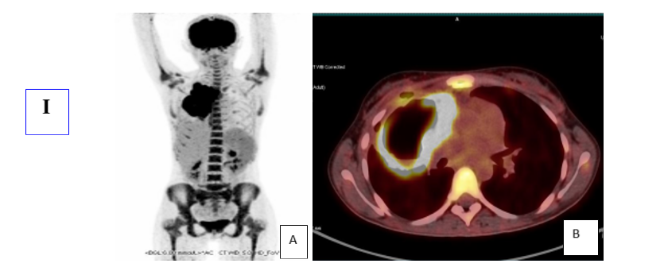

Figure I: Initial PET scan: A: Maximal Intensity Projection (MIP) image showing Mediastinal involvement with contiguous right lung involvement, B: PET-CT merged slices, SUV max=21.2
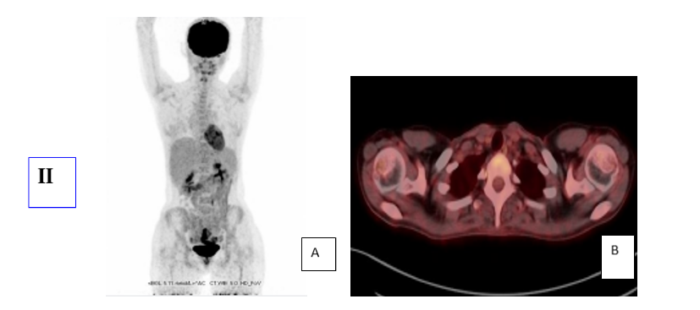
Figure II: MIP image (A) and merged PET-CT axial section (B) show the disappearance of mediastinal and pulmonary lymphomatous involvement, confirming CR on end-of-treatment PET.
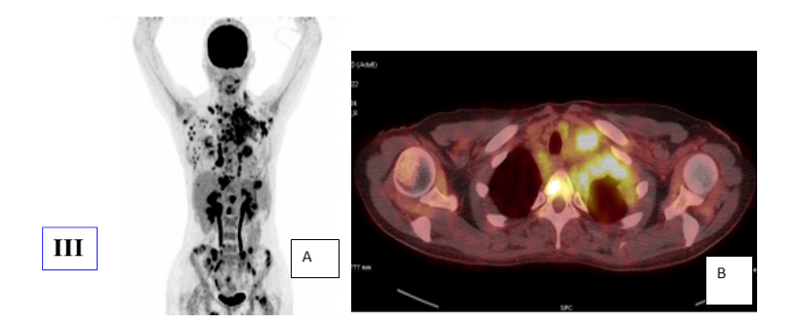
Figure III: MIP image (A) and merged axial section PET-CT (B) show tumour progression in lymph nodes, pleura, liver and bone. Right breast hypermetabolism in relation to secondary lymphomatous site.
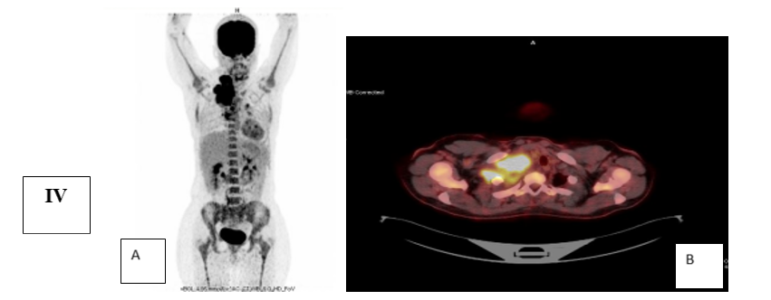
Figure IV: MIP image (A) and merged axial PET-CT section (B) show right cervicothoracic lympho-ganglionic tumor involvement (SUV max= 16.4) with osteolysis of the 1st right rib on initial PET scan.
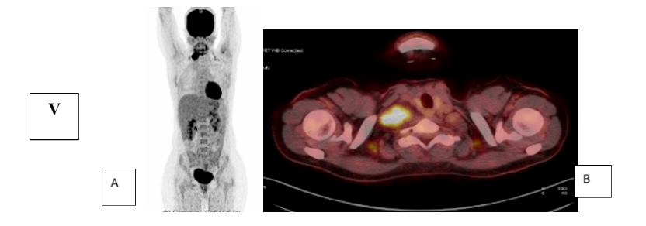

Figure V: MIP image (A) and merged axial section PET-CT (B) show a partial metabolic response (SD=5) to interim PET.

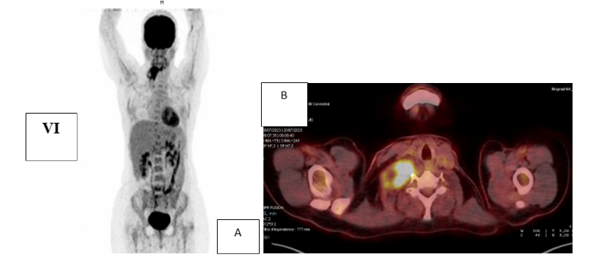
Figure VI: MIP image (A) and merged PET-CT axial section (B) show morpho-metabolic progression of the right laterocervical lymph node cast (SD=5) at end-of-treatment PET.
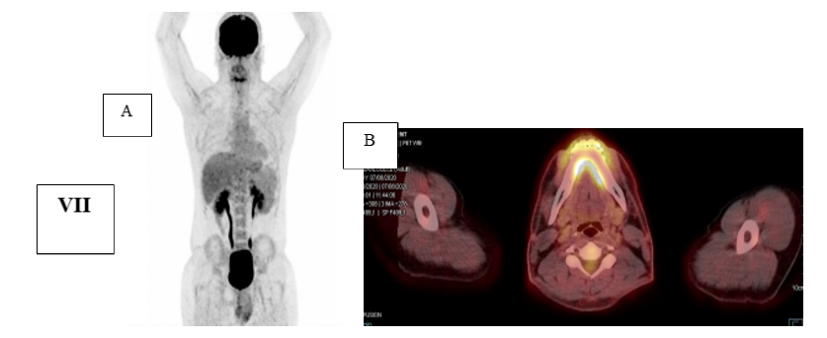
Figure VII: MIP image (A) and merged PET-CT axial section (B) show complete metabolic response (SD=3) at end-of-treatment PET.

