VEGETATIVE PROPAGATION BY SOMATIC EMBRYOGENESIS OF TWO SUGARCANE VARIETIES IN NORTHWEST ARGENTINA

ABSTRACT
An efficient protocol was developed for the induction of somatic embryogenesis and plant regeneration from the apical whorl of two sugarcane varieties (SP 70-1143 and CP 70-1133) grown in the fields of Oran, northwest of Argentina. Callus induction was obtained on MS medium containing 2,4-D (45.25 µM/L) and cefotaxime (0.4 g/L). Rapidly growing nodular calluses were registered, which differentiated into somatic embryos. In embryogenic callus formation and proliferation, the results obtained were dependent on the genotypes evaluated. Shoot formation was effective with BAP (113 µM/L), also with a response influenced by the genotype. In the presence of 2.69 µM/L of ANA, the vitroplantlets showed root formation. To improve the rooting response, an additional treatment with 2.07 µM/L of K-IBA increased the rooting percentage in the genotype with the lowest response. Under controlled conditions, the vitroplantlets were hardened in plastic containers, reached 100% survival in the acclimatation phase. The vitroplantlets were successfully transferred to field conditions. No morphological alterations were observed in the plants regenerated by embryogenesis. Somatic embryogenesis is a valuable tool for the propagation and genetic improvement of sugarcane.

Keywords: sugarcane; embryogenic callus; rooting; acclimatation.

INTRODUCTION
Sugarcane is a commercially important crop grown in tropical and subtropical areas. It plays an important role in the global economy. Cultivated areas have increased in recent years, leading to the expansion of agricultural frontiers into less favorable areas. The industrialization of sugarcane for the production of saccharose and fiber (paper, among other products) is the most important goal, motivating the increase in production areas. In Argentina, in the Salta provinces of and Jujuy, an area of ​​110,000 hectares of sugarcane is projected to be cultivated by 2024, in addition to the 290,000 hectares in the province of Tucumán. The domestic market typically accounts for 60% of the sugarcane content. 70% of the sugar destined for this market is consumed by industry (bottlers of beverages, bakery products, cookies, dairy products, ice cream, sugar confectionery, sweets, jams, powdered juices, liquor manufacturers, laboratories, etc.); the remaining 30% is fractionated for retail consumption. Exports vary depending on harvest production. Furthermore, the opportunity presented by bioethanol for sugarcane was reflected in the evolution of planted areas, which grew around 32% between 2004 and 2018, and by 2024, it was almost 40% more than before the biofuels law. This opportunity was also projected into alcohol production. At the time the Biofuels Law was enacted, the sector produced approximately 200,000 m³ of alcohol annually, a volume that tripled to nearly 583,000 m³ in 2018 and the 600,000 m³ expected to be reached by 2024 (Digital Magazine of the Argentine Sugar Center, 2024). Currently, sugarcane cultivars worldwide are the result of interspecific crosses between Saccharum officinarum, S. barbieri, S. sinense and the wild species S. spontaneum and S. robustum, classified as the Saccharum spp complex (Dibax, 2011). Obtaining new varieties through traditional genetic improvement is a process that requires many years of study and continuous evaluation. Genetic improvement of these species, with a complex polyaneuploid genome, is difficult and time-consuming (Rastogi et al., 2015; Alves and Oropeza, 2015). Conventional propagation methods using cuttings are slow to propagate new commercial varieties; the time between selection and multiplication is more than 10 years (Montes de Oca, 2010). An alternative to this problem is clonal propagation through meristems or axillary buds in vitro and the mass production of somatic embryos (Nieves et al., 2007). In sugarcane, tissue culture techniques have been widely used for the propagation of elite cultivars, in mutation breeding, and in the generation of somaclonal variation (Raza et al., 2012). Plant tissue culture is defined as a highly heterogeneous set of techniques, where an explant (a part separated from the donor plant, which may be protoplasts, cells, tissues, or organs) is aseptically grown in an enriched culture medium and incubated under controlled environmental conditions. One of the most reliable and effective methods for plant regeneration is somatic embryo formation. Plants resulted this way can be of single-cell origin, and the resulting embryogenic cultures can be used for plant breeding and subsequent genetic analysis. The success of this biotechnological tool depends largely on the origin of the plant material, the composition of the growth medium, the growing conditions, and the variety of the donor plants. Among these factors, variety represents an important factor influencing the efficiency of this technique (Gandonou et al., 2005). Somatic embryos are sensitive to the application of exogenous products (phytohormones, herbicides, osmotic stress regulators, etc.) and can therefore be used for the in vitro detection of varieties resistant to toxins or other factors such as drought or salinity. The development of an efficient embryogenic system is essential for the application of transgenic technology (Lakshmanan et al., 2006). Sugarcane in vitro regeneration systems are laborious and require significant time and resources (Nawaz, 2013). The application of this biotechnological tool is appropriate for solving agronomic challenges over conventional techniques, since in vitro plants grow in a controlled environment (Jamil et al., 2017). Micropropagation allows for a higher multiplication rate for plants propagated asexually. In this context, this work proposes establishing an efficient protocol for vegetative propagation of sugarcane germplasm through embryogenic callus induction, plant regeneration, rooting of vitroplantlets, acclimatation, and field transplantation.

MATERIALS AND METHODS

Induction of embryogenic callus
To initiate the induction of somatic embryogenesis, meristematic tissues were extracted from the apical whorl of sugarcane plants of 8 months of age, from two varieties SP 70-1143 and CP 70-1133. In the laboratory, the outer leaves were removed until a section of approximately 20 cm long, including the last node, remained, protected by juvenile leaf primordia. Under aseptic conditions (laminar flow chamber), this material was washed with a 0.15% w/w Benomyl fungicide solution for 15 minutes, then disinfected with 1% v/v sodium hypochlorite for 20 minutes. Subsequently, three washes were done with sterile distilled water for 10 minutes each. Once disinfection was complete, a layer of juvenile leaf primordia was removed using sterile dissection instruments, leaving a stem portion of approximately 1 cm in diameter. Two-mm-thick discs were cut from the stem portion and sown in the culture medium. Murashige Skoog (MS) saline medium and vitamins were used (Murashige and Skoog, 1962). 2,4-D (2,4-dichlorophenoxyacetic acid) was added to the induction culture medium at a concentration of 45.25 µM/L, 20 g/L of sucrose, 0.1 g/L of myo-inositol (PhytoTech Labs, USA) and 7 g/L of agar for solidification. Then, antibiotic Cefotaxime was added to the medium composition at a concentration of 0.4 g/L. The pH of the induction culture medium was adjusted between 6 and 7 before the media was sterilized in an autoclave at 121 ºC at 15 psi for 20 minutes. The experimental unit was defined by a flask of 10 cm in diameter and 10 cm in height, containing 25 ml of culture medium and sealed with PVC film, with 5 discs of stem portions. Once the explants were sown in the induction culture medium, they were kept in darkness for 34 days at a temperature of 25 ± 2 °C, with continuous transplants into the same medium. Detected contaminated explants were discarded. At this stage, the percentage of contamination and callus formation was assessed. The area of ​​the explant that had formed callus was evaluated according to the 5-grade scale of Kryvenki et al. (2008).
- Dead explant,
- Living explant without callus formation,
- 25% of the explant with callus formation,
- 50% of the explant with callus formation,
- 100% of the explant with callus formation.
In this experiment, the vitroplantlets regeneration from embryogenic callus and the rooting were conducted using a completely randomized design (CRD) in a 2x2 factorial scheme, with ten replicates. Treatment effects were analyzed using ANOVA, and the means obtained were compared using Fisher's multiple range test using INFOSTAT® software.

  - Proliferation of embryogenic calluses
The embryogenic calli obtained in the dark induction medium (in the stage described previously) were fractionated and subcultured in MS medium (with the same salt and vitamin composition as the previous stage), but without the addition of antibiotics or 2,4D, under a 16-hour photoperiod with light provided by white fluorescent tubes (1000 Lux) at 25 ± 2 °C. Repotting was carried out every 20 days for three subcultures. At the end of this stage, the percentage of embryogenic callus formation was evaluated in both varieties.

  - Regeneration of vitroplantlets from embryogenic callus
In order to differentiate of vitroplantlets from embryogenic callus, two regeneration media (TR1 and TR2) were formulated, based on MS saline and vitamins, varying in the composition of phytohormones, TR1: supplemented with IBA (indole butyric acid) at a concentration of 40µM/L, and TR2 with BAP (6-benzylaminopurine) at 113 µM/L. The media were supplemented with sucrose at a concentration of 20 g/L and 7 g/L of agar, adjusting the pH as previously described. Calluses were transferred to the respective media, the cultures were maintained under a 16-h photoperiod with light provided by white fluorescent tubes (1000 Lux) at 25 ± 2 °C for four weeks, and repotting to fresh medium was done every 10 days. The experimental unit consisted of a flask containing five embryogenic callus masses. After 30 days of culture in the regeneration treatments (RT), the percentage of embryogenic masses that produced shoots was evaluated. The resulting structures were observed under a Zeiss Discovery V8 stereoscopic magnifier.

  - Rooting of vitroplantlets
The rooting experiment began with the vitroplantlets obtained from both varieties in the regeneration media (TR1 and TR2) from the previous stage. The first two weeks they were mantained on an MS medium supplemented with 2.69 µM/L of naphthaleneacetic acid (NAA). The vitroplantlets that did not show root formation within the two-week period were transplanted to a second rooting medium supplemented with K-IBA (potassium salt of indolebutyric acid) at a concentration of 2.07 µM/L for one week. The rooting percentage was evaluated at the end of the experiment in both rooting treatments.

  - Acclimatation
Once the vitroplantlets were rooted in vitro, the acclimatized process to ex vitro conditions began. The flasks containing the rooted vitroplantlets were opened. They were washed under running water to remove any remaining culture media. The vitroplantlets were transferred to Styrofoam seedling trays with a capacity of 50 seedlings. A substrate composed of equal proportions of perlite and vermiculite was evaluated. The experiment was watered every three days with running water. The trays were covered with transparent plastic and kept under controlled temperature conditions of 25±2°C for 15 days. After this time, the plastic cover was gradually opened until the plantlets (obtained from vitropantulas) were exposed to environmental conditions. The survival rate for both varieties was evaluated. The resulting plantlets were transplanted to the field.

RESULTS AND DISCUSSION

Induction of embryogenic callus
The percentage of contamination in the planted explants reached 5% in SP 70-1143 and 20% in CP 70-1133, produced mainly by fungi, unlike other data available, in which contamination is attributed to bacterial proliferation (Alvarado Capó, et al., 2003). In this work, the percentage of contamination attained with the presence of 0.4 g/L of Cefotaxime in the culture medium is comparable with those reported by Mittal et al. (2009) in India for different varieties of sugarcane, who suggest the use of cefotaxime at a concentration of 0.5 g/L. Cefotaxime is a b-lactam antibiotic, belonging to the third-generation cephalosporin family, which contributes to maintaining asepsis during the morphogenetic process, inhibiting the synthesis of the bacterial cell wall, producing cell lysis (Selwyn, 1983; Leifert et al., 1990). It can act as a promoter of somatic embryogenesis, stimulating subsequent shoot regeneration. Mathias and Boyd (1986) propose that the cefotaxime molecule could mimic the structure of a phytohormone, or that the plant metabolizes it as a phytohormone. In both sugarcane varieties, callus formation began between 7 and 10 days after planting in the induction culture medium. The callus initially consisted of morphogenic cells that cover the explant cut area. Callus formation was assessed according to the Kryvenki scale between 20 and 34 days after the start of explant incubation (Table 1).

Table 1. Area of ​​the explant that formed callus in Saccharum officinarum, between 20 and 34 days after the start of the sowing of explants in the induction culture medium.

Number of days since sowing began | Area of ​​the explant that formed callus according to the Kryvenki Scale
 | SP 70-1143 | CP 70-1133
20 | 3 | 2
27 | 4 | 3
34 | 5 | 4

SP 70-1143 reached 80% embryogenic callus formation, and CP 70-1133 got to 50%. In the callus mass, some cells were divided to form a cellular agglomeration, compatible with proembryogenic structures, which are observed at the periphery of the callus mass. Embryogenic callus characterization was based on texture, color, and response. In SP 70-1143, homogeneous, yellowish white, loose, and easily disaggregated callus was noted (Figure 1 A and B). A limited embryogenic callus formation was displayed in CP 70-1133; however, the embryogenic callus of CP 70-1133 exhibited the same characteristics as in SP 70-1143 (Figure 1 C). The ANOVA for this variable indicates that the response was different between the two genotypes. Differences in the means of the treatment results were compared using the LSD test at the 5% probability level. This comparison demonstrates the influence of genotype on embryogenic callus formation (p=0.0002). Embryogenesis is generally linked to genetic factors, which may be associated with different endogenous auxin levels, resulting from the different physiological states of the explants used (Mahalakshmi et al., 2003).
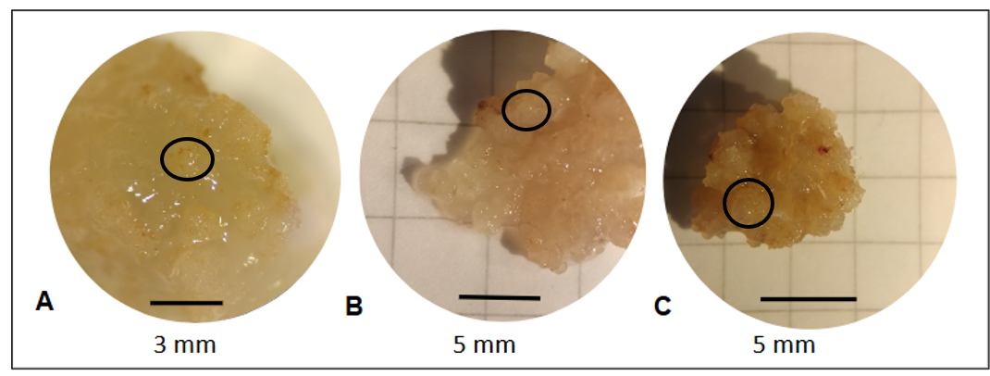
Fig. 1. Appearance of embryogenic calluses of Saccharum officinarum, A and B) variety SP 70-1143 C) variety CP 70-1133. Black circular section corresponds to proembryogenic mass.

Contrary to what other researchers noticed (Freire Seijo et al., 2006), embryogenic callus formation was possible in a semisolid medium. 2,4D acts to induce and regulate callus formation, leading to cell dedifferentiation. It also leads to callus growth, and stimulating its proliferation (Mastuti et al., 2017). The response of the explant to the exogenous addition of auxins is variable and depends on the growth status of the explant (endogenous level of these hormones) and the type and quantity of auxin present in the culture medium. In vitro plant regeneration, embryogenic callus induction was percieved to be initiated by the application of different concentrations of 2-4 D (Jahangir et al., 2010, Dewanti, et al., 2016). Biologically, every part of the sugarcane plant is capable of being utilized to produce callus, however, only the immature leaves rolled from the apex and the inflorescences can produce callus at a significant level (Rao and Jabeen, 2013).
Various genetic and physiological factors influence the induction of somatic embryogenesis, triggering the replacement of the existing gene expression pattern in the explant tissue with a new expression of embryogenic genes. This process is only possible if the cells are competent and receive the appropriate inducing stimuli. Among the factors involved, plant hormones, especially auxins, are key components; their exogenous application is reminiscent of the embryogenic potential of mitotically inactive somatic cells. Auxin signaling and stress may be key events in the genetic reprogramming of somatic cells during early embryogenesis, which is necessary for dedifferentiation and the acquisition of embryogenic status (Silveira et al., 2013). In this assay, using 45.25 µM/L 2,4 D, embryogenic competence of the explant was found, allowing somatic cells to trigger the embryonic response. During the trial, phenolization occurred in both SP 70-1143 and CP 70-1133. The phenolized calli did not differentiate any type of structure and eventually died (Figure 2). The main causes of oxidation may be the corrosive effect caused by the disinfectant agent during the disinfection process, damage to the explant during handling, the composition of the culture medium, the quantity of medium in the flask, and even the quality of the flask (Azofeifa, 2009).

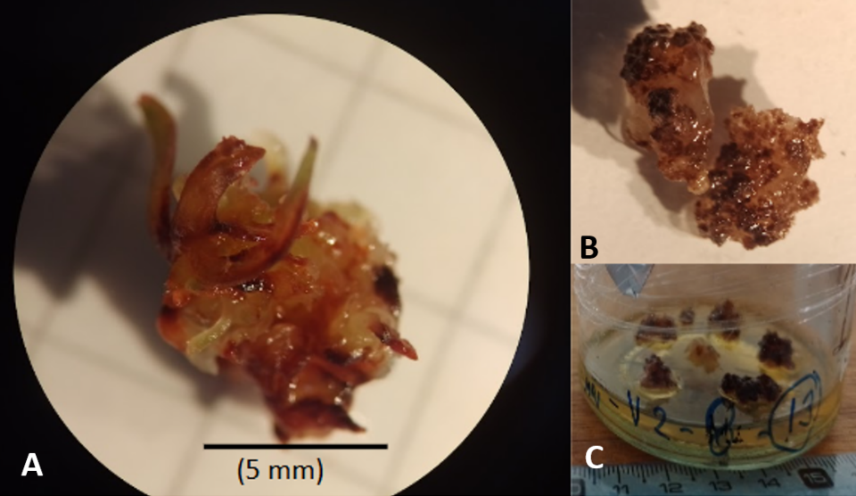

Fig. 2. Phenolized calluses of Saccharum officinarum, A) varieties SP 70-1143, B and C) variety CP 70-1133.

Sugarcane explants have a high content of highly oxidizing polysaccharides, and the meristem releases phenols into the culture medium during the disinfection process. These compounds act as growing inhibitors, leading to their death. Roca (1991) mentions that apical meristems present fewer problems with phenolization than axillary meristems during in vitro propagation; however, in this work, phenolization of the explants is recorded, even when they come from meristematic tissues.

  - Proliferation of embryogenic calluses
The embryogenic calluses generated during the embryogenesis induction stage responded positively during the proliferation stage in MS culture medium (with the same salt and vitamin composition as the previous stage), but without the addition of antibiotics or 2,4D and in the presence of light. The percentage of callus proliferation in both varieties reached 46% in SP 70-1143 and 8% in CP 70-1133. Continued exposure of the explants to 2,4D hampered normal embryo growth (Ahloowalia and Maretzki, 1983). At this stage, the calluses presented a granular appearance, disaggregating easily, without photooxidation and without any type of contamination (Figure 3 A). The explants were placed in the callus proliferation medium for 60 days, with transplants every 20 days. Green dots began to appear in the callus mass, corresponding to embryos in the globular stage, which continued to grow through other embryonic stages, finally generating vitroplantlets with true leaves (Figure 3 B). In sugarcane, no more than 10 in vitro culture cycles are recommended, because somaclonal variations may occur during each culture cycle, which is not advisable in a mass production program of plants with genetic stability.

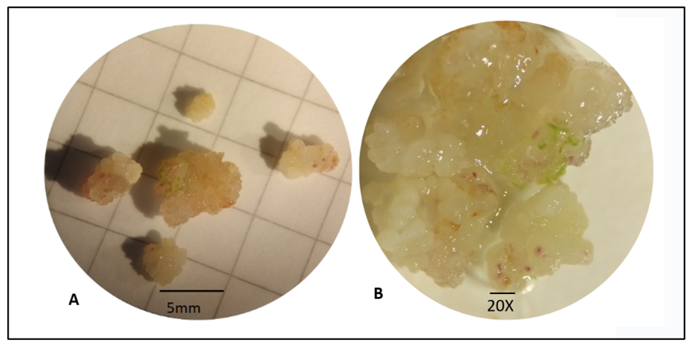
Fig. 3. A) Morphological appearance of embryogenic calli of Saccharum officinarum, 20 days after ringing initiation in the proliferation stage, in SP 70-1143. B) Globular stage embryos of Saccharum officinarum, 40 days after ringing initiation in the proliferation stage, in SP 70-1143.
.
  - Regeneration of vitroplantlets from embryogenic callus
Thirty days after the start of this stage, the percentage of embryogenic masses that produced shoots was evaluated in the media supplemented with IBA or BAP. In the presence of IBA in the culture media, no shoots were generated in either variety. No embryo germination was observed, nor was contamination recorded. Phenolization occurs over time, when the growth of embryogenic agglomerates stops. With BAP in SP 70-1143, 45.88% shoot (plantlet) formation was registered; embryos that germinated, gave rise to a vitroplantlets (Fig. 4 A and B). Embryos in the cotyledonary stage are those that generate fully-developed vitroplantlets, with a cauline and radical system. The creamy yellow calluses progressively presented a change in coloration, which turned green and began to differentiate into shoots, which gradually elongated (Fig. 4 C). Within a month, this growth and differentiation of a complete vitroplantlet was achieved. The presence of BAP in the culture medium promotes the conversion of embryos into complete vitroplantlets. Similar behavior has been reported by Sidek et al. 2022 for Oryza sativa L. (cv. MARDI Siraj 297). In the case of the CP 70-1133 variety, a low percentage of vitroplantlets production was registered, reaching only 8.23% vitroplantlets formation. Vitrification processes (presence of hyperhydric cells) were observed in the SP 70-1143 variety. The ANOVA for this variable indicates that the response was different between the two genotypes. Differences in the means of the treatment results were compared using the LSD test at the 5% probability level. This comparison demonstrates the influence of genotypes on vitroplantlets regeneration from embryogenic callus (p=0.0001).

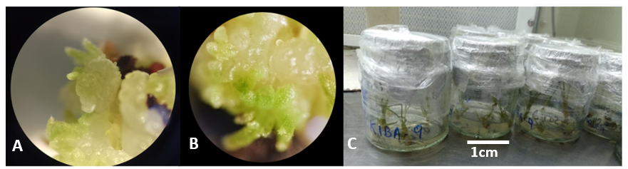
Fig. 4.A) Differentiation and growth of Saccharum officinarum vitroplantlets obtained by somatic embryogenesis. B) Vitroplantlets differentiate at 20 days in a regeneration medium in SP 70-1143. C) Flasks containing Saccharum officinarum vitroplantlets, of the SP 70-1143 variety, obtained from embryogenic calli, 30 days after the start of the vitroplantlet regeneration stage.

In the BAP-supplemented treatment, 1% of explants showed phenolization, manifesting as shoots acquiried a reddish color. Based on this observation, a change to a culture medium containing activated carbon at 3% w/v was evaluated. The phenolization process was reversed. However, growth speed did not recover leading to changes in leaf texture and subsequent death of the vitroplantlets.

  - Rooting of vitroplantlets
Rooting is observed 10 days after the start of this stage. Normal vitroplantlets are identified with adequate growth of the stem and root systems (Fig. 5A). In vitro rooting induction can be stimulated by adding auxins to the culture medium; however, the survival rate decreases when acclimatized to natural conditions. In this study, the rooting percentage with the 2.69 µM/L ANA treatment in SP 70-1143 was 91.93% (Fig. 5B), and 8.07% in CP 70-1133. The ANOVA for this variable indicates that the response was different between the two genotypes. Differences in the means of the treatment results were compared using the LSD test at the 5% probability level. This comparison demonstrates the influence of genotypes on rooting of vitroplantlets (p=0.0001). Vitroplantlets that did not show root formation within 15 days were transferred to a treatment with 2.07 µM/L K-IBA; under this treatment, SP 70-1143 only registered 15.29% more rooting, while CP 70-1133 reached 64.51%, improving the initial response. The potassium salt of IBA is more stable and less sensitive to the enzymatic degradation of auxins (Riov, 1992). It is possible that K-IBA produces an elevation of endogenous auxin levels, leading to the initiation and expression of rooting (Pipinis, et al., 2023).

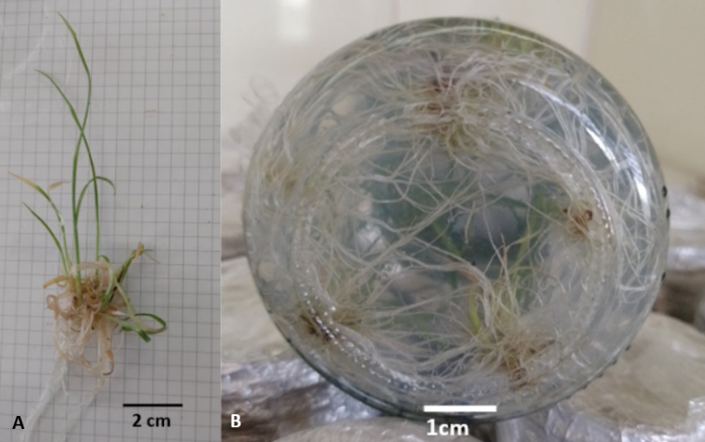
Fig. 5. A) Morphological appearance of a Saccharum officinarum vitroplantlets obtained by somatic embryogenesis in the SP 70-1143 variety, B) Flask containing vitroplantlets during the rooting stage.

  - Acclimatation
Survival during acclimatation is a determining factor for the success of in vitro vegetative propagation (Barpete et al., 2014). To initiate acclimatation, vitroplantlets with good morphological and health appearance obtained by in vitro culture were selected. The substrate composed of equal proportions of perlite and vermiculite allowed adequate air exchange, water absorption by the roots, and good drainage, enabling adequate plantlets growth (Fig. 6A and B). At this stage, a 100% survival rate was achieved in both varieties. The literature indicates that for a high survival rate of vitroplantlets, the roots require 10% air volume in the substrate (Kirkham, 1987), which was observed in this experiment. The vitroplantlets adapted to the substrate, initiating autotrophic growth, and were transferred to field conditions after a month of acclimatation (Fig. 6 C).

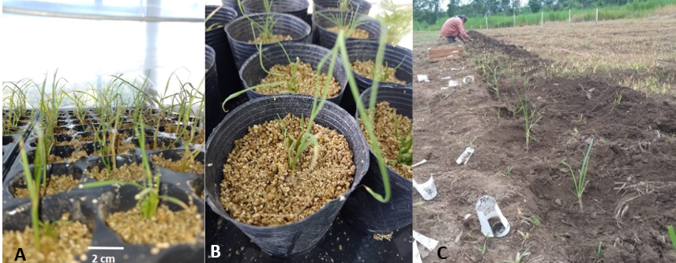
Fig. 6. A y B) Saccharum officinarum plantlets obtained by somatic embryogenesis in plastic trays during the acclimatation process. C) Plants transferred to the field.

The effectiveness of any vegetative propagation methodology depends on the ability to transfer a large number of plants to field conditions at a low cost and with survival rates that justify the application of vegetative propagation via in vitro culture. Vitroplantlets obtained through micropropagation techniques present difficulties when transferred to natural field conditions due to morphological, anatomical, and physiological changes, such as poorly formed cuticle, nonfunctional stomata, heterotrophic cells, and a weak root system (Chandra et al., 2010). In this study, vitroplantlets were successfully transplanted in the field, and they are still being evaluated. The vitroplantlets obtained through this method were no different from those produced by conventional methods, supporting the protocol applied.

CONCLUSIONS
Somatic embryogenesis involves a physiological, morphological, and molecular change that culminates in the development of a plantlet. This work developed an efficient protocol for somatic embryogenesis and plant regeneration, using two genetic materials from the field. Using the established methodology, an acceptable contamination rate was achieved. It was possible to induce the formation of embryogenic callus using 2,4D. Embryogenic calluses responded positively at the proliferation stage, in the absence of 2,4 D and in the presence of light. Appeared homogeneous, yellowish-white, loose, and easily disaggregated. Embryos acquired from embryogenic calli were stimulated with BAP to promote shoot growth. The use of ANA enabled root system growth. The vitroplantlets formed, they were hardened under controlled environmental conditions until normal plantlets were obtained, which were then implanted in the field.
The generation of somatic embryos in varieties adapted to the region may lead to great potential for future work that seek to improve the scale of multiplication or to use this tool as a means for genetic improvement.

DISCLAIMER (ARTIFICIAL INTELLIGENCE)
Author(s) hereby declare that NO generative AI technologies such as Large Language Models (ChatGPT, COPILOT, etc) and text to image generators have been used during writing or editing of t his manuscript.

COMPETING INTERESTS DISCLAIMER:
Authors have declared that they have no known competing financial interests OR non-financial interests OR personal relationships that could have appeared to influence the work reported in this paper.

REFERENCES

Ahloowalia, B. S., & Maretzki, A. (1983). Plant regeneration via somatic embryogenesis in sugarcane. Plant Cell Reports, 2(1), 21-25.
Alvarado Capó, Y., Cruz Martín, M., González, N. P., García Águila, L., Freire Seijo, M., Quiala E. & Gómez Kosky, R. (2003). Working strategy for the prevention and control of bacterial contamination in sugarcane micropropagation. Plant Biotechnology, 3(2).
Alvez, B. & Oropeza, M. (2015). Effect of dicamba and 2,4-dichlorophenoxyacetic acid on somatic embryogenesis in sugarcane. Rev. Colomb. Biotecnol. Vol. XVII No. 2, 85-94.
Azofeifa, A. (2009). Problems of oxidation and browning of in vitro cultured explants. University of Costa Rica, Costa Rica. Agronomía Mesoamericana vol. 20(1): 153-175.
Barpete, S., Khawar, K. M., & Özcan, S. (2014). Differential competence for in vitro adventitious rooting of grass pea (Lathyrus sativus L.). Plant Cell, Tissue and Organ Culture (PCTOC), 119, 39–50.
Chandra, S., Bandopadhyay, R., Kumar, V., & Chandra, R. (2010). Acclimatized tissue-cultured plantlets: from laboratory to land. Biotechnology letters, 32, 1199-1205.
Dewanti, P., Widuri, L. I., Alfian, F. N., Addy, H. S., Okviandari, P., & Sugiharto, B. (2016). Rapid propagation of virus-free sugarcane (Saccharum officinarum) by somatic embryogenesis. Agriculture and Agricultural Science Procedia, 9, 456-461.
Dibax, R., de Alcântara, G. B., Bespalhok Filho, J. C., Machado, M. P., de Oliveira, Y., da Silva, A. L. L., & Machado, M. P. (2011). Plant regeneration of sugarcane cv. RB931003 and RB98710 from somatic embryos and acclimatized. Journal of Biotechnology and Biodiversity, 2(3), 32-37.
Freire Seijo, M., Gómez Kosky, R., Herrera Ofarril, I., Reyes, M. (2006). Callus formation and establishment of sugarcane embryogenic cell suspensions from plant leaf segments in vitro. Plant Biotechnology Vol. 6, No. 1: 51 - 57.
Gandonou, G., Errabii, T., Abrini, J., Idaomar, M., Chibi, F., Skali Senhaji, N. (2005). Effect of genotype on callus induction and plant regeneration from leaf explants of sugarcane (Saccharum sp.). African Journal of Biotechnology Vol. 4 (11), pp. 1250-1255.
Jahangir, G.Z., Nasir, I.A., Sial, R.A., Javid, M.A., Husnain, T. (2010). Various hormonal supplementations activate sugarcane regeneration in vitro. Journal of Agricultural Science, 2(4), 231.
Jamil, S., Shahzad, R., Talha, G., Sakhawat, G., Rahman, S., Sultana, R., et. al. (2017). Optimization of protocols for in vitro regeneration of sugarcane (Saccharum officinarum). International Journal of Agronomy, 2017(1), 2089381.
Kirkham, M.B. (1987). Soil-oxygen and plant-root interaction: an electrical analog study. In Plant and Soil Interfaces and Interactions: Proceedings of the International Symposium: Plant and Soil: Interfaces and Interactions. Wageningen, The Netherlands August 6–8, 1986 (pp. 11-19). Springer Netherlands.
Kryvenki, M., Gómez Kosky, R., Guerrero, D., Dominguez, M., & Reyes, M. (2008). Obtaining calluses with embryogenic structures from Stevia rebaudiana Bert. in semisolid culture media. Plant Biotechnology, 8(2).
Lakshmanan, P., Geijskes, R.J., Wang, L., Elliott, A., Grof, C.P., Berding, N., et. al. (2006). Developmental and hormonal regulation of direct shoot organogenesis and somatic embryogenesis in sugarcane (Saccharum spp. interspecific hybrids) leaf culture. Plant cell reports, 25(10), 1007-1015.
Leifert, C., Waites, W. M., Nicholas, J. R. & Keetley, J. W. (1990). Yeast contaminants of micropropagated plant cultures. Journal of Applied Microbiology, 69(4), 471-476.
Mahalakshmi, A., Khurana, J. P., & Khurana, P. (2003). Rapid induction of somatic embryogenesis by 2, 4-D in leaf base cultures of wheat (Triticum aestivum L.). Plant Biotechnology, 20(4), 267-273.
Mastuti, R., Munawarti, A., & Firdiana, E. R. (2017). The combination effect of auxin and cytokinin on in vitro callus formation of Physalis angulata L.–A medicinal plant. In AIP Conference Proceedings (Vol. 1908, No. 1). AIP Publishing.
Mathias, R. J. and Boyd, L. A. (1986). Cefotaxime stimulates callus growth, embryogenesis and regeneration in haploid breed wheat (Triticum aestivum L.). The Plant Sci. 46:217-223
Mittal, P., Gosal, S.S., Senger, A., Kumar, P. (2009). Impact of cefotaxime on somatic embryogenesis and shoot regeneration in sugarcane. Physiology and Molecular Biology of Plants, 15, 257-265.
Montes de Oca, J. L., Veitia Rodríguez, N., Bernal, A., Machado, P., Jiménez, M., Rivera, O., et. al. (2010). Increasing the efficiency of the micropropagation of the water pipe (Saccharum spp hibrido) in temporal immersion systems. AGRIS - International System for Agricultural Science and Technology.
Murashige, T.; Skoog, F. (1962). A revised medium for rapid growth and bioassays with tobacco tissue culture. Physiology Plantarum,15:473-497.
Nawaz, M., Ullah, I., Iqbal, M., Javed, M. (2013). Improving in vitro leaf disk regeneration system of sugarcane (Saccharum officinarum L.) with concurrent shoot/root induction from somatic embryos. Turkish Journal of Biology 37:726-732.
Nieves, N., Rodríguez, K., Cid, M., Castillo, R., González, J.L., Núñez, M. (2007). Effect of the brassinosteroid analogs BB-6 and MH-5 on protein metabolism in sugarcane somatic embryogenesis. Agronomía Costarricense, 31(2), 71-77.
Pipinis, E., Kostas, S., Hatzilazarou, S., Petropoulos, S., Mitsi, D., Stampoulidis, A., et. al. (2023). Effects of donor tree age, cutting collection time and K-IBA application on rooting ability of L. stem cuttings: preliminary results. Folia Oecologica, 50(1), 97-103.
Rao, S., Jabeen, S. (2013). Optimization of Protocols for Callus Induction, Regeneration and Acclimatized of Sugarcane (Saccharum officinarum L.) Cultivar CO-86032. Current Trends in Biotechnology and Pharmacy. Flight. 7 (4) 861-869.
Rastogi, J., Siddhant, P. B., Sharma, B. L. (2015). Somaclonal Variation: A new dimension for sugarcane improvement. GERF Bulletin of Biosciences, 6(1), 5-10.
Raza, S., Qamarunisa, S., Hussain, M., Jamil, I., Anjum, S., Azhar, A., et. al. (2012). Regeneration in sugarcane via somatic embryogenesis and genomic instability in regenerated plants. Journal of Crop Science and Biotechnology, 15, 131-136.
Revista digital del Centro Azucarero Argentino: Sector Sucroalcoholero Argentino. July 2024.
Riov, J. (1992). Endogenous and exogenous auxin conjugates in rooting of cuttings. In VII International Symposium on Plant Growth Regulators in Fruit Production 329 (pp. 284-288).
Roca William. (1991), "Cultivo de tejidos en la agricultura", funds and applications, CIAT, pp. 545-547.
Selwyn, S. (1983). Antibiotics other than beta-lactam compounds. In Chemotherapeutic Strategy: Proceedings of the Symposium Held on June 2-4 1982 at the World Trade Centre, London UK (p. 47). Macmillan Press.
Sidek, N., Nulit, R., Kong, Y. C., Yien, C. Y. S., Sekeli, R., & EL-Barghathi, M. F. (2022). Callogenesis and somatic embryogenesis of Oryza sativa L. (cv. MARDI Siraj 297) under the influence of 2, 4-dichlorophenoxyacetic acid and kinetin. AIMS Agriculture and Food, Volume 7, Issue 3: 536-552. doi: 10.3934/agrfood.2022033
Silveira, V., de Vita, A. M., Macedo, A. F., Dias, M. F. R., Floh, E. I. S., & Santa-Catarina, C. (2013). Morphological and polyamine content changes in embryogenic and non-embryogenic callus of sugarcane. Plant Cell, Tissue and Organ Culture (PCTOC), 114, 351-364.

