Varietal Performance of Pechay (Brassica rapa L.) Under Simulated Waterlogging: Implications for Lowland Vegetable Production

ABSTRACT

Waterlogging, often caused by excessive rainfall, threatens crop productivity by depriving roots of oxygen. Pechay is a vital crop for food security, capable of producing significantly more food per unit area than cereal crops. The study was conducted from February to April 2025 at the Casiaman Research Farm of the Don Mariano Marcos Memorial State University-North La Union Campus, Bacnotan, La Union. This study assessed the growth responses of three pechay varieties: Pavo and Pac Choi under different waterlogging durations (0, 24, 48, and 72 hours). Two weeks after sowing, seedlings were transplanted into polyethylene pots and grown for another two weeks before submersion. The study was laid out following a 2x4 factorial experiment in Split Plot Design with three blocks and 6 sample plants per treatment per block. Results showed no significant differences among varieties in terms of survival rate, plant height, and number of leaves. However, plants submerged for 72 hours exhibited significantly lower survival and growth. No significant interaction effects were found between variety and submersion period except on the percentage survival recovery. The study suggests that pechay can tolerate waterlogging for up to 48 hours, but prolonged submersion negatively impacts plant development and survival. These findings are useful for guiding flood-resilient pechay cultivation.

Keywords: Pac choi, Pavo Pechay, submersion, waterlogging

1. INTRODUCTION

Agriculture continues to be a major driver of the Philippine economy, providing employment, ensuring food security, and supporting rural development. Vegetable production, particularly of staple and high-value crops, plays a critical role in this system. Among the widely cultivated leafy vegetables, pechay (Brassica rapa L.) holds a prominent position due to its short growing period, nutritional value, and adaptability to various agroecological zones (PSA, 2023; DA, 2022). Its consistent demand in local markets and culinary traditions reflects its role in enhancing dietary diversity and nutrition among Filipino households.
Pechay varieties such as Pac Choi and Pavo have become popular among farmers due to their fast growth, uniformity, and resilience under standard growing conditions. The Pavo variety, for example, is favored for its compact rosette form, dark green leaves, and high marketability (East-West Seed, 2024). However, despite these positive traits, the productivity of pechay remains highly susceptible to environmental stress—particularly waterlogging, which is a growing concern in flood-prone agricultural areas during the rainy season.
Waterlogging significantly restricts oxygen availability in the root zone, hindering root respiration, nutrient uptake, and overall plant development (Herzog et al., 2016). In extreme cases, prolonged saturation of the root zone leads to stunted growth, wilting, and death. Recent research on Brassica species has documented reductions in chlorophyll content, root biomass, and survival rates under waterlogged conditions (Ding et al., 2022). Studies on Brassica napus have also shown that waterlogging stress alters cell structure, physiological, and biochemical characteristics (BMC Plant Biology, 2024) and even modifies root cell wall polysaccharides as an adaptive mechanism (BMC Biology, 2024). Despite these advances, limited research has focused on the morphophysiological response of Brassica rapa varieties to waterlogging under Philippine conditions, where climatic events such as erratic rainfall and flooding are increasingly frequent due to climate change (IPCC, 2023; Lobell et al., 2011).
As weather patterns continue to shift, identifying vegetable crops with improved stress tolerance is critical to safeguarding food production systems. In the case of pechay, determining which varieties can survive and thrive under transient or prolonged waterlogging can provide valuable insights for climate-resilient farming. Such knowledge will be essential in supporting smallholder farmers, especially those operating in low-lying areas where flooding is recurrent.
Moreover, this study aligns with Sustainable Development Goal 2 (Zero Hunger), which emphasizes sustainable agriculture, food security, and the development of crop varieties resilient to environmental stressors (UN, 2023). Promoting waterlogging-tolerant varieties contributes to continuous vegetable production, enhances income stability among farming communities, and strengthens local food systems.
While Brassica rapa has been widely studied for its adaptability, yield potential, and nutritional profile, only a few investigations—particularly in the Philippine context—have evaluated its morphophysiological response to waterlogging stress (Vega, Sampaga, & Wagayen, 2025). Thus, assessing varietal response under such stress conditions is crucial for developing adaptive strategies in horticultural production systems.
This study aimed to determine the morphophysiological responses of pechay (Brassica rapa L.) varieties to waterlogging conditions under Philippine field settings. Specifically, it sought to:
1. Evaluate the growth and survival performance of selected pechay varieties under both waterlogged and non-waterlogged conditions;
2. Identify which pechay varieties exhibit the highest tolerance to waterlogging stress based on morphological and physiological indicators;
3. Determine the maximum duration of waterlogging each variety can tolerate without significant reductions in growth or survival; and
4. Analyze the interaction between pechay varieties and waterlogging duration in relation to growth, physiological response, and survival rates.

2. Materials and methods

The study was conducted from February to April 2025 at the Casiaman Research Farm of the Don Mariano Marcos Memorial State University-North La Union Campus, Bacnotan, La Union (Figure 1). It is situated in the northwestern part of Bacnotan, La Union. The area experiences a Type I climate under the modified Corona’s Climate Classification with distinct wet and dry seasons. The dry season typically from November to April while the wet season occurs from May to October, influenced by the southwestern monsoon (Habagat) (PAGASA, 2020).
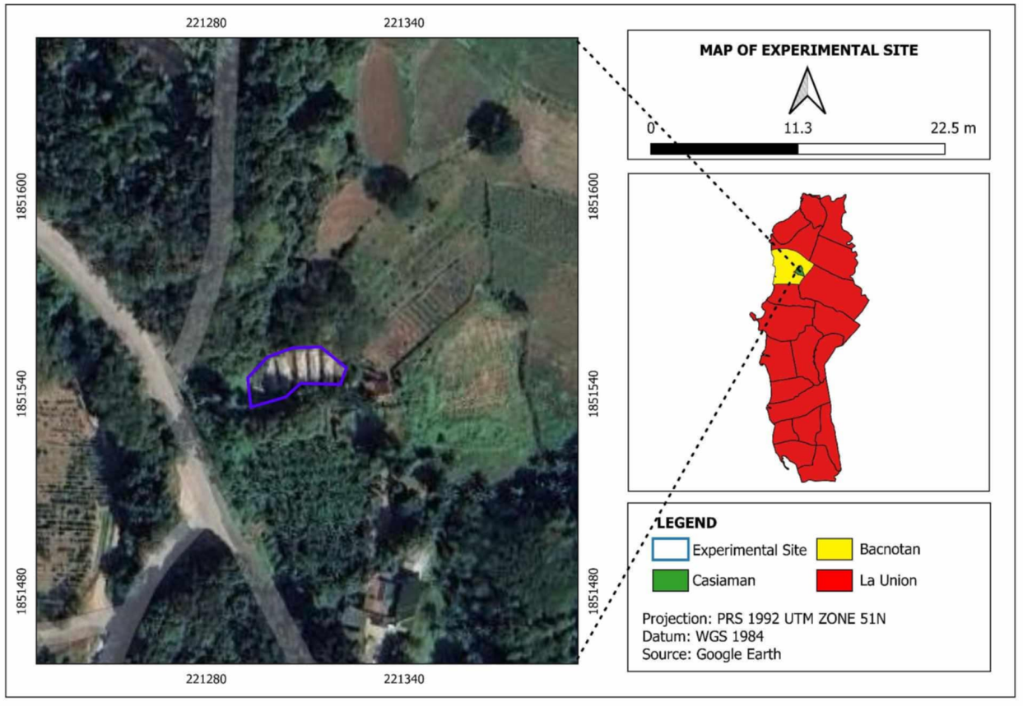
Fig. 1. Map of the Study Area
The climatological data during the conduct of the study is presented in Table 1.
Table 1. Rainfall (mm, Temperature (°C), and Relative Humidity (%) During the Conduct of the Study
Month
Month | Rainfall  (mm) | Temperature (°C) | Relative Humidity (%)
Month | Rainfall  (mm) | Min Max | Min | Max
March | 2.3 | 22.0 29.5 | 22 | 73.4
April | 2.4 | 23.5 30.1 | 26.8 | 73.8

Source: AGROMET Weather Station, DMMMSU-NLUC, Bacnotan, La Union
During the month of March, a total rainfall of 2.3 mm was recorded. The minimum temperature was 2.2°C, while the maximum reached 29.5°C. Relative humidity ranged from a minimum of 22.0% to a maximum of 73.4%. While, during the month of April, a total rainfall of 2.4mm was recorded. The minimum RH is 26.8% and maximum of 73.8% Notably, no rainfall was recorded during the three-day submersion period, nor during the post-submersion observation period.
The study was laid out following a 2x4 factorial experiment in Split Plot Design with three blocks and 6 sample plants per treatment per block.
The treatments used in the study are as follows:
Main plot - Varieties: Sub plot - Submersion Period:
V1– Pavo B1 – Control (No Submersion)
V2- Pac Choi B2 – 24 Hours
B3 – 48 Hours
B4 – 72 Hours
Seed Sowing and Seedling Preparation
Two to three (2–3) seeds of each pechay variety were sown per hole in seedling trays filled with fine, ordinary garden soil. The trays were placed under nursery conditions. After two (2) weeks, healthy and uniform seedlings were selected and transplanted into individual plastic pots measuring 4 x 6 inches. The seedlings were maintained under the nursery for another two (2) weeks to ensure proper establishment before treatment application.
Waterlogging Treatments
Waterlogging condition was simulated using lona submersion ponds. Each potted seedling was carefully submerged in water, ensuring that the entire shoot was covered with water without submerging the leaves entirely. Water levels were regularly checked and adjusted to ensure they consistently reached the plant shoot level across all treatments.
The experiment followed a staggered submersion schedule to ensure that all treatments concluded simultaneously. Plants in Subplot B4, assigned to the 72-hour submersion treatment, were submerged first. After 24 hours, plants in Subplot B3, designated for 48-hour submersion, were submerged. On the third day, plants in Subplot B2 underwent the 24-hour submersion treatment. Meanwhile, Subplot B1 served as the control group; these plants were not submerged but were placed adjacent to the submersion ponds to ensure they were exposed to similar environmental conditions as the submerged treatments.
After completing their designated submersion durations, plants from each subplot were removed from the lona ponds and returned to the observation area beside the pond. The plants were arranged following their original positions during the submersion process to maintain uniform exposure and arrangement throughout the observation period.
For the post-submersion observation, all potted plants were observed daily for a 3-day period. Parameters such as plant wilting, recovery, new leaf formation, and signs of stress or mortality were recorded. This observation period assessed the short-term impact of waterlogging on plant survival.

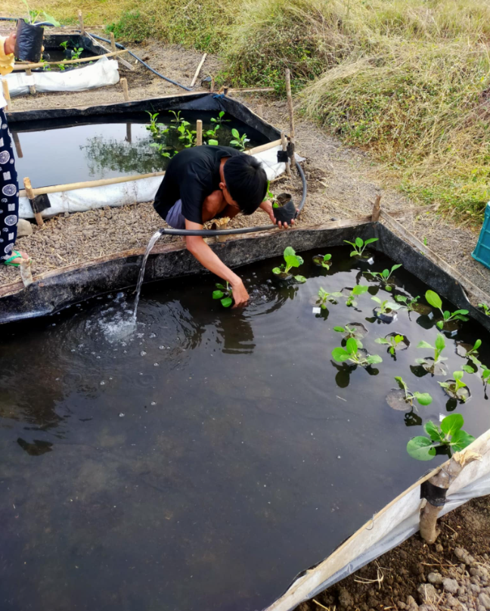
Plate 1. Submersion Period

3. results and discussion

Percentage Survival at Post Submersion Period

Table 2a presents the percentage survival rate of pechay measured after the post-submersion period. It can be observed that the two varieties exhibited high survival rates, ranging from 84.70% to 91.65%. Although slight numerical differences were recorded among the varieties, statistical analysis indicated that these differences were not significant. This result suggests that the pechay varieties used in the study possess inherent tolerance to temporary waterlogging, which is critical for survival under adverse soil moisture conditions.

The high survival rates across varieties may be attributed to general characteristics such as robust root systems, capacity for anaerobic respiration, and morphological adaptations like thicker leaves or faster recovery growth (Setter & Waters, 2003). These findings imply that varietal selection for pechay cultivation under intermittent flooding conditions may not need to heavily prioritize survival traits, as most commercial varieties show sufficient resilience.

Table 2a. Percentage Survival of Pechay Varieties at Post-Submersion Period
Pechay Varieties | Percentage Survival at Post Submersion Period (%)⁺
V₁– Pavo | 91.65
V2- Pac Choi | 84.70
+=not significant at p<0.05

Effects of Submersion Period. Table 1b presents the percentage survival of pechay varieties as affected by the submersion period.

Table 2b. Percentage Survival of Pechay as Affected by Submersion Period
Submersion Period | Percentage Survival at Post Submersion Period (%)*
B₁ – Control (No Submersion) | 100.00ª
B₂ – 24 Hours | 92.58^{ab}
B₃ – 48 Hours | 87.01^{b}
B₄ – 72 Hours | 72.18^{c}
*=significant at p < 0.05. Means with the same letter are not significantly different; means with the same letters are significantly different.

It can be gleaned from the table that a significant difference exists in the percentage survival of pechay varieties subjected to varying submersion durations. A perfect survival rate (100%) was observed among plants under the control treatment, which were not submerged in water. This result is statistically comparable to the plants that were submerged for only 24 hours, suggesting that short-term submersion does not significantly affect the survival of pechay. Plants submerged for 48 hours exhibited a slightly lower survival rate of 87.01%, which was still statistically comparable to those submerged for 24 hours (92.58%). This suggests that pechay may possess a level of tolerance to brief periods of waterlogging, likely due to its ability to maintain oxygen transport and root function under mildly hypoxic conditions.
However, a marked decline in survival rate was noted at the 72-hour submersion level, with only 72.18% of plants surviving. This result supports the hypothesis that prolonged submersion has detrimental effects on pechay, potentially due to anoxic stress, impaired root respiration, and reduced nutrient uptake. According to Herzog et al. (2016), in their study on wheat (Triticum aestivum) prolonged flooding leads to oxygen deficiency in the root zone, which adversely affects plant metabolism and can lead to cellular damage or death. The decrease in survival after 72 hours of submersion indicates that this duration surpasses the tolerance threshold for pechay under the experimental conditions.
This trend aligns with the findings of Li et al. (2023), who reported that Brassica crops, including pechay and Chinese cabbage, experience significant reductions in survival and biomass accumulation under waterlogged conditions exceeding 48 hours. Similarly, Yamauchi et al. (2018) noted that oxygen deprivation in root tissues under extended flooding causes the accumulation of toxic metabolites and limits aerobic respiration, which are critical for cell maintenance and survival.
Conversely, some studies suggest that certain cultivars or varieties of leafy vegetables exhibit greater tolerance to waterlogging. For example, research by Mohan et al. (2025) on mustard greens (a close relative of pechay) demonstrated high survival rates even after 72 hours of flooding, particularly when the plants were in earlier developmental stages. These discrepancies could be attributed to genetic variation, differences in root architecture, and physiological adaptations such as adventitious rooting.
The observed results in this study highlight the sensitivity of pechay to prolonged submersion, emphasizing the need for water management strategies during periods of heavy rainfall or poor drainage. The findings also suggest the importance of screening and selecting pechay varieties with greater flood tolerance for areas prone to waterlogging.
Interaction Effect. Table 2c presents the interaction effect between pechay varieties and submersion period on the percentage survival of pechay varieties gathered at the post-submersion period. This finding suggests that the percentage survival of pechay varieties is not significantly influenced by the interaction between pechay varieties and the submersion period. Therefore, any of the treatment combinations can be effectively used without negatively impacting the percentage survival.

Table 2c. Interaction Table Between Pechay Varieties and Submersion Period
Treatment | Percentage Survival at Post Submersion Period (%)⁺
A₁B₀ | 100.00
A₁B₁ | 94.43
A₁B₂ | 94.43
A₁B₃ | 77.73
A₂B₀ | 100.00
A₂B₁ | 94.43
A₂B₂ | 83.33
A₂B₃ | 61.07

+= not significant at p < 0.05

Plant Height (cm)
As to the final height of pechay varieties as affected by submersion period (Figure 2), Analysis of Variance showed a significant difference in plant height at 72 hours post-submersion. A particularly noteworthy result was that plants under the control treatment (non-submerged) reached the tallest height of 114.50 cm, and the only treatment that showed an increase in height after 72 hours. In contrast, all submerged plants either decreased in height or showed a little growth. The decline in height was most pronounced in plants submerged for 72 hours.
Interestingly, the plants submerged for only 24 hours experience a very little decrease in height (0.3cm), indicating that their physiological functions were already affected, albeit not to a destructive extent. This stagnation suggests that even short-term submersion can disturb normal plant metabolic activities such as cell elongation and nutrient transport.

*=significant at p < 0.05. Means with the same letter are not significantly different; means with the same letters are significantly different.

Fig. 2. Final Height of Pechay as Affected by Submersion Period

Waterlogging or submersion affects plant growth by limiting oxygen availability in the root zone, which is crucial for aerobic respiration. Oxygen deprivation leads to a decline in root metabolic activity, causing reduced nutrient uptake and inhibition of hormone-regulated growth processes such as gibberellin-induced stem elongation (Setter & Waters, 2003). According to Jackson and Colmer (2005), hypoxic conditions resulting from waterlogging suppress cell division and elongation, thereby halting vertical growth. Similarly, Dat et al. (2004) noted that prolonged submersion triggers ethylene accumulation and reactive oxygen species (ROS) formation, which in turn leads to oxidative stress and leaf senescence.
In a study on Brassica crops, Malik et al. (2002) observed that plant height and biomass accumulation were significantly reduced after 48 to 72 hours of waterlogging. These findings are consistent with the present results, where extended submersion caused visible signs of stress and growth retardation.
In summary, the observed reduction or stagnation in plant height under submerged conditions confirms that waterlogging severely impairs physiological processes essential for plant development. The lack of oxygen disrupted hormonal signaling, and stress responses collectively contribute to growth inhibition and in some cases, deterioration of plant structure (Herzog et al., 2016).
Interaction Effect. Table 3 presents the interaction effect between pechay varieties and submersion period on the height of pechay varieties. Analysis of variance revealed no significant difference among the different treatment combinations.

Table 3. Interaction Table Between Pechay Varieties and Submersion Period on the Initial and Final Height of Pechay

Treatment | Initial Height (cm)⁺ | Final Height (cm)⁺
A₁B₀ | 239.17 | 305.00
A₁B₁ | 255.50 | 190.83
A₁B₂ | 379.67 | 192.32
A₁B₃ | 263.33 | 252.70
A₂B₀ | 267.68 | 355.83
A₂B₁ | 288.17 | 289.00
A₂B₂ | 268.50 | 215.80
A2B3 | 271.50 | 224.17
+= not significant at p < 0.05

Leaf Number
Effect of varieties. Table 4 presents the data on the leaf production of different pechay varieties. The initial number of leaves was recorded prior to the submersion treatment, while the final leaf count was gathered after the submersion period. It can be observed that the initial leaf numbers among the different pechay varieties did not differ significantly. Results of the Analysis of Variance (ANOVA) revealed no significant differences in initial leaf number, suggesting that the plants were statistically uniform before the application of the waterlogging treatments.
This uniformity is crucial for the validity of experimental results, as it ensures that observed effects post-treatment can be attributed to treatment differences rather than pre-existing variation among varieties. Similar findings were reported by Maity et al. (2018), who emphasized the importance of varietal uniformity in evaluating abiotic stress responses in leafy vegetables. In their study on mustard greens under stress conditions, they noted that initial morphological uniformity allowed for a clearer interpretation of post-treatment outcomes.
Additionally, research by Tripathi and Singh (2015) on Brassica species highlighted that varietal differences in leaf number typically emerge during later growth stages, especially when environmental stressors such as flooding or waterlogging are introduced. Therefore, the lack of initial variation in this study confirms that subsequent changes in leaf number can be accurately attributed to submersion stress rather than varietal disparities from the outset.
Table 4. Initial and Final Leaf Number of Pechay as Affected by Different Varieties
Pechay Varieties | Initial Leaf Number⁺ | Final Leaf Number⁺
V₁₋ Pavo | 4.45 | 1.94
V₂ ₋ Pac Choi | 4.56 | 2.53
+= not significant at p < 0.05
As to the final number of leaves of pechay varieties gathered at the post-submersion period, the analysis of variance reveals no significant difference among the pechay varieties used. This result suggests that the pechay varieties exhibited comparable resilience in terms of leaf retention or regeneration following the submersion stress event. However, it is important to note that the observation period was limited to only 72 hours after the submersion. Given this short recovery duration, there was insufficient time for the plants to initiate and complete new leaf production, which typically requires several days under optimal conditions. Thus, the recorded leaf count primarily reflects leaf retention rather than regrowth.

This limited timeframe may have constrained the detection of varietal differences in post-submersion recovery capacity, particularly in leaf regeneration potential. According to Ponnamperuma (1984), while many leafy vegetables such as pechay are capable of surviving transient flooding, observable morphological recovery—especially the emergence of new leaves—often occurs several days after water is drained, depending on environmental conditions and plant vigor. Likewise, Setter and Laureles (1996) emphasized that the re-growth of leaves post-flooding is influenced more by the recovery conditions and duration than by the inherent varietal characteristics when the stress period is brief.

The findings are also consistent with those of Kayak, (2024), who reported minimal changes in the number of leaves among Brassica species within short-term post-flooding periods. In their study, differences among varieties became apparent only after extended observation beyond one week. This suggests that, while pechay varieties may possess varied capacities for leaf regeneration, such differences might not be evident under a limited 72-hour observation window.

Effect of Submersion Period. It can be gleaned in Table 5 the initial number of leaves of pechay varieties as affected by submersion period. The initial number of leaves showed no significant difference among the varieties, with values ranging from 4.37 to 4.65. This indicates that prior to the application of the submersion treatment, the pechay plants were relatively uniform in vegetative development, particularly in terms of leaf count. Such uniformity at the baseline is essential for evaluating the effects of a treatment because it minimizes the influence of initial variability on the final results (Gomez & Gomez, 1984).

Table 5. Leaf Number of Pechay Varieties as Affected by Submersion Period
Submersion Period | Initial No. of Leaves⁺
B₁ – Control (No Submersion) | 4.43
B₂ – 24 Hours | 4.37
B₃ – 48 Hours | 4.65
B₄ – 72 Hours | 4.52
⁺=significant at p < 0.05
The lack of a significant difference in initial leaf number aligns with observations in similar studies on leafy vegetables. For instance, Kayak (2024) found that when seedlings of uniform age and size are used, the initial leaf count across Brassica varieties remains statistically similar, which ensures that post-treatment variations are attributable to the applied stress and not pre-existing plant differences.

Furthermore, the relatively stable initial leaf number emphasizes that any subsequent changes observed in the final leaf number—whether loss or lack of new growth—can be attributed primarily to the effect of the submersion period. This reinforces the importance of baseline data in analyzing physiological responses to abiotic stresses such as waterlogging or submersion (Fukao et al., 2019).

As to the final number of leaves gathered at the post-submersion period after 72 hours, analysis of variance revealed a significant difference among treatments as can be gleaned from Figure 3. This indicates that the duration of submersion had a measurable impact on the leaf number of pechay. It can be observed that plants under the control treatment (no submersion) continued to produce new leaves, demonstrating normal vegetative growth under non-stress conditions. In contrast, all plants subjected to submersion—whether for 24, 48, or 72 hours—exhibited a decrease in the final number of leaves compared to their initial counts. This decline in leaf number among submerged plants can be attributed to several physiological responses to flooding stress. Submersion reduces oxygen availability in the root zone, inducing hypoxic or anoxic conditions that disrupt aerobic respiration and energy production (Fukao et al., 2019). These oxygen-deprived conditions can cause cellular damage, hinder nutrient uptake, and lead to the accumulation of reactive oxygen species (ROS), which collectively impair growth and accelerate senescence processes (Ghosh et al., 2018; Zhou & Lin, 2020). Moreover, hormonal imbalances, such as increased ethylene and reduced cytokinins, may promote leaf yellowing and abscission as adaptive survival mechanisms under prolonged stress (Kumar et al., 2022).

*=significant at p < 0.05. Means with the same letter are not significantly different; means with different letters are significantly different.

Fig. 3. Final Number of Leaves as Affected by Submersion Period

The significant differences observed suggest that even short-term submersion can adversely affect leaf retention in pechay. This aligns with the findings of Li et al. (2023) and Kumar et al. (2022), who reported that waterlogging stress in leafy vegetables leads to a reduction in photosynthetic surface area due to leaf senescence and abscission, particularly when the stress duration exceeds 24 hours. The sustained leaf production observed in the control plants further underscores the high sensitivity of pechay to excess water and highlights the importance of maintaining well-drained conditions during early vegetative growth.

Furthermore, the progressive severity of the response across 24, 48, and 72-hour treatments suggests a dose-dependent effect, where prolonged submersion exacerbates the physiological damage. Although the full recovery potential of the plants was not assessed due to the limited 72-hour post-observation period, the observed trend implies that the longer the duration of flooding, the greater the inhibition of vegetative growth.

Interaction Effect. Table 6 presents the interaction effect between pechay varieties and submersion duration on the leaf number of pechay plants. The analysis of variance revealed no significant interaction effect, indicating that the combination of pechay varieties and submersion duration did not influence the leaf number of pechay.

The lack of a significant interaction effect between pechay variety and submersion duration on leaf number is consistent with findings in Brassica rapa subspecies and other species where leaf number remains stable under shorter or moderate periods of waterlogging. For instance, Issarakraisila et al. (2007) reported no reduction in leaf number in Brassica rapa (Caisin) under waterlogging, even though other growth parameters were affected. Similarly, in the study of Black Behi Pechay in Bacnotan, leaf number was hardly different from control for waterlogging up to 24–48 hours (Vega, Sampaga, & Wagayen, 2025), and only the longest exposure (72 h) significantly reduced leaf number. These patterns suggest that leaf number may be less sensitive to waterlogging stress—at least up to a certain duration—compared to traits like leaf area, biomass, or survival. The result in our study may therefore reflect that the durations of submersion tested were within a threshold before leaf number decline becomes pronounced, or that the varieties tested possess some buffering capacity with respect to leaf initiation under water stress.

Table 6. Interaction Effect Between Pechay Varieties and Submersion Period on the Leaf Number
Treatments | Leaf Number⁺
A₁B₀ | 4.27
A₁B₁ | 4.20
A₁B₂ | 4.83
A₁B₃ | 4.37
A₂B₀ | 4.43
A₂B₁ | 4.40
A₂B₂ | 4.40
A₂B₃ | 4.73
A₃B₀ | 4.40
A₃B₁ | 4.20
A₃B₂ | 4.57
A₃B₃ | 4.37
⁺= not significant at p < 0.05

4. Conclusion

Based on the results and findings of the study, it was revealed that Pavo and Pac choi pechay varieties showed no significant effects on growth parameters such as percentage survival, plant height, and number of leaves. However, highly significant differences were observed in the percentage survival recovery following submersion. Among the varieties tested, Variety 2 (Pac Choi) registered higher recovery percentages, indicating better tolerance to waterlogging conditions compared to Variety 1 (Pavo). Furthermore, pechay plants submerged for 72 hours exhibited significantly lower percentage survival, reduced recovery survival percentage, shorter plant height, and fewer leaves during the post-submersion period. This finding indicates that prolonged waterlogging severely affects the physiological and morphological performance of pechay, limiting its ability to recover and resume normal growth after stress. Finally, no significant interaction effects were observed between pechay varieties and submersion period combinations across all measured parameters.

DISCLAIMER (ARTIFICIAL INTELLIGENCE)
Author hereby declare that NO generative AI technologies such as Large Language Models (ChatGPT, COPILOT, etc.) and text-to-image generators have been used during the writing or editing of this manuscript.

References

Mohan, V. R., MacDonald, M. T., & Abbey, L. (2025). Impact of Water Deficit Stress on Brassica Crops: Growth and Yield, Physiological and Biochemical Responses. Plants, 14(13), 1942.
Kumar, M. R., Bahadur, V., Ekka, S. K., & Kujur, R. (2022). Growing of vegetables under water deficiency and water logging. Pharma Innovation. J, 8, 1612-1615.
Kayak, N. (2024). The effect on morpho-physiological and biochemical characteristics of cauliflower and cabbage harvested at different times under flooding stress conditions. Journal of Crop Health, 76(1), 145-159.

Department of Agriculture [DA]. (2022). Performance of Philippine vegetables.

East-West Seed. (2024). Pavo Pechay Hybrid Variety Technical Bulletin. https://www.eastwestseed.com

Ding, L. N., Liu, R., Li, T., et al. (2022). Physiological and comparative transcriptome analyses reveal the mechanisms
underlying waterlogging tolerance in a rapeseed anthocyanin-more mutant. Biotechnology for Biofuels and Bioproducts, 15, 55. https://doi.org/10.1186/s13068-022-02155-5

East-West Seed. (2024). Pavo variety description. https://ph.eastwestseed.com

Ghosh, D., Xu, J., Abi-Haidar, A., & Li, W. (2018). Flooding stress in plants: Molecular and physiological responses. Acta
Physiologiae Plantarum, 40(10), 195. https://doi.org/10.1007/s11738-018-2775-1
Gomez, K. A., & Gomez, A. A. (1984). Statistical procedures for agricultural research (2nd ed.). John Wiley & Sons.
Herzog, M., Striker, G. G., Colmer, T. D., & Pedersen, O. (2016). Mechanisms of waterlogging tolerance in wheat–a
review of root and shoot physiology. Plant, Cell & Environment, 39(5), 1068–1086. https://doi.org/10.1111/pce.12676

Hong, B., Zhou, B., Zhao, D., Liao, L., Chang, T., Wu, X., Wu, J., Yao, M., Chen, H., Mao, J., Guan, C., & Guan, M.
(2024). Yield, cell structure and physiological and biochemical characteristics of rapeseed under waterlogging stress. BMC Plant Biology, 24(1), Article 941. https://doi.org/10.1186/s12870-024-05599-z

Intergovernmental Panel on Climate Change [IPCC]. (2023). Climate Change 2023: Synthesis Report. https://www.ipcc.ch

Issarakraisila, M., Ma, Q., & Turner, D. W. (2007). Photosynthetic and growth responses of juvenile Chinese kale
(Brassica oleracea var. alboglabra) and Caisin (Brassica rapa subsp. parachinensis) to waterlogging and water deficit. Scientia Horticulturae, 111(2), 107–113. https://doi.org/10.1016/j.scienta.2006.09.002

IPCC. (2021). Climate Change 2021: The Physical Science Basis. Contribution of Working Group I to the Sixth
Assessment Report of the Intergovernmental Panel on Climate Change. Cambridge University Press. https://www.ipcc.ch/report/ar6/wg1/

IPCC. (2023). Synthesis Report of the Sixth Assessment Report. Intergovernmental Panel on Climate Change.
https://www.ipcc.ch/report/ar6/syr/

Li, J., Zhang, Y., Chen, Y., Wang, Y., Zhou, Z., Tu, J., Guo, L., & Yao, X. (2024). The roles of cell wall polysaccharides in
response to waterlogging stress in Brassica napus L. root. BMC Biology, 22(1), Article 191. https://doi.org/10.1186/s12915-024-01972-4

Lobell, D. B., Schlenker, W., & Costa-Roberts, J. (2011). Climate trends and global crop production since 1980. Science,
333(6042), 616–620. https://doi.org/10.1126/science.1204531

Malik, A. I., Colmer, T. D., Lambers, H., Setter, T. L., & Schortemeyer, M. (2002). Short-term waterlogging has long-term
effects on the growth and physiology of Brassica species. Functional Plant Biology, 29(10), 1155–1164. https://doi.org/10.1071/PP01143
PAGASA. (2020). Climate classification and seasonal patterns in the Philippines. Philippine Atmospheric, Geophysical
and Astronomical Services Administration. https://www.pagasa.dost.gov.ph

Li, L., Zhang, L., Tang, J., Xing, H., Zhao, L., Jie, H., & Jie, Y. (2023). Waterlogging increases greenhouse gas release and decreases yield in winter rapeseed (Brassica napus L.) seedlings. Scientific Reports, 13(1), 18673.

PCARRD. (2006). Production guide for leafy vegetables. Philippine Council for Agriculture, Forestry and Natural
Resources Research and Development.
Philippine Statistics Authority (PSA). (2023). Major Vegetables and Root Crops Quarterly Bulletin. https://psa.gov.ph
Ponnamperuma, F. N. (1984). Effects of flooding on soils. In T. T. Kozlowski (Ed.), Flooding and plant growth (pp. 9–45).
Academic Press.

Setter, T. L., & Waters, I. (2003). Review of prospects for germplasm improvement for waterlogging tolerance in wheat,
barley and oats. Plant and Soil, 253(1), 1–34. https://doi.org/10.1023/A:1024560008470

United Nations. (2023). The Sustainable Development Goals Report 2023. United Nations.
https://unstats.un.org/sdgs/report/2023/

Yamauchi, T., Colmer, T. D., & Nakazono, M. (2018). Regulation of root traits for internal aeration and tolerance to soil
waterlogging–flooding stress. Plant Physiology, 176(2), 1118–1130. https://doi.org/10.1104/pp.17.01157

Fukao, T., Barrera-Figueroa, B. E., Juntawong, P., & Peña-Castro, J. M. (2019). Submergence and waterlogging stress in plants: a review highlighting research opportunities and understudied aspects. Frontiers in Plant Science, 10, 340.

Zhou, W., & Lin, W. (2020). Plant adaptation to flooding stress: Morphological and physiological traits. Annals of Botany,
125(3), 345–359. https://doi.org/10.1093/aob/mcz164

