Evaluation of soil physicochemical parameters across selected litchi (Litchi chinensis Sonn.) cultivars
ABSTRACT
Litchi (Litchi chinensis Sonn.) is a member of the Sapindaceae family and is occasionally referred to as the “Queen of Fruits.” The exceptional flavor, scent, white aril, and eye-catching scarlet skin of litchi fruits make them incredibly popular. Its production is influenced by a variety of soil and climatic conditions, although scientific data on soil quality across different litchi cultivars is limited. The aim of this study was to evaluate the physicochemical parameters of rhizosphere soils from nine litchi cultivars: ‘Shahi’, ‘Rose Scented’, ‘Dehradun’, ‘Dehra Rose’, ‘Ajhauli’, ‘China’, ‘Mandraji’, ‘Purbi’, and ‘Bombai’, which were collected from the ICAR-National Research Centre on Litchi, Muzaffarpur, Bihar. At a depth of 0–20 cm, soil samples were taken, and their moisture content, water-holding capacity, pH, and electrical conductivity were measured. Litchi cultivars, especially Ajhauli (20.58%) and Dehradun (70%), had generally higher soil moisture content and water-holding capacity, while Rose Scented (8.9) and Purbi (0.59 dS/m) showed maximum pH and electrical conductivity. These specific cultivars highlight their significance in improving soil quality and promoting fruit development. These findings highlight the ecological benefits of litchi-based systems for sustaining soil health.
Keywords: Litchi, Cultivars, Soil moisture, Water-holding capacity, pH, Electrical conductivity.

- INTRODUCTION

Litchi (Litchi chinensis Sonn.) is known as the “queen” of subtropical fruits due to its high quality, which comprises a juicy aril with a good balance of sugar and acid, a distinct, pleasant flavor, an eye-catching color, and high nutritional value. It is a subtropical evergreen fruit tree that demands very specific climate conditions to improve fruit quality and yield. As a result, it is only grown commercially in a few subtropical nations (Kumar et al., 2023). India, Vietnam, Thailand, Taiwan, Australia, Israel, and China are the top litchi-producing countries. According to Sahni et al., (2020), India is the world’s second-largest producer of litchi after China. West Bengal, Uttar Pradesh, Bihar, and Jharkhand are the main Indian states that produce litchi. Bihar is India’s most productive state in terms of land area and litchi output.
Litchi is grown all over India and comes in 35 different varieties. The majority of these varieties originated from Chinese cultivars. Most litchi is produced from just six cultivars: Shahi, China, Rose Scented (Dehradun), Muzaffarpur, Seedless, and Bombai. Indeed, there are dominating cultivars in each district. The classification of litchi cultivars by maturity period is shown in Table 1.
Table 1: Maturity periods of litchi cultivars
Period | Cultivars
Early | Shahi, Dehradun, Rose Scented, Dehra Rose, Ajhauli, Deshi, Muzaffarpur, Trikolia, Green
Mid | China, Bedana, Purbi, Bombai, Culcuttia, Swarna Roopa, Kasba, Sabour Madhu, Sabour Bedana
Late | Late Bedana, Kaselia, Longia
(Source: The Litchi, FAO, 2012)
Since litchi fruit has a short post-harvest life and is highly sensitive to soil and climate, it is not commonly grown. Warm, humid summers and chilly, dry winters are ideal for litchi plant growth. According to Kumar et al., (2023), one of the most crucial factors affecting litchi compatibility is soil pH (Singh et al., 2012, Mitra, 2002, Singh and Babita, 2002). The majority of litchi orchards in the world are located on slightly to moderately acidic soil (Kumar et al., 2018b, Singh et al., 2012), however litchi in north Bihar, India is predominantly planted on calcareous soil with pH 7.5 to 8.8 (Kumar et al., 2018b; Nath et al., 2018c; Singh et al., 2012). The effective commercial cultivation of litchi in north Bihar (India) on calcareous soil demonstrates that litchi may be grown in a variety of soil conditions (Kumar et al., 2018a). It was discovered that soil properties directly affect plant growth, yield performance, and fruit quality, but they have little to no effect on flowering and fruit set (Kumar et al., 2016, Singh et al., 2012). The successful growth, development, and fruit production of litchi are significantly influenced by adequate soil moisture. Insufficient water during the crucial phases of crop development impacts shoot development and inhibits blooming, ultimately resulting in a low litchi yield (Marboh et al., 2018). The present study was conducted to examine the physicochemical parameters of soils associated with several litchi cultivars in the Muzaffarpur region of Bihar, in light of the significance of the soil environment in maintaining litchi productivity.

- MATERIALS AND METHODS

  - Study sites
Rhizosphere soil samples of nine distinct litchi cultivars—‘Shahi’, ‘Rose Scented’, ‘Dehradun’, ‘Dehra Rose’, ‘Ajhauli’, ‘China’, ‘Mandaraji’, ‘Purbi’, and ‘Bombai’ were gathered from the litchi orchards of the ICAR-National Research Centre on Litchi, Mushahari, Muzaffarpur, Bihar. The centre is situated in Muzaffarpur, Bihar, at an elevation of 210 meters, between latitudes 26°5′87′′N and longitudes 85°26′64′′E. The region has a subtropical climate, with 1100–1300 mm of rainfall on average each year. The soil at the site is calcareous, sandy loam in texture, alluvial, and has a pH between 7.5 and 8.0.

  - Collection of soil samples
Soil samples were taken from the rhizospheres of early and mid-season litchi cultivars in order to investigate variations in the physical and chemical properties of the soil. ‘Shahi’, ‘Rose Scented’, ‘Dehradun’, ‘Dehra Rose’, and ‘Ajhauli’ were among the early-maturing, while ‘China’, ‘Mandraji’, ‘Purbi’, and ‘Bombai’ were among the mid-season-maturing litchi cultivars. Rhizosphere soil samples were taken at random from the root zone of each cultivar at a depth of 0–20 cm after the topsoil layer, grasses, and surface debris were removed. Three replicates were taken from each tree and properly mixed. Surface soil (between 0 and 20 cm) was taken from a nearby uncultivated area for the control. An approximate 500 g sample of soil was gathered and placed in sterile sample bags for storage. In the laboratory, the obtained samples were air-dried, pounded with a mortar and pestle, sieved, and stored in plastic bags for soil analysis. Soil samples were sent to the Central Soil Testing Laboratory (CSTL), located in Mithapur, Patna, to estimate the soil’s physicochemical parameters.

  - Analysis of soil parameters
Soil moisture was evaluated using the gravimetric method, which involves placing the soil sample in an oven at 105°C and drying it to a consistent weight. The weight difference is assumed to be water present in the soil sample. Water-holding capacity was determined using the method given by Muratore and Knorr (2025) and was calculated based on the volume of water retained by the soil. Soil pH was measured by a pH meter, and electrical conductivity (EC) was measured by an electrical conductivity meter in 1:2 soil water suspensions. The methodology described in the methods manual Soil Testing in India (Anonymous, 2011) was followed for laboratory analysis.

  - Statistical analysis
Analysis of variance (ANOVA) was used to statistically analyse the data for each soil parameter. A one-way ANOVA was used in Excel to compare various litchi cultivars. Three replicates of the experiment were conducted, and the data were expressed using the mean ± standard deviation (SD).

- RESULTS

  - Soil moisture
The soil moisture content in the rhizosphere soil of early and mid-season maturing litchi cultivars was measured and compared to the control (Figure 1). The soil moisture content in the rhizosphere soil ranged from 10.78% to 20.58%, while the control (6.84%) showed the lowest soil moisture content. Ajhauli had the highest soil moisture content among the early litchi cultivars (20.58%), while Dehra Rose had the lowest (10.78%). China had the highest percentage of soil moisture content among the mid-season litchi cultivar (15.83%), while Mandarji had the lowest (12.19%). When compared to the control, these differences were statistically significant at p < 0.001.
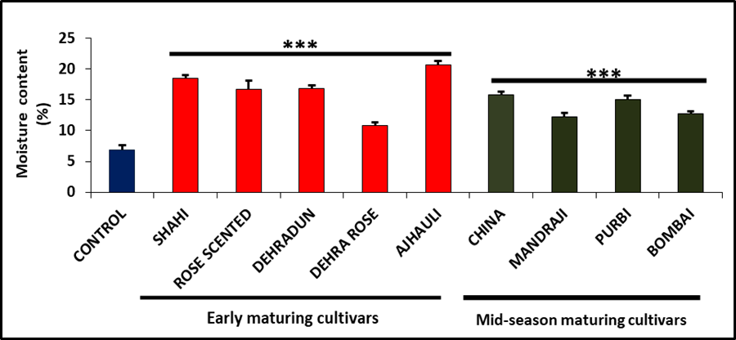
Figure 1. Soil moisture content in the rhizosphere soil of early and mid-season-maturing litchi cultivars was measured and compared to the control. Experiments were performed in triplicate, and data is represented as mean ± SD. The asterisks indicate a significant difference (p < 0.001).

  - Soil water-holding capacity
The water-holding capacity of the rhizosphere soil of litchi cultivars that mature early and mid-season is depicted in Figure 2 in comparison to the control. The findings showed that the control had a water-holding capacity of 46.67%, but the rhizosphere soil’s ranged from 43.33% to 70%. Of the early litchi cultivars, Rose Scented had the lowest water-holding capacity (43.33%), while Dehradun had the highest (70%). Among the mid-season maturing litchi cultivars, Purbi had the maximum water-holding capacity (66.67%), whereas Mandarji had the lowest (48.33%). Litchi cultivars that mature in the early and mid-seasons both have substantially greater water-holding capacities than the control.
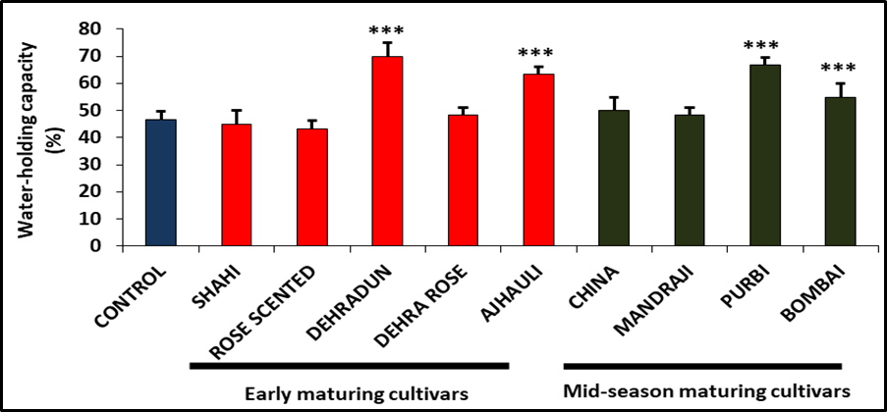
Figure 2. Water-holding capacity in the rhizosphere soil of early and mid-season maturing litchi cultivars was compared to the control. Experiments were performed in triplicate, and data is represented as mean ± SD. The asterisks indicate a significant difference (p < 0.001).
  - Soil pH
The pH level in the rhizosphere soil of early and mid-season maturing litchi cultivars was measured and compared to the control (Figure 3). The control (7.96) has the lowest pH value and is moderately alkaline, but the rhizosphere’s soil pH ranged from 8.5 to 8.9, which is moderately to strongly alkaline. Rose Scented had the highest soil pH of any early litchi cultivar (8.9), whereas Dehra Rose had the lowest (8.5). China, Mandraji, and Purbi all had the highest soil pH among the mid-season mature litchi cultivars (8.8), whereas Bombai had the lowest (8.7). Compared to the control, these differences were statistically significant (p < 0.001). According to these findings, the pH values of early- and mid-season litchi cultivars are both noticeably higher than those of the control, with even more variation observed in early-maturing cultivars.
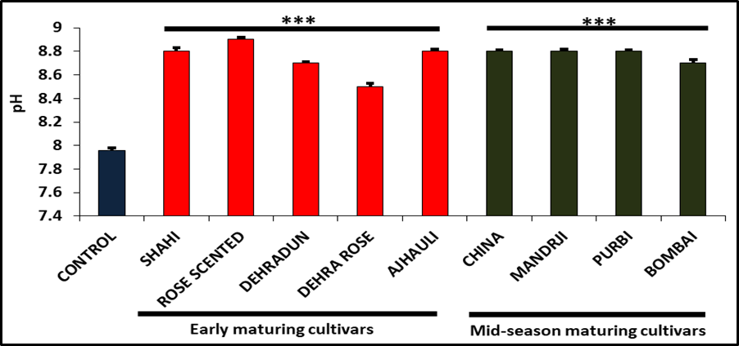
Figure 3. Soil pH in the rhizosphere soil of early and mid-season maturing litchi cultivars was compared to the control. Experiments were performed in triplicate, and data is represented as mean ± SD. The asterisks indicate a significant difference (p < 0.001).

  - Soil electrical conductivity (EC)
Litchi cultivars that matured early and mid-season were compared to the control in terms of their rhizosphere soil electrical conductivity (Figure 4). The control had the lowest EC value (0.40 dS/m), while the rhizosphere’s soil electrical conductivity ranged from 0.49 to 0.59 dS/m. Dehra Rose had the lowest soil EC value (0.49 dS/m), whereas Rose Scented had the highest (0.59 dS/m) of any early litchi cultivar. China and Bombai were the two cultivars of mid-season mature litchi with the lowest soil EC values (0.51 dS/m), while Purbi had the highest (0.59 dS/m). Additionally, these differences were statistically significant (p < 0.001) when compared to the control. According to our results, all soil samples showed lower EC values (less than 4 dS/m).
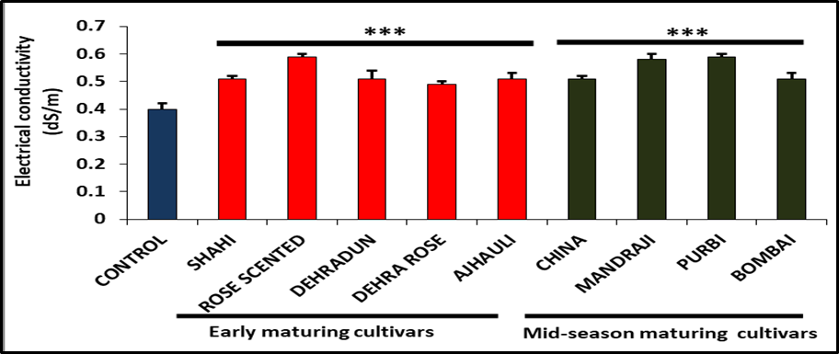
Figure 4. Electrical conductivity in the rhizosphere soil of early and mid-season maturing litchi cultivars was compared to the control. Experiments were performed in triplicate, and data is represented as mean ± SD. The asterisks indicate a significant difference (p < 0.001).

- DISCUSSION

  - Soil moisture
Soil moisture refers to the amount of water present in the soil. According to Cronje and Mosturt (2010), soil moisture is crucial for growing litchi with a high yield and quality. Variations in soil moisture during fruit development result in significant drops in the weight of each individual fruit and in extreme situations can cause fruit cracking. Fruit quality, crop productivity, and marketing are all negatively impacted by this. The most important interventions for litchi-bearing behavior and high-quality production are soil moisture conservation (Kaur and Kaundal, 2009). For fruit to set and develop to maturity, litchi needs a lot of moisture in the soil. Skin cracking is lessened by the high soil moisture content throughout maturity (Lal et al., 2022). In our study, we measured and compared the rhizosphere soil moisture content of each early- and mid-season-maturing litchi cultivar with that of the control. We found that the soil moisture content in the rhizosphere soil ranged from 10.78% to 20.58%, while the control (6.84%) showed the lowest soil moisture content (Figure 1). Our results revealed that the rhizosphere soil samples from Ajhauli (20.58%) and China (15.83%) had the highest soil moisture content, while Dehra Rose (10.78%) and Mandarji (12.19%) had the lowest.

  - Soil water-holding capacity
The water-holding capacity or field capacity refers to the volume of water that remains in the soil after excess gravitational water has been removed and the downward water movement has significantly slowed, as defined by Veihmeyer and Hendrickson (1931). This state of field capacity is achieved between 48 to 72 hours of being saturated. It represents the highest level of soil moisture that is accessible to plants. Each early- and mid-season-maturing litchi cultivar’s rhizosphere soil water-holding capacity was compared to the control in our study. We found that the control had a water-holding capacity of 46.67%, but the rhizosphere soil’s ranged from 43.33% to 70% (Figure 2). Comparing the rhizosphere soil samples from Purbi (66.67%) and Dehradun (70%) to the control group, we discovered that they had the greatest capacity to hold water whereas the lowest was observed in Mandarji (48.33%) and Rose Scented (43.33%).

  - Soil pH
The pH of soil is defined as the negative logarithm of the concentration of hydrogen ions. Soil pH, also known as soil reaction, indicates the acidity or alkalinity of soil and is measured in pH units. It is a simple but critical assessment for soils, as soil pH has a significant impact on crop nutrient availability. The soil’s acidity (pH) classification is given in Table 2.
Table 2: Classification of soils according to pH
Extremely acid | Strongly acid | Moderately acid | Slightly acid | Neutral | Moderately alkaline | Strongly alkaline
<4.6 | 4.6-5.5 | 5.6-6.5 | 6.6-6.9 | 7.0 | 7.1-8.5 | >8.5
(Source: Anonymous, 2011)
In our study, we compared the rhizosphere soil pH level of each early- and mid-season litchi cultivar to the control. We found that the pH value in the rhizosphere soil ranged from 8.5 to 8.9, while the control showed the lowest pH value, i.e., 7.96 (Figure 3). According to our findings, the rhizosphere soil samples from Purbi (8.8), Mandraji (8.8), China (8.8), and Rose Scented (8.9) had the greatest soil pH in comparison to the control (7.96), while Dehra Rose (8.5) and Bombai (8.7) had the lowest. It clearly showed that all the soil samples are moderately alkaline to strongly alkaline. Kumar et al., (2018) found that in the first year of observation, the soil pH varied between 7.8 and 8.9, aligning closely with our findings. Kumar et al., (2016) found that litchi orchard soil pH ranged from 7.42 to 9.53. The pH values observed in our study were within this interval. Our results are consistent with those of Singh et al., (2012), who reported pH values ranging 5.06 to 8.9, supporting the notion that litchi trees may flourish in a variety of soil pH conditions (Arnon and Johnson, 1942). According to Rai et al., (2001), litchi flourishes on Bihar’s calcareous soils at pH levels ranging from 7.5 to 8.5. The soil pH has a direct or indirect effect on the availability of various nutrients, which ultimately impacts the yield and quality.

  - Soil electrical conductivity
Electrical conductivity (EC) is used to determine soluble salt concentrations in soil and is widely used to measure salinity. Saline soils have an EC higher than 4 dS/m, while non-saline soils have an EC below 4 dS/m. In our study, we compared the rhizosphere soil electrical conductivity of early- and mid-season litchi cultivars to the control. We found that the EC value in the rhizosphere soil ranged from 0.49 to 0.59 dS/m, while the control showed the lowest EC value, i.e., 0.40 dS/m (Figure 4). Our results also revealed that the rhizosphere soil samples from Rose Scented (0.59 dS/m) and Purbi (0.59 dS/m) had the highest soil EC when compared to the control. The lowest soil electrical conductivity was observed in Dehra Rose (0.49 dS/m), China (0.51 dS/m), and Bombai (0.51 dS/m). It clearly showed that all the soil samples have lower EC values. Kumar et al., (2018) reported that electrical conductivity was less than 0.2 dS/m. Kumar et al., (2016) also found that electrical conductivity of soil in litchi orchards ranged from 0.07 to 0.39 dS/m. Our data reveal that the EC range found in this investigation was greater than that reported in the majority of the previous literature.

- CONCLUSION
In the present study, we found that litchi cultivation considerably enhanced soil physicochemical parameters when compared to the control. In comparison to control soil, we discovered that litchi cultivars’ rhizosphere soils had greater levels of moisture content, water-holding capacity, pH, and electrical conductivity. These enhancements reduce problems like fruit breaking and promote better fruit development. Rose Scented and Purbi exhibited the highest pH and electrical conductivity among early- and mid-season-maturing litchi cultivars, whereas Ajhauli and Dehradun improved soil moisture and water-holding capacity. These findings suggest that litchi cultivation not only promotes favorable soil conditions for fruit development, but also contributes to improved soil quality, increasing productivity and sustainability in litchi-based agroecosystems.

ACKNOWLEDGEMENT
The authors thank the Director of ICAR-National Research Centre on Litchi, Muzaffarpur, and the Central Soil Testing Laboratory, Patna, for providing the necessary facilities and guidance for this research.

Disclaimer (Artificial intelligence)
Option 1:
Author(s) hereby declare that NO generative AI technologies such as Large Language Models (ChatGPT, COPILOT, etc.) and text-to-image generators have been used during the writing or editing of this manuscript.
Option 2:
Author(s) hereby declare that generative AI technologies such as Large Language Models, etc. have been used during the writing or editing of manuscripts. This explanation will include the name, version, model, and source of the generative AI technology and as well as all input prompts provided to the generative AI technology
Details of the AI usage are given below:
1.
2.
3.

REFERENCES
- Anonymous, 2011. Methods Manual, Soil Testing in India. Department of Agriculture and Cooperation, Ministry of Agriculture, Govt. of India, New Delhi.
- Arnon, D.I., and Johnson, C.M., 1942. Influence of hydrogen-ion concentration on the growth of higher plants under controlled conditions. Plant Physiol., 17:525-39.
- Cronje, R.B., and Mostert, P.G., 2010. A Holistic Approach to Improve Litchi Orchard Management in South Africa.
- Kaur, K., and Kaundal, G., 2009. Efficacy of herbicides, mulching and sod cover on control of weeds in plum orchards. Indian J. Weed Sci., 104:110-12.
- Kumar, G., Kumar, A., Pandey, S. D. 2016. Biofertilizers and micronutrients for quality litchi production. In: Nath, V., Ahmad, F., Mir, H., Kundu, M., Sahay, S., Pandey, S.D., Srivastava, K., Pongener, A. (Eds.), Litchi: Global Perspectives, Excel India Publishers, New Delhi, ISBN 978-93-85777-71-4. Pages: 350.
- Kumar, G., Kumar, R., Nath, V., Pande, S.D., Marboh, E.S., and Kumar, P., 2018. Integrated Soil Management Technique for Young Growing Orchards of Litchi (Lychee chinensis). Int. J. Curr. Microbiol. App. Sci, 7(9), pp.710-722.
- Kumar, G., Kumar, R., Nath, V., Pandey, S.D., Marboh, E.S., Kumar, P., 2018a. Integrated soil management technique for young growing orchards of litchi (Lychee chinensis). Int. J. Curr. Microbiol. App. Sci. 7 (09), 710–722.
- Kumar, G., Nath, V., Mandal, U., Sena, D.R., Pongener, A., Ranjan, R., and Madhu, M., 2023. Climate and soil suitability zonation for Litchi (Litchi chinensis) in India using geo-science tool-based analytical hierarchy process. The Egyptian Journal of Remote Sensing and Space Sciences, 26(3), pp.581-594.
- Kumar, G., Tewari, G., Kumar, V., Pandey, S.D., and Nath, V., 2018. Climate resilience in litchi (Litchi chinensis) orchards in Bihar through soil manipulations. Indian Journal of Soil Conservation, 46(2), pp.190-198.
- Kumar, G., Tiwari, G., Kumar, V., Pandey, S.D., Nath, V., 2018b. Climate resilience in litchi (Litchi chinensis) orchards in Bihar through soil manipulations. Ind. J. Soil Conser. 46 (2), 190–198.
- Kumar, K.A., Maiti, C.S., Alila, P., Sarkar, A. and Singh, A.K., 2023. Effect of different mulching materials on yield and quality of litchi grown in Nagaland. Int. J. Minor Fruits Med. Aromat. Plants, 9, pp.149-158.
- Lal, N., Rangare, N.R., Jayswal, D.K., Chandola, J.C., Lakra, J., Chack, S., Kumar, B., Chhigarha, J., Tandon, K. and Sahu, K., 2022. Eco physiology of litchi in relation to variable climatic factors. Agricultural Mechanization in Asia, 53(9), pp.9683-9693.
- Marboh, E.S., Gupta, A.K., Lal, N., Pandey, S.D. and Nath, V., 2018. An overview of differential response of litchi trees to water stress. International Journal of Innovative Horticulture, 7(1), pp.17-26.
- Mitra, S.K., 2002. Overview of lychee production in the Asia-Pacific region. In: Papademetriou M.K., Dent, F.J. (Eds.), Lychee Production in the Asia-Pacific Region.
- Muratore, T., and Knorr, M., 2025. Determination of Water Holding Capacity (WHC) of Soil Samples.
- Nath, V., Pandey, S.D., Pongener, A., Srivastava, K., Marboh, E.S., 2018c. Challenges and opportunities for improved productivity of litchi. Acta Hort. 1211, 21–28.
- Rai, M., Nath, V. and Dey, P., 2001. Genetic Resources, Production, Protection and Post-Harvest Management and Nutrient Management. Litchi. pp. 45-50.
- Sahni, R.K., Kumari, S., Kumar, M., Kumar, M. and Kumar, A., 2020. Status of Litchi Cultivation in India. Int. J. Curr. Microbiol. App. Sci., 9(4):1827-1840.
- Singh, B. and Chadha, K.L., 2012. Evaluation of critical limits and development of leaf nutrient standards in litchi (Litchi chinensis Sonn.). International Journal of Innovative Horticulture, 1(1), pp.24-32.
- Singh, G., Nath, V., Pandey, S.D., Ray P.K., and Singh, H.S., 2012. The Litchi. Food and Agriculture Organization of the United Nations (FAO). New Delhi, India.
- Singh, G., Nath, V., Pandey, S.D., Ray, P.K., and Singh, H.S., 2012. The Litchi, New Delhi, FAO of the United Nations. pp. 219.
- Singh, H.P., Babita, S., 2002. Lychee production in India. FAO of United Nations, New Delhi, India.
- Veihmeyer, F.J., and Hendrickson, A.H., 1931. The moisture equivalent as a measure of field capacity of soils. Soil Sci. 32, 181-194.

