Effects of Copper Sulphate on Seed Germination and Early Seedling Growth of Cicer arietinum
ABSTRACT
The present research uses scientific methods to investigate the role of copper sulphate in the growth and germination of chickpea (Cicer arietinum) plants. The present research shows that certain concentrations of copper sulphate act as a nutrient while certain concentrations act as a poison for the plant. In the present experiment, it has also been found that all concentrations of copper sulphate have effects on the germination and growth of chickpea seeds, but its effect is observed only to a certain extent after seed germination. The present research has found that a concentration of 50 µM copper sulphate is ideal for early chickpea seedlings or seed germination. The concentration of 50 µM copper sulphate makes an unprecedented contribution to the growth and elongation of both roots and shoots. This research has shown that copper sulphate at a concentration of 50 µM has a positive effect on germination and plant growth, which plays a role as an important cofactor to produce enzymes required for important metabolic processes such as photosynthesis and lignin formation in cell walls in plants. Conversely, the present study provided clear evidence of copper's dose-dependent toxicity. Concentrations exceeding this optimal level specifically at 100, 200, and 500 µM which led to a progressive and significant reduction in both shoot and root lengths. This severe growth inhibition is a direct result of copper's ability to generate reactive oxygen species, which induces oxidative stress, damages cellular components, and interferes with nutrient uptake, particularly in the sensitive root tissues. These findings underscore the critical importance of a precise balance in copper fertilization for sustainable agriculture, aiming to maximize chickpea (Cicer arietinum) yield while avoiding the detrimental effects of heavy metal toxicity.

Keywords: Chick pea (Cicer arietinum) copper sulphate, Seed germination.

1. INTRODUCTION
The chickpea (Cicer arietinum) is a widely used pulse, serving as a primary root of carbohydrates, protein, and necessary dietary Fiber, particularly for human populations in arid and semi-arid regions of the world (Marschner, 1995). Its exceptional nutritional profile is further enriched with variety of minerals, which include vital micronutrients like copper (Cu), zinc and iron (Singh et al., 2007). This all micronutrients required in less quantities but crucial for the proper functioning of plants physiological and metabolic process. Specifically, copper plays a crucial role as a cofactor for numerous enzymes involved in key biological pathways, such as the electron transport chain in photosynthesis and respiration, the synthesis of lignin for cell wall structure, and the vital detoxification of harmful reactive oxygen species (ROS) (Siddiqui et al., 2022). This makes copper a cornerstone of plant health and productivity.
Despite its essentiality, copper's effect on plant growth is acutely dependent on its concentration. When its presence in the growth medium or soil surpasses the plant’s optimal requirement, it rapidly transitions from a vital nutrient to a potent heavy metal toxin (Hussain et al., 2019). This shift can trigger a cascade of detrimental physiological disorders, including the generation of oxidative stress, damage to cellular membranes, and severe inhibition of growth (Halliwell & Gutteridge, 2015). This dual-role paradox makes the precise management of copper levels in agricultural systems a critical challenge.
Present research has highlighted the diverse ways in which plants cope with heavy metal stress. Some species, known as hyperaccumulators, have developed remarkable eco-physiological adaptations to thrive in metal-contaminated soils by sequestering and accumulating heavy metals within their tissues without suffering significant harm (Singh et al., 2008). For example, Phaseolus vulgaris (common bean) has been identified as an effective accumulator of lead and cadmium (Garay et al., 2000). However, most crops, including chickpea, are sensitive to heavy metal toxicity, with root growth being particularly vulnerable to elevated levels of copper and zinc (Hajiboland et al., 2006; Shen et al., 1998). The mechanisms involved in heavy metal tolerance can range from the exclusion of metals from the roots to their compartmentalization within vacuoles, depending on the specific plant species and its genetic makeup (Muzuroglu & Geckil, 2002).
In the context of chickpea, its immense global importance as a protein source for a growing population and its valuable role in sustainable agriculture through symbiotic nitrogen fixation (Tuba et al., 2021) necessitate a deeper understanding of its specific micronutrient requirements. Given the crop's sensitivity and the increasing risk of heavy metal contamination in agricultural soils, a precise investigation into the effects of copper on chickpea growth is essential. This experiment was therefore meticulously designed to study the specific effects of varying copper concentrations on the early seedling development of Cicer arietinum, with the aim of identifying the optimal concentration that maximizes growth while also establishing the toxic threshold that leads to growth inhibition.
1.1 Research Objectives
The present study was specifically designed with the following objectives:
- To investigate the effect of varying copper sulphate concentrations on the percent germination of Cicer arietinum seedlings.
- To determine the optimal concentration of copper that promotes the most significant growth in terms of plumule and radicle length.
- To identify the concentration at which copper becomes phytotoxic, leading to a reduction in seedling growth.
1.2 Research Questions
- Does the application of different copper sulphate concentrations significantly affect the percent germination of Cicer arietinum seeds?
- Is there an optimal concentration of copper that maximizes the plumule and radicle lengths of Cicer arietinum seedlings?
- Do higher concentrations of copper sulphate inhibit the growth of Cicer arietinum seedlings?
1.3 Hypotheses
- H₁: The application of varying copper sulphate concentrations will have an insignificant effect on the overall percent germination of Cicer arietinum seedlings.
- H₂: An optimal concentration of 50 µM copper sulphate will significantly promote the growth of the plumule and radicle, leading to their maximum lengths.
- H₃: Concentrations of copper sulphate exceeding 50 µM will result in a significant and progressive reduction in both shoot and root lengths, demonstrating copper's phytotoxic effects.

2. MATERIAL AND METHODS
To ensure the reliability and reproducibility of the experimental result this research was conducted under controlled laboratory conditions.
2.1 Plant Material and Seed Sterilization
This experiment was conducted using a single batch of Cicer arietinum (chickpea) seeds, a commonly cultivated variety selected for its agricultural relevance and consistent germination rate. The seeds were rigorously surface-disinfected to eliminate potential fungal and bacterial contamination that could interfere with germination and seedling development. This was achieved by a two-step process: first, the seeds were immersed in a 0.1% mercuric chloride (HgCl₂) solution for five minutes, followed by three successive rinses with pure distilled water. Subsequently, they were treated with 70% ethyl alcohol for 30 seconds to remove any remaining microbial spores, followed by another three thorough rinses with distilled water. This sterilization protocol is a standard practice in plant biology research to ensure that observed growth effects are solely attributable to the experimental treatments (Siddiqui & Khan, 2021),
2.2 Preparation of Copper Sulphate Solutions
Different concentrations of copper sulphate (CuSO₄) solutions were meticulously prepared using pure distilled water, which served as the solvent to avoid any mineral interference. The copper source was a high-purity, analytical-grade copper sulphate pentahydrate (CuSO₄⋅5H₂O), with its micro molar mass (249.68 g/mol) used to calculate the precise mass required for each concentration. The treatment concentrations were set at 50, 100, 200, and 500 µM. A control group was established using pure distilled water, providing a baseline for normal seedling growth in the absence of copper.
2.3 Experimental Design and Cultivation
The experiment was arranged in a randomized complete block design to minimize the effects of environmental variables. The experiment was performed in triplicate, with 10 replicates for each of the five treatment groups (one control and four copper concentrations), resulting in a total of 150 seeds per experimental run. Each replicate consisted of a sterile Petri dish lined with a Blotting paper bed to maintain moisture. Seeds of uniform size were pre-soaked in their respective pure distilled water (for the control) or copper sulphate solutions for 3 hours. This initial soaking period ensures the absorption of the treatment solutions into the seeds, which is an important step for chemical absorption (Raskin & Ensley, 2000). After soaking, the seeds were carefully transferred to their assigned Petri dishes, with the Blotting paper bed continuously kept moist with the respective solutions.
2.4 Measurement of Growth Parameters
Plant growth was carefully monitored and measurements were taken at regular intervals. After the initiation of germination measurements were taken at 24, 48, 72, 168, and 360 hours. The key growth parameters measured were:
- Shoot Length (Plumule Length): Measured from the tip of the first true leaves to the base of the stem.
- Root Length (Radicle Length): Measured from the tip of the longest root to the base of the stem.
These measurements were recorded every 24 hours after germination for all treatments using a Scale. The collected data were then subjected to statistical analysis to determine the significance of the observed effects of copper on chickpea growth.
3. RESULTS AND DISCUSSION
The experimental findings provided a detailed insight into the concentration-dependent effects of copper on the early development of Cicer arietinum seedlings. The collected data on shoot and root lengths revealed distinct trends, underscoring copper's dual role as both a vigorous micronutrient and an effective phytotoxin.

Shoot Length
The present study's results revealed that elevated concentrations of copper sulphate (CuSO₄​) had a clear adverse effect on shoot elongation. While the control group, treated with distilled water, exhibited healthy and consistent growth, a progressive decrease in shoot length was observed as copper concentrations increased.
A detailed analysis of shoot length measurements revealed that at a concentration of 50 µM, the seedlings demonstrated the most vigorous growth, with their shoot length being significantly greater than all other copper-treated groups. This outcome highlights the optimal concentration at which copper functions as a beneficial micronutrient, essential for metabolic activities such as photosynthesis and the synthesis of structural components that contribute to shoot elongation.
Conversely, concentrations of 200 µM and 500 µM of CuSO4​ led to a notable inhibition of shoot growth. The most severe stunting was observed at 500 µM, where the shoot length was reduced compared to the control group after 72 hours. This finding is consistent with research on heavy metal toxicity, which is responsible for shoot growth.

Root Length
The analysis of root length measurements provided an even more sensitive indicator of copper's effects, as roots are the first organ to encounter the heavy metal in the growth medium. The results showed that higher concentrations of CuSO_{4​} had a significant negative impact on root growth, confirming its phytotoxic nature at elevated levels.
While the control group exhibited a robust increase in root length, the 50 µM and 100 µM concentrations showed a relatively small reduction in root length after 48 hours compared to the control. This indicates a potential subtle stress response even at lower concentrations, though not as severe as seen with shoot growth. However, a significant reduction in root length was recorded at 72 hours, particularly at the highest concentration. The least increase in root length was observed in the 500 µM concentration, which was severely stunted.
Research can prove to be very useful in the present times. In the present times, the use of chemical fertilizers is increasing a lot. Which is very harmful for the fertility of the soil. Copper plays an important role in the growth and development of any plant, But if copper's quantity increases, it acts like poison for both the soil and the plants. Research shows that copper is beneficial for plants and seedling when applied at 50 µM concentration. Thus, the present research will be useful and a form of direction for all those associated with the agricultural business.

Table 1: Effect of copper sulphate on root length (cm) of Cicer arietinum:
 | Control | Concentration of CuS0₄ (µM)
 | Control | 50 | 100 | 200 | 500
After24h | 1.8±0.8 | 2.1±1.1 | 1.5±.06 | 1.6±0.7 | 1.3±0.5
After48h | 2.6±1.1 | 2.9±1.2 | 2.0±0.8 | 2.2±0.9 | 1.9±0.8
After72h | 3.3±1.4 | 3.5±1.5 | 2.8±1.2 | 2.7±1.2 | 2.4±1.0
After168h | 3.9±1.7 | 4.3±1.9 | 3.2±1.4 | 3.2±1.5 | 2.9±1.2

Table 2: Effect of copper sulphate on shoot length (cm) of Cicer arietinum:
Treatment/  Time | Control | Concentration of CuS0₄ (µM)
Treatment/  Time | Control | 50 | 100 | 200 | 500
After24h | 0.0 | 0.0 | 0.0 | 0.0 | 0.0
After48h | 1.2±0.5 | 1.3±0.5 | 0.8±0.3 | 0.6±0.2 | 0.3±0.1
After72h | 1.7±0.7 | 2.2±0.9 | 1.3±0.6 | 1.1±0.4 | 0.5±0.2
After168h | 5.4±2.4 | 6.2±2.7 | 4.1±1.8 | 2.3±1.0 | 1.2±0.5
After360h | 14.2±6.3 | 20.2±9.0 | 13.6±6.0 | 9.2±4.1 | 2.6±1.1

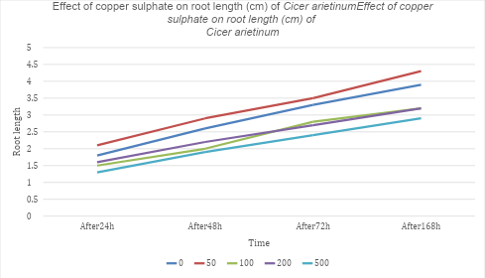
Chart 1: Effect of copper sulphate on root length (cm) of Cicer arietinum
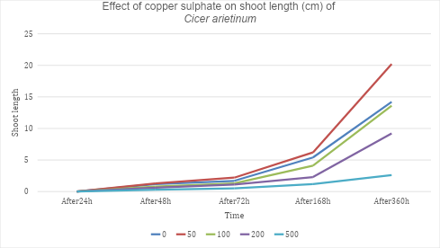
Chart 2: Effect of copper sulphate on shoot length (cm) of Cicer arietinum
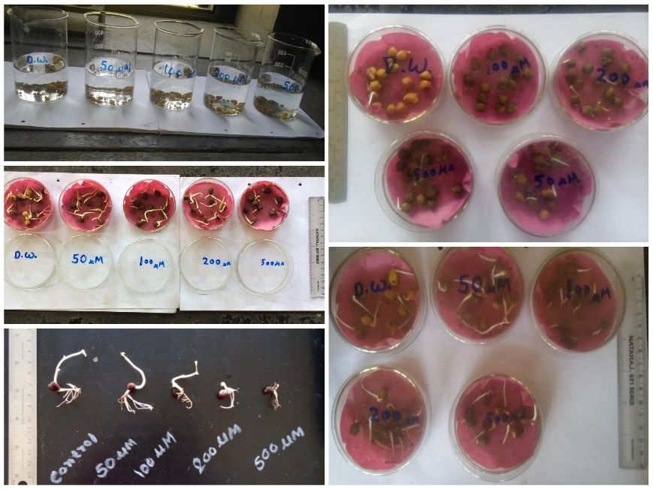
C
B
E
D
A

Fig. 1: Effects of different concentration of CuSo4 on (Cicer arietinum) seeds: A. Soaked of chick pea for 2 h. B. Germination after 24 h. C. Germination after 48h. D. Germination after 72h. E. Germination after 168h.
4. CONCLUSION
This study conclusively shows copper in dual role for the growth and development of Cicer arietinum. The research successfully answered and validated the three core questions and corresponding hypotheses. It verified that while copper at the tested concentrations has a negligible impact on seed germination, it has a major impact on post-germination growth. As evidenced by the maximum length of both the plumule (shoot) and radicle (root) this findings further established that an optimal concentration of 50 µM copper sulphate is most effective for promoting seedling growth. Without causing stress This result highlights copper's essential function as a micronutrient at this specific concentration, facilitating robust growth.
Conversely, the study provided clear evidence that concentrations exceeding this optimal threshold specifically 100, 200, and 500 µM are detrimental. As per our third hypothesis, these supra-optimal levels led to a significant and progressive reduction in shoot and root lengths. This growth inhibition is attributed to copper's ability to induce oxidative stress and disrupt cellular functions, as has been shown in another research (Halliwell & Gutteridge, 2015). The study on the cytological analysis of root tip cells showed the clastogenic and a eugenic effect of this heavy metal on Cicer arietinum root and shoot length (Shen et al., 1998). It is important to note that the high accumulation of copper in root tissues is a well-documented tolerance mechanism, which plants develop to reduce the toxic effects of heavy metals (Yurekli & Porgali, 2006).
In conclusion, these findings emphasize the critical importance of precision in copper fertilization for sustainable agriculture. While copper is important for maximizing chickpea production, especially in the early stages of development, any application must be carefully managed to avoid heavy metal toxicity. The dose-dependent response observed in Cicer arietinum serves as a powerful model for understanding the delicate balance between the supply of essential nutrients and environmental stress. Future research could explore the long-term effects of this optimal concentration on mature plants and examine the interactive effects of copper with other micronutrients in complex soil systems.

COMPETING INTERESTS DISCLAIMER:
Authors have declared that they have no known competing financial interests OR non-financial interests OR personal relationships that could have appeared to influence the work reported in this paper.
DISCLAIMER (ARTIFICIAL INTELLIGENCE)
Author(s) hereby declares that NO generative AI technologies such as Large Language Models (ChatGPT, COPILOT, etc.) and text-to-image generators have been used during the writing or editing of this manuscript.

REFERENCES
Alia, K.V.S.K. Prasadand, & Saradhi, P.P. (1995). Effect of zinc on free radical and praline in Brassica juncea and Cajanus cajann. Phytochemistry, 39, 45.
Alia, Saradhi, P. P., & Mohanty, P. (1995). Drought-induced changes in the activities of antioxidative enzymes in two mulberry cultivars. Plant Physiology and Biochemistry, 33(2), 173–177.
Bouazizi, H., Jeddi, F., & Hichem, T. (2008). The genotoxic effect of copper on Vicia faba root tip cells. Caryologia, 61(4), 381–385.
Bouazizi, H., Jouili, H., Geitmann, A., & Ferjani, E. (2008). Effect of copper excess on H2O2 accumulation and peroxidase activities in bean roots. Acta Biologica Hungarica, 59, 233-245.
El-Tayeb, M. A., Ahmed, N. L., & El-Enany, A. E. (2006). Salicylic acid alleviates the copper toxicity in sunflower seedlings. International Journal of Botany, 2, 380-387.
El-Tayeb, M. A., Hassanein, A. A., & Yasin, M. T. (2006). Stress tolerance in mung bean: Effect of salicylic acid on seed germination and early seedling growth. Pakistan Journal of Biological Sciences, 9(9), 1629–1637.
Farooq, S. (2003). Influence of hydrogen peroxide on initial leaf and coleoptile growth in etiolated wheat (Triticum aestivum L.) seedlings. Asian Journal of Plant Science, 2, 1121-1125.
Garay, H., Palomino, L., & Rojas, S. (2000). Lead and cadmium accumulation in common bean (Phaseolus vulgaris L.). Journal of Plant Nutrition, 23(10), 1545–1553.
Hajiboland, R., Jamil, M., & Aftab, T. (2006). Copper and zinc toxicity and their effect on root growth of chickpea seedlings. Journal of Plant Physiology and Biochemistry, 19(3), 291–297.
Hajiboland, R., Niknam, V., Ebrahim-Zadeh, H., & Mozafari, A. (2006). Uptake, transport and chelation of Cu and Zn at toxic levels in tolerant and sensitive species from North West of Iran. Journal of Science, I.R. Iran, 17, 203-214.
Halliwell, B., & Gutteridge, J. M. C. (2007). Free radicals in biology and medicine. Oxford University Press.
Halliwell, B., & Gutteridge, J. M. C. (2015). Free radicals in biology and medicine. Oxford University Press.
Harnmens, N., & Visser, M. (1993). Zinc toxicity in two cultivars of spring barley: The effect on root growth and cell division. Journal of Plant Nutrition, 16(2), 241–254.
Hussain, M., Ali, I., & Khan, M. A. (2019). Copper toxicity in plants: An overview. Journal of Agricultural Sciences, 32(4), 115–123.
Kaushik, P., Garg, V. K., & Singh, B. (2005). Effect of textile effluents on growth performance of wheat cultivars. Bioresource Technology, 96, 1189-1193.
Marschner, H. (1995). Mineral nutrition of higher plants (2nd ed.). Academic Press.
Mondal, M. M. A., Paul, S., & Begum, M. (2016). Growth and yield of chickpea (Cicer arietinum L.) as affected by phosphorus and zinc fertilization. International Journal of Agricultural Research, 11(4), 162–169.
Muzuroglu, A., & Geckil, H. (2002). Mechanisms of heavy metal tolerance in plants. Turkish Journal of Biology, 26(2), 119–128.
Palanivelu, P., & Somasundaram, A. (2022). A detailed study on the effect of metal nanoparticles on plant growth and development. Journal of Agricultural Science and Technology, 24(3), 541-555.
Pourakbar, A. B., Movahedi, Z. H., & Ebrahimzadeh, A. H. (2007). The effects of copper and zinc on the growth and accumulation of metals in the common bean (Phaseolus vulgaris L.). Iranian Journal of Science & Technology, 31(B4), 369–378.
Prasad, M. N. V. (2004). Heavy metal stress in plants: From molecules to ecosystems. Springer.
Raskin, I., & Ensley, B. D. (2000). Phytoremediation of toxic metals: Using plants to clean up the environment. John Wiley & Sons.
Seregin, S. V., & Kozhevnikova, A. D. (2008). Effect of copper on the growth and development of pea seedlings. Russian Journal of Plant Physiology, 55(2), 220-226.
Shen, Z. G., Li, X. Q., & Lu, X. Y. (1998). Effects of copper and zinc on growth of mung bean (Phaseolus aures Roxb. cv VC-3762) in a solution culture. Journal of Plant Nutrition, 21(9), 1883–1893.
Shen, Z., Fenqin, Z., & Fusuo, Z. (1998). Toxicity of copper and zinc in seedlings of Mung bean and inducing accumulation of polyamine. Journal of Plant Nutrition, 21, 1153-1162.
Siddiqui, Z. S., & Khan, M. N. (2021). A protocol for plant seed sterilization and germination under controlled laboratory conditions. Methods in Plant Biology, 2(1), 45-51.
Siddiqui, Z. S., Siddiqui, Y. A., & Khan, M. N. (2022). Copper’s role in plant growth and stress tolerance. In A. A. Siddiqui & Y. A. Siddiqui (Eds.), Plant mineral nutrition and abiotic stress tolerance (pp. 121-145). Springer.
Singh, D., Nath, K., & Sharma, Y. K. (2007). Response of wheat seed germination and seedling growth under copper stress. Journal of Environmental Biology, 28, 409-414.
Singh, D., Singh, R., & Prasad, S. M. (2008). Phytoremediation of heavy metals: An eco-physiological adaptation in metalliferous soil. Journal of Environmental Biology, 29(4), 589–592.
Singh, P., Singh, S. K., & Sharma, M. P. (2007). Effect of copper toxicity on growth of chickpea (Cicer arietinum). Journal of Environmental Biology, 28(4), 857–860.
Souguir, M., Chebbi, H., & El-Gharbi, S. (2008). The genotoxicity of copper on Vicia faba and Pisum sativum. Biologia Plantarum, 52(4), 747-752.
Tuba, F., Riaz, A., & Nadeem, S. M. (2021). Symbiotic nitrogen fixation in chickpea. Journal of Agriculture and Plant Sciences, 15(2), 85–92.
Yurekli, N. O., & Porgali, N. (2006). Accumulation of heavy metals in the roots and leaves of different plant species grown on mine tailings. Bulletin of Environmental Contamination and Toxicology, 77(1), 118–125.

