Integrated Nutrient Management in Sustainable Agriculture: Advances and Challenges
Abstract
Integrated Nutrient Management (INM) is a critical strategy in sustainable agriculture to maximise the utilisation of organic and inorganic nutrient sources to sustain soil fertility, increase crop productivity, and minimise environmental degradation. As concerns about soil health, climate change, and food security have grown, INM provides a realistic solution to harmonise agricultural productivity with sustainability. This review discusses recent progress in INM practices, their contribution towards sustainable agriculture, and the challenges involved. Emphasis is laid on technological breakthroughs, policy structures, and field-level constraints in implementation, as well as suggestions for further research and development. INM is founded on a series of scientifically valid principles that seek to maximise crop yields while maintaining soil and environmental integrity. These include Balanced Use of Nutrients, Integration of Nutrient Sources, Site-Specific Nutrient Management (SSNM), and Sustainability Focus. Moreover, it was noted that great strides have been taken in developing and using biofertilizers. Microbial inoculants like Rhizobium, Azospirillum, Azotobacter, and phosphate-solubilising bacteria (PSB) are being used increasingly for biological nitrogen fixation and phosphorus solubilization. The development of smart fertilisers has added a new dimension to INM. Tools like Nutrient Expert, developed by the International Plant Nutrition Institute (IPNI), provide tailored fertiliser recommendations based on soil health, crop needs, and management practices. Mainstreaming INM practice will require reinforcing research and innovation, capitalising on capacity building, enhancing public-private partnerships, and incorporating climate-smart agriculture principles. Widespread adoption has the potential to bring about a more harmonious and environmentally friendly agricultural model for future and current generations.

Keywords: integrated nutrient management, sustainable agriculture, soil fertility, balanced nutrients, constraints
1. Introduction
Sustainable agriculture is a holistic approach that aims to fulfil the current food and nutritional needs of the growing global population while preserving natural resources and ensuring ecological balance for future generations (Oberč et al., 2020). One of the critical components of sustainable agriculture is efficient nutrient management, which directly influences soil health, crop productivity, and environmental sustainability (M. Tahat et al., 2020).
In traditional farming practices, indiscriminate and excessive use of chemical fertilisers has been a major issue (Reda and Hailu, 2017). In recent years, the presence of unauthorised fertilisers, pesticides, and the results of biological monitoring have led to environmental contamination (Yadav et al., 2024). Although these inputs have helped produce more food during the Green Revolution, over-reliance on them over the long term has created many environmental and agronomic problems, such as soil acidification, nutrient imbalance, pollution of groundwater, greenhouse gas emissions, and loss of favourable microorganisms in the soil (Prabhakar et al., 2024). All these undermine the resilience of agricultural systems and jeopardise the long-term sustainability of agriculture (Urruty et al., 2016).
To meet these challenges, the theme of Integrated Nutrient Management (INM) has arisen as an environmentally accountable and scientifically justifiable approach (Wu and Ma, 2015). INM promotes the balanced and integrated employment of organic sources (like farmyard manure, compost, green manures, and crop residues), biological inputs (like biofertilizers), and inorganic fertilisers for maximising the availability and crop uptake of nutrients. An efficient combination of soil, water, organic matter, etc. is used in integrated nutrient management, which was developed on the principles of environmentally friendly and effective balanced fertilisation. It is based on optimising nutrient supplies from all available sources, both inorganic and organic, for the crop's pre-determined yield targets (Kumar et al., 2023). This holistic method not only improves nutrient use efficiency but also aids in soil physical, chemical, and biological property maintenance or enhancement (Sharma et al., 2022).
In addition, INM helps to advance the use of resources more efficiently, saving farmers' input costs, and mitigating the negative effects of agriculture on the environment (Panta and Parajulee 2021). INM is also consistent with agroecological principles as it promotes recycling of nutrients within the farm system, increasing soil organic matter content, and sustaining nutrient cycling (Sarvade et al., 2025). INM also contributes to the overall objectives of climate-smart agriculture through carbon sequestration and mitigation of emissions associated with fertiliser use.
Integrated Nutrient Management (INM) of cereal crops is a long-term, eco-friendly way of increasing crop yields while sustaining soil health (Antil and Raj, 2019). INM is the rational use of organic and inorganic nutrient sources for ensuring a balanced and appropriate supply of nutrients to promote vigorous growth of crops and greater productivity. INM plays a powerful role in sustaining improvement in soil fertility (Tamang et al., 2024).
The use of organic amendments like compost, farmyard manure, and green manure enhances soil structure, increases microbial activity, and enhances the nutrient-holding capacity of the soil (Singh et al., 2024). It reduces the sole dependence on chemical fertilisers, thus minimising the chances of environmental degradation such as water pollution due to run-off of nutrients. It also helps reduce the carbon footprint that comes with producing synthetic fertilisers (Kumar et al., 2020).
Economically, INM saves input costs through efficiency in nutrient use and use of locally produced organic materials as sources of nutrients, hence becoming a viable input-saving strategy for farmers (Bhattacharyya et al., 2020). In addition, by enhancing soil fertility and sustaining ecological balance, INM makes agricultural systems resilient to the negative effects of climate change, including drought and soil degradation (Lal et al., 2012).
Integrated Nutrient Management in cereals is an eco-friendly and comprehensive approach that maximises productivity, maintains soil fertility, protects the environment, and promotes the economic stability of agricultural systems (Sharma, 2025).

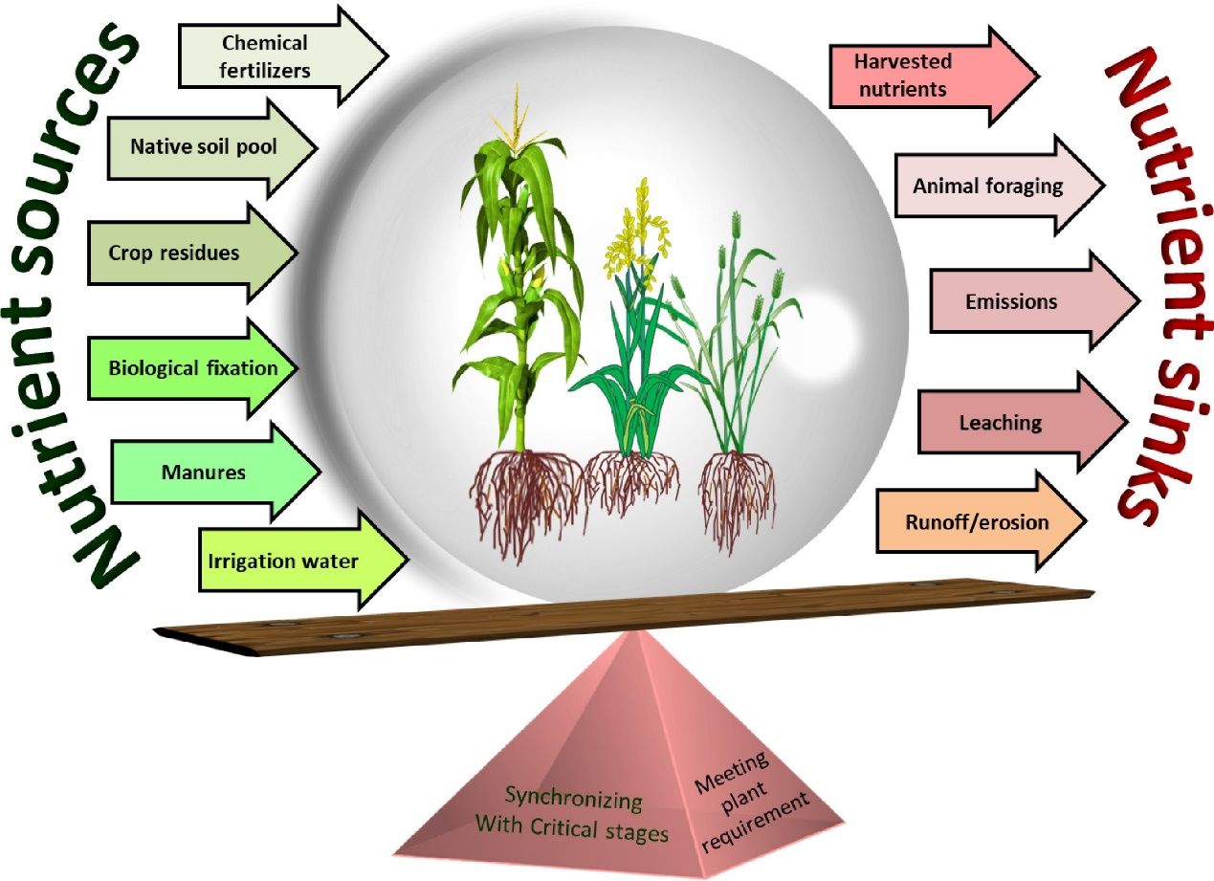

(Source, Chejara et al., 2021)
Figure-1. Balancing the nutrient sources and sinks for meeting plant requirements and synchronising plant availability in integrated nutrient management
Meeting the target of zero hunger, narrowing nutritional deficits, and providing food security to the ever-growing world population are some of the key challenges facing agricultural planners globally (Meybeck et al., 2017). Among the different agronomic interventions, plant nutrient management, specifically optimal and efficient fertiliser use, is of vital concern. Integrated Nutrient Management (INM) is a strategic and sustainable agronomic intervention to address these challenges (Jat et al., 2015).
INM is the rationale-based adoption of a minimum effective dose of balanced nutrients through an integrated mixture of chemical fertilisers, organic manures, and biofertilizers (Selim, 2020). This method not only provides crops with their nutrient needs but also reduces the costs of inputs and risks to the environment. The addition of organic materials like compost, farmyard manure, green manure, and crop residues increases the organic carbon content in the soil, its physical and chemical properties, and microbial activity through providing soil microorganisms with available nitrogen and energy sources (Sharma et al., 2022).
Blending inorganic fertilisers with organics is more and more being seen as a valuable approach, with several benefits. It results in sustained and improved crop yields, soil fertility, and ecological balance enhancement (Roba, 2018). The organic component of INM reduces the damaging effects of toxic residues and enhances the soil's structure, water holding capacity, and aeration (Verma et al., 2019).
Integrated Nutrient Management here is attracting growing interest from researchers, policy makers, and practitioners as a potential solution to attain sustainable intensification of agriculture. The review seeks to identify the developments achieved in the area of INM, its on-farm applicability, advantages, and the issues encountered in adopting it in various agro-ecological zones. It also emphasises the necessity for novel research, awareness among farmers, and conducive policy environments for mainstreaming INM in agricultural systems globally.
2. Integrated Nutrient Management Principles
Integrated Nutrient Management (INM) is founded on a series of scientifically valid principles that seek to maximise crop yields while maintaining soil and environmental integrity (Chejara et al., 2021). The most important principles are as follows:
Balanced Use of Nutrients
Fertiliser application should be according to soil test data, plant nutrient needs, and production levels. This allows the plant to obtain the proper nutrients in the proper amounts at the appropriate times without deficiencies or excesses. Balanced fertilisation maintains soil nutrient balance, increases crop yield and quality, and minimises loss of nutrients to the environment (Samanta and Sengupta, 2025).
Integration of Nutrient Sources
INM focuses on the integrated application of various sources of nutrients, including organic manures (such as farmyard manure, compost, and green manure), biofertilizers (such as Rhizobium, Azotobacter, and phosphate-solubilising bacteria), and chemical fertilisers. INM increases nutrient availability, enhances microbial activity, and improves soil organic matter, thus making a positive contribution to soil health and yield (Yadav et al., 2025).
Site-Specific Nutrient Management (SSNM)
Nutrient management practices must be modified to suit the individual conditions of a place, taking into account factors like soil, climate, cropping pattern, and resource endowment. Site-specific nutrient management allows for fertiliser application recommendations to be made based on local requirements, resulting in effective use of nutrients and minimising environmental degradation (Samanta and Sengupta, 2025).
Sustainability Focus
INM works to sustain or improve soil fertility in the long term, enabling sustained agricultural production. Through minimising reliance on synthetic fertilisers and encouraging recycling of organic materials, INM promotes ecological harmony and reduces the threat of soil degradation, water contamination, and loss of biodiversity (Gruhn et al., 2000).
Table 1: Components of Integrated Nutrient Management in Sustainable Agriculture
Component | Source/Example | Role in INM | Recent Advances | Challenges
Organic Manures | Farmyard manure (FYM), compost, green manures | Improve soil organic matter, structure, and nutrient availability | Use of enriched compost, vermicomposting, and biochar | Low availability, slow nutrient release, bulkiness
Crop Residues | Paddy straw, wheat stubble, legume residues | Recycle nutrients, improve soil moisture and structure | In-situ residue management tools (e.g., Happy Seeder), microbial decomposers | Burning of residues, poor awareness
Biofertilizers | Rhizobium, Azotobacter, PSB, Mycorrhizae | Fixation of N, solubilization of P, and improvement of nutrient uptake | Use of microbial consortia, nano-biofertilizers | Short shelf life, poor quality control, limited field adoption
Chemical Fertilizers | Urea, DAP, MOP, SSP | Quick and targeted nutrient supply | Slow/controlled-release formulations, nano-fertilisers | Overuse leads to nutrient imbalance, leaching, and pollution
Green Manuring | Dhaincha, Sunhemp, Sesbania | Nitrogen fixation, weed suppression, and soil enrichment | Improved varieties with higher biomass and faster decomposition | Requires land and time, farmers are reluctant to adopt
Agro-industrial Wastes | Press mud, distillery sludge, poultry litter | Supplement nutrients, organic carbon source | Treated/composted agro-waste with microbial additives | Heavy metal contamination risk, handling issues
Legume Intercropping | Cowpea, mungbean, pigeonpea | Biological nitrogen fixation, improving N economy | Crop rotation models integrating legumes | Competition for resources, management complexity
Soil Amendments | Lime, gypsum, zeolites | Improve nutrient use efficiency and soil pH | Nano-zeolites, soil conditioners, fortified lime | Cost and availability, variable field efficacy
Decision Support Tools | Soil Health Cards, Nutrient Expert, DSSAT | Site-specific and balanced fertiliser recommendation | Integration with remote sensing, mobile apps, and AI-based tools | Digital divide, lack of training among farmers
Precision Nutrient Mgmt. | GPS, GIS, drones, sensors | Enhance nutrient use efficiency, reduce losses | Smart farming technologies, sensor-based fertigation | High initial cost, lack of skilled manpower
Integrated Farming Systems (IFS) | Crop-livestock-poultry-fishery combinations | On-farm recycling of nutrients, sustainable productivity | IFS models for different agro-ecologies | Labour-intensive, knowledge

3. Advances in Integrated Nutrient Management
The past few years have seen major developments in Integrated Nutrient Management (INM) that are helping to facilitate sustainable agriculture. These developments range from organic recycling techniques to microbial interventions, smart fertiliser technologies, and digital decision-making tools (Ali et al., 2020). The major developments are described below:
3.1 Organic Sources and Recycling
Use of organic matter continues to be a keystone of INM. The conventional inputs like farmyard manure (FYM), compost, green manures, and crop residues are being optimised more and more for recycling nutrients. Organic amendments help to improve structure, promote microbial activity, and raise the water-holding capacity of soil (Wu and Ma 2015).
Sophisticated methods like vermicomposting, where earthworms are utilised to transform organic waste into nutritious compost, are increasingly attracting attention because of their effectiveness and ecological sustainability (Hajam et al., 2023). Likewise, biochar, a type of carbon-rich charcoal made from biomass, has been identified as an exciting soil conditioning agent. Biochar enhances the aeration of soil, increases nutrient holding, and facilitates long-term carbon storage (Singh et al., 2020).
3.2 Biofertilizers and Microbial Innovations
Great strides have been taken in developing and using biofertilizers. Microbial inoculants like Rhizobium, Azospirillum, Azotobacter, and phosphate-solubilising bacteria (PSB) are being used increasingly for biological nitrogen fixation and phosphorus solubilization (Mitter et al., 2021).
In addition, inoculation with mycorrhizal fungi, specifically arbuscular mycorrhizae, has been found useful in enhancing phosphorus nutrition, increasing water uptake, and enhancing resistance of plants against soil-borne pathogens (Kumar et al., 2025). Such microbial technologies facilitate sustainable nutrient delivery and minimise the use of chemical inputs (Riaz et al., 2025).
3.3 Smart Fertiliser Technologies
The development of smart fertilisers has added a new dimension to INM. Nano-fertilisers, with their ultra-fine particle size, provide greater surface area and improved absorption, which results in enhanced nutrient use efficiency (Singh et al., 2024). Similarly, slow-release and controlled-release fertilisers aid in minimising nutrient loss through leaching and volatilisation, thereby providing continuous availability of nutrients during the crop period (Agrahari et al., 2021).
Besides, such precision tools as sensors, drones, and Geographic Information System (GIS) mapping enable accurate measurement of crop nutrient content and site-specific fertiliser application. These technologies enable resource-efficient agriculture and minimise the environmental impact of agriculture (Karthik et al., 2021).
3.4 Decision Support Tools and Digital Platforms
The integration of digital tools and platforms in nutrient management has revolutionised farm-level decision-making. Tools like Nutrient Expert, developed by the International Plant Nutrition Institute (IPNI), provide tailored fertiliser recommendations based on soil health, crop needs, and management practices (Cambra Baseca et al., 2019).
Soil Health Cards, an Indian government programme, assist farmers in comprehending soil fertility levels and practising balanced fertilisation. Moreover, mobile apps, remote sensing, and cloud-based platforms provide crop health status, weather forecasts, and nutrient needs data in real-time, facilitating timely intervention and increasing farm productivity (Sarma et al., 2024).
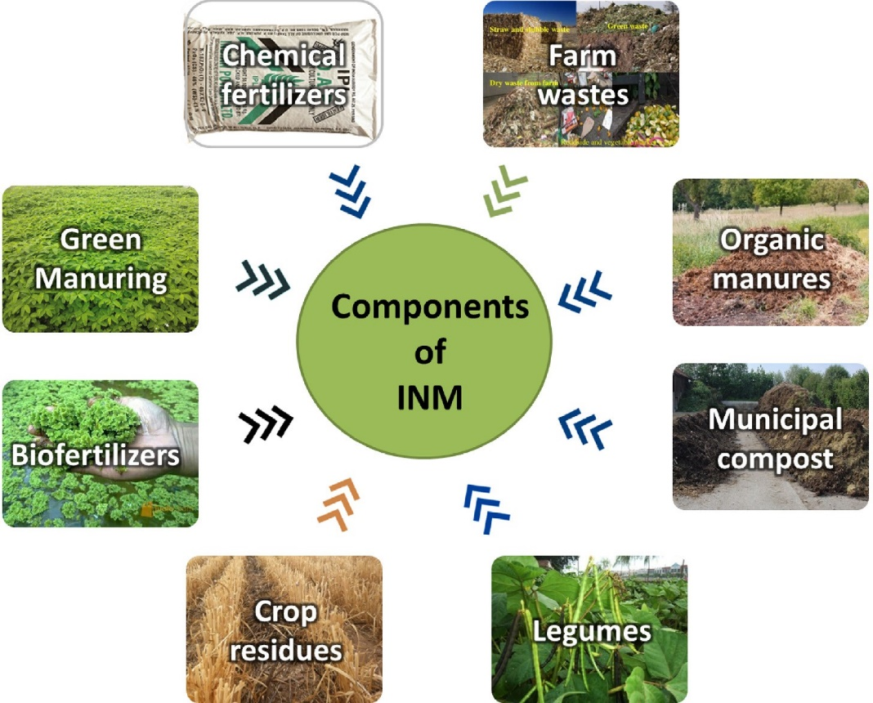

(Source, Chejara et al., 2021)
Fig 2. Components of INM
4. Integrated Nutrient Management's Role in Sustainable Agriculture
Integrated Nutrient Management (INM) plays a central role in fostering the long-term sustainability of agricultural systems. INM's multi-faceted advantages lead to ecological stability, economic profitability, and social well-being (Gruhn et al., 2000). The major roles of INM in sustainable agriculture are given below:
4.1 Improvement of Soil Health
Probably the most important impact of INM is the improvement in soil health. The addition of organic manures, compost, and biofertilizers enhances soil organic matter content, thereby improving soil structure, porosity, and water-holding capacity (Jat et al., 2015). These operations provide a healthy population of beneficial soil microorganisms that are vital for nutrient cycling and disease suppression. INM creates a strong and fertile system of soil over time that can support sustainable crop production (Meelu 1996).
4.2 Yield and Productivity
INM, by promoting a balanced and efficient supply of nutrients, promotes sustained crop yields and enhances the quality of farm produce. The integrated method ensures continuous release of the nutrients during the growing stages of the crop, thereby minimising the effects of nutrient stress. This not only increases productivity but also maintains consistency in production year after year, thus enhancing food security (Chejara et al., 2021).
4.3 Environmental Protection
INM plays an important role in minimising the environmental impact of agriculture. The judicious application of chemical fertilisers in conjunction with organic and biological inputs minimises the loss of nutrients through runoff, leaching, and volatilisation, which leads to water pollution and greenhouse gas emissions (Dordas 2008). Through recycling of organic waste and minimising the use of synthetic fertilisers, INM also helps to mitigate climate change and promote biodiversity conservation (Chao and Bo, 2006).
4.4 Economic Viability
INM increases the economic viability of agricultural systems by lowering input costs related to chemical fertilisers and benefit-cost ratios. Nutrient management becomes cheaper through the utilisation of readily available local organic resources and biofertilizers, particularly for smallholder farmers (Sommer et al., 2013). Improved soil condition and stable yield also play a role in improved profitability in the long term.
5. Key advantages of Integrated Nutrient Management (INM)
5.1. Improved Soil Fertility and Health
Integrated Nutrient Management significantly enhances soil fertility and health by improving soil structure, increasing organic matter content, and stimulating microbial activity. The use of organic manures, compost, green manures, biofertilizers, and judicious amounts of chemical fertilisers ensures better nutrient cycling and biological balance in the soil (Wu and Ma, 2015).
5.2. Balanced and Efficient Nutrient Supply
INM ensures a balanced and timely supply of both macro and micronutrients to crops. This integrated approach minimises nutrient deficiencies, promotes efficient nutrient uptake, and enhances overall nutrient-use efficiency, leading to better crop performance and health (Salim, 2020).
5.3. Sustainable Crop Productivity
By maintaining the physical, chemical, and biological integrity of the soil, INM supports long-term agricultural sustainability. It helps in achieving stable and sustained crop yields over time without compromising environmental quality or future productivity potential (Chejara, 2021).
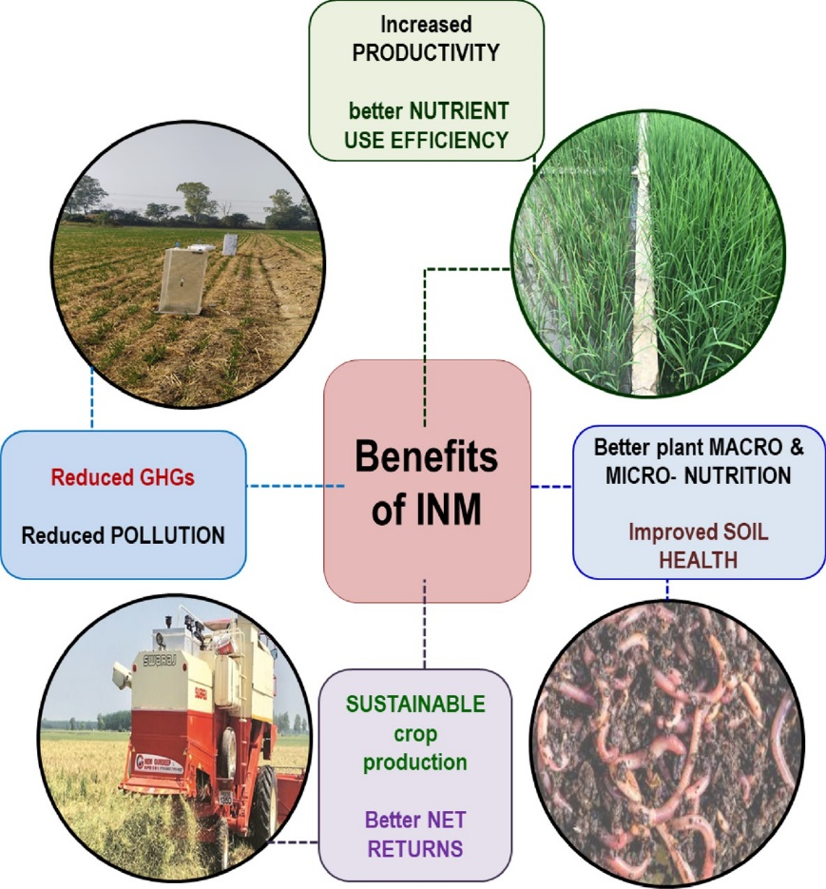

Fig 3. Benefits of INM

5.4. Reduced Environmental Pollution
The adoption of INM minimises the excessive use of synthetic fertilisers, thereby reducing the risk of nitrate leaching into groundwater, soil acidification, and eutrophication of water bodies. This contributes to a cleaner and more environmentally friendly agricultural system (Maharaj and Gupta, 2009).
5.5. Cost-Effective and Resource-Conserving
INM is a cost-effective strategy as it reduces dependency on expensive chemical fertilisers by promoting the use of locally available organic inputs. This not only lowers the cost of cultivation for farmers but also encourages the sustainable utilisation of on-farm resources (Paramesh et al., 2023).
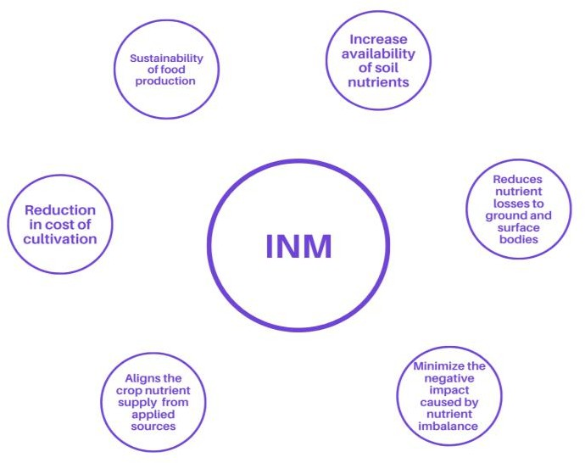

(Source, Saini et al., 2025)
Fig 4. Cost-Effective and Resource-Conserving Integrated Nutrient Management
6. Challenges of Adoption of Integrated Nutrient Management
Although its benefits are well established, the adoption of Integrated Nutrient Management (INM) across the board is beset by numerous challenges in the case of developing agricultural economies. These challenges are manifold, including awareness, input supply, policy infrastructures, and agro-climatic variability. The major hurdles are listed below:
6.1 Lack of Awareness and Extension Services
The key constraint for INM adoption is the lack of awareness among farmers regarding its concepts, practices, and long-term gains. Most farmers are still depending greatly on chemical fertilisers because they lack information on other nutrient sources and their efficient application. Additionally, the lack of extension services and access to expert advice impedes the propagation of information on INM. Improving agricultural extension networks and conducting regular capacity-building exercises, field demonstrations, and farmer training camps are critical to fill this knowledge gap.
6.2 Lack of Organic Input Supply
The access and supply of good-quality organic inputs, including compost, farmyard manure, green manure seeds, and biofertilizers, continue to be low in most rural and remote areas. Farmers are usually short of these inputs in adequate quantities and with assured quality standards. Moreover, the absence of composting and vermicomposting infrastructure further limits the local availability and utilisation of organic manure.
6.3 Policy and Institutional Gaps
The disincentivising governmental support and subsidy imbalance between chemical fertilisers and organic or biological inputs dissuades their adoption under INM. While chemical fertilisers are usually highly subsidised, comparatively lesser institutional support or financial motivation exists for the application of organic manures, biofertilizers, and environmentally friendly methods. Lack of consistent policy support, quality control, and certification mechanisms for organic inputs also discourages their comprehensive adoption.
6.4 Soil and Climatic Variability
India's huge and multifaceted agro-ecological zones pose a big challenge to standardising INM practices. Soil type, cropping systems, rainfall regimes, and climatic conditions differ greatly, and it is challenging to apply a blanket nutrient management practice. This calls for location-specific INM models, which demand site-specific data, tailored advice, and regular monitoring efforts that prove to be resource-intensive and time-consuming.
Table 2: Challenges in Adoption of Integrated Nutrient Management (INM)
S. No. | Challenge | Description
1 | Lack of Awareness and Extension Services | Farmers often lack awareness of INM practices and their long-term benefits. Limited extension services and technical support hinder the dissemination of knowledge.
2 | Lack of Organic Input Supply | Availability of quality compost, green manure, and biofertilizers is inadequate, especially in remote areas. Infrastructure for composting is also underdeveloped.
3 | Policy and Institutional Gaps | Imbalanced subsidies favour chemical fertilisers, while organic and biological inputs receive limited policy and financial support. Certification and quality control are also lacking.
4 | Soil and Climatic Variability | Diverse agro-ecological zones make it difficult to standardise INM practices. Site-specific solutions require intensive data and monitoring, making implementation complex.

7. Policy Support and Government Programs
Understanding the significance of sustainable nutrient management, the Government of India has initiated a number of policy initiatives and programs for encouraging the implementation of Integrated Nutrient Management (INM). These efforts intend to enhance soil health, support organic and balanced fertilisation, and increase farm sustainability. The major government initiatives are described below:
7.1 Soil Health Management (SHM) under the National Mission for Sustainable Agriculture (NMSA)
The Soil Health Management (SHM) component under the National Mission for Sustainable Agriculture (NMSA) aims at encouraging integrated nutrient management practices for soil fertility. It encompasses activities like soil testing, nutrient mapping, and the distribution of Soil Health Cards, which give specific fertiliser advice to farmers. Encouraging informed choice in nutrient application, this program encourages proper use of fertilisers and enhances productivity without compromising the quality of the soil.
7.2 Paramparagat Krishi Vikas Yojana (PKVY)
Paramparagat Krishi Vikas Yojana (PKVY) is a government flagship scheme introduced by the Government of India with the aim of encouraging organic farming practices in clusters throughout India. It promotes the adoption of organic manures, compost, green manuring, and biofertilizers in lieu of chemical inputs. PKVY, through training, certification, and financial support, seeks to make agriculture more sustainable, thus indirectly consolidating the principles of INM.
7.3 Fertiliser Subsidy Reforms
In order to promote the utilisation of alternative sources of nutrients and minimise over-reliance on chemical fertilisers, the government is implementing fertiliser subsidy reforms. The reforms will rationalise subsidies, encourage usage of biofertilizers, city compost, nano-fertilisers, and tailor-made fertilisers, and provide a timely supply of quality inputs. Attempts are also being made to move from product-based to nutrient-based subsidy systems, thus encouraging balanced fertilisation.
7.4 Integrated Farming Systems (IFS) Promotion
Promotion of Integrated Farming Systems (IFS) is yet another policy strategy that complements INM by focusing on nutrient recycling through the ecosystem of the farm. Through the combination of crops, livestock, fisheries, agroforestry, and horticulture, IFS contributes to the efficient recycling of organic wastes and nutrient flows with minimal recourse to external inputs. Government programs promoting IFS are intended to increase farm income, promote resource-use efficiency, and enhance ecological resilience.
8. Future Directions and Recommendations
To achieve the full potential of Integrated Nutrient Management (INM) for sustainable agriculture, it is crucial to follow a visionary and holistic approach. The following future directions and recommendations are suggested to enhance INM practices and facilitate their widespread adoption:
8.1 Enhancing Research on Microbial Consortia and Nano-Nutrients
There is an urgent need to accelerate research on microbial consortia, including synergistic products of helpful microbes like nitrogen-fixers, phosphate-solubilisers, and mycorrhizal fungi. Research on nano-nutrients and nano-fertilisers is also imperative because the above technologies provide increased nutrient-use efficiency as well as lower environmental effects. Crop-specific and region-specific microbial solutions will improve the performance and consistency of biological sources of nutrients.
8.2 Capacity Building and Training for Farmers and Extension Workers
Successful adoption of INM involves continuous training and sensitisation programs for farmers and agricultural extension staff. Capacity building exercises should emphasise practical demonstrations, farm trials, and participatory learning approaches. Extension officers need to be knowledgeable about current nutrient management tools, decision-support systems, and sustainable methods in order to advise farmers effectively.
8.3 Strong Supply Chains for Organic and Biological Inputs
For ensuring prompt and cost-effective availability of organic manures, compost, green manure seeds, and biofertilizers, efficient and decentralised supply chains need to be developed. These involve encouraging local production units, quality control systems, and distribution channels, especially in distant and resource-constrained areas. Public and private sector investments in supply infrastructure will be essential for scaling up INM inputs.
8.4 Promoting Public-Private Partnerships (PPP) for Scaling Up INM Technologies
Public-private partnerships (PPP) have the potential to accelerate the scale-up of INM technology adoption through innovation, enhanced coordination of access to resources, and provision of training and advisory services. Partnerships among government departments, research centres, agri-tech firms, and farmer associations can result in the creation, testing, and transfer of site-specific INM packages.
8.5 Synthesis of Climate-Smart Agriculture Strategies with INM Practices
INM must be closely integrated with climate-smart agriculture (CSA) strategies to promote resilience against climate variability and minimise the environmental impact of agriculture. INM must be integrated with practices such as resource-conserving technologies, conservation tillage, and integrated water management to establish a holistic and responsive framework for sustainable agriculture. Integrating INM with these practices will also aid national and international climate objectives by curbing emissions and enhancing carbon sequestration.
Table 3: Future Directions and Recommendations for INM
S. No. | Recommendation | Description
1 | Enhancing Research on Microbial Consortia and Nano-Nutrients | Invest in research on microbial blends (e.g., nitrogen-fixers, phosphate-solubilisers, mycorrhiza) and nano-fertilisers to boost nutrient-use efficiency and environmental safety.
2 | Capacity Building and Training for Farmers and Extension Workers | Conduct regular training, field demonstrations, and participatory learning to educate both farmers and extension personnel on INM practices.
3 | Strong Supply Chains for Organic and Biological Inputs | Develop decentralised production and distribution networks for compost, biofertilizers, and green manure seeds, with public-private investment and quality control.
4 | Promoting Public-Private Partnerships (PPP) | Leverage PPPs to scale up INM adoption through coordinated access to resources, training, technology development, and extension services.
5 | Synthesis of Climate-Smart Agriculture with INM | Integrate INM with climate-resilient practices like conservation tillage, resource-efficient irrigation, and integrated water management to support sustainable and climate-smart agriculture.

9. Conclusion
Integrated Nutrient Management (INM) is a foundational approach in the quest for sustainable agriculture. Through the encouragement of the sustainable and equitable use of organic, inorganic, and biologic plant nutrient sources, INM not only increases agricultural productivity but also ensures long-term soil health and environmental stability. Significant progress has been made at the research, technological, and policy levels regarding INM over the past decades.
Nonetheless, the successful adoption of INM at the grassroots level still remains beset by numerous challenges, such as low awareness, poor supply chains for organic inputs, and the absence of enabling policies. Sustaining an agenda to address these issues needs to be a coordinated and multi-stakeholder effort, including research institutions, government, private sector actors, extension agencies, and farmers.
Mainstreaming INM practice will require reinforcing research and innovation, capitalising on capacity building, enhancing public-private partnerships, and incorporating climate-smart agriculture principles. Through this, INM can be a transformative strategy fostering enhanced food security, environmental conservation, economic farm resilience, and the general objective of rural development. Widespread adoption has the potential to bring about a more harmonious and environmentally friendly agricultural model for future and current generations.

Disclaimer (Artificial intelligence)
Option 1:
Author(s) hereby declare that NO generative AI technologies such as Large Language Models (ChatGPT, COPILOT, etc.) and text-to-image generators have been used during the writing or editing of this manuscript.
Option 2:
Author(s) hereby declare that generative AI technologies such as Large Language Models, etc. have been used during the writing or editing of manuscripts. This explanation will include the name, version, model, and source of the generative AI technology and as well as all input prompts provided to the generative AI technology
Details of the AI usage are given below:
1.
2.
3.

Reference
Agrahari, R. K., Kobayashi, Y., Tanaka, T. S. T., Panda, S. K., & Koyama, H. (2021). Smart fertilizer management: the progress of imaging technologies and possible implementation of plant biomarkers in agriculture. Soil Science and Plant Nutrition, 67(3), 248-258.
Ali, A. M. (2020). Advances in integrated plant nutrient management. In Achieving sustainable crop nutrition (pp. 515-554). Burleigh Dodds Science Publishing.
Antil, R. S., & Raj, D. (2019). Integrated nutrient management for sustainable crop production and improving soil health. In Nutrient dynamics for sustainable crop production (pp. 67-101). Singapore: Springer Singapore.
Bhattacharyya, P., Pathak, H., Pal, S., Bhattacharyya, P., Pathak, H., & Pal, S. (2020). Crop management for climate-smart agriculture. Climate smart agriculture: Concepts, challenges, and opportunities, 85-111.
Cambra Baseca, C., Sendra, S., Lloret, J., & Tomas, J. (2019). A smart decision system for digital farming. Agronomy, 9(5), 216.
Chao, G. A. O., & Bo, S. U. N. (2006). Sustainable nutrient management in Chinese agriculture: challenges and perspective. Pedosphere, 16(2), 253-263.
Chejara, S., Malik, K., Rani, M., & Bhardwaj, A. K. (2021). Integrated nutrient management: Concept, constraints, and advantages for a sustainable agriculture. Journal of Natural Resource Conservation and Management, 2(2), 85-94.
Dordas, C. (2008). Role of nutrients in controlling plant diseases in sustainable agriculture. A review. Agronomy for sustainable development, 28, 33-46.
Gruhn, P., Goletti, F., & Yudelman, M. (2000). Integrated nutrient management, soil fertility, and sustainable agriculture: current issues and future challenges. Intl Food Policy Res Inst.
Hajam, Y. A., Kumar, R., & Kumar, A. (2023). Environmental waste management strategies and vermi transformation for sustainable development. Environmental Challenges, 13, 100747.
Jat, L. K., Singh, Y. V., Meena, S. K., Meena, S. K., Parihar, M., Jatav, H. S., ... & Meena, V. S. (2015). Does integrated nutrient management enhance agricultural productivity. J Pure Appl Microbiol, 9(2), 1211-1221.
Karthik, A., & Maheswari, M. U. (2021). Smart fertilizer strategy for better crop production. Agricultural Reviews, 42(1), 12-21.
Kumar, A., Meena, S. K., Singh, S. K., & Sinha, S. K. (2025). Revolutionizing Agriculture through Advances in Biofertilizer Formulations and Innovative Application Systems. New Era Agriculture Magazine, 156-158.
Kumar, S., Samiksha, & Sukul, P. (2020). Green manuring and its role in soil health management. Soil health, 219-241.
Lal, R. (2012). Climate change and soil degradation mitigation by sustainable management of soils and other natural resources. Agricultural Research, 1, 199-212.
M. Tahat, M., M. Alananbeh, K., A. Othman, Y., & I. Leskovar, D. (2020). Soil health and sustainable agriculture. Sustainability, 12(12), 4859.
Mahajan, A., & Gupta, R. D. (Eds.). (2009). Integrated nutrient management (INM) in a sustainable rice—wheat cropping system. Dordrecht: Springer Netherlands.
Meelu, O. P. (1996). Integrated nutrient management for ecologically sustainable agriculture. Journal of the Indian Society of Soil Science, 44(4), 582-592.
Meybeck, A., Laval, E., Lévesque, R., & Parent, G. (2017, September). Food security and nutrition in the age of climate change. In Proceedings of the International Symposium organized by the Government of Québec in collaboration with FAO. Québec City (p. 132).
Mitter, E. K., Tosi, M., Obregón, D., Dunfield, K. E., & Germida, J. J. (2021). Rethinking crop nutrition in times of modern microbiology: innovative biofertilizer technologies. Frontiers in Sustainable Food Systems, 5, 606815.
Oberč, B. P., & Arroyo Schnell, A. (2020). Approaches to sustainable agriculture. Exploring the pathways, 486.
Panta, S., & Parajulee, D. (2021). Integrated Nutrient Management (INM) in soil and sustainable agriculture. International Journal of Applied Sciences and Biotechnology, 9(3), 160-165.
Paramesh, V., Mohan Kumar, R., Rajanna, G. A., Gowda, S., Nath, A. J., Madival, Y., ... & Toraskar, S. (2023). Integrated nutrient management for improving crop yields, soil properties, and reducing greenhouse gas emissions. Frontiers in Sustainable Food Systems, 7, 1173258.
Prabhakar, A. C., & Brar, G. P. (2024). Green Revolution, Agricultural Performance with Sustainability and Bio-diversity: Special Reference to India. International Journal of Economic Performance, 7(1), 281-318.
Reda, A., & Hailu, A. H. (2017). Extensive utilization of inorganic fertilizers in ethiopian agriculture and its possible consequences on soil quality. Journal of Integrative Agricultural Science, 13(4), 155-171.
Riaz, N. F., Jabbar, N., Ahmed, M., & Virk, I. M. (2025). Bio medical Innovations in sustainable Agriculture: Harnessing Biofertilizer, Biostimulants, and Microbial Interactions for Enhanced Crop Productivity: A Public Health Perspective. Open Access Public Health and Health Administration Review, 3(2), 165-181.
Roba, T. B. (2018). Review on: The effect of mixing organic and inorganic fertilizer on productivity and soil fertility. Open Access Library Journal, 5(06), 1.
Saini, N., Yadav, H. S., Saini, S., Sharma, A., & Saini, N. (2025). Advances in Integrated Nutrient Management Practices for Cereal Crops: A Comprehensive Review. International Journal of Plant & Soil Science, 37(1), 375-383.
Samanta, S., & Sengupta, S. (2024). Integrated nutrient management (INM) in sustainable plant nutrition. International Journal of Agriculture and Food Science; 6(2): 128-130
Sarma, H. H., Das, B. C., Deka, T., Rahman, S., Medhi, M., & Kakoti, M. (2024). Data-driven agriculture: Software innovations for enhanced soil health, crop nutrients, disease detection, weather forecasting, and fertilizer optimization in agriculture. Journal of Advances in Biology and Biotechnology, 27(8), 878-896.
Sarvade, S., Agrawal, S. B., Bajpai, R., Thakur, R. K., & Shrivastava, A. (2025). Integrated Nutrient Management Practices in Agroforestry.
Selim, M. M. (2020). Introduction to the integrated nutrient management strategies and their contribution to yield and soil properties. International Journal of Agronomy, 2020(1), 2821678.
Sharma, K. (2025). Eco-Friendly Approaches for Stress Resilience in Cereals: Current Status and Future Prospects. Integrated Land and Water Resource Management for Sustainable Agriculture Volume 1, 215-223.
Sharma, T., Arya, V. M., Sharma, V., Sharma, J., Gulshan, T., Bera, A., & Laskar, Y. A. (2022). Integrated nutrient management: A long-term approach towards sustainability. International Journal of Plant & Soil Science, 34(20), 433-446.
Singh, A., Karmegam, N., Singh, G. S., Bhadauria, T., Chang, S. W., Awasthi, M. K., ... & Ravindran, B. (2020). Earthworms and vermicompost: an eco-friendly approach for repaying nature’s debt. Environmental Geochemistry and Health, 42, 1617-1642.
Singh, N. K., Sachan, K., Bp, M., Panotra, N., & Katiyar, D. (2024). Building soil health and fertility through organic amendments and practices: a review. Asian Journal of Soil Science and Plant Nutrition, 10(1), 175-197.
Singh, S., Singh, R., Singh, K., Katoch, K., Zaeen, A. A., Birhan, D. A., ... & Sahrma, L. K. (2024). Smart fertilizer technologies: An environmental impact assessment for sustainable agriculture. Smart Agricultural Technology, 100504.
Sommer, R., Bossio, D., Desta, L., Dimes, J., Kihara, J., Koala, S., ... & Winowiecki, L. (2013). Profitable and sustainable nutrient management systems for East and Southern African smallholder farming systems challenges and opportunities: A synthesis of the Eastern and Southern Africa situation in terms of past experiences, present and future opportunities in promoting nutrients use in Africa.
Tamang, A., Ghosh, K., Mallick, J. A., Som, D., Saha, M., & Mitran, T. (2024). Basic Principles of Integrated Nutrient Management.
Urruty, N., Tailliez-Lefebvre, D., & Huyghe, C. (2016). Stability, robustness, vulnerability and resilience of agricultural systems. A review. Agronomy for sustainable development, 36, 1-15.
Verma, B. C., Pramanik, P., & Bhaduri, D. (2019). Organic fertilizers for sustainable soil and environmental management. In Nutrient dynamics for sustainable crop production (pp. 289-313). Singapore: Springer Singapore.
Wu, W., & Ma, B. (2015). Integrated nutrient management (INM) for sustaining crop productivity and reducing environmental impact: A review. Science of the Total Environment, 512, 415-427.
Yadav, A. C., Shekhar, S., Singh, C., Kumar, M., Singh, R. K., & Singh, V. (2025). Advances in integrated nutrient management for sustainable crop production. International Journal of Research in Agronomy, 8(5), 173–175.
Kumar, S., Agrawal, S., Jilani, N., Kole, P., Kaur, G., Mishra, A., & Tiwari, H. (2023). Effect of integrated nutrient management practices on growth and productivity of rice: A review. The Pharma Innovation Journal, 12(5), 2648-2662.
Yadav, H. C., Singh, A., Srivastava, A. K., Singh, B. K., Vikram, B., Rai, A., Bakash, H., & Prajapati, P. (2024). Impact of Integrated Nutrient Management (INM) on Growth Attributes of Strawberry (Fragaria × ananassa Duch.) cv. Winter Dawn. Journal of Advances in Biology & Biotechnology, 27(7), 1297–1306.

