Cervicothoracic Cellulitis Complicated by Descending Mediastinitis in a Diabetic Patient: Multidisciplinary Management and Reconstructive Surgery Using a Pedicled Pectoralis Major Muscle Flap: A Case Report from the Military Hospital Mohammed V of Rabat

Abstract
Introduction:
Cervical cellulitis or necrotizing cervical fasciitis are soft tissue infections that develop from dental or pharyngeal sites and, if not recognized early, can spread to the mediastinum. The initial clinical signs are sometimes vague and can lead to a delay in diagnosis. The key examination is cervical and thoracic computed tomography. Treatment consists of extensive and repeated tissue excisions combined with antibiotic therapy targeting aerobic and anaerobic bacteria.
We report the case of a patient with known diabetes presenting with cervico-thoracic cellulitis of cutaneous origin complicated by descending mediastinitis. highlighting the importance of early diagnosis, surgical treatment, and reconstructive surgery.
Aims:
We aimed to report a rare case of cervicothoracic cellulitis complicated by descending mediastinitis in a diabetic patient.
Presentation of Case:
We report here an observation of cervicothoracic cellulitis complicated by mediastinitis in a 66-year-old man who presented with anterior cervicothoracic swelling accompanied by oozing skin ulceration with pus discharge in the context of fever and general asthenia. Blood tests revealed an inflammatory and infectious syndrome and ketoacidosis. A cervical-thoracic CT scan confirmed the diagnosis of cervicothoracic cellulitis complicated by descending mediastinitis. An emergency cervicotomy with extensive debridement and drainage was performed. Bacteriological testing identified multisensitive Staphylococcus aureus, which led to targeted antibiotic treatment. Due to significant tissue loss, reconstructive surgery was performed. The postoperative course was that of a full recovery.
Conclusion:
Cervicothoracic cellulitis is a serious condition requiring urgent treatment and multidisciplinary medical and surgical care. CT imaging guides surgical planning, while surgical debridement of necrotic tissue, targeted antibiotics, and reconstruction techniques are essential for achieving favorable outcomes.
Keywords: Cervicothoracic cellulitis; Descending necrotizing mediastinitis; Deep neck infection; Surgical drainage; Diabetes mellitus; Computed tomography

Introduction
Cervical cellulitis, also known as necrotizing cervical fasciitis, is a severe infection of the soft tissues with a risk of rapid extension to the mediastinum if not recognized early. Descending necrotizing mediastinitis represents the most feared complication, often associated with significant morbidity and mortality‎ [1]. We report the case of a diabetic patient who developed cervicothoracic cellulitis of cutaneous origin complicated by mediastinitis, successfully managed through multidisciplinary care.

Case Presentation
A 66-year-old male with a medical history of non-insulin-dependent diabetes mellitus for 8 years presented to the emergency department with fever, asthenia, and an anterior cervicothoracic mass. Clinical examination revealed erythematous induration extending from the cervical to thoracic region, with a cutaneous ulceration discharging pus and an associated scratch lesion in the submental area.
Laboratory evaluation demonstrated leukocytosis (27,300/µl), elevated C-reactive protein (479 mg/L), and diabetic ketoacidosis.
Imaging: Cervicothoracic CT scan showed diffuse phlegmonous infiltration of the anterior cervical and thoracic soft tissues, extending through the superior sternal orifice into the retro-manubrial space. Bilateral pleural effusions and passive atelectasis were also noted.
Treatment: Initial, adjuvant, probabilistic antibiotic therapy was administered intravenously as quickly as possible: amoxicillin + clavulanic acid (Augmentin 2 g × 3/day) combined with 5-nitroimidazoles (Flagyl 500 mg × 3/day).
An emergency cervicotomy was then performed, involving a large cervical incision, drainage of the phlegmon, and extensive tissue debridement. Samples were taken for bacterial culture, which revealed the presence of multisensitive Staphylococcus aureus. Initial antibiotic therapy was subsequently adjusted based on the culture results.
The entry wound was treated locally in the submental region with betadine and hydrogen peroxide, followed by antibiotic ointments such as Fucidine.
Due to extensive tissue loss, reconstructive surgery was required. A pedicled pectoralis major muscle flap was performed to cover the exposed musculature, ensuring adequate vascularized coverage and preventing secondary infection.
Outcome: The patient’s condition improved progressively, with resolution of infection and normalization of inflammatory markers. He was discharged following a favorable recovery.

Figure 1 & 2: Front and side view showing cervical-thoracic swelling with diffuse inflammatory plaque and oozing central skin ulceration in our patient upon admission to the emergency room.

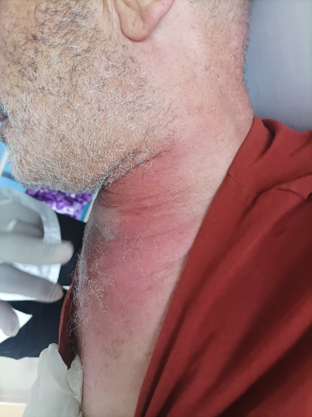
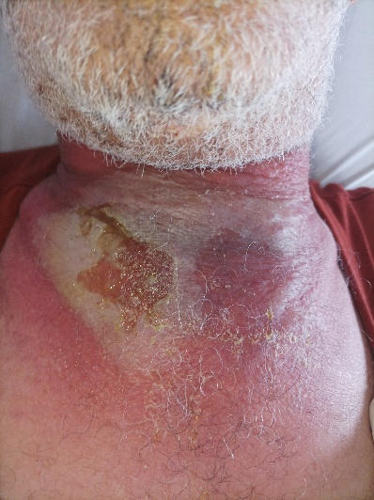

Figure 3 & 4: Intraoperative view of the cervicotomy showing infiltration of the cervical soft and muscles.

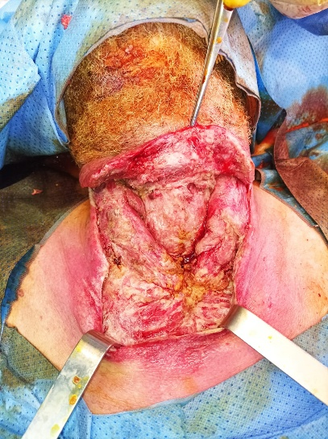
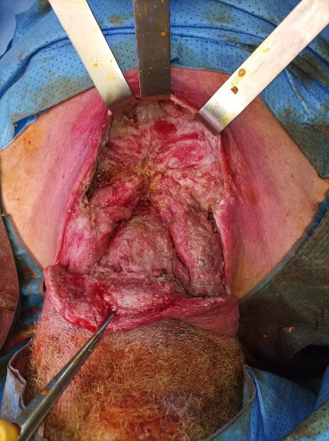
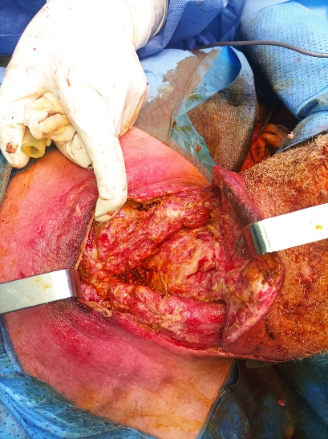

Figure 5 & 6 & 7: Intraoperative view of the pectoralis major muscle flap graft to cover the cervicotomy dehiscence

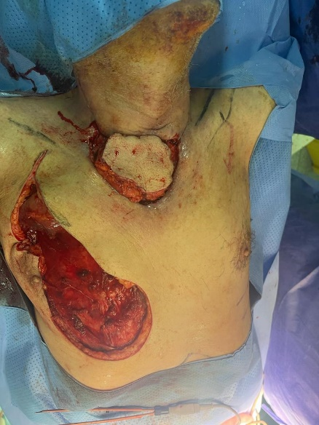
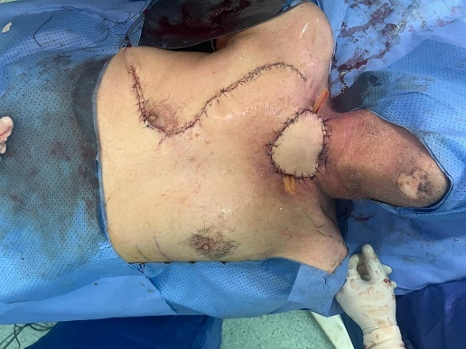
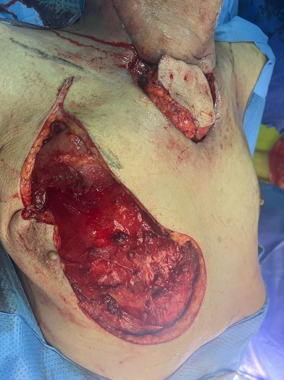

Figure 8 & 9 & 10 :images taken one month after reconstructive surgery showing patient recovery
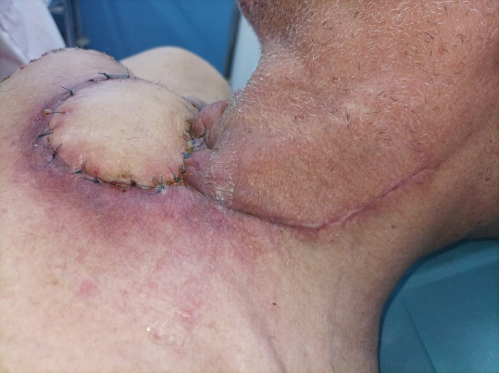
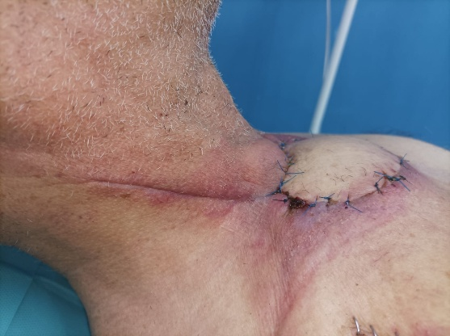
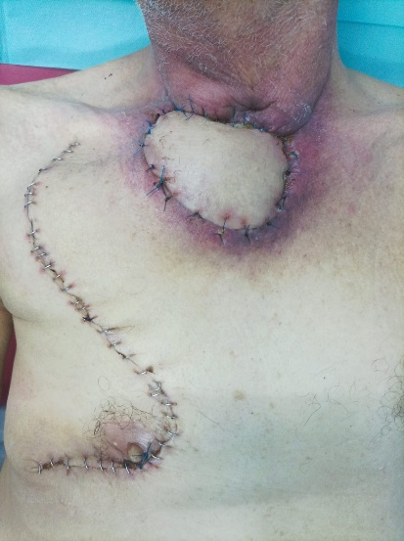

Discussion
The term cervical cellulitis covers a range of anatomical and pathological conditions affecting the dermis, subcutaneous tissue, and deep cervical fascia. The infection spreads very quickly, making urgent treatment essential. Without early and effective surgical treatment, the infection will spread to the mediastinum in more than 20% of cases, leading to descending necrotizing mediastinitis [‎5]. This is a distinct condition that must be differentiated from other types of mediastinitis (post-surgical, hollow organ perforation). The Anglo-Saxon nomenclature has assigned the name descending mediastinitis exclusively to this type of mediastinitis‎ [6].
Immunocompromised states such as diabetes, alcoholism, malignancy, or corticosteroid therapy are recognized risk factors [‎4]. In our case, poorly controlled diabetes with ketoacidosis was a major predisposing factor, compounded by a skin lesion caused by scratching in the submental region, which subsequently became infected and served as a gateway for the infection.
The clinical examination is often poor initially but may reveal erythema or local edema, which is often subtle. The neck then becomes red, tense, and painful. The presence of crepitus indicates gas production. The examination should focus on looking for signs of extension: dysphagia and laryngeal dyspnea, which indicate an impact on the upper airways. The patient's general condition may remain stable for a long time and then deteriorate suddenly.
The biological investigations reveal a non-specific inflammatory syndrome The main part of the localization and extension assessment is performed using contrast-enhanced cervical-thoracic computed tomography, performed as early as possible. The injection is made into the upper left vena cava in order to properly opacify the brachiocephalic trunk. This examination looks for: the point of origin of the infection and signs of soft tissue involvement: tissue infiltration, collections, presence of gas.
The idea of a medical-surgical collaboration is crucial to the treatment of cervical cellulitis. The main causes of many failures are delayed diagnosis, a wait-and-see strategy, even with well-managed antibiotic medication, and delayed and/or inadequate surgery.
The use of antibiotics is merely "adjuvant" in the post-operative treatment plan. It helps to restrict the spread of infection to healthy peripheral areas and its hematogenous dispersion, even though its value is restricted in seriously damaged areas due to the absence of local diffusion of antibiotics. Similar to any severe illness, a loading dosage of antibiotics is given to encourage the passage of free antibiotics into the tissues once transport proteins are saturated. Depending on the antibiotics being used, high doses are then given frequently. The outcomes of pre- and intraoperative cultures are used to modify antibiotic therapy in a subsequent stage. It always includes a minimum of one antibiotic that is effective against both aerobic and anaerobic bacteria. Mixed aerobic-anaerobic flora and polymicrobials account for 60–90% of cervical cellulitis cases. Prevotella X1, a few Staphylococcus aureus or coagulase-negative staphylococci, pyogenic streptococci, and streptococci of the milleri group (anginosus, constellatus, and intermedius) are the most common bacteria identified‎ [2]. The main aim is anaerobes (which are frequently beta-lactam-sensitive) and streptococci, especially group A streptococci. The traditional combination consists of 30 MU/day of penicillin G (or 100 mg/kg of amoxicillin) plus 600 mg of clindamycin four times a day or 10 mg/kg of rifampicin twice a day. The ideal dosage is 2 g/day × 3 of amoxicillin-clavulanic acid and 6–8 mg/kg of high-dose gentamicin administered by injection every day ‎[8].
The site of infection is accessed via a large cervical incision and the mediastinum is drained according to the extent of the infection using Delbet drain inserted via the cervicotomy, sternotomy, or thoracotomy when the collections are deeper. The pitfall to avoid is overly conservative treatment that does not remove all necrotic and infected tissue‎ [8].
In cases of extensive tissue necrosis, reconstructive procedures are often required. The pedicled pectoralis major flap is a reliable option for cervicothoracic reconstruction due to its robust vascularization, proximity, and versatility ‎[3,‎7]. In our patient, its use provided durable coverage, reduced the risk of reinfection, and facilitated functional recovery.

Conclusion
Descending Necrotising Mediastinitis is an uncommon entity with an often-nonspecific clinical presentation. A high index of suspicion when managing patients with deep neck infections should prompt timely investigation in the form of contrast-enhanced CT scanning to identify DNM. Management priorities should include securing the patients airway, initiating broad-spectrum antibiotics to cover aerobic and anaerobic species, and surgical intervention with minimal delay, reconstructive techniques such as pedicled pectoralis muscle flaps is a good alternative for the coverage of cervicotomy dehiscences. Delayed or insufficient treatment can increase mortality and the average length of hospital stay.

Consent
Written informed consent was obtained from the patient for publication of this case report and any accompanying images.

Ethical Approval
This case report did not require formal ethical approval according to institutional policies, as it describes a single clinical case with patient consent obtained.

Authors’ Contributions
- Oumaima Mansoum: Drafted the manuscript, collected clinical data, and contributed to patient follow-up.
- C.Habib El Wely, S. Ouraini: Assisted in surgical management and critically reviewed the manuscript.
- B. Hemmaoui ,F. Benariba, N. Errami: Supervised clinical care and provided final approval of the manuscript.
All authors read and approved the final version of the manuscript.

Competing Interests
The authors declare that they have no competing interests.
Disclaimer (Artificial intelligence)
Author(s) hereby declare that NO generative AI technologies such as Large Language Models
(ChatGPT, COPILOT, etc.) and text-to-image generators have been used during the writing or editing
of this manuscript.

References
- Prado-Calleros HM, Jiménez-Fuentes E, Jiménez-Escobar I. Descending necrotizing mediastinitis: Systematic review on its treatment in the last 6 years, 75 years after its description. Head Neck. 2016 Apr;38 Suppl 1:E2275-83. doi: 10.1002/hed.24183. Epub 2016 Feb 1. PMID: 26829352.
https://pubmed.ncbi.nlm.nih.gov/26829352/
- Brook I. Microbiology and management of deep facial infections and lemierre syndrome. Otolaryngol Head Neck Surg. 2003;128(5):633–8.
https://karger.com/orl/article-abstract/65/2/117/260787
- Hu YC, Xu XS, Ou CS, Chen K, Zhou YS, Li BT, Zhou HY. [Repair of high-voltage electric burn in jaw and neck region with insular pectoralis major myocutaneous flap]. Zhonghua Shao Shang Za Zhi. 2009 Feb;25(1):22-4. Chinese. PMID: 19588756.
https://pubmed.ncbi.nlm.nih.gov/19588756/
- Shevchuk IM, Snizhko SS. [CAUSES AND WAYS OF THE NECK PHLEGMON SPREADING ON MEDIASTINUM WITH A DESCENDING PURULENT MEDIASTINITIS OCCURRENCE]. Klin Khir. 2017;(1):36-8. Ukrainian. PMID: 30272911.
https://pubmed.ncbi.nlm.nih.gov/30272911/
- Li RM, Kiemeney M. Infections of the Neck. Emerg Med Clin North Am. 2019 Feb;37(1):95-107. doi: 10.1016/j.emc.2018.09.003. PMID: 30454783.
https://pubmed.ncbi.nlm.nih.gov/30454783/
- Jarboui S, Jerraya H, Moussi A, Ben Moussa M, Marrakchi M, Kaffel N, Haouet K, Ferjaoui M, Zaouche A. Médiastinite nécrosante descendante odontogénique [Descending necrotizing mediastinitis of odontogenic origin]. Tunis Med. 2009 Nov;87(11):770-5. French. PMID: 20209836.
https://pubmed.ncbi.nlm.nih.gov/20209836/
- Albacete Neto A, Coltro PS, Horácio GS, Almeida IR, Farina Junior JA. Unilateral pectoralis major muscle flap for the treatment of sternal wounds due to Ludwig's angina. Int Wound J. 2018 Feb;15(1):174-177. doi: 10.1111/iwj.12844. Epub 2017 Nov 24. PMID: 29171159; PMCID: PMC7950080.
https://pubmed.ncbi.nlm.nih.gov/29171159/

- Serghini I, Aissaoui Y, Quamouss Y, Sedikki R, Filali K, Zoubir M, Boughanem M. Médiastinite compliquant une cellulite cervicale à porte d'entrée dentaire: à propos d'un cas et revue de la littérature [Mediastinitis complicating cervical cellulitis at the dental gateway: report of a case and review of the literature]. Pan Afr Med J. 2011;8:25. French. Epub 2011 Mar 15. PMID: 22121434; PMCID: PMC3201590.
https://pmc.ncbi.nlm.nih.gov/articles/PMC3201590/

