Hydrogeological Parameters Significantly Affecting the Productivity of Boreholes in the Bedrock Aquifer of the Bounkani Region, Northeastern Côte d'Ivoire

.
ABSTRACT
Drilling involves mechanical surveys carried out directly above aquifers to capture groundwater that will be used to supply drinking water to populations and their activities. It is therefore important to understand the hydrogeological indicators responsible for the productivity of a well drilled into bedrock aquifers. This is the context for the present study, carried out in the Bounkani region (northeastern Côte d'Ivoire). It is in this context that the present study was conducted in the Bounkani region (northeastern Côte d'Ivoire), where hydrogeology has not yet been fully understood. The objective was to statistically determine the hydrogeological parameters responsible for optimizing the productivity of a borehole in order to guarantee a sustainable water supply for the populations of the Bounkani region. To achieve this objective, statistical analyses of the hydrogeological parameters, derived from existing drilling technical data sheets, were performed using Benford's law, the chi-square test, and focused principal component analysis (FPC) to obtain significant correlations between the hydrogeological parameters with a p-value < 0.05. Benford's law combined with the chi-square goodness-of-fit test showed that flow rate and specific flow rate obey Benford's law. However, the static level, alteration thickness, water arrival depth, and total drilling depth contradict this law. In addition, flow rate, specific flow rate, and water inflows are predominant in the first 60 meters of total drilling depth. Water inflows are mainly observed when alteration thicknesses are located within the first 41 meters, which also shows low fluctuation in static levels in boreholes in the Bounkani region. In summary, this study made it possible to determine the threshold values for hydrogeological parameters that must not be exceeded in order to optimize future boreholes in the study area.

Keywords: Hydrogeological parameters, Productivity, Fracture aquifers, Bounkani region, Ivory Coast
1. INTRODUCTION
Surface water was abundant in the Bounkani region. However, the drying up, depletion, and pollution of these waters caused by climate change and human activities have increasingly encouraged the exploitation of groundwater to supply urban and rural areas. In areas with crystalline and crystallophyllian bedrock, groundwater is found in fracture and weathering aquifers (Koudou et al., 2014). However, it is fracture and fissure aquifers that are desirable for supplying drinking water to populations. Fracture aquifers are generally identified either by geophysics (Kouassi et al., 2018 ; Bouadou et al., 2019), remote sensing (Mangoua et al., 2019 ; Coulibaly et al., 2021), or a combination of the two methods (Bouadou, 2022) prior to mechanical drilling. At the end of the drilling process, once the borehole has been delivered, the hydrogeological parameters are finally known. These include the thickness of weathering (EA), the total depth drilled, the depth of water inflows, the flow rate, the static level, and the specific flow rate, etc., which vary greatly from one region to another.
Knowledge of hydrogeological parameters makes it possible to gauge the productivity of boreholes in order to get an idea of the yield of the catchment structure over time. Thus, research by Richard (2015) found that specific flow rate is the most important indicator of productivity. Meanwhile, Coulibaly (2009) used flow rate in the department of Katiola (central-northern Côte d'Ivoire) and Lasm et al. (2014) and Kouadio (2021) presented weathering thickness, total drilled depth, and water inflow depth as parameters of borehole productivity in the Katiola region (central-northern Côte d'Ivoire) and the N'Zi Comoe area, respectively.
However, in 2018, according to a report by the Ivorian Press Agency (AIP), 35% of residents in northern Côte d'Ivoire did not have access to drinking water, despite the existing boreholes. These statistics were confirmed by the work of Bouadou (2022), which indicates that 64% of water collection structures in the Bounkani region have low flow rates, leading to low productivity of boreholes in the study area. Consequently, our objective is to statistically determine the hydrogeological parameter(s) responsible for optimizing the productivity of a borehole in order to guarantee a sustainable supply of drinking water to the population in the long term.
2. Presentation of the study area
The Bounkani region is located in the northeastern part of Côte d'Ivoire between longitudes 2°34'51.6“ and 4°20'02.4” West and latitudes 8°10'55.2“ and 9°59'34.8” North. The terrain is varied, consisting of plateaus and mountains. The plateaus slope in a north-south direction, and the highest point is Mount Bowé (725 m) located in Bouna (Kouadio, 2013). The region has a transitional tropical climate (UNEP-GEF Volta Project, 2008), with average temperatures ranging from 24°C (August) to 28°C (March). February to April are the hottest months (average temperature of 30°C).
The drainage system in the west and center is provided by the tributaries of the Comoé River (Iringou, Bavé, Bouin, and Kongo) and in the east by the tributaries of the Black Volta (Binéda, Kolodio, and Koulda). The hydrogeological context is governed by a composite aquifer consisting of alterite aquifers or shallow aquifers and bedrock aquifers or fissure and fracture aquifers (Bouadou, 2022). Their geological structure is marked by an alternation of lower Proterozoic complexes and Birimian series (Tagini, 1971) (Figure 1).
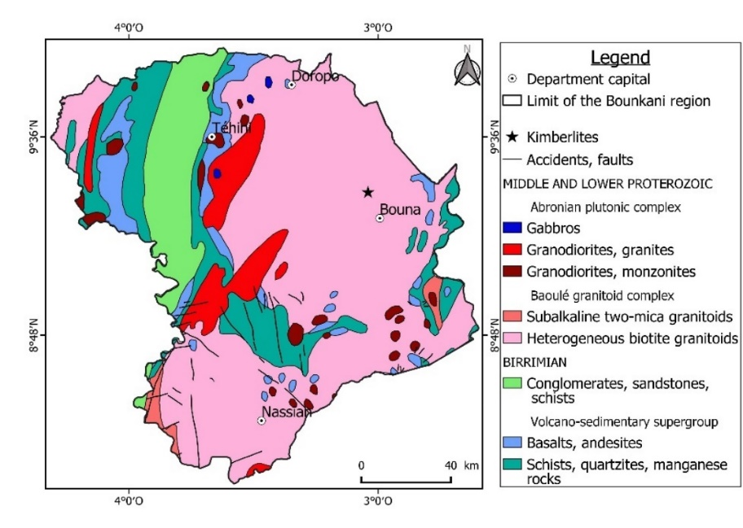
Fig. 1. Geological map of the Bounkani region (Tagini, 1971)
3. STUDY DATA
The drilling data comes from technical data sheets for boreholes drilled following geophysical studies for the Côte d'Ivoire village water supply project (HVCI/UEMOA) carried out between 2013 and 2015 in the Bounkani region. This data concerns drilling rates, total depth drilled (Pt), weathering thickness (EA), static levels (NS), water inflows (AE), and specific flow rates. A total of 116 boreholes installed in the study area enabled this study to be carried out (Figure 2).
Fig. 2. Spatial distribution of boreholes in the study area
4. Methodology
4.1 Benford's law
To gain a better understanding of hydrogeological parameters in the Baya watershed (east, Côte d'Ivoire region), Mangoua et al. (2019) conducted a critical test on the parameters of boreholes in bedrock using Benford's law. This law highlights irregularities in borehole data. The probabilities of the first digits appearing were determined by the following expression:
$$P\left(N=n\right)=\log_{10}(1+\frac{1}{n})$$
Indeed, Benford's law is a logarithmic function explaining the probability of appearance of the first digits (1 to 9) in certain statistical series. Applying equation (1) for a first digit n = 1, approximately 0.3010 or 30% for a studied drilling parameter whose values start with “1” while the probability of occurrence of the first digit n = 9 drops to 0.0458 or 4.58% for a studied drilling parameter whose values start with “9”.
In practice, curves for each parameter studied were plotted and compared to the model curve for the occurrence of the first digits in Benford's law. This law was applied to specific flow (Qs), flow (Q), drilled depth (Pt), static level (NS), water arrival depths (AE), and weathering thickness (EA).
4.2 Benford's law compliance test: Chi-square test (χ2)
The Chi-square test was used to verify whether the hydrogeological parameters of the boreholes follow Benford's law (null hypothesis H0) or not. It is based on the distribution of observations into classes and then on the comparison of the observed numbers per class with the theoretical numbers (Bonache et al., 2013). It is valid if the data studied are independent. The Chi-square test (χ²) is a statistical test designed to determine whether the difference between two frequency distributions is attributable to sampling error (chance) or is large enough to be statistically significant. To do this, the Chi-square test (χ²) is determined according to the following expression:
$$χ^{2}=\sum{(\frac{{Ef}_{{Obs}_{i}}-{Ef}_{{th}_{i}}}{{Ef}_{{th}_{i}}})^{2}}$$
With, ${Ef}_{{Obs}_{i}}$: observed frequency for the first digit i; ${Ef}_{{th}_{i}}$: theoretical frequency for the first digit i according to Benford's law.
Next, the calculated Chi-square ($χ^{2}$) is compared to the threshold Chi-square ($χ_{Seuil}^{2}$) with 8 degrees of freedom for a probability of error of 0.05, or 5%. Based on this comparison, we can deduce that:
- $χ^{2}<χ_{Seuil}^{2}$, the H0 hypothesis is accepted (the parameter follows Benford's law): the distribution of the theoretical and observed counts is not significantly different;
- $χ^{2}>χ_{Seuil}^{2}$, the H0 hypothesis is rejected at the significance threshold with a 5% risk of error (the parameter does not follow Benford's law): the distribution of the theoretical and observed numbers is significantly different.
4.3 Focused principal component analysis (FPCA)
Focused principal component analysis (FPCA) is an exploratory post-hoc analysis method used to search for relationships between a group of variables based on a given characteristic of the sample (Canuto et al., 2010). This analysis has therefore made it possible to identify significant relationships between the various hydrogeological parameters in order to provide information on the productivity and profitability of boreholes. The hydrogeological parameters to be analyzed are specific flow rate (Qs), well yield (Q), drilled depth (Pt), alteration thickness (EA), static levels (NS), and water arrival depths (AE).
It should be noted that the Focused Principal Component Analysis (FPC) was performed with the R software using the psy package (Falissard, 2012).
However, the results of the Focused Principal Component Analysis (FPC) made it possible to carry out relational studies between the hydrogeological parameters that were significantly correlated with the dependent hydrogeological parameter with p < 0.05.
5. results and discussion
5.1 Results
5.1.1 Benford's Law and Chi-square test
5.1.1.1 Flow rate
The flow curve has a parabolic shape and is not very consistent with Benford's law (Figure 3). This is because the flow curve and Benford's law emphasize the first digits “1,” “3,” “4,” “6,” and “9.” However, the Benford's law goodness-of-fit test shows that the flow rates obey Benford's law because its chi-square ($χ^{2}=χ_{Obs}^{2}=$14.21) has a value lower than the chi-square threshold ($χ_{Seuil}^{2}=χ_{0.95}^{2}$15.51).

Fig. 3. Comparison of Benford's curve with the flow curve
5.1.1.2 Static level
The static level curve does not correspond to Benford's law because its shape is very contrasting (Figure 4). The first digits “1,” “6,” “6,” and “9” appeared frequently. The probabilities of occurrence are higher than those predicted by Benford's law. The Benford's law goodness-of-fit test shows that its chi-square ($χ^{2}=χ_{Obs}^{2}=$40.91) is greater than the chi-square threshold ($χ_{Seuil}^{2}=χ_{0.95}^{2}=15.51)$, and therefore negative at the 5% acceptance threshold. We can deduce from these results that the static levels reject Benford's law because the H0 hypothesis is rejected.

Fig. 4. Comparison of Benford's curve with that of the static level
5.1.1.3 Alteration thickness
Figure 5 shows the probability curves for alteration thickness values based on the first digit values according to Benford's law. Referring to the ideal Benford curve, we can see that the alteration thickness varies greatly and does not follow Benford's proposed curve. We frequently see the digits “1,” “2,” and “3.” The Benford's law goodness-of-fit test shows that the chi-square ($χ^{2}$=33.32) of the alteration thicknesses is greater than the chi-square threshold ($χ_{Seuil}^{2}=χ_{0.95}^{2}=$15.51), and therefore negative at the 5% acceptance threshold. We can therefore conclude that hypothesis H0 is rejected. Thus, the alteration thicknesses reject Benford's law.

Fig. 5. Comparison of Benford's curve with that of alteration thickness
5.1.1.4 Water arrival depths
The comparison of Benford's curve with that of water inflow depths is similar to that of total drilled depths (Figure 6). The first digits “3,” “4,” and “5” frequently appear because they have higher probabilities of occurrence than those predicted by Benford's law. The Benford's law goodness-of-fit test shows that the chi-square ($χ^{2}=χ_{Obs}^{2}$=173.15) of water arrival depths is greater than the chi-square threshold ($χ_{Seuil}^{2}=χ_{0,95}^{2}$=15.51), and therefore negative at the 5% acceptance threshold. We can therefore conclude that hypothesis H0 is rejected. Thus, water arrival depths reject Benford's law.

Fig. 6. Comparison of Benford's curve with that of water arrival depth
5.1.1.5 Total depth drilled
The curve of drilled depths does not correspond to Benford's law because the pattern of the curve of drilled depths is very contrasting (Figure 7). The first digits “4,” “5,” “6,” “7,” “8,” and “9” appeared frequently. The probabilities of occurrence are higher than those predicted by Benford's law. The Benford's law adequacy test shows that the chi-square ($χ^{2}=χ_{Obs}^{2}=$286.94) of the drilled depths is greater than the chi-square threshold ($χ_{Seuil}^{2}=χ_{0.95}^{2}=15.51)$, and therefore negative at the 5% acceptance threshold. We can therefore conclude that hypothesis H0 is rejected. The drilled depths therefore reject Benford's law.

Fig. 7. Comparison of Benford's curve with that of total depth drilled
5.1.1.6 Specific flow rate
The specific flow curve has a parabolic shape and is not very consistent with Benford's law (Figure 8). The first digits “1,” “2,” “5,” “6,” “8,” and “9” are commonly observed. However, the Benford's law goodness-of-fit test shows that specific flows obey Benford's law because they have a chi-square ($χ^{2}=χ_{Obs}^{2}=$7.28) lower than the chi-square threshold ($χ_{Seuil}^{2}=χ_{0.95}^{2}$15.51).

Fig. 8. Comparison of Benford's curve with that of Specific flow rate
5.1.2 Focused Principal Component Analysis of hydrogeological parameters
The results of the focused principal component analysis (FPCA) indicate that there are certain significant correlations between hydrogeological parameters with a p-value < 0.05 (Figure 9). Flows are positively correlated with specific flows (r = 0.584) and negatively correlated with total drilled depths (r = -0.31). Static levels are weakly and positively influenced by alteration thicknesses (r = 0.224). Alteration thicknesses also show a positive correlation with water inflows (r = 0.357). Total drilled depths also have positive correlations with water inflows (r = 0.40) and negative correlations with specific flows (r = -0.28). The summary of the results of the focused principal component analysis revealed significant relationships between:
- flow rate (Q) and specific flow rate (Qs);
- flow rate (Q) and total drilled depth (Pt);
- total drilled depth (Pt) and specific flow rate (Qs);
- total drilled depth (Pt) and water arrival depth (AE);
- static level (NS) and alteration thickness (EA);
- alteration thickness (EA) and water arrival depth (AE).

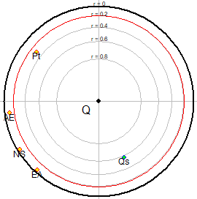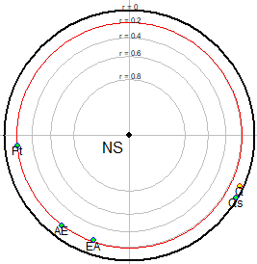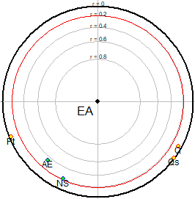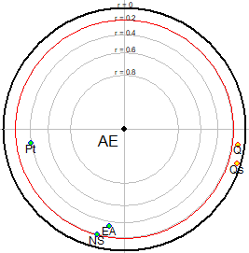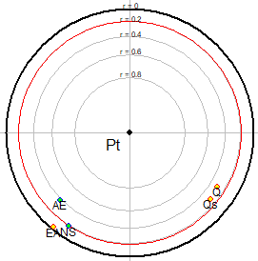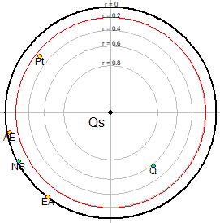
Fig. 9. Focused principal component analysis of hydrogeological parameters (Q = flow rates; AE = water arrival depth; EA = alteration thicknesses; Pt = total drilled depth; NS = static level; Qs = specific flow rate)

5.1.3 Focused Principal Component Analysis of hydrogeological parameters
5.1.3.1 Flow rate (Q) and specific flow rate (Qs)
The specific flow rate and flow rate are represented on a double logarithmic graph (Figure 10). The various points show a straight power-type trend line with slight dispersions. This resulted in a weak correlation between these two parameters with a coefficient of determination of R2 = 0.3302 (r = 0.5746 or r = 57.46%) and a straight line equation expressed as:
$$Q_{s}=0.069×Q^{1.104}$$
The value of the correlation coefficient shows that the specific flow rate and the flow rate are 57.46% similar. The remaining 42.54% represents flow losses when there is a sudden increase in drawdown while the well is in operation.

Fig. 10. Relationship between flow rate and specific flow rate
5.1.3.2 Flow rate (Q) and total drilled depth (Pt)
Figure 11 shows a distribution of flow rate as a function of total drilled depth. A scatter plot around a power regression line was observed, yielding an equation with a negative slope (-0.113). This negativity demonstrates that flow rate decreases gradually with increasing total drilled depth.

Fig. 11. Relationship between flow rate and total drilled depth
5.1.3.3 Total drilled depth (Pt) and specific flow rate (Qs)
To verify the impact of total drilled depths on specific flow rates, a graph showing the cumulative specific flow rates as a function of depth has been created (Figure 12). Specific flow rates increase in the first 60 meters of depth. Beyond this depth, specific flow rates are constant and low. This consistency in cumulative specific flow rates is linked to very low specific flow rate values at depths greater than 60 m (Pt > 60 m).

Fig. 12. Influence of total drilled depth on specific flow rate
5.1.3.4 Total drilled depth (Pt) and water inflow (AE)
The first water inflows increase between 40 and 55 m total drilled depth. After reaching 55 m drilled depth, a drop in water inflow frequency is observed (Figure 13). This shows that drilled depths in the 40 to 60 m range are favorable for good drilling performance.

Fig. 13. Influence of drilled depths on water inflows
5.1.3.5 Alteration thickness (EA) and water arrival depth (AE)
The distribution of water inflows based on weathering thicknesses shows a more or less scattered scatter plot, with no clear trend emerging (Figure 14). However, analysis of Figure 14 reveals the presence of low water inflows for alteration thicknesses greater than 41 m. Consequently, alteration thicknesses less than 41 m allowed for the maximum number of water inflows to be observed.

Fig. 14. Distribution of water arrival depth according to alteration thickness
5.1.3.6 Static level (NS) and alteration thickness (EA)
Figure 15 shows the vertical distribution of static levels per meter of Alteration thickness. Alteration thicknesses (EA) vary from 2.8 m to 60 m, with an average of 21.01 m. Static levels per meter of alteration thickness range from 0.024 m/EA to 4.44 m/EA, with an average of 0.62 m/EA. This illustration shows a gradual decrease in static levels per meter of alteration thickness as alteration thicknesses increase. High alteration thicknesses often result in high total drilling depths, which cause the static level to drop because the recorded water inflows are absorbed by one or more bottom holes that change the water level in the borehole.

Fig. 15 Distribution of static level per meter of alteration thickness
The graph showing the cumulative static level per meter of alteration thickness as a function of alteration thickness produced an exponential curve that showed a favorable alteration thickness threshold for a small decrease in the static level (Figure 16). Thus, for a total cumulative value of 68.48 m/mEA, equation (4) gave a threshold of approximately 41 m of alteration thickness at which the static level decreases slightly.
$$EA=3.217×e^{0.0372×\frac{NS}{EA}}$$

Fig. 16. Cumulative percentage of static level per meter of alteration thickness according to alteration thickness
5.2 Discussion
Analysis of the hydrogeological parameters of boreholes in the Bounkani region has made it possible to determine indicators for optimizing the productivity of water collection structures located in fractured aquifers. According to Lasm et al. (2014), in fractured aquifers, in addition to fracture density and orientation, the productivity of boreholes can also be influenced by certain hydrogeological parameters of the water collection structures. The static level, total drilled depth, depth of water inflows, and alteration thicknesses were rejected by Benford's law and its goodness-of-fit test. These results corroborate those of Gauvrit et Delahaye (2009), which show that certain parameters cannot obey Benford's law, even if their data are spread out and regular. In other words, if there is a discrepancy with Benford's law, this does not cast doubt on the authenticity of the data. The static level fluctuates according to the seasons (rainy and dry seasons) and is due to exchanges between the water table and a surrounding watercourse or heavy use of water from the borehole by the population. The thickness of weathering, the depth of water inflows, and the total depth of boreholes are subject to financial constraints and also to poor measurement by the drilling technician. However, knowledge of hydrogeological parameters that may follow Benford's law must be recorded, as indicated in Mangoua et al. (2019). In the case of this study, flow rate and specific flow rate were the hydrogeological parameters that followed this law. As in Coulibaly (2009) and Mangoua (2013), which were conducted in the department of Katiola (central-northern Côte d'Ivoire) and in the Baya watershed (northeastern Côte d'Ivoire), respectively, flow rate and specific flow rate obeyed Benford's law.
Focused principal component analysis revealed significant correlations between hydrogeological parameters. Thus, flow losses beyond total drilled depths greater than 60 m cause a gradual increase in drawdown, leading to specific flow declines. According to Biémi (1992), Gombert (1997), Kouadio (2005) and Kouadio et al. (2010), over-excavation is unnecessary. Furthermore, flow rate and specific flow rate losses can be explained by the fact that at great depths, dry or sterile fractures can be intersected by drilling and absorb the quantities of water observed in the first depths of the drilled bedrock. Losses in flow rates were observed by Baka (2012) during his work in the Oumé region. Finally, for alteration thicknesses with a limit of 41 m, water inflows are observed on a massive scale and fluctuations in static levels are low. In fact, thick alteration layers often result in deep total drilling depths, which cause the static level to drop because the recorded water inflows are absorbed by one or more deep holes that change the water level in the borehole.
6. Conclusion
This study provides indicators that will be used to optimize the productivity of water drilling in the bedrock environment of the Bounkani region. Initially, Benford's law combined with the Chi-square goodness-of-fit test showed that flow rate and specific flow rate obey Benford's law and therefore depend on the natural conditions of the environment. However, the static level, alteration thickness, water arrival depth, and total drilling depth contradict Benford's law. In addition, focused principal component analysis showed that certain hydrogeological parameters are significantly correlated with a p-value < 0.05. These correlations have proven that:
- The loss of flow rate results in low specific flow rate for a gradual increase in drawdown.
- Flow rate, specific flow rate, and water arrival depth are predominant in the first 60 meters of total drilled depth.
- Water arrival depths are mainly observed when alteration thicknesses are less than 41 m, depths at which static levels decrease slightly.
Thus, based on these relationships between hydrogeological parameters, even if the correlations between them are weak or strong, neglecting a parameter can lead to poor drilling performance or even negative drilling after a few years of operation of the catchment structure by the population.

DISCLAIMER (ARTIFICIAL INTELLIGENCE)
Author(s) hereby declare that NO generative AI technologies such as Large Language Models (ChatGPT, COPILOT, etc.) and text-to-image generators have been used during the writing or editing of this manuscript.

References
Baka, D. (2012). Geometry, hydrodynamics, and modeling of fractured reservoirs in the Proterozoic basement of the Oumé region (central-western Côte d'Ivoire). Doctoral thesis, Félix Houphouët Boigny University, Abidjan, Côte d'Ivoire, 283 p.
Biemi, J. (1992). Contribution to the geological, hydrogeological, and remote-sensing study of sub-Sahelian watersheds of the Precambrian basement of West Africa: hydrostructural, hydrodynamic, and isotopic aspects of discontinuous aquifers in furrows and granitic areas of the Marahoué River (Cote d'Ivoire). Doctoral thesis in Natural Sciences, University of Cocody, Abidjan, Côte d'Ivoire, 479 p.
Bonache, A., Maurice, J., & Moris, K. (2013). Reliability of Environmental Provisions and Benford's Law: Application and Implications. Accounting Without Borders. The French Connection, Montreal, Canada, 27 p.
Bouadou, R. A. M. (2022). Coupling Remote Sensing and Electrical Resistivity in the Identification of Water Well Drilling Sites in Fractured Basement Environments in the Bounkani Region (Northeastern Côte d'Ivoire). Doctoral Thesis, Abidjan, Côte d'Ivoire, 253 p.
Bouadou, R. A. M., Kouassi, K. A., Kouassi, F. W., Coulibaly, A., & Gnagne, T. (2019). Use of the Inverse Slope Method for the Characterization of Geometry of Basement Aquifers: Case of the Department of Bouna (Ivory Coast). Journal of Geoscience and Environment Protection, 7, 166-183. https://doi.org/10.4236/gep.2019.76014
Canuto, R., Camey, S., Gigante, D. P., Menezes, A. M. B., & Olinto, M. T. A. (2010). Focused Principal Component Analysis: a graphical method for exploring dietary patterns. Cad. Saúde Pública, Rio de Janeiro, 26 (11), 2149-2156.
Coulibaly, H. S. J. P., Coulibaly, T. J. H., Coulibaly, N., Kouadio, K. C. A., Didi, S. R. M., Diedhiou, A., & Savane, I. (2021). Groundwater exploration using lineament extraction from SRTM DEM and water flows in the Béré region. Egyptian Journal of Remote Sensing and Space Sciences, 24, 391–400
Coulibaly, T. J. H. (2009). Spatial distribution, management, and exploitation of groundwater: The case of the Katiola department, savannah region of Côte d'Ivoire. Doctoral thesis, University of Paris Est, Paris, France, 141 p.
Falissard, B. (2012). psy: Various procedures used in psychometry. R package version 1.1. http://CRAN.R-project.org/package=psy
Gauvrit, N., & Delahaye, J.-P. (2009). General Benford's law. Mathematics and Human Sciences, 186, 5–15.
Gombert, P. (1997). Spatial variability of Sahelian bedrock aquifer productivity in rural hydraulics. Hard Rock Hydrosystems, IAHS Publ., 241, 113-122
Kouadio, A. K. S. (2021). Productivity of water wells using the electrical resistivity method in bedrock environments (N'Zi Comoe area; Ivory Coast). Doctoral thesis, Abidjan, Ivory Coast, 242 p.
Kouadio, K. E. (2005). Prospecting strategy for fissure layers using spatial analysis of productivity potential and optimization of drilling depth. Case of Denguelé (Northwest Ivory Coast). University of Cocody-Abidjan, Ivory Coast. 181p.
Kouadio, K. E., Soro, N., & Savané, I. (2010). Drilling Depth Optimization Strategy in a Basement Context: Application to the Denguélé Region, Northwest Côte d’Ivoire. Revue des Sciences de l’Eau, 23(1), 1-15
Kouadio, N. F. (2013). Drinking Water Supply for the Populations of Gontougo and Bounkani: Current Situation and Prospects. Master’s Degree in Water and Environmental Engineering, 2IE, Ouagadougou, Burkina Faso, 63 pp.
Kouassi, F. W., Coulibaly, A., Kouassi, K. A., & Oteyami, G. D. (2018). Interpretative Approach of Electrical Resistivity Data for Efficient Installation of Drilling on Basement Zones: Case of Guibéroua (Côte d’Ivoire). Environmental and Water Sciences, Public Health & Territorial Intelligence, 2(4), 95-105.
Koudou, A., Assoma, T. V., Adiaffi, B., Youan Ta, M., Kouame, K. F., & Lasm, T. (2014). Statistical and geostatistical analyses of fracturing extracted from ASAR Envisat imagery of southeastern Côte d’Ivoire. Larhyss Journal, 20, 147-166.
Lasm, T., Gnamba, F. M., Oga, Y. M. S., Gnangne, T., Biémi, J., & Kouakou, Y. K. N. (2014). Productivity analysis of Paleoproterozoic basement fissure aquifers in the Katiola region (North-Central Côte d’Ivoire). European Scientific Journal, 10 (5), 79-98.
Mangoua, M. J. (2013). Assessment of the potential and vulnerability of groundwater resources in the fissured aquifers of the Baya watershed (eastern Côte d'Ivoire). Doctoral thesis, Abidjan, Côte d'Ivoire, 199 p.
Mangoua, M. J., Kouassi, K. A., Douagui, G. A., Savané, I., & Biémi, J. (2019). Remote sensing and GIS contribution for groundwater mapping reservoirs in the Baya watershed (eastern region of Côte d'Ivoire). Journal of Geography, Environment and Earth Science International, 23 (3), 1-14.
Mangoua, M. J., Kouassi, K. A., Douagui, G. A., Savané, I., & Biémi J. (2019). 19). Application of Benford's Law to Hydrogeological Parameters: Case of the Baya Watershed (Eastern Côte d'Ivoire). Asian Journal of Geological Research, 2 (3), pp. 1-7.
Richard, S. (2015). Representativeness of Transmissivity Values Estimated from Hydraulic Tests for Fractured Rock Aquifers: Scale Effects and Hydraulic Connections. Doctoral Thesis, University of Quebec at Chicoutimi, Canada, 209 pp.
Tagini, B. (1971). Structural Sketch of Côte d'Ivoire. Regional Geotechnical Essay. Thesis, University of Lausanne (Switzerland), 302 pp.
UNEP-GEF Volta Project (2008). Study on the Establishment of a Regional System for the Exchange of Data and Information Related to the Volta Watershed in Côte d'Ivoire. UNEP/GEF/Volta/NR RCI.2/2008

