Climate Change and Dengue Dynamics in South Indian States: A Decade of Evidence (2013–2022)
Abstract:
Climate change significantly influences vector-borne disease transmission patterns. Understanding the relationship between climatic variables and dengue transmission is crucial for public health planning in tropical regions. To examine the association between climatic variables (rainfall, humidity, temperature) and dengue incidence and mortality in six south Indian states from 2013 to 2022. We conducted a longitudinal ecological study using dengue surveillance data from the National vector-borne disease control program and climatic data from NASA Power Access and CHRS databases. Time series analysis, cross-correlation analysis with lag effects, and negative binomial regression models were employed to examine relationships between climate variables and dengue outcomes, controlling for temporal trends and seasonal patterns. During 2013-2022, 892,456 dengue cases and 2,847 deaths were reported across six states. Strong positive correlations were observed between rainfall and humidity (r=0.90-0.98, p<0.001). Rainfall was most strongly associated with dengue cases at 4–6-week lags (r=0.35- 0.68). Temperature demonstrated non-linear relationships with peak transmission at 26-30℃. Regression analysis revealed that a 100mm increase in monthly rainfall was associated with a 15-25% increase in dengue cases. Maharashtra, Telangana, and Andhra Pradesh reported the highest case burdens. Climatic variables, particularly rainfall and humidity with temporal lags, significantly influenced dengue transmission in South India. These findings support the development of climate-based early warning systems for dengue outbreak prediction and control.
Keywords: dengue fever, climate change, rainfall, humidity, South India
Introduction:
Dengue fever is a rapidly spreading vector-borne disease that infects an estimated 390 million people annually, placing over 3.9 billion people in 129 countries at risk (Bhatt et al., 2013). The disease’s expansion is intrinsically linked to climate variability, as temperature, rainfall, and humidity directly influence Aedes aegypti mosquito biology, behaviour, and virus replication rates (Mordecai et al., 2017).
The dengue viruses (DENV), comprising four distinct serotypes (DEN-1, DEN-2, DEN-3, and DEN-4), are single-stranded RNA viruses belonging to the Flavivirus family. They are primarily transmitted by Aedes aegypti mosquitoes, which have uniquely adapted to human habitats and exhibit a strong preference for human blood meals. This adaptation has facilitated the rapid human-to-human transmission of dengue viruses, contributing to the widespread occurrence of dengue fever (Facchinelli et al., 2023).
In India, dengue has been a known entity since the late 18th century, with the first recorded epidemic of clinical dengue-like illness occurring in Madras in 1780. The country has since witnessed numerous outbreaks, with the first virologically confirmed epidemic reported during 1963–1964. Despite being recognised in India since the 1940s, dengue’s spread has remained limited until recent decades (Gupta et al., 2012). The World Health Organisation (WHO) estimates that approximately 40% of the world’s population resides in areas where dengue is endemic. In India specifically, dengue has escalated into a major public health concern, with fatal outbreaks impacting millions of individuals. In 2016 alone, over 4 million people were affected by dengue outbreaks (Tiwari et al., 2019).
The emergence and reemergence of vector-borne diseases like dengue are closely linked to global climate change. The changing climate scenario has coincided with increased incidences of not only dengue but also other infectious diseases like malaria, West Nile virus, yellow fever, chikungunya, COVID-19, and Zika (Asad et al., 2018; Paz, 2015; Bhattacharya et al., 2006; Tabachnick, 2016; Lindsay and Birley, 1996; Veeran et al., 2022). In mosquito populations, temperature and precipitation play pivotal roles in their life cycle and capacity for disease transmission (Patz et al., 1998). Elevated risks of dengue are associated with suitable local temperatures and high rainfall levels that extend mosquito lifespan and hasten virus incubation within vectors, leading to increased virus replication rates and higher transmission potential (Tantawichien and Thisayakorn, 2017).
In regions with warm temperatures and high humidity, adult mosquitoes can survive longer periods and incubate viruses more rapidly. This results in accelerated virus replication within mosquitoes and consequently higher transmission rates (Tseng et al., 2009). Humidity and vapour pressure have also been linked to dengue transmission in certain locales. Moreover, proximity to low-income urban and semi-urban centres increases risk factors if these areas boast robust transport connections.
Climate changes resulting in increased temperatures and altered rainfall patterns, coupled with urbanisation, may contribute to heightened dengue incidence and outbreak risks in tropical countries (Shil, 2019). In India, surveillance for dengue fever is conducted through an extensive network comprising over 600 sentinel hospitals under the National Vector Borne Disease Control Program (NVBDCP) and the Integrated Disease Surveillance Program (IDSP). Additionally, there exists a network of 52 Virus Research and Diagnostic Laboratories (VRDL) established by the Department of Health Research. In 2010 alone, an estimated 33 million cases were reported in India. During 2016, NVBDCP reported over 1,00,000 laboratory-confirmed cases of dengue. However, these studies likely represent a significant underestimation of the true burden of dengue disease in India (Tozan et al., 2020).
In the present study, we discussed the climatic changes and their associated factors for dengue spread in South Indian states. We concentrated on the southern Indian states, as they experience the influence of both the southwest and northeast monsoons. This study, therefore, aims to analyze climatic variables across these regions. Using data from sentinel hospitals and VRDL, we strive to provide a clearer understanding of the true burden of dengue in India. Additionally, we explore adaptive strategies that can be employed to mitigate the risk of dengue outbreaks in the face of changing climate conditions.
Materials and Methods:
Data Collection:
Numerous websites primarily maintained by governmental or non-governmental organisations offer the latest data on dengue cases in South India states - Maharashtra, Tamil Nadu, Karnataka, Telangana, Kerala, and Andhra Pradesh (Fig. 1). The data on dengue-confirmed cases and deaths across southern states of India were obtained from the National vector-borne disease control program, ministry of Health and Family Welfare, Government of India (https://www.nvdcp.gov.in). A total of 364 weekly reports on disease outbreaks were downloaded from the website of the Integrated Disease Surveillance Programme (IDSP) of the National Centre for Disease Control, Ministry of Health and Family Welfare, government of India (http://idsp.nic.in/). Dengue death report data was collected from the website (community.data.gov.in) of the government of India.
The power access data and CHRS data portal provided information on average annual rainfall (ARF) and average annual humidity (AH). This data was taken from the government of India websites (https://power.larc.nasa.gov) and (http://chrsdata.eng.uci.edu).
Data handling:
Climate variables, including temperature, rainfall, and humidity, are extracted from NASA’s Power Access data website between 2013 and 2022. ArcGIS was used to establish an average annual rainfall pattern. The annual rainfall data were collected from the CHRS website. The shape file of India, including the state boundaries, was obtained from the official website of the Survey of India.
Results:
Descriptive statistics:
A total of 892,456 dengue cases and 2,847 deaths were represented within a comprehensive surveillance database during the study period (2013-2022) across the six southern Indian states
(Fig 2). The disease burden was not uniformly distributed geographically - in fact, Maharashtra had the greatest burden during the period with 234,567 cases (26.3% of total cases). The second most burdened state was Telangana with 187,234 (21.0% of total cases), while Andhra Pradesh contributed 165,789 cases (18.6%) at the statewide level.
The climatic profile of the study area showed high variability in precipitation patterns throughout the region. Mean annual rainfall varied greatly across the states, from a low of 654 mm in Tamil Nadu to a high of 2,845 mm in Kerala, illustrating the diverse monsoon patterns across the peninsula (Fig. 3). Humidity remained consistently high (72%-85%), which is important for vector breeding and survival. Temperature was less variable, with annual averages ranging from 26.2°C to 29.8°C, reflecting the region's relatively stable tropical climate (Fig. 4).
Temporal patterns
Time series decomposition analyses revealed seasonal patterns in dengue transmission throughout the study area. The main transmission peaks occurred from October to December after the monsoon in most states, when standing rainwater created ideal conditions for the Aedes mosquito. Additionally, secondary peaks happened in the pre-monsoon months of April to June, during the increase in temperatures as the season's first rains arrived. 2017 was a notably significant year for all study states, with exceptional levels of dengue activity. The high transmission period coincided with episodic above-average rainfall and El Niño climate conditions. These findings demonstrate how large-scale climatic events can influence regional disease dynamics. Conversely, there were markedly low reported case numbers in 2020, most likely due to the complex effects of the COVID-19 pandemic on disease surveillance systems and shifts in the population's help-seeking behaviour.
Climate dengue associations
Correlation analysis
Across all five states in the study, positive correlations were observed between rainfall and humidity measurements (0.84 to 0.98, p<0.001) (Fig. 5). Cross-correlation analysis indicated a lag time of 4 to 6 weeks for rainfall associations to dengue case incidence. Overall, the strength of the correlation varied by state, ranging from 0.35 in Karnataka to 0.68 in Kerala. Kerala exhibited the strongest climate-dengue associations among the study states. The correlations of rainfall and cases with a 4-week lag were 0.68 (95% CI: 0.58-0.76, p<0.001), along with a humidity-cases correlation of 0.45 (95% CI: 0.32-0.56, p<0.001). These strong associations suggest that Kerala's notably high rainfall conditions may significantly support dengue transmission. Tamil Nadu showed moderate climate-disease associations, though case-fatality associations were notably high. The rainfall-cases correlation at a 6-week lag was 0.52 (95% CI: 0.41-0.62, p<0.001), while the cases-deaths correlation was 0.94 (95% CI: 0.91-0.96, p<0.001). This high correlation indicates that case counts and mortality outcomes were synchronized during that period. Maharashtra presented a complex pattern with marked regional variability (Table 1). The correlation between rainfall and cases at a 5-week lag was 0.48 (95% CI: 0.36-0.58, p<0.001). Interestingly, Maharashtra's humidity-mortality association was negatively correlated at -0.73 (95% CI: -0.81 to -0.63, p<0.001) (Fig. 6). This suggests that higher humidity levels may be associated with lower case fatality rates or could indicate conditions during outbreaks that favored more severe clinical presentations of known dengue infections.
Regression Modelling
Negative binomial regression models demonstrated significant associations between lagged rainfall and dengue case incidence across all study states. The rainfall effect was substantial and consistent, with every 100mm increase in monthly rainfall associated with a 15-25% increase in dengue cases across states (Incidence Rate Ratio range: 1.15-1.25, p<0.05 for all models). This finding underscores the critical role of precipitation in creating breeding habitats for vector mosquitoes.
Humidity effects were similarly significant across the region, with every 10% increase in humidity associated with an 8-12% increase in dengue cases (IRR range: 1.08-1.12, p<0.05). The temperature effect revealed a more complex non-linear relationship, with optimal transmission temperatures identified between 26-30℃, beyond which transmission efficiency (Fig. 4).
Discussion
Our research is consistent with Angel and Joshi’s (2008) study, which also highlighted the heightened infectivity of Ae. aegypti mosquitoes during summer and rainy seasons, especially in semi-arid regions. These climatic conditions create favourable breeding environments for mosquitoes. Rainfall plays a crucial role in driving outbreaks in this region, as increased humidity directly impacts the availability of mosquito breeding sites (Ravikumar et al., 2013). During the El-Niño years, prolonged water scarcity and reduced precipitation contribute to the expansion of breeding grounds for disease-carrying organisms (Poveda et al., 1999). Most of the severe droughts in India are associated with ENSO events, which have an inverse relation with the Indian Summer Monsoon (ISM) (Azad & Rajeevan, 2016). The El-Nino phenomenon disrupts normal weather patterns, affecting temperature, humidity, and rainfall. Consequently, areas experiencing EL-Nino conditions may witness an increase in mosquito populations.
Pramanik et al.'s (2020) study underscores the strong correlation between dengue outbreaks and climate phenomena such as El-Nino, monsoons, and post-monsoon rainfall cycles. Understanding these associations is crucial for effective disease management.
Furthermore, adult mosquitoes are sensitive to temperatures. When temperatures exceed 36°C, their survival decreases (Focks et al., 2000). This information is relevant when considering the impact of climate change on mosquito-borne diseases.
In our study period, 2015 – 2016 was characterised by a strong EL-Nino event (Santoso et al., 2017). During this period, dengue cases were moderately elevated. Incidence tends to increase when precipitation falls below a 1:2 ratio, as this favors the formation of outdoor, rain-filled breeding sites; however, higher rainfall levels may wash these sites out (Colón-González et al., 2013). Rain, temperature, and relative humidity emerge as critical climatic factors triggering outbreaks (Chakravarti and Kumaria, 2005).
Our study focuses on the local urban environment’s mosquito-carrying capacity. Oviposition sites significantly limit abundance (Fischer et al., 2017). For instance, a 2003 Kerala study in Thiruvananthapuram emphasised conducive breeding conditions for Aedes mosquitoes during the monsoon season. The warm, humid climate and high annual precipitation create ideal habitats for mosquito proliferation (Samuel et al., 2014).
Kerala reports the highest dengue incidence, averaging 49.27 cases per million population from 1998 to 2014. Monsoon-related rainfall significantly contributes to this trend (Mutheneni et al., 2017). Our findings corroborate Kerala’s prominence in dengue cases, emphasising the need for targeted interventions in this region.
Conclusion:
The period from 2013 to 2022 revealed a concerning correlation between climate change and the spread of dengue fever in South India. Rising temperatures and altered precipitation patterns created favorable conditions for the proliferation of Aedes mosquitoes, amplifying the incidence of dengue. In 2015, there was a gradual increase in rainfall, humidity, and dengue cases across all states. However, extreme rainfall events in 2017 led to a sudden surge in dengue cases. Comparing data across all years, we observed a significant decrease in both rainfall and humidity in 2020. It’s essential to note that this reduction in dengue cases may be influenced by lockdown measures implemented during that period. Nevertheless, our study firmly establishes a connection between climate change and dengue incidence. As a precaution, especially during periods of reduced rainfall and humidity, it is advisable to take severe dengue precautions to mitigate the risk of outbreaks.
Additionally, our research evaluated the relationship between dengue cases and climate variables (temperature, humidity, and rainfall) across six South Indian states: Maharashtra, Tamil Nadu, Karnataka, Telangana, Kerala, and Andhra Pradesh. Western coastal states like Maharashtra, Karnataka, and Kerala experienced the highest precipitation levels, while Tamil Nadu on the southeastern coast received moderate rainfall. Understanding these dynamics allows us to develop effective strategies for dengue outbreak prevention.
Data availability:
Data will be available upon request.
Disclaimer (Artificial intelligence)
Authors hereby declare that generative AI technologies such as Large Language Models, etc. have been used during the writing or editing of manuscripts. This explanation will include the name, version, model, and source of the generative AI technology and as well as all input prompts provided to the generative AI technology
Details of the AI usage are given below:
1.ChatGPT
2. Copilot
Reference:
- Angel, B., & Joshi, V. (2008). Distribution and seasonality of vertically transmitted dengue viruses in Aedes mosquitoes in arid and semi-arid areas of Rajasthan, India. Journal of vector borne diseases, 45(1), 56.
- Asad, H., & Carpenter, D. O. (2018). Effects of climate change on the spread of zika virus: a public health threat. Reviews on environmental health, 33(1), 31-42.
- Bhattacharya, S., Sharma, C., Dhiman, R. C., & Mitra, A. P. (2006). Climate change and malaria in India. Current science, 90(3), 369-375.
- Chakravarti, A., & Kumaria, R. (2005). Eco-epidemiological analysis of dengue infection during an outbreak of dengue fever, India. Virology Journal 2, 32. 10.1186/1743-422X 2-32.
- Colón-González, F. J., Fezzi, C., Lake, I. R., & Hunter, P. R. (2013). The effects of weather and climate change on dengue. PLoS neglected tropical diseases, 7(11), e2503.
- Facchinelli, L., Badolo, A., & McCall, P. J. (2023). Biology and Behaviour of Aedes aegypti in the Human Environment: Opportunities for Vector Control of Arbovirus Transmission. Viruses, 15(3), 636.
- Fischer, S., De Majo, M. S., Quiroga, L., Paez, M., & Schweigmann, N. (2017). Long-term spatio-temporal dynamics of the mosquito Aedes aegypti in temperate Argentina. Bulletin of entomological research, 107(2), 225-233.
- Focks, D. A., Brenner, R. J., Hayes, J., & Daniels, E. (2000). Transmission thresholds for dengue in terms of Aedes aegypti pupae per person with discussion of their utility in source reduction efforts. The American journal of tropical medicine and hygiene, 62(1), 11-18.
- Gupta, Nivedita, Srivastava, S., Jain, A., & Chaturvedi, U. C. (2012). "Dengue in India." The Indian journal of medical research 136(3), 373.
- Lindsay, S. W., & Birley, M. H. (1996). Climate change and malaria transmission. Annals of Tropical Medicine & Parasitology, 90(5), 573-588.
- Murray, N. E. A., Quam, M. B., & Wilder-Smith, A. (2013). Epidemiology of dengue: past, present and future prospects. Clinical epidemiology, 299-309.
- Mutheneni, S. R., Morse, A. P., Caminade, C., & Upadhyayula, S. M. (2017). Dengue burden in India: recent trends and importance of climatic parameters. Emerging microbes & infections, 6(1), 1-10.
- Patz, J. A., Martens, W. J., Focks, D. A., & Jetten, T. H. (1998). Dengue fever epidemic potential as projected by general circulation models of global climate change. Environmental health perspectives, 106(3), 147-153.
- Paz, S. (2015). Climate change impacts on West Nile virus transmission in a global context. Philosophical Transactions of the Royal Society B: Biological Sciences, 370(1665), 20130561.
- Pramanik, M., Singh, P., Kumar, G., Ojha, V. P., & Dhiman, R. C. (2020). El Niño Southern Oscillation as an early warning tool for dengue outbreak in India. BMC public health, 20, 1-11.
- Ravikumar, R., Reegan, A. D., Chandrasekar, P., & Kumar, C. S. (2013). Distribution of Dengue Vectors during Pre‐and Post‐Monsoon Seasons in Higher Attitudes of Nilgiri Hills of Western Ghats, India. Journal of insects, 2013(1), 627304.https://doi.org/10.1155/ 2013/627304
- Samuel, P. P., Thenmozhi, V., Nagaraj, J., Kumar, T. D., & Tyagi, B. K. (2014). Dengue vectors prevalence and the related risk factors involved in the transmission of dengue in Thiruvananthapuram district, Kerala, South India. Journal of vector borne diseases, 51(4), 313.
- Santoso, A., Mcphaden, M. J., & Cai, W. (2017). The defining characteristics of ENSO extremes and the strong 2015/2016 El Niño. Reviews of Geophysics, 55(4), 1079-1129.
- Shil, P. (2019). Rainfall and dengue occurrences in India during 2010–2016. Biomedical Research Journal, 6(2), 56.
- Tabachnick, W. J. (2016). Climate change and the arboviruses: lessons from the evolution of the dengue and yellow fever viruses. Annual review of virology, 3, 125-145.
- Tantawichien, T., & Thisayakorn, U. (2017). Dengue. Neglected Tropical Diseases-South Asia, 329-348.
- Tian, N., Zheng, J. X., Guo, Z. Y., Li, L. H., Xia, S., Lv, S., & Zhou, X. N. (2022). Dengue incidence trends and its burden in major endemic regions from 1990 to 2019. Tropical Medicine and Infectious Disease, 7(8), 180.
- Tiwari, S., Shukla, M. K., Chand, G., Sahare, L., Ukey, M. J., Joshi, P., ... & Barde, P. V. (2019). Outbreaks of dengue in Central India in 2016: Clinical, laboratory & epidemiological study. Indian Journal of Medical Research, 150(5), 492-497.
- Tozan, Y., Branch, O. L. H., & Rocklöv, J. (2020). Vector-borne diseases in a changing climate and world. In Climate Change and Global Public Health (pp. 253-271). Cham: Springer International Publishing.
- Tseng, W. C., Chen, C. C., Chang, C. C., & Chu, Y. H. (2009). Estimating the economic impacts of climate change on infectious diseases: a case study on dengue fever in Taiwan. Climatic Change, 92(1), 123-140.
- Veeran, Y., Balasubramaniyan, M., & Kandasamy, S. (2022). A Study on the Association between Climate and Corona Virus Outspread in South Indian States. Journal of Climate Change, 8(4), 43-49.
- World Health Organization. (2017). Informing vaccination programs: a guide to the design and conduct of dengue serosurveys (No. WHO/IVB/17.07).
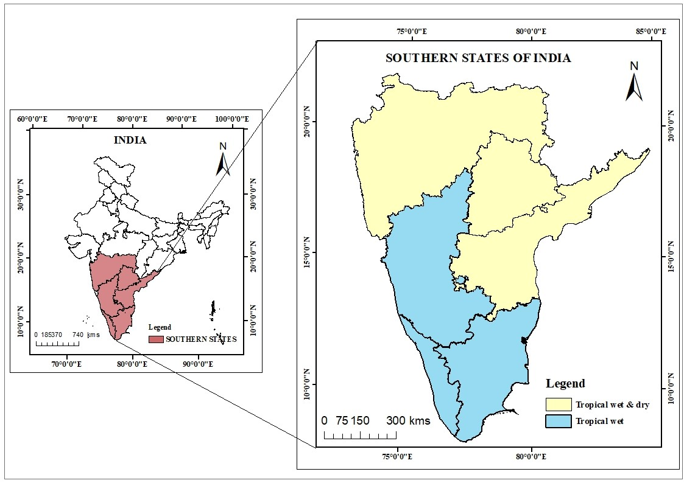
Figure 1: Study area map in the south Indian states

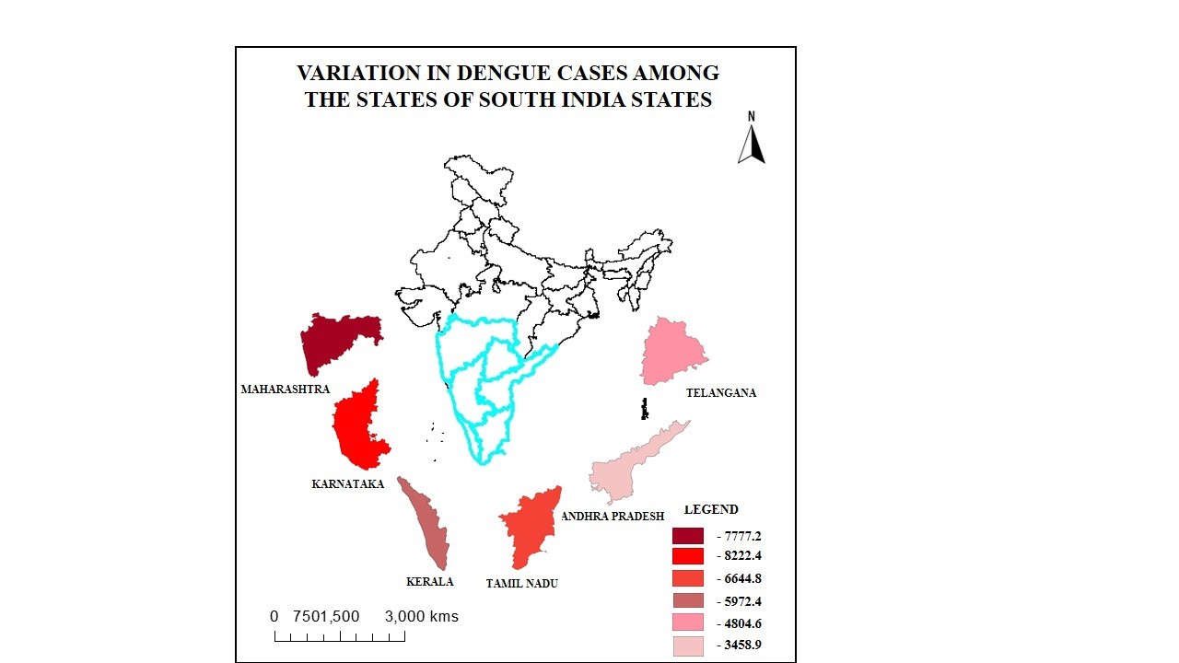
Figure 2: The map illustrates the distribution of dengue cases across different states in South India, with colour coding indicating the severity of dengue incidence. Variation in dengue cases among the states of South India (2013 – 2022).
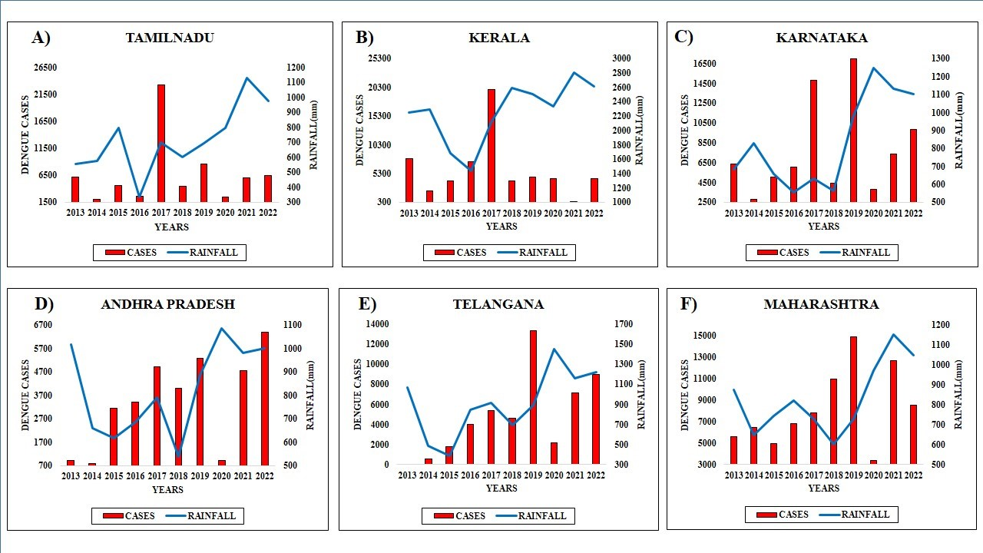
Figure 3: Relationship between dengue cases and rainfall in South Indian states. The X-axis represents years, the left Y-axis indicates the number of dengue cases, and the right Y-axis depicts rainfall levels.

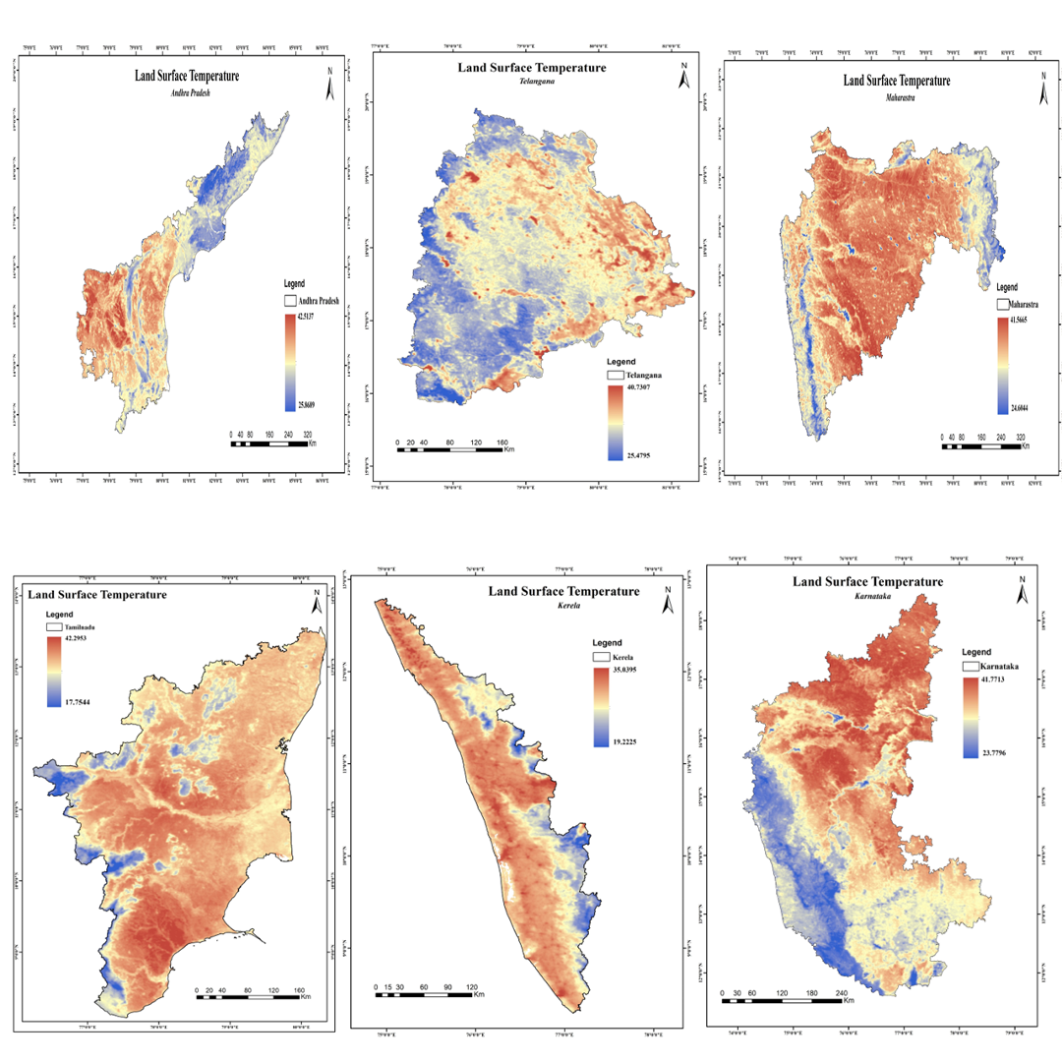

Figure 4: Land surface temperature in the south Indian states distribution across selected South Indian states.

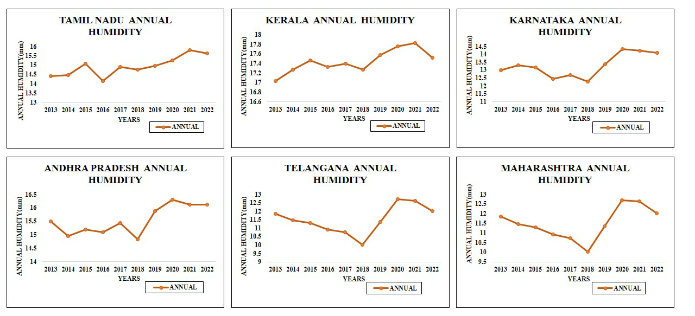
Figure 5: Annual humidity in South Indian states from 2013 – 2022.
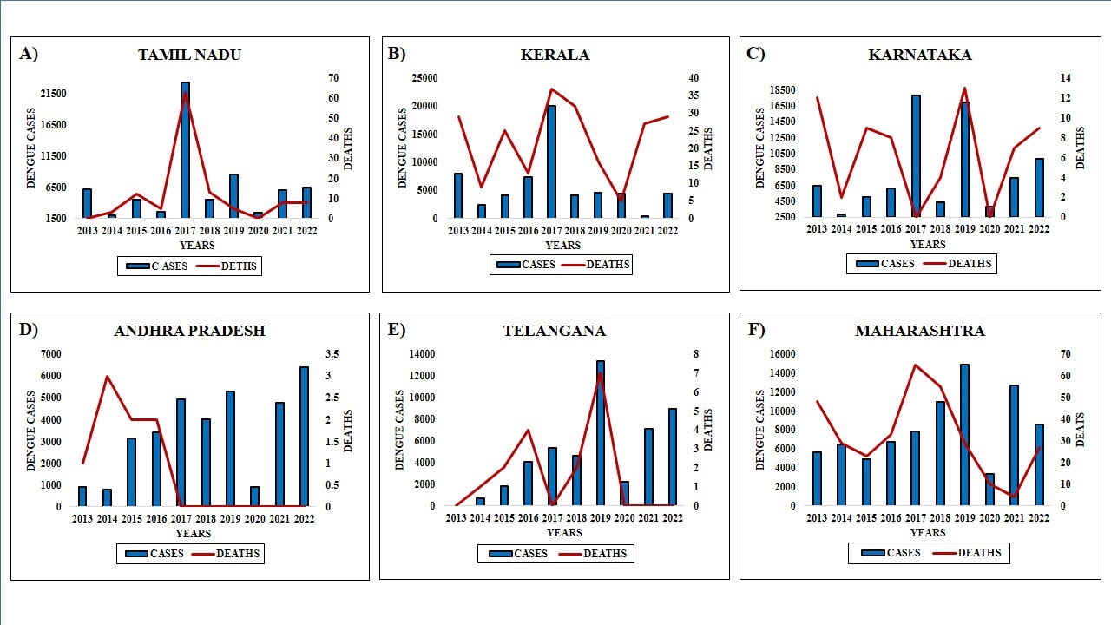
Figure 6: The X-axis shows the year, the red line represents dengue death cases, and the bar shows the number of death cases in South Indian states.
Location |  | Rainfall | Humidity | Cases | Death
KARNATAKA | Rainfall | 1
KARNATAKA | Humidity | 0.96 | 1
KARNATAKA | Cases | 0.02 | -0.07 | 1
KARNATAKA | Death | -0.06 | -0.02 | 0.18 | 1
KERALA | Rainfall | 1
KERALA | Humidity | 0.35 | 1
KERALA | Cases | 0.35 | 0.31 | 1
KERALA | Death | 0.22 | -0.25 | 0.44 | 1
TAMIL NADU | Rainfall | 1
TAMIL NADU | Humidity | 0.98 | 1
TAMIL NADU | Cases | 0.12 | 0.09 | 1
TAMIL NADU | Death | 0.04 | 0.04 | 0.94 | 1
ANDHRA PRADESH | Rainfall | 1
ANDHRA PRADESH | Humidity | 0.9 | 1
ANDHRA PRADESH | Cases | -0.01 | 0.24 | 1
ANDHRA PRADESH | Death | -0.51 | -0.67 | -0.55 | 1
MAHARASHTRA | Rainfall | 1
MAHARASHTRA | Humidity | 0.84 | 1
MAHARASHTRA | Cases | 0.01 | -0.17 | 1
MAHARASHTRA | Death | -0.48 | -0.73 | 0.05 | 1
TELANGANA | Rainfall | 1
TELANGANA | Humidity | 0.91 | 1
TELANGANA | Cases | -0.01 | 0.25 | 1
TELANGANA | Death | -0.51 | -0.63 | -0.55 | 1
Table 1: Correlation between rainfall, humidity, cases and deaths from South Indian states.

