Rainfall characterization in different blocks in Mahasamund district of Chhattisgarh

Abstract
The study on focused on the title of Rainfall characterization in different blocks in Mahasamund district of Chhattisgarh is important to scientific communities for understanding the characteristics, variability and climate change trends of rainfall over the study area. It also important for identify the maximum and minimum rainfall months and seasons, and seasonal rainfall contribution of the study area. In general, the study was to initiate scientific community for studying impact of rainfall on agriculture, water, health, and etc.. over the region. The study utilized 30 years (1992-2021) of daily weather data for five blocks Mahasamund, Bagbahara, Pithora, Basna and Saraipali to analyze trends and anomalies in rainfall. Gridded data were downloaded from NASA POWER dataset. Statistical measuring techniques such as mean, standard deviation, coefficient of variation and linear regression were employed, along with Weather Cock software (15.0). The analysis showed that monthly rainfall July recorded the highest rainfall of 348.4 mm and November was the lowest 3.3 mm rainfall. Saraipali block received the highest annual average rainfall 1315.3 mm and Bagbahara the lowest of 1066.0 mm. The seasonal rainfall analysis shows south west monsoon average 1067.6 ± 71.5 mm CV with 7%, highest in Basna 1150 mm. North east monsoon average 51.0 mm with Saraipali received the highest 70.8 mm. Winter and summer rainfall were low and variable, average 21.0 mm and 32.8 mm, respectively across the district. Trend analysis showed non-significant annual rainfall increase in Bagbahara @6.3 mm/year and Basna @7.5 mm/year while Mahasamund @-1.9 mm/year, Pithora @-6.4 mm/year and Saraipali @-4.4 mm/year showed slight decrease. (SWM) trends followed a similar pattern. Overall, rainfall changes are minimum and do not significantly affect agriculture or livelihoods.
Key words: Rainfall Characterization, Rainfall Variability, Trend Analysis Mahasamund District

Introduction

Agricultural production in India is becoming increasingly vulnerable to climate variability and change characterized (Rao et al. 2015) and altered frequency, timing and magnitude of precipitation (Bal et al. 2022). In spite of the large-scale development of soil water and crop based technologies to optimize and sustain agricultural productivity in recent years, the latter continues to be affected by a number of factors. Factors like temperature, rainfall, relative humidity, light, availability of water, mineral nutrients etc. determine plant growth and development (Onwuka &amp; Mang, 2018). The effect of each atmospheric factor on crop performance depends on its intensity and duration (Soares et al. 2019; Francini &amp; Sebastiani, 2019). However, some of these factors become stressful, due to the recurring features of climate variability, e.g. heat/cold waves, floods/heavy rain, hail/thunderstorms, cyclones/tidal waves etc., and these critical environmental threats are often referred as extreme weather events. (Bal and Minhas. 2017). Chhattisgarh is located in the central part of India between the latitudes of 17° 46’ N - 24° 5’ N and the longitudes of 80° 15’ E - 84° 20’E. Its proximate position with the Tropic of Cancer has a major influence on its climate (Reis et al., 2018; Mueller, 2019). The climate of Chhattisgarh state is dry sub humid type. The average rainfall is around 1200 mm of which more than 80-85% is received during the south west monsoon (June-September). The onset of monsoon is around 10 th June in southern most par of Bastar district and extends over the entire area of the state by 25 th June. Chhattisgarh is divided into three distinct Agro - climatic zones viz., Chhattisgarh plains, Bastar plateau and Northern hills and it covers 50.52%, 28.62% and 20.86% geographic area, respectivelyrespectively . (Bhuarya et al. 2018). The Mahasamund district is come under Chhattisgarh plain zone. The district lies between 20º49’30”: 21º33’07” N latitude and 81º59’56”: 83º16’10” E.longitude, surrounded by districts of Raigarh and Raipur of Chhattisgarh State. District area comprises of the five blocks name are Bagbahara, Mahasamund, Pithora, Basna and Saraipali is located in the eastern part of Chhattisgarh state. The total geographical area of Mahasamund district is 496.3 ha. The coverage of sole cropped is 267.6 ha. and double cropped area is 34.4 ha., with total irrigated area 108.2 ha. The percentage of irrigation is 36% which covers 302.1 ha. Of total cropped area. Mahasamund typically receives average annual rainfall for the study area is around 1228.47 mm. Paddy is grown as main food crop in this district. In addition, arhar, sesamum, gram, linseed, mustard are mainly grown. In some areas, double cropping is also practiced. This particular study is made on different aspects of rainfall characterization, climatology variation and to develop appropriate risk management strategies in Mahasamund district of Chhattisgarh state (Shah & amp; Elwadhi, 2019; Dash et al., 2024).

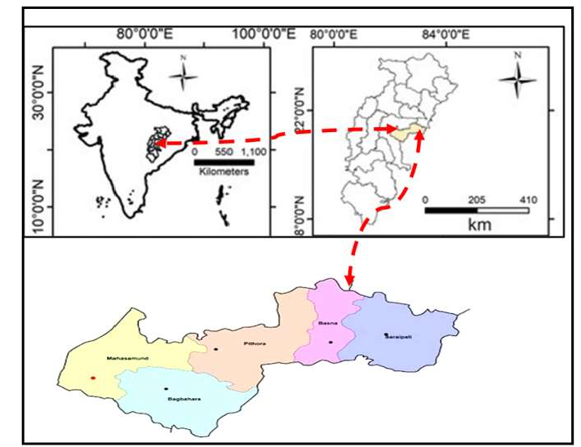
Material and Method Study area description
Chhattisgarh is a 21st century state, that came into existence on November 1, 2000. Chhattisgarh state is situated in eastern India which stretches between 80° 15ʹ to 80° 24ʹ E longitude and 17° 46ʹ to 24°. It covers a total geographical area of about 1,35,194 km². This state has three Agroclimatic zones viz., Chhattisgarh plains, Bastar plateau and Northern hill region. Covering 51%, 28% and 21% of the geographical area respectively. The Mahasamund
district covers an area of 3902.36 sq. km. The block are Mahasamund, Bagbahara, Basna, Pithora and Saraipali. Mahasamund district is situated in the eastern part of the Chhattisgarh state. The district is situated at Latitude 20º49’30”: 21º33’07”N and Longitude 81º59’56”: 83º16’10” E. The average annual rainfall of the district is 1131.0 mm. The average annual temperature varies from 10°C in winter to 40°C in summer. The relative humidity varies from 75% in rainy season to 30- 40% during winter.
Data set - Climatic data for the study period (1992–2021), including rainfall gridded data were dowloded from NASA POWER.

Fig1 . Mahasamund district of Chhattisgarh map in India

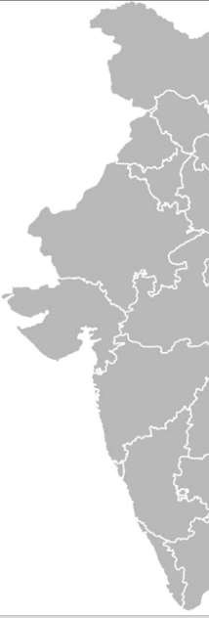
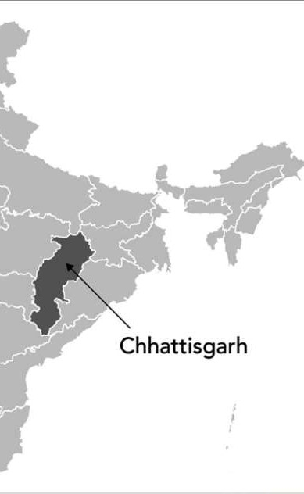
Method - Daily rainfall data were converted into weekly,

monthly, seasonal and annual basis with the help of WC software (15.0) and processed in excel worksheet. The detailed analysis of rainfall viz., rainfall variability, trend of rainfall, weather related extremes were computed. Statistical tools including mean,

Fig 2 : Map in India
M
standard deviation, coefficient of variation and simple linear regression measures the relationship between two variables: x and y. x is the independent variable and y is the dependent variable. The linear regression line is derived using the following equation: Y = a + bx
Where, Y = Dependent variable, a = Intercept, b = Slope, x = Independent variable

Result and Discussion

Rainfall characterization of Mahasamund district of Chhattisgarh

Rainfall characterization at a given location is necessary to investigate the climatic variation, its influence on crop production and identify the local weather condition. Rainfall data are used for 30 years during 1992 to 2021 for characterization of rainfall and find out rainfall for pattern, trend and frequency.

Characterization of monthly rainfall (mm) of Mahasamund district
Average monthly rainfall of 5 blocks in Mahasamund district based on 1992 to 2021 data set has been worked out. The result is presented on Table-1 among the all blocks average monthly rainfall was observed. The highest rainfall was recorded in the month of July 348.4 ± 25.5 mm with 7% CV while lowest monthly rainfall observed in the month of November 3.3 ± 2.7 mm with 82% CV. Block wise result also obtained in this study Bagbahara block received highest monthly rainfall received in the month of July 329.0 mm followed by 294.0 mm in August. The lowest value was observed in November and March 1.0 mm. The maximum amount of monthly rainfall received at Basna block in the month of July
370.2 mm followed by 335.3 mm in August while lowest rainfall received in January 1.8 mm followed by
2.6 mm in the month of April. Highest monthly rainfall observed at Mahasamund block in the month of August 315.6 mm followed by 314.9 mm in July, While the lowest rainfall was observed in November month 1.6 mm followed by April 4.6 mm at Pithora. It was highest in July month 356.7 mm followed by
333.2 mm in August. Similarly, highest monthly rainfall observed at Saraipali in July 371.4 mm followed by 333.3 mm in August. Average annual rainfall also completed for all 5 blocks whereas highest annual rainfall received in Saraipali block 1315 ± 134.7 with CV 10% and lowest rainfall was observed in Bagbahara 1066.0 ± 126.3 mm with CV 12%. The district average of annual rainfall was 1173.5 ± 132.4 mm along with CV 11%.

Table 1: Characterization of monthly rainfall (mm) in 5 blocks of Mahasamund district

Month | Bagbahara | Basna | Mahasamund | Pithora | Saraipali | Average RF (mm) | SD | CV (%)
Jan | 6.0 | 1.8 | 20.6 | 12.4 | 13.2 | 10.8 | 7.2 | 67
Feb | 4.0 | 5.7 | 18.8 | 8.1 | 15.7 | 10.4 | 6.5 | 63
Mar | 1.0 | 3.0 | 14.3 | 5.4 | 26.2 | 10.0 | 10.4 | 104
Apr | 3.0 | 2.6 | 4.6 | 7.1 | 31.2 | 9.7 | 12.1 | 125
May | 6.0 | 6.1 | 5.4 | 15.4 | 32.9 | 13.2 | 11.8 | 89
Jun | 165.0 | 200.6 | 158.9 | 150.4 | 201.3 | 175.2 | 24 | 14
Jul | 329.0 | 370.2 | 314.9 | 356.7 | 371.4 | 348.4 | 25.3 | 7
Aug | 294.0 | 335.3 | 315.6 | 333.2 | 333.3 | 322.3 | 17.7 | 5
Sep | 216.0 | 243.9 | 198.4 | 229.8 | 219.4 | 221.5 | 16.9 | 8
Oct | 39.0 | 52.3 | 27.0 | 39.4 | 52.8 | 42.1 | 10.8 | 26
Nov | 1.0 | 3.1 | 1.6 | 4.9 | 7.0 | 3.3 | 2.7 | 82
Dec | 3.0 | 3.5 | 5.3 | 5.0 | 11.1 | 5.6 | 3.2 | 57

(mm)
Annual RF 1066.0 | 1228.1 | 1085.4 | 1167.6 | 1315.3 | 1172.5 92.1 | 8
SD 126.2 | 143.5 | 123.2 | 135.6 | 134.7 | 132.4

CV% 12 12 11 12 10 11

Characterization of seasonal rainfall (mm) of Mahasamund district
Seasonal rainfall occurs during certain time of year influenced by climate topography and atmospheric condition. (SWM) seasonal rainfall is very important for Chhattisagarh as well as Mahasamund district because it contributes 75-80% of total annual rainfall. Table - 2 the result of South west monsoon rainfall was observed highest in Basna block 1150.0 ± 265.9 mm with 23% CV followed by Saraipali 1125.3 ± 325.0 mm with 29% CV. The lowest seasonal SWM rainfall was observed at Mahasamund block 987.8 ± 310.7 mm with 31% CV followed by Bagbahara 1004.8 ± 206.9. The average of SWM seasonal rainfall found as average of 5 blocks was 1067.6 ± 71.5mm with CV 7%. North east monsoon is the key source of rainfall for southern state such as Tamilnadu, Kerala, Andhra-Pradesh and some part of Karnataka. State of Chhattisgarh receives rainfall from north east monsoon after contribution of south west monsoon. The result of NEM rainfall observed for district was 51.0 ± 14.4 mm with 28% CV. Block wise result revealed that the highest rainfall was observed at Saraipali 70.8 ± 69.7 mm with 98% CV followed by Basna 58.9 ± 60.4 mm with 103% CV. Whereas lowest rainfall was recorded at Mahasamund 34.0 ± 35.4 mm followed by Pithora 49.2 ± 45.4 mm with CV 92%. North east monsoon rainfall perform as lifesaving irrigation for rabi crop in Chhattisgarh as well as in Mahasamund district. The average rainfall of winter season of the district Mahasamund was observed 21.0 ± 13.4 mm with 64% CV. During the season highest rainfall was received 39.4 ± 19.8 mm with 51% CV in Mahasamund block followed by 29.9 ± 41.6 mm with 143% CV in Saraipali, while the lowest rainfall was received in Basna
7.5 ± 27.5 mm with 393% CV, during this season. The rainfall recorded for the summer season among average amount of rainfall for the district received 32.8 ± 33.0 mm with CV 101%. The highest rainfall observed of this season at Saraipali 50.0 ± 70.0 mm followed by Pithora 27.8 ± 29.7 mm with CV 106%. Whereas lowest rainfall received 10.2 ± 20.9 mm in Bagbahara followed by Basna 11.7 ± 23.2 mm. Characterization of seasonal rainfall (mm) in 5 block of Mahasamund district was depicted in table 1.

Table 2: Characterization of seasonal rainfall (mm) in 5 blocks of Mahasamund district

Seasonal rainfall (mm) Bagbahara Basna Mahasamund Pithora Saraipali
Seasonal average of district

Winter Total RF  (Jan-Feb) SD | 9.2  24.3 | 7.5  27.5 | 39.4  19.8 | 20.4  28.2 | 29.9  41.6 | 21.0  13.4
CV% | 270.0 | 393 | 51.0 | 141 | 143 | 64.0
Summer Total RF | 10.2 | 11.7 | 24.0 | 27.8 | 50.0 | 32.8
(Mar-May) SD | 20.9 | 23.2 | 69.6 | 29.7 | 70.0 | 33.0
CV% | 209.0 | 193.0 | 290.0 | 106.0 | 140.0 | 101.0
Southwest Total RF | 1004.8 | 1150.0 | 987.8 | 1070.1 | 1125.0 | 1067.6
(Jun-Sep) SD | 206.9 | 265.9 | 310.7 | 249.1 | 325.0 | 71.5
CV% | 21.0 | 23.0 | 31.0 | 23.0 | 29.0 | 7.0
Total RF | 42.2 | 58.9 | 34.0 | 49.2 | 70.8 | 51.0
Northeast SD | 49.5 | 60.4 | 35.4 | 45.4 | 69.7 | 14.4
(Oct-Dec) CV% | 117.0 | 103.0 | 104.0 | 92.0 | 98.0 | 28.0
Total | 1066.0 | 1228.1 | 1085.4 | 1167.6 | 1315.3 | 1172.5

Trend analysis of rainfall of Mahasamund district
Block wise seasonal (SWM) and annual trend of rainfall was calculated for all five blocks of Mahasamund district. The trend analysis was done by using linear regression best fitted line method. Result of all block wise annual and seasonal trend of rainfall presented in Fig.3. The result found that on annual basis, only 2 blocks Bagbahara and Basna showed (non-significant increasing) trend. In Bagbahara block annual increasing rate of rainfall (mm) was observed @6.399 or – 6.4 mm/year and @7.5mm/year in Basna. While remaining 3 blocks Mahasamund, Pithora and Saraipali found decreasing trend which is (non- significant). The rate of decreasing rainfall (mm) observed at Mahasamund was @ 1.9mm/year, it was @-
6.4mm in Pithora and @-4.4mm in Saraipali block. The rate of decreasing and increasing rainfall is very less, therefore we consider the change of shift of rainfall is not affecting crop production and other livelihood. The trend found for seasonal SWM rainfall amongst all 5 blocks showed increasing and decreasing pattern. Bagbahara and Basna showed non-significant increasing trend and 3 blocks Mahasamund, Pithora and Saraipali showed decreasing trend which work non-significant. The rate of increasing amount of rainfall observed in Bagbahara block was found @3.5mm/season in SWM and @3.3 mm/season in Basna. Similarly the rate of decreasing amount of rainfall @-4.1 mm/season of SWM at Mahasamund, @-4.4mm/season in Pithora and @-8.06 mm/season in Saraipali. Comparative result were found between the seasonal and annual rainfall trend. Result clearly showed that the trend pattern of both annual and seasonal rainfall was same. The difference was noticed in increment of rainfall amount per year. The highest amount of rainfall increasing per year at Basna with the rate of @7.5mm/year annual and lowest was observed in @3.3mm/year season in some place. While decrement was found highest in Saraipali of annual trend and lowest was recorded at Mahasamund @-1.9mm/year.



Fig.3: Annual and seasonal (south west monsoon ) rainfall trend in Mahasamund district
Bagbahara Block
2000.0
1500.0
1000.0
500.0
0.0
annual
y = 6.399x + 967.2 R² = 0.057
Linear (annual)
Year
Bagbahara SWM
2000
1500
1000
500
0
SWM
y = 3.473x + 950.9 R² = 0.021
Linear (SWM)
Year
Rainfall (mm)
Rainfall (mm)




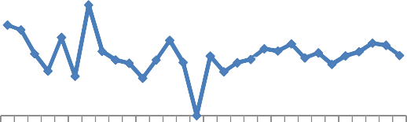
Mahasamund SWM
Basna Block
2000
1500
1000
500
0
Annual
y = 7.518x + 1111.
R² = 0.051
Linear (Annual)
Year
Basna SWM

2000
1500
1000
500
0
SWM
y = 3.320x + 1098.
R² = 0.012
Linear (SWM)
Year
Mahasamund Block
y = -1.932x + 1115.
2500
2000
1500
1000
500
0
Average
R² = 0.003
Linear (
Average)
Year
Rainfall (mm)
1992
1994
1996
1998
2000
2002
2004
2006
2008
2010
2012
2014
2016
2018
2020
Rainfall (mm)
1992
1994
1996
1998
2000
2002
2004
2006
2008
2010
2012
2014
2016
2018
2020
2000
Rainfall (mm)
Rainfall(mm)
1500
1000
500
0
1992
1994
1996
1998
2000
2002
2004
2006
2008
2010
2012
2014
2016
2018
2020
y = -4.093x + 1051.
R² = 0.013
SWM Linear (SWM)


Pithora Block

y = -6.474x + 1268 R² = 0.056

Pithora SWM
Year

y = -4.493x + 1139.
1992
1994
1996
1998
2000
2002
2004
2006
2008
2010
2012
2014
2016
2018
2020
R² = 0.025

2000
Rainfall(mm)
1500
1000
500
0
Average Linear (Average)
2000
1500
Rainfall(mm)
1000
500
0
1992
1994
1996
1998
2000
2002
2004
2006
2008
2010
2012
2014
2016
2018
2020
1992
1994
1996
1998
2000
2002
2004
2006
2008
2010
2012
2014
2016
2018
2020
SWM Linear (SWM)

Saraipali Block
2500
Year

y = -4.498x + 1385 R² = 0.018

Saraipali SWM
2500
Year
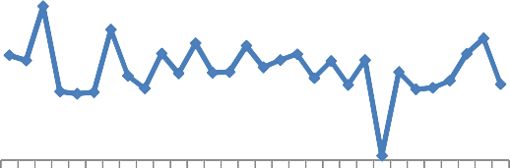
y = -8.068x + 1250.
R² = 0.047

2000
Rainfall(mm)
1500
1000
500
0
Average Linear (Average)
2000
1500
Rainfall(mm)
1000
500
0
SWM Linear (SWM)

1992
1994
1996
1998
2000
2002
2004
2006
2008
2010
2012
2014
2016
2018
2020
1992
1994
1996
1998
2000
2002
2004
2006
2008
2010
2012
2014
2016
2018
2020

Year Year
1992
1994
1996
1998
2000
2002
2004
2006
2008
2010
2012
2014
2016
2018
2020
1992
1994
1996
1998
2000
2002
2004
2006
2008
2010
2012
2014
2016
2018
2020

Conclusion
The rainfall analysis of Mahasamund district shows highest monthly rainfall in July month
348.4 ± 25.5 mm with CV 7% and lowest in November 3.3 ± 2.7 mm with CV 82%. Saraipali received the highest annual rainfall 1315.3 mm, Bagbahara the lowest 1066.0 mm. District average annual rainfall was 1173.5 ± 132.4 mm. The seasonal rainfall analysis shows south west monsoon average 1067.6 ± 71.5 mm CV with 7%, highest in Basna 1150 mm. North east monsoon average 51.0 mm with Saraipali received the highest 70.8 mm. Winter and summer rainfall were low and variable, average 21.0 mm and 32.8 mm respectively across the district. Trend analysis showed non-significant annual rainfall increase in Bagbahara @6.3 mm/year and Basna @7.5 mm/year, while Mahasamund @-1.9 mm/year, Pithora @-
6.4 mm/year and Saraipali @-4.4 mm/year showed slight decrease. SWM trends followed a similar pattern. Overall, rainfall changes are minimum and do not significantly affect agriculture or livelihoods. Acknowledgement
Declaration of Competing Interest

Disclaimer (Artificial intelligence)
Option 1:
Author(s) hereby declare that NO generative AI technologies such as Large Language Models (ChatGPT, COPILOT, etc.) and text-to-image generators have been used during the writing or editing of this manuscript.
Option 2:
Author(s) hereby declare that generative AI technologies such as Large Language Models, etc. have been used during the writing or editing of manuscripts. This explanation will include the name, version, model, and source of the generative AI technology and as well as all input prompts provided to the generative AI technology
Details of the AI usage are given below:
1.
2.
3.

References
Bal, S.K., Sandeep, V.M., Kumar, P.V., Rao, A.S., Pramod, V.P., Manikandan, N., Rao, C.S., Singh, N.P. and Bhaskar, S. 2022. Assessing impact of dry spells on the principal rainfed crops in major dryland regions of India. Agricultural and Forest Meteorology, p. 313.
Bal, S.K. and Minhas, P.S. 2017. Atmospheric stressors challenges and coping strategies. Abiotic stress management for resilient agriculture, p. 9-50.
Bhuarya, H.K., Sastri, A.S.R.A.S., Chandrawanshi, S.K., Bobade, P. and Kaushik, D.K. 2018. Agro-climatic characterization for agro-climatic zone of Chhattisgarh. Int. J. Curr. Microbiol. App. Sci, 7(8): 108-117.
Rao, B.B., Chowdary, P.S., Sandeep, V.M., Pramod, V.P. and Rao, V.U.M., 2015. Spatial analysis of the sensitivity of wheat yields to temperature in India. Agricultural and Forest Meteorology, 200: p. 192-202.
Soares, J. C., Santos, C. S., Carvalho, S. M., Pintado, M. M., &amp; Vasconcelos, M. W. (2019). Preserving the nutritional quality of crop plants under a changing climate: importance and strategies. Plant and Soil, 443(1), 1-26.
Francini, A., &amp; Sebastiani, L. (2019). Abiotic stress effects on performance of horticultural crops.
Horticulturae, 5(4), 67.

Onwuka, B., &amp; Mang, B. J. A. P. A. R. (2018). Effects of soil temperature on some soil properties and plant growth. Adv. Plants Agric. Res, 8(1), 34-37.
Shah, M. A., &amp; Elwadhi, S. (2019). Evaluation of entrepreneurs&#39; risk: A study with reference to Chhattisgarh State. ICTACT Journal on Management Studies, 5(4).
Dash, C. J., Yadav, P., Kumar, R., Patra, S. S., Hombegowda, H. C., &amp; Adhikary, P. P. (2024). Assessing rainfall patterns, erosivity dynamics, and sustainable soil and water management strategies
across agro-climatic zones of Chhattisgarh, India. Indian Journal of Soil Conservation, 52(2), 147-159.

Reis, J., Handschumacher, P., Palmer, V. S., &amp; Spencer, P. S. (2018). Climatic factors under the tropics. In Neuroepidemiology in Tropical Health (pp. 25-39). Academic Press.
Mueller, L. M. (2019). Cancer in the tropics: geographical pathology and the formation of cancer epidemiology.
BioSocieties, 14(4), 512-528.

