Optimizing Carbon Sequestration: The Role of Coconut Palm in Agroforestry

Abstract
Terrestrial carbon sequestration is an essential tactic for mitigating climate change, because atmospheric carbon dioxide (CO₂) has increased significantly since pre-industrial times. The potential of the perennial coconut palm (Cocos nucifera) as a carbon sink and the mutually beneficial effects of incorporating it into intercropping systems are examined in this review. Different techniques such as destructive, non-destructive, remote sensing and GIS methods can be used for estimating the plant biomass and carbon stock. Among all allometric equations are mostly used for estimating the carbon sequestration. Because of their long lifespan, coconut palms can store a lot of carbon; older, taller varieties are better at sequestering carbon. Intercropping systems significantly increase carbon sequestration, storing much more carbon than monocultures. This is supported by a 23% rise in root biomass and a 4% increase in soil organic carbon within these mixed systems. This agroforestry approach provides a comprehensive solution, improving ecosystem services, helping to achieve global climate goals and giving farmers economic resilience through diversified income.
Key words: allometric equations, carbon sequestration, carbon stock, Intercropping
systems
1. Introduction
Increase in population leads to increase in anthropogenic activity, which have led to a significant increase in greenhouse gases, elevating global temperatures by 1°C since pre-industrial times. Fossil fuel combustion (coal, oil, and gas), cement manufacturing, deforestation and fertilizer use have all contributed to the greenhouse effect by increasing emissions of gases such as carbon dioxide, methane and nitrous oxide (Davis et al., 2010). Among all greenhouse gases CO₂ is the primary contributor for increasing of global temperature. CO₂Earth (2023) projects that CO₂ concentrations could vary from 540 parts per million to over 970 parts per million by the end of the century, with a mid-range estimate of about 670 parts per million (CO2Earth, 2023). Sea levels will increase and there will be more extreme weather events like floods, droughts and tropical storms if emissions are not significantly reduced. The global temperature will rise by about 3.5°Cover pre-industrial levels. It has been stated that carbon sequestration is necessary to keep CO₂ concentrations below 441 parts per million by the year 2100 (Rohit & Soumyajit, 2022). Carbon sequestration is the technique of capturing and retaining carbon dioxide (CO₂) to prevent it from entering the atmosphere. Following its capture, the carbon is subsequently released into the soil, vegetation, sea and underground geological formations, among other locations (USGS, 2008). Plantation crops play a major role in terrestrial carbon sequestration due to perennial nature (Subramaniyan et al.,2017)
For thousands of years, humanity have utilized the coconut palm, scientifically known as Cocos nucifera, a highly important and versatile tropical plant. The reason it is frequently referred to as the "tree of life" because its various parts can be used to create a wide range of beneficial products. According to FAOSTAT 2025, global production of coconut is approximately 62 million metric tons. Among all the countries India is the third largest coconut producing country i.e approximately 13.3 million metric tons (FAOSTAT, 2025). Coconut palms play a vital role in combating climate change. The process of terrestrial carbon sequestration in these coconut trees is a key strategy for reducing global warming.
2. Carbon sequestration in coconut
The coconut tree, like other higher plants, absorbs carbon dioxide (CO₂) through its leaves' stomata, after which photosynthesis takes place. The majority of the CO₂ that dissolves in the leaves roughly 270 PgC/yr diffuses back out without being utilized for photosynthesis (Nwite et al., 2023). The amount of CO_{2​,} that is converted into carbohydrates during photosynthesis is called Gross Primary Production (GPP), and this is estimated to be around 120 PgC/yr (Ciais et al., 1997). This value is roughly what is needed to support plant growth, with a portion of the GPP being absorbed into the plant's tissues (leaves, roots, and wood) and the rest being released back into the atmosphere as CO₂​ through the plant's own respiration. The annual growth of a plant, known as Net Primary Production (NPP), is the result of the amount of carbon fixed during photosynthesis minus the carbon released through the plant's own respiration (autotrophic respiration) (Hall et al., 1993).
In case of coconut, contrary to other dicot trees the NPP (85%) is translocated to the easily degradable structure like fruits, leaves, peduncles, and fine roots other than long lasting stems and course roots (Mialet-Serra et al., 2008). The calculation of carbon sequestration requires measurements of four major carbon pools: soil, necromass (dead plant matter), and the aboveground and belowground live components of plants, including stems, leaves, and roots (Ganeshamurthy, 2013). Upper-ground carbon in coconut tree is directly a function of above-ground biomass. The research revealed that dry leaves contained a greater percentage of carbon (48.1%-48.7%) compared to trunk wood (45.9%-46.3%), with total biomass varying from 100.02 to 226.45 (Mitra et al., 2018). They are almost as productive as tropical rainforests and despite releasing some carbon through natural processes, they consistently sequester a large net amount. This makes them a highly effective and stable choice for carbon sequestration (Roupsard et al., 2008).
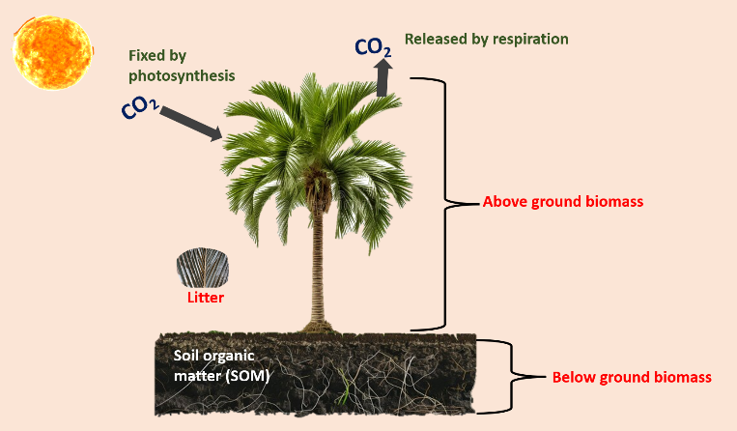

Fig.1. Process of carbon sequestration in coconut
3. Factors affecting carbon sequestration in coconut
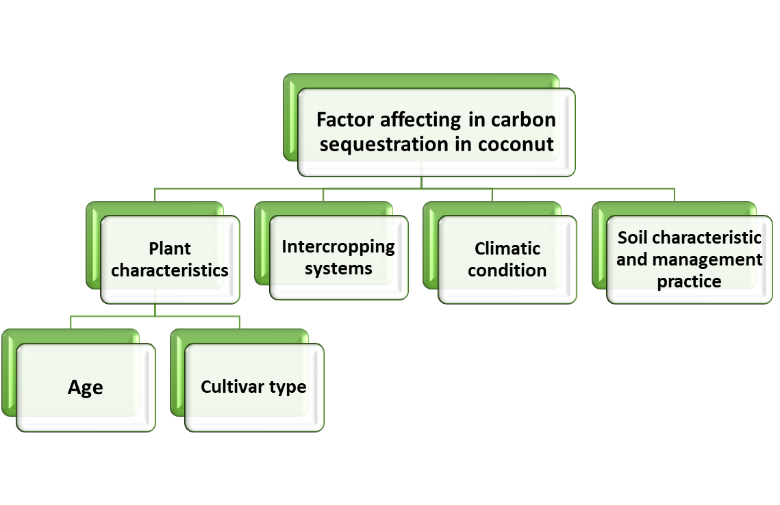
The rate and effectiveness of carbon sequestration in coconut agro-ecosystems are influenced by a number of factors. To maximize carbon storage and strengthen the contribution of coconut plantations to climate change mitigation, it is imperative to comprehend these factors.

Fig.2. Graphical representation of carbon sequestration in coconut
3.1. Plant characteristic
Age and different variety of coconut plantation has primary impact on the carbon sequestration capacity. Increase in age has an impact on the change in plant morphology Increase in age of plant leads to increase in total carbon stock of the coconut plants. When comparing the carbon stocks of the various plant parts - leaves, nuts, and roots - the carbon stock rises over time; for example, trees that are 50 years old have a higher carbon stock than trees that are 10 years old. However, when it comes to leaves, the carbon stocks of 10-year-old palms were the highest, while those that are 50 years old had the lowest. The reason for this decline is that as palms mature, their leaves become shorter and narrower, and after 20 years, there are fewer leaflets overall (Nuwarapaksha et al., 2025). Age and cultivar have a major impact on a coconut palm's capacity to sequester carbon. Clear differences were found when tall varieties, like Aliyar Nagar 1, and dwarf varieties, like Chowghat Orange Dwarf (COD) and Chowghat Green Dwarf (CGD) were compared at ages ranging from 5 to 25 years. The annual sequestration rates of tall coconut trees increased from 1.91 tons per acre at age 5 to 3.83 tons per acre at age 25, indicating an increasing capacity for carbon sequestration with age. Dwarf varieties, on the other hand, sequestered less carbon at all ages; for the same age range, their annual rates ranged from 0.78 to 2.48 tons per acre. Because of its larger biomass from increased height and trunk diameter, the taller coconut variety has a higher capacity to sequester carbon than the dwarf variety (Boomiraj et al., 2021).

3.2. Intercropping system
Growing other crops alongside coconuts is known as intercropping and it is an efficient method for farmers to maximize the use of their land. It makes use most of the vertical space and organic shade that the coconut palms provide (Selva Rani et al., 2024). Integrating trees with crops and livestock in agroforestry systems significantly enhances carbon capture in aboveground biomass and soil compared to monocultures, and also boosts ecosystem services, biodiversity, and resilience to climate extremes (Sharma et al., 2025). Research shows that coconut-only farms, with a typical spacing of 7.5 x 7.5 m², only use about 22.3% of the available land (Durieux, 1997). The trees themselves only utilize about 30% of the air space and 50% of the sunlight (Thiruvarassan et al., 2014). All these characters of coconut make it suitable for intercropping. Crops which are selected for intercropping with coconuts should be shade-tolerant, not grow too tall and exploit different soil zones to avoid competition. They should also be resistant to the same diseases as coconuts and not damage the main crop during harvest. Finally, the choice of intercrop should consider local conditions like soil type, rainfall, and market availability (CPCRI, 2010).
Table.1. Different crops used as intercrop in coconut
Crop categories | Examples | References
Cereals | Rice, pearl millet, finger millet, baragu, wheat | (Gopalasundaram and Nelliat, 1979)
Beverages | Cocoa and coffee | (Osei-Bonsu et al., 2002)
Exotic fruit crops | Rambutan, mangosteen  and avocado | (Thamban et al., 2021)
Flowers | Heliconia, anthurium and jasminum sp. | (CPCRI, 2003)
Spices & Condiments | Ginger, turmeric, black pepper, chilli, nutmeg and clove | (Bhoomika et al., 2024)
Fodder | Hybrid Bajra Napier Co₃ and Co₄ | (Gangaiah et al., 2019)
Vegetables | Okra, baby corn, gherkin, and cucumber, potato, French bean, snake gourd, and Amaranthus, | (Mandal et al., 2016)
Medicinal crops | Aloe vera, asparagus, swertia, ashwagandha, and mentha | (Malathi et al., 2024)
Tubers and root crops | Cassava, sweet potato, yam and taro | (Malathi et al., 2024)
Oil seed | Ground nut | (CPCRI, 2010)
Grain legume | Green gram, black gram, cowpea, soyabean | (CPCRI, 2010)

Intercropping system majorly contributes toward efficient land use, increase the production and productivity improve soil health and fertility enhancement along with all these it contributes towards the increase in carbon sequestration by increase in plant biomass and also, Intercropped fields had a 4% higher organic C content in the top 20 cm of soil compared to single-crop fields. The total root biomass in intercropped systems was, on average, 23% greater than in single-crop systems contributed to the higher soil C sequestration (Cong et al., 2015). A dense, widespread root system not only accumulates more carbon but also enhances soil structure and moisture retention (Gautam et al., 2025), also improves soil physicochemical properties and boost the content of soil organic carbon (SOC), including its more active forms like readily oxidized organic carbon (ROC) and dissolved organic carbon (DOC) (Hu et al., 2022).
Intercropping also reduces CO_{2​} emissions by decreasing microbial carbon limitation through changes in soil pH and water content. This process boosts mineral-associated organic carbon (MAOC) and help in enhancing microbial diversity and activity, which are crucial for the soil carbon cycle and nutrient availability (Xiao et al., 2023). In high-density planting multi-species cropping systems, Thomas et al. (2010) found that microbial biomass carbon was significantly higher in the soil near the roots of coconut trees than in the soil of other crops planted in the same system. Increasing the number of intercrops with coconut trees produces a recyclable biomass that increases soil organic carbon (SOC) (Shinde et al., 2021b). This is backed by a study that identified a boost in soil organic carbon in cropping systems using coconut compared to monoculture plantations (Mishra et al., 2022).

Table.2. Comparative analysis of Carbon Sequestration in Coconut Monocropping and intercropping systems

Coconut and coconut based intercropping system | Above ground carbon sequestration | Below ground carbon sequestration | Reference
Coconut monocropping  (Age: 50 years) | 51.14 t/ha | 26.87 t/ha (0-30 cm)  20.19 t/ha (31-60 cm) | (Bhagya et al., 2017)
Coconut (Age: 50 years) + jamun (Age: 7 years) | 60.93 t/ha | 45.18 t/ha (0-30 cm)  33.95 t/ha (31-60 cm) | (Bhagya et al., 2017)
Coconut (Age: 50 years) + mango (Age: 7 years) | 56.45 t/ha | 47.39 t/ha (0-30 cm)  35.08 t/ha (31-60 cm) | (Bhagya et al., 2017)
Coconut (Age: 50 years) + kokum (Age: 7 years) | 53.02 t/ha | 46.32 t/ha (0-30 cm)  32.37 t/ha (31-60 cm) | (Bhagya et al., 2017)
Coconut Monoculture  (Age: 30 years) | 60.01 t/ha | 19.53 t/ha  (0-20 cm) | (Raveendra et al., 2017)
Coconut (Age: 30 years) + Gliricidia  (Age: 6 years) | 117.92 t/ha | 20.87 t/ha  (0-20 cm) | (Raveendra et al., 2017)
Coconut (Age: 30 years) + Cocoa (Age: 4 years) | 47.65 t/ha | 20.59 t/ha  (0-20 cm) | (Raveendra et al., 2017)
Coconut (Age: 30 years) + Gliricidia (Age: 6 years) | 114.83 t/ha | 57.69 t/ha  (0-30 cm) | (Nuwarapaksha et al., 2025)
Coconut monocropping system  (Age: 30 years) | 67.76 t/ha | 17.85 t/ha  (0-30 cm) | (Nuwarapaksha et al., 2025)
Okra-Fallow-Tomato-Fallow (as intercrop in coconut (Age: 45 years) from 2012 - 2014) | 3.01 t/ha  (Increment over 2012 – 2014) | 9.59 t/ha  (15 – 30 cm, 2012 – 2013)  9.47 t/ha  (15 – 30 cm, 2013 – 2014) | (Naveen Kumar and Maheswarappa, 2019)
Green manure (Mucuna)-Cucumber-Green Manure-Cucumber (as intercrop in coconut (Age: 45 years) from 2012 - 2014) | 3.01 t/ha  (Increment over 2012 – 2014) | 9.19 t/ha  (15 – 30 cm, 2012 – 2013)  9.00 t/ha  (15 – 30 cm, 2013 – 2014) | (Naveen Kumar and Maheswarappa, 2019)
Baby corn-Gherkin-Baby Corn-Gherkin (as intercrop in coconut (Age: 45 years) from 2012 - 2014) | 3.01 t/ha  (Increment over 2012 – 2014) | 9.84 t/ha  (15 – 30 cm, 2012 – 2013)  10.18 t/ha  (15 – 30 cm, 2013 – 2014) | (Naveen Kumar and Maheswarappa, 2019)
Coconut Monoculture  (Age: 45 years) | 2.31 t/ha  (Increment over 2012 – 2014) | 7.33 t/ha  (15 – 30 cm, 2012 – 2013)  7.24 t/ha  (15 – 30 cm, 2013 – 2014) | (Naveen Kumar and Maheswarappa, 2019)
Calliandra + Coconut  (Age: 35 years) | 46.51 t/ha  (total dry fodder biomass of Calliandra) | 68.80 - 131.84 t/ha (overall) | (Joy et al., 2019)
Coconut Monoculture  (Age: 35 years) | 108.73 t/ha | 75.57 t/ha  (from a depth of 1 m) | (Joy et al., 2019)

3.3. Climate
Temperature, precipitation and salinity have significant impacts on coconut growth and production (Wilson et al., 2011; Hebbar et al., 2021) Although increased atmospheric carbon dioxide (CO₂) tends to Favour C₃ crops such as coconut, elevated temperatures reverse the advantage (Hebbar et al., 2013). Particularly, very hot summer temperatures above 40°C and low humidity drastically curtail nut yields. The reason is that excessive heat impairs pollen germination (Hebbar et al., 2018) and pollen tube development, (Hebbar et al., 2020) resulting in poor fertilization and reduced nuts. Other than high temperatures, another factor that constrains coconut growth is a shortage of water. Rapid change in climate has major impact on the biomass decrease in plant leads to major contributor towards the decrease in carbon sequestration.
Table.3. Impact of climatic factor on carbon sequestration
Climatic Factor | Effect on Carbon Sequestration | References
Temperature | Warming can enhance the rate of decomposition of soil organic matter, creating positive climate change feedback. But if the inputs of carbon from vegetation exceed decomposition, the feedback will be negative | Davidson & Janssens (2006)
Precipitation | Lower precipitation might result in increased storage in soil organic layer and mineral soil carbon. This is largely attributed to reduced rates of decomposition and increased chemical recalcitrance of organic matter. | Campo & Merino (2016)
Pre-Monsoon  (Seasonal Effect) | CO₂ absorption due to rising temperature and radiation. Plants have high growth and respiration rates as well as CO₂ uptake during this time, with highest daily evapotranspiration and photosynthesis rates that are most strongly coupled. It is dominated by the largest daily gross primary productivity (GPP) and evapotranspiration rates. | Deb Burman et al. (2020)
Monsoon  (Seasonal Effect) | The monsoon season brings about a bimodal regime in gross primary productivity (GPP) in a tropical semi-evergreen forest of North-East India. Heavy cloud cover that inhibits photosynthesis and reduces incoming solar radiation during June and July results in a decline in GPP | Deb Burman et al. (2020)
Post-Monsoon  (Seasonal Effect) | As the monsoon recedes, temperature and radiation fall, inhibiting both photosynthetic uptake and respiration. The ecosystem remains a net source of CO₂ for this season. CO₂ uptake is similar to pre-monsoon and monsoon periods, but the general direction of NEE is positive. | Deb Burman et al. (2020)
Winter  (Seasonal Effect) | least favourable season for photosynthetic | Deb Burman et al. (2020)
Extreme weather events | Droughts, floods and storms damage soil structure, vegetation, and erosion, reducing soil carbon sequestration | Saco et al. (2021)
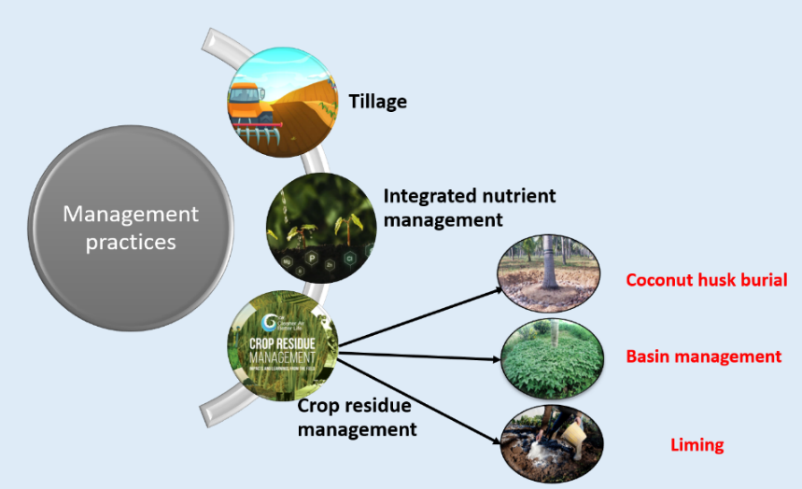
3.4. Management practice

Fig.3. Graphical representation of different management practice for improving
carbon sequestration

3.4.1. Minimum tillage
Minimum tillage is better than conventional tillage for maximizing soil organic carbon (SOC) because it leads to less oxidative loss of organic matter (Sudha & George, 2011). Similarly, Khan and Parvej (2010) found that mulch and zero-till soil had the highest water-retentive capacity across all crop growth stages, which they attributed to the conservation of soil organic matter (SOM).
3.4.2. INM (Integrated Nutrient Management)
Integrated Nutrient Management (INM) is an eco-friendly farming technique which combines application of organic, inorganic, and biological sources of nutrients to sustain soil fertility and regulate plant nutrient supply for long-term crop productivity. Adding soil amendment also improve the carbon sequestration. According to Shinde et al. (2020) Specifically, a treatment with 75% Recommended Dose of Fertilizers (RDF) and 25% organic N sequestered the highest amount of above-ground carbon stock at 31.1 t ha⁻¹ nutmeg, cinnamon, banana and pineapple with coconut based intercropping system but a treatment using 100% organic N resulted in the highest soil carbon stock in the coconut rhizosphere, reaching 42.3 t ha⁻¹. INM has more carbon sequestration compare to monoculture coconut system.
3.4.3. Crop residue management
Coconut husk burial, basin management with leguminous crop and liming is the major managing strategies for the improvement of carbon sequestration in coconut. Coconut husk burial is a successful technology for the retention of soil moisture, increasing the water holding capacity of the soil, enhancing the available potassium status of the soil, enhancing the nutrient holding. Green manure crops growing in the coconut basin is an efficient measure to enhance the microbial activity and soil organic matter (Thomas and Shantaram, 1984). It has been found that applying a sufficient quantity of liming materials increased the soil's calcium availability caused earthworms to proliferate in the soil, accelerating the organic matter's turnover (Mathew, Haris, & Anithakumari, 2023).
4. Estimation of carbon sequestration in coconut palms
The total carbon stock in any land-based ecosystem is made up of carbon from the soil, dead organic matter and living things (Koala et al., 2017). Within these ecosystems, Eggleston et al. (2006) found five distinct carbon pools: soil organic matter, woody debris, litter, above-ground biomass (AGB), and below-ground biomass (BGB). Hamburg (2000) offered the level of precision necessary to measure each pool profitably i.e Allometric equations based on stem diameter are used to measure living trees non-destructively. Destructive methods are used to quantify litter (both fine and coarse/standing) and vegetation (including trees with a diameter of less than 5 cm). and a lot of methods are available for measurement of carbon sequestration in coconut

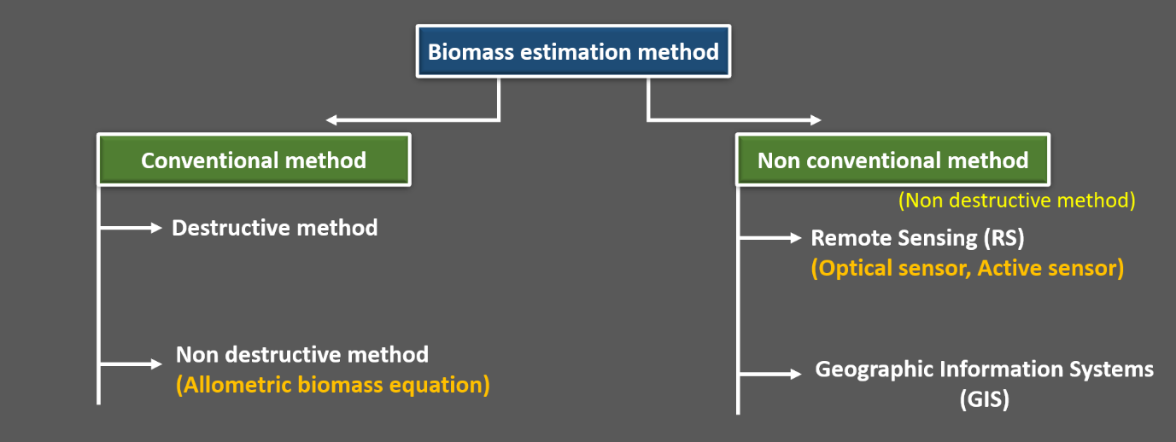

Fig.4. Different methods of estimation of carbon sequestration (Issa et al., 2019)
4.1. Estimation of Above Ground Biomass
AGB is the most noticeable, important and dynamic element among them. For calculating above ground biomass different method used like conventional method and non-conventional method. Both destructive and non-destructive methods are part of the conventional approach. Destructive method is more accurate because it incorporates the destructive harvest approach. This method of estimating biomass is expensive, labour-intensive, time-consuming and only applicable to small areas. Furthermore, these techniques, which mostly rely on ground measurements and have the potential to severely harm the environment and destroy forests, may be illegal, especially when applied to trees (Maulana et al., 2016). The non-destructive method includes allometric equation to calculate the plant biomass and unconventional techniques that make use of geographic information systems (GIS) and remote sensing (RS) are efficient in terms of time and money for calculating the plant biomass (Issa et al., 2019). According to Antiporda et al. (2024), combining optical remote sensing and Synthetic Aperture Radar (SAR) data produced a reliable model for forecasting Above-Ground Biomass (AGB) with a low Root Mean Square Error (RMSE) of 0.143 and an R² value of 0.72, the model showed excellent accuracy. Although remote sensing is great for assessing AGB on a large scale, it occasionally underestimates biomass. This is frequently caused by intricate vegetation structures, like thick canopies and different tree shapes, which can make it challenging for sensors to precisely measure the vegetation's entire vertical size and shape.
Table.4. Allometric equations for measuring the carbon sequestration in coconut
Research study | Study area | Allometric equation for above ground biomass | R² value | Remark
Brown et al. (1989) | Dry Life Zone: India | AGB=34.4703−8.0671(D)+0.6589(D²)  D: diameter in cm | 0.67 | tropical broadleaf forest trees
Brown et al. (1989) | Moist Life Zone: Japan, Venezuela, and Brazil | - AGB=38.4908−11.7883(D)+1.1926D²  - AGB =exp{−3.1141+0.9719ln(D²H)}  - AGB=exp{−2.4090+0.9522ln(D²HS)}  D: diameter in cm; H: height in m; S: wood density g/cm³ | - 0.78  - 0.97  - 0.99 | tropical broadleaf forest trees
Brown et al. (1989) | Wet Life Zone: Papua New Guinea and Puerto Rico | - AGB =13.2579−4.8945(D)+0.6713(D²)  - AGB =exp{−3.3012+0.9439ln(D²H)}  D: diameter in cm; H: height in m | - 0.90  - 0.90 | tropical broadleaf forest trees
Hairiah et al. (2001) | Sumatra, Indonesia | AGB = (π x p x D² x ht)/40  ht: tree height in m; p: stem density in kg/m; D: stem diameter at breast height in m; π, phi or 3.14 constant value | NA | Allometric for branchless trees
Chave et al. (2005) | Three continents:  America, Asia and Oceania | AGB = 0.0509 x p x D² x ht  ht: tree height in m; p: stem density in kg/m; D: stem diameter at breast height in m | 0.95 | Global model from 2410 trees with diameter > 5 cm
Naresh, Kasthuri and George, (2008) | (CPCRI), Kasaragod, Kerala, India. | Stem dry weight (kg)=Length (in meters) × girth² (in meters, at 1.5 m above ground level) × 41.14142. | 0.8982 | Coconut  Grown in India
^{Zahabu et al. (2018)} | Tanzania | AGB = 3.7964xht^{1.8130}  ht: tree height in m | 0.78 | for C. nucifera
Sooriyaarachchi et al. (2024) | Sri Lanka | TC = (0.0073 × a) + 0.0852 | 0.94 | coconut palm  (tall variety)

4.2. Below ground biomass
The below ground carbon mass is 20% of above ground carbon mass (Cairns et al., 1997). Carbon stock generally, for any plant species 50% of its biomass (Pearson et al., 2005) i.e.
Carbon stock = Biomass × 0.5
CO₂ (t/ha) sequestered = Carbon stock (t/ha) x 3.67 as factor

4.3. Soil Organic Matter (SOM)
For tropical soils to remain productive, soil organic matter (SOM) is essential. In addition to providing substrates and energy, it maintains the biological variety necessary to maintain soil quality and ecosystem function. SOM is a crucial component of total soil condition due to its immediate impact on soil characteristics (Wendling et al., 2010). For calculating soil organic matter, soil sample will be gathered in accordance with standard protocols from the crop basin. Wet oxidation method proposed by Walkey & Black (1934) will be used for calculating organic carbon.

Soil carbon stock was estimated by formula:
Soil organic carbon stock (Mg ha⁻¹) = [C concentration layer (kg Mg⁻¹) × (Bulk density)
layer
(Mg m⁻³) × Depth (m) × 10⁻³ Mg kg⁻¹ × 10⁴
(m² ha⁻¹)

(Srinivasan et al., 2012)

5. Conclusion
Older, taller coconut palms store the most carbon, making them an efficient, long-term carbon sink. The most significant finding is that the potential for carbon sequestration is greatly increased when coconut palms are incorporated into intercropping systems. Compared to monocultures, these mixed systems—like coconut with Gliricidia—sequester 69.46% more carbon. Intercropping is a better method of mitigating climate change because it promotes better soil health and more effective land use. This agro-forestry model improves overall ecosystem services and diversifies income, which benefits farmers' economic resilience in addition to the environment. Making the transition to these integrated systems is essential to developing rural landscapes that are more prosperous and sustainable.

Disclaimer (Artificial intelligence)
Option 1:
Author(s) hereby declare that NO generative AI technologies such as Large Language Models (ChatGPT, COPILOT, etc.) and text-to-image generators have been used during the writing or editing of this manuscript.
Option 2:
Author(s) hereby declare that generative AI technologies such as Large Language Models, etc. have been used during the writing or editing of manuscripts. This explanation will include the name, version, model, and source of the generative AI technology and as well as all input prompts provided to the generative AI technology
Details of the AI usage are given below:
1.
2.
3.

6. References
- Antiporda, G. W., Bernaldez, K. M. E., & Gesta, J. L. E. (2024, October 17). Assessment of Synthetic Aperture Radar (SAR) and Optical Remote Sensing Data in Aboveground Carbon Stock Estimation of Coconut (Cocos nucifera L.) in Butuan City. In Proceedings of International Exchange and Innovation Conference on Engineering & Sciences (IEICES) (Vol. 10, pp. 211–218). https://doi.org/10.5109/7323265
- Avalos, G., Cambronero, M. and Alvarez-Vergnani, C. (2022). Allometric Models to Estimate Carbon Content in Arecaceae Based on Seven Species of Neotropical Palms. Front. For. Glob. Change, 5, p.867912.
- Bhagya, H.P., Maheswarappa, H.P., Surekha, and Bhat, R. 2017. Carbon sequestration potential in coconut-based cropping systems. Indian Journal of Horticulture, 74(1): 1-5
- Bhoomika, H. R., Srigandha, D. D. and Tejashwini, C. R. 2024. Spices as intercrops in coconut based cropping system. Vigyan Varta 5(3): 41-45.
- Boomiraj, K., Poornima, R., Umar, R. M., Senthilraja, K., Sudhagar, R. J., & Jagadeeswaran, R. (2021). Assessing the climate change mitigation potential of coconut plantation in Dindigul district of Tamil Nadu. International Journal of Chemical Studies, 9(2), pp. 298–301.
- Bui, M.; Adjiman, C.S.; Bardow, A.; Anthony, E.J.; Boston, A.; Brown, S.; Mac Dowell, N. Carbon capture and storage (CCS): The wayforward. Energy Environ. Sci. 2018, 11, 1062–1176.
- Campo, J., & Merino, A. (2016). Variations in soil carbon sequestration and their determinants along a precipitation gradient in seasonally dry tropical forest ecosystems. Global Change Biology, 22(5), 1942–1956.
- Chave J, Andalo C, Brown S, Cairns MA, Chambers JQ, Eamus D, Fölster H, Fromard F, Higuchi N, Kira T, Lescure JP, Nelson BW, Ogawa H, Puig H, Riéra B, Yamakura T (2005) Tree allometry and improved estimation of carbon stocks and balance in tropical forests. Oecologia 145:87–99. https://doi.org/10.1007/s00442-005-0100-x
- Ciais P, Denning AS, Tans PP, Berry JA, Randall DA, Collatz GJ, Sellers PJ, White JWC, Trolier M, Meijer HAJ, Francey RJ, Monfray P, & Heimann M (1997), A three-dimensional synthesis study of δ18O in atmospheric CO2. 1. Surface Fluxes. Journal of Geophysical Research – Atmosphere, 102: 5857 – 5872.
- CO2.Earth, 2023. CO2 Future Projection. Available at: https://www.co2.earth/23-co2-future [Accessed 13 August 2025]
- Cong, W. F., Hoffland, E., Li, L., Six, J., Sun, J. H., Bao, X. G., Zhang, F. S., & Van Der Werf, W. (2015). Intercropping enhances soil carbon and nitrogen. Global change biology, 21(4), 1715–1726. https://doi.org/10.1111/gcb.12738
- CPCRI. Annual Report 2002-03. Central Plantation Crops Research Institute; c2003. p. 32-33, 38.
- Central Plantation Crops Research Institute (CPCRI). (2010). Intercropping in coconut garden. CPCRI. https://cpcri.gov.in/filemgr/webfs/publication/CP17561.pdf
- C.S. Ranasinghe, and K.S.H. Thimothias, Estimation of carbon sequestration potential in coconut plantations under different agroecological regions and land suitability classes. Journal Of Manuscript Studies, 2015, 5(1), 1-17.
- Davidson, E. A., & Janssens, I. A. (2006). Temperature sensitivity of soil carbon decomposition and feedbacks to climate change. Nature, 440(7080), 165-173.
- Davis, S.J., Caldeira, K. and Matthews, H.D. (2010). Future CO2 emissions and climate change from existing energy infrastructure. Sci. 329(3): 1330-1333.
- Deb Burman, P. K., Sarma, D., Chakraborty, S., Karipot, A., & Jain, A. K. (2020). The effect of Indian summer monsoon on the seasonal variation of carbon sequestration by a forest ecosystem over North-East India. SN Applied Sciences, 2(1), 154.
- Durieux A. Effect of lighting on the production of vegetable crops. III International Symposium on artificial lighting in horticulture. ISHS Acta Horticulturae. 1997;418.
- FAOSTAT (2025) Crops and Livestock Products – Coconut. Rome, Food and Agriculture Organization of the United Nations. Available at: https://www.fao.org/faostat (Accessed: 13 August 2025).
- Gangaiah, B., Pooja Bohra, Harsha Haridas, P. A. Bala, K. Saktivel, S. K. Zamir Ahmed, N. Bommayasamy, K. Saravanan, Sushil Kumar Singh and T. P. Swarnam. 2019. An Overview of Integrated Farming Systems of Coastal India. ICAR- Central Island Agricultural Research Institute, Port Blair, pp 1-185.
- Ganeshamurthy, A.N. Strategies for Soil Carbon Sequestration Through Horticultural Crops. In Climate-Resilient Horticulture: Adaptation and Mitigation Strategies; Springer: Haldia, India, 2013; pp. 221–235.
- Gautam, K., Kumar, N., Ram, A., Dev, I., Choudhury, B. U., Singh, N. R., Handa, A. K., Yadav, A., Anuragi, H., Uthappa, A. R., Kumar, D., Arunachalam, A., & Jinger, D. (2025). Root architecture and carbon sequestration potential of fast-growing agroforestry tree species in semi-arid Central India. Frontiers in Agronomy, 7, Article 1597122. https://doi.org/10.3389/fagro.2025.1597122
- George V. Thomas, V. Krishanakumar, H.P. Maheswarappa and C. Palaniswami. 2010. Coconut Based Cropping/Farming Systems. Central Plantation Crops Research Institute, Kasaragod. 2010, 231 p.
- Gopalasundaram, P. and Nelliat, E. V. (1979). Intercropping in coconut. 6-23. In: Multiple Cropping in Coconut and Arecanut gardens (Nelliat, E. V. and Bhat, K. S. (Eds.).. Tech. Bull. No. 3, Central Plantation Crops Research Institute, Kasaragod.
- Hairiah K, Sitompul SM, Van Noordwijk M, Palm C (2001) Methods for sampling carbon stocks above and below ground. Bogor
- Hall DO, Scurlock JMO, Bolhar-Nordenkampfe HR, Leegood PC, & Long SP (1993). Photosynthesis and Production in a Changing Environment: A Field and Laboratory Manual, (eds.)]. Chapman and Hall, London, 464pp.
- Hamburg,S.P. Simple rules for measuring changes in ecosystem carbon in forestry-offset projects. Mitig. Adapt. Strateg. Glob. Change 2000, 5, 25–37.
- Hebbar, K.B.; Neethu, P.; Sukumar, P.A.; Sujithra, M.; Santhosh, A.; Ramesh, S.V.; Niral, V.; Hareesh, G.S.; Nameer, P.O.; Prasad, P.V.V. Understanding physiology and impacts of high temperature stress on the progamic phase of coconut (Cocos nucifera L.). Plants 2020, 9, 1651.
- Hebbar,K.B.; Rose, H.M.; Nair, A.R.; Kannan, S.; Niral, V.; Arivalagan, M.; Gupta, A.; Samsudeen, K.; Chandran, K.P.; Chowdappa, P.; et al. Differences in In Vitro Pollen Germination and Pollen tube Growth of Coconut (Cocos nucifera L.) Cultivars in Response to High Temperature Stress; Elsevier B.V.: Amsterdam, The Netherlands, 2018; Volume 153, ISBN 9149942328.
- Hebbar, K.B.; Santhosh, A.; Sukumar, A.P.; Neethu, P.; Ramesh, S.V.; Selvamani, V. Effect of sea water substitution on growth, physiological and biochemical processes of coconut (Cocos nucifera L.) seedlings—A hydroponic study. Sci. Hortic. (Amst.) 2021, 280, 109935.
- Hebbar, K.B.; Sheena, T.L.; Kumari, K.S.; Padmanabhan, S.; Balasimha, D.; Kumar, M.; Thomas, G.V. Response of coconut seedlings to elevated CO2 and high temperature in drought and high nutrient conditions. J. Plant. Crop. 2013, 41, 118–122.
- HS Eggleston, L Buendia, K Miwa, T Ngara, K Tanabe (2006) Institute for Global Environmental Strategies. Hayama, Japan 2: 48
- Hu, L., Huang, R., Deng, H., Li, K., Peng, J., Zhou, L., & Ou, H. (2022). Effects of Different Intercropping Methods on Soil Organic Carbon and Aggregate Stability in Sugarcane Field. Polish Journal of Environmental Studies, 31(4), 3587–3596. https://doi.org/10.15244/pjoes/147187
- Issa, S. M. G., Dahy, B., Ksiksi, T., & Saleous, N. Z. (2019). Non-Conventional Methods as a New Alternative for the Estimation of Terrestrial Biomass and Carbon Sequestered–A Mini Review. World Journal of Agriculture and Soil Science, 4(1). https://doi.org/10.33552/WJASS.2019.04.000579
- J Koala, L Sawadogo, P Savadogo, E Aynekulu, J Heiskanen, et al. (2017) Allometric equations for below-ground biomass of four key woody species in West African savanna-woodlands. Silva Fennica 51(3).
- Joy, J., Raj, A. K., Kunhamu, T. K., Jamaludheen, V., & Jayasree, K. (2019). Fodder production and carbon stock of calliandra under coconut plantation. Range Management & Agroforestry, 40(1), 109-117
- Khan, M.A.H. and Parvej, M.R. 2010. Impact of conservation till age under organic mulches on the reproductive efficacy and yield of quality protein maize. The Journal of Agricultural Sciences 5(2): 52–63
- Kumar,S.N.; Bai, K.V.K.; Rajagopal, V.; Aggarwal, P.K. Simulating coconut growth, development and yield with the Info Crop coconut model (Tree Physiology 28 (1049–1058)). Tree Physiol. 2009, 29, 751.
- Kumar, K. S. Naveen and Maheswarappa, H. P. "Carbon sequestration potential of coconut based cropping systems under integrated nutrient management practices." Journal of Plantation Crops, vol. 47, no. 2, 2019, pp. 107-114. The DOI is 10.25081/jpc.2019.v47.12.5776.
- MA Cairns, S Brown, EH Helmer, GA Baumgardner (1997) Root biomass allocation in the world’s upland forests. Oecologia 111: 1-11. 17.
- Malathi, G., Sankar, V., Senthil Kumar, R., Jegathambal, R., & Chandrasekaran, N. (2024). Horticultural Crops Suitable for Coconut Planting Systems. Vigyan Varta, 5(2), 759-764
- Mandal, P. K., Palaniswami, C., Subramanian, P., Maheswarappa, H. P., George V. Thomas, & Dhanapal, R. (2016). Effect of integrated nutrient management practices on growth and yield of vegetable crops grown as intercrops in coconut (Cocos nucifera) garden. The Indian Journal of Agricultural Sciences, 86(10), 1361–1365. https://doi.org/10.56093/ijas.v86i10.62140
- Mathew, J., Haris, A., & Anithakumari, P. (2023). Agro-techniques for augmentation of carbon storage through crop residue recycling in coconut-based cropping system. Indian Coconut Journal, 65(9), 7–11.
- Mialet-Serra I, Clement A, Sonderegger N, Roupsard O, Jourdan C, Labouisse JP, & Dingkuhn N 2005. Assimilate storage in vegetative organs of coconut (Cocos nucifera). Experimental Agriculture, 41(2): 161 – 174.
- Mishra, G., Karna, S. S. A., Pattanayak, S., and Maheswarappa, H. (2022). Effect of coconut based integrated cropping system on soil organic carbon and microbial populations in coastal Odisha condition. Ecol. Environ. Conserv. 28, 133–137. doi: 10.53550/EEC.2022.v28i01s.019
- Mitra, A., Biswas, S., Pramanick, P., Biswas, P., Roy, S., & Mitra, A. (2018). Can coconut tree be a potential sink of carbon? Techno International Journal of Health, Engineering, Management & Science.
- Naresh, K.S., Kasthuri, B.K.V. and George, J. 2008. A method for non-destructive estimation of dry weight of coconut stem. J. Plant. Crops, 36: 296-99.
- Nuwarapaksha, T. D., Dilhan, R. M. C. P., Udumann, S. S., Ranasinghe, C. S., Egodawatta, W. C. P., Dissanayaka, N. S., & Atapattu, A. J. (2025). Estimation of the total carbon sequestration potential of coconut-gliricidia mixed cropping systems in Sri Lanka. Carbon Footprints, 4(4).
- Nwite, J. N., Ogbonna, C. O., & Olatunji, S. O. (2023). Coconut-based agroecosystem for carbon sequestration. Proceedings of the Nigerian Academy of Science, 16(1), 47–61. https://nasjournal.org.ng/site/index.php/pnas/article/download/484/222
- Osei-Bonsu, K., Opoku-Ameyaw, K., Amoah, F.M. et al. Cacao-coconut intercropping in Ghana: agronomic and economic perspectives. Agroforestry Systems 55, 1–8 (2002). https://doi.org/10.1023/A:1020271608483
- Pearson, T.R.H., Brown, S. and Ravindranath, N.H. 2005. Integrating carbon benefits estimates into GEF Projects: 1-56.
- Pooja Sharma, Ravindra Pratap Singh Jetawat, Rashmi Mohapatra, D R K Saikanth, R. Ranjith, Prashant Tiwari & Jay Prasad Jena. (2025). Synergistic Effects of Agroforestry on Carbon Sequestration and Climate Adaptation: A Comprehensive Review. Asian Journal of Soil Science and Plant Nutrition, 11(1), 454–471. https://doi.org/10.9734/ajsspn/2025/v11i1495
- Prasetyo, A., Ariyanto, D. P., Erwinda, D. P. H., Pratamaningsih, M. M., Siahaan, H., Santosa, B., Alouw, J. C., Marwanto, S., & Lubis, M. A. R. (2025). Allometric Model of Carbon Sequestration in Coconut (Cocos nucifera L.) Agroforestry System in Indonesia. National Research and Innovation Agency & Sebelas Maret University. Posted August 7th, 2025. DOI: https://doi.org/10.21203/rs.3.rs-7179099/v1
- Raveendra, S.A.S.T., A.A.A.J. Atapattu, S.H.S. Senarathne, C.S. Ranasinghe and K.W.L.K. Weerasinghe. 2017. "EVALUATION OF THE CARBON SEQUESTRATION POTENTIAL OF INTERCROPPING SYSTEMS UNDER COCONUT IN SRI LANKA". International Journal of Geology, Earth & Environmental Sciences 7 (1): 1-7.
- Rohit, S.; Soumyajit, M. The development of carbon capture and storage (CCS) in India: A critical review. Carbon Capture Sci. Technol. 2022, 2, 100036
- Roupsard, O., Lamanda, N., Jourdan, C., Navarro, M., Mialet-Serra, I., Dauzat, J. and Sileye, T. (2008) 'Coconut Carbon Sequestration Part 1/ Highlights on Carbon Cycle in Coconut Plantations', Cord, 24(1), pp. 1-14.
- Saco, P.M.; McDonough, K.R.; Rodriguez, J.F.; Rivera-Zayas, J.; Sandi, S.G. The role of soils in the regulation of hazards and extreme events. Philos. Trans. R. Soc. B 2021, 376, 20200178
- Selva Rani, A., Subbulakshmi, S., Kavitha, K., Nazreen Hassan, S., Latha, R., & Suresh, S. (2024). A review on coconut based intercropping. International Journal of Research in Agronomy, Special Issue, 7(9), 243–247. https://doi.org/10.33545/2618060X.2024.v7.i9Sd.1475
- Shinde, V. V., Maheswarappa, H. P., Ghavale, S. L., Sumitha, S., Wankhede, S. M., & Haldankar, P. M. (2020). Productivity and carbon sequestration potential of coconut-based cropping system as influenced by integrated nutrient management practices. Journal of Plantation Crops, 48(2), 103– 110. https://doi.org/10.25081/jpc.2020.v48.i2.6368
- Shinde, V. V., Sumitha, S., and Maheswarappa, H. P. (2021b). Soil fertility properties, leaf nutrient status and yield of coconut and intercrops as influenced and coconut based cropping system in coastal plain of western India. Bangladesh J. Bot. 50, 1067–1075. doi: 10.3329/bjb.v50i4.57074
- SI Maulana, Y Wibisono, and S Utomo (2016) Indonesian Journal of Forestry Research 3: 107.
- Six, J.; Frey, S.D.; Thiet, R.K.; Batten, K.M. Bacterial and fungal contributions to carbon sequestration in agroecosystems. Soil Sci. Soc. Am. J. 2006, 70, 555–569.
- Sooriyaarachchi, S.A.R.S., Dilhan, R.M.C.P., Nuwarapaksha, T.D., Rathnayaka, R.M.S.M.B., Vibodhani, D.D.N. and Atapattu, A.J., 2024. Develop an Allometric Model to Estimate the Total Carbon Sequestration Potential of Coconut Cultivation. [pdf] Coconut Research Institute, Sri Lanka.
- Srinivasan, V., Maheswarppa, H.P. and Lal, R. 2012. Long term effects of topsoil depth and amendments on particulate and non-particulate carbon fractions in a Miamian soil of Central Ohio. Soil Tillage Res. 121: 10-17.
- Subramaniyan, P., Jothi, L. J., Shoba, N., & Murugesan, S. (2017). Carbon sequestration in plantation crops. International Journal of Scientific Development and Research, 2(5), 94-101.
- Sudha, B., & George, A. (2011). Tillage and residue management for organic carbon sequestration in coconut (Cocos nucifera)-based cropping systems. Indian Journal of Agronomy, 56(3), 223–227.
- Thamban, C., Rajesh, M.K., Beegum, S., Prathibha, P. S., & Daliyamol. (2021). Intercropping of fruit crops in Coconut Garden – Vignettes from ‘Chowtara thota’ Meeyapadavu. Indian Coconut Journal, 63(9), 8-13.
- Thiruvarassan S, Maheswarappa HP, Subramani T. Evaluation of Coconut based multispecies cropping systems for East Coast Region of Tamil Nadu. J Andaman Sci Assoc. 2014;19(1):59-64
- Thomas, G. V., Palaniswami, C., & Krishnakumar, V. (2010). Technologies for coconut, arecanut and cocoa: Status and way forward. In Indian Institute of Spices Research (Eds.), CABI Digital Library. https://www.cabidigitallibrary.org/doi/pdf/10.5555/20220539276
- Thomas, G. V., & Shantaram, M. V. (1984). In situ cultivation and incorporation of green manure legumes in coconut basins. Plant and Soil, 80(3), 373–380. https://doi.org/10.1007/BF02140044
- USGS. (2008). Carbon Sequestration to Mitigate Climate Change. Retrieved from https://pubs.usgs.gov/fs/2008/3097/pdf/CarbonFS.
- Walkey A and Black IA (1934). An examination of the Degtjareft method for determining soil organic matter and proposed modification of the chromic acid titration method. Soil Science 37(1) 29-38.
- Wendling, B., Jucksch, I., Mendonca, E.S., Alvarenga, R.C., 2010. Organic-matter pools of soil under pines and annual cultures. Communications in Soil Science and Plant Analysis 41, 1707–1722.
- Wilson, C.D.; Roberts, D.; Reid, N. Applying species distribution modelling to identify areas of high conservation value for endangered species: A case study using Margaritifera (L.). Biol. Conserve. 2011, 144, 821–829.
- Wu, L., Fu, Y., Zhang, T., & Sun, T. (2025). Microbial Carbon Limitation Mediates Soil Organic Carbon Sequestration in Sugarcane-Watermelon Intercropping System. Microorganisms, 13(5),1049.https://doi.org/10.3390/microorganisms13051049
- Xiao, X., Han, L., Chen, H., Wang, J., Zhang, Y., & Hu, A. (2023). Intercropping enhances microbial community diversity and ecosystem functioning in maize fields. Frontiersinmicrobiology, 13,1084452.https://doi.org/10.3389/fmicb.2022.1084452
- Zahabu E, Mugasha AW, Malimbwi RE, Katani JZ (2018) Allometric Biomass and Volume Models for Coconut Trees. In: Malimbwi RE, Eid T, Chamshama SAO (eds) Allometric Tree Biomass and Volume Models in Tanzania, Second Edition. E&D Vision Publishing, Morogoro, pp 107–116

