Original Research Article
Development of Weather-Based Yield Prediction Model for Ginger (Zingiber officinale) Using Principal Component Analysis

Abstract:
Ginger (Zingiber officinale) is a herbaceous perennial plant widely recognized as a popular spice across the world. India ranks as the largest producer and consumer of ginger globally. However, ginger cultivation faces several production constraints, primarily due to variability in weather conditions. The uncertainty associated with weather patterns poses significant challenges for both farmers and policymakers, hindering timely decision-making at the field and market levels. Crop weather models serve as a reliable statistical tool that represents complex relationship between crop and weather parameters. A field experiment conducted at Kerala Agricultural University, Vellanikkara, Thrissur district using Maran variety in 2021-2022. The experiment was conducted using a split plot design. The main plot treatments consisted of four planting dates: 1st June (D1), 15th June (D2), 1st July (D3), and 15th July (D4). The subplot treatments comprised three types of organic mulches: green leaves (M1), paddy straw (M2), and dry coconut leaves (M3). The June 1st planted crop yielded more fresh ginger (19957.81 kg ha⁻¹) than the July 15th planted crop. A consistent decline in observed yield was noted from D1 to D4 across all mulch types. Early planting (D1) showed the highest yields, (15,276.74 kg ha⁻¹), whereas the latest planting (D4) yielded the lowest (1,589.5 kg ha⁻¹). Paddy straw mulch produced high yield (fresh yield of 16941.36 kg ha⁻¹) which was on par with and green leaves mulch (fresh yield of 15798.1 kg ha⁻¹). PCA is an adaptive data analysis technique for reducing the dimensionality of large data sets like weather parameters hence increasing the interpretability with minimum information loss. Regression equations were fitted estimating yield for green leaves; paddy straw and dry coconut leaves mulch by performing Principal Component Analysis (PCA). From analysis both the observed and estimated yields were comparable. This study investigates the effects of planting dates and mulching types on ginger yield in the face of fluctuating weather patterns, as well as the usefulness of statistical modelling like PCA and regression in yield prediction. This yield prediction models can be utilised by farmers and policy makers to predict yield in advance.
Keywords: Crop weather models, Principal component analysis, Yield prediction, Ginger

Introduction
Ginger (Zingiber officinale) is a herbaceous perennial indigenous to South Asia belonging to Zingiberaceae family. The crop is famous for its spicy flavour and distinctive aromatic and medicinal properties. Ginger thrives in a warm, humid environment. The plants can grow well from sea level to 1500 metres in the Himalayas, with the ideal elevation being between 300 and 900 metres (Pruthi, 1983; Mohanty et al., 1990).
Ginger cultivation is very suited, and all highly productive under Kerala conditions in recent years. The soil, temperature, and other ecological characteristics in Kerala region promote crop growth. In Kerala ginger cultivating area was estimated as 2819 ha with a production of 11917 tonnes in 2020 as per Agriculture Development and Farmers’ Welfare Department of Kerala, 2022. Ginger is planted as a rainfed crop after the receipt of pre-monsoon showers in Kerala (pop KAU). The best time to plant ginger has a significant impact on its productivity and quality. Ginger output, growth, and performance are all affected by early or late planting. The timing of planting is critical in cultivation since it affects germination, tiller emergence, growth, yield, and quality of ginger rhizomes cultivated under diverse agro-climatic conditions according to Nybe and Raj (2004). The practice of mulching involves covering the soil to create an environment that is better for plant emergence and growth. Ginger is a long duration crop that needs proper mulching to prevent weed growth, conserve water and control soil temperature. In Kerala Kannan and Nair (1965) determined that using 20 tonnes per hectare of green leaves as mulch in ginger production boosted productivity by 200 percent as compared to absolute control (no mulch). Mohanthy (1977) of Pottangi (Orissa), India, stated that in field trial with ginger variety Maran, positive results in terms of germination, yield, weed control, and soil erosion were observed when the plants were mulched with banana leaves, followed by grass. During heavy rainfall events the mulching serves as a protective cover for ginger beds from getting eroded. So, it is essential to mulch the beds in rainy season.
Weather parameters like rainfall, maximum and minimum temperature, sunshine hours play significant role in determining the yield of ginger. In a study conducted by Anandaraj et al. (2014), the evaluation of eleven turmeric cultivars revealed that environmental factors accounted for a significant proportion (70.8%) of the variation observed in fresh yield. A crop-weather model is described as a simplified depiction of the complex relationship between weather or climate on performance (such as growth or yield) using statistical tools. The cumulative yield contributions and the mathematical correlations between each input variable and yield at every given crop growth stage are provided by such a model output (Baier, 1973). India produces approximately 2,224.84 metric tonnes of ginger annually from a cultivated area of 204,840 hectares, with a national average productivity of 10.86 MT/ha. This is significantly lower than the productivity reported in Kerala, which stands at 20.83 MT/ha. In Kerala, ginger is cultivated on 2,700 hectares, yielding a total production of 56.24 metric tonnes (Indiastat, 2022). This helps the farmers to predict the yield of the crop at any phenophase influenced by the prevailing weather experienced by the crop. Early yield forecasting aids farmers and policymakers in assessing the situation and minimizing profit loss so they may take the appropriate measures. Therefore, this study attempts to develop a crop-weather model for ginger to predict the yield at any phenophase provided with current weather data experienced by the crop.
Materials and methods
The field experiment was carried out at College of Agriculture, Vellanikkara in Kerala Agricultural University during 2021-2022. The ginger variety Maran was used in a split plot design, with the main plot treatment consisting of four distinct planting dates viz. 1st June (D1), 15th June (D2) and 1st July (D3) and 15th July (D4). The sub plot treatment consisting of three different types of mulches used by the farmers. The mulches used were green leaves (M1), paddy straw (M2) and dry coconut leaves (M3).
Different weather parameters recorded from Principal Agromet Observatory, Vellanikkara on daily basis, including maximum temperature (Tmax), minimum temperature (Tmin), rainfall (RF), relative humidity (RH), rainy days (RD), bright sunshine hours (BSS), wind speed (WS), evaporation (Evp). Daily measurements of the soil temperature (°C) at depths of 5 and 15 cm were made at 7.00 IST in the morning and 14.00 IST in the afternoon. Fortnightly measurements of soil moisture (%) at depths of 5 cm and 15 cm were made. In ginger, the following phenological stages were observed: planting to 50% germination (P1), 50% germination to active tillering (P2), active tillering to bulking (P3), and bulking to physiological maturity (P4). The crop was harvested after 7 months, for which yield and yield attributes were recoded.
The complicated weather characteristics cannot be explained by a standard linear regression model because of multi-collinearity among parameters. Principal component (PCA) analysis is a multivariate statistical technique that can be used to solve this (Suryanarayana and Mistry, 2016).
Weather parameters are subjected to principal component analysis (PCA) in order to minimize the number of variables required to describe the weather. This method gives more accuracy than common regression models used by the researches. In PCA, the explanatory variables or predictors are independent variables which are original set of variables that account for the variance in the data. Weather variables were used as explanatory variables (Massy, 1965). Stepwise regression is used to fit the crop weather model to predict ginger yield under different mulches, and PCA was used to determine which weather variables contributed most to the yield with the help of experimental data. The scree plots were used in deciding principal components that should be included in the model. The principal components derived from R statistical software were used to develop regression models in SPSS software for yield prediction. The error percentage between observed and predicted yield was also analysed by using:
Error percentage =[(Simulated-observed)/observed]*100
The model is written in the form of:
Y=Intercept + (PC1 Coeff)⋅X1 + (PC2 Coeff)⋅X2​
Y = Predicted crop yield
X1​ = PC1 (Principal Component 1)
X2​ = PC2 (Principal Component 2)
Results and discussion
The eigen value and cumulative variance percentage were used to choose the principal components (Marukatat, 2023). The amount of variance that a certain component adds to the overall variance is known as its eigen value (Greenacre et al., 2022).
From the analysis of crop weather relationship, among the four phenophases, the dry matter partioning was greater for the third phenophase ie, active tillering to bulking which contributed greater towards the rhizome development (Divakaran et al., 2024). Thus, PCA of weather variables of third phenophase is given here.
The Table 1 showed that the first two principal components, PC1 and PC2, had a cumulative percentage of 96.11 percent in case of third phenophase in green leaves mulch. PC1 explained a variance of 68.43 percent with an eigenvalue of 6.15, and PC2 explained a variance of 27.68 percent with an eigenvalue of 2.49. In figure 1(a) the scree plot is used to illustrate the proportion of variance. In fitting the regression equation for yield prediction of green leaves mulch, only the first two components were considered. Contributions of different weather parameters in the two principal components were illustrated in the variables factor map generated from PCA analysis, as shown in Fig 1(b). Table 2. contains the loading values for various weather parameters. In table 2, all the positive values negatively influenced the yield and all negative values positively influenced the yield. Hence the effect of these factors will be influencing yield in the third phenophase of each mulching treatments. The regression equation was fitted, and the estimated yield and predicted yield were compared (Table 3).For green leaves mulch Error % ranged from -1.89% to +4.38%, Which also showed high prediction accuracy and yield stability across planting dates. Here Y is the predicted yield, X1 is the corresponding loading value of PC1 and X2 is the corresponding loading value of PC2. Table 3 represents regression on yield with PCs.
Regression equation fitted was Y=9375.25+20.161X1**-1656.49X2**
The third phenophase of paddy straw mulched treatment explained a total variance percent from both PC1 and PC2 of 93.19 percent. PC1 alone explained 73.19% of the total variance and PC2 explained 19.99%. With PC1 accounting for an eigenvalue of 6.58 while PC2 account for 1.79 (Table 1). Only the first two PC components were used while fitting the regression equation for predicting yield paddy straw mulch in third phenophase. The importance of various weather parameters in the two components was displayed in the variables factor map obtained after PCA analysis, as shown in Fig.2. (b) The loading values for different weather parameters are shown in Table 2. After fitting the regression equation, the estimated yield and predicted yield were compared (Table 3).
Regression equation fitted was
Y=9518.519+15.30464X1**-1968.25X2**
The third phenophase of dry coconut leaves mulched treatment showed a cumulative percentage variance of 93.15 percent from both components, PC1 and PC2, as shown in Table 1. The first principal component (PC1) had an eigenvalue of 7.06 to explain 78.45 percent of the variance, and PC2 had an eigenvalue of 1.32 to explain for 14.70 percent of the variation. In figure 3(a) the scree plot is used to select PC components as well as illustrate the proportion of variance. When fitting the regression equation for third phenophase yield prediction, only PC1 and PC2 were considered. The influence of different weather parameters in these two components are demonstrated in the variables factor map obtained from PCA analysis (Fig.3(b)). Table 2 displays the loading values for various weather parameters. The estimated yield and predicted yield were compared after the regression equation was fitted (Table 3)
Regression equation fitted for dry coconut leaves mulched treatment was
Y=8578.446-32.065X1**-1235.31X2**.
From table 2 it was found that across all mulch types, maximum temperature consistently emerged as a negatively impacting factor (positive loadings), particularly in PC2. Conversely, relative humidity, vapor pressure deficit, and soil moisture generally exhibited positive associations with yield (negative loadings). Similar results were reported by Kandiannan et al (2015) and Divakaran et al (2024). From table x it was found that PC1 was significant in all the cases of regression analysis.
Statistical model development
Principal components were calculated by taking sum of the product of values of each weather variables and each corresponding loading values (Harithalekshmi and Ajithkumar., 2021). The selected principal components were used to fit linear regression models.
The yield prediction model for green leaves mulch
Y=9375.25+20161X1**-1656.49X2**
The model for paddy straw mulch
Y=9518.519+15.30464X1**-1968.25X2**
The model for dry coconut leaves mulch
Y=8578.446-32.065X1**-1235.31X2**
By using these linear regression models ginger yield forecasted for each treatment and their error percentage were given in Table 4. The predicted in the Fig.4(a to c)

Conclusion
Effect of dates of planting was significantly different in all dates of planting under the study in all fortnights. Farmers should be advised to complete ginger planting by early June to maximize yield potential. Findings indicate that early planting on June 1 combined with the application of paddy straw mulch resulted in the highest yields. To analyze the impact of weather variables, Principal Component Analysis (PCA) was employed to reduce the dimensionality of the weather data, followed by regression modeling to estimate crop yield. Given the high degree of multicollinearity among the 15 weather variables, Principal Component Analysis (PCA) reduced them into two uncorrelated principal components. These components were then utilized as explanatory variables in regression modelling under different mulch treatments. By using these models yield was predicted from weather variables of third phenophase of ginger. The predicted yields from these models closely aligned with the observed yields, demonstrating the reliability of such modeling approaches. Incorporating PCA-based yield prediction models into digital agricultural advisory platforms can serve as a strong foundation for developing location-specific, climate-smart agronomic practices and decision-support tools. These models enable real-time decision support, helping farmers make informed choices tailored to their specific environmental and climatic conditions and policymakers to make informed decisions related to pricing, procurement, distribution, as well as the import and export of ginger.

COMPETING INTERESTS DISCLAIMER:
Authors have declared that they have no known competing financial interests OR non-financial interests OR personal relationships that could have appeared to influence the work reported in this paper.

Disclaimer (Artificial intelligence)
Option 1:
Author(s) hereby declare that NO generative AI technologies such as Large Language Models (ChatGPT, manuscript.
Option 2:
Author(s) hereby declare that generative AI technologies such as Large Language Models, etc. have been used during the writing or editing of manuscripts. This explanation will include the name, version, model, and source of the generative AI technology and as well as all input prompts provided to the generative AI technology
Details of the AI usage are given below:
1.
2.
3.

References
Abin D.A.,Davis, P.L., Ajithkumar, B., Vysakh, A. and KS, V., 2024. Crop weather relationship of turmeric under different mulching practices: Crop weather relationship of turmeric. Journal of AgriSearch, 11(01), pp.26-30.
Abin D.A.,Davis, P.L. and Ajithkumar, B., 2024. Weather based turmeric yield prediction model using principal component analysis (PCA). Annals of Agricultural Research, 45(3), pp.300-307.
Anandaraj, M., Prasath, D., Kandiannan, K., Zachariah, T.J., Srinivasan, V., Jha, A.K., Singh, B.K., Singh, A.K., Pandey, V.P., Singh, S.P. and Shoba, N., 2014. Genotype by environment interaction effects on yield and curcumin in turmeric (Curcuma longa L.). Industrial Crops and Products, 53, pp.358-364.
Aravind, K.S., Vashisth, A., Krishanan, P. and Das, B., 2022. Wheat yield prediction based on weather parameters using multiple linear, neural network and penalised regression models. Journal of Agrometeorology, 24(1), pp.18-25.
Baier, W., 1973. Crop-weather analysis model: review and model development. Journal of Applied Meteorology and Climatology, 12(6), pp.937-947.
Greenacre, M., Groenen, P.J., Hastie, T., d’Enza, A.I., Markos, A. and Tuzhilina, E., 2022. Principal component analysis. Nature Reviews Methods Primers, 2(1), p.100.
Hackett, C. and Carolane, J., 1982. Edible horticultural crops. A compendium of information on fruit, vegetable, spice and nut species (pp. 673-pp).
Harithalekshmi, V., Ajithkumar, B., Lincy Davis, P., Laly John, C. and Latha, A., 2021. Growing season weather impacts on rice phenology development in the central zone of Kerala. Journal of Pharmacognosy and Phytochemistry, 10(1), pp.2406-2410.
Indiastat. 2022. Area production, and productivity of ginger in India. [online] Available at: <http://indiastat.com> [Accessed 28 Oct. 2024].
Kandiannan, K., Chandaragiri, K.K. and Anandaraj, M., 2015. Models to elucidate crop-weather association in turmeric (Curcuma longa L.). Journal of Agrometeorology, 2(2015).
Kannan, K. and Nair, K.P.V., 1965. Ginger (Zingiber officinale R.) in Kerala. Madras agric. J, 52, pp.168-76.
KAU (Kerala Agricultural University) Package of practices Recommendations: Crops (16th Ed.) Kerala Agricultural University, Thrissur 2016, 140p.
Marukatat, S., 2023. Tutorial on PCA and approximate PCA and approximate kernel PCA. Artificial Intelligence Review, 56(6), pp.5445-5477.
Massy, W.F., 1965. Principal components regression in exploratory statistical research. Journal of the American Statistical Association, 60(309), pp.234-256.
Mohanty, D.C., 1977. Studies on the effect of different mulch materials on the performance of ginger in the hills of Pottangi. Orissa Journal of Horticulture, 5(2), pp.11-17.
Mohanty, D.C., Naik, B.S., Dash, D.K., Sarma, Y.N. and Panda, B.S., 1990. Genetic resources and their evaluat+ion in ginger. Indian Journal of Plant Genetic Resources, 3(01), pp.41-45.
Nybe, E.V. and Raj, N.M., 2016. Ginger production in India and other South Asian countries. In Ginger (pp. 231-260). CRC Press.
Pruthi, J.S., 1993. Major spices of India. Crop management and post-harvest technology.
Suryanarayana, T.M.V. and Mistry, P.B., 2016. Principal component regression for crop yield estimation (p. 63). Singapore:: Springer.

Mulch | Components | Eigenvalue | Variance percent | Cumulative variance percent
Green leaves | PC1 | 6.15 | 68.43 | -
Green leaves | PC2 | 2.49 | 27.68 | 96.11
Paddy straw mulch | PC1 | 6.58 | 73.19 | -
Paddy straw mulch | PC2 | 1.79 | 19.99 | 93.19
Dry coconut leaves mulch | PC1 | 7.06 | 78.45 | -
Dry coconut leaves mulch | PC2 | 1.32 | 14.7 | 93.15

Weather parameters |  | Green leaves |  | Paddy straw |  | Dry coconut leaves
 |  | PC1 | PC2 | PC1 | PC2 | PC1 | PC2
Tmax | Maximum temperature | 0.09 | -0.56 | 0.13 | -0.63 | 0.31 | 0.48
VPD1 | Forenoon vapor pressure difference | -0.4 | 0.06 | -0.38 | 0.01 | -0.37 | 0.06
RH1 | Forenoon relative humidity | -0.38 | 0.19 | -0.38 | 0.15 | -0.37 | -0.08
WS | Wind speed | 0.38 | 0.08 | 0.37 | 0.16 | 0.35 | 0.26
Total RF | Total Rainfall | -0.18 | -0.55 | -0.23 | -0.51 | -0.35 | 0.08
BSS | Bright sunshine hours | -0.33 | -0.34 | -0.32 | -0.39 | -0.23 | 0.53
EVP | Evaporation | -0.35 | 0.3 | -0.35 | 0.28 | -0.36 | -0.02
STA5 | Afternoon soil temperature at 5cm depth | 0.34 | 0.26 | 0.33 | 0.04 | -0.22 | 0.62
STA15 | Afternoon soil temperature at 15cm depth | - | - | -0.37 | 0.2 | - | -
SM5 | Soil moisture at 5cm depth | -0.37 | 0.21 | - | - | -0.36 | -0.08

Table 1: Important components obtained from PCA analysis of third phenophase
Table 2. Loading values of weather parameters in forming principal components of different mulches

Type of mulch | Coefficents |  |  | R Square
Type of mulch | Intercept | PC1 component | PC2 component | R Square
Green leaves mulch | 9375.257 | 20.16179704 | -1656.493408 | 0.95
paddy straw mulch | 9518.519 | 15.30463833 | -1968.245642 | 0.85
dry coconut leaves mulch | 8578.446 | -32.06539241 | -1235.310968 | 0.72

Table 3 Regression on yield with PCs

Dates of planting | Yield (kg ha⁻¹) Green lraves mulch,- M1 |  |  | Yield (kg ha⁻¹) Paddy straw mulch- M2 |  |  | Yield (kg ha⁻¹) -M3
Dates of planting | Observed yield (P3) | Estimated yield (P3) | Error % | Observed yield (P3) | Estimated yield (P3) | Error % | Observed yield (P3) | Estimated yield (P3) | Error %
D1 | 12773.66 | 12736.98 | -0.287153408 | 15276.74 | 15330.17 | 0.349747394 | 15276.74 | 14189.74 | -7.11539242
D2 | 13662.55 | 13808.33 | 1.067004329 | 12197.53 | 11707.7 | -4.01581304 | 12197.53 | 11628.39 | -4.66602665
D3 | 9475.3 | 9296.6 | -1.885956117 | 7515.43 | 8200.96 | 9.121633759 | 7515.43 | 7095.75 | -5.58424468
D4 | 1589.5 | 1659.1 | 4.378735451 | 3084.36 | 2835.22 | -8.07752662 | 3084.36 | 2799.89 | -9.22298305

Table 4 comparison of yield obtained from PCA analysis and observed yield of ginger

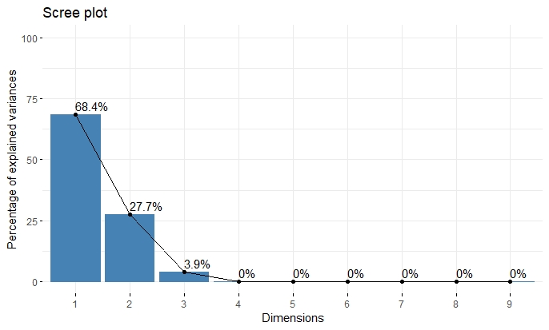
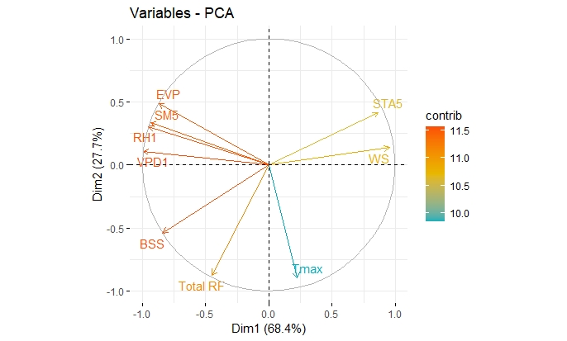
Fig 1(a) Scree plot and 1(b) variable factor map obtained from PCA analysis of first phenophase in green leaves mulch

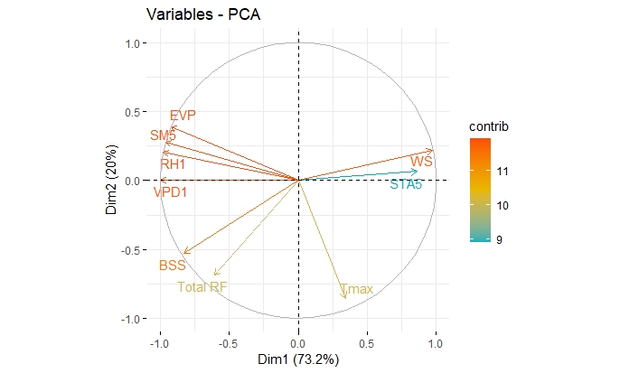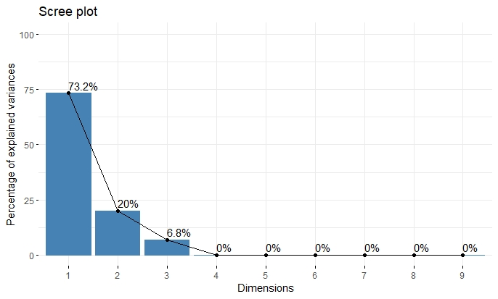
Fig 2(a) Scree plot and 2(b) variable factor map obtained from PCA analysis of first phenophase in paddy straw mulch

Fig 3(a) Scree plot and 3(b) variable factor map obtained from PCA analysis of first phenophase in dry coconut leaves mulch
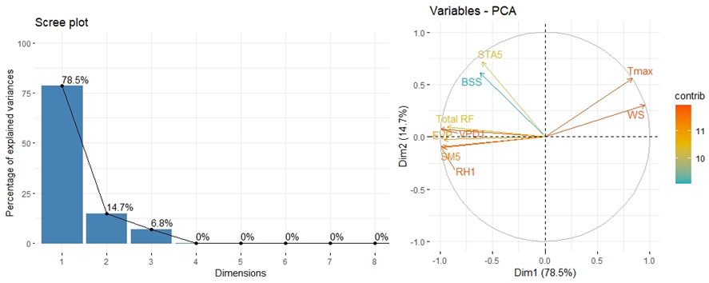

Fig 4(a) Observed yield and estimated yield in green leaves mulch

Fig 4(b) Observed yield and estimated yield in paddy straw mulch

Fig 4(c) Observed yield and estimated yield in dry coconut leaves mulch

