Landslide Susceptibility Mapping Using Weighted Overlay Analysis

.
ABSTRACT
In India's Upper Himalayas, in the state of Uttarakhand, the Bhilangana Basin is having fragile geologically and topographically complicated area where landslides occur very often. Based on the application of the Analytical Hierarchy Process (AHP) combined with the Weighted Overlay analysis method within a GIS environment, the study helps to make map landslide susceptibility zones in the bhilangna river basin. According to their geomorphological, climatic condition , and human intervention play a major role for landslide ,in the study we using ten causative factors which were chosen for study such as slope, digital elevation model (DEM), rainfall, curvature, land use/land cover (LULC), normalized difference vegetation index (NDVI), aspect, relative relief, distance from roads, and distance from rivers. AHP-derived weights identified slope (20%), road distance (18%), rainfall (14%), and river distance (13%) as the most significant factors. The combined susceptibility map categorized the basin into Low (40.6%), Moderate (46.0%), and High (11.97%) risk zones. High-risk areas, though in a narrow range of coverage, are practically all clustered in mid-elevation belts with high slopes, barren land, concave topography, and proximity to road and river networks. These zones pose high risks to infrastructure, transport, and settlement, that need site-specific mitigation work such as stabilization of slopes, improved drainage, and re-establishment of vegetation. The approach demonstrates the value of multi-criteria decision analysis for landslide hazard evaluation in mountainous regions and can be applied to disaster preparedness and land-use management in other mountain regions. Patients. These predictors still require additional work to establish reliability.The thematic maps that were partitioned into risk values and susceptibility classes were prepared from satellite, field, and secondary data.

Keywords: GIS, Landslide susceptibility mapping, weighted overlay,LULC,NDVI

- INTRODUCTION
Landslides are natural cause, particularly in mountain regions. Landslides is the movement of soil, rock, and debris down a slope due to the force of gravity. Natural processes may lead to landslides, but human intervention through deforestation, unplanned construction, alteration of slopes, and improper use of land also largely contributes to their occurrence and intensity (Rahman et al., 2020). Landslides cause massive loss to peoples life, property, and environmental damage globally, especially for geologically sensitive and densely populated areas. Uttarakhand, being part of the seismically active Himalayan belt of northern India, is extremely landslide-prone. Its young and unstable geological formations, steep slopes, heavy monsoonal rainfall, and recurring earthquakes make the state a landslide hotbed. Rudraprayag, Chamoli, Pithoragarh, Bageshwar, Tehri Garhwal, and Uttarkashi districts have witnessed scores of destructive events, like the 2013 Kedarnath flood and the 2021 Chamoli landslide (Dikshit et al., 2020) (Shrestha et al., 2025).
Human-caused stresses like accelerating urbanization, major hydropower schemes, intensifying road networks, and uncontrolled tourism have destabilized natural slopes further. Climate change has contributed to this threat by modifying rainfall patterns and ramping up glacial melting, which in turn increases slope failures, predominantly in the higher elevation areas.
To mitigate these issues, landslide hazard analysis is essential. It encompasses the determination of hazard-prone areas, exposure assessment, and vulnerability analysis (Du et al., 2020). Methods such as remote sensing, GIS, and Multi-Criteria Decision-Making (MCDM) technique such as AHP is used to create landslide susceptibility maps. Such maps helps in planning, infrastructure construction, and disaster preparedness (Anbalagan et al., 2015) (Sur et al., 2022).
In summary, an integrative strategy involving geospatial analysis, scientific evaluation, early warning systems, and awareness at the community level is essential in curbing landslide risk and building resilience in the ecologically vulnerable Uttarakhand.
2. methodology
2.1 Study Area
The Bhilangana Basin is located in the Upper Himalayan region, specifically within the Uttarkashi district of Uttarakhand, India. Covering an area of approximately 1400 square kilometers, the basin features elevation levels ranging between 4,000 and 5,800 m. Geographically, it is positioned between latitudes 31°1’39.31”N and 30°42’8.30”N, and longitudes 78°43’29.61”E to 79°50’45.55”E. The variation in elevation across the basin was assessed using Shuttle Radar Topography Mission (SRTM) Digital Elevation Model (DEM) data at a spatial resolution of 30 m, as depicted in Fig. 1.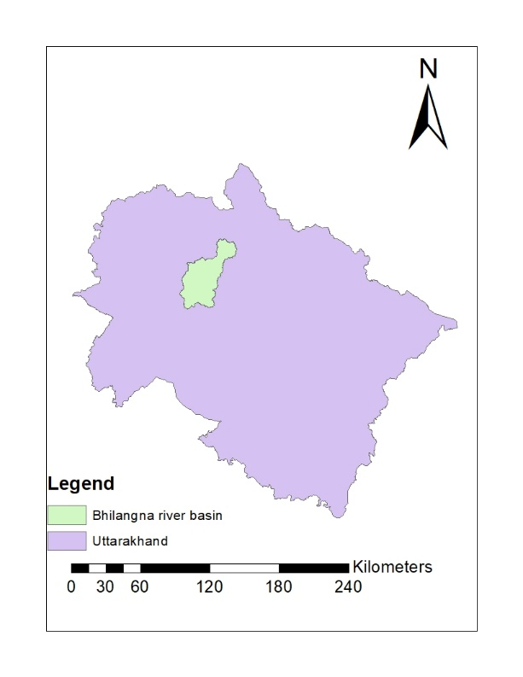
Fig. 1. Study Area, Bhilangna River Basin

Landslide susceptibility mapping is done using the Analytical Hierarchy Process (AHP) based Weighted Overlay method in GIS environment. The objective for the study is to delineate areas prone to landslides with the of multiple thematic layers. The parameters considered in this analysis are Slope, Digital Elevation Model (DEM), Rainfall, Curvature, Land Use Land Cover (LULC), Normalized Difference Vegetation Index (NDVI), Distance from Roads, Distance from Rivers, Aspect, and Relative Relief.

2.2 Generation and Classification of Thematic Layers
Bhilangana River Basin of area around 1400 km ² is located in the Upper Himalayas region in Uttarkashi district( Uttarakhand) it is geologically fragile and topographically complex region. Understanding the primary factors for landslides in this basin is to be critical and accurate for risk assessment and mitigation planning for future.
The following parameters were selected on the basis of their geomorphological, climatic, and anthropogenic relevance to the landslide occurrences in the region for the generation of thematic layer for landslide susceptibility mapping.
- Bhilangana River Basin have elevation ranges from approximately 4,000 to 5,800 m. Elevation effect rainfall intensity and weathering processes. At higher elevations the basin are more prone to frost action such as glacial melt, and precipitation induced slope failures, particularly in snow-bound and glaciated zones.
- Slope plays a determinant role for the gravitational force acting on slope materials. In the Bhilangana river Basin, the steep slopes dominate much of the terrain, particularly in high-relief zones, and make them highly vulnerable to mass destruction. Slopes exceeding 30° showed a higher landslide frequency, particularly during monsoon duration.
- Slope aspect determines the direction of slope exposurein the basin which affects solar radiation, snowmelt rates, and moisture retention. In the Bhilangana Basin, landslides are regresssly observed in southeast facing slopes because of higher sun exposure in the basin and accelerated thawing.

- Curvature helps to understand shape of the land surface and its impact on water flow with in the basin and its accumulation. Concave slopes within the Bhilangana River Basin prone to collect water and debris within the area, increasing the pore pressure and triggering slope for failures, whereas convex slopes often experience surface soil erosion.
- Bhilangna river basin receives the moderate to high rainfall in monsoon season, ranging from 550 mm to 1200 mm. heavy precipitation increases infiltration and saturation of soil and weathered rock, especially on deforested slopes, leading to frequent landslide activity in the middle and lower region of the mountain.
- Normalized Difference Vegetation Index (NDVI) is explained the Vegetation which helps to stabilize the slopes by reducing surface runoff and reinforcing the soil with root of the vegetation. In the Bhilangana river basin, areas with dead or sparse vegetation, because of deforestation or high altitude cold climatic conditions, show a higher incidence of landslides.
- Land Use and Land Cover (LULC) in Bhilangana River Basin includes various parameters. Landslides are primarily concentrated in forest region and barren areas of the basin, where human activity (e.g., slope cutting and logging) and natural exposure decrease slope stability. Some events also occurred near roads.
- Relative Relief in the basin exhibits a high variation in it, reflecting rugged terrain and steep elevation. Lower relative relief shows typically in middle elevations and have a higher landslide density showing the human interference and weathering processes than at higher altitudes.
- Distance from Roads in the Bhilangana River Basin shows that often curves into the steep hillsides without proper engineering measures. poor drainage and lack of vegetation near road area lead to increase in landslide occurrences, particularly during or after rainfall in the region.
- Distance from Streams significantly impact the slope stability because of toe soil erosion, increased saturation in soil and undercutting of soil. The Bhilangana River Basin and its tributaries erode the base of adjacent side slopes, particularly during the monsoon season, meandering nearby the areas are more susceptible to landslides.
3. results and discussion
The Bhilangana River Basin landslide susceptibility analysis was done employing Weighted Overlay within a GIS setting, using ten causative parameters: Elevation, Slope, Aspect, Curvature, Rainfall, NDVI, Land Use/Land Cover (LULC), Relative Relief, Distance from Roads, and Distance from Streams. Every parameter was categorized into sub-parameters and ranked using risk values based on their contribution to slope instability, deduced from field experience and literature.
3.1 Elevation and Slope
The elevation of the bhilangna river basin ranges from 4,000 m to more than 5,800 m. Areas prone to landslides was found in range of 2,700–4,600 m elevation, corresponding to the risk classes. These locations are transitional in type frequently with steep slopes paired with active human and glacial activity. Likewise, the slope factor indicated that regions with slopes exceeding 30° (high to very high class) were most vulnerable to landslides. These areas undergo gravitational stress and material detachment, particularly when there is intense rainfall and snowmelt.
3.2 Aspect and Curvature
Aspect analysis indicated a greater frequency of landslides on southeast slopes, which are more exposed to solar radiation, increasing snowmelt and summer soil dryness, followed by wetting during monsoon. Curvature analysis indicated that concave slopes were most prone to water accumulation and enhanced pore pressure, which caused failure in loose material.
3.3 Rainfall and NDVI
Rainfall intensity throughout the basin varied from 550 mm to 1200 mm. The areas of high rainfall (more than 1000 mm) showed a direct relation with higher landslide occurrence. NDVI analysis confirmed this finding, showing that dead or poor vegetation cover (NDVI value towards bare land or degraded vegetation) areas witnessed higher frequency of landslides. Vegetation loss diminishes root cohesion and enhances runoff, making the slope more unstable.
3.4 Land use and Land cover
LULC analysis indicated that landslides predominantly happened in barren land and forest categories. Forests in the mid-altitude zones, although providing some root reinforcement, tend to be degraded from anthropogenic activities. Barren lands indicated highest hazard due to absence of cover and susceptibility to erosive forces. While settlements were not the immediate site of landslides, proximity to built-up area, particularly roads, tended to indicate slope failures.
3.5 Relative Relief and Proximity Factors
Relative relief analysis showed that regions of moderate elevation range (99–180 m) were most prone to landslides because they normally consist of moderate to steep slopes with higher accessibility and human usage. Regions with very low relief (0–98 m), particularly valley floors, also indicated extensive landslide occurrence caused by sediment deposition and toe erosion. Distance from Road was identified as a key factor. Landslides were also commonly found along 100–300 m of road alignments, indicating the destabilizing influence of uncontrolled slope slashing, inadequate drainage, and vibrational loads from traffic. Likewise, sites within 100–200 m of streams were highly prone to sliding in light of toe erosion, undercutting, and saturation of slopes, particularly during monsoon and glacial melt seasons.
Table 1. Classification and score of landslide parameters

Parameter | Class Range / Type | Classification | Assigned Risk Value
Elevation (m) | 700–1800 | Very Low | 1
 | 1900–2600 | Low | 2
 | 2700–3500 | Moderate | 5
 | 3600–4600 | High | 7
 | 4700–6600 | Very High | 9
Slope (°) | 0–10 | Very Low | 1
 | 10–20 | Low | 2
 | 20–30 | Moderate | 3
 | 30–40 | High | 4
 | >40 | Very High | 5
Aspect | Flat | Flat | 1
 | North | North | 2
 | Northeast | Northeast | 7
 | East | East | 4
 | Southeast | Southeast | 9
 | South | South | 5
 | Southwest | Southwest | 4
 | West | West | 3
 | Northwest | Northwest | 2
Curvature | Flat | Flat | 1
 | Concave | Concave | 7
 | Convex | Convex | 5
Rainfall (mm) | 550–730 | Very Low | 1
 | 740–880 | Low | 3
 | 890–1000 | Moderate | 5
 | 1001–1100 | High | 8
 | 1101–1200 | Very High | 9
NDVI | Dead Plant | Dead vegetation | 9
 | Unhealthy vegetation | Unhealthy vegetation | 7
 | Moderate vegetation | Moderate vegetation | 4
 | Very healthy vegetation | Very healthy vegetation | 1
LULC | Water | Water | 1
 | Tree | Forest | 2
 | Crops | Agricultural | 3
 | Built-up area | Built-up | 8
 | Bare garland | Barren land | 9
 | Snow | Snow | 1
 | Rangeland | Rangeland | 3
Relative Relief | 0–98 | High | 9
 | 99–180 | Moderate | 5
 | 190–250 | Low | 2
Distance from Road (m) | 100 | Very High (near road) | 1
 | 200 | Low | 9
 | 300 | Moderate | 7
 | 400 | Low | 6
 | 500 | Very Low | 4
 | >500 | Normal | 2
Distance from Stream (m) | 100 | Very High | 9
 | 200 | Low | 6
 | 300 | Moderate | 5
 | 400 | Low | 3
 | 500 | Very Low | 2
 | >500 | Normal | 1
3.6 AHP Weight Calculation
To make the relative importance of landslide conditioning factors using for study, the Analytical Hierarchy Process (AHP) was employed. In this method a pairwise comparison matrix was constructed using the given priority values of the 10 parameters such as (Slope, DEM, Curvature, Rainfall, Aspect, Distance from Rivers, Distance from Roads, LULC, NDVI, and Relative Relief). The matrix was normalized and eigenvector weights were computed with respect to the parameters. The resulting consistency ratio coming is (CR = 0.0083) was found to be well below the acceptable threshold of 0.10 which is good. Among the factors which were using for the study are Slope, Distance from Roads, and Rainfall emerged as the most influential criteria for landslide susceptibility , whereas NDVI and Relative Relief showed comparatively lower weights.
Table 2. AHP Pairwise Matrix

 | DEM | Slope | Curvature | Rainfall | Aspect | Distance from Rivers | Distance from Roads | LULC | NDVI | Relative Relief
DEM | 1 | 0.3 | 1 | 0.5 | 2 | 0.5 | 0.5 | 1 | 2 | 3
Slope | 3 | 1 | 2 | 2 | 4 | 2 | 1 | 3 | 5 | 7
Curvature | 1 | 0.5 | 1 | 1 | 2 | 1 | 0.5 | 1 | 3 | 3
Rainfall | 2 | 0.5 | 1 | 1 | 3 | 1 | 1 | 2 | 4 | 5
Aspect | 0.5 | 0.25 | 0.5 | 0.3 | 1 | 0.3 | 0.25 | 0.5 | 1 | 2
Distance from Rivers | 2 | 0.5 | 1 | 1 | 3 | 1 | 1 | 2 | 3 | 4
Distance from Roads | 2 | 1 | 2 | 1 | 4 | 1 | 1 | 2 | 5 | 6
LULC | 1 | 0.33 | 1 | 0.5 | 2 | 0.5 | 0.5 | 1 | 2 | 3
NDVI | 0.5 | 0.2 | 0.33 | 0.25 | 1 | 0.33 | 0.2 | 0.5 | 1 | 1
Relative Relief | 0.33 | 0.14 | 0.33 | 0.2 | 0.5 | 0.25 | 0.16 | 0.33 | 1 | 1

TABLE 3. A pairwise comparison matrix was created for AHP, and consistency was checked (CR < 0.1) and normalized weight
Criteria | Given Priority | Normalized Weight
DEM | 8 | 0.07767
Slope | 20 | 0.194175
Curvature | 10 | 0.097087
Rainfall | 14 | 0.135922
Aspect | 5 | 0.048544
Distance from Rivers | 13 | 0.126214
Distance from Roads | 18 | 0.174757
LULC | 8 | 0.07767
NDVI | 4 | 0.038835
Relative Relief | 3 | 0.029126
3.7 Landslide Susceptibility Zonation Map
3.7.1 Overall Susceptibility Mapping
The integrated landslide susceptibility map categorized the basin into three susceptibility zones: Low, Moderate, and High-risk zones were primarily located in the mid-elevation zones of the basin, often near road networks, concave slopes, barren land, and steep gradients. These zones demand immediate attention for mitigation planning, especially in areas where infrastructure and settlements are expanding.
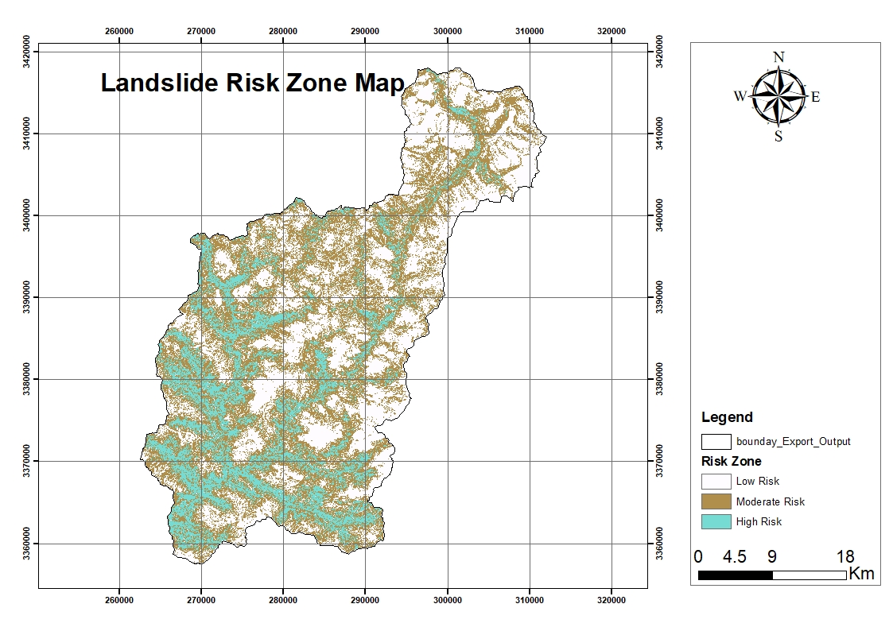
Fig. 2. Landslide Risk Zone Map
Table 4. Area Distribution of Susceptibility Classes
Susceptibility Zone | Area (sq.km) | Percentage (%)
Low | 569 | 40.6
Moderate | 645 | 46.0
High | 168 | 11.97
3.7.2 Validation with landslide inventory
The landslide susceptibility mapping of the Bhilangna River Basin which is around 1400 km² area, prepared using the Weighted Overlay Method which highlights the spatial possibility of landslide occurrence under the thematic layers used for study. The basin is classified by topography, terrain slopes, its lithology, and amount of rainfall in the study area. A total number of 353 landslide locations data which is obtained from the Bhookosh (GSI) landslide inventory, were used for validation of the susceptibility mapping zones .The thematic layers considered in the analysis include various 10 layer such as slope, elevation, relative relief, lithology of the area, amount of rainfall, land use/land cover (LULC), distance from roads, distance from streams, NDVI, curvature, and aspect. Each factor was assigned a individual relative weight based on its influence on landslide initiation in the region, and the weighted overlay technique was employed to generate the final susceptibility map. Validation was performed using 353 mapped landslide locations. Approximately 65–73% of the recorded landslides were found to have within the High and Very High Susceptibility mapping Zone, while only a small fraction around (<15%) occurred in the Low or Very Low zones. Based on the spatial agreement between predicted susceptibility and actual landslide occurrence points, the weighted overlay approach applied for Bhilangna River Basin appears to be robust. the results clearly shows the role of terrain slope , lithology of the area, and distance from roads and distance from streams as the most influential parameters in controlling slope instability. Road construction activities and slope disturbance by streams appear to be primary triggering factors for landslide. Areas under sparse vegetation and degraded forest cover (low NDVI values) also correspond well with high susceptibility classes, shows the importance of land cover in maintaining slope stability .Compared to similar studies in other Himalayan basins, the Bhilangna River Basin shows a higher proportion of terrain under moderate to high susceptibility, which can be attributed to its rugged topography, high relief, and the prevalence of structurally weak lithological units. The model outputs thus provide valuable insights for disaster risk reduction, infrastructure planning, and watershed management in this fragile Himalayan environment.
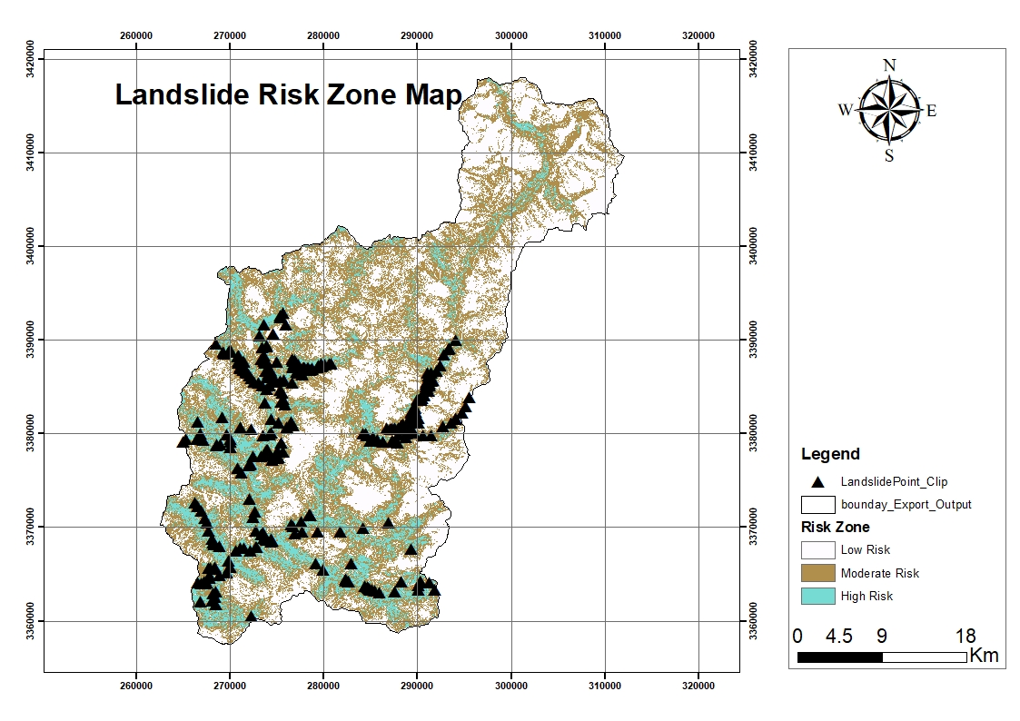
Fig.3.Validation point distribution Map
4. Conclusion

The susceptibility zonation classified the basin into 3 categories: Low, Moderate and High landslide susceptibility mapping zone. Most of the area of the river basin fell under moderate risk (46%) low risk (40.6%) and in high (11.97%) zones though spatially smaller pose significant threats to infrastructure, transportation networks, and nearby settlements. These areas require priority attention for slope stabilization, drainage improvement, and vegetation restoration.

COMPETING INTERESTS DISCLAIMER:
Authors have declared that they have no known competing financial interests OR non-financial interests OR personal relationships that could have appeared to influence the work reported in this paper.
Disclaimer (Artificial intelligence)
Option 1:
Author(s) hereby declare that NO generative AI technologies such as Large Language Models (ChatGPT, COPILOT, etc.) and text-to-image generators have been used during the writing or editing of this manuscript.
Option 2:
Author(s) hereby declare that generative AI technologies such as Large Language Models, etc. have been used during the writing or editing of manuscripts. This explanation will include the name, version, model, and source of the generative AI technology and as well as all input prompts provided to the generative AI technology
Details of the AI usage are given below:
1.
2.
3.

References

Agrawal, N., & Dixit, J. (2022). Assessment of landslide susceptibility for Meghalaya (India) using bivariate (frequency ratio and Shannon entropy) and multi-criteria decision analysis (AHP and fuzzy-AHP) models. All Earth, 34(1), 179. https://doi.org/10.1080/27669645.2022.2101256
Akbar, T.A. and Ha, S.R. (2011). Landslide hazard zoning along Himalayan Kaghan Valley of Pakistan by integration of GPS, GIS, and remote sensing technology. Landslides, 8(4): 527-540.
Akgun, A. and Türk, N. (2010). Landslide susceptibility mapping for Ayvalik (Western Turkey) and its vicinity by multicriteria decision analysis. Environ. Earth Sci., 61(3): 595-611.
Anbalagan, R., Kumar, R., Lakshmanan, K., Parida, S., & Neethu, S. (2015). Landslide hazard zonation mapping using frequency ratio and fuzzy logic approach, a case study of Lachung Valley, Sikkim. Geoenvironmental Disasters, 2(1). https://doi.org/10.1186/s40677-014-0009-y
Avtar, R., Singh, C.K., Singh, G., Verma, R.L., Mukherjee, S. and Sawada, H. (2011). Landslide susceptibility zonation study using remote sensing and GIS technology in the Ken-Betwa River Link area, India. Bull. Eng. Geol. Environ., 70(4): 595-606.
Basharat, M., Shah, H. R., and Hameed, N. (2016). Landslide susceptibility mapping using GIS and weighted overlay method: a case study from NW Himalayas, Pakistan. Arabian Journal of Geosciences, 9(4). https://doi.org/10.1007/s12517-016-2308-
Batar, A. K., and Watanabe, T. (2021). Landslide Susceptibility Mapping and Assessment Using Geospatial Platforms and Weights of Evidence (WoE) Method in the Indian Himalayan Region: Recent Developments, Gaps, and Future Directions. ISPRS International Journal of Geo-Information, 10(3), 114. https://doi.org/10.3390/ijgi10030114
Chang, K.-T., Merghadi, A., Yunus, A. P., Pham, B. T., and Dou, J. (2019). Evaluating scale effects of topographic variables in landslide susceptibility models using GIS-based machine learning techniques. Scientific Reports, 9(1). https://doi.org/10.1038/s41598-019-48773-2
Chauhan, S., Sharma, M., Arora, M.K. and Gupta, N.K. (2010). Landslide susceptibility zonation through ratings derived from artificial neural network. Int. J. Appl. Earth Obs. Geoinf., 12(5): 340-350.
Chauhan, V., Gupta, L., and Dixit, J. (2025). Landslide susceptibility assessment for Uttarakhand, a Himalayan state of India, using multi-criteria decision making, bivariate, and machine learning models. Geoenvironmental Disasters, 12(1). https://doi.org/10.1186/s40677-024-00307-3
Daneshvar, M.R. and Bagherzadeh, A. (2011). Landslide hazard zonation assessment using GIS analysis at Golmakan Watershed, Iran. Front. Earth Sci., 5(1): 70-81.
Devara, M., Tiwari, A. and Dwivedi, R. (2021). Landslide susceptibility mapping using MT-InSAR and AHP enabled GIS-based multi-criteria decision analysis. Geomat. Nat. Hazards Risk, 12(1): 675-693.
Dikshit, A., Sarkar, R., Pradhan, B., Segoni, S., & Alamri, A. (2020). Rainfall Induced Landslide Studies in Indian Himalayan Region: A Critical Review [Review of Rainfall Induced Landslide Studies in Indian Himalayan Region: A Critical Review]. Applied Sciences, 10(7), 2466. Multidisciplinary Digital Publishing Institute. https://doi.org/10.3390/app10072466
Dikshit, A., Sarkar, R., Pradhan, B., Segoni, S., and Alamri, A. (2020). Rainfall Induced Landslide Studies in Indian Himalayan Region: A Critical Review [Review of Rainfall Induced Landslide Studies in Indian Himalayan Region: A Critical Review]. Applied Sciences, 10(7), 2466. Multidisciplinary Digital Publishing Institute. https://doi.org/10.3390/app10072466
Du, J., Glade, T., Woldai, T., Chai, B., & Zeng, B. (2020). Landslide susceptibility assessment based on an incomplete landslide inventory in the Jilong Valley, Tibet, Chinese Himalayas. Engineering Geology, 270, 105572. https://doi.org/10.1016/j.enggeo.2020.105572
Du, J., Glade, T., Woldai, T., Chai, B., and Zeng, B. (2020). Landslide susceptibility assessment based on an incomplete landslide inventory in the Jilong Valley, Tibet, Chinese Himalayas. Engineering Geology, 270, 105572. https://doi.org/ 10.1016 j.enggeo.2020.105572
Ghimire, M., & Timalsina, N. (2020). Landslide Distribution and Processes in the Hills of Central Nepal: Geomorphic and Statistical Approach to Susceptibility Assessment. Journal of Geoscience and Environment Protection, 8(12), 276. https://doi.org/10.4236/gep.2020.812017
Ghimire, M., and Timalsina, N. (2020). Landslide Distribution and Processes in the Hills of Central Nepal: Geomorphic and Statistical Approach to Susceptibility Assessment. Journal of Geoscience and Environment Protection, 8(12), 276. https://doi.org/ 10.4236/gep.2020.812017
Hussain, S., Sun, H., Ali, M. Z., and Ali, M. Z. (2021). PS-InSAR based validated landslide susceptibility modelling: a case study of Ghizer valley, Northern Pakistan. Geocarto International, 37(13), 3941. https://doi.org/ 10.1080/ 10106049.2020.1870165
Kamp, U., Growley, B.J., Khattak, G.A. and Owen, L.A., (2008). GIS-based landslide susceptibility mapping for the 2005 Kashmir earthquake region. Geomorphology, 101(4): 631-642.
Kayastha, P., Dhital, M.R. and De Smedt, F. 2013. Application of the analytical hierarchy process (AHP) for landslide susceptibility mapping: A case study from the Tinau watershed, west Nepal. Comput. Geosci., 52: 398-408.
Khaidem, S., and Singh, K. (2021). Landslide Susceptibility Mapping along Manipur-Assam NH-37. IOP Conference Series Earth and Environmental Science, 889(1), 12002. https://doi.org/10.1088/1755-1315/889/1/012002
Mandal, K., Saha, S., & Mandal, S. (2021). Applying deep learning and benchmark machine learning algorithms for landslide susceptibility modelling in Rorachu river basin of Sikkim Himalaya, India. Geoscience Frontiers, 12(5), 101203. https://doi.org/10.1016/j.gsf.2021.101203
Mandal, K., Saha, S., and Mandal, S. (2021). Applying deep learning and benchmark machine learning algorithms for landslide susceptibility modelling in Rorachu river basin of Sikkim Himalaya, India. Geoscience Frontiers, 12(5), 101203. https://doi.org/10.1016/j.gsf.2021.101203
Melsse, D. W., Tegegne, M. A., Mekonnen, Y. A., and Bihon, Y. T. (2025). Morphometric analysis for understanding river basin hydrology: a case of gelda watershed, Tana Sub-Basin, Ethiopia. Applied Water Science, 15(7), 171. https://doi.org/10.1007/s13201-025-02526-x
Mondal, S. and Maiti, R. (2012). Landslide susceptibility analysis of Shiv-Khola watershed, Darjiling: a remote sensing and GIS based Analytical Hierarchy Process (AHP). J. Indian Soc. Remote Sens., 40(3): 483-496.
Napoli, M. D., Martire, D. D., Bausilio, G., Calcaterra, D., Confuorto, P., Firpo, M., Pepe, G., and Cevasco, A. (2021). Rainfall-Induced Shallow Landslide Detachment, Transit and Runout Susceptibility Mapping by Integrating Machine Learning Techniques and GIS-Based Approaches. Water, 13(4), 488. https://doi.org/10.3390/w13040488
Nath, N. K., Panigrahi, B., Raul, S. K., & Paul, J. C. (2021). Development of landslide susceptibility maps of Tripura, India using GIS and analytical hierarchy process. Research Square (Research Square). https://doi.org/10.21203/rs.3.rs-175331/v1
Noorollahi, Y. (2018). Landslide modelling and susceptibility mapping using AHP and fuzzy approaches. International Journal of Hydrology, 2(2). https://doi.org/ 10. 15406/ijh.2018.02.00063
Othman, A.N., Naim, W.M. and Noraini, S. (2012). GIS based multi-criteria decision making for landslide hazard zonation. Procedia Soc. Behav. Sci., 35: 595-602.
Panchal, S., and Shrivastava, A. K. (2020). Application of analytic hierarchy process in landslide susceptibility mapping at regional scale in GIS environment. Journal of Statistics and Management Systems, 23(2), 199. https://doi.org/ 10.1080/ 09720510.2020.1724620
Pandey, A., Dabral, P.P., Chowdary, V.M. and Yadav, N.K. (2008). Landslide hazard zonation using remote sensing and GIS: a case study of Dikrong river basin, Arunachal Pradesh, India. Environ. Geol., 54(7): 1517-1529.
Pathak, L., Baral, B., Joshi, K., Basnet, D. R., and Godone, D. (2025). Landslides in the Himalayas: The Role of Conditioning Factors and Their Resolution in Susceptibility Mapping. Geosciences, 15(4), 131. https://doi.org/10.3390 /geosciences15040131
Pirasteh, S., and Li, J. (2017). Probabilistic frequency ratio (PFR) model for quality improvement of landslide susceptibility mapping from LiDAR-derived DEMs. Geoenvironmental Disasters, 4(1). https://doi.org/10.1186/s40677-017-0083-z
Pradhan, B. (2010). Use of GIS-based fuzzy logic relations and its cross application to produce landslide susceptibility maps in three test areas in Malaysia. Environmental Earth Sciences, 63(2), 329. https://doi.org/10.1007/s12665-010-0705-1
Qi, T., Zhao, Y., Meng, X., Chen, G., and Dijkstra, T. (2021). AI-Based Susceptibility Analysis of Shallow Landslides Induced by Heavy Rainfall in Tianshui, China. Remote Sensing, 13(9), 1819. https://doi.org/10.3390/rs13091819
Rahman, G., Rahman, A., Bacha, A. S., Mahmood, S., Moazzam, M. F. U., & Lee, B. G. (2020). Assessment of Landslide Susceptibility using Weight of Evidence and Frequency Ratio Model in Shahpur Valley, Eastern Hindu Kush. https://doi.org/10.5194/nhess-2020-167
Rasheed, Y., Agalgaonkar, A. P., and Muttaqi, K. M. (2025). Enhancing Resiliency in Distribution Power Grids with Distributed Generation Through Application of Visualisation Techniques. Energies, 18(7), 1847. https://doi.org/ 10.3390/ en18071847
Roccati, A., Paliaga, G., Luino, F., Faccini, F., and Turconi, L. (2021). GIS-Based Landslide Susceptibility Mapping for Land Use Planning and Risk Assessment. Land, 10(2), 162. https://doi.org/10.3390/land10020162
Saha, A.K., Gupta, R.P., Sarkar, I., Arora, M.K. and Csaplovics, E. (2005). An approach for GIS-based statistical landslide susceptibility zonation—with a case study in the Himalayas. Landslides, 2(1): 61-69.
Selamat, S. N., Majid, N. A., and Taha, M. R. (2025). Multicollinearity and spatial correlation analysis of landslide conditioning factors in Langat River Basin, Selangor. Natural Hazards, 121(3), 2665-2684.
Shano, L., Raghuvanshi, T. K., and Meten, M. (2020). Landslide susceptibility evaluation and hazard zonation techniques – a review [Review of Landslide susceptibility evaluation and hazard zonation techniques – a review]. Geoenvironmental Disasters, 7(1). Springer Nature. https://doi.org/10.1186/ s40677-020-00152-0
Sharma, M. and Kumar, R. (2008). GIS-based landslide hazard zonation: a case study from the Parwanoo area, Lesser and Outer Himalaya, HP, India. Bull. Eng. Geol. Environ., 67(1): 129-137.
Shrestha, M., Sharma, S., & Shrestha, R. P. (2025). Landslides in the Himalayas: A Comprehensive Review of Hazards, Impacts, and Adaptive Strategies [Review of Landslides in the Himalayas: A Comprehensive Review of Hazards, Impacts, and Adaptive Strategies]. Deleted Journal, 3(1), 10002. https://doi.org/10.70322/rrd.2025.10002
Sinčić, M., Gazibara, S. B., Krkač, M., and Arbanas, S. M. (2022). Landslide susceptibility assessment of the city of karlovac using the bivariate statistical analysis. Rudarsko-Geološko-Naftni Zbornik, 37(2), 149. https://doi.org/ 10.17794/ rgn.2022.2.13
Sujatha, E. R., and Sridhar, V. (2021). Landslide Susceptibility Analysis: A Logistic Regression Model Case Study in Coonoor, India. Hydrology, 8(1), 41. https://doi.org/10.3390/hydrology8010041
Sur, U., Singh, P., and Meena, S. R. (2020). Landslide susceptibility assessment in a lesser Himalayan road corridor (India) applying fuzzy AHP technique and earth-observation data. Geomatics Natural Hazards and Risk, 11(1), 2176. https://doi.org/10.1080/19475705.2020.1836038
Sur, U., Singh, P., Meena, S. R., & Singh, T. N. (2022). Predicting Landslides Susceptible Zones in the Lesser Himalayas by Ensemble of Per Pixel and Object-Based Models. Remote Sensing, 14(8), 1953. https://doi.org/10.3390/rs14081953
Sur, U., Singh, P., Meena, S. R., and Singh, T. N. (2022). Predicting Landslides Susceptible Zones in the Lesser Himalayas by Ensemble of Per Pixel and Object-Based Models. Remote Sensing, 14(8), 1953. https://doi.org/ 10.3390/ rs14081953
Veerappan, R., Negi, A. and Siddan, A. (2017). Landslide susceptibility mapping and comparison using frequency ratio and analytical hierarchy process in part of NH-58, Uttarakhand, India. ‘In: Workshop on World Landslide Forum’ at Slovenia, during. May. pp. 1081-1091.
Xie, W., Li, X., Jian, W., Yang, Y., Liu, H., Robledo, L. F., & Nie, W. (2021). A Novel Hybrid Method for Landslide Susceptibility Mapping-Based GeoDetector and Machine Learning Cluster: A Case of Xiaojin County, China. ISPRS International Journal of Geo-Information, 10(2), 93.

