Assessing the Condition of Web-Based Waste Bank Information Management System in Padang City

Abstract

Many residents of Padang city are still unaware the nearest location of the waste bank. The use of Geographic Information Sistem (GIS) web-based allows spatial information give the location and status of waste banks to be accessed by the public in real-time, openly, and in an integrated manner. This research aims to describe the development of a web-based waste bank (GIS) to manage waste bank and reduce waste accumulation in Padang City The type of research is mixed methods approach to obtain more comprehensive and contextual data regarding the developed system The research location is the waste bank located in Padang city Data collection techniques include interviews, observation, documentation, and online questionnaires. Research findings reveal a decline in the distribution of waste banks in Padang City. This is evidenced by data found after field observations: the number of active waste banks is 62 units registered with the DLH, and 1 unit is not yet registered. Whereas, data from the DLH shows that the number of active waste banks in Padang City is 168 units. Some of the publicappreciating the digital mapping of waste bank locations because previously information was only in the form of manual documents. Based on the distribution of the survey on user perception of the web-based waste bank (GIS), it can be concluded that the majority of respondents stated they "strongly agree" with the (GIS) interface. However, there are some areas for improvement, such as the need for integration of the waste scale reporting feature and an automated notification system. Therefore, this research can be used as a reference for other researchers to develop a web-based waste bank, ultimately creating a waste-free Padang city.

Keywords: management, GIS, waste bank, web

- Introduction
Padang City as the capital of West Sumatera also experieced has a massive accumulation of waste (Admin Diskominfo, 2023), In fact, there was found that in one day it can bulid 640 tons. Therefore, it is hoped the mayor's participation to encourage citizens in waste bank management. Overcoming the massive accumutation of waste, Wako invites all citizens to manage their waste begin from their own home.

The increasing volume of landfills needs management. Waste bank management that does not use friendly environmentally methods and techniques can cause a negative impact on health and bother environmental function sustainability both residential and forest environments, rice fields, rivers and ocean. In fact, if waste do not manage properly, it will have a negative impact on the environment, including: environmental pollution, causes of disease and clogged drains and floods. The same thing was expressed by (Adistha Eka Noveyani, Iva Nuril Ma'rifa, Elly, 2023) Improper waste management can cause various problems for human life, namely as a source of infectious diseases including diarrhea, typhus and respiratory tract infections, and so on.
Waste that is managed properly and in an friendly environment can have a positive impact on society and the environment itself. In waste management, legal certainty, clarity of government responsibilities and authorities, and community participation are expected to ensure effective waste management. The government establishes a mechanism for managing household and household-type waste through Law Number 18 of 2008, Article 20. This is evidenced by Law Number 18 of 2008. (INDONESIA, 2008) which reads "The central government and regional governments are obliged to carry out the activities referred to in paragraph (1) as follows: a. determine targets for gradual waste reduction within a certain time period; b. facilitate the application of environmentally friendly technology; c. facilitate the application of environmentally friendly product labels; d. facilitate reuse and recycling activities; and e. facilitate the marketing of recycled products. The same thing was also expressed by(Guardian, 2021), in Article 5 paragraph 1 concerning the management of recycled waste products consisting of: regional apparatus; waste management institutions; waste banks; and/or craftsmen of recycled waste products.
Similarly, the Brazilian government has also created a policy on waste management. This was stated by (Campos et al., 2002) In recent years, the environmental impact of solid waste has prompted the implementation of new government policies for solid waste management. In an effort to improve waste management practices, Brazilian authorities introduced the National Solid Waste Policy (NPSW), which sets goals, prohibits inadequate waste disposal, and provides incentives for material reuse and recycling.
A good waste bank must have criteria such as having a legal entity, an administrative system, a permanent collector, a savings book, and a responsible party and other officers (Juju, 2012). Based on data presented by Mrs. Siti Nurbaya Bakar, as Minister of Environment and Forestry (LHK),when Currently, there are 25,540 waste bank units in Indonesia, one of which is a waste bank operated by PT Pegadaian. (Full Moon, 2023).
Specifically in Padang City, the number of waste banks in Padang City is currently the largest in West Sumatra province, with 188 active waste banks and 20 inactive waste banks recorded by the Padang City Environmental Agency (DLH). Based on field observation data obtained from the Padang City Environmental Agency in January 2025, data on waste banks was obtained and grouped by sub-district. However, according to data from the Padang City Environmental Agency (DLH), waste bank locations remain unevenly distributed and digital information is limited. Many residents don't know the location of their nearest waste bank, its operating hours, or the types of waste accepted.
To address the waste bank problem in Padang City, a modern website-based information system is needed. (Burrough & Rachael A. McDonnell, 1998; Ari Muhardono et al., 2023; Mayra et al., 2025; Muttaqin et al., 2024) stating through the use of technology Geographic Information System (GIS) and systemWeb-based, spatial information about waste banks can be accessed widely and in real time. The use of Geographic Information System (GIS) technology and web-based information systems allows spatial information on the location and status of waste banks to be accessed by the public in real time, openly, and integrated. This technology supports better decision-making in waste management, encourages public participation, and increases the transparency and effectiveness of environmental management systems at the local level.
Besides that, (Annisha et al., 2025) also implemented a modern website-based information system at the Karya Mandiri Waste Bank in Padang City. This system improves data management efficiency, reduces human error, and ensures data transparency accessible to customers. With a website-based waste bank information system, managers can more easily monitor operational progress, while customers gain direct access to quickly and accurately check balances, transactions, and other information.
Based on the background above and previous research, there are still few studies that discuss development. Geographic Information System (GIS) Web-based waste bank. Therefore, this study examines the "Development ofGeographic Information System (GIS) Web-Based Waste Bank in Padang City”. This research aims to realize a clean and waste-free Padang city that requires efforts to change community behavior in the form of environmental awareness. In addition, the Environmental Agency's supervision of the management of this waste bank is still weak, because they only rely on initial data from when the waste bank was first established but do not supervise the waste bank. In addition, the weak public awareness to be able to save in the waste bank is also due to the lack of socialization carried out by the Environmental Agency to the community itself. Thus, this research provides a new contribution by combining aspects of development Geographic Information System (GIS), waste bank and Web in waste bank management to reduce waste accumulation through web-based programs in Padang City. Additionally, the web-based GIS waste bank can provide extensive information to the public, who initially were unaware of the waste bank program, making them interested in actively participating for environmental cleanliness and helping family finances. Thru the waste bank program, the public can become more creative and innovative in utilizing waste into commercial economic materials.

2. Materials and Methods
This type of research uses Mixed Methods with a Sequential Explanatory design with the following stages:
- Stage 1 (Quantitative): public perception of waste bank management and development of web-based waste bank (GIS).
- Stage 2 (Qualitative): Interviews with the community and managers to determine the needs of a waste bank management system.
According to (Creswell & Vicki L. Plano Clark, 2011), Mixed methods is a systematic research approach that combines quantitative and qualitative methods in one study to strengthen the validity and completeness of the results.
Referring to Moleong (2019:105), the research location is the place of knowledge that describes where the research is located. Specifically for Padang City, the number of waste banks in Padang City, based on data from the Environmental Agency (DLH), is currently the largest in West Sumatra province with 168 active waste banks recorded out of 188 waste banks in the province. The data collection techniques of this study using interviews, observation, and documentation based on the opinion of Moleong (2019:163),
According to Sugiyono (2019), random sampling is a random sampling technique where every member of the population has an equal chance of being selected as a research respondent. Therefore, respondent selection in this study used the random sampling technique. The application of random sampling means the researcher can randomly select residents, waste bank managers, or community groups from the target population. Beside the community and the managers of the waste bank, the respondents in this study needed information from service officers (stakeholders) as more in-depth informants about information regarding waste banks and waste management. Stakeholders include the Padang City Environmental Agency (DLH), PT. Semen Padang, and PT Pegadaian Padang City.
Furthermore, quantitative data analysis techniques were obtained from questionnaires distributed to users of the Web-Based Geographic Information System (GIS) for the Waste Bank, such as the public, waste bank managers, and government officials. This data was analyzed using descriptive statistics techniques. The questionnaire was structured based on a five-point Likert scale, as explained by Sugiyono (2019:147).This questionnaire consists of 5 answer choices, namely strongly disagree, disagree, neutral, agree, and strongly agree. The indicators used to base the statements in the questionnaire are: (1) knowledge and perceptions about waste banks; (2) obstacles regarding waste banks; and (3)Perceptions of Web-Based GIS Systems.This questionnaire was distributed to respondents online via Google Form with the link:https://forms.gle/DVDAaZurN4XtrYaV8). The questionnaire data processing uses SPSS to see the hypothesis test, homogeneity test, normality test, regression, and correlation.
This study uses source triangulation techniques to ensure the validity of the findings, namely by comparing the results of interviews, supporting documents, and field observations. In the web-based system development stage, this study uses two methods: the spiral method and the testing method according to (Pressman, 2001)as follows.
- Spiral Method
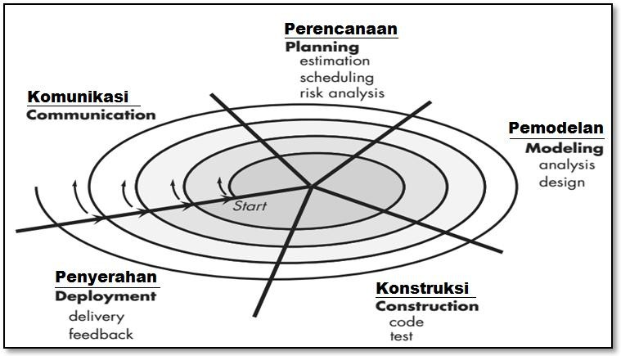
The Spiral Method is an evolutionary software model that combines an iterative prototyping approach with the systematic and controlled aspects of the waterfall model. The stages of spiral model development can be seen in Figure 1.

Figure 1. Spiral Model
(Source:Pressman, 2001:54)
The spiral software development process model is a risk-driven software process model used to guide stakeholders to simultaneously engineer highly nuanced software systems. The spiral model has two main distinguishing features compared to other models. The stages in the Spiral Model are as follows (Pressman, 2001):
- Communication is the first stage in the spiral development method, Customer Communication; communication between the developer and the customer.
- Planning is the second stage in the spiral development method. This stage involves planning the resources, time required, and other information related to software development. It also creates a schedule of activities for the system development process and analyzes the management and technical risks of software development.
- Modeling is the third stage in the spiral development method. In this stage, the process is to model the system to be developed by creating a data flow with DFD (Data Flow Diagram) and data modeling with ERD (Entity Relational Database) as well as an analysis of the system to be built.
- Construction (Construction) the fourth stage in the spiral development method, Construction and release; testing, installation, and providing support including training for users and creating documentation. At this stage the program is coded by creating a programming interface design that will be used, namely using PHP (Hetertext Preprocessor) and MySQL as its database and conducting testing or testing using Blackbox, where in this case the program is tested to determine whether the software created is in accordance with the specified limitations whether the input is valid or invalid and whether the output produced by the system is appropriate or not.
- Deployment is the final stage in the spiral development method, Customer Evaluation, which assesses the engineering results. At this stage, the application is handed over and evaluated to determine whether it meets the initial stages of the spiral development method: Communication, Planning, Modeling, and Construction and whether it meets the customer's wishes.
The advantages of the Spiral model are as follows:
- It takes into account the risk of possible errors so it is very reliable for large-scale software development.
- This model approach is carried out through very good stages by combining the waterfall model with repetitions so that it is more realistic in reflecting the actual situation.
- Both developers and users can quickly identify the shortcomings and errors in the system because the processes can be observed well.
Apart from that, the spiral model also has the following disadvantages:
- The time required to develop software is quite long and the costs are also high.
- It really depends on the experts who can estimate the risks.
- There are also difficulties in controlling the process. Currently, because it is relatively new, there is no evidence that this method is reliable enough to be implemented.
- Convincing consumers (especially in contract situations) that the evolutionary approach can be controlled.
From the description of the advantages and disadvantages of the spiral model, it can be seen that this model is highly suitable for large-scale systems and software development, where developers and users can more easily understand the conditions at each stage and react to potential errors. Furthermore, it is expected that sufficient time and funding will be available.

Testing Method
According to (Pressman, 2001) Black box testing, also called behavioral testing, focuses on the functional requirements of software. That is, black box testing techniques allow you to create multiple sets of input conditions that will fully implement all functional requirements for a program. Black box testing is not an alternative to white box testing. Rather, it is a complementary approach that may be used to uncover different classes of errors than those uncovered by white box methods.
Black box testing attempts to find errors in the following categories: (1) incorrect or missing functions, (2) interface errors, (3) errors in data structures or external database access, (4) behavioral or performance errors, and (5) initialization and termination errors. By applying black box techniques, you obtain a set of test cases that meet the following criteria: (1) test cases that reduce by greater than one the number of additional test cases that must be designed to achieve reasonable testing, and (2) test cases that say something about the presence or absence of a class of errors, rather than errors related only to the specific test for which they were created (Pressman, 2012). The following is an example of black box testing on the exit menu.

Table 1: Black Box Testing Example Table
Test Class | Test Scenario | Expected results | Conclusion
Login Menu | When input ID and password | Come on stagehome page | [√] Success  [ ] Not successful

So, it can be concluded that blackbox testing focuses on the functional specifications of the software or the process of running an application to determine whether there are errors or if any functions are not working as expected. Therefore, for testing this inventory system, the researcher preferred to use blackbox testing to test all functions within the system.

3. Results and Discussion
a.1. Location of Waste Banks in Padang City
Based on data from the Environmental Service (DLH) Padang City in January 2025Padang City currently has the largest number of waste banks in West Sumatra province, with 168 active waste banks registered out of 188 in the province. This is evident in the distribution of waste banks in Padang City, can be seen from the following table:
Table 2. Distribution of Padang City Waste Banks
No. | District Name | Number of Waste Banks | Active | Not active
1. | West Padang | 12 | 9 | 3
2. | East Padang | 12 | 11 | 1
3. | South Padang | 7 | 4 | 3
4. | North Padang | 10 | 8 | 2
5. | Central City | 37 | 36 | 1
6. | Kuranji | 17 | 15 | 2
7. | Nanggalo | 29 | 23 | 6
8. | Pauh | 39 | 39
9. | Begalung Basin | 18 | 16 | 2
10. | Lubuk Kilangan | 6 | 6
11. | Bungus Teluk Kabung | 1 | 1 | 0
Amount |  | 188 | 168 | 20
(Data Source: Padang City Environmental Agency 2025)

However, after conducting research with field observations from March to July 13, 2025, there was a decrease in the number of active waste banks in Padang City. The data from the Environmental Agency (DLH) shows that the number of active waste banks in Padang City is 168 units. Meanwhile, based on the data observation found that the number of active waste banks is 62 units registered with the DLH and 1 unit is not registered, bringing the total to 63 active waste banks. Furthermore, there are 105 inactive waste banks. This can be seen in the table of results of data observations of waste bins in Padang City.

Table 3. Primary Data Processing 2025 on the Distribution of Padang City Waste Banks
No. | District Name | Number of Waste Banks | Active | Not active
1. | West Padang | 12 | 3 | 9
2. | East Padang | 12 | 4 | 8
3. | South Padang | 7 | 3 | 4
4. | North Padang | 10 | 2 | 8
5. | Central City | 37 | 16 | 21
6. | Kuranji | 17 | 11 | 6
7. | Nanggalo | 29 | 6 | 23
8. | Pauh | 39 | 2 | 37
9. | Begalung Basin | 18 | 10 | 8
10. | Lubuk Kilangan | 6 | 5 | 1
11. | Bungus Teluk Kabung | 1 | 1 | 0
Amount |  | 188 | 63 | 125

The inactivity of several waste banks in Padang City is due to several factors. This data was discovered during observations and interviews with the community, waste bank managers, and local government officials, such as employees and village heads. The factors contributing to the inactivity of waste banks in Padang City include:
- The society who do not active participate in managing waste bank because they have moved house/domicile and lack of financial support from the government and related institutions.
- The society are not willing to be appointed as waste bank managers because they already have permanent jobs, some even prefer to become scavengers because the money they get from scavenging for waste is received immediately without having to wait for the amount of waste that has been sorted to accumulate.
- The operational time of the waste bank do not match with the activities of the waste bank customers, resulting in excessive waste accumulation in customers' homes.
- In administration, there is no transparency regarding the incentives received by waste bank managers and customers.
Based on the data on active and inactive waste banks in table 3 above,

Fig 2: a spatial distribution map of waste banks in Padang City can be depicted, namely.
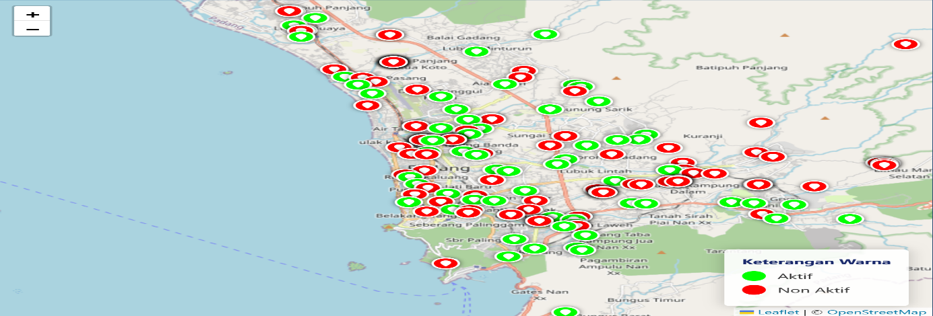

Color description:

(Green) indicates an active waste bank

(Red) indicates that the waste bank is inactive.

a.2. Results of the Analysis of Public Perceptions of Geographic Information System (GIS) Web-Based Waste Bank
Based on the results of distributing questionnaires to 174 respondents, an overview of the level of knowledge, perceptions, obstacles, and responses to the development of a web-based geographic information system (GIS) for waste banks was obtained. The questionnaire instrument was developed based on seven main sub-indicators, with a 5-point Likert scale. Based on the results of the questionnaire analysis, it can be described that the respondents consisted of active and inactive waste bank managers, customers, and the general public. The respondents ranged in age from 27 to 63 years with various educational backgrounds, from elementary school graduates to doctoral graduates. Respondents were spread across all sub-districts in Padang City. Of the 174 respondents, 119 people (68.4%) had used waste bank services and 55 people (31.6%) stated that they had never used waste bank services.
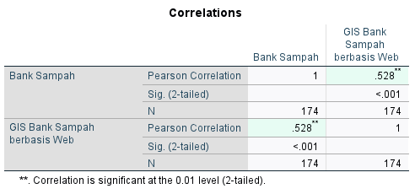
Table 4 Correlation Results of Questionnaire Distribution on DevelopmentGeographic Information SystemWeb-Based (GIS) in Padang City

Based on to the table above, the correlation between the waste bank variable and the web-based GIS for waste bins is 0.58. Based on theory, the correlation coefficient can be said to be at a moderate level, while the asterisk in the table indicates that the higher the use of waste banks, the higher the use of GIS for waste banks in the community.

a.3. Analysis Results of the Development of a Web-Based GIS Waste Bank System
This research uses a design model with the final result being a ready-to-use application for online recording, documentation, and storage, allowing the people of Padang City to obtain fast, accurate information about the existence of waste banks through a web-based (GIS). The application is designed using the PHP (Hypertext Preprocessor) programming language, which can be accessed using any browser. The application's appearance is quite simple and can dynamically adjust to the size of the gadget used by users, managers, and waste bank customers.
The result of this research is a web-based application, namely the Waste Bank Application with the name "Padang Waste Bank" which is installed on a server from Anymhost with a hosting option using the Warrior package and the domain used is my.id. so that the application can be called using the address: https://padang.survey.my.id/banksampah/. Furthermore, the "Padang Waste Bank" application that has been developed will be socialized to partner communities through village or sub-district officials.
The Unified Modeling Language (UML) modeling language is used when designing object-oriented applications.
1. System Design Use Case Diagram

This diagram shows all the system activities performed from the user's perspective. This diagram does not show how the system works, but shows what it does. This helps the writer know What functions are in the system and who can use those functions? The following is a Use Case Diagram of the application that will be developed by the researcher:

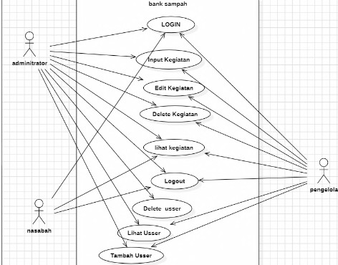

Figure 3.Use Case Diagram

- Interface Design Implementation
  - Home Page
The main page's appearance was kept as simple as possible to ensure speed and ease of access for users of the application, as admins can input data from waste banks in Padang City. This is because not all residents in the research area are familiar with this technology. The application was developed to be as easy to use and user-friendly as possible. The main page can be accessed via the link https://padang.survey.my.id/banksampah/gis/crud/master.php with a username and password that are kept confidential. The main page display can be seen in Figure 4 below.
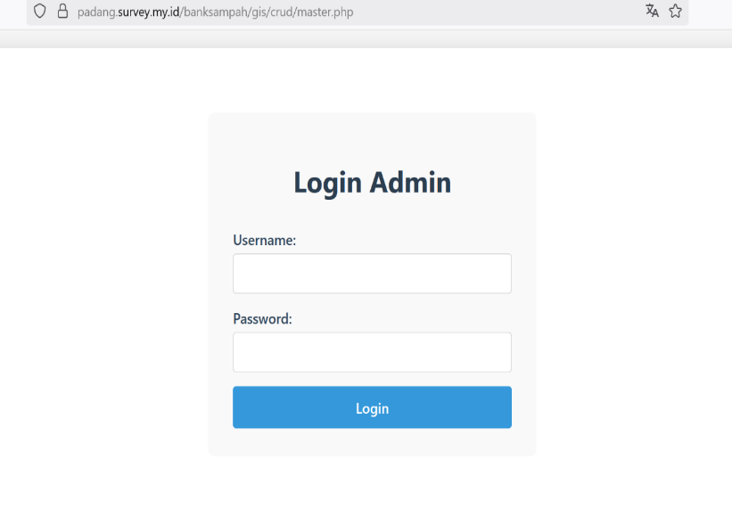
Figure 4. Main Page View

  - Login Page
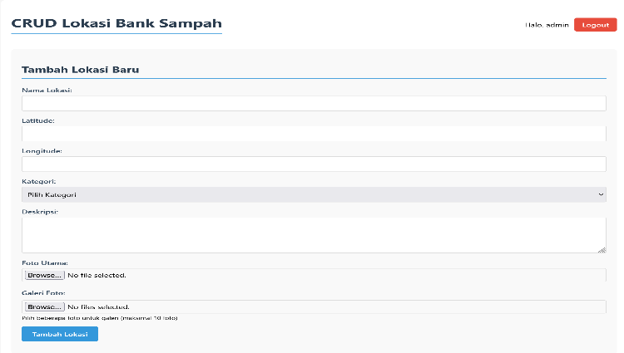
The login page display is successfully opened after the admin successfully logs in to the main page by entering the correct username and password, then the login page will appear to input the waste bank data in Padang city. In the CRUD Waste Bank Location display, the admin can add waste bank data in the available columns, namely: (1) the location name indicates the input of data for the name of the waste bank, whether active or inactive. (2) in the Latitude and Longitude columns is a description of the geographical coordinates that show the east-west position of a point on the Earth's surface and functions to input the Geographic Information System (GIS) of the waste bank based on the existing map of Padang city. (3) in the category column, the admin can input or select the word 'active' to describe an active waste bank, while the choice of the word 'inactive' to describe an inactive waste bank. (4) in the description column is the input data for explaining the address of the waste bank. (5) in the photo and gallery columns is the input data in the form of photos of the waste bank banner/building and ongoing activities carried out by the waste bank manager and customers.

Figure 5. Admin Login Page Display for Inputting Waste Bank Data
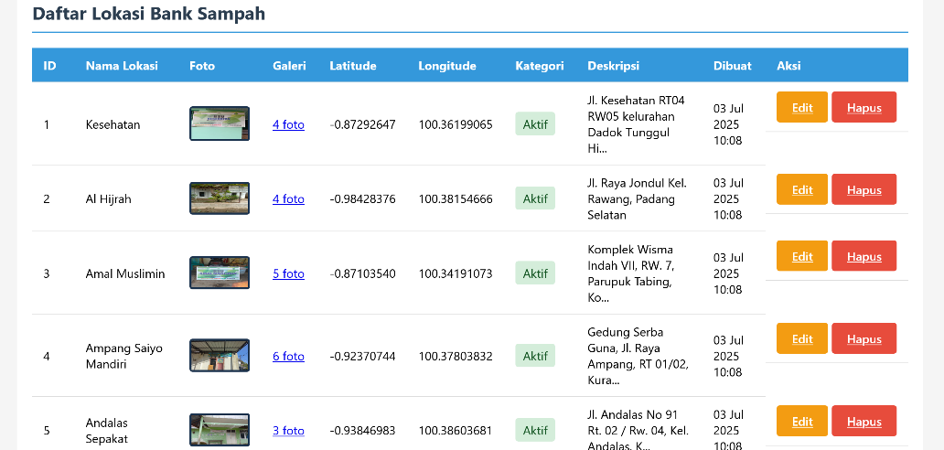
After the admin has successfully entered the data in the 6 available columns, a list of waste bank locations in Padang City will appear.

Figure 6. List of Waste Banks after the Admin has finished inputting data in the available columns.

  - Home view
The home display is the result of the design of the waste bank web application in Padang city with a browser search on the link:
https://padang.survey.my.id/banksampah/ After searching for the link, the e-waste bank homepage will appear, displaying several features to make it easier for managers, customers, and the public to learn about the waste bank program in Padang City. This can be seen in Figure 7 below.
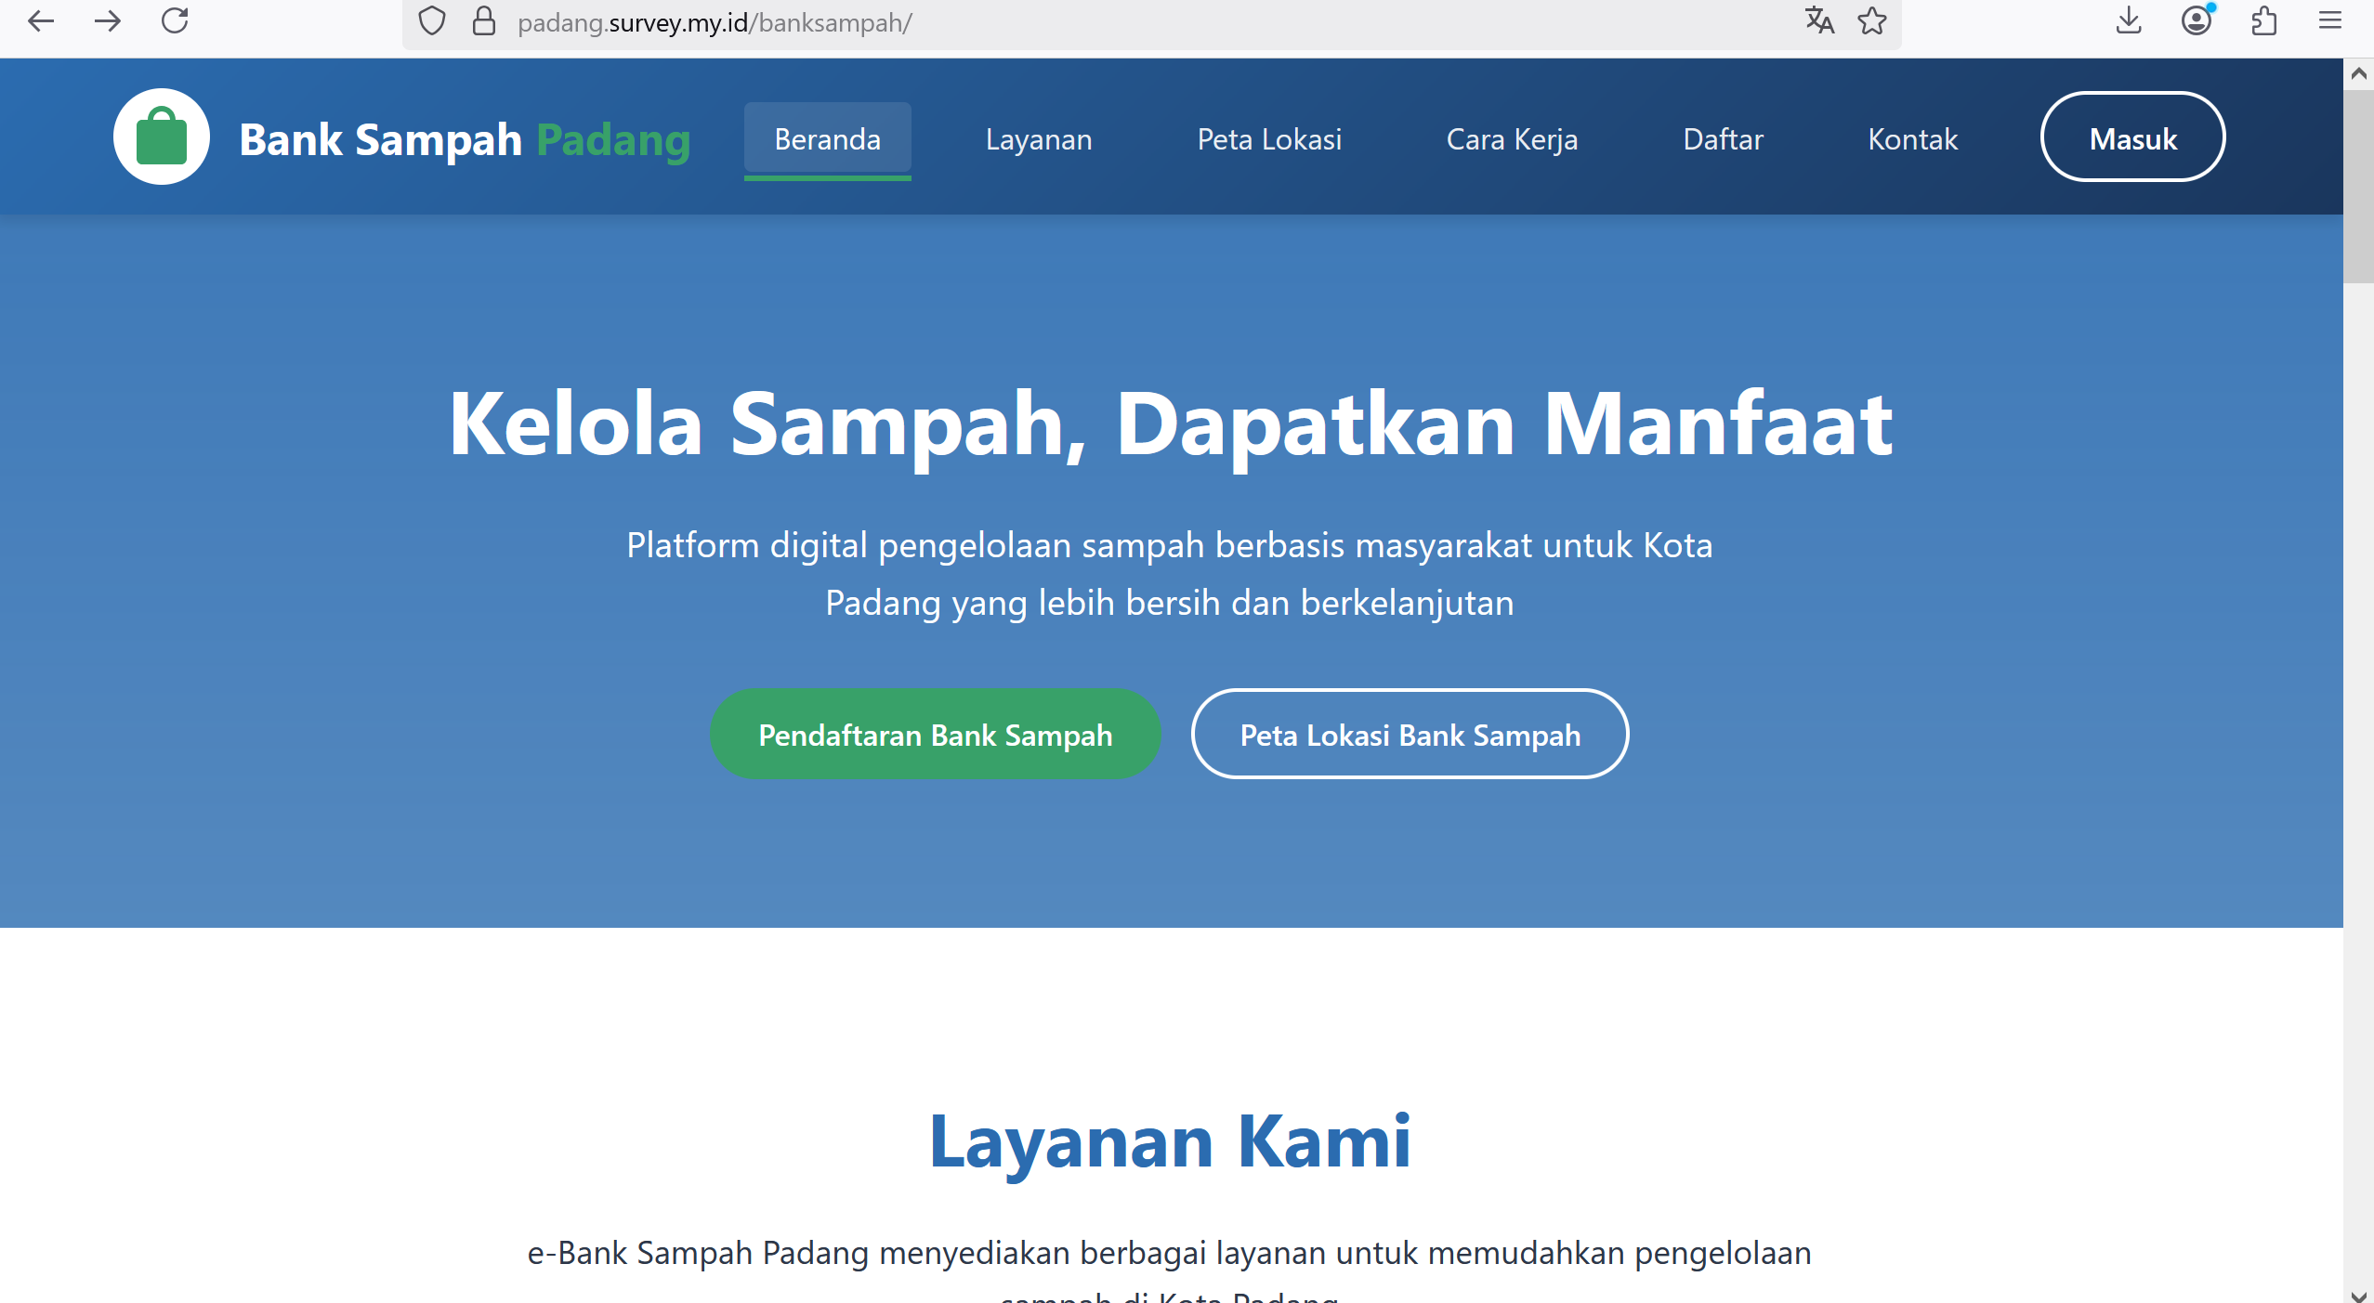
Figure 7. Home View

In addition to the home page, the home screen also displays a Geographic Information System (GIS) map of waste banks in Padang City. This GIS map helps the public identify the locations of active and inactive waste banks in Padang City that cannot be found on Google Maps. This can be seen in Figure 8 below.
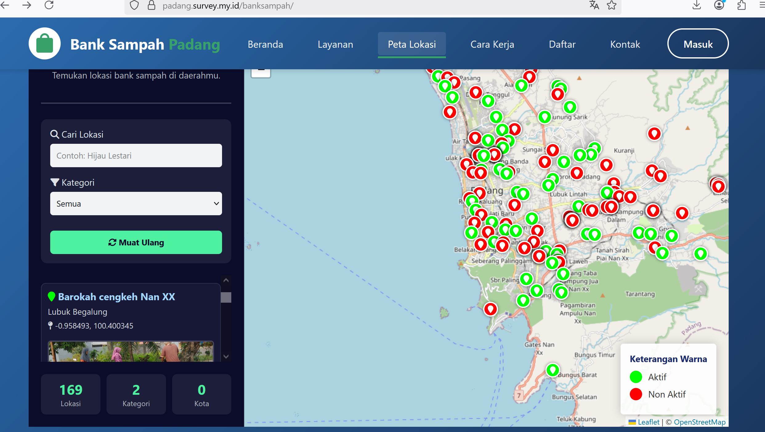
Figure 8. Geographic Information System (GIS) display of active and inactive waste banks in Padang City

- System Context and Flow Diagram
The Padang e-bank waste web system that was built consists of several entities:
- Users: view maps, locations, and information
- Admin: manage location data via backend (not discussed in frontend) Context diagrams and system flowcharts describe the interactions between users, frontend systems, and backend APIs.

- System Testing
Testing of the waste Padang e-bank website was carried out by:
- Test the search and filter functions
- Test map display and popup
- Performance and responsiveness testing
- Test errors and dummy data fallback
The application was successfully developed using HTML, CSS, JavaScript, and LeafletJS. The system supports location searches and filters, as well as interactive and responsive data display. The system is ready for use by agencies and the public to identify waste bank locations in the Padang city area.
Based on the results of a qualitative analysis of the spatial distribution of waste banks in Padang City and after conducting field observations from March to July 13, 2025, there was a decrease in the number of active waste banks in Padang City. Data from the Environmental Agency (DLH) shows that the number of active waste banks in Padang City is one hundred and sixty-eight (168) units. Meanwhile, the data found after observation of the number of active waste banks is sixty-two (62) units registered with the DLH and one (1) unit has not been registered, so that the total number of active waste banks is sixty-three (63) units. Thus, there has been a decrease in the number of active waste banks by one hundred and five (105) units (62.5%) compared to the official DLH data.
These findings indicate problems in the operational sustainability of waste banks in Padang City. Several possible causes of the decline in the number of active waste banks include: (1) Lack of community participation in managing waste banks consistently. (2) Minimal assistance and supervision from the Environmental Agency (DLH), resulting in many waste banks no longer operating even though they are still registered. (3) Economic and managerial factors, where waste bank managers have difficulty maintaining business sustainability due to low waste transaction volumes, fluctuating selling prices for recycled materials, and limited human resources. (4) Uneven spatial distribution, resulting in some areas having better access to waste bank facilities, while other areas experience a lack of services. (5) Lack of integration of digital information systems, resulting in data held by the DLH not always being updated according to actual conditions in the field.
From a spatial perspective, the decline in the number of active waste banks also impacts the effectiveness of waste management at the city level. Areas that previously had waste bank locations are now at risk of experiencing household waste accumulation, as residents lose access to community-based management facilities. This clearly contradicts the goals of sustainable development and the Padang Zero Waste program launched by the local government. Therefore, these findings provide an important basis for the Padang City government, through the Environment Agency (DLH), to conduct a comprehensive evaluation of data collection, monitoring, and community empowerment strategies. Digital-based data integration (digital mapping and dashboard monitoring) is needed to monitor waste bank development in real time, as well as increased collaboration between the government, the private sector, and communities to revitalize inactive waste banks.
Based on the distribution of the perception questionnaire of web-based Geographic Information System (GIS) waste bank users, it can be concluded that the majority of respondents stated "strongly agree" with the Geographic Information System (GIS) interface. The average score for the indicators of ease of access, system speed, and accuracy of waste bank locations reached a high value (4–5 on a Likert scale). This indicates that the web-based system is very helpful for users in accessing information on the location and type of waste bank services in Padang City. According to Sugiyono (2019), if the majority of respondents give a high score on the Likert scale, then the developed system has met the criteria for usability and user-friendliness.

- Conclusion
Based on the results of observations and interviews, it was found that the number of active waste banks in Padang city is 63 units. Based on the result of this study it can be concluded that in quantitative spatial data of waste banks has decreased in the number of active waste banks by one hundred and five (105) units (62.5%) compared to official DLH data. Beside that on a spatial perspective, this decrease in the number of active waste banks also impacts the effectiveness of waste management at the city level. The areas that previously had waste bank points are now potentially experiencing an accumulation of household waste, because people have lost access to community-based management facilities. Moreover, the development of a web-based Geographic Information System (GIS) for waste banks has succeeded in providing accurate and easily accessible waste bank location information to the people of Padang City. The majority of respondents gave high scores, namely "strongly agree" regarding aspects of ease of use, speed of access, and clarity of information. Then, in qualitatively results, users and managers stated that the system was very helpful in conveying information on waste bank locations. However, further development is still needed, especially in the waste reporting feature, notification system, and more regular location data updates.

Thank-you note
This research is the result of a thesis written to fulfill the requirements for completing further studies in the Postgraduate Environmental Studies Study Program at the University of PGRI West Sumatra. Thank you to Mr. Dasrizal and Mrs. Nefelinda for their guidance in writing this research.

Disclaimer (Artificial intelligence)
Option 1:
Author(s) hereby declare that NO generative AI technologies such as Large Language Models (ChatGPT, COPILOT, etc.) and text-to-image generators have been used during the writing or editing of this manuscript.
Option 2:
Author(s) hereby declare that generative AI technologies such as Large Language Models, etc. have been used during the writing or editing of manuscripts. This explanation will include the name, version, model, and source of the generative AI technology and as well as all input prompts provided to the generative AI technology
Details of the AI usage are given below:
1.
2.
3.

Bibliography
Adistha Eka Noveyani, Iva Nuril Ma’rifa, Elly, I. U. H. (2023). Pencegahan Risiko Penyakit Infeksi dengan PePencegahan Risiko Penyakit Infeksi dengan Pengelolaan Sampah Rumah Tangga Metode Komposting Takakurangelolaan. Pengabdian Kepada Masyarakat Nusantara, 3(2), 2153–2161.
Annisha, A. F., Teguh Kusuma Pradana, Riki Afriansyah, & LInda Fujiyanti. (2025). Sistem Informasi Pengeloaan Bank Sampah Berbasis Web dalam Meningkatkan Kemudahan Transaksi (Studi Kasus: Bank Sampah Karya Mandiri). Technologia : Jurnal Ilmiah, 16(1), 146. https://doi.org/10.31602/tji.v16i1.17357
Ari Muhardono, Dwi Susilo, Nalda Raist Sahara Fitri, & Mazidatul Khasanah. (2023). Sistem Informasi Bank Sampah Berbasis Web untuk Manajemen Pengelolaan Sampah di Desa Sumurjomblangbogo Kabupaten Pekalongan. G-Tech : Jurnal Teknologi Terapan, 7(4). https://ejournal.uniramalang.ac.id/g-tech/article/view/3248/2126
Burrough, P. A., & Mcdonnell, R. A. (1998). Principle of Geographic Information Systems. Oxford Univrsity Press. https://www.researchgate.net/publication/37419765
Campos, N., Bruhn, P., Tulio, M., Viglioni, D., & Nunnse, R. F. (20023). Recyclable waste in Brazilian municipalities: A spatial-temporal analysis before and after the national policy on solid waste. Journal of Cleaner Production, 10(4), 401. https://doi.org/10.1016/s0959-6526(02)00002-1
Creswell, J. W., & Vicki L. Plano Clark. (2011). Designing and Conducting Mixed Methods Research. SAGE Publication.
INDONESIA, P. R. (2008). UNDANG-UNDANG REPUBLIK INDONESIA NOMOR 18 TAHUN 2008 TENTANG PENGELOLAAN SAMPAH. In PRESIDEN REPUBLIK INDONESIA (pp. 61–64).
Mayra, I. G. A. A. E., I Nyoman Yudi Anggara Wijaya, Anak Agung Gede Adi Mega Putra, & Ni Putu Noviyanti Kusuma. (2025). RANCANG BANGUN SISTEM INFORMASI BANK SAMPAH BERBASIS WEBSITE DENGAN METODE PROTOTYPEPADA YAYASAN MULUNG PARAHITA. INFOTECHjournal, 11(2), 148–157. https://www.ejournal.unma.ac.id/index.php/infotech/article/view/14874/6678
Muttaqin, M., Yusuf, M., Syaula, M., & Widodo, A. A. (2024). Waste Bank Information System in Improving the Economy and Environmental Impact Control in Pari City Village. Journal of Information Technology, Computer Science and Electrical Engineering (JITCSE), 1(3), 425–435. https://doi.org/10.30596/jitcse
Pressman, R. S. (2001). Software Engineering: A Practitioner’s Approach. Thomas Casson.
Purnama, S. (2023). KLHK catat 25 ribu bank sampah di Indonesia.
Wali, K. P. (2021). Peraturan Wali Kota Padang No.39 Tahun 2021.

