Short Research Article

Study of Thermal Requirement and Impact of Climate Change on Wheat (Triticum aestivum L.) in Middle Gujarat, India

ABSTRACT
Wheat (Triticum aestivum L.) is a major winter cereal in India, and its productivity in warm, arid regions such as middle Gujarat is increasingly threatened by rising temperatures. In Gujarat, the crop area has expanded from 1.2–1.4 to 1.25 million hectares in recent years, producing 4.02 million tonnes—about 40.2 lakh tonnes. Climate change, characterised by long-term shifts in temperature and weather patterns, has emerged as a major challenge to crop production. This study assessed the projected impacts of climate change on wheat thermal duration using observed and RegCM4-4 downscaled climate data (CCCma-CanESM2) under RCP 4.5 and RCP 8.5 for the period 2025–2100. Accumulated growing degree days (AGDD), crop duration, and spatial variability were analysed across four districts (Anand, Ahmedabad, Kheda, Vadodara) for three sowing dates (1, 15, and 30 November). The statistical significance of trends was tested using the non-parametric Mann–Kendall test. Spatial interpolation of AGDD for each sowing date and variety was performed using the Inverse Distance Weighted (IDW) method in QGIS 3.38. Results indicated a consistent reduction in crop duration across all scenarios and sowing dates, with greater declines under RCP 8.5 (2–7 days shorter) compared to RCP 4.5. Early sowing (1 November) maintained the longest growth period, while late sowing (30 November) was most affected due to accelerated maturity from terminal heat. Anand recorded the largest reductions, followed by Ahmedabad, Kheda, and Vadodara. The most pronounced reductions were observed in Anand and Ahmedabad, where crop duration shortened by 6–8 days between the two emission scenarios. In contrast, Kheda and Vadodara showed smaller contractions of about 2–5 days. These findings highlight the need for adaptive strategies, including advancing sowing dates and selecting varieties with higher thermal requirements, to sustain wheat productivity under future warming in middle Gujarat.

1. Introduction
Wheat (Triticum aestivum L.) is the second most important cereal crop after maize, with global production reaching 760 million tonnes in 2020. The current wheat production in South Asia is around 95 million tonnes, and demand for 2020 is estimated to be around 137 million tonnes. The demand for wheat is increasing, but there is no further increase in area, mainly due to growing urbanisation and diversification (Chatrath et al., 2020). China, India, and Russia together account for about 41% of this output (Anonymous, 2024). In India, it occupies 31.12 million hectares with a production of 109.59 million tonnes and an average productivity of 3521 kg ha⁻¹ (Singh et al., 2024). In India, three species of wheat are cultivated: Triticum aestivum, Triticum durum, and Triticum dicoccum. Bread wheat accounts for approximately 95% of the wheat grown, while 4% is durum wheat and 1% is dicoccum wheat (Joshi et al., 2021). In Gujarat, the crop area has expanded from 1.2–1.4 to 1.25 million hectares in recent years, producing 4.02 million tonnes—about 40.2 lakh tonnes. Climate change, characterised by long-term shifts in temperature and weather patterns, has emerged as a major challenge to crop production (Hashmi et al., 2023). The IPCC (2014) reported a 0.6°C increase in global mean temperature during the 20th century, with projections of a further 1.5–3.5°C rise by the end of this century. Elevated temperatures, particularly during critical reproductive stages, can significantly reduce yields, with a 2°C rise potentially causing yield losses of 15–17% in wheat (Bisht et al., 2019). Warm, arid regions, such as parts of India, are especially vulnerable, with yield growth having slowed by 1-2% per decade due to climatic stress (Gourdji et al., 2013; Pathak et al., 2023).
Growing degree days (GDD) represent the accumulated heat units required for a crop to complete its growth cycle, serving as a vital agrometeorological index to assess thermal requirements and predict phenological stages (Gouri et al., 2005). With global climate warming, heat stress has become a critical limiting factor for wheat productivity (Abdelrahman et al., 2020; Dreccer et al., 2018; García et al., 2015; Ye et al., 2020; Zheng et al., 2017). Spatiotemporal variation in GDD is influenced by local climate, cultivar characteristics, and management practices, making it an important tool for understanding crop responses to climate change. Analyses of historical phenology reveal shifts toward earlier maturity in wheat under warming conditions, with notable regional differences in temperature trends across Gujarat—Anand showing consistent warming, while other locations exhibit mixed patterns (Lunagaria et al, 2012)

2. Materials and Methods
2.1 Temperature Dataset
Daily maximum and minimum temperature, bright sunshine hours, and precipitation data for the wheat-growing season were obtained from the Department of Agricultural Meteorology, Anand Agricultural University, Anand, covering multiple stations across middle Gujarat, India. The dataset spans the baseline period and future projections from 2006 to 2100, including both observed and model-simulated values. Future climate data were derived from the RegCM4-4 regional climate model, which dynamically downscales the CCCma-CanESM2 global climate model under two Representative Concentration Pathways (RCP 4.5 and RCP 8.5). Model outputs were sourced from the Indian Institute of Tropical Meteorology (IITM), Pune, through the Centre for Climate Change Research portal. Data were quality-checked for continuity and completeness before analysis.
  - Estimation Based on Daily Temperature
Thermal time indices, including accumulated growing degree days (AGDD, °C day), crop duration in days, start of the growing period (emergence) to end of the growing period (physiological maturity), were calculated for each location. A base temperature (T_{b}) of 5°C was used for wheat (Slafer and Savin, 1991). Thermal requirements and heat use efficiency of wheat were calculated as:
$$AGDD=\sum_{i=1}^{n}{\frac{T_{max}+T_{min}}{2}}-T_{b}$$
Where, T_{max} - Daily maximum Temperature (°C), T_{min} - Daily minimum Temperature (°C), T_{b} - Base Temperature (5°C)
2.3 Trend Analysis
For each district, trends in AGDD, crop duration, and seasonal mean temperature were calculated using least squares linear regression, with the slope representing the rate of change per year. The statistical significance of trends was tested using the non-parametric Mann–Kendall test (Sneyers, 1990). Sensitivity of crop duration to mean temperature was determined through regression analysis, with the slope indicating the number of days gained or lost per °C change in temperature (Yin et al., 2019).
2.4 Spatial Analysis
Spatial interpolation of AGDD for each sowing date and variety was performed using the Inverse Distance Weighted (IDW) method in QGIS 3.38. Interpolated raster layers were masked to the boundaries of middle Gujarat, classified into five AGDD ranges, and mapped for visual interpretation of spatial variability.
3. Results and Discussion
To comprehensively understand the projected climate change impacts on wheat in Middle Gujarat, it is crucial to analyse the trends of days taken to complete the growth of the crop over the projection period from 2025 to 2100. The projected calendar days required to attain current AGDD levels in middle Gujarat under RCP 4.5 and RCP 8.5 scenarios consistently indicate a decline across all sowing dates and districts (Anand, Ahmedabad, Kheda, and Vadodara) during the future period.
3.1 1st November Sowing (D1)
For the early sowing date (1st November, GW-451), the baseline crop duration during 2016–2023 varied across districts, ranging from 111 to 127 days. Anand recorded the longest average duration (125 days), followed by Kheda (116 days), Vadodara (113 days), and Ahmedabad (115 days). This indicates that wheat in Anand required comparatively more time to accumulate the thermal units needed for maturity, while Vadodara showed relatively shorter duration.
Under future climate projections, a consistent reduction in crop duration was observed. The mean duration under RCP 4.5 ranged between 101 and 119 days, whereas under RCP 8.5 it further declined to 99–113 days (Fig. 1a, Fig. 2a). The largest reduction occurred in Anand, where crop duration decreased by about 5–7 days between RCP 4.5 and RCP 8.5. Ahmedabad and Kheda also exhibited similar reductions of 3–6 days, while Vadodara recorded a smaller decline of 1–4 days.
3.2 15th November Sowing (D2)
For the mid-November sowing date (15th November, GW-451), the baseline crop duration (2016–2023) varied between 112 and 132 days across districts. Anand showed the highest average duration (125 days), followed by Kheda (116 days), Vadodara (114 days), and Ahmedabad (115 days). The inter-annual variation was more pronounced in Anand, where the crop duration ranged from 121 to 132 days, compared to relatively stable values in other districts.
Under projected climate scenarios, the mean duration under RCP 4.5 ranged between 97 and 116 days, whereas under RCP 8.5 it decreased further to 98–109 days (Fig. 1b, Fig. 2b). The steepest reductions were again observed in Anand, where crop duration contracted by about 7–8 days between RCP 4.5 and RCP 8.5. Ahmedabad and Kheda followed a similar trend with reductions of 3–6 days, while Vadodara showed comparatively smaller decreases of 2–5 days.

3.3 30th November Sowing (D3)
For the late sowing date (30th November, GW-451), the baseline crop duration (2016–2023) ranged between 110 and 128 days across districts. Anand recorded the longest average duration (122 days), followed by Kheda (115 days), Vadodara (113 days), and Ahmedabad (112 days). Anand again showed greater variability, with duration fluctuating between 118 and 128 days, while the other districts exhibited relatively smaller year-to-year variation.
Future climate projections indicated a clear decline in crop duration. Under RCP 4.5, the range of durations varied between 95 and 113 days, whereas under RCP 8.5, the values further decreased to 97–105 days (Fig. 1c, Fig. 2c). The most pronounced reductions were observed in Anand and Ahmedabad, where crop duration shortened by 6–8 days between the two emission scenarios. In contrast, Kheda and Vadodara showed smaller contractions of about 2–5 days.

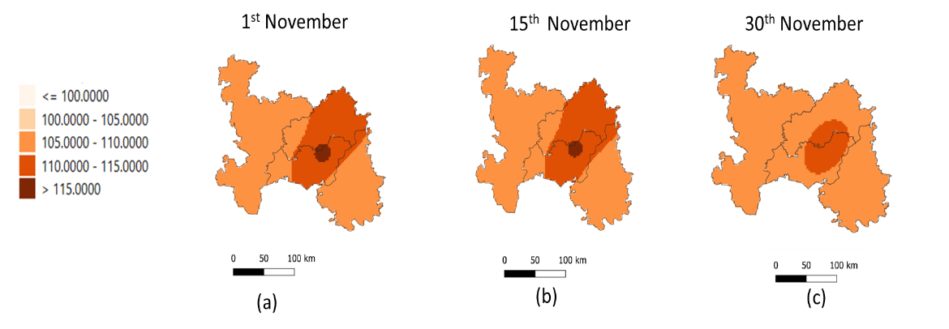
Fig 1: Spatial and Temporal variation in wheat under sowing dates 1st,15th and 30th November under the Baseline of year 2024
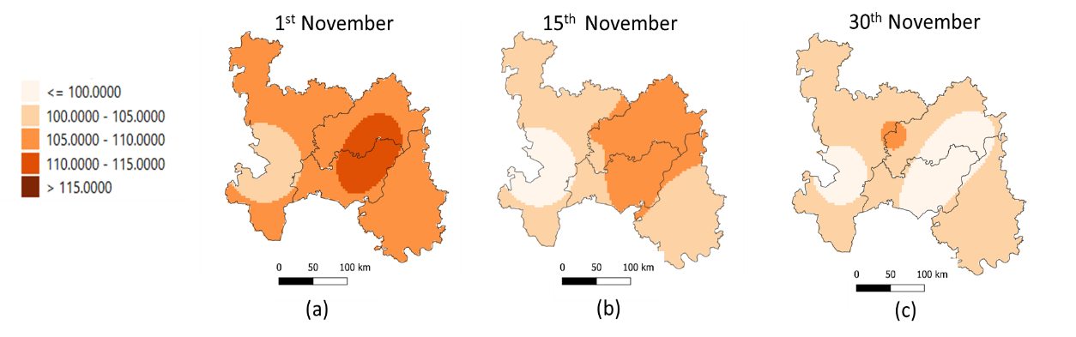
Fig 2: Spatial and Temporal variation in wheat under sowing dates 1st,15th and 30th November under the future scenario RCP 4.5

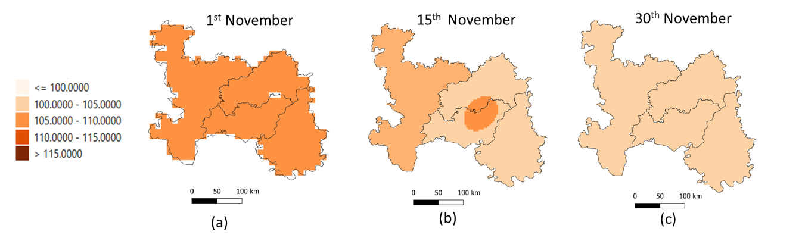
Fig 3: Spatial and Temporal variation in wheat under sowing dates 1st,15th and 30th November under the future scenario RCP 8.5
3.4 Comparative Observations
The magnitude of reduction in thermal duration from RCP 4.5 to RCP 8.5 followed the order: Anand > Ahmedabad ≈ Kheda > Vadodara. Early sowing dates (1st November) maintained the highest number of calendar days across scenarios, while late sowing dates (30th November) had the shortest durations. This contraction in the growth period is directly linked to higher projected temperatures, which hasten phenological development, potentially reducing biomass accumulation and grain filling time.
Ahmed (2021) projected that by 2040–2050, winter wheat in the Eastern Nile Basin will face a 9% rise in GDDs and shorter seasons—by 5 days (CCCma-CanESM2) to 18 days (CSIRO-MK3)—necessitating sowing shifts to 1 December or adoption of new varieties. In Ethiopia, rainfed wheat seasons may shorten by 13 days, requiring a 90-day sowing delay or a shift to winter cropping. Ruiz Castillo and Gaitán Ospina (2016) found that climate change will shorten the winter wheat growth period in southwest Oklahoma, with both RCP 4.5 and RCP 8.5 projecting a decrease in the number of days required to accumulate 1825 GDD, particularly in the late 21st century, leading to earlier crop maturity. Yin et al. (2019) analysed 52 years (1960–2011) of homogenised daily mean temperature data from 536 stations across China to quantify shifts in growing season (GS) length at base temperature. The GS lengthened by 10 –11 days, driven by both an advance in start of season (SOS) by 4.86–6.71 days and a delay in end of season (EOS) by 4.32–6.19 days. Spatially, >82 % of stations showed GS extension, most notably in East, Northeast, and Northwest China, while slight reductions occurred in parts of Southwest China. Similarly, Rezaie et al. (2022) reported that winter wheat maturity will advance significantly under all RCP scenarios at both Sanandaj. At Sanandaj, the growth duration is projected to shorten by 1.0, 1.6, and 3.7 days by 2100 under RCP 2.6, 4.5, and 8.5, respectively, mainly due to a reduced grain-filling period. The trends were statistically significant under higher emission scenarios (p < 0.01), highlighting the risk of shorter wheat growth periods and associated yield loss in warmer climates.
4. Conclusion
The analysis indicates that under future climate scenarios, wheat in middle Gujarat will mature faster, with a reduction in required calendar days for AGDD accumulation across all districts. RCP 8.5 consistently shows a sharper decline compared to RCP 4.5, with differences of 2–7 days. Early sowing (1st November) mitigates the impact to some extent, while late sowing (30th November) is most affected. Among districts, Anand maintains relatively baseline durations, while Ahmedabad shows the lowest, highlighting spatial variability in climate impact. These findings suggest that advancing sowing dates and selecting varieties with higher thermal requirements could help sustain yield potential under future warming.
Competing interests

Authors have declared that no competing interests exist.

Disclaimer (Artificial intelligence)
Option 1:
Author(s) hereby declare that NO generative AI technologies such as Large Language Models (ChatGPT, manuscript.
Option 2:
Author(s) hereby declare that generative AI technologies such as Large Language Models, etc. have been used during the writing or editing of manuscripts. This explanation will include the name, version, model, and source of the generative AI technology and as well as all input prompts provided to the generative AI technology
Details of the AI usage are given below:
1.
2.
3.

References
Abdelrahman, M., Burritt, D. J., Gupta, A., Tsujimoto, H., & Tran, L. S. P. (2020). Heat stress effects on source–sink relationships and metabolome dynamics in wheat. Journal of Experimental Botany, 71(2), 543-554.
Ahmed, S. M. (2021). Climatic change impacts on growing degree days and climatologically suitable cropping areas in the Eastern Nile Basin. Agricultural Research, 10(1), 72-82.
Bisht, H., Singh, D. K., Mishra, A. K., Sarangi, A., Prajapati, V. K., Singh, M., & Krishnan, P. (2019). Heat unit requirement of wheat (Triticum aestivum L.) under different thermal and moisture regimes. Journal of Agrometeorology, 21(1), 36-41
Dreccer, M. F., Fainges, J., Whish, J., Ogbonnaya, F. C., & Sadras, V. O. (2018). Comparison of sensitive stages of wheat, barley, canola, chickpea and field pea to temperature and water stress across Australia. Agricultural and Forest Meteorology, 248, 275-294.
García, G. A., Dreccer, M. F., Miralles, D. J., & Serrago, R. A. (2015). High night temperatures during grain number determination reduce wheat and barley grain yield: a field study. Global change biology, 21(11), 4153-4164.
Gourdji, S. M., Sibley, A. M., and Lobell, D. B. (2013). Global crop exposure to critical high temperatures in the reproductive period: historical trends and future projections. Environmental Research Letters, 8 (2), 024041.
Gouri V., Reddy D.R., Rao S.B., S.N. and Rao A.Y. (2005) Thermal requirement of rabi groundnut in southern Telangana zone of Andhra Pradesh. Journal Agricultural Meteorol 7 (1),90-94.
IPCC, Parry M., L., Canziani, O., F., Palutikof, J.,P, Linden, P., J.and Hanson,C., E.,(2007) Climate change Impacts, adaptation and vulnerability 7-22.Cambridge University Press.
Lunagaria, M. M., Pandey, V. Y. A. S., and Patel, H. R. (2012). Climatic trends in Gujarat and its likely impact on different crops. Journal of Agrometeorology.
Pathak, H. (2023). Impact, adaptation, and mitigation of climate change in Indian agriculture. Environmental Monitoring and Assessment, 195 (1), 52.
Rezaie, B., Hosseinpanahi, F., Siosemardeh, A., Darand, M., & Bannayan, M. (2022). Shifting the sowing date of winter wheat as a strategy for adaptation to climate change in a Mediterranean-type environment. International Journal of Plant Production, 16(4), 595-610.
Ruiz Castillo, N., & Gaitán Ospina, C. F. (2016). Projecting future change in growing degree days for winter wheat. Agriculture, 6(3), 47.
Slafer, G. A., & Savin, R. (1991). Developmental base temperature in different phenological phases of wheat (Triticum aestivum). Journal of Experimental Botany, 42(238), 1077–1082.
Ye, Z., Qiu, X., Chen, J., Cammarano, D., Ge, Z., Ruane, A. C. & Zhu, Y. (2020). Impacts of 1.5 C and 2.0 C global warming above pre-industrial on potential winter wheat production of China. European Journal of Agronomy, 120, 126149.
Yin, Y., Deng, H., & Wu, S. (2019). Spatial-temporal variations in the thermal growing degree-days and season under climate warming in China during 1960–2011. International Journal of Biometeorology, 63(5), 649-658.
Zheng, C., Zhang, J., Chen, J., Chen, C., Tian, Y., Deng, A.,& Zhang, W. (2017). Nighttime warming increases winter-sown wheat yield across major Chinese cropping regions. Field Crops Research, 214, 202-210.
Chatrath, R., et al. (2020). Challenges to wheat production in South Asia. In Climate Change and Food Security in South Asia (pp. 123-135). Springer, Dordrecht.
Joshi, A. K., et al. (2021). Wheat improvement in India: present status, emerging challenges and future prospects. Euphytica, 217, 119.
Singh, R., Sahu, R. P., Sharma, P. B., Sahu, V., Thakur, S., Patel, R., Singh, S., & Kumawat, R. K. (2024). Unveiling the potential of wheat (Triticum aestivum L.) varietal performance evaluation through organic nutrient management. Journal of Scientific Research and Reports, 30(4), 170–178.
Hashmi, Q. A., Ahmad, M., Ahmad, E., Tariq, M., Rafeh, A., & Awais, M. (2023). Exploring drought tolerance in wheat: Insights from biochemical, morphological, and physiological responses. Asian Journal of Research in Crop Science, 8(4), 344–360.

