The changing climate and its impact on livelihood in India

Abstract
Among the most important environmental issues the world is currently facing is climate change. India has a number of issues. Climate change is linked to a number of detrimental effects on health, agriculture, water resources, forests, biodiversity, coastal management, and temperature rise. India's primary climate change impact is a decline in agricultural productivity. Most people rely either directly or indirectly on agriculture. The ecological and socioeconomic systems are already under extreme strain from fast industrialization, urbanization, and economic growth; climate change would put further strain on them. In the context of India, this paper examines the effects of climate change and its different facets. Most people believe that there have been sudden changes in the precipitation regime and an increase in average temperatures in the region. It is reported that there have been significant changes in the duration, amount, and form of atmospheric precipitation. During the winter months, the locals are experiencing more and more liquid precipitation instead of the solid precipitation that they were used to, which was snow. This is thought to be the cause of the region's shorter snowfall duration. People in the area are already experiencing a shortage of water as a result of this, which is blamed for the decreased water availability. Concurrently, the majority of the local population acknowledges that flowering and fruiting times have changed.

Keywords: Impact, Climate change, Biodiversity, Agriculture.
Introduction
India is a country that spans 3.28 million km and is located in sub-tropical regions beneath the Himalayas. Its topography, climate, and biosphere are highly varied. It is the seventh-largest country in the world, taking up nearly 23 % of the planet's land area, but it is home to nearly 18 % of its people. This increases the pressure on the country to effectively manage a sustainable development path and to utilize its resources. India is home to more than 1.21 billion people from diverse sociocultural backgrounds, who together comprise the largest democracy in the world. India is susceptible to climate change impacts on a number of sectors, including agriculture, forestry, health, and biodiversity, as a country located in a tropical area. The Indian government, realizing the significance of adaptation to and effects of climate change, has been conducting studies since 2004 to estimate the effects of climate change on significant industries, coordinating with the Ministry of Environment and Forests overall. India's varied climate and natural areas make it possible to raise a variety of livestock and grow a broad variety of crops. A significant source of employment, the agricultural sector employs roughly 47% of the labour force in the country, despite its GDP contribution declining over the past 20 years from 29% in 1990 to 17% in 2016 [Ministry of Labour and Employment]. India is among the nation’s most susceptible to the effects of predicted climate change and one of the biggest emitters of greenhouse gases worldwide. As per the findings of the Intergovernmental Panel on Climate Change, which comprises a consortium of eminent climate researchers, it is imperative for the global community to achieve a reduction of at least 43 percent in greenhouse gas emissions by the year 2030, in comparison to the levels recorded in 2019. Furthermore, a reduction of at least 60 percent by the year 2035 is deemed necessary to curtail global warming within the confines of a 1.5-degree Celsius threshold. The Earth's overall surface temperature has already undergone an escalation of approximately 1.15 degrees Celsius when juxtaposed with the mean temperature for the period spanning 1850 to 1900. This rise can be attributed to the swiftly escalating levels of greenhouse gases, primarily carbon dioxide and methane, present in the Earth's atmosphere. The publication issued by the Department of Environment and Climate Change, Government of Maharashtra, entitled 'Securing water in times of climate change through natural ecosystems management,' underscores the critical need for coordinated and holistic approaches to water resource management in the fight against desertification and the promotion of resilience to drought. The document, which emerged from a collaborative workshop involving multiple stakeholders in March, also aligns with the theme of this year's World Environment Day, 'Land restoration, desertification, and drought resilience,' underscoring the interconnected nature of land and water resources.
The nation is already dealing with a changing climate and its effects, such as heat waves, droughts, severe storms, flooding, and other events that have a detrimental impact on people's health and way of life. The earth's climate system is thought to be changing as a result of trace gas accumulation in the atmosphere, primarily from human activity like burning fossil fuels. These gases include carbon dioxide (CO₂) and methane (CH₄). "Warming of climate system is now unequivocal, as is now evident from observations of increases in global average air and ocean temperatures, widespread melting of snow and ice, and rising global seal level," the Intergovernmental Panel on Climate Change (IPCC) noted in its fourth assessment report (Soloman et al., 2007). Given that a large portion of India's population makes their living from climate-sensitive industries like forestry, fisheries, and agriculture, the country has good reason to be concerned about climate change. The country's livelihood issues have gotten worse as a result of climate change's negative effects, which include rising temperatures and decreasing rainfall. The ecological and socioeconomic systems, which are already under a great deal of strain from the rapid industrialization, urbanization, and economic development that is occurring, would be further stressed by climate change. Global warming has been proven by science, and this conclusion cannot be changed. These are also understood to be layered on top of a range of other environmental and social stresses, many of which are acknowledged to be extremely severe.
Methodology
The electronic literature search method was conducted according to the aforementioned issue “Climate Change” and author searched for news articles and research articles published between 2010 to till now. The following keywords was followed to the electronic search via Google search engine and restricted to India: (Climate Change* OR Impact of Climate Change* OR Global Warming OR Changing Climate OR Indian Climate).
The most popular media websites included in the search were selected in the present study. In addition, previous literature reviews and reference lists of all included studies were hand-searched. Climate change related research published in Peer-reviewed Journal in English and Hindi language were included in this study. Online technical databases which were searched to download relevant literature, primarily included ResearchGate and Google Scholar. The collected literature was then thoroughly reviewed.
Result
There is no long-term substitute for the water that glaciers give, which may lead to unprecedented levels of water scarcity. Thus, it is predicted that droughts and floods would increase as a result of climate change. This will result in a significant loss of crops and render big areas of fertile land unusable for farming. In summary, food security will be threatened. Farmers may be losing between 9% and 25% of their net revenue as a result of a 2 to 3.5⁰ C increase in temperature and a 7% to 25% change in precipitation. This may have a negative impact on the GDP of 1.8% to 3.4% (Kavi Kumar and Parikh, 1998). The rising demand of water and future availability of water manifested in table (1) while table 2 showing the threshold value of basins in Indian context.
Food security in the south will suffer greatly, and India could lose a staggering 125 million tonnes, or about 18 percent, of its rainfed cereal output (Fisher et al. (2001). By 2010, foodgrain consumption in India was projected to reach over 250 million metric tons. By 2010, the gross arable area is predicted to rise from 191 to 215 mha, necessitating a cropping intensity increase of about 150 percent (Sinha et al. 1998). The need for more food in India can only be satisfied by increasing yield per unit of land, water, energy, and time—a feat that can only be attained through precision farming—because land is a finite resource for agriculture. According to Kavi Kumar and Parikh (2001), there would still be a significant impact of climate change on Indian agriculture even with farm-level adaptations. They calculated that farm level total net revenue would decrease by 9% with a temperature change of +2 ⁰C and corresponding precipitation change of +7%, while the fall would be almost 25% with a temperature increase of +3 ⁰C and corresponding precipitation change of +15%. Mall and associates (2006) offer a comprehensive overview of studies on the effects of climate change, primarily from a physical standpoint, on Indian agriculture. According to the data currently available, climate change is significantly reducing the yields of important cereal crops like wheat and rice. Unfortunately, there hasn't been enough research done on the biophysical effects on some significant crops, like sugarcane, cotton, and sunflower.
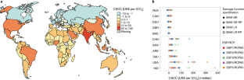

Image: 1- Spatial distribution of median estimates of the CSCCs (Ricke et al. 2018).
Source: (Ricke et al. 2018).

Year | Population  (Million) | Per Capita Water Availability (m³/Year)
1951 | 361 | 5177
1955 | 395 | 4732
1991 | 846 | 2209
2001 | 1027 | 1820
2025 | 1394 | 1341
2050 | 1640 | 1140

Table: 1 – Population and per capita water availability. (Source: Government of India, Ministry of Water Resources, 2009).
Basin | Threshold Value (Ha) | No. of Sub-Basins | Total Area (Ha)
Barhmani | 99,700 | 19 | 4,999,399
Cauvery | 350,000 | 11 | 6,467,199
Ganga | 2,000,000 | 29 | 87,180,000
Godavri | 600,000 | 27 | 30,003,299
Krishna | 600,000 | 21 | 24,647,200
Luni | 750,000 | 9 | 12,793,400
Mahanadi | 400,000 | 21 | 14,027,300
Mahi | 100,000 | 13 | 3,579,000
Narmada | 350,000 | 15 | 9,765,000
Pennar | 200,000 | 11 | 5,524,600
Subarmati | 48,900 | 8 | 1,668,026
Tapi | 200,000 | 13 | 6,853,799

Table: 2 – Some of the Basic Details of the Basins Analysed. (Source: Gosain; 2006)
Crop | Average Yield (t/ha) | Yield Loss due to Heat Stress (%) | Yield Loss due to Erratic Rainfall (%)
Rice | 2.5 | 12 | 18
Wheat | 3.2 | 15 | 12
Maize | 2.0 | 10 | 15
Pulses | 0.9 | 8 | 10

Table: 3 – Crop yield losses in India.
Region | Migration Rate (% of households) | Primary Driver
Rajasthan | 22 | Drought
Bihar | 18 | Flood
Odisha | 25 | Cyclone
Gujrat | 15 | Heat Stress
Table: 4 – Climate induced migration in India.

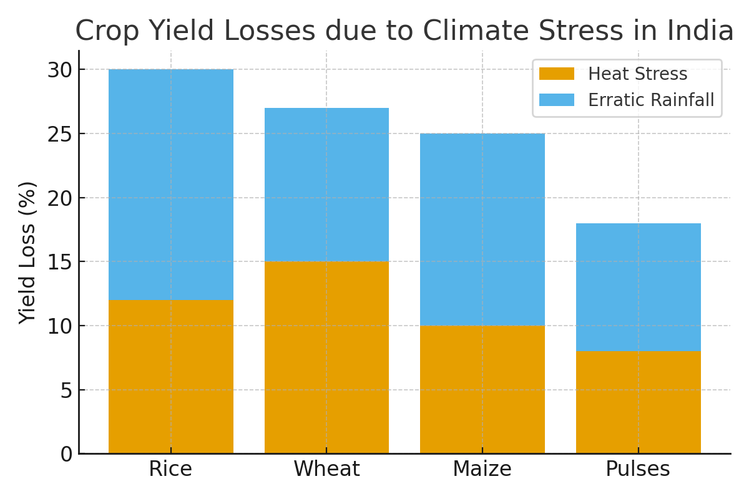

Histogram: 1- Crop yield losses due to climate stress in India.
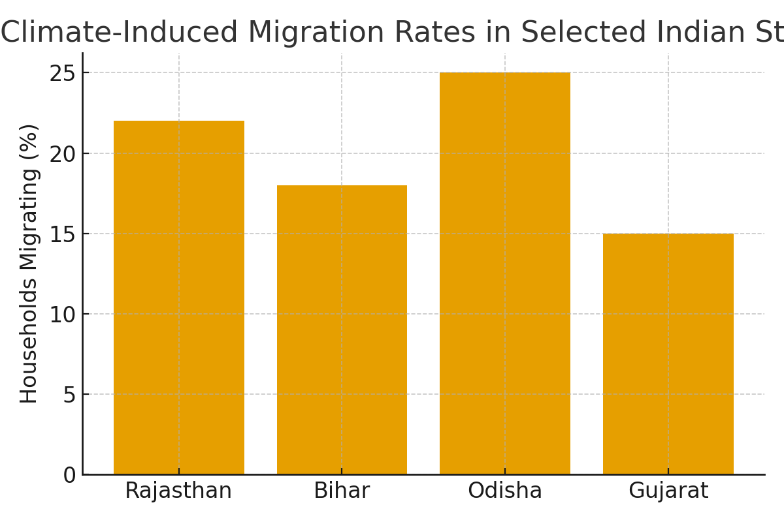

Histogram: 2- Showing Climate induced migration rates in selected Indian states.

The analysis highlights that climate change has had significant and widespread impacts on rural and urban livelihoods in India. Observed climatic shifts over the last three decades include a 0.6–0.8°C rise in average annual temperatures, more frequent heatwaves, erratic monsoon rainfall, and an increased frequency of extreme weather events such as floods, droughts, and cyclones (IMD, 2020; IPCC, 2021). These changes are altering agricultural productivity, fisheries, livestock rearing, and non-farm employment opportunities.
Crop yield data show substantial inter-annual variability. Rice and wheat yield in the Indo-Gangetic plains have been negatively affected by rising minimum temperatures and delayed monsoon onset (Lal et al., 2011; Mall et al., 2017). Semi-arid regions such as Rajasthan and Madhya Pradesh report soil moisture stress, delayed sowing, and increased irrigation demand (Birthal et al., 2014). In contrast, eastern states occasionally experience short-term yield gains due to prolonged rainfall, but these are unstable and often offset by flooding (Tripathi & Mishra, 2017). Coastal fisheries are vulnerable to rising sea surface temperatures, ocean acidification, and increased cyclone intensity (Vivekanandan et al., 2016). Fishers in Kerala, Odisha, and West Bengal reported declining catch volumes and reduced breeding success of commercially important species. Coastal erosion and saline intrusion have disrupted both capture fisheries and aquaculture (Mohanty et al., 2010). Climate-induced heat stress in cattle and goats has reduced milk yields and increased disease outbreaks, especially during drought years (Upadhyay et al., 2009; Rojas-Downing et al., 2017). Pastoralists in Gujarat and Rajasthan have been forced to extend migration routes to secure fodder and water (Kumar et al., 2012). Climate shocks reduce employment opportunities in climate-sensitive informal sectors such as construction, brick kilns, and handicrafts. Seasonal and distress migration has emerged as a major coping mechanism, with younger rural members moving to urban areas, altering household income structures (Deshingkar & Akter, 2009; Gupta & Singh, 2020). Households expressed awareness of climate risks but limited adaptive capacity due to lack of credit access, institutional support, and climate information services (Aggarwal, 2008; Füssel, 2010). Common practices include crop diversification, traditional water harvesting, and adjusted sowing dates, though these measures remain insufficient for long-term resilience (Sahu & Mishra, 2013).
Discussion
The risk of contracting foodborne and waterborne illnesses increases with rising air and water temperatures. Numerous previous cases have demonstrated an effect on human health in various parts of India. The Odisha heatwave of 1998 claimed over 2,000 lives. A heatwave in 2003 claimed 1,421 lives in Andhra Pradesh; comparable consequences were also noted in Uttar Pradesh, Haryana, Punjab, Rajasthan, Gujarat, Bihar, and Orissa. Due to factors such as growing population, expanding agriculture, and rapid industrialization, there is a significant imbalance between the quantity and quality of water resources, which has led to an increase in demand for water over time. The Ministry of Water Resources reports that from 3,450 cm in 1951 to 1,250 cm in 1999, India's per capita water availability declined steadily. By 2050, it is predicted to drop even further to 760 cm.
The findings reinforce the argument that climate change is a socio-economic challenge in India, disproportionately affecting vulnerable populations. The dependence of nearly 55% of the workforce on agriculture (GoI, 2021) magnifies the risks of climate-induced livelihood insecurity. The vulnerability of Indian agriculture to rising temperatures and rainfall variability is well documented (Lobell et al., 2012; Auffhammer et al., 2012). Reduced productivity and higher input costs lower profit margins, forcing farmers into crop diversification or migration. Results indicate that coastal livelihoods face both gradual climate risks (warming seas, salinity intrusion) and sudden shocks (cyclones), in line with IPCC (2021) projections. Loss of productive coastal land is expected to displace millions by mid-century (Dasgupta et al., 2009). Livestock productivity losses are a key dimension of livelihood stress. Heat stress and declining fodder highlight the need for climate-resilient breeds and integrated fodder management strategies (Thornton et al., 2009). Migration emerges as both a coping strategy and a driver of new vulnerabilities. While remittances help buffer household income, dependence on unstable urban informal labor markets exposes migrants to additional risks (Rigg et al., 2020). Although farmers and fishers employ traditional coping mechanisms, structural barriers—such as lack of institutional credit, poor extension services, and inadequate climate-resilient technologies—restrict transformative adaptation (Aggarwal, 2008; Sahu & Mishra, 2013). The evidence underscores the urgent need for livelihood-centric adaptation policies. Climate-smart agriculture, expansion of crop insurance, rural skill development, and social safety nets are essential for strengthening resilience (Birthal et al., 2015; TERI, 2022). Integrating these measures into rural development frameworks can safeguard India’s most climate-exposed populations.
Conclusion
Climate change is anticipated to have a significant impact on human well-being in various ways, including on capital, ecosystems, diseases, and migration. Despite the importance of this issue, it remains unclear how to accurately measure its value using current economic tools. Studies have shown that changes in temperature and precipitation patterns are already being observed, with a shift towards more rainfall than snowfall. These changes are affecting both hydrological systems and agricultural productivity, as well as the timing of natural events such as flowering and harvesting. Additionally, shifts in wildlife populations and behaviour are also being seen. This is leading to losses in livelihoods, changes in agricultural practices, and the emergence of invasive species. The agricultural sector, which supports a large portion of the workforce, is particularly vulnerable to these changes. While migration is often cited as a contributing factor, it is clear that climate change will continue to have negative impacts on livelihoods dependent on forestry, agriculture, and livestock.
Ethical approval
The present study didn’t come under ethical consideration.
Data and materials availability
All data associated regarding this manuscript is present in the paper.
Disclaimer (Artificial intelligence)
Authors hereby declares that NO generative AI technologies such as Large Language Models (ChatGPT) has been used during the writing or editing of manuscripts.

References
Aggarwal, P. K. (2008). Global climate change and Indian agriculture: impacts, adaptation and mitigation. Indian Journal of Agricultural Sciences, 78(11), 911–919.
Auffhammer, M., Ramanathan, V., & Vincent, J. R. (2012). Climate change, the monsoon, and rice yield in India. Climatic Change, 111(2), 411–424.
Birthal, P. S., Khan, T., Negi, D. S., & Agarwal, S. (2014). Impact of climate change on yields of major food crops in India: Implications for food security. Agricultural Economics Research Review, 27(2), 145–155.
Dasgupta, S., Laplante, B., Murray, S., & Wheeler, D. (2009). Sea-level rise and storm surges: A comparative analysis of impacts in developing countries. World Bank Policy Research Working Paper No. 4901.
Deshingkar, P., & Akter, S. (2009). Migration and human development in India. Human Development Research Paper 2009/13, UNDP.
Fisher, G., Mahendra, S., Harrij, V. V. and Freddy, N. O. (2001), “Global Agro-Ecological Assessment for Agriculture in the 21st Century”, International Institute of Applied Systems Analysis, pp. 27-31, Austria.
Füssel, H. M. (2010). Adaptation planning for climate change: concepts, assessment approaches, and key lessons. Sustainability Science, 2(2), 265–275.
GoI (Government of India). (2021). Agricultural Statistics at a Glance 2021. Ministry of Agriculture & Farmers Welfare.
Gosain, A. K., Sandhya, R and Debajit, B. (2006), “Climate Change Impact Assessment on Hydrology of Indian River Basins”, Current Science, Vol. 90, No. 3, pp. 346-353.
Gupta, A., & Singh, S. (2020). Climate variability and rural livelihood diversification: Evidence from India. Journal of Rural Studies, 77, 183–194.
IMD (India Meteorological Department). (2020). State of the Climate in India 2020. Ministry of Earth Sciences.
Intergovernmental Panel on Climate Change (IPCC) (2001a), Climate Change 2001: Synthesis Report, Geneva, Switzerland.
Intergovernmental Panel on Climate Change (IPCC) (2001b), Third Assessment Report, Vol. 1, Cambridge University Press, Cambridge.
International Institute for Population Sciences (IIPS) and Macro International (2007), National Family Health Survey (NFHS-3) 2005-06, Vol. 1, Mumbai, India.
IPCC. (2021). Climate Change 2021: The Physical Science Basis. Contribution of Working Group I to the Sixth Assessment Report of the Intergovernmental Panel on Climate Change. Cambridge University Press.
Ives, J. D., Messerli, B. (1989), The Himalayan Dilemma: Reconciling Development and Conservation. London: John Wiley and Sons.
Kale, V. S., Gupta, A., Singhvi, A. K. (2004), Late Pleistocene-Holocene palaeohydrology of monsoon Asia. Journal of Geological Society of India, 64: 403-417.
Kavi Kumar, K. S. (2009), “Climate Sensitivity of Indian Agriculture”, Madras School of Economics, Working Paper 43, pp. 1-33. 22.
Kavi Kumar, K. S. and Jyoti, P. (1998), “Climate Change Impacts on Indian Agriculture: The Ricardian Approach” in A Dinar et al. (Eds.), Measuring the Impacts of Climate Change on Indian Agriculture, World Bank, Washington, DC. 23.
Kavi Kumar, K. S. and Jyoti, P. (2001), “Socio-Economic Impacts of Climate Change on Indian Agriculture”, International Review of Environmental Strategies, Vol. 2, No. 2, pp. 277-293.
Kumar, R. and Gautam, H. R. (2014). Climate Change and its impact on agriculture productivity in India. Journal of Climatology and Weather Forecasting, 2(1): 1000109.
Kumar, S., Rai, A. K., & Singh, N. (2012). Pastoralism and climate change in India: Impacts, adaptation and mitigation. Indian Journal of Animal Sciences, 82(3), 234–240.
Lal, M., Aggarwal, P. K., Rathore, L. S., Subbiah, S., & Sehgal, M. (2011). Climate change and agriculture in India: impacts and adaptation. Current Science, 90(3), 334–345.
Lobell, D. B., Sibley, A., & Ortiz-Monasterio, J. I. (2012). Extreme heat effects on wheat senescence in India. Nature Climate Change, 2(3), 186–189.
Mall, R. K., Gupta, A., Singh, R., Singh, R. S., & Rathore, L. S. (2017). Water resources and climate change: An Indian perspective. Current Science, 90(12), 1610–1626.
Mall, R. K., Singh, R., Gupta, A. et al. (2006), “Impact of Climate Change on Indian Agriculture: A Review”, Climate Change, Vol. 78, pp. 445-478.
Ministry of Environment and Forest (MoEF) (2004a), India’s Initial National Communication to United Nations Framework Convention on Climate Change, pp. 72- 82, New Delhi.
Ministry of Environment and Forest (MoEF) (2004b), India’s Initial National Communication to United Nations Framework Convention on Climate Change, Chapter 3, “Vulnerability and Adaptation”, pp. 59-71.
Mohanty, A., Panda, U. S., & Kar, R. N. (2010). Vulnerability of Indian coastal districts to climate change. Journal of Coastal Research, 26(3), 523–530.
Parikh, J., Kirit, P., Subir, G. et al. (1991), “Consumption Patterns: The Driving Force of Environmental Stress”, IGIDR prepared for the United Nations Conference on Environment and Development (UNCED), IGIDR Monograph.
Rautela, P. and Bhavna, K. (2015), “Impact of Climate Change on Life and Livelihood of Indigenous People of Higher Himalaya in Uttarakhand, India.” American Journal of Environmental Protection, vol. 3, no. 4: 112-124. doi: 10.12691/env-3-4-2.
Ricke, K. et al. (2018). Country-level social cost of carbon. Nature Clim Change, 8: 895–900. https://doi.org/10.1038/s41558-018-0282-y
Rigg, J., Oven, K., Basyal, G. K., & Lamichhane, R. (2020). Between a rock and a hard place: vulnerability and precarity in rural India. Geoforum, 110, 87–96.
Rojas-Downing, M. M., Nejadhashemi, A. P., Harrigan, T., & Woznicki, S. A. (2017). Climate change and livestock: Impacts, adaptation, and mitigation. Climate Risk Management, 16, 145–163.
Sahu, N. C., & Mishra, D. (2013). Analysis of perception and adaptability strategies of the farmers to climate change in Odisha, India. Agricultural Economics Research Review, 26(2), 301–316.
Sinha, S. K., Rai, M. and Singh, G. B. (1998), “Decline in Productivity in Punjab and Haryana: A Myth or Reality?”, p. 89, Indian Council of Agricultural Research (ICAR) Publication, New Delhi, India.
Solomon, S. D., Qin, M., Manning, Z. et al. (2007) (Eds.), Climate Change 2007: The Physical Science Basis, p. 996, Contribution of Working Group I to the Fourth Assessment 46 The IUP Journal of Environmental Sciences, Vol. VI, No. 1 (2012) Report of the Intergovernmental Panel on Climate Change, Cambridge University Press, Cambridge.
State Forest Report (2001), Forest Survey of India, Ministry of Environment and Forest, Dehradun.
Subodh, S., Sumana, B. and Amit, G. (2006), “Greenhouse Gas Emissions from India: A Perspective”, Current Science, Vol. 90, No. 3, pp. 326-333.
TERI (The Energy and Resources Institute). (2022). Climate Resilience for Sustainable Livelihoods in India. New Delhi: TERI Press.
Thornton, P. K., Van de Steeg, J., Notenbaert, A., & Herrero, M. (2009). The impacts of climate change on livestock and livestock systems in developing countries: A review. Agricultural Systems, 101(3), 113–127.
Tripathi, A., & Mishra, A. K. (2017). Knowledge and passive adaptation to climate change: An example from Indian farmers. Climatic Change, 123(2), 157–170.
Upadhyay, R. C., Singh, S. V., Kumar, A., & Gupta, S. K. (2009). Impact of climate change on livestock. Indian Dairyman, 61(3), 17–23.
Vivekanandan, E., Sharma, S. R., & Hussain, S. M. (2016). Climate change and Indian marine fisheries. Journal of Marine Biological Association of India, 58(1), 7–15.

