Comparative Analysis of Morphological Traits of Dalbergia sissoo in Forested and Non-Forested Areas of Bilaspur, Chhattisgarh, India

ABSTRACT:
This study presents a comparative analysis of the morphological traits of Dalbergia sissoo (Indian Rosewood) in forested and non-forested areas of Bilaspur, Chhattisgarh, India. Key parameters including tree height, stem diameter at breast height (DBH), crown diameter, leaf morphology, seed and pod characteristics, and bark features were examined to assess phenotypic diversity and ecological adaptability. Data were collected using field-based measurements and qualitative observations across selected sites.The results revealed that trees in forested areas exhibited greater average height (20.4 m) and DBH (~100.2 cm) compared to those in non-forested sites (average height 17.8 m; DBH ~95 cm). Crown diameters ranged between 8–12 m, with forested populations showing relatively wider canopy spread. Leaf morphology was consistent across both environments, characterized by odd pinnately compound leaves with dark green coloration. Pods were elongated (5–8 cm) and matured from green to dark brown, while seeds were uniformly oval-shaped. Bark in both environments showed a rough, grayish-brown texture with lenticels, indicating adaptability to varying ecological pressures.These findings highlight the morphological variability and adaptability of D. sissoo across different habitats, underscoring its ecological plasticity and potential for sustainable management in both natural forests and agroforestry systems. The study provides baseline data that can guide conservation strategies, plantation programs, and future ecological and genetic research on this economically and ecologically significant species.
Keywords: Dalbergia sissoo, morphological traits, DBH, phenotypic diversity, forested and non-forested areas
1.0 Introduction

Dalbergia sissoo, commonly known as Indian Rosewood or Sheesham, is a deciduous tree species belonging to the Fabaceae family. It is native to the Indian subcontinent, including regions like India, Nepal, Pakistan, and Bangladesh. This tree species holds significant cultural, ecological, and economic importance in the region.
With its robust and durable nature, Dalbergia sissoo has been extensively utilized in various applications. The heartwood of the tree is prized for its distinctive dark brown to deep purple color and beautiful grain pattern, making it a popular choice for high-quality furniture, cabinetry, musical instruments (such as sitars and guitars), and handicrafts.
Seed germination is affected by both internal and external factors. Internal factors, such as genetic traits, seed viability, and dormancy, are inherited from the parent plants and significantly influence the seed’s germination potential and subsequent growth (Bargahet al., 2025). External factors include moisture, temperature, oxygen, light, and soil conditions. Additionally, internal aspects like the maturity of the embryo, seed viability, and dormancy play a critical role in the germination process (Sheikh & Abdul, 2007; Sharma, & Bakshi, 2014).
In addition to its commercial value, Dalbergia sissoo plays a crucial ecological role. It serves as a valuable component of natural forests, contributing to biodiversity by providing habitat and food for various wildlife species. Moreover, its extensive root system helps prevent soil erosion and improves water retention, making it a valuable species for afforestation and soil conservation efforts.( Singh et.al 2016)
Agroforestry also involves processes such as the transfer of biomass or organic matter, such as the incorporation of leaf litter into the soil or its utilization as manure by livestock (Bargahet al.,2024).
Khan et al. (2018) conducted a study on the morphological and anatomical characteristics of Dalbergia sissoo wood. They examined the wood anatomy, including vessel size and distribution, fiber characteristics, and ray width. The study provided insights into the wood structure of Dalbergia sissoo, which is essential for understanding its timber properties and utilization. Hussain et al. (2020) investigated the leaf morphological variations of Dalbergia sissoo in different provenances of Pakistan. The study analyzed leaf traits, such as leaf length, leaf width, leaf area, and specific leaf area. It revealed significant variations in leaf morphology among different provenances, indicating the presence of genetic diversity and potential for selecting superior genotypes for specific purposes.
Dabralet al. (2019) conducted a study on the morphological variations and phenotypic plasticity of Dalbergia sissoo in the Terai region of Uttarakhand, India. The study assessed various morphological traits, including stem diameter, tree height, crown diameter, and leaf characteristics. It found considerable variations in morphological traits among different populations, highlighting the role of environmental factors in shaping the phenotype of Dalbergia sissoo. A investigation study was done on morphological and anatomical variations of Dalbergiasissoo wood in different agroclimatic regions of Rajasthan, India. The study analyzed wood anatomical features, such as vessel diameter, vessel density, fiber length, and fiber diameter. It identified significant variations in wood characteristics among different regions, suggesting the influence of environmental conditions on wood formation
Kukretiet al. (2020) investigated the morphological and physiological adaptations of Dalbergia sissoo to drought stress. The study examined various morphological traits, including leaf area, leaf thickness, root length, and stomatal density. It also analyzed physiological parameters such as chlorophyll content, photosynthetic rate, and water use efficiency. The findings highlighted the adaptive responses of Dalbergia sissoo to water scarcity and provided insights into its drought tolerance mechanisms.
Ghosh et al. (2019) conducted a study on the morphological and physiological variations of Dalbergia sissoo in response to heavy metal stress. The research assessed morphological traits such as plant height, stem diameter, leaf size, and root length, as well as physiological parameters including chlorophyll content, antioxidant enzyme activities, and metal accumulation. The findings demonstrated the morphological and physiological adaptations of Dalbergia sissoo to heavy metal-contaminated environments.
Research gap:
This study investigates the morphological characteristics of Dalbergia sissoo populations in
Bilaspur, Chhattisgarh, highlighting variations across forested and non-forested areas. Key
parameters such as tree height, stem diameter (DBH), crown diameter, leaf, seed, pod, and barkmorphology were analyzed to assess the species’ phenotypic diversity and adaptability.

Knowledge gaps: Despite the existing body of research, several knowledge gaps remain. First, there is a need for more comprehensive studies that examine the complete range of morphological traits and their variations across different growth stages of Dalbergia sissoo. Second, further research is needed to elucidate the genetic basis of the observed morphological variations and their relationship with environmental factors. Molecular studies, such as genetic diversity assessments using molecular markers, can provide valuable insights in this regard (Bhandari et al., 2025). Lastly, there is a limited understanding of the long-term ecological implications of Dalbergia sissoo's morphological characteristics, particularly in terms of its interactions with other species and its role in ecosystem functioning.

1.1 Research Objectives of study
The main objectives of this study are to:
- Examine the morphological characteristics (tree height, DBH, crown diameter, leaves, seeds, pods, and bark) of Dalbergia sissoo.
- Compare these traits between populations found in forested and non-forested areas of Bilaspur, Chhattisgarh.
- Assess the phenotypic diversity and adaptability of the species under varying ecological conditions.
- Provide scientific insights that can support conservation and sustainable management of D. sissoo.

1.2 Research Questions of study
This study seeks to answer the following questions:
- Do tree height, stem diameter (DBH), and crown diameter of Dalbergia sissoo vary significantly between forested and non-forested areas?
- Are there noticeable differences in leaf, seed, and pod morphology across the two ecological settings?
- How do bark characteristics reflect the adaptability of D. sissoo to different environmental conditions?
- What are the theoretical and practical implications of these morphological variations for sustainable management and conservation of the species?
2.0 Material and methods
2.1 Study area
This research study was carried out focusing on Dalbergia sissoo morphology in the Bilaspur district of Chhattisgarh, India. Bilaspur is located in central Chhattisgarh and is known for its diverse vegetation and forested areas. The district experiences a subtropical climate with hot summers and mild winters. The average annual rainfall ranges from 1,000 to 1,200 mm, primarily received during the monsoon season from June to September.
Bilaspur is a city located in the state of Chhattisgarh, India. Here are some of its characteristics, including latitude and longitude, as well as geographical factors:
Latitude and Longitude:
Latitude: 22.0796° N, Longitude: 82.1399° E
Geographical Location:
Bilaspur is situated in the central part of India, in the Chhattisgarh Plain region.It lies on the eastern bank of the Arpa River, which is a tributary of the Mahanadi River.The city is surrounded by agricultural lands and is known for its fertile soil.
Climate:
Bilaspur experiences a tropical wet and dry climate.Summers (March to June) are hot and humid, with temperatures ranging from 30°C to 45°C (86°F to 113°F).Monsoons (July to September) bring heavy rainfall, which is essential for the region's agriculture.Winters (November to February) are mild and pleasant, with temperatures ranging from 10°C to 25°C (50°F to 77°F).
Vegetation:
The region around Bilaspur is characterized by mixed vegetation.It consists of deciduous forests, which primarily include teak, sal, and bamboo trees.Agriculture is also a significant activity, with crops like rice, wheat, pulses, and oilseeds being grown.
Topography:
The topography of Bilaspur is relatively flat, with gentle undulations in some areas.It is located in the fertile plains of the Chhattisgarh region, which is known for its agricultural productivity.The city is situated at an average elevation of approximately 270 meters (886 feet) above sea level.
Natural Resources:
Bilaspur is rich in natural resources such as coal and limestone.The region has significant coal deposits, which contribute to its industrial development.Limestone is also abundant and is used for cement production and other construction purposes.
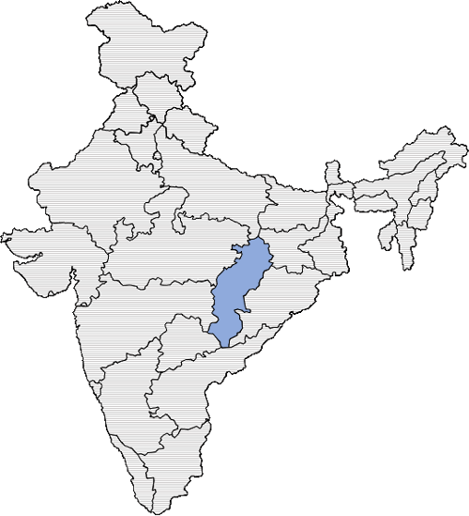
Fig. 1: Map of India highlighting the state of Chhattisgarh.
Source:https://www.researchgate.net/publication/350932915_Constructing_an_inclusive_vision_of_sustainable_transition_to_decentralised_energy.

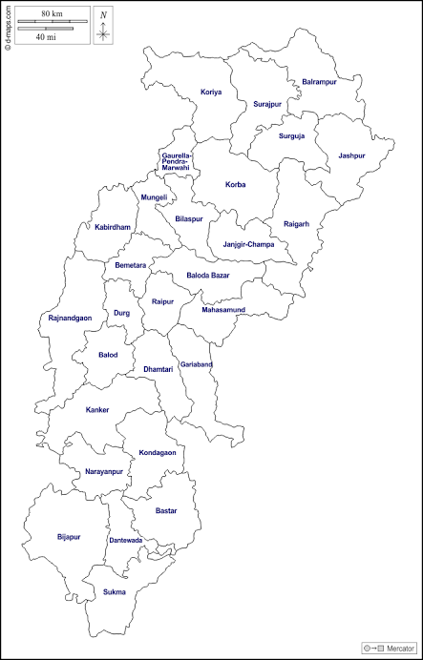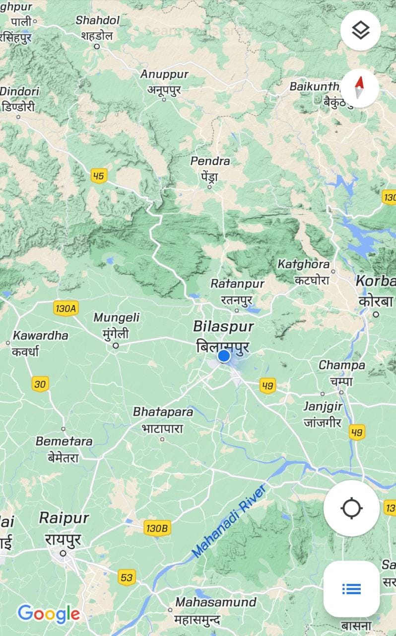
Fig. 2: Map showing Bilaspur District in Chhattisgarh.
Source:https://en.wikipedia.org/wiki/Bilaspur_district,_Chhattisgarh
Site Selection
The research was carried out between January 2023 and July 2023.Data were collected from 10 samples from different geographical locations of Bilaspur viz Koni, Uslapur, Ratanpur, Kota, and Birkona. 5 samples from forest region and 5 from non forestregion.Trees were observed to be under highly diverse environmental conditions and management practices. Morphological characters of trees were considered for diversity analysis based on height, DBH, leaf, pods, seeds, and other characteristics of the tree. The location of the tree and its history were documented.
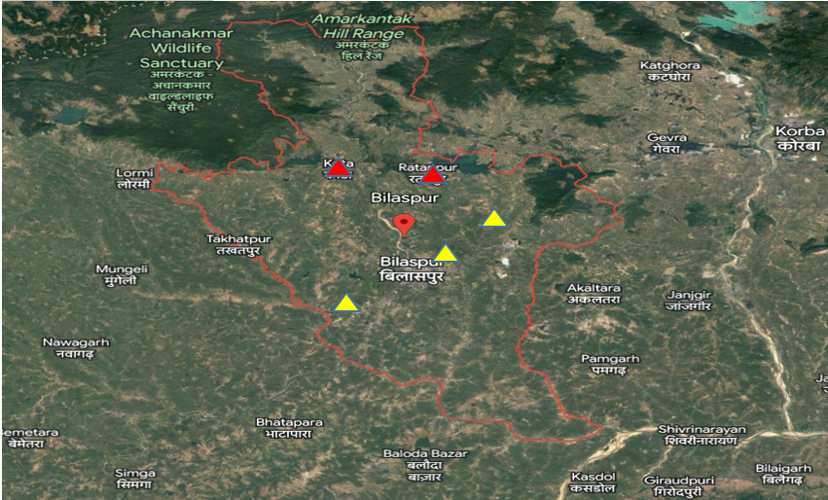
Fig 3: Location map of study sites. Red marks indicate forested areas and yellow marks indicate non-forested areas.
Source: Self made
Table 1: Details of Dalbergia sissoo data locations with latitude and longitude.
Sample | Location | Latitude | Longitude
Tree 1 | Koni | 22.1293° N | 82.1360° E
Tree 2 | Koni | 22.1293° N | 82.1360° E
Tree 3 | Uslapur | 22.1022° N | 82.1122° E
Tree 4 | Uslapur | 22.1022° N | 82.1122° E
Tree 5 | Birkona | 22.1173° N | 82.0602° E
Tree 6 | Ratanpur | 22.2859° N | 82.1652° E
Tree 7 | Ratanpur | 22.2859° N | 82.1652° E
Tree 8 | Ratanpur | 22.2859° N | 82.1652° E
Tree 9 | Kota | 22.2945° N | 82.0246° E
Tree 10 | Kota | 22.2945° N | 82.0246° E
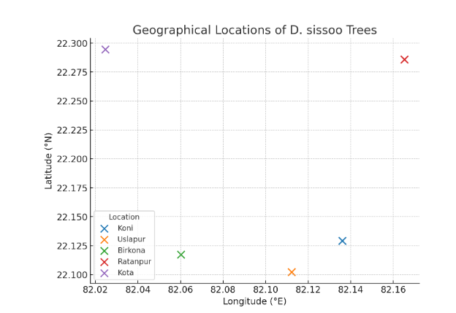
Fig. 4: Details of Dalbergia sissoo data locations with latitude and longitude.

2.2. Research Design:
The present study adopts a comparative field-based research design aimed at evaluating the morphological diversity of Dalbergia sissoo populations across two distinct ecological settings: forested and non-forested areas of Bilaspur, Chhattisgarh.
This design is appropriate as it allows systematic comparison of growth parameters (tree height, DBH, crown diameter) and morphological traits (leaf, seed, pod, and bark) under different habitat conditions. The approach combines quantitative measurements (e.g., height, diameter, crown spread) with qualitative observations (leaf structure, bark texture, seed and pod morphology).
The comparative design ensures:
- Identification of site-specific morphological variations.
- Assessment of the adaptability of D. sissoo to varying ecological conditions.
- Generation of baseline data for future ecological and conservation studies.
2.3. Sampling Techniques:
Sampling sites : The study will employ a systematic sampling design to ensure representative coverage of Dalbergia sissoo populations in the study area. The selection of environmental conditions.
Sample Size: The sample size was depended on the specific objectives of the study and the availability of resources. A sufficient number of samples were collected to capture the morphological variations within the Dalbergia sissoo populations in Bilaspur, Chhattisgarh. A minimum sample size of 10 individuals was collected to achieve a robust representation of the population (Krejcie and Morgan, 1970).
Data Collection Method: The samples were collected in the form of branches, leaves, and seeds from mature Dalbergia sissoo trees. Branches were cut using appropriate tools, ensuring minimal damage to the tree. Leaf samples were collected from various positions on the tree, representing different growth stages and canopy positions. Seeds were collected from mature pods found on the trees or on the ground in the vicinity.
Sample Selection Criteria: To ensure the inclusion of diverse genotypes and variations in morphology, the following criteria will be considered during sample selection:
Geographic Distribution: Samples were collected from different locations within the Bilaspur district, including forested areas, agroforestry plantations, and other suitable habitats where Dalbergia sissoo is present.
Size and Age: Samples were selected from trees of different sizes and age classes to account for potential variations in morphology with tree development.
Environmental Conditions: Samples were collected from sites with varying environmental conditions, such as different soil types, slope gradients, and levels of light exposure.
Data Recording: Relevant data were recorded for each collected sample, including tree height, stem diameter, branch length, leaf size and shape, seed size, and any other morphological characteristics of interest. GPS coordinates and site information were recorded for proper sample identification and site characterization.The sample collection and selection process will aim to capture the morphological variations within the Dalbergia sissoo populations in Bilaspur, Chhattisgarh, providing a representative dataset for further analysis and interpretation.
Result and Discussions:
3.0. Data Analysis
The average tree height ranged between 15 to 22 meters, with forested trees exhibiting greater height and stem diameter (mean DBH ~100.2 cm) compared to those in non-forested areas (mean DBH ~95 cm). Crown diameters varied from 8 to 12 meters, indicating competitive canopy spread. Leaf morphology consistently showed odd pinnately compound leaves with dark green coloration, demonstrating no significant color variation across regions. Seed and pod analyses revealed oval-shaped seeds and elongated pods, with pod length averaging 5 to 8 cm, maturing from green to dark brown. Bark characteristics displayed a rough, grayish-brown texture with lenticels, facilitating environmental adaptability.
3.1. Morphological parameters to be measured
In the study of Dalbergia sissoo morphology in Bilaspur, Chhattisgarh, various morphological parameters was measured to characterize the trees and capture their variations. The selection of parameters should align with the research objectives and the specific traits of interest. Below are some key morphological parameters that can be measured with reference to relevant studies:
- Tree Height: The height of each sampled tree was measured using a measuring tape or clinometer. Tree height is an essential parameter to assess the growth potential and age-related variations among individuals (Singh and Tiwari, 2014).
- Stem Diameter: The diameter at breast height (DBH) of each tree was measured using a caliper or DBH tape. DBH is a standard metric for characterizing tree size and growth (Rai and Shukla, 2019).
- Crown Diameter: The horizontal spread of the tree's crown was measured to assess the canopy size and shape. Crown diameter provides insights into the tree's spatial occupation and competitive ability (Sahu and Singh, 2013).
- Leaf Morphology: Leaf parameters was included in the measurements of leaf length, leaf width, and leaf shape. The leaves of Dalbergia sissoo are compound, and the variation in leaf morphology can provide insights into the adaptability and growth strategies of the species (Naithaniet al., 2017).
- Seed Morphology: Seed length, seed width, and seed shape was measured to assess seed variations. The study of seed morphology is relevant for understanding reproduction, seed dispersal, and potential genetic differences among populations (Mandal and Das, 2014).
- Bark Characteristics: Qualitative assessments of bark color, texture, and presence of lenticels was conducted. Bark characteristics can be indicative of environmental adaptations and medicinal properties (Rai and Shukla, 2019).
- Branching Pattern: The branching architecture of the tree, including the number and angle of branches, was observed and recorded. Branching patterns can influence tree stability and canopy development (Singh and Tiwari, 2014).
- Pod Length
Length of single pod was measured from tip to base of peduncle using thread and scale and expressed in centimetre (cm).

- Pod width
Width of single pod was measured using metric scale at the centre of the fruit and expressed in centimetre (cm).

- Number of seeds/pod
Number of seeds per fruit was counted manually.

- Single seed weight
Total seed weight per fruit was weighed and from that single seed weight was derived and expressed in gram (g).

- Seed length
It is the length of the seeds measured and the mean expressed in centimetre (cm).

- Seed breadth
It is the breadth of the seeds measured and the mean expressed in centimetre (cm).

- Seed Weight
Weight of seed were taken with the help of Electronic wt. Machine.

- Germination percentage
Number of germinated seeds was counted manually and percent germination was calculated as below.

Total number of seeds germinated
Germination % = -------------------------------------------------- * 100
Total number of seeds sown

- Shoot length
Length of shoot of seedling was measured using metric scale and expressed in centimetre (cm).

- Root Length
Length of root of seedling was measured using metric scale and expressed in centimetre (cm). (Khan et al., 2018).

- Plant height
Seedling height was measured from tip to ground level of seedling using metric scale and expressed in centimetre (cm).

By measuring these morphological parameters, the study can comprehensively analyze the variations in Dalbergia sissoo within the study area and provide valuable insights into its growth patterns, adaptive traits, and ecological significance.
The analysis of the morphological characteristics of Dalbergia sissoo in Bilaspur, Chhattisgarh, revealed several key findings. These findings provide insights into the morphological variations and adaptations of the species in the study area. The following morphological characteristics were observed and analysed:
Tree Height: The average tree height of Dalbergia sissoo in Bilaspur was found to be approximately 15-20 meters, with some individuals reaching up to 25 meters. The height measurements indicated considerable variation within the population, reflecting differences in growth rates and tree age.
Stem Diameter: The analysis of stem diameter (DBH) revealed that Dalbergia sissoo trees in Bilaspur exhibited an average DBH ranging from 75 to 125 centimeters . The stem diameter measurements indicated the robustness and maturity of the sampled individuals.
Crown Diameter: The crown diameter of Dalbergia sissoo varied between 8-12 meters, with larger individuals exhibiting wider crown spreads. The crown diameter measurements indicated the extent of the canopy and the competitive ability of the trees.

Table 2: Morphological characteristics of different Dalbergia sissoo trees.

Sisso Tree | Height(m) | DBH(cm) | Crown Diameter(m) | Leaf colour | Bark Colour | Disease
Tree 1 | 20 | 75 | 12 | Dark Green | Greyish Brown | Absent
Tree 2 | 18 | 78 | 10 | Dark Green | Brown | Absent
Tree 3 | 16 | 92 | 8 | Dark Green | Brown | Absent
Tree 4 | 15 | 110 | 8 | Dark Green | Brown | Absent
Tree 5 | 20 | 120 | 10 | Dark Green | Greyish Brown | Present
Tree 6 | 20 | 89 | 9 | Dark Green | Greyish Brown | Absent
Tree 7 | 17 | 84 | 9 | Dark Green | Brown | Absent
Tree 8 | 19 | 96 | 8 | Dark Green | Brown | Absent
Tree 9 | 22 | 108 | 12 | Dark Green | Greyish Brown | Absent
Tree 10 | 20 | 124 | 11 | Dark Green | Greyish Brown | Absent
MEAN | 18.6 | 97.6 | 9.7 |  | 5:5 | 1:10
Source : Research Findings (2025)
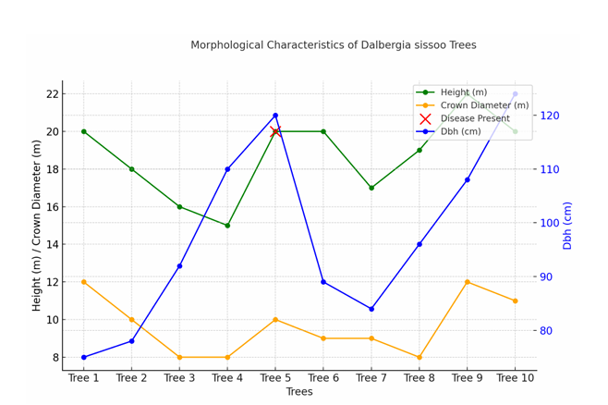
Fig: 5,A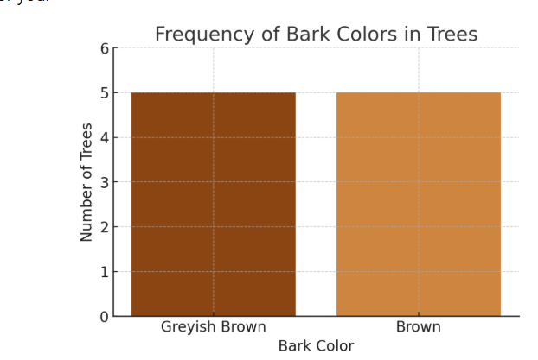
Fig: 5, B
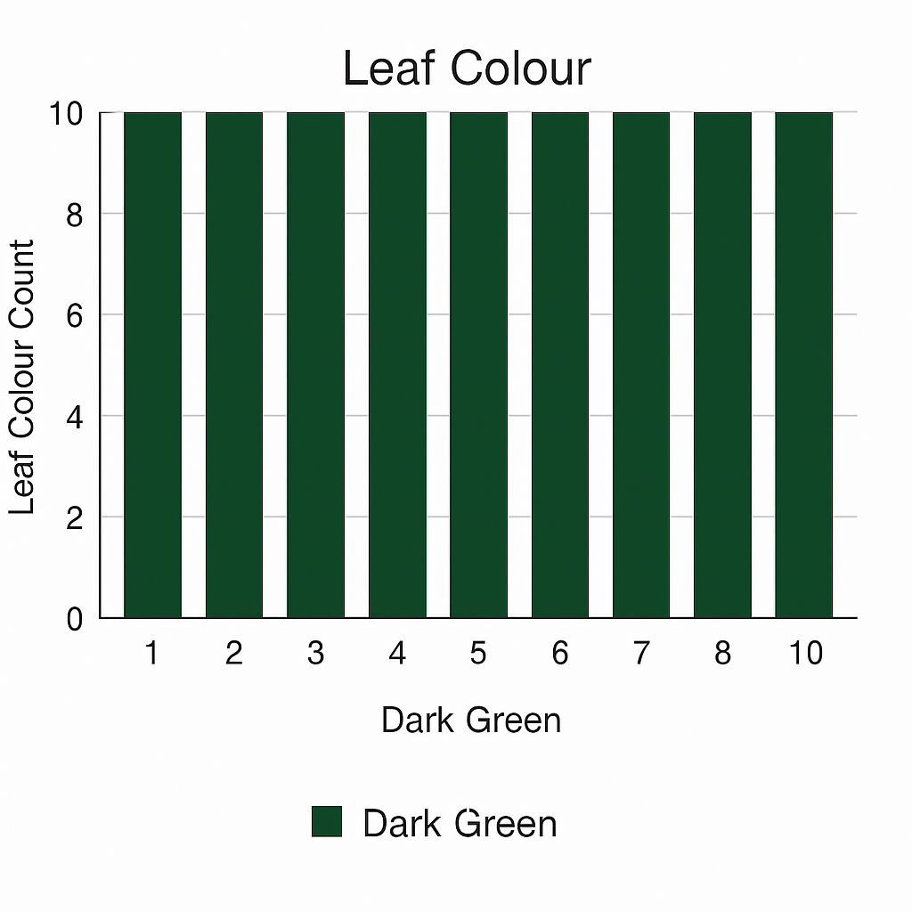

Fig:5,C
Fig 5 A,B,C: Morphological characteristics of different Dalbergia sissoo trees.
Source : Research Findings (2025)

Table 3: Morphological variation in non-forested area.
Sisso Trees | Height (m) | DBH(cm) | Crown Diameter (m) | Leaf Colour | Bark Colour | Disease
Tree 1 | 20 | 75 | 12 | Dark Green | Greyish Brown | Absent
Tree 2 | 18 | 78 | 10 | Dark Green | Brown | Absent
Tree 3 | 16 | 92 | 8 | Dark Green | Brown | Absent
Tree 4 | 15 | 110 | 8 | Dark Green | Brown | Absent
Tree 5 | 20 | 120 | 10 | Dark Green | Greyish Brown | Present
Mean | 17.8 | 95 | 9.6 |  |  | 4:1
Source : Research Findings (2025)
Table 4: Morphological variation in forested area.
Sissoo Tree | Height(m) | DBH(cm) | Crown Diameter (m) | Leaf Colour | Bark Colour | Disease
Tree 1 | 20 | 89 | 9 | Dark Green | Greyish Brown | Absent
Tree 2 | 17 | 84 | 9 | Dark Green | Brown | Absent
Tree 3 | 19 | 96 | 8 | Dark Green | Brown | Absent
Tree 4 | 22 | 108 | 12 | Dark Green | Greyish Brown | Absent
Tree 5 | 20 | 124 | 11 | Dark Green | Greyish Brown | Absent
Mean | 19.6 | 100.2 | 9.8 |  | 2:3
Source : Research Findings (2025)
The height of the trees was taken with the help of a Haga Altimeter and Variations were seen due to diff temperatures, soil types, and climatic factors. Tree 1 to 5 is from Nonforest Area & 6-10 is from Forest Area. The average height observed all over was 18.6. The max height observed was 22m. Min height observed was 15m. (Table:2)

Fig: 6 Graph Showing Variation in Height in Forested and Non-Forested Areas.
Source : Research Findings (2025)
The average height observed in the Non-Forest area was 17.8. (Fig: 6 ,Table 3)
The average height observed in the Forest area was 19.6. (Fig: 6, Table 4)
Therefore the trees in forest Areas have more height as compared to nonforest areas.

Fig:7 Variation in Diameter at Breast Height (DBH)"
Source : Research Findings (2025)
The DBH of different trees was taken using tape and caliper. Variations were seen due to different climatic & topographic factors. 1-5 shows non forested areas and 6-7 shows forested area. The average of the DBHobserved was 97.6. The DBH of forest-grown trees was observed more in compare to nonforest areas. Max DBH obtained was 124 cm. Min DBH Obtained was 75 cm. (Fig:5 , Table:2)

Fig:8 Graph Showing Variation in DBH (cm) in Forested and Non-Forested Areas.

Source : Research Findings (2025)
Average DBH Observed in Nonforested area is 95.( Table 3)
Average DBH observed in Forested area is 100.2 .( Table 4)
Therefore , trees in forested area have more diameter as compared to non forested region.
Leaf Morphology:
The analysis of leaf morphology revealed compound leaves with an average length of 15-20 centimeters and a width of 8-12 centimeters . The leaflets were observed to be alternate, pinnately compound, and elliptical or lanceolate in shape. The variations in leaf size and shape reflect the adaptability of the species to different environmental conditions.(Fig:9)
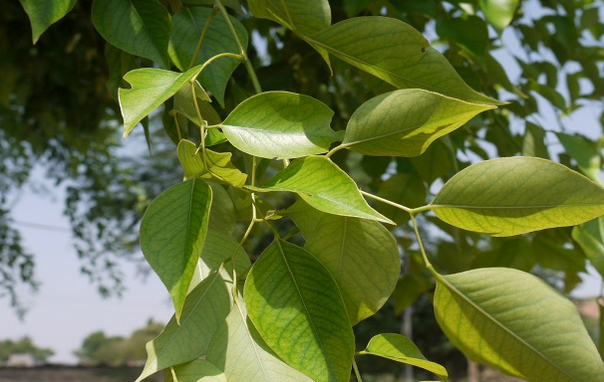
Fig: 9 Leaf Morphology
Source:https://greenparadiselive.com/products/shisham-dalbergia-sissoo-plant?srsltid=AfmBOooy3jJE286LY_r7-w4Ij7iCOwg9lWRmNpd-EKk__oQbGHHiotY_
- Leaf type: Odd pinnately compound
- Leaflet margin: Entire
- Leaflet shape: Elliptic (oval) to orbiculate
- Leaflet venation: Pinnate
- Leaf type and persistence: Semi-green, persistent
- Leaflet blade length: 2 to 4 inches
- Leaf color: Dark green
- Fall color: No change
The leaf colour of the both the areas were observed to be Dark Green in colour. No variations were observed in leaf colour.
Seed Morphology: The analysis of seed morphology showed that Dalbergia sissoo seeds were approximately 2-3 centimeters long and 1-1.5 centimeters wide. The seeds were observed to be oval-shaped with a smooth surface. The seed measurements indicated the reproductive characteristics and potential genetic variations within the population. (Fig:10 A, B))

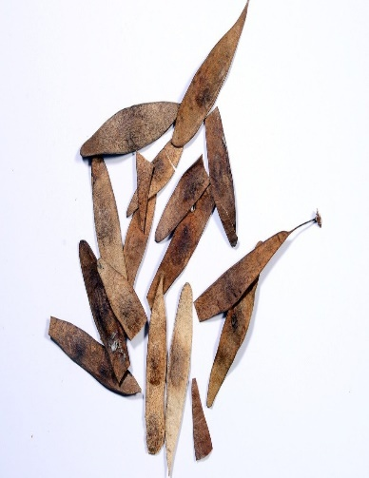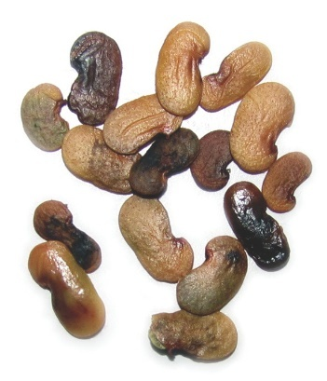
Fig .10 A Pods Shape Fig.10,B Seeds Shape
Source:https://www.flipkart.com/green-india-shisham-tree-seed-sisoo-dalbergia-sissoo-seed-pack-100-g/p/itme97a89bc8ab23
Pod Morphology: The pods of Dalbergia sissoo are elongated and slender, resembling flat, thin, and elongated strips or straps. They are typically straight or slightly curved and have pointed ends.
Pod Length: The average length of the pods ranges from about 5 to 8 centimeters, with some variations observed depending on environmental factors and tree age.
Pod Color: The pods are initially green when young and gradually mature to a dark brown or black color as they ripen. (Fig.11,12 )
Pod Texture: The surface of the pods is smooth and glossy when mature.
Pod Structure: The pods are legumes, and when mature, they split open along one side to release the seeds contained inside.Number - 4,7 or 5. Length - 4.7 to 5 cm , Breadth - 7.4 mm to 7.48 mm, 100 pod weight = 6.459 to 8.315 gm, Average = 7.055 gm, Number of seeds in pods - 1 to 4 seeds ,Colour - brown to black
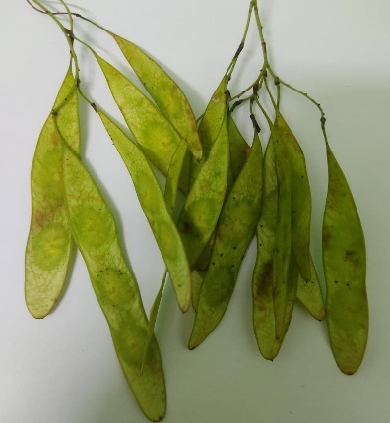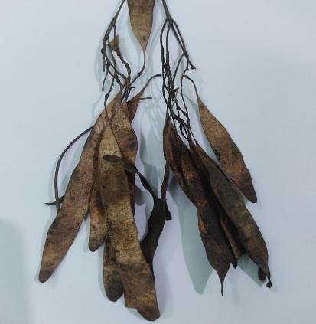
Fig :11Green Pods Fig :12 Pods after drying
Source:https://www.flipkart.com/green-india-shisham-tree-seed-sisoo-dalbergia-sissoo-seed-pack-100-g/p/itme97a89bc8ab23
Bark Characteristics: The qualitative analysis of bark characteristics revealed that the bark of Dalbergia sissoo in Bilaspur exhibited a grayish-brown color with a rough texture. Lenticels were present on the bark surface, facilitating gas exchange and allowing the tree to adapt to varying environmental conditions. (Fig: 13)
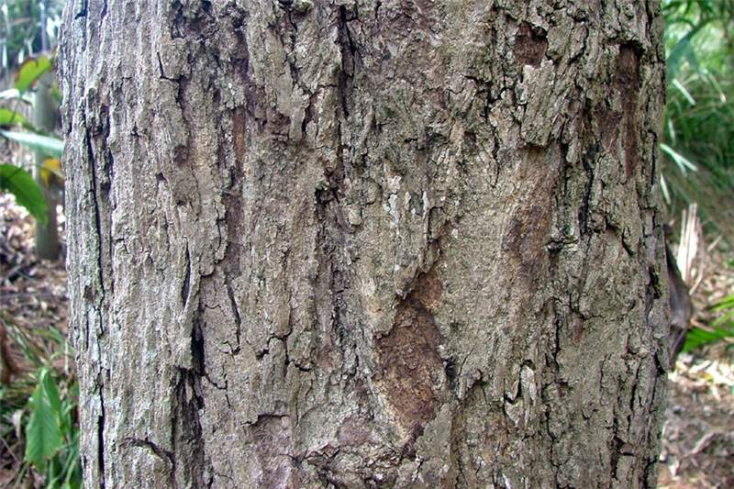
Fig :13. Bark Structure
Source : Research Findings (2025)
The morphological characteristics of Dalbergia sissoo in Bilaspur demonstrate its adaptability to the local environmental conditions. The variations observed in tree height, stem diameter, crown diameter, leaf morphology, seed morphology, and bark characteristics highlight the phenotypic diversity within the species. These findings contribute to understanding the species' growth patterns, adaptations, and potential implications for its conservation and management.
- Bark colour were observed as brown to black.

Fig:14 Chart Showing Variation in Bark Colour in Forested and Non-Forested Areas.

Source : Research Findings (2025)
4.0 Conclusion:
The comparative study of Dalbergia sissoo in forested and non-forested areas of Bilaspur, Chhattisgarh, revealed significant variations in key morphological traits such as tree height, DBH, and crown diameter, while leaf, seed, pod, and bark characteristics remained largely consistent across sites. Forested populations generally exhibited superior growth performance, indicating the positive influence of favorable ecological conditions. At the same time, the ability of D. sissoo to thrive in non-forested environments demonstrates its remarkable adaptability and ecological resilience.
These findings confirm the species’ phenotypic diversity and adaptability, which are essential for its sustainable management, conservation, and utilization in both forestry and agroforestry systems. The study also provides a baseline dataset that can support future ecological and genetic research, guide plantation programs, and inform policymakers in developing effective conservation strategies.

5.0 Recommendations
Based on the comparative analysis of Dalbergia sissoo populations in forested and non-forested areas of Bilaspur, the following recommendations are proposed:
- Conservation and Protection
  - Forested populations, showing superior height and DBH, should be prioritized for in situ conservation to maintain genetic vigor.
  - Measures should be taken to protect natural stands from deforestation, grazing, and anthropogenic pressures.
- Agroforestry and Plantation Practices
  - D. sissoo can be promoted in agroforestry systems, particularly in non-forested or degraded lands, due to its adaptability and ecological resilience.
  - Selection of high-performing phenotypes (based on DBH and crown spread) for plantation programs can improve productivity.
- Sustainable Utilization
  - Local communities and forest departments should be encouraged to utilize D. sissoo sustainably, focusing on timber, fodder, and shade values without overexploitation.
  - Harvesting practices should include regulated cutting cycles and replanting to maintain ecological balance.
- Future Research
  - Long-term monitoring of morphological traits under changing climatic conditions is recommended to assess resilience.
  - Molecular/genetic studies should be integrated with morphological observations to identify genotype–environment interactions.
  - Further comparative studies across different districts of Chhattisgarh could provide a broader understanding of the species’ adaptability.

5.1 Recommendations to Future Researchers
Based on the findings and limitations of this study, the following recommendations are suggested for future researchers working on Dalbergia sissoo and related species:
- Expanded Geographical Scope
  - Conduct comparative studies in multiple regions of Chhattisgarh and other states to capture wider ecological variations.
  - Include different altitudinal and climatic zones to understand environmental influences more comprehensively.
- Longitudinal Studies
  - Carry out long-term monitoring of D. sissoo populations to assess growth patterns and morphological variations over time.
  - Study seasonal changes in leaf, seed, and bark traits for a complete phenological understanding.
- Integration of Genetic and Molecular Approaches
  - Combine morphological studies with genetic and molecular analyses to explore genotype–environment interactions.
  - Identify genetic markers linked with adaptability, disease resistance, and growth performance.
- Soil and Environmental Factors
  - Examine the influence of soil type, nutrient status, and water availability on morphological diversity.
  - Study the impact of abiotic stress (e.g., drought, salinity) on growth and adaptability.
- Silvicultural and Agroforestry Applications
  - Explore the performance of D. sissoo in mixed plantations with other species.
  - Assess its role in carbon sequestration, soil fertility improvement, and livelihood support for farmers.
- Conservation and Climate Change
  - Investigate the resilience of D. sissoo under predicted climate change scenarios.
  - Develop conservation models that combine both in situ and ex situ approaches.
Full Term | Abbreviation
Comparative Analysis | CA
Morphological Traits | MT
Dalbergia sissoo | DS
Forested and Non-Forested Areas | FNFA
Bilaspur, Chhattisgarh, India | BCI

Disclaimer (Artificial intelligence)
Author(s) hereby declare that NO generative AI technologies such as Large Language Models (ChatGPT, manuscript.

Reference:
Bhandari, M. S., Pandey, S., Kant, R., Joshi, P., Thapliyal, G., Mishra, G., ... & Bisht, S. S. (2025). Global genecological status of vulnerable Dalbergia latifolia: need to introspect the conservation perspectives. Vegetos, 1-17.
Bargah, A. S., Pratap Toppo, D. L. S., Tuteja, S. S., Mankur, M. K., &PainkraandPankaj, D. S. Effect of nutrient management on growth performance of Geranium (Pelargonium graveolens) under Karanj (Pongamiapinnata) based agroforestry system in Chhattisgarh plain.
Bargah, A. S., Sharma, D., Kumar, R., Nag, R., & Pradhan, R. (2025). Enhancing Germination of Forest Tree Seeds in Chhattisgarh through PGR-Based Treatments: A Review. Journal of Advances in Biology & Biotechnology, 28(7), 851-863.
Dabral, R., Singh, P., & Rawat, V. S. (2019). Morphological variations and phenotypic plasticity of Dalbergia sissoo in the Terai region of Uttarakhand, India. Indian Journal of Forestry, 42(2), 123–131.
Ghosh, A., Verma, S., & Singh, P. (2019). Morphological and physiological responses of Dalbergia sissoo Roxb. to heavy metal stress: Implications for phytoremediation. Environmental Monitoring and Assessment, 191(12), 755.
Hussain, A., Khan, M. A., Ahmad, M., & Shah, S. (2020). Leaf morphological variations in different provenances of Dalbergia sissoo Roxb. ex DC. in Pakistan. Pakistan Journal of Botany, 52(4), 1357–1364.
Sheikh, A. H., & Abdul, M. M. D. (2007). Seed morphology and germination studies of Dalbergia sissoo Roxb. at nursery stage in Bangladesh. Journal of Agriculture and Biological Sciences, 3(1), 35-39.
Sharma, A., & Bakshi, M. (2014). Variability in growth, physiological, and biochemical characteristics among various clones of Dalbergia sissoo in a clonal seed orchard. International Journal of Forestry Research, 2014(1), 829368.
Singh, R., Singh, D., & Singh, A. (2016). Dalbergia sissoo: Ecology, uses and conservation significance. Journal of Forestry Research, 27(4), 857–866.

