Impact Assessment of Endogenous Land Restoration Techniques in the Sahel Using a Counterfactual Model: Case of the urban commune of Tagazar, Tillabéri, southwest of Niger

ABSTRACT
This study evaluates the impact of endogenous land restoration techniques, particularly on certain fundamental soil properties, namely bulk density, volumetric moisture, and texture. The urban commune of Tagazar in Niger, which served as the experimental field for the study, is located in the heart of the Sahel and is highly exposed to land degradation.
The methodological approach used is quasi-experimental, based on a counterfactual model, by comparing plots treated with sylvopastoral bunds and forest half-moons on the one hand, and untreated control plots on the other, located on glacis and plateau sites. A significant improvement in the physical properties of the soil was observed following the treatment of the sites with these techniques. Indeed, bulk density decreased by an average of 0.23 g/cm³ on glacis and 0.22 g/cm³ on plateaus, indicating improved porosity and soil structure. At the same time, volumetric moisture increased by 6.4% and 5.1%, respectively, in the two environments, reflecting better soil water retention capacity. These effects are statistically significant (p < 0.05).
As for the soil textural analysis, it shows a clear improvement in soil structure in areas rehabilitated with half-moons and bunds, with a reduction in sand content and an enrichment in silt and clay, especially at depth (10–30 cm).
These results thus confirm the effectiveness of these land and water restoration and conservation techniques through the improvement of the soil’s hydrophysical function. They are particularly valuable for strengthening the resilience of Sahelian agroecosystems due to their simplicity, low cost, and adaptability to the local agroecological context.
Keywords: Land Restoration, Sahel, Texture, Endogenous Techniques, Counterfactual Model

INTRODUCTION
Of both climatic and anthropogenic origin, land degradation is one of the major environmental challenges of the modern world. It leads in particular to a decline in agricultural productivity, intensified water erosion, progressive loss of biodiversity, reduced soil organic carbon, and the disruption of entire ecosystems [1].
It is estimated that around 40% of the planet’s land is degraded, meaning that half of humanity is affected and more than half of the world’s GDP (USD 44 trillion) is at risk [2].
If no action is taken against land degradation, the associated costs could be three to five times higher, particularly in Asia and Africa [3].
Sub-Saharan Africa is severely affected by this phenomenon, which manifests itself through profound changes in landscapes, with the corollary of declining crop productivity despite the central role of agriculture for Sahelian communities [4].
Niger is a striking example, where land degradation, combined with other socio-economic and demographic challenges, is disrupting the livelihoods of already vulnerable rural communities [5]. As a result of this degradation, rainwater infiltration is low estimated at less than 10%combined with high evaporation rates ranging from 30 to 50%, while surface runoff can reach 25 to 50%. This hydrological imbalance contributes to soil impoverishment, limits groundwater recharge, and seriously undermines agricultural yields [6],[7].
In response to this situation, rural Sahelian communities have developed and tested endogenous land restoration techniques that are in harmony with their ecological and socio-economic environment [8],[9]. These techniques enable populations to better manage their ecosystems and improve their production areas, thereby strengthening their resilience to environmental changes such as climate change, land degradation, and drought events [10].
Among these techniques, sylvopastoral bunds and forest half-moons have proven particularly effective in slowing runoff, promoting water infiltration, trapping sediments, and fostering vegetation regeneration [11].
The commune of Tagazar, located in the Tillabéri region of the Republic of Niger, is a representative example of these dynamics. It faces advanced degradation of its plateaus and glacis, affecting food security, ecosystem resilience, and the livelihoods of local populations.
This study therefore aims to measure the environmental impact of endogenous land restoration techniques (bunds and half-moons) on soil properties, through a rigorous comparison between treated and untreated areas. It employs a robust impact evaluation approach based on a quasi-experimental counterfactual model, allowing for the comparison of treated and untreated sites with similar characteristics.

2. MATERIALS AND METHODS

2.1. Study Area
The study was conducted in the urban commune of Tagazar, located in the Balleyara department, in the southeast of the Tillabéri region (Niger), between 13°31’ and 13°52’ N and 3°08’ and 3°33’ E (Figure 1). The commune covers an area of 1,314 km² (see Figure 1) and has approximately 107,134 inhabitants, of whom 52.28% are women. The population relies heavily on natural resources, which are subject to strong anthropogenic and climatic pressures [12].
The climate of the area is Sahelian, characterized by a long dry season (October to May) and annual rainfall ranging from 200 to 500 mm. Temperatures fluctuate between 18 °C and 45 °C. The main soil types encountered are sandy, lateritic, or clayey, while the vegetation consists of shrub steppes and tiger bush. Geomorphologically, the territory is structured around plateaus, valleys, and glacis, currently affected by accelerated land degradation (erosion, impoverishment, loss of vegetation cover) [13].

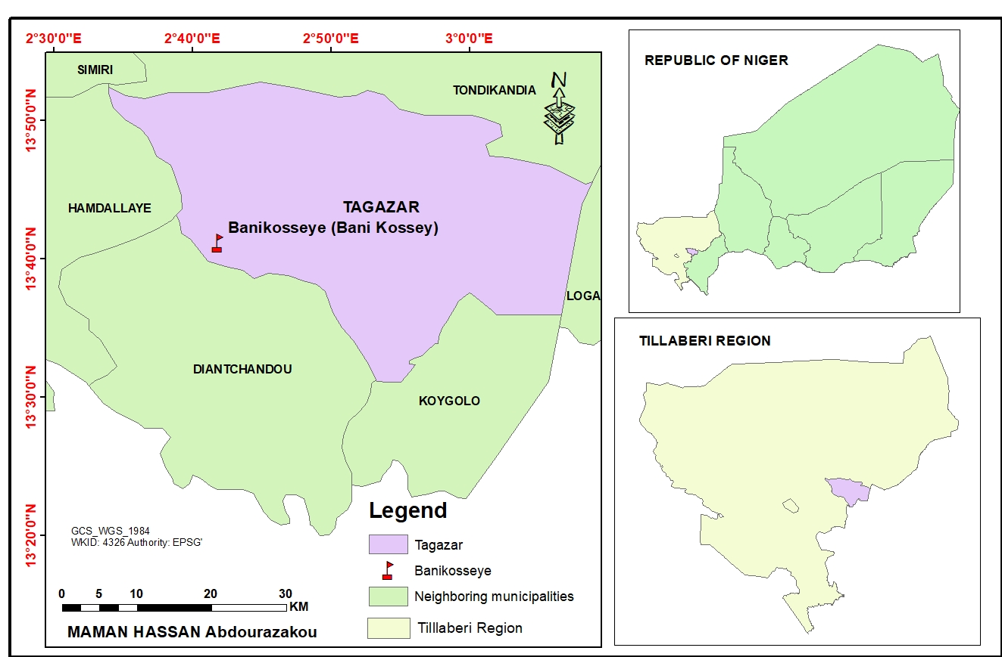
Figure1. Location of the Study Area

2.2. Experimental Design and Counterfactual Approach
The approach adopted is quasi-experimental, based on a counterfactual model aimed at assessing the causal effect of two endogenous restoration techniques (sylvopastoral bunds and forest half-moons) on the physical properties of the soil.
The principle consists of comparing two groups:
- A treated group, composed of plots managed using the endogenous techniques;
- A control group, consisting of untreated plots but with similar pedoclimatic characteristics.
The causal effect α is estimated as the difference between the expected outcomes with and without intervention:
α =E(Y∣P=1) −E(Y∣P=0) Eqn 1
Where Y represents the variable of interest (volumetric moisture or bulk density) and P the treatment status (1 = presence of intervention; 0 = absence) [14].
This approach allows isolating the net effect of the techniques by controlling for biases related to the natural heterogeneity of soils.

2.3. Site Selection Criteria and Description
Two experimental sites were selected based on the following criteria: advanced degradation status, accessibility, geomorphological homogeneity, and feasibility of sampling.
Site 1: Sylvopastoral Bunds (Plateaus)
The first site, covering an area of 16 hectares, is located at 13°41’46.9” N; 2°44’53.0” E.
The soil is ferruginous, tropical, slightly leached, shallow, with some presence of gravel crusts and erosion. The site was developed using 280 sylvopastoral bunds within which 1,400 Ziziphus mauritiana plants were planted (on the 8 hectares used as treated plots) (Figure 2).
These bunds consist of long excavations arranged along the contour lines and equipped with wings-oriented upslope. They generally consist of a ridge on the downslope side and a ditch upslope fitted with two wings, the space between which is seeded with herbaceous plants, while fodder trees are planted along the edges.
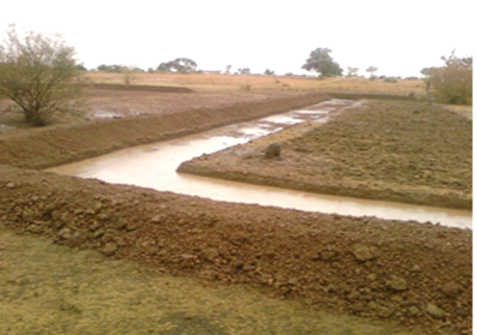
Figure2. Sylvopastoral Bunds
Site 2: Forest Half-Moons (Glacis)
The second site, also covering 16 hectares of glacis, is located at coordinates 13°39’54.5” N; 2°42’22.6” E. Pedologically, it is covered by a leached ferruginous soil, relatively deep (100–120 cm), affected by sheet and rill erosion, and structural crusts.
The treated part of the site was restored using 4,000 forest half-moons, with an equal number of Ziziphus mauritiana plants. The other half of the plot (the remaining 8 hectares) was kept as a control area (Figure 3).

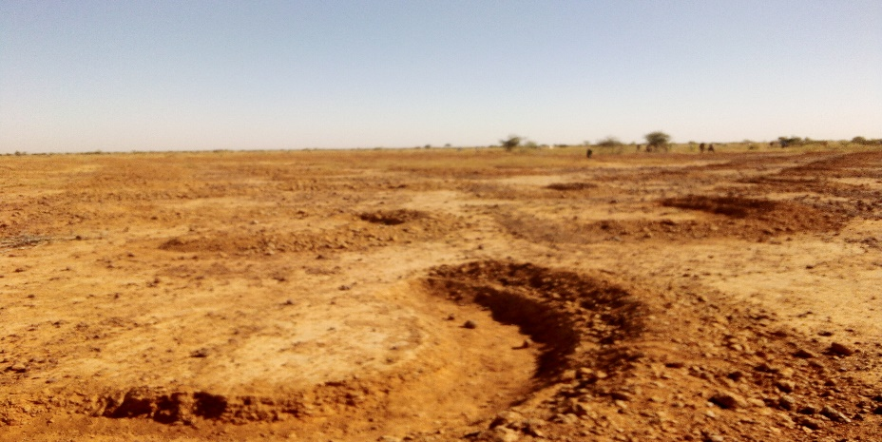
Figure3. Forest Half-Moons

2.4. Sampling, Data Collection, and Analysis
Soil samples were collected from both restored (treated) and unrestored (control) sites to analyze key physicochemical parameters: volumetric moisture (%), bulk density (g/cm³), and soil texture (silt, sand, clay). Disturbed sampling was conducted at two depths, 0–10 cm and 10–30 cm, with four samples taken per hectare between October 19 and 30, 2023.
For the bunds, samples were taken upstream, inside the basin, and downstream of the ridge (three profiles). For each zone, a composite sample was created by combining four closely located subsamples, which were then identified and labeled.
For the half-moons, a similar approach was adopted by sampling the soil at 0–10 cm and 10–30 cm within seven representative half-moons, randomly selected. Samples were collected at the center, just outside, and at the edge of each half-moon, also forming three profiles. A composite sample was then created.
The different samples were analyzed in the laboratory for bulk density, volumetric moisture, and texture. Table 1 presents the equipment used.
Table 1 : Materials Used
Tool | Utility
Shovel | Soil sampling
Clean bags | Collection and mixing
Markers and labels | Sample identification
Metal rings (100 cm³) | Undisturbed sampling
Tarpaulin | Sample mixing
Plastic bags | Sending to the laboratory

The core ring method, drying at 105°C, and sieving were respectively used for the analysis of bulk density, volumetric moisture, and soil texture.

2.5. Data Processing and Statistical Analysis
The data were processed using SPSS version 29 to test the effect of the restoration techniques on the physical properties of the soil. A comparative statistical analysis was conducted using the Student’s t-test for two independent samples to compare the mean values of volumetric moisture and bulk density between treated sites. et les sites témoins pour chacun des deux milieux (plateaux et glacis). Le seuil de signification statistique a été fixé à p < 0,05.
RESULTS AND DISCUSSION
Descriptive presentation of Bulk Density and Volumetric Moisture Data
The descriptive analysis of data from both control and treated sites, in the two environments (glacis and plateau), provides the following means and standard deviations for bulk density and volumetric moisture of the soil (Table 2).
Table 2 : Descriptive Data Analysis
Environment | Status | Bulk Density (g/cm³) | Volumetric Moisture (%)
Glacis | Treated | 1.12 ± 0.02 | 16.06 ± 0.36
Glacis | Control | 1.35 ± 0.02 | 9.64 ± 0.23
Plateau | Treated | 1.19 ± 0.02 | 13.75 ± 0.35
Plateau | Control | 1.42 ± 0.02 | 8.64 ± 0.27

Impact of treatment on soil bulk density
As part of the evaluation of the effect of indigenous land restoration techniques on soil bulk density, an independent-samples Student’s t-test, assuming equal variances, was conducted.
On the Glacis site, the results show a mean difference of 0.23 g/cm³ between the treated group (M = 1.1225; n = 20) and the control group (M = 1.3525; n = 20). The observed t-statistic was −35.50 with 38 degrees of freedom, which far exceeds the two-tailed critical value (±2.024) at the 5% significance level. The obtained p-value (9.48 × 10⁻³¹) indicates a highly significant difference between the two groups. These results allow for the rejection of the null hypothesis of equal means and suggest that the treatment had a significant effect on soil bulk density, reflecting a measurable improvement in this physical property compared to the baseline situation.
At the Plateau site, a similar analysis was conducted. The observed means were 1.1945 g/cm³ for the treated group (n = 20) and 1.4175 g/cm³ for the control group (n = 20), corresponding to a mean difference of 0.223 g/cm³. The t-statistic of −33.27 (df = 38) and the p-value of 1.03 × 10⁻²⁹ also confirm a highly significant difference. These results indicate that the treatment led to a statistically significant reduction in bulk density, evidencing an improved soil structure induced by the interventions.
Impact of the treatment on soil volumetric moisture content
Regarding soil volumetric moisture content, the effects of the treatment were also evaluated using an independent-samples Student’s t-test.
On the Glacis site, mean values were 16.06% for the treated group (n = 20) versus 9.635% for the control group (n = 20), representing a mean difference of 6.425 percentage points. The t-statistic of 67.59 (df = 38) and the p-value of 3.33 × 10⁻⁴¹ indicate an extremely significant treatment effect. This result highlights a substantial improvement in the water-holding capacity of the restored soil, reflecting enhanced infiltration and porosity.
Similarly, on the Plateau site, the treatment had a notable effect on soil moisture. The treated group recorded a mean of 13.75%, compared to 8.635% for the control group, a difference of 5.115 percentage points. The t-statistic of 51.59 with a p-value of 8.58 × 10⁻³⁷ confirms a highly significant difference between the two groups. Thus, the treatment significantly improved soil water content, indicating an effective restoration of the soil’s ecological functions.
The analysis results reveal the substantial impact of indigenous land restoration techniques (silvopastoral bunds, forest half-moons) on the physical properties of soils at both Glacis and Plateau sites, as emphasized in this study. A marked reduction in bulk density and an increase in volumetric moisture content were observed in both landforms.
The reduction in bulk density in treated sites from 1.41 to 1.19 g/cm³ on the Plateau and from 1.35 to 1.12 g/cm³ on the Glacis suggests an improvement in soil structure. This decrease is consistent with previous studies [15] that demonstrated how bunds and half-moons help loosen the soil through the accumulation of organic matter and the reduction of water erosion. Other research has shown that lower soil density promotes better aeration and deeper root penetration [16].
The increase in volumetric moisture content in treated areas was also significant, rising from 4.2% to 6.8% on the Plateau and from 9.6% to 16.1% on the Glacis. These results indicate that the interventions enhanced the soil’s capacity to retain water. This phenomenon can be attributed to reduced runoff and improved infiltration, mechanisms well documented in studies on assisted natural regeneration and water-harvesting structures in the Sahel. The effect was more pronounced on the Glacis, likely due to the topographic nature of these environments, which favors water accumulation when restored. These hydrological effects are well documented in the literature on runoff water-harvesting techniques in the Sahel [17][18].
Moreover, the impact is even greater when techniques are combined with revegetation, which promotes vegetation cover regeneration and soil stabilization, as confirmed by similar studies in Niger on the physical and biological effects of land restoration treatments [16].
Nevertheless, this study has certain limitations, particularly because data were collected over a relatively short experimental period (October 2023), which does not allow for the assessment of seasonal dynamics in soil properties. Furthermore, the study could have been more comprehensive if other variables such as organic matter content, porosity, structural stability, and actual infiltration had been considered.
Finally, the results have important implications for land restoration policies in Niger. Indigenous techniques are effective, low-cost, and well adapted to local conditions [19][20][21]. As many Sahelian countries have made them a priority in their climate change adaptation and mitigation commitments, large-scale land restoration could significantly reduce desertification and, beyond that, improve household food security [22].
Changes in soil texture in restored sites
The analysis of mean soil textural fractions reveals significant differences between non-restored sites (whether with bunds or half-moons) and those subjected to restoration techniques. Non-restored soils exhibit high sand content (65% at 0–10 cm and 61% at 10–30 cm), with relatively low proportions of silt (20–22%) and clay (15–17%). In areas restored with half-moons, the sand fraction decreases to 55% at the surface and 50% at depth, while silt and clay fractions increase to 25–27% and 20–23%, respectively. Forest bunds display the lowest sand values (52% at 0–10 cm and 47% at 10–30 cm), accompanied by the highest silt (26–30%) and clay (22–23%) contents. This indicates a clear trend of enrichment in fine particles (silt and clay) in restored soils, particularly pronounced in bunds and in the deeper horizon (10–30 cm)
(Figure 4).

Figure4. Soil texture
These soil analysis results are consistent with previous research on the impacts of bunds and half-moons on land restoration in western Niger [23]. They indicate that restoration techniques such as half-moons and bunds promote a positive evolution in soil texture by reducing sand dominance in favor of finer fractions. This transformation is particularly evident in bunds, suggesting a more effective trapping of fine sediments and reduction of water erosion. The accumulation of silt and clay enhances soil structure, increases water-holding capacity, and promotes biological activity, thereby contributing to greater agroecological resilience. Furthermore, the improvement is more pronounced at a depth of 10–30 cm, reflecting a progressive pedogenetic dynamic and the vertical infiltration of fine particles. These observations confirm the ecological benefits of mechanical restoration works in Sahelian contexts, particularly forest bunds, which appear to be promising solutions for the sustainable restoration of degraded lands [24].
CONCLUSION
This study, focusing on the impact assessment of soil restoration on Sahelian lands, highlights the measurable environmental effects of indigenous soil restoration techniques. It emphasizes the positive changes that such environmental interventions can bring for the benefit of local communities.
Through an approach based on a quasi-experimental counterfactual model, the results clearly show that widely promoted and applied techniques in the Sahel such as silvopastoral bunds and forest half-moons restore ecosystems to their former qualities. This is particularly evidenced by the observed reduction in bulk density and increase in volumetric moisture content, which, in turn, lead to improvements in soil structure and porosity on one hand, and enhanced water infiltration and retention on the other.

COMPETING INTERESTS DISCLAIMER:
Authors have declared that they have no known competing financial interests OR non-financial interests OR personal relationships that could have appeared to influence the work reported in this paper.

Disclaimer (Artificial intelligence)
Option 1:
Author(s) hereby declare that NO generative AI technologies such as Large Language Models (ChatGPT, manuscript.
Option 2:
Author(s) hereby declare that generative AI technologies such as Large Language Models, etc. have been used during the writing or editing of manuscripts. This explanation will include the name, version, model, and source of the generative AI technology and as well as all input prompts provided to the generative AI technology
Details of the AI usage are given below:
1.
2.
3.

References
1. Gichuki, L., et al. (2019). Land rehabilitation and landscape restoration: Policy convergence between forest landscape restoration and land degradation neutrality. IUCN. https://doi.org/10.2305/iucn.ch.2019.11.fr
2. Wischnewski, W. (2022). Land degradation report: The UN issues strict warning and proposes practical remedies in “Global Land Outlook 2.” https://www.unccd.int/resources/global-land-outlook/glo2
3. Ekka, P., Patra, S., Upreti, M., Kumar, G., Kumar, A., & Saikia, P. (2023). Land degradation and its impacts on biodiversity and ecosystem services. Land and environmental management through forestry, 77-101.

4. Coulibaly, K., Baggnian, I., Zakou, A., & Nacro, H. B. (2022). Farmers’ perceptions of soil and water conservation and soil defense and restoration techniques in West Africa: Case of Burkina Faso and Niger. European Scientific Journal, 18(27), 121. https://doi.org/10.19044/esj.2022.v18n27p121
5. CNEDD. (2019). Republic of Niger process for defining land degradation neutrality targets: Final report of the NDT target definition program (p. 9). https://knowledge.unccd.int/sites/default/files/ldn_targets/Niger%20LDN%20TSP%20Country%20Report.pdf
6. Ado, M. N. (2021). Effects of multifunctional half-moons on sorghum production in West Africa: Case study of the Tahoua region in Niger (pp. 112–125). https://doi.org/10.19044/esj.2021.v17n34p112
7. Ren, J. W. F., & Coffman, G. C. (2023). Integrating the resilience concept into ecosystem restoration. Restoration Ecology, 31(5), 1–8. https://doi.org/10.1111/rec.13907
8. Nord, A., Snapp, S., & Traore, B. (2022). Current knowledge on practices targeting soil fertility and agricultural land rehabilitation in the Sahel. A review. Agronomy for Sustainable Development, 42(4), 79.
9. Dugué, P., Andrieu, N., & Bakker, T. (2024). Towards sustainable soil management in sub-Saharan Africa. Cahiers Agricultures, 33. https://doi.org/10.1051/cagri/2024003
10. GIZ. (2021). À la résilience des producteurs : Table des matières du guide de renforcement des capacités des agriculteurs (Document interne). Luxembourg
11. Moussa, B., Nkonya, E., Meyer, S., Kato, E., Johnson, T., & Hawkins, J. (2016). Economics of land degradation and improvement in Niger. Economics of Land Degradation and Improvement–A Global Assessment for Sustainable Development, 499-539.
12. République du Niger, Ministère des Finances, Institut National de la Statistique. (2014). Répertoire national des localités (ReNaLoC) [Avant-propos : liste de tous les sites habités du Niger visités durant le 4ᵉ Recensement général de la population et de l’habitat] (p. 796). Niamey, Niger. http://arks.princeton.edu/ark:/88435/dsp012227ms07n
13. Biga, I., Soumana, I., Idrissa, A., & Mahamane, A. (2024). A. Evaluation et spatialisation de la fertilité physico-chimique des sols des parcs agroforestiers de la commune de Tagazar (Niger). [Evaluation and mapping of the physicochemical fertility of soils in agroforestry parks of the Tagazar commune, Niger], 62(2), 11539–11561.
14. Gertler, P.J., & Martinez, S. (n.d.). Impact evaluation in practice.
15. Hassen, G., Bantider, A., Legesse, A., & Maimbo, M. (2021). Assessment of design and constraints of physical soil and water conservation structures in respect to the standard in the case of Gidabo sub-basin, Ethiopia. Cogent Food & Agriculture, 7(1), 1855818. https://doi.org/10.1080/23311932.2021.1855818
16. Idrissa, S., Abasse, T.A., & Mahamane, L. (2014). Effects of physical and biological treatments in restoring degraded crusted soil in Niger.
17. Nyamekye, C., Thiel, M., Schönbrodt-Stitt, S., Zoungrana, B. J. B., & Amekudzi, L. K. (2018). Soil and water conservation in Burkina Faso, West Africa. Sustainability, 10(9), 1–24. https://doi.org/10.3390/su10093182
18. Zougmore, R., Zida, Z., & Kambou, F. (1999). Réhabilitation des sols dégradés: rôles des amendements dans le succès des techniques de demi-lune et de zaï au Sahel [Rehabilitation of degraded soils: The role of amendments in the success of half-moon and zaï techniques in the Sahel]. Bulletin de la Recherche sur l’Erosion, 536–551. https://beep.ird.fr/greenstone/collect/bre/index/assoc/19-536-5.dir/19-536-550.pdf
19. Abdou, A., Saley, K., Ali, M., & Aboubacar, I. (2021). Impacts of a degraded land restoration technique on the survival and growth of seedlings of four Combretaceae species in the Sahelian zone of Niger. European Scientific Journal, 17(43), 134–157. https://doi.org/10.19044/esj.2021.v17n43p134
20. Soubeiga Wanogo, H., et al. (2024). Ecological impacts of degraded land restoration activities in three village territories of the Maradi region (Niger). International Journal of Biological and Chemical Sciences, 18(2), 389–404. https://doi.org/10.4314/ijbcs.v18i2.6
21. Bado, B. V., Savadogo, P., & Sanoussi Manzo, M. L. (2016). Restoration of degraded lands in West Africa Sahel: Review of experiences in Burkina Faso and Niger (Technical Report). ICRISAT.
22. Sacande, M., Martucci, A., & Vollrath, A. (2021). Monitoring large-scale restoration interventions from land preparation to biomass growth in the Sahel. Remote Sensing, 13(18). https://doi.org/10.3390/rs13183767
23. Abdou, A., Issifou, A., Soukaradji, B., Elh, A., Moustapha, M., & Ali, M. (2021). Impacts of forest bunds and half-moons on soil physicochemical characteristics and spontaneous vegetation diversity in western Niger, 34(3), 9324.
24. Ministère de l’Éducation nationale et de l’Alphabétisation du Burkina Faso Technologie 5. Ouagadougou : Gouvernement du Burkina Faso, pp. 96–98.

