Adaptation to Soil Salinization in Lower Casamance, Senegal: A Socio-Demographic Perspective

Abstract

This study aims to identify the causes and consequences of rice field degradation, as well as the adaptation methods used by rice growers to cope with degradation. In Casamance, land degradation, particularly through salinization, has become a major factor limiting agricultural production. This degradation, aggravated by climate change and strong human pressure on natural resources, is leading to the loss of ecosystem fertility, productivity and biodiversity. In parallel with these adverse effects, the demand for food due to rapid population growth has become ever greater. The approach used is based on a questionnaire sent to 348 producers out of a total of 2 652 households in 9 villages. A semi-structured survey was conducted among former and new rice growers. The results showed that rice growing in lower Casamance is facing a sharp drop in yields (90.60%), mainly due to the combined effects of salinization of farmland (78.3%) and its causes (reduced rainfall (33.1%), lack of manpower (22.0%) and lack of land maintenance (17.9%)). As a result, a large proportion of producers (92.06%) have abandoned more than half (78%) of their rice-growing area. Faced with these constraints, various biological (52.20%) and/or mechanical (8.6%) control methods have been undertaken
by growers to mitigate the effects of salinization. This study shows that farmers have efficient and appropriate technologies at their disposal, which should be considered in saline land rehabilitation programs. To combat the salinization of rice paddies in Lower Casamance, it is necessary not only to improve the soil with compounds rich in salt-fixing agents but also to develop rice paddies with dikes and bunds to ensure good water management and limit the progression of salinization.

Keywords: salinization, survey, biological, mechanical, yield

Introduction
Salinity is among the major environmental factors causing land degradation. Soil salinity is one of the common environmental problems that affect agricultural production and land resources mainly in semi-arid and arid areas. Land use/land cover changes also a major contributing factor to soil degradation in Senegal. Also, changes in the vegetation cover and extent of the salt marshes have considerably contributed to expansion of salt-affected areas which will result in further environmental degradation (Thiam et al., 2021; Sene et al., 2023). Land salinization has become a major global problem. It is also inﬂuenced by the adverse eﬀects of climate change (i.e., sea level rise), and thus making it diﬃcult to monitor and miti-gate. In view of this, the continuous and long-term monitoring of the land use change is considered as an essential step for understanding soil salinity change and its eﬀects on other land use types (Tarolli et al., 2024). According to FAO estimates, it affects at least 400 million ha and seriously threatens an equivalent surface area (Legros, 2009). Saline lands are mainly located in the arid climate zones of Africa (Marlet and Job, 2006), where around 38 million hectares of land, or 2% of the continent's surface area, are affected. In Senegal, particularly in the valleys of the Lower Casamance, the advance of salt water and inappropriate farming practices have led to the abandonment of large areas that used to be suitable for rice cultivation (Sène, 2018; Fall and Sané, 2020). This alarming situation presents the country with enormous challenges as the largest consumer of rice in West Africa (FAO, 2023).
In Senegal, a number of national programs have been launched over the past few years to combat salt-induced land degradation. In general, three control methods have been adopted: (i) mechanical control through the installation of retaining or anti-salt dykes; (ii) chemical control through the use of phosphogypsum or liming; and (iii) biological control through the afforestation of tans and their surroundings using salt-tolerant plants and/or organic matter (shellfish, peanut shells, compost) (Fall et al., 2020). However, these methods are often applied to arable land and often carried out on a sector-by-sector basis, which has always limited the area of saline land reclaimed in Senegal. However, stakeholders in this field have observed that a better fight to reclaim these saline lands requires a combination of different methods, but above all the involvement of local producers in order to achieve the desired results at national level (Djighaly et al., 2020). The lack of involvement of local populations in the design and/or implementation of certain projects, as well as the non-adoption of certain technologies by the populations, is a hindrance to the efforts made to combat salinization
In the Lower Casamance regionfarmers have endogenous technologies for combating salinity on rice-growing land. These control techniques involve mainly the use of organic matter and hydro-agricultural developments aimed primarily at water management. This is illustrated by the ridge cultivation system practiced in the Ziguinchor region, which acts as a barrier to prevent salinity from reaching the roots of crops, while also helping to slow the progression of salinization (Abdourahmane, 2018). In the Sine-Saloum basin (central-western Senegal) and
in Casamance, as winter approaches, organic matter inputs consist of manure, groundnut hulls, crop residues, sawdust or fish scales (Fall et al., 2020). Thus, carrying out projects to combat salinization without the involvement of local populations would be an approach with a high risk of failure. An approach aimed at implementing ecological strategies to restore ecosystem services on degraded land at lower cost (Dubourguier et al., 2001), with the involvement of local populations, could facilitate the adoption of these technologies by the local population. Thus, this study aimed to identify, through a socio-demographic analysis, the causes and consequences of rice field degradation, as well as the adaptation methods used by local rice farmers to cope with rice field degradation.

Materials and methods

Presentation of the study area
The study was carried out in nine villages in the departments of Ziguichor (Selecky, Enampore, Bandial), Oussouye (Siganar, Nianbalang, Kabrousse) and Bignona (Affiniam, Diatock, Kartiack) in the Ziguinchor region (Figure 1). The study area is located at 12°33' north latitude and 16°16' west longitude. It covers an area of 7339 km² or 3.73% of the national territory. It is bordered to the north by the Republic of Gambia, to the south by the Republic of Guinea Bissau, to the east by the regions of Kolda and Sédhiou and to the west by the Atlantic Ocean (ANSD, 2018). Ziguinchor's population more than doubled in 40 years between 1976 and 2018, rising from 242,980 to 641,254, with 70% young people and a sex ratio of 105 men to 100 women (ANSD, 2020). Rural areas account for 54% of the region's total population. According to ANSD (2013), the Diolas (57.8%), the Mandingues (11.10%), the Pulaars (10.5%), the Ouolofs
(3.9%), the Manjacks (3.5%), the Ballantes (2.9%), the Sérères (2.70%) and the Mancagnes (2.4%) are the representative ethnic groups in the Ziguinchor region.
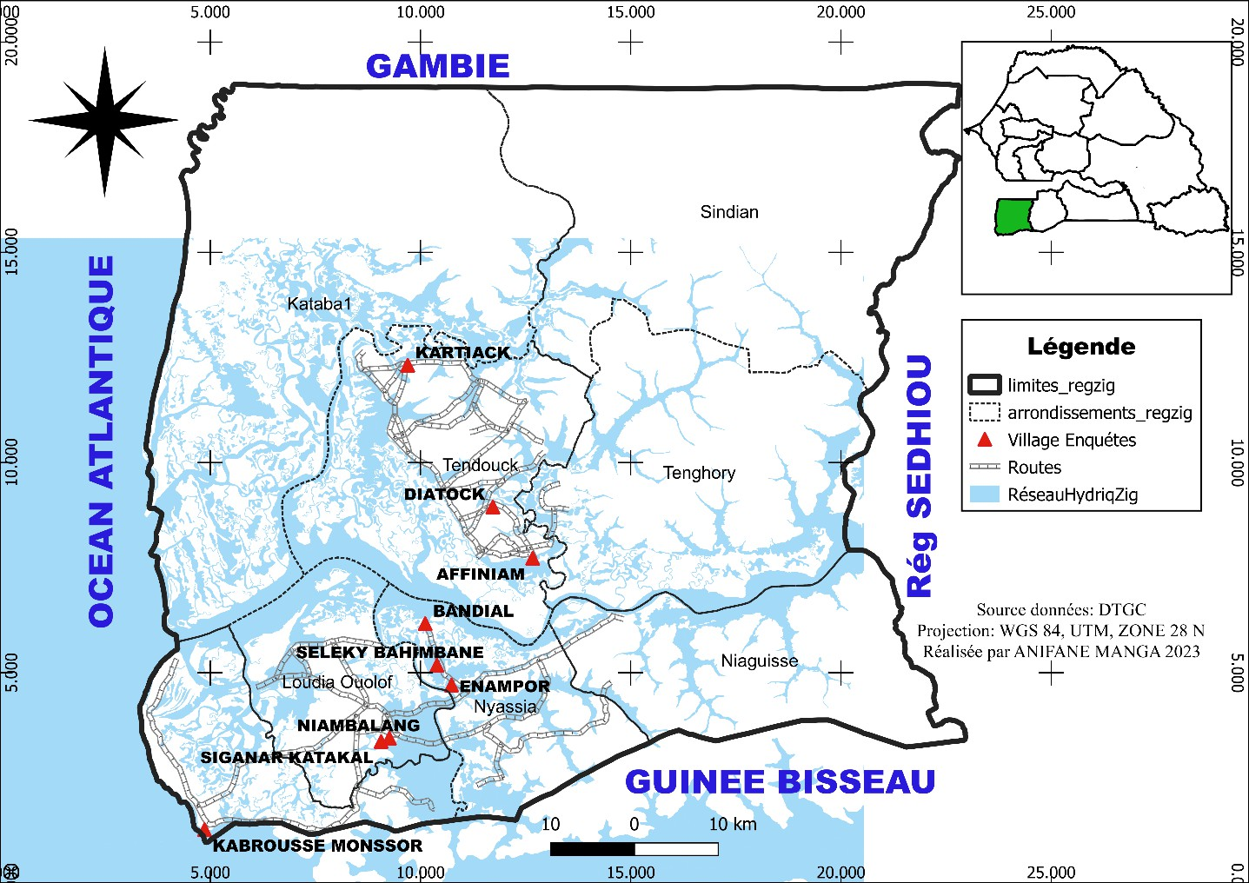
Figure 1: Location of study areas

The region is irrigated by the Casamance River, 350 km long, often bordered by mangroves and invaded by marine waters up to 200 km from its mouth (Diana Malari/Sédhiou), where between 60 and 280 million m⁽³⁾ ^{of} water are discharged per year. Ziguinchor's climate is of the southern Sudan-coastal type, dominated by a dry season from November to mid-June and a rainy season from June to September, during which agricultural activities are carried out (Sagna, 2005). The average annual temperature is around 27° C, with a maximum monthly average of 37° C in April and a minimum of 15.50° C in January (ANSD, 2020)

2100

1900

1700

1500
Average= 1300

1100

900

700

Years
Rainfall (mm)

Figure 2: Annual change in rainfall at Ziguinchor station from 1992 to 2022 (ANACIM, 2023)
1992
1994
1996
1998
2000
2002
2004
2006
2008
2010
2012
2014
2016
2018
2020
2022

Choice of sites and distribution of respondents

The survey was carried out in nine (9) villages in the three pre-described departments of the Ziguinchor region. The villages surveyed were chosen based on their accessibility, their position about the inlet, the impact of salinization on their land, and the size of theirs. Populations and their influence on rice-growing practices in the area. The number of producers surveyed was determined using Fisher's (2012) formula. In this study, 348 households were sampled with a margin of error of ε = 5% (Table 1)

Table 1: Sampling of the number of households by village
Departments | Borough | Villages | Total number of households ANSD, 2013 | Number of households to be sampled
Ziguinchor | Niassia | Bandial | 45 | 6
Ziguinchor | Niassia | Enampore | 116 | 15
Ziguinchor | Niassia | Séleky | 178 | 23
Oussouye | Loudia ouolof | Siganar | 203 | 27
Oussouye | Loudia ouolof | Nianbalang | 210 | 28
Oussouye | Kabrousse | Kabrousse | 452 | 59
Bignona | Tendouck | Affiniam | 225 | 30
Bignona | Tendouck | Diatock | 236 | 31
Bignona | Tendouck | Kartiack | 987 | 129
Total |  |  | 2 652 | 348

Sampling and sampling frame
Sampling was based on 2 652 households in 9 villages (ANSD, 2013). Thus, the sample size (nf) was determined on the basis of the total number of households in the villages using Fischer's formula.
$nf=\frac{n}{1+n/N}$ With 𝑛 = 1/𝑑 ² =1/ (0.05) ²= 400 nf = sample size; d = degree of error =5%; N= t total number of household Application:$nf=\frac{400}{1+400/2652}$ = 347.57 ≈ 348. The number of households to be interviewed per village was determined in proportion to the number of households in each village (table 1).
Surveys

The survey was carried out using a questionnaire covering: (1) identification of producers; (2) cultivation practices; (3) impacts of salinization and technologies adopted to limit its constraints; (4) use of plant species to combat salinity and (5) technologies practiced in the recovery of degraded land. The targets were people who had grown rice in the area at least once. The direct respondent in each village was the village chief or delegate responsible for validating the questionnaire and indicating the resource persons to be surveyed.
Statistical data analysis

The data collected was analyzed using Sphinx Plus² (V5) software, and graphs were produced using Excel spreadsheets.

Results

Socio-demographic characteristics of producers

Of a sample of 348 households surveyed, 56% were men and 44% were women (Figure 1a). The majority of those surveyed were of the "Diola" ethnic group (94.10%), the majority in the study area.

% of responses
(a)
Female

Male
56%
44%
Figure 3: (b) ethnic breakdown
Figure 3: (a) sex ratio (male/female)

Producers' spatial occupation


The distribution of the population surveyed by type of cropping ecology is fairly uneven. In the Ziguinchor region, rice is grown mainly during the rainy season in the lowlands (66.9%). Upland rice-growing is practiced to a lesser extent by producers (2.9%) in the area (Figure 4). On the other hand, a large proportion of farmers (30.2%) cultivate in both types of ecosystem (lowland and upland).
% of responses
80
70
60
50
40
30
20
10
0
66.9
30.2
2.9
Lowlands
Tray
Types of ecology
Plateau and lowlands

Figure 4: Distribution of rice growers by type of ecology

Rice yield trends in the Ziguinchor region
There has been a sharp decline in rice yields (90.60%) in the Ziguinchor region (Figure 5) over the last 10 years. Nevertheless, some producers have seen their yields increase (5.30%) and others (4.10%) who have seen no change in the evolution of their yields.

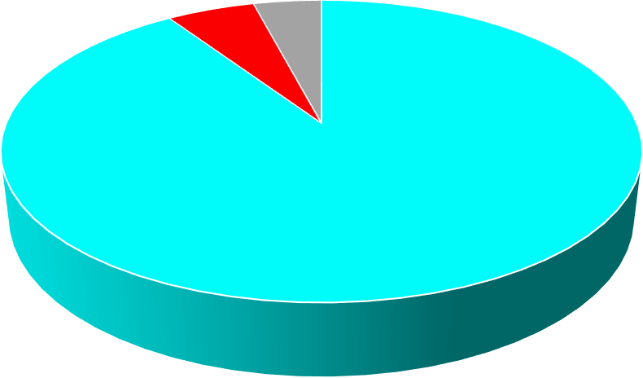
Yield trends over the last 5 to 10 years
5.30%
4.10%
90.60%
Regression
Increase
No change
Figure 5: Trends in rice yields over the last 5 to 10 years

Causes of declining rice yields in the Ziguinchor region
For some farmers (Figure 6), the drop in rice yields is mainly due to the combined effects of salinization of farmland (78.3%) and reduced rainfall (33.1%). For others, it is induced by a lack of manpower (22.0%) and a lack of land maintenance (17.9%). Other causes were also reported by respondents, the most frequent being bird pests (6.7%), animals roaming around (6.4%) and the impact of the Affiniam dam (5.8%).

% of responses

Figure 6: Causes of yield decline
Consequences of declining rice yields in the Ziguinchor region
The regressive evolution of yields in the Ziguinchor region has had a number of negative consequences (Figure 7), the most notable of which are: an increase in daily expenditure through the purchase of imported rice (79.10%), the disappearance of agricultural practices and certain rice varieties (8.40%) and rural exodus (7.50%).

Consequences

Figure 7: The socio-economic consequences of changes in rice yields in the Ziguinchor region

Causes of rice-growing land abandonment in the Ziguinchor region
In the Ziguinchor region, 92.06% of farmers have abandoned plots of land they used to cultivate (Figure 7). Some even left more than half (78.8%) of their arable land. Lowland land (96.2%) is often the most abandoned.

Figure 8: Abandonment of agricultural land in the Ziguinchor region

Technologies for reclaiming land degraded by salinity in the Ziguinchor region
Forced to abandon their land in the face of increased salinization, some farmers have undertaken technologies to try and recover their degraded plots (Figure 9). Thus, 55% of farmers in the area have already used saline land recovery techniques.

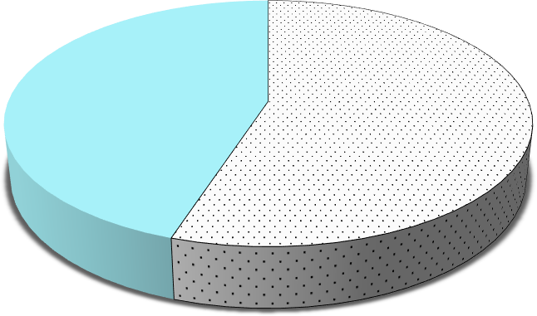
Have you ever reclaimed degraded soil?
45.00%
55.00%
Yes
No
Figure 9: Producers attempt to reclaim abandoned land

The majority of farmers have already used organic soil improvers (43.1%) to recover soil degraded by salinization (Figure 10). Among these organic amendments, the most widely used and effective (according to the farmers surveyed) are mango leaves alone (10.80%) or combined with cow dung (2.4%) or cowpea pods (4.50%). The use of organic manure (6.60%), sometimes combined with cow dung (2.2%). The spreading of ashes (known as fougnoulène in Djola), especially in the dry season, is also one of the effective organic inputs (3.60%) used by farmers to combat salts . Other farmers erect anti-salt dykes and retrofit plot bunds with drainage channels (8.6%). However, dike technology is often considered ineffective (7.6%) by farmers .



43.10%
8.60%
3.20%
5.00%
4.10%
0.60%
Organic amendment
Chemical amendment
Improved Fallow 1 to 3 Drainage Anti-salt dike
fallow years and
maintenance of dikes with drainage channels
Technologies for reclaiming degraded land

% Of responses

Figure 10: Types of degraded land reclamation technologies used by growers.

Solutions to combat soil salinity in the Ziguinchor region
Faced with the degradation of saline soils, farmers in the Ziguinchor region suggested a range of biological, mechanical and governmental solutions (Figure 11). Most of them (50.4%) felt that mechanical measures, such as building and maintaining anti-salt dykes, or drainage, would be the best way to combat salinization. Others opt for biological control (15.6%), using organic soil improvers (rice straw, oyster shells, peanut shells, cowpea pods, mango leaves, poultry droppings, etc.), salt-tolerant varieties or phytoremediation (planting trees capable of reducing soil salinization). However, to limit or eliminate the problem of salinization, some farmers use technologies combining biological and mechanical control (7.3%), or improved fallow and organic amendments (0.7%). Elsewhere, 2.1% of farmers would like the Senegalese government to become more involved in the fight against salinization of rice fields, by adopting effective policies to prevent mangrove cutting. In the department of Bignona, farmers are specifically calling on the State to develop the Affiniam dam or, in the extreme case, to eliminate it (Figure 11).

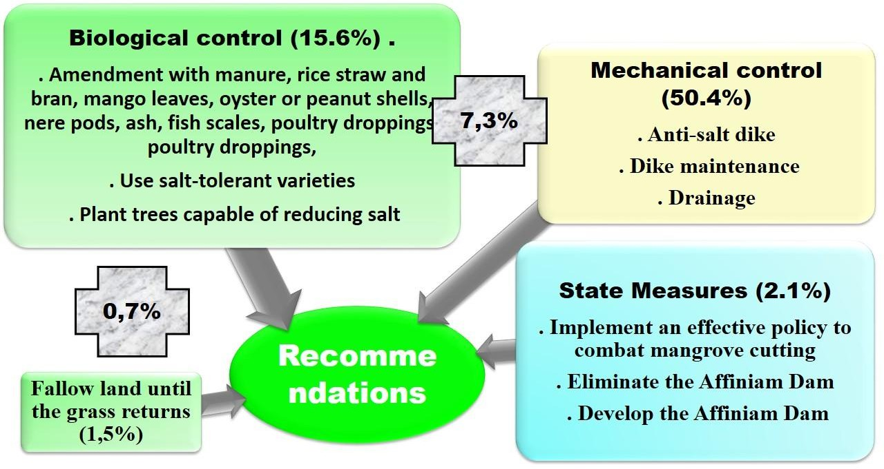
Figure 11: Types of solutions proposed by respondents to combat land salinization

Discussion

Surveys of the socio-demographic characteristics of Ziguinchor's farmers reveal that rice growing is more common among men (56%) than women (44%). The Diola ethnic group accounts for 94.10% of rice growers in our study area. This trend could be explained by the fact that arduous practices such as ploughing are more common among men and that the villages surveyed are predominantly inhabited by the Diola ethnic group. Several studies carried out in the area mention that ridge ploughing requires a great deal of physical effort and is generally practised by men (GRDR, 2009; Mendy, 2018 and Diédhiou et al., 2021, Diatta et al., 2022
A sharp decline in rice yields (90.60%) has been observed in the Ziguinchor region over the past 10 years. This has led to an increase in purchases of imported rice (79.10%), the disappearance of farming practices and local varieties (8.40%) and rural exodus (7.50%). Declines in rice yields were mainly due to the combined effects of salinization of farmland (78.3%) and its causes (reduced rainfall (33.1%), lack of manpower (22.0%) and lack of land maintenance (17.9%)). These results corroborate those of Abdourahmane (2018), who show that the decline in rice production in Casamance is mainly due to the salinization of arable land. Indeed, soil salinization in Basse Casamance is caused by marine intrusions from the

Casamance River, reduced rainfall and higher temperatures caused by climate change (Brunet, 1994; Montoroi, 1996; Noblet and al . ., 2018).
Faced with these constraints, some growers end up abandoning part of their rice fields (92.06%). In most cases, more than half (78.8%) of the land remains unoccupied due to salinization (71.60 %) or lack of manpower (36.10%). It is often the lowlands (96.2%) that are abandoned. In the valleys of Lower Casamance, for example, reduced rainfall has led to an advance of salt water, followed by the abandonment of large areas that were suitable for rice cultivation (Sané, 2016). Communes such as Adéane have been forced to abandon more than 3036 hectares of rice-growing land due to salinization (Sane, 2016). These abandonments have also been noted in Baïla, where 75% of rice fields have become uncultivable due to salinization linked to the rise of seawater through the Casamance River and its tributaries (Cissokho et al.,
. 2019).
To combat this phenomenon, some growers (55%) have adopted technologies to try and recover their degraded plots. These are generally organic matter inputs (43.1%) and fallows (4.1%), sometimes improved (5%). These technologies help maintain soil fertility and improve soil pH, which is often acidic (Diatta and al., 2022)). Indeed, farmers in the area have traditionally given their land a rest period after a series of crops (Gaudy, 1965; Jouve, 1993; Carrière, 2003). According to Kachaka (2020)), fallowing improves the fertility of the land so that it can once again be profitably cultivated. The most widely used and effective organic matter amendments are mango leaves (10.80%), sometimes combined with cow dung (2.4%) or cowpea pods (4.50%). These inputs add organic matter to the soil to improve its physical, chemical and biological components (Fall and al., 2020). Work by Kwey and al., (2015) has shown that organic amendments reduce soil salinization by correcting the soil's buffering capacity and chemical stability. They also enable the establishment of a vegetation cover which, in the long term, improves soil physico-chemical properties and crop growth (Mulaji, 2011).
Some growers in the area use mechanical and physical control (8.6%) to recover certain degraded soils. This involves installing dikes and anti-salt bunds with drainage channels. This technology is widely used by farmers to contain advancing salt wedges, while regulating the exchange of salt and fresh water. Rice growers in Basse Casamance have built dikes and mini-dams to stop salt water from entering small alluvial valleys and channel rainwater (Albergel and al. 1992; Brunet and al. 1994). However, these systems are considered inefficient, partly because of their lack of management, as they constantly need to be consolidated, repaired or rebuilt. On the other hand, micro-dams simply stop surface runoff but do not affect underground flow. As for anti-salt dams, they suffer from the absence of a suitable drainage system to evacuate salt-laden water after leaching (Fall and al., 2020).

Conclusion
The study identified the causes of rice field degradation and local technologies for combating soil salinity and acidity.
Rice growing in Casamance is facing a sharp drop in yields, mainly due to the combined effects of the salinization of farmland and its causes (reduced rainfall, lack of manpower and poor land maintenance). This has led many farmers to abandon more than half their rice fields, often in low-lying areas. However, some farmers in the Lower Casamance region are using biological technologies such as organic matter inputs and improved fallows, and mechanical and physical technologies such as anti-salt dykes and dikes with drainage channels or micro-dams, to recover salt-damaged plots.
However, to combat the salinization of rice paddies in Lower Casamance, it is necessary not only to improve the soil with compounds rich in salt-fixing agents but also to develop rice paddies with dikes and bunds to ensure good water management and limit the progression of salinization.
Disclaimer (Artificial intelligence)

Option 1:

Author(s) hereby declare that NO generative AI technologies such as Large Language Models (ChatGPT, COPILOT, etc.) and text-to-image generators have been used during the writing or editing of this manuscript.

Option 2:

Author(s) hereby declare that generative AI technologies such as Large Language Models, etc. have been used during the writing or editing of manuscripts. This explanation will include the name, version, model, and source of the generative AI technology and as well as all input prompts provided to the generative AI technology

Details of the AI usage are given below:
1.
2.
3.

References:
Abdourahmane, M. S. (2018). Degradation of lowland rice fields in a context of climate change in Basse Casamance (Senegal). 15.
Albergel, J., Brunet, D., Dubée, G., Montoroi, J.-P., & Zante, P. (1992). Management of an anti-salt dam in lower Casamance (Senegal). 12.
ANACIM. (2023). Rainfall at the Zig department station 1922-2022.
ANSD, 2013. SES (regional economic and social situation), 5p
ANSD. (2018). Economic and Social Situation of Senegal Ed. 2015.
ANSD. (2020). Regional economic and social situation. 2017-2018
Brunet, D. (1994). A Simple Hydraulic Development for the Rehabilitation of Salty Soils: Rice Farming in Lower Casamance. 8.
CARRIÈRE, Stéphanie. Introduction to Part 2 In: Forest Orphans: Peasant Practices and Forest Ecology (The Ntumu of Southern Cameroon) [online]. Marseille: IRD Éditions, 2003 (generated on 18 March 2024). Available on the Internet: <http://books.openedition.org/irdeditions/10256>. ISBN: 978-2-7099-2316-3. DOI: https://doi.org/10.4000/books.irdeditions.10256.
Cissokho, D., Coly, J. P., Faye, C., & Diombaty, I. (2019). Degradation of rice fields by salinization in an era of climate change: A threat to food security in Baïla (Lower Casamance).
Dasylva M, Ndour N, Sambou B, Dieng S D, 2019. Agronomic diagnosis of peri-urban rice cultivation in the Commune of Ziguinchor, Senegal. European Scientific Journal October 2019 edition Vol.15, No.30 ISSN: 1857 - 7881 (Print) e - ISSN 1857-7431URL:http://dx.doi.org/10.19044/esj.2019.v15n30p229

Diatta, M. Y., Diédhiou, S., Kémo Goudiaby, A. O., Bassene, M. J., Paterne Sagna, M. Y., Sow, M. M., & Dalanda Diallo, M. (2022). Perception and Adaptation Strategies of Producers to the Salinization of Rice Valleys in the Commune of Enampore in Lower Casamance. European Scientific Journal, ESJ, 18 (11), 71.https://doi.org/10.19044/esj.2022.v18n11p71
Diedhiou S.O., Thior M., Diouf A.C., Mballo I. & Diallo A.K. (2021). Rainfed rice in lowlands in the Sédhiou region (Senegal): production constraints and adaptation strategy. European Scientific Journal, ESJ, 17(24), 88. https://doi.org/10.19044/esj.2021.v17n24p88
Djighaly, P. I. (2019). Optimization of the association Casuarina/arbuscular mycorrhizal fungi and/or nitrogen-fixing bacteria for the rehabilitation of saline lands in Senegal [Unique Doctoral Thesis]. ASSANE SECK UNIVERSITY OF ZIGUINCHOR.
Dubourguier Henri-Charles, Annabelle D ERAM, Daniel PETIT, & Catherine LOGEAY. (2001). Phytomanagement: Elements of synthesis. Centers of Expertise: Polluted Sites and Sediments.
Fall C. A. L, Sane Y, 2020. "Diagnosis of the Constraints of Rice Development in Fluvio-Marine Soils of the Bignona Marsh, Lower Casamance, Senegal." European Scientific Journal January 2020 edition Vol. 16, No. 3 ISSN: 1857-7881 (Print) e - ISSN 1857-7431. URL: http://dx.doi.org/10.19044/esj.2020.v16n3p359.
FAO. (2023). Monthly report on food price trends. https://www.fao.org/3/cc8975fr/cc8975fr.pdf
Gaudy, M., 1965. Manual of Tropical Agriculture. Tropical and Equatorial Africa, 2nd edition. The Rustic House. Paris 412pGRDR, 2009: Development and enhancement of valleys in Basse Casamance. Approach developed by GRDR, 39p.
Jouve, P.M. 1993. Uses and functions of fallow land in Africa in Floret, C. Serpantié, G. (eds.). “Fallow in Africa (West Africa. pp 55-65), ORS TOM Paris.
Kachaka, E. Y. (2020). Effects of age of Acacia auriculiformis agroforestry falls on soils, crop yields and adoption by farmers in the Batéké Plateau, Democratic Republic of Congo [Unique Doctoral Thesis]. LAVAL.
KAMBOU, G., SOME, N., & OUEDRAOGO, S. (2000). Effects of néré pods, Parkia biglobosa (Jacq.) R.Br. Ex. G. Ddon on the emergence of Striga hermonthica (deI) Benth, soil agrochemical properties and maize yield. http://www.slire.net/download/1187/kambou_bra_029_2000-2.pdf
Kwey, M. M., Banze, S. K., & Mukalay, J.B. (2015). (PDF) Case study on the impact of organic amendments with respect to salinity in banana cultivation. 11(3), 152-160.
Legros, P.J.-P., 2009. Land salinization in the world 14.
Marlet, S., Job, J.O., 2006. Soil Salinity Processes and Management. Treatise on Irrigation, Second Edition 29.
Mendy, V. (2018). Degradation of Agroecosystems and the Problem of Revitalizing Rice Cultivation in Basse-Casamance [Doctoral Dissertation]. Assane SECK University of Ziguinchor.
Montoroi, J. P. (1996). Development of Lowlands in Lower Casamance (Senegal).
Mulaji Kyela Crispin (2011). Use of Household Biowaste Composts to Improve the Fertility of Acid Soils in the Province of Kinshasa (Dem. Rep. of Congo) (Doctoral Dissertation). Gembloux, Belgium, University of Liège, Gembloux Agro-Bio Tech, 172 pp., 32
Noblet, M., Faye, A., Camara, I., Seck, A., Sadio, M., & Bah, A. (2018). State of the art of scientific knowledge on climate change in the water resources, agriculture, and coastal zone sectors. Website www.undp.org
Sagna, P., 2005. Climate dynamics and its recent evolution in the western part of West Africa (PhD thesis). Cheikh Anta Diop University 270.
Sane, M. (2016). Problems of reclaiming salted rice fields in the commune of Adeane in lower Casamance [Master's thesis]. ASSANE SECK UNIVERSITY OF ZIGUINCHOR. Sané Y., (2016): "Impacts of degradation of rice fields by salinization and silting in the commune of Tenghory: from transgambian Tenghory to Diourou.". Master 2 thesis, geography UASZ. 125p

Sané T, Mering C, Cormier-Salem M C, Diedhiou I, Ba B D, Diaw A T. Permanences and mutations in the rice-growing areas of Basse-Casamance (Senegal). Belin | "L'Espace géographique" 2018/3 Volume 47 | pages 201 to 218. ISSN 0046-2497 ISBN 9782410014273.
Sène. M. À, 2018. "Degradation of lowland rice fields in a context of climate change in Basse Casamance (Senegal)". 15p

Thiam, S., Villamor, G. B., Faye, L. C., Sène, J. H. B., Diwediga, B., & Kyei-Baffour, N. (2021). Monitoring land use and soil salinity changes in coastal landscape: A case study from Senegal. Environmental Monitoring and Assessment, 193, 1-18.
Tarolli, P., Luo, J., Park, E., Barcaccia, G., & Masin, R. (2024). Soil salinization in agriculture: Mitigation and adaptation strategies combining nature-based solutions and bioengineering. Iscience, 27(2).
Sene, J. H. B., Faye, E., & Tine, A. K. (2023). Curbing the Salinization of Arable Land and Agronomically Restoring Salt-affected Soils, a food security challenge: assessment and prospects, the case of Senegal, West Africa. Moscow University Soil Science Bulletin, 78(5), 461-466.

Table 2: Biological technologies

Type of  Technologies | technology details | of  responses | Assessment
Biological | Cow dung amendment | 0,90 | Efficient
Biological | Cow dung + oyster shell amendment | 0,30 | Efficient
Biological | Cow dung + poultry manure amendment | 0,90 | Efficient
Biological | Ash amendment "fougnoulène" + mango leaf | 0,60 | Efficient
Biological | Peanut shell amendment | 0,60 | Efficient
Biological | Néré pod + peanut hull amendment in dry period | 0,30 | Efficient
Biological | Oyster shell amendment | 0,30 | Not very  effective
Biological | Cowpea pod amendment | 0,60 | Efficient
Biological | Néré husk amendment + "fougnoulène" ash | 0,60 | Efficient
Biological | Néré pod amendment + mango leaf + manure | 0,30 | Efficient
Biological | Mango leaf amendment | 10,80 | Efficient
Biological | Mango leaf amendment + cow dung | 2,40 | Efficient
Biological | Mango leaf amendment + cow dung + rice straw | 0,30 | Efficient
Biological | Néré pod + mango leaf amendment | 4,50 | Efficient
Biological | Mango leaf amendment + "Fougnoulène" ash | 0,30 | Efficient
Biological | Mango leaf + cailcedrat leaf amendment | 0,30 | Efficient
Biological | Mango leaf amendment + manure in dry period | 0,60 | Efficient
Biological | Mango leaf amendment + NPK | 0,30 | Efficient
Biological | Mango leaf amendment + phosphogypsum | 0,90 | Efficient
Biological | Poultry manure amendment | 0,90 | Efficient
Biological | Manure amendment + cow dung | 2,20 | Efficient
Biological | Manure amendment + goat dung | 0,30 | Efficient
Biological | Manure amendment + fish scales during the dry season | 0,30 | Efficient
Biological | Manure amendment + "fougnoulène" ash | 0,90 | Efficient
Biological | Manure amendment + rice straw + cow dung | 0,30 | Not very  effective
Biological | Manure amendment in dry periods | 6,60 | Efficient

 | Rice straw amendment |  | 0,30 | Efficient
 | Rice straw + cow dung amendment |  | 0,30 | Efficient
 | Rice straw + cow dung + goat dung amendment |  | 0,30 | Efficient
 | Rice bran + poultry manure amendment |  | 0,60 | Efficient
 | Fougoulène" ash spreading + drainage |  | 0,30 | Efficient
 | Dry season "fougnoulène" ash spreading |  | 3,60 | Efficient
 | Fougnoulène" ash spreading + goat droppings |  | 0,30 | Efficient
 | Fougoulène" ash spreading + fish scales |  | 0,30 | Efficient
 | Fallow with cow dung amendment + mango leaf until grass returns |  | 0,60 | Efficient
 | Fallow with cow dung amendment until grass returns |  | 0,60 | Efficient
 | Fallow with oyster-shell amendment until grass returns |  | 0,30 | Efficient
 | Fallow with oyster shell amendment + cow dung until grass returns |  | 0,60 | Efficient
 | Fallow with oyster shell amendment + cowpea pods until grasses return |  | 0,30 | Efficient
 | Fallow with cowpea pod amendment until grass returns |  | 0,30 | Efficient
 | Fallow with mango leaf amendment until grass returns |  | 0,60 | Efficient
 | Fallow until grass returns |  | 3,40 | Efficient
Mechanical  engineering |  | Anti-salt dike and maintenance of dikes with drainage channels | 7,60 | Not very  effective
Chemicals |  | Phosphogypsum amendment | 0,90% | Efficient
Organic* Mechanical engineering |  | Anti-salt dyke + cowpea pod amendment + cow dung | 0,30% | Efficient
 |  | Anti-salt diguette + cowpea pod amendment | 0,30% | Efficient
 |  | Anti-salt diguette + manure amendment | 0,30% | Low  Efficiency
 |  | Anti-salt fence with drainage channels + manure amendment | 0,30% | Efficient
 |  | Fougnoulen" ash spreading + drainage | 0,30% | Efficient

