Type of the article: Original Research Article
Sunflower Lecithin-based Liposomal Formulations of Sesbania grandiflora and Acerola Cherry Extracts: Enhancing Stability and Controlled Release

Abstract:
Background: Despite the potential of cosmeceuticals, challenges like poor solubility, bioavailability, and stability limit their full effectiveness. Liposomal delivery systems have shown promise in overcoming these challenges by improving the stability and controlled release of active compounds.
Methodology: This study investigates the liposomal encapsulation using sunflower lecithin and gum acacia of Sesbania grandiflora and Acerola cherry extracts, characterization using SEM-EDX and studies dissolution profiles.
Results and discussion: Both S. grandiflora and A. cherry liposomes exhibited smoother surfaces compared to their respective extracts. This indicates that the encapsulation process, involving sunflower lecithin and gum acacia, resulted in the formation of a liposomal cavity encapsulating the extract that altered the surface texture. The average size of S. grandiflora extract and its liposomes was found to be 15.64 µm and 18.032 µm respectively. Similarly, the average size estimated from SEM imaging for A. cherry extract was found to be 14.916 µm versus 15.079 µm for its liposomal counterpart. The EDX patter showed increase phosphorus, potassium, and calcium elements in the liposomal extracts. Dissolution studies revealed that the S. grandiflora liposomes showed a sustained release (98% at 120 mins) pattern for biotin as to the neat extract (100% at 60 mins) or synthetic capsule (100% at 15 mins).Similar data was observed for Vitamin C release from liposomal, neat A. cherry extract, and vitamin C synthetic capsules.
Conclusion: These results highlight that sunflower lecithin-based liposomes can improve stability and provide controlled release of plant bioactive for better bioactivity. This offers a promising strategy for advanced nutraceutical and cosmeceutical formulations
Keywords: Dissolution, microencapsulation, SEM-EDX, sustained-release, liposomes

Graphical Abstract:
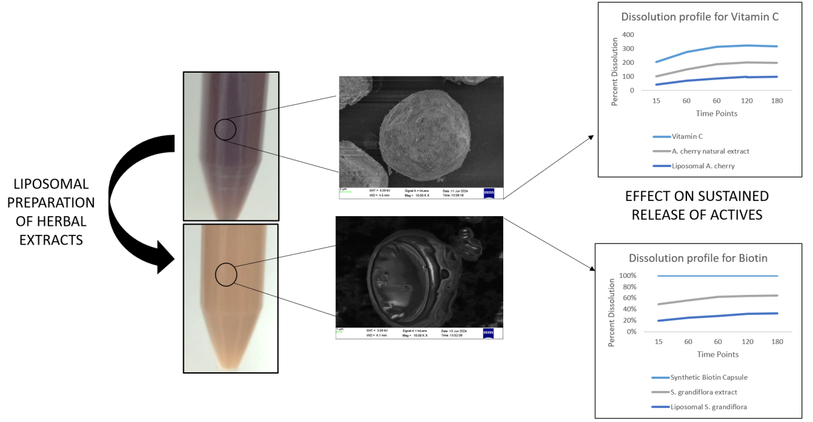

Introduction:
The nutraceutical industry is thriving, driven by natural products that offer significant value in treating various diseases, promoting overall health, and enhancing skin and hair wellness. Consumers are getting increasingly aware of the benefits nutraceuticals can provide in the cosmetic niche as well. The market has seen a rise in cosmeceutical products that uses oral nutraceuticals for their positive effects on skin and hair. For instance, addressing concerns such as anti-aging, hydration, protection against UV, and promoting hair growth enhancing “beauty from within" and often promoted as "oral cosmetics" [1]. However, the effectiveness of these agents are limited by issues such as their low solubility, bioavailability, and stability during processing and application. This presents a challenge for scientists, who are tasked with finding solutions to overcome the problems related to the direct consumption of these nutraceuticals [2].
Advancements in science and technology have led to the development of liposome-based preparations and delivery systems for nutraceutical agents, which are proving to be effective in preserving and even enhancing the biological activity of these compounds. This approach helps maintain their stability, improve bioavailability, and expand their applicability [3]. Liposomes are synthetic nanostructures composed of one or more phospholipid bilayers, featuring polar heads and lipophilic tails. Aqueous substances can be trapped in the central core, while non-polar compounds can integrate with the lipid domains. Due to their structural resemblance to the human body, liposomes are highly compatible, stable, and bioavailable [4]. Among the various drug delivery systems such as microspheres, emulsions, nanoparticles, and lipid-based systems, liposomal (lipid-based) systems possess excellent performance abilities. This can be attributed to their biodegradability index and superior paracellular and transcellular transport capacities [5].
There are some challenges pertaining to the utilization of liposomes delivery system for oral consumptions due to the use of surfactants and organic solvents that are impermissible components as food agents along with the costs involved in sourcing pure phospholipids. The utilization of affordable alternatives of high-cost phospholipids such as lecithin that can be extracted from animal sources (eggs and milk) or vegetable sources such as (soy or sunflower) along with high-pressure homogenizers can overcome the current challenges [6].
Vegetable lecithin mainly contains phosphatidylcholine, phosphatidylethanolamine, phosphatidylserine, phosphatidic acid, and traces of sphingolipids, triglycerides, carbohydrates, sterols, and fatty acids [7]. The lecithin and their fractions are graded as per the content of phosphatidylcholine content, for instance, raw lecithin contains 15% PC while purified fractions can contain up to 95%. The long use of soy lecithin has been diminished due to the absence of the genes or proteins tracing its origin back to the parent plants. Hence it has been replaced by sunflower lecithin for application in liposomes research and development [8].
However, liposomal preparations can still face challenges with respect to stability issues due to prolonged storages or physical stressors such as temperature and pH variations. The physical stability of the liposomal particles can be effectively improved by increasing the repulsion between the particles through electrostatic, steric, and electrosteric interactions. Once way of increasing the repulsion between the particles in the colloidal solution would be adding high molecular weight polysaccharides as stabilizers and thickening agents. Examples include utilization of gum Arabic and sodium alginate that can either provide steric stabilization as with gum Arabic. Sodium alginate on the other hand can form long chain of monosaccharides resulting into gel formation. The concept of electrostatic interaction of hydrophilic biopolymers (gum or alginate) and liposomes is crucial for the stability of liposomes is well established [9].
Previous studies have shown impact of liposomal actives over their free counterparts have shown improved efficiency. For instant, ethanolic extract of ginger and its liposome encapsulate were tested for antioxidant efficiencies. The nano-liposomal ginger extract showed higher antioxidant capacity and also deferred heat induced-oxidation in sunflower oil as compared to untreated ginger extract and butylated hydroxytoluene (BHT) [10]. Further emphasizing the effect of liposome-technology on product efficacy and performance.
Literature also exists on the ability of liposomes to prevent toxicity caused by encapsulated phytoactives thereby increasing the bio-activities. For instance, in a study conducted by Caddeo et al. (2008), resveratrol at several concentrations was tested for its cell proliferative and photoprotective effects on UV-induced HEK 293 cells [11]. At a low concentration of 10µM the extract showed excellent cell proliferative effect and protection from UV-B induced cytotoxicity but the activity was inversely proportional to its concentrations. At a higher concentration of 100 µM, the extract exhibited detrimental effects inducing cell toxicity. This is an inherent property of polyphenols where at lower concentrations they exhibit antioxidative benefits whereas at higher concentrations they are pro-oxidative in nature. Encapsulation of the active in liposomes effectively diminished the cytotoxic effect of resveratrol at 100 µM suggesting reduction in massive distribution within the cell’s microenvironment. It further increased the UV-B protection by promoting cell-proliferation of resveratrol at its otherwise toxic dosage.
Thus, liposomes entrapped phytocompounds are known to have a stable, biocompatible, safe, efficacious, and biodegradable performance as compared to its free counterparts. Several phytosomes (phytocompounds encapsulated in liposomes) have studied in the past such as curcumin, dehydro-silymarin, and catechin for increased bioavailability. Encapsulation have not only resulted into increased safety and prolonged activity of resveratrol but also increased antitumor activity and antioxidative effect of quercetin [12].
The objective of the current study was to synthesize liposomal extracts to increase sustained release of bioactives from the extracts. In the current, Sesbania grandiflora leaf extract with 0.8% biotin was formulated as liposomal extracts. The extract has been extensively tested for its anti-ageing, hair growth promoting effects and known for the presence of 100% biobased biotin content [13-15]. With its already known sustainable release ability, the extract was further modified to promote stability and even better release pattern using liposomal technology in the current study. The same technology was used to prepare Acerola cherry liposomal extract using hydroalcoholic extract of fruits of A.cherry standardized to 17% Vitamin C. The liposomal extracts and their free counterparts were tested for its physical characteristics for using scanning electron microscopy and dissolution potential.
Materials and Methods:
All materials used for extraction were of analytical grade, while high-purity chemicals were employed for advanced instrumentation analyses.
Preparation of liposomal extracts
The liposomes were prepared for S. grandiflora (50-55%) and A. cherry extracts (30-35%) using sunflower lecithin (10-15%), gum acacia (35-40% for S. grandiflora and 55-60% for A. cherry), and q.s. volumes of ethanol and water. The individual solutions were homogenized for a specified period of time, spray dried, and stored at room temperature until further use.
SEM and EDX analysis
The morphological analysis and surface evaluation was done using Scanning Electron Microscopy for both the extracts and their respective liposomes. Further energy dispersive X-ray (EDX) analysis was done to analyze elemental fingerprint of the extracts.
Phytochemical release profile
The extracts and the liposomes were subjected to phytochemical release profile using the methodology mentioned by Gadani et al (2014) with slight modifications. Six capsules containing extract or liposomal variants or standards were added to 6 vessels and equilibrated at 37ºC in a dissolution medium containing 0.02 N anhydrous disodium hydrogen phosphate adjust pH 4.7 with o-phosphoric acid. The dissolution apparatus used was a paddle-type with 75 rpm speed operated at 37ºC till the end of the experiments. At relevant time points (10, 30,6 60, 120, and 180 mins) about 10 ml of the suspension was withdrawn and analyzed using HPLC to determine the percentage release of individual actives under study [15].
For the phytochemical release profile, 1000 mg of S. grandiflora extract with 0.8% of biotin and 1000 mg of liposomal extract of S. grandiflora containing 0.25% biotin were applied. Similarly, 1000 mg synthetic biotin (0.87% biotin) was also tested for phytochemical release profile. For vitamin C release study, 1000 mg of A. cherry extract (17%), A. cherry liposomes (10%), and synthetic vitamin c capsules (96%) were tested. The release of biotin was done using HPLC analysis as mentioned by Gadani et al (2014) whereas the release of vitamin C was analysed as per AOAC official method of analysis for vitamin C [16].
The percentage dissolution of the actives was measured using HPLC and was used to calculate similarity and dissimilarity between the extracts and liposomal counterparts.
Statistical analysis:
The sizes of the particles were reported as mean and standard deviation. The means were compared with Independent T-test to measure the significance between the extracts and their corresponding liposomes. A p-value less than 0.05 was considered to be statistically significant. For the dissolution profiles, fit factors f1 and f2 were calculated to determine the sustained ability of liposomal extracts to release particular actives under study.
Results and discussions:
Morphological analysis with SEM
The SEM analysis revealed that the S. grandiflora extract has an amorphous and almost spherical shaped phytocompounds (Figure 1). The size of the particles was also measured and it was found that particle sizes ranges from 11.56 to 23.18 µm (15.64 µm average) (Figure 2). The liposome encapsulated extract of S. grandiflora also revealed similar shape (Figure 3). The size of the particles although varied from 13.14 - 22.78 µm (18.032 µm average) (Figure 4). The independent T-test analysis revealed no significant difference in the size of the particle between the extract and liposomes (p=0.84).
Similarly for A. cherry extract the particles were perfectly spherical in shape (Figure 5) with sizes ranging from 3.343 – 23.82 µm (average=14.916) (Figure 6) whereas the liposomes of A. cherry extract had particles (Figures 7 and 8) ranging from 3.48-30.68 µm (average= 15.079). Although liposomal particles appeared larger than extract, the difference was not found to be statistically significant (0.966).
As per the SEM images and the physical appearance, the liposomal extracts of both the plant materials appeared to be coated and converted into liposomes (Figures 1,3,5, and 7).
Figure 1: Spherical shape of S. grandiflora extract | Figure 2: Particle size of S. grandiflora extract
Figure 3: Spherical shape of S. grandiflora liposomal extract | Figure 4: Particle size of S. grandiflora liposomal extract
Figure 5: Spherical shape of A. cherry extract | Figure 6: Particle size of A. cherry extract
Figure 7: Spherical shape of A. cherry liposomal extract | Figure 8: Particle size of A. cherry liposomal extract

Elemental analysis with EDX
The elemental analysis for S. grandiflora extract (Figure 9) revealed presence of only carbon and oxygen. The EDX study demonstrated that the liposomal extract possessed phosphorus due to the phosphate groups of phospholipids (sunflower lecithin) and the carbon present in the fatty acid along with oxygen chains. Presence of calcium ensure proper coating of liposomes with gum acacia (Figure 10).
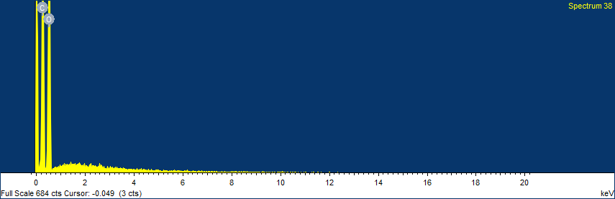
Figure 9: EDX pattern for S. grandiflora extract
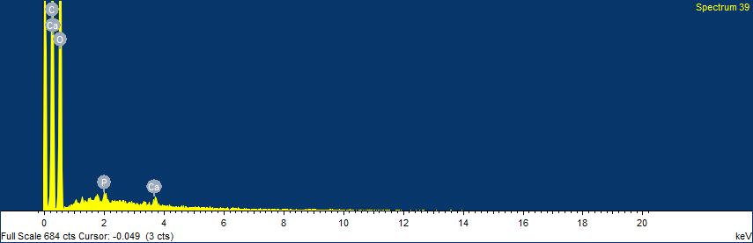
Figure 10: EDX pattern for S. grandiflora liposomal extract
The elemental analysis for A. cherry extract (Figure 10) revealed presence of carbon, oxygen, magnesium, potassium, phosphorus, calcium, iron, copper, zinc, etc. The EDX study demonstrated increased weights of magnesium, potassium, and calcium ions in the liposomal extracts that ensures proper coating of liposomes with gum acacia (Figure 10).
Phytochemical release profile
The biotin release profile of natural extract, liposomal extracts, and synthetic active was compared for 180 mins. The dissolution percentages for the samples at different time points were used to calculate the fit factors f1 and f2. The factor f1 (values 0-15) is the mean of percent difference between the time points of product versus reference or product b. If the value of f1 is zero, it indicates the two materials are identical and the increase in f1 is directly proportional to dissimilarity in dissolution profiles. On the other hand, f2 indicates similarity between the two products and values are between 0-100, where dissimilarity increases as the value approaches zero [17]. In the current study, the f1 factors were greater than 15 whereas f2 was less than 50 suggesting that all three samples (natural extract, liposomal extract, and synthetic actives for both biotin and vitamin C) exhibited nearly distinct dissolution profiles.
A sustained release pattern was observed for the 0.8% natural biotin extract and S. grandiflora extract, in contrast to the synthetic extract. For the synthetic biotin capsule, complete release of biotin occurred within 15 minutes. However, with S. grandiflora extract, the release was gradual, and 100% dissolution was not achieved until 60 minutes. In the case of liposomal S. grandiflora extract, the release was further delayed, leading to improved retention of the biotin content. A complete dissolution of 98.7% was reached at 120 minutes, which is twice the time it took for the biotin release from S. grandiflora.

Figure 11: Dissolution Profile for Biotin between S. grandiflora extract, S. grandiflora liposomal extract, and synthetic capsule
Table 1: Fit factors f1 and f2 between S. grandiflora, S. grandiflora liposomal extract, and synthetic vitamin C capsule
Fit Factors | Liposomes of S. grandiflora versus  S. Grandiflora | Liposomes of S. grandiflora versus Synthetic Biotin | S. grandiflora versus  Synthetic biotin
f1 | 27 | 77 | 39
f2 | 37 | 14 | 23
The liposomal extract of S. grandiflora revealed an f1 value of 37 and 77 respectively when compared to the dissolution profiles of S. grandiflora extract and synthetic biotin respectively.
For the A. cherry extract, a similar trend was observed as for S. grandiflora. The synthetic vitamin C capsules showed complete dissolution at 15 mins which explains no gradual release was seen, followed by A. cherry natural extract that showed 100% vitamin C dissolution at 60 mins. The most sustained release was observed for liposomal preparation of A. cherry extract with a complete dissolution observed at 120 mins.

Figure 12: Dissolution Profile for Biotin between A. cherry extract, A. cherry liposomal extract, and synthetic capsule
Table 2: Fit factors f1 and f2 between A. cherry, A. cherry liposomal extract, and synthetic vitamin C capsule
Fit Factors | Liposomes of A. cherry  Versus  A.cherry | Liposomes of A. cherry  versus Synthetic Vitamin C | A.cherry  versus  Synthetic Vitamin C
f1 | 21 | 78 | 47
f2 | 43 | 14 | 20

The f1 and f2 factors were measured amongst A. cherry liposomal extract, A cherry extract, and synthetic vitamin C. It was found that the f1 factor for A. cherry liposomal extract was higher than 15 versus both A. cherry extract (21) and synthetic vitamin C (78), indicating dissimilarity between the dissolution patterns at the given time points.
This indicates that the formation of liposomes contributed to a controlled release of biotin as well as vitamin C from the respective lipid-based vehicles, enhancing the sustained release profile as compared to its unencapsulated counterpart and commercial synthetic capsules.

Discussions:
Nutraceutical agents have potential leads as new functional foods but their applicability is often limited due to their easy oxidizable nature [18]. Liposomal encapsulation of such active metabolites can increase their stability and are suitable delivery systems considering their biochemical nature [18]. The enhanced stability, bioavailability, and sustained release profiles of liposomal formulations make them ideal candidates for incorporation into oral cosmetics, which are becoming increasingly popular among consumers seeking effective anti-aging, hydration, and hair growth solutions [1].
In a particular study, lipid film hydration method-based liposomes of A.angustifolia extract (AAE) were tested for efficacy and release invitro in an intestinal cell line. In comparison to the neat extract, the liposomal extract showed sustained release and antioxidant potential [19]. This supports the utilization of lipid compositions as carriers as an advancement in the phyto-industry. In a study conducted by Jovanović, et al., 2024, the rose-hip extract and their encapsulated liposomes with similar polyphenol concentration was loaded on the cellulose acetate membrane and check for diffusion in water and simulated intestinal fluid (SIF). The steady-state for diffusion the rosehip fruit extract was achieved within 120 mins whereas the liposomal extract did not plateau even after 360 min. A similar trend was observed in the SIF where the diffusion was slower in the SIF through the liposomes in comparison to the rosehip extract [20]. Since the release of the phytocompounds has lowered in rate due to encapsulation, the possibility of stability in the intestinal conditions increase considerably.
The present study supports these claims by demonstrating that liposomal formulations of Sesbania grandiflora and Acerola cherry extracts offer superior release profiles and stability compared to their free counterparts, which could ultimately lead to more effective nutraceutical products for cosmetic use. Liposomes are considered to be a promising choice in the nutraceutical industry because it can improve targeting of bioactives by enhancing stability, bioavailability, and delivery [21]. They are also considered for cosmetic application since it is suggested that lipid-based formulations surpass other carrier options by almost 50% as they are natural biological components of the skin [22]. However, further studies are warranted to demonstrate the underlying mechanism for release of the bioactives from the liposomes for the current study.
Limitations:
The invivo validation of bioavailability and efficacy is warranted. The stability studies are crucial for commercially establishing any product in the market and is currently undertaken by the team.

Conclusion:
In conclusion, the use of liposomal delivery systems in nutraceuticals represents a promising strategy for enhancing the bioavailability, stability, and controlled release of active ingredients such as biotin and Vitamin C. The results of this study demonstrate that liposomal encapsulation of Sesbania grandiflora and Acerola cherry extracts significantly improves the release kinetics and stability of these compounds. These findings underscore the potential of liposomal technology in developing more effective cosmeceutical products that to increase sustained release of bioactives.

COMPETING INTERESTS DISCLAIMER:
Authors have declared that they have no known competing financial interests OR non-financial interests OR personal relationships that could have appeared to influence the work reported in this paper.

Disclaimer (Artificial intelligence)
Authors hereby declare that NO generative AI technologies such as Large Language Models (ChatGPT, COPILOT, etc.) and text-to-image generators have been used during the writing or editing of this manuscript.

References:
- Anunciato TP, Da Rocha Filho PA. Carotenoids and polyphenols in nutricosmetics, nutraceuticals, and cosmeceuticals. J Cosmet Dermatol. 2012;11(1):51–4.
- Ashfaq R, Rasul A, Asghar S, Kovács A, Berkó S, Budai-Szűcs M. Lipid nanoparticles: An effective tool to improve the bioavailability of nutraceuticals. Int J Mol Sci. 2023;24(21):15764.
- Üner M. Preparation, characterization, and physico-chemical properties of solid lipid nanoparticles (SLN) and nanostructured lipid carriers (NLC): Their benefits as colloidal drug carrier systems. Die Pharmazie. 2006;61(5):375–86.
- Pasarin D, Ghizdareanu A, Enascuta CE, Matei CB, Bilbie C, Paraschiv-Palada L, et al. Coating materials to increase the stability of liposomes. Polymers. 2023;15(3):782.
- Sogut O, Sezer UA, Sezer S. Liposomal delivery systems for herbal extracts. J Drug Deliv Sci Technol. 2020;61:102147.
- Peng S, Zou L, Liu W, Liu C, McClements DJ. Fabrication and characterization of curcumin-loaded liposomes formed from sunflower lecithin: Impact of composition and environmental stress. J Agric Food Chem. 2018;66(46):12421–30.
- Guiotto EN, Tomás MC, Diehl BW. Sunflower lecithin. In: Elsevier eBooks. 2015. p. 57–75.
- Shade CW. Liposomes as advanced delivery systems for nutraceuticals [Internet]. PMC; 2016 [cited 2025 Mar 27].
- Li J, Zhai J, Dyett B, Yang Y, Drummond CJ, Conn CE. Effect of gum arabic or sodium alginate incorporation on the physicochemical and curcumin retention properties of liposomes. LWT. 2020;139:110571.
- Ganji S, Sayyed-Alangi SZ. Encapsulation of ginger ethanolic extract in nanoliposome and evaluation of its antioxidant activity on sunflower oil. Chem Pap. 2017;71(9):1781–9.
- Caddeo C, Teskač K, Sinico C, Kristl J. Effect of resveratrol incorporated in liposomes on proliferation and UV-B protection of cells. Int J Pharm. 2008;363(1–2):183–91.
- Mignet N, Seguin J, Chabot G. Bioavailability of polyphenol liposomes: A challenge ahead. Pharmaceutics. 2013;5(3):457–71.
- Upadhyay R, Gadani MC, Badak S. Skin health-promoting effects of a proprietary nutraceutical ingredient (SesZen-BioTM): A placebo-controlled, double-blind, and randomized clinical study. Int J Res Dermatol. 2024.
- Upadhyay R, Gadani MC, Badak S, Patel N, Merja A, Patel M. A prospective, randomized double-blind, placebo-controlled study for safety and efficacy of SesZen-BioTM: A proprietary Sesbania grandiflora extract in managing hair and scalp health in healthy adults. Int J Clin Trials. 2024;11(2):124–31.
- Gadani M, Badak S, Upadhyay R. Innovative and cost-effective SesZen-BioTM with enriched biotin and improved superior dissolution efficiency. J Appl Pharm Res. 2024;12(3):68–76.
- AOAC. Standard Method Performance Requirements for vitamin C in infant formula and adult/pediatric nutritional formula. 2021.
- Ramli N, Ali N, Hamzah S, Yatim N. Physicochemical characteristics of liposome encapsulation of stingless bees’ propolis. Heliyon. 2021;7(4):e06649.
- Kassaye L, Genete G. Evaluation and comparison of in-vitro dissolution profiles for different brands of amoxicillin capsules. Afr Health Sci. 2013;13(2).
- Cassini C, Moura S, De Avila E Silva S, Bridi R, Kogan MJ, Salvador M, et al. Liposome-based delivery of Araucaria angustifolia aqueous extract phenolic compounds. Waste Biomass Valorization. 2024.
- Jovanović AA, Balanč B, Petrović PM, Volić M, Micić D, Živković J, et al. Design and characterization of liposomal-based carriers for the encapsulation of Rosa canina fruit extract: In vitro gastrointestinal release behavior. Plants. 2024;13(18):2608.
- Subramani, T., & Ganapathyswamy, H. (2020). An overview of liposomal nano-encapsulation techniques and its applications in food and nutraceutical. Journal of Food Science and Technology, 57(10), 3545–3555.
- Pandya, V., Patel, A. A., Raval, M. A., Patel, V. A., Prajapati, B., Alexander, A., & Patela, R. J. (2023). Role of Lipids in Cosmeceuticals. In Lipid-Based Drug Delivery Systems (pp. 681–765).

